## SEPAL tutorial for the generation of fusion tables

Sign in the Gmail account and access to Google Drive.

Fusion Table option has to be active, Connect otherwise

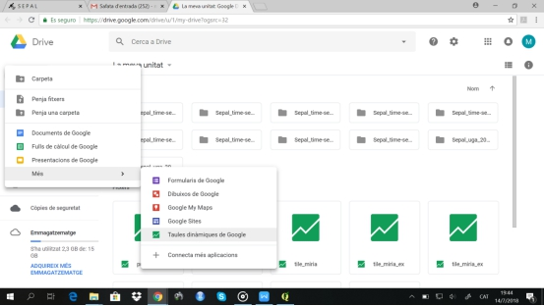

From here, the .kml can be uploaded

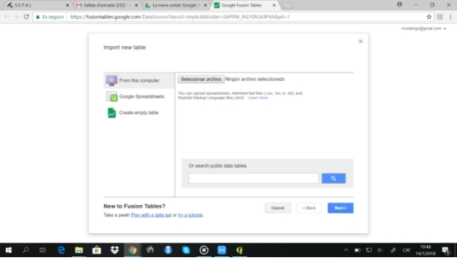

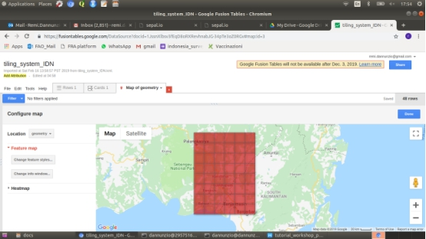

The Fusion Table has to be public

Tools / Publish / Change visibility / Public to the web

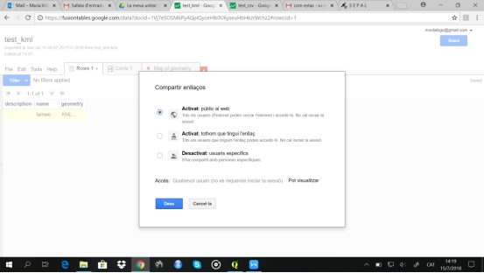

ID available in the menu File/About this table:

