## SEPAL tutorial for the generation of mosaics and classification

The following steps should be followed in order to generate a mosaic of Sentinel 2 or Landsat imagery in SEPAL.

Once you logged in, go to your personal settings (bottom right “username”) and make sure your account is set with your own white listed GEE-API Google account: this will allow you to export your products to your own drive or asset space.

If you don’t have a GEE white listed account, you can use SEPAL default’s account (“USE SEPAL’S ACCOUNT”) but that will not allow you to export large products

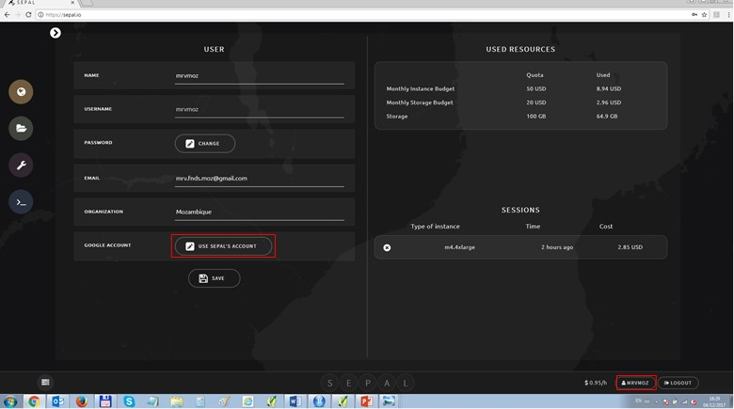

Go to “Search” (top icon on the left panel), choose MOSAIC. You can see the list of saved recipes for mosaics and classifications in that part.

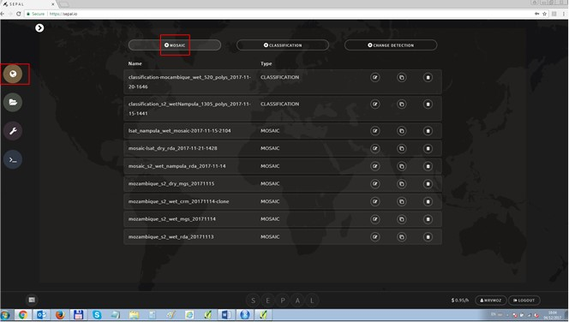

Choose your area of interest (either a country, with a 10km buffer by default or a hand-drown polygon). Select the sensor you are interested in (Landsat or Sentinel) and select the date (year, month, day)

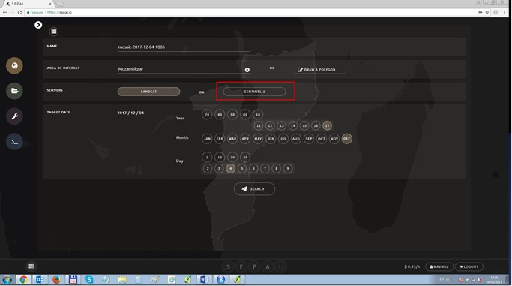

You will first get an empty list of scenes: go to AUTO-SELECT and SUBMIT without changing parameters. You can fine tune them later.

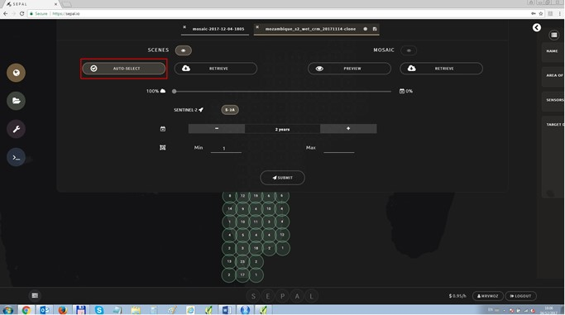

You will see a list of available scenes to create the composite over your AOI. Click on PREVIEW to visualize the quality of the mosaic and choose a usual band combination.

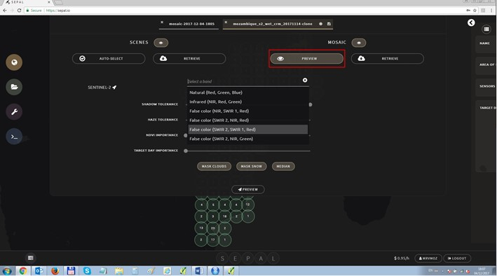

Depending on your connection, your mosaic may take some time to load. Once you have loaded the mosaic, you can select particular scenes for which you would like to improve the quality. Click directly on the desired tile.

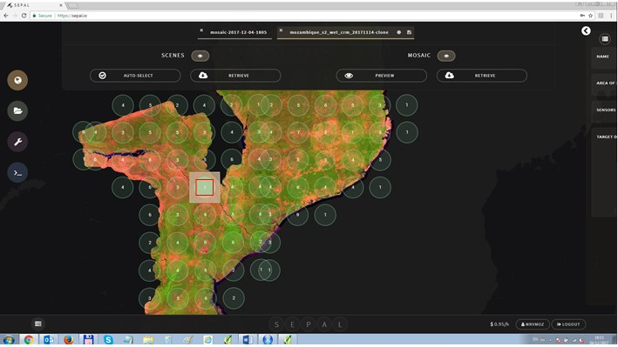

You will access the full list of available scene for the parameters you have selected. You can choose to make a scene go into the mosaic (click on the + in the list of available on the left) or go outside the mosaic (click on the x in the list of selected on the right)

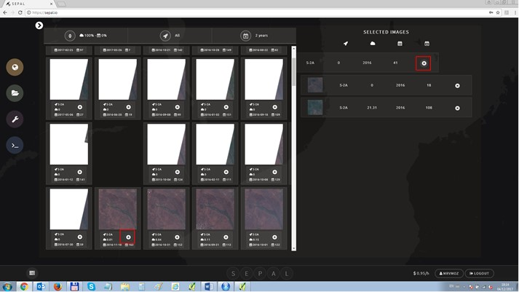

You can enlarge each scene by directly clicking on the image and assess its quality. Click again on the image to go back to the list.

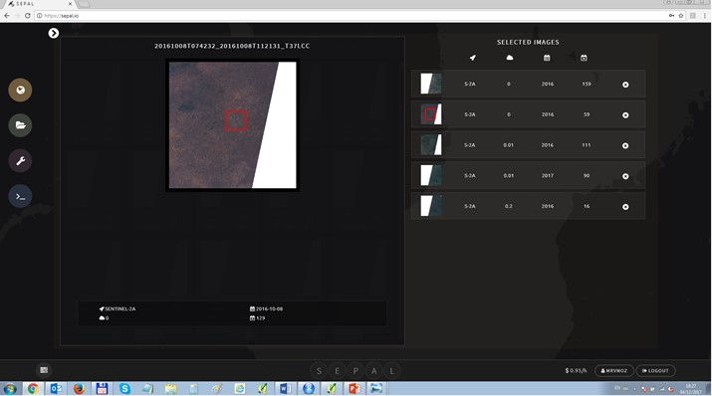

Once you are satisfied with your mosaic, you can save as a recipe in the top right button. You will be able to access again your mosaic with the saved parameters.

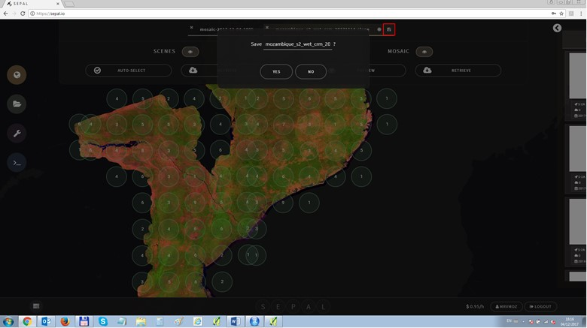

You can finally retrieve your mosaic: if it is a large area (country wide) it is preferable to export as an asset (you have 250GB of data available as an asset by default).

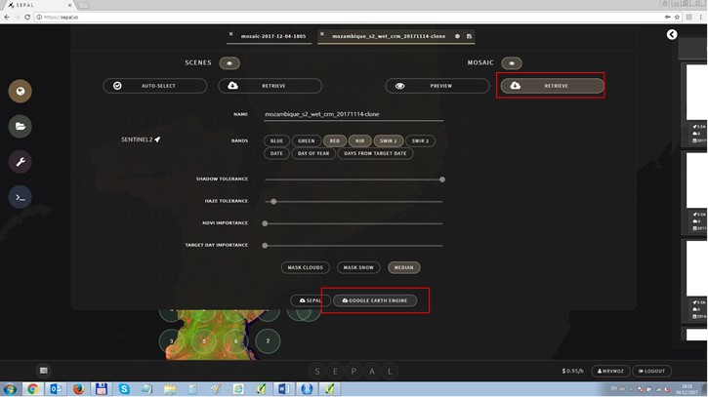

A quick description of the tunable parameters is available below

**Mosaics**

|  |  |
| --- | --- |
| Shadow tolerance | Lowering it removes darker pixels |
| Haze tolerance | Lowering it removes hazy pixels |
| NDVI importance | Increasing it removes pixels with lower NDVI |
| Target day importance | Increasing it removes pixels further from the target day |

 These filters are applied in order. For instance, if Haze tolerance is set to 0, there will only be a single pixel, the least hazy one. NDVI and target day importance will therefore have no impact.

|  |  |
| --- | --- |
| Mask snow | Masks snow |
| Mask clouds | If an area only has clouds, enabling this option will mask out that area. This can remove some buildings and deserts. Only available for Sentinel 2, where cloud masking is less accurate. |
| BRDF correction | Apply BRDF correction to the mosaic. This will slow down the mosaic creation. Only available for Landsat. |
| Median | Create a median composite. If disabled, the pixel value closest to the median is used. |
| Retrieve to Sepal | Download the mosaic to Sepal |
| Retrieve to Google Earth Engine | Export the mosaic as a Google Earth Engine asset. Only available if using a personal Google account. |

The most efficient way to create a mosaic is to have max tolerance, min importance, not apply BRDF correction, and do a median composite, using as few scenes as possible. Each change from this will add additional processing overhead.

**Classification**

|  |  |
| --- | --- |
| Input recipe | The saved Sepal recipe to classify |
| GEE asset ID | The Google asset ID to classify |
| Fusion table ID | The ID of the Fusion table with training data |
| Class column | The column of the Fusion table with the classes |
| Preview | Display a preview of the classification |
| Export to Sepal | Download the classification to Sepal |
| Export to Earth Engine | Export the classification as a Google Earth Engine asset. Only available if using a personal Google account. |

.