#K $ Getting Started
Getting started in Layout Manager can be a confusing task at first, but this guide will help explain what you need to do to get started. This guide will briefly explain all the necessary components needed to create a basic layout file for your POS. Follow the steps below to get started in creating a layout file.

Begin by starting Layout Manager through PEP. To start Layout Manager through PEP, go to the ‘Tools’ Menu, then ‘Touch Layout’, then ‘Edit Touch Layout’.

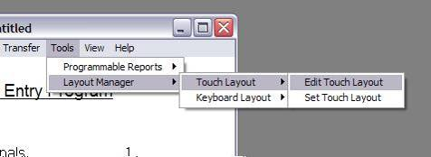

The first thing that you need to do, while starting a new layout, is decide what default attributes you want your layout to have. The default attributes determine what your windows, buttons, and text controls will look like when you first create them.

Note: The default attributes can be changed at another time if you wish. Therefore, you should not worry about the settings you make now being permanent.

You should see a dialog like this:

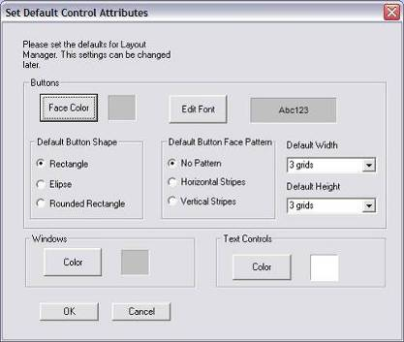

This screen is the Default Attributes Dialog. You can now start entering the default attributes you wish your buttons, windows, and text controls to have. Once you have done this, press ‘Ok’.

You should now see a screen like this:

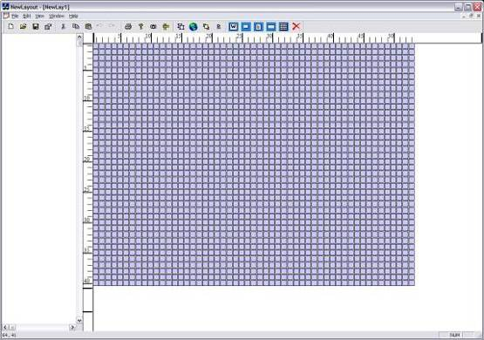

These blue grids that you see are the workspace for layout manager. The workspace is where you will place windows, buttons, etc to develop your layout.

Note: The grid size is related to the resolution specified in Layout Manager. For example, a resolution of 800 x 600 yields a grid size of 53 x 40. A resolution of 1024 x 768 yields a grid size of 68 x 51. The resolution should be set to match the size of the resolution on your terminals. The resolution can be changed under the ‘View Menu’ and then ‘Resolution’. Changing the resolution will change the grid size to the appropriate size.

You are now ready to start making a layout file. Begin by following the steps listed below:

- First, you must create a window. On a typical layout there are usually about 10~15 windows, but you can have as many windows as you want. This all depends on what all you need in the layout file. You may always add more at a later point in time should you need more.

See the links below for information about windows and how to
create them
- What are Windows?
- How to create Windows

Important: The Windows that are going to contain the items seen when the terminal first starts up, need to be created first. The window types on these windows MUST also be defined as Non-Popup.

- Once you have created the window(s) in the first step, you now need to create the items that will be placed on the window(s). Follow the steps listed below:

  - Begin by creating the mandatory buttons that you will need. There will be other buttons that you must also create, but these listed here are the mandatory ones.

Create the following buttons: “A Key” (Sign-In A), “B Key” (Sign-in B if set to be used in PEP), a number pad, and mode keys (SUP, PROG, and REG).

See the links below for information about buttons and how to create them
- What are Buttons?
- How to create Buttons

  - Next, create the Text Displays that you must have:
    - On the window(s) you created, you also must have the following displays:
      - Single Receipt Main
      - Lead Thru
      - Descriptor
      - SUP/PROG

See the links below for information about text displays and how to create them
What are Text Display?
- How to create Text Displays

Notes:
- For Single Receipt Main and SUP/PROG displays to look proper, it’s best to have their size ratio set close to 3:5 (width : height). That is, it is better for their height to be much larger than their width.

- For the Lead Thru and Descriptor, its best for their width to be much greater than their height. Their width to height ratio should be around a 5:3 (width : height) ratio. It is also best for each of these displays to be placed on separate windows, although it is not absolutely necessary.

- If the terminal you are using will be running multiple receipt windows, or will be part of a drive thru system, then you must also add the Multi Receipt 1 - 3 displays onto your layout. These displays also look their best at a 3:5 (width : height) ratio.

  - Now create the Labels that you want
    - Labels are just a way to display information. They are not necessary and are only meant to enhance the ease of use for the POS.

See the links below for information about labels and how to create them
- What are Labels?
- How to create Labels

  - Finally, you need to add an OEP Display
    - Adding an OEP Display on your layout is not necessary, unless you are using an OEP in your PEP setup.

See the links below for information about an OEP and how to create one
- What is an OEP?
- How to create an OEP

- Once you have completed these steps, make sure to save the layout file.

- You can now go back to PEP and transfer your layout file to the terminal(s)

#K $ What is Layout Manager
“Layout Manager” is a PC software program provided to users of NeighborhoodPOS to help design and create the layout of buttons, text displays and other controls for the terminals. Layout Manager allows a user to design how the Point of Sale system will look using the following features:
- Windows
  - What are Windows?
  - How to create Windows
- Buttons
  - What are Buttons?
  - How to create Buttons
- Text Controls
  - What are Text Controls?
  - How to create Text Controls
- Labels
  - What are Labels?
  - How to create Labels
- OEP Display
  - What is the OEP
  - How to create an OEP

#K $ What are Windows

What are Windows?
Windows are the most basic concept in Layout Manager. Windows provide a way for Layout Manager to associate multiple buttons, text controls, and labels together in one area. Windows act as a foundation for which everything else is stacked upon.

Here is some information about windows:
- Multiple Windows can exist in the same grid area on your Layout
- Are used to “hold” buttons, text controls, and labels
- Window Type:
  - Non-Popup: A non-popup window is a window that is not allowed to be user dismissed, unless a window dismiss button is placed on the window. A button may be assigned to display a non-popup window, but that same button cannot dismiss the window. Non-popup windows should always be used for holding text controls.
  - Popup: A popup window is a window that can be dismissed by a user after so many picks (how many times a button on this window was pressed). Unlike Non-Popup, they can be dismissed by the same button that called them. Also, a popup window should only be used when a user will call that window. It should NEVER be used for a window that contains a receipt window, or any other text control/display.
- Default User Screen option:
  - This option allows you to specify what screen(s) will be displayed when NeighborhoodPOS starts up and when a transaction is completed.
  - Multiple windows can have this option checked.

- Click here to see how to create Windows

#K $ What are Buttons

What are Buttons?
Buttons are what allows the user to complete a desired action. They are the key component of Neighborhood Point of Sale System.

Here is some information about buttons:
- Buttons depict key presses and releases.
- Cannot overlap another button, label, or text control on the same window
- Can have an icon as the background image. You may still have text over a icon if you wish
- A button can have its text orientation set to be horizontally or vertically. Note: only while testing the layout and the layout being on the terminal will you see the text orientation vertically.
- Buttons cannot extend the boundaries of the window being placed on.

- Click here to see how to create Buttons

#K $ What are Labels

What are Labels?
Labels are a simple way of displaying text or an image in a certain area in layout manager. Labels have no functionality other than to provide a message to the user of the POS.

Here is some information about Labels:
- Do not depict key presses or releases
- Cannot overlap any other buttons, text controls, or labels.
- Cannot extend the boundaries of the window being placed on.
- Can have an icon for the background image, as well as use text over an icon.

- Click here to see How to create Labels

#K $ What are Text Displays

What are Text Displays?
Text displays are the way Neighborhood Point of Sale system shows data to the user. This can include showing what items have been rung up, the date and time, Supervisor and Program mode operability, etc.

Currently there are only ten text displays that are selectable, and they are:
- Single Receipt Main – this is the main text control and it shows information dealing with what items have been entered for this transaction. This text control is where you will see a list of what has been entered.
- It is best to have the size of this text display at a 3:5 (width : height) ratio.

- Multiple Receipt Display 1 – this is the first of three multiple receipt text controls that will show the order currently being place, if the Terminal type is set to show this text control.
- It is best to have the size of this text display at a 3:5 (width : height) ratio.

- Multiple Receipt Display 2 – this is the second of three multiple receipt text controls and it will show the previous order entered, if the Terminal type is set to show this text control.
- It is best to have the size of this text display at a 3:5 (width : height) ratio.

- Multiple Receipt Display 3 – this is the third out of three multiple receipt text control, and it shows the second to last order entered, if the Terminal type is set to show this text control.
- It is best to have the size of this text display at a 3:5 (width : height) ratio.

- Lead Thru – this text control shows the mnemonics for errors, items being entered, data entry, etc
- It is best to have the size of this text display at a 5:3 (width : height) ratio.

- Descriptor – this text control shows the status of the terminal. It will display whether or not the master and backup master are in synch, if the master is down, KDS is down, terminal is communicating, etc.
- It is best to have the size of this text display at a 5:3 (width : height) ratio.

- Single Receipt Sub – this text control displays the information dealing with the operator, total of the check, tax, as well as any open guest checks that the operator has.
- It is best to have the size of this text display at a 3:5 (width : height) ratio.

- Single Receipt Scroll – this text control only shows arrows either pointing up or down, to indicate that the Single Receipt Main text control has more items that are not visible, either up or down.
- Width of this text display only needs to be 1, while height can be any value

- Clock – this text control displays the date and time of the terminal.
- It is best to have the size of this text display at a 5:3 (width : height) ratio.

- Supervisor / Program – this text control displays the Supervisor and Program menus when logged into supervisor or program mode.
- It is best to have the size of this text display at a 3:5 (width : height) ratio.

Important Information about Text Displays:
- Text controls MUST be on Non-popup windows.
- Cannot extend the boundaries of the window being placed upon.
- Cannot overlap other text controls, buttons, or labels.

Note: If the terminal you are using will be running multiple receipt windows, then you must also add the Multi Receipt 1- 3 displays onto your layout. These displays also look their best at a 3:5 (width : height) ratio.

- Click here to see how to create Text Displays

#K $ What is an OEP Display

What is an OEP Display?
An OEP (Order Entry Prompt) is a type of text display that can automatically generate buttons. The buttons are generated based upon how many PLU’s are associated within a certain table in PEP (AC 160). To see more information about OEP, see the PEP help file under AC 160. When creating this OEP display, Layout Manager will automatically generate a window for the OEP to rest on. There will be no need to edit this window, unless you want to change the name of the window. The window the OEP display creates for itself will be named “OEP Window” by default.

- Click here to see how to create an OEP Display

#K $ Creates a new Layout file and prompt for the default attributes.
#K $ Permits opening of existing Layout files.
#K $ Writes over previous save. Applicable if performed "Save As."
#K $ Permits saving of file with an eight-character name
#K $ Permits printing of layout
#K $ Permits selection of printer types, etc.
#K $ Exports the layout file into a CSV (comma separated value) file. NOTE: This is currently not implemented. This feature will be implemented in a later release.
#K $ Imports the layout file from a CSV (comma separated value) file. NOTE: This is currently not implemented. This feature will be implemented in a later release.
#K $ Allows for user to see how a layout will look on a terminal. Selecting this will show you a preview of your layout file. To exit this test, press ESC. Note: During this test, you may press any buttons on the windows, but no functionality will exist on them. The only buttons that will have some functionality will be the buttons that call other windows. Pressing buttons that call other windows will bring up that window, as it would if it were actually on the terminal.
#K $ The status bar is the bar at the very bottom on the layout manager. It shows the coordinates of your mouse cursor, as well as NUM Lock, CAPS lock, and SCROLL lock.
#K $ The resolution is what determines how big the grid area will be. This size should reflect the resolution that the terminals will have. In another words, if the resolution on the terminals is 800 x 600, then the resolution in Layout Manager needs to be 800 x 600.
#K $ Allows you to specify the language used in Layout Manager. Currently the following languages are supported: English, French, Spanish, German, and Simplified Chinese.
#K $ Allows you to enable or disable the rulers in Layout Manager.

GettingStarted
Concept: Getting Started
Getting Started
whatIsLayoutManager
Concept: What are Windows
What are Windows
whatAreWindows
Concept: What are Windows
What are Windows
whatAreButtons
Concept: What are Buttons
What are Buttons
whatAreLabels
Concept: What are Labels
What are Labels
whatAreTextControls
Concept: What are Text Controls
What are Text Controls
whatIsTheOEP
Concept: What is the OEP
What is the OEP
fileNew
File Menu: Open New File
File Menu –New
fileOpen
File Menu: Open Existing File
File Menu – Open
fileSave
File Menu: Save File
File Menu –Save
fileSaveAs
File Menu: Save File As
File Menu –Save As
filePrint
File Menu: Print
File Menu –Print
filePrintSetup
File Menu: Print Setup
File Menu –Print Setup
fileExport
File Menu: Export and Import: Export
File Menu – Export and Import
fileImport
File Menu: Export and Import: Import
File Menu – Export and Import
fileTestLayoutFile
File Menu: Layout File: Test Layout File
File Menu – Layout File
viewStatus
View Menu: Status Bar
View Menu – Status Bar
viewResolution
View Menu: Resolution
View Menu – Resolution
viewLanguage
View Menu: Language
View Menu – Language
viewRuler
View Menu: Ruler
View Menu – Ruler

