Open Geospatial Consortium, Inc.
Date: 2011-07-01
Reference number of this document: OGC 11-xxxx
Version: 0.1.0
Category: OGC™ Interoperability Experiment Report
Editors: xx

OGC® Surfacewater Interoperability Experiment

FINAL REPORT

Copyright © 2011 Open Geospatial Consortium, Inc. All Rights Reserved.
To obtain additional rights of use, visit http://www.opengeospatial.org/legal/.

Warning
This document is not an OGC Standard. This document presents a discussion of technology issues considered in an initiative of the OGC Interoperability Program. This document does not represent an official position of the OGC. It is subject to change without notice and may not be referred to as an OGC Standard. However, the discussions in this document could very well lead to the definition of an OGC Standard. Recipients of this document are invited to submit, with their comments, notification of any relevant patent rights of which they are aware and to provide supporting documentation.
Document type: OpenGIS® Engineering Report
Document subtype: NA
Document stage: Not approved for public release
Document language: English

Preface
This report describes the methods, results, issues and recommendations generated by the Surfacewater Interoperability Experiment (SW IE), carried out as an activity of the OGC Hydrology Domain Working Group (HDWG). The SW IE is designed to:
Suggested additions, changes, and comments on this draft report are welcome and encouraged. Such suggestions may be submitted by email message or by making suggested changes in an edited copy of this document.
The changes made in this document version, relative to the previous version, are tracked by Microsoft Word, and can be viewed if desired. If you choose to submit suggested changes by editing this document, please first accept all the current changes, and then make your suggested changes with change tracking on.

Contents Page
1 Introduction 1
1.1 Scope 1
1.2 Document contributor contact points 2
1.3 Revision history 2
1.4 Future work 2
1.5 Forward 2
2 References 4
3 Terms and definitions 6
4 Conventions 7
4.1 Abbreviated terms 7
4.2 UML notation 8
5 SWIE Overview 9
5.1 Background 9
5.2 Motivation and Goals 9
5.3 User Scenarios 9
5.4 Use Cases 9
6 SWIE Architecture 10
6.1 Motivation and Goals 10
6.2 Design and Implementation 10
6.3 Architectural Issues and Recommendations 10
7 SWIE Best Practices AND outstanding issues 11
7.1 SWIE Services Profile 11
7.2 Issues and Recommendations 11
7.3 SWIE WaterML 2 Profile 12
8 SW IE Client Implementation 13
8.1 Motivation and Goals 13
8.2 Client 13
8.3 University of Calgary (UC) 13
8.4 34 North (34N) 13
9 Acknowledgements 14

Figures Page
No table of figures entries found.
In your document, select the words to include in the table of contents, and then on the Home tab, under Styles, click a heading style. Repeat for each heading that you want to include, and then insert the table of contents in your document. To manually create a table of contents, on the Document Elements tab, under Table of Contents, point to a style and then click the down arrow button. Click one of the styles under Manual Table of Contents, and then type the entries manually.

Introduction

Scope
This report describes the methods, results, issues and recommendations generated by the Surfacewater Interoperability Experiment (SW IE), carried out as an activity of the OGC Hydrology Domain Working Group (HDWG). The SW IE is designed to:
The SW IE concluded
Attention is drawn to the possibility that some of the elements of this document may be the subject of patent rights. The Open Geospatial Consortium Inc. shall not be held responsible for identifying any or all such patent rights.
Recipients of this document are requested to submit, with their comments, notification of any relevant patent claims or other intellectual property rights of which they may be aware that might be infringed by any implementation of the standard set forth in this document, and to provide supporting documentation.

Document contributor contact points
All questions regarding this document should be directed to the editors or contributors:
Name | Organization
Michael Utech | KISTERS
Stefan Fuest | KISTERS
Michael Natschke | KISTERS

Revision history
Date | Release | Editor | Primary clauses modified | Description

Future work
Future improvements to this document are desirable to clarify technical details arising from subsequent implementation of OGC standards and related technologies.
Aspects of the SW IE will continue informally amongst participants interested in maintaining and expanding surfacewater data sharing.

Forward
This is an information document that describes the methods, issues, solutions, and recommendations relevant to the SW IE.
Attention is drawn to the possibility that some of the elements of this document may be the subject of patent rights. The Open Geospatial Consortium Inc. shall not be held responsible for identifying any or all such patent rights.
Recipients of this document are requested to submit, with their comments, notification of any relevant patent claims or other intellectual property rights of which they may be aware that might be infringed by any implementation of the standard set forth in this document, and to provide supporting documentation.

References
The following documents are referenced in this document. For dated references, subsequent amendments to, or revisions of, any of these publications do not apply. For undated references, the latest edition of the normative document referred to applies.
OGC 01-068r3, Web Map Service Implementation Specification, 1.1.1, 2002-01-16, http://www.opengeospatial.org/standards/wms
OGC 04-094, Web Feature Service Implementation Specification, 1.1.0, 2005-05-03, http://www.opengeospatial.org/standards/wfs.
OGC 04-095, OpenGIS Filter Encoding Implementation Specification, 1.1.0, 2005-05-03, http://portal.opengeospatial.org/files/?artifact_id=8340.In addition to this document, this report includes several XML Schema Document files as specified in Annex A.
OGC 06-009r6, OpenGIS Sensor Observation Service, 1.0, 2007-10-26, http://www.opengeospatial.org/standards/sos.
OGC 06-042, OpenGIS Web Map Service (WMS) Implementation Specification, 1.3.0, 2006-03-15, http://www.opengeospatial.org/standards/wms.
OGC 06-121r3 OGC Web Services Common Specification, http://portal.opengeospatial.org/files/?artifact_id=20040.
OGC® 07-000, OpenGIS® Sensor Model Language (SensorML) Implementation Specification, 1.0.0, 2007-07-17, http://portal.opengeospatial.org/files/index.php?artifact_id=21273&passcode=fxphjb8qrca4gwy7g626.
OGC 07-022r1, Observations and Measurements – Part 1 - Observation schema 1.0, 2007-12-08 http://portal.opengeospatial.org/files/?artifact_id=22466.
OGC 07-036 OpenGIS Geography Markup Language (GML) Encoding Standard, 3.2.1, 2007-08-27, http://portal.opengeospatial.org/files/?artifact_id=20509.
OGC 09-001, OpenGIS SWE Service Model Implementation Standard, 2009-09-30.
OGC 09-025r1 and ISO/DIS 19142, OpenGIS Web Feature Service 2.0 Interface Standard, 2010-11-02, http://www.opengeospatial.org/standards/wfs
OGC 09-026r1 and ISO/DIS 19143, OpenGIS Filter Encoding 2.0 Encoding Standard, 2010-11-22, http://www.opengeospatial.org/standards/filter
OGC 10-037, OGC SOS 2 Interface Standard, 2010-09-02, http://www.opengeospatial.org/standards/sos
OGC 10-037, OGC SOS 2 Interface Standard, 2010-09-02, http://www.opengeospatial.org/standards/sos.
OGC 10-126r1, OGC® WaterML2.0: An O&M profile for water observations data, 2010-05-27.

OGC 11-xxxxOGC 10-004r2 and ISO/DIS 19156, Geographic information - Observations and measurements,2010-05-03.

OGC 10-025r1, OGC 11-xxxx.

Terms and definitions
For the purposes of this report, the definitions specified in Clause 4 of the OWS Common Implementation Specification [OGC 06-121r3], clause 4 of Sensor Observation Service [OGC 06-009r6], and Clause 4 of Observations and Measurements – Part 1 [OGC 07-022r1].

Conventions

Abbreviated terms
API Application Programming Interface
CSIRO Australian Commonwealth Scientific and Research Organization
CUAHSI Consortium of Universities for the Advancement of Hydrologic Science
GSC Geological Survey of Canada
GML Geography Markup Language
GW IE OGC Groundwater Interoperability Experiment
GWML Groundwater Markup Language
HDWG OGC Hydrology Domain Working Group
ISO International Organization for Standardization
KML Keyhole Markup Language
KiTSM KISTERS Time Series Server
KiWIS KISTERS Web Interoperability Solution

NCSA National Center for Supercomputing Applications, U Illinois Urbana
OGC Open Geospatial Consortium
OWS OGC Web Services
O&M Observations and Measurements
SensorML Sensor Model Language
SOS Sensor Observation Service
SWE Sensor Web Enablement
UML Unified Modeling Language
USGS US Geological Survey
WaterML 2 Water Markup Language
WISKI Water Information System KISTERS
WMC Web Mapping Context
WMS Web Mapping Service
WFS Web Feature Service
XML eXtensible Markup Language
XSD XML Schema Definition

  - UML notation
Class diagrams that appear in this report are presented using the Unified Modeling Language (UML) static structure diagram, as described in Subclause 5.2 of [OGC 06-121r3].

SWIE Overview

Background

Motivation and Goals
This interoperability experiment will advance the development of WaterML2, test its use with various OGC service standards (SOS, WFS, WMS and CSW) and emerging clients.

User Scenarios

Use Cases
General description of use cases, followed by detailed descriptions of each use case

Use Case 1

Contributors
Role | Contributor

Description

Goals

Use Case 2 - Forecasting
The purpose of Use Case 2 was to evaluate the suitability of the WaterML2 encoding of SOS and O&M to support frequent incremental feeds in real time of hydrological (time series) data from known data sources to client applications conducting hydrological forecast. This experiment will not address the delivery of hydrological forecasts via an SOS, as this evaluation is foreseen for the interoperability experiment on Hydrological Forecasting.

Contributors
Role | Contributor
SOS service | USGS, KISTERS
SOS client | Deltares & NOAA/NWS, KISTERS

Description
Hydrologic forecasting applications are real time system applications that continuously need to be aware of the latest state of the water and weather system. Their data feed process is characterized by a incremental data ingest occurring at relative high frequency (1-15 minutes). The record lengths of data transmitted are typically small (i.e. one or a few values per observation). However, given the real time aspect of these systems, they need to be high performing and their data feed as well.

Goal
Evaluate the suitability of SOS and the WaterML2.0 encoding to support high-performance forecasting systems with high-frequency, incremental observational data updates.

Use Case 2 Architecture

Motivation and Goals
Data exchange scenarios for real time purposes, such as hydrologic forecasting, have other needs than many other data exchange scenarios. These scenarios are characterized by the high-frequent exchange of data increments from a known set of monitoring points for a known set of phenomena. The exchange needs to be fast, so that it disrupts the forecast system as little as possible. Data discovery is typically not relevant in this context, and meta-data should be kept to a minimum to reduce the payload and parsing time.
This use case intends to evaluate the suitability of SOS and the WaterML2.0 encoding to support high-performance forecasting systems with high frequency, incremental observational data updates. In this evaluation, a comparison is made against other standardized file formats that are commonly used to exchange hydrometeorologic time series for forecasting purposes:

Design and Implementation
To assess the performance of WaterML2.0 encoded files, a comparison is made against other standardized file formats that are commonly used to exchange hydrometeorologic time series for forecasting:
- SHEF: The US - Standard Hydrometeorological Exchange Format
- PI-xml: the Published Interface format from the Delft-Flood Early Warning System
The following evaluation criteria have been applied:
- ingest time
- file size (compressed/uncompressed) as a proxy for network transportation
The SOS2-service used to deliver the data was hosted by USGS (http://http://nwisvaws02.er.usgs.gov/ogc-swie/). Some other tests have been done with a SOS1 service using SWE Common encoding, hosted by 52North.
Deltares implemented the SOS client in the Delft-FEWS software platform. The test application was the NCRFC-CHPS (North Central River Forecasting Center's implementation of the Community Hydrologic Prediction System (CHPS)).
Ingest time was evaluated from the moment of receiving the SOS-response message to the internal data commit for WaterML2 encoded data. From this data set, a set of SHEF and PI-xml files were created and posted to the local disk. These files were then read from disk. For these two formats, ingest time was calculated from the start of file read to internal data commit.

Architectural issues and recommendations
Issues discovered:
Having a clear and shared agreement on the SOS-profile is essential for forecasting systems, as these applications are not designed to discover data or figure out by themselves how to query a service. Their purpose is to bring in the data as fast as possible. While feature of interest and observedProperty are rather clear, the use of offerings and procedures leaves too much room for mixing one and the other.
Metadata is burdening the performance of xml-encoded WaterML2 messages in high-frequent incremental data exchange. The overhead in a WaterML2 encoded message is 5-10 times the overhead in SHEF and PI-formats. This is reflected both in message size as well as ingest time. The relative overhead shrinks with longer timeseries, but those are not typical within a forecasting context. Reduction of nested data structure complexity is likely to contribute to better performance. It is recognized that both SHEF and PI-xml are highly optimized formats for specific data and uses, and we can expect them to out perform a generalized data format such as WaterML2.
NWS and USGS use different identifiers for the same stations. An Identification Mapping service (ID Mapping) would be highly desirable to accommodate the mixed usage of station identifiers from either organization (and others).

USE case Best Practices AND outstanding issues

Services Profile
Example below.
SWIE-compliant SOS-services need to be clear on the interpretation of the terms 'offering' and 'procedure'. Currently too much variation exists between services that use these items.
(PETER F: THIS NEEDS TO BE TRANSLATED IN A STATEMENT USE A FOR OFFEREING AND B FOR PROCEDURE).

- SWIE-compliant SOS services SHALL use the SOS 1.0 specification, even if the resulting Observation collection is GML 3.2.

Issues and Recommendations
Any reduction of metadata transmission will be beneficial for incremental high frequency data exchange.
Additional research will be needed to evaluate if binary encodings can overcome some of the poor performance problems form WaterML2 in full xml-encoding.

Use Case 3

Contributors
Role | Contributor
SOS Services | KISTERS
SOS Client | KISTERS
Data Provider | GRDC
Data Provider | USGS
Service Provider | USGS

Use Case Architecture

Motivation and Goals
Making Data from the GTNR Stations provided by Global Runoff Data Center available through SOS/WaterML2 and enable the GRDC to ingest data from the USGS (Mississippi Area) through SOS/WaterML2.0

Design and Implementation
The GRDC System has been implemented in the DMZ of KISTERS. The GTNR Data has been migrated into the WISKI/KiTSM System including Gauge Name and WMO Identifier, country the gauge is in, the time zone information and spatial references, the WMO catchment name and associated size.
On top of the WISKI/KiTSM System the KISTERS Interoperability Solution KiWIS has been installed, serving the data through SOS/WaterML2 (http://kiwis.kisters.de).
The WISKI Desktop application has been enables to consume meta data and time series data through SOS consumer classes. For this use case a dedicated consumer class has been developed to ingest data from the USGS NWIS Services (URL goes here).
The following diagram shows the architecture of the use case 3 system
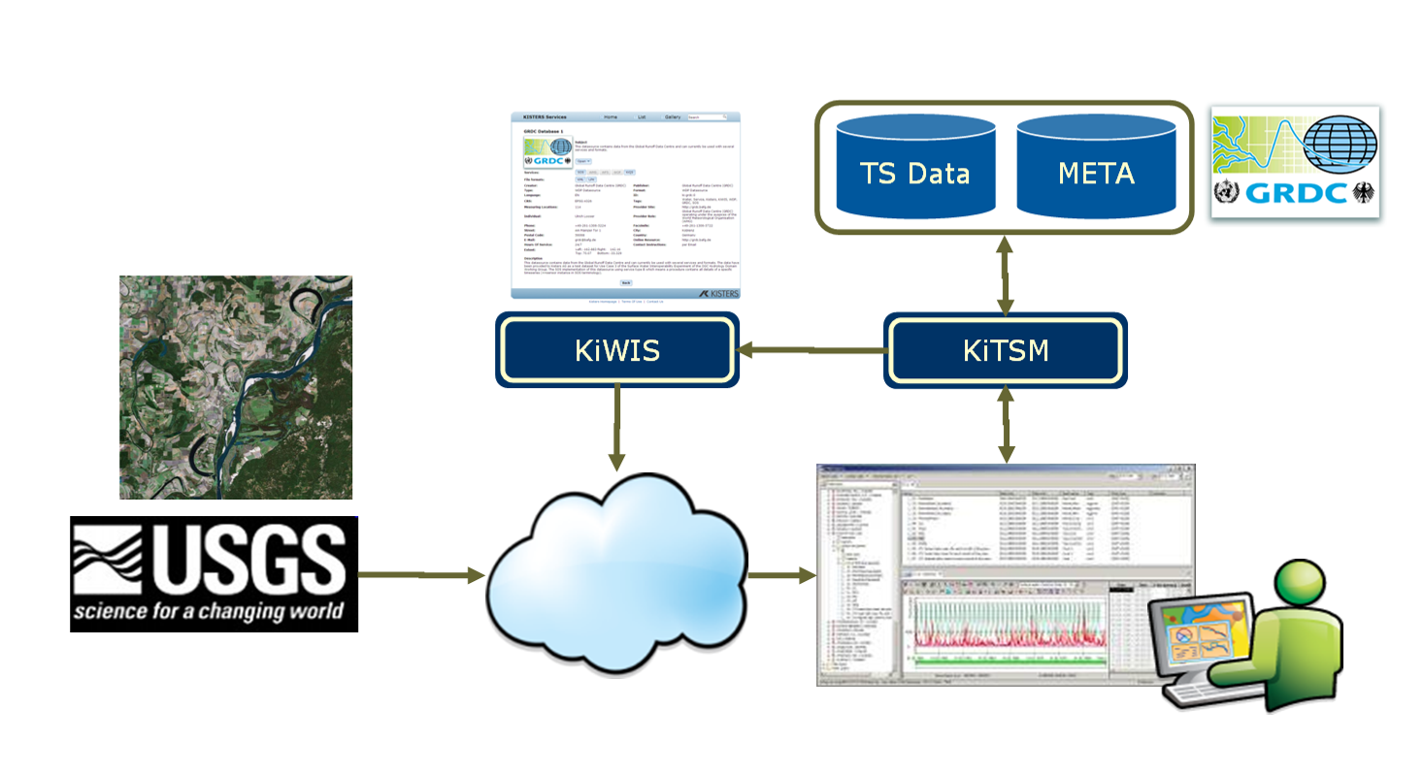

Architectural issues and recommendations

see with section 11.3

SWIE Best Practices AND outstanding issues

SWIE Services Profile
Example below.
- GWIE-compliant SOS services SHALL use the SOS 1.0 specification, even if the resulting Observation collection is GML 3.2.

Issues and Recommendations
Example:
- SOS GetCapabilities
The SOS 1 specification demands that the list of features-of-interest be explicitly serialized in the GetCapabilities document. This list is either used for discovery (harvesting by catalog) or to provide a valid list of feature identifiers to be used in GetObservation (the feature-of-interest id being one of the parameters of this operation).
SOS 2 has a relatedFeature property (no more information is provided, beside the property cardinality in Table 17 of OGC 10-037), which seems to play a slightly more restricted role.
The Capabilities document of SOS 2.0 lists related features instead of all features-of-interest. The related features are selected by the service provider and serve discovery purposes.
In the current WaterML2 model, it has been decided that the feature-of-interest should be the monitoring station (or any other relevant sampling feature). But, some systems can contain large quantities of features-of-interest, so it is impractical for performance reasons to serialize them individually.
Nonetheless, the service must still need to publish a collection of feature-of-interest that can be used in GetObservation to extract observation related to a specific feature-of-interest.
Proposed Solution
We propose that the profile element SOS5 be fomally part of the SOS specification. The capabilities document should be allowed to provide a composite feature as feature-of-interest. The composite feature shall be a gml:FeatureCollection nesting other gml:FeatureCollections. The collection would be composed of a list of sub-collections. If the sub-collection contains a reasonable amount of features-of-interest, the list would be serialized explicitly; otherwise the composite feature is serialized. The nesting logic within collections is up to the server. It can follow a purely geometric partitioning (e.g. quad-tree) or follow an administrative structure (state/county/city/zip).
  - SWIE SOS Hydrology Profile
    - Overview
Experience with the existing SOS services shows that there is a range of ways to understand the generic SOS terminology. Discussions have taken place in several groups and it appears that all of those led to different ways of SOS implementations. Different SOS implementations cause ambiguous client/server interaction with technically proper but semantically wrong request/response pattern. Interaction is just possible, if client and server have been doing a common process of adjustment, development or implementation.
Why is this? Current SOS approach is an intentional approach in order to support a broad range of use cases ranging from fixed in-situ sensors to tracking applications or even complex remote sensing systems. Thus, the flexibility is absolutely necessary to accomplish this. It is up to the certain domain to limit this flexibility to get a reasonable set of options.
This chapter should therefore propose a certain way of SOS usage (with respect to the WaterML2 proposal). It should be seen as a “SOS Usage Profile for the Hydrology Domain” to which data providers and data consumer in the hydrological world can agree and comply with their software systems. This is necessary because just “SOS compliance” will not mean that the client knows how the specific server understands the main SOS terms (“procedure”, “observed property”, “feature of interest”, “offering”).

    - Definitions
General definitions as taken from the SOS 1.0 and O&M 1.0 specification documents:

Observation Offering:
An observation offering is a logical grouping of observations offered by a service that are related in some way. The parameters that constrain the offering should be defined in such as way that the offering is 'dense' in the sense that requests for observations that are within the specified parameters should be unlikely to result in an empty set.

Procedure:
Method, algorithm or instrument. (O&M: ...which is often an instrument or sensor but may be a process chain, human observer, an algorithm, a computation or simulator.)

ObservedProperty:
The observedProperty identifies or describes the phenomenon for which the observation result provides an estimate of its value. It must be a property associated with the type of the feature of interest.

FeatureOfInterest:
The featureOfInterest is a feature of any type (ISO 19109, ISO 19101), which is a representation of the observation target, being the real-world object regarding which the observation is made.
    - Analysis

The following thematic SOS types have been identified during this experiment:
SOS Server Type A (procedure == sensor-type)
A SOS service which serves more than raw data or medium/larger networks should use the following structure for the getCapabilities response – A procedure is seen as a sensor-type (==time-series type) and NOT as a sensor instance (==time-series instance). This structure should be homogenously used and not be used with other encodings.
Example: http://kiwis.kisters.de/KiWIS/KiWIS?service=SOS&request=getCapabilities&datasource=0
SOS Server Type B (procedure == sensor-instance)
A SOS service which is a bit more as originally intended by SOS specification should use the following structure for the getCapabilities response - A procedure is seen as a sensor-instance (==complete identification of a single timeseries) . This structure encodes a path into the procedure field but allows inconsistent requests with features and properties.
Example: http://kiwis.kisters.de/KiWIS/KiWIS?service=SOS&request=getCapabilities&datasource=1
SOS Server Type C (procedure==sensor-type/system)
A SOS as intended by the GroundWater IE should use the following structure for the getCapabilities response - A procedure is seen as a sensor-type or system. This structure requires additional requests or knowledge to “drill” into the data if you want to do it by sensor instance. Also refer to:
http://external.opengis.org/twiki_public/bin/view/HydrologyDWG/GwIeGetCapabilitiesBestPractices,
http://external.opengis.org/twiki_public/bin/view/HydrologyDWG/SOSLargeCollectionSensorDiscussion)
Example:
http://kiwis.kisters.de/KiWIS/KiWIS?service=SOS&request=getCapabilities&datasource=2
SOS Server Type D “MIXED” (procedure==sensor-instance AND derived timeseries type)
In addition to all types above there is also the option to use everything together in a “MIXED” way of doing. A procedure is seen as a sensor-instance or a derived timeseries type. This way actual sensor timeseries and derived timeseries can be distinguished. There is one procedure, one relatedFeature and one observedProperty per offering as long as there are different properties. This is a clear language but it will generate very large getCapabilities documents.
Also refer to:
https://wiki.csiro.au/confluence/display/WaterML20/Adapting+to+SOS+(2.0)

The following statistics list GetCapabilities document sizes for the different types:
 |  |  |  |  | SOS A = TS type |  | SOS B = TS instance |  | SOS C = GW IE
Stations/ Sites/  FOI | TS per Station | Lines per  Proc | Lines per FOI | Lines per ObsProp | Lines | File size  (kB) | Lines | File size  (kB) | Lines | File size  (kB)
0 (Info only) | 0 | 0 | 0 | 0 | 100 | 4 | 100 | 4 | 100 | 4
1 | 20 | 3 | 2 | 2 | 164 | 7 | 164 | 9 | 107 | 4
10 | 20 | 3 | 2 | 2 | 182 | 9 | 722 | 49 | 107 | 4
100 | 20 | 3 | 2 | 2 | 362 | 20 | 6,302 | 456 | 107 | 4
1,000 | 20 | 3 | 2 | 2 | 2,162 | 134 | 62,102 | 4,526 | 107 | 4
10,000 | 20 | 3 | 2 | 2 | 20,162 | 1,277 | 620,102 | 45,219 | 107 | 4
50,000 | 20 | 3 | 2 | 2 | 100,162 | 6,355 | 3,100,102 | 226,078 | 107 | 4
100,000 | 20 | 3 | 2 | 2 | 200,162 | 12,703 | 6,200,102 | 452,153 | 107 | 4
500,000 | 20 | 3 | 2 | 2 | 1,000,162 | 63,484 | 31,000,102 | 2,260,746 | 107 | 4
1,000,000 | 20 | 3 | 2 | 2 | 2,000,162 | 126,960 | 62,000,102 | 4,521,488 | 107 | 4
The table is an estimate using:
- a couple of lines for the ServiceIdentifikation / ServiceProvider sections
- variable lines depending on the amount of FOI
- variable lines for the amount of Procedure
- a rough estimate of 55-75 Bytes per line
It is obvious that – depending on the SOS service type – the size is exploding. It was common sense in the HydroDWG workshop on Sept, 21st that the GetCap document should be a quick handshake document and not a full listing of database content (that just excludes the time-series values and some metadata from the full description).
    - Recommendation

Based on discussions and the above analysis there are several problems and inconveniences that have to be solved when full interoperability for a SOS is attempted. The biggest discrepancy lies between the empiric definitons of O&M and the SOS compared to the common hierarchical storage formats like shown in the WISKI system below:
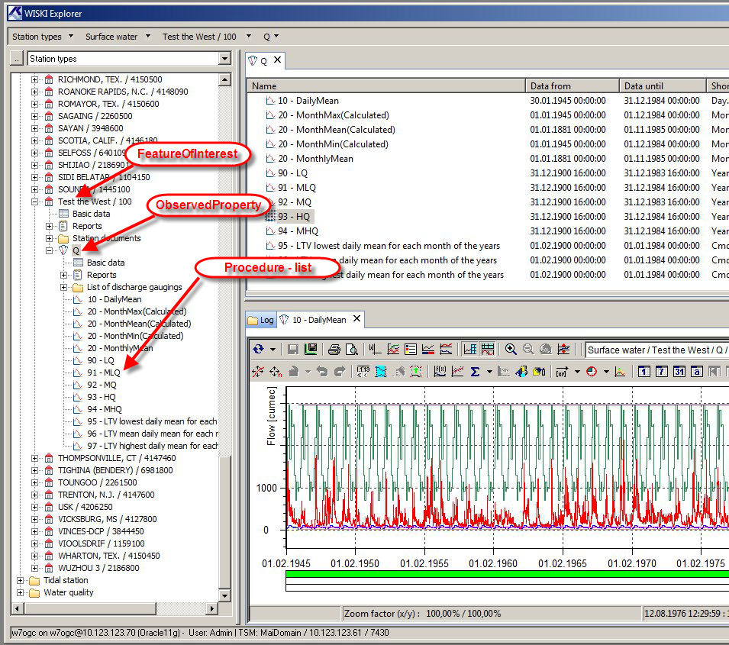 Example screenshot showing KISTERS WISKI7 explorer window and some derived time-series as defined in SW-UC3 with mappings for a Type C SOS
Most database and system architectures require a unique identification of timeseries which in the SOS must be accomplished by suitable mapping.
Further relevant points are, that the SOS definition by default allows large bulk requests for data (e.g. complete data of all timeseries for one property) and the usage of the featureOfInterest in form of a real world feature like a river does not enable you to request data of a specific station.
Therefore the following set of rules has been agreed on to provide an interoperable SOS type for the GWIE:

- GWIE-compliant SOS services shall use the procedure as sensor or algorithm type like described in Type C, not as instance.
- GWIE-compliant SOS services shall use the featureOfInterest as samplingFeature in the sense of a site or station, not as the actual observed object (e.g. a river).
- GWIE-compliant SOS services shall use a global featureOfInterest in the GetCapabilities document and not list all existing samplingFeatures.
- GWIE-compliant SOS services shall use a mandatory GetFeatureOfInterest request to identify actual samplingFeatures either by filters or as complete list based on the global featureOfInterst.
- GWIE-compliant SOS services shall use a GetObservation request that either answers the full amount of data requested, or with an appropriate error message if the service provider wants to prevent large bulk requests.
- ??? Should the optional profile field in GetCap documents be used to announce a GWIE/Type C SOS ???

SWIE WaterML 2 Profile
The WaterML 2 Profile used by the SWIE is shown below in Figure 2.

SW IE Client Implementation

DelftFEWS SOS Client – Deltares

Motivation and goals
As a major supplier of forecasting system applications based on its Delft-FEWS software platform, Deltares would like to contribute to a WaterML2 standard that is suitable for hydrologic forecasting. As such the first step is to evaluate the suitability of SOS-services and WaterML2 encodings as a data feed to a forecasting system.
To enable this evaluation, Deltares implemented a SOS client in the Delft-FEWS software platform. The test application was the NCRFC-CHPS (North Central River Forecasting Center's application of the Community Hydrologic Prediction System (CHPS)).

Design and Implementation
Forecasting agencies rely on data feeds they trust. These data feeds change infrequently, data discovery needs are infrequent and often require action by the user (i.e. configuration). Given this context, Delft-FEWS requires the customization of the SOS client to query a specific SOS-service for the observations within a moving time window for a specific set of features of interest, observed property(s) and, if required by the service, offering and procedure. The variability in the usage of offering and procedure by SOS services makes it hard to setup these clients.
After implementation of the SOS client and customization for a data feed from USGS, a set of observations (with 15 minute interval) was retrieved for a 1-day period and a 10-day period. Ingest times were derived. The data sets were exported to local disk in two other file formats for comparison: SHEF.E and PI-xml file format.

Results
Below, three data samples are displayed, all providing 8 observation values with a 15-minute interval for the Escanaba River at Cornell, MI (NWS id CRNM4, USGS id 04059000).
In SHEF, the US - Standard Hydrometeorological Data Exchange Format, it looks like:
: Date/time forecast: 20110415
.ER CRNM4 20110413 Z DH06/DC201104161002/STG /DIN15
.E1 405.00/ 403.00/ 403.00/ 404.00/ 405.00/ 404.00/ 404.00/ 403.00/
PI-xml, the Deltares FEWS Published Interface encoding looks like:
<?xml version="1.0" encoding="UTF-8"?>
<TimeSeries xmlns="http://www.wldelft.nl/fews/PI" xmlns:xsi="http://www.w3.org/2001/XMLSchema-instance" xsi:schemaLocation="http://www.wldelft.nl/fews/PI http://fews.wldelft.nl/schemas/version1.0/pi-schemas/pi_timeseries.xsd" version="1.2">
<timeZone>0.0</timeZone>
<series>
<header>
<type>instantaneous</type>
<locationId>CRNM4</locationId>
<parameterId>STG</parameterId>
<timeStep unit="nonequidistant"/>
<startDate date="2011-04-13" time="06:00:00"/>
<endDate date="2011-04-15" time="06:00:00"/>
<missVal>-999.0</missVal>
<stationName>Cornell</stationName>
<units>M</units>
</header>
<event date="2011-04-13" time="06:00:00" value="405.0" flag="0"/>
<event date="2011-04-13" time="06:15:00" value="403.0" flag="0"/>
<event date="2011-04-13" time="06:30:00" value="403.0" flag="0"/>
<event date="2011-04-13" time="06:45:00" value="404.0" flag="0"/>
<event date="2011-04-13" time="07:00:00" value="405.0" flag="0"/>
<event date="2011-04-13" time="07:15:00" value="404.0" flag="0"/>
<event date="2011-04-13" time="07:30:00" value="404.0" flag="0"/>
<event date="2011-04-13" time="07:45:00" value="403.0" flag="0"/>

The associated WaterML2 encoding (same station, discharge instead of stage) looks like:
<wml2:TimeseriesObservation xmlns:gml="http://www.opengis.net/gml/3.2"
xmlns:om="http://www.opengis.net/om/2.0" xmlns:sa="http://www.opengis.net/sampling/2.0"
xmlns:swe="http://www.opengis.net/swe/2.0" xmlns:xlink="http://www.w3.org/1999/xlink"
xmlns:xsi="http://www.w3.org/2001/XMLSchema-instance"
xmlns:wml2="http://www.opengis.net/waterml/2.0" xmlns:gmd="http://www.isotc211.org/2005/gmd"
xmlns:gco="http://www.isotc211.org/2005/gco" xmlns:sf="http://www.opengis.net/sampling/2.0"
xmlns:sams="http://www.opengis.net/samplingSpatial/2.0" gml:id="USGS"
xsi:schemaLocation="http://www.opengis.net/waterml/2.0 ../waterml2.xsd">
<gml:identifier codeSpace="http://nwis.waterdata.usgs.gov/MI/nwis"
>USGS.04059000</gml:identifier>
<gml:name codeSpace="http://nwis.waterdata.usgs.gov/MI/nwis">ESCANABA RIVER AT CORNELL,
MI</gml:name>
<om:metadata>
<wml2:ObservationMetadata>
<gmd:contact xlink:href="http://cida.usgs.gov"/>
<gmd:dateStamp>
<gco:Date>2011-04-15</gco:Date>
</gmd:dateStamp>
<gmd:identificationInfo xlink:href="urn:OGC:unknown"/>
<wml2:status xlink:href="http://waterdata.usgs.gov/MI/nwis/help/?provisional"/>
</wml2:ObservationMetadata>
</om:metadata>
<om:phenomenonTime>
<gml:TimePeriod gml:id="ts_period">
<gml:beginPosition>2011-04-14T00:00:00-05:00</gml:beginPosition>
<gml:endPosition>2011-04-15T03:45:00-05:00</gml:endPosition>
</gml:TimePeriod>
</om:phenomenonTime>
<om:resultTime>
<gml:TimeInstant gml:id="result_time">
<gml:timePosition>2011-04-15T05:30:14</gml:timePosition>
</gml:TimeInstant>
</om:resultTime>
<om:procedure xlink:href="http://www.nemi.gov" xlink:title="Discharge"/>
<om:observedProperty xlink:href="urn:ogc:def:phenomenon:OGC:Discharge" xlink:title="Discharge"/>
<om:featureOfInterest>
<wml2:MonitoringPoint gml:id="USGS.WMP.04059000">
<sf:sampledFeature
xlink:href="http://nwisvaws02.er.usgs.gov/ogc-swie/wfs?request=GetFeature&amp;featureId=04059000"/>
<sf:parameter>
<om:NamedValue>
<om:name xlink:title="Watershed"/>
<om:value>Escanaba</om:value>
</om:NamedValue>
</sf:parameter>
<sams:shape>
<gml:Point gml:id="USGS.P.04059000">
<gml:pos srsName="urn:ogc:def:crs:EPSG:4269">45.90857270 -87.21374820</gml:pos>
</gml:Point>
</sams:shape>
<wml2:descriptionReference
xlink:href="http://external.opengis.org/twiki_public/bin/view/HydrologyDWG/SurfacewaterInteroperabilityExperiment#Use_Case_2"
xlink:title="This wiki page describes the IE"/>
<wml2:timeZone>
<wml2:TimeZone>
<wml2:zoneOffset>-05:00</wml2:zoneOffset>
<wml2:zoneAbbreviation>EST</wml2:zoneAbbreviation>
</wml2:TimeZone>
</wml2:timeZone>
</wml2:MonitoringPoint>
</om:featureOfInterest>
<om:result>
<wml2:owner>
<gmd:organisationName>
<gmd:CharacterString>Michigan Water Science Center</gmd:CharacterString>
</gmd:organisationName>
</wml2:owner>
<wml2:Timeseries gml:id="time_series_loc_0">
<wml2:domainExtent xlink:href="ts_period">
<gml:TimePeriod gml:id="USGS.TP.04059000">
<gml:beginPosition>2011-04-14T00:00:00-05:00</gml:beginPosition>
<gml:endPosition>2011-04-15T03:45:00-05:00</gml:endPosition>
</gml:TimePeriod>
</wml2:domainExtent>
<wml2:defaultTimeValuePair>
<wml2:TimeValuePair>
<wml2:unitOfMeasure uom="cfs"/>
<wml2:dataType
xlink:href="http://www.opengis.net/def/timeseriesType/WaterML/2.0/Continuous"
xlink:title="Continuous/Instantaneous"/>
<wml2:qualifier xlink:href="http://waterdata.usgs.gov/MI/nwis/help/?provisional"
xlink:title="Provisional data subject to revision."/>
</wml2:TimeValuePair>
</wml2:defaultTimeValuePair>
<wml2:Point>
<wml2:TimeValuePair>
<wml2:time>2011-04-15T03:45:00-05:00</wml2:time>
<wml2:value>2860</wml2:value>
</wml2:TimeValuePair>
</wml2:Point>
<wml2:Point>
<wml2:TimeValuePair>
<wml2:time>2011-04-15T03:30:00-05:00</wml2:time>
<wml2:value>2860</wml2:value>
</wml2:TimeValuePair>
</wml2:Point>
<wml2:Point>
<wml2:TimeValuePair>
<wml2:time>2011-04-15T03:15:00-05:00</wml2:time>
<wml2:value>2860</wml2:value>
</wml2:TimeValuePair>
</wml2:Point>
<wml2:Point>
<wml2:TimeValuePair>
<wml2:time>2011-04-15T03:00:00-05:00</wml2:time>
<wml2:value>2860</wml2:value>
</wml2:TimeValuePair>
</wml2:Point>
<wml2:Point>
<wml2:TimeValuePair>
<wml2:time>2011-04-15T02:45:00-05:00</wml2:time>
<wml2:value>2890</wml2:value>
</wml2:TimeValuePair>
</wml2:Point>
<wml2:Point>
<wml2:TimeValuePair>
<wml2:time>2011-04-15T02:30:00-05:00</wml2:time>
<wml2:value>2890</wml2:value>
</wml2:TimeValuePair>
</wml2:Point>
<wml2:Point>
<wml2:TimeValuePair>
<wml2:time>2011-04-15T02:15:00-05:00</wml2:time>
<wml2:value>2890</wml2:value>
</wml2:TimeValuePair>
</wml2:Point>
<wml2:Point>
<wml2:TimeValuePair>
<wml2:time>2011-04-15T02:00:00-05:00</wml2:time>
<wml2:value>2920</wml2:value>
</wml2:TimeValuePair>
</wml2:Point>
File size (compressed/uncompressed)
In terms of file size, it is clear that SHEF (not an xml-based format) is tiny compared to PI-xml and WaterML2. PI xml is about half the size of a WaterML2 encoding, but the difference becomes less when compressed using a normal zip-algorithm. WaterML2 compresses significantly, its compressed file is not much larger than the zipped PI-xml file.
Ingest time.
The average ingest time of the WaterML2 encoded messages for a 1-day period with 15 minute interval data, was a factor 3 slower than the same dataset in SHEF and a factor 6 slower than the PI-xml encoding. The average ingest time per value reduces with larger timeseries, but the reduction for the PI-xml and SHEF encoded formats is higher than the reduction for WaterML2.

- Issues
The above results are from limited experiments only. Due to the ongoing evolvement of WaterML2 and the USGS-SOS service, the SOS client was often broken, hindering the ability to conduct more experiments.
  - Client 1 - Organsation

Motivation and goals

Design and Implementation

Results

Issues

  - Client 2

Motivation and goals

Design and Implementation

Results

Issues

.

Acknowledgements
The SWIE is grateful for the invaluable guidance provided by the OGC, and for the commitment and dedication of SWIE participants.

