Open Geospatial Consortium Inc.
Date: 2009-09-10
Reference number of this OGC® project document: OGC 09-124
Version: 0.1.0
Category: OpenGIS© Discussion Paper
Editor: Peter Taylor
Harmonising Standards for Water Observation Data - Discussion Paper

Copyright notice
Copyright © 2009 Open Geospatial Consortium, Inc. All Rights Reserved.
To obtain additional rights of use, visit http://www.opengeospatial.org/legal/.
Warning
This document is not an OGC Standard. This document is an OGC Discussion Paper and is therefore not an official position of the OGC membership. It is distributed for review and comment. It is subject to change without notice and may not be referred to as an OGC Standard. Further, an OGC Discussion Paper should not be referenced as required or mandatory technology in procurements..
Document type: OGC® Discussion Paper
Document stage: Draft
Document language: English
Contents
1 Scope 1
2 Normative references 1
3 Terms and definitions 2
4 Conventions 2
4.1 Symbols (and abbreviated terms) 2
4.2 UML Notation 3
5 Motivation 5
5.1 Structure of this document 6
6 Relevant standards 6
6.1 Standards and best practices for information modelling 6
6.2 Observations and Measurements (O&M) 7
6.3 Standards for hydrological information 10
6.3.1 ArcHydro 10
6.3.2 WaterML1.0 11
6.3.3 Australian Water Data Transfer Format 11
6.3.4 United States Environmental Protection Agency (EPA) – Water Quality Exchange (WQX) 12
6.3.5 XHydro 12
6.3.6 UK Environmental Agency time series data exchange 12
6.4 Other standards of relevance 13
6.4.1 SWE Common 13
6.4.2 Climate Science Modelling Language (CSML) 13
6.4.3 Integrated Ocean Observing System (IOOS) 13
6.4.4 Ground Water Mark-up Language (GWML) 13
6.4.5 The Global Runoff Data Centre (GRDC) Hydrologic Datasets - metadata profile 14
6.4.6 The Integrated Ocean Observing System (IOOS) 14
7 Harmonising core concepts 14
7.1 Defining existing concepts 14
7.2 Results 16
7.2.1 Time series 16
7.2.2 Existing time series models 17
7.2.3 Per value vs. per time series properties 23
7.2.4 Interpolation Types 23
7.2.5 Continuous/Instantaneous 23
7.2.6 Discontinuous 24
7.2.7 Instantaneous total 24
7.2.8 Average in preceding interval 25
7.2.9 Maximum in preceding interval 25
7.2.10 Minimum in preceding interval 26
7.2.11 Preceding total 26
7.2.12 Average in succeeding interval 27
7.2.13 Succeeding total 27
7.2.14 Cumulative 28
7.2.15 Categorical 28
7.2.16 Handling cumulative data 28
7.2.17 Note on reporting intervals 30
7.2.18 Timing metadata 31
7.2.19 Null Points 31
7.2.20 Values 32
7.2.21 Data Quality 33
7.2.22 Comments 33
8 Features and sampling features 33
9 Procedures 36
9.1 Derived time series 37
10 Observed properties 37
10.1 SWE Common 38
10.2 IOOS approach 39
10.3 Potential future approach 39
10.4 Linking to ontologies 40
11 Grouping observations 41
12 Summary of requirements for a core water observation model 42
12.1 Encoding types 43
13 Creating a harmonised water observation model 44
13.1 Identifying core requirements 44
13.2 Soft-typing vs. hard-typing 46
14 Data Exchange vs. Archival 47
15 Adopting a common model 48
16 Conclusion 49

Figures
Figure 1 — UML notation 4
Figure 2 - Observations and Measurements UML model 8
Figure 3 - Example sampling feature relationship 9
Figure 4 - The ODM model for hydrological observations 10
Figure 5. ArcHydro 2 conceptual model 11
Figure 6 – Basins UML in the GRDC profile 35
Figure 7 - Example river flow observation in UML 36
Figure 8 - SWE common phenomenon definition UML 38
Figure 9 - Example link to weather phenomena within an ontology 41
Figure 10 - Alignment of concepts 45

Tables
Table 1 - Relevance of standards to the harmonisation process 15
Table 2 – Comparison of interpolation/data types 23
Table 3 - Mapping interpolation/data types between models 29

- Preface
This is an OGC Discussion Paper for review by OGC members and other interested parties. It is a working draft document and may be updated, replaced by other documents at any time. It is inappropriate to use OGC Discussion Papers as reference material or to cite them as other than “work in progress.” This is work in progress and does not imply endorsement by the OGC membership.
- Submitting organizations
The following organizations submitted this document to the Open Geospatial Consortium
Inc.
- CSIRO
- CUAHSI
- Submission contact points
All questions regarding this submission should be directed to the editor or the submitters:
CONTACT | COMPANY
Peter Taylor | CSIRO
David Valentine | CUAHSI
Gavin Walker | CSIRO

- Revision history
Date | Release | Author | Paragraph modified | Description
2009-09-11 | 0.1.0 | Peter Taylor | All | First version of Discussion Paper.
- Changes to the OGC® Abstract Specification
The OGC® Abstract Specification does not require changes to accommodate this OGC® standard.
Foreword
This work is part of the water information research and development alliance between CSIRO’s Water for a Healthy Country Flagship and the Australian Bureau of Meteorology. This work has also been supported by The Consortium for the Advancement of Hydrological Sciences Inc. (CUAHSI).
Attention is drawn to the possibility that some of the elements of this document may be the subject of patent rights. Open Geospatial Consortium Inc. shall not be held responsible for identifying any or all such patent rights. However, to date, no such rights have been claimed or identified.
Recipients of this document are requested to submit, with their comments, notification of any relevant patent claims or other intellectual property rights of which they may be aware that might be infringed by any implementation of the specification set forth in this document, and to provide supporting documentation.
Introduction
This discussion paper has two broad goals. Firstly, it will investigate the core requirements for an information model which describes the results of hydrological observations (these are primarily time series). This will be done by analysing existing data standards for hydrology, or closely related domains. It will be shown that existing standards contain concepts that are sufficiently aligned that a harmonised view may be developed.
Secondly, the discussion paper will provide an approach for developing a harmonised core conceptual model for hydrological observations. It is proposed that such a model provides a basis from which other application specific implementations may be derived that address particular user needs.
The explored approach will focus on re-using existing open standards and information modelling best practices in order to develop a model that better supports interoperability and re-use of existing tools.

Harmonising Standards for Water Observation Data

Scope
This document investigates the potential for harmonisation of water data standards, with the goal of developing an OGC compliant standard for the exchange of water observation data. It examines the content and structure of existing standards and suggests future methodology for developing a harmonised model for observation data. This suggested model will make use of existing standards where possible.

Normative references
The following normative documents contain provisions which, through reference in this text, constitute provisions of this document. For dated references, subsequent amendments to, or revisions of, any of these publications do not apply. For undated references, the latest edition of the normative document referred to applies.
ISO 19101:2003, Geographic Information--ReferenceModel
ISO 19109:2006, Geographic Information — Rules for application schemas
ISO 19123:2005, Geographic Information — Coverages
ISO DIS 19136:2006, Geographic Information — Geography Markup Language
ISO/FDTS 19139:2006, Geographic Information — Metadata — XML schema implementation
OpenGIS® Implementation Specification Observations and Measurements – Part 1: Observation Schema, OGC document OGC 07-022r1.
OpenGIS® Implementation Standard Observations and Measurements – Part 2: Sampling Features, OGC document 07-002r3.
OpenGIS® Implementation Specification Sensor Model Language (SensorML), OGC Document OGC 07-000

OpenGIS® Implementation Specification Sensor Observation Service, OGC document OGC 06-009r6.
W3C XLink, XML Linking Language (XLink) Version 1.0. W3C Recommendation (27 June 2001)
W3C XML, Extensible Markup Language (XML) 1.0 (Second Edition), W3C Recommendation (6 October 2000)
W3C XML Namespaces, Namespaces in XML. W3C Recommendation (14 January 1999)
W3C XML Schema Part 1, XML Schema Part 1: Structures. W3C Recommendation (28th October 2004)
W3C XML Schema Part 2, XML Schema Part 2: Datatypes. W3C Recommendation (28th October 2004)

Terms and definitions
For the purposes of this document, the following terms and definitions apply:

Discharge
The volume of fluid passing a point per unit time

Gauging station
Monitoring point for making observations of terrestrial water bodies

Phenomenon
Concept that is a characteristic of one or more feature types, the value for which may be estimated by application of some procedure in an observation.

Rating curve
A curve describing the relationship between river level and river flow (or discharge)

Conventions

Symbols (and abbreviated terms)
AWRIS Australian Water Resources Information System
CSML Climate Science Modelling Language
CUAHSI Consortium of Universities for Advancement of Hydrologic Science
GeoSciML Geological Sciences Markup Language
GF General Feature (Model)
GIS Geographic Information System
GML Geography Markup Language
GWML Groundwater Markup Language
HIS Hydrologic Information System
ISO/TC 211 ISO/TC 211 standards catalogue
INSPIRE Infrastructure for Spatial Information in the European Community
MDA Model Driven Architecture
netCDF network Common Data Form
O&M Observations and Measurements
ODM Observation Data Model
OGC Open Geospatial Consortium
OMG Object Management Group
OpenGIS Abstract Specification
SDI Spatial Data Infrastructure
SensorML Sensor Markup Language
SOS Sensor Observation Service
SWE Sensor Web Enablement
UML Unified Modeling Language
URN Uniform Resource Name
WaterML Water Markup Language
WCS Web Coverage Service
WISE Water Information System for Europe
W3C World Wide Web Consortium
XMI XML Metadata Interchange
XML eXtensible Markup Language

UML Notation
The diagrams that appear in this standard are presented using the Unified Modeling Language (UML) static structure diagram. The UML notations used in this standard are described in the diagram below.
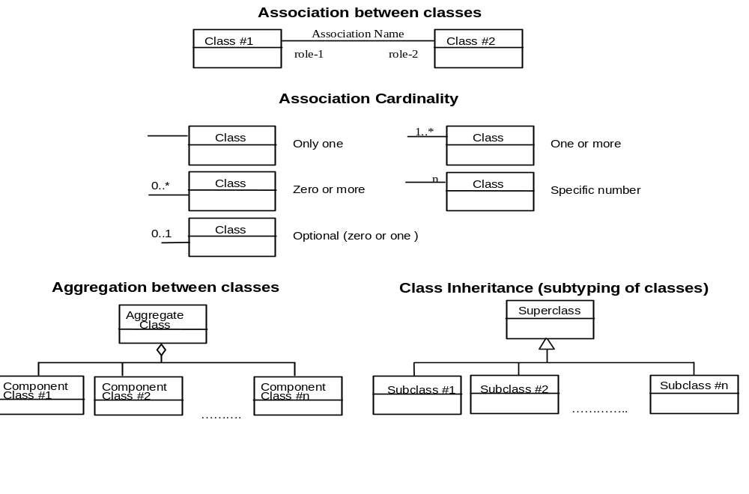
Figure 1 — UML notation
In this document, the following three stereotypes of UML classes are used:
- <<Interface>> A definition of a set of operations that is supported by objects having this interface. An Interface class cannot contain any attributes.
- <<DataType>> A descriptor of a set of values that lack identity (independent existence and the possibility of side effects). A DataType is a class with no operations whose primary purpose is to hold the information.
- <<CodeList>> is a flexible enumeration that uses string values for expressing a list of potential values.
In this document, the following standard data types are used:
- CharacterString – A sequence of characters
- Integer – An integer number
- Double – A double precision floating point number
- Float – A single precision floating point number

Motivation
There is a global push within information communities for the development of consistent information models for the capture of spatial and temporal data and metadata. The current state of data existing in ‘stove pipes’ is seen as inconsistent, inefficient and a major barrier to improving interoperability of information systems.
A worldwide initiative, Global Earth Observation System of Systems, has the goal of developing a system to allow world-wide integration of observation data to improve our understanding of the global environment. Its 10-year plan outlines issues with data availability: “…the current situation with respect to the availability of Earth observations is not optimal. This situation is particularly true with respect to coordination and data sharing among countries, organizations and disciplines, and meeting the needs of sustainable development.” [GEO2005]
Within the US there are programmes and initiatives to promote data sharing and re-use through the use of standards and Web Services for information exchange. For example the Consortium for the Advancement of Hydrologic Sciences Inc. (CUAHSI) has developed a number of schemas and technologies to facilitate improved sharing of hydrological data sets.
Within Australia, the Bureau of Meteorology (the Bureau) is developing an Australian Water Resources Information System (AWRIS), with the goal of obtaining a deeper understanding of the current state of water resources across the country. This is resulting in developments that are addressing data standards within the hydrology community. The Australian government’s water act 2007 [AUSWA2007] empowers the Bureau to collect and set standards for water information across the country.
In Europe, the Water Information System for Europe (WISE) is developing a gateway for water information with the aim of providing data to the public collected by institutions across the member countries. More broadly in Europe, the Infrastructure for Spatial Information in the European Community (INSPIRE) initiative has the directive to develop an EU wide spatial data infrastructure for sharing spatial data sets. The directive states: “The loss of time and resources in searching for existing spatial data or establishing whether they may be used for a particular purpose is a key obstacle to the full exploitation of the data available” [EU2007].
These initiatives are dealing with the large scale complexity of disparate data sets and all are working on improved standards for water information. This type of information covers both spatial and temporal data sets, each of which has its own level of complexity. In order to avoid re-solving well understood issues with handling such data, most initiatives are looking to leverage existing standards and methodologies where possible [EU2007] [GEO2005]. The International Standards Organisation (ISO) and the Open Geospatial Consortium (OGC) are two bodies that define standards directly relevant to the issues being addressed.
The OGC and the World Meteorology Organisation (WMO) have recently formed the Hydrology Domain Working Group (HDWG) [LEM2008] which is a forum for the collaboration and development of standards for hydrological data. This group has members from countries dealing with similar issues of developing and reusing standards.
An international workshop held in Australia on Water Resources Information models in September 2007 [COX2007] indicated some of the benefits of developing shared models were: “…improved efficiency and quality of local information models and systems; wider use and re-use of information; new tool development, and new value from existing information via unexpected uses”. This workshop suggested the development of a harmonised information model and transfer formats for water data.

Structure of this document
Section 6 of this document will give an overview of existing relevant standards; firstly standards associated with methodologies for developing information models and secondly existing standards for hydrological information. Sections 7-10 examine these standards in each of four core areas: results, features and sampling, procedures and observed properties. From this analysis the discussion paper will outline a core set of requirements for an information model for hydrological observations. These are summarised in section 12.
Section 13 and onwards proposes an approach for developing a core conceptual model for hydrological observations. This approach will make use of existing best practice and standards by examining projects that have employed similar techniques. This model should be extensible to suit particular requirements for the exchange of hydrological observations. The potential uses of this model are considered in section 14 and a discussion on the repercussions of adoption is put forward in section 15.

Relevant standards

Standards and best practices for information modelling
In a Model Driven Architecture (MDA) [OMGa] approach, a domain modeller captures a conceptual model of an information system with a formal modelling language such as the Unified Modeling Language (UML) [OMGb]. UML allows construction of an abstract graphical representation of information artefacts and their relationships using diagrammatic elements that have well defined semantics. From this model it is possible to generate specific implementations of the model, such as the eXtensible Markup Language (XML) Schema [W3Ca] or database schema.
Combining MDA with existing standards, the ISO Technical Committee 211 has developed standards and methodologies to support the development of information models for SDIs. The ISO19101 model is the reference model for the 19100 series on the development of geographic information standards; it, along with ISO19109 (rules for application schema), outline a methodology for developing conceptual models and application schema with a goal to improve interoperability. Note that geographic information is defined as “information concerning phenomena implicitly or explicitly associated with a location relative to the Earth” [ISO19101]; hydrological phenomena fit into this category. The INSPIRE project has taken the IS019101 approach in defining a methodology for developing its standards for data exchange.
The methodologies described in ISO19000 define rules for the use of tools such as UML for creating conformant conceptual models that have explicit relationships to other platforms such as XML. This allows construction, sharing and composition of standards in UML, removing the complexity of dealing with XML Schema or other implementations.
The INSPIRE project has developed broad methodologies for the development of common information models to promote data sharing and re-use across the EU:
“…a key step in the data harmonisation process is to achieve interoperability on the conceptual level (semantic interoperability) so that users and implementers of different information systems can understand the semantics of the relevant information provided by the other system(s). “ [INS2007]
Whilst the INSPIRE project is focusing on spatial data sets, the general methodology for harmonisation is relevant to developing information models for observational data sets. The Observations & Measurements (O&M) model from OGC is within scope of INSPIRE and suggests that temporal data will play a role in the specification of INSPIRE’s information models.
Model-driven approaches to information modelling are also being investigated within the Microsoft Active Data Objects (ADO) framework through its Entity Framework [MSEF] concept. This uses a conceptual model to define element structure, relationships and constraints. Using this framework a conceptual model is built using a tool called the Entity Data Model, which is similar to UML. Mappings can be created to underlying storage mechanisms (databases, schema etc.), allowing automatic generation from the conceptual model to a particular storage type. This generation of schema is still being developed. It will allow information to be modelled without artefacts that are specific to the underlying storage technology, creating a cleaner separation of concerns.
There are other model-driven frameworks emerging such as the two open source products, AndroMDA [AND2009] and Hibernate OOMEGA [OOM2009].
A large, actively developed standard that uses a model-driven approach is GeoSciML. The standard is used to describe geologic features with an emphasis on geological information for use in portraying geologic maps. The project has been a driving force in the development of tools to support MDA approaches to information modelling, such as the HollowWorld [HOL2009] and FullMoon [FUL2009] toolsets.

Observations and Measurements (O&M)
The OGC’s Observations and Measurements (O&M) (a UML representation is shown in Figure 2) standard provides a mechanism for describing the components of the observation process. It is a conceptual model that defines an observation as “…an action whose result is an estimate of the value of some property of the feature-of-interest, obtained using a specified procedure.” [COX2007b]
This model provides a separation of the elements involved in observations as well as defining the relationships between them. By separating the core elements of observation descriptions, we have a basis for exchanging, and discussing, observational data sets.
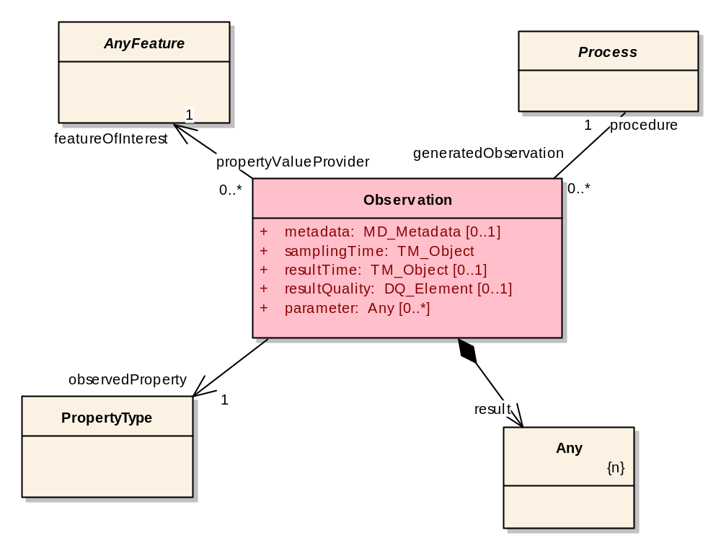
Figure 2 - Observations and Measurements UML model
Part 2 - Sampling Features of O&M [COX2007c] defines a sampling model for capturing cases where the actual target of an observation is not the ultimate feature but a proxy for measuring a property of the feature. It introduces the concept of a sampling feature that is the proxy for the measurement. This sampling feature has a relationship named sampled feature, which is the real world feature being observed.
The O&M model can be used to describe hydrological observations, and the sampling features section helps to describe common observation patterns in the domain. The sampling features concept does not describe ‘domain features’ such as lakes and rivers, but the intermediate process that occurs in observing them. Such intermediate concepts are often call stations but may include profiles or other sampling dimensions.
For example, a river level gauge is actually sampling the height of a river at a particular point (a gauging station); this observation is providing an estimate for the ‘ultimate feature of interest’ which is the actual river height. The sampling point here would be the gauging station.
An example of a hydrological observation using this model is shown using UML in Figure 3. This diagram shows three river flow observations, each at a different station, ultimately measuring two rivers. These use a calculation to estimate the river flow. There is another observation provided by a sensor measuring the temperature of the river. All have time series as their results, described here using discrete coverages [COX2008].
Figure 3 - Example sampling feature relationship
Sampling feature collections are also defined, allowing for logical groupings of sampling points. Such groupings of sampling points are common within hydrology, but are often given different names. Sometimes a ‘site’ is a collection of ‘stations’; another view of a ‘site’ is a collection of measuring ‘locations’. The conceptual grouping is generally similar but naming convention differs widely. These groupings may also have relationships to larger, spatial groupings such as catchments, hydrologic units etc. Defining approaches to correctly capturing such relationships within hydrological data sets is an area requiring further work.
The O&M concepts can easily be adapted to describe hydrological observations. For example, observing salinity in a lake will produce salinity in mg/L (result) which is an estimate of the salinity (observed property) in Eagle Lake (feature of interest) using salinity meter 00435 (procedure) [WAL2009].
O&M can be compared to the model at the core of the Observation Data Model (ODM) [TAR2008]. ODM similarly defines a separation of the core elements involved in the observations, with a specific focus on hydrological observations, shown in Figure 4.
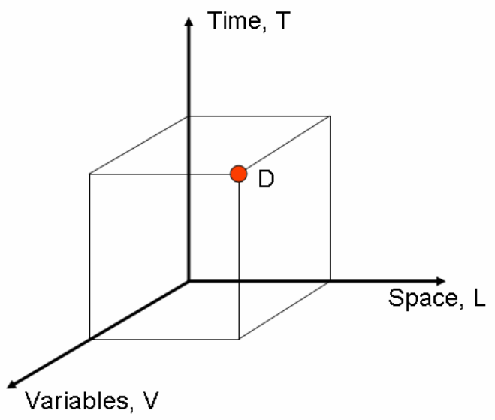
Figure 4 - The ODM model for hydrological observations
The ODM takes a more data centric viewpoint when compared to the broader observation view that O&M takes. Elements such as the description of the observation procedure are built upon the ODM model whereby O&M contains it as a core feature of its model. The differences have implications for how data is interpreted by end users and systems.

Standards for hydrological information
Existing standards for hydrology data all have a different focus, driven by a particular need for standards in a particular context. This paper examines significant standards of relevance with the aim of capturing core requirements for hydrological observational data. A broader survey of existing standards has been performed in [LEF2008].
Below is a brief summary of existing standards of interest to this paper and how they may be relevant to the harmonisation process.

ArcHydro
ArcHydro [MAI2002] is a data model (Figure 5) for Water Resources and has focused on surface water with input from key state, national, and international contributors. It is implemented as an ERSI geodatabase schema. It is widely utilized within the hydrologic community. It is simple and designed to be extended by the users of the data model. A toolset based on the ArcHydro data model is available for ArcGIS desktop applications. The data model presented for time series information only covers the basic information that is needed for analysis.
The ArcHydro data model is undergoing revision to better incorporate “series” into the model. Four additional conceptual information sets are being added: time series (in the original), feature series, attribute series, and raster series.
Figure 5. ArcHydro 2 conceptual model

WaterML1.0
The Consortium for the Advancement of Hydrological Sciences Inc (CUAHSI) has developed the WaterML standard, now in version 1.1, which allows for the encoding of hydrological observations via their WaterOneFlow web services. The initial driver for the development of WaterML1.0 was “… to encode the semantics of hydrologic observation discovery and retrieval and implement water data services in a way that is both generic and unambiguous across different data providers, thus creating the least barriers for adoption by the hydrologic research community.”
WaterML1.0 is implemented as an XML schema and does not currently make use of OGC or other existing standards. The semantics utilized are from the CUAHSI Observations Data Model [TAR2008]. One of the future goals of developing a harmonised observation model is to allow WaterML1.0 to converge with existing standards.

Australian Water Data Transfer Format
The Water Data Transfer Format (WDTF) is currently being developed by the Bureau of Meteorology and CSIRIO as part of the water information research and development alliance. It forms part of the Bureau of Meteorology’s AWRIS software. The scope of the format is to allow for the encoding of information that must be supplied to the Bureau from state water agencies or organisations that take hydrological measurements. The standard not only addressed observational data, but also descriptions of features (storages, water courses), transactional information (for synchronising with a data warehouse), conversions (e.g. a rating table conversion) and water quality samples. Version 1.0 is planned to include groundwater observations.
This format makes use of the O&M specification, through a simple features GML profile [ISO19125-1] that restricts certain aspects such as the available geometries and complexity of types. It also uses GML for spatial types.

United States Environmental Protection Agency (EPA) – Water Quality Exchange (WQX)
WQX is focused on the exchange of water quality information. It is based on the Environmental Sampling, Analysis, and Results (ESAR) data standard [ESA2006] which was developed to facilitate the sharing of laboratory result data. EPA also provides a validation service that allows for documents to be validated against the schema definitions.
The WQX standards are developed by the Environmental Data Standards Council (The Council) which is comprised of ten members from Tribes, States and US EPA. The Council’s primary function is to develop and adopt Data Standards - documented agreements on terms, definitions, and formats - when there is an environmental business reason. Version 2.0 of the standard is used by the US EPA, and the US Geological Survey to deliver water quality information over web services and REST interfaces.

XHydro
The goal of developing XHydro was to allow for the transmission of water level data through web services for the German Federal Waterways and Shipping Administration. It goes slightly further in that it specifies an XML schema for the encoding of generic time series, with an extension that is tailored specifically for water level and discharge data. The time series model is the key point of interest.
The documentation of XHydro also refers to the creation of a generic conceptual model from which other schemas can be created to address particular needs; the core premise of the proposed methodology. The modularity of the model also assists when assessing the standard from a harmonisation point of view.

UK Environmental Agency time series data exchange
The UK Environmental Agency developed the EA Time Series Data Exchange Format (UK-EA-TS) to address the need “…to exchange a variety of sets of time-series data with both internal and external stakeholders”. The primary type of time series were hydrological data types such as lake and reservoir levels, river levels and flows, rainfall etc.
The standard addresses:
- Rainfall amounts
- River levels and flows
- Tide levels
- Lake and reservoir levels
- Groundwater levels
- Areal modelled evaporation, soil moisture deficits, etc.
- Continuously monitored water quality parameters: e.g. dissolved oxygen and ammonia quantities
- Climate station data: e.g. temperatures, wind speed and radiation

Other standards of relevance
There are a number of existing standards that are of interest for their approach on either using other standards or solving similar harmonisation issues. The aspect of each model that is relevant is outlined.

SWE Common
Sensor Web Enablement (SWE) is a group within the OGC that develops standards associated with encoding and transmitting sensor data as well as other functions such as providing sensor descriptions, control, alerting and processing. There is a common specification within SWE, known as SWE Common, which defines re-usable data structures and types such as data records, arrays and techniques for defining phenomena and more. O&M makes use of parts of this specification as to other standards within the SWE group.

Climate Science Modelling Language (CSML)
CSML makes use of the ISO coverage model extensively for its modelling of the result sets for climate science. These are often gridded data sets but also cover time series data. CSML also leverages existing OGC standards such as GML and SWE. They also employ the MDA approach to developing information models.

Integrated Ocean Observing System (IOOS)
IOOS through the data integration framework (DIF) have made extensive use of GML, O&M and SWE common for defining standards for ocean observation data. The project is performing an initial phase of the project to assess the use of information standards and services for handling this style of information. They have profiled O&M to be more specific to the needs of the ocean observing community.

Ground Water Mark-up Language (GWML)
GWML makes use of GeoSciML to define a model for capturing information on groundwater, with a focus on the definitions of features. It has used similar model-driven approaches to developing the model and as such can be used as a reference for methodology.

The Global Runoff Data Centre (GRDC) Hydrologic Datasets - metadata profile
The GRDC operates under the auspices of the World Meteorological Organisation (WMO) and have recently developed a metadata profile for hydrological data sets. They have used a model-driven approach to the development of this standard, with close alignment to the ISO19115 metadata specification.
The profile also makes use of the O&M model to define observations and their associated properties. This specification is of interest for its use of standards as well as its definitions of hydrographical features.

The Integrated Ocean Observing System (IOOS)
IOOS is “a federal, regional, and private-sector partnership working to enhance our ability to collect, deliver, and use ocean information.” [IOS2009]. The Data Integration Framework initiative within IOSS is focussed on improving management and delivery of ocean observation data. The project is using a number of open standards for information structure and web service delivery. They have made use of the O&M model to develop an information model suitable for ocean observing systems.

Harmonising core concepts

Defining existing concepts
In order to harmonise on a model for hydrological observations, this paper will analyse the components of existing standards and define a core set of properties that must be represented in a common model.
The focus of this analysis is on time series data but other areas such as descriptions of features, processes and other areas will be touched on. Hydrological data sets such as rating curve descriptions, gauging measurements, and water quality will be addressed in future work.
The following table rates existing standards along axis of interest for harmonisation. The scores are not just based on ability but on relevance within each area to the goal of a conceptual model for hydrological observational data. This is not a general qualitative rating for each standard.
The + ratings give a relevance score for each standard against each aspect of the O&M conceptual model. This allows us to focus on particular aspects of each standard to identify concepts for harmonisation. For example, GWML is a standards-driven model with some areas of interest in its definition of features and procedures, but does not have relevance in terms of encoding time series.
Each aspect of the table is described as follows:
Results: the generated values of an observation (e.g. time series) and the metadata describing the result structure. (ODM: DataValues)
Features: descriptions of the real world objects involved in the observation (e.g. gauging stations, rivers, lakes etc.)
Procedures: the process involved in making an observation (e.g., turbidity sensor, laboratory procedure etc.)
Properties: the phenomena that are the subject of observation (e.g. water level, rainfall etc.)

 | Use of standards |  | Features | Procedures | Properties | Results
Australian Water Data Transfer Format | ++ |  | + | + | + | +++
WaterML1.0 | - |  | + | + | + | +++
XHydro | + |  | - | - | + | ++
UK Environmental Agency time series data exchange | - |  | - | - | - | ++
Climate Science Modelling Language | ++ |  | + | - | + | ++
Ground Water Mark-up Language (GWML) | ++ |  | + | + | - | -
INSPIRE Hydrography model | +++ |  | +++ | -
GRDC Hydrologic Datasets - metadata | ++ |  | +++ | ++ | + | +
Integrated Ocean Observing System (IOOS) | ++ |  | + | ++ | + | +
Marine Metadata Interoperability | ++ |  | - | - | +++ | -
Table 1 - Relevance of standards to the harmonisation process
- = Standard does not contain a relevant approach to the concept
+ = Standard at least contains a reference to the concept
++ = Standard defines the concept partially
+++ = Standard provides mechanisms for full description of the concept
Table 1 indicates that most identified standards can contribute to various aspects of a common model. In this document the focus will be on WaterML and WDTF for results, with EK-EA-TS and XHydro providing extra inputs. Further revisions of this document may incorporate contributions from other standards. It is useful to have a number of standards when looking at the result model to see the variety of interpretations of time series that exist.
For feature definitions, there are broader standards available such as the INSPIRE and GRDC models with their definitions of hydrographical features. Most models make reference to external procedure definitions through identifiers, but a few provide partial descriptions of the underlying process types; such as the GRDC profile and the IOOS Data Integration Framework.
The next section will address each of the areas of concern in turn, taking into account the appropriate standards for analysis of concepts and approach. The initial focus of harmonisation has been the definition of results.

Results
Hydrological observations primarily produce a time series of values that represent an estimated value for a given phenomenon at a particular time (or across a time period). The focus of this section is to investigate a consistent model for representing hydrological time series. Other observation types such as geometric observations (river cross sections etc.) or rating curve descriptions are out of scope for this paper, but future work on a consistent model for such concepts is required.

Time series
Time series values can have a different relationship to the temporal spacing in which they occur. The differences come about either through different measuring processes (e.g. a sensor) or the result of post-processing a time series (e.g. result of an aggregation calculation). Capturing the relationship between points is important when interpreting the values for analysis or further processing.
These time series type are particularly important when one is to perform interpolation between time series points in order to estimate the value of a phenomenon where no measurement occurs. A re-usable information model within hydrology must make explicit the type of data that is being represented; it must also be sufficiently precise to allow other models to map their structure onto this model.

Existing time series models
The concepts that are captured in the existing standards provide a baseline set of requirements that need to be investigated for a time series model.
The following examples show the time series encoding section of existing standards. The examples shown are not encoding the same data; they are provided from the specifications and only contain time series descriptions. Full examples are listed in Annex A.

WDTF
<wdtf:result>
<wdtf:TimeSeries>
<wdtf:defaultInterpolationType>InstVal</wdtf:defaultInterpolationType>
<wdtf:defaultUnitsOfMeasure>m</wdtf:defaultUnitsOfMeasure>
<wdtf:defaultQuality>quality-A</wdtf:defaultQuality>
<wdtf:timeValuePair
time="2001-07-31T20:12:01+10:00">1.25</wdtf:timeValuePair>
<!-- This time point is missing -->
<wdtf:timeValuePair
time="2001-08-01T20:15:01+10:00"
comment="text"
interpolationType="InstVal"
xsi:nil="true"/>
<wdtf:timeValuePair
time="2001-08-02T20:10:01+10:00"
comment="Sample comment"
quality="quality-B">1.28</wdtf:timeValuePair>
</wdtf:TimeSeries>
</wdtf:result>

WaterML1.1
<values unitsAbbreviation="mg/L" unitsCode="199" unitsType="Angle" count="5">
<value censorCode="nc" dateTime="2007-11-07T13:00:00" qualityControlLevel="Derived products" methodID="25" sourceID="3" sampleID="26">10.5</value>
<value censorCode="nc" dateTime="2007-11-13T12:30:00" qualityControlLevel="Derived products" methodID="25" sourceID="3" sampleID="32">2.5</value>
<value censorCode="nc" dateTime="2007-11-21T14:00:00" qualityControlLevel="Derived products" methodID="25" sourceID="3" sampleID="38">7.2</value>
<value censorCode="nc" dateTime="2007-12-05T11:00:00" qualityControlLevel="Derived products" methodID="25" sourceID="3" sampleID="83">2.5</value>
<value censorCode="nc" dateTime="2007-12-20T14:05:00" qualityControlLevel="Derived products" methodID="25" sourceID="3" sampleID="171">2.5</value>
<method methodID="25">
<MethodDescription>Water chemistry grab sample collected by technicians in the field.</MethodDescription>
</method>
<source sourceID="3">
<Organization>Utah State University Utah Water Research Laboratory</Organization>
<SourceDescription>Water chemistry monitoring data collected by Utah State University as part of a National Science Foundation funded test bed project.</SourceDescription>
<ContactInformation>
<ContactName>Amber Spackman</ContactName>
<TypeOfContact>main</TypeOfContact>
<Phone>1-435-797-0045</Phone>
<Email>amber.s@aggiemail.usu.edu</Email>
<Address xsi:type="xsd:string">8200 Old Main Hill
,Logan, Utah 84322-8200</Address>
</ContactInformation>
<SourceLink>http://water.usu.edu/littlebearriver</SourceLink>
</source>
</values>

UK-EA-TS
<!-- Four days of daily mean flows -->
<SetofValues parameter="Flow" dataType="Mean" period="Day" characteristic="Derived"
units="m3/s" startDate="2003-04-20" endDate="2003-04-23" dayOrigin="09:00:00">
<Value date="2003-04-20" flag1="1" flag2="1" percentFlag2="100">15.63</Value>
<Value date="2003-04-21" flag1="2" flag2="1" percentFlag2="92.5">16.21</Value>
<Value date="2003-04-22" flag1="1" flag2="1" percentFlag2="87" flag3="2"
percentFlag3="5.5">16</Value>
<Value date="2003-04-23" flag1="2" flag2="1" percentFlag2="85.2" flag3="2"
percentFlag3="14.8">17.36</Value>
<Comment startDate="2003-04-22">This daily mean flow was derived from an incomplete set
of good and suspect data but has been validated and found to be of good overall
quality</Comment>
<Comment startDate="2003-04-21" endDate="2003-04-23">This demonstrates that you can have
nested comments</Comment>
</SetofValues>

XHydro
* The element names used in the schema are abbreviations for the actual concept names.
<?xml version="1.0" encoding="UTF-8"?>
<tsel xmlns="http://xhydro.org/minimal/2007/06"
xmlns:d="http://www.disy.net/device"
xmlns:xsi="http://www.w3.org/2001/XMLSchema-instance"
xsi:schemaLocation="http://xhydro.org/minimal/2007/06 http://www.xhydro.org/download/schemas/v200706/schemas/XHydro.xsd">
<ext />
<tse>
<!-- snip -->
<tsmd>
<tsd>
<dn>ddts</dn>
<dd>A dummy dis device to measure time.</dd>
</tsd>
<tsq>
<tsmi>1.5E-6</tsmi>
<tsqr codeList="disy1" codeListAgency="disy"
codeListVersion="1.0">
ownCode
</tsqr>
</tsq>
</tsmd>
<d>
<tde>
<!-- No timestamp is given because isochron -->
<vls>
<v>
<vq>
<vmi>6E-4</vmi>
<xvqr>affected</xvqr>
</vq>
<vl>
<pt>
<xrs>32632</xrs>
<px>5.0</px>
<py>6.0</py>
</pt>
</vl>
<vf>4.5</vf>
</v>
<v>
<vf>4.6</vf>
</v>
<v>
<vq>
<xvqr>missing</xvqr>
</vq>
<va xsi:nil="true" />
</v>
</vls>
</tde>
</d>
</tse>
</tsel>

The following table provides a summary of the concepts that each format is capturing with a description of where the property has been modelled.

Table 2 - Comparison of time series meta data elements
Name: element name used.
Defined: describes where in schema the property is defined.
Type: typing mechanism used.
Concept | WDTF | WaterML1.0 | XHydro | EA UK TS
Qualifiers | Name: valueQualifier.  Defined: Per measurement (not time series value).  Type: Unconstrained string. | Name: qualifiers  Defined: Per point, with ability to define qualifiers as series metadata.  Type: xsi:Token | Name: dataValueQualityRemark (grouped quality and qualifiers)  Defined: Per point.  Type: Locally defined code list element OR externally defined code list element OR free text. | Name: qualifier  Defined: Per parameter (series, set of values).  Type: Locally defined code lists element only.
Quality | Name: quality  Defined: Per point.  Type: Locally defined code list. | Name: quality  Defined: Per point.  Type: Locally defined code list. | Name: dataValueQuality  Defined: Per point.  Type: Locally defined code list element OR externally defined code list element OR free text. | Name: flag  Defined: Per point. Multiple quality levels specified.  Type: Locally defined code lists. Provides 10 levels of quality flags.
Comments | Name: comment  Defined: Per point.  Type: Unconstrained string. | N/A | N/A | Name: comment  Defined: Series level but allows a period of record to be specified, allowing multiple comments to be encoded.  Type: Unconstrained string.
Interpolation type | Name: interpolationType.  Defined: Default per series or per point.  Type: Locally defined code list. | Name: dataType.  Defined: Per variable (set across a time series).  Type: Locally defined code list. | Name: dataType.  Defined: Per time series.  Type: Locally defined code list. | Name: dataType  Defined: Per time series.  Type: Locally defined code list.
Processing | Name: processingType  Defined: Default per series or per point.  Type: Locally defined code list. | Name: valueType  Defined: Per variable.  Type: Locally defined code list. | N/A | Name: characteristic  Defined: Per time series.  Type: Locally defined code list.
Accuracy | N/A | Name: accuracyStdDev  Definition: Per value.  Type: double | Name:dataValueMeasurementInaccuracy  Defined: Per value.  Type: float | N/A
Units | Name: uom  Defined: Per point.  Type: Locally defined code list. | Name: unit  Defined: Per variable.  Type: Complex type containing unit code (from code list), description, abbreviation and type (mass, length, velocity etc.). | Name: unit  Defined: Per parameter.  Type: Locally defined code list OR externally defined code list. | Name: units  Defined: Per time series.  Type: Locally defined code list.
Offsets | N/A | Name: offset  Defined: per value  Type: Complex type allowing offset value, type, description and units to be defined. | N/A | N/A
Null Values | Uses xsi:nillable. | Defines a NoDataValue per document to describel a value to indicate null values. | Uses xsi:nillable. | NaN, INF and –INF through the use of the W3C float type.

Locally defined code list: The technique used by the schema is an XML Schema enumeration simple type. This is can be checked against using schema validation.
Unconstrained string: Free text. No validation is implied.

Per value vs. per time series properties
One of the common structural differences of the compared properties for time series is if they are defined per value, or if the property holds across a full time series. WDTF has used a default property pattern where one is able to specify for the whole series the default value, or define individually for each value. The need to define properties per time series point arises from characteristic changes within the series. WDTF employs this for interpolation type, processing code, quality and unit of measure. This model is a useful trade off between flexibility and verbosity of the encoding.
The ways in which per value vs. per series properties are structured have implications for the discovery process. These will need to be investigated further.

Interpolation Types
One of the core aspects of time series is the relationship between the value and its associated time instant (or period). This relationship is determined by the procedure that was used to make the estimate that the value represents. In most data models this is referred to as the data type or interpolation type.
Whilst it is possible to provide a placeholder to allow users to specify the interpolation or data type of a time series within their given context (through code lists), it is important to understand the way existing standards deal with this concept, as it is pivotal for correct interpretation of a time series, consistent post-processing and summary statistics .

Table 2 – Comparison of interpolation/data types
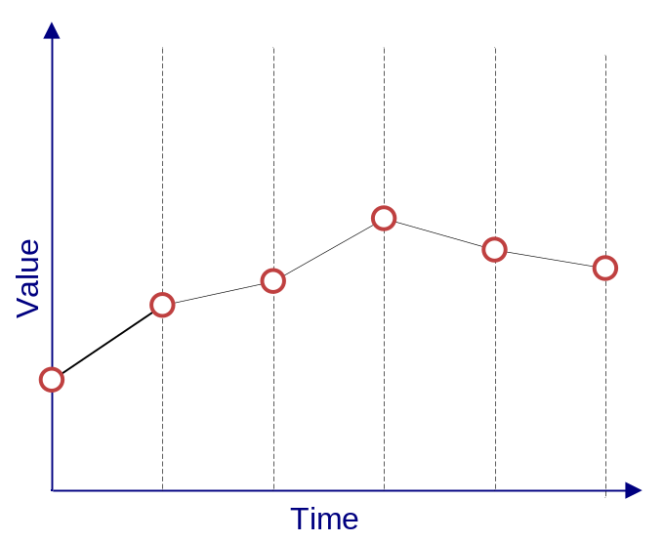 | Continuous/Instantaneous  WDTF: InstVal  WaterML1.0: Continuous  XHydro: contData  UK-EA-TS: Instantaneous  A continuous time series indicates the observation result is the value of a property at the indicated instant in time. The points are essentially connected and interpolation may occur between points in order to estimate the value of the property between points. The appropriate time spacing between successive points to mimimise interpolation errors is related to rate of change (wrt time) of the property.
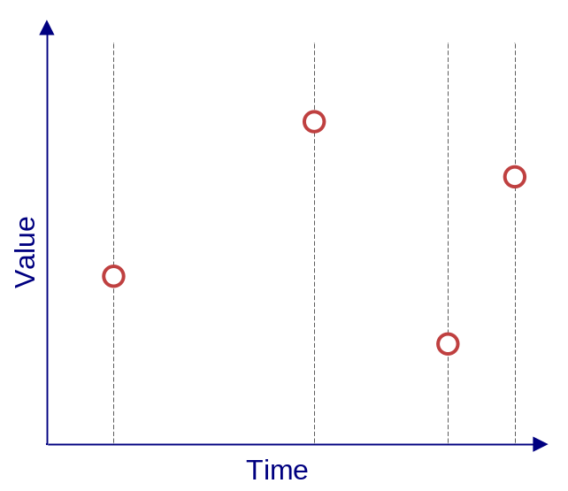 | Discontinuous  WDTF: NoJoin  WaterML1.0: Sporadic  XHydro: N/A  UK-EA-TS: Instantaneous  The sampling of the property occurs such that it is not possible to regard the series as continuous. The time between samples is too large to classify the measurements as continuous.  Example: Infrequent water sample measuring pH.
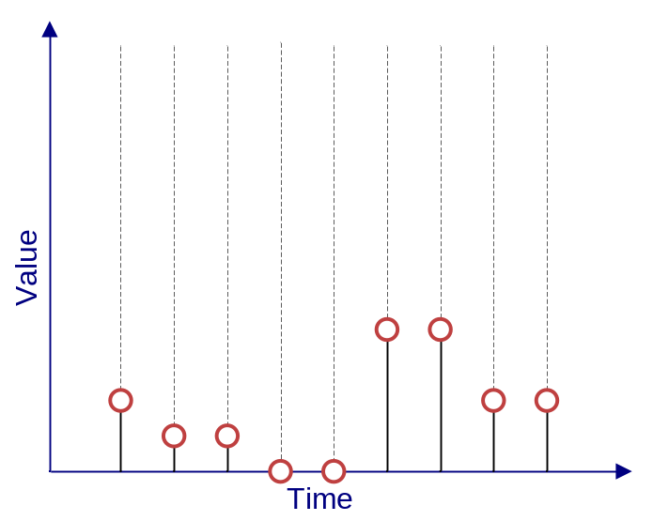 | Instantaneous total  WDTF: InstTot  WaterML1.0: Incremental  XHydro: contTotal  UK-EA-TS: Event  Value represents a total attributed to a specific time instant. This is normally generated from an event based measuring device such as a tipping bucket rain gauge.  Example: An individual tip of a tipping bucket rain gauge.
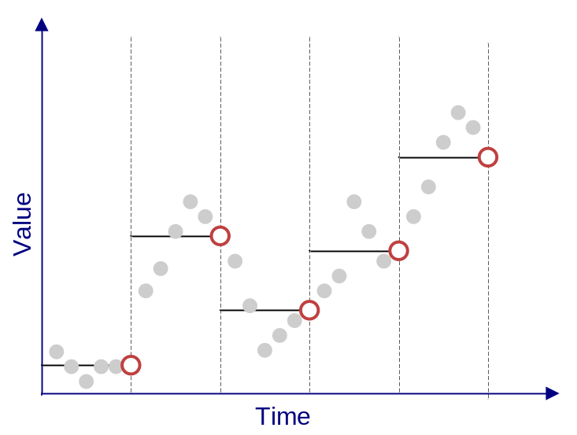 | Average in preceding interval  WDTF: PrecVal  WaterML1.0: Average  XHydro: aggMean  UK-EA-TS: Mean  Value represents the average value over the preceding interval.  Example: Daily mean discharge.
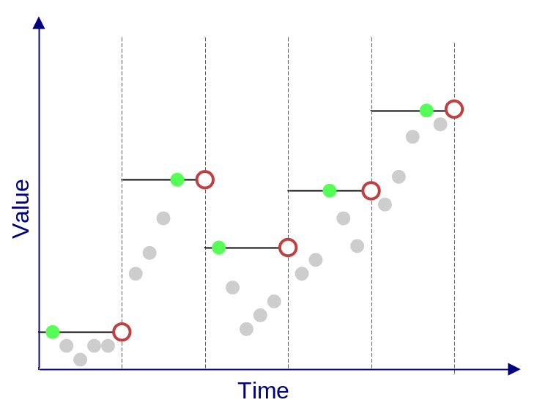 | Maximum in preceding interval  WDTF: PrecMax  WaterML1.0: N/A (diff interval)  XHydro: aggMax  UK-EA-TS: Maximum  Value represents the maximum value that was measured during the preceding time interval.  Example: Monthly maximum discharge
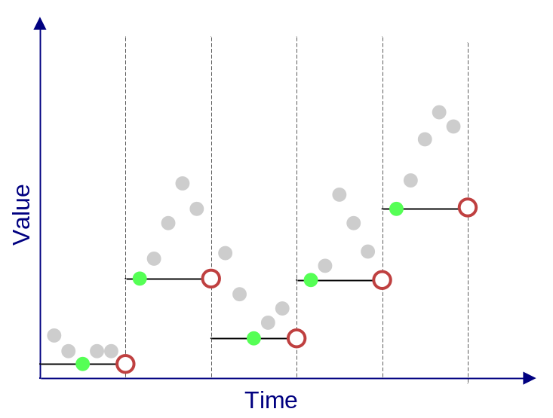 | Minimum in preceding interval  WDTF: PrecMin  WaterML1.0: N/A (diff interval)  XHydro: aggMin  UK-EA-TS: Minimum  Value represents the minimum value that was measured during the preceding time interval.  Example: Daily minimum temperature.

Preceding total
WDTF: PrecTot
WaterML1.0: N/A (diff interval)
XHydro: aggTotal
UK-EA-TS: Total
Value represents the total of measurements taken within the previous time interval.
Example: Daily pan evaporation
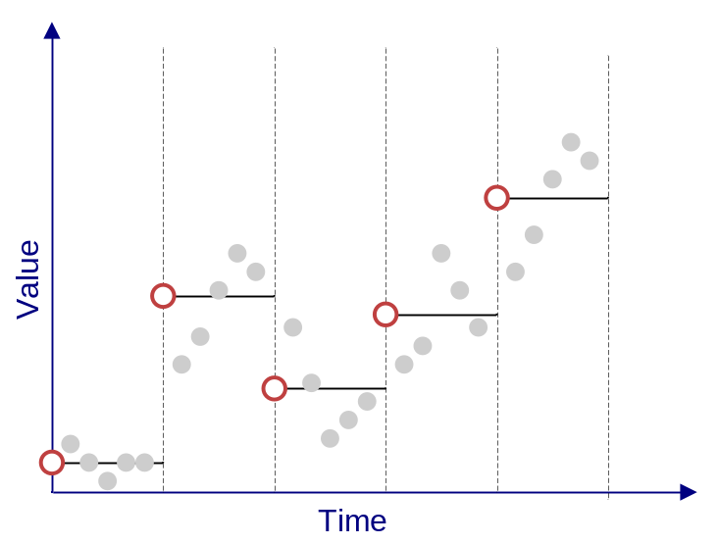 | Average in succeeding interval  WDTF: SucVal  WaterML1.0: N/A  XHydro: aggMean  UK-EA-TS: N/A  Value represents the average value over the following interval.  Example: Daily mean discharge encoded as value representing beginning of interval (ODM style).
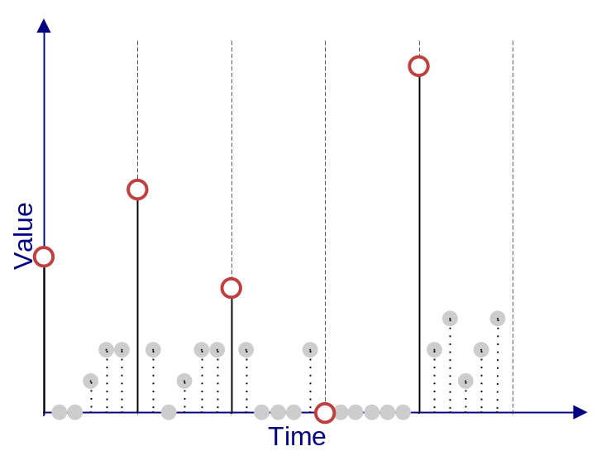 | Succeeding total  WDTF: SucTot  WaterML1.0: N/A  XHydro: aggTotal  UK-EA-TS: N/A  Value represents the total of measurements taken within the following time interval.  Example: Total daily rainfall from 9am to 9am.
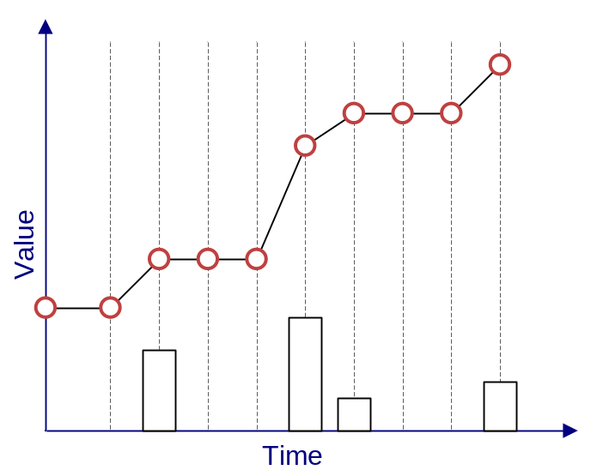 | Cumulative  WDTF: accumulated (metadata)  WaterML1.0: Cumulative  XHydro: aggTotal  UK-EA-TS: Cumulative Total  Value represents an accumulated total since a reset time.  Example: Total rainfall across a period, total river discharge etc.
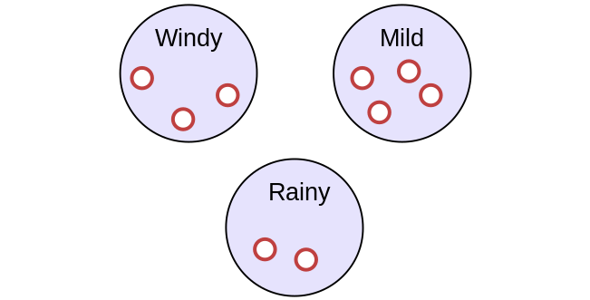 | Categorical  WDTF: Different result type  WaterML1.0: Categorical  XHydro: Different result type  UK-EA-TS: N/A  A categorical measurement represents named ‘bins’ to which values can be assigned. Example: human weather observations: ‘mild’, ‘windy’, ‘rainy’ etc.

Handling cumulative data
Data of type instantaneous total is often accumulated across a period to show the running total since accumulation commenced. This is often the way in which rainfall data is reported (e.g. total rainfall from 9am to 9am – 24 hours of accumulated instantaneous total data). Existing models handle this concept slightly differently.
WaterML1.0 and UK-EA-TS captures accumulation as a separate data type where as WDTF designates at a time series level whether the series is accumulated. UK-EA-TS and WDTF store the accumulation begin and end points to allow for correct de-accumulation to performed.

Table 3 - Mapping interpolation/data types between models
WDTF | XHydro | UK-EA-TS | WaterML1.0 | Comments
InstVal | contData | Instantaneous | Continuous
InstTot | contTotal | Event | Constant Over Interval
PrecVal |  | Mean | N/A | See note on reporting intervals
PrecMax | aggMax | Maximum | N/A | See note on reporting intervals
PrecMin | aggMin | Minimum | N/A | See note on reporting intervals
PrecTot | aggTotal | Total | Incremental*
PrecDir | N/A | N/A | N/A
SuccVal | N/A | N/A | Average
SuccTot | N/A | N/A | Incremental
NoJoin | N/A | N/A | Sporadic
N/A | N/A | N/A | Mode
WDTF breaks into separate observation type ComplexObservation which has a possible result type of String which would represent the category. | N/A | N/A | Categorical
N/A | aggStdDev | N/A | StandardDeviation
N/A | N/A | N/A | Unknown
N/A | N/A | N/A | Minimum | See note on reporting intervals
N/A | N/A | N/A | Maximum | See note on reporting intervals
N/A | N/A | N/A | Best Easy Systematic Estimator
Captured in the time series meta data as Boolean. | N/A | Cumulative Total | Cumulative
N/A | aggMedian | N/A | Median
N/A | N/A | N/A | Variance
N/A | aggMovingMean | N/A | N/A

Note on reporting intervals
When values are being attributed to a certain time interval, it must be made explicit which part of the interval the value holds over. It may be the value represents the beginning of the observed value for the interval or the end of the interval.
WDTF makes this explicit in the data type by specifying whether the value holds over the preceding interval or the succeeding interval.
CUAHSI ODM defines the value at a particular time represents the beginning of the interval. This is represented as succeeding interval in WDTF. The justification from ODM is as follows [TAR2008]:
“Data types 4 to 8 above apply to data values that occur over an interval of time. The date and time reported and entered in to the ODM database associated with each interval data value is the beginning time of the observation interval. This convention was adopted to be consistent with the way dates and times are represented in most common database management systems. It should be noted that using the beginning of the interval is not consistent with the time a data logger would log an observation value. Care should be exercised in adding data to the ODM to ensure that the beginning of interval convention is followed.”
XHydro separates this definition into a time stamp qualifier that specifies whether the time stamp represents the start, middle or end of the interval.
As stated in the ODM specification, loggers generally report the value at the end of the period of measurement but it should be possible to accommodate each type.

Timing metadata
Existing standards define a number of timing metadata elements that relate to various temporal properties of time series. It is important to clarify some different concepts in terms of hydrological time series. The names given here are for descriptive purpose only.
- Reporting frequency: The time sampling regime of the observation. For a sensor, this would be the frequency of sensor measurements (e.g. 15 minutely); for manual observations this would be how often the observation is recorded, for example daily temperature checks. Termed spacing in the ODM specification [TAR2008].
- Download/update frequency: Describes how often a data set is unloaded from a logger or other recording device. This may not be captured and is often not relevant to exchange formats, but is important for understanding update cycles.
- Regularity: This describes whether the time distance between points is equidistant. It is often used for performance and compression techniques in systems storing or transmitting data. This can be determined by examining the data set.
- Spacing (waterml1.0): The interval that the sample is measured. For instantaneous, the value is zero. For daily observations, the sampling interval would be 1 day. This is needed because there may be daily datasets which are averaged over a 5 or 7 day period.

In the CUAHSI ODM specification, the idea of support scale is introduced, which contains three components as identified from Blöschl [BLO1995] [BLO1996]. These are extent, spacing and support.
- Extent is the temporal extent over which the values occur (i.e. start and finish times of the time series).
- Spacing relates the distance in time between each point. This is essentially a descriptive component as it may be derived by looking at the values. However this information may be useful when discovering data sets to get an idea of the regularity of the measurements. Note that this may actually be different than the sampling frequency that is described in a description of the sensor or procedure making the measurement.
- Support relates to the time distance between points (as described above).
A harmonised model of the above concepts would allow for clarification of the concepts across standards.

Null Points
It is often the case in hydrological time series that a point will exist but has been marked as a null point. There are a number of reasons that a data point may be flagged as null or missing and sometimes the semantics of this indication is only known to a particular system (e.g. a point may be indicating that between this point and the next null point no interpolation should occur).
Often systems include point comments to indicate the nature of the null point. The system may flag the values as null due to some particular processing that has occurred (e.g. a phenomenon has exceeded allowable limit). Null points may also carry particular semantics within a system, such as being an ‘anchor’ point for the calculation of total values. This point would indicate that it is the first point where the accumulation period has begun.
WDTF allows null values to be expressed using the xsi:Nil attribute (through defining the element as nillable). XHydro also takes this approach.
WaterML1.0 uses the concept named NoDataValue in order to identify a value that will represent null points in the context of a document. This is driven by an often used technique within agencies to use special values to represent null values. Using this technique allows for the particular usage information to be conveyed, but if no technique exists then an arbitrary number must be assigned as a stand-in (typically at either extreme of the supported numeric scale).
In future definitions of null values it would be useful to include a property outlining the reason for a null value. This is something GML captures through its definition of a Nil Reason Type which elaborates on why the value has been omitted.

Values
For hydrological observation results the values for each time series point are generally a measurement that indicates an estimate of the observed phenomenon. This is largely the case across the four core hydrological standards under review with the addition of categorical values that are supported in WDTF, WaterML1.1 and XHydro. XHydro adds the ability to embed binary content such as images through the use of MIME types.

Accuracy
WaterML1.0 allows for the specification of accuracy per time series value. This is captured as a double value indicating the standard deviation of the measurement.
XHydro also allows for the specification of accuracy through its data quality definition. It is represented as a decimal value.
SWE common provides a mechanism for specifying the qualitative values for each measurement. One of these may be a specification of the accuracy of a value.
This gives us the ability to encode “values of precision, accuracy, tolerance, and confidence level.” [BOT2007]
The example below shows two ways in which this approach may be used.

<swe:quality>
<swe:QuantityRange definition=" urn:ogc:def:property:OGC:tolerance2std">
<swe:value> -0.02 0.02 </value>
</swe:QuantityRange>
</swe:quality>

<swe:quality>
<swe:QuantityRange definition= "urn:ogc:def:property:OGC:absoluteAccuracy">
<swe:uom xlink:href="urn:ogc:unit:percent"/>
<swe:value>-0.5 0.5</swe:value>
</swe:QuantityRange>
</swe:quality>

This approach is flexible in that allows users to specify the particular qualitative properties that may be of interest, but this implies there should be a set of well know definitions of accuracy measures that may be used in order for people to interpret the meaning correctly.

Data Quality
Data quality is obviously a commonly represented property. The use of code lists here to constrain possible types is common across the standards, with some providing extra metadata along side a code. Harmonising on quality code definitions is something that will not be attempted in defining a core model; arguments over common models for data quality have raged long in many data communities. The concept will exist in the model, but will be left for organisations to specify for their context. A comparison of the available types is supplied in Appendix A.

Comments
Per point comments are common occurrences within hydrological time series, describing notes from the field or particular information regarding corrections, shifts or editing that may have occurred to the data. As shown in Table 2, WDTF and UK-EA-TS have the ability to capture time series point comments.

Features and sampling features
As described in section 2.1, O&M breaks features into two categories:
- Sampled features: natural, real world features (rivers, storages, dams etc.)
- Sampling features: features involved in the sampling process (gauging stations, bottles, specimens etc.)
Most hydrological data is linked directly to the station where observations are made. The site name will sometimes contain the name of the river being measured, but the connection between the station and the actual river is sometimes implicit in the data (through its coordinates, identifier system etc.) or in an internal system the data is stored in.
For observational data to be incorporated into broader SDIs, it is important to improve definitions of links to actual features that are being measured. This is also important for hydrological modelling, where river networks and flow processes are key in model development.
WDTF has adapted O&M to fit the structure in use by the Bureau where by a site may contain many sensors, all measuring at different locations. This hierarchy is achieved through the use of the SamplingPoint and SamplingGroup concepts. Each sampling group is defined with its properties (name, location, time zone etc.) and each sampling point is associated with this group. This allows for flexible spatial groupings to occur.
WaterML1.1 links observation data to individual sites which represent the location of the measurement being captured. Groupings of sites are achieved through the concept of a network which is defined as “a collection of sites where a particular set of variables is measured” [VAL2009b]. This also allows for similar flexible spatial groupings to occur.
Further work is required on defining features specific to the hydrology domain. There are a number of existing standards that may be utilised here, currently the most relevant are:
- INSPIRE data specification for hydrography [INS2008]
- GRDC metadata profile for hydrologic datasets [DOR2009]
- Australian Hydrologic Geofabric [BOM2008]
- ArcHydro data model [MAI2002]
By making use of similar model-driven and standards-based approaches of these projects, the ability to create connections between observational data sets and the spatial domain which they reference becomes easier.
The GRDC metadata profile describes hydrographic features and their relationships. For example, Figure 6 shows the relationship between basins, catchments and rivers, lagoons, reservoirs etc.

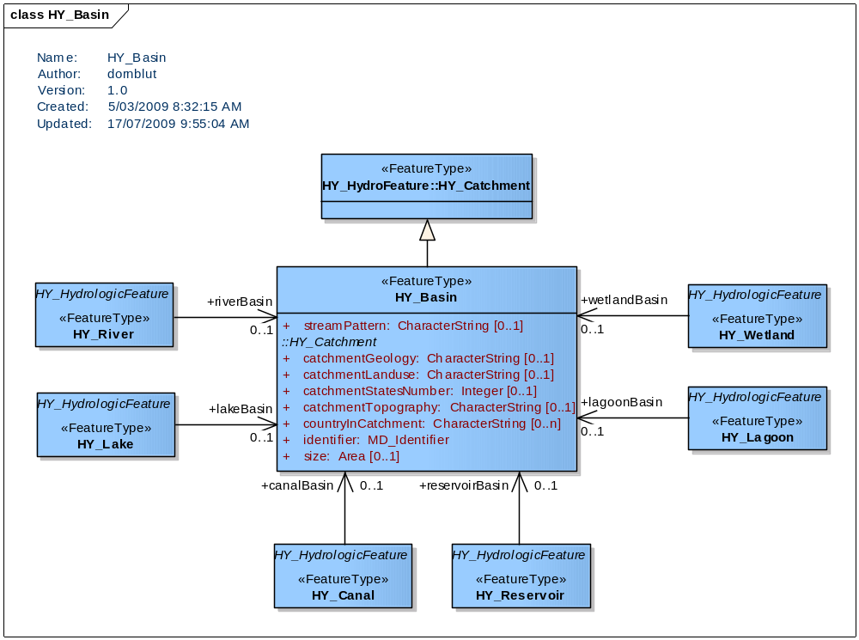
Figure 6 – Basins UML in the GRDC profile
By re-using the GRDC model, O&M descriptions of observations can be linked to the relevant spatial features. Figure 7 shows an example of how this may be done using an example of a flow observation at a site on a river. The elements in green represent components in the observation process from O&M; those in blue are instances of classes from the GRDC metadata profile.

Figure 7 - Example river flow observation in UML
A literal reading of the example gives, “A doppler flow meter was used to make a flow measurement of the Macquarie river at the Macquarie at Trefusis station. The result of this observation was a time series. The Macquarie River is in the South Esk Basin.”
The example does not show the properties of all the classes involved (such as observation times, results etc.) but these exist within each of the class definitions and would be described explicitly when encoding occurs.
The process is shown as a generic O&M process instance (being a doppler meter). The GRDC profile does define some specialisation of process types such as instrument, so these classes may also be used. The following section addresses procedure descriptions further.

Procedures
The description of the process used to generate an observation result can vary in complexity. Raw observational results generated from sensors undergo internal processing to convert signals into parameter estimations; time series are generated from chains of conversion processes to convert units or estimate related phenomenon; models link complex process chains to provide past and future estimates for phenomenon. This information is useful when interpreting data sets to gain further insight into the nature of the estimation.
The existing standards analysed provide some categorical grouping of the types of processing that occurred on a particular data set, but they generally don’t provide a high level of metadata that could be used for further interpretation (i.e. to provide estimates of uncertainty in data).
Within the OGC Sensor Web Enablement suite of specifications the SensorML specification is a schema for describing in detail the processes that occur when sensors and instruments take in creating estimates of phenomenon. It is a very flexible schema, and there is need to investigate its use, a subset of it, or alternate specifications, for describing fully the procedure used to generate hydrologic observation results.
The GRDC metadata profile provides some initial work in this area, with its specialisation of the O&M procedure and separating instruments and simulations (models etc.). Further testing of this model will be required to determine whether it is capable of matching current and future requirements.

Derived time series
The CUAHSI ODM allows for grouping and derived from associations to be created. This concept can be used to provide metadata information for how a particular time series may have been generated. A group of values may be associated with another group from which the series was derived. This association can then be linked to a method identifier which describes the process that was undertaken to generate the derived values. Essentially this is modelling two concepts: process chains and describing dependencies between data sets.
This grouping and dependency tracking is a common requirement in hydrological data, where there are many derived data products that have dependencies both to other data sets and to algorithms. Maintaining the relationship between time series for when dealing with sharing of data requires a common (or at least transparent) identifier system; this allows series to be cross referenced and resolved appropriately. Further investigation should be done in capturing a common model for such requirements.
There is a difficulty managing the identity of data values when externally processing information in a program or model that does not fully support a data model. Operating the processing chain over a grouping, or series, and maintaining relationships between groups requires less information and allows for external processing operations.

Observed properties
Observed properties relates to the definition of the phenomenon that is being observed. Hydrological observed properties are generally phenomenon such as water level, river flow (or discharge), turbidity etc. Exchange formats may want to refer to well defined lists of possible observed properties or describe the nature of the observed property inline in an instance document. Both models should be supported.
There are differences in the definitions of what constitutes an observed property across existing hydrological standards. This appears to be mainly due to the way the underlying model has captured the various components of observations. This is an area that requires further harmonisation and will be within scope of defining a harmonized model.
WaterML1.1 uses the ODM concept of a variable, which links the observed property, units of measure and the temporal sampling regime being used (e.g. regular hourly intervals). It is also possible to specify the medium being sampled (e.g. surface water, air, ground water etc.). Additionally, it includes series information, like interpolation and data type, and meta information about the variable such as general category and no data value. In the HIS discovery system [HIS2009], an ontology is used to link variables to concepts.
WDTF mainly uses the referencing of controlled terms approach to defining its property types. It does have the ability to provide an inline description that sets a unit against a particular observed phenomenon. WDTF also provides a mechanism for creating compound properties that links to phenomenon through a mapping. This allows for complex observations to be formed that may contain multiple observed properties. This has been used to allow for the definition of rating (conversion) tables (compound property defines the level to flow mapping).

SWE Common
SWE common provides mechanisms for defining property types (phenomenon) along with the facility to create compound and constrained properties. This model is shown in Figure 8.

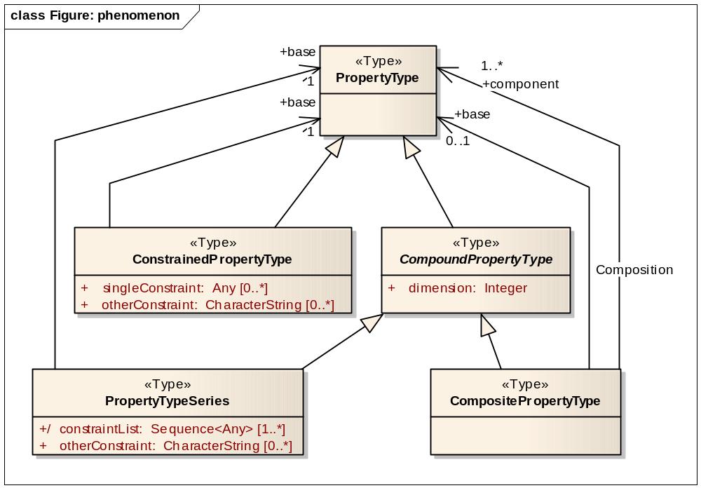
Figure 8 - SWE common phenomenon definition UML

An example use of a constrained phenomenon to limit temperature is given in the SensorML specification [BOT2007]:
<swe:ConstrainedPhenomenon gml:id="SurfaceWaterTemperature">
<gml:name codeSpace="urn:ogc:tc:arch:doc-rp(05-010)">
urn:ogc:def:property:OGC:SurfaceWaterTemperature
</gml:name>
<gml:name>Surface Water Temperature</gml:name>
<swe:base xlink:href="#WaterTemperature"/>
<swe:singleConstraint>
<swe:TypedValue>
<swe:property codeSpace="./">Depth</swe:property>
<swe:value>
<swe:Interval>
<swe:lowerBound xsi:type="gml:MeasureType" uom="./units.xml#m">
0.0
</swe:lowerBound>
<swe:upperBound xsi:type="gml:MeasureType" uom="./units.xml#m">
1.5
</swe:upperBound>
</swe:Interval>
</swe:value>
</swe:TypedValue>
</swe:singleConstraint>
</swe:ConstrainedPhenomenon>

IOOS approach
IOOS leverages the SWE Common property definitions along with GML dictionaries to allow phenomenon definitions within documents.
<om:observedProperty xlink:href="http://www.csc.noaa.gov/ioos/schema/IOOS-DIF/IOOS/0.6.1/dictionaries/phenomenaDictionary.xml#WaterLevel"/>

Where the definition of the type is as follows:

<gml:definitionMember>
<swe:Phenomenon gml:id="WaterLevel">
<gml:description>Level of the water.</gml:description>
<gml:identifier codeSpace="urn:x-noaa:ioos:def:phenomenonNames">WaterLevel</gml:identifier>
</swe:Phenomenon>
</gml:definitionMember>

Potential future approach
When defining local property definitions the SWE common approach is quite flexible. It allows property definitions to be used that are appropriate for the context of use. For example, a US agency serving information for the National Water Information System (NWIS) may encode their property definition as follows:

<om:observedProperty>
<swe:Phenomenon gml:id="NWIS_00060">
<gml:description>Discharge, cubic feet per second</gml:description>
<gml:name>00060</gml:name>
</swe:Phenomenon>
</om:observedProperty>

Or alternatively, the definition could be referenced via xlink using an identifier:

<om:observedProperty xlink:href="http://nwis.waterdata.usgs.gov/usa/nwis/pmcodes/00060"/>

It would be optimal if this identifier could be resolved to an equivalent definition of the property. This will depend somewhat on the governing body of the definitions, but having such definitions available allows for a more consistent use by data providers.

Linking to ontologies
The concept of linking out to definitions is to allow a clear reference to be made to a well governed definition of a concept. The Semantic Web [W3Cb] community is all about making connections between how data relates to real world objects. Ontologies [WIK2009] are one technique available for defining the nature of real world objects and their relationships. A number of information modelling groups are looking towards using ontologies, and linking to them, to allow data to be connected with its conceptual meaning. There are some existing approaches on how best to ‘mark-up’ data with appropriate connections to such ontological definitions.
The Marine Metadata Interoperability (MMI) project recommends usage [ALE2009] of URLs for defining links to terms within ontologies. If this target URL is resolvable then one could retrieve the definition of the term within a hierarchy of related definitions.
The suggested structure is as follows: http://{hostdomain}/{ontologiesRoot}/{authority}/{version}/{resourceType}/{shortName}
Following such a definition, an example could be encoded as follows (referencing a CUAHSI ontology for surface hydrology to define stream discharge):
<om:observedProperty xlink:href=" https://svn.sdsc.edu/repo/WATER/CUAHSI/OntologyOwl/StarTree_Current/ontology/surfhydrosyn/ dischargeStream"/>
Current work within the W3C Semantic Sensor Networks incubator group [W3Cc] is investigating techniques for marking up data with links to its semantic meaning. They provide an example on a weather compound phenomenon [COM2009] linked to an ontology describing the components making up weather observables:

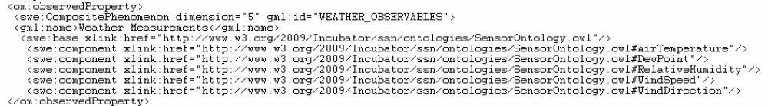
Figure 9 - Example link to weather phenomena within an ontology

SWE common provides sufficient linking mechanisms (through use of xlink) to define links to ontologies using this approach. Dictionaries that are local to the schema can be defined, and these may be generated from catalogs that are used as the definitive source of the definitions. The actual approach used will depend upon the end user of a schema; descriptions of recommended approaches would be useful.

Grouping observations
The O&M model describes individual observations that capture the relationship between the observed property, the feature of interest, the procedure and the ultimate result. Grouping of observations is important when handling transmission of observation series, for example as responses to web services or other query interfaces. Often such groupings are called series (WaterML1.0), datasets (GRDC metadata profile) or collections.
O&M version 1.0 contains an observation collection definition that allows for grouping of multiple observation descriptions. However, this definition may not be included in subsequent versions. The basis for this decision is that the description of collections is not a part of the observation description, merely a convenience for transmission of observational sets. These types of structure come into play when defining a service interface to the model.
CSML defines a dataset class, allowing for:
- Spatial extent summary of the grouping
- Local dictionary definitions of coordinate reference systems, phenomenon, units of measure
- Description of multiple features (and coverages).
Grouping in WDTF allows for description of
- Features
- Group metadata (versioning, data owner, document generation etc.)
- Local phenomena definitions
- Transactional information
- Specimens
- Conversions
- Observations.
Grouping in WaterML1.0 is based around the interface used for discovering data. Observation groupings are called series (a unique combination of site, variable and time intervals). A location has group of series called a series catalog. Since locations can be shared, it is possible to have more than one series catalog, although this has been deprecated. Within the CUAHSI HIS, series are essential to the discovery process. A central metadata catalogue of series allows for the discovery of information across data provider. A series catalog is a group of series that is defined for a site. This is used for discovery purposes through the GetSiteInfo service call in WaterOneFlow. Time series are grouped in time series response documents which results from a GetValues service call.
Grouping structures of observations are often developed from the viewpoint of how people discover observational data sets. Within OGC the service model built around accessing O&M data is the Sensor Observation Service (SOS). This service has a concept of “offering” that allows for grouping of data sets along with interface calls for discovery and filtering of concepts.
Groups are important to the management of the information, and they often reflect how the information is collected and managed. For streaming data, United States data providers manage data streams as “site-variable-begin date-end date” which it calls “period of record”. This differs from a water quality collection model which uses a project-site-methods-results grouping. This water quality model is reflected in the WQX standards used both by the EPA, and the USGS. Functionally equivalent to the series/period of record concept are ‘availability records’ for a particular location-variable. These are used by agencies, such as the National Climate Data Center, and the National Resources Conservation Service. SOS provides a mechanism that is called “offering” but since grouping outlined above can have millions of records it is not possible to use in SOS 1.0 to expose large numbers of “offerings”.
A conceptual model for hydrological observations needs to provide a standardized mechanism for discovering time series groupings. Periods of records/offerings/series are presently basic practice when exposing hydrologic information. The CUAHSI HIS system has demonstrated that such groupings allow for discovery of information.

Summary of requirements for a core water observation model
This section provides a summary of requirements for a core model and provides guidance for future work on harmonising, and developing, future standards for exchange of water information. It is not a comprehensive list and further engagement by a wider community will help to identify areas that require extra work.
Results: The core properties that were identified in this report include: interpolation types, quality, value qualifiers, accuracy, processing metadata (linked to procedure definitions), textual comments, units, null values, temporal metadata. Adapting these into a specialised O&M result model and testing against a number of exchange requirements is underway. The focus of this report is on time series; other observation types do occur in hydrological observations, such as geometric observations of river cross sections – these will need to be addressed further.
Feature descriptions: mechanisms for linking to feature descriptions should be provided. Full descriptions may be supported by linking to existing information models. Certain usages patterns require different levels of metadata, unpacking these will be important future work. For example, an information model to support a flow forecast model has higher requirements on network descriptions than a rainfall reporting service.
Procedures: Current metadata is limited in existing standards. Linking to external descriptions should at least be possible. Further investigation of a common approach for specific hydrological processes is needed, addressing processes such as hydrologic models, complex conversions (rating curves, volume calculations etc.) and sensor descriptions. The procedural information is often closely related to the result types and associated metadata; understanding different viewpoints and needs of observation data will assist here. Procedure descriptions assist greatly in downstream interpretation of data sets; this is an area that is not currently well supported.
Groupings: Grouping observation sets is important for discovery purposes. Existing standards are built around end user needs of discovery – these should be analysed further.
Flexible code lists: ability to link to existing code lists for particular agencies is a common requirement.
Observed properties/phenomenon: SWE common provides an initial approach to capturing the definitions of observed properties. There is a need to harmonise on the way relationships are drawn between observed phenomenon, results and procedures (which O&M provides guidance on) – existing standards group concepts together slightly differently and the core components need to be separated in a consistent manner.

Encoding types
The existing formats investigated are all based on XML encodings for data exchange. Current practice for data exchange of hydrological observations hinges largely on the exchange of CSV and Excel spreadsheets. These formats often have minimum metadata and often rely on apriori knowledge of opaque conventions and identifier systems. XML, whilst sometimes verbose, allows easier machine interpretation of data sets and increases the capability for self describing metadata when linked to schema.
Other communities, such as the climate sciences, use existing standards such as netCDF [UNI2009] that allow for efficient encoding of large data sets such as gridded surfaces. There is current work [GAL2009] on using netCDF (and specifically CF-netCDF, a climate and forecast extension) as an encoding through OGC services such as the Web Coverage Service [WCS2007]. These types of initiatives are of interest as they are supporting existing community standards but attempting to adapt them to technologies and standards that improve our ability to share and interpret data sets. It also may be possible to generate encodings of a common water model using netCDF.
Time series can be large data sets; large in the sense of number of recorded points, rather than storage space. This is often the case for unprocessed data where values may be recorded at very regular intervals. This has implications for the parsing and searching of time series as well as the way access mechanisms should be designed.
Further investigation into encoding a conceptual model using different techniques would be relevant. It may be possible to use the conceptual model to define a common structure for CSV files; this would help in progressing users to more advanced techniques for encoding their data.
Tools to support XML parsing and validation against developed schema will help in hiding some of the underlying complexity that often detracts users from XML.

Creating a harmonised water observation model
The O&M model defines the core concepts and relationships of the observation process. This model is generic in the sense that it does not define concepts specific to hydrological observations.
In order to create a specific model for water observations, a profile may be developed of this model that addresses the requirements of hydrological observations. This model would form a core conceptual model for the exchange of water information.
Such a specialisation of the O&M model will define types and patterns that are common to hydrological observations. For example, the result types within O&M are currently not restricted; a hydrological profile will create a time series result model that captures requirements such as those identified in this discussion paper (interpolation types, quality etc.).

Identifying core requirements
Existing standards will already have a certain level of semantic alignment of concepts between them, as shown in Figure 10, due to the nature of the domain. Close alignment of concepts occurs in centre of the diagram; areas outside the core may require harmonisation – concepts should only be considered for harmonisation if they can be matched to a common requirement. If they can not, they may exist in a specific application of the core model. Familiar concepts such as units of measure and spatial locations could be expected to exist across the standards.

Standard A
Standard B
Standard C
Figure 10 - Alignment of concepts

Analysing the existing sets of standards gives us a proxy for the requirements of exchange formats (as they have been driven by particular needs), but an analysis of further requirements is important.
Building exchange formats around such a core model provides a number of benefits:
- Clear definition of the semantics of each concept within the model and its relationships. This allows agreement to be set at a high level between people, organisations or systems by referring to the model rather than having to resolve semantic differences for each concept. An example from the investigated standards would be reconciling the differences between variable (WaterML), parameter (UK-EA-TS) and phenomenon (WDTF). This benefit is paramount when addressing interoperability of systems.
- Schemas, databases, documentation and code may be generated directly from the model. This allows easier management of versioning as a number of artefacts can be generated when changes occur.
- Sharing of tools that have been developed to support the model. Code need not be re-written for all the standard requirements when using exchange formats such as ingestion, encoding, validation etc.
- Tools such as web services may also be re-used to provide query and access interfaces to both people and other applications. The use of a core model here simplifies the adoption of such services for use in an organisation.
- The parts of an exchange format that are specific to an organisation can be governed and introduced separately to the model. This helps with managing complexity of a format and enhances extensibility.
Having such a core model is especially beneficial when dealing with large scale distribution of stakeholders and systems. This is the case with initiatives mentioned such as INSPIRE, AWRIS and CUAHSI. The issue with data integration in such distributed systems is that if each system is communicating with one another, the number of format translations required increases exponentially with the inclusion of new systems.
The Canonical Data Model pattern [HOH2003] describes the use of a common information model that all members of the system must subscribe to in order to communicate with other systems. This allows translation to occur only at one point (where the system is introduced), rather than for each communication channel between distributed parties. This seems like an obvious concept when designing systems, but the current state of data exchange is actually multi-channel when considering channels such as FTP, phone, email – all often used to exchange data. For example, a common occurrence is for a data holder to email a CSV data file to an interested party, who subsequently rings up and asks about the metadata (what coordinate system is used, what is phenomenon ID6854 etc.) in order to correctly interpret the file.
Developing a common model assumes that it is actually possible to correctly harmonise on the concepts within the domain. A separation of concerns can help here in packing problems into manageable parcels which capture a set of agreed upon concepts. This allows commitment to these definitions without pulling in a full descriptive model which they may not align to.

Soft-typing vs. hard-typing
The concept of soft-typing refers to the case where a schema does not make explicit structural definitions for what types should be allowed for particular classes or concepts. The types can essentially be defined at ‘run-time’. The opposite of this is hard typing which defines up front the types and their structure that should be allowed within a schema.
Adapting the explanation provided in the CSML definition [WOO2007] to a description of time series,
DataRecord
+element (param, value)
TimeSeries
+ date
+ value
+ property
RiverLevel Measurement
+ date
+ level
Soft-typed
Hard-typed
An example instance:
<DataRecord>
<element param="time">01/01/2009T09:00:00</element>
<element param="value">0.3</element>
<element param="observedProperty">RiverLevel</element>
</DataRecord>
<TimeSeries>
<date>01/01/2009T09:00:00</date>
<value>0.3</value>
<property>RiverLevel</property>
</TimeSeries>
<RiverLevelMeasurement>
<date>01/01/2009T09:00:00</date>
<level>0.3</level>
</RiverLevelMeasurement

Balancing between hard-typing and soft-typing in descriptions of concepts and types in a conceptual model is important. Soft typing allows flexibility but reduces the specificity of the model, which creates ambiguity, reduces interoperability and affects the validation process of encoded documents; hard-typing tightly defines concepts making semantics clear and validation using existing tools easier, but reduces the ability to extend definitions without revising the schema.
The general approach is that if a concept is core to the domain and can be harmonised to provide a common definition, then it is a candidate to be hard-typed. Concepts that are more specific to particular organisations or contexts should be made available through the use of soft-typed definitions.
The use of code lists is an area that is often dependent on the context of use. Placeholders for these can be specified in the model that holds a certain semantic definition (such as organisation codes, units of measure, measured properties) but the definitions of the codes are kept open for definition in a particular usage context. True interoperability can occur only when it is possible to either translate exactly between codes from different organisations or a common set of codes are adopted. While this is the goal, it is realised that significant advances in interoperability can occur even when there is only a common format capable of housing those codes.

Data Exchange vs. Archival
There are two diverse aspects to sharing hydrological data: sending out minimal information, enough to allow use; or exchanging enough for archival storage.
There are formats that are more archival nature, e.g. GRDC Hydrologic Datasets metadata profile is based on the ISO metadata standard. Presently, many datasets are available in text formats which enable use. They require the user to infer the details of the information which is often documented outside of the downloaded file.
CUAHSI noted that presently, scientists tend to store retrieved information on disk after retrieval from a data source, even when the source was a method from a web service. Because of this observation, it was determined that a set of results must be returned with data for disconnected use (site information, variable information, and data value attributes).
Future work will need to determine at which point along the spectrum a schema will exist or be developed. While outside the scope of the conceptual model, it will need to determine how ancillary information, such as rating curves and the details of a laboratory analysis, will be made available.

Adopting a common model
In order for users to adopt a core conceptual model there would be a process of ‘contextualising’ the model to satisfy an end–user’s need. The process will be determined somewhat by their requirements for data exchange (file based exchange format, web service responses, database schemas etc.) but there are common requirements that could be foreseen. It would be of benefit for best practices or specifications to be developed for various hydrological data exchange patterns. Such work could be envisaged for the Hydrology Domain Working Group (HDWG).
The process may include:
- Generating a schema from the core model that suits a deployment platform. For example, this could be generation of GML simple features XML Schema. Generating GML schema is currently the most supported target platform in terms of tool development, but others such as CSV, netCDF or other XML Schema types may be developed.
- Defining or importing other specific schema requirements. A user may have requirements that are not a part of the core model such as transactional information, describing ground water structures or other more explicit feature descriptions. It may be possible to import these from other existing standards or they may need to be developed as needed.
- Linking a schema to vocabulary definitions. Some core vocabularies (such as observed properties, units of measure etc.) for the hydrology domain may be established through community groups such as the HDWG. These could be used directly if they have sufficient coverage. Others that are more context-dependent can be developed or adapted to link to the schema.
- Generating documentation. It would be possible to generate or re-use documentation of concepts and examples for the core parts of the model. Examples and context specific usage could be development on top of this.
- Customising a validation framework. A core model may contain conformance criteria that allows for validation of instances against the generated schema. These may use normal schema validation approaches plus extra domain specific rule checking, such as observed phenomenon types against interpolation types (e.g. rainfall may only be encoded as total data types). Extra validation rules may be developed in addition to these to suit the particular target usage.
- Adapting tools. Tools to encode and decode the target schema may have been developed. These would need to be integrated into existing systems to allow mapping from existing schemas to the developed schema.

Conclusion
This discussion paper has investigated aspects of creating a harmonised model for hydrological observations, with further focus on capturing the results of observations. The key aspects of hydrological time series were explored by analysing a set of existing standards for hydrological observational data. A large number of concepts that exist across existing standards are compatible; suggesting a harmonised model of observational data could be captured.
The premise for a harmonised conceptual model is that it will allow application specific profiles to be developed or extended (if required) to suite particular needs. In addition to this, service models may be used or built that allow for access to the information model (or aspects of it), such as WaterOneFlow and the Sensor Observation Service.
There are many concepts that will require further harmonisation, and input into this process should come from current stakeholders. This discussion paper has focused on time series, with the aim to initiate further discussions on critical concepts.
Using a model-driven approach, it will be possible to generate encodings directly from the harmonised model. Tools already exist to produce GML compliant encodings using XML Schema and it would be possible to create different encodings to suite particular needs within the community.
The development of such a model would provide benefits to a large number of organisations looking to manage water information by providing a common platform for definitions of concepts and relationships.

Annex A
(informative)
XML instance examples
  - WaterML1.1 example
<?xml version="1.0"?>
<timeSeriesResponse xmlns:xsi="http://www.w3.org/2001/XMLSchema-instance" xmlns:xsd="http://www.w3.org/2001/XMLSchema" xmlns="http://www.cuahsi.org/waterML/1.0/">
<queryInfo>
<creationTime>2009-06-12T17:48:01.8125Z</creationTime>
<criteria>
<locationParam>LBR_TEST:USU-LBR-Mendon</locationParam>
<variableParam>LBR_TEST:USU3</variableParam>
<timeParam>
<beginDateTime>2005-08-05</beginDateTime>
<endDateTime>2005-08-06</endDateTime>
</timeParam>
</criteria>
<note>OD Web Service</note>
</queryInfo>
<timeSeries>
<sourceInfo xsi:type="SiteInfoType">
<siteName>Little Bear River at Mendon Road near Mendon, Utah</siteName>
<siteCode network="LBR" siteID="1">USU-LBR-Mendon</siteCode>
<geoLocation>
<geogLocation xsi:type="LatLonPointType" srs="EPSG:4269">
<latitude>41.718473</latitude>
<longitude>-111.946402</longitude>
</geogLocation>
<localSiteXY projectionInformation=" NAD83 / UTM zone 12N">
<X>421276.323</X>
<Y>4618952.04</Y>
</localSiteXY>
</geoLocation>
<elevation_m>1345</elevation_m>
<verticalDatum>NGVD29</verticalDatum>
<note title="County">Cache</note>
<note title="State">Utah</note>
<note title="Site Comments">Located below county road bridge at Mendon Road crossing</note>
</sourceInfo>
<variable>
<variableCode vocabulary="LBR" default="true" variableID="3">USU3</variableCode>
<variableName>Battery voltage</variableName>
<valueType>Field Observation</valueType>
<dataType>Minimum</dataType>
<generalCategory>Instrumentation</generalCategory>
<sampleMedium>Other</sampleMedium>
<units unitsAbbreviation="V" unitsCode="168">volts</units>
<NoDataValue>-9999</NoDataValue>
<timeSupport isRegular="true">
<unit UnitID="102">
<UnitDescription>minute</UnitDescription>
<UnitType>Time</UnitType>
<UnitAbbreviation>min</UnitAbbreviation>
</unit>
<timeInterval>30</timeInterval>
</timeSupport>
</variable>
<values unitsAbbreviation="V" unitsCode="168" unitsType="Angle" count="49">
<value censorCode="nc" dateTime="2005-08-05T00:00:00" qualityControlLevel="Raw data" methodID="4" sourceID="1">12.91645</value>
<value censorCode="nc" dateTime="2005-08-05T00:30:00" qualityControlLevel="Raw data" methodID="4" sourceID="1">12.91477</value>
<value censorCode="nc" dateTime="2005-08-05T01:00:00" qualityControlLevel="Raw data" methodID="4" sourceID="1">12.90721</value>
<value censorCode="nc" dateTime="2005-08-05T01:30:00" qualityControlLevel="Raw data" methodID="4" sourceID="1">12.90301</value>
<!-- snip -->
<value censorCode="nc" dateTime="2005-08-05T23:30:00" qualityControlLevel="Raw data" methodID="4" sourceID="1">12.97437</value>
<value censorCode="nc" dateTime="2005-08-06T00:00:00" qualityControlLevel="Raw data" methodID="4" sourceID="1">12.95674</value>
<method methodID="4">
<MethodDescription>Battery voltage measured by Campbell Scientific CR206 datalogger.</MethodDescription>
<MethodLink>http://www.campbellsci.com</MethodLink>
</method>
<source sourceID="1">
<Organization>Utah State University Utah Water Research Laboratory</Organization>
<SourceDescription>Continuous water quality monitoring by Utah State University as part of the USDA CEAP Grant</SourceDescription>
<ContactInformation>
<ContactName>Jeff Horsburgh</ContactName>
<TypeOfContact>main</TypeOfContact>
<Phone>1-435-797-2946</Phone>
<Email>jeff.horsburgh@usu.edu</Email>
<Address xsi:type="xsd:string">8200 Old Main Hill
,Logan, UT 84322-8200</Address>
</ContactInformation>
<SourceLink>http://www.bearriverinfo.org</SourceLink>
</source>
</values>
</timeSeries>
</timeSeriesResponse>

  - Water Data Transfer Format
<?xml version="1.0"?>
<wdtf:HydroCollection
xmlns:sa="http://www.opengis.net/sampling/1.0/sf1"
xmlns:om="http://www.opengis.net/om/1.0/sf1"
xmlns:xsi="http://www.w3.org/2001/XMLSchema-instance"
xmlns:xlink="http://www.w3.org/1999/xlink"
xmlns:gml="http://www.opengis.net/gml"
xmlns:wdtf="http://www.bom.gov.au/std/water/xml/wdtf0.3"
xmlns:ahgf="http://www.bom.gov.au/std/water/xml/ahgf0.1"
xsi:schemaLocation="http://www.opengis.net/sampling/1.0/sf1 ../sampling/sampling.xsd
http://www.bom.gov.au/std/water/xml/wdtf0.3 ../wdtf/water.xsd
http://www.bom.gov.au/std/water/xml/ahgf0.1 ../ahgf/waterFeatures.xsd"
gml:id="HC-t1">
<!-- Change log -->
<!-- snip -->
<gml:description> This document encodes timeseries. Documentation snipped.
</gml:description>
<gml:name codeSpace="http://www.bom.gov.au/std/water/xml/wio0.2/feature/HydroCollection/w00001/">HC-t1</gml:name>
<wdtf:metadata>
<wdtf:DocumentInfo>
<!-- specify the version of the data package -->
<wdtf:version>wdtf-package-v0.3</wdtf:version>
<wdtf:dataOwner codeSpace="http://www.bom.gov.au/std/water/xml/wio0.2/party/person/bom/">w00001</wdtf:dataOwner>
<wdtf:dataProvider codeSpace="http://www.bom.gov.au/std/water/xml/wio0.2/party/person/bom/">w00001</wdtf:dataProvider>
<!-- All dates and time should include a time zone or terminate in Z for UTC -->
<wdtf:generationDate>2008-07-11T00:00:00+10:00</wdtf:generationDate>
<wdtf:generationSystem>AWRIPS</wdtf:generationSystem>
</wdtf:DocumentInfo>
</wdtf:metadata>
<!-- transaction Members indicate the transactions associated with the document -->
<wdtf:transactionMember>
<!-- A synchronizationTransaction is used to replace a block in the time period -->
<wdtf:SynchronizationTransaction
gml:id="synch1">
<!-- a nil period would indicate that the new data replaces the entire existing data set -->
<wdtf:period>
<om:TimePeriod>
<om:begin>2001-07-31T20:12:01</om:begin>
<om:end>2001-08-02T20:10:01</om:end>
</om:TimePeriod>
</wdtf:period>
</wdtf:SynchronizationTransaction>
</wdtf:transactionMember>
<!-- defining data time series -->
<!-- one Time series observation per observation member but any number of observation members -->
<wdtf:observationMember>
<wdtf:TimeSeriesObservation
gml:id="TS1">
<!-- comment snip -->
<gml:description>Telemetry data, and other unstructured information</gml:description>
<gml:name codeSpace="http://www.bom.gov.au/std/water/xml/wio0.2/feature/TimeSeriesObservation/w00001/410729/1/level/">1</gml:name>
<!-- resultTime indicates the time at which this time series was last revised (validation, annotation, etc) as opposed
to when the data was collected -->
<om:resultTime>2008-07-10T10:30:00</om:resultTime>
<!-- here a procedure unique across all sites for w0001 or a generic procedure type is used so it is not
qualified by either the sampling point or group ids -->
<om:procedure
xlink:href="http://www.bom.gov.au/std/water/xml/wio0.2/procedure//w00001/gaugeABC"/>
<om:observedProperty
xlink:href="http://www.bom.gov.au/std/water/xml/wio0.2/property//bom/WaterCourseLevel_m"/>
<!-- mandatory link back to the Sampling point or location -->
<om:featureOfInterest
xlink:href="http://www.bom.gov.au/std/water/xml/wio0.2/feature/SamplingPoint/w00001/410729/1"/>
<!-- overall quality -->
<om:resultQuality>quality-A</om:resultQuality>
<!-- mandatory link back to the sampling Group or site -->
<wdtf:relatedSamplingFeature
xlink:href="http://www.bom.gov.au/std/water/xml/wio0.2/feature/SamplingGroup/w00001/410729"/>
<wdtf:metadata>
<wdtf:TimeSeriesObservationMetadata>
<wdtf:relatedTransaction xlink:href="#synch1"/>
<!-- the regulation property these measurements relate to -->
<wdtf:regulationProperty>Reg200806.s3.1a</wdtf:regulationProperty>
<wdtf:securityConstraints>CommerciallySensitive</wdtf:securityConstraints>
<!-- the next report is expected in a day -->
<wdtf:reportingFrequency>P1D</wdtf:reportingFrequency>
<wdtf:status>validated</wdtf:status>
</wdtf:TimeSeriesObservationMetadata>
</wdtf:metadata>
<wdtf:result>
<wdtf:TimeSeries>
<wdtf:defaultInterpolationType>InstVal</wdtf:defaultInterpolationType>
<wdtf:defaultUnitsOfMeasure>m</wdtf:defaultUnitsOfMeasure>
<wdtf:defaultQuality>quality-A</wdtf:defaultQuality>
<wdtf:timeValuePair
time="2001-07-31T20:12:01+10:00">1.25</wdtf:timeValuePair>
<!-- This time point is missing -->
<wdtf:timeValuePair
time="2001-08-01T20:15:01+10:00"
comment="text"
interpolationType="InstVal"
xsi:nil="true"/>
<wdtf:timeValuePair
time="2001-08-02T20:10:01+10:00"
comment="example comment"
quality="quality-B">1.28</wdtf:timeValuePair>
</wdtf:TimeSeries>
</wdtf:result>
</wdtf:TimeSeriesObservation>
</wdtf:observationMember>
</wdtf:HydroCollection>

  - UK Environmental Agency Time Series Exchange format
<?xml version="1.0" encoding="UTF-8"?>
<EATimeSeriesDataExchangeFormat xmlns:xsi="http://www.w3.org/2001/XMLSchema-instance"
xsi:schemaLocation="http://www.environment-agency.gov.uk/XMLSchemas/EATimeSeriesDataExchangeFormat EATimeSeriesDataExchangeFormat.1.2.xsd"
xmlns="http://www.environment-agency.gov.uk/XMLSchemas/EATimeSeriesDataExchangeFormat" xmlns:md="http://www.environment-agency.gov.uk/XMLSchemas/EAMetadataFormat">
<md:Publisher>Environment Agency</md:Publisher>
<md:Source>Plain English Document</md:Source>
<md:Description>Mixed data file</md:Description>
<md:Date>2003-06-20</md:Date>
<md:Time>15:30:15</md:Time>
<Station region="Thames" stationReference="2200" stationName="RIVER THAMES AT READING"
ngr="SU71807406">
<!-- Four days of daily mean flows -->
<SetofValues parameter="Flow" dataType="Mean" period="Day" characteristic="Derived"
units="m3/s" startDate="2003-04-20" endDate="2003-04-23" dayOrigin="09:00:00">
<Value date="2003-04-20" flag1="1" flag2="1" percentFlag2="100">15.63</Value>
<Value date="2003-04-21" flag1="2" flag2="1" percentFlag2="92.5">16.21</Value>
<Value date="2003-04-22" flag1="1" flag2="1" percentFlag2="87" flag3="2"
percentFlag3="5.5">16</Value>
<Value date="2003-04-23" flag1="2" flag2="1" percentFlag2="85.2" flag3="2"
percentFlag3="14.8">17.36</Value>
<Comment startDate="2003-04-22">This daily mean flow was derived from an incomplete set
of good and suspect data but has been validated and found to be of good overall
quality</Comment>
<Comment startDate="2003-04-21" endDate="2003-04-23">This demonstrates that you can have
nested comments</Comment>
</SetofValues>
<!-- 1 and a half hours of recorded levels (e.g. from telemetry) -->
<SetofValues parameter="Water Level" qualifier="Stage" dataType="Instantaneous"
period="15 min" characteristic="Measured" productRef="H12" units="m"
startDate="2003-04-20" startTime="12:00:00" endDate="2003-04-20" endTime="13:30:00"
dayOrigin="09:00:00" valuesPerDay="96">
<Value date="2003-04-20" time="12:00:00">3.125</Value>
<Value date="2003-04-20" time="12:15:00">3.126</Value>
<Value date="2003-04-20" time="12:30:00">3.125</Value>
<Value date="2003-04-20" time="12:45:00">3.127</Value>
<Value date="2003-04-20" time="13:00:00" flag1="25">8.568</Value>
<Value date="2003-04-20" time="13:15:00">3.127</Value>
<Value date="2003-04-20" time="13:30:00">3.126</Value>
</SetofValues>
</Station>
<Station region="Thames" stationReference="265922" stationName="CAVERSHAM LOCK" ngr="SU72067403">
<!-- 1 monthly rainfall total -->
<SetofValues parameter="Rainfall" qualifier="Storage Raingauge" dataType="Total"
period="Month" characteristic="Measured" units="mm" startDate="2003-04-01"
endDate="2003-04-01" dayOrigin="09:00:00">
<Value date="2003-04-01" flag1="4">36.5</Value>
</SetofValues>
</Station>
</EATimeSeriesDataExchangeFormat>

  - XHydro
<?xml version="1.0" encoding="UTF-8"?>
<tsel xmlns="http://xhydro.org/minimal/2007/06"
xmlns:d="http://www.disy.net/device"
xmlns:xsi="http://www.w3.org/2001/XMLSchema-instance"
xsi:schemaLocation="http://xhydro.org/minimal/2007/06 http://www.xhydro.org/download/schemas/v200706/schemas/XHydro.xsd">
<ext />
<tse>
<xids>
<xid>
<ext />
<xk>disy</xk>
<xv>test</xv>
</xid>
</xids>
<org>
<on>disy</on>
<od>A company.</od>
</org>
<iso>
<dst>P1D</dst>
<sts>
<tsq>
<tsmi>1.5E-6</tsmi>
</tsq>
<tsv>2001-12-31T12:00:00</tsv>
</sts>
</iso>
<pmdl>
<pmd>
<xp>W</xp>
<c>This is a non-standard category code/remark.</c>
<xu>m</xu>
<tl>
<ldn>
<ln>Europe/Germany/Karlsruhe</ln>
<ld>Karlsruhe, a german city.</ld>
</ldn>
</tl>
<dt>
<xdtc>aggMean</xdtc>
<ag>
<it>P1D</it>
<ot>P15M</ot>
<f>P1M</f>
<xtsp>begin</xtsp>
<l>1.5</l>
</ag>
</dt>
<pd>
<ext>
<d:serial>ABCDEFG</d:serial>
</ext>
<dn>dd</dn>
<dd>A dummy disy device.</dd>
<dl>
<ldn>
<ln>Europe/Germany/Karlsruhe</ln>
<ld>Karlsruhe, a german city.</ld>
</ldn>
</dl>
</pd>
<vq>
<vmi>5E-3</vmi>
<vqr>
It is a quite imprecise device, isn't it? This quality remark
demonstrates that free-text remarks are possible, too.
</vqr>
</vq>
</pmd>
</pmdl>
<tsmd>
<tsd>
<dn>ddts</dn>
<dd>A dummy dis device to measure time.</dd>
</tsd>
<tsq>
<tsmi>1.5E-6</tsmi>
<tsqr codeList="disy1" codeListAgency="disy"
codeListVersion="1.0">
ownCode
</tsqr>
</tsq>
</tsmd>
<d>
<tde>
<!-- No timestamp is given because isochron -->
<vls>
<v>
<vq>
<vmi>6E-4</vmi>
<xvqr>affected</xvqr>
</vq>
<vl>
<pt>
<xrs>32632</xrs>
<px>5.0</px>
<py>6.0</py>
</pt>
</vl>
<vf>4.5</vf>
</v>
<v>
<vf>4.6</vf>
</v>
<v>
<vq>
<xvqr>missing</xvqr>
</vq>
<va xsi:nil="true" />
</v>
</vls>
</tde>
</d>
</tse>
</tsel>
Bibliography
[AND2009] AndroMDA, Open Source MDA toolkit - http://andromda.org.
[ALE2009] Alexander, P. 2009. "Citing Terms." In The MMI Guides: Navigating the World of Marine Metadata. http://marinemetadata.org/guides/vocabs/ont/existing/citing. Accessed: 08/18/2009
[AUSWA2007] Australian Government, Water Act 2007, accessible from http://www.comlaw.gov.au/comlaw/management.nsf/lookupindexpagesbyid/IP200733064?OpenDocument
[BLO1996] Blöschl, G., (1996), Scale and Scaling in Hydrology, Habilitationsschrift, Weiner Mitteilungen Wasser Abwasser Gewasser, Wien, 346 p.
[BLO1995] Blöschl, G. and M. Sivapalan, (1995), "Scale Issues in Hydrological Modelling: A Review," Hydrological Processes, 9(1995): 251-290.
[BOM2009a] Australian Water Data Transfer Format, http://www.bom.gov.au/water/WDTF_technical_information.shtml
[BOM2008b] Australian Water Resources Information System, Geofabric concept http://www.bom.gov.au/water/publications/awris.pdf
[BOT2007] OpenGIS® Sensor Model Language (SensorML) Implementation Specification, OGC document 07-000
[COM2009] Compton, M et. al. A Survey of the Semantic Specification of Sensors, http://lists.w3.org/Archives/Public/public-xg-ssn/2009Aug/att-0037/SSN-XG_StateOfArt.pdf
[COX2008] Cox S, 2008, GML Encoding of Discrete Coverages (interleaved pattern), OGC document 06-188r2.
[COX2007a] Cox S & Brodaric, B 2007 Water Resources Information Model Workshop Canberra, 25-27 September, 2007 http://wron.net.au/documents/WaterML_workshop_report.pdf
[COX2007b] Cox, S (ed.) 2007a Observations and Measurements – Part 1 - Observation schema Version 1.0 OGC document 07-022r1 8 Dec. 2007 Accessible from http://www.opengeospatial.org/standards/o%2526m
[COX2007c] Cox, S (ed.) 2007b Observations and Measurements – Part 2 - Sampling Features Version 1.0 OGC document 06-188r1 8 Dec. 2007 Accessible from http://www.opengeospatial.org/standards/o%2526m
[DOR2009] Dornblut, I. Report 39 - Hydrologic Information – Metadata). Version 1, June 2009. Accessible from http://www.bafg.de/nn_317460/GRDC/EN/02__Services/04__Report__Series/39__metadata.html?__nnn=true
[ESA2006] Environmental Sampling, Analysisand Results Data Standards. http://www.exchangenetwork.net/standards/ESAR_Overview_01_06_2006_Final.pdf
[EU2007] Directive 2007/2/EC of the European Parliament and of the Council of 14 March 2007 establishing an Infrastructure for Spatial Information in the European Community (INSPIRE).
[FUL2009] FullMoon tool for standards-based, model-driven development of information models, http://projects.arcs.org.au/trac/fullmoon/
[GAL2009] Geo-interface for Atmospheric, Land, Earth and Ocean netCDF project (GALEON). http://www.opengeospatial.org/projects/initiatives/galeonie
[GEO2005] Global Earth Observation System of Systems (GEOSS) 10-year implementation plan, available at http://earthobservations.org/docs/10-Year%20Implementation%20Plan.pdf.
[HIS2009] HydroSeek data discovery tool, http://his.cuahsi.org/hydroseek.html.
[HOH2003] Hohpe, G, Woolf B, Enterprise Integration Patterns: Designing, Building, and Deploying Messaging Solutions. Addison-Wesley Professional (October 20, 2003).
[HOL2009] HollowWorld UML tool for assisting development of GML application schemas, https://www.seegrid.csiro.au/twiki/bin/view/AppSchemas/HollowWorld
[INS2008] INSPIRE Thematic Working Group Hydrography, D2.8.I.8 INSPIRE Data Specification on Hydrography – Draft Guidelines, 19th December, 2008.
[INS2007] INSPIRE Drafting Team "Data Specifications", deliverable D2.6: Methodology for the development of data specifications, 23rd August 2007.
[IOS2009] Integrated Ocean Observing System, National Oceanic and Atmospheric Administration (NOAA), http://ioos.gov/
[ISO19125-1] ISO/TC-211 2004, 19125-1 Simple feature access -- Part 1: Common architecture, International Organization for Standardization.
[LEF2008] Lefort, L 2008, Towards defining a water data exchange format: State of the art review on water data standards, CSIRO ICT Centre Technical Report 08/111.
[LEM2008] Hydrology Domain Working Group Charter, OGC document 08-095r5, 26th April 2008 updated 2 September 2009.
[MAI2002] Maidment, D, 2002. Arc Hydro: GIS for Water Resources. ESRI Press.
[MSEF] Microsoft Entity Framework, http://msdn.microsoft.com/en-us/library/aa697427(VS.80).aspx
[OMGa] Model Driven Architecture, Object Management Group, http://www.omg.org/mda
[OMGb] Unified Modeling Language, Object Management Group, http://www.uml.org/
[OOM2009] Hibernate OOMEGA, Model-driven software engineering - http://www.oomega.net/
[TAR2008] Tarboton DG, Horsburgh JS, Maidment DR. CUAHSI Community Observations Data Model (ODM) Design Specifications. Version 1.0 May 2008. Accessible from http://his.cuahsi.org/documents/ODM1.1DesignSpecifications.pdf
[UNI2009] network Common Data Form (netCDF), Unidata: http://www.unidata.ucar.edu/software/netcdf/
[W3Ca] World Wide Web Consortium (W3C) XML Schema, http://www.w3.org/XML/Schema
[W3Cb] World Wide Web Consortium (W3C), Semantic Web concept http://www.w3.org/2001/sw/
[W3Cc] World Wide Web Consortium (W3C), Semantic Sensor Networks incubator group, http://www.w3.org/2005/Incubator/ssn/charter
[WCS2007] OpenGIS Web Coverage Service (WCS) Implementation Standard, OGC document 07-067r5.
[WAL2009] Walker G, Taylor P A, Cox S, Sheahan P. Water Data Transfer Format (IWDTF): Guiding principles, technical challenges and the future. MODSIM 2009.
[WIK2009] Ontology definition (information science), http://en.wikipedia.org/wiki/Ontology_(information_science)
[WOO2007] Woolf, A & Lowe, D 2007, CSML User's Manual, v2.doc Accessible from http://ndg.nerc.ac.uk/csml/
[VAL2009b] Valentine, D & Zaslavsky, I WaterML1.1 Draft Specification, Part 2. 5 June 2009. Accessible from http://his.cuahsi.org/documents/WaterML_1.1_part2_v1.docx [2] IEC 60027 (all parts), Letter symbols to be used in electrical technology.

Assumption has been made the interval being described is the preceding interval

