Groundwater Interoperability Experiment 2

Use case 2 - Policy

Abstract
The Water Framework Directive 20000/60/EC (WFD) requires all EU member states to achieve and preserve good status for all European waters, including groundwaters. Process to achieve WFD requirements includes definition and delineation of water bodies as management units, environmental monitoring, status assessment and finally developing river basin management plans.
This use case describes process steps and interactions necessary for delivering data required to assess the groundwater bodies and thus fulfill the related EU reporting obligation. The activity includes: collection and evaluation of the geological and hydrogeological characteristics, as well as quantitative and qualitative monitoring of defined chemical and physical indicators and finally groundwater body overall status assessment.
Delineation on WFD groundwater bodies, in many cases, is not done accordingly to their natural boundaries but usually follows administrative units.
In order to better demonstrate interoperability the use case description covers also a cross border scenario. It defines the additional step of synchronizing of the collected information by two different member state water authorities. This integrating approach facilitates, promoted by WFD facilitates a coordinated assessment and planning of potential future measures.
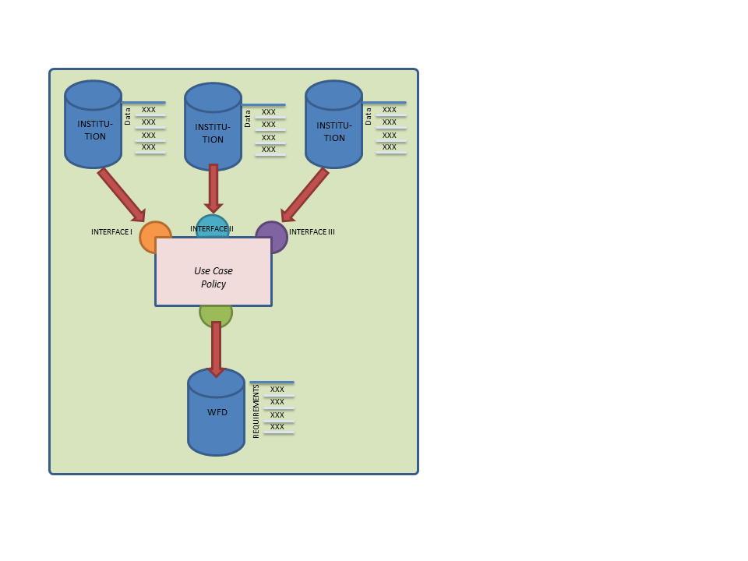 | 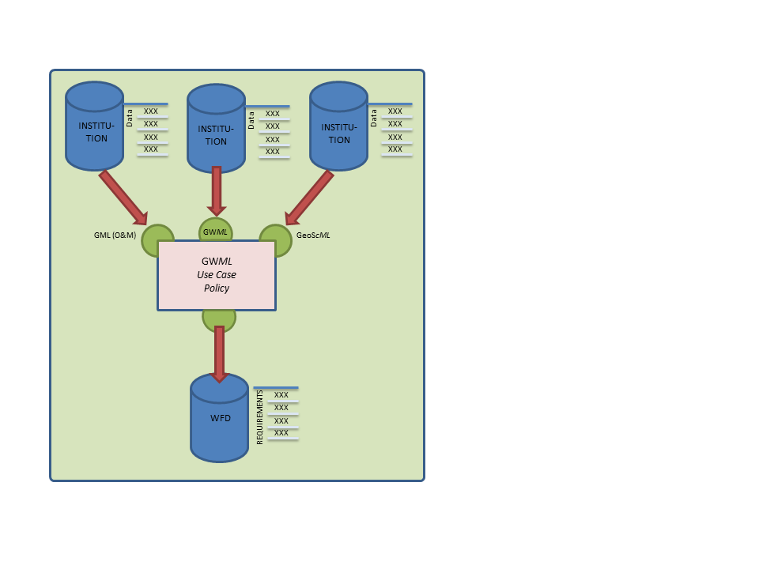
Figure 1: Input and output schema with different interfaces. | Figure 2: Input and output schema with “standard” interface.

Objective
The provision of WFD required data and information on the trans-boundary groundwater body.

Actors
1st Member State water authority
2nd Member State water authority

Actions
- Step 1: Discovering and collecting initial information on hydrogeological, geological, chemical and physical data about the each groundwater body
- Step 2: Preprocessing, syntactical and semantically transformation of the input information.
- Step 3: Assessment of required output,
- Step 4: Delivering of groundwater module for WFD reports

Entities (Features, Observations, Properties)

The overview of the main entities necessary for this Use case.

For the detailed description of the required WFD-Groundwater bodies properties see the following document.

General ID
- WFD_Ground Water Body (GWB)
  - general: id (RBC-code), national code, name, location, protected area association
  - pressures: pressure types (diffuse, point, abstraction, artificial recharge)
  - impacts: impact types (on geological, hydrogeological, characteristic of superficial deposit and soils, dynamical linked w.b….)
  - other impact: further pressure description, other impact description
  - trend reversal: reversal trend, free text
  - trend upward: upward trend, free text
  - hydrogeological characteristics: GW layer, area, depth, thickness, depth range, geological formation, capacity, link surface water, link eco system
  - quantitative status: quantitative status value, comment
  - chemical status (qualitative): chemical status value, comment
  - protected area status (optional): protected area code (unique), type of protection, Type of association, status value

Figure 2: Input and output schema with “standard” interface.

