Workplan: data ingests for forecasting (Use Case 2)
Part of the OGC/WMO Domain Working Group in Hydrology Interoperability experiment 2 – Surface water (HDWG_SWIE).

Document history
Date | Version | Author | Paragraph modified | Description
18/6/‘10 | 0.1 | Peter Gijsbers | All | First version
29/6/10 | 0.2 | John Halquist | All | Minor edits
30/7/10 | 0.3 | Peter Gijsbers | Focus, Deltares, USGS, NWS | Updates after conf. call USGS/NWS/Deltares
10/8/10 | 0.4 | Peter Gijsbers | Architecture | Added sequence diagrams

Overall goal
The experiment will evaluate the suitability of the WaterML2 encoding of SOS and O&M to support frequent incremental feeds in real time of hydrological (time series) data from known data sources to client applications conducting hydrological forecast. This experiment will not address the delivery of hydrological forecasts via an SOS, as this evaluation is foreseen for the interoperability experiment on Hydrological Forecasting.

Evaluation focus areas:
The experiment will include:
- Notification of new data updates + pull of new data
- Push of new data (SOS Insert)
- Same for communicating changes to past data
The Evaluation will focus on
- overall performance for the service specification
- identification of specification bottlenecks during request, response/transfer, receive/ingest
- ease of specification implementation in code base
The experiment may also demonstrate the suitability to use:
- sensor events to initiate incremental data updates.
- weather data feeds using WCS

The experiment will also evaluate the exchange process for rating curves. The USGS hydro-xml format will be applied as stand-in, until the WaterML2 specification includes a rating curve definition.

Participants

Deltares – United States of America & Netherlands
- Will extend the code base of its Delft Flood Early Warning system (FEWS) to act as an SOS client using WaterML 2 encoding. This client allows forecasting agencies to view data from the delivering web-services within a forecasting system and use the data to create forecasts
- Intends to extend the code base of DelftFEWS for retrieval of USGS xml-encoded rating curves
- In a later stage, FEWS may be extended to act as a client for weather data published via a THREDDS (Web Coverage Service and/or OpenDAP)
- Will provide the updated FEWS software to BoM, CSIRO and NOAA/NWS to setup a FEWS application for further evaluation
- Will provide feedback on the ease of implementation, and the performance (bottlenecks) of the service specification experienced by a client application
- Participants include Peter Gijsbers (lead, Silver Spring, MD, USA), and colleagues from Delft, The Netherlands: peter.gijsbers@deltares-us.us

Bureau of Meteorology (BoM) - Australia
- Will provide real time ??hydrological observations?? in the ???? basin published via SOS using the WaterML 2.0 encoding (TO DO: stations and data to be defined)
- Will act as an end user of hydrological forecasting systems, and setup an WaterML 2 client using the FEWS forecasting system to conduct hydrological forecasts.
- Will provide feedback on the performance of the services and client application
- Participants for service provision include Paul Sheahan (AWRIS ingest manager, Canberra, ACT): p.sheahan@bom.gov.au
- Participants for the forecasting client application Justin Robinson ??? (Forecasting division): j.robinson@bom.gov.au

Commonwealth Scientific and Industrial Research Organisation (CSIRO) - Australia
- CSIRO will publish hydrological observations in real time for the South Elk catchment using a WaterML2 encoded Sensor Observation Service (Tasmania, Australia)
- Will provide feedback on the performance (bottlenecks) of the service specification
- Participants include Peter Fitch and associates from the CSIRO, Land & Water division, Canberra, ACT: peter.fitch@csiro.au.

U.S. Geological Survey (USGS) – United States of America
- USGS will publish hydrological observations in real time for selected locations using a Web Feature Service and a WaterML2 encoded Sensor Observation Service.
  - Candidate gauging stations are along the:
      - Chippewa, Wisconsin, and Rock tributaries of the Mississippi river
      - The St.Louis river draining into Lake Superior (Great Lakes basin)
  - Candidate phenomena are:
      - Stage and discharge observations (raw and QC’ed)
- USGS intends to publish Nexrad QPE grids via a THREDDS data server
- USGS will publish rating curves in the USGS xml-format
- Will provide feedback on the performance (bottlenecks) of the service specification
- Participants include Nate Booth and associates from the USGS, Center for Integrated Data Analytics (Middleton, WI): nlbooth@usgs.gov

Unidata – United States of America
- Unidata will publish weather data for the USA via its THREDDS data server
- Will provide feedback on the performance (bottlenecks) of the service specification
- Participants include Ben Domenico and associates from UCAR/Unidata, Boulder, CO: ben@unidata.ucar.edu

NOAA/National Weather Service (NWS) – United States of America
- As an end-user of hydrological forecasts systems, NWS will setup a WaterML 2 client using CHPS to conduct hydrological forecasts. The client will query:
  - USGS published SOS for real time stage and discharge observations in the Mississippi and Great Lakes basin
  - USGS published WFS for the associated gauging stations
  - USGS published THREDDS for nationwide real time Nexrad QPE grids
- Will provide feedback on the performance of the services and client application
- Participants include John Halquist (NOHRSC, Chanhassen, MN) and (North Central River Forecasting Center, MN): john.halquist@noaa.gov

Applied Science Associates (ASA) – United States of America
- ASA will provide its Environmental Data Connector (EDC) application, both as stand alone Java based application and as ArcGIS plug-in, to act as a client for WaterML2 encoded Sensor Observation Services.
- Will provide feedback on the ease of implementation, and the performance (bottlenecks) of the service specification experienced by a client application
- Participants include Eoin Howlett / Mark Wholey (ehowlett@asascience.com)

For organizational purposes it is appropriate to recognize at least the following teams:
- NWS partnering with USGS with potential extension to include Unidata
- BoM partnering with CSIRO

Deltares will supply a FEWS client to both teams.

Architecture
The setup of the cross border experiment will include several server implementations of WaterML2.0 using SOS, WFS) and clients able to consume WaterML2.0 encoded data, as well as a THREDDS/ implementation to serve weather data. In a later stage, update notifications may be distributed using a WaterML2 encoded Sensor Event Service.

A schematic overview of technology and data sources as well as the role of the participants is shown in Figure 1. The use case will use a simple setup with service endpoints known to the participants. Since this use case involves the utilization of data in models, which require the pre-configuration of data inputs, it does not include the use of catalogue services for data discovery purposes.

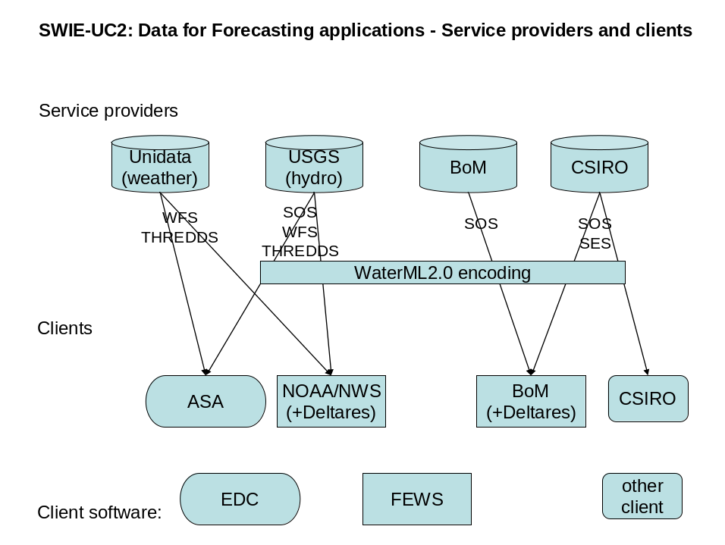
Figure 1 SWIE-UC2 Service providers and clients

The use case aims to test three situations:
- A client pulling data (single event) or a repetitive data increment on a clock based interval (Figure 2 Client pulls increment on clock intervall (Figure 2). This could be a typical situation for retrieval of raw data.
- A server repetitively pushing a data increment on new availability basis (Figure 3). This could be a typical situation for retrieval of QC’ed/processed data
- A server sending a notification to the client upon availability of new data, with the client pulling the data increment (Figure 4). This could be a typical situation for retrieval of QC’ed/processed data

To ensure that all situations are covered, the various teams will have a different priority assigned to each test situation, which is likely to be reflected in the order of tests conducted. See Table 1.

Test teams | Test situation A | Test situation B | Test situation C
US: NWS/USGS | 1 | 2 | 3
Aus: CSIRO/BoM | 1 | 3 | 2
Table 1 Priority in which test situations are addressed (1=high, 3-low)

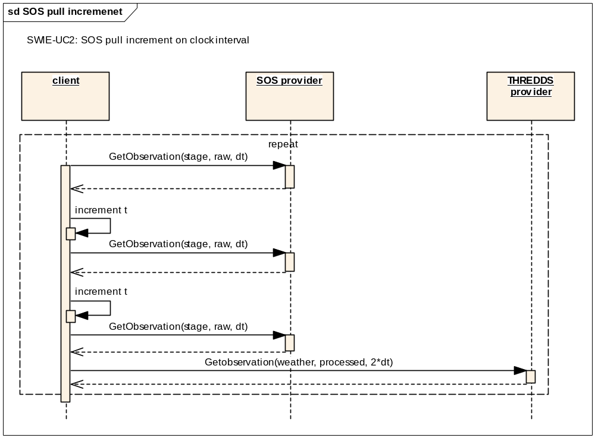
Figure 2 Client pulls increment on clock interval

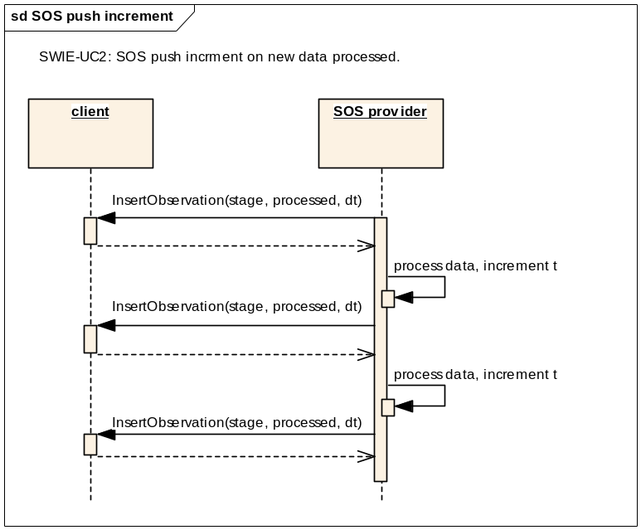
Figure 3 Server pushes increment on new data availability basis

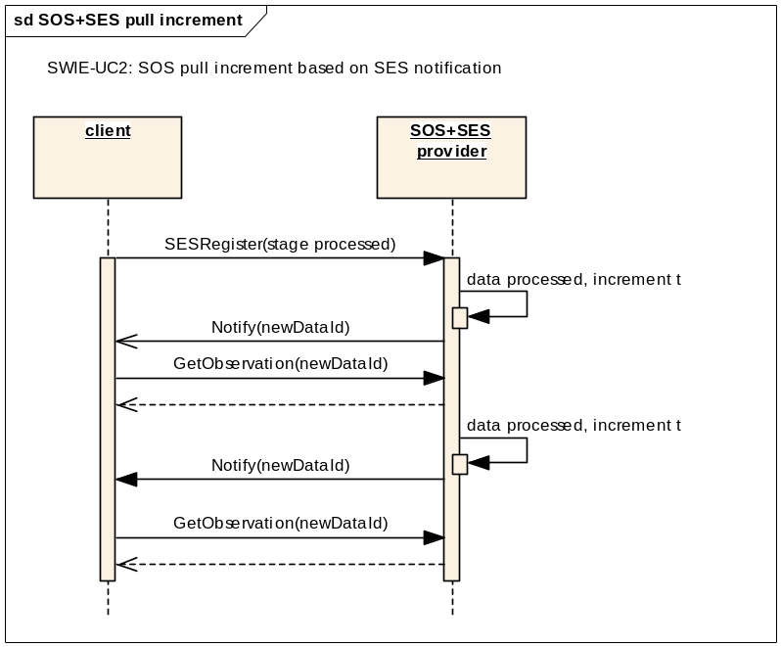
Figure 4 Server notifying client for incremental data pull

Deliverables:

Main deliverables to DWG Hydro
- WaterML2 evaluation report from a forecasting client perspective
- Feedback to the WaterML2 development team on bottlenecks (if any) identified in the specification(s)

Other outcomes
- FEWS software (Java) can ingest WaterML2 encoded hydrological observations data published via SOS
- FEWS software (Java) can ingest weather data published via WCS or openDAP
- EDC software (Java) can ingest WaterML2 encoded hydrological observations data published via SOS
- USGS can provide WaterML2 encoded surface water observations via SOS
- BoM can provide WaterML2 encoded surface water observations via SOS
- CSIRO can provide WaterML2 encoded surface water observations via SOS
- NWS can utilize WaterML2 encoded surface water observations in their hydrological forecasting system (CHPS)
- BoM can utilize WaterML2 encoded surface water observations in their future hydrological forecasting system

Time line and mile stones
The Use Case follows the milestone plan of the whole Surface Water (HDWG_IE2), with demonstrations at the later milestones.

Milestone 1 (September 2010)
- Workplan and evaluation criteria agreed

Milestone 2 (December 2010)
- Completed prototype implementation of FEWS client software for ingest of hydrological data published via WaterML2 encoded SOS
- Completed (prototype) implementation of EDC client software for ingest of hydrological data published via WaterML2 encoded SOS
- Preliminary feedback on specification issues identified during implementation
- Complemented (prototype) implementation of WaterML2 encoded SOS services and publication of hydrological data by USGS, CSIRO and BoM

Milestone 3 (March 2010)
- FEWS client application completed for NOAA/NWS and BoM
- WaterML2 encoded SOS services made available by USGS, CSIRO and BoM
- Initial demonstration
- Possibly completed prototype implementation of FEWS client software for ingest of weather data published via THREDDS
- Preliminary evaluation report on the specification suitability within a hydrological forecasting context

Milestone 4 (June 2010)
- FEWS client application completed for NOAA/NWS and BoM
- WaterML2 encoded SOS services made available by USGS, CSIRO and BoM
- WFS services made available by USFS
- Weather data published by Unidata and USGS using THREDDS
- Full Demonstration
- Final evaluation report on the specification suitability within a hydrological forecasting context

Actions needed to complete work plan
- Peter Fitch to contact BoM and invite them to join
- BoM and CSIRO: Agree on river sections/stations for which data is published
- All agree on the time line of actions and deliverables related to your organization
- Next conefernce call: August 9, 2010: 9pm UTC
(= 5pm EDT, 4pm CDT, Aug.10, 7am Canberra, Aus.)
- Send info to peter.gijsbers@deltares-usa.us and john.halquist@noaa.gov
- Please use track changes when making modifications to his document

