Use Cases
For
Hydrogeological data model use
Use Case Specification: Developing a hydrogeological data model for GW2IE
Version 0.2

Revision History
Name | Date | Reason For Changes | Version
Piotr Wojda | 15/02/2011 | Small corrections | 0.1
Janusz Michalak | 12/11/2012 | Changes for use by GW2IE | 0.2

Use Cases List
Primary Actor | Use Cases | Use Case Name
Hydrogeologist | 001 | A new groundwater intake study with applying a flow model
Use Case 1
Use Case ID: | 001
Use Case Name: | A new groundwater intake study with applying a flow model
Created By: | Piotr Wojda | Last Updated By: | Janusz Michalak
Date Created: | 11/02/2011 | Date Last Updated: | 12/11/2012

Actors: | Hydrogeologist – A hydrogeologist conducting a groundwater intake study by using spatial data web-services  MS-User – Governmental institutions responsible for groundwater resources  NSDI-User – Governmental institutions responsible for GI management of the INSPIRE data themes in the MS  JRC-User – European Commission (DG JRC, DG ENV) user– responsible for support to the WFD and GD implementation
Description: | A new groundwater intake is needed to support further development of a trans-boundary region, with a total population of around 200.000 inhabitants and a water-demanding industry. Its potential impact on groundwater resources quantity and quality should be evaluated.  A hydrogeologist needs to connect to hydrogeological spatial data web-services, using a common hydrogeological data model to transfer data. He/she comes up with a feasibility study and recommendations.
Trigger: | Economic growth of the trans-boundary region, increasing population and industry needs.  Groundwater Framework Directive (2006/118/EC) requirements on a good quality of groundwater: deterioration in the quality of groundwater bodies shall be avoided in order to reduce the level of purification treatment required in the production of drinking water.
Preconditions: | NSDI –user put an appropriate infrastructure in place.  A common hydrogeological data model as a GML-Application schema exists.  MS-User made hydrogeological and environmental data available through a common hydrogeological data model being a GML-Application Schema.  Hydrogeological maps and data available through web-services  Groundwater monitoring network established and data are available through web-services.  Environmental data available through web-services.
Post conditions: | Groundwater flow model established and calibrated.  Different uses scenarios tested and described.  Influence of a high-rate pumping station on aquifer system, groundwater table and hydrological system is described.  Guidelines and recommendations provided.
Normal Flow: | - A hydrogeologist uses web discovery/catalogue services to establish services and data availability.  - A hydrogeologist connects his/her GIS application to the identified hydrogeological web-services, that uses a common hydrogeological data model to transfer data.  - He/she accesses hydrogeological data on an aquifer system with its aquifers, groundwater flow system with its groundwater bodies, existing production wells with geological description and hydrogeological parameters, chemical analysis on groundwater quality, established protection zones,…).  - He/she accesses groundwater monitoring stations for additional hydrogeological data.  - He/she connects the GIS application to other appropriate environmental web-services.  - All necessary hydrogeological data are transferred into a groundwater flow modeling software, using a common hydrogeological data model.  - Hydrogeological processes are modeled independently.  - Exploitation scenarios are developed and might be made public through a web-service – for discussion/consent.  - A hydrogeologist produces a final report for MS-User  - A new groundwater intake can be produced.
Alternative Flows:
Exceptions: | - Illegal request, service exception  - Service does not exist  - Wrong authentication credentials, authentication exception  - Authentication expires, authentication exception  - User unauthorized for service, authorization exception
Includes:
Priority:
Frequency of Use: | Several times per year for a region where a new water intake needs to be built.
Business Rules:
Special Requirements:
Notes and Issues:

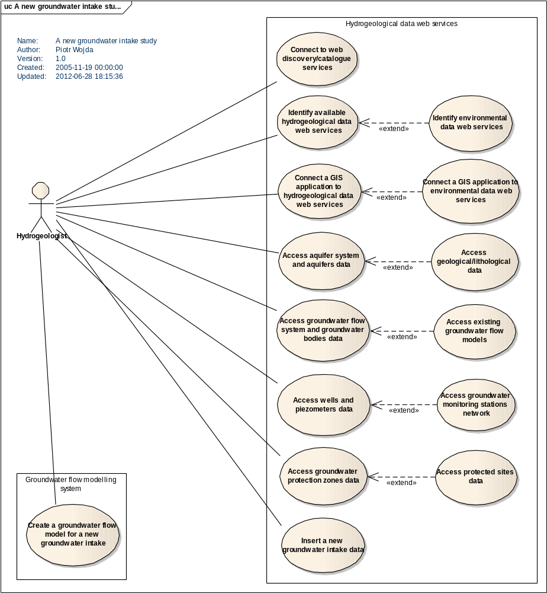

Figure 1. Use Case diagram for a new groundwater intake study with applying a flow model

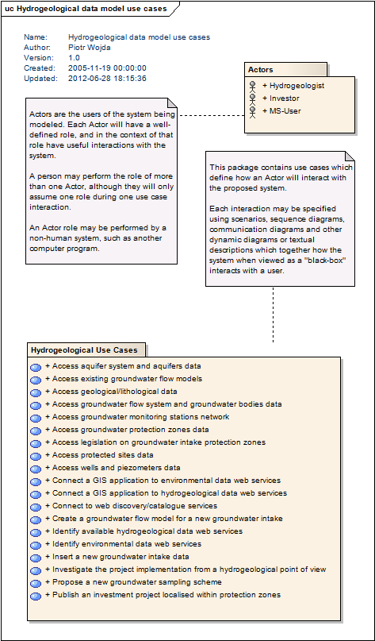

Figure 2. Use Case package diagram for a new groundwater intake study with applying a flow model

