Water for a Healthy Country

Profiling WaterML2.0
Report on existing implementations and techniques

Peter Taylor, Doug Palmer
WIRADA Deliverable 1.12.2.1
20th December, 2012
For the Bureau of Meteorology (the Bureau)



Water for a Healthy Country Flagship Report

Australia is founding its future on science and innovation. Its national science agency, CSIRO, is a powerhouse of ideas, technologies and skills.
CSIRO initiated the National Research Flagships to address Australia’s major research challenges and opportunities. They apply large scale, long term, multidisciplinary science and aim for widespread adoption of solutions. The Flagship Collaboration Fund supports the best and brightest researchers to address these complex challenges through partnerships between CSIRO, universities, research agencies and industry.
The Water for a Healthy Country Flagship aims to provide Australia with solutions for water resource management, creating economic gains of $3 billion per annum by 2030, while protecting or restoring our major water ecosystems. The work contained in this report is collaboration between CSIRO and [list collaborators]
For more information about Water for a Healthy Country Flagship or the National Research Flagship Initiative visit www.csiro.au/org/HealthyCountry.html
Citation
Taylor P, Palmer D (2012). Profiling WaterML2.0: Report on existing implementations and techniques. CSIRO Water for a Healthy Country Flagship, Australia.
Copyright and disclaimer
© 2012 CSIRO To the extent permitted by law, all rights are reserved and no part of this publication covered by copyright may be reproduced or copied in any form or by any means except with the written permission of CSIRO.
Important disclaimer
CSIRO advises that the information contained in this publication comprises general statements based on scientific research. The reader is advised and needs to be aware that such information may be incomplete or unable to be used in any specific situation. No reliance or actions must therefore be made on that information without seeking prior expert professional, scientific and technical advice. To the extent permitted by law, CSIRO (including its employees and consultants) excludes all liability to any person for any consequences, including but not limited to all losses, damages, costs, expenses and any other compensation, arising directly or indirectly from using this publication (in part or in whole) and any information or material contained in it.

Contents
Acknowledgments iii
Executive summary iv
1 Overview 1
Problem statement 1
2 Profiling WaterML2.0 3
2.1 Expressing constraints within WaterML2.0 3
2.2 Existing profile definitions 4
2.3 Summary of profiles 8
2.4 Existing implementations 9
3 Existing and emerging profile approaches 10
3.1 MDA profiles for WDTF 10
3.2 GeoSciML 3.0 11
3.3 INSPIRE 12
4 Recommendations 15
4.1 Community repository of profiles 15
4.2 Templates for profile specifications 15
4.3 Link profiles to validation 15
5 Annex A – full implementation review results 16
5.1 UK CEH Implementation 16
5.2 USGS SOS 2.0 implementation 23
References 34

Acknowledgments
This work is part of the water information research and development alliance between CSIRO’s Water for a Healthy Country Flagship and the Bureau of Meteorology.

Executive summary
This report provides background analysis on the issue of ‘profiling‘ the WaterML2.0 standard. Profiling refers to the concept of using the standard within a certain context to address data exchange for specific scenarios (e.g. how to exchange river level data for a particular agency). WaterML2.0 was defined as a relatively flexible standard capable of expressing a range of metadata relating to hydrological time series. Profiling addresses ambiguity in the usage of a standard to allow easier tool support, validation and encoding. An example profile of WaterML2.0 may define the following:
- How identifiers are used within encodings;
- Which vocabularies are used in the encoding? E.g. how are value qualifiers expressed?
- How vertical positions of spatial elements are defined (e.g. a 3D location for a monitoring point);
- How collections of observations are expressed;
- How related spatial features are described;
- How WaterML2.0 was adapted for use with a web service or related transport mode.
This report examines how these issues are addressed in related standards, also investigating how implementations of WaterML2.0 currently approach these problems. Through this analysis, a number of recommendations for defining profiles are described; it is suggested that these are a useful basis for the community to share WaterML2.0 implementation descriptions.

Overview
This report is in three parts: this section gives an overview of the problem being investigated; the second analyses existing implementations of WaterML2.0 with the aim of understanding how each tackles the various flexible aspects of WaterML2.0; the third gives an overview of non-WaterML2.0 profiling approaches that are in use or emerging. The report concludes with some recommendations on next steps.
This report was planned as an initial background primer on the issue of profiling, with the intention of developing a profiling approach as a next deliverable (WIRADA Deliverable 1.12.2.2).
Problem statement
The following topics describe the profiling problems as they relate to WaterML2.0 implementations. The list is not comprehensive, but represents some of the more significant issues.
Use of soft-types and extension
There are a number of ways in which WaterML2.0 may be extended. The main approach is through use of the om:NamedValue type, as shown in Figure 1. Within its XML implementation, this type provides a means of associating named elements with any XML type. Parsers have difficulty parsing the named-value type without some indication of what to expect. It is thus desirable to have some specification of each name-value pair along with the type of the value.
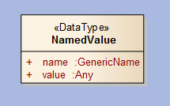
Figure 1 - NamedValue type from O&M
Vocabularies
WaterML2.0 provides a small set of vocabularies for use in its specification of timeseries. There are many places where vocabularies will need to be selected and used based on the requirements of the implementing organisation. Defining which vocabularies are being used in each of these places would allow better interpretation of the vocabularies being used. E.g. what qualifiers are available and what do they mean?
Additionally, vocabularies are encoded in GML XML using an xlink pointer to a term. What the xlink reference refers to is not specified within the encoding, so any link resolution is going to have trouble negotiating any content from the reference. A part of specifying a target vocabulary involves specifying how it will be available (e.g. SKOS etc.), or whether a parser should even dereference it.
WaterML2.0 provides a local dictionary (GML dictionary type) that allows vocabularies that are used within an XML document to be encoded along side the data. This allows a style of local cache whereby the vocabulary definition and some context is provided alongside its use. This is beneficial particularly when documents are to be stored outside of the transfer system as it allows third parties to understand what is being referred to without having access to a vocabulary service. When referencing vocabularies external to the local XML document, WaterML2.0 makes use of the approach now used in GML3.3 whereby xlink:href’s are used to specify HTTP URLs that should resolve to vocabulary descriptions.
Services
WaterML2.0, being based on O&M, has a logical connection with the Sensor Observation Service (SOS) for transferring of data. All of the implementations discussed below relate to WaterML2.0’s use with SOS and how the encoding matches the functions available in SOS. But WaterML2.0 may also be transferred using other web services or exchange protocols, such as FTP, or non XML-POST/XML-RPC/XML-SOAP interfaces. Binding the WaterML2.0 encoding to the service interface involves a number of decisions that directly influence how the WaterML2.0 XML schema is implemented, such as when xlinks are used, what vocabularies references refer to, how default metadata is used etc.
There is one model-driven example described below that attempts a UML description of binding the information model to the service interface. In other cases this information tends to be implicit in a service implementation.
The service itself should provide the means to identify which parts of the WaterML2.0 specification are being conformed to. The SOS provides such a means through a ows:profile XML element. The WaterML2.0 collection type provides a similar element.
Identifiers
There are three general mechanisms with GML to provide ‘identifiers’: gml:id, gml:identifier and gml:name. Each has a specific role as described by GML:
- The gml:name property provides a label or identifier for the object, commonly a descriptive name. Several names may be supplied (often named differently by different organisations);
- The attribute gml:id supports provision of a handle for the XML element representing a GML object. Its use is mandatory for all GML objects.
- gml:identifier is “…a special identifier is assigned to an object by the authority that maintains the feature with the intention that it is used in references to the object.” And is “…is usually unique either globally or within an application domain”.
The actual usage of these varies across implementations, along with their mapping to internal identifier systems. Some use URL identifiers, others just simple alphanumeric identifiers.

Profiling WaterML2.0

Expressing constraints within WaterML2.0
The WaterML2.0 specification consists of multiple related artefacts that express the various information classes, properties and constraints at different implementation levels. An overview of the structure is shown in Figure 2. The conceptual model is expressed in UML, where the UML diagrams represent normative artefacts that capture the key aspects of the types. The structure is based on OGC’s Modular Specification. The model for this is shown in Figure 3.
The XML implementation of the UML model introduces additional requirements that relate specifically to the XML. These requirements are represented in text but are translated into specific Schematron rules. Ongoing management of all the artefacts is an issue, specifically when changes being are being made to multiple parts, or new rules are being developed. Solid Ground and the underlying methodologies are providing improvements in this area.
Within the modular specification, profiles are define as
“…Specification or standard consisting of a set of references to one or more base standards and/or other profiles, and the identification of any chosen conformance test classes, conforming subsets, options and parameters of those base standards, or profiles necessary to accomplish a particular function.”
Whereas extensions are defined as being requirements classes themselves. Thus a profile in the context of current broader use is actually a specification in its own right; consisting of extensions to a standard plus a set of classes that are being conformed to. The modular specification thus provides a good basis on which to structure ‘profile’ definitions themselves. This is consistent with the approach identified with the recent report on using MDA for defining profiles of WDTF. A number of the profile specifications explored within this report take this approach, using a slightly less formal representation of the modular specification. Further work needs to unpack the definition of requirements classes in the OGC context and how these are packaged together to capture additional constraints on classes.
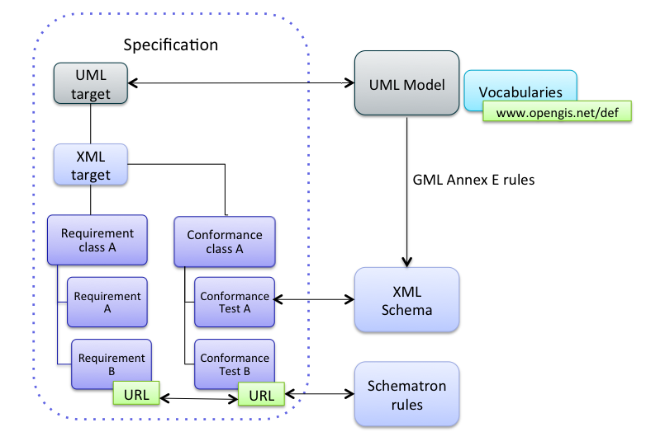
Figure 2 - Specification elements of WaterML2.0
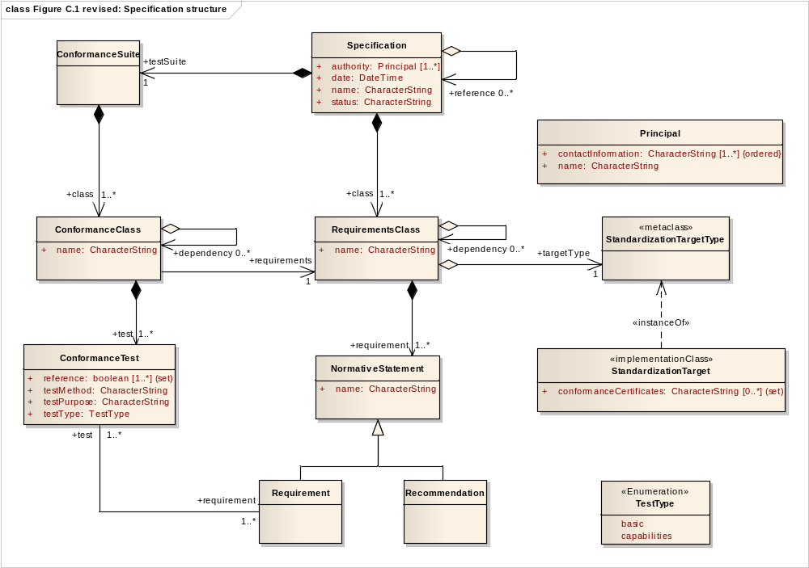
Figure 3 - OGC modular specification model

Existing profile definitions
Many of the existing WaterML2.0 implementations have arisen from three Hydrology Domain Working Group Interoperability Experiments (IE). The level of formalisation of the WaterML2.0 profile definitions within these implementations varies. This section explores these profile definitions and explores the approach taken.

Groundwater IE
The Groundwater IE formalised the profiles used within its final Engineering Report. This detailed the following profile elements:
- 13 requirements for use of Sensor Observation Services;
- 3 requirements for use of Web Feature Services;
- 7 requirements for use of WaterML2.0;
The WaterML2.0 profile components are detailed in Table 1. They show a range of restrictions, some additional business rules that relate to exchange of timeseries specific to monitoring groundwater information; others are general restrictions to provide more clarity for client implementers.
Table 1 - GW IE profile elements
ID | Description | Type of profile element
1 | gml:identifier is mandatory. | Cardinality change of base attribute.
2 | om:parameter shall report spatial location | Use of soft type. Directly associated with a requirements class from O&M: http://www.opengis.net/spec/OMXML/2.0/req/SpatialObservation
3 | om:procedure shall be a reference to the water level sensor at the monitoring well. | Restriction on element content to by-reference only.  Additional restriction on content of target of the reference.
4 | om:observedProperty shall be GroundWaterLevel | Vocabulary restriction.
5 | om:featureOfInterest shall be a resolvable link to the groundwater well in GWML. | Restriction on element content to by-reference only.  Additional restriction on content of target of the reference.  Additional restriction on resolvability of target (WFS).
6 | om:result SHALL be wml2:TimeSeries. | Element restriction. Relates to a requirements class within WaterML2.0.
7 | Within wml2:TimeSeries, wml2:element/wml2:TimeValuePair/wml2:value/swe:Quantity are scalar values with units that represent distance below land-surface datum | Element restriction.  Additional business constrain on units/observed phenomenon.

Surface water IE
The surface water resulted in the definition of a SOS/WaterML2.0 profile specification. This is an example of the coupling of the information to a web service to define how they will be used in concert, rather than a specific WaterML2.0 profile separate from the web service. There are some aspects that will always require specification of the two together. The profile document groups the various rules into four styles of implementation of the SOS. While these relate to the approach of implementing the SOS, the decisions affect the WaterML2.0 profile that is encoded. These are explained in Table 2.
Table 2 - SW IE profile components
ID | Description | Type of profile element
1 | SOS type A: the procedure element encodes the sensor type. | Restriction on element content in WaterML2.0.
2 | SOS type B: the procedure element encodes the sensor instance. | Restriction on element content in WaterML2.0.
3 | SOS type C: the procedure element encodes the sensor type and the feature of interest is a collection. | Restriction on element content in WaterML2.0 x 2.
4 | SOS type D: the procedure element encodes the sensor instance and the offering contains a single instance. | Restriction on element content x 2 (one in WaterML2.0, one in sos:ObservationOffering).

GEOWOW project
The Global Earth Observing System of Systems for Interoperability for Weather, Ocean and Water (GEOWOW) project is aiming to “...improve Earth observation data discovery, accessibility and exploitability, and to evolve GEOSS in terms of interoperability, standardization and functionality”. One of the aspects of this project is focussing on hydrological data exchange and a particular deliverable of this was to define a hydrological data profile for SOS and WaterML2.0. This document is only in draft stage, but the basis are summarised here.
Table 3 - summary of GEOWOW profile
ID | Description | Type of profile element
1 | All sampling features within the scope of this profile shall be restricted to the type wml2:MonitoringPoint. | Restriction on useable sampling feature types.
2 | All procedures within the scope of this profile shall be restricted to the type wml2:ObservationProcess. | Restriction on element content. Satisfies requirement class: http://www.opengis.net/spec/waterml/2.0/req/xsd-observation-process.
3 | Identification of entities shall refer to the gml:identifier field of the entity wherever possible, while the gml:name field shall hold a label name for it. | Restatement of GML requirement.
4 | If the entity is not listed as a complex element and therefore does not feature a gml:identifier, the xlink:href attribute shall be used as identifier, while the xlink:title field shall hold a label name for it. | Conditional restriction on element content.
5 | The GetCapabilities content section shall list sampled features only as related features, no sampling features shall be exposed. | Restriction on capabilities from SOS.
6 | The GetFeatureOfInterest request shall be mandatory. | Restriction on implementation of SOS operation.
7 | The GetFeatureOfInterest request shall return entities of the type wml2:MonitoringPoint only. | Restriction of response type from SOS request in relation to WaterML2.0.
8 | The GetFeatureOfInterest operation shall be extended by an optional feature type parameter. | Extension of SOS operation.
9 | The GetObservation request shall return metadata of all existing timeseries in form of the wml2:TimeseriesObservation element even if they do not contain any values for the requested time range. | Restriction of SOS operation in relation to WaterML2.0.
10 | The GetObservation request shall return all existing timeseries that match the request parameters. | Restriction on SOS operation in relation to WaterML2.0
11 | If the GetObservation request does not contain a temporal filter the service shall only return the last value of each timeseries instead of the full content. | Restriction on SOS operation.

Groundwater Information Network (GIN) SOS 2.0, WaterML2.0 Profile
The GIN SOS profile was used within the GW IE, but has been extended for use within the Climate-Hydrology Information Pilot (CHISP-1). The profile is still work in progress, but initial specifications of the profile provide an example of the style issues being encountered within the broader community. Figure 4 shows a UML description of the profile. This profile differs from others in that it describes the binding of WaterML2.0 to the SOS 2.0 interface using UML, along with some vocabularies for observable property types. Most other profile descriptions don’t capture the mapping between the SOS interface and the application schema. The diagram at its current stage represents an informal specification of the way the SOS is being used with WaterML2.0, plus some example restrictions on vocabularies for the SOS -- the WaterML2.0 model itself is not being profiled any further in this diagram. The diagram would not be used to automate any code or schemas, but as an informative specification of the way the service is being used.
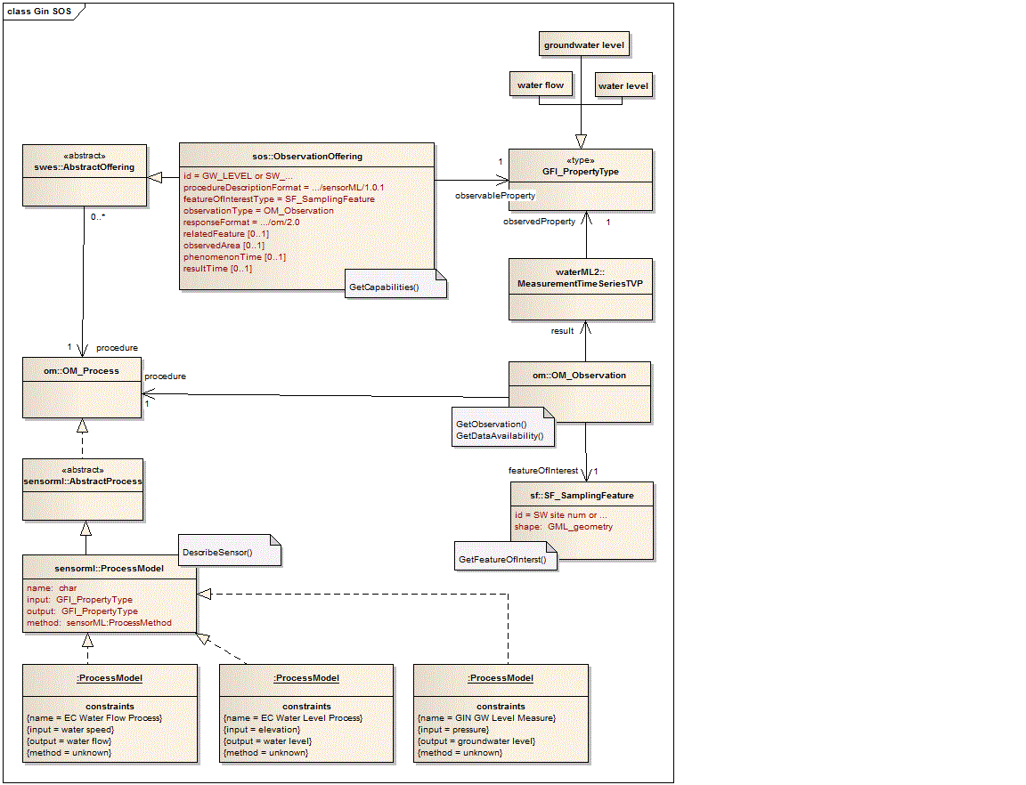
Figure 4 – Draft SOS2.0/WaterML2.0 profile for CHISP-1
This intention of the UML model at this stage is informative in that it does not generate any particular artefacts that are used within implementations.

Summary of profiles
Name | Number of profile components | Granularity | Formality
GW IE | 7 | Medium | Medium
SW IE | 4 | Low | Low
GEOWOW | 11 | Medium | Medium
GIN CHISP-1 | Unspecified | High | Medium-High
Figure 5 - summary of profiles

Existing implementations
This section explores implementations that have no formal specification of their profile; the decisions relating to a profile are merely existent within the implementation of the encoding. An analysis of the existing implementations was performed to understand their scope of implementation and handling of the various profile issues discussed above. The results are available within the Annex A. Not all of the results are described in the Annex for the sake of brevity. The results are summarised here.

Results summary
Generally, the more recent implementations are making better use of WaterML2.0 and its features, with a few providing links back to the conformance classes being implemented. This reflects some learning within the community on how to implement OGC standards.
All the implementations tend to use xlink references to vocabularies that do not exist in any machine readable form – the links do not resolve to a specific definition of the code being used, but an HTML page that provides some basic description of a project. This reflects a lack of machine-readable vocabulary definitions generally across the domain (as well as other domains). Some of the implementing organisations have expressed intentions to move towards SKOS-based, or similar, vocabulary systems.
Most of the implementations make use of SOS as a transport mechanism. The CEH implementation just uses plain XML files that can be referenced using a site identifier within a parameterised URL. The CEH implementation makes use of the wml2:profile element to specify which conformance classes are being adhered to.
Soft-types were used within the WaterOneFlow (CUAHSI) implementation as an extension to the monitoring point types, specifically for elevation (rather than 3D coordinates), county, state and site comments. These are all of type string, so are not highly complicated extensions.
Some of the implementations use incorrect UCUM codes for specifying units. Having an easy place to locate correct UCUM codes for units could alleviate this, or even better, a service that can validate the syntax and check the combinations of units that UCUM supports.

Existing and emerging profile approaches
This section explores broader profiling work that is happening outside of the WaterML2.0 context. It gives an overview of the profiling activity that is occurring as part of the development of the Water Data Transfer Format (WDTF); related work from the GeoSciML ongoing development; and an overview of approaches being using within INSPIRE (Infrastructure for Spatial Information for Europe).

MDA profiles for WDTF
The recent work on profiling within the Bureau of Meteorology (the Bureau) using MDA for WDTF has outlined some additional rules and patterns for modelling profiles in a UML environment. These patterns extend the ISO modelling profile and associated rules for conversion of UML to XML Schema. The requirements addressed are replicated in Table 4. Many of these requirements are relevant to profiling of WaterML2.0 and the broader community.
The implementation of approaches to address each of these requirements is under development. The process is testing various methods and assessing them in terms of their effect on model representation, ease of transformation into other forms (e.g. documentation, validation rules, schema-mapping tools). The level of specification of each approach varies as they are all still in development.
Table 4 - Bureau requirements for modeling profiles
Ref (Bureau document) |  | Name | Description
2.1.1 | Contextual ids |  | Support for designating use of combination of attributes as a composite key
2.2, 2.7 | Sub-typing mechanisms |  | Support for object sub-typing using specialisation or vocabulary binding
2.3 | Reuse of properties |  | Declare that properties are the same when scoped in different feature types
2.4 | Simple vs. Complex types |  | Encoding flexibility to force specialisations to be encoded in a compatible form to profiled schema (e.g. simple type)
2.5 | Defaulting |  | Set default values of schema elements for an implementation. No method defined as yet.
2.6.1 | Transitive simplification |  | Allow related classes to be collapsed to a single class if 1:1 relationship, simplifying encoding. Not currently being investigated.
2.6.2 | Temporality |  | Standard metadata encoding patterns for temporally variable properties
2.8.1 | Vocabulary Reference encoding |  | Standardised encoding of vocabulary terms
2.8.2 | Flexible Vocabs |  | Support extension of vocabularies through binding to fixed and extensible sub-sets.
2.8.3 | Model and Vocab separation |  | Allow vocabularies to be managed independently of profile specifications
3.1 | Documentation artefacts |  | Support association of model with documentation of non-modeled aspects
3.2 | Associating rules |  | Model contextual rules
3.3 | Association of examples |  | Support association of model elements with example documents
3.4 | Mapping classes to implementations |  | Support explicit mappings of model elements to equivalent implementations
4.0 | Modularity |  | Support more flexible containers to allow re-use
4.1 | Transfer metadata |  | Support collection-level metadata definition

The full content of the methodology is not reproduced here, but the process has identified four patterns of profiles that are being tested:
- Package based constraints. Constraints are placed on the UML packages as a whole group using a constraint expression language, such as Object Constraint Language (OCL)
- Parallel schema and profile packages. Separate the specification of the information model profile and the schema schema model that is used to generate the target implementation schema (e.g. XSD files).
- Interleaved schema and profile packages. Profiles are imported by the schema (implementation) packages and classmaps resolve the schema dependencies.
- Mixed schema and profile packages. Combine the profiling and schema definition into one UML model. This is the approached used in the current WaterML2.0 model, and is often done in the existing community to simplify the development process.
The next phase of development of the WaterML2.0 profiling approach should closely take into consideration the learning’s and tools of the WDTF approach.

GeoSciML 3.0
GeoSciML represents one of the more advanced formal models - in the environmental information space - in terms of its approach and definitions of additional constraints. The problem of profiling has been present through a number of versions and version 3.0 defines a specific methodology for handling definitions.
The approach is based on capturing additional rules within Schematron that is associated to documentation that generally is hand written. The reasons identified for making use of Schematron are as follows:
- Some model constraints can't (or can't easily) be expressed in XML Schema but can in Schematron.
- In some cases we want to leave the general model flexible for use in different situations but we want to enforce tighter constraints for use in a particular situation (create a profile).
- Schematron is also convenient for reporting best practice violations that might not render a document invalid but could be reported as warnings.
The schematron rules are broken into validation phases that capture different aspects of a profile definition. These were in development at the time of writing but may be summarised as follows:
- Model constraints: These are constraints that all instances must obey. They may be constraints that belong in the GeoSciML UML model but that can't be enforced by XML Schema or extra constraints we require on imported Schemas which aren't under the governance of GeoSciML, for example.
- Full referential integrity: Check that by reference properties and URI valued properties point to something appropriate.
- CGI profile - Some extra constraints to conform to a standard "CGI profile", mainly meaning using CGI approved dictionaries where they exist for particular properties.
- Onegeology profile: A restricted profile for OneGeology.
- Web Feature Service 2.0: Rules particular to instance documents returned by WFS v2 services
Relating these phases to the WaterML2.0 rules the first two sit within the specification of the conformance classes within the modular specification. These rules are documented in plan English and translated to Schematron manually. This approach is also taken with GeoSciML3.0. This results in rules that are documented, but contain more than one point of truth; if the rule changes, it requires updating in two places. Examination of the rule types indicates they are very similar in nature, suggesting a common approach to management of these rules and documentation elements would be re-usable across communities.

INSPIRE
The INSPIRE approach to model profiles is well documented and contains some extensions to the standard ISO UML modelling techniques. The most relevant is to the definition of profiles is the specification of used vocabularies/code lists. Parts of the approach will be too specific for purposes outside INSPIRE, but the requirements being addressed are similar.

Use of code lists

Enumerations vs. code lists
Recommendation 4: In the case of an attribute type with coded values, an enumeration or code list should be used. If the set of allowed values is fixed, an enumeration should be used. If the set of allowed values may be extended by user communities or without a major revision of the data specification, a code list should be used.

External vocabularies
Recommendation 5: If for a specific property in an INSPIRE application schema, there is already an existing, well-established code list that is maintained by an international organisation, this code list should be referenced from the INSPIRE application schema and they provide the following requirements for externally managed vocabs:
1. It should be managed by a competent international organisation.
2. It should be well maintained, i.e. all its values must remain available forever, even if they have been deprecated, retired or superseded.
3. The code list and each of its values should be identifiable through a persistent URI in the "http" scheme.
4. The code list should be available in HTML plus at least one of the following machine-readable representations:
GML dictionary
SKOS
There is a caveat that recognises that not all lists will meet such requirements, in which case, the values will be made available through the common INSPIRE code list registry

Versioning code lists
Recommendation 6: The reference to the code list should not be to a specific version.

Use of subsets of vocabularies
Recommendation 7: To reference only a subset of an externally managed code list (e.g. only the top level(s) of a hierarchical code list or a certain thematic subset), the subset to be re-used in INSPIRE should be specified in additional requirements.

Extra rules for vocabularies
Must use <<codeList>> stereotype
Type should contain the Value suffix (e.g. SoilTypeValue).
The “vocabulary” tagged value is used to specify the persistent URI for the code list. This may be an existing URI, if available; otherwise “the URI shall be constructed following the pattern http://inspire.ec.europa.eu/codelist/<UpperCamelCaseName>”.
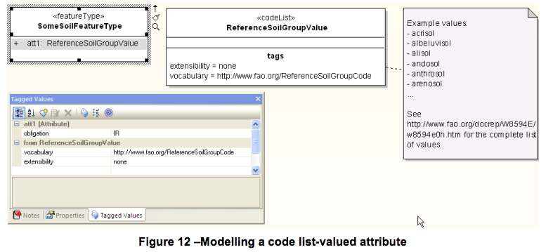
Figure 6 - INSPIRE code list example
Extending vocabularies
INSPIRE provides some rules for extension of vocabularies:
Requirement 28: The extensibility shall be specified using the tagged value “extensibility” on the «codeList» class. The tagged value may take the following values:
- “none” representing code lists whose allowed values comprise only the values specified in the Implementing Rules (a specific domain model);
- “narrower”‖ representing code lists whose allowed values comprise the values specified in the Implementing Rules and narrower values defined by data providers;
- “open” representing code lists whose allowed values comprise the values specified in the IRs and additional values at any level defined by data providers; and
- “any”‖ representing code lists, for which the Implementing Rules do not specify any allowed values, i.e. whose allowed values comprise any values defined by data providers.
The extension here just refers to the use of terms in an implementation – it does not relate to extension of the vocabularies through whatever governance processes are in place by the owning organisation. The “obligation” tag was removed after the extensibility values were redefined.
Requirement 30: An empty code list may also be used as a super-class for a number of specific code lists whose values may be used to specify the attribute value. If the subclasses specified in the model represent all valid extensions to the empty code list, the subtyping relationship shall be qualified with the standard UML constraint "{complete,disjoint}".
An example of this constraint is shown in Figure 7.
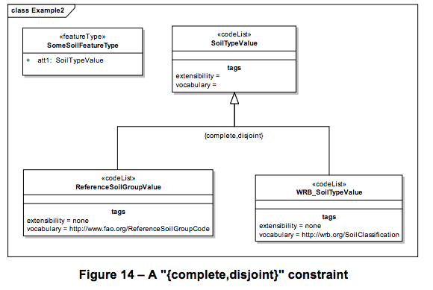
Figure 7 - Example use of complete, disjoint constraint

Recommendations
The level of formality of the description of profiles varies across implementations, which is natural given the different backgrounds of the implementations and profile definitions. As implementations and the community mature, so will their requirements for specifying and sharing profile definitions. As this occurs it will be important the community begins to converge on approaches, else a number of non-consistent approaches emerge. From the cases explored in this report there are beginnings of more formalised approaches, but they are lacking any consistency in terms of granularity and approach taken.

WaterML2.0 profile specification maturity
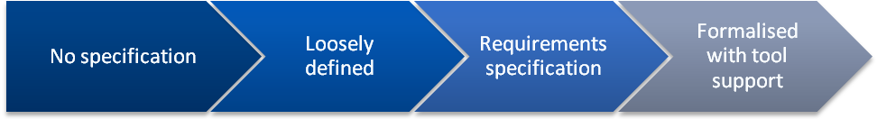
Current approaches
No guidance
Emerging

The following recommendations provide some general points that will assist in progressing towards a fully formal model.

Community repository of profiles
Setup the WaterML2.0 community network site to maintain a list of implementations and profile specifications. Often the first step an implementer takes when profiling a standard is to look how others have done it. If there is an available approach, even if it’s not a fully formalised model, it will provide better consistency than the current situation. Having the definitions available as web pages, rather than within specification documents, also enhances ease of use and discovery. This may simply begin with the WaterML2.0 community wiki page being populated with profile definitions and references.

Templates for profile specifications
Define a simple template that allows specification of the key profile components identified in this report. Along with the first recommendation, this would move the community towards earlier consistency rather than waiting for a standardised, or at least formalised, approach. It also provides a means to identify common vocabularies that are being used within implementations. This will allow implementers who don’t have the capacity to define profiles using UML, OCL and/or Schematron to still define profiles in a sharable and explicit way.

Test WDTF profiling method with WaterML2.0
The WDTF profiling methodology is evolving as various approaches are tested and refined. Currently the method addresses a number of the requirements identified from the Bureau that are also relevant for WaterML2.0. There are differences, however, in how WaterML2.0 has been defined using UML. Using the WDTF profiling methods with WaterML2.0 to capture example WDTF requirements would allow some preliminary results on how well WaterML2.0 may be profiled for WDTF2.0.

Link profiles to validation
A validation tool should provide descriptions of the conformance classes being adhered to within a submitted instance document. An advanced tool would allow for validation against community specified profiles that are captured in a common way.

Annex A – full implementation review results

UK CEH Implementation
http://www.ceh.ac.uk/nrfa/xml/waterml2?db=nrfa_public&stn=92001&dt=gdf
Conformance Classes
References are prefixed by
http://www.opengis.net/spec/waterml/2.0
Reference | Description | Y | P | N | NA | Comments
/req/uml-timeseries-observation |  | Y
/req/uml-timeseries-observation/result | Result is a time series | Y
/req/uml-timeseries-observation/featureOfInterest | FoI is a domain feature or monitoring point | Y |  |  |  | Uses collection reference
/req/uml-timeseries-observation/procedure | Procedure is ObservationProcess (xml  wml2:ObservationProcess) | Y
/req/uml-timeseries-observation/observedProperty | Observed property is of type GFI_PropertyType | Y
/req/uml-timeseries-observation/phenomenonTime | phenomenonTime defines period of observation | Y
/req/uml-timeseries-core |  | Y
/req/uml-timeseries-core/domain-object | Domain is temporal elements of timeseries | Y
/req/uml-timeseries-core/time-increasing | Time values ordered in increasing time | Y
/req/uml-timeseries-core/record-homogenous | The range has a homogeneous type | Y
/req/uml-timeseries-core/quality | Quality comes from the  http://www.opengis.net/def/waterml/2.0/quality namespace |  |  |  | NA | Not used
/req/uml-timeseries-core/timeseries-metadata | Timeseries metadata is of type TimeseriesMetadata (xml  wml2:TimeseriesMetadata) | Y
/req/uml-timeseries-core/point-metadata | Individual points have metadata of type PointMetadata (xml  wml2:TVPMetadata) |  |  |  | NA | Not used
/req/uml-observervation-process |  | Y
/req/uml-observation-process/valid | The om:procedureproperty is of type ObservationProcess (xml  wml2:ObservationProcess) | Y
/req/uml-observation-process/processType | Process type is from the  http://www.opengis.net/def/waterml/2.0/processType namespace | Y
/req/uml-monitoring-point-feature-of-interest  /req/uml-monitoring-point-feature-of-interest/foi | Target of featureOfInterest is a monitoring point | Y
/req/uml-timeseries-domain-range-observation  /req/uml-timeseries-domain-range-observation/result | Domain-range observations  Result of a D-R observation is TimeseriesDomainRange |  |  |  | NA
/req/uml-measurement-timeseries-domain-range-observation  /req/uml-measurement-timeseries-domain-range-observation/result | Measurement D-R observations  Measurement D-R observation is MeasurementTimeseriesDomainRange (xml ???) |  |  |  | NA
/req/uml-categorical-timeseries-domain-range-observation  /req/uml-categorical-timeseries-domain-range-observation/result | Category D-R observations  Category D-R observation result is  CategoricalTimeseriesDomainRange (xml ???) |  |  |  | NA
/req/uml-timeseries-tvp-observation  /req/uml-timeseries-tvp-observation/result | Interleaved Time-Value pair observations  TVP result isTVPTimeseries (xml wml2:Timeseries) | Y
/req/uml-measurement-timeseries-tvp-observation  /req/uml-measurement-timeseries-tvp-observation/result | Measurement TVP observations  Measurement TVP result is  MeasurementTimeseriesTVP (xml  wml2:MeasurementTimeseries) | Y
/req/uml-categorical-timeseries-tvp-observation  /req/uml-timeseries-tvp-observation/result | Category TVP observations  Category TVP result is  CategoricalTimeseriesTVP (xml  wml2:CategoricalTimeseries) |  |  |  | NA
/req/uml-timeseries-domain-range | Domain-range requirements |  |  |  | NA
/req/uml-timeseries-domain-range/domain-range-separate | Domain and range values represented separately with a 1-1 correspondance |  |  |  | NA
/req/uml-timeseries-tvp | Time-value pair requirements | Y
/req/uml-timeseries-tvp/interleaved | Time-value pairs are of type TimeValuePair with geometry the time instant and value the value (xml  wml2:TimeValuePair) | Y
/req/uml-measurement-timeseries-tvp | Measurement TVP requirements | Y
/req/uml-measurement-timeseries-tvp/value-type | Values are of type Measurement | Y
/req/uml-measurement-timeseries-tvp/interpolation-type | Interpolation type is from the  http://www.opengis.net/def/waterml/2.0/interpolationType namespace | Y
/req/uml-categorical-timeseries-tvp | Category TVP requirements |  |  |  | NA
/req/uml-categorical-timeseries-tvp/value-type | Values are of type Category |  |  |  | NA
/req/uml-measurement-timeseries-domain-range | Measurement D-R requirements |  |  |  | NA
/req/uml-measurement-timeseries-domain-range/value-type | Range elements are of type Measurement |  |  |  | NA
/req/uml-categorical-timeseries-domain-range | Category D-R requirements |  |  |  | NA
/req/uml-categorical-timeseries-domain-range-category/value-type | Values are of type Category |  |  |  | NA
/req/uml-monitoring-point/valid | Monitoring point FoI is a valid MonitoringPoint (xml  wml2:MonitoringPoint) | Y
/rec/uml-monitoring-point/time-zone-abbreviation | Time zone should come from  http://www.timeanddate.com/library/abbreviations/timezones/ | Y
/req/uml-sampling-feature-collections | Requirements for sampling feature collections |  |  |  | NA
/req/uml-sampling-feature-collections/groups | Groups of SFs should be SamplingFeatureGroup |  |  |  | NA
/req/uml-collection | Collections requirements | Y
/req/uml-collection/valid | Collection is of type Collection (xml  wml2:Collection) | Y
/req/xsd-xml-rules | Common XML encoding rules | Y
/req/xsd-xml-rules/iso8601-time | Date-time elements use ISO8601 | Y
/req/xsd-xml-rules/time-zone | Time zones use  (Z|[+-]HH:MM) | Y
/req/xsd-xml-rules/unit-of-measure | Uunits of measure use UCUM and wml2:uom | Y
/req/xsd-xml-rules/swe-types | No swe:quality, swe:nilValues, swe:constraint |  |  |  | NA
/rec/xsd-xml-rules/xlink-title | If an xlink:href is used, the xlink:title should also be used | Y
/rec/xsd-xml-rules/vocabulary-references | Vocabulary references using href should be resolvable | Y
/req/xsd-timeseries-observation | Observation XML encoding rules | Y
/req/xsd-timeseries-observation/procedure | om:procedure is wml:ObservationProcess or xlink | Y
/req/xsd-timeseries-observation/metadata | om:metadatais from  wml2:ObservationMetadata substitutions or xlink | Y
/req/xsd-timeseries-observation/result | om:result is from wml2:Timeseries subtitutions | Y
/req/xsd-timeseries-observation/phenomenonTime | om:phenomoenonTime contains gml:TimePeriod | Y
/rec/xsd-timeseries-observation/resultQuality | om:resultQuality is xlink |  |  |  | NA
/req/xsd-timeseries-tvp-observation  /req/xsd-timeseries-tvp-observation/result | XML requirements for TVP observations  Result is from wml2:Timeseries substitutions | Y
/req/xsd-measurement-timeseries-tvp-observation  /req/xsd-measurement-timeseries-tvp-observation/result | XML requirements for Measurement TVPs  Result is wml2:MeasurementTimeseries | Y
/req/xsd-categorical-timeseries-tvp-observation  /req/xsd-categorical-timeseries-tvp-observation/result | XML requirements for Category TVPs  Result is wml:CategoricalTimeseries |  |  |  | NA
/req/xsd-timeseries-tvp | XML requirements for TVPs | Y
/req/xsd-timeseries-tvp/valid | Content matches wml2:Timeseries | Y
/req/xsd-timeseries-tvp/time-increasing | Time values increase | Y
/req/xsd-timeseries-tvp/record-homogenous | Values are homogenous types | Y
/req/xsd-timeseries-tvp/domain-time | Domain is time value | Y
/req/xsd-timeseries-tvp/default-point-metadata | Presence of wml:defaultPointMetadata permitted | Y
/req/xsd-timeseries-tvp/equidistant-encoding | If baseTime and spacing defined, time is not present |  |  |  | NA
/req/xsd-timeseries-tvp/time-mandatory | If baseTime and spacing not defined, time is present | Y
/req/xsd-timeseries-tvp/null-value | If value is null, xsi:nil set to true |  |  |  | NA
/req/xsd-timeseries-tvp/null-point-reason | If value is null, nilReason or censoredReason is set |  |  |  | NA
/req/xsd-timeseries-tvp/timeseries-metadata | Timeseries metadata is of type  wml2:TimeseriesMetadata substitution | Y
/rec/xsd-timeseries-tvp/nil-reason-vocab | Nil reason is from the  http://www.opengis.net/def/nil/OGC/0 namespace |  |  |  | NA
/req/xsd-measurement-timeseries-tvp | XML requirements for measurement TVPs | Y
/req/xsd-measurement-tvp-timeseries/interpolation-type | Either explicit or default interpolation type defined | Y
/req/xsd-measurement-tvp-timeseries/value-measure | Type of wml2:pointis  wml2:MeasurementTVP | Y
/req/xsd-measurement-tvp-timeseries/point-metadata | Point metadata is  wml2:TVPMeasurementMetadata or default point metadata is wml2:DefaultTVPMeasurementMetadata | Y
/req/xsd-categorical-timeseries-tvp | XML categorical TVP requirements |  |  |  | NA
/req/xsd-categorical-timeseries-tvp/value-category | Type of wm2point is  wml2:CategoricalTVP |  |  |  | NA
/req/xsd-categorical-tvp-timeseries/metadata | Point metadata is  wml2:CategoricalTimeseriesMetadata or default point metadata is wml2:CategoricalTimeseriesMetadata |  |  |  | NA
/req/xsd-feature-of-interest-monitoring-point | FoI is  wml2:MonitoringPoint | Y
/req/xsd-observation-process  /req/xsd-observation-process/valid | process is  wml2:ObservationProcess or xlink | Y
/req/xsd-monitoring-point  /req/xsd-monitoring-point/valid | Monitoring point is a valid wml2:MonitoringPoint | Y
/req/xsd-collection  /req/xsd-collection/valid | Collection conforms to  wml2:Collection | Y

Summary of profile elements
Identifier Use and Description
- gml:identifier is used to identify observations, gml:description is not used
- Internal use of gml:id for document fragments
Use of Soft Types and Extension
Definition of terms used in soft types, e.g. NamedValue pairs.
- No soft types used
Availability and 'formality' of definition of the profile
Is GetCaps describing the conf classes implemented
- Observation offerings from GetCapabilities lists text/xml; subtype=""WaterML/2.0" as a format
- Observation offerings from GetCapabilities lists wml:WaterMonitoringObservation as a result model (this seems to be an old reference)
- Document metadata uses wml2:profile to list conformance classes
Vocabularies
Use of WaterML2 vocabs
Are WaterML2 vocabs being adhered to?
- Yes, a thousand times yes!
Use of internal vocabs
When internal vocabularies are used, how is the implementation described?
- Vocabularies use code spaces
- Sampled feature is not resolvable, simply referring back to the organisational web site. Feature is named.
- Status is not resolvable, referring back to a descriptive web page
Encoding of vocabularies
Do vocabularies refer to code spaces or code lists?
- Yes. Local CEH code space http://www.ceh.ac.uk/data/nrfa used
Use of local dictionaries for caching
Are local codes/internal vocabularies encoded in a local dictionary?
- Property vocabularies are defined using local dictionaries
Use of default metadata in time series stream
Is a default metadata object used for common point metadata?
- Yes
Handling of domain concepts
Vertical profiles
- No vertical columns of data used
- Monitoring point specifies a verticalDatum using urn:ogc:def:crs:EPSG::7405 format
Feature of interest
Is the monitoring point property described, with appropriate references to sampled feature, etc. Is the point named, responsible organisation named
- Yes, although sampled feature is not resolvable
Domain Features
- Domain features are limited to items specifically referenced by the specification
Procedures
Is an observation procedure defined with supporting data as to the type and quality of the observation
- Observation process lists process type (Unknown) and has a general link to an organisational web page.
Use of services
Use of linked open data. Use of other OGC services.
- No use of linked open data beyond OGC URIs

USGS SOS 2.0 implementation
http://nwisvaws02.er.usgs.gov/ogc-swie/
Conformance Classes
References are prefixed by
http://www.opengis.net/spec/waterml/2.0
Reference | Description | Y | P | N | NA | Comments
/req/uml-timeseries-observation |  | Y
/req/uml-timeseries-observation/result | Result is a time series | Y
/req/uml-timeseries-observation/featureOfInterest | FoI is a domain feature or monitoring point | Y
/req/uml-timeseries-observation/procedure | Procedure is ObservationProcess (xml  wml2:ObservationProcess) |  |  | N |  | Link to html description
/req/uml-timeseries-observation/observedProperty | Observed property is of type GFI_PropertyType |  |  | N |  | Link to html description
/req/uml-timeseries-observation/phenomenonTime | phenomenonTime defines period of observation | Y
/req/uml-timeseries-core |  | Y
/req/uml-timeseries-core/domain-object | Domain is temporal elements of timeseries | Y
/req/uml-timeseries-core/time-increasing | Time values ordered in increasing time | Y
/req/uml-timeseries-core/record-homogenous | The range has a homogeneous type | Y
/req/uml-timeseries-core/quality | Quality comes from the  http://www.opengis.net/def/waterml/2.0/quality namespace |  |  |  | NA | Not used
/req/uml-timeseries-core/timeseries-metadata | Timeseries metadata is of type TimeseriesMetadata (xml  wml2:TimeseriesMetadata) | Y
/req/uml-timeseries-core/point-metadata | Individual points have metadata of type PointMetadata (xml  wml2:TVPMetadata) |  |  |  | NA | Default point metadata used
/req/uml-observervation-process |  |  |  | N
/req/uml-observation-process/valid | The om:procedureproperty is of type ObservationProcess (xml  wml2:ObservationProcess) |  |  | N
/req/uml-observation-process/processType | Process type is from the  http://www.opengis.net/def/waterml/2.0/processType namespace |  |  | N
/req/uml-monitoring-point-feature-of-interest  /req/uml-monitoring-point-feature-of-interest/foi | Target of featureOfInterest is a monitoring point | Y
/req/uml-timeseries-domain-range-observation  /req/uml-timeseries-domain-range-observation/result | Domain-range observations  Result of a D-R observation is TimeseriesDomainRange |  |  |  | NA
/req/uml-measurement-timeseries-domain-range-observation  /req/uml-measurement-timeseries-domain-range-observation/result | Measurement D-R observations  Measurement D-R observation is MeasurementTimeseriesDomainRange (xml ???) |  |  |  | NA
/req/uml-categorical-timeseries-domain-range-observation  /req/uml-categorical-timeseries-domain-range-observation/result | Category D-R observations  Category D-R observation result is  CategoricalTimeseriesDomainRange (xml ???) |  |  |  | NA
/req/uml-timeseries-tvp-observation  /req/uml-timeseries-tvp-observation/result | Interleaved Time-Value pair observations  TVP result isTVPTimeseries (xml wml2:Timeseries) | Y
/req/uml-measurement-timeseries-tvp-observation  /req/uml-measurement-timeseries-tvp-observation/result | Measurement TVP observations  Measurement TVP result is  MeasurementTimeseriesTVP (xml  wml2:MeasurementTimeseries) | Y
/req/uml-categorical-timeseries-tvp-observation  /req/uml-timeseries-tvp-observation/result | Category TVP observations  Category TVP result is  CategoricalTimeseriesTVP (xml  wml2:CategoricalTimeseries) |  |  |  | NA
/req/uml-timeseries-domain-range | Domain-range requirements |  |  |  | NA
/req/uml-timeseries-domain-range/domain-range-separate | Domain and range values represented separately with a 1-1 correspondance |  |  |  | NA
/req/uml-timeseries-tvp | Time-value pair requirements | Y
/req/uml-timeseries-tvp/interleaved | Time-value pairs are of type TimeValuePair with geometry the time instant and value the value (xml  wml2:TimeValuePair) | Y
/req/uml-measurement-timeseries-tvp | Measurement TVP requirements |  | P
/req/uml-measurement-timeseries-tvp/value-type | Values are of type Measurement | Y
/req/uml-measurement-timeseries-tvp/interpolation-type | Interpolation type is from the  http://www.opengis.net/def/waterml/2.0/interpolationType namespace |  |  | N |  | Uses http://www.opengis.net/def/interpolationType/WaterML/2.0
/req/uml-categorical-timeseries-tvp | Category TVP requirements |  |  |  | NA
/req/uml-categorical-timeseries-tvp/value-type | Values are of type Category |  |  |  | NA
/req/uml-measurement-timeseries-domain-range | Measurement D-R requirements |  |  |  | NA
/req/uml-measurement-timeseries-domain-range/value-type | Range elements are of type Measurement |  |  |  | NA
/req/uml-categorical-timeseries-domain-range | Category D-R requirements |  |  |  | NA
/req/uml-categorical-timeseries-domain-range-category/value-type | Values are of type Category |  |  |  | NA
/req/uml-monitoring-point/valid | Monitoring point FoI is a valid MonitoringPoint (xml  wml2:MonitoringPoint) | Y
/rec/uml-monitoring-point/time-zone-abbreviation | Time zone should come from  http://www.timeanddate.com/library/abbreviations/timezones/ | Y
/req/uml-sampling-feature-collections | Requirements for sampling feature collections |  |  |  | NA
/req/uml-sampling-feature-collections/groups | Groups of SFs should be SamplingFeatureGroup |  |  |  | NA
/req/uml-collection | Collections requirements | Y
/req/uml-collection/valid | Collection is of type Collection (xml  wml2:Collection) | Y
/req/xsd-xml-rules | Common XML encoding rules |  | P
/req/xsd-xml-rules/iso8601-time | Date-time elements use ISO8601 | Y
/req/xsd-xml-rules/time-zone | Time zones use  (Z|[+-]HH:MM) | Y
/req/xsd-xml-rules/unit-of-measure | Uunits of measure use UCUM and wml2:uom |  |  | N |  | cfs is not a valid UCUM code
/req/xsd-xml-rules/swe-types | No swe:quality, swe:nilValues, swe:constraint | Y
/rec/xsd-xml-rules/xlink-title | If an xlink:href is used, the xlink:title should also be used | Y
/rec/xsd-xml-rules/vocabulary-references | Vocabulary references using href should be resolvable |  | P |  |  | wml2:qualifier xlink:href="http://waterdata.usgs.gov/WI/nwis/help" xlink:title="Provisional data subject to revision." only partially resolvable
/req/xsd-timeseries-observation | Observation XML encoding rules | Y
/req/xsd-timeseries-observation/procedure | om:procedure is wml:ObservationProcess or xlink | Y
/req/xsd-timeseries-observation/metadata | om:metadata is from  wml2:ObservationMetadata substitutions or xlink | Y
/req/xsd-timeseries-observation/result | om:result is from wml2:Timeseries subtitutions | Y
/req/xsd-timeseries-observation/phenomenonTime | om:phenomoenonTime contains gml:TimePeriod | Y
/rec/xsd-timeseries-observation/resultQuality | om:resultQuality is xlink |  |  |  | NA | Not present
/req/xsd-timeseries-tvp-observation  /req/xsd-timeseries-tvp-observation/result | XML requirements for TVP observations  Result is from wml2:Timeseries substitutions | Y
/req/xsd-measurement-timeseries-tvp-observation  /req/xsd-measurement-timeseries-tvp-observation/result | XML requirements for Measurement TVPs  Result is wml2:MeasurementTimeseries | Y
/req/xsd-categorical-timeseries-tvp-observation  /req/xsd-categorical-timeseries-tvp-observation/result | XML requirements for Category TVPs  Result is wml:CategoricalTimeseries |  |  |  | NA
/req/xsd-timeseries-tvp | XML requirements for TVPs | Y
/req/xsd-timeseries-tvp/valid | Content matches wml2:Timeseries | Y
/req/xsd-timeseries-tvp/time-increasing | Time values increase | Y
/req/xsd-timeseries-tvp/record-homogenous | Values are homogenous types | Y
/req/xsd-timeseries-tvp/domain-time | Domain is time value | Y
/req/xsd-timeseries-tvp/default-point-metadata | Presence of wml:defaultPointMetadata permitted | Y
/req/xsd-timeseries-tvp/equidistant-encoding | If baseTime and spacing defined, time is not present |  |  |  | NA | Not used
/req/xsd-timeseries-tvp/time-mandatory | If baseTime and spacing not defined, time is present | Y
/req/xsd-timeseries-tvp/null-value | If value is null, xsi:nil set to true |  |  |  | NA | Not used
/req/xsd-timeseries-tvp/null-point-reason | If value is null, nilReason or censoredReason is set |  |  |  | NA | Not used
/req/xsd-timeseries-tvp/timeseries-metadata | Timeseries metadata is of type  wml2:TimeseriesMetadata substitution | Y
/rec/xsd-timeseries-tvp/nil-reason-vocab | Nil reason is from the  http://www.opengis.net/def/nil/OGC/0 namespace |  |  |  | NA | Not used
/req/xsd-measurement-timeseries-tvp | XML requirements for measurement TVPs | Y
/req/xsd-measurement-tvp-timeseries/interpolation-type | Either explicit or default interpolation type defined | Y
/req/xsd-measurement-tvp-timeseries/value-measure | Type of wml2:point is  wml2:MeasurementTVP | Y
/req/xsd-measurement-tvp-timeseries/point-metadata | Point metadata is  wml2:TVPMeasurementMetadata or default point metadata is wml2:DefaultTVPMeasurementMetadata | Y
/req/xsd-categorical-timeseries-tvp | XML categorical TVP requirements |  |  |  | NA
/req/xsd-categorical-timeseries-tvp/value-category | Type of wm2point is  wml2:CategoricalTVP |  |  |  | NA
/req/xsd-categorical-tvp-timeseries/metadata | Point metadata is  wml2:CategoricalTimeseriesMetadata or default point metadata is wml2:CategoricalTimeseriesMetadata |  |  |  | NA
/req/xsd-feature-of-interest-monitoring-point | FoI is  wml2:MonitoringPoint | Y
/req/xsd-observation-process  /req/xsd-observation-process/valid | process is  wml2:ObservationProcess or xlink |  | P |  |  | Xlink to non-process
/req/xsd-monitoring-point  /req/xsd-monitoring-point/valid | Monitoring point is a valid wml2:MonitoringPoint | Y
/req/xsd-collection  /req/xsd-collection/valid | Collection conforms to  wml2:Collection | Y

Identifier Use and Description
- No use of gml:identifier or gml:descrioption
- Internal use of gml:id for document fragments
Use of Soft Types and Extension
Definition of terms used in soft types, e.g. NamedValue pairs.
- Used in monitoring point to identify watershed
Availability and 'formality' of definition of the profile
Is GetCaps describing the conf classes implemented
- Observation offerings from GetCapabilities lists text/xml; subtype="WML2" as a format
Vocabularies
Use of WaterML2 vocabs
Are WaterML2 vocabs being adhered to?
- Interpolation type has incorrect URI
- Invalid UCUM units
Use of internal vocabs
When internal vocabularies are used, how is the implementation described?
- Internal vocabularies use xlink:href/xlink:title URI pairs. The URIs refer to html pages of varying degrees of specificity.
Encoding of vocabularies
Do vocabularies refer to code spaces or code lists?
- responsilbe party metadata uses the ISO TC 211 role codes http://www.isotc211.org/2005/resources/CodeList/gmxCodelists.xml#CI_RoleCode
Use of local dictionaries for caching
Are local codes/internal vocabularies encoded in a local dictionary?
- Not used
Use of default metadata in time series stream
Is a default metadata object used for common point metadata?
- Yes
Handling of domain concepts
Feature of interest
Is the monitoring point property described, with appropriate references to sampled feature, etc. Is the point named, responsible organisation named
Procedures
Is an observation procedure defined with supporting data as to the type and quality of the observation
- ObservationProcess is not used. Instead, an xlink to a text page is used.
Use of services
Use of linked open data. Use of other OGC services.
- Property types a semi-linked open data, resolving to an html description page
- Sampled feature is a link to a WFS

References
- Atkinson R, Cox S, Yu J, Taylor P, Walker G, Francis W (2012). Implementing WDTF Data Specifications using a Model Driven Architecture: A methodology to support creation, registration, retrieval and cross referencing of data exchange specifications, with particular regard to profiles of Observations and Measurements and WaterML 2.0.
- GeoSciML: https://www.seegrid.csiro.au/wiki/CGIModel/GeoSciMLModel
- OGC Observations and Measurements v2.0 OGC Document 10-004r1 http://www.opengis.net/doc/AS/Topic20 (also published as ISO 19156:2010, Geographic information — Observations and Measurements)
- USGS SOS 2.0 implementation
  - Implemetaiton used for analysis: http://nwisvaws02.er.usgs.gov/ogc-swie/
- NRCan SOS 1.0 implementation
  - Implementation used: http://ngwd-bdnes.cits.nrcan.gc.ca/service/api_ngwds/en/sosform.html#d246e91a5065
- 52North, smart project SOS 2.0 implementation
  - Implementation used: https://wiki.52north.org/bin/view/Projects/GSoC2012ProjectsExchangeableEncodingsForSos, Example SOS request
- Smart project (NZ GW monitoring: http://www.smart-project.info/)
- GEOWOW project SOS profile definition
  - http://www.geowow.eu/deliverables.html
  - Profile report: https://wiki.csiro.au/download/attachments/545044370/Hydrology+Profile+for+SOS+and+WML2_2.doc?version=1&modificationDate=1341467370143
- CUAHSI implementation WaterOneFlow implementation
  - Implementation used: http://river.sdsc.edu/wiki/(X(1)S(ocg4qjn0sinjkv555hvmbd55))/Default.aspx?Page=GenericODws%20WaterML2%20prototypes&NS=&AspxAutoDetectCookieSupport=1
- SISS4BoM implementation SOS 2.0
  - Ref implementation used: https://www.seegrid.csiro.au/wiki/SISS4BoM/SISSExtensions
  - Mapping of the IMOS buoy database (contains use cases for compound results, vertical profiles, use of feature of interest etc): https://jira.csiro.au/browse/SBOM-36
- UK CEH Implementation
  - http://www.ceh.ac.uk/nrfa/xml/waterml2?db=nrfa_public&stn=92001&dt=gdf

CONTACT US  t 1300 363 400  +61 3 9545 2176  e enquiries@csiro.au  w www.csiro.au  Your CSIRO  Australia is founding its future on science and innovation. Its national science agency, CSIRO, is a powerhouse of ideas, technologies and skills for building prosperity, growth, health and sustainability. It serves governments, industries, business and communities across the nation. |  | For further information  ICT Centre  Peter Taylor  t +61 3 6232 5530  e peter.taylor@csiro.au  w www.csiro.au/ict  CSIRO Land and Water  David Lemon  t +61 3 9123 4567  e david.lemon@csiro.au  w http://www.clw.csiro.au/

https://www.seegrid.csiro.au/wiki/CGIModel/GeoSciML3SchematronRules

