Open Geospatial Consortium
Submission Date: YYYY-MM-DD
Approval Date: YYYY-MM-DD
Publication Date: YYYY-MM-DD
External identifier of this OGC® document: http://www.opengis.net/doc/wp/XXX
Internal reference number of this OGC® document: 25-038
Category: OGC® Technical Paper
Editors: Kathi Schleidt

Observation and Sampling of a Smiley Face
Observations, Measurements and Samples 101

Copyright notice
Copyright © YYYY Open Geospatial Consortium
To obtain additional rights of use, visit http://www.opengeospatial.org/legal/.

Warning
This document is not an OGC Standard. This document is an OGC Technical Paper and is therefore not an official position of the OGC membership. It is distributed for review and comment. It is subject to change without notice and may not be referred to as an OGC Standard. Further, an OGC Technical Paper should not be referenced as required or mandatory technology in procurements.
Document type: OGC® Technical Paper
Document subtype:
Document stage: Draft/Approved for Public Release
Document language: English

License Agreement
Permission is hereby granted by the Open Geospatial Consortium, ("Licensor"), free of charge and subject to the terms set forth below, to any person obtaining a copy of this Intellectual Property and any associated documentation, to deal in the Intellectual Property without restriction (except as set forth below), including without limitation the rights to implement, use, copy, modify, merge, publish, distribute, and/or sublicense copies of the Intellectual Property, and to permit persons to whom the Intellectual Property is furnished to do so, provided that all copyright notices on the intellectual property are retained intact and that each person to whom the Intellectual Property is furnished agrees to the terms of this Agreement.
If you modify the Intellectual Property, all copies of the modified Intellectual Property must include, in addition to the above copyright notice, a notice that the Intellectual Property includes modifications that have not been approved or adopted by LICENSOR.
THIS LICENSE IS A COPYRIGHT LICENSE ONLY, AND DOES NOT CONVEY ANY RIGHTS UNDER ANY PATENTS THAT MAY BE IN FORCE ANYWHERE IN THE WORLD.
THE INTELLECTUAL PROPERTY IS PROVIDED "AS IS", WITHOUT WARRANTY OF ANY KIND, EXPRESS OR IMPLIED, INCLUDING BUT NOT LIMITED TO THE WARRANTIES OF MERCHANTABILITY, FITNESS FOR A PARTICULAR PURPOSE, AND NONINFRINGEMENT OF THIRD PARTY RIGHTS. THE COPYRIGHT HOLDER OR HOLDERS INCLUDED IN THIS NOTICE DO NOT WARRANT THAT THE FUNCTIONS CONTAINED IN THE INTELLECTUAL PROPERTY WILL MEET YOUR REQUIREMENTS OR THAT THE OPERATION OF THE INTELLECTUAL PROPERTY WILL BE UNINTERRUPTED OR ERROR FREE. ANY USE OF THE INTELLECTUAL PROPERTY SHALL BE MADE ENTIRELY AT THE USER’S OWN RISK. IN NO EVENT SHALL THE COPYRIGHT HOLDER OR ANY CONTRIBUTOR OF INTELLECTUAL PROPERTY RIGHTS TO THE INTELLECTUAL PROPERTY BE LIABLE FOR ANY CLAIM, OR ANY DIRECT, SPECIAL, INDIRECT OR CONSEQUENTIAL DAMAGES, OR ANY DAMAGES WHATSOEVER RESULTING FROM ANY ALLEGED INFRINGEMENT OR ANY LOSS OF USE, DATA OR PROFITS, WHETHER IN AN ACTION OF CONTRACT, NEGLIGENCE OR UNDER ANY OTHER LEGAL THEORY, ARISING OUT OF OR IN CONNECTION WITH THE IMPLEMENTATION, USE, COMMERCIALIZATION OR PERFORMANCE OF THIS INTELLECTUAL PROPERTY.
This license is effective until terminated. You may terminate it at any time by destroying the Intellectual Property together with all copies in any form. The license will also terminate if you fail to comply with any term or condition of this Agreement. Except as provided in the following sentence, no such termination of this license shall require the termination of any third party end-user sublicense to the Intellectual Property which is in force as of the date of notice of such termination. In addition, should the Intellectual Property, or the operation of the Intellectual Property, infringe, or in LICENSOR’s sole opinion be likely to infringe, any patent, copyright, trademark or other right of a third party, you agree that LICENSOR, in its sole discretion, may terminate this license without any compensation or liability to you, your licensees or any other party. You agree upon termination of any kind to destroy or cause to be destroyed the Intellectual Property together with all copies in any form, whether held by you or by any third party.
Except as contained in this notice, the name of LICENSOR or of any other holder of a copyright in all or part of the Intellectual Property shall not be used in advertising or otherwise to promote the sale, use or other dealings in this Intellectual Property without prior written authorization of LICENSOR or such copyright holder. LICENSOR is and shall at all times be the sole entity that may authorize you or any third party to use certification marks, trademarks or other special designations to indicate compliance with any LICENSOR standards or specifications. This Agreement is governed by the laws of the Commonwealth of Massachusetts. The application to this Agreement of the United Nations Convention on Contracts for the International Sale of Goods is hereby expressly excluded. In the event any provision of this Agreement shall be deemed unenforceable, void or invalid, such provision shall be modified so as to make it valid and enforceable, and as so modified the entire Agreement shall remain in full force and effect. No decision, action or inaction by LICENSOR shall be construed to be a waiver of any rights or remedies available to it.

Introduction
This OGC document provides an overview of the OGC/ISO Observations, measurements and samples (OMS) standard (ISO 19156:2023). The core example is abstracted from the currently described OMS use cases, often pertaining to measurements on specific media. To illustrate the applicability of OMS, the example of determining the color of a smiley face sticker is used. This is in order to avoid bias by focusing on a specific domain. The example covers all concepts defined within the OMS Standard, showing all options for both Observation and Sampling representation.
The same mechanisms utilized here to define the core example can be applied to a wide range of topics such as:
- Ozone concentration of the air at a point
- River flow at a given hydro station
- Nitrate concentration of a water sample
  - Various statistics on the concentration over time, e.g. mean, min, max, percentiles
- Consistency of a soil sample
- Temperature of a room
- State of a traffic light
- Population density in a NUTS region
- Gender distribution within the districts of a city
In the final section of this document, real-world examples of the implementation and use of the OMS Standard are provided.

Symbology
Within this document, a simplified representation of UML object diagrams is utilized. In order to avoid overloading the diagrams with text, a few conventions are defined:
- Classes are represented by rectangular forms, literals by ovals.
- The specific class represented is indicated by color, as shown in the legends in Figure 1 - Figure 3 below.
- Representative text is displayed within the form.

While color coding can cause issues for the colorblind, the advantages for the color-sighted outweigh this issue. In order to enable the colorblind to follow, the legend includes the text used in the main diagrams.
The full UML of the OMS model is available from the ISO cloud.

Classes and Objects
In the simplified UML object diagram representation, all objects are depicted as rectangles. The legend below shows the color scheme used to differentiate between the classes of the OMS model in all the Figures of this document. For example, medium blue rectangles represent instances (objects) of the OMS Observation class. The ObservationCharacteristics and ObservingCapabilities are rendered in darker shades of blue, as these concepts are very closely related to the Observation concept.
For the Observation part of the OMS model, the following legend applies:
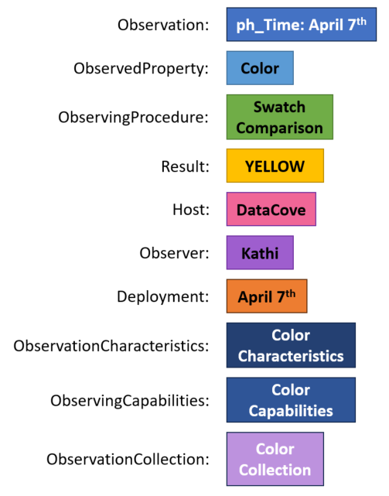
Figure 1: Legend Observation

For the Sampling part of the OMS model, the following legend applies:
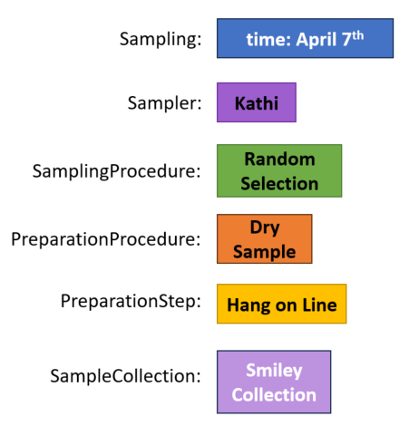
Figure 2: Legend Sampling

Literals
In our simplified UML object diagram representation, all literals (e.g. simple strings) are depicted as ovals, as shown in the figure below.
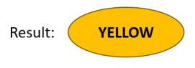
Figure 3: Legend Literals

Observation of a Smiley Face

Simplest form – class with attributes
The simplest form of an Observation is an attribute that carries information on an object (feature). As shown in both Figure 4 and Box 1, the color and expression of a smiley face sticker is being observed. In the simplest form, the object has the two attributes Color and Expression, with the values YELLOW and HAPPY respectively,.

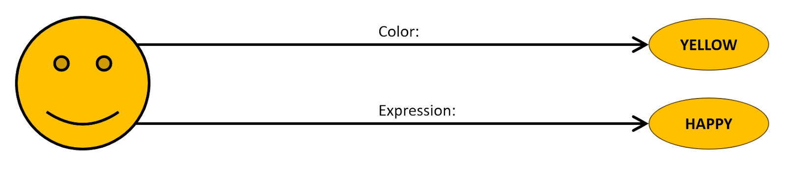
Figure 4: Smiley with simple attributes
{
"color": "Yellow",
"expression": "Happy"
}
Box 1: JSON representation of Smiley with simple attributes.

This example works well as long as no additional information needs to be provided together with the attribute. However, if additional qualifiers to the attribute, such as the ObservingProcedure used to ascertain the value, are required, this approach becomes difficult. We cannot provide this procedural information with the simple attribute approach. This leads to the ObservingProcedure information floating next to the attribute information, as shown in Figure 5
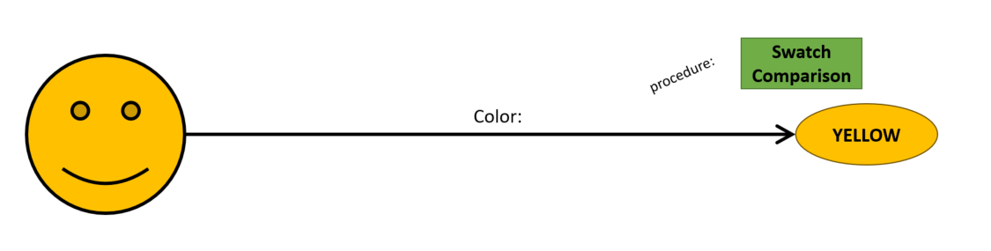
Figure 5: Smiley with floating Procedure

Basic Observation
This is where the OMS Observation comes into play. The Observation class is designed to collect all relevant information on how an observation was performed. In the OMS model, the Procedure (OMS ObservingProcedure class) is linked to the observation class. This provides necessary context to the resulting value. Figure 6 shows how Observation can be used to bring the ObservingProcedure from above into context (in our example ‘Swatch Comparison’).
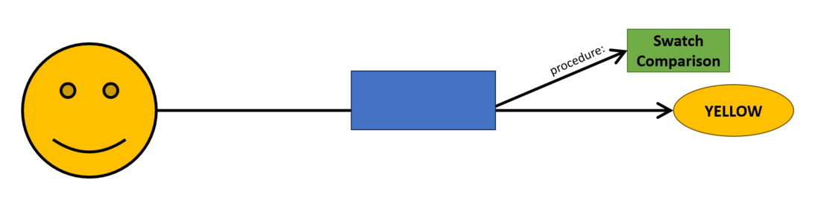
Figure 6: Basic Observation Take 1

However, now that Observation has been introduced, the information on what exactly the attribute represents, in this example ‘Color’, has been lost. Thus, an additional association ObservedProperty must be added to the Observation to convey this information, as shown in Figure 7.
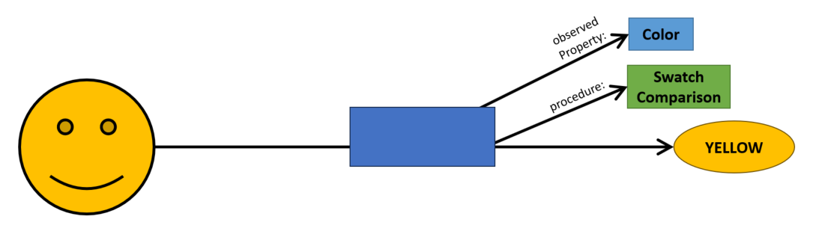
Figure 7: Basic Observation Take 2

In order to complete the picture of the basic Observation, some additional information is required. The association to the Result, in this case ‘YELLOW’, gets the association role result, while the association to the Smiley Face, the object of the Observation, gets the association role featureOfInterest to identify what feature the observation is actually about, as shown in Figure 8. This is in line with the Observation concept from O&M.
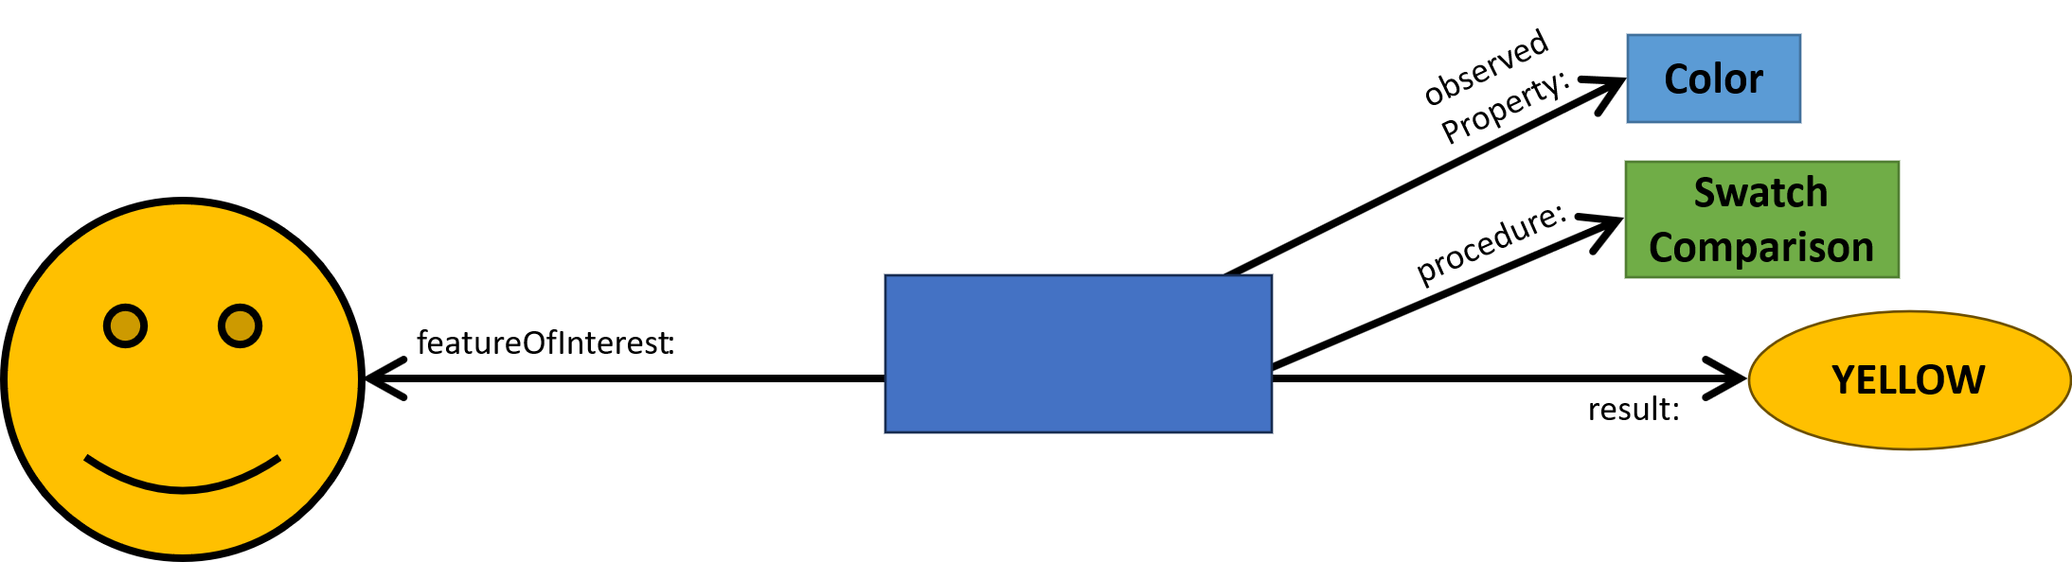
Figure 8: Complete basic Observation

Observer and Host
Within OMS, some additional concepts are introduced. The first is the Observer, the entity that made the Observation. This can be a sensor or alternatively a human being as shown in Figure 9.

The addition of the Observer solves the old question under O&M of what the Procedure describes: The process performed (e.g. the steps laid down by an ISO analysis standard) or the explicit device performing the measurement (e.g. a specific sensor). The Observer describes the explicit device performing the observation, while the Procedure describes the process performed to gain a result.

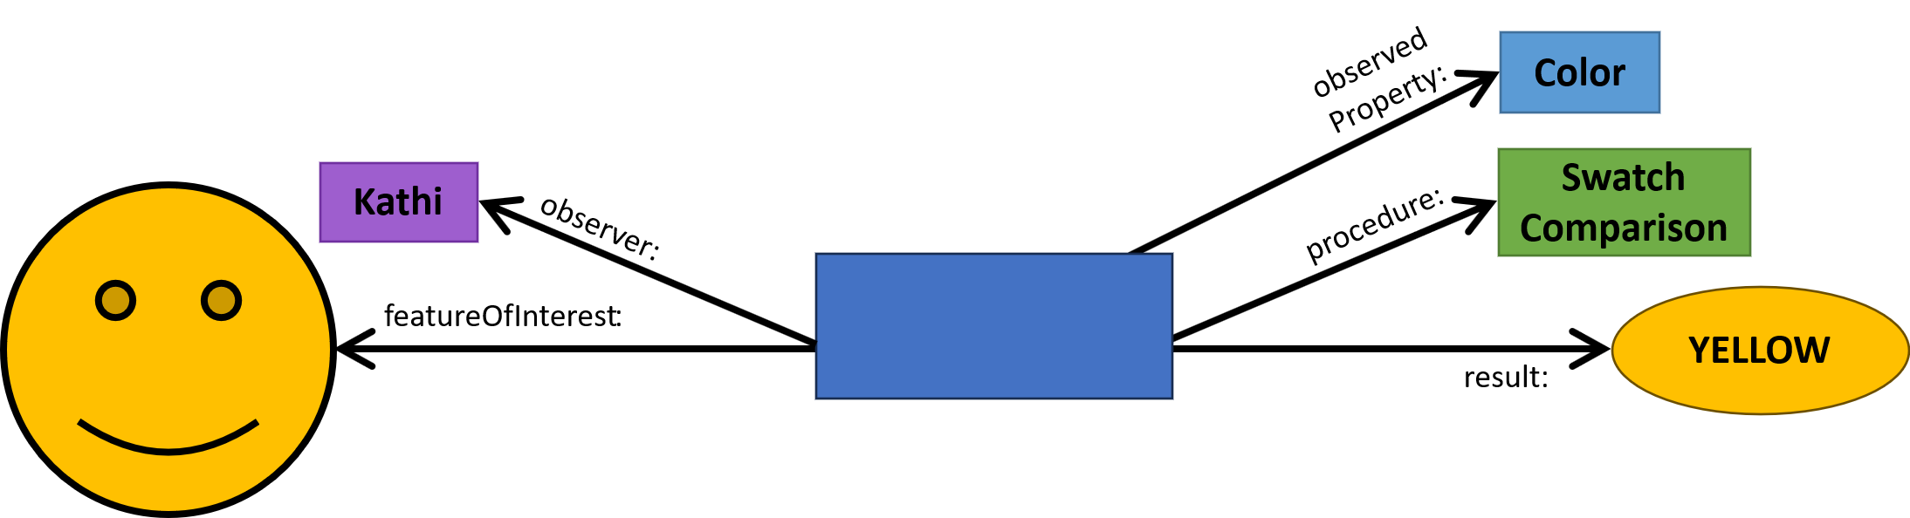
Figure 9: Observation with Observer

In many cases, there is some sort of facility hosting one or more sensors at a specific location. Similarly, when humans perform observations, this is often done in the context of a specific survey or regular monitoring. To provide information on such a facility or similar organizational grouping of Observers, the OMS concept of Host is introduced as shown in Figure 10.

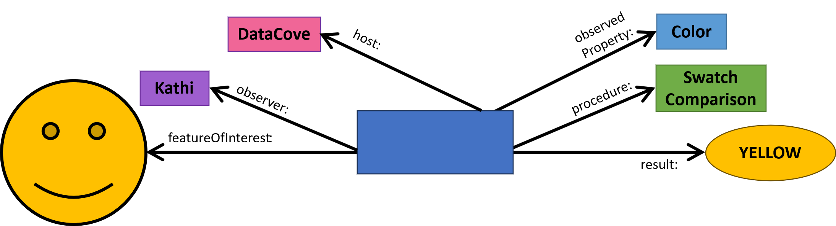
Figure 10: Observation with added Host

A further addition to the OMS Standard is the Deployment Class, providing information on when which Observer has been deployed at which Host, including information relevant to the deployment such as the date and time of deployment. In our example we describe how on April 7, ‘Kathi’, who is working at ‘Datacove’, has observed a yellow smiley sticker. The determination of the color is based on a swatch comparison, as shown in Figure 11.

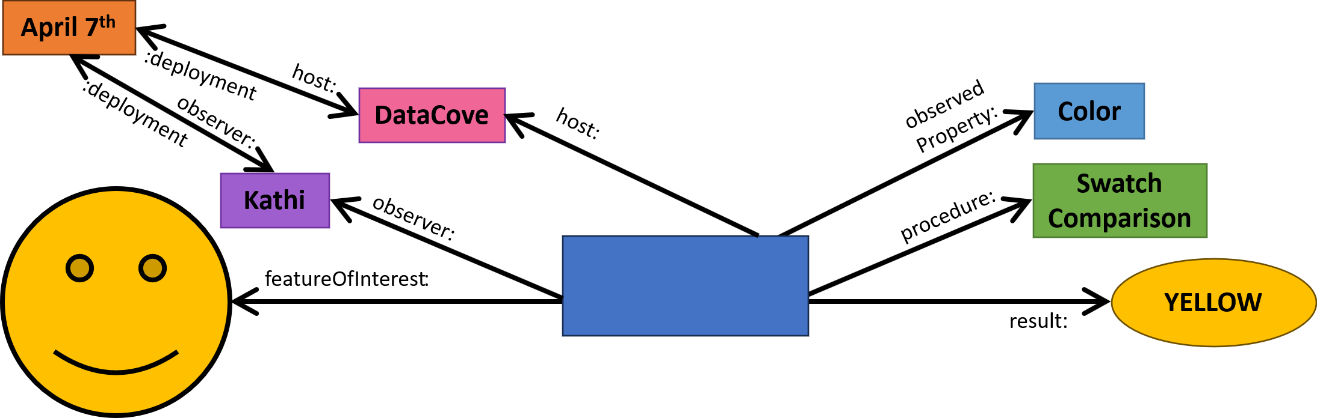
Figure 11: Observation with Deployment

Temporal aspects
As shown in Figure 12, a further essential qualification enabled by the OMS Observation pertains to time. The following times can be provided as attributes within an Observation:
- phenomenonTime: The time for which the result applies to the characteristic of the FeatureOfInterest being observed.
- resultTime: The instant of time when the result of the Observation became available.
- validTime: The time interval during which the result is assumed to be applicable for use.
All these temporal attributes can be time instants or time periods, as required by the nature of the Observation. Depending on the use case, the times can be very exact (e.g. at a specific second), alternatively more general (e.g. referring to a specific calendar day for daily values).

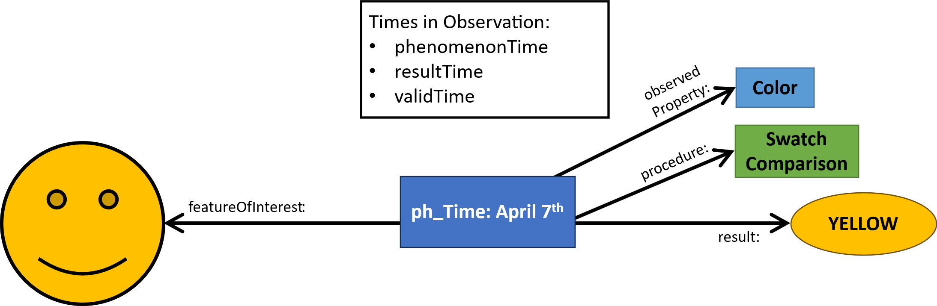
Figure 12: Observation with time
Note: phenomenonTime has been shortened to “ph_Time” in the diagram for brevity
Note: as times are attributes of Observation, they are shown within the Observation box
Note: Sensor, Deployment and Observer have been removed in this diagram for simplicity

Feature-of-Interest types
A final addition to the OMS Observation pertains to specializations of the featureOfInterest. This has been subtyped to:
- proximateFeatureOfInterest: The entity that is directly of interest in the act of observing.
- ultimateFeatureOfInterest: The entity that is ultimately of interest in the act of observing.

In the example, the ProximateFeatureOfInterest is the Smiley Face Sticker. The UltimateFeatureOfInterest could be a wider population of Smiley Face Stickers. The specific Smiley Face Sticker actually being observed could have been selected via some random (or statistical) sampling approach as shown in Figure 13. More details on the actual sampling approach selected is described in chapter 4 Sampling.

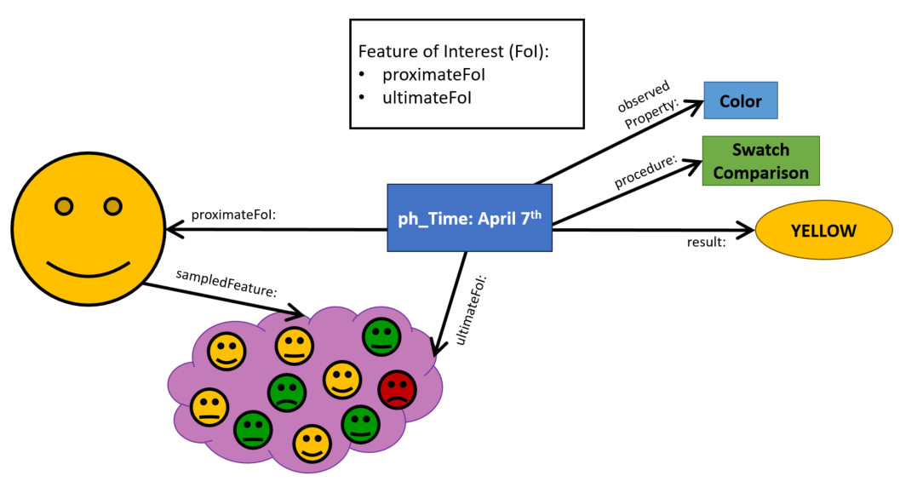
Figure 13: Observation with proximate- and ultimateFeatureOfInterest

Observation Characteristics
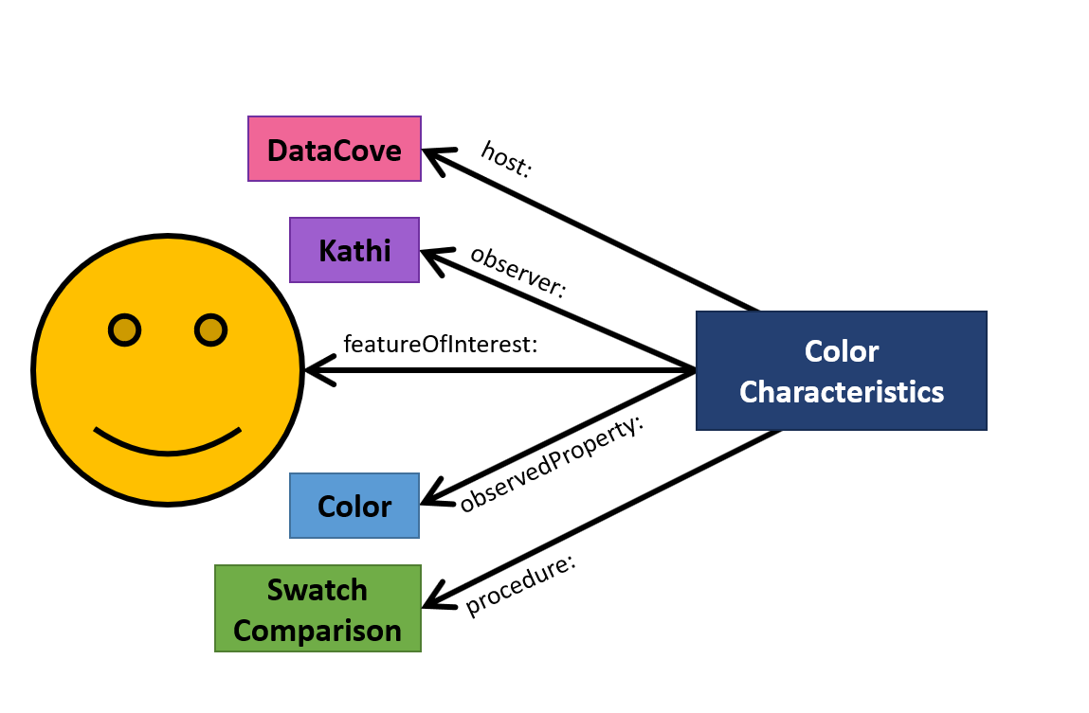
There are many cases where it is useful to have a class with all the characteristics of an observation, but without any of the constraints. For this purpose, OMS introduced the ObservationCharacteristics class (Figure 14). The information provided by the ObservationCharacteristics is the same information as used in our example describing Observations.
Figure 14: Observation Characteristics

This class is utilized in various contexts within OMS, as shown in the following sections.

Observation Collection
As it is often useful to be able to group observational data into collections, OMS provides the ObservationCollection class. In its simplest form, the ObservationCollection is a simple grab-bag collection, containing whatever Observation(s) it makes sense to collect. ( Figure 15).
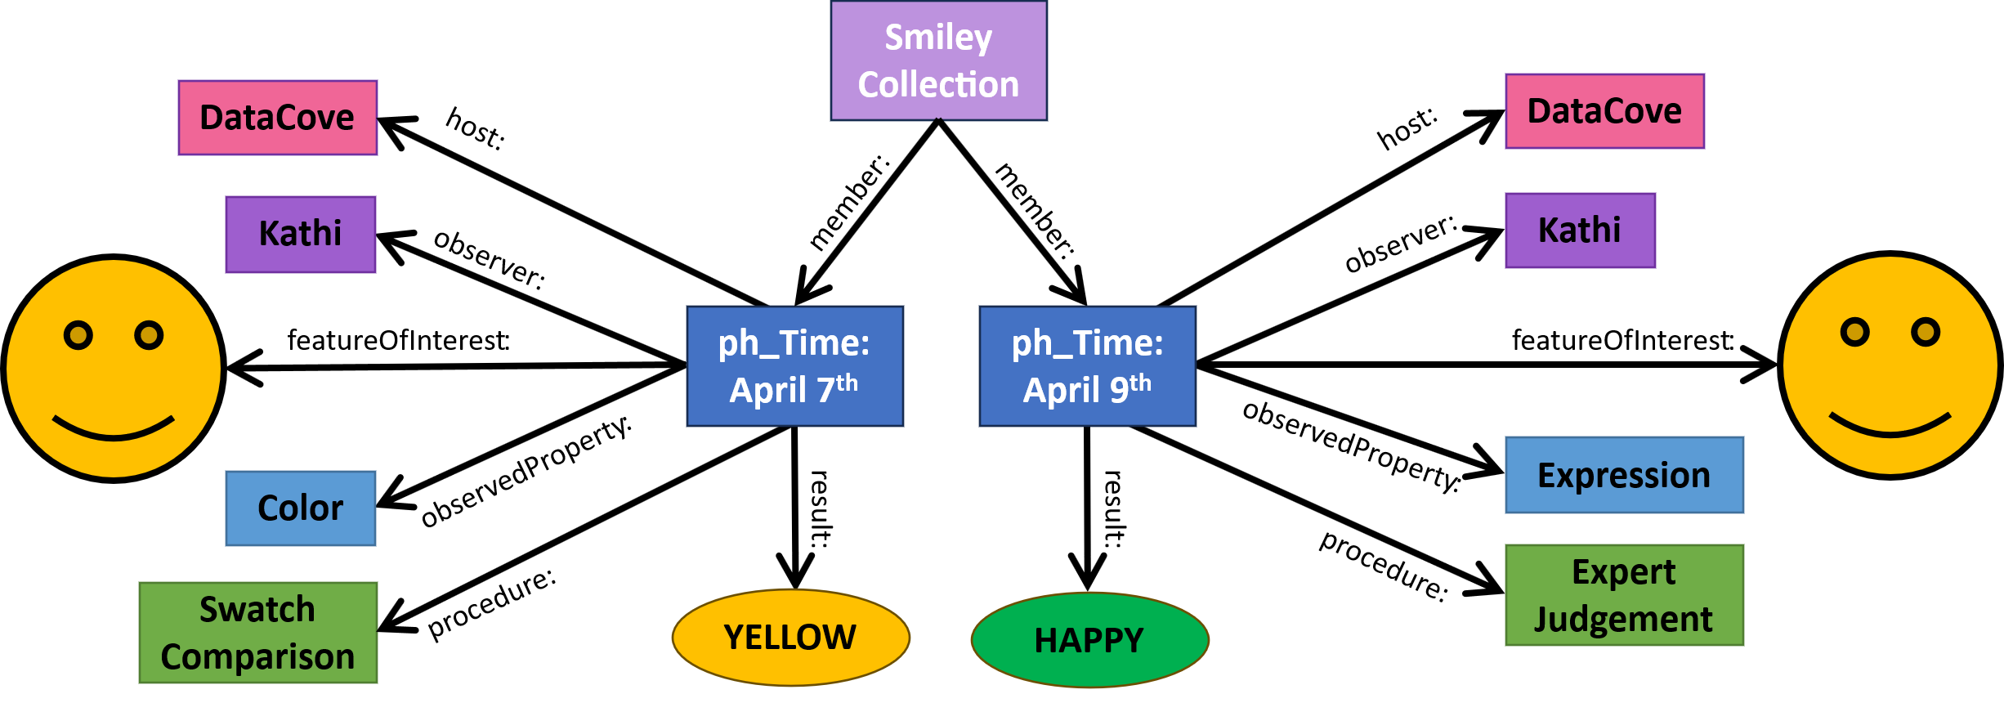
Figure 15: Simple Observation Collection

However, in many cases, the Observation(s) contained within an ObservationCollection have certain commonalities, such as all Observation(s) pertain to a specific FeatureOfInterest, are performed by the same Observer at the same Host. This is where the ObservationCharacteristics comes into play. Each ObservationCollection can link to one ObservationCharacteristics via the memberCharacteristics association. In Figure 16 we see a collection where all Observations contained have our Smiley Face Sticker as FeatureOfInterest, ‘DataCove’ as the Host and ‘Kathi’ as the Observer, described by the ObservationCharacteristics Smiley Characteristics. For characteristics not provided within the ObservationCharacteristics of the ObservationCollection, the member Observations can specify any values. In our example, one Observation has the ObservedProperty ‘Color’, the other has the ObservedProperty ‘Expression’.
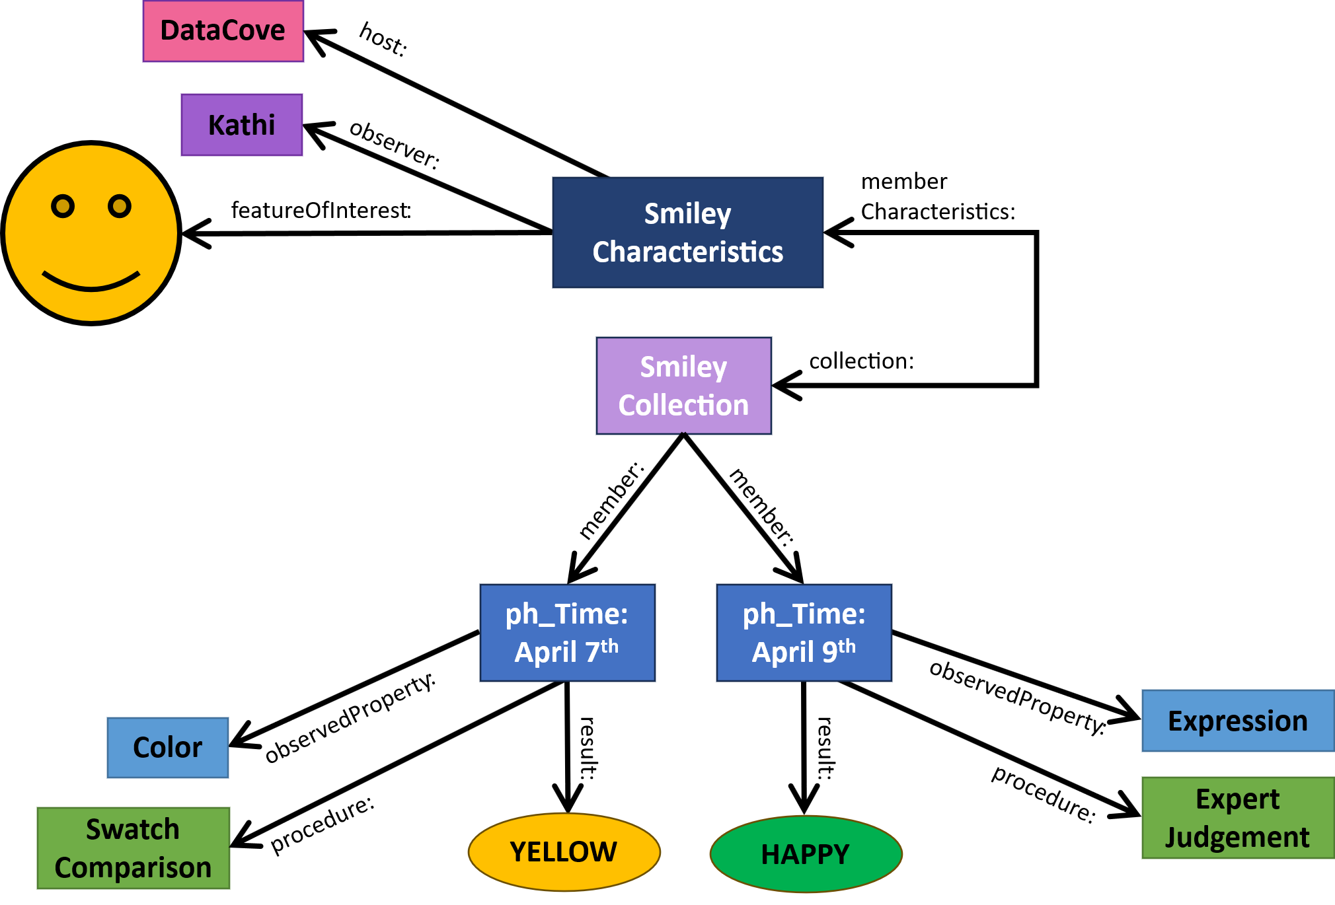
Figure 16: Observation Collection with Characteristics

In some cases, all Observation(s) within a collection share all ObservationCharacteristics. All Observation(s) shown in Figure 17 pertain not just to the same FeatureOfInterest, Observer and Host, but also share ObservedProperty and ObservingProcedure. This information is conveyed by the ObservationCharacteristics (renamed Color Characteristics as it indicates that all Observations contained have the ObservedProperty ‘Color’). Therefore, individual Observation(s) do not need to provide this information
In such cases, the Observation(s) can be reduced to a simple time and value. This is similar to our initial approach at the start of this example, but complemented with the relevant information at the ObservationCollection level. This is a valuable approach for the provision of time-series, as done in the OGC TimeseriesML 2.0 standard.
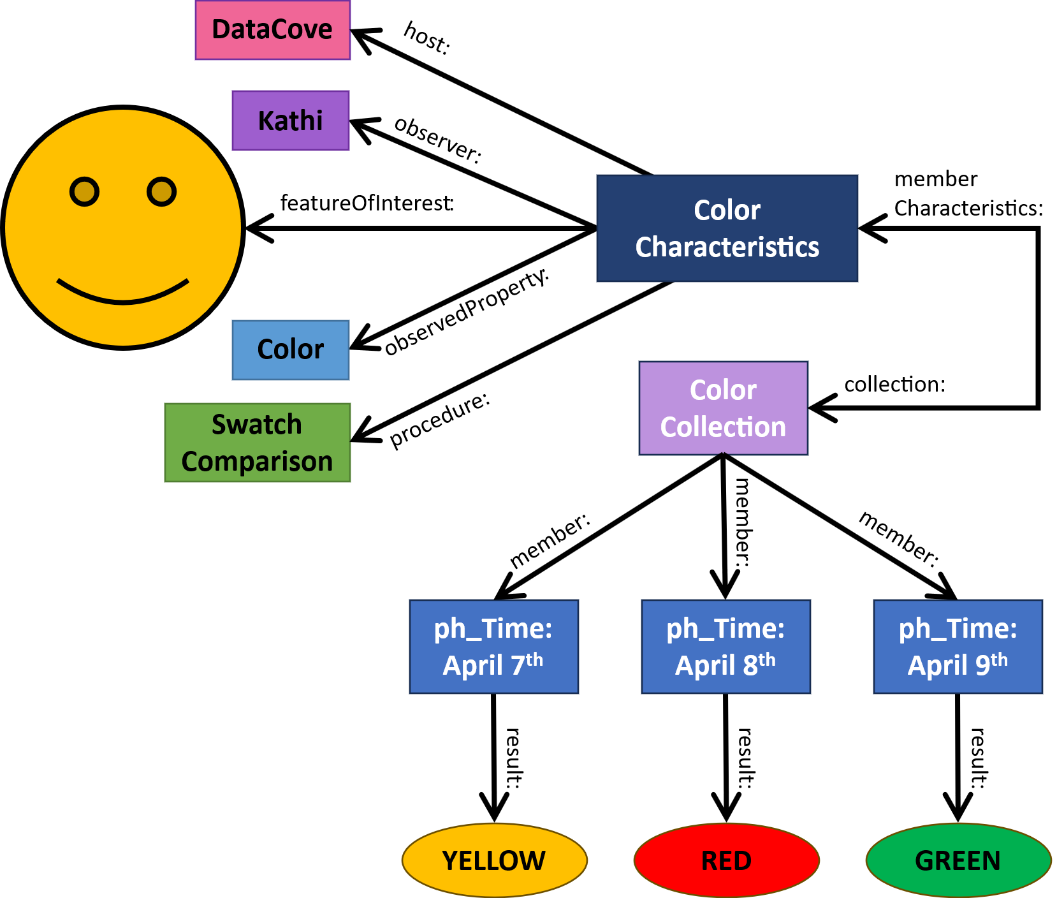
Figure 17: Observation Collection with homogeneous Characteristics

Please note that OMS is a conceptual model, implementations may vary in their interpretation. For example, OGC SensorThings API merges the OMS ObservationCollection and ObservationCharacteristics concepts to the Datastream class.

Observing Capability
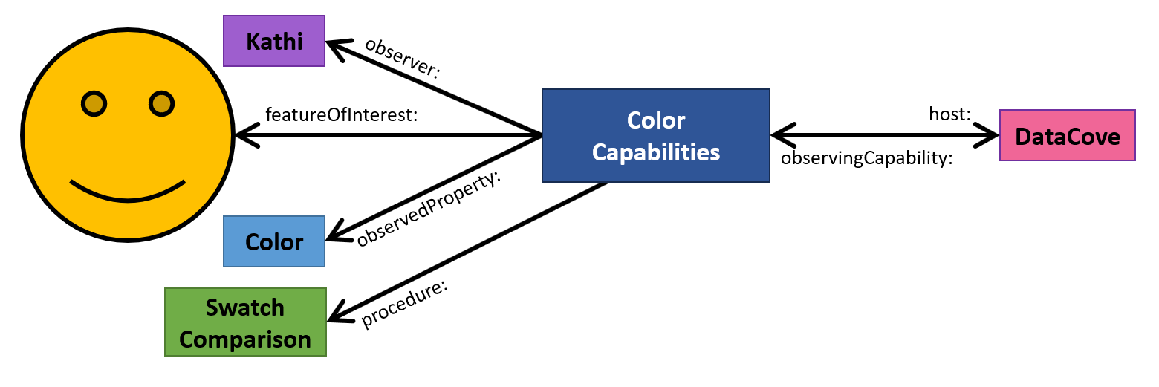
The OMS ObservationCharacteristics are reused in a second context, the ObservingCapabilities class. This class can be used to indicate potential Observation(s) that could be performed at a specific Host. This class is often required in reporting contexts, where countries must indicate which environmental factors they monitor at what location with what methodology, without being obliged to provide the actual data collected. Figure 18 shows that the Host ‘DataCove’ has been set up with the necessary instrumentation (Observer) to determine the color (ObservedProperty) of the Smiley Face Sticker, using ‘Swatch Comparison’ (Procedure).
Figure 18: Host with ObservingCapability

Sampling

Sampled Feature
Understanding how the object serving as the feature of interest of an Observation has been selected is often essential to understanding the quality and robustness of data. The OMS Sample model is designed to represent all relevant aspects of both sample selection as well as preparation steps performed on the sample. This model is similar to the Observation model described in the previous section, relying on similar concepts such as the ‘feature of interest’. The sampling act takes the central role under Sampling, similar to the act of observation being the core of Observation.
Continuing with the example, the next step is to investigate how the Smiley Face Sticker under consideration has been selected from the wider population of Smiley Face Stickers, as well as preparation steps taken on this Smiley Face Sticker before performing the Observation as described above. The Smiley Face Sticker and population of Smiley Face Stickers are associated with the sampledFeature relationship as shown in Figure 19.
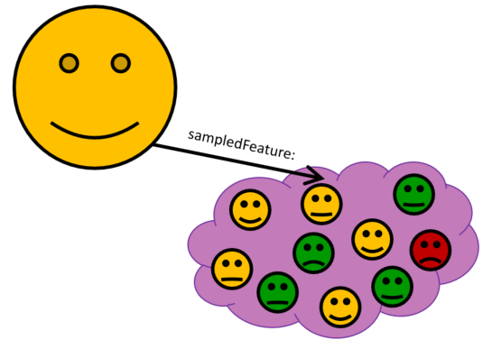
Figure 19: Sample with Sampled Feature

Sampling
In order to provide more explicit information on the sampling act, a Sampling object is added as shown in Figure 20. Sampling provides information on the time of the sampling act, as well as links to the Sample(s) created by this sampling act (via the sample association) and the source of the Sample(s) (indicated as featureOfInterest). The sampledFeature association can be seen as a shorthand notation of the more complex Sampling approach.

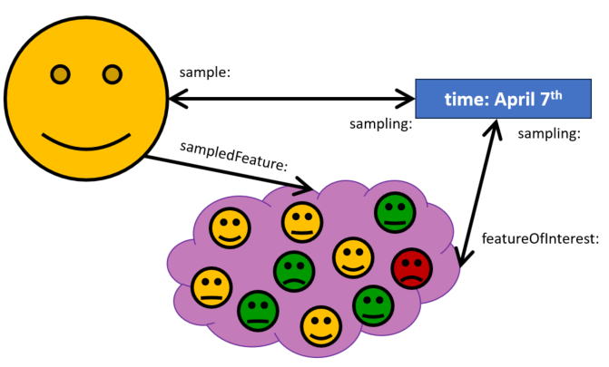
Figure 20: Sample with added Sampling

The Sampling provides information on both the SamplingProcedure utilized in the sampling act as well as the Sampler. The Sampler is the device or entity (including humans) that is used by or implements said SamplingProcedure to create or transform one or more Sample(s).
In the example the SamplingProcedure ‘random selection’ is utilized by our Sampler ‘Kathi’ as shown in Figure 21.

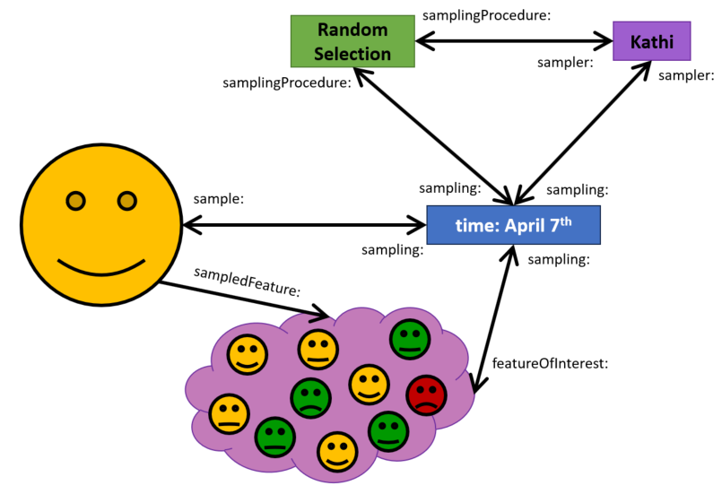
Figure 21: Sampling with added SamplingProcedure and Sampling

Sample Preparation
In many cases, some preparatory steps must be performed before an Observation can be performed on a Sample. In the example, it is important that the Smiley Face Sticker is dry before the color is determined, as a wet sticker may have a different color.
OMS provides the PreparationStep class to describe individual treatments to the Sample , whereby each PreparationStep can reference multiple PreparationProcedure that detail the procedures used in this step. In the example, the PreparationStep ‘Dry Sample’ implements the PreparationProcedure ‘Hang on Line’ (Figure 22).

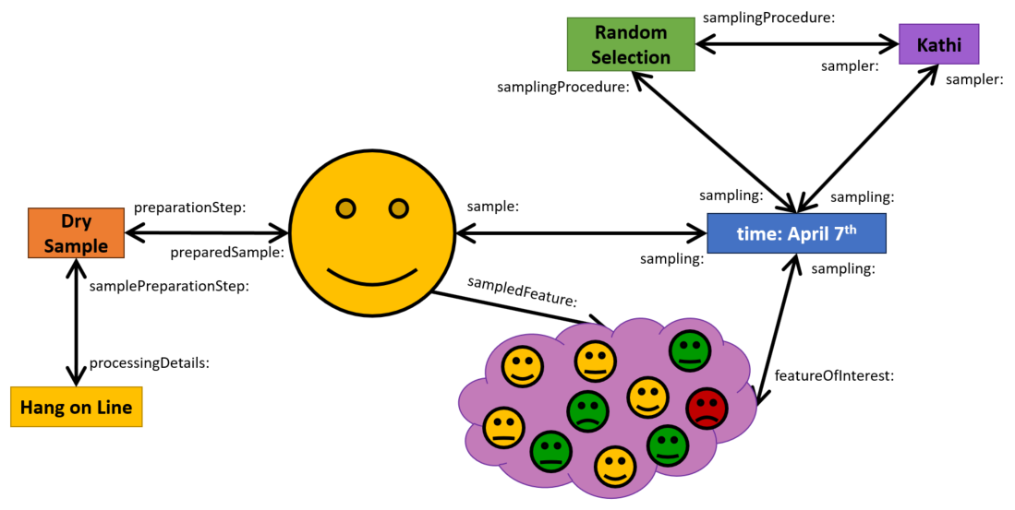
Figure 22: Sample with PreparationStep and PreparationProcedure

Sample Collection
Similar to the ObservationCollection, OMS also provides a SampleCollection class (Figure 23). As no further indication on the nature of the contained Sample(s) is provided, this class is far simpler than ObservationCollection.
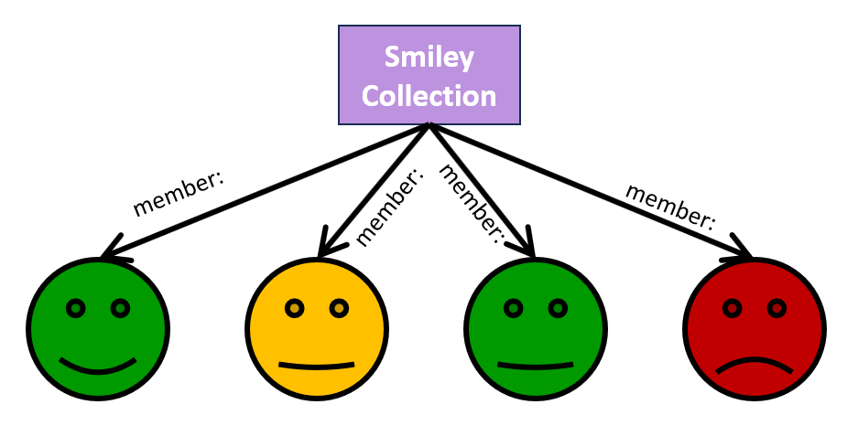
Figure 23: Sample Collection

Observations and Sampling applied to Environmental Media

Air Quality Observation Examples

Observation of Ozone Concentration at an Air Quality Station
Figure 24: Observation of Ozone Concentration at an Air Quality Station shows how the ObservedProperty ‘Ozone Concentration’ is determined at the air quality station ‘STA.09.LIES’ (the Host). As the exact location of the air intake is relevant to understanding the data provided, the featureOfInterest is modelled as the air bubble around the intake. It also indicates that this observation was performed by a sensor of type ‘Horiba APNA 360’ (the Observer), that was deployed at the air quality station from March 1st 1996 through March 1st 2019, and utilizes the ObservingProcedure ‘Chemiluminescense’.

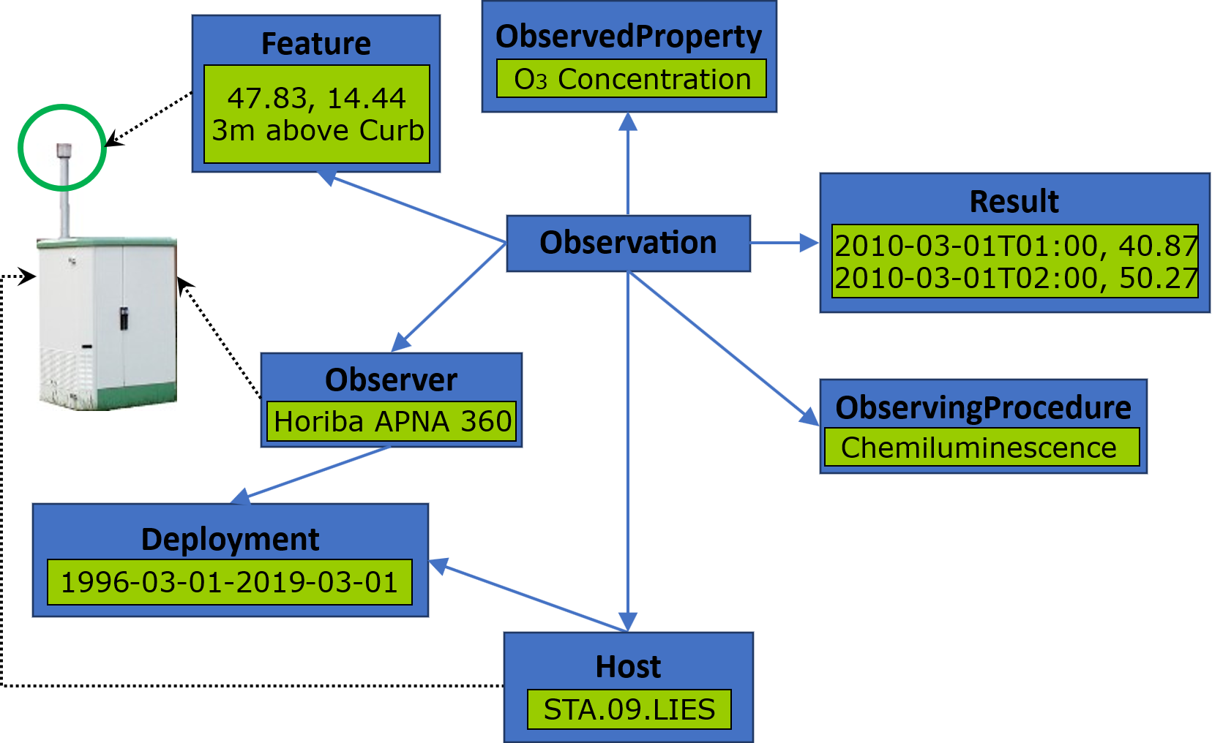
Figure 24: Observation of Ozone Concentration at an Air Quality Station

Biodiversity Observation Examples

Breast Height Diameter of a Tree
Figure 25: Breast Height Diameter of a Tree shows how the ObservedProperty ‘Diameter at breast height’ is determined on a specific Tree (the featureOfInterest), using the ObservingProcedure ‘Measurement w/ DBH Clip’, and utilizing a specific clip ‘DBH Clip #23’ as the Observer.
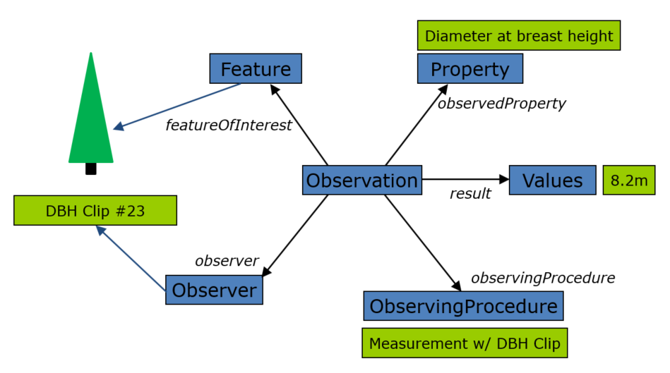
Figure 25: Breast Height Diameter of a Tree

Water Quality Observation Examples
In the water quality examples described in this section, we indicate which of the used classes were available under O&M, the previous version of the standard, and which classes were introduced under OMS.

Surface water in situ Temperature
In the example shown in Figure 26: Surface water in situ Temperature, additional information is provided, utilizing classes introduced under OMS. The Host is indicated, as well as the time during which the specified Observer was deployed (Deployment) at that Host. In addition, the featureOfInterest concept has been differentiated into proximateFeatureOfInterest and ultimateFeatureOfInterest, providing the sampling location and sampled stream respectively.

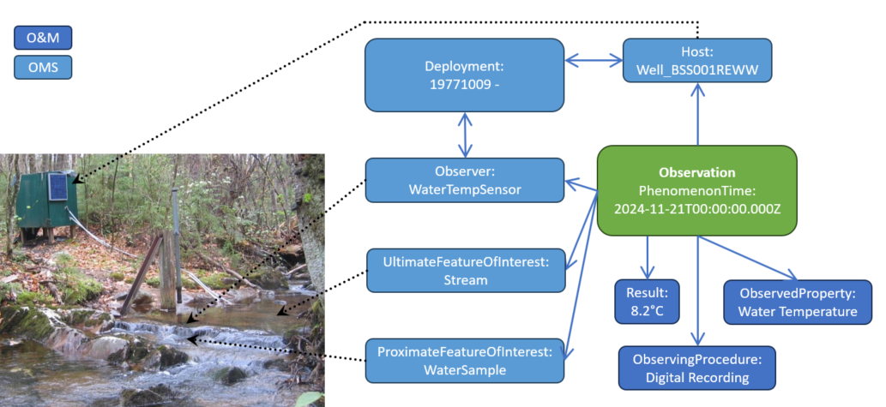
Figure 26: Surface water in situ Temperature

Ground Water ex situ Arsenic
In the example shown in Figure 27: Ground Water ex situ Arsenic - Observation, aspects of OMS Samples are integrated. The water Sample must be prepared before the Sample can be sent to a laboratory. The example shows a PreparationStep performing the ‘Acid Stabilization’ PreparationProcedure on the Sample.
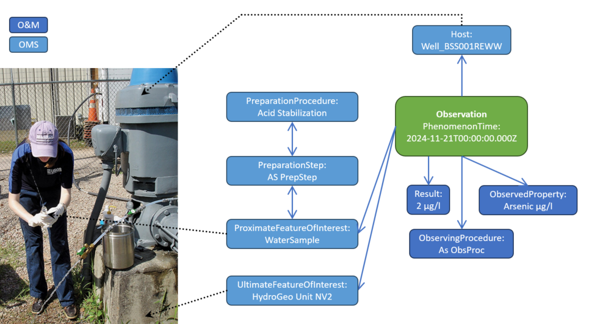
Figure 27: Ground Water ex situ Arsenic - Observation

In Figure 28: Ground Water ex situ Arsenic - Sampling, further sampling related aspects of this example are shown. In this example, two Sampling acts are documented. An initial Sample is taken from the featureOfInterest ‘Well_BSS001REWW’ in a first Sampling, creating a raw MaterialSample. In a second Sampling act, this Sample is subsampled to create the specific Sample ‘Arsenic Sample” and then prepared as described above.
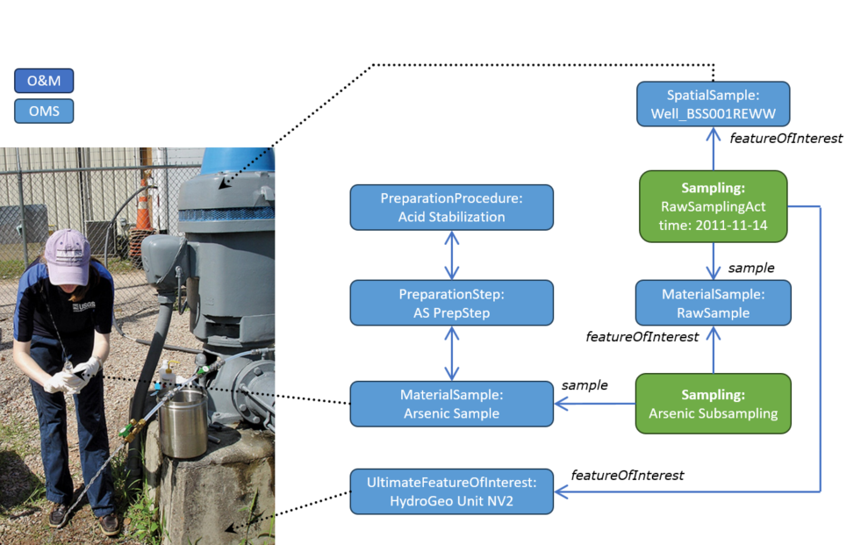
Figure 28: Ground Water ex situ Arsenic - Sampling

Soil Observation Examples

Observation of average precipitation on a Soil Plot
Figure 29: Observation of average precipitation on a Soil Plot shows how information on average precipitation can be provided for a Soil Plot. The featureOfInterest associates the Observation with a specific Soil Plot. The observedProperty references a codelist indicating that the Observation will provide information on average precipitation. The procedure indicates that a rain gauge has been used to determine the precipitation. The result shows that the average precipitation on the plot under investigation in the given year was 1434mm.
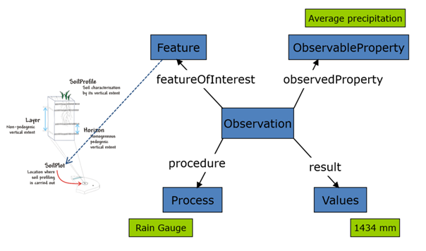
Figure 29: Observation of average precipitation on a Soil Plot

Observation of the effective soil depth on a Soil Profile
Figure 30: Observation of the effective soil depth on a Soil Profile shows how information on the effective soil depth can be provided for a Soil Profile. The featureOfInterest associates the Observation with a specific Soil Profile. The observedProperty references a codelist indicating that the Observation will provide information on the effective soil depth. The procedure indicates that this value has been determined in line with the requirements from ICP Forest. The result shows that the effective soil depth on the profile under investigation in the given year was 314cm.
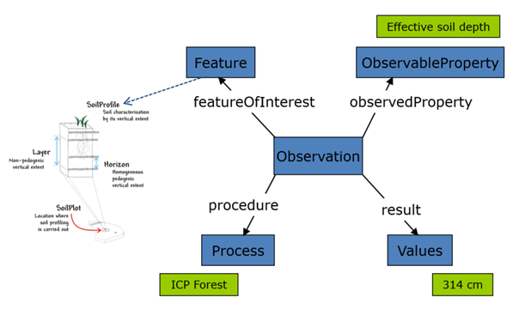
Figure 30: Observation of the effective soil depth on a Soil Profile

Observation of the percentage of clay in a Soil Horizon
Figure 31: Observation of the percentage of clay in a Soil Horizon shows how information on the percentage of clay can be provided for a Soil Horizon. The featureOfInterest associates the Observation with a specific Soil Horizon. The observedProperty references a codelist indicating that the Observation will provide information on the percentage of clay. The procedure indicates that this value has been determined by expert judgement. The result shows that the percentage of clay on the horizon under investigation in the given year was 30%.
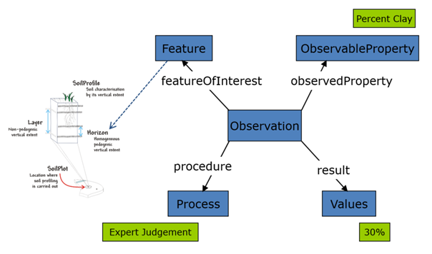
Figure 31: Observation of the percentage of clay in a Soil Horizon

Observation of the textural class of a Soil Layer
Figure 32: Observation of the textural class of a Soil Layer shows how information on the textural class can be provided for a Soil Layer. The featureOfInterest associates the Observation with a specific Soil Layer. The observedProperty references a codelist indicating that the Observation will provide information on the textural class. The procedure indicates that this value has been determined by expert judgement. The result shows that the textural class on the layer under investigation in the given year was 30%.
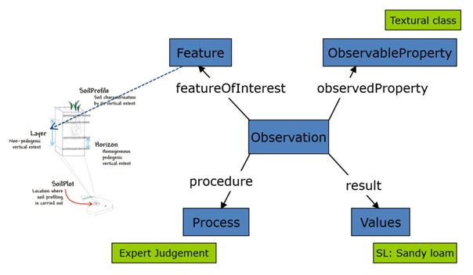
Figure 32: Observation of the textural class of a Soil Layer

Observation of the pH of a Soil Layer
Figure 33: Observation of the pH of a Soil Layer shows how information on the pH can be provided for a Soil Layer. The featureOfInterest associates the Observation with a specific Soil Layer. The observedProperty references a codelist indicating that the Observation will provide information on the pH. The procedure indicates that this value has been determined in accordance with ISO 10390:2005. The result shows that the textural class on the layer under investigation in the given year was 6.4.
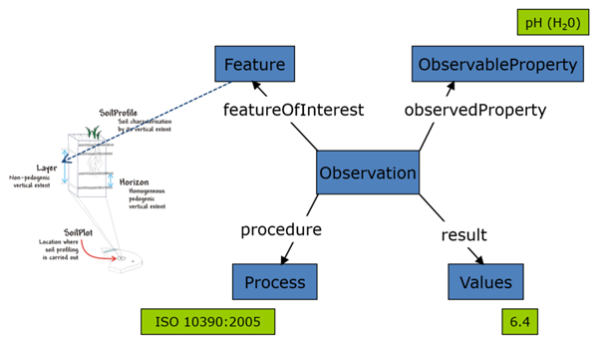
Figure 33: Observation of the pH of a Soil Layer

https://www.ogc.org/standards/om/
https://www.iso.org/standard/82463.html
https://iso.sparxcloud.com/index.php?m=1&o=4542A7F6-7BC7-4218-8D91-4B799164C14A
https://iso.sparxcloud.com/

