Open Geospatial Consortium
Publication Date: 2019-?
Approval Data: 2019-?
Submission Date:2019-?
Reference URL for this document: www.opengeospatial.net/doc/IS/?
Internal reference number of this OGC ® document:
?
Version: XXX
Category: OGC ® Implementation Standard
Editor(s): Erwan Bocher, Olivier Ertz
DRAFT

OGC 2D FeatureType style and symbology extensions

Copyright notice

Copyright © 2019 Open Geospatial Consortium
To obtain additional rights of use, visit http://www.opengeospatial.org/legal/.

Warning

This document is an OGC Member approved international standard. This document is available on a royalty free, non-discriminatory basis. Recipients of this document are invited to submit, with their comments, notification of any relevant patent rights of which they are aware and to provide supporting documentation.

Document type: OGC ® Implementation Standard
Document subtype: -l
Document stage: -
Document language:English

Change history:
Purpose | When | Who
Remove ExpressionParameter, FunctionParameter type is enough | 2021-04-06 | E. Bocher (CNRS)  O. Ertz (HEIG-VD)
Clean up extension modules | 2020-12-10 | E. Bocher (CNRS)
Edits considering the received comments coming from the early public comment | 2019-03-29 | E. Bocher (CNRS)  O. Ertz (HEIG-VD)
Introducing the idea of “core/extensions” (split into two specdocs: core + extensions) | 2018-02-01 | O. Ertz (HEIG-VD)
First edits applying the principles described in  https://peerj.com/articles/cs-143/ | 2016-09-30 | E. Bocher (CNRS)
Proposition about modularization | 2015-04-03 | O. Ertz (HEIG-VD)
Initial document | 2014-02-28 | E. Bocher (CNRS)  O. Ertz (HEIG-VD)

Permission is hereby granted by the Open Geospatial Consortium, ("Licensor"), free of charge and subject to the terms set forth below, to any person obtaining a copy of this Intellectual Property and any associated documentation, to deal in the Intellectual Property without restriction (except as set forth below), including without limitation the rights to implement, use, copy, modify, merge, publish, distribute, and/or sublicense copies of the Intellectual Property, and to permit persons to whom the Intellectual Property is furnished to do so, provided that all copyright notices on the intellectual property are retained intact and that each person to whom the Intellectual Property is furnished agrees to the terms of this Agreement.

If you modify the Intellectual Property, all copies of the modified Intellectual Property must include, in addition to the above
copyright notice, a notice that the Intellectual Property includes modifications that have not been approved or adopted by LICENSOR.
THIS LICENSE IS A COPYRIGHT LICENSE ONLY, AND DOES NOT CONVEY ANY RIGHTS UNDER ANY PATENTS
THAT MAY BE IN FORCE ANYWHERE IN THE WORLD. THE INTELLECTUAL PROPERTY IS PROVIDED "AS IS", WITHOUT WARRANTY OF ANY KIND, EXPRESS OR IMPLIED, INCLUDING BUT NOT LIMITED TO THE WARRANTIES OF MERCHANTABILITY, FITNESS FOR A PARTICULAR PURPOSE, AND NONINFRINGEMENT OF THIRD PARTY RIGHTS. THE COPYRIGHT HOLDER OR HOLDERS INCLUDED IN THIS NOTICE DO NOT WARRANT THAT THE FUNCTIONS CONTAINED IN THE INTELLECTUAL PROPERTY WILL MEET YOUR REQUIREMENTS OR THAT THE OPERATION OF THE INTELLECTUAL PROPERTY WILL BE UNINTERRUPTED OR ERROR FREE. ANY USE OF THE INTELLECTUAL PROPERTY SHALL BE MADE ENTIRELY AT THE USER’S OWN RISK. IN NO EVENT SHALL THE COPYRIGHT HOLDER OR ANY CONTRIBUTOR OF INTELLECTUAL PROPERTY RIGHTS TO THE INTELLECTUAL PROPERTY BE LIABLE FOR ANY CLAIM, OR ANY DIRECT, SPECIAL, INDIRECT OR CONSEQUENTIAL DAMAGES, OR ANY DAMAGES WHATSOEVER RESULTING FROM ANY ALLEGED INFRINGEMENT OR ANY LOSS OF USE, DATA OR PROFITS, WHETHER IN AN ACTION OF CONTRACT, NEGLIGENCE OR UNDER ANY OTHER LEGAL THEORY, ARISING OUT OF OR IN CONNECTION WITH THE IMPLEMENTATION, USE, COMMERCIALIZATION OR PERFORMANCE OF THIS INTELLECTUAL PROPERTY.

This license is effective until terminated. You may terminate it at any time by destroying the Intellectual Property together with all copies in any form. The license will also terminate if you fail to comply with any term or condition of this Agreement. Except as provided in the following sentence, no such termination of this license shall require the termination of any third party end-user sublicense to the Intellectual Property which is in force as of the date of notice of such termination. In addition, should the Intellectual Property, or the operation of the Intellectual Property, infringe, or in LICENSOR’s sole opinion be likely to infringe, any patent, copyright, trademark or other right of a third party, you agree that LICENSOR, in its sole discretion, may terminate this license without any compensation or liability to you, your licensees or any other party. You agree upon termination of any kind to destroy or cause to be destroyed the Intellectual Property together with all copies in any form, whether held by you or by any third party.

Except as contained in this notice, the name of LICENSOR or of any other holder of a copyright in all or part of the Intellectual Property shall not be used in advertising or otherwise to promote the sale, use or other dealings in this Intellectual Property without prior written authorization of LICENSOR or such copyright holder. LICENSOR is and shall at all times be the sole entity that may authorize you or any third party to use certification marks, trademarks or other special designations to indicate compliance with any LICENSOR standards or specifications. This Agreement is governed by the laws of the Commonwealth of Massachusetts. The application to this Agreement of the United Nations Convention on Contracts for the International Sale of Goods is hereby expressly excluded. In the event any provision of this Agreement shall be deemed unenforceable, void or invalid, such provision shall be modified so as to make it valid and enforceable, and as so modified the entire Agreement shall remain in full force and effect. No decision, action or inaction by LICENSOR shall be construed to be a waiver of any rights or remedies available to it.

Contents

​1​ ​Scope
​2​ ​Conformance
​3​ ​Normative References
​4​ ​Definitions and Abbreviations
​5​ ​Overview
​5.1​ ​FeatureTypeStyle
​5.2​ ​Rule extensions
​5.2.1​ ​ScaledRule extension
​5.2.2​ ​​FilteredRule extension
​5.3​ ​Symbolizer extensions
​5.3.1​ ​AreaSymbolizer extension
​5.3.2​ ​LineSymbolizer extension
​5.3.3​ ​PointSymbolizer extension
​5.3.4​ ​TextSymbolizer extension
​5.4​ ​Graphical extensions
​5.4.1​ ​SolidFill extension
​5.4.2​ ​GraphicFill extension
​5.4.3​ ​HatchedFill extension
​5.4.4​ ​PenStroke extension
​5.4.5​ ​GraphicStroke extension
​5.4.6​ ​TextStroke extension
​5.4.7​ ​RGBColor extension
​5.4.8​ ​ExternalGraphic extension
​5.4.9​ ​MarkGraphic extension
​5.4.10​ ​Halo extension
​5.4.11​ ​PerpendicularOffset extension
​5.4.12​ ​LineProperties extension
​5.4.13​ ​DashProperties extension
​5.5​ ​Data extensions
​5.5.1​ ​ValueReference extension
​5.5.2​ ​Function extension
​5.5.2​ ​Expression extension
​5.6​ ​Transformation extensions
​5.6.1​ ​Transform extension
​5.6.2​ ​Translate extension
​5.6.3​ ​Rotate extension
​5.6.4​ ​Scale extension
​5.6.5​ ​Matrix extension
​5.7​ ​Labelling extensions
​5.7.1​ ​PointLabel extension
​5.7.2​ ​LineLabel extension
​5.7.3​ ​LabelAlignment extension
​5.7.4​ ​ExclusionZone extension
​5.7.5​ ​ExclusionRadius extension
​5.7.6​ ​ExclusionRectangle extension
​5.7.7​ ​Clip extension
​5.7.8​ ​LabelRotation extension
​5.8​ ​Orientation extensions
​5.8.1​ ​RelativeOrientation extension
​5.8.2​ ​RelativePosition extension
​5.9​ ​Rendering extensions
​5.9.1​ ​SymbolizerLevel extension
​6​ ​Conformance Class Abstract Test Suite (Normative)
​​6.2.1​ ​Conformance Test Class : FeatureTypeStyle
​6.2.1.1​ Implements the FeatureTypeStyle class
​6.2.1.2​ ​Implements the geometry property for PointSymbolizer class
​6.2.1.3​ ​Implements the geometry property for LineSymbolizer class
​6.2.1.4​ ​Implements the geometry property for AreaSymbolizer class
​6.2.1.5​ ​Implements the geometry property for TextSymbolizer class
​6.3​ ​Symbolizer conformance classes
​6.3.1​ ​Conformance Test Class: AreaSymbolizer
​6.3.2​ ​ Conformance Test Class: PointSymbolizer
​6.3.3​ ​Conformance Test Class: LineSymbolizer
​6.3.4​ ​Conformance Test Class: TextSymbolizer
​6.4​ ​Graphical conformance classes
​6.4.1​ ​Conformance Test Class : SolidFill
​6.4.2​ ​Conformance Test Class : PenStroke
​6.4.3​ ​Conformance Test Class : RGBColor
​7​ ​Annexe A: more explanations (normative)
​7.1​ ​ScaledRule
​7.2​ ​FiltereRule
​8​ ​Annexe B : some illustrations (normative)
​8.1​GraphicFill
​8.2​ ​HatchedFill
​8.3​ ​PerpendicularOffset
​8.5​ ​RelativeOrientation
​8.6​ ​LabelAlignment
​8.7​ ​ExclusionZone

Abstract
This document proposes a set of concrete extensions of the Symbology Conceptual Core Model standard to control how 2D features data (eg. vector layer) are rendered.

Keywords
The following are keywords to be used by search engines and document catalogues
Ogcdoc, COP, Common Operating Picture, SymCore, Symbology Extension
Preface
Attention is drawn to the possibility that some of the elements of this document may be the subject of patent rights. The Open Geospatial Consortium shall not be held responsible for identifying any or all such patent rights.
Recipients of this document are requested to submit, with their comments, notification of any relevant patent claims or other intellectual property rights of which they may be aware that might be infringed by any implementation of the standard set forth in this document, and to provide supporting documentation when possible.
Submitting organizations
The following organizations submitted this Implementation Standard to the Open Geospatial Consortium as an Implementation Standard
All questions regarding this submission should be directed to the editor or the above listed contact points.
Contact | Organization
Erwan Bocher | CNRS
Ertz Olivier | HEIG-VD
Matt Sorenson | Strategic ACI
Dimitri Sarafinof | IGN

​1​ Scope
This document proposes a set of concrete extensions of the Symbology Conceptual Core Model standard to control how the features data (eg. vector layer) are rendered.

​2​ Conformance
This document defines a standardisation target for encodings which implement the OGC Symbology conceptual model in order to allow different encodings to have equivalent content and semantics so that they can be interoperable. It establishes a set of extensions with URI of http://www.opengis.net/spec/symbology/2.0/req/FeatureTypeStyle.
Requirements and conformance test URIs defined in this document are relative to http://www.opengis.net/spec/symbology/2.0/FeatureTypeStyle.
Conformance with this standard shall be checked using all the relevant tests specified in Chapter 6 of this document. The framework, concepts, and methodology for testing, and the criteria to be achieved to claim conformance are specified in the OGC Compliance Testing Policies and Procedures and the OGC Compliance Testing web site.

​3​ Normative References
TODO

​4​ Definitions and Abbreviations
TODO

​5​ Overview
The FeatureType Style extensions provide a set of concrete Symbology Core Model implementations to renderer 2D features (eg. vector data).
The extensions are organized as packages (Figure 1).

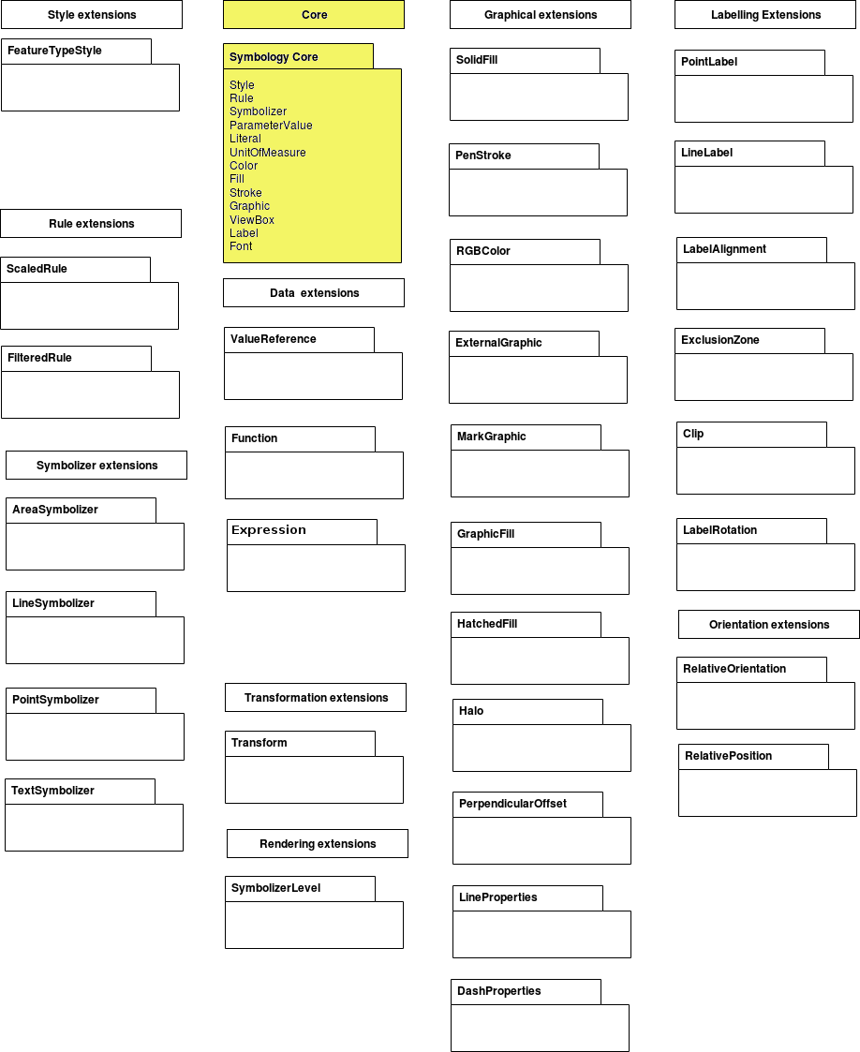
Figure 1 – FeatureType style packages in white, symbology core model dependency in yellow

​5.1​ FeatureTypeStyle
Requirement Class: http://www.opengis.net/spec/symbology/2.0/req/FeatureTypeStyle
Scope: All requirements in this subsection relate to the above requirement class.
Dependencies: http://www.opengis.net/spec/symbology/2.0/req/core
Description: The FeatureTypeStyle extension defines the styling that is to be applied to a single feature type.
Requirement ID: http://www.opengis.net/spec/symbology/2.0/req/FeatureTypeStyleClass
Requirement Txt: Implementations shall support the encoding of all parameters of the FeatureTypeStyleClass and meet all of the tabulated constraints and notes.
This class extends the abstract Style class described in the core. It defines the ability to portray a Layer built of N instances of GML AbstractFeatureType (Portele, 2007) with the ability to access features according to Simple Feature SF-2 (Van den Brink et al., 2012).
The rendering engine is driven according to the following execution: all features are applied to each symbolizer in sequence as they appear nested in rule and following the “painters model” with the first item in a list being the first item plotted and hence being on the “bottom”.
Name | Definition | Data type and value | Multiplicity
featureTypeName | Identifies the specific feature type that the feature-type style is for | Literal data type | zero or one

To define the access to the exact feature type geometry to style, the extension adds a geometry property to the PointSymbolizer, LineSymbolizer, AreaSymbolizer and TextSymbolizer classes with the related behaviours (described below for each requirement).
Requirement ID: http://www.opengis.net/spec/symbology/2.0/req/PointSymbolizerClass/Geomerty
Requirement Txt: Implementations shall support the encoding of the below added property to the PointSymbolizer class and meet all of the tabulated constraints and notes.
Requirement ID: http://www.opengis.net/spec/symbology/2.0/req/LineSymbolizerClass/Geomerty
Requirement Txt: Implementations shall support the encoding of the below added property to the LineSymbolizer class and meet all of the tabulated constraints and notes.
Requirement ID: http://www.opengis.net/spec/symbology/2.0/req/AreaSymbolizerClass/Geomerty
Requirement Txt: Implementations shall support the encoding of the below added property to the AreaSymbolizer class and meet all of the tabulated constraints and notes.
Requirement ID: http://www.opengis.net/spec/symbology/2.0/req/TextSymbolizerClass/Geomerty
Requirement Txt: Implementations shall support the encoding of the below added property to the TextSymbolizer class and meet all of the tabulated constraints and notes.
Name | Definition | Data type and value | Multiplicity
geometry | Geometry attribute or sub-element of a geometry attribute (a) added to the Symbolizer | ParameterValue data type  Geometry | one

​5.2​ Rule extensions

​5.2.1​ ScaledRule extension
Requirement Class: http://www.opengis.net/spec/symbology/2.0/req/ScaledRule
Scope: All requirements in this subsection relate to the above requirement class.
Dependency: http://www.opengis.net/spec/symbology/2.0/req/core
Requirement ID: http://www.opengis.net/spec/symbology/2.0/req/RuleClass/ScaleDenominator
Requirement Txt: Implementations shall support the encoding of all properties of the ScaledRule extension and meet all of the tabulated constraints and notes.
The ScaledRule extension extends the Rule class with two properties (MinScaleDenominator and MaxScaleDenominator) defining the range of map-rendering scales for which the rule should be applied. See some more explanations about Annexe A - ScaledRule.
Name | Definition | Data type and value | Multiplicity
minScaleDenominator | Minimum of map scale range for which a rule should apply | ParameterValue data type (Float)  Value: (0;+∞)  Default value: 0 | zero or one
maxScaleDenominator | Maximum of map scale range for which a rule should apply | ParameterValue data type (Float)  Value: (0;+∞)  Default value: +∞ | zero or one

​5.2.2​ FilteredRule extension
Requirement Class: http://www.opengis.net/spec/symbology/2.0/req/FilteredRule
Scope: All requirements in this subsection relate to the above requirement class.
Dependency: http://www.opengis.net/spec/symbology/2.0/req/core
Dependency: Filter Encoding 2.0
Requirement ID: http://www.opengis.net/spec/symbology/2.0/req/RuleClass/Filter
Requirement Txt: Implementations shall support the encoding of all properties of the FilteredRule extension and meet all of the tabulated constraints and notes.
The FilteredRule extension extends the Rule class with a property (Filter) to specify a filter mechanism. It is "used to identify a subset of resources from a collection of resources whose property values satisfy a set of logically connected predicates. If the property values of a resource satisfy all the predicates in a filter then that resource is considered to be part of the resulting subset" such as a subset of features to style by applying a given Symbolizer. An encoding shall offer a mechanism to select features according to a where clause using comparison and logical operators and additional functions (see ParameterValue subclause). More explanations about the filtering mechanism in Annexe B - FilteredRule.
Name | Definition | Data type and value | Multiplicity
filter | Filtering mechanism | Expression data type | zero or one

​5.3​ Symbolizer extensions

​5.3.1​ AreaSymbolizer extension
Requirement Class: http://www.opengis.net/spec/symbology/2.0/req/AreaSymbolizer
Scope: All requirements in this subsection relate to the above requirement class.
Dependency: http://www.opengis.net/spec/symbology/2.0/req/core
Requirement ID: http://www.opengis.net/spec/symbology/2.0/req/AreaSymbolizerClass
Requirement Txt: Implementations shall support the encoding of all properties of the AreaSymbolizer extension and meet all of the tabulated constraints and notes.
An AreaSymbolizer is used to symbolize a geometry into an area including filling its interior and stroking its outline. It is typically used for a 2-dimensional geometry (e.g. Polygon).
Name | Definition | Data type and value | Multiplicity
fill | Filling style to draw the interior area | Fill data type | Zero or one
stroke | Stroke style to draw the outline | Stroke data type | Zero or one
- If a geometry has “holes,” then they are not filled, but the borders around the holes are stroked in the usual way if a Stroke parameter is mentioned. “Islands” within holes are filled and stroked, and so on. If a point is used, then a small, square, orthogonal-normal area should be constructed for rendering. If a line is used, then the line (string) is closed for filling (only) by connecting its end point to its start point, any line crossings are corrected in some way, and only the original line is stroked.
- A missing Fill property means that the geometry will not be filled. A missing Stroke property means that the geometry will not be stroked. When both are used, the filling is rendered first and then the stroking rendered on top of the filling.

​5.3.2​ LineSymbolizer extension
Requirement class: http://www.opengis.net/spec/symbology/2.0/req/LineSymbolizer
Scope: All requirements in this subsection relate to the above requirement class.
Dependency: http://www.opengis.net/spec/symbology/2.0/req/core
Requirement ID: http://www.opengis.net/spec/symbology/2.0/req//LineSymbolizerClass
Requirement Txt: Implementations shall support the encoding of all properties of the LineSymbolizer extension and meet all of the tabulated constraints and notes.
​The LineSymbolizer extension is used to symbolize a geometry into a stroke, typically along an 1-dimensional geometry, such as a LineString.
Name | Definition | Data type and value | Multiplicity
stroke | Stroke style to draw the line | Stroke data type | one
- For a 0-dimensional geometry (e.g. point) the stroke is applied on a line of “epsilon” length (arbitrarily small) with a horizontal orientation centered on the rendered geometry with two end caps. For a 2-dimensional geometry (e.g. polygon) the stroke is applied on its closed outline as the line rendered with no end caps.

​5.3.3​ PointSymbolizer extension
Requirement Class: http://www.opengis.net/spec/symbology/2.0/req/PointSymbolizer
Scope: All requirements in this subsection relate to the above requirement class.
Dependency: http://www.opengis.net/spec/symbology/2.0/req/core
Requirement ID: http://www.opengis.net/spec/symbology/2.0/req/PointSymbolizerClass
Requirement Txt: Implementations shall support the encoding of all properties of the PointSymbolizer extension and meet all of the tabulated constraints and notes.
The PointSymbolizer extension is used to symbolize a geometry into a point at which a graphic is placed.
Name | Definition | Data type and value | Multiplicity
graphic | Graphic to draw at the point | Graphic data type | One
- For a geometry type other than 0-dimensional (e.g. a line, polygon) the semantic is to compute and use a representative interior central point as the point placement (i.e. guaranteed to lie on the line or the surface interior).

​5.3.4​ TextSymbolizer extension
Requirement Class: http://www.opengis.net/spec/symbology/2.0/req/TextSymbolizer
Scope: All requirements in this subsection relate to the above requirement class.
Dependency: http://www.opengis.net/spec/symbology/2.0/req/core
Requirement ID: http://www.opengis.net/spec/symbology/2.0/req/TextSymbolizerClass
Requirement Txt: Implementations shall support the encoding of all properties of the TextSymbolizer extension and meet all of the tabulated constraints and notes.
The TextSymbolizer extension is used to symbolize a geometry into text labels, whatever is the geometry type.
Name | Definition | Data type and value | Multiplicity
label | Label text and styling details | Label data type | One

​5.4​ Graphical extensions

​5.4.1​ Fill extensions

​5.4.1.1​ SolidFill extension
Requirement class: http://www.opengis.net/spec/symbology/2.0/req/SolidFill
Scope: All requirements in this subsection relate to the above requirement class.
Dependency: http://www.opengis.net/spec/symbology/2.0/req/core
Requirement ID: http://www.opengis.net/spec/symbology/2.0/req/SolidFillClass
Requirement Txt: Implementations shall support the encoding of all properties of the SolidFill class and meet all of the tabulated constraints and notes.
The SolidFill class is a concrete implementation of the Fill class and allows to formulate a filling of an area (e.g. a polygon geometry or any kind of symbol).
Name | Definition | Data type and value | Multiplicity
color | The color to fill the area | Color data type | zero or one
opacity | Opacity of the Color | ParameterValue type (Float)  Value: [0;1] (1 means 100% opaque)  Default value: 0 | zero or one

​5.4.1.2​ GraphicFill extension
Requirement class: http://www.opengis.net/spec/symbology/2.0/req/GraphicFill
Scope: All requirements in this subsection relate to the above requirement class.
Dependency: http://www.opengis.net/spec/symbology/2.0/req/core
Requirement ID: http://www.opengis.net/spec/symbology/2.0/req/GraphicFillClass
Requirement Txt: Implementations shall support the encoding of all properties of the GraphicFill class and meet all of the tabulated constraints and notes.
The GraphicFill extension is a concrete implementation of the Fill class. It repeats a rectangular tiling pattern over an area (i.e. mosaïc). A graphic can be defined very informally as “a little picture”. The appearance of the graphic is defined with the embedded Graphic class parameter.
The graphic fill repeats the Graphic in a rectangular tiling pattern with a TileGap between tiles. The TileGap parameter allows to define vertical and horizontal gaps between tiles.
Name | Definition | Data type and value | Multiplicity
graphic | The graphic to repeat within the area | Graphic data type | one
tileGap | Allow to define a empty space to put between two consecutive tile (i.e. graphic) | TileGap data type | zero or one

TileGap is introduced as an extension. It shall meet all of the tabulated constraints and notes.
Name | Definition | Data type and value | Multiplicity
x | Horizontal gap between two tiles | Double ParameterValue data type, see  Value range is [0:+∞[.  Default is 0. | zero or one
y | Vertical gap between two tiles | Double ParameterValue data type, Value range is [0:+∞[.  Default is 0. | zero or one
- The X parameter indicates the horizontal gap between two consecutive tiles. This value is a non-negative real number.
- The Y parameter has the same definition as the X one, but for the vertical gap. The default gap size is zero units in each direction.
The graphicFill mechanism is illustrated in Annexe B - GraphicFill.

​5.4.1.3​ HatchedFill extension
Requirement class: http://www.opengis.net/spec/symbology/2.0/req/HatchedFill
Scope: All requirements in this subsection relate to the above requirement class.
Dependency: http://www.opengis.net/spec/symbology/2.0/req/core
Requirement ID: http://www.opengis.net/spec/symbology/2.0/req/HatchedFillClass
Requirement Txt: Implementations shall support the encoding of all properties of the HatchedFill class and meet all of the tabulated constraints and notes.
The HatchedFill extension is a concrete implementation of Fill class. It offers simple parameters which allows to control a hatching easily in a way conventional in cartography.
Name | Definition | Data type and value | Multiplicity
stroke | The stroke to use to style hatches | Stroke data type | zero or one
angle | Hatches orientation, clockwise degree | Double ParameterValue data type,  Value range is ]-∞;+∞[.  Default is 45. | zero or one
distance | Distance between geometry bases of two consecutive hatches | Double ParameterValue data type,  Value range is [0;+∞[.  Default is equivalent to 2mm. | zero or one
offset | Allow to define a empty space to put between two consecutive tile (i.e. graphic) | Double, ParameterValue data type,  Value range is [0;+∞[.  Default is 0. | zero or one
- Hatching is defined by a juxtaposed hatches. A hatch is rendered by a Stroke and oriented given an Angle. The Distance parameter defines the perpendicular space between two consecutive hatches.
Hatches are organized according to a reference line which is defined as the line that crosses a system-dependent anchor point and is oriented given the provided Angle. Also, the complementary Offset parameter allows to move the anchor point according to a displacement in the direction of value Angle+90° (see Annexe B - GraphicFill).
- Clockwise is the rotation of Angle because of the coordinate system of the view box with X axis advancing to the right of the origin and the Y axis advancing downward.

​5.4.2​ Stroke extensions

​5.4.2.1​ PenStroke extension
Requirement class: http://www.opengis.net/spec/symbology/2.0/req/PenStroke
Scope: All requirements in this subsection relate to the above requirement class.
Dependency: http://www.opengis.net/spec/symbology/2.0/req/core
Requirement ID: http://www.opengis.net/spec/symbology/2.0/req/PenStrokeClass
Requirement Txt: Implementations shall support the encoding of all properties of the PenStroke class and meet all of the tabulated constraints and notes.
The PenStroke extension is a concrete implementation of the Stroke class. It allows to draw a line (e.g. a 1-dimensional geometry, the outline of a marker, etc) analogously to how a pen is used with ink, that is to say by filling the area formed by the thickness of the line.
Name | Definition | Data type and value | Multiplicity
width | Thickness of the line which gives form to an area to fill (a) | ParameterValue data type (Float)  Value: [0;+∞)  Default value: 1px | zero or one
fill | The filling style to draw the linear area | Fill data type | zero or one
- The Width parameter is in the context of a UnitOfMeasure code (that may be inherited from a parent element).

​5.4.2.2​ GraphicStroke extension
Requirement class: http://www.opengis.net/spec/symbology/2.0/req/GraphicStroke
Scope: All requirements in this subsection relate to the above requirement class.
Dependency: http://www.opengis.net/spec/symbology/2.0/req/core
Requirement ID: http://www.opengis.net/spec/symbology/2.0/req/GraphicStrokeClass
Requirement Txt: Implementations shall support the encoding of all properties of the GraphicStroke class and meet all of the tabulated constraints and notes.
The GraphicStroke extension is a concrete implementation of the Stroke class. It is about one graphic repeated along a line. A renderer may apply some aesthetic embellishments like trying to bend a graphic around corners or avoid a graphic to be cut at the start or at the end.
Name | Definition | Data type and value | Multiplicity
graphic | The graphic to plot | Graphic data type | one
length | Linear length to reserve along the line to plot a single graphic (a) | ParameterValue data type (Float)  Value: [0;+∞)  Default: graphic natural length | zero or one
- The Length property specifies the linear length to reserve along the line for one of the repeated graphics to plot. By default, the linear length is equal to the Graphic natural length (which depends on the view box of the graphic). It has the effect to perfectly juxtapose the repeated graphics all along the line. Zero length value means the graphic is not repeated within all the available linear space. Notice that a single graphic is not plotted if the size of the available linear space smaller than the Length.

​5.4.2.3​ TextStroke extension
Requirement class: http://www.opengis.net/spec/symbology/2.0/req/TextStroke
Scope: All requirements in this subsection relate to the above requirement class.
Dependency: http://www.opengis.net/spec/symbology/2.0/req/core
Requirement ID: http://www.opengis.net/spec/symbology/2.0/req/TextStrokeClass
Requirement Txt: Implementations shall support the encoding of all properties of the TextStroke class and meet all of the tabulated constraints and notes.
The TextStroke extension is a concrete implementation of the Stroke class. It is about the repetition of a text label along a line in a similar way GraphicStroke does by repeating a graphic. The text glyphs are plotted as integral rotated units following the line.
Name | Definition | Data type and value | Multiplicity
lineLabel | The label configuration | LineLabel data type | one
length | Linear length to reserve along the line to plot the label (a) | ParameterValue data type (Float)  Value: [0;+∞)  Default: label natural length | zero or one
- The Length parameter specifies the linear length to reserve along the line for one of the repeated labels to plot. By default, the linear length is equal to the label natural length (which depends on the LalbelText and Font configurations extensions). It has the effect to perfectly juxtapose the repeated labels all along the line. Zero length value means the label is not repeated.

​5.4.3​ Color extensions

​5.4.3.1​ HexaColor extension
Requirement class: http://www.opengis.net/spec/symbology/2.0/req/HexaColor
Scope: All requirements in this subsection relate to the above requirement class.
Dependency: http://www.opengis.net/spec/symbology/2.0/req/core
Requirement ID: http://www.opengis.net/spec/symbology/2.0/req/HexaColorClass
Requirement Txt: Implementations shall support the encoding of all properties of the HexaColor extension and meet all of the tabulated constraints and notes.
The HexaColor extension is a concrete implementation of the Color class to express a RGB color model. The format of the color is in hexadecimal notation. It is a ‘#’ immediately followed by either three or six hexadecimal characters.
Name | Definition | Data type and value | Multiplicity
color | The hexadecimal notation of the color | ParameterValue data type (String) Default value: #000000 | one

​5.4.3.3​ RGBColor extension
Requirement class: http://www.opengis.net/spec/symbology/2.0/req/RGBColor
Scope: All requirements in this subsection relate to the above requirement class.
Dependency: http://www.opengis.net/spec/symbology/2.0/req/core
Requirement ID: http://www.opengis.net/spec/symbology/2.0/req/RGBColorClass
Requirement Txt: Implementations shall support the encoding of all properties of the RGBColor extension and meet all of the tabulated constraints and notes.
The RGBColor extension is a concrete implementation of the Color class where the color is expressed as three integer properties in conformance with the sRGB standardized color space.
Name | Definition | Data type and value | Multiplicity
red | The red value of the color | ParameterValue data type (Integer)  Value: (0;255)  Default value: 0 | one
green | The green value of the colorR | ParameterValue data type (Integer)  Value: (0;255)  Default value: 0 | one
blue | The blue value of the color | ParameterValue data type (Integer)  Value: (0;255)  Default value: 0 | one

​5.4.3.4​ WellKnownNameColor extension
Requirement ID: http://www.opengis.net/spec/symbology/2.0/req/WellKnownNameColorClass
Requirement Txt: Implementations shall support the encoding of all properties of the WellKnownNameColor and meet all of the tabulated constraints and notes.
WellKnownNameColor is a codeList element that provides a list of color names to define a Color. The color names are case-insensitive. The list is based of the X11 colors.

​5.4.4​ Graphic extensions

​5.4.4.1​ ExternalGraphic extension
Requirement class: http://www.opengis.net/spec/symbology/2.0/req/ExternalGraphic
Scope: All requirements in this subsection relate to the above requirement class.
Dependency: http://www.opengis.net/spec/symbology/2.0/req/core
Requirement ID: http://www.opengis.net/spec/symbology/2.0/req/ExternalGraphicClass
Requirement Txt: Implementations shall support the encoding of all properties of the ExternalGraphic extension and meet all of the tabulated constraints and notes.
The ExternalGraphic extension extends the abstract Graphic type. It allows to reference a graphic resource to use as a graphic symbolizer (e.g. PNG bitmap graphic, SVG vector graphic, ...).
Name | Definition | Data type and value | Multiplicity
onlineResource | Reference to on-line resource from which a graphic can be obtained (a) | ParameterValue data type (CharacterString)  Value: an URL identifier | one (exclusive with InlineContent)
inlineContent | Inline content of a graphic object (a,b) | Literal data type | one (exclusive with OnlineResource)
encoding | Expected inline content encoding (b) | Literal data type | one (exclusive with OnlineResource)
format | Expected content format of a successful fetch (a) | Literal data type  Value: a MIME type identifier | one
opacity | Opacity of the graphic | ParameterValue data type (Float)  Value: [0;1]  (1 means 100% opaque)  Default values: 0 | zero or one
- There are two ways to define an external format graphic, either using OnlineResource or InlineContent. They can't be defined together. The external Format of the graphic shall be mentioned as the expected content MIME type of a successful fetch.
- When using the alternative InlineContent parameter to include in-line the content of an external graphic object, then the inline encoding shall be mentioned. The two choices for encoding are XML and Base-64-encoded binary.

​5.4.4.2​ MarkGraphic extension
Requirement class: http://www.opengis.net/spec/symbology/2.0/req/MarkGraphic
Scope: All requirements in this subsection relate to the above requirement class.
Dependency: http://www.opengis.net/spec/symbology/2.0/req/core
Requirement ID: http://www.opengis.net/spec/symbology/2.0/req/MarkGraphicClass
Requirement Txt: Implementations shall support the encoding of all properties of the MarkGraphic extension and meet all of the tabulated constraints and notes.
The MarkGraphic extension extends the abstract Graphic type. It allows a graphic to be created by stroking and filling a shape.
Name | Definition | Data type and value | Multiplicity
wellKnownName | Name of the shape to stroke and fill (a,b) | WellKnownName code | one (exclusive with OnlineResource and InlineContent)
onlineResource | Online location of a mark objects archive (a,c) | ParameterValue data type (CharacterString)  Value: an URL identifier | One (exclusive with WellKnownName and InlineContent)
inlineContent | Inline content of a mark objects archive (a,c) | Literal data type | One (exclusive with OnlineResource and WellKnownName)
encoding | Expected inline content encoding (c) | Literal data type  Value: XML | base64 | One (exclusive with OnlineResource and WellKnownName)
format | Expected content format of a successful fetch (c) | Literal data type  Value: a MIME type identifier | One (exclusive with WellKnownName)
markIndex | Index of a mark from a mark objects archive (c) | ParameterValue data type (Integer)  Value: [0;+∞) | One (exclusive with WellKnownName)
fill | The filling style to fill the shape (d) | Fill data type | Zero or one
stroke | The stroke style to draw the outline of the shape (d) | Stroke data type | Zero or one
- There are three ways to define a mark shape, either using WellKnownName, OnlineResource or InlineContent. They can't be defined together.
- WellKnownName is used to draw predefined internal marks. The center of the view box is the default anchor point, except for star and triangle.
- OnlineResource and InlineContent are two ways to select a mark from an external mark archive (e.g. glyph from TrueType or SVG font). The MarkIndex property represents a numeric identifier which allows an individual mark in a mark archive to be selected. The default anchor point is format-dependent, while the center of the view box shall be used if no information is available.
- A missing Fill parameter means that the geometry will not be filled. A missing Stroke parameter means that the geometry will not be stroked. When both are used, the filling is rendered first and then the stroking rendered on top of the filling. A missing Halo parameter means no halo is drawn.
- The encoding must describe the order in which transformations are executed.
The extension introduces also WellKnownName code list extension, used to draw predefined shape of mark graphics. It includes the following codes : square, circle, triangle, star, cross, x.
Name | Definition | Data type and value | Multiplicity
wellKnownName | Shall support an optional codelist parameter. | Literal data type | one
extension | Any encoding should allow the user to extend the codelist to include custom items | Any | zero or more

​5.4.5​ Shape extensions

​5.4.5.1​ Halo extension
Requirement class: http://www.opengis.net/spec/symbology/2.0/req/Halo
Scope: All requirements in this subsection relate to the above requirement class.
Dependency: None.
Requirement ID: http://www.opengis.net/spec/symbology/2.0/req/HaloClass
Requirement Txt: Implementations shall support the encoding of all properties of the Halo extension and meet all of the tabulated constraints and notes.
The Halo extension may be used to improve the visibility of shapes like font glyphs or graphics by drawing an extended area surrounding the shapes.
- the extension adds a new class Halo: the halo is calculated according to a radius (in context of an UnitOfMeasure) and then filled adequately so as to highlight the shapes.
Name | Definition | Data type and value | Multiplicity
unitOfMeasure | Unit of measure to apply to all graphical properties inside a Halo | UnitOfMeasure code | zero or one
radius | Span size of the surrounding halo area (a) | ParameterValue data type (Float)  Value: [0;+∞)  Default value: 1px | zero or one
fill | Fill style to fill the halo area | Fill data type | zero or one
extension | Any encoding should allow the user to extend the halo to include custom items | Any | zero or more
- To calculate the halo area, the radius is taken from the outside edge of a shape (and the inside edge of “holes” in the shape)
- the extension adds a property to the classes MarkGraphic, ExternalGraphic, PointLabel and LineLabel.
Name | Definition | Data type and value | Multiplicity
halo | Fill a halo around the shape | Halo data type | zero or one

​5.4.5.2​ PerpendicularOffset extension
Requirement Class: http://www.opengis.net/spec/symbology/2.0/req/PerpendicularOffset
Scope: All requirements in this subsection relate to the above requirement class.

Description: The extension allows to construct parallel lines around a geometry. It adds a property to the classes LineSymbolizer, AreaSymbolizer and TextSymbolizer with related behaviours (described below for each requirement).
Name | Definition | Data type and value | Multiplicity
perpendicularOffset | Construct parallel lines around of the original geometry | ParameterValue data type (Float)  Value: (-∞;+∞) | zero or one

Requirement ID:
http://www.opengis.net/spec/symbology/2.0/req/LineSymbolizerClass/PerpendicularOffset
Requirement Txt: Implementations shall support the encoding of the added property of the LineSymbolizer extension and meet all of the tabulated constraints and notes.
For a LineSymbolizer, the distance between original geometry and drawn line stays equal. This construction can result in drawn lines that are actually smaller or longer than the original geometry. The distance is in the context of the UnitOfMeasure property and is positive to the left-hand side of the line string. Negative numbers mean right (see Annexe B - PerpendicularOffset).
Requirement ID: http://www.opengis.net/spec/symbology/2.0/req/AreaSymbolizerClass/PerpendicularOffset
Requirement Txt: Implementations shall support the encoding of the added property of the AreaSymbolizer extension and meet all of the tabulated constraints and notes.
For a AreaSymbolizer, the extension allows to shrink or grow the area impacting both the stroking of the outline and the filling of the area. The distance is in the context of the UnitOfMeasure parameter and is positive to the outside of the polygon. Negative numbers mean drawing the polygon smaller (see Annexe B - PerpendicularOffset).
Requirement ID: http://www.opengis.net/spec/symbology/2.0/req/TextSymbolizerClass/PerpendicularOffset
Requirement Txt: Implementations shall support the encoding of the added property of the TextSymbolizer extension and meet all of the tabulated constraints and notes.
For a TextSymbolizer, the extension has the same meaning as for LineSymbolizer and for AreaSymbolizer, but can be ignored for punctual geometry. Before symbolizing the geometry into a text label, the geometry is transformed according to a perpendicular offset which produces a parallel line. The text label is then drawn according to that parallel line.

​5.4.6​ Properties extensions

​5.4.6.1​ LineProperties extension
Requirement Class: http://www.opengis.net/spec/symbology/2.0/req/LineProperties
Scope: All requirements in this subsection relate to the above requirement class.
Dependency: http://www.opengis.net/spec/symbology/2.0/req/core

Description: The extension extends the PenStroke class with two properties LineJoin and LineCap used to define the the line style.

Name | Definition | Data type and value | Multiplicity
lineJoin | Type of joining at the corners between the line segments (c) | LineJoin code | zero or one
lineCap | Type of cap to be used at the two ends of an open line (c) | LineCap code | zero or one

Requirement ID: http://www.opengis.net/spec/symbology/2.0/req/PenStrokeClass/LineJoinProperty
Requirement Txt: Implementations shall support the encoding of all properties of the LineJoinProperty extension and meet all of the tabulated constraints and notes.
The extension introduces a code list used to define the the line style. The semantic of LineJoin is similar to their SVG equivalents. It includes the following codes : mitre, round and level.
Name | Definition | Data type and value | Multiplicity
lineJoin | Type of joining at the corners between the line segments (c) | Literal data type  Default value: mitre | one
extension | Any encoding should allow the user to extend the codelist to include custom items | Any | zero or more

Requirement ID: http://www.opengis.net/spec/symbology/2.0/req/PenStrokeClass/LineCapProperty
Requirement Txt: Implementations shall support the encoding of all properties of the LineCapProperty extension and meet all of the tabulated constraints and notes.
The extension introduces a code list used to define the the line style. The semantic of LineCap is similar to their SVG equivalents. It includes the following codes : butt, round and square.
Name | Definition | Data type and value | Multiplicity
lineCap | Type of cap to be used at the two ends of an open line (c) | Literal data type  Default value: butt | one
extension | Any encoding should allow the user to extend the codelist to include custom items | Any | zero or more

​5.4.6.2​ DashProperties extension
Requirement Class: http://www.opengis.net/spec/symbology/2.0/req/DashProperties
Scope: All requirements in this subsection relate to the above requirement class.
Dependency: http://www.opengis.net/spec/symbology/2.0/req/core
Description: The extension extends the PenStroke class with two properties DashArray and DashOffset used to manage dash values on a line.

Requirement ID: http://www.opengis.net/spec/symbology/2.0/req/PenStrokeClass/DashArrayProperties
Requirement Txt: Implementations shall support the encoding of all properties of the DashArrayProperty extension and meet all of the tabulated constraints and notes.
Name | Definition | Data type and value | Multiplicity
dashArray | Dash pattern to repeat (a)(b) | ParameterValue data type (Float)  Value: ]0;+∞)  Default value: unbroken line | zero or more
- DashArray property is in the context of a UnitOfMeasure code (that may be inherited from a parent element).
- The Dasharray property specifies a dash pattern as a sequence of floating values strictly positive. The first number gives the length of dash to draw, the second gives the amount of space to leave, and this pattern repeats. If an odd number of values is given, then the pattern is expanded by repeating it twice to give an even number of values.
Requirement ID: http://www.opengis.net/spec/symbology/2.0/req/PenStrokeClass/DashOffsetProperties
Requirement Txt: Implementations shall support the encoding of all properties of the DashOffsetProperty extension and meet all of the tabulated constraints and notes.
Name | Definition | Data type and value | Multiplicity
dashOffset | Offset into a dash pattern at which to start drawing (a) | ParameterValue data type (Float)  Value: (∞;+∞)  Default value: 0 | zero or one
- DashOffset property is in the context of a UnitOfMeasure code (that may be inherited from a parent element).

​5.5​ ParameterValue extensions

​5.5.1​ ValueReference extension
Requirement ID: http://www.opengis.net/spec/symbology/2.0/req/ValueReferenceClass
Requirement Txt: Implementations shall support the encoding of all parameters of the ValueReference extension and meet all of the tabulated constraints and notes.
The ValueReference extension is a concrete implementation of the ParameterValue class. A value reference is a string that represents a value that is to be evaluated by a predicate. It has a relatively straightforward meaning as conceptually defined by Filter Encoding 2.0 specification (OGC® Filter Encoding 2.0 Encoding Standard , section 7.4.1).
Name | Definition | Data type and value | Multiplicity
name | Specify the name of any property | Any | one

​5.5.2​ Function extension
Requirement ID: http://www.opengis.net/spec/symbology/2.0/req/FunctionClass
Requirement Txt: Implementations shall support the encoding of all parameters of the Function extension and meet all of the tabulated constraints and notes.
The Function extension is a concrete implementation of the ParameterValue class. A function is a named procedure that performs a distinct computation. It has a relatively straightforward meaning as conceptually defined by Filter Encoding 2.0 specification (OGC® Filter Encoding 2.0 Encoding Standard , section 7.6.1).

​5.6​ Transformation extensions

​5.6.1​ Transform extension
Requirement class: http://www.opengis.net/spec/symbology/2.0/req/Transform
Scope: All requirements in this subsection relate to the above requirement class.
Dependencies:
http://www.opengis.net/spec/symbology/2.0/core
http://www.opengis.net/spec/symbology/2.0/req/PointLabelClass
Description: This class describes the extension of the Graphic abstract class and the PointLabel class to support the transformation of the anchor point to hang up a graphic or a label. The extension introduces a new Transform data type and adds a property of this type to the Graphic class and one to the PointLabel class.
Requirement ID: http://www.opengis.net/spec/symbology/2.0/req/Transform
Requirement Txt: Implementations shall support the encoding of all parameters of the Transform class and meet all of the tabulated constraints and notes.
Name | Definition | Data type and value | Multiplicity
unitOfMeasure | Unit of measure to use for the tranformation | UnitOfMeasure code | zero or one
extension | Any encoding should allow to extend with custom items | Any type | zero or more

Requirement ID:
http://www.opengis.net/spec/symbology/2.0/req/core/GraphicClass/Transform
Requirement Txt: Implementations shall support the encoding of the below added property to the Graphic class and meet all of the tabulated constraints and notes.
Requirement ID:
http://www.opengis.net/spec/symbology/2.0/req/PointLabel/Transform
Requirement Txt: Implementations shall support the encoding of the below added property to the PointLabel class and meet all of the tabulated constraints and notes.
Name | Definition | Data type and value | Multiplicity
Transform | The affine transformations to apply on the graphic | Transform data type | zero or more

​5.6.3​ Translate extension
Requirement class: http://www.opengis.net/spec/symbology/2.0/req/Translate
Scope: All requirements in this subsection relate to the above requirement class.
Dependency: None.
Description: The extension introduces the ability to define the translation of a graphical object. It defines the new Translate class and adds a property of that new class type to the AreaSymbolizer, TextSymbolizer, LineSymbolizer, PointSymbolizer, MarkGraphic, ExternalGraphic, PointLabel classes with the related behaviours (described below for each requirement).
Requirement ID: http://www.opengis.net/spec/symbology/2.0/req/TranslateClass
Requirement Txt: Implementations shall support the encoding of all properties of the TranslateClass and meet all of the tabulated constraints and notes.
According to the object coordinate system, a positive X value translates the object to the right and a positive Y value translates it downward.
Name | Definition | Data type and value | Multiplicity
UnitOfMeasure | Unit of measure to use for the translation | UnitOfMeasure code | zero or one
X | Horizontal displacement | ParameterValue date type Float  Value: (-∞;+∞)  Default value: 0 | one
Y | Vertical displacement | ParameterValue date type Float  Value: (-∞;+∞)  Default value: 0 | one
Extension | Any encoding should allow to extend a Translate with custom items | Any type | zero or more

Requirement ID: http://www.opengis.net/spec/symbology/2.0/req/AreaSymbolizerClass/Displacement
Requirement Txt: Implementations shall support the encoding of the added property of the AreaSymbolizer extension and meet all of the tabulated constraints and notes.
For a AreaSymbolizer, the Displacement parameter offers X and Y translation that may be used to avoid overplotting of multiple AreaSymbolizer for one geometry or produce shadow effects. When drawing a geometry, it is transformed from the coordinate reference system into the view coordinate space before any translation.
Requirement ID: http://www.opengis.net/spec/symbology/2.0/req/TextSymbolizerClass/Displacement
Requirement Txt: Implementations shall support the encoding of the added property of the LineSymbolizer extension and meet all of the tabulated constraints and notes.
Requirement ID: http://www.opengis.net/spec/symbology/2.0/req/PointSymbolizerClass/Displacement
Requirement Txt: Implementations shall support the encoding of the added property of the PointSymbolizer extension and meet all of the tabulated constraints and notes.
Requirement ID: http://www.opengis.net/spec/symbology/2.0/req/LineSymbolizerClass/Displacement
Requirement Txt: Implementations shall support the encoding of the added property of the LineSymbolizer extension and meet all of the tabulated constraints and notes.
Requirement ID: http://www.opengis.net/spec/symbology/2.0/req/ExternalGraphicClass/Translate
Requirement Txt: Implementations shall support the encoding of the added property of the ExternalGraphic extension and meet all of the tabulated constraints and notes.
Requirement ID: http://www.opengis.net/spec/symbology/2.0/req/MarkGraphicClass/Translate
Requirement Txt: Implementations shall support the encoding of the added property of the MarkGraphic extension and meet all of the tabulated constraints and notes.
Requirement ID: http://www.opengis.net/spec/symbology/2.0/req/PointLabelClass/Translate
Requirement Txt: Implementations shall support the encoding of the added property of the PointLabel extension and meet all of the tabulated constraints and notes.

​5.6.4​ Rotate extension
Requirement class:
Scope:
Dependency:
Description:

Requirement ID: http://www.opengis.net/spec/symbology/2.0/req/core/RotateClass
Requirement Txt: Implementations shall support the encoding of all parameters of the RotateClass and meet all of the tabulated constraints and notes.
The Rotate data type specifies the rotation of an object given a rotation center point combined with a rotation angle.
Name | Definition | Data type and value | Multiplicity
UnitOfMeasure | Unit of measure to use for the X and Y displacement | UnitOfMeasure code | zero or one
X | Rotation center horizontal displacement (a) | ParameterValue date type Float  Value: (-∞;+∞)  Default value: 0 | zero or one
Y | Rotation center vertical displacement (a) | ParameterValue date type Float  Value: (-∞;+∞)  Default value: 0 | zero or one
Angle | Rotation angle in clockwise degrees | ParameterValue date type Float  Value: (-∞;+∞) | one
Extension | Any encoding should allow to extend a Rotate with custom items | Any type | zero or more
- If X and Y are not supplied, the rotation is about the origin of the current object coordinate system. If supplied, it is about the point (X, Y). The operation is then the equivalent of the following sequence: translate(X,Y) rotate(Angle) translate(-X, -Y).

​5.6.5​ Scale extension
Requirement class:
Scope:
Dependency:
Description:

Requirement ID: http://www.opengis.net/spec/symbology/2.0/req/core/ScaleClass
Requirement Txt: Implementations shall support the encoding of all parameters of the ScaleClass and meet all of the tabulated constraints and notes.
The Scale data type specifies a scaling operation with the homothetic center which corresponds to the object coordinate system origin. Scaling factors are unitless.
Name | Definition | Data type and value | Multiplicity
X | Horizontal factor | ParameterValue date type Float  Default value: Y value if defined, otherwise 1 | zero or one
Y | Vertical factor | ParameterValue date type Float  Default value: X value if defined, otherwise 1 | zero or one
Extension | Any encoding should allow to extend a Scale with custom items | Any type | zero or more

​5.6.6​ Matrix extension
Requirement class:
Scope:
Dependency:
Description:

​Requirement ID: http://www.opengis.net/spec/symbology/2.0/req/core/MatrixClass
Requirement Txt: Implementations shall support the encoding of all parameters of the MatrixClass and meet all of the tabulated constraints and notes.
The Matrix data type specifies a transformation in the form of a transformation matrix of six values. Matrix values are unitless.
Name | Definition | Data type and value | Multiplicity
A | A cell | ParameterValue date type Float  Value: (-∞;+∞)  Default value: 1 | zero or one
B | B cell | ParameterValue date type Float  Value: (-∞;+∞)  Default value: 0 | zero or one
C | C cell | ParameterValue date type Float  Value: (-∞;+∞)  Default value: 0 | zero or one
D | D cell | ParameterValue date type Float  Value: (-∞;+∞)  Default value: 1 | zero or one
E | E cell | ParameterValue date type Float  Value: (-∞;+∞)  Default value: 0 | zero or one
F | F cell | ParameterValue date type Float  Value: (-∞;+∞)  Default value: 0 | zero or one

​5.7​ Labelling extensions

​5.7.1​ PointLabel extension
Requirement ID: http://www.opengis.net/spec/symbology/2.0/req/PointLabelClass
Requirement Txt: Implementations shall support the encoding of all parameters of the PointLabel extension and meet all of the tabulated constraints and notes.
PointLabel extends the abstract Label type. It is used by TextSymbolizer. It draws a text label relative to a point placement. The latter is defined the same way it is for a Graphic within a PointSymbolizer.
It draws a text label relative to a point placement:
- for 0-dimensional geometry, it is the geometry itself
- for 1 or 2-dimensional geometry the semantic is to compute and use a representative interior central point as the point placement (i.e. guaranteed to lie on the line or the surface interior
- For a collection of geometry, the label is just repeated at each part.

Name | Definition | Data type and value | Multiplicity
unitOfMeasure | Unit of measure to use for the PointLabel | UnitOfMeasure code | zero or one
extension | Any encoding should allow to extend a PointLabel with custom items | Any type | zero or more

​5.7.2​ LineLabel extension
Requirement ID: http://www.opengis.net/spec/symbology/2.0/req/LineLabelExtension
Requirement Txt: Implementations shall support the encoding of all parameters of the TextSymbolizer extension and meet all of the tabulated constraints and notes.
LineLabel extends the abstract Label type. It is used by TextSymbolizer and TextStroke extension. It draws an aligned text label relative to a placement line:
- for 0-dimensional geometry, it is a line of “epsilon” length (arbitrarily small)
- for 1-dimensional geometry, it is the line itself
- for 2-dimensional geometry, it is a line following the shape of the geometry
Name | Definition | Data type and value | Multiplicity
unitOfMeasure | Unit of measure to use for the LineLabel | UnitOfMeasure code | zero or one
extension | Any encoding should allow to extend a LineLabel with custom items | Any type | zero or more

​5.7.3​ LabelAlignment extension
Requirement Class: http://www.opengis.net/spec/symbology/2.0/req/LabelAligmentProperties
Scope: All requirements in this subsection relate to the above requirement class.
Description: The LabelAlignment extensions extends the PointLabel and LineLabel classes with two properties VerticalAlignment and HorizontalAlignment.
Name | Definition | Data type and value | Multiplicity
VerticalAlignment | Shall support an optional codelist parameter to define the vertical alignment of the label.(a) | Literal data type  Default value: top | One
HorizontalAlignment | Shall support an optional codelist parameter to define the horizontal alignment of the label.(b) | Literal data type  Default value: center | One
- The list of supported vertical alignments is top, bottom, middle or baseline.
- The list of supported horizontal alignments is left , right or center.

Requirement ID: http://www.opengis.net/spec/symbology/2.0/req/PointLabelClass/LineAligmentProperties
Requirement Txt: Implementations shall support the encoding of all properties of the PointLabel extension and meet all of the tabulated constraints and notes.
The label is aligned vertically. Relative to the placement point, it is either aligned at the top, at the bottom, through its middle line or through its baseline (see Annexe B - LabelAlignment).
The label is aligned horizontally. Relative to the placement point, it is either drawn at the left, centered, or at the right (see Annexe B - LabelAlignment).
Requirement ID: http://www.opengis.net/spec/symbology/2.0/req/LineLabelClass/LineAligmentProperties
Requirement Txt: Implementations shall support the encoding of all properties of the LineLabel extension and meet all of the tabulated constraints and notes.
VerticalAlignement is a preference hint of where to draw vertically the label relative to the placement line. It is drawn either aligned at the top, at the bottom, through its middle line or through its baseline.
HorizontalAlignment is a preference hint of where to draw horizontally the label along the placement line. It is aligned either at the left (start point side), at the right (end point side) or centered to the line.
The semantic of top, middle, bottom, baseline, left, center and right is relative to the orientation of the curve.

​5.7.4​ ExclusionZone extension
Requirement ID: http://www.opengis.net/spec/symbology/2.0/req/ExclusionZoneClass
Requirement Txt: Implementations shall support the encoding of all parameters of the ExclusionZone class and meet all of the tabulated constraints and notes.
The ExclusionZone element is an abstract class to prevent to plot the label within a zone for a PointLabel extension.
Name | Definition | Data type and value | Multiplicity
unitOfMeasure | Unit of measure to use for the ExclusionZone | UnitOfMeasure code | zero or one
extension | Any encoding should allow to extend a ExclusionZone with custom items | Any type | zero or more

​5.7.5​ ExclusionRadius extension
Requirement ID: http://www.opengis.net/spec/symbology/2.0/req/ExclusionRadiusExtension
Requirement Txt: Implementations shall support the encoding of all parameters of the ExclusionRadius extension and meet all of the tabulated constraints and notes.
Concrete implementation of the ExclusionZone class. It is used to define a circular zone of exclusion, centered on a plotting point, in which it can not be plotted (see Annexe B - ExclusionZone).
Name | Definition | Data type and value | Multiplicity
radius | The radius value to define the circular exclusion zone | ParameterValue data type (Float)  Value: (0;+∞) | one

​5.7.6​ ExclusionRectangle extension
Requirement ID: http://www.opengis.net/spec/symbology/2.0/req/ExclusionRectangleExtension
Requirement Txt: Implementations shall support the encoding of all parameters of the ExclusionRectangle extension and meet all of the tabulated constraints and notes.
Concrete implementation of the ExclusionZone class. It defines a rectangular zone of exclusion, centered on a plotting point, in which it can not be plotted (see Annexe B - ExclusionZone).
Name | Definition | Data type and value | Multiplicity
width | The width value to define the rectangular exclusion zone | ParameterValue data type (Float)  Value: (0;+∞) | one
height | The height value to define the rectangular exclusion zone | ParameterValue data type (Float)  Value: (0;+∞) | one

​5.7.7​ Clip extension
Requirement Class: http://www.opengis.net/spec/symbology/2.0/req/Clip
Scope: All requirements in this subsection relate to the above requirement class.

Description: The extension indicates if a geometry to be labeled has to be clipped to the map view. It adds a property to the class TextSymbolizer with the related behaviour.
Requirement ID: http://www.opengis.net/spec/symbology/2.0/req/TextSymbolizerClass/Clip
Requirement Txt: Implementations shall support the encoding of all parameters of the Clip extension and meet all of the tabulated constraints and notes.
Name | Definition | Data type and value | Multiplicity
clip | Indicates if the geometry is clipped to the map view | Boolean  Default value: false | zero or one

​5.7.8​ LabelRotation extension
Requirement Class: http://www.opengis.net/spec/symbology/2.0/req/LabelRotation
Scope: All requirements in this subsection relate to the above requirement class.

Description: The extension indicates the rotation angle of a label. It adds a property to the class PointLabel with the related behaviour.
Requirement ID: http://www.opengis.net/spec/symbology/2.0/req/PointLabelClass/LabelRotation
Requirement Txt: Implementations shall support the encoding of all parameters of the PointLabel extension and meet all of the tabulated constraints and notes.
Name | Definition | Data type and value | Multiplicity
labelRotation | Rotation angle of the label (in clockwise degrees) | ParameterValue data type (Float)  Value: (-∞;+∞)  Default value: 0° | zero or one

​5.8​ Orientation extensions

​5.8.1​ RelativeOrientation extension
Requirement Class: http://www.opengis.net/spec/symbology/2.0/req/RelativeOrientation
Scope: All requirements in this subsection relate to the above requirement class.

Description: The extension allows to rotate a label text or a graphic against the line according to several possible orientations. It adds a property to the classes LineLabel and GraphicStroke with related behaviours.
Requirement ID: http://www.opengis.net/spec/symbology/2.0/req/LineLabelClass/RelativeOrientation
Requirement Txt: Implementations shall support the encoding of all parameters of the LineLabel extension and meet all of the tabulated constraints and notes.
Requirement ID: http://www.opengis.net/spec/symbology/2.0/req/GraphicStrokelClass/RelativeOrientation
Requirement Txt: Implementations shall support the encoding of all parameters of the GraphicStroke extension and meet all of the tabulated constraints and notes.
The height of the graphic view box is used for line and lineUp orientations, and the width is used for normal, normalUp and portrayal orientations. The codelist of supported orientation is therefore line, lineUp,normal or portrayal. See Annexe B - RelativeOrientation for a correct understanding of the semantics of these orientations.
Name | Definition | Data type and value | Multiplicity
relativeOrientation | Shall support an optional codelist parameter to define the relative orientation of the label. | Literal data type  Default value: line | One
extension | Any encoding should allow to extend a RelativeOrientation with custom items | Any type | zero or more

​5.8.2​ RelativePosition extension

Requirement Class: http://www.opengis.net/spec/symbology/2.0/req/RelativePosition
Scope: All requirements in this subsection relate to the above requirement class.
Dependency: none
Description: The extension extension allows to rotate a label text or a graphic against the line according to several possible orientations. It adds a property to the classes GraphicStroke and TextStroke with related behaviours.
Name | Definition | Data type and value | Multiplicity
relativePosition | Relative position on the reserved linear length to plot the label or a graphic(a) | ParameterValue data type (Float)  Value: [0;1]  Default: 0.5 | zero to one

- The RelativePosition property is a decimal number from 0 (start of reserved linear length) to 1 (end of reserved linear length). By default, the value 0.5 means the graphic or the label is plotted at the midpoint of the linear length.
Requirement ID: http://www.opengis.net/spec/symbology/2.0/req/GraphicStrokeClass/RelativePosition
Requirement Txt: Implementations shall support the encoding of all parameters of the GraphicStroke extension and meet all of the tabulated constraints and notes.
For a GraphicStroke, it defines the relative position on the reserved linear length to plot the graphic.
Requirement ID: http://www.opengis.net/spec/symbology/2.0/req/TextStrokeClass/RelativePosition
Requirement Txt: Implementations shall support the encoding of all parameters of the TextStroke extension and meet all of the tabulated constraints and notes.
For a TextStroke, it defines the relative position on the reserved linear length to plot the label.

​5.9​ Rendering extensions

​5.9.1​ SymbolizerLevel extension
Requirement Class: http://www.opengis.net/spec/symbology/2.0/req/SymbolizerLevel
Scope: All requirements in this subsection relate to the above requirement class.

Description: The extension extension allows to control the rendering order of the symbolizers. It adds a property to the symbolizer class with related behaviour.
Requirement ID: http://www.opengis.net/spec/symbology/2.0/req/core/SymbolizerClass/SymbolizerLevel
Requirement Txt: Implementations shall support the encoding of all parameters of the symbolizer extensions and meet all of the tabulated constraints and notes.
Name | Definition | Data type and value | Multiplicity
level | The level of the symbolizer | ParameterValue data type (Integer)  Value: (0;+∞) | one

​6​ Conformance Class Abstract Test Suite (Normative)
A FeatureTypeStyle implementation shall satisfy the following characteristics to be conformant with this specification.

​6.1​ Conformance Test Class : FeatureTypeStyle
The OGC URI identifier of this conformance class is: http://www.opengis.net/spec/symbology/2.0/conf/FeatureTypeStyle
It is the root of the test identifiers described below.

​6.1.0.1​ Implements the FeatureTypeStyle class
Test ID: http://www.opengis.net/spec/symbology/2.0/conf/core/FeatureTypeStyleClass
Test Purpose: To test requirement http://www.opengis.net/spec/symbology/2.0/conf/req/FeatureTypeStyleClass
Test Method:
Review all rows of the FeatureTypeStyle class and confirm that an encoding rule is defined for each element in the encoding specification.

​6.1.0.2​ Implements the geometry property for PointSymbolizer class
Test ID: http://www.opengis.net/spec/symbology/2.0/conf/PointSymbolizerClass/Geometry
Test Purpose: To test requirement http://www.opengis.net/spec/symbology/2.0/conf/req/PointSymbolizerClass/Geometry
Test Method:
If the PointSymbolizer class is implemented, review the geometry property and confirm that an encoding rule is defined for this element in the encoding specification.

​6.1.0.3​ Implements the geometry property for LineSymbolizer class
Test ID: http://www.opengis.net/spec/symbology/2.0/conf/LineSymbolizerClass/Geometry
Test Purpose: To test requirement http://www.opengis.net/spec/symbology/2.0/conf/req/LineSymbolizerClass/Geometry
Test Method:
If the LineSymbolizer class is implemented, review the geometry property and confirm that an encoding rule is defined for this element in the encoding specification.

​6.1.0.4​ Implements the geometry property for AreaSymbolizer class
Test ID: http://www.opengis.net/spec/symbology/2.0/conf/AreaSymbolizerClass/Geometry
Test Purpose: To test requirement http://www.opengis.net/spec/symbology/2.0/conf/req/AreaSymbolizerClass/Geometry
Test Method:
If the AreaSymbolizer class is implemented, review the geometry property and confirm that an encoding rule is defined for this element in the encoding specification.

​6.1.0.5​ Implements the geometry property for TextSymbolizer class
Test ID: http://www.opengis.net/spec/symbology/2.0/conf/TextSymbolizerClass/Geometry
Test Purpose: To test requirement http://www.opengis.net/spec/symbology/2.0/conf/req/TextSymbolizerClass/Geometry
Test Method:
If the TextSymbolizer class is implemented, review the geometry property and confirm that an encoding rule is defined for this element in the encoding specification.

​6.2​ Symbolizer conformance classes

​6.2.1​ Conformance Test Class: AreaSymbolizer
Test ID: http://www.opengis.net/spec/symbology/2.0/conf/AreaSymbolizerClass
Test purpose:
To test requirement http://www.opengis.net/spec/symbology/2.0/conf/req/AreaSymbolizerClass
Test method:
Review all rows of the AreaSymbolizerClass and confirm that an encoding rule is defined for each element in the encoding specification.

​6.2.2​ Conformance Test Class: PointSymbolizer

​6.2.3​ Conformance Test Class: LineSymbolizer

​6.2.4​ Conformance Test Class: TextSymbolizer

​6.3​ Graphical conformance classes

​6.3.1​ Conformance Test Class : SolidFill
Test ID: http://www.opengis.net/spec/symbology/2.0/conf/SolidFillClass
Test purpose:
To test requirement http://www.opengis.net/spec/symbology/2.0/conf/req/SolidFillClass
Test method:
Review all rows of the SolidFill and confirm that an encoding rule is defined for each element in the encoding specification.

​6.3.2​ Conformance Test Class : PenStroke
Test ID: http://www.opengis.net/spec/symbology/2.0/conf/PenStrokeClass
Test purpose:
To test requirement http://www.opengis.net/spec/symbology/2.0/conf/req/PenStrokelClass
Test method:
Review all rows of the PenStroke and confirm that an encoding rule is defined for each element in the encoding specification.

​6.3.3​ Conformance Test Class : RGBColor
Test ID: http://www.opengis.net/spec/symbology/2.0/conf/RGBColorClass
Test purpose:
To test requirement http://www.opengis.net/spec/symbology/2.0/conf/req/RGBColorClass
Test method:
Review all rows of the RGBColor and confirm that an encoding rule is defined for each element in the encoding specification.

​7​ Annexe A: more explanations (normative)

​7.1​ ScaledRule
The MinScaleDenominator and MaxScaleDenominator properties of a Rule define the range of map-rendering scales for which the rule should be applied. They are simply the minimum and maximum ranges of scale (denominators) of maps for which a rule should apply. The minimum scale is inclusive and the maximum scale is exclusive. So, for example, the following scale range:
MinScaleDenominator = 100e3
MaxScaleDenominator = 1e6
corresponds to the logical condition :
scale_denom >= 100e3 && scale_denom < 1e6
Both of the elements are optional. The absence of a MinScaleDenominator property means there is no minimum-scale term to the condition or logically that the default value is 0. The absence of a MaxScaleDenominator property means that there is no maximum scale term to the condition of logically that the default value is infinity. So, the following scale constraint :
MinScaleDenominator = 100e3
corresponds to the logical condition:
scale_denom >= 100e3
There is a similar correspondence for MaxScaleDenominator property. The absence of both scale elements in a Rule mean that there is no scale constraint and that the rule is applicable to maps of all scales.
To insure consistent behaviour, scales must be handled consistently between map rendering engines. Scale is the ratio of a length unit in the map and its equivalent on the ground. The concept of scale has nothing to do with viewer client resolution, though given the mapping from a rectangular ground area to an equivalent array of pixels, the size of a pixel is required to determine the scale.

​7.2​ FiltereRule
The Filter elements of a Rule allow the selection of features in rules to be controlled by conditions. The Filter data type has a relatively straightforward meaning conceptually defined in the Filter Encoding 2.0 specification. It allows both attribute (property) and spatial filtering (geometry). As a simple example, a Filter could be applied on a numerical attribute named “num_lanes” gives from the FeatureTypeStyle “Roads_FT” to select only road features that have four or more lanes.
If a rule has no Filter element, the interpretation is that the rule condition is always true, i.e., all features are accepted and styled by the rule.

​8​ Annexe B : some illustrations (normative)

This annexe give a set of illustrations to prevent any ambiguity and make everything comprehensible the best we can.

​8.1​ GraphicFill
​The following figure illustrates two examples using GraphicFill. The nested graphic is a simple 5mm wide light-orange circle. In a) the GraphicFill only defines the circle and, in b), a TileGap of 1mm in both directions is added.
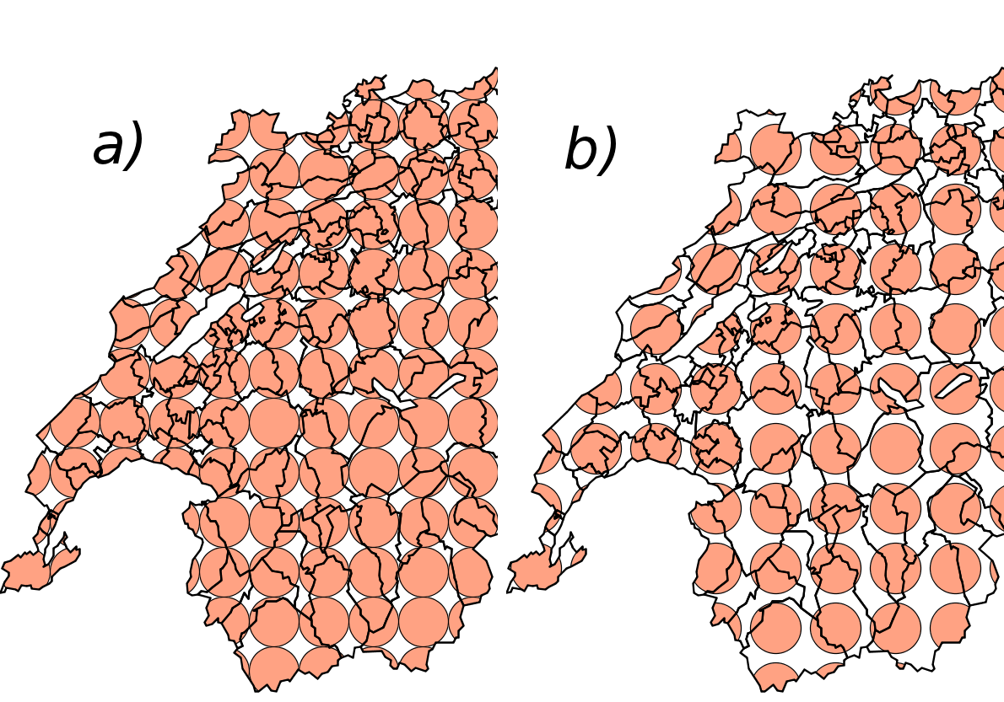
Notice, the tiling shall be consistent between neighboring features. Moreover, tiles shall be organized according to a system-dependent geographic anchor point, which implies each feature is filled by the pattern in a unique way at a given scale level, as shown in next figure.
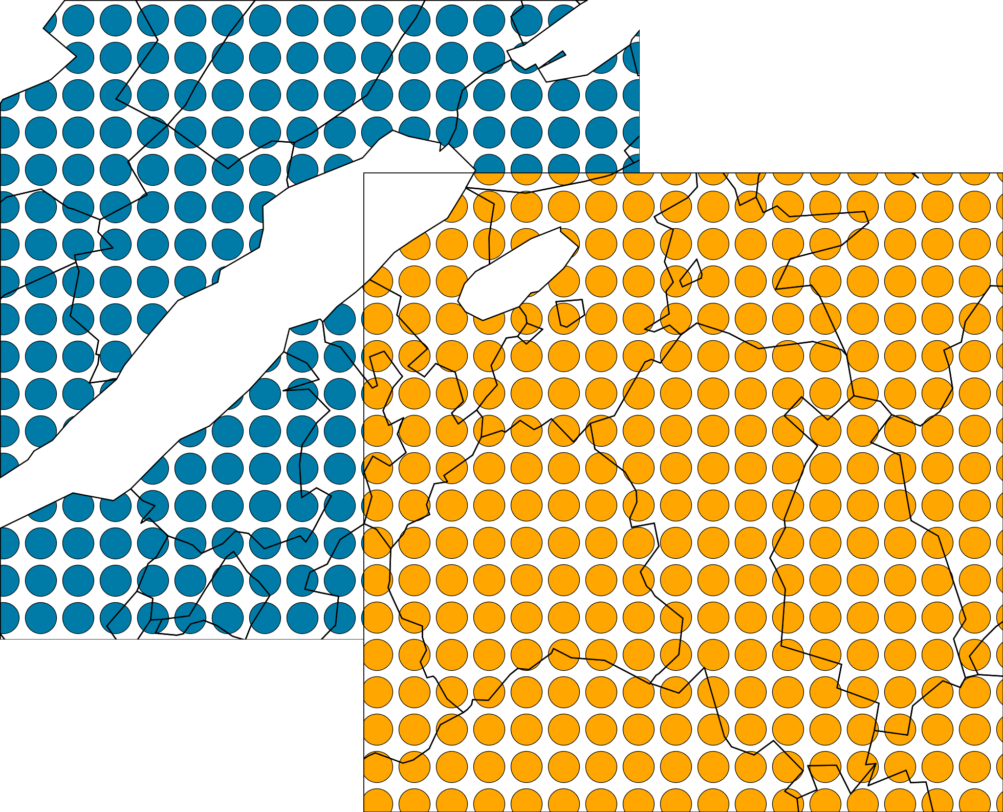​
​The features are always filled in the same way at a given scale, whatever the map bounding-box is.

​8.2​ HatchedFill
The following figure illustrates the effect inducted by adding an offset (no offset in a), offset in b)).
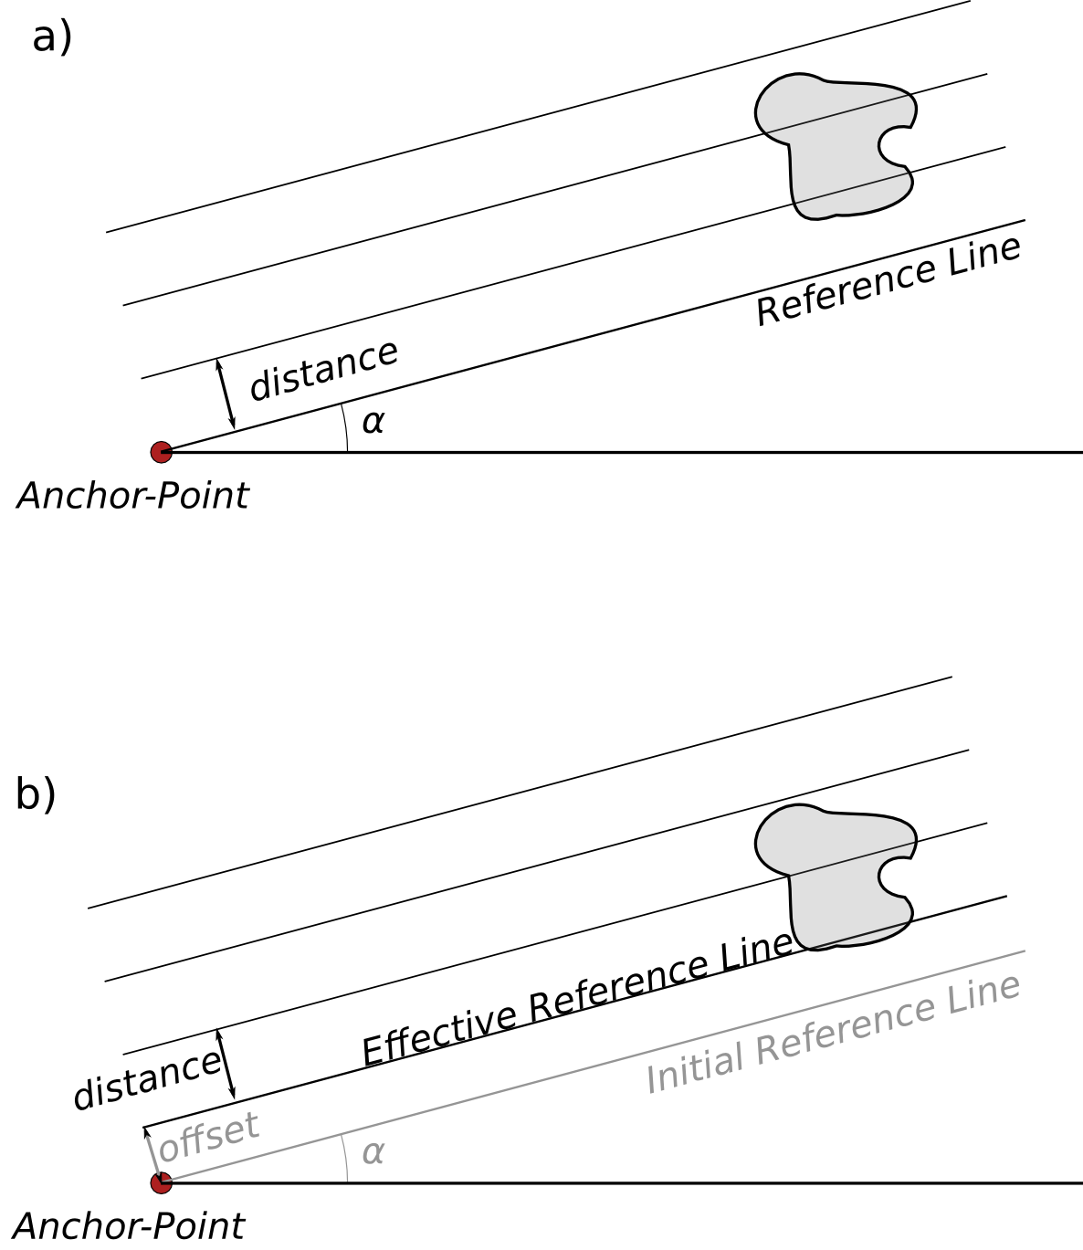
a) illustrates how hatches shall be generated according to an anchor-point. b) shows the same but with the addition of an offset

​8.3​ PerpendicularOffset

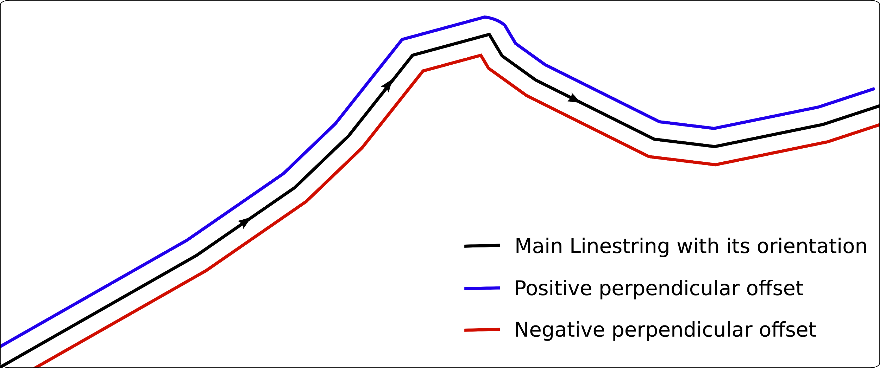
Figure 1. Positive and negative perpendicular offset against a 1-dimensional geometry

ADD A FIGURE HERE
Figure 2. Positive and negative perpendicular offset against a 2-dimensional geometry

​8.5​ RelativeOrientation

RelativeOrientation tells what angle to rotate the graphic to when it is plotted. Allowed values are “normal” (default) meaning rotated to the mathematical normal (perpendicular) of the line at the plotting point, “line” which means to rotate to the direction of the line at the plotting point, “portrayal” which means always upright with respect to the parent portrayal environment (usually the map), and “normalUp” which means to rotate with respect to the normal of the line, but rotate an additional 180 degrees if the graphic would otherwise end up pointing downward with respect to the parent portrayal environment.

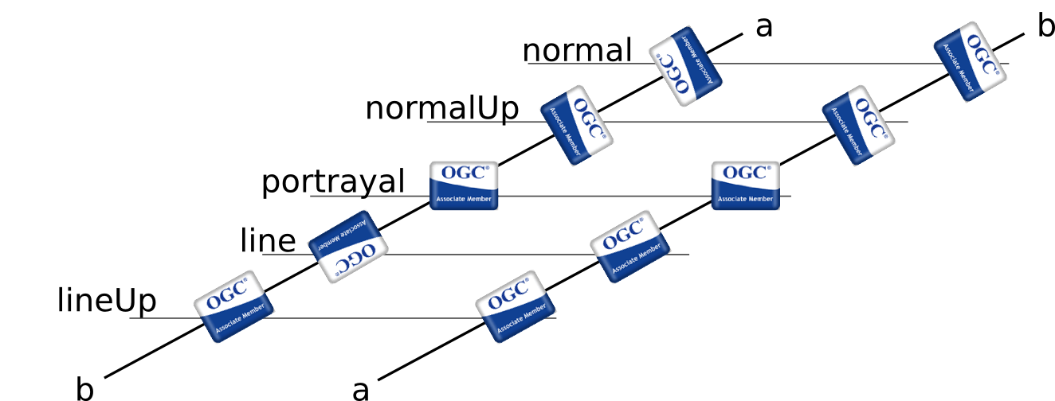
Figure 3. TITLE

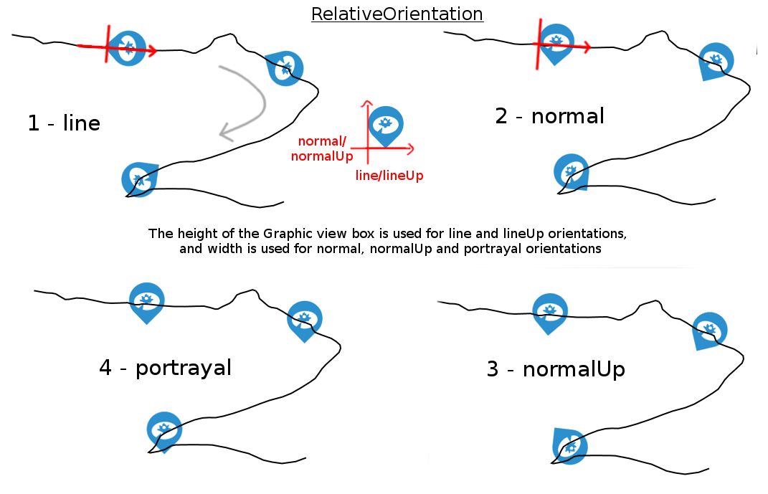
Figure 4. TITLE

​8.6​ LabelAlignment
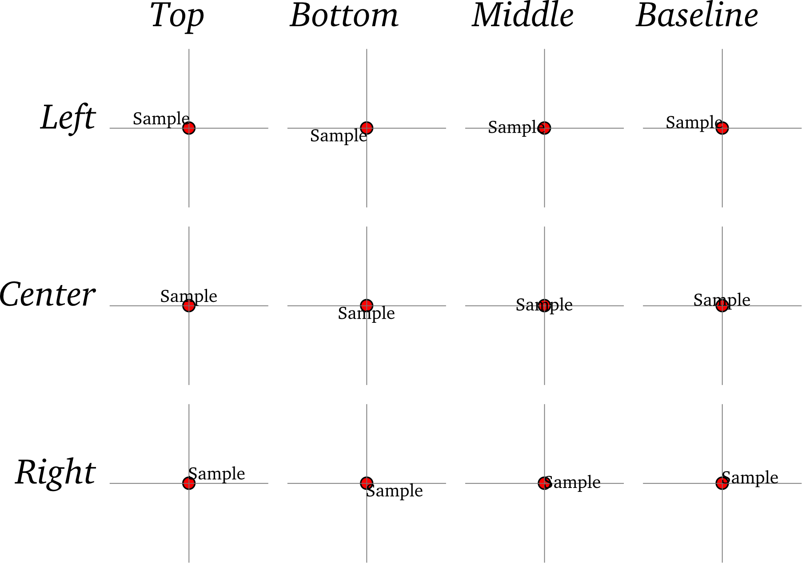
Figure 5. PointLabel alignments

​8.7​ ExclusionZone

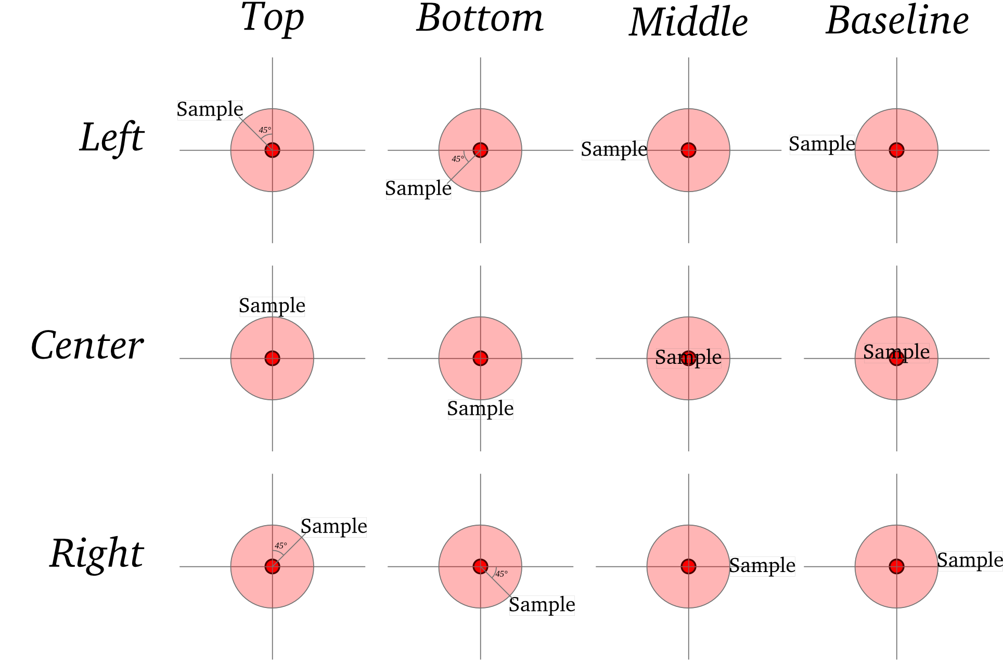
Figure 6. PointLabel alignments with a radius exclusion zone

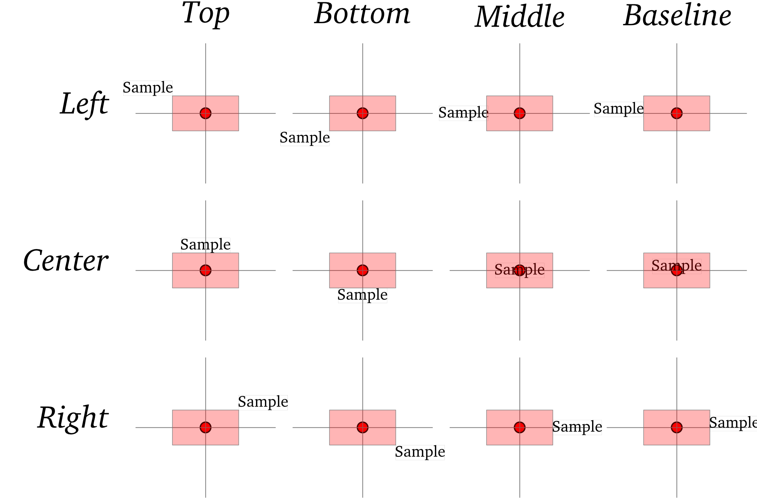
Figure 7. PointLabel alignments with a rectangle exclusion zone

from OGC 06-103r4 / http://www.opengis.net/doc/IS/SFA/6.1.2
from http://www.opengis.net/doc/IS/FES/2.0/clause/7.1

