Open Government Platform
Functional Requirement Document
(DMS)

Project Name: Data management System (DMS)
Date started:

Table of Contents

1 Introduction…..…………………………….…………............................................. 4

1.1 Purpose…………………………….…….…………............................................... 4

1.2 Scope……………………….………….………………….………………………….…………4

1.3 Background……………………………….…...……………………………….….………...4

1.4 References...………………………….…………….………….…………….………………5

1.5 Assumptions and constraints....……………….……………………….………………5

2 Methodology..............................................................................................5

2.1 System Analysis............……….....………….………….………………….…………..6

2.2 Business Analysis............……….....…….………….………………….………………6

3 Functional Requirements………….............…….………………….………….………11

Functional Requirement Document

Introduction

1.1 Purpose

This functional requirements document (FRD) provides functional requirements and design for the Data Management System (DMS), which is a module of the Open Government Platform (OGPL), the open source product developed jointly by India and the United States that is being made available so that governments around the world can create their own open data sites.

For each instantiation of the OGPL, it is envisioned that there will be a coordinating group (herein called a Program Management Unit, PMU) that is responsible for the development and implementation of DMS to include the process of coordinating, reviewing, analyzing, and publishing all data in the OGPL. (While the term “datasets” is used in this FRD for the sake of simplicity, the DMS can be used for objects beyond datasets (documents, tools, etc.)

The requirements described in this FRD shall support the PMU by providing from start to finish the necessary tools and capabilities to provide an automated, manageable process for publishing data in the Open Government Platform catalogue. DMS will be available to anyone who has the URL and password.

A successful implementation of the DMS would be achieved when the PMU, (governmental?) organization managers, and Contributor can submit, approve, and update data electronically and view management metric reports.
DMS will support management and decision-making through any web browser. DMS will help organizations rapidly provide their data through on-line entry or upload of their metadata tools from multiple on-line environments. These are really specific requirements and not part of the overview. Perhaps…This DMS is envisioned as a decision-making system for governments to be able to manage, upload, approve, and view data online.

1.2 Scope
This FRD describes the functional characteristics of DMS. This document is prepared in support of the OGPL project to document functions and operational procedures for data submissions and changes. Role Management, security compliance as well as accessibility compliance are also addressed.

1.2 Background
During the U.S.-India Open Government Dialogue, Secretary of State Hillary Rodham Clinton and Minister of External Affairs S. M. Krishna announced the U.S.-India Innovation Exchange.
Under the Indo-US collaboration, the two countries had knowledge sharing and technical exchange sessions for a week at GSA, Washington-DC. In which the High Level Functional Requirements of “Data.gov-in-a-Box,” were deliberated and formulated based on the Data.Gov of United States’ data portal and India.gov.in of India’s National portal. Detailed report is enclosed as Appendix A. It will be available for implementation by countries globally, encouraging governments around the world to adopt open data sites.
As the U.S. and India began collaborating on “Data.gov-in-a-Box,” it became clear that the resulting product would be more than a data catalog and site, and as a result, the project name was changed to Open Government Platform (OGPL). Documents and statements earlier in the project will contain references to “Data.gov-in-a-Box” or “DGIB” for short.

1.4 References

- India National Portal – http://india.gov.in/
- U.S. Data.gov – http://www.data.gov/

1.5 Assumptions and Constraints

1.5.1 Assumptions

Assumptions associated with DMS are listed below:

- All OGPL components will be available for unrestricted download and access without fee or licensing and open source.
- In any implementation, there is a central PMU responsible for management of the OGPL website.
- DMS supports two-tier hierarchical organizational structures for managing data submissions.
- Contributors may submit metadata along with a URL of the data source, or submit metadata with a data source attached.
- DMS is a separate and isolated system from the main OGPL application that serves public-facing website contents.
- Operational requirements vary based on the specifications of the infrastructure on which OGPL is deployed.
1.5.2 Constraints
Constraints imposed on DMS are listed below:

- DMS has the same system requirements as Drupal 6.x. (see Drupal’s System Requirements)
- An SSL certificate must be installed on web servers.
- Operational requirements are dependent on the actual infrastructure on which the application is deployed.

2 Methodology

2.1 System Analysis

This Functional Requirements Document has been formulated to blueprint the functional and system requirements to upgrade the current Dataset Management System (DMS) to automate and simplify the data publication process to provide users the ability to electronically submit, track, and manage data for OGPL to promote data usage, usability, and availability to the public and the government agencies.

2.2 Business Analysis

During the week of August 29 – September 2, 2011, a delegation of representatives from the Indian National Informatics Centre (NIC) visited Washington, DC, for a knowledge sharing and technical exchange session with the Data.gov team about the Data.gov-in-a-Box initiative.

Knowledge Sharing and Technical Exchange

The five-day exchange began with demonstrations of the existing United States Data.gov website, the communities, catalogs, and Dataset Management System (DMS). Valuable discussions and questions and answers took place and the group reached a shared understanding of the current capabilities, architecture, and underlying technology of both Data.gov and India’s India.gov.in document portal. A series of assumptions about the nature of the project were captured and agreed-upon, including the idea that the DGIB (now OGPL) would be open-source, modular, and customizable to any potential installation. The group outlined the desired characteristics and specifications of the various components of the proposed OGPL product.

Early on it was agreed that version 1.0 of OGPL will focus on data discovery and data access, with any type of data presentation or visualization beyond simple downloading to be incorporated in later versions. Visualization tools would be an ideal candidate for an open-source community developer challenge. Discussions centered around the basic architecture of the “minimum viable product” at the initial launch – two instantiations of Drupal, one for the website and one for the DMS. A significant agreement was reached that the U.S. Data.gov would also migrate to the same open-source architecture, thereby keeping both Data.gov and OGPL in synch. The group also held lengthy discussions about the metadata template to be the standard for OGPL. The intent is to enable any adopting country to customize the look and feel of the website, the functionality, the workflow for approving data within the DMS, and the metadata. The group agreed that a well-defined, modular standard metadata template would promote wide adoption and enable future international data sharing.
3 Architecture and Flow

3.1 Architecture

System interfaces are depicted below in Error: Reference source not found.
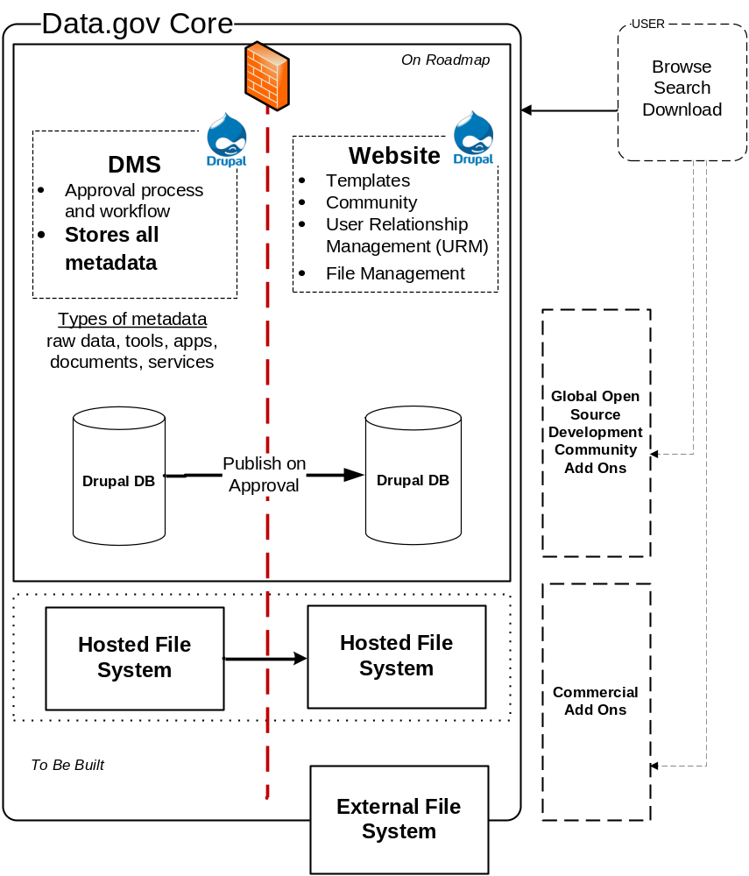

Figure 1: Open Government Platform Conceptual Architecture

3.2 Data Flow Diagram

The following diagram illustrates the basic approval workflow that a dataset record must go through in DMS before it is published on the website.

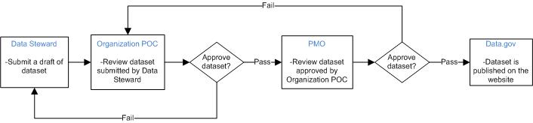

Figure 2: Data Flow Diagram

3.3 Logical Data Model

Metadata model is logically separated into 4 sections: Core, Access Type Extensions, Data-specific Extensions, and Administrative Extensions. Core is required for all data submissions, and appropriate extensions will be required as users identify what type of data is being submitted. All extensions shall be customizable by the system administrator.

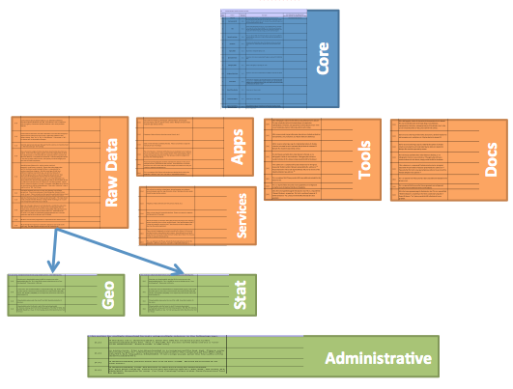
Figure 3: OGPL Metadata Logical Data Model

4 Functional Roles

4.1 Users

The following basic categories of users are defined as functional, business user roles of DMS.

- PMU
- Data Controller (Validator)
- Contributor
DMS shall allow administrators to customize user role hierarchy by creating more than one level of basic category of user roles. Each user role shall have a dedicated workflow step assigned. User roles and workflow shall be customizable by system administrators.

A special system user role called System Administrator shall be available in DMS to administer the site. System Administrator shall not have a functional role within the data approval workflow. Detailed user requirements per each user role are defined below.

4.2 System Administrator

System Administrator is an individual who maintains and administrates the OGPL and CMS websites, software, and possibly hardware. The System Administrator’s primary responsibility is to support operation of the website, and the System Administrator is not directly involved in the DMS data approval workflow.

Table 1: User Requirements for System Administrator
Req. ID | Requirement Definition
U1.1 | System Administrator shall have access to all records.
U1.2 | System Administrator shall have functionalities to add, update, or disable all user accounts.
U1.3 | System Administrator shall have functionalities to add, update, or disable all organizations.
U1.4 | System Administrator shall have access to function as any other user, including all other roles.
U1.5 | System Administrator shall have access to configure and customize the application as needed, via an administration interface.

4.3 Program Management Unit

PMU is a role assigned to individual(s) who manage data portal and the DMS. PMU publishes the validated/approved submissions, on the Data Portal, received from the Ministries/ Departments/ Government Entities. In case of unsuitable and invalid record submission, they can send it back to the Data controller (Validator) for review. They are also responsible for user management for the DMS module.
Table 2: User Requirements for Program Management Office
Req. ID | Requirement Definition
U2.1 | PMU shall review records that have been approved by Validators.
U2.2 | PMU shall be able to approve records to be published on the data portal or reject records to send back to Validators.
U2.3 | PMU shall have functionalities to start the new submission of records.
U2.4 | PMU shall have access to all records.
U2.5 | PMU shall have access to update all the published records
U2.6 | PMU shall have access to download the record in CSV format
U2.7 | PMU shall able to filter the listed records with criteria such as workflow state (Pending with Contributor,Pending with Validator, Pending with PMU, Published) and Request type (Create, Update, Delete)
U2.8 | PMU shall have functionalities to add, update, or disable all user accounts, including other PMU accounts, except for the System Administrator account.
U2.9 | PMU shall have functionalities to add, update, or disable all organizations.
U2.10 | PMU shall have access to generate all metric reports.
 | PMU shall have access to delete the published records
U2.11 | PMU shall have access to function as any validator or Contributor.
U2.12 | PMU shall able to preview visualization of the records (Datasets) that have been approved by Validators.
U2.13 | PMU shall able to approve visualization of the records (Datasets) to be published on the data portal
U2.14 | PMU shall able to disapprove visualization of the records (Datasets)

4.4 Data Controller (Validator)
An Organization Validator is a representative from an organization who identifies, describes, and who would validate the data for inclusion in OGPL. Validator is also responsible for ensuring data submitted meet the data policy standards, licensing, copy right policies etc as defined by the government.

Validators shall use DMS using authorized government organization unique User ID (email address) and password through following steps:

- Login through valid government email id
- Apply for role request
(External user, Data controller (Validator), Not known)
- PMU shall approve role request sent by the user.
Validators after PMU approval shall login into the DMS (Data management system). Validators shall able to view user management tab in his/her account. User management tab categorized into 2 sub tabs.

- Create Contributor
- Manage users
Validators shall able to create Contributor by giving authenticated user id. On creating Contributor, system shall send a mail to Contributor email id with username and password then Contributor shall be able to login into CMS as Contributor.

Validator users shall create any number of Contributors and shall approve or decline the created Contributor from manage users sub tab.
Table 3: User Requirements for Organization Points of Contact
Req. ID | Requirement Definition
U3.1 | Validator shall review records that have been submitted by Contributor in their organization.
U3.2 | Validator shall be able to approve records up to the PMU, or reject records to send back to Contributor.
U3.3 | Validator shall have functionalities to start the new submission of records.
U3.4 | Validator shall have access to edit the records
U3.5 | Validator shall have access to download the record in CSV format
U3.7 | Validator shall able to filter the listed records with criteria such as workflow state (Pending with Contributor, Pending with Validator/approver, Pending with PMU, Published) and Request type (Create, Update, Delete)
U3.8 | Validator shall have access to all records for the organization associated to the Validator’s user account.
U3.9 | Validator shall have functionalities to add, update, or disable Contributor and other Validator user accounts for the organization associated to the Validator’s user account.
U3.10 | Validator shall have access to generate all metric reports for the organization associated to Validator’s user account.
U3.11 | Validator shall be assigned to one and only one organization.

4.5 Contributor
Contributor is a representative from an organization shall be responsible for getting the datasets collated, cleaned and access DMS to create new submissions on datasets or apps in the format provisioned in the DMS. They would also be responsible for the classification of datasets and pushing for validation and approval by the Validator.
Contributor shall use DMS using authorized email id/password approved by the Validator. Contributor shall able to view following 2 catalog buttons.

- Data catalog
- Apps catalog

Contributor shall create data set through data catalog page. The workflow of creating data catalog is a 2 step process.
Step- 1 consists of following fields:
Title (Text box) - Mandatory
Description (Text box) - Mandatory
Released on (calendar)
Sectors (Drop down) - Mandatory
Asset jurisdiction (Drop down) - Mandatory
Keywords (Text box) - Mandatory
Access method- Upload a data set/Link to URL (Drop down) - Mandatory
Dataset group name (Text box)
Frequency (drop down) - Mandatory
NDSAP compliance (for contributor) (check box) - Mandatory
Save and continue (button)
Cancel (button)

Step- 2 consists of following fields:

Contributor (Radio button)
Validator (Radio button)
Comment (Text box)
Workflow history
Delete (Button)
Cancel (Button)
Save and Go back (Button)
Finish (Button)
Contributor shall create app catalog through app catalog page. The workflow of creating app catalog is a 2 step process.
Step- 1 consists of following fields:-
Title (Text box)- Mandatory
Description (Text box) - Mandatory
Released on (calendar)
Sectors (Drop down) - Mandatory
Asset jurisdiction (Drop down) - Mandatory
Keywords (Text box) - Mandatory
Access method- Upload a data set/Link to URL (Drop down) - Mandatory
App Type (Drop down)
Dataset (s) Used (text box)
Language (List box) - Mandatory
NDSAP compliance (for contributor) (check box) - Mandatory
Save and continue (button)
Cancel (button)

Step- 2 consists of following fields:-

Contributor (Radio button)
Validator (Radio button)
Comment (Text box)
Workflow history
Delete (Button)
Cancel (Button)
Save and Go back (Button)
Finish (Button)
Table 4: User Requirements for Contributor
Req. ID | Requirement Definition
U4.1 | Contributor shall be able to submit records up to the Validator for the organization associated to Contributor’s user account.
U4.2 | Contributor shall have functionalities to start new submission records.
U4.3 | Contributor shall have access to all records initiated by the user.
U4.4 | Contributor Steward shall have access to all published records for the organization associated to validator’s user account.
U4.5 | Contributor shall be assigned to one and only one organization.

5 Functional Requirements

Functional requirements are categorized as follows:

- System Access
- User Registration and Management
- User Authentication
- Data Submission
- Approval Workflow
- General Display and Reports
- System Help

5.1 System Access

The system is accessible via any web browser via a URL using HTTPS to promote collaboration across multiple organizations, which may be located in various geographic locations while ensuring security and validity of data submitted. A simple Internet connection is all that is necessary to access the system to encourage rapid growth of datasets.

Table 5: System Access Requirements
Req. ID | Requirement Definition
FR1.1 | DMS shall be accessible via a URL using any generic web browser.
FR1.2 | DMS shall be accessible via HTTPS only.

5.2 User Registration and Management

User registration needs to be configured in a way to strengthen security and validate authoritative source of data. With a unique account and a strong password policy, hacking or breaching can be prevented with a strong audit trail.

Table 6: User Registration and Management Requirements
Req. ID | Requirement Definition
FR2.1 | DMS shall create one System Administrator account upon installation.
FR2.2 | DMS shall not allow users to self-register.
FR2.3 | DMS shall enforce an arbitrary password policy, configurable by the System Administrator.
FR2.4 | DMS shall enforce an arbitrary password expiration policy, configurable by the System Administrator.
FR2.5 | DMS shall enforce an arbitrary password reuse policy, configurable by the System Administrator.
FR2.6 | DMS shall allow System Administrator to add, edit, or disable users of all roles.
FR2.7 | DMS shall allow PMU to add, edit, or disable users of all roles except for System Administrator, for any organizations.
FR2.8 | DMS shall allow validator to add, edit, or disable users of Validator or Contributor roles, for the organization associated to validator’s user account.
FR2.9 | DMS shall allow PMU to add, edit, or disable organizations and their hierarchy.
FR2.10 | DMS shall require the following information to create a user account: email address, name, phone number, organization, and user role.
FR2.11 | DMS shall send a temporary 1-time password via email when a new user is created. This temporary password should expire within 24 hours.
FR2.12 | DMS shall force users to update their password when logging in DMS using temporary passwords.
FR2.13 | DMS shall allow users to reset passwords with email validations.
FR2.14 | DMS shall store user passwords using a one-way encryption, and shall not allow users to retrieve a lost or forgotten password.

5.3 User Authentication

Users must authenticate themselves using a unique User ID (email address) and password before performing any actions in DMS. A session expiration policy is necessary to prevent unintended use of the system by unauthorized users. DMS shall not use any persistent cookies to prevent potential unwanted saving of user credentials and to comply with generic privacy policies.

Table 7: User Authentication Requirements
Req. ID | Requirement Definition
FR3.1 | DMS shall allow users to login to the system using their email addresses and passwords.
FR3.2 | DMS shall allow users to logout and invalidate their sessions by clicking on “Logout” link.
FR3.3 | DMS shall not allow users the option to save user credentials using persistent cookies.
FR3.4 | DMS shall automatically logout the user when user’s session is inactive for 30 minutes with a warning at 20 minutes.

5.4 Data Submission

Users must provide a wide range of information, as identified by the OGPL metadata model, to submit a dataset in order to measure the usability and to gather enough searchable information to allow the public to find datasets.

Table 8: Data Submission Requirements
Req. ID | Requirement Definition
FR4.1 | DMS shall allow users to start a new dataset submission record, in the workflow step the individual user is responsible for.
FR4.2 | DMS shall allow users to enter complete metadata using web interface.
FR4.3 | DMS shall allow users to upload CSV and XML files to enter one or more dataset submission records.
FR4.4 | DMS shall allow users to save a record without submitting or approving it. Data shall not be validated while saving.
FR4.5 | DMS shall allow users to edit, submit, approve, reject, or delete records that are in the workflow step users are responsible for, as appropriately filtered by data access control based on users’ roles.
FR4.6 | DMS shall allow users to enter all metadata fields in Core template.
FR4.7 | DMS shall allow users to enter Type-based metadata extension fields, based on the type of data selected.
FR4.8 | DMS shall allow users to enter Category-based metadata extension fields, based on the category of data selected.
FR4.9 | DMS shall allow users to enter administrative metadata extension fields.
FR4.10 | DMS shall validate data entered, as set by administrators, while submitting or approving records. Data validation rules shall be defined by the metadata model.
FR4.11 | DMS shall allow System Administrator to create, edit, or delete Data Types and Categories, which extensions are based on.
FR4.12 | DMS shall allow System Administrator to create, edit, or delete type- and category-based metadata extension fields.
FR4.13 | DMS shall allow System Administrator to group metadata fields into logical groups.
FR4.14 | DMS shall display data entry forms grouped by logical groups.

5.5 Approval Workflow

An approval workflow is necessary to ensure that each organization has completed its due diligence to ensure datasets meet publishing organization’s standards.

Table 9: Approval Workflow Requirements
Req. ID | Requirement Definition
FR5.1 | DMS shall facilitate a linear dataset approval workflow process, as defined in Section .
FR5.2 | DMS shall allow System Administrator to define an arbitrary number of workflow steps. Each step must have a user role responsible for the step assigned.
FR5.3 | DMS shall allow users to complete a workflow step and advance the record to the next workflow step, unless the record is published.
FR5.4 | DMS shall allow users to reject a record and send the record back to the previous workflow step, unless the record is already at the step it started at.
FR5.5 | DMS shall allow users to create requests to update or delete already published records. DMS shall keep the original record intact until the update or delete request has gone through the approval workflow. When update or delete request has completed the workflow, the original record shall be archived and the new record shall replace it.
FR5.6 | DMS shall send email notifications to the new workflow owner(s) on transitions.
FR5.7 | DMS shall send email notifications to all involved users when a record is published.
FR5.8 | DMS shall allow users to approve or rejects multiple records at once.
FR5.9 | DMS shall allow users to provide comments while approving or rejecting a record.

5.6 General Display and Reports

The system provides several build-in reports to show statistics on dataset approval workflow process, where the comprehensive status of dataset submissions is easily accessible. DMS shall also provide a facility for PMU and System Administrator to communicate to all users via notifications on the home page or a repository of documents.

Table 10: General Display and Reports Requirements
Req. ID | Requirement Definition
FR6.1 | DMS shall display all records in the user’s workflow step, appropriately filtered by access control rules enforced by user’s roles, upon login.
FR6.2 | DMS shall allow users to preview records in the same format as the OGPL website template.
FR6.3 | DMS shall allow users to download existing records as CSV or XML.
FR6.4 | DMS shall allow users to perform keyword searches to filter records.
FR6.5 | DMS shall allow users to filter all records view by workflow step or request type.
FR6.6 | DMS shall allow users to sort all records view by title or date last updated.
FR6.7 | DMS shall provide a document library where System Administrators or PMU can upload any arbitrary documents.
FR6.8 | DMS shall display “What’s New” notifications on the home screen, prior to user authentication. Notifications shall be added, edited, or deleted by System Administrators or PMU.
FR6.9 | DMS shall provide a summary table to all users upon login, which displays number of records in each workflow steps, as filtered appropriately by access control defined by users’ roles.
FR6.10 | DMS shall provide a detailed summary report, which displays number of records in each workflow steps by each organization to System Administrators, PMU.
FR6.11 | DMS shall provide a summary statistics report on average time datasets stayed in each workflow steps, by each organization to System Administrators, PMU.

5.7 System Help

DMS’s help system, which consists of the User Guide and the help messages, promotes growth and improvement through user feedbacks and creates a user-friendly environment for the system.

Table 11: System Help Requirements
Req. ID | Requirement Definition
FR7.1 | DMS shall display a help message assigned to each metadata field while users are trying to input data.
FR7.2 | DMS shall display context based help messages, when requested, on each functional page.
FR7.3 | DMS shall allow users to download the user’s guide.

5.8 Data Conversion Tool
Data Conversion Tool is an add-on service for the DMS which helps the users to download the data files in different other open source formats.

Table 123: Data Conversion Tool Requirements
Req. ID | Requirement Definition
FR8.1 | A link has to be shown on each published catalog having data file associated with it
FR8.2 | The tool should convert the given data file to compatible open source formats.

6 Other Requirements

6.1 Interface Requirements

DMS shall push published metadata to DGIB Website software via HTTPS protocol.

DMS shall push published data source files using SCP protocol.

On web/application server, ports 22 and 443 must be open. On database server, ports 22 and 3306 must be open.

7 Hardware/Software Requirements

7.1 Hardware Requirements

There are no specific hardware requirements for DMS. DMS may be deployed on physical servers or virtual servers. For security, it is recommended web and database servers are separated.

7.2 Software Requirements

DMS is built using open source content management software called Drupal, version 6.x. As such, the same system requirements for Drupal 6.x apply to DMS. Notably, the following software packages listed are required.

- Linux
- Apache webserver 2.x
- MySQL 5.x
- PHP 5.x
- Apache Solr

7.3 Web Accessibility Requirements

DMS shall be accessible by any generic web browsers: Internet Explorer, Firefox, Safari or Chrome. [Note that IE 6 will not be supported. DMS shall conform to guidelines provided by the Web Content Accessibility Guidelines 2.0.

8 Operational Requirements

The following sections are provided for illustrative purposes, but the specific operational requirements will be dependent on each organization that chooses to deploy OGPL.

8.1 Security and Privacy

DMS shall not rely on collecting any personally identifiable information. DMS shall not rely on the use of any persistent cookies stored in browsers.

8.2 Audit Trail

DMS shall track the user’s system ID, workflow step, date and time whenever a record is created or updated.

DMS shall maintain audit trail of the user’s system ID, date and time whenever a record is approved or rejected in the workflow.

8.3 Reliability
System failure shall be defined as “show-stopper” bugs in DMS, which would prevent users from submitting a dataset. Impact of system failure is minimal and does not involve loss of human life, complete or partial loss of the ability to perform a mission critical function, or loss of revenue. System failure may result in minor loss of employee productivity.

8.4 Disaster Recovery

Disaster recovery shall be implemented at the operating system level, following policies of the organization deploying OGPL application.

8.5 System Availability

System availability is dependent on the infrastructure OGPL application is deployed on.

8.6 System Performance

System performance is dependent on the infrastructure OGPL application is deployed on.

8.7 Capacity

Capacity requirement is dependent on use cases created by the organization deploying OGPL application.

8.8 Data Retention Policy

DMS shall retain application information until the system is retired. DMS is not designed to enforce any specific data retention policy.

