**Instructions on how to install FormSG on your GSIB laptop**

The installation of the script does not require any prior IT experience and takes about 30 minutes to setup. Please email me at [formsg@tech.gov.sg](mailto:formsg@tech.gov.sg) if you face any issues.

|  |
| --- |
| **Note: These instructions are sequential and each step is necessary. Please follow the steps sequentially and do not skip any.** |

**Part 1: Outlook Configuration**

|  |
| --- |
| **Note that if you are using a shared inbox to collect form responses, please refer to Part 4 below to set that up.** |

1. In Outlook, to prevent FormSG’s emails from ending in Junk, add FormSG’s email to the safe senders list. In the **Home** tab, go to **Junk > Junk E-mail Options**:

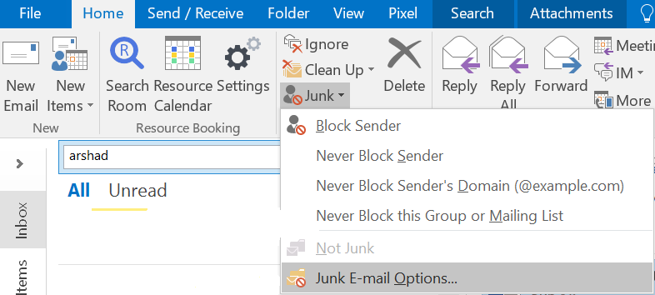

1. Switch to the **Safe Senders** tab and click **Add** to add FormSG’s email domain: **@form.sg**

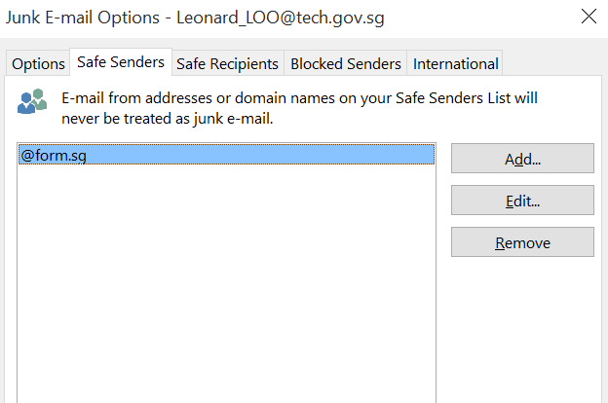

1. Create a new folder in your **Inbox** called **Formsg** by going to the **Folder** tab > **New Folder:**

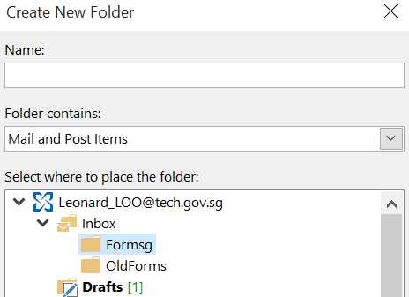

1. Create a new rule that automatically transfers incoming email with a specified Subject title to the Formsg folder. In the **Home** tab, click on **Rules > Create Rule.** Check **Subject contains** and fill it in with **formsg-auto.** Check **Move item to folder** and select **Formsg** folder. The end result should look like this **(please pay attention to only the checked boxes, ignore other check boxes such as “From GOVTECH Internal Comms”):**

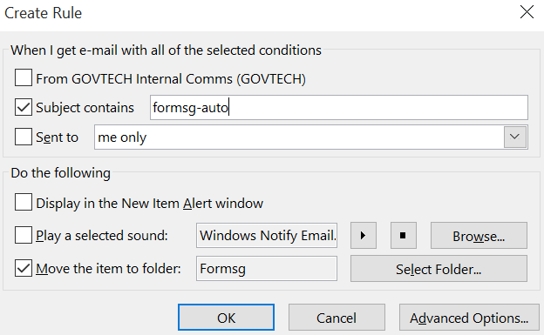

To check that your rule has been created, on the **Home** tab again, click on **Rules > Manage Rules & Alerts** and you should see the rule present.

**Part 2: Folder setup**

1. Navigate to your **Documents** directory and create a new folder, **Formsg.**

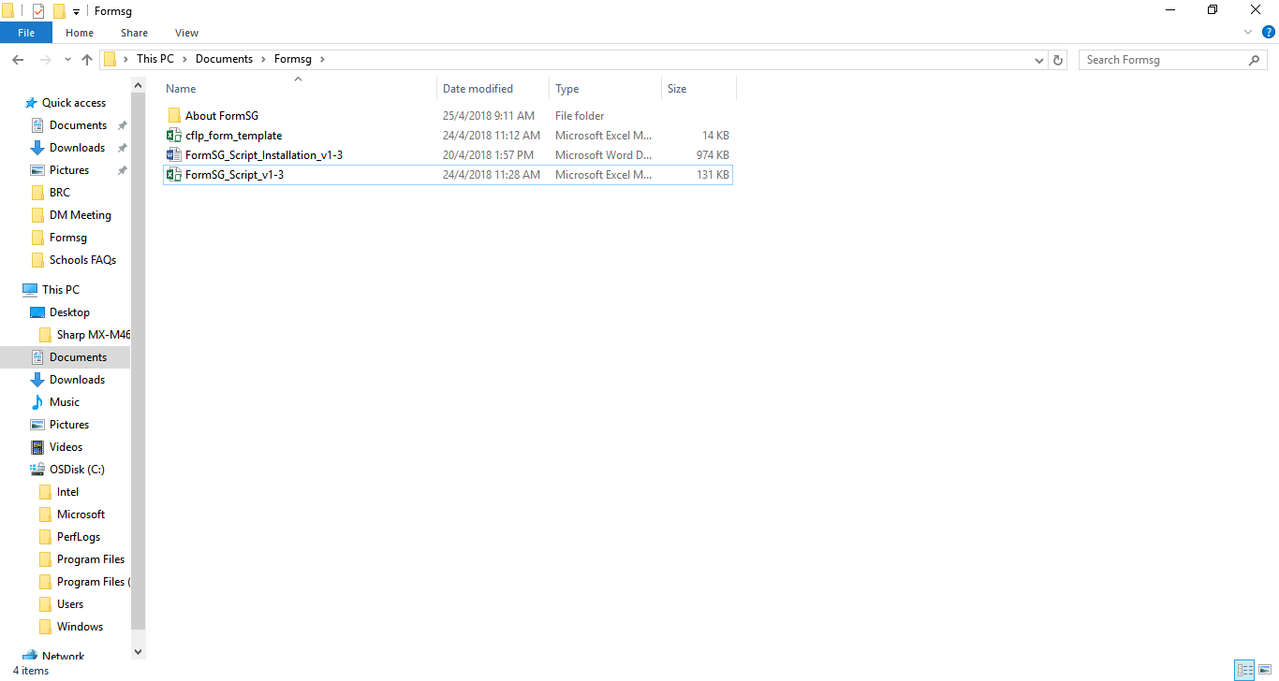

1. **Place your template Excel file here** and name it accordingly. The script will be populating this template. In our example, we’ll name it “cflp_form_template.xls”. Remember your template filename as that will be used in the installation of scripts in Part 3 below. An example of a simple template file includes the column headers:

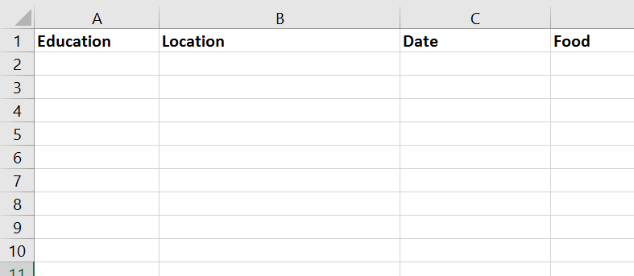

|  |
| --- |
| **Tip:**  The script will aggregate email from your Outlook and generate an Excel spreadsheet in the Formsg folder. Note that the script looks for all emails with the same form name within the same Outlook inbox and aggregate them into the same Excel, i.e. if I have a form name of “cflp form”, all email responses with this form name will be in the same Excel file. |

**Part 3: Script installation**

1. **Unblock the script file if necessary**

On some GSIB machines, the administrator might by default block macro-enabled files. You will have to manually unblock the script file by **right-clicking the script file > Properties > check the Unblock checkbox under Security tab.**

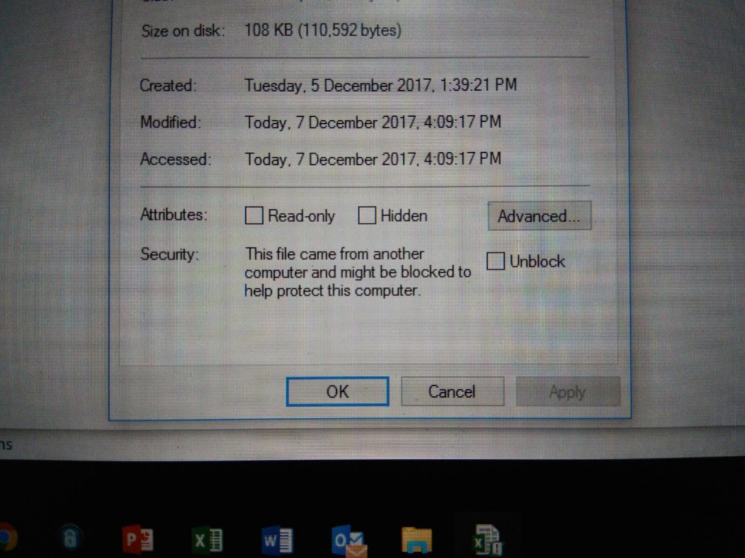

If this Security option is not there on your script, this means the script is already unblocked by default.

1. **Enable macros with a self-signed cert within Microsoft Excel**

|  |
| --- |
| **Note that in older GSIB machines, this step is not required as Excel macros work out of the box. To find out if it is working, set all five compulsory fields in the Excel workbook (refer to Part C below to find out more) then press Run. Please proceed with this section if it says macros are disabled:** |

Go into **Windows Explorer** and navigate to your Microsoft Office directory: **C: > Program Files > Microsoft Office > Office16**. Launch the **SELFCERT.exe** application present in that folder.

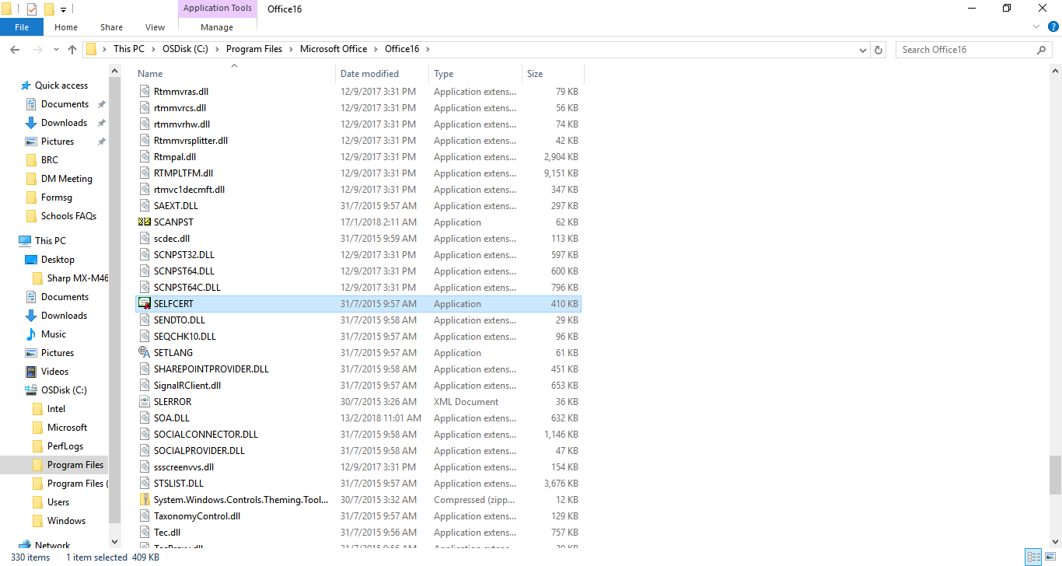

Name the certificate **Formsg** and click OK to create it:

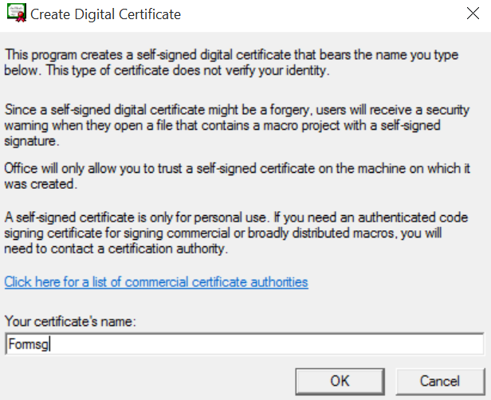

Once your certificate is created, we will need to use it with our scripts. Open the file FormSG_Script.xlsm from your FormSG folder, press **Alt + F11** to open up the Visual Basic Editor.

If this does not work, you will need to enable visual basic.

Open FormSG_Script.xlsm > Go to **File** > **Options** > **Customize Ribbon** > Tick the **Developer** check box > Click **OK**.

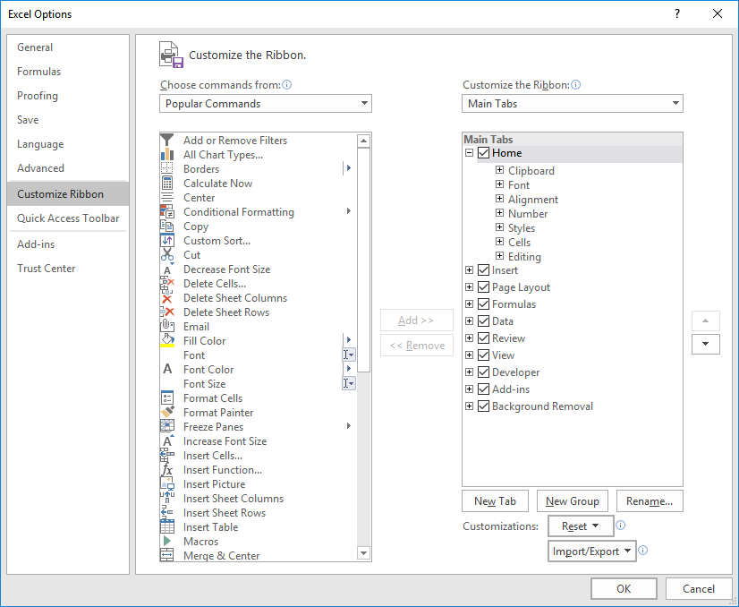

Now try to press **Alt + F11** to open up the Visual Basic Editor.

On the menu bar, click on **Tools > Digital Signature.** A popup should appear for you to **Choose** your certificate. If you have issues at this step, and the popup is not appearing, **restart your PC**.

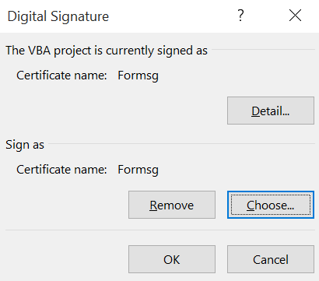

**Choose** the **Formsg** certificate, and click **OK.**

Next, **close Excel** (the entire Excel workbook, not just the Visual Basic Editor) and click **Yes** to **Save** the VBA Project. On reopening FormSG_Script.xlsm, you will see a popup at the top to Enable macros:

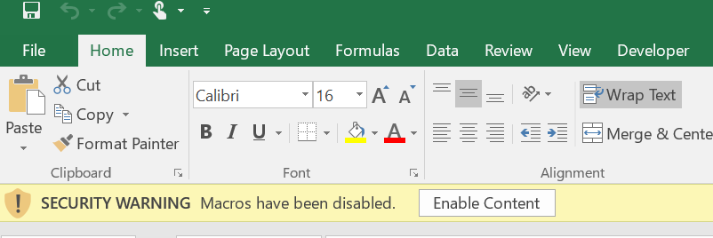

Click “Enable Content” and you can now run the script.

1. **Include references**

|  |
| --- |
| **Please proceed with this section only if you run into this error when you run:**  cid:image001.png@01D348E8.AC0222B0 |

The scripts work on both Outlook and Excel; hence we have to include those references. To include the references, we:

1. In the Visual Basic Editor (Alt + F11), Go to **Tools > References**…
2. If references are greyed out, you are on break mode. To get out of break mode, press the **Stop button** which is the blue square:

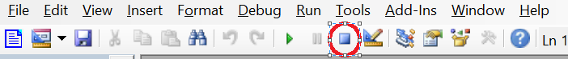

1. In the references popup, check **six references** (the list is long but sorted alphabetically)**:** Visual Basic For Applications, Microsoft Outlook 16.0 Object Library, Microsoft Excel 16.0 Object Library, Microsoft Office 16.0 Object Library, Microsoft XML, v6.0 and Microsoft HTML Object Library. Click OK. If there were other options being checked, that is fine. If the version of Microsoft Office is 15.0 or lower, that is fine too.

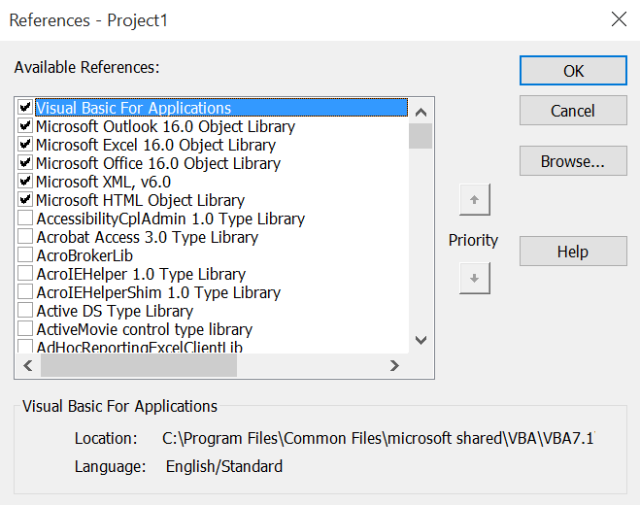

You have successfully included the necessary references for the scripts to run.

Note that if you are on version 15.0 for your libraries, make sure to uncheck the MISSING 16.0 references such as the one highlighted on the left, and choose the corresponding 15.0 reference on the right:

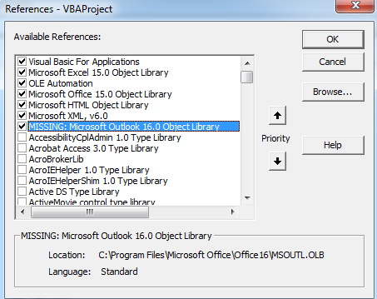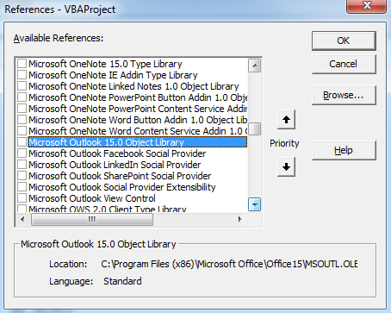

**D. Running the script**

You can run the script from any folder. However, note that the template file (see below) has to be in the Documents/Formsg folder.

There are 7 fields to fill in, 5 of which are mandatory:

1. **Form Name:** This should be exactly the same as the form name on the form you created on https://form.sg. You may copy and paste that from the Configure tab on admin panel. To double-check it, the form name can be obtained from the email entry; On the below example, the form name is between formsg-auto: and the reference number. In this case, it is CFLP Form.

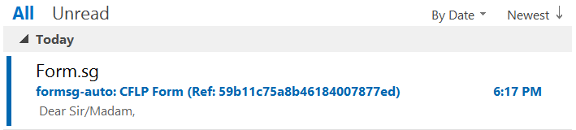

1. **Shared Inbox (Optional):** This is the name of the shared inbox, which appears at the top of the mail box, above the menu bar, when the shared mail box is open:



1. **Outlook Folder:** This is the outlook inbox folder that receives form email responses. If you set up mail forwarding as per the installation instructions in Part 1 above, the default Outlook Folder for your FormSG responses should be Formsg. Note that for Shared Inbox, this should be filled in with the Outlook Folder at top level and not nested inside Inbox.
2. **Template File Name (Optional):** A template file is a blank Excel file that contains column headers. The column headers are typically the same as your form fields. On the right example, they are Education, Location, etc. The script will pull data from Outlook and populate it on this template file. This is optional, and if left blank, the script will populate onto an empty Excel sheet.
3. **Saved File Name (Optional):** The saved file is the file name of the Excel after it has been populated. If the file already exists, it will not be replaced, it will just be duplicated. This is optional, and if left blank, the saved Excel will have the same filename as the form name.
4. **Starting Row**: Starting row is the first row in Excel that the script should start populating data from. If your column headers are in the first row, then your starting row should be 2. In the example below, there are some instructions before the data is populated; the starting row is 9:

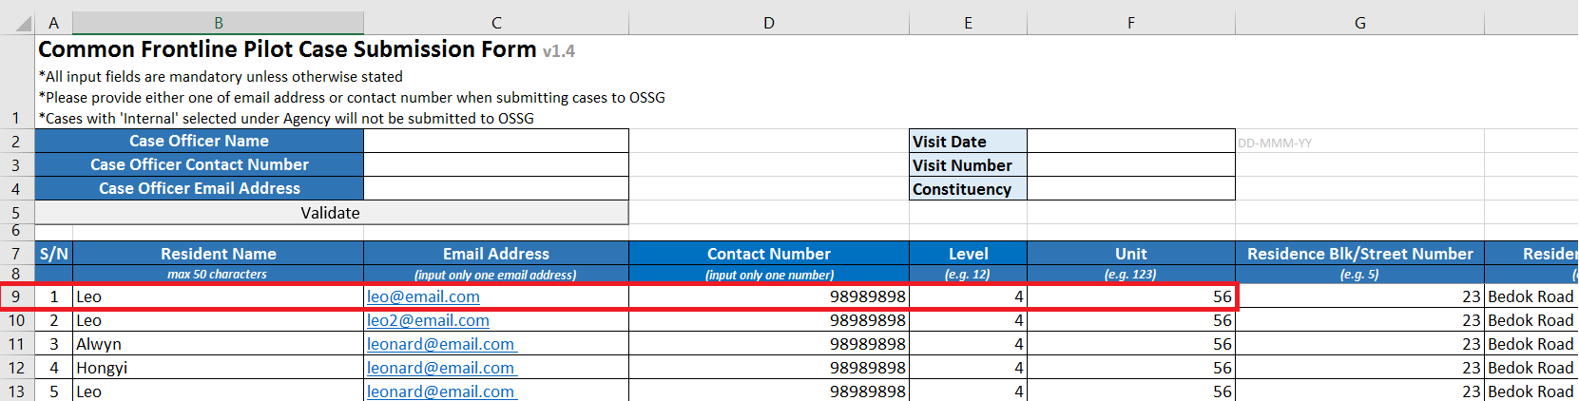

1. **Starting Column:** Starting column is the first column in Excel to start populating data. If your first header is along the column A, then this should be 1.

**After setting these fields, you may press Run Script to run the script. The populated Excel will be in your Documents/Formsg folder.**

**Part 4 (Optional): Shared inbox setup**

1. **Create top-level folder in Outlook (not in Inbox)**

Unlike with your personal Inbox, where the folder for FormSG responses is nested inside the Inbox (left screenshot), for a Shared Inbox, the folder for FormSG responses should be created at the top level, at the same level as Inbox (right screenshot):

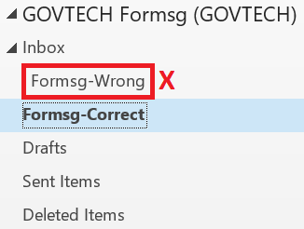 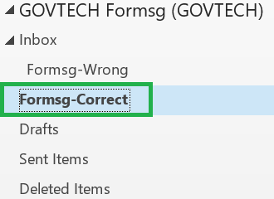

1. **Set up mail forwarding rules**

For mail forwarding rules, you will need admin rights to the shared account, or contact your IT department to help you setup mail forwarding rules that direct FormSG responses from Inbox into Formsg-Top, or Outlook folder name of your preference. Similar to Step 4 of Part 1 above, you may set up forwarding rules by checking if the email subject contains **formsg-auto.**

1. **Set Shared Inbox and Outlook folder fields in the script**

To enabled shared inbox, the Shared Inbox field on the script must be filled in. Specifically, this is filled in with the mailbox name which can be found either on the Outlook folder directory on the side bar, or at the top blue bar of the Outlook client:

Shared Inbox:

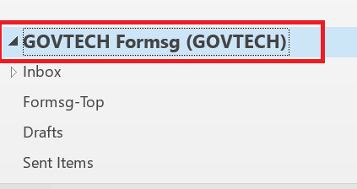



Outlook folder:

For outlook folder, make sure that this is the folder defined in the top level of the Shared Inbox (and not nested inside Inbox).

1. **Running the script from personal or shared inbox**

You may run the script as long as your Outlook client is open, regardless of whether you are in your personal or shared inbox. The script is run the same way by pushing the Run Script button.