Apposition Process Design
- Alter cbtb database
- Add a field on each table, the field name is “Last_Mmodify_Date”.
- Alter cbtb Entity Bean
- Rebuild all Entity Bean
- Alter cbtb all Model(JavaBean)
- Add a property and two method on each model
Property:
lastModifyDate
Method:
setLastModifyDate()
getLastModifyDate()

- Alter all update record and delete record method in session bean
- We will compare the old Last_Modify_Date value with the new value in the update or delete method.
- If the record had modify on before update, then cbtb system will throw a exception and prompt error message.

- Add a new method for check the last_modify_date value
Method :
checkLastModifyDate(Date newModifyDate, Date oldLastModifyDate)

Error Message Prompted Design
We will change all javascript message prompted, It is not depend on the OS.
The prompt will open new window, It is show error message .
The sample:
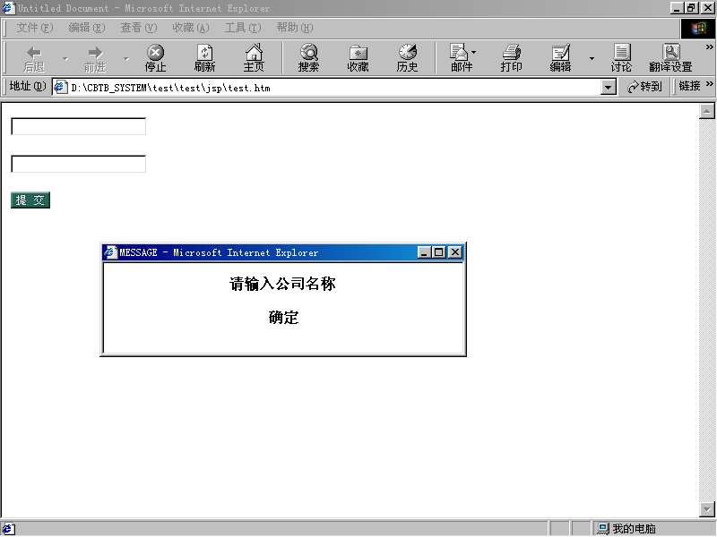

ArrayIndex Error. Process
1.Please add export _JVM_ARGS="inline_instrs_jit=0" in
your .profile or setenv.sh file.
This will disable aggressive inlining by the JIT while
allowing it to perform other performance enhancing tasks,so
u do not receive ioexception error.

2.Please increase heap size ,when u start your weblogic
server,u can modify startweblogic.sh in solaris like this:
"%JAVA_HOME%\bin\java" -hotspot -ms512m -mx512m ...
but when u increase heap size u must obey this rule:
a.you should use as large a heap size as possible without
causing your system to "swap" pages to disk (some
implementations actually allocate as much as twice the heap
size specified to support the copying half space).
when u incrase heap size,u can avoid too many GC.
beacuse too many frequent GC will cause your weblogic
server stop work

