Advanced Propagation Maps for HamClock

Introduction
HamClock provides generic propagation information for amateur radio operators. The user can set the location of a local transceiver (DE) and a distance transceiver (DX) and get a forecast of band conditions as well as create maps that reflect a band’s reliability (rel), takeoff angles (toa) and maximum usable frequency (muf). This information can be produced by using propagation tools provided for amateur radio use by Voice of America Coverage Analysis Program (VOACAP) for Linux (voacapl).
The original back-end server at clearskyinstitute.com appears to have used a generic isotropic antenna that doesn’t reflect the different types of antennae in use by amateur radio operators worldwide.
Introduction of advanced propagation information for HamClock is introduced into HamClock. It is administered using HamClock’s rest interface (which defaults to port 8080). HamClock needs the support of a backend server that provides modeling based on information provided by HamClock. In addition, a small antenna management graphical user interface is provided as part of the rest interface.

Compatibility
Currently, the main existing backends (clearskyinstitute.com, ohb.hamclock.app, hamclock.com) ignore extra parameters received to request band conditions or area maps. HamClock sends information for advanced propagation to the backend and it will be ignored by a backend that does not process these parameters. To allow HamClock to give information to the user regarding if the parameters are supported by the back-end, a new HamClock to back-end server API is introduced to return compatibility information to HamClock. To avoid backend servers from banning a HamClock’s IP address due to excessive 404 replies being generated, the new API interface is introduced as an extra parameter format to an existing backend server application method.

Initial Version
The following describes the feature as it was initially done and may not match the current implementation in all respects. See the corresponding user guides for more up to date information.
The initial version was built that supports the following information set by the user:
- antdeaz - azimuth of local antenna/transceiver.
- antdxaz – aximuth of distant antenna/transcriber.
- antdedxcontrol – an indicator to inform the backend on what antenna models to use for advanced propagation
  - 0 – none
  - 1 – local
  - 2 – distant
  - 3 – both local and distant
- antdeindex – a value to indicate the antenna model of the local antenna (0 defaults to isotropic)
- antdxindex – a value to indicate the antenna model of the distant antenna (0 defaults to isotropic)
new hamclock rest interfaces
- list_antennas.txt – returns a list of indexes, modes and titles. See chapter Antenna Models below.
- get_antennas.txt – returns the list of propagation values, backend server, capabilities and values that will be used by the backend server
- set_antennas – allows the user to change the propagation information listed above
- antennas.html – a gui widget that allows the user to set the parameters above using titles of antenna indexes

Screen Snapshots
The screen snapshots below are from an early prototype. Refer to the user guide for the most up to date information.
Antenna index 1025 is used to highlight the effect of a highly directional antenna.
Antenna index 1025 has title HR 4/4/1 and is described as a very high-gain directional antenna that is excellent for lower HF DX (80m/40m) on long paths; however, the size of the antenna is not available for use by the average amateur radio operator.

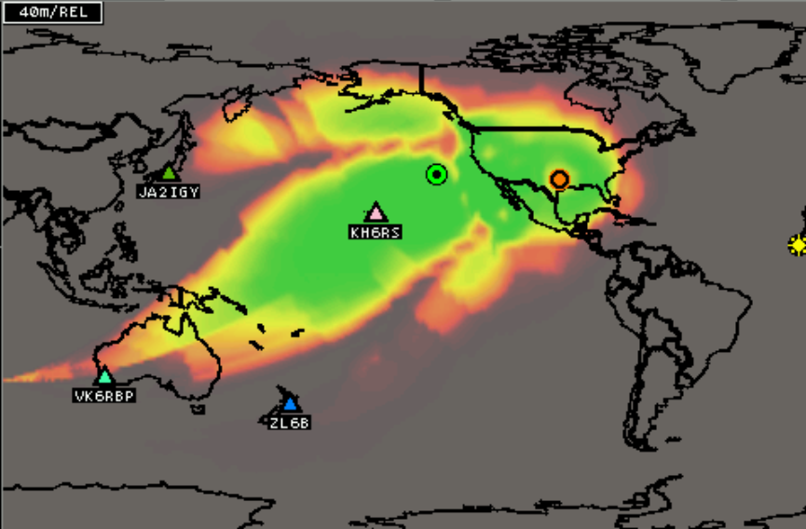
Reliability map between EM12 and CM14 highlighting a directional antenna with antenna at EM12 pointing West at 270 degrees.

Band Conditions
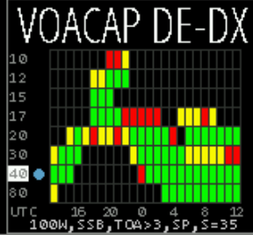
Band conditions between EM12 and CM14 with antenna at EM12 pointing West at 270 degrees.
The results of rest command getantennas.txt
get antennas:
backend server: localhost, supported values below shown in []
antdedxcontrol: 3 [3]
antdeindex set to 1025 [1025] and will be used
antdeaz set to 270.0 [270.0] and will be used
antdxindex set to 0 [0] and will be used
antdxaz set to 0.0 [0.0] and will be used

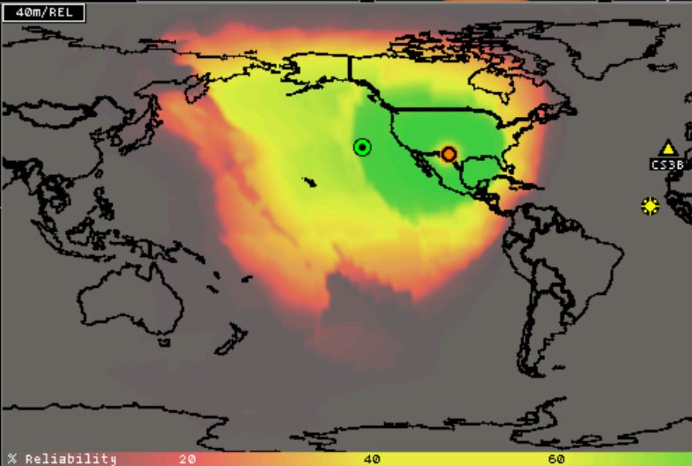
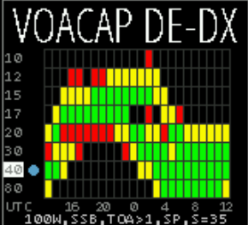
Changing the propagation to use the default antenna results in a much more omnidirectional pattern. This can be done by setting antdeindex and antdxindex to 0 or just setting antdedxcontrol to 0 to inform the backend to not generate advanced propagation maps.
Here is the result of rest command get_antennas.txt that shows what values were used (because of antdedxcontrol)
get antennas:
backend server: localhost, supported values below shown in []
antdedxcontrol: 0 [0]
antdeindex set to 1025 [1025] and will not be used
antdeaz set to 270.0 [270.0] and will not be used
antdxindex set to 0 [0] and will not be used
antdxaz set to 0.0 [0.0] and will not be used
A gui widget is introduced to manage antenna propagation controls. It is accessed using the R/W rest interface port which defaults to 8080 so the default url is
http://ip-of-hamclock:8080/antennas.html as shown below:
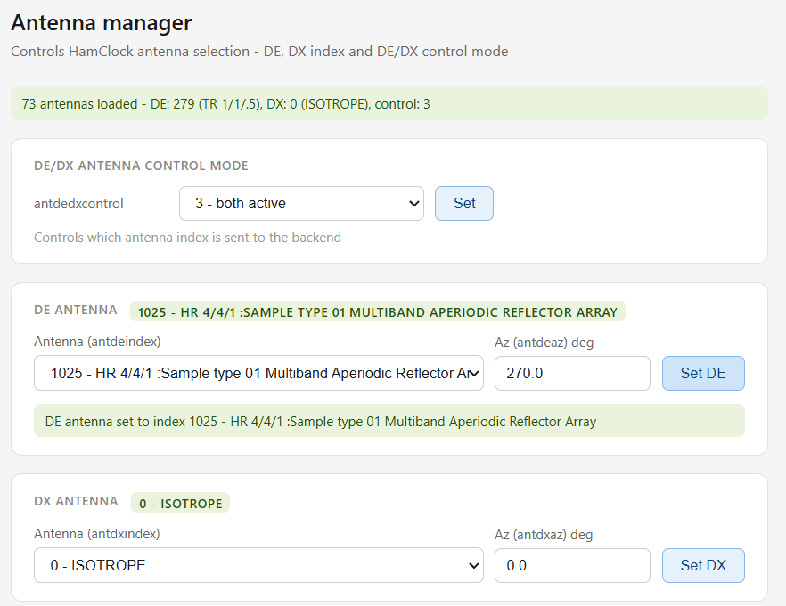

Antenna Models
Each of the models below include and index value. Index 0 is chosen on purpose as a default that reflect the istrope antenna model which closely aligns to the model seemingly used by the original HamClock backend, clearskyinstitute.com. When run for the first time, HamClock will initialize the persistent values to 0 to reflect default behavior.
Other Index values are collected into groups to allow expansion:
- 0 – default group
- 256 – starting values for default ccir.xxx models where index is 256+xxx
- 768 – special group for default models that do not follow ccir.xxx naming
- 1024 – starting value for stamples sample.xx models where index is 1024+xx
- 1294 – special group for sample model 14x that doesn’t follow the naming of sample.xx

Index | Model | Short Title | Description | Gain & Takeoff | Ham Usage
0 | isotrope | ISOTROPE | Perfect isotropic radiator, 0 dBi, omnidirectional at all angles | 0 dBi; fully omnidirectional | Identical to ccir.000; neutral reference antenna for gain-normalized propagation predictions
256 | ccir.000 | ISOTROPE | Perfect isotropic radiator, 0 dBi reference, omnidirectional at all angles | 0 dBi; fully omnidirectional | Neutral baseline reference; use when you want propagation results independent of any antenna pattern
257 | ccir.001 | HR 4/4/1 | Horizontal curtain array, 4 columns × 4 rows, lowest row at 1λ height | 0 dBi listed (likely placeholder); low takeoff expected (~5–10°) | Large curtain array at full wavelength height; good for long-path DX on lower HF bands
258 | ccir.002 | HR 4/4/.8 | Horizontal curtain array, 4 columns × 4 rows, lowest row at 0.8λ height | ~21.75 dBi peak; very low takeoff (~5–10°) | High-gain curtain slightly lower than 1λ; excellent for DX, minimal compromise vs full height
259 | ccir.003 | HR 4/4/.5 | Horizontal curtain array, 4 columns × 4 rows, lowest row at 0.5λ height | ~21.21 dBi peak; low takeoff (~10–15°) | Still very high gain; takeoff angle slightly higher due to lower mounting height
260 | ccir.004 | HR 4/3/.5 | Horizontal curtain array, 4 columns × 3 rows, lowest row at 0.5λ height | ~20.17 dBi peak; low takeoff (~10–15°) | Slightly reduced vertical aperture vs 4×4; good DX curtain where full stack height isn't available
261 | ccir.005 | HR 4/2/.5 | Horizontal curtain array, 4 columns × 2 rows, lowest row at 0.5λ height | ~18.69 dBi peak; medium-low takeoff (~15–20°) | Compact 2-high curtain with wide horizontal aperture; practical for many broadcast-style installations
262 | ccir.006 | HR 4/2/.3 | Horizontal curtain array, 4 columns × 2 rows, lowest row at 0.3λ height | ~17.34 dBi peak; medium takeoff (~20–30°) | Low-hung wide curtain; higher takeoff angle suits regional/NVIS paths more than long DX
263 | ccir.007 | HR 2/4/1 | Horizontal curtain array, 2 columns × 4 rows, lowest row at 1λ height | ~19.39 dBi peak; very low takeoff (~5–10°) | Tall narrow curtain; excellent low-angle radiation for long transoceanic DX paths
264 | ccir.008 | HR 2/4/.8 | Horizontal curtain array, 2 columns × 4 rows, lowest row at 0.8λ height | ~19.10 dBi peak; very low takeoff (~5–10°) | Near-equivalent to ccir.007; minimal performance difference from slightly lower mounting
265 | ccir.009 | HR 2/4/.5 | Horizontal curtain array, 2 columns × 4 rows, lowest row at 0.5λ height | ~18.54 dBi peak; low takeoff (~8–12°) | Tall narrow curtain at moderate height; still good low-angle performance for DX
266 | ccir.010 | HR 2/3/.5 | Horizontal curtain array, 2 columns × 3 rows, lowest row at 0.5λ height | ~17.51 dBi peak; low takeoff (~10–15°) | Medium curtain; good balance of gain and takeoff angle for mixed DX/regional use
267 | ccir.011 | HR 2/2/.5 | Horizontal curtain array, 2 columns × 2 rows, lowest row at 0.5λ height | ~16.04 dBi peak; medium-low takeoff (~15–20°) | Practical 2×2 curtain at modest height; achievable by serious ham stations on 20m/40m
268 | ccir.012 | HR 2/2/.3 | Horizontal curtain array, 2 columns × 2 rows, lowest row at 0.3λ height | ~14.74 dBi peak; medium takeoff (~20–30°) | Low-hung 2×2 curtain; higher takeoff favors regional paths; reduced DX performance
269 | ccir.013 | HR 2/1/.5 | Horizontal curtain array, 2 columns × 1 row, at 0.5λ height | ~13.72 dBi peak; medium takeoff (~20–30°) | Single-row 2-element curtain (essentially a 2-element collinear dipole); practical ham antenna on 20m+
270 | ccir.014 | HR 2/1/.3 | Horizontal curtain array, 2 columns × 1 row, at 0.3λ height | ~12.87 dBi peak; medium-high takeoff (~25–35°) | Low 2-element curtain; better for NVIS/regional than DX due to higher takeoff angle
271 | ccir.015 | HR 1/2/.5 | Horizontal curtain array, 1 column × 2 rows (stacked dipoles), at 0.5λ base height | ~14.40 dBi peak; medium-low takeoff (~15–20°) | Stacked dipole pair; achievable ham antenna, good gain improvement over single dipole
272 | ccir.016 | HR 1/2/.3 | Horizontal curtain array, 1 column × 2 rows (stacked dipoles), at 0.3λ base height | ~13.19 dBi peak; medium takeoff (~25–35°) | Low stacked dipoles; NVIS/regional bias due to low mounting; less effective for DX
273 | ccir.017 | HR 1/1/.5 | Single horizontal dipole at 0.5λ height | ~12.27 dBi peak; medium-high takeoff (~30–40°) | Classic single dipole at half-wave height; good for NVIS/regional on 40m/80m
274 | ccir.018 | HR 1/1/.3 | Single horizontal dipole at 0.3λ height (very low) | ~11.72 dBi peak; high takeoff (~40–60°) | Very low dipole; primarily NVIS. Best for regional contacts within a few hundred to ~2000 km
275 | ccir.019 | TR 2/1/.5 | Traveling wave (rhombic-style) antenna, 2 elements × 1 row at 0.5λ height | ~9.88 dBi peak; low-medium takeoff (~15–25°) | Terminated traveling wave array; broadband and directional, used in some fixed HF broadcast links
276 | ccir.020 | TR 2/1/.3 | Traveling wave antenna, 2 elements × 1 row at 0.3λ height | ~7.86 dBi peak; medium takeoff (~25–35°) | Lower-mounted traveling wave; reduced gain and higher angle vs ccir.019
277 | ccir.021 | TR 1/2/.5 | Traveling wave antenna, 1 element × 2 rows at 0.5λ height | ~5.83 dBi peak; medium takeoff (~20–30°) | Modest traveling wave array; lower gain than 2-row HR curtains; niche broadcast/fixed link use
278 | ccir.022 | TR 1/2/.3 | Traveling wave antenna, 1 element × 2 rows at 0.3λ height | ~8.72 dBi peak; medium takeoff (~25–35°) | Low traveling wave array; gain figure suggests favorable stacking interaction despite low height
279 | ccir.023 | TR 1/1/.5 | Traveling wave antenna, single element at 0.5λ height | ~7.85 dBi peak; medium takeoff (~25–35°) | Basic single traveling wave element; directional but modest gain; suitable for fixed-link HF paths
280 | ccir.024 | TR 1/1/.3 | Traveling wave antenna, single element at 0.3λ height | ~6.46 dBi peak; medium-high takeoff (~30–40°) | Lowest-gain TR variant; high takeoff angle limits DX utility; regional/NVIS oriented
281 | ccir.025 | Omni 4dB [HQ 1/.3] | Omnidirectional antenna, 4 dBi gain, horizontal quarterwave at 0.3λ height | 4.00 dBi; omnidirectional | Low-gain omni reference; useful for modeling non-directional HF stations or as a simple baseline
282 | ccir.026 | SWWhip for REC533 | Shortwave whip antenna pattern per REC533 standard; 91-point elevation gain table | 0 dBi max; elevation-dependent gain, peaks around 19–20°, falls off sharply at high and low angles | ITU REC533 standard receive whip; models a typical fixed receive antenna; not optimized for DX
529 | const17.voa | Const 17dB | Constant 17 dBi transmit antenna used by VOA; fixed elevation pattern, full gain only between ~4–9°, drops sharply outside that window | 17.00 dBi; very narrow elevation pattern centered on low angles | VOA broadcast reference antenna; useful for modeling high-power fixed-link transmit scenarios; not a real ham antenna
768 | swwhip.voa | SWWhip VOA | Shortwave whip receive antenna used by VOA; 91-point elevation gain table, identical pattern to ccir.026 | 0 dBi max; peaks ~19–20° elevation, rolls off at both extremes; efficiency −4.8 dB | Standard VOA receive whip model; good for modeling a simple receive antenna or portable whip; not a DX antenna
Notes:
- ccir.000 and isotrope are identical — both isotropic references.
- ccir.026 and swwhip.voa have identical elevation patterns; ccir.026 is labeled for ITU REC533 use while swwhip.voa is the VOA version.
- HR = Horizontal Rhombic/curtain array; TR = Terminated (traveling wave) Rhombic array.
- The notation rows/stack/height in the short title means: columns in a row / rows stacked vertically / lowest element height in wavelengths.
- ccir.001 shows 0.00 dBi in the header — this appears to be a placeholder/uncalculated entry unlike the others.

Index | Model | Short Title | Long Title | Description | Gain & Takeoff | Ham Usage
1024 | sample.00 | ISOTROPE | Sample type 00 Constant gain isotrope | Perfect isotropic radiator, 0 dBi, omnidirectional at all angles | 0 dBi; fully omnidirectional | Neutral reference baseline; use when propagation results independent of any antenna pattern are needed
1025 | sample.01 | HR 4/4/1 | Sample type 01 Multiband Aperiodic Reflector Array | Horizontal curtain array, 4 columns × 4 rows, lowest row at 1λ height | ~22.06 dBi peak; very low takeoff (~5–10°) | Very high-gain directional. Excellent for lower HF DX (80m/40m) on long paths
1026 | sample.02 | HR 2/2/.3 | Sample type 02 Dual-Band Center-Fed Half-Wave Dipole Array | Horizontal curtain, 2 columns × 2 rows at 0.3λ height, center-fed dipole elements | ~14.14 dBi; medium-high takeoff (~25–35°) | Dual-band curtain at low height; better for regional/NVIS than long DX
1027 | sample.03 | HR 4/4/.5 | Sample type 03 Dual-Band End-Fed Half-Wave Dipole Array | Horizontal curtain, 4 columns × 4 rows at 0.5λ height, end-fed elements | ~20.93 dBi; low takeoff (~10–15°) | High-gain dual-band curtain; good DX performance despite moderate mounting height
1028 | sample.04 | TR 2/1/.5 | Sample type 04 Tropical Array | Terminated traveling wave array, 2 elements × 1 row at 0.5λ height | ~9.88 dBi; medium takeoff (~20–30°) | Broadband directional; used in tropical/fixed HF broadcast links; modest ham DX utility
1029 | sample.05 | LPH 29/.8/31.1/67.1/7/21.60/450 | Sample type 05 Horiz Log-Periodic | Horizontal log-periodic, 29 elements, shortest 0.8m, longest 31.1m, 67.1° half-angle | ~10.84 dBi; low-medium takeoff (~15–25°) | Wideband directional; covers multiple HF bands without retuning; popular for multi-band DX
1030 | sample.06 | LPV 12/4/25/56/2/14/450 | Sample type 06 Vertical Log-Periodic | Vertical log-periodic, 12 elements, shortest 4m, longest 25m | ~3.09 dBi; low-medium takeoff (~15–25°) | Low-gain vertical LPDA; omnidirectional azimuth; useful where horizontal space is limited
1031 | sample.07 | RH155/40.3/68 | Sample type 07 Horizontal Rhombic | Horizontal rhombic, leg length 154.86m, height 40.3m, half-obtuse angle 68.47° | ~22.03 dBi; very low takeoff (~5–10°) | Very high-gain fixed-direction wire antenna; classic long-path DX antenna, large land area required
1032 | sample.08 | Omni 4dB [HQ 1/.3] | Sample type 08 Quadrant Antenna | Omnidirectional quadrant antenna at 0.32λ height, 4 dBi gain | 4.00 dBi; omnidirectional | Low-gain omni reference; models non-directional HF stations or simple baseline transmit antenna
1033 | sample.09 | HX .3 | Sample type 09 Crossed-Dipole Antenna | Crossed horizontal dipoles at 0.3λ height; provides near-omnidirectional pattern | ~8.07 dBi; medium-high takeoff (~30–40°) | Good for omnidirectional coverage at modest height; useful for beacon or NVIS applications
1034 | sample.10 | VM 8/8/120/3 | Sample type 10 Vertical Monopole | Vertical monopole, 8m height, 8m earth radius, 120 radials, 3mm wire | ~−0.29 dBi; medium-high takeoff (~25–40°) | Realistic lossy vertical monopole model; representative of a ground-mounted HF vertical with radial system
1035 | sample.11 | SWWhip for REC533 | Sample type 11 Gain Table versus Elevation Angle | Shortwave whip per ITU REC533; 91-point elevation gain table, efficiency −4.8 dB | 0 dBi max; peaks ~19–20°, rolls off at extremes | Standard ITU receive whip model; useful for receive-only or portable whip scenarios
1036 | sample.12 | HR 4/4/1 | Sample type 12 Curtain Array NTIA Report 87-215 | 4×4 horizontal curtain per NTIA Report 87-215 model; computed gain table | 0 dBi listed (computed internally); very low takeoff (~5–10°) | Reference curtain model per NTIA standard; use when NTIA-method gain computation is desired
1037 | sample.13 | HR 4/4/.5 | Sample type 13 360 degree gain table | 4×4 curtain at 0.5λ height modeled as full 360°×91° gain table at 11.85 MHz | 0 dBi listed (table-driven); low takeoff (~10–15°) | Full azimuth+elevation gain table; most accurate pattern representation for area coverage modeling
1038 | sample.14 | RH155/40.3/68 | Sample type 14 Point-to-Point gain @ 30 freqs | Horizontal rhombic with 30-frequency gain table (efficiency + 91 elevation values per freq) | 0 dBi listed (table-driven); very low takeoff | Point-to-point frequency-specific gain tables; most accurate for multi-band rhombic path modeling
1045 | sample.21 | RH67/88/17 | Sample type 21 ITSA-1 Terminated Horizontal Rhombic | ITSA-1 model: terminated rhombic, half-obtuse angle 67.5°, leg 88.39m, height 16.76m | 0 dBi listed (computed internally); very low takeoff (~5–10°) | Classic terminated rhombic; high-gain fixed-direction wire DX antenna; large space required
1046 | sample.22 | VM/.25 | Sample type 22 ITSA-1 Vertical Monopole | ITSA-1 model: quarter-wave vertical monopole, height −0.25λ (below-ground feed point convention) | 0 dBi listed (computed); medium-high takeoff (~25–40°) | Standard vertical monopole reference; representative of a simple HF ground-plane vertical
1047 | sample.23 | HD/.5/.25 | Sample type 23 ITSA-1 Horizontal Dipole | ITSA-1 model: horizontal dipole, length −0.5λ, height −0.25λ | 0 dBi listed (computed); high takeoff (~40–60°) | Low horizontal dipole; NVIS/regional specialist; classic 40m/80m close-range antenna
1048 | sample.24 | HY/.5/.25 | Sample type 24 ITSA-1 Horizontal Yagi | ITSA-1 model: horizontal Yagi, length −0.5λ, height −0.25λ, +3 dB gain above dipole | 0 dBi listed; +3 dBd gain; medium-high takeoff | Low-mounted Yagi reference; directional but high takeoff at this height; better for regional than DX
1049 | sample.25 | VLP/.25/2 | Sample type 25 ITSA-1 Vertical Log-Periodic | ITSA-1 model: vertical log-periodic, +2 dBd gain above dipole | 0 dBi listed; +2 dBd; low-medium takeoff | Vertical LPDA reference; broadband, low-gain omni vertical for multi-band use
1050 | sample.26 | H/2/4 | Sample type 26 ITSA-1 Curtain | ITSA-1 model: horizontal curtain, 2 bays, element length 22m, element height 16m | 0 dBi listed (computed); low takeoff (~10–20°) | ITSA-1 curtain reference; moderate-gain directional for fixed HF links
1051 | sample.27 | V23/122/15/1.8 | Sample type 27 ITSA-1 Sloping Vee | ITSA-1 model: sloping vee, half-apex 22.5°, leg 121.9m, height 15.24m | 0 dBi listed (computed); low takeoff (~10–20°) | Large wire antenna; directional, low-angle radiation; requires significant land area
1052 | sample.28 | L/21/10 | Sample type 28 ITSA-1 Inverted L | ITSA-1 model: inverted-L, length 21.34m, height 10m | 0 dBi listed (computed); medium-high takeoff (~30–45°) | Compromise vertical/horizontal wire; simple to build; better for regional than DX
1053 | sample.29 | SR/23/88/17/8 | Sample type 29 ITSA-1 Sloping Rhombic | ITSA-1 model: sloping rhombic, half-apex 22.5°, leg 88.39m, height 16.76m | 0 dBi listed (computed); low takeoff (~10–15°) | Sloped variant of rhombic; high gain with lower profile than flat rhombic
1054 | sample.30 | IR/70/114/20/4 | Sample type 30 ITSA-1 Interlaced Rhombic | ITSA-1 model: interlaced rhombic, half-apex 70°, leg 114m, lower height 20m | 0 dBi listed (computed); very low takeoff (~5–10°) | Dual interlaced rhombic for extended frequency coverage; very high gain, large installation
1055 | sample.31 | RH67/88/17 | Sample type 31 ITS-78 Terminated Horizontal Rhombic | ITS-78 model: same geometry as sample.21 but using updated ITS-78 computation method | 0 dBi listed (computed); very low takeoff (~5–10°) | Use in preference to sample.21 where ITS-78 method accuracy is desired
1056 | sample.32 | VM/.25 | Sample type 32 ITS-78 Vertical Monopole | ITS-78 model: quarter-wave vertical monopole, same geometry as sample.22 | 0 dBi listed (computed); medium-high takeoff (~25–40°) | ITS-78 updated vertical monopole; use in preference to sample.22 for modern predictions
1058 | sample.34 | HY/.5/.25 | Sample type 34 ITS-78 Horizontal Yagi | ITS-78 model: horizontal Yagi, height 30m, driven length −0.5λ, reflector −0.58λ | 0 dBi listed (computed); low-medium takeoff (~20–30°) | ITS-78 Yagi with explicit reflector; more physically detailed than sample.24
1059 | sample.35 | VD/.5/.25 | Sample type 35 ITS-78 Vertical Dipole | ITS-78 model: vertical dipole, length −0.5λ, feed height −0.25λ | 0 dBi listed (computed); low-medium takeoff (~15–25°) | Vertical dipole; better low-angle than monopole; good for DX where horizontal antennas not feasible
1060 | sample.36 | H/2/4 | Sample type 36 ITS-78 Curtain | ITS-78 model: horizontal curtain, 2 bays, element length 22m, height 16m | 0 dBi listed (computed); low takeoff (~10–20°) | ITS-78 curtain; use in preference to sample.26 for updated computation method
1061 | sample.37 | V23/122/15/1.8 | Sample type 37 ITS-78 Terminated Sloping Vee | ITS-78 model: terminated sloping vee, half-apex 22.5°, leg 121.9m, height 15.24m | 0 dBi listed (computed); low takeoff (~10–20°) | Terminated version of sloping vee; ITS-78 method; reduced backlobes vs unterminated
1062 | sample.38 | L/21/10 | Sample type 38 ITS-78 Inverted L | ITS-78 model: inverted-L, length 21.34m, height 10m | 0 dBi listed (computed); medium-high takeoff (~30–45°) | ITS-78 inverted-L; use in preference to sample.28 for updated predictions
1063 | sample.39 | SR/23/88/17/8 | Sample type 39 ITS-78 Terminated Sloping Rhombic | ITS-78 model: terminated sloping rhombic, half-apex 22.5°, leg 88.39m, height 16.76m | 0 dBi listed (computed); low takeoff (~10–15°) | ITS-78 sloping rhombic; terminated for reduced backlobes; good fixed-link DX antenna
1065 | sample.41 | SLW10/91/0 | Sample type 41 ITS-78 Sloping Long Wire | ITS-78 model: sloping long wire, 10° slope from horizontal, length 91.44m, feed at ground | 0 dBi listed (computed); low takeoff (~10–20°) | Simple high-gain wire antenna; low angle at modest slope; practical for fixed DX links
1067 | sample.43 | HxD3/33/54/450 | Sample type 43 ITS-78 Horizontal X-Dipole Log Periodic | ITS-78 model: horizontal crossed-dipole log-periodic, feed height 2.96m, rear element 33.47m, 54° slope | 0 dBi listed (computed); low-medium takeoff | Broadband crossed-dipole LPDA; horizontal polarization; covers wide HF range
1068 | sample.44 | ATD45/.5/.25 | Sample type 44 ITS-78 Arbitrary Tilted Dipole | ITS-78 model: dipole tilted 45° from horizontal, length −0.5λ, feed height −0.25λ | 0 dBi listed (computed); mixed polarization | Tilted dipole producing mixed H/V polarization; models sloper-style antennas common in ham use
1069 | sample.45 | SLR28/80 | Sample type 45 ITS-78 Side-Loaded Vertical Half-Rhombic | ITS-78 model: vertical half-rhombic, leg-ground angle 28°, leg length 80m | 0 dBi listed (computed); low takeoff (~10–20°) | Low-profile high-gain wire; vertical polarization; good fixed-link DX with modest height
1070 | sample.46 | SDR62/150 | Sample type 46 ITS-78 Sloping Double-Rhomboid | ITS-78 model: sloping double-rhomboid, feed height 62m, short leg 150m | 0 dBi listed (computed); very low takeoff (~5–10°) | Very high-gain sloping wire array; excellent low-angle DX performance; large installation required
1071 | sample.47 | VM/.25/76/2/120 | Sample type 47 ITS-78 Vertical Monopole + Ground Screen | ITS-78 model: quarter-wave monopole with ground screen, 76.2m radials, 120 radials | 0 dBi listed (computed); medium-high takeoff (~25–40°) | Most realistic vertical monopole model; ground screen dramatically improves efficiency vs bare ground
1072 | sample.48 | INVCONE | Sample type 48 NOSC Inverted Cone antenna | Inverted cone broadband antenna per NOSC specification | 0 dBi listed; broadband omnidirectional | Wideband receive/transmit antenna; used by military/NOSC; models a broadband vertical cone structure
1114 | sample.90 | IONCAP Rhombic - External type 90 | Terminated Horizontal Rhombic, sample.21 | External IONCAP antenna type 90; should produce identical results to sample.21 internal rhombic | 0 dBi listed (computed); very low takeoff (~5–10°) | Use to verify external vs internal antenna model consistency; functionally equivalent to sample.21
1123 | sample.99 | ISOTROPE | Sample type 99 Harris antenna | Isotropic reference antenna per Harris specification, 0 dBi | 0 dBi; fully omnidirectional | Harris/military isotropic reference; functionally identical to sample.00 but tagged for Harris system use
1294 | sample.14x | RH155/40.3/68 | Sample type 14 Point-to-Point gain @ 30 freqs | As sample.14 but with 3 dBi max gain entry; extended variant | 3.00 dBi listed; very low takeoff | Variant of sample.14 with non-zero max gain entry; use to compare gain table vs parametric modeling
Notes:
- Files using ITSA-1 (samples 21–30) and ITS-78 (samples 31–48) model types compute gain internally from physical parameters — the 0.00 dBi in the header is a placeholder, not the actual gain.
- The ITSA-1 and ITS-78 series are paired sets of the same antenna geometries computed by two different propagation model generations.
- sample.90 is explicitly documented in its file as a cross-check against sample.21.

References
- https://www.voacap.com/
- https://github.com/jawatson/voacapl
- https://web.archive.org/web/20260123074655/https://www.clearskyinstitute.com/ham/HamClock/
- https://ohb.works/
- https://claude.ai/

Disclaimer
This project is not affiliated with HamClock or its creator, Elwood Downey, WB0OEW. We extend our sincere condolences to the Downey family.

