WMA Professional 10.0
Digital Media Division

An Overview of Windows Media Audio Professional Decoding

Table of Contents

Table of Tables V
Table of Figures IX
Audience and Disclaimer X
Summary X
1 Introduction 1
1.1 Notation 4
1.1.1 Arithmetic Operators 4
1.1.2 Logical operators 4
1.1.3 Relational operators 4
1.1.4 Bitwise operators 5
1.1.5 Assignment 5
1.1.6 Mnemonics 5
1.1.7 Constants 5
1.1.8 How to Read the Bitstream Syntax? 5
2 Bitstream Syntax 8
2.1 Overall Decode Process 9
2.2 Packet Layer Decoder 11
2.3 Frame Layer Decoder 12
2.4 Syntax for Frame Header 13
2.5 Syntax for Frame Data 18
2.6 Syntax for Tile Header 19
2.6.1 Multi-Channel Transformation 22
2.6.2 Tile Quantization Step Size 27
2.6.3 Channel Quantization Step Size 28
2.6.4 Band Quantization Step Sizes (Mask) 29
2.6.5 LPC Filter Common Parameters 32
2.6.6 AC Filter 32
2.7 Syntax for Tile Data 33
2.8 Syntax for LBR Data 42
2.8.1 Overview of baseplus 42
2.8.2 Overview of frequency extension 42
2.8.3 Overview of channel extension 42
2.8.4 Overview of basepeak 43
2.8.5 Plus Encode Option Syntax 43
2.8.6 Plus Syntax 44
2.8.7 Baseplus Syntax 46
2.8.8 Frequency Extension (a.k.a. fex, freqex) Syntax 54
2.8.9 Channel Extension (a.k.a. chex) Syntax 75
2.8.10 Basepeak syntax 79
2.9 Parameter Definitions 82
3 Decoder Initialization 83
3.1 Is it WMA Pro Bitstream? 83
3.2 Is RTM Bitstream? 83
3.3 log2_bits_per_packet 84
3.4 Decipher Channel_MaskPosition of Sub-woofer (low frequency effects) Channel 84
3.5 Samples Per Frame 84
3.6 Number of possible window sizes 85
3.7 Bark-band boundaries 86
3.8 Bark Resampling Matrix 86
3.9 Subwoofer cutoff index 87
3.10 Maximum Number of Subframes in a Frame 87
3.11 Unpack other encode options 87
3.12 Initializing other parameters 88
4 Packet Layer Decoding 89
5 Frame Layer Decoding 90
5.1 Frame Header Decoding 90
5.2 Tile Configuration in WMA Pro 91
5.3 Decoding Tile Configuration 93
5.3.1 Tile Start Position 93
5.3.2 Determine Set of Possible Tile Channels 93
5.3.3 Skip Channel Mask and Skip Size Information 93
5.3.4 Decoding the set of tile channels 94
5.3.5 Determine Bits for Tile Size Description 95
5.3.6 Update Subframe Configuration of Tile Channels 95
5.4 Decoding Post Processing Transform 96
5.5 Decoding Silence Information 96
6 Tile Layer Decoding 96
6.1 Initialization 96
6.2 Decoding Tile Header (Lossy Coding) 98
6.2.1 Reserved Data 98
6.2.2 Overview of Multi-Channel Transform 98
6.2.3 Pre-defined Multi-Channel Transforms 99
6.2.4 General Multi-Channel Transforms 100
6.2.5 Examples of rotation factors 102
6.2.6 Decoding Multi-Channel Transforms 103
6.2.7 Vector Information 105
6.2.8 Quantizer Step Sizes 105
6.3 Decoding Tile Data (Lossy Coding) 106
6.3.1 Vector Decoding of Spectral Coefficients 106
6.3.2 Sign-Run-Level Decoding of Spectral Coefficients 108
6.4 Decoding Tile Header (Mixed Lossless Coding) 108
6.4.1 Different Types of Tiles 108
6.4.2 Raw PCM Tiles 109
6.4.3 RTM bitstream and BETA bitstream 109
6.5 Decoding Tile Data (Mixed lossless Coding) 109
6.5.1 Decode Raw Data in Raw PCM Tile 109
6.5.2 Decode LPC Filter Coefficients 109
6.5.3 Decode Coefficient Residues (Golomb Code) 109
6.6 Decoding LBR Data 110
6.7 After Decoding a Tile 111
7 Reconstructing Audio Data 111
7.1 Inverse Multi-Channel Transform, if lossy coded 111
7.2 Band Limiting Sub-woofer Channel, if lossy coded 113
7.3 Inverse Quantization, if lossy coded 113
7.4 Inverse Modulated Lapped Transform (Inverse MDCT), if Lossy Coded 114
7.4.1 DCT-IV 115
7.4.2 Window Function Generation 115
7.4.3 Obtaining Reconstruction Values 118
7.5 Reconstruction in Mixed Lossless mode 119
7.5.1 Restore Mixed Lossless channel coefficients in Mixed Lossless Mode 119
7.5.2 Coefficient Mapping in Mixed Lossless Mode 121
7.6 Post-Processing Multi-Channel Transform 122
7.7 Removal of Silent Samples 122
7.8 Dynamic Range Control 123
7.9 Channel Down-mixing 127
7.9.1 Custom Fold-down Matrices 127
7.9.2 Default Fold-Down Matrices 128
8 Tables 130
8.1 Constants 130
8.2 Speaker positions 131
8.3 Bark Frequencies 136
8.4 DCT Type II Multi-Channel Transforms 136
8.5 VLC (Huffman) Table for Band Quantization Step Sizes, when anchor is not available 137
8.6 Run-Level Table for Band Quantization Step Sizes, when anchor is available 138
8.7 Run-Level Table for Quantized Spectral Coefficients when coef_rlc_table_number is 0 140
8.8 Run-Level Table for Quantized Spectral Coefficients when coef_rlc_table_number is 1 143
8.9 Vector Huffman Table for Quantized Spectral Coefficients for vector dimension 4 145
8.10 Vector Huffman Table for Quantized Spectral Coefficients for vector dimension 2 147
8.11 Vector Huffman Table for Quantized Spectral Coefficients for vector dimension 1 148
9 Parameter Restrictions on Legal WMA Bit streams & Compliant WMA Pro Decoders 149
9.1 Legal WMA Pro Versions 10 Bit streams 149
9.2 Maximum buffer size requirements 150
9.3 Compliant WMA Professional Decoders 150
9.4 Modes of Microsoft’s WMA Pro Version 10 Encoders 152
9.5 Additional Bitstream Constraints (Informative) 158
10 Glossary 158

Table of Tables

Table 1 Conditionals & loops in the syntax description 5
Table 2 Array notation 6
Table 3 Syntax of decode_packet_layer() 11
Table 4 Syntax of decode_packet() 12
Table 5 Syntax of decode_packet_header() 12
Table 6 Syntax of decode_frame_layer() 12
Table 7 Syntax of decode_frame_header () 13
Table 8 Syntax of decode_tile_configuration() 13
Table 9 Syntax of decode_postproc_transform() 16
Table 10 Function signExtend4 17
Table 11 Syntax of decode_silence_information() 17
Table 12 Syntax for Frame Data 18
Table 13 Syntax for Tile Header 19
Table 14 Syntax for Reserved Data 21
Table 15 Syntax for Channel Transform 22
Table 16 Syntax for Channel Group Transformation 23
Table 17 Syntax for General Channel Group Transform 26
Table 18 Syntax for Tile Quantizer Step Size 27
Table 19 Syntax for Channel Quantizer Step Size 28
Table 20 Syntax for Quant-Step-Band Values 29
Table 21 Syntax for Quant-step-band, when anchor values are not available 30
Table 22 Syntax for Quant-step-band, when anchor values are available 31
Table 23 Syntax for LPC Filter Common Parameters 32
Table 24 Syntax for AC filter 32
Table 25 Syntax for Tile Data 33
Table 26 Syntax for decoding lossy Quantized Spectral Coefficients. 34
Table 27 Syntax for Vector Huffman Decoding of 4D vectors. 35
Table 28 Syntax for Quantized Spectral Coefficients, once in sign-run-level mode 37
Table 29 Syntax for Escape Decoding of Levels. 38
Table 30 Syntax for Escape Decoding of Runs 38
Table 31 Syntax for Decoding Mixed Lossless Channel Residues in Mixed Lossless Mode 39
• Table 32 - Plus Encode Options Layout 43
• Table 33 - Plus versioning layout 43
• Table 34 - Plus versioning 43
• Table 35 - Plus Encopt Bits 44
• Table 36 - Actual Channels when Chex Used 44
• Table 37 - plusDecodeTileHeader 44
• Table 38 - plusDecodeSuperframeHeaderFirstTile 45
• Table 39 - plusDecodeSuperframeheaderLastTile 46
• Table 40 - plusDecodeTile 46
• Table 41 - plusDecodeBasePlusHeader 47
• Table 42 - plusDecodeBase 47
• Table 43 - bpdecDecodeTile 47
• Table 44 - basePlusDecodeOverlayMode 48
• Table 45 - basePlusDecodeExclusiveMode 49
• Table 46 - baseplusDecodeSFBandTableIndex 49
• Table 47 - baseplusDecodeIOverlayWindow 49
• Table 48 - basePlusDecodeFirstTileHeaderExclusiveMode 50
• Table 49 - basePlusDecodeTileScaleFactor 51
• Table 50 - basePlusDecodeTileQuantStepSize 51
• Table 51 - basePlusDecodeTileChannelQuantStepSize 52
• Table 52 - basePlusDecodeInterleaveModeParams 52
• Table 53 - basePlusDecodePredictionModeParams 53
• Table 54 - basePlusDecodePDFShiftModeParams 53
• Table 55 - baseplusDecodeFirstTileHeaderOverlayMode 53
• Table 56 - baseplusDecodeWeightFactorOverlayMode 54
• Table 57 - plusDecodeCodingFexHeader 54
• Table 58 - freqexDecodeCodingGlobalParam 54
• Table 59 - freqexDecodeCodingGrpD 55
• Table 60 - freqexDecodeReconGrpD 55
• Table 61 - freqexDecodeCodingGrpA 55
• Table 62 - freqexDecodeReconGrpA 55
• Table 63 - freqexDecodeNumScMvBands 56
• Table 64 - freqexDecodeCodingGrpB 56
• Table 65 - freqexDecodeCodingGrpC 56
• Table 66 - freqexDecodeReconGrpC 56
• Table 67 - plusDecodeReconFexHeader 57
• Table 68 - freqexDecodeReconGlobalParam 57
• Table 69 - freqexDecodeReconGrpB 57
• Table 70 - plusDecodeCodingFex 58
• Table 71 - freqexDecodeTile 58
• Table 72 - freqexDecodeTlieConfigV1 59
• Table 73 - freqexDecodeBandConfig 60
• Table 74 - Band Config Coding 61
• Table 75 - Update Group 61
• Table 76 - plusDecodeReconFex 61
• Table 77 - freqexDecodeHeaderReconFex 62
• Table 78 – freqexDecodeHeaderReconFexV3 63
• Table 79 - freqexDecodeCh 66
• Table 80 - freqexDecodeTileMvMergedV2 67
• Table 81 - freqexDecodeCodingTileConfigV2 67
• Table 82 - freqexDecodeReconTileConfigV2 68
• Table 83 – freqexDecodeCodingTileConfigV3 69
• Table 84 – freqexDecodeReconTileConfigV3 69
• Table 85 – freqexDecodeGlobalParamV3 73
• Table 86 - MvCodebookSet 74
• Table 87 - freqexDecodeScaleFrameV2 75
• Table 88 - freqexDecodeBaseScaleFrameV2 75
• Table 89 - plusDecodeChexHeader 76
• Table 90 – plusDecodeCx 77
• Table 91 – chexDecodeTile 79
• Table 92- plusDecodeBasePeak 79
• Table 93- plusDecodeBasePeak_Channel 81
Table 94 Restore Mixed Lossless channel coefficients in Mixed Lossless Tile (BETA Bitstream) 120
Table 95 Restore Mixed Lossless channel coefficients in Mixed Lossless Tile (RTM Bitstream) 120
Table 96 Relationship between the channel_b4_recon and channel_windows_pcm 121
Table 97 Relationship between channel_b4_recon and channel_coeffs 121
Table 98 Syntax for determining DRC scale factor. 125
Table 99 Syntax for applying release and attack times in DRC scale factors. 126
• Table 100 Assumed Speaker Directions 128
Table 101 Constants used by the decoder 130
Table 102 Constants defining speaker positions for source channels 131
Table 103 Popular Speaker Positions 131
Table 104 Bark Frequencies 136
Table 105 Pre-defined DCT Type II Multi-Channel Transformations 136
Table 106 Huffman Table for Band Quantization Step Sizes, when anchor mask is not available 137
Table 107 RLC Table for Band Quantization Step Sizes, when anchor mask is available 138
Table 108 RLC Table for Quantized Spectral Coefs when coef_rlc_table_number is 0 140
Table 109 RLC Table for Quantized Spectral Coeffs when coef_rlc_table_number is 1 143
Table 110 Parameter limitations of WMA Pro 10 legal bit streams 149
Table 111 WMA Pro Profile/Level Summary 150
Table 112 – 24-Bit (non-LBR and non-recon domain LBR) Accuracy Compliance Levels 151
Table 113 – 16-Bit (non-LBR and non-recon domain LBR) Accuracy Compliance Levels 151
Table 113 – LBR v2/v3 (recon domain LBR) Accuracy Compliance Levels 152
Table 114 – WMA Pro Frequency Accuracy Compliance 152
Table 115 CBR Modes in WMA Pro Versions 10 Encoders, in Audio-only streams 153
Table 116 CBR Modes in WMA Pro Version 10 Encoders, in Audio-And-Video (AV) streams 154
Table 117 One Pass (Quality-Based) VBR Modes in WMA Pro Version 10 Encoders 156
Table 118 Two Pass VBR Modes in WMA Pro Version 10 Encoders 156
Table 119 Maximum Number of Compressed Bits in a WMA Pro Stream 158

Table of Figures

Figure 1 Windows Media Audio Professional Encoder Block Diagram 2
Figure 2 Windows Media Audio Professional Decoder Block Diagram 3
Figure 3 WMA-Pro Packets in ASF Stream 10
Figure 4 Cascaded Packet and Frame Layer Decoders 11
Figure 5 Straddling Compressed Frame 19
Figure 6 Input Audio (Stereo) Signals 91
Figure 7 Window Configurations in WMA Pro (Stereo) 91
Figure 8 Example of Tile Configuration of a frame in WMA Pro (for 2 channels) 92
Figure 9 Example of Tile Configuration in WMA Pro (for 6 channels) 92
Figure 10 Example of a Partially Decoded Tile Configuration (After Decoding Four Tile Descriptions) 94
Figure 11 Overall Hierarchical MC-Transform in WMA Pro Decoder 99
Figure 12 Upper triangle of a Squared Matrix 102
Figure 13 Inverse Modulated Lapped Transform Process 115
Figure 14 Example Window Function Values for various combinations of subframe sizes 117
Figure 15 DRC output and scale factor as function of input (in dB). 125

Audience and Disclaimer
This document is MICROSOFT CONFIDENTIAL-- appropriate care should be taken when distributing copies. The intended audience is members of the Digital Media Division that need to know the details of Windows Media Audio Professional Decoder. Others with special permissions from Microsoft Corp. may also read this document. Every attempt has been made to provide a complete and accurate description of the current WMA Professional decoder in this document. However, Microsoft’s ANSI-C software implementation of the decoder is the real reference and this document merely tries to document it. In addition, Microsoft may modify its WMA Professional decoder for improvements in the future. In case of any divergence or disputes, the reference software implementation shall prevail.

Summary
This document provides an overview of functional blocks in a WMA Professional decoder. It gives the syntax and semantics of the bitstream.

Introduction
The Windows Media Audio Professional (WMA Pro) system uses the waveform coding concepts of subband/transform coding, quantization, and variable length coding to achieve its compression. In addition it models properties of human auditory system to achieve the highest quality of audio even at low data rates. The WMA Professional encoder and decoder systems are shown in Figure 1 and Figure 2 respectively. This document focuses on the WMA Pro bitstream syntax and semantics, and describes the operation of the decoder.

Windows Media Audio Lossless (WMA Lossless) and Windows Media Voice (WMA Voice) also use portions of WMA Pro bitstream syntax and decoder operations. However, these are covered in separate documents. Windows Media Audio and Windows Media Audio Professional share a number of functional modules. However, the bitstream syntax and semantics are different enough to have their own decoder specifications.

This section is organized as follows. Section 1.1 provides the mathematical operators used to describe the operation of the decoder. It also provides the method used to describe the bitstream syntax.

The remainder of this document is organized as follows. Section 2 gives the syntax of WMA Pro bitstream. Section 3 describes the initialization of the decoder. Sections 4 through 7 describe the operation of the decoder. Section 8 lists the tables needed by the decoder. Section 9 gives the current limits on parameter values allowed in a legal WMA Pro bitstream and requirements of a legal WMA Pro decoder. Section 10 provides an overall glossary for this document.

Besides the decompression process described in this document, a WMA Pro decoder might perform other functions, such as a rights management, post-processing such as sample rate conversion, noise reduction, modifying the number of channels, changing resolution of the output (bits/channel-sample), bass management, equalization etc. These other functionalities are not documented here.

Perception
Modeler
Frequency
Transformer Part II
Multi-Channel
Transformer
Quantizer
Weighter
Entropy
Encoder
Rate/Quality
Controller
Bitstream
MUX
Audio
Encoder
Input Audio
Samples
Output
Bitstream
Mixed Lossless Coder
Frequency Transformer
Part I (Windowing)
Multi-Channel Pre-
Processing
Entropy
Encoder
Tile
Configurer
Figure 1 Windows Media Audio Professional Encoder Block Diagram

Inv. Frequency
Transformer Part I
Inverse Multi-
Channel
Transf.
Inverse
Quantizer &
Inverse
Weighter
Entropy
Decoder
Bitstream
DEMUX
Bitstream
Audio
Decoder
Mixed Lossless Decoder
Inv. Frequency
Transformer Part II
(Overlap & Add)
Multi-Channel Post-
Processing
Tile Config
Decoder
Figure 2 Windows Media Audio Professional Decoder Block Diagram

Notation

Arithmetic Operators
+ | Addition.
− | Subtraction (as a binary operator) or negation (as a unary operator).
++ | Increment.
− − | Decrement.
* | Multiplication.
^ | Power.
/ | Integer or real division. If integer division, they are flagged as such. In this case, truncate the result toward zero. For example, 7/4 and −7/−4 are truncated to 1 and −7/4 and 7/−4 are truncated to −1.
// | Rest of the line is a comment.
| | | Absolute value.
 | | x | = x , when x > 0
 | | x | = 0, when x == 0
 | | x | = −x, when x < 0
% | Modulus operator. Defined only for positive numbers.
Sign( ) | Sign.
 | Sign(x) = 1, when x > 0
 | Sign(x) = 0, when x == 0
 | Sign(x) = −1, when x < 0
INT ( ) | Truncation to integer operator. Returns the integer part of the real-valued argument.
NINT ( ) | Nearest integer operator. Returns the nearest integer value to the real-valued argument. Half-integer values are rounded away from zero.
sin | Sine.
cos | Cosine.
max | Maximum of the arguments.
min | Minimum of the arguments.
exp | Exponential.
√ | Square root.
log2 | Logarithm to base 2.

Logical operators
|| | Logical OR.
&& | Logical AND.
! | Logical NOT

Relational operators
> | Greater than.
>= | Greater than or equal to.
< | Less than.
<= | Less than or equal to.
== | Equal to.
!= | Not equal to.

Bitwise operators
A twos complement number representation is assumed where the bitwise operators are used.
& | AND
| | OR
>> | Shift right with sign extension.
<< | Shift left with zero fill.

Assignment
= | Assignment operator.

Mnemonics
The following mnemonics are defined to describe the different data types used in the coded bit stream.
uimsbf | Unsigned integer, most significant bit first.
imsbf | Signed integer, most significant bit first.
vlclbf | Variable length code, left bit first, where "left" refers to the order in which the VLC codes are written.
The byte order of multi-byte words is the same as network byte order: most significant byte first.

Constants
π | 3.1415 9265 358...
Other constants used in the decoding process are pre-fixed by “D_”, e.g. D_SPEAKER_LOW_FREQUENCY. These constants are listed in Table 101.

How to Read the Bitstream Syntax?
The syntax of a legal WMA Pro bitstream is described in Section 2. The syntax description uses the following style. Each data item in the bit stream is in bold type, e.g. tile_aligned. Its length in bits, and a mnemonic for its type follows the data item’s name. The mnemonics used in this document are given in Section 1.1.6.

The action caused by a decoded data element in a bit stream depends on the value of that data element and on data elements previously decoded. The decoding of the data elements and the definition of the state variables used in their decoding are described in Sections through 5.

The language constructs used to describe the bitstream syntax are same as in ‘C’ language (cf. Table 1). The conditionals, branching etc are given in normal type. In the evaluation of the conditionals, we use the 'C'-code convention that a variable or expression evaluating to a non-zero value is equivalent to a condition that is TRUE.

Table 1 Conditionals & loops in the syntax description
while ( condition )  {  data_element0  . . .  } | if ( condition)  {  data_element3  . . .  }  else  {  data_element4  . . .  }
do  {  data_element1  . . .  } while ( condition ) | for (expr1; expr2; expr3)  {  data_element5  . . .  }
if ( condition)  {  data_element2  . . .  } | Functionx ()  {  data_element6  …  }

Just like in ‘C’, nested conditional constructs are allowed. For compactness, the {} may be omitted when only one data element follows. We use the following notation while describing the arrays. Note that when a particular element of an array is given in bold, e.g. data_element [m][n], that particular element value should be read from the bitstream, using the bit-length and type that are associated with the data element. On the other hand, if that element is given in normal font, e.g. data_element7 [m][n], its value should be used in a conditional or other valid “C” statement, and should not be decoded .

Table 2 Array notation
Syntax | Semantic
data_element [ ] | data_element [ ] is an array of data. The number of data elements is indicated by the context.
data_element [n] | data_element [n] is the n+1th element of an array of data.
data_element [m][n] | data_element [m][n] is the m+1, n+1 th element of a two-dimensional array of data.
data_element [l][m][n] | data_element [l][m][n] is the l+1, m+1, n+1 th element of a three-dimensional array of data.

Sets
In addition to normal ‘C’ syntax, WMA Pro syntax description uses the concept of a set. In WMA Pro, the set has finite integer members. For example, a set setOfTileChannels can equal {0, 3, 4}, to indicate that channels 0, 3, and 4 are members of this set. The operand “iCh in setOfTileChannels” evaluates to true if iCh is a member of the set, and false if iCh is not a member.

Definition of function bytealigned()
The function bytealigned ( ) returns 1 if the current position is on a byte boundary, that is the next bit in the bit stream is the first bit in a byte. Otherwise it returns 0.

Definition of function data_available()
This function returns a value of ‘1’ as long as data is available, otherwise ‘0’.

Definition of function LOG2(i)
int LOG2(unsigned int i)
{
unsigned int iLog2 = 0;
while ((i >> iLog2) > 1)
iLog2++;
Return iLog2;
}

Bitstream Syntax

Using the notation introduced in Section 1.1, this section provides the syntax of a legal WMA Pro bitstream here. In particular, it defines a correct and error-free input bit stream. One should not assume that blindly following this syntax/semantic implements a satisfactory decoding procedure in all the cases. Actual decoders must include a means to recognize lost packets, a means to process users seek requests, as well as a means to present the decompressed data.

Interleaved in the bitstream syntax are hints to the decoding process. The decoding process itself is described in Sections through 5.

A WMA Pro bitstream, in most cases, is present in advanced streaming format (ASF). The ASF is specified in a separate document available from Microsoft Corp. The following parameters are assumed to be available at the decoder through the ASF stream or otherwise:
- version_number, the version of WMA Pro stream,
- samples_per_second, the sample rate in Hz of the source material,
- num_channels, the number of channels in the source material,
- bytes_per_second, the average compressed stream rate, in number of bytes per second,
- bits_per_packet, the fixed packet size, in bits,
- encoder_options, a bit-packed word with values indicating if certain features of the bitstream are used or not,
- bytes_per_sample, the container size for each decoded sample per channel (can either be 2 or 3),
- validBitsPerSample, that can either be 16 or 24, which indicates the size in bits of valid data portion in decoded sample per channel. Rest of the (least significant “8 * bytes_per_sample – validBitsPerSample”) bits in each output container are guaranteed to be zero,
- channel_mask, a bit-packed double word indicating the “recommended” speaker positions for each source channel.

In addition, a number of playback parameters are also passed to the decoder at the initialization time:
- drc_setting, dynamic range control setting, which could be one of D_DRC_HIGH, D_DRC_MED, or D_DRC_LOW,
- peak_amplitude_ref, peak_amplitude_target, rms_amplitude_ref, rms_amplitude_target, all 32-bit integers to control dynamic range control.

Based on these parameter values, the following parameter values are computed, as described in Section 3, and are used in the bitstream parsing:

- samples_per_frame,
- log2_bits_per_packet,
- allow_subframes,
- fFrameSizeInHeader,
- fGenerateDRCParams,
- cBitSize0, cBitSIze1, and
- log2_samppfr.

Overall Decode Process
WMA Pro Packets, in general, are embodied in ASF stream. However, it is conceivable that the WMA Pro packets are embedded in other multiplex formats.

If WMA Pro packets are embodied in ASF stream, multiple WMA Pro packets could be embedded in one ASF packet, as shown in Figure 3. The details of ASF stream and its parsing are beyond the scope of this document. This document covers only WMA Pro Packets.

ASF Header Section
ASF Data Section containing N ASF Packets each of which contain one or more payloads
Packet/Payload
Header
One or more WMA Pro Packets
Packet/Payload
Header
One or more WMA Pro Packets
Packet/Payload
Header
One or more WMA Pro Packets
WMA
Pro
Packet
Header
Frame 0
starts and may continue
on in subsequent WMA
Pro Packets
WMA
Pro
Packet
Header
More
Bits for
Frame
j-1
Frame j
starts and may
continue on in
subsequent WMA
Pro Packets
WMA
Pro
Packet
Header
More
Bits for
Frame
m-1
Frame m (last)
ends in the last
payload that
contains WMA
Pro Packets
WMA Pro
Packet
Sequence
number
4-bits
seekable?
1-bit
WMA Pro
Packet
Bit Offset To
Beginning of
Next Frame
More Bits for Frame j-1
Frame j starts here and may continue on in subsequent WMA Pro Packets.
ASF File:
Spliced
packet?
1-bit
Figure 3 WMA-Pro Packets in ASF Stream

The decoding process happens in two stages: depacketization, followed by frame decoding, as shown in Figure 4. The packet layer decoder feeds bits to the frame layer decoder. A frame refers to a constant number of samples of audio. The number of compressed bits representing a frame varies over time. In a constant bit rate (CBR) bitstream, a bitstream buffer is used at the decoder to smooth the fluctuations in compressed frame size, and an average bit rate is maintained.

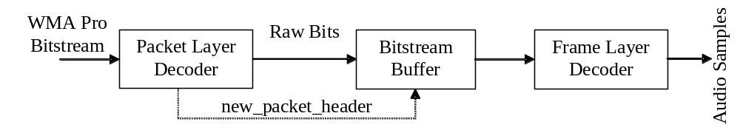
Figure 4 Cascaded Packet and Frame Layer Decoders
Syntax to follow in each layer appears next.

Packet Layer Decoder
Table 3 Syntax of decode_packet_layer()
Syntax | # bits | Notes
decode_packet_layer()
{
initialize(); |  | Section 3
while (data_available())
{
decode_packet();
}
}

Table 4 Syntax of decode_packet()
Syntax | # bits | Notes
decode_packet()
{
new_packet_header = 1;
decode_packet_header();
// Send remaining (payload) bits in the packet to
// frame layer to be decoded.
}

Table 5 Syntax of decode_packet_header()
Syntax | No of bits | Notes
decode_packet_header()
{
packet_number | 4 | uimsbf
seekable_frame_in_packet | 1 | uimsbf
spliced_packet | 1 | uimsbf
seek_offset_in_bits | log2_bits_per_packet+1 | Section 3.3
}

Frame Layer Decoder
This layer listens to the packet layer decoder, and calls decode_frame() continuously.

Table 6 Syntax of decode_frame_layer()
Syntax | # bits | Notes
decode_frame_layer()
{
while (data_available())
{
decode_frame_header ();
decode_frame_data ();
if (!more_frames_in_this_packet)  move on to next packet. |  | decode_frame  _data can change this flag
}
}

Syntax for Frame Header
Table 7 Syntax of decode_frame_header ()
Syntax | # bits | Notes
decode_frame_header()
{
// Perform initialization |  | Section 5.1
if (fFrameSizeInHeader) |  | Section 3.11
compressed_frame_size_bits | log2_bits_  per_packet+1 | Section 3.3
decode_tile_configuration ();
decode_post_proc_transform();
if (fGenerateDRCParams) |  | Section 3.11
drc_frame_scale_factor | 8 | uimsbf
decode_silence_information(); |  | Table 11
}

Note: compressed_frame_size_bits indicates the size of the compressed frame (in bits) including this field. That is, the size of compressed frame includes the size field itself.

Table 8 Syntax of decode_tile_configuration()
Syntax | # bits | Notes
decode_tile_configuration() |  | Sections 5.2, 5.3
{
if (!allow_subframes)
{
// Nothing to decode from bitstream
int iCh;// One subframe
num_tiles = 1;
for (iCh = 0;
iCh < num_channels; iCh++)
{
subframe_config[iCh].num_subframes = 1;
subframe_config[iCh].subframe_start [0] = 0;
subframe_config[iCh].subframe_size [0] =
samples_per_frame;
}
tile_start[0] = 0;
setOfTileChannels[0] ={0, …, num_channels-1};
tile_size[0] = samples_per_frame;
}
else
{
tile_aligned | 1 | uimsbf
int samples_left = samples_per_frame * num_channels;
num_tiles = 0;
while (samples_left > 0)
{
// Compute tileStartPosition
computeTileStartPosition(); |  | Section 5.3.1
// Determine set of possible channels in the tile &
// count number of such channels
determineSetOfPossibleTileChannels(); |  | Section 5.3.2
bool skip_size = (samples_per_frame-tileStartPosition)  == samples_per_smallest_window; |  | Section 5.3.3
bool skip_channel_mask = (tile_aligned ||  (numOfPossibleTileChannels == 1) || skip_size); |  | Section 5.3.3
if (skip_channel_mask)
setOfTileChannels[num_tiles] =
setOfPossibleTileChannels;
else
decodeSetOfTileChannels(); |  | Section 5.3.4
if (skip_size)
tile_size[num_tiles] =
samples_per_smallest_window;
else
{
// compute cBitSize0, cBitSize1
int tile_size_shift;
determineBitsForTileSize(); |  | Section 5.3.5
if(cBitSize0 == 0)
tile_size_shift | cBitSize1 | uimsbf
else
{
tile_size_shift | cBitSize0 | uimsbf
if (tile_size_shift >=
cBitSize0)
{
tile_size_shift | cBitSize1 | uimsbf
tile_size_shift = tile_size_shift +
cBitSize0;
}
}
tile_size[num_tiles] = samples_per_frame /
(1 << tile_size_shift);
}
samples_left = samples_left –
numOfTileChannels * tile_size[num_tiles];
updateSubframeConfigOfChannels(); |  | Section 5.3.6
num_tiles=num_tiles+1;
} // while (samples_left > 0)
}
}

Table 9 Syntax of decode_postproc_transform()
Syntax | # bits | Notes
decode_postproc_transform() |  | Section 5.4
{
// remember what was done in previous frame
postproc_transform_prev = postproc_transform;
postproc_transform_array_prev = postproc_transform_array;
postproc_transform = 0;
general_postproc_transform = 0;
if (num_channels > 1)
postproc_transform | 1 | uimsbf
if (postproc_transform)
general_postproc_transform | 1 | uimsbf
if (general_postproc_transform)
{
int iCh0, iCh1, iTmp;
for (iCh0 = 0;
iCh0 < num_channels;
iCh0++)
{
for (iCh1 = 0;
iCh1 < num_channels;
iCh1++)
{
iTmp | 4 | uimsbf
postproc_transform_array[iCh0][iCh1] =  signExtend4(iTmp)/-8.0; |  | Table 10
}
}
}
}

The sign extension is done through the small function:

Table 10 Function signExtend4
Syntax | # bits | Notes
int signExtend4 (int iTmp)
{
if (iTmp & 0x08)
{
iTmp |= 0xFFFFFFF0;// assuming 32-bit integer
}
return iTmp;
}

Table 11 Syntax of decode_silence_information()
Syntax | # bits | Notes
decode_silence_information()
{
leading_silence_samples = 0;
trailing_silence_samples = 0;
silence_info_present | 1 | uimsbf
if (silence_info_present)
{
leading_silence_info_present | 1 | uimsbf
if (leading_silence_info_present)
leading_silence_samples | log2_samppfr+1 | uimsbf
trailing_silence_info_present | 1 | uimsbf
if (trailing_silence_info_present)
trailing_silence_samples | log2_samppfr+1 | uimsbf
}
}

Syntax for Frame Data

Table 12 Syntax for Frame Data
Syntax | # bits | Notes
decode_frame_data() |  | Section 5.4
{
int iTile;
for (iTile = 0;
iTile < num_tiles; iTile++)
{
decode_tile_header(); |  | Table 13
decode_tile_data(); |  | Table 25
}
do
{
no_stuff_bits | 1 | uimsbf
} while (0 == no_stuff_bits);
more_frames_in_this_packet | 1 | uimsbf
}
Note: The bit more_frames_in_this_packet refers to the packet where the current compressed frame started (i.e. where its frame header started). If this bit is 0, then there are no more frames that start in the packet where the current frame has started. If this bit is 1, then one or more compressed frames start in that packet.

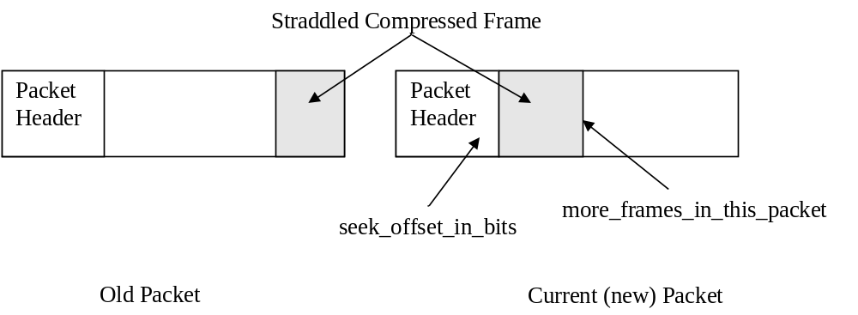
Figure 5 Straddling Compressed Frame
As a rule, if the current frame is straddling across packets (Figure 5), more_frames_in_this_packet is zero. In this straddled frame case, to determine if there are any more compressed frames in the current (new) packet, the following logic is used.

The seek_offset_in_bits field present in the current (new) packet header indicates where the next compressed frame begins. If this offset is inside the current packet, there are more valid compressed frames in the current packet. If on the other hand, the seek_offset_in_bits points to outside the current packet, the remainder of the current packet is all stuffing, and should be skipped over. This logic is valid irrespective of whether the seekable_frame_in_packet in the current packet header is 0 or 1.

Syntax for Tile Header
Table 13 Syntax for Tile Header
Syntax | # bits | Notes
decode_tile_header() |  | Section 6.2
{
decode_reserved_data(); |  | Table 14
lossless_tile | 1 | uimsbf
if (!lossless_tile)
{
decode_channel_transform(); |  | Table 15
bool skip_all = true;
for (iCh = 0; iCh < num_channels; iCh++)
{
if(iCh in setOfTileChannels[iTile])
{
is_channel_coded[iCh] | 1 | uimsbf
skip_all &= !(is_channel_coded[iCh])
}
}
if (skip_all) return;
explicit_num_vecs_available | 1 | uimsbf
if (explicit_ num_vecs _available)
{
for (iCh = 0;
iCh < num_channels; iCh++)
{
if(iCh in setOfTileChannels[iTile])
num_vecs[iCh] | size_num_vecs | uimsbf,  Section 6.2
}
}
decode_quant_step_tile(); |  | Table 18
decode_quant_step_channel(); |  | Table 19
decode_quant_step_band(); |  | Table 20
}
Else
{
// Lossless coded tile
seekable_tile = 1;
pure_lossless_tile | 1 | uimsbf
if (pure_lossless_tile)
{
Report_Bitstream_Error;
}
else
mixed_lossless_tile = 1;
rawpcm_tile | 1 | uimsbf
for (iCh = 0; iCh < num_channels; iCh++)
{
if(iCh in setOfTileChannels[iTile])
is_channel_coded[iCh] | 1 | uimsbf
}
if (bV3RTM) |  | Section 3.2
{
decode_lpc_filter_common (); |  | Table 23
}
else
{
decode_ac_filter (); |  | Table 24
}
if (!rawpcm_tile && seekable_tile)
{
lossless_quant_stepsize | 8 | uimsbf
lossless_quant_stepsize += 1;
}
decode_quant_step_band (); |  | Table 20
}
}
Note: In WMA Pro, pure_lossless_tile is a reserved bit which should always be 0. If a value of 1 is received, it indicates bitstream corruption, and the decoder should act accordingly.

Table 14 Syntax for Reserved Data
Syntax | # bits | Notes
decode_reserved_data () |  | Section 6.2
{
reserved_data_present | 1 | uimsbf
if (reserved_data_present)
{
num_reserved_bits0 | 2 | uimsbf
if (num_reserved_bits0 == 0)
{
size_num_reserved_bits | 4 | uimsbf
num_reserved_bits | size_num_reserved_bits | uimsbf
num_reserved_bits += 1;
}
reserved_data | num_reserved_bits | uimsbf
}
}
Note: In the current specification of WMA Professional, the reserved bits are used to send the LBR (low bitrate) portion of the syntax.

Multi-Channel Transformation
Table 15 Syntax for Channel Transform
Syntax | # bits | Notes
decode_channel_transform()
{
// Initialize channel transform |  | Section 6.2.6.1
iStage = 0;
if (num_channels == 1)
{
num_groups[1] = 1;
setOfGroupChannels[1][0] = 0;
transform_type[1][0] = ‘identity’;
return;
}
fDecodingSuperGroupXform | 1 | uimsbf
if (0 == fDecodingSuperGroupXform)
iStage++; // no information for stage 0.
while (iStage < 2)
{
iGroup = 0;
while (numOfPossibleGroupChannels[iStage][iGroup] > 0)
{
decode_channel_group_transform(); |  | Table 16
// Update set of possible channels in next channel group
setOfPossibleGroupChannels[iStage][iGroup+1] =
setOfPossibleGroupChannels[iStage][iGroup] -
setOfGroupChannels[iStage][iGroup]
// Update number of possible channels in the
// next channel group, numOfPossibleGroupChannels as well.
iGroup++;
if (iStage == 0)
{
fDecodingSuperGroupXform_continued | 1 | uimsbf
if (fDecodingSuperGroupXform_continued == 0)
{
break; // move to iStage = 1.
}
}
}
num_groups[iStage] = iGroup;
iStage++;
}
}

The syntax for decoding the linear transform for channel group iGroup at stage iStage of the current tile is given below.
Table 16 Syntax for Channel Group Transformation
Syntax | # bits | Notes
decode_channel_group_transform()
{
// decide members of channel group
if (numOfPossibleGroupChannels[iStage][iGroup] <= 2)
{
setOfGroupChannels[iStage][iGroup] =
setOfPossibleGroupChannels[iStage][iGroup];
}
else
{
// Update numOfGroupChannels, setOfGroupChannels
decodeSetOfGroupChannels(); | numOfPossibleGroupChannels | Section 6.2.6.2
}
if (numOfGroupChannels[iStage][iGroup] == 1)
{
// Use identity transform for this channel group
transform_type[iStage][iGroup] = ‘identity’;
}
else if (numOfGroupChannels[iStage][iGroup] == 2)
{
int iTmp0, iTmp1;
iTmp0 | 1 | uimsbf
if (iTmp0 == 0)
{
// Use Hadamard Transform for this
// stereo pair
transform_type[iStage][iGroup] = ‘hadamard’;
}
else
{
iTmp1 | 1 | uimsbf
if (iTmp1 == 0)
{
// use Identity Transform for this
// stereo pair.
transform_type[iStage][iGroup] =
‘identity’;
}
else
{
transform_type[iStage][iGroup] =
‘general’;
decode_general_channel_transform() |  | Table 17
}
}
}
else
{
// more than 2 channels in this group
int iTmp0, iTmp1;
iTmp0 | 1 | uimsbf
if (0 == iTmp0)
{
// use Identity Transform for this
// channel group.
transform_type[iStage][iGroup] =
‘identity’;
}
else
{
iTmp1 | 1 | uimsbf
if (iTmp1 == 0)
{
// use DCT Type 2 Transform for this
// channel group.
transform_type[iStage][iGroup] =
‘dcttype2’;
}
else
{
transform_type[iStage][iGroup] =
‘general’;
decode_general_channel_transform(); |  | Table 17
}
}
}
// Transform on-off
transform_on_for_all_bands[iStage][iGroup] = 1;
if (transform_type[iStage][iGroup] != ‘identity’)
{
transform_on_for_all_bands[iStage][iGroup] | 1 | uimsbf
}
if (transform_on_for_all_bands[iStage][iGroup])
{
int iBand;
for (iBand = 0; iBand < num_bark_bands[iWin];
iBand++)
{
transform_on[iStage][iGroup][iBand] = 1;
}
}
else
{ // read from bit stream
int iBand;
for (iBand = 0; iBand < num_bark_bands[iWin];
iBand++)
{
transform_on[iStage][iGroup][iBand] | 1 | uimsbf
}
}
}

Table 17 Syntax for General Channel Group Transform
Syntax | # bits | Notes
decode_general_channel_transform ()
{
int iAngle=0, iSign=0;
for (iAngle = 0;
iAngle < numOfGroupChannels * (numOfGroupChannels-1)/2;
iAngle++)
{
int iTmp;
iTmp | 6 | uimsbf
rotation_angles[iStage][iGroup][iAngle] = (iTmp – 32). π/2;
}
for (iSign = 0;
iSign < numOfGroupChannel;
iSign ++)
{
int iTmp;
iTmp | 1 | uimsbf
rotation_sign[iStage][iGroup][iSign] = (iTmp == 0) ? -1 : 1;
}
}

Tile Quantization Step Size
Table 18 Syntax for Tile Quantizer Step Size
Syntax | # bits | Notes
decode_quant_step_tile () |  | Section 6.2.8
{
int quant_incr_sign, quant_incr0, quant_incr1;//32-bit
bool quant_escaped = false;
quant_step_tile = 90 * validBitsPerSample / 16;
// First part is in 2’s complement
quant_incr0 | 6 | uimsbf
quant_incr_sign = (quant_incr0 & 0x20) ? -1 : 1;
if (quant_incr_sign == -1)
quant_incr0 |= 0xFFFFFFC0; // extend the sign
quant_step_tile += quant_incr0;
if (quant_incr0 <= -32 || quant_incr0 >= 31)
{
quant_escaped = true;
}
while (quant_escaped)
{
// Further increments are absolute values
quant_incr1 | 5 | uimsbf
quant_step_tile += (quant_incr1 * quant_incr_sign)
quant_escaped = (quant_incr1 == 31) ? true : false;
}
}

Channel Quantization Step Size
Table 19 Syntax for Channel Quantizer Step Size
Syntax | # bits | Notes
decode_quant_step_channel () |  | Section 6.2.8.2
{
int iCh, qsc_size;
// initialize
for (iCh = 0; iCh < num_channels; iCh++)
{
if (iCh in setOfTileChannels[iTile])
{
quant_step_channel[iCh] = 0;
}
}
if (numOfTileChannels[iTile] == 1)
return; |  | early exit
qsc_size | 3 | uimsbf
for (iCh = 0; iCh < num_channels; iCh++)
{
if (iCh in setOfTileChannels[iTile])
{
quant_step_channel[iCh] | 1 | uimsbf
if (!quant_step_channel[iCh])
{
if (qsc_size == 0)
{
quant_step_channel[iCh] = 1;
}
else
{
quant_step_channel[iCh] | qsc_size | uimsbf
quant_step_channel[iCh] += 1;
}
}
}
}
}

Band Quantization Step Sizes (Mask)
Table 20 Syntax for Quant-Step-Band Values
Syntax | # bits | Notes
decode_quant_step_band () |  | Section 6.2.8.3
{
int iCh, iBand;
for (iCh = 0; iCh < num_channels; iCh++)
{
if (iCh in setOfTileChannels[iTile])
{
quant_step_band_updated[iCh] = true;
if (subframe_config[iCh].curr_subframe > 1 ||
lossless_mode)
{
quant_step_band_updated[iCh] | 1 | uimsbf
}
if (quant_step_band_updated[iCh])
{
if (anchor_quant_step_band_available[iCh])
{
decode_quant_step_band_rlc(); |  | Table 22
}
else
{
quant_step_band_multiplier[iCh] | 2 | uimsbf
quant_step_band_multiplier[iCh] += 1;
decode_quant_step_band_vlc(); |  | Table 21
}
// remember the size of current tile window.
anchor_quant_step_band_available[iCh] = true;
win_with_quant_step_band_update [iCh] = iWin;
// update max values of quant_step_band
max_quant_step_band[iCh] = quant_step_band [iCh][0];
for (iBand = 1; iBand < num_bark_bands[iWin]; iBand++)
{
max_quant_step_band[iCh] = max(max_quant_step_band[iCh], quant_step_band [iCh][iBand]);
}
}
}
}
}

Table 21 Syntax for Quant-step-band, when anchor values are not available
Syntax | # bits | Notes
decode_quant_step_band_vlc ()
{
int band = 0;
int quant_step_band_prev = 45/ quant_step_band_multiplier[iCh]; |  | integer divide
int quant_step_band_diff;
for (; band < num_bark_bands[iWin];
band++)
{
quant_step_band_diff | 1-19 | vlclbf
quant_step_band[iCh][band] = quant_step_band_diff +
quant_step_band_prev – 60;
quant_step_band_prev = quant_step_band[iCh][band];
}
}
The Huffman table to be used in decode_quant_step_band_vlc() is given in Table 106.

Table 22 Syntax for Quant-step-band, when anchor values are available
Syntax | # bits | Notes
decode_quant_step_band_rlc () |  | Section 6.2.8.3
{
int iBand = 0;
// Copy over the predicted mask
for (iBand = 0; iBand < num_bark_bands[iWin]; iBand++)
{
quant_step_band[iCh][iBand] =
quant_step_band_prediction[iCh][iBand];
}
// decode delta from bitstream
iBand = 0;
while (iBand < num_bark_bands[iWin])
{
rlc_symbol | 2-21 | vlclbf
if (rlc_symbol == “END_OF_BLOCK”)
{
return;
}
else if (rlc_symbol == “ESCAPE_CODE”)
{
abs_level; | 8 | uimsbf
run; | 5 | uimsbf
sign_level; | 1 | uimsbf
}
else
{
// from rlc_symbol, get abs_level, run
sign_level; | 1 | uimsbf
}
iBand += run + 1;
quant_step_band[iCh][iBand] +=
(sign_level == 1) ? abs_level : -abs_level;
}
}

The run-level Huffman table to be used in decode_quant_step_band_rlc is given in Table 107.

LPC Filter Common Parameters
Table 23 Syntax for LPC Filter Common Parameters
Syntax | # bits | Notes
decode_lpc_filter_common ()
{
if (bV3RTM)
{
do_lpc | 1 | uimsbf
if (do_lpc)
{
lpc_order | 5 | uimsbf
lpc_scaling | 4 | uimsbf
lpc_intbits | 3 | uimsbf
}
}
}

AC Filter
Table 24 Syntax for AC filter
Syntax | # bits | Notes
decode_ac_filter ()
{
if (seekable_subframe && !rampcm_subframe)
{
ac_filter_coeff | 6 | uimsbf
}
}

Syntax for Tile Data
Table 25 Syntax for Tile Data
Syntax | # bits | Notes
decode_tile_data ()
{
if (!lossless_mode)
{
for (iCh = 0; iCh < num_channels; iCh++)
{
if(iCh in setOfTileChannels[iTile])
{
int index;
int subframe_size_curr = samples_per_frame / (1 << iWin);
// initialize
for (index = 0; index < subframe_size_curr; index++)
quantized_spec_coef[iCh][index] = 0;
if (is_channel_coded[iCh])
decode_channel_coefficients_lossy(); |  | Table 26
}
}
}
Else
{
for (iCh = 0; iCh < num_channels; iCh++)
{
if(iCh in setOfTileChannels[iTile])
{
if (is_channel_coded[iCh])
decode_channel_residues_lossless();
}
}
}

Table 26 Syntax for decoding lossy Quantized Spectral Coefficients.
Syntax | # bits | Notes
decode_channel_coefficients_lossy ()
{
int index = 0;
int subframe_size_curr = samples_per_frame / (1 << iWin);
int iVector = 0;
int iThreshold = subframe_size_curr / 256;
int iZeroCount = 0;
int iComp;
coef_rlc_table_number | 1 | uimsbf
while (1)
{
decode_vector_huffman_4d(); |  | Table 27
// decode_vector_huffman_4d() returns 4d-arrays of sign_level and abs_level
for (iComp = 0; iComp < 4; iComp++)
{
quantized_spec_coef[iCh][index] =
(sign_level[iComp] == 1) ? abs_level[iComp] : -abs_level[iComp];
index++;
}
if (explicit_num_vecs_available)
{
iVector++;
if (iVector == num_vecs[iCh])
break;
}
else
{
for (iComp = 0; iComp < 4; iComp++)
{
if (levels[iComp] == 0)
iZeroCount++;
else
iZeroCount = 0;
}
if (iZeroCount > iThreshold)
break;
}
}
// The index value is valid here for sign-run-level decoding
decode_quantized_spec_coef_rlc (); |  | Table 28
}

Table 27 Syntax for Vector Huffman Decoding of 4D vectors.
Syntax | # bits | Notes
decode_vector_huffman_4d ()
{
int iComp2, iComp1;
int iComp = 0;
vec4_symbol | 1-12 | vlclbf
if (vec4_symbol == “ESCAPE_CODE_VEC4”)
{
for (iComp2=0; iComp2 < 2; iComp2++)
{
vec2_symbol | 3-12 | vlclbf
if (vec2_symbol == “ESCAPE_CODE_VEC2”)
{
for (iComp1=0; iComp1 < 2; iComp1++)
{
vec1_symbol | 5-11 | vlclbf
if (vec1_symbol == “ESCAPE_CODE_VEC1”)
{
abs_level[iComp] = decode_escape_level(); |  | Table 29
abs_level[iComp++] += ESCAPE_CODE_VEC1;
}
else
{
abs_level[iComp++]=vec1_symbol_to_level[vec1_symbol];
}
}
}
else
{
abs_level[iComp++]=(vec2_symbol_to_level[vec2_symbol]>>4) & 0xf;
abs_level[iComp++]=(vec2_symbol_to_level[vec2_symbol] ) & 0xf;
}
}
}
else
{
abs_level[iComp++]=(vec4_symbol_to_level[vec4_symbol]>>12) & 0xf;
abs_level[iComp++]=(vec4_symbol_to_level[vec4_symbol]>> 8) & 0xf;
abs_level[iComp++]=(vec4_symbol_to_level[vec4_symbol]>> 4) & 0xf;
abs_level[iComp++]=(vec4_symbol_to_level[vec4_symbol] ) & 0xf;
}
sign_level[0] | 1 | uimsbf
sign_level[1] | 1 | uimsbf
sign_level[2] | 1 | uimsbf
sign_level[3] | 1 | uimsbf
}

Table 28 Syntax for Quantized Spectral Coefficients, once in sign-run-level mode
Syntax | # bits | Notes
decode_quantized_spec_coef_rlc () |  | Section 6.3.2
{
// initial index value, subframe_size_curr are
// available from the caller
// Select the RLC table based on coef_rlc_table_number
while (index < subframe_size_curr)
{
rlc_symbol | 2-22 | vlclbf
if (rlc_symbol == “END_OF_BLOCK”)
{
return;
}
else if (rlc_symbol == “ESCAPE_CODE”) {
{
abs_level = decode_escape_level(); |  | Table 29
run = decode_escape_run(); |  | Table 30
sign_level | 1 | uimsbf
}
else
{
// from rlc_symbol, get abs_level, run
abs_level = rlc_symbol_to_level[rlc_symbol];
run = rlc_symbol_to_run[rlc_symbol];
sign_level; | 1 | uimsbf
}
index += run;
quantized_spec_coef[iCh][index] =
(sign_level == 1) ? abs_level : -abs_level;
index++;
}
}

Table 29 Syntax for Escape Decoding of Levels.
Syntax | # bits | Notes
decode_escape_level ()
{
unsigned int uBit;
unsigned int uLevel;
uBit | 1 | uimsbf
if (uBit == 0)
{
uLevel | 8 | uimsbf
}
else
{
uBit | 1 | uimsbf
if (uBit == 0)
{
uLevel | 16 | uimsbf
}
else
{
uBit | 1 | uimsbf
if (uBit == 0)
uLevel | 24 | uimsbf
else
uLevel | 31 | uimsbf
}
}
return uLevel;
}

Table 30 Syntax for Escape Decoding of Runs
Syntax | # bits | Notes
decode_escape_run ()
{
unsigned int uBit;
unsigned int uRun;
unsigned int cMaxRun = LOG2(subframe_size_curr-1) + 1;
uBit | 1 | uimsbf
if (uBit == 0)
{
uRun = 0;
}
else
{
uBit | 1 | uimsbf
if (uBit == 0)
{
uRun | 2 | uimsbf
uRun += 1;
}
else
{
uBit | 1 | uimsbf
uRun | cMaxRun | uimsbf
uRun += 4;
}
}
return uRun;
}

Table 31 Syntax for Decoding Mixed Lossless Channel Residues in Mixed Lossless Mode
Syntax | # bits | Notes
decode_channel_residue_lossless ()
{
int index = 0;
if (rawpcm_tile)
{
int subframe_size_curr = samples_per_frame / (1 << iWin);
while (index < subframe_size_curr)
{
channel_coeffs[iCh][index] | validBitsPerSample | imsbf
channel_coeffs[iCh][index] *= 2;
}
}
else
{
if (bV3RTM && do_lpc)
{
int cBits = lpc_intbits + lpc_scaling;
for (iCoeff = 0; iCoeff < lpc_order; iCoeff++)
{
lpc_coeffs[ich][iCoeff] | cBits | imsbf
}
}
idiv_width | 5 | uimsbf
if (seekable_tile)
{
channel_residues[iCh][0] | validBitsPerSample+1 | imsbf
index++;
}
while (index < subframe_size_curr)
{
int iQuo = 0, iRem;
while (1)
{
int bit;
bit | 1 | uimsbf
if (bit)
iQuo++;
else
break;
}
iRem | idiv_width | uimsbf
channel_residues[iCh][index]
= iQuo << idiv_width + iRem;
}
}
}

Syntax for LBR Data

LBR v1 consists of
- v1 frequency extension (coding fex) in coding domain
LBR v2 consists of
- baseplus (exclusive/overlay) in coding domain
- v2 frequency extension (recon fex + coding fex) in coding and recon domain
- channel extension (chex) in recon domain
LBR v3 consists of
- baseplus (exclusive/overlay/extend) in coding domain
- basepeak in coding domain
- v3 frequency extension (recon fex + coding fex) in coding and recon domain
- channel extension (chex) in recon domain

Overview of baseplus

Baseplus contains two modes in LBR v2: exclusive mode and overlay mode.
Baseplus contains three modes in LBR v3: the above two and extend mode.

Baseplus exclusive mode is designed to replace the current WMAPro’s base layer for better coding efficiency. When baseplus exclusive mode is on, WMAPro’s base layer would code everything as silence and the real coding is done in baseplus. Compared with WMAPro’s base layer, baseplus has three new technologies: 1) final mask, which is called scalefactor in baseplus, 2) V4 entropy coding for coefficients, and 3) three tool boxes for signal with particular features.

Baseplus overlay mode is designed to complement the WMAPro’s base layer. It finds holes in base layer and fills them.

Baseplus extend mode is designed to complement the WMAPro’s base layer like overlay mode. It codes the coefficients from the upper bound of base layer.

Like all other Pro+ modes such as freqex, reconfex and chex, the compressed bits of baseplus are be saved in the reserved bits in sub frame header.

Overview of frequency extension

Frequency extension consists of taking portions of the already coded spectrum or vectors from a fixed codebook, potentially applying a nonlinear transform (such as exponentiation or combination of two vectors) and scaling it to reproduce the higher frequencies. It can be applied in the same transform domain as the base codec (coding fex) or in a transform domain which uses smaller time windows (recon fex). If recon domain frequency extension is used in combination with channel extension, than the smaller time window time-to-frequency transformation used for both is identical. The parameters to specify this new tiling is given by the recon processing header information (reconProc).

Overview of channel extension

Channel extension consists of taking a single channel and applying a bandwise scale factor in a transform domain which uses smaller time windows and is potentially complex (e.g. MCLT) or for a low power implementation can use a real transform (MLT). The scale factors are derived from parameters sent which specify the normalized correlation matrix for channel groups. The scaled coefficients are added to potentially postprocessed (after a filter) and scaled coefficients to recreate the final output. The final output is recreated so that the complex second order statistics (the correlation matrix) is matched to that of the original on a bandwise basis.

Overview of basepeak
Basepeak codes the coefficients, especially with aiming spectral peaks, from the upper bound of base or baseplus layer. The coefficient positions are quantized differentially either with inter-frame prediction or intra-frame prediction. The shape of peaks is encoded using a vector quantizer. Basepeak decoder is called from base decoder if Baseplus is not present in the current tile, Otherwise, it is called from Baseplus decoder.

Plus Encode Option Syntax

WMAUDIO3WAVEFORMAT
Field | dwReserved1 | dwReserved2 | wEncodeOptions | wReserved3
Variable |  | uAdvancedEncodeOpt2 | uEncodeOpt | uAdvancedEncodeOpt
- Table 32 - Plus Encode Options Layout

uAdvancedEncodeOpt = pppx xxxx xxxx xxxx
ppp = plus version bits
- Table 33 - Plus versioning layout

000 | no plus
001 | v2 -- iPlusVersion = 2
010 | v3 -– iPlusVersion = 3
011 | reserved
100 | v1 -- iPlusVersion = 1
101 | reserved
110 | v1 -- iPlusVersion = 1
111 | not allowed
- Table 34 - Plus versioning

if (iPlusVersion == 1)
{
uAdvancedEncodeOpt = pppx xxxb bbss smmm
bbb = Bits to specify maximum fex bands
sss = Bits to specify default scale factor bins
mmm = Bits to specify default mv bins
}
else if (iPlusVersion >= 2)
{
uAdvancedEncodeOpt = pppx aabb bttt tcrl
l = Baseplus used?
r = Recon fex used?
c = Chex used?
tttt = Bits to specify recon domain tiling (min/max tiles)
bbb = Bits to specify maximum fex bands
aa = Bits to specify maximum chex anchors per frame
uAdvancedEncodeOpt2 = xxxx xxxx xxxx xxxx xxxx xxxx xxbb bccc
ccc = Bits to specify actual number of source channels when chex
used (since chex can code less than full)
bbb = Bits to specify maximum chex bands
}
- Table 35 - Plus Encopt Bits

Bits to specify actual channels when chex used | Actual number of channels | Actual channel mask
000 | Original number of channels | *
001 | STEREO | 0x3
010 | THREE | 0x7
011 | QUAD | 0x33
100 | 5 | 0x37
101 | 5DOT1DTS | 0x3f
110 | 5DOT1DOLBY | 0x60f
111 | 7DOT1 | 0xff
- Table 36 - Actual Channels when Chex Used

Plus Syntax

Syntax | # bits | Notes
plusDecodeTileHeader ()
{
if (iPlusVersion>=2 && 0==iCurrTile)
plusDecodeSuperframeHeaderFirstTile() |  | Table 38
if (iPlusVersion>=2 && cTiles-1==iCurrTile &&
!bLastTileHeaderDecoded)
plusDecodeSuperframeHeaderLastTile() |  | Table 39
setPlusOrder()
}
- Table 37 - plusDecodeTileHeader

Syntax | # bits | Notes
plusDecodeSuperframeHeaderFirstTile ()
{
bPlusSuperframe | 1 | uimsbf
if (bPlusSuperframe)
{
if (iPlusVersion==3)
{
bBasePeakPresent | 1 | uimsbf
}
bBasePlusPresent | 1 | uimsbf
bCodingFexPresent | 1 | uimsbf
if (bBasePlusPresent)
{
plusDecodeBasePlusHeader() |  | Table 41
}
if (bCodingFexPresent)
{
plusDecodeCodingFexHeader() |  | Table 58
}
if (bBasePlusPresent || bCodingFexPresent)
{
plusDecodeSuperframeHeaderLastTile() |  | Table 39
}
}
- Table 38 - plusDecodeSuperframeHeaderFirstTile

Syntax | # bits | Notes
plusDecodeSuperframeHeaderLastTile ()
{
if (bPlusSuperframe)
{
bChexPresent | 1 | uimsbf
bReconFexPresent | 1 | uimsbf
if (bChexPresent)
{
plusDecodeChexHeader() |  | Table 89
}
if (bReconFexPresent)
{
plusDecodeReconFexHeader() |  | Table 67
}
if (bChexPresent || bReconFexPresent)
{
iTileSplitType  /*  iTileSplitType  0: TileSplitBaseSmall  10: TileSplitBasic  11: TileSplitArbitrary  */ | 1-2
}
}
if ((bChexPresent || bReconFexPresent) &&
iTileSplitType==ReconProcTileSplitArbitrary)
{
for (iTile=0; iTile < iNTilesPerFrameBasic; iTile++)
{
bTileSplitArbitrary[iTile] | 1
}
}
bLastTileHeaderDecoded = TRUE
}
- Table 39 - plusDecodeSuperframeheaderLastTile

Syntax | # bits | Notes
plusDecodeTile()
{
plusDecodeBase() |  | Table 42
plusDecodeChex() |  | Table 90
plusDecodeFex() |  | Table 70
reconProcUpdateCodingFexFlag()
plusDecodeReconFex() |  | Table 76
}
- Table 40 - plusDecodeTile

Baseplus Syntax

Syntax | # bits | Notes
plusDecodeBasePlusHeader()
{
bBasePlusOverlayMode | 1 | uimsbf
if (!bBasePlusOverlayMode)
{
bScalePriorToChannelXForm | 1 | uimsbf
bLinearQuantization | 1 | uimsbf
if (!bLinearQuantization)
NLQIndex | 2 | uimsbf
bFrameParamUpdate | 1 | uimsbf
fUseProMaskRunLevelTbl | 1 | uimsbf
fLowDelayWindow | 1 | uimsbf
if (fLowDelayWindow)
iOverlapWindowDelay (0->1, 10->2, 11->4) | 1-2 | vlclbf
}
Else
{
iHoleWidthMinIdx | 1 | uimsbf
iHoleSegWidthMinIdx | 1 | uimsbf
bSingleWeightFactor | 1 | uimsbf
iWeightQuantMultiplier | 2 | uimsbf
bWeightFactorOnCodedChannel | 1 | uimsbf
fFrameParamUpdate | 1 | uimsbf
}
}
- Table 41 - plusDecodeBasePlusHeader

Syntax | # bits | Notes
plusDecodeBase()
{
if (bBasePlusPresent)
{
fBasePlusTileCoded | 1 | uimsbf
bpdecDecodeTile() |  | Table 43
}
}
- Table 42 - plusDecodeBase

Syntax | # bits | Notes
bpdecDecodeTile()
{
if (fBasePlusTileCoded)
{
if (fOverlayMode)
basePlusDecodeOverlayMode() |  | Table 44
Else
basePlusDecodeTileExclusiveMode() |  | Table 45
}
}
- Table 43 - bpdecDecodeTile

Syntax | # bits | Notes
basePlusDecodeOverlayMode()
{
if (bFirstTileInFrame)
basePlusDecodeFirstTileHeaderOverlayMode() |  | Table 55
if (FALSE == bWeightFactorOnCodedChannel)
baseplusDecodeWeightFactorOverlayMode() |  | Table 56
for (iCh=0; iCh < cChInTile; iCh++)
{
ulPower | 1 | Uimsbf
if (ulPower)
{
if (bWeightFactorOnCodedChannel)
{
if (bSingleWeighFactor)
{
iMaxWeightFactor | CEILLOG2(  MAX_WEIGHT_FACTOR/  iWeightQuantMultiplier) | Vlclbf
}
Else
{
basePlusDecodeRLCCoefQOverlay()
}
}
}
}
plusDecodeBasePeak() |  | Table 92
for (iCh=0; iCh < cChInTile; iCh)
{
plusDecodeBasePeak_Channel() |  | Table 93Table 32
}
}
- Table 44 - basePlusDecodeOverlayMode

Syntax | # bits | Notes
basePlusDecodeExclusiveMode()
{
if (bFirstTileInFrame)
prvBasePlusDecodeFirstTileHeaderExclusiveMode() |  | Table 48
prvBasePlusEntropyDecodeChannelXform()
prvBasePlusDecodeTileScaleFactors() |  | Table 49
prvBasePlusDecodeTileQuantStepSize() |  | Table 50
prvBasePlusDecodeChannelQuantStepSize() |  | Table 51
for (iCh=0; iCh < cChInTile; iCh)
{
ulPower | 1 | uimsbf
if (ulPower)
{
bUseToolboxes | 1 | uimsbf
if (bUseToolboxes)
{
iToolboxIndex | 2 | uimsbf
if (iToolboxIndex == 0)
{
basePlusDecodeInterleaveModeParams() |  | Table 52
basePlusDecodeRLCCoefQ()
basePlusDeInterleave()
}
else if (iToolboxIndex == 1)
{
basePlusDecodePredictionModeParams() |  | Table 53
basePlusDecodeRLCCoefQ()
basePlusDePrediction()
}
else if (iToolboxIndex == 2)
{
basePlusDecodePDFShiftModeParams() |  | Table 54
basePlusDecodeRLCCoefQ()
basePlusDePDFShift()
}
}
else
{
basePlusDecodeRLCCoefQ()
}
} // ulPower
} // iCh
plusDecodeBasePeak()
for (iCh=0; iCh < cChInTile; iCh)
{
plusDecodeBasePeak_Channel()
}
}
- Table 45 - basePlusDecodeExclusiveMode

Syntax | # bits | Notes
baseplusDecodeSFBandTableIndex()
{
iScaleFactorTable | 1-3 | vlclbf
/* scale factor table for this frame
0: Table 0
10: Table 1
110: Table 2
111: Table 3
*/
}
- Table 46 - baseplusDecodeSFBandTableIndex

Syntax | # bits | Notes
baseplusDecodeIOverlayWindowDelay()
{
iOverlapWindowDelay | 1-2 | vlclbf
/*
0: 1
10: 2
11: 4
*/

}
- Table 47 - baseplusDecodeIOverlayWindow

Syntax | # bits | Notes
basePlusDecodeFirstTileHeaderExclusiveMode()
{
if (fFrameParamUpdate)
{ |  | Table 46
baseplusDecodeSFBandTableIndex()
fScalePriorToChannelXfromAtDec | 1
fLinearQuantization | 1
if (0 == fLinearQuantization)
{
NLQIndex | 2
}
fUsePorMaskRunLevelTbl | 1
}
iScaleFactorQuantizeStepSize | 2
/* scale factor quantization step size
0: 1dB
1: 2dB
2: 3dB
3: 4dB
*/
}
- Table 48 - basePlusDecodeFirstTileHeaderExclusiveMode

Syntax | # bits | Notes
basePlusDecodeTileScaleFactor()
{
for (iChGrp = 0; iChGrp < cBPCHGroup; iChGrp++)
{
if (cChannelsInGrp > 1)
fOneScaleFactorPerChGrp | 1
else
fOneScaleFactorPerChGrp = 1
if (fOneScaleFactorPerChGrp)
{
if (fAnchorSFAvailable)
fScaleFactorTemporalPreded | 1
if (!fScaleFactorTemporalPreded)
fScaleFactorSpectralPreded = 1
fScaleFactorInterleavedCoded | 1
iScaleFactorHuffmanTableIndex // four tables | 2
Call Huffman decoding of scalefactors;
}
else
{
for (iCh=0; iCh < cChsInTile; iCh++)
{
if (iCh in the current ChGrp)
{
fMaskUpdate | 1
if (fMaskUpate)
{
if (fAnchorSFAvailable)
fScaleFactorTemporalPreded | 1
if (!fFirstChannelInGrp &&
!fScaleFactorTempralPreded)
fScaleFactorSpatialPreded | 1
if (!fScaleFactorTemporalPreded &&
!fScaleFactorSpatialPreded)
fScaleFactorSpectralPreded = 1;
fScaleFactorInterleavedCoded | 2
iScaleFactorHuffmanTableIndex; // four tables
Call Huffman decoding of scalefactors;
}
}
}
}
}
}
- Table 49 - basePlusDecodeTileScaleFactor

Syntax | # bits | Notes
basePlusDecodeTileQuantStepSize()
{
iStepSize | 6
iQuantStepSign = (iStepSize & 0x20) ? -1 : 1;
if (iQuantStepSign == -1)
iStepSize != 0xFFFFFFC0;
iQuantStepSize += iStepSize;
if (iStepSize == -32 || iStepSize == 31)
fQuantStepEscaped = 1;
while (fQuantStepEscaped)
{
iStepSize | 5
if (iStepSize != 31)
{
iQuantStepSize += (iStepSize * iQuanStepSign);
Break;
}
iQuanStepSize += 31 * iQuanStepSign;
}
}
- Table 50 - basePlusDecodeTileQuantStepSize

Syntax | # bits | Notes
basePlusDecodeTileChannelQuantStepSize()
{
if (pau->m_cChInTile == 1)
Exit;
cBitQuantStepModiferIndex // how many bits we use for Ch QuantStepSize | 3
for (iCh=0; iCh<cChInTile; iCh++)
{
iBPChannelQuant | 1
if (iBPChannelQuant)
{
if (0 == cBitQuantStepModiferIndex)
iBPChannelQuant = 1;
else
{
iBPChannelQuant[cBitQuantStepModiferIndex];
iBPChannelQuant++;
}
}
}
}
- Table 51 - basePlusDecodeTileChannelQuantStepSize

Syntax | # bits | Notes
basePlusDecodeInterleaveModeParams()
{
iPeriodLimit = cSubFrameSampleHalf / 16;
iPeriod [Log2(iPeriodLimit)];
iPeriod++;
iPeriodFraction | 3
iFirstInterleavePeriod | 3
cMaxPeriods = (cSubFrameSampleHalf * 8) / (iPeriod * 8 + iPeriodFraction);
iLastInterleavePeriod | [CEILLOG2(cMaxPeriods)];
iPreroll | 2
}
- Table 52 - basePlusDecodeInterleaveModeParams

Syntax | # bits | Notes
basePlusDecodePredictionModeParams()
{
fUsePredictor | 1
if (fUsePredictor)
{
iCoefQLPCOrder | 1-4
/*
0: order 1
10: order 2
110: order 4
1110: order 8
*/
iCoefQLPCShift | 3
if (cSubband > 128)
{
iCoefQLPCSegment | [LOG2(min(8, cSubband/128))]
}
else
{
iCoefQLPCSegment = 1;
}
if (iCoefQLPCSegment > 1)
{
iCoefQLPCMask | iCoefQLPCSegment
}
for (iSeg = 0; iSeg < iCoefQLPCSegment; iSeg++)
{
If (iCoefQLPCMask >> iSeg & 1)
{
For (i = 0; i = iCoefQLPCOrder; i++)
{
iCoefQPredictor[iSeg][i] | [iQCoefLPCShift+2]
}
}
}
}
- Table 53 - basePlusDecodePredictionModeParams

Syntax | # bits | Notes
basePlusDecodePDFShiftModeParams()
{
iPeriodLimit = cSubband/8
iPeriod | LOG2(iPeriodLimit)
iPeriod++;
iInsertPos | CEILLOG2(iPeriod/2)
}
- Table 54 - basePlusDecodePDFShiftModeParams

Syntax | # bits | Notes
baseplusDecodeFirstTileHeaderOverlayMode()
{
if (fFrameParamUpdate)
{
iHoleWidthIdex | 1
iHoleSegWidethMinIdx | 1
bSingleWeightFactor | 1
iWeightQuantMultiplier | 2
bWeightFactorOnCodedChannel | 1
}
}
- Table 55 - baseplusDecodeFirstTileHeaderOverlayMode

Syntax | # bits | Notes
baseplusDecodeWeightFactorOverlayMode()
{
for (iCh = 0; iCh < cChInTile; iCh++)
{
if (bSingleWeightFactor)
{
iMaxWeightFactor | [CEILLOG2(  MAX_WEIGHT_FACTOR/  iWeightQuantMultiplier];
}
Else
{
Call huffman decoding of weight factors.
}
}
}
- Table 56 - baseplusDecodeWeightFactorOverlayMode

Frequency Extension (a.k.a. fex, freqex) Syntax

Syntax | # bits | Notes
plusDecodeCodingFexHeader()
{
if (iPlusVersion==2)
freqexDecodeCodingGlobalParam() |  | Table 58
else if (iPlusVersion>2)
freqexDecodeGlobalParamV3(FexGlobalParamUpdateFull) |  | Table 85
}
- Table 57 - plusDecodeCodingFexHeader

Syntax | # bits | Notes
freqexDecodeCodingGlobalParam ()
{
freqexDecodeCodingGrpD() |  | Table 59
freqexDecodeCodingGrpA() |  | Table 61
freqexDecodeCodingGrpB() |  | Table 64
freqexDecodeCodingGrpC() |  | Table 65
}
- Table 58 - freqexDecodeCodingGlobalParam

Syntax | # bits | Notes
freqexDecodeCodingGrpD ()
{
bEnableV1Compatible | 1 | uimsbf
freqexDecodeReconGrpD() |  | Table 60
}
- Table 59 - freqexDecodeCodingGrpD

Syntax | # bits | Notes
freqexDecodeReconGrpD ()
{
bRecursiveCwGeneration | 1 | uimsbf
if (bRecursiveCwGeneration)
iKHzRecursiveCwWidth | 2 | uimsbf
iMvRangeType | 2 | uimsbf
iMvResType | 2 | uimsbf
iMvCodebookSet (0->0, 10->1, 11->2) | 1-2 | vlclbf
if (0 == iMvCodebookSet || 1 == iMvCodebookSet)
{
bUseRandomNoise | 1 | uimsbf
iNoiseFloorThresh | 2 | uimsbf
}
iMaxFreq | 2+ | vlclbf
}
- Table 60 - freqexDecodeReconGrpD

Syntax | # bits | Notes
freqexDecodeCodingGrpA ()
{
bScaleBandSplitV2 | 1 | uimsbf
bNoArbitraryUniformConfig | 1 | uimsbf
}
- Table 61 - freqexDecodeCodingGrpA

Syntax | # bits | Notes
freqexDecodeReconGrpA ()
{
bScaleBandSplitV2 | 1 | uimsbf
bArbitraryScaleBandConfig | 1 | uimsbf
if (!bArbitraryScaleBandConfig)
freqexDecodeNumScMvBands() |  | Table 63
Else
freqexDecodeArbitraryUniformBandConfig()
}
- Table 62 - freqexDecodeReconGrpA

Syntax | # bits | Notes
freqexDecodeNumScMvBands()
{
cScaleBands/cMvBands | 3+ | vlclbf
}
- Table 63 - freqexDecodeNumScMvBands

Syntax | # bits | Notes
freqexDecodeCodingGrpB()
{
bUseImplicitStartPos | 1 | uimsbf
if (bUseImplicitStartPos)
bOverlay | 1 | uimsbf
Else
iMinFreq = freqexDecodeFreqV2() | 3+ | vlclbf
if (bUseImplicitStartPos)
cMinRunOfZerosForOverlayIndex | 2 | uimsbf
}
- Table 64 - freqexDecodeCodingGrpB

Syntax | # bits | Notes
freqexDecodeCodingGrpC()
{
if (bEnableV1Compatible)
iScBinsIndex | 3 | uimsbf
freqexDecodeReconGrpC() |  | Table 66
}
- Table 65 - freqexDecodeCodingGrpC

Syntax | # bits | Notes
freqexDecodeReconGrpC()
{
iScFacStepSize | 1 | uimsbf
iMvBinsIndex | 3 | uimsbf
if (iMvCodebookSet == 0)
{
bEnableNoiseFloor | 1 | uimsbf
bEnableExponent | 1 | uimsbf
bEnableSign | 1 | uimsbf
bEnableReverse | 1 | uimsbf
}
Else
{
iMvCodebook | 4-5 | vlclbf
}
}
- Table 66 - freqexDecodeReconGrpC

Syntax | # bits | Notes
plusDecodeReconFexHeader()
{
if (iPlusVersion==2)
freqexDecodeReconGlobalParam() |  | Table 68
else if (iPlusVersion>2)
freqexDecodeGlobalParamV3(FexGlobalParamUpdateFull) |  | Table 85
}
- Table 67 - plusDecodeReconFexHeader

Syntax | # bits | Notes
freqexDecodeReconGlobalParam()
{
freqexDecodeReconGrpD() |  | Table 60
freqexDecodeReconGrpA() |  | Table 62
freqexDecodeReconGrpB() |  | Table 69
freqexDecodeReconGrpC() |  | Table 66
}
- Table 68 - freqexDecodeReconGlobalParam

Syntax | # bits | Notes
freqexDecodeReconGrpB()
{
bBaseBands | 1 | uimsbf
if (bBaseBands)
{
bBaseBandSplitV2 | 1 | uimsbf
cBaseBands | cBandsBits | uimsbf
iMaxBaseFreq = freqexDecodeFreqV2() | 3+ | vlclbf
iBaseFacStepSize | 1 | uimsbf
}
iMinFreq = freqexDecodeFreqV2() | 3+ | vlclbf
}
- Table 69 - freqexDecodeReconGrpB

Syntax | # bits | Notes
plusDecodeCodingFex()
{
if (bFreqexPresent)
{
bCoded = freqexTileCoded() // Check if coded
if (bCoded)
{
if (iPlusVersion == 1)
{
bBasePlus // must be 0 | 1 | uimsbf
}
if (!bCodingFexIsLast || iPlusVersion == 1)
{
bCodingFexCoded | 1 | uimsbf
}
if (bCodingFexCoded)
{
bReconDomain = FALSE
freqexSetDomainToCoding()
freqexDecodeTile() |  | Table 71
}
}
}
}
- Table 70 - plusDecodeCodingFex

Syntax | # bits | Notes
freqexDecodeTile()
{
if (iPlusVersion == 1)
{
freqexDecodeTileConfigV1() |  | Table 72
}
else if (bReconDomain)
{
if (iPlusVersion == 2)
freqexDecodeReconTileConfigV2() |  | Table 82
else if (iPlusVersion>2)
freqexDecodeReconTileConfigV3() |  | Table 84
}
else
{
if (iPlusVersion == 2)
freqexDecodeCodingTileConfigV2() |  | Table 81
else if (iPlusVersion>2)
freqexDecodeCodingTileConfigV3() |  | Table 83
}
iChCode = 0;
for (iCh=0; iCh < cChInTile; iCh++)
{
if (bNeedChCode[iCh])
freqexDecodeCh() |  | Table 79
iChCode++;
}
}
- Table 71 - freqexDecodeTile

Syntax | # bits | Notes
freqexDecodeTileConfigV1()
{
if (bFirstTileInFrame)
{
iMaxFreq | cEndPosBits | Uimsbf
if (nChCode > 1)
bUseSingleMv | 1 | Uimsbf
iScBinsMultiplier | 1+ | Vlclbf
iMvBinsMultiplier | 1+ | Vlclbf
bOverlayCoded = FALSE
bNoiseFloorParamsCoded = FALSE
bMinRunOfZerosForOverlayCoded = FALSE
}
bSplitTileIntoSubtiles | 1 | Uimsbf
for (i=0; i < cNumMvChannels; i++)
{
bUseExponent[i] | 1 | Uimsbf
bUseNoiseFloor[i] | 1 | Uimsbf
bUseSign[i] | 1 | Uimsbf
}
if (bUseNoiseFloor[any channel] &&
FALSE==bNoiseFloorParamsCoded)
{
bUseRandomMv2 | 1 | Uimsbf
iNoiseFloorThresh | 2 | Uimsbf
bNoiseFloorParamsCoded = TRUE;
}
eFxMvRangeType | 2 | Uimsbf
bUseMvPredLowband | 1 | Uimsbf
bUseMvPredNoise | 1 | Uimsbf
for (i=0; i < cNumMvChannels; i++)
{
bUseImplicitStartPos[i] | 1 | Uimsbf
if (bUseImplicitStartPos[i] && !bMvRangeFull &&
FALSE==bOverlayCoded)
{
bOverlay | 1 | Uimsbf
bOverlayCoded = TRUE;
}
}
if (!bUseImplicitStartPos[all channels])
{
iExplicitStartPos | cStartPosBits | Uimsbf
}
if ((!bUseImplicitStartPos[all channels] ||
(bOverlay && bOverlayCoded) ||
MvRangeFullNoOverwriteBase==eMvRangeType) &&
FALSE==bMinRunOfZerosForOverlayCoded)
{
cMinRunOfZerosForOverlayIndex | 2 | Uimsbf
bMinRunOfZerosForOverlayCoded = TRUE;
}
freqexDecodeBandConfig() |  | Table 73
}
- Table 72 - freqexDecodeTlieConfigV1

Syntax | # bits | Notes
freqexDecodeBandConfig()
{
iConfig=0
iChannelRem=cMvChannel
while( 1 )
{
bUseUniformBands[iConfig] | 1
bArbitraryBandConfig[iConfig] | 1
if(bUseUniformBands[iConfig] ||
bArbitraryBandConfig[iConfig])
cScaleBands | [LOG2(cMaxBands)+1]
Else
cScaleBands | [LOG2(cMaxBands)]
if (bArbitraryBandConfig[iConfig])
{
iMinRatioBandSizeM | 1-3
freqexDecodeBandSizeM()
}
if (iChannelRem==1)
bApplyToAllRemChannel=1
Else
bApplyToAllRemChannel | 1
for (iCh=0; iCh<cMvChannel; iCh++)
{
if (iCh is not coded)
{
if (!bApplyToAllRemChannel )
bApplyToThisChannel | 1
if (bApplyToAllRemChannel ||
bApplyToThisChannel)
iChannelRem--
}
}
if (iChannelRem==0)
break;
iConfig++
}
}
- Table 73 - freqexDecodeBandConfig

B – BinarySplit
1D - Sc=Mv
L - Linear Split
2D - Sc/Mv
AU - Arbitrary/Uniform Split
[Recon - GrpA]
ScBandSplit/NumBandCoding
00: B-2D 100: B-1D 110: AU-1D
01: L-2D 101: L-1D 111: AU-2D
[Coding - GrpA]
ScBandSplit/NumBandCoding
00: B-1D 100: B-2D 110: AU-1D
01: L-1D 101: L-2D 111: AU-2D
- Table 74 - Band Config Coding

<Update Group>
0: No Update
100: All Update
101: GrpA
1100: GrpB
1101: GrpC
1110: GrpA+GrpB
1111: GrpA+GrpB+GrpC
- Table 75 - Update Group

Syntax | # bits | Notes
plusDecodeReconFex()
{
if (bReconFexPresent)
{
bReconDomain = TRUE
freqexSwitchCodingDomainToRecon()
if (iPlusVersion==2)
freqexDecodeHeaderReconFex() |  | Table 77
else if (iPlusVersion>2)
freqexDecodeHeaderReconFexV3() |  | Table 78
for (iTile=0; iTile < cTilesPerFrame;
iTile++)
freqexDecodeTile(); |  | Table 71
}
}
- Table 76 - plusDecodeReconFex

Syntax | # bits | Notes
freqexDecodeHeaderReconFex()
{
bAlignReconFexBoundary | 1 | uimsbf
if (!bAlignReconFexBoundary)
{
if (!bReconFexLast)
{
bTileReconFex | 2 | uimsbf
/* 00: NoRecon
01: AllRecon
10: SwitchOnce
11: ArbitrarySwitch */
}
Else
{
bTileReconFex | 1 | uimsbf
/* 0: AllRecon
10: SwitchOnce
11: ArbitrarySwitch */
}
}
if (SwitchOnce)
{
bStartReconFex | 1 | uimsbf
iSwitchPos | LOG2(cTilesPerFrameBasic) | uimsbf
}
if (ArbitrarySwitch)
{
for (iTile=0;
iTile < cTilesPerFrame;
iTile++)
bTileReconFex[iTile] | 1 | uimsbf
}
}
- Table 77 - freqexDecodeHeaderReconFex

Syntax | # bits | Notes
freqexDecodeHeaderReconFexV3()
{
bTileReconFex | 1 | uimsbf
if (bTileReconFex)
{
bAlignReconFexBoundary | 1 | uimsbf
if (!bAlignReconFexBoundary)
{
bTileReconFex | 2 | uimsbf
/* 00: NoRecon
01: AllRecon
10: SwitchOnce
11: ArbitrarySwitch */
}
}
if (SwitchOnce)
{
bStartReconFex | 1 | uimsbf
iSwitchPos | LOG2(cTilesPerFrameBasic) | uimsbf
}
if (ArbitrarySwitch)
{
if (bPlusSuperframe)
cNumTilesCoded | LOG2(cMaxTilesPerFrame) | uimsbf
for (iTile=0;
iTile < cTilesPerFrame;
iTile++)
bTileReconFex[iTile] | 1 | uimsbf
}
if (bTileReconFex)
{
bTileReconBs | 1 | uimsbf
if (bTileReconBs)
{
bTileReconBs
/* 00: AllRecon
01: Align
10: SwitchOnce
11: ArbitrarySwitch */
if (SwitchOnce)
{
bStartReconBs | 1 | uimsbf
iSwitchPos | LOG2(cTilesPerFrameBasic) | uimsbf
}
if (ArbitrarySwitch)
{
if (bPlusSuperframe&&
cNumTilesCoded>0)
cNumTilesCoded | LOG2(cMaxTilesPerFrame) | uimsbf
for (iTile=0;
iTile < cTilesPerFrame;
iTile++)
bTileReconFex[iTile] | 1 | uimsbf
}
}
}
}
- Table 78 – freqexDecodeHeaderReconFexV3

Syntax | # bits | Notes
freqexDecodeCh()
{
if (iPlusVersion==1 || bV1Compatible)
{
for (iBand=0; iBand<cMvBands; iBand++)
{
iScFac[iBand] |  | vlclbf
if (bNeedMvCoding && (iChCode==0 || !bSingleMv))
{
iCb[iBand] | 1-2 | vlclbf
/* 00: Pred(=0)
01: Pred+NoiseFloor(=2)
1: Noise(=1) */
if ((iCb[iBand]==0 or 2) && !bMvResTypeCoded)
{
bMvResType | 1 | uimsbf
bMvResTypeCoded=1;
}
if (bUseExp[iChCode] && iCb[iBand] != 2)
{
fExp[iBand] | 1-2 | uimsbf
/* 0: =0.5
10: =1.0
11: =2.0 */
}
if (bUseSign[iChCode])
iSign[iBand] | 1 | uimsbf
iMv[iBand] | log2(cMvBins) | uimsbf
if (iCb[iBand]==2 && !bUseRandomMv2[iChCode])
iMv2[iBand] | log2(cMvBins) | uimsbf
if (iCb[iBand]==2)
iScFacNoise[iBand] |  | vlclbf
}
}
}
else
{
if (bReconDomain)
{
if (bFirstTile)
{
cTilesScale=cTilesPerFrame
Call freqexDecodeBaseScaleV2() |  | Table 88
Call freqexDecodeScaleFacV2() |  | Table 87
Call freqexDecodeMvMergedV2() |  | Table 80
}
}
else
{
cTilesScale=1;
Call freqexDecodeScaleFacV2() |  | Table 87
}
for (iBand=0; iBand < cMvBands; iBand++)
{
if (bMvUpdate &&
bNeedMvCoding &&
(iChCode==0 || !bSingleMv))
{
if (iMvCodebookSet==0)
{
iCb[iBand] | 1-2 | vlclbf
/* 00: Pred(=0)
01: Pred+NoiseFloor(=2 or 4)
1: Noise(=1) */
}
else if (!rgMvCodeebok[iMvCodebook].bNoiseMv)
{
iCb[iBand]=0
}
else if (!rgMvCodeebok[iMvCodebook].bPredMv)
{
iCb[iBand]=1
}
else
{
iCb[iBand] | 1 | uimsbf
}
if (iCb[iBand]==0 &&
rgMvCodebook[iMvCodebook].bPredNoiseFloor)
{
iCb[iBand] | 1 | uimsbf
/* 0: =0
1: =2 or 4 */
}
if (iMvCodebookSet==0)
{
if (bUseExp && 2 != iCb[iBand])
{
fExp[iBand] | 1-2 | vlclbf
/* 0: =0.5
10: =1.0
11: =2.0 */
}
if (bUseSign[0])
{
iSign[iBand] | 1 | uimsbf
}
iMv[iBand] | log2(cMvBins) | uimsbf
if (bUseReverse)
bRev[iBand] | 1 | uimsbf
}
else
{
if ((iCb[iBand]==0 &&
rgMvCodebook[iMvCodebook].bPredExp) ||
(iCb[iBand]==1 &&
rgMvCodebook[iMvCodebook].bNoiseExp) ||
(iCb[iBand]==4 &&
rgMvCodebook[iMvCodebook].bPredExp) ||
{
fExp[iBand] | 1-2 | vlclbf
/* 0: =0.5
1: =1.0
2: =2.0 */
}
if (((iCb[iBand]==0,2,or 4) &&
rgMvCodebook[iMvCodebook].bPredSign) ||
(iCb[iBand]==1 &&
rgMvCodebook[iMvCodebook].bNoiseSign))
iSign[iBand] | 1 | uimsbf
if (((iCb[iBand]==0,2,or 4) &&
rgMvCodebook[iMvCodebook].bPredMv) ||
(iCb[iBand]==1 &&
rgMvCodebook[iMvCodebook].bNoiseMv))
iMv[iBand] | log2(cMvBins) | uimsbf
if (((iCb[iBand]==0,2,or 4) &&
rgMvCodebook[iMvCodebook].bPredRev) ||
(iCb[iBand]==1 &&
rgMvCodebook[iMvCodebook].bNoiseRev))
bRev[iBand] | 1 | uimsbf
if (iCb==2 && !bUseRandomNoise)
iMv2[iBand] | log2(cMvBins) | uimsbf
if (iCb== 2)
iScFacV2[iBand] |  | vlclbf
if (iPlusVersion>2 && bReconDomain &&
iCb==4)
iBaseScFacV3[iBand] |  | vlclbf
}
} // bNeedMvCoding
} // iBand
} // iVersion
if (iChCode==0)
cTilesMvMerged--
iChCode++
} // freqexDeocodeCh
- Table 79 - freqexDecodeCh

Syntax | # bits | Notes
freqexDecodeTileMvMergedV2()
{
if (cTilesMvMerged==0 && iChCode == 0)
{
bTilesMvMergedAll | 1 | uimsbf
if (!bTilesMvMergedAll)
cTilesMvMerged | 3+ | vlclbf
bMvUpdate=1
}
}
- Table 80 - freqexDecodeTileMvMergedV2

Syntax | # bits | Notes
freqexDecodeCodingTileConfigV2()
{
if (bFirstTile)
{
bParamUpdate | 1 | uimsbf
if (bParamUpdate)
{
Call <UpdateGrp> // See which group to be updated |  | Table 75
Call plusDecodeHeaderCodingFex() |  | Table 58
}
if (bEnableV1Compatible)
{
bV1Compatible | 1 | uimsbf
if (bV1Compatible)
Call freqexDecodeTileConfigV1() |  | Table 72
}
If (nChCode > 1 && !bEnableV1Compatible)
bUseSingleMv | 1 | uimsbf
}
if (!bUseImplicitStartPos || bOverlay)
bOverlayOnly | 1 | uimsbf
if (iMvCodebookSet==0)
{
if (bEnableNoiseFloor)
bUseNoiseFloor | 1 | uimsbf
if (bEnableExponent)
bUseExp | 1 | uimsbf
if (bEnableSign)
bUseSign | 1 | uimsbf
if (bEnableRev)
bUseRev | 1 | uimsbf
}
freqexDecodeNumScMvBands() |  | Table 63
}
- Table 81 - freqexDecodeCodingTileConfigV2

Syntax | # bits | Notes
freqexDecodeReconTileConfigV2()
{
bParamUpdate | 1
if (bParamUpdate)
{
Call <UpdateGrp> |  | Table 75
Call freqexDecodeReconGlobalParam() |  | Table 68
}
if (!fUpdateGrpB)
{
iMinFreq | 1+
}
if (nChCode > 1)
bUseSingleMv | 1
cTilesMvMerged = 0
}
- Table 82 - freqexDecodeReconTileConfigV2

Syntax | # bits | Notes
freqexDecodeCodingTileConfigV3()
{
if (bFirstTile)
{
bParamUpdate | 1 | Uimsbf
bUpdateFull=0
if (bParamUpdate)
{
iGlobalParamUpdate | 1-2 | vlclbf
/* 0: GlobalParamUpdateTileList
10: GlobalParamUpdateList
11: GlobalParamUpdateFull */
freqexDecodeGlobalParamV3(iGlobalParamUpdate) |  | Table 85
if (iGlobalParamUpdate==GlobalParamUpdateFull)
bUpdateFull=1
}
if (!bUpdateFull)
freqexDecodeGlobalParamV3(GlobalParamUpdateFrame) |  | Table 85
if (bEnableV1Compatible)
{
bV1Compatible | 1 | uimsbf
if (bV1Compatible)
freqexDecodeTileConfigV1() |  | Table 72
}
}
if (bV1Compatible)
freqexDecodeTileConfigV1() |  | Table 72
if (!bUpdateFull)
freqexDecodeGlobalParamV3(GlobalParamUpdateTile) |  | Table 85
if (iMvCodebookSet==0)
{
if (bEnableNoiseFloor)
bUseNoiseFloor | 1 | uimsbf
if (bEnableExponent)
bUseExp | 1 | uimsbf
if (bEnableSign)
bUseSign | 1 | uimsbf
if (bEnableRev)
bUseRev | 1 | uimsbf
}
}
- Table 83 – freqexDecodeCodingTileConfigV3

Syntax | # bits | Notes
freqexDecodeReconTileConfigV3()
{
bParamUpdate | 1 | uimsbf
bUpdateFull=0
if (bParamUpdate)
{
iGlobalParamUpdate | 1 | uimsbf
/* 0: GlobalParamUpdateList
1: GlobalParamUpdateFull */
freqexDecodeGlobalParamV3(iGlobalParamUpdate) |  | Table 85
if (iGlobalParamUpdate==GlobalParamUpdateFull)
bUpdateFull=1
}
if (!bUpdateFull)
freqexDecodeGlobalParamV3(GlobalParamUpdateFrame) |  | Table 85
}
- Table 84 – freqexDecodeReconTileConfigV3

Syntax | # bits | Notes
freqexDecodeGlobalParamV3(iUpdateType)
{
uUpdateFlag=uUpdateListFrame0=uUpdateListTile0=0
bDiffCoding=0
switch (iUpdateType)
{
case FexGlobalParamUpdateFull:
uUpdateFlag=0x001fffff
case FexGlobalParamUpdateList:
uUpdateFlag|=0x00200000
uUpdateListFrame0=0x001fffff
case FexGlobalParamUpdateTileList:
uUpdateFlag|=0x00400000
uUpdateListTile0=uUpdateListTile
break
case FexGlobalParamFrame:
uUpdateFlag=uUpdateListFrame & ~(uUpdateListTile)
bDiffCoding=1
break
case FexGlobalParamTile:
uUpdateFlag=uUpdateListTile
bDiffCoding=1
break
}
if (uUpdateFlag & 0x00000001)
iMvBinsIndex | 3 | uimsbf
if (uUpdateFlag & 0x00000002)
iCodebookSet /* 0: 0, 10: 1, 11: 2 */ | 1-2
if (uUpdateFlag & 0x00000004)
{
if (iCodebookSet==0) | 3 | uimsbf
{
bEnableNoiseFloor | 1 | uimsbf
bEnableExponent | 1 | uimsbf
bEnableSign | 1 | uimsbf
bEnableReverse | 1 | uimsbf
}
else
{
iMvCodebook | 2-5
}
}
if (uUpdateFlag & 0x00000008)
bUseRandomNoise | 1 | uimsbf
if (uUpdateFlag & 0x00000010)
iNoiseFloorThresh | 2 | uimsbf
if (uUpdateFlag & 0x00000020)
iMvRangeType | 2 | uimsbf
if (uUpdateFlag & 0x00000040)
iMvResType | 2 | uimsbf
if (uUpdateFlag & 0x00000080)
{
bRecursiveCwGeneration | 1 | uimsbf
if (bRecursiveCwGeneration)
ikHzRecursiveCwWidth | 2 | uimsbf
}
if (uUpdateFlag & 0x00000100)
bSingleMv | 1 | uimsbf
if (uUpdateFlag & 0x00000200)
iScFacStepSize | 1 | uimsbf
if (uUpdateFlag & 0x00000400)
bScaleBandSplitV2 | 1 | uimsbf
if (uUpdateFlag & 0x00000800)
{
bArbitraryUniformBandConfig | 1 | uimsbf
if (!bArbitraryUniformBandConfig)
{
bRegularCoding=1
if (bDiffCoding)
{
bChange | 1 | uimsbf
if (!bChange)
bRegularCoding=0
}
if (bRegularCoding)
freqexDecodeNumScMvBands() |  | Table 63
}
else
{
freqexDecodeArbitraryUniformBandConfig()
}
}
if (uUpdateFlag & 0x00001000)
{
bRegularCoding=1
if (bDiffCoding)
{
bRegularUpdate | 1 | uimsbf
if (!bRegularUpdate)
{
bChange | 1 | uimsbf
if (bChange)
{
iDiff | 2 | uimsbf
iSign | 1 | uimsbf
}
bRegularCoding=0
}
}
if (bRegularCoding)
freqexDecodeFreqV2() | 3+ | vlclbf
}
if (uUpdateFlag & 0x00002000)
{
bRegularCoding=1
if (bDiffCoding)
{
bRegularUpdate | 1 | uimsbf
if (!bRegularUpdate)
{
bChange | 1 | uimsbf
if (bChange)
{
iDiff | 2 | uimsbf
iSign | 1 | uimsbf
}
bRegularCoding=0
}
}
if (bRegularCoding)
freqexDecodeFreqV2() | 3+ | vlclbf
}
if (uUpdateFlag & 0x00004000)
bUseCb4 | 1 | uimsbf
if (uUpdateFlag & 0x00008000)
{
if (bReconDomain)
bBaseBandSplitV2 | 1 | uimsbf
else
bUseImplicitStartPos | 1 | uimsbf
}
if (uUpdateFlag & 0x00010000)
{
if (bReconDomain)
{
bRegularCoding=1
if (bDiffCoding)
{
if (bTileReconBs)
{
bRegularCoding=0
}
else
{
bChange | 1 | uimsbf
if (!bChange)
bRegularCoding=0
}
}
if (bRegularCoding)
{
bAnyBaseBand=1
if (!bDiffCoding)
bAnyBaseBand | 1 | uimsbf
if (bAnyBaseBand)
cBaseBands | cBandsBits | uimsbf
}
}
else
{
cMinRunOfZerosForOverlayIndex | 3 | uimsbf
}
}
if (uUpdateFlag & 0x00020000)
{
if (bReconDomain)
{
bRegularCoding=1
if (bDiffCoding)
{
bRegularUpdate | 1 | uimsbf
if (!bRegularUpdate)
{
bChange | 1 | uimsbf
if (bChange)
{
iDiff | 2 | uimsbf
iSign | 1 | uimsbf
}
bRegularCoding=0
}
}
if (bRegularCoding)
freqexDecodeFreqV2() | 3+ | vlclbf
}
else
{
cMaxRunOfZerosPerBandForOverlayIndex | 3 | uimsbf
}
}
if (uUpdateFlag & 0x00040000)
{
if (bReconDomain)
iBaseFacStepSize | 1 | uimsbf
else
bOverlay | 1 | uimsbf
}
if (uUpdateFlag & 0x00080000 && !bReconDomain)
iEndHoleFillConditionIndex /* 0: 0, 10: 1, 11: 2 */ | 1-2 | vlclbf
if (uUpdateFlag & 0x00100000 && !bReconDomain)
{
bEnableV1Compatible | 1 | uimsbf
if (bEnableV1Compatible)
iScBinsIndex | 3 | uimsbf
}
if (uUpdateFlag & 0x00200000)
{
while (uUpdateListFrame0)
{
uUpdate | 1 | uimsbf
uUpdateListFrame0>>=1
}
}
if (uUpdateFlag & 0x00400000)
{
while (uUpdateListTile0)
{
if (uUpdateListTile0 & 0x1)
{
uUpdate | 1 | uimsbf
uUpdateListTile0>>=1
}
}
}
}
- Table 85 – freqexDecodeGlobalParamV3

iMvCodebookSet=1:
00: (0/1/2,Mv,Exp,Sign,Rev, NoiseFloor)
01: (0/1/2,Mv,Exp,Sign, ,NoiseFloor)
10: (0/1/2,Mv,Exp, ,NoiseFloor)
1100: (0/1,Mv,Exp,Sign,Rev)
1101: (0/1,Mv,Exp, Rev)
1110: (0,Mv,Exp,Sign) or (1,Mv,Sign)
1111: (0,Mv,Exp) or (1,Mv)
iMvCodebookSet=2
00: (0,Mv,Exp,Sign) or (1,Mv,Sign)
01: (0,Mv,Exp,Sign)
10: (0,Mv,Exp,Sign,Rev)
11000: (0,Mv,Exp,Sign,Rev) or (1,Mv,Sign)
11001: (0/1,Mv,Exp,Sign,Rev)
11010: (0/1,Mv,Exp, ,Rev)
11011: (0,Mv,Exp) or (1,Mv)
11100: (0,Mv,Exp,Rev)
11101: (0,Mv,Exp)
11110: (0,Mv)
11111: (1,Mv)
- Table 86 - MvCodebookSet

Syntax | # bits | Notes
freqexDecodeScaleFrameV2()
{
if (iChCode==0)
{
bBasePowerRef | 1 | uimsbf
if (!bBasePowerRef)
iFirstScFac[0] | ~5 | vlclbf
iPredType[0]=Intra
for (iTile=0; iTile<cTiles; iTile++)
{
iPredType[iTile] | 1-2 | vlclbf
/* 0: InterPred
10: IntraPred
11: IntplPred */
if (iPredType[iTile]==IntraPred)
iFirstScFac[iTile] | ~5 | vlclbf
}
}
else
{
bChPred | 1 | uimsbf
if (bChPred)
{
for (iTile=0; iTile<cTiles; iTile++)
iPredType[iTile] = ChPred;
iChPredOffset [1]
if (1 == iChPredOffset)
{
x | 2 | uimsbf
iChPredOffsetSign | 1 | uimsbf
}
}
else
{
Same as iChCode=0 case
}
}
Decode run-level for IntraPred residual + signs
Decode run-level for InterPred residual + signs
Decode run-level for IntplPred residual + signs
Decode run-level for ChPred residual + signs
Decode remaining sign
}
- Table 87 - freqexDecodeScaleFrameV2

Syntax | # bits | Notes
freqexDecoedBaseScaleFrameV2()
{
for (iTile=0; iTile<cTilesPerFrame; iTile++)
{
iBasePredType[iTile] | 1 | uimsbf
/* 0: =IntraPred
1: =ReconPred */
if (iBasePredType[iTile]==IntraPred)
iFirstBaseFac[iTile] | ~5 | vlclbf
}
Decode run-level for IntraPred residual + signs
Decode run-level for ReconPred residual + signs
Decode remaining sign
}
- Table 88 - freqexDecodeBaseScaleFrameV2

Channel Extension (a.k.a. chex) Syntax

Syntax | # bits | Notes
plusDecodeChexHeader()
{
iNumBandIndex | iNumBandIndexBits | uimsbf
if (g_iCxBands[pcx->m_iNumBandIndex] >
g_iMinCxBandsForTwoConfigs)
iBandMultIndex | 1 | uimsbf
else
iBandMultIndex = 0
bBandConfigPerTile | 1 | uimsbf
iStartBand | log2(g_iCxBands[pcx->m_iNumBandIndex]) | uimsbf
bStartBandPerTile | 1 | uimsbf
bCodeLMRM | 1 | uimsbf
iAdjustScaleThreshIndex | iAdjustScaleThreshBits | uimsbf
eAutoAdjustScale | 1-2 | vlclbf
iMaxMatrixScaleIndex | 2 | uimsbf
eFilterTapOutput | 2-3 | vlclbf
iQuantStepIndex | 2 | uimsbf
iQuantStepIndexPhase | 2 | uimsbf
if (!bCodeLMRM)
iQuantStepIndexLR | 2 | uimsbf
eCxChCoding | 2 | uimsbf
}
- Table 89 - plusDecodeChexHeader

Chex Band Configuration syntax elements:

- iNumBandIndex: index into table which tells number of bands being used
- iBandMultIndex: index into table which specifies which band size multiplier array is being used for given number of bands (specifies how band sizes relate to each other)
- bBandConfigPerTile: boolean to specify whether number of bands or band size multiplier is being specified per tile
- iStartBand: starting band at which chex should start (prior to this, traditional channel coding is done)
- bStartBandPerTile: Boolean to specify whether starting band is being specified per tile

Chex Parameter->Transform conversion and reverb control syntax elements:

- bCodeLMRM: which parameterization is being used for the chex parameters, the value for this will always be 0 since the LMRM parameterization is not used by the encoder.
- iAdjustScaleThreshIndex: index into table which specifies at which percentage of the original power, the reverb output should be capped to (to prevent postecho due to reverb)
- eAutoAdjustScale: enum which specifies whether the parameter->transform matrix conversion should do auto scaling to account for the modification in power in the sum channel due to the cross-correlation (3 possible values here are: do scaling, don’t do scaling, value is sent per tile)
- iMaxMatrixScaleIndex: index into table to specify maximum scale value in the transform matrix
- eFilterTapOutput: enum which specifies which tap of the reverb filter should be taken (5 possible values, tap 0, tap 1, tap 2, tap 3, or value is sent per tile)

Chex Quantization step sizes:

- iQuantStepIndex: index into table which specifies quantization step sizes of scale factor parameters
- iQuantStepIndexPhase: index into table which specifies quantization step sizes of phase of cross-correlation
- iQuantStepIndexLR: index into table which specifies quantization step sizes of magnitude of cross-correaltion

Chex Channel coding parameter:

- eCxChCoding: enum which specifies whether base channel being coded is sum or diff, 4 possible values are: sum, diff, value sent per tile, value sent per band

Syntax | # bits | Notes
plusDecodeCx()
{
if (!bCxIsLast)
bCxCoded | 1 | uimsbf
else
bCxCoded = (any bits left?)
if (bCxCoded)
chexDecodeTile() |  | Table
}
- Table 90 – plusDecodeCx

- bCxCoded: specifies whether this frame has chex parameters coded or not

Syntax | # bits | Notes
chexDecodeTile()
{
bParamsCoded | 1 | uimsbf
if (!bParamsCoded)
{
copyParamsFromLastCodedTile()
}
else
{
bEvenLengthSegment | 1 | uimsbf
bStartBandSame = bBandConfigSame = TRUE
if (bStartBandPerTile &&
bBandConfigPerTile)
bStartBandSame/bBandConfigSame | 1-3 | vlclbf
else if (bStartBandPerTile)
bStartBandSame | 1 | uimsbf
else if (bBandConfigPerTile)
bBandConfigSame | 1 | uimsbf
if (!bBandConfigSame)
{
iNumBandIndex | 3 | uimsbf
if (g_iCxBands[iNumBandIndex] >
g_iMinCxBandsForTwoConfigs)
iBandMultIndex | 1 | uimsbf
else
iBandMultIndex = 0
}
if (!bStartBandSame)
iStartBand | log2(  g_iCxBands[  iNumBandIndex]) | uimsbf
if (ChexAutoAdjustPerTile == eAutoAdjustScale)
eAutoAdjustScaleTile | 1 | uimsbf
else
eAutoAdjustScaleTile = eAutoAdjustScale
if (ChexFilterOutputPerTile == eFilterTapOutput)
eFilterTapOutputTile | 2 | uimsbf
else
eFilterTapOutputTile = eFilterTapOutput
if (ChexChCodingPerTile == eCxChCoding)
eCxChCodingTile | 1-2 | vlclbf
else
eCxChCodingTile = eCxChCoding
if (bCodeLMRM)
{
predTypeLMScale | 1-2 | vlclbf
predTypeRMScale | 1-2 | vlclbf
predTypeLRAng | 1-2 | vlclbf
}
else
{
predTypeLScale | 1-2 | vlclbf
predTypeLRScale | 1 | uimsbf
predTypeLRAng | 1-2 | vlclbf
}
for (iBand=0; iBand < g_iChxBands[iNumBandIndex];
iBand++)
{
if (eCxChCodingTile == ChexChCodingPerBand)
iCodeMono[iBand] | 1 | uimsbf
Else
iCodeMono[iBand]=
(ChexMono == eCxChCoding) ? 1 : 0
if (bCodeLMRM)
{
lmSc[iBand] |  | vlclbf
rmSc[iBand] |  | vlclbf
lrRI[iBand] |  | vlclbf
}
else
{
lScNorm[iBand] |  | vlclbf
lrScNorm[iBand] |  | vlclbf
lrScAng[iBand] |  | vlclbf
}
} // iBand
} // bParamCoded
}
- Table 91 – chexDecodeTile

Tiles are partitioned into segments, each segment consists of a group of tiles, each segment’s parameters are coded in the tile which is in the center of that segment (or the closest one if the segment has even number of tiles), the tile which is coded is called an “anchor tile”. The parameters used for a given tile are found by linearly interpolating the parameters from the left and right anchor points.

- bParamsCoded: specifies whether chex parameters are coded for this tile or not (is this an anchor tile?)
- bEvenLengthSegment: specifies whether the current tile is in an even length segment or an odd length segment (useful for determining exact segment boundaries).
- bStartBandSame: is start band same as that for previous segment?
- bBandConfigSame: is band config (# of bands and band size multiplier) same as that for previous segment?
- eAutoAdjustScaleTile: 2 possible values here are auto scale adjustment is done or is not done
- eFilterTapOutputTile: 4 possible values here are tap0, tap1, tap2, tap3
- eCxChCodingTile: 3 possible values here are: sum, diff, or value sent per band
- predType*: prediction being used for chex parameters, possible values here are: no prediction, prediction done across frequency, prediction done across time (predTypeLRScale is an exception which does not allow the no prediction case since it is never really used). For prediction across frequency, first band is not predicted since there is nothing before it.
- iCodeMono: is band coded using sum or diff? only needs to be read if eCxChCodingTile==value sent per band
LMRM parameterization params (this parameterization is not used by the encoder):
- lmSc[iBand]: Per band parameter specifying (left/mono) scale factor
- rmSc[iBand]: Per band parameter specifying (right/mono) scale factor
- lrRI[iBand]: Per band parameter specifying (left,right) cross correlation (real/imag) ratio.
Normalized cross-correlation matrix params (only this parameterization will be used by the encoder):
- lScNorm[iBand]: Per band parameter specifying normalized power in left
- lrScNorm[iBand]: Per band parameter specifying normalized (left,right) cross correlation magnitude
- lrScAng[iBand]: Per band parameter specifying normalized (left,right) cross correlation phase

Basepeak syntax

Syntax | # bits | Notes
plusDecodeBasePeak()
{
if (any bits left?)
bBasePeakPresentTile | 1 | uimsbf
}
- Table 92- plusDecodeBasePeak

Syntax | # bits | Notes
plusDecodeBasePeak_Channel()
{
iMaskDiff | 2-7 | vlclbf
if (iMaskDiff==g_bpeakMaxMaskDelta-g_bpeakMinMaskDelta+2 ||
iMaskDiff==g_bpeakMaxMaskDelta-g_bpeakMinMaskDelta+1)
iMaskEscape | 3 | uimsbf
if (ChannelPower==0)
exit
iBasePeakCoefPred | 2 | uimsbf
/* 00: BasePeakCoefNo,
01: BasePeakCoefInd
10: BasePeakCoefInterPred,
11: BasePeakCoefInterPredAndInd */
if (iBasePeakCoefPred==BasePeakCoefNo)
exit
if (bBasePeakFirstTile)
BasePeakNLQDecTbl | 2 | uimsbf
iBasePeakShapeCB | 1-2 | vlclbf
/* 0: CB=0, 10: CB=1, 11: CB=2 */
if (iBasePeakCoefPred==BasePeakCoefInterPred ||
iBasePeakCoefPred==BasePeakCoefInterPredAndInd)
{
for (i=0; i<cBasePeakCoefs; i++)
iShift /* -5,-4,…0,…4,5, and remove */ | 1-9 | vlclbf
}
Update cBasePeakCoefs
if (iBasePeakCoefPred==BasePeakCoefInd ||
iBasePeakCoefPred==BasePeakCoefInterPredAndInd)
{
cBasePeaksIndCoefs | 3-8 | vlclbf
bEnableShortZeroRun | 1 | uimsbf
bConstrainedZeroRun | 1 | uimsbf
cMaxBitsRun=LOG2(SubFrameSize >> 3)
iOffsetRun=0
if (bEnableShortZeroRun)
iOffsetRun=3
iLastCodedIndex = iBasePeakLastCodedIndex;
for (i=0; i<cBasePeakIndCoefs; i++)
{
cBitsRun=CEILLOG2(SubFrameSize-iLastCodedIndex
-1-iOffsetRun)
if (bConstrainedZeroRun)
cBitsRun=max(cBitsRun,cMaxBitsRun)
if (bEnableShortZeroRun)
cRun | 2-cBitsRun | vlclbf
Else
cRun | cBitsRun | vlclbf
iLastCodedIndex+=cRun+1
cBasePeakCoefs++
}
}
for (i=0; i<cBasePeakCoefs; i++)
{
iLevel | 1-8 | vlclbf
switch (iBasePeakShapeCB)
{
case 0: iShape=0 |  | S
case 1: iShape | 1-3 | vlclbf
case 2: iShape | 2-4 | vlclbf
}
iSign | 1 | uimsbf
}
}
- Table 93- plusDecodeBasePeak_Channel

Parameter Definitions
To be populated further.
abs_level | Quantized absolute level of a non-zero coefficient. Used for band quantization steps as well as spectral coefficients.
allow_subframes | A Boolean flag indicating if subframes might occur in a bitstream.
bitstream buffer | A buffer in a WMA Pro decoder for storage of compressed audio data.
bytes_per_second | The average compressed stream rate, in number of bytes per second.
encoder_options | A bit-packed word with values indicating if certain features of the bitstream are used or not.
is_channel_coded | An array indicating if a channel is coded (or spectral coefficient skipped).
num_channels | The number of channels in the source material.
packet_number | A sequence number that helps in detecting lost packets.
payload | Data present in a packet, after the packet header.
rlc_symbol | The (run, |level|) pair decoded by RLC decoder.
run | The number of coefficients quantized to zero level preceding a non-zero level.
samples_per_frame | The maximum number of new time-samples generated by an inverse transform.
samples_per_second | The sample rate in Hz of the source material.
sign_level | The sign of the quantized coefficient.
Imsbf | Signed integer, most significant bit first.
uimsbf | Unsigned integer, most significant bit first.
version_number | The version of WMA stream. WMA Pro requires the version number to be 3.
vlclbf | Variable length code, left bit first, where “left” refers to the order in which the VLC codes are written (or read).

Decoder Initialization
A WMA Pro bitstream, in general, is present in advanced streaming format (ASF). The ASF is specified in a separate document. The following parameters are assumed to be available at the decoder through the ASF stream or otherwise:
- version_number, the version of WMA Pro stream,
- samples_per_second, the sample rate in Hz of the source material,
- num_channels, the number of channels in the source material,
- bytes_per_second, the average compressed stream rate, in number of bytes per second,
- bits_per_packet, the fixed packet size, in bits,
- encoder_options, a bit-packed word with values indicating if certain features of the bitstream are used or not,
- bytes_per_sample, the container size for each decoded sample per channel (can either be 2 or 3),
- validBitsPerSample, that can either be 16 or 24, which indicates the size in bits of valid data portion in decoded sample per channel. Rest of the (least significant “8 * bytes_per_sample – validBitsPerSample”) bits in each output container must be made zero by the decoder,
- channel_mask, a bit-packed double word indicating the “recommended” speaker positions for each source channel.

Based on these parameter values, a few additional parameters used in the decoding process are derived, as described below.

Is it WMA Pro Bitstream?

bPureLossless = (encoder_options & D_ENCOPT3_PURE_LOSSLESS) ?
true : false;
bWMAPro = (version_number == 3) && !bPureLossless;
If bPureLossless is true, this bit stream is WMA Lossless stream. This specification can not describe its decoding process. If version_number is less than 3, the bitstream is WMA (Standard), and this specification does not describe its decoding process.

Is RTM Bitstream?
There is one bit in encoder_options to indicate if the WMA Pro bitstream is RTM bitstream or BETA bitstream. That bit is used for a historic reason: the WMA Pro bitstream syntax had to be enhanced marginally from beta to the final release, “release to the media”. This bit only affects decoding lossless tiles. Nevertheless, all the WMA Pro bitstreams produced by the series 9 encoder (beta as well as RTM) have bV3RTM value of 0. Future encoders could generate bitstreams with bV3RTM value of 1.

if (encoder_options & ENCOPT3_RTMBITS)
bV3RTM = 1;

log2_bits_per_packet
This value is constant for the given bitstream, and is used in packet header decoding and frame-seek operation.
Equation 1

Decipher Channel_MaskPosition of Sub-woofer (low frequency effects) Channel
The channel_mask is a packed bit map contains information on which speaker positions are present in the coded bitstream. Bit-mask for each speaker position is given in Table 102. These values are identical to the values defined for waveformatextensible PCM file format. When more than one channel is present in the WMA Pro bitstream, the channel number to speaker position mapping can be inferred from the channel_mask value: the channels must be sequenced in the speaker positions listed in Table 102. For example, if channel_mask has a value of 0x30, the mask indicates that there are two channels present in the stream, one at back left and the other at back right, as 0x30 == SPEAKER_BACK_LEFT | SPEAKER_BACK_RIGHT. Since the channels are numbered as in Table 102, the first coded channel is for back left, and the second is for back right.

The WMA Pro decode process is mostly speaker-position independent. The exception is for the sub-woofer (also called low frequency effects) channel, if present. The decoded data in this channel is low-pass filtered to approximately 200Hz, so its position, nSubWooferChannel, should be determined as follows:

nSubWooferChannel = -1; // that is channel is absent.
If (channel_mask & D_SPEAKER_LOW_FREQUENCY)
{
// determine the exact source channel number for sub-woofer
unsigned int nTmp = 0x1;
int iCh;
for (iCh = 0; iCh < 32; iCh++)
{
// count valid channels up to subwoofer position
if (nTmp & nChannelMask) nSubWooferChannel++;
if (nTmp & D_SPEAKER_LOW_FREQUENCY) break;
nTmp <<= 1;
}
}

Samples Per Frame
The forward MLT is a transformation involving more than one block of input samples. Accordingly generating time samples from decoded spectral coefficients involves more than one block of decoded spectral coefficients. The maximum number of new time samples generated by an inverse MLT transform size is denoted by samples_per_frame. Its value is derived from the sampling rate of the source material samples_per_second in WMA Pro through Equation 2.
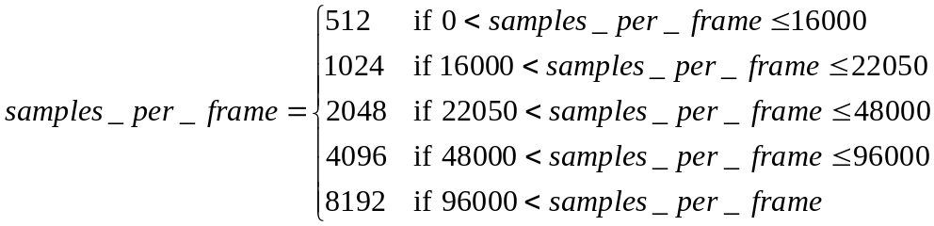

Equation 2
Then, samples_per_frame is modified based on encoder_options:
Equation 3
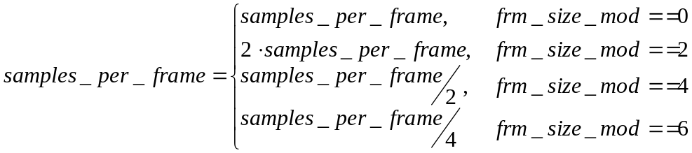
Equation 4

Sampling period is computed as:
Equation 5

Another quantity that depends on samples_per_frame is log2_samppfr, used in run-level decoding process:

.
Equation 6

Number of possible window sizes
The maximum number of possible window sizes for any channel are specified in encoder_options, as follows:
iMaxSubFrameDiv = 1 << ((encoder_options & D_ENCOPT3_SUBFRM_DIV) >> 3);
samples_per_smallest_window = samples_per_frame/iMaxSubFrameDiv;
cPossibleWinSize = LOG2(iMaxSubFrameDiv) + 1;
allow_subframes = (cPossibleWinSize > 1) ? 1 : 0;

Note: Since the smallest frame size is 128 (at sample rates 16000Hz and below), syntactically WMA Pro can have a smallest window of size of just 1 sample! Current encoder (WMA Professional in Series 9) uses a smallest window size of 128.

Bark-band boundaries
For a given sampling rate, the current window (subframe) size dictates the number of bark bands present for the channel. In WMA Pro, the following pseudo-code can be used to compute num_bark_bands, and the array bark_index. The array bark_freqs_v3 used in this process is given in Section 8.3.
WMA Pro uses the following pseudo-code segment (SetBarkIndex()).
// Get the number of barks and bark frequencies for each window size
for (iWin = 0; iWin < cPossibleWinSize; iWin++)
{
bark_index[iWin][0] = 0;
int curr_freq = 0;
int curr = 1;
int subframe_size_curr = samples_per_frame / (1 << iWin);
int iIndex;

while (1)
{
// integer operation
iIndex = ((bark_freqs_v3 [curr_freq ++]* samples_per_frame)/
samples_per_second + 2);
// Make a multiple of 4 through truncation
iIndex -= iIndex % 4;
if(iIndex > bark_index[iWin][curr - 1])
bark_index[iWin][curr++] = iIndex;
if(curr_freq >= 28 ||
bark_index[iWin][curr - 1] > subframe_size_curr)
{
bark_index[iWin][curr - 1] = subframe_size_curr;
num_bark_bands[iWin] = curr - 1;
break;
}
}
}

Bark Resampling Matrix
BarkResamplingMatrix is used by WMA Pro to resample quant_step_band (mask) values from one window size to another. Its entrees are integers, and are computed as follows.
// Get the number of barks and bark frequencies for each window size
int iWinOut, iWinIn, iBarkOut, iBarkIn;
int iFreqOut, iFreqIn;
for (iWinOut = 0; iWinOut < cPossibleWinSize; iWinOut++)
{
for (iBarkOut = 0; iBarkOut < num_bark_bands[iWinOut]; iBarkOut++)
{
// representative freq for iBarkOut in iWinOut
iFreqOut = (bark_index[iWinOut][iBarkOut] +
bark_index[iWinOut][iBarkOut+1] -1) *
(1<<iWinOut)/2;
for (iWinIn = 0; iWinIn < cPossibleWinSize; iWinIn++)
{
// Locate the first bark in iWinIn that contains
// iFreqOut.

iBarkIn = 0;
while ((iFreqIn = bark_index[iWinIn][iBarkIn+1] *
(1 << iWinIn)) < iFreqOut)
{
iBarkIn++;
}
bark_resample_matrix[iWinOut][iWinIn][iBarkIn] =
iBarkOut;
}
}
}

Subwoofer cutoff index
The current window (subframe) size dictates the number of surviving coefficients for the subwoofer channel. In WMA Pro, the following pseudo-code can be used to compute subwoofer_cutoff_index.
WMA Pro uses the following pseudo-code segment.
// Get the bandwidth for subwoofer channel for each window size
float subwoofer_cutoff_hz = 220.0;
float sampling_period = 1.0/samples_per_second;

for (iWin = 0; iWin < cPossibleWinSize; iWin++)
{
int samples_per_window = samples_per_frame/(1 << iWin);
int iIndex = (int) ceil((subwoofer_cutoff_hz * samples_per_window *
sampling_period) + 0.5);
subwoofer_cutoff_index[iWin] = min(max(4, iIndex),
samples_per_window/2);
}

Maximum Number of Subframes in a Frame
The maximum number of subframes for a channel in a frame can be obtained through the equation:
Equation 7

This parameter is mainly to determine the memory that would have to be reserved.

Unpack other encode options
Other parts of encoder_options are split into multiple Booleans:
fFrameSizeInHeader = encoder_options & D_ENCOPT3_WRITE_FRAMESIZE_IN_HDR
fGenerateDRCParams = encoder_options & D_ENCOPT3_GENERATE_DRC_PARAMS

Initializing other parameters
Other parameters are initialized as shown here. The same is done whenever a bitstream error is encountered. subframe_config[iCh].subframe_size[-1] is a holder for size of last subframe of channel iCh in previous frame.
new_packet_header = 0;
postproc_transform = 0;
lossless_mode = 0;
for (iCh = 0; iCh < num_channels; iCh++)
{
subframe_size_prev[iCh] = samples_per_frame;
subframe_size_curr[iCh] = samples_per_frame;
subframe_config[iCh].num_subframes = 1;
subframe_config[iCh].subframe_start[0] = 0;
subframe_config[iCh].subframe_size[0] =
samples_per_frame;
subframe_config[iCh].subframe_size[-1] =
samples_per_frame;
curr_coef_position[iCh] = 0;
}
This is followed by seek to next seekable packet, and a seek to first frame in seekable packet, as described in Section 4.

Packet Layer Decoding
The packet size is fixed for a given WMA bitstream, and is known ahead of time, outside of the WMA bitstream. A packet can contain multiple compressed frames. Similarly, the last frame in a packet can straddle across multiple packets. If it does, that last frame can be completly decoded only after decoding portion of the next packet(s).

Conceptually, a packet layer decoder removes a packet header, and transfers the payload (remainder of a packet) to the frame layer decoder. In real implementations, this decoder detects lost/out of sequence packets and enables random seeks into a bitstream. They can use the parameter value seek_offset_in_bits to seek to the beginning of a new frame in any packet, whenever that packet is seekable. The packet is seekable if seekable_frame_in_packet is true.

The seek_offset_in_bits is the offset from the bit position AFTER decoding seek_offset_in_bits.

If the packet is seekable, the bit position “seek_offset_in_bits + log2_bits_per_packet+7” from the beginning of the packet must be inside the packet. Otherwise, the packet is considered to have been corrupted. The compressed bits starting at position “seek_offset_in_bits + log2_bits_per_packet+7” in the packet represent a frame that can be randomly decoded.

If spliced_packet is true, it indicates a discontinuity in the bitstream, this packet should be considered as the first packet, and the decoder must be reset, as described in Section 3.11. This bit is normally 0, and is made 1 only by bitstream editors to indicate bitstream splicing.

A packet layer decoder notifies the frame layer decoder whenever a new packet is received through new_packet_header signal.

Frame Layer Decoding
Frame layer decoding consists of decoding frame header and decoding frame data.

Frame Header Decoding
At the beginning of each frame header decoding, the following initialization is executed:
int iCh;
// Some initialization
for (iCh = 0; iCh < num_channels; iCh++)
{
// Remember last subframe sizes from previous frame
int prev_num_subframes = subframe_config[iCh].num_subframes;
int prev_size =
subframe_config[iCh].subframe_size[prev_num_subframes-1];
subframe_config[iCh].subframe_size[-1] = prev_size;
subframe_config[iCh].num_subframes = 0;
subframe_config[iCh].subframe_start[0] = 0;
subframe_config[iCh].curr_subframe = 0;
curr_coef_position[iCh] = 0;
anchor_quant_step_band_available[iCh] = false;
}

If fFrameSizeInHeader is true (Section 3.11), the frame header contains the size of compressed frame in bits. The compressed_frame_size_bits indicates the size of the compressed frame (in bits) including this field. That is, the size of compressed frame includes the size field itself. In some circumstances, the compressed frame could be larger than a WMA Pro packet. In those cases, compressed_frame_size_bits would have a value of bits_per_packet. This specific value of compressed_frame_size_bits should be understood as “un-known” or “un-reliable” compressed frame size information in the bitstream for the current frame.

If fGenerateDRCParams is true (Section 3.11), the frame header contains the dynamic range control scale factor for this frame.

The post processing transform is used to blend decoded channels to either create special effects or to create phantom channels at the decoder. The post processing transform is described in Section 7.6.

The silence information is used to clip the decoded output so that the length (number of samples) of decoded waveform matches exactly what the original source waveform had (Section 7.7). In general, this information is present only at the beginning and at the end of a WMA Pro stream. However, a WMA Pro decoder should be able to deal with the presence of this information in the middle of a stream.

The largest possible block of decoded data is “Frame” of size samples_per_frame, as mentioned in Section 3.5. This is the maximum size of overlapping windows. WMA Pro allows smaller overlapping windows to be used to reduce pre-echo artifacts. The exact size of these overlapping windows (i.e. tile configuration) is conveyed for each frame through the tile configuration in frame header, as described next.

Tile Configuration in WMA Pro
In a traditional audio codec, such as WMA Standard, the input audio signal is broken into overlapping windows for frequency transformation. Larger windows are needed to get frequency resolution and better redundancy removal (i.e. better compressed size), while smaller windows are needed to get better time resolution. Better time resolution is needed to control audible pre-echo artifacts gets introduced when the signal transitions from low energy to high. However, using such smaller windows reduces compressibility, and a trade-off has to be made by the encoder to balance compression factor and the audible artifacts. In these codecs, a frame of audio is divided into one or more such overlapping windows.

For a given input signal shown in Figure 6, a WMA Pro encoder detects a signal transition in channel 0. To reduce pre-echo, it divides a frame into smaller windows. These windows are termed “subframes”. The window configuration is shown in Figure 7.
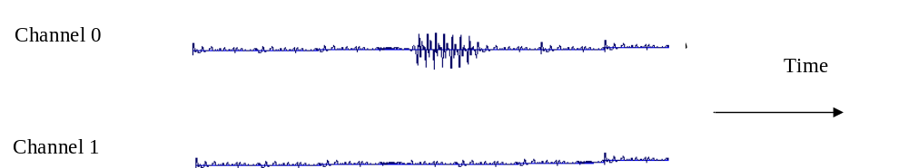
Figure 6 Input Audio (Stereo) Signals

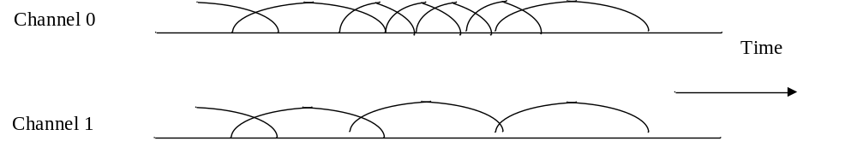
Figure 7 Window Configurations in WMA Pro (Stereo)
To simplify the description in this document, we denote the overlapped window configuration in boxes, as shown in Figure 8. In this figure, the dotted lines delimit a particular frame.

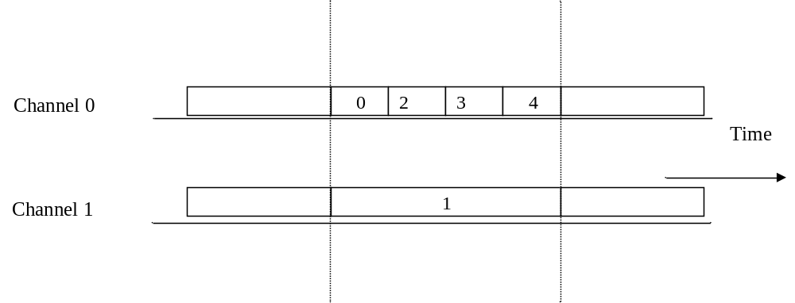
Figure 8 Example of Tile Configuration of a frame in WMA Pro (for 2 channels)

The bitstream syntax of WMA Professional lets windows (i.e. subframes) of each channel to have a configuration independent of other channels. Windows that have identical start and stop times are considered to be part of a “Tile”. Example tile configuration for six channel source is shown in Figure 9. As shown here, a tile can have one or more channels as members. These tile members need not be contiguous.
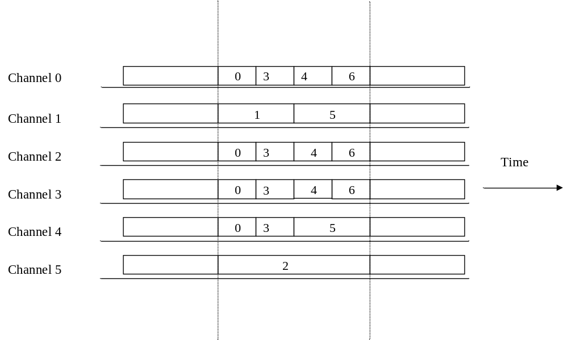
Figure 9 Example of Tile Configuration in WMA Pro (for 6 channels)
In Figure 9, we have six tiles. Tile 0 has samples from channels 0, 2, 3, and 4, and spans first quarter of a frame. Tile 1 has samples from channel 1 and spans first half of the frame. Tile 2 has samples from channel 5, but spans entire frame. Channel 4 starts off having a window configuration similar to channels 0, 2, and 3, but has a different window configuration starting from middle of the frame. WMA Pro syntax allows such flexible windowing.

Decoding Tile Configuration
The description of each tile includes:
- window start position.
- window size
- channels present in the tile. The channel membership is described through a channel mask.

The overall general process of describing all tiles is as follows:
- Mark all samples unvisited.
- Scan the samples in the frame (over time).
- At this given sample, scan the channels not visited at this sample position.
- Club into a tile all window configurations that start at current sample and have same end position. Describe this tile by (a) size of the tile and (b) indicating which channels are parts of this tile. Mark all samples in the tile as visited.
- Continue with step 3 until all channels are visited at this sample position.
- Continue with step 2 until all samples in the frame are visited.

Tile Start Position
In the process given in Table 8, the decoder searches for the tile start position (computeTileStartPosition()). This is done through:
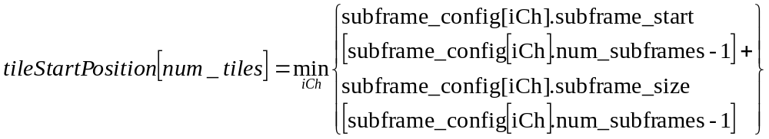
Equation 8
This gives the first sample in the frame that has not yet been covered by existing tiles.

Determine Set of Possible Tile Channels
Here, the decoder identifies all channels that can be member of this current tile. This is the set of channels that need subframe description from “tileStartPosition”.
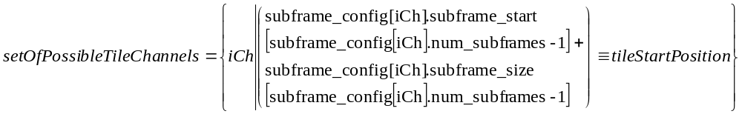
Equation 9
The number of members (i.e. cardinality of the set) in setOfPossibleTileChannels is numOfPossibleTileChannels.

Skip Channel Mask and Skip Size Information
In describing the tile configuration, the following special cases are considered:
- If all the tiles are aligned (i.e. all channels have identical subframe configuration), then the channel mask is skipped. In this case, all channels in setOfPossibleTileChannels are in setOfTileChannels.
- If only one tile is left (i.e. its window size is minimum window size allowed) to be described, then the channel mask as well as the size information is skipped. In this case, all channels in setOfPossibleTileChannels are in setOfTileChannels. The size of tile is samples_per_smallest_window computed in Section 3.6.
- If subframe configuration of only one channel needs to be described, then the channel mask is skipped. In this case, all channels in setOfPossibleTileChannels are in setOfTileChannels.

Decoding the set of tile channels
The decodeSetOfTileChannels() is done by decoding numOfPossibleTileChannel number of bits, i.e. one bit per possible channel, in ascending order of all possible tile channels. If bit is 0, corresponding “possible tile channel” is not a member of “tile channel”, and if the bit is 1, the corresponding “possible tile channel” is a member of “tile channel”. This process generates setOfTileChannels and numOfTileChannels.

Note: Every tile should have at least one channel in it. That is, the numOfTileChannels should be strictly greater than 0. The maximum value the numOfTileChannels can take is num_channels.

Example of decoding setOfTileChannels

Channel 0

0

3

Channel 1

1

Channel 2
0

3

Channel 3

0

3

Channel 4

0

3

Channel 5

2

tileStartPosition[4]
Frame boundaries
Figure 10 Example of a Partially Decoded Tile Configuration (After Decoding Four Tile Descriptions)
As an example, at a certain stage of decoding tile configuration, let the partial configuration that has already been decoded be as shown in Figure 10. In this figure, the start position for the fifth tile (i.e. tile numbered 4) is also noted. Since channels 0, 1, 2, 3, and 4 have the currently described tile endings match the tileStartPosition[4], these channels are in set of possible tile channels for the tile being described:
Equation 10
Since the number of members in setOfPossibleTileChannels[4] is 5,
Equation 11
Then, to decode set of tile channels, 5 bits are read, say “1 0 1 1 0”. First bit has a value of 1, indicating that the first member of setOfPossibleTileChannels[4], channel 0, is a tile channel, i.e. is in setOfTileChannels. The second bit is 0, and it indicates that the second member of setOfPossibleTileChannels[4], channel 1, is not a tile channel, i.e. is not in setOfTileChannels. Using this logic, based on these 5-bits read, we have:
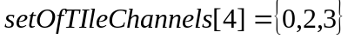
Equation 12
This is a partial description of configuration of tile 4. Its description would be complete, once its size has been determined.

Determine Bits for Tile Size Description
The function determineTileSizeBits() computes cBitSize0, cBitSize1, and cBitSize, as given below. Note that these values are fixed for the entire bitstream, and could be computed during initialization.
if (iMaxSubFrameDiv == 4)
{
cBitSize0 = 1; cBitSize1 = 1;
}
else if (iMaxSubFrameDiv == 16)
{
cBitSize0 = 1; cBitSize1 = 2;
}
else
{
cBitSize0 = 0;
cBitSize1 = LOG2(cPossibleWinSize – 1) + 1;
}
cBitSize = cBitSize0 + cBitSize1;

Update Subframe Configuration of Tile Channels
The function updateSubframeConfigOfChannels() updates the subframe configuration for channels that are members of the current tile. The tile_size and setOfTileChannels was decoded as described earlier.
int iCh;
for (iCh = 0;
iCh < num_channels; iCh++)
{
if (iCh in setOfTileChannels[iTile])
{
int num_subframes = subframe_config[iCh].num_subframes;
subframe_config[iCh].subframe_size[num_subframes] = tile_size;
// start for next subframe
subframe_config[iCh].subframe_start[num_subframes+1] = subframe_config[iCh].subframe_start[num_subframes] +
tile_size;
subframe_config[iCh].num_subframes += 1;
}
}

Decoding Post Processing Transform
If a post processing multi-channel transform is to be performed on the current frame, postproc_transform is 1. Otherwise, it is zero. The post-processing transform can either be a general transform, or a pre-defined transformation, and is indicated through general_postproc_transform. The only pre-defined transformation is when channel_mask is 63 and num_channels is 6, indicating a 5.1 channel configuration. For this configuration, if general_postproc_transform is 0,
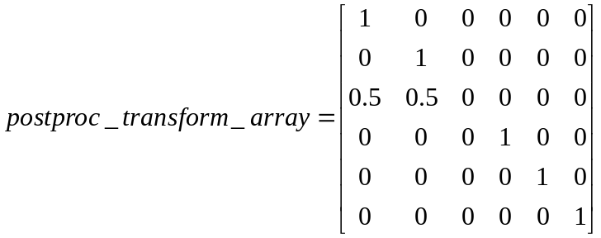.
Equation 13

Decoding Silence Information
The syntax given in Table 11 is very self explanatory. The fields decoded here are used in the process described in Section 7.7.

Tile Layer Decoding

Initialization
While decoding tile numbered iTile, the tile start position (tileStartPosition[iTile]), tile window size (tile_size[iTile]), and the member channels in the current tile (setOfTileChannels[iTile]) are already known from the decoded tile configuration. Based on samples_per_frame and tile_size[iTile], 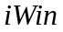the window size is computed:
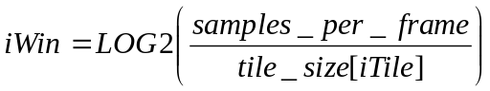
Equation 14
Based on this, the number of Bark bands (num_bark_bands[iWin]) and the Bark boundaries (bark_index[iWin]) for this window size is known. In addition, the cut-off index for subwoofer (subwoofer_cutoff_index[iWin]) is also known for this window size.

For each channel iCh in the tile, the size of preceding window (subframe_size_prev[iCh]), the size of current window (subframe_size_curr[iCh] = tile_size[iTile]), and the size of next window (subframe_size_next[iCh]).

int iCh;
for (iCh = 0; iCh < num_channels; iCh++)
{
if (iCh in setOfTileChannels[iTile])
{
int curr_subframe = subframe_config[iCh].curr_subframe;
subframe_size_prev[iCh] =
subframe_config[iCh].subframe_size[curr_subframe -1];
subframe_size_curr[iCh] =
subframe_config[iCh].subframe_size[curr_subframe];
subframe_size_next[iCh] =
subframe_config[iCh].subframe_size[curr_subframe +1];
}
}
Note: At the beginning of bitstream decoding (first packet after a packet reset), subframe_size_prev[iCh] might not be known. It should be assumed to equal the largest possible window size, samples_per_frame.

Note: At the end of a frame, subframe_size_next[iCh] would not be known until the next frame header is decoded. If there is no next frame (due to packet loss or end of stream), it should be assumed to equal the largest possible window size, samples_per_frame.

For each channel, if anchor quant_step_band value is available, the anchor quant_step_band is resampled to generate quant_step_band_prediction. The resampling is from quantized quant_step_band to quantized quant_step_band. In addition, quant_step_band_updated field is reset for each channel, and maximum quant_step_band value is noted.

int iCh, iBand, iBandIn;
for (iCh = 0; iCh < num_channels; iCh++)
{
quant_step_band_updated[iCh] = false;
max_quant_step_band[iCh] = 0;
if (iCh in setOfTileChannels[iTile] &&
anchor_quant_step_band_available[iCh])
{
int iWinIn = win_with_quant_step_band_update[iCh];
for (iBand = 0; iBand < num_bark_bands[iWin]; iBand++)
{
iBandIn = bark_resample_matrix[iWin][iWinIn][iBand];
quant_step_band_prediction[iCh][iBand] =
anchor_quant_step_band[iCh][iBandIn];
max_quant_step_band[iCh] = max(max_quant_step_band[iCh],
quant_step_band_prediction[iCh][iBand]);
}
}
}

For each channel, if anchor quant_step_band is not available, quant_step_band_multiplier[iCh] is initialized to 1.
int iCh;
for (iCh = 0; iCh < num_channels; iCh++)
{
if (iCh in setOfTileChannels[iTile] &&
!anchor_quant_step_band_available[iCh])
{
quant_step_band_multiplier[iCh] = 1;
}
}

Decoding Tile Header (Lossy Coding)

Reserved Data
In the current specification of WMA Professional, the reserved bits are used to store the LBR syntax.

Overview of Multi-Channel Transform
WMA Pro uses linear transformation across multiple channels of a tile. At each tile, overall Multi-Channel transformation is performed in two cascaded stages. In each stage, subsets of setOfTileChannels are transformed together. These subsets are called Channel Groups. This is shown in Figure 11. As an example, tile 3 in Figure 9 has four channels in it (0, 2, 3, and 4). It is possible that channels 0, 2, and 4 are in one channel group, and channel 3 can be a group in itself.

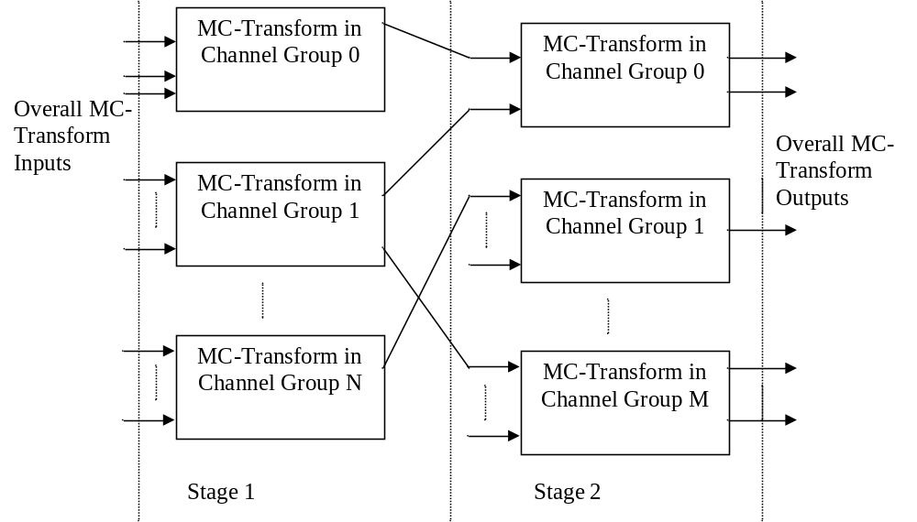
Figure 11 Overall Hierarchical MC-Transform in WMA Pro Decoder
At each stage of hierarchy, a channel in a given tile can be a member of one and only one channel group. The number of channel groups and sizes of channel groups at each stage can be different. As in the tile description, the channels in a channel group need not be contiguous.

Stage 2 is mandatory for all channels: every channel in the tile must be in a stage 2 channel group. However, not every channel needs to go through stage 1. For channels that are not represented in stage 1 description, they are assumed to undergo an identity transformation at that stage.

In each little linear transform block in Figure 11, the transformation can be turned on and off on a Bark band basis. When the multi-channel transform is turned off for a particular band, the decoder uses identity transform for that frequency band (i.e. passes through input data without altering).

The transform for each little transform block in Figure 11 could be described in two ways:
  - Pre-defined transformations,
  - Use of quantized Given’s rotation parameters.

These approaches are described next.

Pre-defined Multi-Channel Transforms
A WMA Pro decoder has the following multi-channel transforms pre-defined:
- Identity:
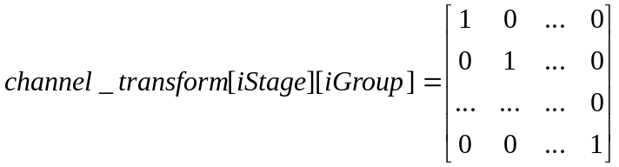
Equation 15
- Hadamard transform for channel group of size 2:
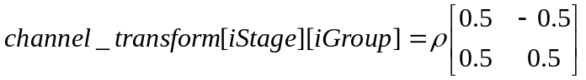,
Equation 16
where 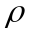is a normalizing scalar 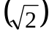.
- DCT Type II transformation for any sized channel group:
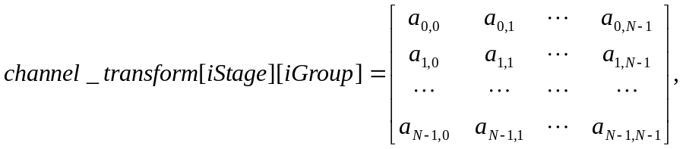
Equation 17
where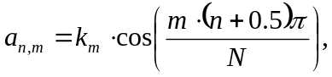and
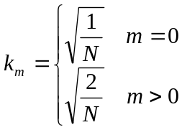

General Multi-Channel Transforms
Any unitary (linear) transformation can be represented using Givens factorizing rotations. Using this factorization, any unitary transform can be represented as:
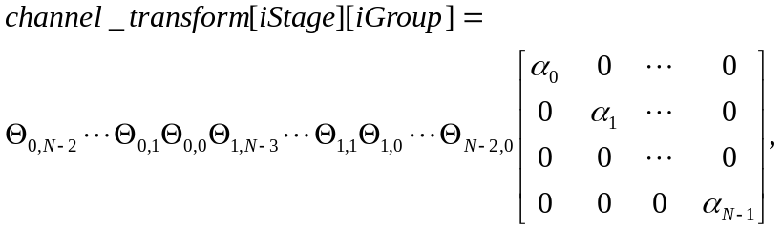
Equation 18 Givens Factorization of a Unitary Transform

where 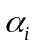is +1 or -1 (sign of rotation), and each is of the form:
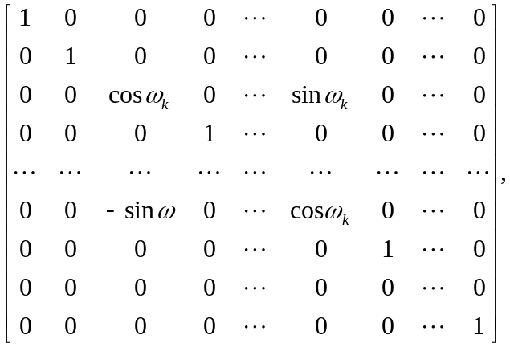
Equation 19
which is almost like an identity matrix with four sin/cosine terms, with varying positions (the two cosine terms are always on the diagonal, the two sin terms are in same row/column as the cosine terms). Each has one rotation angle, and its value can have a range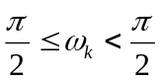. The number of such rotation matricesneeded to completely describe the unitary matrix of size is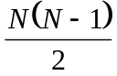. In WMA Pro, each rotation angle is uniformly quantized to 64 possible values. The rotation signs are indicated with one bit each. Thus, WMA Pro requires a total of 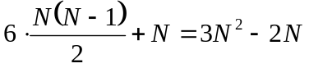bits to represent the MC-Transform of with a very high degree of precision.

The easiest way to understand the sequence of factors is to note that the upper triangle in a square matrix of size N has Nx(N-1)/2 “slots” (Figure 12).

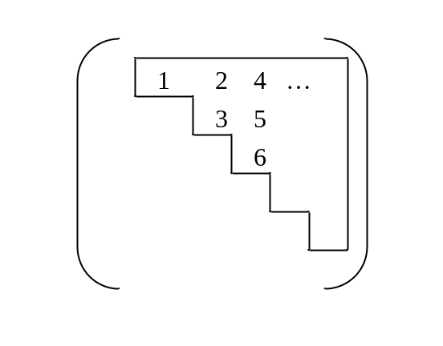
Figure 12 Upper triangle of a Squared Matrix
Correspondingly, there are Nx(N-1)/2 rotations. The upper triangle is iterated in rows-first manner, as indicated in Figure 12. In WMA Pro, the sine of rotation angle is iterated in this sequence.
Note: The sin, cosine values are “integerized” in the reference implementation. In the reference implementation, all of the above matrix arithmetic is performed in integers.

Examples of rotation factors
Examples of are given below:
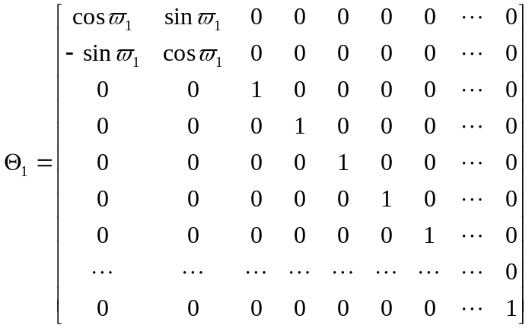
Equation 20 Example factor

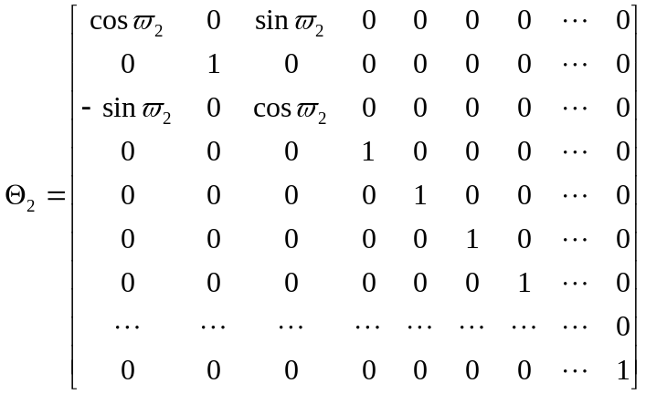
Equation 21 Example factor
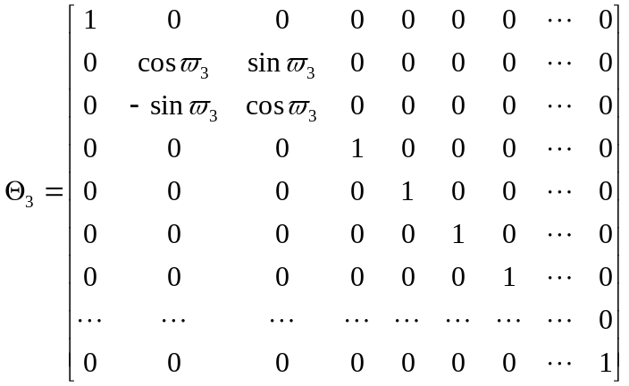
Equation 22 Example factor

Decoding Multi-Channel Transforms
At each stage of the multi-channel transform information for a tile includes:
- the number of channel groups, and (channel) members of each channel group,
- for each channel group, the linear transformation to use,
- transform on-off information at each Bark band for each channel group.

Initialization
The following initialization is performed prior to decoding multi-channel transform information. The “setOfPossibleGroupChannels” is initially the entire tile.

for (iStage = 0; iStage < 2; iStage++)
{
iGroup = 0;
num_groups[iStage] = 0;
setOfPossibleGroupChannels[iStage][iGroup] =
setOfTileChannels[iTile];
numOfPossibleGroupChannels[iStage][iGroup] =
numOfTileChannels[iTile];
transform_type[iStage][iGroup] = ‘identity’;
}
If the bit field fDecodingSuperGroupXform is ‘1’, it indicates there is information for stage 0. Other wise, the decoding shifts to stage 1.

Set of “Group Channels”
Similar to identifying channels in a tile, the set of channels in a channel group is indicated through a bit string. The bit string has a length “numOfPossibleGroupChannels[iStage][iGroup]”, with one bit per possible channel, in ascending order of all possible group channels. If bit is 0, corresponding “possible group channel” is not a member of “channel group”, and if the bit is 1, the corresponding “possible group channel” is a member of “channel group”. This process generates setOfGroupChannels and numOfGroupChannels. As a special case, when the numOfPossibleGroupChannels is less than or equal to 2, as indicated in Table 16, this process is skipped.

Group Transform
Depending on the type of transform indicated for the group, the following process is used to compute the multi-channel transform for the group. The resulting channel transform is always a squared array of size numOfGroupChannels x numOfGroupChannels.
If transform_type[iStage][iGroup] is ‘identity’, the channel_transform is simply identity, as given in Equation 15.
Equation 23
If transform_type[iStage][iGroup] is ‘hadamard’, the channel_transform is as given in Equation 16.
If transform_type[iStage][iGroup] is ‘dcttype2’, if numOfGroupChannels[iStage][iGroup] is up to 6, the values given in Table 105 are used. If numOfGroupChannels[iStage][iGroup] is more than 6, the channel_transform as given in Equation 17 is used.
If transform_type[iStage][iGroup] is ‘general’, Given’s rotation factors are used to compute the channel_transform, as given in Equation 18. An example of sequence of multiplication is given next.

Applying the Givens Rotation Factors
The sequence of rotation angles is as shown in Figure 12. Here we give an example case when numOfGroupChannels is 4. For this size, the number of angles is 6 and the number of signs is 4. For simplicity, we represent rotation_angles[iStage][iGroup][iAngle] for iAngle=0..5 with 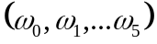, and rotation_sign[iStage][iGroup][iSign] for iSign=0..3 with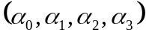. Also for simplicity, 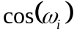 is abbreviated as , and 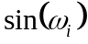 is abbreviated as .
Then, the channel_transform is given by:
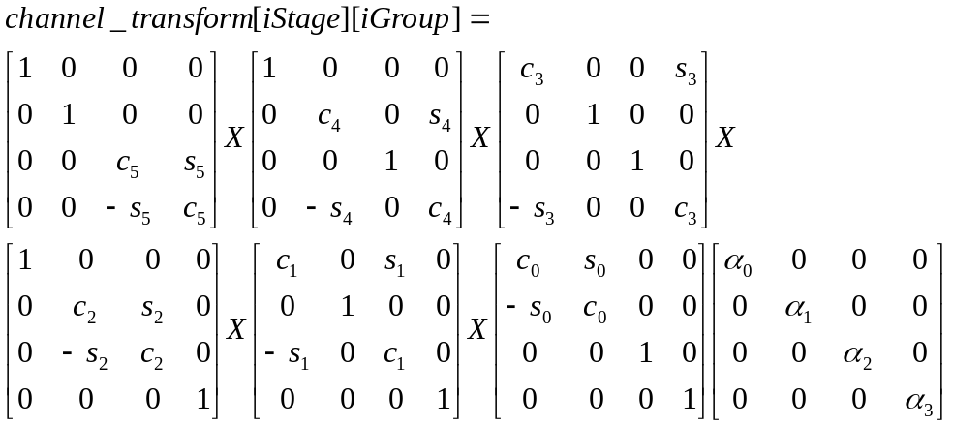
Equation 24
Note: The sin, cosine values are “integerized” in the reference implementation. In the reference implementation, all of the above matrix arithmetic is performed in integers.

All the computation in determining the channel transform from the rotation angles is integerized in the reference implementation. This is done by pre-computing sin, and cos for all 64 angles, and storing the result in a 32-bit integer table with 30-bits of precision using , and . Then, all the multiplication is done by multiplying two integers and keeping the top 30 bits of precision as 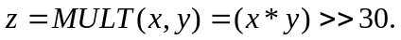 Of course, now the multiplication of x and y is done with 64-bit integers, or equivalently in some assembly code. Finally, the transform is converted back to floating point by converting to float and removing the scale by dividing by 2³⁰.

Vector Information

The value of size_num_vecs is computed through:
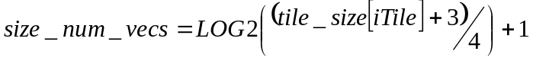
Equation 25

Quantizer Step Sizes
WMA Pro has three kinds of quantizer step sizes:
- One that captures overall step size for the tile, quant_step_tile,
- One that captures the differential step size for each channel in the tile, quant_step_channel[iChannel], and
- One that captures the differential step sizes for each Bark band of each channel in the tile, quant_step_band[iChannel][iBand].

Tile Quantization Step Size
The tile quantization step size is initialized to an “expected value”. Note that the initialized value depends on the bit depth of the coded mode, the valid bits per sample. Then, differential from this expected value is extracted from the bitstream, as described in Table 18.
Note: Decoded quant_step_tile should always be a positive value.

Channel Quantization Step Sizes
The channel quantization step sizes are initialized to 0.
Note: All decoded quant_step_channel values should be greater than or equal to zero.

Band Quantization Step Sizes (Mask)
Two processes of describing the quant_step_band are available in WMA Pro. One is to use ‘intra-subframe’ coding through DPCM across Bark bands, and the other is to use ‘inter-subframe’ coding using predicted values. The particular method to be used is decided based on whether anchor values of quant_step_band are available or not.

If quant_step_band_prediction[iCh] (i.e. anchor) is not available, ‘intra-subframe’ method is used. This method uses simple variable-length (Huffman) coding on the spatial prediction residual. The prediction is preceding band step size. The Huffman table to be used in decode_quant_step_band_vlc() is given in Table 106.

If anchor is available, the prediction residual is decoded through sign-run-level decoding, and the residual is added to the temporal prediction to form the final quant_step_band. In this coding, the differentials of quant_step_band are represented by a single triplet: (Run, Sign, |Level|). This triplet has the meaning of having Run number of differentials with value zero followed by a differential of value Sign * |Level|. At the encoder, the triplet (Run, Sign, |Level|) is decomposed into two pieces: Sign, and a 2-D symbol (Run, |Level|). In the bitstream, the Sign is indicated by one bit: a value of 1 indicates a positive differential Level, and a negative differential Level otherwise. To further enhance the compression factors, the 2-D symbol (Run, |Level|) is encoded using Huffman coding, a variable length coding scheme. The particular table used is given in Table 107.

Decoding Tile Data (Lossy Coding)
In WMA Pro, the quantized spectral coefficients are coded using a combination of vector and sign-run-level coding. The initial portion of the spectrum is coded using vectors, where as the remainder is coded using sign-run-level coding. The transition from the vector coding to the sign-run-level coding is done through either:
- Automatic manner, where the decoder determines the transition based on the decoded vectors (when explicit_num_vecs_available is 0), or
- Explicit manner, when the bitstream contains the num_vecs[iCh] information, when explicit_num_vecs_available is 1.

Complete process for vector decoding is given next.

Vector Decoding of Spectral Coefficients
In vector encoding of spectral coefficients, the levels are directly encoded using 4-dimensional vectors using the following.

- If the sum of the levels of the components of the vectors is below a certain threshold, the vector is encoded using a Huffman codebook, else an escape code is sent, and the vector is encoded as two 2-dimensional vectors.
- For each 2-dimensional vector, if the sum of the levels of the components is below a certain threshold, the vector is encoded using a Huffman codebook, else an escape code is sent, and the vector is encoded as two scalar values.
- For each scalar value, if the level is below a certain threshold, the scalar is encoded using a Huffman codebook, else an escape code is sent, and the vector is escape encoded.

The vector to symbol conversions use the following equations. For a 4-dimensional vector, assume the vector us 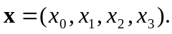 Then, the symbol to be encoded for the 4-dimensional vector is s, where
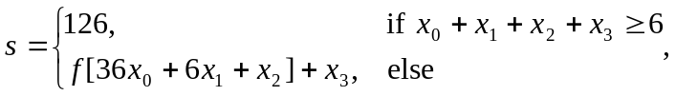
Equation 26
and where 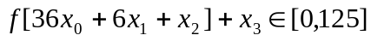, when 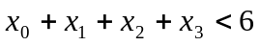, since there are 126 such vectors such that the sum of their components is less than 6. The f is a fixed array which is used in this conversion and is of size 181. The maximum index into table f is 180 and occurs when x₀ = 5, since 36*5 = 180. The s is the symbol coded using a Huffman code, and if s=126, then the 4-dimensional vector is split into two 2-dimensional vectors, and each is then encoded.

For coding of the two dimensional vectors, we create vector to symbol conversions for 2-dimensional vectors, 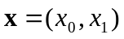, using
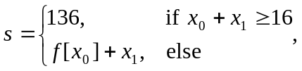
Equation 27
where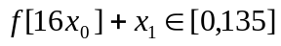, when 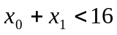, since there are 136 such vectors that the sum of their components is less than 16. Again, f is a fixed array of size 16, since the maximum argument into the array occurs when x₀ = 15. The symbol s is then encoded using a Huffman table. If the symbol s is equal to 136, then the two dimensional vector is split into scalars (1-dimensional vectors), and each is encoded separately.

For coding of scalars, x₀, the symbol is simply found using
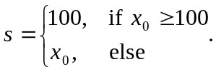
Equation 28
The symbol s is again encoded, and if the scalar is greater than or equal to 100, then a table-less method is used to encode the value. This table-less encoding is done via the following pseudo code, where the value encoded is the x₀-100, since we know that x₀ is larger than 100.
If (value < 2⁸) {
Send “0” and value using 8 bits;
} else if (value < 2¹⁶) {
Send “10” and value using 16 bits
} else if (value < 2²⁴) {
Send “110” and value using 24 bits;
} else if (value < 2³¹) {
Send “111” and value using 31 bits;
}

Therefore, the decoding of vector Huffman is as follows:

- Get an symbol from the bitstream using the Huffman codebook for 4-dimensional vectors. If the symbol is less than 126 (the escape symbol for 4-dimensional vectors = ESCAPE_CODE_VEC4), then decode the vector using a table as (x₀, x₁, x₂, x₃) = vec4_symbol_to_level[symbol]. Since, the values of x_{i} are guaranteed to be less than 6, we can store them each using 4-bits. If the value of the symbol is equal to 126, then we decode two 2-dimensional vectors.
- To decode 2-dimensional vectors, get a symbol from the bitstream using the Huffman codebook for 2-d vectors. If the symbol is less than 136 (ESCAPE_CODE_VEC2), then decode the vector using a table as (x₀, x₁) = vec2_symbol_to_level[symbol]. Since the values are less than 16, we can again store them in 4-bits in a single table. If the value of the symbol is equal to 136, then decode the 2 scalar components.
- To decode a scalar, get a symbol from the bitstream using a codebook for the scalars. If the symbol is less than 100, then the scalar value is the symbol x₀ = symbol, else decode using the escape decoding in Table 29. However, now since we know that the symbol is greater than or 100, we add 100 to the value returned by the escape decoding.

Sign-Run-Level Decoding of Spectral Coefficients
The sign-run-level decoding of spectral coefficients is similar to the decoding of quant_step_band differentials when anchor is present.
In this coding, a number of quantized spectral coefficients are represented jointly by a single triplet: (Run, Sign, |Level|). This triplet has the meaning of having Run number of quantized spectral coefficients with value zero followed by a quantized spectral coefficient of value Sign * |Level|.
At the encoder, the triplet (Run, Sign, |Level|) is decomposed into two pieces: Sign, and a 2-D symbol (Run, |Level|). In the bitstream, the Sign is indicated by one bit: a value of 1 indicates a positive Level, and a negative Level otherwise. To further enhance the compression factors, the 2-D symbol (Run, |Level|) is encoded using Huffman coding, a variable length coding scheme.
There are two possible Huffman tables for each coded channel. The exact table to be used is indicated through “coef_rlc_table_number” in Table 26. If coef_rlc_table_number is 0, the sign-run-level Table 108 is used. Otherwise, the Table 109 is used.

Decoding Tile Header (Mixed Lossless Coding)

Different Types of Tiles
WMA Pro supports unified lossy and nearly lossless audio compression which permits the encoder to seamlessly switch between lossy and nearly lossless codecs when encoding one single WAV file. The unified approach in WMA Pro is used in order to solve the problem that one isolated tile is not efficiently compressed by lossy codec. That tile is compressed by a nearly lossless codec which is called mixed lossless codec in WMA Pro. The mixed lossless codec uses LPC to compress the audio nearly losslessly and the corresponding tile is called the mixed lossless tile.
In tile header, we have bits to indicate the type of the present tile. The first bit is lossless_tile which tells whether the current tile is a lossless tile. Then, there is one bit for pure_lossless_tile to represent the pure lossless tile. If it is 0, the current tile is a mixed lossless tile. Otherwise, a pure lossless tile is being decoded. Different types of tiles have different decoding and reconstruction procedures which will be described later in Section 7.5. Pure lossless tile in WMA Pro is a reserved feature which is out of the scope of this document.

Raw PCM Tiles
The mixed lossless tile could be a raw PCM tile if the mixed lossless codec fails to compress the audio efficiently. The mixed lossless audio codec usually can compress the audio to half of its original size. But in some special tiles which are very noisy or artificially designed the codec may generate more bits than original PCM bits. When such a case happens, the encoder chooses to send uncompressed raw data to the bitstream.

RTM bitstream and BETA bitstream
The lossless tile takes advantage of the bV3RTM bit from encoder_options to add more features in RTM bitstream and be compatible with BETA bitstream at the same time. In the BETA bitstream, an AC filter is used as core algorithm for the mixed lossless codec. The AC filter is a one order LPC filter to remove the DC component of the audio. In the RTM bitstream, a more generalized LPC filter is used. The LPC filters in different channels in one tile could be different but they share some common parameters such as order (lpc_order), precision (lpc_scaling), and range (lpc_intbits). Those parameters are decoded in tile header.

Decoding Tile Data (Mixed lossless Coding)

Decode Raw Data in Raw PCM Tile
If the tile header indicates the present tile is a raw PCM tile, the tile data are raw data instead of compressed bits. The decoding process is much easier. For each channel in the current tile, there are samples_per_frame coefficients sent. Each coefficient uses validBitsPerSample bits. After decoding those coefficients from bitstream they are multiplied by 2 to match the process in encoder side.
The coefficients decoded here are mixed lossless channel coefficients. The definition and more details of the mixed lossless channel coefficients can be found in Section 7.5. Basically, the mixed lossless channel coefficients are windowed PCM samples going through some simple mapping process.

Decode LPC Filter Coefficients
In RTM bitstream, an optional LPC filter is the first stage of the compression. Each channel has its own LPC filter and the filter’s coefficients are sent in tile data. Each coefficient uses lpc_intbits + lpc_scaling bits and they are signed integer.

Decode Coefficient Residues (Golomb Code)
At first, idiv_width is decoded. idiv_width is the divisor (in power of 2) of the Golomb code. Next, if the current tile is a seekable tile, the first residue is decoded separately. In that case, the first residue is sent by encoder directly using validBitsPerSample+1 bits. The rest residues are decoded as Golomb codes. A Golomb code is generated by dividing a residue with a divisor (2^ idiv_width). It has two parts. The first part is quotient (iQuo) and the second part is remaining (iRem). The first part is represented by iQuo ‘0’s followed by one ‘1’ and the second part is just iRem’s binary representation in idiv_width bits. After decoder gets iQuo and iRem, the residue is restored as:

Decoding LBR Data
Base and basepeak operations are similar to base decoding. Both of these are used to directly code the spectral coefficients in the MLT domain.

Coding domain frequency extension consists of dividing the MLT domain spectrum into bands. Each band is represented by its scale factor which represents the energy in the band and shape data which consists of a motion vector from the baseband or a noise codebook, and possibly other data such as an exponent, reverse, and sign. The exponent, reverse, and sign are used to modify the shape vector. Once the codevector is modified, the power of the vector is normalized so that it represents that sent in the bitstream. The modified and scaled vector is then used to represent the band. Sometimes a single band in coding domain fex can be represented using two scale factors and potentially two shape parameters where one can be used to represent the peaks, and the other to represent the noise floor.

Once the MLT coding domain processing is done, the decoder reconstructs the signal to get back the PCM samples. Further LBR processing -- if it is to be done -- happens by taking the PCM samples and applying a forward transform with a smaller window size to go back into the MLT frequency domain. However, the MLT domain has a smaller transform size than that used to code the base. This is done so that there can be finer temporal control of the parameters used for further LBR processing. Further LBR processing in the so called “recon domain” is the recon domain frequency extension and the channel extension processing.

Recon domain frequency extension is similar to coding domain frequency extension in that each band is represented by a gain factor and data used to represent a shape parameter. The recon domain processing can be in place of coding domain frequency extension (only applied to places where there is no coding domain frequency extension) or it can be used to add frequencies in places where coding domain is already being done. Recon domain fex also includes a technique to simply scale the already coded data (without a shape parameter) called base scaling which simply corrects each band to have the correct energy.

Frequency extension parameters are used to control band configuration (starting position, ending position, number of bands, band configuration), shape codebooks (whether sign, reversal, exponent parameters are being sent), fex usage (time/frequency locations where recon domain is being used, where coding domain is used, where both are used, or neither are used). In recon domain fex, not all tiles in the smaller window size MLT domain have scale and shape parameters sent. Scale parameters are sent at anchor tiles and interpolated in between the anchor tiles. Typically the same shape parameters are used for many tiles.

The other portion of processing in recon domain is channel extension. Channel extension consists of dividing the frequency spectrum into bands and sending parameters which can be used by the decoder to obtain a complex normalized correlation matrix for each of the bands. These parameters are sent only at the anchor points and interpolated in between. Using these parameters, the decoder comes up with a channel transform matrix which can be used to correctly recreate the channel correlation characteristics even when the encoder zeros out the difference channel when encoding the base. This channel transform is used to recreate the individual physical channels (such as the left and the right). Since the channel transform matrix is complex, the MLT coefficients can first be converted to MCLT coefficients before proceeding with the chex processing. Alternatively, a low power implementation can choose to use the magnitude of the transform matrix to apply directly to the MLT coefficients. Chex parameters are used to control starting position, number of bands and band configuration being used. Other chex parameters control the parameterization, generation of the decorrelated signal, and which channel of the sum/diff transform is being coded in the base.

After Decoding a Tile
After decoding each tile, subframe_config[iCh].curr_subframe is updated for each channel in the tile:
int iCh;
for (iCh = 0; iCh < num_channels; iCh++)
{
if (iCh in setOfTileChannels[iTile])
{
subframe_config[iCh].curr_subframe += 1;
}
}

Reconstructing Audio Data
The reconstruction of audio data goes through a number of stages, as indicated in Figure 2. The process is different, depending on how the tile was encoded.

If the tile is coded in lossy manner, i.e. lossless_mode = 0, the quantized spectral coefficients are inverse multi-channel transformed, as described in Section 7.1. The multi-channel transformed coefficients are weighted (inverse quantized) to obtain spectral coefficients for each channel of the tile, as described in Section 7.3. The spectral coefficients of the current tile, along with adjacent tile spectral coefficients, are inverse MDCT transformed to obtain time-domain audio reconstructed samples. This process is described in Section 7.4.

If the tile is not coded in lossy manner, it could either be coded in mixed lossless mode. The reconstruction procedure for mixed lossless mode is given in Section 7.5. At the end of each of these processes, time-domain audio reconstructed samples are generated.

WMA Pro specifies two post-processes on the reconstructed time-domain audio samples. First is the application of post-processing multi-channel transform. This is described in Section 7.6. Second is dynamic range control, as described in Section 7.8. Other potential post-processes, such as sample rate conversion, re-matrixing to a different number of speakers, bass management etc., are not part of the specification.

Inverse Multi-Channel Transform, if lossy coded
In each tile, quantized_spec_coef’s are multi-channel transformed, using the channel grouping information and the channel_transform for each group. First, stage 0 transforms, if any, are applied, followed by stage 1 transformation. As described earlier, these transforms are linear operations: multiplication by a squared matrix.

The following process summarizes the process for the current tile. The process is described to be in-place. That is, the multi-channel transformed coefficients are stored back in quantized_spec_coef.
int iStage, iGroup, iChSrc, iCh;
for (iStage = 0; iStage < 2; iStage++)
{
for (iGroup = 0; iGroup < num_groups[iStage]; iGroup++)
{
// temporary storage
float input[num_channels], output[num_channels];
for (iBand = 0; iBand < num_bark_bands[iWin]; iBand++)
{
if (transform_on[iStage][iGroup][iBand] == 0)
continue; // move to next band.
for (index = bark_index[iWin][iBand];
index < bark_index[iWin][iBand+1]; index++)
{
// Collect co-sited quantized spectral
// coefficients from this channel group.
iCh = 0;
for (iChSrc = 0; iChSrc < num_channels; iCh++)
{
if (iChSrc in
setOfGroupChannels[iStage][iGroup])
{
input[iCh] =
quantized_spec_coef[iCh][index];
iCh++;
}
}
// multiply matrix with vector to get vector
output = channel_transform[iStage][iGroup] *
input;
// Put-back co-sited mixed quantized spectral
// coefficients in this channel group.
iCh = 0;
for (iChSrc = 0; iChSrc < num_channels; iCh++)
{
if (iChSrc in
setOfGroupChannels[iStage][iGroup])
{
quantized_spec_coef[iCh][index] =
output[iCh];
iCh++;
}
}
}
}
if (num_channel == 2 && /* number of channels in source */
transform_type[iStage][iGroup] == ‘hadamard’)
{
// Apply special scale factor to mixed output
int subframe_size_curr =
samples_per_frame / (1 << iWin);
for (iChSrc = 0; iChSrc < num_channels; iCh++)
{
for (index = 0;
index < subframe_size_curr; index++)
{
quantized_spec_coef[iChSrc][index] *=
sqrt(2.0);
}
}
}
}
}

Note that the scaling by sqrt(2.0) is done only in the stereo (2-channel source) case, when Hadamard transform is used for the group. This, when combined with 1.0/sqrt(2.0) in channel_transform can be used to reduce number of multiplications for this case.

The output of this process is quantized_spec_coef, with array members modified. These are processed further next.

Band Limiting Sub-woofer Channel, if lossy coded
After inverse multi-channel transformation, due to quantization noise, there is potentially leakage of content from one channel into another. The reconstructed sub-woofer channel is expected to have only very low frequency components. For these reasons, WMA Pro band limits the quantized_spec_coef of sub-woofer channel, as given below.
int iCh, index;
int samples_per_window = samples_per_frame/(1 << iWin);
for (iCh = 0; iCh < num_channels; iCh++)
{
if (iCh in setOfTileChannels[iTile] &&
iCh == nSubWooferChannel)
{
for (index = subwoofer_cutoff_index[iWin]+1;
index < samples_per_window; index++)
quantized_spec_coef[iCh][index] = 0;
}
}

Inverse Quantization, if lossy coded
In this step, the channel transformed quantized spectral coefficients of a tile are inverse quantized. The quantizer step size to be used depends on the channel and the band index. The quantizer step size for a given Bark band for a given channel in the tile is computed by compositing quant_step_tile, quant_step_channel, quant_step_band, quant_step_band_multiplier, and max_quant_band_step.

int iCh, iBand, index;
int scaleDB;
float scale;
for (iCh = 0; iCh < num_channels; iCh++)
{
if (iCh in setOfTileChannels[iTile])
{
int curr_subframe = subframe_config[iCh].curr_subframe;
for (iBand = 0; iCh < num_bark_band[iWin]; iBand++)
{
scaleDB = quant_step_tile + quant_step_channel[iCh] +
(quant_step_band[iCh][iBand]-
max_quant_step_band[iCh]) *
quant_step_band_multiplier[iCh];
// convert decibels to linear scale
scale = 10.0^(scaleDB/20.0); // exponential
// scale all elements of quantized_spec_coef[iCh][*]
//
for (index = bark_index[iWin][iBand];
index < bark_index[iWin][iBand+1]; index++)
spec_coef[iCh][curr_subframe][index] =
quantized_spec_coef[iCh][index] * scale;
}
}
}

The output of inverse quantization is spec_coef for each channel in the tile. Note that the spec_coef is three-dimensional array.

Inverse Modulated Lapped Transform (Inverse MDCT), if Lossy Coded
WMA Pro uses transform coding to exploit temporal redundancy present in an audio source for an efficient compression. The transform size in WMA Pro can vary over time, so that local (temporal) characteristics of the source are properly taken into account. The particular transformation used by WMA is Modulated Lapped Transform, MLT. The inversion of MLT coefficients is shown in Figure 13.
The DCT-IV is described in Section 7.4.1. The window function generator is given in Section 7.4.2. Final time sample reconstruction is given in Section 7.4.3.

This process is performed on each channel separately, and by processing each “subframe” of each channel. To simplify the description, here we assume that the spectral coefficients for the entire frame are available (i.e. all tiles have been decoded), and subframe sizes for previous frame and next frame are also available. Then, the following process outlines the overall process:

int iCh, iSubframe;
for (iCh = 0; iCh < num_channels; iCh++)
{
for (iSubframe = 0; iSubframe < subframe_config[iCh].num_subframes;
iSubframe++)
{
subframe_size_prev =
subframe_config[iCh].subframe_size[iSubframe-1];
subframe_size_curr =
subframe_config[iCh].subframe_size[iSubframe];
subframe_size_next =
subframe_config[iCh].subframe_size[iSubframe+1];
Feed spec_coefiCh][iSubframe][*] to Figure 13.
}
}

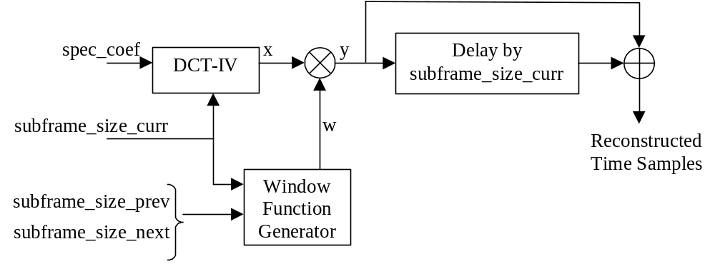
Figure 13 Inverse Modulated Lapped Transform Process

DCT-IV
Mathematically, the DCT-IV operation used in WMA Pro can be described as

Equation 29
for 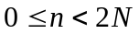

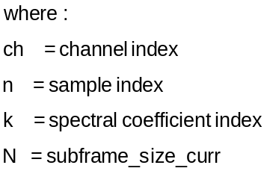

Note: This DCT-IV operation takes N-inputs, and produces 2N-outputs.

Window Function Generation
The values of the window function ‘w’ depend on the sizes of previous, current, and next subframe, subframe_size_prev, subframe_size_curr, and subframe_size_next respectively. The window values w[n] are defined for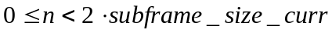. The window values depend on subframe_size_prev and subframe_size_curr, where as depend on subframe_size_curr and subframe_size_next.

The window function values for 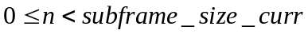 are compactly represented by Equation 30.

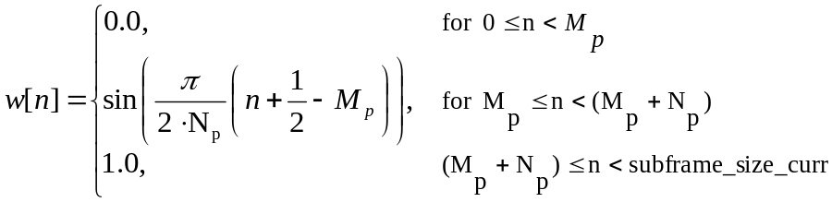
Equation 30

where, and 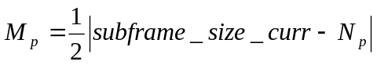. Note that 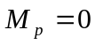 whenever.

The computation of window function values for is a mirror image of Equation 30, and is given in Equation 31.

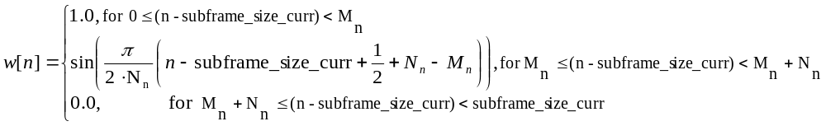
Equation 31
where, and 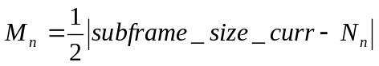. Note that 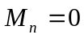 whenever.

The shape of the window function is illustrated in Figure 14 for a number of sequences of subframe sizes.

Subframe Sizes | Window Function
subframe_size_prev = 1024  subframe_size_curr = 1024  subframe_size_next = 1024 | 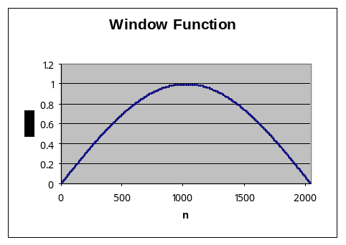
subframe_size_prev = 2048  subframe_size_curr = 1024  subframe_size_next = 2048 | 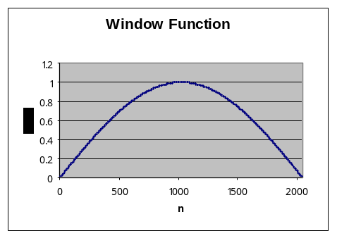
subframe_size_prev = 512  subframe_size_curr = 1024  subframe_size_next = 2048 | 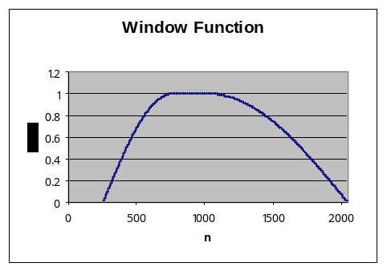
subframe_size_prev = 512  subframe_size_curr = 1024  subframe_size_next = 512 | 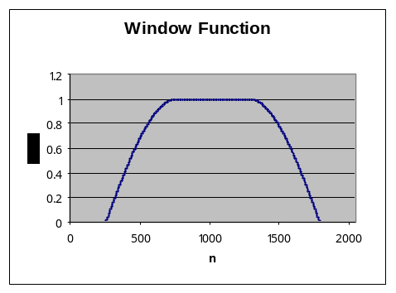
Figure 14 Example Window Function Values for various combinations of subframe sizes

The window function thus generated is used in obtaining reconstructed audio samples, as described in the following.

Obtaining Reconstruction Values

As shown in Figure 13, an intermediate array 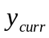 is filled through straight multiplication given in Equation 32.
.
Equation 32
Portions of the intermediate results would have to be saved for reconstructing the next subframe.
The intermediate results from previous subframe 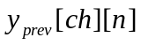are valid in the range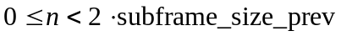. The following logic explains how to perform the overlap-add and obtain reconstructed samples, using the notation:
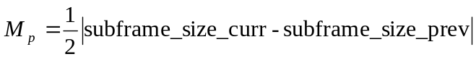,
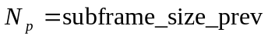, and
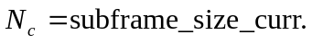
Note: To simplify the equations, this notation is different from the notation used in Section 7.4.2.

The reconstructed samples are given out sequentially every subframe. The number of samples output by the overlap-add operation in all cases equals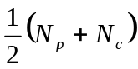.

Case 1. subframe_size_prev == subframe_size_curr
If previous and current subframe have same size, then
.
Equation 33

Case 2. subframe_size_prev > subframe_size_curr
In this case, the reconstructed values are given by:
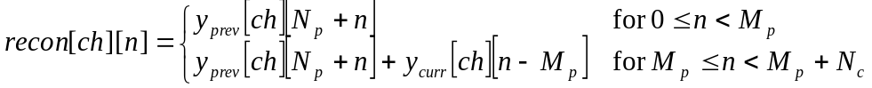.
Equation 34

Case 3. subframe_size_prev < subframe_size_curr
In this case, the reconstructed values are given by:
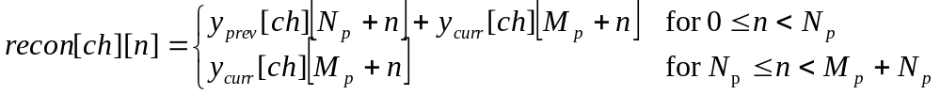.
Equation 35
The reconstructed values, as given in the above procedure are real numbers.

Stream Boundaries
At stream boundaries, unknown partial results are assumed to be 0.

Specifically, at the beginning of the stream (or when seeked-into), values are not available. These are taken to be all zeros. As mentioned elsewhere in the document, the size of the previous (non-existent) window is taken to be the largest window size, samples_per_frame. The number of samples given out to the presentation layer depends on the value of leading_silence_samples, as described in Section 7.7.

Similarly, at the end of a stream, reconstruction based only on has to be made. Here, values are not available. These are taken to be all zeros. As mentioned elsewhere in the document, the size of the current (non-existent) window is taken to be the largest window size, samples_per_frame. The number of samples given out to the presentation layer depends on the value of trailing_silence_samples, as described in Section 7.7.

Reconstruction in Mixed Lossless mode

Restore Mixed Lossless channel coefficients in Mixed Lossless Mode
In encoder’s mixed lossless mode, the PCM data in one channel is first windowed and mapped (to simulate IMDCT X MDCT, which will be described later in Section 7.5.2) to mixed lossless channel coefficients, then mixed lossless is used to compress the mixed lossless channel coefficients. The mixed lossless codec processes the coefficients using AC or LPC filter. The output of the process is residue. The output of AC or LPC filter may go through a quantization step to implement noise feedback code. The residue is sent to bitstream using Golomb coding.

The decoder works in inverse way. It first decodes Golomb codes to channel residues. Then the mixed lossless channel coefficients are restored from the channel residues. Next, the mixed lossless channel coefficients are reordered and passed to audio sample reconstruction process to reconstruct PCM samples.

If the current tile is raw PCM tile, after the decoder_channel_residues_lossless, the coefficients are already ready, no restoration is needed.

The mixed lossless mode use AC filter (BETA bitstream) or LPC filter (RTM bitstream) to convert the coefficients to residues in encoder side. The decoder needs to restore the coefficients from residues. The coefficients are used to reconstruct PCM samples later.

Table 94 and Table 95 show how the coefficients are restored in BETA bitstream and RTM bitstream respectively.

Table 94 Restore Mixed Lossless channel coefficients in Mixed Lossless Tile (BETA Bitstream)
//dequantization for noise feedback coding
for (index = 0; index < subframe_size_curr; index++)
{
channel_residues[iCh][index] *= lossless_quant_stepsize;
}
//inverse AC filter
channel_coeffs[0] = channel_residues[0];
for (index = 1; index < subframe_size_curr; index ++)
{
channel_coeffs[iCh][index] = channel_residues[iCh][index] + ((channel_residues[iCh][index - 1] * ac_filter_coeff + 32) >> 6);
}

Table 95 Restore Mixed Lossless channel coefficients in Mixed Lossless Tile (RTM Bitstream)
//dequantization for noise feedback coding
for (index = 0; index < subframe_size_curr; index++)
{
channel_residues[iCh][index] *= lossless_quant_stepsize;
}
//inverse LPC filter
for (index = 0; index < lpc_order; index++)
{
if (index == 0)
{
channel_coeffs[iCh][0] = channel_residues[iCh][0];
}
else if (index == 1)
{
channel_coeffs[iCh][1] =
channel_residues[iCh][1] + channel_coeffs[iCh][0];
}
else
{
channel_coeffs[iCh][index] = channel_residues[iCh][index] + channel_coeffs[iCh][index - 1] * 2
- channel_coeffs[iCh][index - 2];
}
}
for (index = lpc_order; index < subframe_size_curr; index++)
{
int itmp = 0;
for (itap = 0; itap < lpc_order; itap++)
{
itmp +=
channel_residues[iCh][index – itap - 1] *
lpc_coeff[iCh][itap];
}
channel_coeffs[iCh][index] =
channel_residues[iCh][index] + itmp >> lpc_scaling;
}

Coefficient Mapping in Mixed Lossless Mode
In encoder side, after the window function, the lossy codec and mixed lossless codec have different algorithms to process the windowed PCM data. In lossy mode, MDCT is applied. The decoder side uses IMDCT to invert the MDCT. Although the output of IMDCT is not exactly the windowed PCM samples, with the help of the overlapped windows, the decoder can reconstruct the PCM samples. For details of the reconstruction audio data, please refer to Section 7.4.3. The mixed lossless mode in WMA Pro is designed to be transparent to lossy mode at reconstruction stage to make the switching between lossy and mixed lossless codecs seamlessly. The mixed lossless channel coefficients (channel_coeffs) in the mixed lossless mode are actually equivalent to the output of the IMDCT in the lossy codec. The output of IMDCT in the lossy mode is sum of the mirroring samples in the second half of the windowed PCM samples and difference of the mirroring samples in the first half if there is no quantization loss (see WMA Professional Architecture for details). Suppose the PCM samples in a channel are channel_pcm. After the windowing, they are channel_windowed_pcm. The output of the IMDCT is channel_b4_recon (which is x in Equation 29). The relationship of them is shown in Table 96.
Table 96 Relationship between the channel_b4_recon and channel_windows_pcm
if (i < subframe_size_curr / 2)
{
channel_b4_recon[i] =
channe_windows_pcm[3*subframe_size_curr/2-i] +
channe_windows_pcm[3*subframe_size_curr/2+i];
}
else
{
channel_b4_recon[i] =
channe_windows_pcm[subframe_size_curr/2 + (subframe_size_curr - i)]-
channe_windows_pcm[subframe_size_curr/2 - (subframe_size_curr - i)];
}

In the mixed lossless mode, after 7.5.1 and Error: Reference source not found, the channel_coeffs are restored. The channel_coeffs is actually channel_b4_recon in reverse order. Table 97 shows the relationship between channel_b4_recon and channel_coeffs.
Table 97 Relationship between channel_b4_recon and channel_coeffs
Channel_b4_recon[index] = channel_coeffs[subframe_size_curr – index];

Therefore, after the mixed lossless decoder restores the channel_coeffs, the decoder will reorganize it in reverse order and pass it to the reconstruction part in 7.4.3. The lossy and mixed lossless codecs are transparent to the reconstruction stage therefore nothing needs to be changed.

Post-Processing Multi-Channel Transform
This is performed on the time-domain data. At this stage, it is assumed that the entire frame worth of time samples (for all channels) is available. The actual multi-channel post-processing depends on the values of postproc_transform, postproc_transform_prev, postproc_transfrorm_array, and postproc_transform_array_prev. At each sample position in the frame, a linear transformation matrix is computed, and is applied on the reconstructed data. If previous and current frame are both post-processed, the actual transformation used is an interpolated value between two arrays.
This process takes recon [*][*] as input, and overwrites with results.

// temporary storage
float input[num_channels], output[num_channels];
float postproc_transform_array_curr[num_channels][num_channels];
Int iCh, index;
if (postproc_transform == 0)
return; // Nothing to perform
For (index = 0; index < samples_per_frame; index++)
{
if (postproc_transform_prev == 0)
// previous frame was not post-processed
postproc_transform_array_curr = postproc_transform_array;
else
{
float beta = (float)index/(float)samples_per_frame;
float alpha = 1.0 – beta;
postproc_transform_array_curr =
alpha * postproc_transform_array_prev +
beta * postproc_transform_array;
}
// Collect co-sited reconstructed coefficients from this frame.
for (iCh = 0; iCh < num_channels; iCh++)
input[iCh] = recon[iCh][index];
// multiply matrix with vector to get vector
output = postproc_transform_array_curr * input;
// Put-back co-sited mixed reconstructed coefficients in
// this frame.
for (iCh = 0; iCh < num_channels; iCh++)
recon[iCh][index] = output[iCh];
}

Removal of Silent Samples
When silence information is present in the frame header, this information is used to clip the reconstructed samples before passing them to the presentation unit. If leading silence information is present, the first leading_silence_samples out of samples_per_frame are pruned. Similarly, if trailing silence information is present, the final trailing_silence_samples of the reconstructed samples are pruned. These samples were added by the encoder to round-up the input signal into frames.
Thus, the total number of samples given out by the WMA Pro decoder to the presentation unit in a frame is:
Equation 36

Dynamic Range Control
Dynamic range control involves the use of scale factors to scale each of the PCM samples being output by the decoder so that the difference between the peak level and average level of the content can be controlled. This is useful in situations when one does not want to hear large differences in volume across a content. In order to determine the scale factor, the decoder uses the player setting for dynamic range control. which can be one of D_DRC_HIGH, D_DRC_MED, and D_DRC_LOW, the two values of actual RMS and peak present in the content, rms_amplitude_ref and peak_amplitude_ref, the two target author controlled target values for RMS and peak, rms_amplitude_target and peak_amplitude_target, and the author controlled scale factors for scaling all the samples in a given frame, drc_frame_scale_factor.

Since it is computationally expensive to compute a scale factor for every individual sample, DRC is applied blockwise in the PCM (time) domain. Once all decoding has taken place for a frame, blocks of PCM data are taken samples_per_block samples at a time. For example, samples_per_block may be number of samples in a frame (samples_per_frame). The number of DRC blocks and the drc block size for this block of PCM data is first obtained by the following.

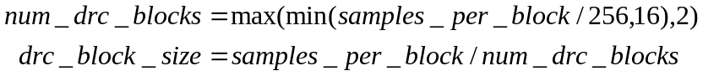

The four values of rms_amplitude_ref, peak_amplitude_ref, rms_amplitude_target, and peak_amplitude_target, are all 16-bit signed integers to used control the dynamic range. For purposes of this decoder, dynamic range is defined as follows. First, all the four values are converted to dB, by using
Equation 37
The amplitude_dB is a number between –dB and 0 dB, but is clipped to be between -200 dB and 0dB. The original dynamic range of the content is defined to be

Equation 38
and the target dynamic range is defined to be,
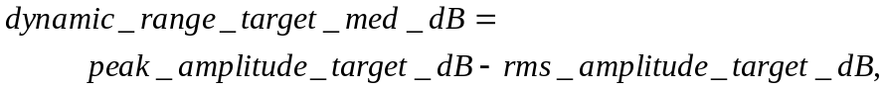
Equation 39
when the setting is D_DRC_MED, and one-half of that when the setting is D_DRC_LOW. So, we can define the following using Equation 39,
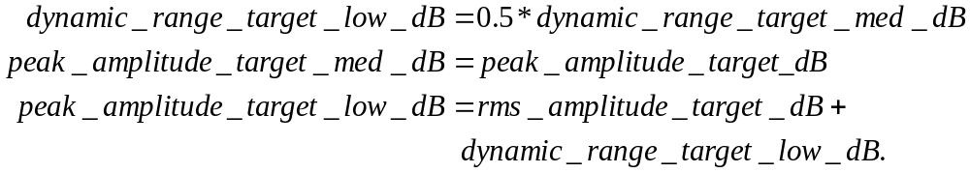
Equation 40
As a special case, when rms_amplitude_target = rms_amplitude_ref, and peak_amplitude_target = peak_amplitude_ref, then it is assumed that dynamic_range_target_med_dB = 12 dB, and all other quantities are adjusted accordingly. So, dynamic_range_target_low_dB becomes 6 dB, and the target peaks for both medium and low settings are adjusted.

The overall scale applied to each sample is same for all channels at a given time instant. This is so that the there is no change in channel localization. The actual scale factor applied is a function of the player setting as follows.
- D_DRC_HIGH: No scaling is applied. Content is played in original form.
- D_DRC_MED: drc_frame_scale_factor is applied along with a scale factor to make the output rms of the content rms_amplitude_target_dB, and the peak of the content be peak_amplitude_target_med_dB.
- D_DRC_LOW: drc_frame_scale_factor is applied along with a scale factor to make the output rms of the content rms_amplitude_target_dB, and the peak of the content be peak_amplitude_target_low_dB.

Since DRC only has an effect when the setting is D_DRC_MED or D_DRC_LOW, for the remaining purposes of this section, the following algorithm is only applied in one of these settings. Furthermore, since the only difference between the two settings is in the peak_amplitude_target_dB, in the following algorithm, we will use peak_amplitude_target_dB, and it should be understood, that in the low setting, we are actually referring to peak_amplitude_target_low_dB. Also, when we mention dynamic_range_target_dB, we mean either medium or low target dynamic range depending on what setting we are in.

The frame level scaling parameter that is sent in the frame header is actually a nonlinear encoded version of a true scale parameter. To get the actual scaling parameter, when fGenerateDrcParams is true, the decoder decodes an 8-bit unsigned integer scale factor in the frame header, drc_frame_scale_factor, as shown in Table 7. The true scale factor is obtained by the following equations, which take the first 3 bits of the 8-bit scale factor as a signed integer between -4 and 3, and the last 5 bits of the 8-bit scale factor as an unsigned integer between 0 and 31,

shift_scale = (signed char)drc_frame_scale_factor >> 5, a number between -4 and 3
mult_scale = drc_frame_scale_factor & 0x1f, a number between 0 and 31,
scale_factor = 2^{shift_scale} * (1 + mult_scale / 32).

Therefore, the overall scale factor is between 2⁻⁴ = 1/16 and 2³*(63/32), or approximately 2⁴ = 16. If fGenerateDrcParams is false, then the decoder sets drc_frame_scale_factor = 1.0.

The decoder will then scale everything within a frame by this scale_factor, along with another scale factor which is a function of the input to try and match the target rms and dynamic range for the content to the target values. The scale factor to match the target rms and dynamic range for the content is determined using the curve shown in Figure 15. This figure is for the case when we have to apply soft clipping to prevent artifacts due to the scaling. If the gain needed to meet the target rms is less than 1, or if the (actual peak)*(gain) is less than the maximum value, soft clipping is not used. The overall scale factor is determined and applied on a block-by-block basis to each of the num_drc_blocks of size drc_block_size. The overall scale factor is determined by the following algorithm in Table 98, which also adjusts the target peak and rms by a few dB, because limiting the dynamic range of the content results in a reduced rms from the reference. As mentioned before, there is soft clipping at the peak to prevent unpleasant artifacts if needed.

Input (dB)
-200
Output (dB)
0
0
gainDb
clipThresholdYDb
m_linearThresholdDb
slope = m_ratioDb
slope =
1.0
Input (dB)
-200
Scale (dB)
0
0
gainDb
m_linearThresholdDb
Scale (dB) = Output (dB) - Input (dB)
Figure 15 DRC output and scale factor as function of input (in dB).

Table 98 Syntax for determining DRC scale factor.
// DRC scale factor calculation
// find reduction in peak due to peak limiting
peak_chop_dB = max(peak_amplitude_ref_dB-peak_amplitude_target_dB, 0);
// boost target rms and peak by 1dB for every 8dB reduction in peak
peak_boost_dB = peak_chop_dB / 8;
rms_amplitude_target_dB += peak_boost_dB;
peak_amplitude_target_dB += peak_boost_dB;
// find gain needed to match target rms, could be (-)
gain_dB = rms_amplitude_target_dB – rms_amplitude_ref_dB;
// find soft clipping threshold and ratio, if needed
if (gain_dB + peak_amplitude_ref_dB >= peak_amplitude_target_dB)
{
linear_threshold_dB = peak_amplitude_target_dB – 6 – gain_dB;
ratio_dB = -6.0 / linear_threshold_dB;
}
else
{
linear_threshold_dB = 0;
ratio_dB = 0;
}
max_value = 1<<validBitsPerSample
// Everything up to this point only needs to be done once for each
// setting of DRC (low and medium) at initialization.
// determine maximum absolute value of samples in block over all channels
max_sample = -1;
for (iSample = 0; iSample < drc_block_size; iSample++)
for (iCh = 0; iCh < num_channels; iCh++)
if (abs(sample[iSample][iCh]) > max_sample)
max_sample = abs(sample[iSample][iCh]);
// determine maximum sample after application of frame level scale factor.
max_sample *= scale_factor;
// determine sample value in dB
max_sample_dB = -20 * log10(max_value / max_sample);
// see if sample is in linear range, or soft-clipping range, and find
// scale factor appropriately.
if (max_sample_dB < linear_threshold_dB)
drc_scale_factor_dB = gain_dB;
else
drc_scale_factor_dB = linear_threshold_dB + gain_dB +
(max_sample_dB-linear_threshold_dB)*ratio_dB – max_sample_dB;
// convert scale factor back from dB
drc_scale_factor = 10.0^(drc_scale_factor_dB/20.0);
// total scale factor is product of frame level, and drc scale factors.
total_scale_factor = drc_scale_factor * scale_factor;

Of course, since the calculation is fairly complex, and to avoid conversions between dB, and scale, the decoder can pre-compute a table for determining drc_scale_factor using the 10 MSB’s of the sample, and store it in a 1024 entry table. Also, it can determine the slope between successive points, and then linearly interpolate to get a good approximation to the scale factor. Then, the scale factor calculation becomes as follows once the maximum sample over all the channels has been found.

// DRC scale factor calculation
max_sample *= scale_factor;
drc_scale_factor = table_lookup_and_interpolate(max_sample);
total_scale_factor = drc_scale_factor * scale_factor;

The total_scale_factor is not the actual one that is applied. This is because we use attack and release times to control the rate of change of scale factors so as to not cause unpleasant artifacts. To control this, we use the following algorithm, assuming prev_scale_factor was the scale factor at the previous sample, and total_scale_factor is the current desired scale factor obtained from the algorithm given above. The value for prev_scale_factor is initialized to 1.0 before any decoding begins.

Table 99 Syntax for applying release and attack times in DRC scale factors.
// DRC scale factor calculation smoothing over time
// the following coefficients need to be calculated only once
// at initialization.
attack_coeff = 1.0 – exp(-2.2 / (0.1*sampling_rate));
release_coeff = 1.0 – exp(-2.2 / (0.5*sampling_rate));
samples_for_full_attack = 1.0/attack_coeff;
samples_for_full_release = 1.0/release_coeff;
if (total_scale_factor <= prev_scale_factor)
if (drc_block_size >= samples_for_full_attack)
act_scale_factor = total_scale_factor;
else
act_scale_factor =
attack_coeff*drc_block_size*total_scale_factor +
(1-attack_coeff*drc_block_size)*prev_scale_factor;
else
if (drc_block_size >= samples_for_full_release)
act_scale_factor = total_scale_factor;
else
act_scale_factor =
release_coeff*drc_block_size*total_scale_factor +
(1-release_coeff*drc_block_size)*prev_scale_factor;
// clipping scale factor so as to not exceed target peak.
if (act_scale_factor*max_sample > peak_amplitude_target)
act_scale_factor = peak_amplitude_target / max_sample;

In this way, the scale factor is smoothed out over time, as well as the desired peak target being met.
One thing to note in this DRC algorithm is that there is no dynamic range expansion. So, if the dynamic_range_target_dB was larger than dynamic_range_ref_dB, then the target dynamic range would be the same as dynamic_range_ref_dB, and the target peaks would be also be lower than desired.

Channel Down-mixing
Channel down-mixing is used when there is a mismatch between the number of source channels and the number of speakers available for presentation. A simple technique would be to use a linear transform across the channels of the reconstructed samples. WMA Pro can help the process by defining the linear transformations that could be used for this purpose.

A WMA Pro decoder has to handle two types of fold-down matrices:
(1) content author specified custom fold-down matrices, and
(2) in the absence of custom fold-down, a default fold-down.
These are described in the following.

Custom Fold-down Matrices
The WMA Pro ASF stream can carry custom down-mixing transform values. When ASF or other Mux format carries the custom matrix for a particular setting, it overrides default channel down-mix matrix. This information is carried as fold-down metadata, on a per-file basis. The string would have “FoldDown%dTo%dChannels” and contains comma delineated fold-down values destined for the codec. These values are in scaled decibel units, and are scanned in the order of source channel speaker positions. A linear matrix entry can be obtained from such scaled entry through:
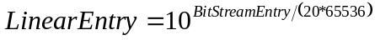
Equation 41
Subsequently the matrix is normalized to have unity gain per output channel.

Default Fold-Down Matrices
WMA Pro has capability to derive default channel fold-down matrices for a wide range of combinations of source & destination speaker positions. It is done using a projection method. First, a matrix is generated to fold-down among non-subwoofer source channels to non-subwoofer destination channels. Then, the subwoofer channel is handled in a second step.

Generation of Fold-Down Matrix for Non-Subwoofer Channels
For this purpose, the speakers are assumed to be placed at direction specified in Table 100. Note that for other speaker positions (e.g. top etc), this algorithm can not produce a fold-down matrix.

Speaker | Direction (Degrees)
Front Left | -30 + 360
Front Right | +30
Front Center | 0
Subwoofer | 0
Back Left | -135+360
Back Right | +135
Front Left of Center | -15 + 360
Front Right of Center | +15
Back Center | +180
Side Left | -110
Side Right | +110
- Table 100 Assumed Speaker Directions
Using Table 100, speaker directions of source and destination are noted in two arrays rgfltInPhi & rgfltOutPhi. These directions are sorted in ascending order (in-place), with sorting order captured in rgiInCMap and rgiOutCMap. Then, angles between adjacent destination channels are computed (where cDstChan is number of non-subwoofer destination channels, cSrcChan is number of non-subwoofer source channels):

for(i = 0; i < cDstChan-1; i++)
{
rgfltOutDel[i] = rgfltOutPhi[i+1] - rgfltOutPhi[i];
}
rgfltOutDel[cDstChan-1] = rgfltOutPhi[0] - rgfltOutPhi[cDstChan-1] + 360.0F;

Then, a raw channel fold-down matrix is computed between non-subwoofer sorted source channels to non-subwoofer sorted destination channels:
for (i = 0; i < cSrcChan; i++)
{
fltSource = rgfltInPhi[i];
j = 0;
while ((fltSource > rgfltOutPhi[j]) && (j < cDstChan))
{
j++;
}
if (j == 0)
{
iTarg1 = cDstChan - 1;
iTarg2=0;
}
else if ( j > cDstChan-1 )
{
iTarg1 = cDstChan - 1;
iTarg2 = 0;
}
else
{
iTarg1 = j-1;
iTarg2 = j;
}
fltTmp = fltSource - rgfltOutPhi[iTarg1];
while ( fltTmp < 0.0F )
{
fltTmp = fltTmp + 360.0F;
}
fltTmp = fltTmp/rgfltOutDel[iTarg1];
fltG1 = cos(fltTmp * /2.0F);
if (fltG1 < 0 )
{
fltG1 = 0;
}
fltG2 = sin(fltTmp * /2.0F);
if ( fltG2 < 0)
{
fltG2 = 0;
}
if (cDstChan == 1 )
{
fltG1 = fltG2 = 1.0F;
}
rgrgfltChDnMixMtx[rgiOutCMap[iTarg1]][rgiInCMap[i]] = fltG1;
rgrgfltChDnMixMtx[rgiOutCMap[iTarg2]][rgiInCMap[i]] = fltG2;
}

The rgrgfltChDnMixMtx now has raw (un-normalized) channel fold-down matrix between non-subwoofer source to non-subwoofer destination.

Next, to perform normalization, fltGain is computed:
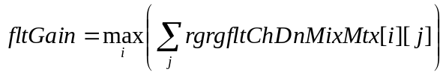
- Equation 42
Next, each entry in the channel fold-down matrix is normalized:
- Equation 43

Handling the Subwoofer Channels
There are several cases to consider in this step.
- If both source and destination channel masks have subwoofer, then the matrix rgrgfltChDnMixMtx is updated to include a pass-thru for this channel. That is, a row and a column are inserted in the matrix at positions corresponding to source subwoofer and destination subwoofer, with element equal to 1, rest 0.
- If only the source channel mask has a subwoofer, and the destination does not, rgrgfltChDnMixMtx is updated to have 20% of LFE level leak into all destination channels combined.
This is done by (1) scaling down each row of the matrix rgrgfltChDnMixMtx by 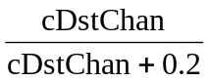, and (2) inserting one column into the matrix at a position corresponding to the source subwoofer with all entrees equal to 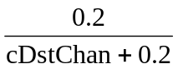.
- If only destination channel mask has a subwoofer, and the source does not, rgrgfltChDnMixMtx is updated to have zero output in the subwoofer channel. That is, a row is inserted into the matrix at a position corresponding to the destination subwoofer, with all entrees zero.
- If neither destination nor the source have subwoofer, the matrix rgrgfltChDnMixMtx should not be updated.
At the end of this process, the final default matrix for channel fold-down is obtained.

Tables

Constants
Table 101 Constants used by the decoder
Constant | Value
D_DRC_HIGH | 0
D_DRC_MED | 1
D_DRC_LO | 2
D_ENCOPT3_PURE_LOSSLESS | 0x0001
D_ENCOPT3_FRM_SIZE_MOD | 0x0006
D_ENCOPT3_SUBFRM_DIV | 0x0038
D_ENCOPT3_WRITE_FRAMESIZE_IN_HDR | 0x0040
D_ENCOPT3_GENERATE_DRC_PARAMS | 0x0080
D_ENCOPT3_RTMBITS | 0x0100
D_SPEAKER_LOW_FREQUENCY | 0x0008
D_CURRFRM | 0
D_NEXTFRM | 1

Speaker positions
Table 102 Constants defining speaker positions for source channels
Constant | Value
SPEAKER_FRONT_LEFT | 0x0000 0001
SPEAKER_FRONT_RIGHT | 0x0000 0002
SPEAKER_FRONT_CENTER | 0x0000 0004
SPEAKER_LOW_FREQUENCY | 0x0000 0008
SPEAKER_BACK_LEFT | 0x0000 0010
SPEAKER_BACK_RIGHT | 0x0000 0020
SPEAKER_FRONT_LEFT_OF_CENTER | 0x0000 0040
SPEAKER_FRONT_RIGHT_OF_CENTER | 0x0000 0080
SPEAKER_BACK_CENTER | 0x0000 0100
SPEAKER_SIDE_LEFT | 0x0000 0200
SPEAKER_SIDE_RIGHT | 0x0000 0400
SPEAKER_TOP_CENTER | 0x0000 0800
SPEAKER_TOP_FRONT_LEFT | 0x0000 1000
SPEAKER_TOP_FRONT_CENTER | 0x0000 2000
SPEAKER_TOP_FRONT_RIGHT | 0x0000 4000
SPEAKER_TOP_BACK_LEFT | 0x0000 8000
SPEAKER_TOP_BACK_CENTER | 0x0001 0000
SPEAKER_TOP_BACK_RIGHT | 0x0002 0000

Each WMA file specifies one and only one speaker layout through channel mask.
Using the bit fields listed in Table 102, a number of “intended” speaker layouts are possible. Some of these channel masks are quite popular, and are listed in Table 103.

Table 103 Popular Speaker Positions
Number of Channels | Channel Mask | Channel Members | Intended Speaker Layout
1 (Home Theater) | 0x0004 | SPEAKER_FRONT_CENTER | 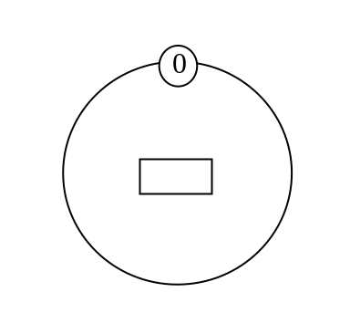
2 (Home Theater) | 0x0003 | SPEAKER_FRONT_LEFT |  SPEAKER_FRONT_RIGHT | 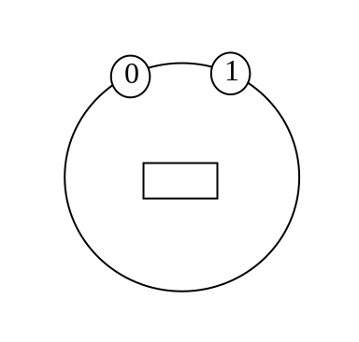
3 (Home Theater) | 0x0007 | SPEAKER_FRONT_LEF |  SPEAKER_FRONT_RIGHT |  SPEAKER_FRONT_CENTER | 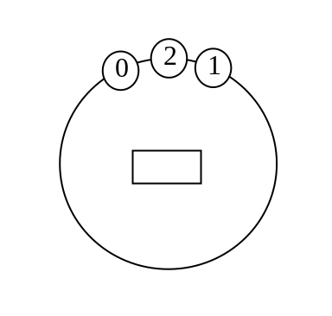
4 | 0x0033 | SPEAKER_FRONT_LEFT |  SPEAKER_FRONT_RIGHT |  SPEAKER_BACK_LEFT |  SPEAKER_BACK_RIGHT | 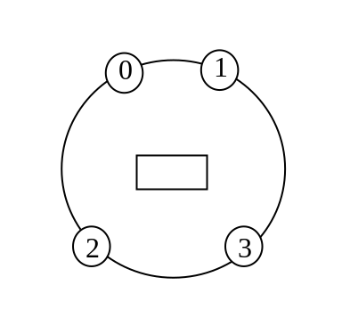
4 (Home Theater) | 0x107 | SPEAKER_FRONT_LEFT |  SPEAKER_FRONT_RIGHT |  SPEAKER_FRONT_CENTER|  SPEAKER_BACK_CENTER | 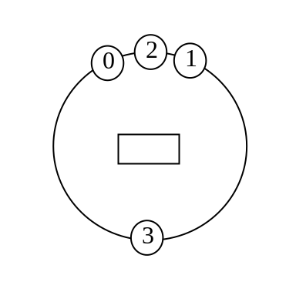
5 (Home Theater) | 0x0607 | SPEAKER_FRONT_LEFT|  SPEAKER_FRONT_RIGHT|  SPEAKER_FRONT_CENTER|  SPEAKER_SIDE_LEFT|  SPEAKER_SIDE_RIGHT | 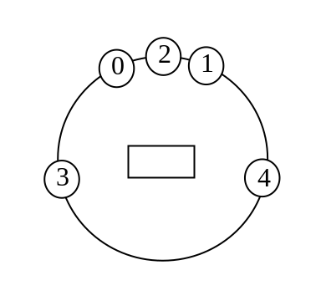
5 | 0x0037 | SPEAKER_FRONT_LEFT|  SPEAKER_FRONT_RIGHT|  SPEAKER_FRONT_CENTER|  SPEAKER_BACK_LEFT|  SPEAKER_BACK_RIGHT | 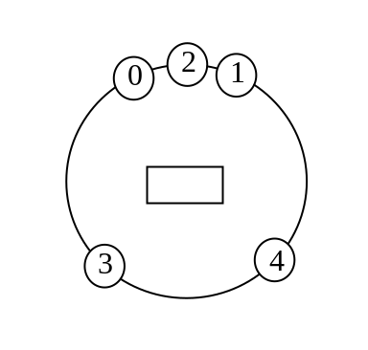
6 (Home Theater) | 0x060F | SPEAKER_FRONT_LEFT|  SPEAKER_FRONT_RIGHT|  SPEAKER_FRONT_CENTER|  SPEAKER_LOW_FREQUENCY|  SPEAKER_SIDE_LEFT|  SPEAKER_SIDE_RIGHT | 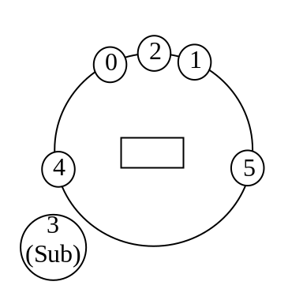
6 | 0x003F | SPEAKER_FRONT_LEFT|  SPEAKER_FRONT_RIGHT|  SPEAKER_FRONT_CENTER|  SPEAKER_LOW_FREQUENCY|  SPEAKER_BACK_LEFT|  SPEAKER_BACK_RIGHT | 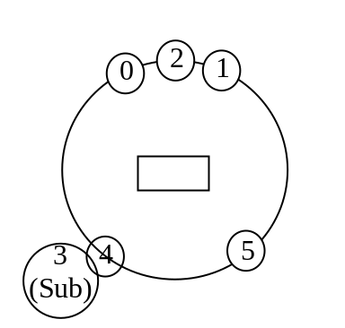
6.0 (Home Theater, without LFE) | 0x0707 | SPEAKER_FRONT_LEFT|  SPEAKER_FRONT_RIGHT|  SPEAKER_FRONT_CENTER|  SPEAKER_BACK_CENTER|  SPEAKER_SIDE_LEFT|  SPEAKER_SIDE_RIGHT | 0  1  2  4  5  3
6.0, without LFE | 0x137 | SPEAKER_FRONT_LEFT|  SPEAKER_FRONT_RIGHT|  SPEAKER_FRONT_CENTER|  SPEAKER_BACK_LEFT|  SPEAKER_BACK_RIGHT|  SPEAKER_BACK_CENTER | 0  1  2  3  4  5
7 (Home Theater) | 0x070F | SPEAKER_FRONT_LEFT|  SPEAKER_FRONT_RIGHT|  SPEAKER_FRONT_CENTER|  SPEAKER_LOW_FREQUENCY|  SPEAKER_BACK_CENTER|  SPEAKER_SIDE_LEFT|  SPEAKER_SIDE_RIGHT | 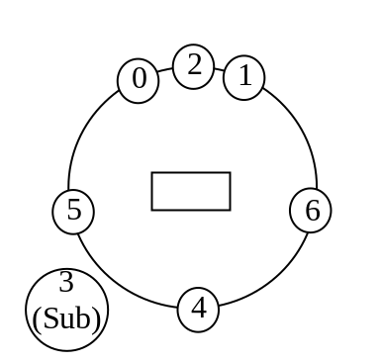
7 | 0x13F | SPEAKER_FRONT_LEFT|  SPEAKER_FRONT_RIGHT|  SPEAKER_FRONT_CENTER|  SPEAKER_LOW_FREQUENCY|  SPEAKER_BACK_LEFT|  SPEAKER_BACK_RIGHT|  SPEAKER_BACK_CENTER | 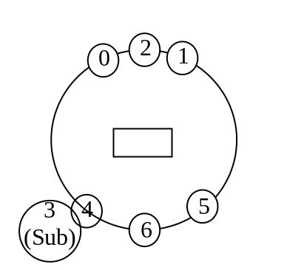
7.0 (Home Theater, without LFE) | 0x0637 | SPEAKER_FRONT_LEFT|  SPEAKER_FRONT_RIGHT|  SPEAKER_FRONT_CENTER|  SPEAKER_BACK_LEFT|  SPEAKER_BACK_RIGHT|  SPEAKER_SIDE_LEFT|  SPEAKER_SIDE_RIGHT | 0  1  2  3  4  5  6
7.0 (without LFE) | 0x00F7 | SPEAKER_FRONT_LEFT|  SPEAKER_FRONT_RIGHT|  SPEAKER_FRONT_CENTER|  SPEAKER_BACK_LEFT|  SPEAKER_BACK_RIGHT|  SPEAKER_FRONT_LEFT_OF_CENTER|  SPEAKER_FRONT_RIGHT_OF_CENTER | 0  1  2  3  4  5  6
8 (Home Theater) | 0x063F | SPEAKER_FRONT_LEFT|  SPEAKER_FRONT_RIGHT|  SPEAKER_FRONT_CENTER|  SPEAKER_LOW_FREQUENCY|  SPEAKER_BACK_LEFT|  SPEAKER_BACK_RIGHT|  SPEAKER_SIDE_LEFT|  SPEAKER_SIDE_RIGHT | 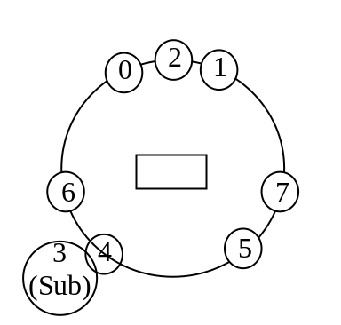
8 | 0x00FF | SPEAKER_FRONT_LEFT|  SPEAKER_FRONT_RIGHT|  SPEAKER_FRONT_CENTER|  SPEAKER_LOW_FREQUENCY|  SPEAKER_BACK_LEFT|  SPEAKER_BACK_RIGHT|  SPEAKER_FRONT_LEFT_OF_CENTER|  SPEAKER_FRONT_RIGHT_OF_CENTER | 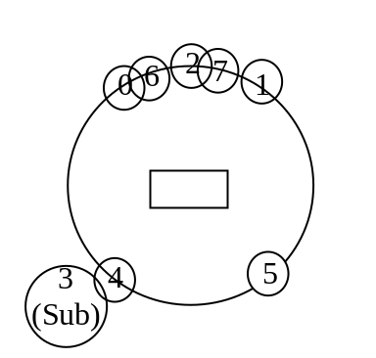

A system implementing WMA Professional decoder should be able to handle all these popular speaker positions correctly. If the actual physical speaker configuration does not match the content’s channel mask, an effort shall be made by the decoder system to perform a channel mix-down or mix-up (also called channel down-mix) before presenting the decoded content. However, the following notes should be considered while performing the channel mixing:
- Channel mixing should be avoided to the extent possible, and discrete output should be given first priority while dealing with small variations in speaker positions.
- Speaker configurations with label “Home Theater” are expected to be more popular and prevalent than other configurations.
- If a channel mask value is zero in the WMA content, it should be taken as “Home Theater” setting. As an example, an eight-channel speaker configuration with channel mask zero is equivalent to an eight-channel speaker configuration with a channel mask of 0x063F (Home Theater).
- Five channel speaker configurations with channel masks 0x0607 and 0x0037 should be considered synonymous (i.e. equivalent), and no channel mixing should be performed to go between the two configurations.
- Six channel speaker configurations with channel masks 0x060F and 0x003F should be considered synonymous (i.e. equivalent), and no channel mixing should be performed to go between the two configurations.

Bark Frequencies
Table 104 Bark Frequencies
unsigned short bark_freqs_v3 [28]=
{ 100, 200, 300, 400, 510,
630, 770, 920, 1080, 1270,
1480, 1720, 2000, 2320, 2700,
3150, 3700, 4400, 5300, 6400,
7700, 9500, 12000, 15500, 20675,
28575, 41375, 63875
};

DCT Type II Multi-Channel Transforms
These tables are generated using the generic DCT Type II equations, with (1) quantization to 8 decimal bits, (2) shuffling rows at a couple of places.
Table 105 Pre-defined DCT Type II Multi-Channel Transformations
numOf  Group  Channels  [iStage]  [iGroup] | channel_transform  [iStage][iGroup]
1 | 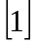
2 | 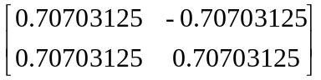
3 | 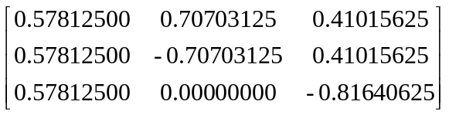
4 | 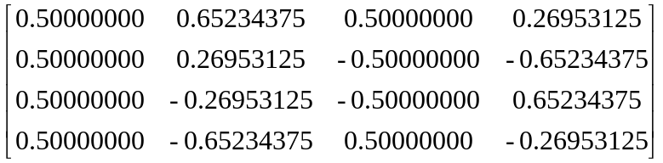
5 | 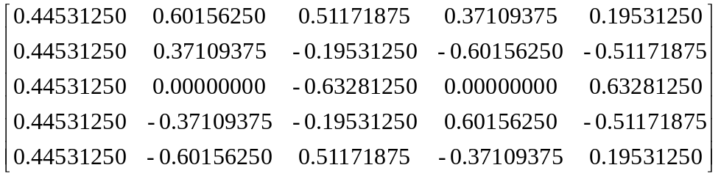
6 | 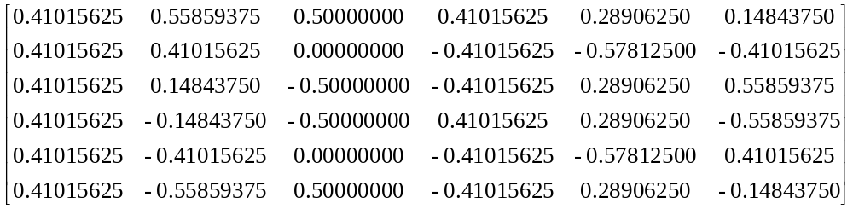

VLC (Huffman) Table for Band Quantization Step Sizes, when anchor is not available
The symbol values listed in the following Huffman table are all unsigned numbers. The “Symbol Value” and “Symbol Length” together define a variable length symbol. For example, a Symbol Value of 58937 and a Symbol Length of 19 together specify a bit string “000 1110 0110 0011 1001”. In bitstream, the bit string always appears “left bit first”. This particular symbol is representing a mask value of 2.

Table 106 Huffman Table for Band Quantization Step Sizes, when anchor mask is not available
Index (Mask) | Symbol Value | Symbol Length | Index (Mask) | Symbol Value | Symbol Length | Index (Mask) | Symbol Value | Symbol Length
0 | 58937 | 19 | 41 | 58918 | 19 | 82 | 59087 | 19
1 | 59074 | 19 | 42 | 58919 | 19 | 83 | 59088 | 19
2 | 59073 | 19 | 43 | 58920 | 19 | 84 | 59089 | 19
3 | 59072 | 19 | 44 | 58921 | 19 | 85 | 59090 | 19
4 | 58943 | 19 | 45 | 58922 | 19 | 86 | 59091 | 19
5 | 58942 | 19 | 46 | 58923 | 19 | 87 | 59092 | 19
6 | 58941 | 19 | 47 | 58924 | 19 | 88 | 59093 | 19
7 | 58940 | 19 | 48 | 58925 | 19 | 89 | 59094 | 19
8 | 58939 | 19 | 49 | 58926 | 19 | 90 | 59095 | 19
9 | 58938 | 19 | 50 | 58927 | 19 | 91 | 59096 | 19
10 | 58936 | 19 | 51 | 58928 | 19 | 92 | 59097 | 19
11 | 58935 | 19 | 52 | 58929 | 19 | 93 | 59098 | 19
12 | 58934 | 19 | 53 | 7391 | 16 | 94 | 59099 | 19
13 | 58933 | 19 | 54 | 3680 | 15 | 95 | 59100 | 19
14 | 58932 | 19 | 55 | 921 | 13 | 96 | 59101 | 19
15 | 58930 | 19 | 56 | 231 | 11 | 97 | 59102 | 19
16 | 58931 | 19 | 57 | 29 | 8 | 98 | 59103 | 19
17 | 58912 | 19 | 58 | 0 | 5 | 99 | 59104 | 19
18 | 29563 | 18 | 59 | 1 | 2 | 100 | 59105 | 19
19 | 58896 | 19 | 60 | 1 | 1 | 101 | 59106 | 19
20 | 58897 | 19 | 61 | 1 | 3 | 102 | 59107 | 19
21 | 58898 | 19 | 62 | 2 | 5 | 103 | 59108 | 19
22 | 58899 | 19 | 63 | 6 | 6 | 104 | 59109 | 19
23 | 58900 | 19 | 64 | 2 | 6 | 105 | 59110 | 19
24 | 58901 | 19 | 65 | 7 | 7 | 106 | 59111 | 19
25 | 58902 | 19 | 66 | 6 | 7 | 107 | 59112 | 19
26 | 58903 | 19 | 67 | 15 | 7 | 108 | 59113 | 19
27 | 58904 | 19 | 68 | 56 | 9 | 109 | 59114 | 19
28 | 58905 | 19 | 69 | 114 | 10 | 110 | 59115 | 19
29 | 58906 | 19 | 70 | 922 | 13 | 111 | 59116 | 19
30 | 58907 | 19 | 71 | 59076 | 19 | 112 | 59117 | 19
31 | 58908 | 19 | 72 | 59077 | 19 | 113 | 59118 | 19
32 | 58909 | 19 | 73 | 59078 | 19 | 114 | 59119 | 19
33 | 58910 | 19 | 74 | 59079 | 19 | 115 | 59120 | 19
34 | 58911 | 19 | 75 | 59080 | 19 | 116 | 59121 | 19
35 | 59075 | 19 | 76 | 59081 | 19 | 117 | 59122 | 19
36 | 58913 | 19 | 77 | 59082 | 19 | 118 | 59123 | 19
37 | 58914 | 19 | 78 | 59083 | 19 | 119 | 59124 | 19
38 | 58915 | 19 | 79 | 59084 | 19 | 120 | 59125 | 19
39 | 58916 | 19 | 80 | 59085 | 19
40 | 58917 | 19 | 81 | 59086 | 19

Run-Level Table for Band Quantization Step Sizes, when anchor is available
The symbol values listed in this Huffman table are all unsigned numbers. The “Symbol Value” and “Symbol Length” together define a variable length symbol. For example, a Symbol Value of 27 and a Symbol Length of 5 together specify a bit string “1 1011”. In bitstream, the bit string always appears “left bit first”. This particular symbol in this RLC table is representing a |level|=1 and run=5.
Table 107 RLC Table for Band Quantization Step Sizes, when anchor mask is available
Index | |Level| | Zero Run | Symbol Value | Symbol Length | Index | |Level| | Zero Run | Symbol Value | Symbol Length
0 | ESCAPE_CODE |  | 268 | 9 | 60 | 4 | 7 | 17 | 11
1 | END_OF_BLOCK |  | 1 | 2 | 61 | 4 | 8 | 270 | 9
2 | 1 | 0 | 1113642 | 21 | 62 | 4 | 9 | 300 | 9
3 | 2 | 0 | 3 | 2 | 63 | 4 | 10 | 42 | 6
4 | 2 | 1 | 3 | 4 | 64 | 4 | 11 | 47 | 8
5 | 2 | 2 | 1 | 5 | 65 | 4 | 12 | 289 | 9
6 | 2 | 3 | 19 | 5 | 66 | 4 | 13 | 70 | 7
7 | 2 | 4 | 32 | 6 | 67 | 4 | 14 | 2174 | 12
8 | 2 | 5 | 41 | 6 | 68 | 4 | 15 | 186 | 10
9 | 2 | 6 | 20 | 7 | 69 | 4 | 16 | 50 | 12
10 | 2 | 7 | 22 | 7 | 70 | 4 | 17 | 34800 | 16
11 | 2 | 8 | 69 | 7 | 71 | 4 | 18 | 22236 | 15
12 | 2 | 9 | 73 | 7 | 72 | 4 | 19 | 748 | 12
13 | 2 | 10 | 47 | 6 | 73 | 4 | 20 | 17402 | 15
14 | 2 | 11 | 66 | 7 | 74 | 4 | 21 | 11119 | 14
15 | 2 | 12 | 142 | 8 | 75 | 4 | 22 | 19176 | 15
16 | 2 | 13 | 143 | 8 | 76 | 4 | 23 | 695 | 10
17 | 2 | 14 | 297 | 9 | 77 | 4 | 24 | 1113643 | 21
18 | 2 | 15 | 9 | 10 | 78 | 5 | 0 | 1 | 6
19 | 2 | 16 | 13 | 10 | 79 | 5 | 1 | 81 | 7
20 | 2 | 17 | 1196 | 11 | 80 | 5 | 2 | 16 | 11
21 | 2 | 18 | 44 | 12 | 81 | 5 | 3 | 750 | 12
22 | 2 | 19 | 1377 | 11 | 82 | 5 | 4 | 2972 | 14
23 | 2 | 20 | 742 | 12 | 83 | 5 | 5 | 9590 | 14
24 | 2 | 21 | 2172 | 12 | 84 | 5 | 6 | 408 | 15
25 | 2 | 22 | 738 | 12 | 85 | 5 | 7 | 22237 | 15
26 | 2 | 23 | 2396 | 12 | 86 | 5 | 8 | 205 | 14
27 | 2 | 24 | 24 | 11 | 87 | 5 | 9 | 2752 | 12
28 | 3 | 0 | 1 | 4 | 88 | 5 | 10 | 368 | 11
29 | 3 | 1 | 22 | 5 | 89 | 5 | 11 | 19183 | 15
30 | 3 | 2 | 68 | 7 | 90 | 5 | 12 | 45 | 12
31 | 3 | 3 | 42 | 8 | 91 | 5 | 13 | 1197 | 11
32 | 3 | 4 | 7 | 9 | 92 | 5 | 14 | 8703 | 14
33 | 3 | 5 | 345 | 9 | 93 | 5 | 15 | 1487 | 13
34 | 3 | 6 | 323 | 9 | 94 | 5 | 16 | 11012 | 14
35 | 3 | 7 | 296 | 9 | 95 | 5 | 17 | 1113641 | 21
36 | 3 | 8 | 346 | 9 | 96 | 5 | 18 | 1113640 | 21
37 | 3 | 9 | 301 | 9 | 97 | 5 | 19 | 749 | 12
38 | 3 | 10 | 43 | 8 | 98 | 5 | 20 | 11892 | 16
39 | 3 | 11 | 160 | 8 | 99 | 5 | 21 | 139204 | 18
40 | 3 | 12 | 322 | 9 | 100 | 5 | 22 | 19182 | 15
41 | 3 | 13 | 298 | 9 | 101 | 5 | 23 | 69603 | 17
42 | 3 | 14 | 751 | 12 | 102 | 5 | 24 | 556823 | 20
43 | 3 | 15 | 1199 | 11 | 103 | 6 | 0 | 0 | 7
44 | 3 | 16 | 2173 | 12 | 104 | 6 | 1 | 151 | 8
45 | 3 | 17 | 19177 | 15 | 105 | 6 | 2 | 739 | 12
46 | 3 | 18 | 17401 | 15 | 106 | 6 | 3 | 2778 | 12
47 | 3 | 19 | 103 | 13 | 107 | 6 | 4 | 9589 | 14
48 | 3 | 20 | 409 | 15 | 108 | 6 | 5 | 5947 | 15
49 | 3 | 21 | 11013 | 14 | 109 | 6 | 6 | 17403 | 15
50 | 3 | 22 | 5507 | 13 | 110 | 6 | 7 | 11893 | 16
51 | 3 | 23 | 8702 | 14 | 111 | 6 | 8 | 1113645 | 21
52 | 3 | 24 | 1113644 | 21 | 112 | 6 | 9 | 5558 | 13
53 | 4 | 0 | 4 | 5 | 113 | 6 | 10 | 1388 | 11
54 | 4 | 1 | 46 | 6 | 114 | 7 | 0 | 87 | 7
55 | 4 | 2 | 269 | 9 | 115 | 7 | 1 | 291 | 9
56 | 4 | 3 | 10 | 10 | 116 | 8 | 0 | 288 | 9
57 | 4 | 4 | 580 | 10 | 117 | 8 | 1 | 542 | 10
58 | 4 | 5 | 23 | 11 | 118 | 9 | 0 | 370 | 11
59 | 4 | 6 | 581 | 10 | 119 | 9 | 1 | 689 | 10

Run-Level Table for Quantized Spectral Coefficients when coef_rlc_table_number is 0
Table 108 RLC Table for Quantized Spectral Coefs when coef_rlc_table_number is 0
Index | |Level| | Zero Run | Symbol Value | Symbol Length | Index | |Level| | Zero Run | Symbol Value | Symbol Length
0 | ESCAPE_CODE |  | 74 | 8 | 136 | 1 | 134 | 8278 | 15
1 | END_OF_BLOCK |  | 43 | 7 | 137 | 1 | 135 | 8658 | 15
2 | 1 | 0 | 0 | 2 | 138 | 1 | 136 | 8391 | 15
3 | 1 | 1 | 3 | 3 | 139 | 1 | 137 | 9170 | 14
4 | 1 | 2 | 6 | 3 | 140 | 1 | 138 | 8428 | 15
5 | 1 | 3 | 9 | 4 | 141 | 1 | 139 | 17600 | 15
6 | 1 | 4 | 15 | 4 | 142 | 1 | 140 | 12258 | 15
7 | 1 | 5 | 16 | 5 | 143 | 1 | 141 | 18267 | 15
8 | 1 | 6 | 22 | 5 | 144 | 1 | 142 | 10755 | 15
9 | 1 | 7 | 17 | 6 | 145 | 1 | 143 | 12259 | 15
10 | 1 | 8 | 22 | 6 | 146 | 1 | 144 | 8674 | 15
11 | 1 | 9 | 40 | 6 | 147 | 1 | 145 | 8656 | 15
12 | 1 | 10 | 47 | 6 | 148 | 1 | 146 | 10801 | 15
13 | 1 | 11 | 38 | 7 | 149 | 1 | 147 | 11795 | 15
14 | 1 | 12 | 41 | 7 | 150 | 1 | 148 | 11781 | 15
15 | 1 | 13 | 69 | 7 | 151 | 1 | 149 | 18405 | 15
16 | 1 | 14 | 85 | 7 | 152 | 2 | 0 | 14 | 4
17 | 1 | 15 | 93 | 7 | 153 | 2 | 1 | 36 | 7
18 | 1 | 16 | 66 | 8 | 154 | 2 | 2 | 136 | 8
19 | 1 | 17 | 78 | 8 | 155 | 2 | 3 | 185 | 9
20 | 1 | 18 | 81 | 8 | 156 | 2 | 4 | 268 | 10
21 | 1 | 19 | 94 | 8 | 157 | 2 | 5 | 548 | 10
22 | 1 | 20 | 141 | 8 | 158 | 2 | 6 | 691 | 10
23 | 1 | 21 | 168 | 8 | 159 | 2 | 7 | 643 | 11
24 | 1 | 22 | 173 | 8 | 160 | 2 | 8 | 749 | 11
25 | 1 | 23 | 128 | 9 | 161 | 2 | 9 | 1147 | 11
26 | 1 | 24 | 150 | 9 | 162 | 2 | 10 | 1054 | 12
27 | 1 | 25 | 159 | 9 | 163 | 2 | 11 | 1085 | 12
28 | 1 | 26 | 170 | 9 | 164 | 2 | 12 | 1269 | 12
29 | 1 | 27 | 190 | 9 | 165 | 2 | 13 | 1533 | 12
30 | 1 | 28 | 284 | 9 | 166 | 2 | 14 | 2706 | 12
31 | 1 | 29 | 339 | 9 | 167 | 2 | 15 | 2966 | 12
32 | 1 | 30 | 344 | 9 | 168 | 2 | 16 | 2104 | 13
33 | 1 | 31 | 368 | 9 | 169 | 2 | 17 | 2417 | 13
34 | 1 | 32 | 260 | 10 | 170 | 2 | 18 | 2947 | 13
35 | 1 | 33 | 269 | 10 | 171 | 2 | 19 | 2944 | 13
36 | 1 | 34 | 261 | 10 | 172 | 2 | 20 | 3065 | 13
37 | 1 | 35 | 259 | 10 | 173 | 2 | 21 | 4563 | 13
38 | 1 | 36 | 303 | 10 | 174 | 2 | 22 | 4584 | 13
39 | 1 | 37 | 375 | 10 | 175 | 2 | 23 | 4567 | 13
40 | 1 | 38 | 373 | 10 | 176 | 2 | 24 | 5415 | 13
41 | 1 | 39 | 343 | 10 | 177 | 2 | 25 | 4600 | 13
42 | 1 | 40 | 372 | 10 | 178 | 2 | 26 | 4211 | 14
43 | 1 | 41 | 549 | 10 | 179 | 2 | 27 | 4336 | 14
44 | 1 | 42 | 571 | 10 | 180 | 2 | 28 | 4324 | 14
45 | 1 | 43 | 525 | 11 | 181 | 2 | 29 | 6136 | 14
46 | 1 | 44 | 543 | 11 | 182 | 2 | 30 | 4194 | 14
47 | 1 | 45 | 641 | 11 | 183 | 2 | 31 | 5122 | 14
48 | 1 | 46 | 635 | 11 | 184 | 2 | 32 | 6115 | 14
49 | 1 | 47 | 642 | 11 | 185 | 2 | 33 | 5402 | 14
50 | 1 | 48 | 684 | 11 | 186 | 2 | 34 | 4215 | 14
51 | 1 | 49 | 765 | 11 | 187 | 2 | 35 | 5419 | 13
52 | 1 | 50 | 1103 | 11 | 188 | 2 | 36 | 5901 | 14
53 | 1 | 51 | 1144 | 11 | 189 | 2 | 37 | 8659 | 15
54 | 1 | 52 | 1101 | 11 | 190 | 2 | 38 | 11841 | 14
55 | 1 | 53 | 748 | 11 | 191 | 2 | 39 | 5058 | 14
56 | 1 | 54 | 1102 | 11 | 192 | 3 | 0 | 41 | 6
57 | 1 | 55 | 1380 | 11 | 193 | 3 | 1 | 169 | 9
58 | 1 | 56 | 1033 | 12 | 194 | 3 | 2 | 605 | 11
59 | 1 | 57 | 1035 | 12 | 195 | 3 | 3 | 1049 | 12
60 | 1 | 58 | 1281 | 12 | 196 | 3 | 4 | 1348 | 12
61 | 1 | 59 | 1349 | 12 | 197 | 3 | 5 | 2955 | 12
62 | 1 | 60 | 1267 | 12 | 198 | 3 | 6 | 2532 | 13
63 | 1 | 61 | 1345 | 12 | 199 | 3 | 7 | 4562 | 13
64 | 1 | 62 | 1083 | 12 | 200 | 3 | 8 | 5414 | 13
65 | 1 | 63 | 1265 | 12 | 201 | 3 | 9 | 5924 | 13
66 | 1 | 64 | 1268 | 12 | 202 | 3 | 10 | 4838 | 14
67 | 1 | 65 | 2301 | 12 | 203 | 3 | 11 | 5387 | 14
68 | 1 | 66 | 2708 | 12 | 204 | 3 | 12 | 6143 | 14
69 | 1 | 67 | 2065 | 13 | 205 | 3 | 13 | 11814 | 14
70 | 1 | 68 | 2952 | 12 | 206 | 3 | 14 | 11851 | 14
71 | 1 | 69 | 2961 | 12 | 207 | 3 | 15 | 11048 | 14
72 | 1 | 70 | 2963 | 12 | 208 | 3 | 16 | 8675 | 15
73 | 1 | 71 | 2282 | 12 | 209 | 3 | 17 | 10772 | 15
74 | 1 | 72 | 2201 | 12 | 210 | 3 | 18 | 18266 | 15
75 | 1 | 73 | 2954 | 12 | 211 | 3 | 19 | 11794 | 15
76 | 1 | 74 | 2418 | 13 | 212 | 4 | 0 | 87 | 7
77 | 1 | 75 | 2533 | 13 | 213 | 4 | 1 | 574 | 10
78 | 1 | 76 | 2703 | 13 | 214 | 4 | 2 | 2704 | 12
79 | 1 | 77 | 2692 | 13 | 215 | 4 | 3 | 3056 | 13
80 | 1 | 78 | 2702 | 13 | 216 | 4 | 4 | 4210 | 14
81 | 1 | 79 | 2560 | 13 | 217 | 4 | 5 | 5378 | 14
82 | 1 | 80 | 2096 | 13 | 218 | 4 | 6 | 9174 | 14
83 | 1 | 81 | 2280 | 12 | 219 | 4 | 7 | 8429 | 15
84 | 1 | 82 | 2965 | 12 | 220 | 4 | 8 | 10800 | 15
85 | 1 | 83 | 2161 | 13 | 221 | 4 | 9 | 17607 | 15
86 | 1 | 84 | 2106 | 13 | 222 | 5 | 0 | 140 | 8
87 | 1 | 85 | 2068 | 13 | 223 | 5 | 1 | 1151 | 11
88 | 1 | 86 | 2163 | 13 | 224 | 5 | 2 | 5418 | 13
89 | 1 | 87 | 3070 | 13 | 225 | 5 | 3 | 8802 | 14
90 | 1 | 88 | 5928 | 13 | 226 | 5 | 4 | 11780 | 15
91 | 1 | 89 | 5525 | 13 | 227 | 6 | 0 | 161 | 9
92 | 1 | 90 | 5906 | 13 | 228 | 6 | 1 | 1529 | 12
93 | 1 | 91 | 4138 | 14 | 229 | 7 | 0 | 371 | 9
94 | 1 | 92 | 4129 | 14 | 230 | 7 | 1 | 2165 | 13
95 | 1 | 93 | 5929 | 13 | 231 | 8 | 0 | 369 | 10
96 | 1 | 94 | 5422 | 13 | 232 | 8 | 1 | 5421 | 13
97 | 1 | 95 | 5059 | 14 | 233 | 9 | 0 | 739 | 10
98 | 1 | 96 | 5921 | 13 | 234 | 9 | 1 | 6114 | 14
99 | 1 | 97 | 5527 | 13 | 235 | 10 | 0 | 685 | 11
100 | 1 | 98 | 5403 | 14 | 236 | 10 | 1 | 8641 | 15
101 | 1 | 99 | 4338 | 14 | 237 | 11 | 0 | 1145 | 11
102 | 1 | 100 | 5123 | 14 | 238 | 11 | 1 | 8679 | 15
103 | 1 | 101 | 5891 | 14 | 239 | 12 | 0 | 1055 | 12
104 | 1 | 102 | 5379 | 14 | 240 | 12 | 1 | 23630 | 15
105 | 1 | 103 | 5896 | 14 | 241 | 13 | 0 | 1347 | 12
106 | 1 | 104 | 5057 | 14 | 242 | 13 | 1 | 23631 | 15
107 | 1 | 105 | 5902 | 14 | 243 | 14 | 0 | 2705 | 12
108 | 1 | 106 | 5900 | 14 | 244 | 14 | 1 | 35213 | 16
109 | 1 | 107 | 4321 | 14 | 245 | 15 | 0 | 2967 | 12
110 | 1 | 108 | 4586 | 13 | 246 | 15 | 1 | 34630 | 17
111 | 1 | 109 | 4128 | 14 | 247 | 16 | 0 | 2416 | 13
112 | 1 | 110 | 5376 | 14 | 248 | 16 | 1 | 34629 | 17
113 | 1 | 111 | 6138 | 14 | 249 | 17 | 0 | 2949 | 13
114 | 1 | 112 | 5892 | 14 | 250 | 17 | 1 | 43094 | 17
115 | 1 | 113 | 5893 | 14 | 251 | 18 | 0 | 5423 | 13
116 | 1 | 114 | 6128 | 14 | 252 | 18 | 1 | 69262 | 18
117 | 1 | 115 | 6139 | 14 | 253 | 19 | 0 | 4325 | 14
118 | 1 | 116 | 8678 | 15 | 254 | 19 | 1 | 43095 | 17
119 | 1 | 117 | 11053 | 14 | 255 | 20 | 0 | 5903 | 14
120 | 1 | 118 | 8390 | 15 | 256 | 20 | 1 | 138513 | 19
121 | 1 | 119 | 11049 | 14 | 257 | 21 | 0 | 10840 | 14
122 | 1 | 120 | 11850 | 14 | 258 | 21 | 1 | 69263 | 18
123 | 1 | 121 | 9132 | 14 | 259 | 22 | 0 | 11840 | 14
124 | 1 | 122 | 5401 | 14 | 260 | 22 | 1 | 138515 | 19
125 | 1 | 123 | 9203 | 14 | 261 | 23 | 0 | 10841 | 14
126 | 1 | 124 | 11052 | 14 | 262 | 23 | 1 | 277029 | 20
127 | 1 | 125 | 8640 | 15 | 263 | 24 | 0 | 10754 | 15
128 | 1 | 126 | 6142 | 14 | 264 | 24 | 1 | 277025 | 20
129 | 1 | 127 | 9175 | 14 | 265 | 25 | 0 | 17601 | 15
130 | 1 | 128 | 6137 | 14 | 266 | 25 | 1 | 554056 | 21
131 | 1 | 129 | 4839 | 14 | 267 | 26 | 0 | 18404 | 15
132 | 1 | 130 | 5056 | 14 | 268 | 26 | 1 | 277024 | 20
133 | 1 | 131 | 8801 | 14 | 269 | 27 | 0 | 21546 | 16
134 | 1 | 132 | 9171 | 14 | 270 | 27 | 1 | 554057 | 21
135 | 1 | 133 | 8279 | 15 | 271 | 28 | 0 | 35212 | 16

Run-Level Table for Quantized Spectral Coefficients when coef_rlc_table_number is 1
Table 109 RLC Table for Quantized Spectral Coeffs when coef_rlc_table_number is 1
Index | |Level| | Zero Run | Symbol Value | Symbol Length | Index | |Level| | Zero Run | Symbol Value | Symbol Length
0 | ESCAPE_CODE |  | 482 | 9 | 122 | 2 | 20 | 50676 | 16
1 | END_OF_BLOCK |  | 127 | 7 | 123 | 2 | 21 | 64991 | 16
2 | 1 | 0 | 0 | 2 | 124 | 2 | 22 | 64990 | 16
3 | 1 | 1 | 2 | 3 | 125 | 2 | 23 | 100896 | 17
4 | 1 | 2 | 8 | 4 | 126 | 2 | 24 | 100973 | 17
5 | 1 | 3 | 14 | 4 | 127 | 2 | 25 | 108155 | 17
6 | 1 | 4 | 25 | 5 | 128 | 2 | 26 | 107620 | 17
7 | 1 | 5 | 47 | 6 | 129 | 2 | 27 | 155425 | 18
8 | 1 | 6 | 55 | 6 | 130 | 2 | 28 | 129506 | 17
9 | 1 | 7 | 96 | 7 | 131 | 2 | 29 | 129507 | 17
10 | 1 | 8 | 108 | 7 | 132 | 3 | 0 | 10 | 4
11 | 1 | 9 | 149 | 8 | 133 | 3 | 1 | 61 | 6
12 | 1 | 10 | 198 | 8 | 134 | 3 | 2 | 296 | 9
13 | 1 | 11 | 240 | 8 | 135 | 3 | 3 | 967 | 10
14 | 1 | 12 | 302 | 9 | 136 | 3 | 4 | 3108 | 12
15 | 1 | 13 | 393 | 9 | 137 | 3 | 5 | 6307 | 13
16 | 1 | 14 | 421 | 9 | 138 | 3 | 6 | 11953 | 14
17 | 1 | 15 | 504 | 9 | 139 | 3 | 7 | 15538 | 14
18 | 1 | 16 | 595 | 10 | 140 | 3 | 8 | 26911 | 15
19 | 1 | 17 | 778 | 10 | 141 | 3 | 9 | 32377 | 15
20 | 1 | 18 | 836 | 10 | 142 | 4 | 0 | 19 | 5
21 | 1 | 19 | 845 | 10 | 143 | 4 | 1 | 187 | 8
22 | 1 | 20 | 1010 | 10 | 144 | 4 | 2 | 846 | 10
23 | 1 | 21 | 1213 | 11 | 145 | 4 | 3 | 3348 | 12
24 | 1 | 22 | 1495 | 11 | 146 | 4 | 4 | 9725 | 14
25 | 1 | 23 | 1578 | 11 | 147 | 4 | 5 | 19431 | 15
26 | 1 | 24 | 1675 | 11 | 148 | 5 | 0 | 36 | 6
27 | 1 | 25 | 1683 | 11 | 149 | 5 | 1 | 392 | 9
28 | 1 | 26 | 1943 | 11 | 150 | 5 | 2 | 2031 | 11
29 | 1 | 27 | 2429 | 12 | 151 | 6 | 0 | 53 | 6
30 | 1 | 28 | 2987 | 12 | 152 | 6 | 1 | 776 | 10
31 | 1 | 29 | 3154 | 12 | 153 | 6 | 2 | 4850 | 13
32 | 1 | 30 | 3166 | 12 | 154 | 7 | 0 | 92 | 7
33 | 1 | 31 | 3361 | 12 | 155 | 7 | 1 | 1014 | 10
34 | 1 | 32 | 3360 | 12 | 156 | 7 | 2 | 9696 | 14
35 | 1 | 33 | 3866 | 12 | 157 | 8 | 0 | 109 | 7
36 | 1 | 34 | 4046 | 12 | 158 | 8 | 1 | 1688 | 11
37 | 1 | 35 | 4049 | 12 | 159 | 9 | 0 | 150 | 8
38 | 1 | 36 | 4849 | 13 | 160 | 9 | 1 | 3109 | 12
39 | 1 | 37 | 5977 | 13 | 161 | 10 | 0 | 199 | 8
40 | 1 | 38 | 6316 | 13 | 162 | 10 | 1 | 3867 | 12
41 | 1 | 39 | 6311 | 13 | 163 | 11 | 0 | 243 | 8
42 | 1 | 40 | 6335 | 13 | 164 | 11 | 1 | 4863 | 13
43 | 1 | 41 | 6699 | 13 | 165 | 12 | 0 | 372 | 9
44 | 1 | 42 | 7762 | 13 | 166 | 12 | 1 | 6758 | 13
45 | 1 | 43 | 7760 | 13 | 167 | 13 | 0 | 416 | 9
46 | 1 | 44 | 7729 | 13 | 168 | 13 | 1 | 12441 | 14
47 | 1 | 45 | 8120 | 13 | 169 | 14 | 0 | 484 | 9
48 | 1 | 46 | 9702 | 14 | 170 | 14 | 1 | 12651 | 14
49 | 1 | 47 | 9703 | 14 | 171 | 15 | 0 | 594 | 10
50 | 1 | 48 | 11956 | 14 | 172 | 15 | 1 | 16177 | 14
51 | 1 | 49 | 11959 | 14 | 173 | 16 | 0 | 779 | 10
52 | 1 | 50 | 12649 | 14 | 174 | 16 | 1 | 19430 | 15
53 | 1 | 51 | 12635 | 14 | 175 | 17 | 0 | 838 | 10
54 | 1 | 52 | 12668 | 14 | 176 | 17 | 1 | 25339 | 15
55 | 1 | 53 | 12652 | 14 | 177 | 18 | 0 | 847 | 10
56 | 1 | 54 | 13514 | 14 | 178 | 18 | 1 | 31078 | 15
57 | 1 | 55 | 13453 | 14 | 179 | 19 | 0 | 1013 | 10
58 | 1 | 56 | 16192 | 14 | 180 | 19 | 1 | 32390 | 15
59 | 1 | 57 | 15522 | 14 | 181 | 20 | 0 | 1492 | 11
60 | 1 | 58 | 16246 | 14 | 182 | 20 | 1 | 50449 | 16
61 | 1 | 59 | 19395 | 15 | 183 | 21 | 0 | 1580 | 11
62 | 1 | 60 | 19429 | 15 | 184 | 21 | 1 | 50677 | 16
63 | 1 | 61 | 16243 | 14 | 185 | 22 | 0 | 1682 | 11
64 | 1 | 62 | 19448 | 15 | 186 | 22 | 1 | 62105 | 16
65 | 1 | 63 | 19449 | 15 | 187 | 23 | 0 | 1941 | 11
66 | 1 | 64 | 24881 | 15 | 188 | 23 | 1 | 62104 | 16
67 | 1 | 65 | 25227 | 15 | 189 | 24 | 0 | 2025 | 11
68 | 1 | 66 | 25225 | 15 | 190 | 24 | 1 | 100897 | 17
69 | 1 | 67 | 25306 | 15 | 191 | 25 | 0 | 2430 | 12
70 | 1 | 68 | 25226 | 15 | 192 | 25 | 1 | 95661 | 17
71 | 1 | 69 | 25300 | 15 | 193 | 26 | 0 | 3111 | 12
72 | 1 | 70 | 27031 | 15 | 194 | 26 | 1 | 108154 | 17
73 | 1 | 71 | 25268 | 15 | 195 | 27 | 0 | 3159 | 12
74 | 1 | 72 | 26904 | 15 | 196 | 27 | 1 | 191321 | 18
75 | 1 | 73 | 31053 | 15 | 197 | 28 | 0 | 3362 | 12
76 | 1 | 74 | 32379 | 15 | 198 | 28 | 1 | 201945 | 18
77 | 1 | 75 | 32391 | 15 | 199 | 29 | 0 | 3865 | 12
78 | 1 | 76 | 32490 | 15 | 200 | 29 | 1 | 259010 | 18
79 | 1 | 77 | 31054 | 15 | 201 | 30 | 0 | 4045 | 12
80 | 1 | 78 | 27037 | 15 | 202 | 30 | 1 | 215243 | 18
81 | 1 | 79 | 31079 | 15 | 203 | 31 | 0 | 4856 | 13
82 | 1 | 80 | 27039 | 15 | 204 | 31 | 1 | 310849 | 19
83 | 1 | 81 | 25307 | 15 | 205 | 32 | 0 | 6304 | 13
84 | 1 | 82 | 32378 | 15 | 206 | 32 | 1 | 259009 | 18
85 | 1 | 83 | 32491 | 15 | 207 | 33 | 0 | 6305 | 13
86 | 1 | 84 | 47808 | 16 | 208 | 33 | 1 | 310848 | 19
87 | 1 | 85 | 38857 | 16 | 209 | 34 | 0 | 6327 | 13
88 | 1 | 86 | 50487 | 16 | 210 | 34 | 1 | 403888 | 19
89 | 1 | 87 | 50603 | 16 | 211 | 35 | 0 | 6756 | 13
90 | 1 | 88 | 53811 | 16 | 212 | 35 | 1 | 860969 | 20
91 | 1 | 89 | 54072 | 16 | 213 | 36 | 0 | 7728 | 13
92 | 1 | 90 | 47809 | 16 | 214 | 36 | 1 | 259011 | 18
93 | 1 | 91 | 53821 | 16 | 215 | 37 | 0 | 8095 | 13
94 | 1 | 92 | 77713 | 17 | 216 | 37 | 1 | 765282 | 20
95 | 1 | 93 | 54073 | 16 | 217 | 38 | 0 | 8089 | 13
96 | 1 | 94 | 64968 | 16 | 218 | 38 | 1 | 1036032 | 20
97 | 1 | 95 | 53820 | 16 | 219 | 39 | 0 | 12442 | 14
98 | 1 | 96 | 64988 | 16 | 220 | 39 | 1 | 403889 | 19
99 | 1 | 97 | 64969 | 16 | 221 | 40 | 0 | 11958 | 14
100 | 1 | 98 | 64989 | 16 | 222 | 40 | 1 | 1530563 | 21
101 | 1 | 99 | 54076 | 16 | 223 | 41 | 0 | 12620 | 14
102 | 2 | 0 | 3 | 3 | 224 | 41 | 1 | 430485 | 19
103 | 2 | 1 | 22 | 5 | 225 | 42 | 0 | 12648 | 14
104 | 2 | 2 | 62 | 6 | 226 | 42 | 1 | 765283 | 20
105 | 2 | 3 | 195 | 8 | 227 | 43 | 0 | 13454 | 14
106 | 2 | 4 | 417 | 9 | 228 | 43 | 1 | 1530561 | 21
107 | 2 | 5 | 839 | 10 | 229 | 44 | 0 | 16176 | 14
108 | 2 | 6 | 1582 | 11 | 230 | 44 | 1 | 518017 | 19
109 | 2 | 7 | 2986 | 12 | 231 | 45 | 0 | 16193 | 14
110 | 2 | 8 | 3885 | 12 | 232 | 45 | 1 | 860968 | 20
111 | 2 | 9 | 6698 | 13 | 233 | 46 | 0 | 16194 | 14
112 | 2 | 10 | 7768 | 13 | 234 | 46 | 1 | 2072067 | 21
113 | 2 | 11 | 12443 | 14 | 235 | 47 | 0 | 19394 | 15
114 | 2 | 12 | 15523 | 14 | 236 | 47 | 1 | 1530562 | 21
115 | 2 | 13 | 23914 | 15 | 237 | 48 | 0 | 16244 | 14
116 | 2 | 14 | 25242 | 15 | 238 | 48 | 1 | 1530560 | 21
117 | 2 | 15 | 27030 | 15 | 239 | 49 | 0 | 23905 | 15
118 | 2 | 16 | 31055 | 15 | 240 | 49 | 1 | 4144133 | 22
119 | 2 | 17 | 32485 | 15 | 241 | 50 | 0 | 24880 | 15
120 | 2 | 18 | 47831 | 16 | 242 | 51 | 0 | 4144132 | 22
121 | 2 | 19 | 50602 | 16 | 243 | 52 | 0 | 25269 | 15

Vector Huffman Table for Quantized Spectral Coefficients for vector dimension 4

Index | 4d-vector | Symbol  Value | Symbol  Length | Index | 4d-vector | Symbol  Value | Symbol  Length
0 | {0,0,0,0} | 25 | 5 | 64 | {1,0,1,3} | 435 | 9
1 | {0,0,0,1} | 39 | 6 | 65 | {1,0,2,0} | 244 | 8
2 | {0,0,0,2} | 242 | 8 | 66 | {1,0,2,1} | 145 | 8
3 | {0,0,0,3} | 954 | 10 | 67 | {1,0,2,2} | 278 | 9
4 | {0,0,0,4} | 2352 | 12 | 68 | {1,0,3,0} | 955 | 10
5 | {0,0,0,5} | 4711 | 13 | 69 | {1,0,3,1} | 533 | 10
6 | {0,0,1,0} | 49 | 6 | 70 | {1,0,4,0} | 2354 | 12
7 | {0,0,1,1} | 48 | 6 | 71 | {1,1,0,0} | 45 | 6
8 | {0,0,1,2} | 151 | 8 | 72 | {1,1,0,1} | 42 | 6
9 | {0,0,1,3} | 545 | 10 | 73 | {1,1,0,2} | 138 | 8
10 | {0,0,1,4} | 1419 | 11 | 74 | {1,1,0,3} | 478 | 9
11 | {0,0,2,0} | 292 | 9 | 75 | {1,1,1,0} | 40 | 6
12 | {0,0,2,1} | 235 | 8 | 76 | {1,1,1,1} | 32 | 6
13 | {0,0,2,2} | 468 | 9 | 77 | {1,1,1,2} | 92 | 7
14 | {0,0,2,3} | 984 | 10 | 78 | {1,1,2,0} | 144 | 8
15 | {0,0,3,0} | 1412 | 11 | 79 | {1,1,2,1} | 104 | 7
16 | {0,0,3,1} | 868 | 10 | 80 | {1,1,3,0} | 494 | 9
17 | {0,0,3,2} | 1119 | 11 | 81 | {1,2,0,0} | 233 | 8
18 | {0,0,4,0} | 3942 | 12 | 82 | {1,2,0,1} | 141 | 8
19 | {0,0,4,1} | 2353 | 12 | 83 | {1,2,0,2} | 298 | 9
20 | {0,0,5,0} | 9421 | 14 | 84 | {1,2,1,0} | 135 | 8
21 | {0,1,0,0} | 47 | 6 | 85 | {1,2,1,1} | 93 | 7
22 | {0,1,0,1} | 57 | 6 | 86 | {1,2,2,0} | 280 | 9
23 | {0,1,0,2} | 232 | 8 | 87 | {1,3,0,0} | 841 | 10
24 | {0,1,0,3} | 707 | 10 | 88 | {1,3,0,1} | 495 | 9
25 | {0,1,0,4} | 1930 | 11 | 89 | {1,3,1,0} | 483 | 9
26 | {0,1,1,0} | 55 | 6 | 90 | {1,4,0,0} | 2233 | 12
27 | {0,1,1,1} | 41 | 6 | 91 | {2,0,0,0} | 240 | 8
28 | {0,1,1,2} | 132 | 8 | 92 | {2,0,0,1} | 211 | 8
29 | {0,1,1,3} | 433 | 9 | 93 | {2,0,0,2} | 532 | 10
30 | {0,1,2,0} | 237 | 8 | 94 | {2,0,0,3} | 1179 | 11
31 | {0,1,2,1} | 134 | 8 | 95 | {2,0,1,0} | 218 | 8
32 | {0,1,2,2} | 249 | 8 | 96 | {2,0,1,1} | 137 | 8
33 | {0,1,3,0} | 939 | 10 | 97 | {2,0,1,2} | 293 | 9
34 | {0,1,3,1} | 491 | 9 | 98 | {2,0,2,0} | 535 | 10
35 | {0,1,4,0} | 2236 | 12 | 99 | {2,0,2,1} | 301 | 9
36 | {0,2,0,0} | 286 | 9 | 100 | {2,0,3,0} | 1680 | 11
37 | {0,2,0,1} | 243 | 8 | 101 | {2,1,0,0} | 148 | 8
38 | {0,2,0,2} | 544 | 10 | 102 | {2,1,0,1} | 125 | 7
39 | {0,2,0,3} | 1418 | 11 | 103 | {2,1,0,2} | 287 | 9
40 | {0,2,1,0} | 236 | 8 | 104 | {2,1,1,0} | 126 | 7
41 | {0,2,1,1} | 142 | 8 | 105 | {2,1,1,1} | 89 | 7
42 | {0,2,1,2} | 299 | 9 | 106 | {2,1,2,0} | 295 | 9
43 | {0,2,2,0} | 490 | 9 | 107 | {2,2,0,0} | 421 | 9
44 | {0,2,2,1} | 281 | 9 | 108 | {2,2,0,1} | 273 | 9
45 | {0,2,3,0} | 1200 | 11 | 109 | {2,2,1,0} | 248 | 8
46 | {0,3,0,0} | 1201 | 11 | 110 | {2,3,0,0} | 1117 | 11
47 | {0,3,0,1} | 952 | 10 | 111 | {3,0,0,0} | 953 | 10
48 | {0,3,0,2} | 1681 | 11 | 112 | {3,0,0,1} | 601 | 10
49 | {0,3,1,0} | 869 | 10 | 113 | {3,0,0,2} | 1408 | 11
50 | {0,3,1,1} | 493 | 9 | 114 | {3,0,1,0} | 705 | 10
51 | {0,3,2,0} | 1178 | 11 | 115 | {3,0,1,1} | 479 | 9
52 | {0,4,0,0} | 3753 | 12 | 116 | {3,0,2,0} | 1413 | 11
53 | {0,4,0,1} | 3752 | 12 | 117 | {3,1,0,0} | 534 | 10
54 | {0,4,1,0} | 2237 | 12 | 118 | {3,1,0,1} | 355 | 9
55 | {0,5,0,0} | 9420 | 14 | 119 | {3,1,1,0} | 432 | 9
56 | {1,0,0,0} | 38 | 6 | 120 | {3,2,0,0} | 964 | 10
57 | {1,0,0,1} | 53 | 6 | 121 | {4,0,0,0} | 2232 | 12
58 | {1,0,0,2} | 219 | 8 | 122 | {4,0,0,1} | 1931 | 11
59 | {1,0,0,3} | 708 | 10 | 123 | {4,0,1,0} | 1877 | 11
60 | {1,0,0,4} | 1970 | 11 | 124 | {4,1,0,0} | 1409 | 11
61 | {1,0,1,0} | 56 | 6 | 125 | {5,0,0,0} | 3943 | 12
62 | {1,0,1,1} | 43 | 6 | 126 | ESCAPE_CODE_VEC4 | 0 | 1
63 | {1,0,1,2} | 127 | 7

Vector Huffman Table for Quantized Spectral Coefficients for vector dimension 2
Index | 2d-vector | Symbol  Value | Symbol  Length | Index | 2d-vector | Symbol  Value | Symbol  Length
0 | {0,0} | 85 | 7 | 69 | {4,11} | 365 | 10
1 | {0,1} | 28 | 6 | 70 | {5,0} | 102 | 7
2 | {0,2} | 26 | 6 | 71 | {5,1} | 53 | 6
3 | {0,3} | 43 | 6 | 72 | {5,2} | 5 | 7
4 | {0,4} | 40 | 7 | 73 | {5,3} | 43 | 7
5 | {0,5} | 103 | 7 | 74 | {5,4} | 73 | 7
6 | {0,6} | 139 | 8 | 75 | {5,5} | 9 | 8
7 | {0,7} | 57 | 9 | 76 | {5,6} | 117 | 8
8 | {0,8} | 368 | 9 | 77 | {5,7} | 203 | 8
9 | {0,9} | 269 | 10 | 78 | {5,8} | 170 | 9
10 | {0,10} | 677 | 10 | 79 | {5,9} | 391 | 9
11 | {0,11} | 71 | 11 | 80 | {5,10} | 262 | 10
12 | {0,12} | 1124 | 11 | 81 | {6,0} | 138 | 8
13 | {0,13} | 1687 | 11 | 82 | {6,1} | 71 | 7
14 | {0,14} | 1315 | 12 | 83 | {6,2} | 96 | 7
15 | {0,15} | 2251 | 12 | 84 | {6,3} | 110 | 7
16 | {1,0} | 27 | 6 | 85 | {6,4} | 29 | 8
17 | {1,1} | 14 | 4 | 86 | {6,5} | 116 | 8
18 | {1,2} | 0 | 5 | 87 | {6,6} | 196 | 8
19 | {1,3} | 16 | 5 | 88 | {6,7} | 30 | 9
20 | {1,4} | 18 | 6 | 89 | {6,8} | 280 | 9
21 | {1,5} | 54 | 6 | 90 | {6,9} | 423 | 9
22 | {1,6} | 72 | 7 | 91 | {7,0} | 56 | 9
23 | {1,7} | 76 | 8 | 92 | {7,1} | 66 | 8
24 | {1,8} | 194 | 8 | 93 | {7,2} | 83 | 8
25 | {1,9} | 155 | 9 | 94 | {7,3} | 118 | 8
26 | {1,10} | 369 | 9 | 95 | {7,4} | 168 | 8
27 | {1,11} | 59 | 10 | 96 | {7,5} | 202 | 8
28 | {1,12} | 548 | 10 | 97 | {7,6} | 130 | 9
29 | {1,13} | 842 | 10 | 98 | {7,7} | 272 | 9
30 | {1,14} | 726 | 11 | 99 | {7,8} | 397 | 9
31 | {2,0} | 25 | 6 | 100 | {8,0} | 301 | 9
32 | {2,1} | 15 | 4 | 101 | {8,1} | 185 | 8
33 | {2,2} | 2 | 5 | 102 | {8,2} | 200 | 8
34 | {2,3} | 20 | 5 | 103 | {8,3} | 222 | 8
35 | {2,4} | 23 | 6 | 104 | {8,4} | 28 | 9
36 | {2,5} | 6 | 7 | 105 | {8,5} | 171 | 9
37 | {2,6} | 93 | 7 | 106 | {8,6} | 275 | 9
38 | {2,7} | 84 | 8 | 107 | {8,7} | 396 | 9
39 | {2,8} | 199 | 8 | 108 | {9,0} | 271 | 10
40 | {2,9} | 180 | 9 | 109 | {9,1} | 154 | 9
41 | {2,10} | 402 | 9 | 110 | {9,2} | 165 | 9
42 | {2,11} | 270 | 10 | 111 | {9,3} | 183 | 9
43 | {2,12} | 563 | 10 | 112 | {9,4} | 282 | 9
44 | {2,13} | 67 | 11 | 113 | {9,5} | 390 | 9
45 | {3,0} | 44 | 6 | 114 | {9,6} | 422 | 9
46 | {3,1} | 15 | 5 | 115 | {10,0} | 601 | 10
47 | {3,2} | 19 | 5 | 116 | {10,1} | 339 | 9
48 | {3,3} | 6 | 6 | 117 | {10,2} | 394 | 9
49 | {3,4} | 47 | 6 | 118 | {10,3} | 403 | 9
50 | {3,5} | 44 | 7 | 119 | {10,4} | 32 | 10
51 | {3,6} | 104 | 7 | 120 | {10,5} | 268 | 10
52 | {3,7} | 119 | 8 | 121 | {11,0} | 70 | 11
53 | {3,8} | 223 | 8 | 122 | {11,1} | 58 | 10
54 | {3,9} | 273 | 9 | 123 | {11,2} | 263 | 10
55 | {3,10} | 420 | 9 | 124 | {11,3} | 329 | 10
56 | {3,11} | 362 | 10 | 125 | {11,4} | 364 | 10
57 | {3,12} | 676 | 10 | 126 | {12,0} | 727 | 11
58 | {4,0} | 39 | 7 | 127 | {12,1} | 549 | 10
59 | {4,1} | 17 | 6 | 128 | {12,2} | 600 | 10
60 | {4,2} | 24 | 6 | 129 | {12,3} | 790 | 10
61 | {4,3} | 45 | 6 | 130 | {13,0} | 1686 | 11
62 | {4,4} | 15 | 7 | 131 | {13,1} | 791 | 10
63 | {4,5} | 74 | 7 | 132 | {13,2} | 66 | 11
64 | {4,6} | 64 | 8 | 133 | {14,0} | 1314 | 12
65 | {4,7} | 151 | 8 | 134 | {14,1} | 656 | 11
66 | {4,8} | 31 | 9 | 135 | {15,0} | 2250 | 12
67 | {4,9} | 283 | 9 | 136 | ESCAPE_CODE_VEC2 | 1 | 3
68 | {4,10} | 34 | 10

Vector Huffman Table for Quantized Spectral Coefficients for vector dimension 1
Index | 1d-scalar | Symbol  Value | Symbol  Length | Index | 1d-scalar | Symbol  Value | Symbol  Length
0 | 0 | 26 | 7 | 51 | 51 | 163 | 9
1 | 1 | 3 | 6 | 52 | 52 | 164 | 9
2 | 2 | 23 | 5 | 53 | 53 | 212 | 9
3 | 3 | 16 | 5 | 54 | 54 | 221 | 9
4 | 4 | 12 | 5 | 55 | 55 | 236 | 9
5 | 5 | 9 | 5 | 56 | 56 | 238 | 9
6 | 6 | 5 | 5 | 57 | 57 | 282 | 9
7 | 7 | 0 | 5 | 58 | 58 | 466 | 9
8 | 8 | 13 | 4 | 59 | 59 | 36 | 10
9 | 9 | 10 | 4 | 60 | 60 | 37 | 10
10 | 10 | 9 | 4 | 61 | 61 | 46 | 10
11 | 11 | 12 | 4 | 62 | 62 | 39 | 10
12 | 12 | 15 | 4 | 63 | 63 | 194 | 10
13 | 13 | 2 | 5 | 64 | 64 | 192 | 10
14 | 14 | 4 | 5 | 65 | 65 | 218 | 10
15 | 15 | 7 | 5 | 66 | 66 | 219 | 10
16 | 16 | 11 | 5 | 67 | 67 | 273 | 10
17 | 17 | 15 | 5 | 68 | 68 | 324 | 10
18 | 18 | 28 | 5 | 69 | 69 | 278 | 10
19 | 19 | 6 | 6 | 70 | 70 | 330 | 10
20 | 20 | 16 | 6 | 71 | 71 | 325 | 10
21 | 21 | 21 | 6 | 72 | 72 | 440 | 10
22 | 22 | 28 | 6 | 73 | 73 | 427 | 10
23 | 23 | 34 | 6 | 74 | 74 | 474 | 10
24 | 24 | 59 | 6 | 75 | 75 | 478 | 10
25 | 25 | 14 | 7 | 76 | 76 | 475 | 10
26 | 26 | 25 | 7 | 77 | 77 | 479 | 10
27 | 27 | 35 | 7 | 78 | 78 | 566 | 10
28 | 28 | 52 | 7 | 79 | 79 | 567 | 10
29 | 29 | 54 | 7 | 80 | 80 | 934 | 10
30 | 30 | 58 | 7 | 81 | 81 | 935 | 10
31 | 31 | 71 | 7 | 82 | 82 | 77 | 11
32 | 32 | 8 | 8 | 83 | 83 | 76 | 11
33 | 33 | 10 | 8 | 84 | 84 | 94 | 11
34 | 34 | 30 | 8 | 85 | 85 | 95 | 11
35 | 35 | 49 | 8 | 86 | 86 | 387 | 11
36 | 36 | 55 | 8 | 87 | 87 | 386 | 11
37 | 37 | 80 | 8 | 88 | 88 | 390 | 11
38 | 38 | 83 | 8 | 89 | 89 | 545 | 11
39 | 39 | 107 | 8 | 90 | 90 | 391 | 11
40 | 40 | 111 | 8 | 91 | 91 | 544 | 11
41 | 41 | 140 | 8 | 92 | 92 | 558 | 11
42 | 42 | 232 | 8 | 93 | 93 | 559 | 11
43 | 43 | 234 | 8 | 94 | 94 | 662 | 11
44 | 44 | 235 | 8 | 95 | 95 | 852 | 11
45 | 45 | 22 | 9 | 96 | 96 | 663 | 11
46 | 46 | 62 | 9 | 97 | 97 | 853 | 11
47 | 47 | 63 | 9 | 98 | 98 | 882 | 11
48 | 48 | 108 | 9 | 99 | 99 | 883 | 11
49 | 49 | 137 | 9 | 100 | ESCAPE_CODE_VEC1 | 22 | 5
50 | 50 | 138 | 9

Parameter Restrictions on Legal WMA Bit streams & Compliant WMA Pro Decoders

Legal WMA Pro Versions 10 Bit streams
All legal WMA Pro bitstream follow the syntax specified in this document. In addition, they have to obey parametric limitations listed in to be decodable by WMA decoders:

Table 110 Parameter limitations of WMA Pro 10 legal bit streams
Parameter | Limitation
Maximum number of channels | 8
Maximum subframe size | 4096
Minimum subframe size | 128
Maximum duration per packet | 2.0sec
Source resolution (bits/channel-sample) | 16 or 24
Maximum sampling rate (Hz) | 96000

Maximum buffer size requirements
For streaming applications, the buffer size for constant bit rate (CBR) streams is the buffer size specified in the WMA Pro modes listed in Table 116 or Table 117. It is close to a buffer of 1.5 seconds at the average rate. For local playback of these streams, smaller buffer could be used, if the read-rate of higher than the average bit rate is available.

Compliant WMA Professional Decoders
The compliance of WMA Pro decoders is multi-fold.

Profile/Level | Property |  | Notes
M0 | Audio Bit Rate | ≤ 192 Kbps | Recommended for music-download/rip scenarios and portable media devices.
M0 | Sampling Rate | ≤ 48 KHz
M0 | Channels | ≤ 2
M0 | Frame Size | ≤2048
M0 | Valid Bits Per Sample | ≤16
M1 | Audio Bit Rate | ≤ 384 Kbps | Recommended for surround sound for standard-definition movies.
M1 | Sampling Rate | ≤ 48 KHz
M1 | Channels | ≤ 5.1
M1 | Frame Size | ≤2048
M2 | Audio Bit Rate | ≤ 768 Kbps | Recommended for surround sound for high-definition movies.
M2 | Sampling Rate | ≤ 96 KHz | Recommended for surround sound for high-definition movies.
M2 | Channels | ≤ 5.1 | Recommended for surround sound for high-definition movies.
M2 | Frame Size | ≤2048 (≤48kHz)  ≤4096 (>48Hz and ≤96Hz) | Recommended for surround sound for high-definition movies.
M3 | Audio Bit Rate | ≤ 1.5 Mbps | Recommended for surround sound for high-definition movies & digital theater
M3 | Sampling Rate | ≤ 96 KHz
M3 | Channels | ≤ 7.1
M3 | Frame Size | ≤2048 (≤48kHz)  ≤4096 (>48Hz and ≤96Hz)
M | Audio Bit Rate | All | This is a PC-only profile intended to showcase full codec capabilities, and is not targeted to devices
M | Sampling Rate | All
M | Channels | All
Table 111 WMA Pro Profile/Level Summary
First, they should be able to accept and decode all WMA Pro bit streams. This implies all the sample rates, number of channels, sample depth, bit rates, buffer sizes, packet sizes, CBR, VBR, one pass, two pass, peak constrained or not, etc in each “profile” that the decoder would like to be compliant. These profiles are defined in Table 111. In addition, they should be able to handle all bitstream syntax elements of WMA Pro, even if the latest WMA Encoder did not produce such bit streams, within the limits of profiles of choice. Examples of such elements are hierarchical multi-channel transformation, a number of pre-defined multi-channel transforms, very small tile sizes, very large frame sizes, use reserved bits, all LBR syntax, all randomized LBR syntax, etc. Some such bit streams are part of the compliance suite.

Second, the decoders should produce decoded output that is numerically very close to the reference software. A number of compliance levels have been defined for WMA Pro decoder. The closeness in computed in two measures: peak error with respect to the reference decoder and a “special” relative error called spl. Both these measures are defined on a per sample basis. These measures are defined in Equation 44 through Equation 46. Using these measures, the compliance levels are defined in Table 112 for 24-bit streams, Table 113 for 16-bit streams, and Table 114 for LBR v2/v3 syntax where recon domain processing is being used.

- Equation 44
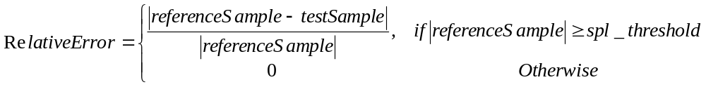
- Equation 45
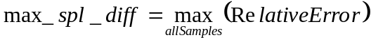
- Equation 46

Level | Relative Error |  | Rounded N Bits | Peak Error (max_diff)
QL1 | max_spl_diff | ≤ 0.001 | 16 | ≤ 4
QL1 | spl_threshold | = 4000 | 16 | ≤ 4
QL2 | max_spl_diff | ≤ 0.001 | 18 | ≤ 4
QL2 | spl_threshold | = 4000 | 18 | ≤ 4
QL3 | max_spl_diff | ≤ 0.0001 | 20 | ≤ 4
QL3 | spl_threshold | = 400 | 20 | ≤ 4
QL4 | max_spl_diff | ≤ 0.0001 | 24 | ≤ 4
QL4 | spl_threshold | = 400 | 24 | ≤ 4
Table 112 – 24-Bit (non-LBR and non-recon domain LBR) Accuracy Compliance Levels
Level | Relative Error |  | Rounded N Bits | Peak Error (max_diff)
QL1 | max_spl_diff | ≤ 0.001 | 16 | ≤ 4
QL1 | spl_threshold | = 4000 | 16 | ≤ 4
QL2 | max_spl_diff | ≤ 0.001 | 16 | ≤ 2
QL2 | spl_threshold | = 4000 | 16 | ≤ 2
QL3 | max_spl_diff | ≤ 0.0001 | 16 | ≤ 2
QL3 | spl_threshold | = 400 | 16 | ≤ 2
QL4 | max_spl_diff | ≤ 0.0001 | 16 | ≤ 2
QL4 | spl_threshold | = 400 | 16 | ≤ 2
Table 113 – 16-Bit (non-LBR and non-recon domain LBR) Accuracy Compliance Levels
Level | Relative Error |  | Rounded N Bits | Peak Error (max_diff)
All | max_spl_diff | ≤ 0.01 | 16 | ≤ 64
All | spl_threshold | = 4000 | 16 | ≤ 64
Table 114 – LBR v2/v3 (recon domain LBR) Accuracy Compliance Levels
LBR v2/v3 where recon domain processing is used (recon-domain frequency extension or channel extension) compliance allows the use of multistage conformance, where the reference decoded output can be inserted into the candidate decoder at certain points in the processing pipeline. This prevents the errors from one stage in the processing to affect future components. The conformance for LBR is given here as a guideline and may be modified. It will be specified in the IC test spec.

In addition, WMA Pro certification allows two levels of frequency accuracy in a compliant decoder.
There are two levels of compliance, HF and FF, based on frequency of reconstruction. In lower precision implementations, implementers can use the half-transforms to reduce the output sample rate, as mentioned in Table 115. Note that the operation of decoder in half-transform is not specified in this document.

HF (Sample Rate) |  | FF (Sample Rate)
Content | Decoded | Content | Decoded
44100 HZ | 44100 HZ | 44100 HZ | 44100 HZ
48000 HZ | 48000 HZ | 48000 HZ | 48000 Hz
88200 HZ | 44100 HZ | 88200 HZ | 88200 Hz
96000 HZ | 48000 HZ | 96000 HZ | 96000 Hz
Table 115 – WMA Pro Frequency Accuracy Compliance

The reference software and conformance bit streams can be obtained from Microsoft through licensing agreements.

Modes of Microsoft’s WMA Pro Version 10 Encoders
WMA Pro encoder in Series 10 can generate WMA Pro bit streams in a number of modes. A few additional modes were introduced in the encoder shipped as part of Windows Media Player 11 (WMA Pro Version 10 Encoder). These modes can be classified under these categories: constant bit rate streams (CBR) and variable bit rate streams (VBR). The syntax and decode process for either of them is the same. For all these modes, the encoder_options is currently 0xE0. That is, bV3RTM is false for all current streams. However, the decoders should be able to handle the cases when bV3RTM is true.

The CBR bit streams can be streamed over constant bit rate channels, and the conceptual (idealized) decoder buffer neither underflows nor overflows when the bitstream is streamed at that rate. These are listed in Table 116 and Table 117.

The VBR bitstream, in general, is assumed to be locally available. However, the ASF (or other mux) stream in this case includes information (or can be derived) to specify: 1) the peak bit rate when measured over a time window of “peak buffer size”, 2) average bit rate when measured over a time window of “average buffer size”, the complete file duration, 3) the maximum bit rate needed to stream (with stop and go), assuming a specified decoder buffer size. Thus, there are two bit rates specified in the ASF header: one bit rate to decide any syntactic elements of the bitstream, and the other bit rate to specify the true achieved average bit rate. Typical value of the peak buffer size is 1500 milliseconds at peak bit rate.

The VBR modes are split into two kinds, one pass (quality based VBR), and two pass (average bit-rate based VBR). The modes for the one pass VBR are listed in Table 118. The modes for the two pass VBR are listed in Table 119. The true achieved average bit rate is available in the ASF headers.

Table 116 CBR Modes in WMA Pro Versions 10 Encoders, in Audio-only streams
Mo-de  No | Bit rate, Kilo Bits Per Sec-  Ond | Bit rate (bits/sec) specified in the ASF Header | Actual Bit rate (bits/sec) | Samp-ling Rate | Num-  ber of Chan-nels | Valid Bits Per Sam-ple | Packet Size (Bytes) | Avg. Sam-ples Per Packet | Pac-kets Per Sec-ond | Buffer Size, in Sec-onds
1 | 32 | 32000 | 32000 | 32000 | 2 | 16 | 1536 | 12288 | 2.6 | 2.049
2 | 48 | 48024 | 48019 | 44100 | 2 | 16 | 2230 | 16384 | 2.7 | 3.065
3 | 64 | 64008 | 64018.2 | 44100 | 2 | 16 | 2731 | 16384 | 2.7 | 1.451
4 | 80 | 80024 | 80017.38 | 44100 | 2 | 16 | 3716 | 16384 | 2.7 | 1.579
5 | 96 | 96024 | 96016.6 | 44100 | 2 | 16 | 4459 | 16384 | 2.7 | 1.579
6 | 128 | 128016 | 128001.43 | 44100 | 2 | 16 | 5945 | 16384 | 2.7 | 1.579
7 | 128 | 128016 | 128014.9 | 44100 | 2 | 24 | 5945 | 16384 | 2.7 | 1.579
8 | 160 | 160016 | 160013.2 | 44100 | 2 | 16 | 7431 | 16384 | 2.7 | 1.579
9 | 192 | 192016 | 192011.6 | 44100 | 2 | 16 | 8917 | 16384 | 2.7 | 1.579
10 | 192 | 192016 | 192011.6 | 44100 | 2 | 24 | 8917 | 16384 | 2.7 | 1.579
11 | 256 | 256016 | 256008.3 | 44100 | 2 | 24 | 11889 | 16384 | 2.7 | 1.579
12 | 256 | 256016 | 256008.3 | 44100 | 2 | 16 | 11889 | 16384 | 2.6 | 1.579
13 | 384 | 384008 | 384001.6 | 44100 | 2 | 24 | 17833 | 16384 | 2.7 | 1.579
14 | 440 | 440016 | 440009.5 | 44100 | 2 | 24 | 20434 | 16384 | 2.7 | 1.579
15 | 128 | 128016 | 128014.9 | 44100 | 6 | 16 | 5945 | 16384 | 2.7 | 1.579
16 | 128 | 128016 | 128014.9 | 44100 | 6 | 24 | 5945 | 16384 | 2.7 | 1.579
17 | 192 | 192016 | 192011.6 | 44100 | 6 | 24 | 8917 | 16384 | 2.7 | 1.579
18 | 192 | 192016 | 192011.6 | 44100 | 6 | 16 | 8917 | 16384 | 2.7 | 1.579
19 | 256 | 256016 | 256008.3 | 44100 | 6 | 16 | 11889 | 16384 | 2.7 | 1.579
20 | 256 | 256016 | 256008.3 | 44100 | 6 | 24 | 11889 | 16384 | 2.7 | 1.579
21 | 384 | 384008 | 384001.6 | 44100 | 6 | 16 | 17833 | 16384 | 2.7 | 1.579
22 | 384 | 384008 | 384001.6 | 44100 | 6 | 24 | 17833 | 16384 | 2.7 | 1.579
23 | 440 | 440016 | 440009.5 | 44100 | 6 | 16 | 20434 | 16384 | 2.7 | 1.579
24 | 440 | 440016 | 440009.5 | 44100 | 6 | 24 | 20434 | 16384 | 2.7 | 1.579
25 | 640 | 640016 | 640009.9 | 44100 | 6 | 24 | 29722 | 16384 | 2.7 | 1.579
26 | 768 | 768008 | 768003.2 | 44100 | 6 | 24 | 35666 | 16384 | 2.7 | 1.579
27 | 48 | 48000 | 48000 | 48000 | 2 | 16 | 2048 | 16384 | 2.9 | 2.817
28 | 64 | 64008 | 64007.8 | 48000 | 2 | 16 | 2731 | 16384 | 2.9 | 1.451
29 | 80 | 80016 | 80015.6 | 48000 | 2 | 16 | 3414 | 16384 | 2.9 | 1.451
30 | 96 | 96000 | 96000 | 48000 | 2 | 16 | 4096 | 16384 | 2.9 | 1.451
31 | 127 | 127000 | 127000 | 48000 | 2 | 24 | 2032 | 6144 | 7.8 | 0.469
32 | 128 | 128016 | 128015.6 | 48000 | 2 | 16 | 5462 | 16384 | 2.9 | 1.451
33 | 128 | 128016 | 128015.6 | 48000 | 2 | 24 | 5462 | 16384 | 2.9 | 1.451
34 | 160 | 160008 | 160007.8 | 48000 | 2 | 16 | 6827 | 16384 | 2.9 | 1.451
35 | 191 | 191000 | 191000 | 48000 | 2 | 24 | 3056 | 6144 | 7.8 | 0.469
36 | 192 | 192000 | 192000 | 48000 | 2 | 16 | 8192 | 16384 | 2.9 | 1.451
37 | 192 | 192000 | 192000 | 48000 | 2 | 24 | 8192 | 16384 | 2.9 | 1.451
38 | 256 | 256008 | 256007.8 | 48000 | 2 | 16 | 10923 | 16384 | 2.9 | 1.451
39 | 256 | 256008 | 256007.8 | 48000 | 2 | 24 | 10923 | 16384 | 2.9 | 1.451
40 | 384 | 384000 | 384000 | 48000 | 2 | 24 | 16384 | 16384 | 2.9 | 1.451
41 | 440 | 440016 | 440015.6 | 48000 | 2 | 24 | 18774 | 16384 | 2.9 | 1.451
42 | 128 | 128016 | 128015.6 | 48000 | 6 | 16 | 5462 | 16384 | 2.9 | 1.451
43 | 128 | 128016 | 128015.6 | 48000 | 6 | 24 | 5462 | 16384 | 2.9 | 1.451
44 | 160 | 16008 | 160007.8 | 48000 | 6 | 16 | 6827 | 16384 | 2.9 | 1.451
45 | 192 | 192000 | 192000 | 48000 | 6 | 16 | 8192 | 16384 | 2.9 | 1.451
46 | 191 | 191000 | 191000 | 48000 | 6 | 24 | 3056 | 6144 | 7.8 | 0.469
47 | 192 | 192000 | 192000 | 48000 | 6 | 24 | 8192 | 16384 | 2.9 | 1.451
48 | 255 | 255000 | 255000 | 48000 | 6 | 24 | 3056 | 6144 | 7.8 | 0.469
49 | 256 | 256008 | 256007.8 | 48000 | 6 | 16 | 10923 | 16384 | 2.9 | 1.451
50 | 256 | 256008 | 256007.8 | 48000 | 6 | 24 | 10923 | 16384 | 2.9 | 1.451
51 | 383 | 383000 | 383000 | 48000 | 6 | 24 | 6128 | 6144 | 7.8 | 0.470
52 | 384 | 384000 | 384000 | 48000 | 6 | 16 | 16384 | 16384 | 2.9 | 1.451
53 | 384 | 384000 | 384000 | 48000 | 6 | 24 | 16384 | 16384 | 2.9 | 1.451
54 | 440 | 440016 | 440015.6 | 48000 | 6 | 16 | 18774 | 16384 | 2.9 | 1.451
55 | 440 | 440016 | 440015.6 | 48000 | 6 | 24 | 18774 | 16384 | 2.9 | 1.451
56 | 640 | 640008 | 640007.8 | 48000 | 6 | 24 | 27307 | 16384 | 2.9 | 1.451
57 | 768 | 768000 | 768000 | 48000 | 6 | 24 | 32768 | 16384 | 2.9 | 1.451
58 | 128 | 128016 | 128015.6 | 48000 | 8 | 16 | 5462 | 16384 | 2.9 | 1.451
59 | 160 | 160008 | 160007.8 | 48000 | 8 | 16 | 6827 | 16384 | 2.9 | 1.451
60 | 384 | 384000 | 384000 | 48000 | 8 | 24 | 16384 | 16384 | 2.9 | 1.451
61 | 768 | 768000 | 768000 | 48000 | 8 | 24 | 32768 | 16384 | 2.9 | 1.451
62 | 128 | 128016 | 128014.9 | 88200 | 2 | 24 | 5945 | 32768 | 2.7 | 1.579
63 | 192 | 192016 | 192011.6 | 88200 | 2 | 24 | 8917 | 32768 | 2.7 | 1.579
64 | 256 | 256016 | 256008.3 | 88200 | 2 | 24 | 11889 | 32768 | 2.7 | 1.579
65 | 384 | 384008 | 384001.6 | 88200 | 2 | 24 | 17833 | 32768 | 2.7 | 1.579
66 | 440 | 440016 | 440009.5 | 88200 | 2 | 24 | 20434 | 32768 | 2.7 | 1.579
67 | 128 | 128016 | 128015.6 | 96000 | 2 | 24 | 5462 | 32768 | 2.9 | 1.451
68 | 192 | 192000 | 192000 | 96000 | 2 | 24 | 8192 | 32768 | 2.9 | 1.451
69 | 256 | 256008 | 256007.8 | 96000 | 2 | 24 | 10923 | 32768 | 2.9 | 1.451
70 | 384 | 384000 | 384000 | 96000 | 2 | 24 | 16384 | 32768 | 2.9 | 1.451
71 | 440 | 440016 | 440015.6 | 96000 | 2 | 24 | 18774 | 32768 | 2.9 | 1.451
72 | 128 | 128016 | 128015.6 | 96000 | 6 | 24 | 5462 | 32768 | 2.9 | 1.451
73 | 192 | 192000 | 192000 | 96000 | 6 | 24 | 8192 | 32768 | 2.9 | 1.451
74 | 256 | 256008 | 256007.8 | 96000 | 6 | 24 | 10923 | 32768 | 2.9 | 1.451
75 | 384 | 384000 | 384000 | 96000 | 6 | 24 | 16384 | 32768 | 2.9 | 1.451
76 | 440 | 440016 | 440015.6 | 96000 | 6 | 24 | 18774 | 32768 | 2.9 | 1.451
77 | 640 | 640008 | 640007.8 | 96000 | 6 | 24 | 27307 | 32768 | 2.9 | 1.451
78 | 768 | 768000 | 768000 | 96000 | 6 | 24 | 32768 | 32768 | 2.9 | 1.451
79 | 768 | 768000 | 768000 | 96000 | 8 | 24 | 32768 | 32768 | 2.9 | 1.451

Table 117 CBR Modes in WMA Pro Version 10 Encoders, in Audio-And-Video (AV) streams
Mo-de  No | Bit rate, Kilo Bits Per Sec-  ond | Bit rate (bits/sec) specified in the ASF Header | Actual Bit rate (bits/sec) | Samp-ling Rate | Num-  ber of Chan-nels | Valid Bits Per Sam-ple | Packet Size (Bytes) | Avg. Sam-ples Per Pac-ket | Pac-kets Per Sec-ond | Buffer Size, in Sec-onds
1 | 128 | 128040 | 128036.43 | 44100 | 2 | 24 | 2973 | 8192 | 5.4 | 1.579
2 | 192 | 192040 | 192033.11 | 44100 | 2 | 24 | 4459 | 8192 | 5.4 | 1.579
3 | 256 | 256032 | 256029.79 | 44100 | 2 | 24 | 5945 | 8192 | 5.4 | 1.579
4 | 384 | 384024 | 384023.14 | 44100 | 2 | 24 | 8917 | 8192 | 5.4 | 1.579
5 | 440 | 440016 | 440009.47 | 44100 | 2 | 24 | 10217 | 8192 | 5.4 | 1.579
6 | 128 | 128040 | 128036.43 | 44100 | 6 | 16 | 2973 | 8192 | 5.4 | 1.579
7 | 128 | 128040 | 128036.43 | 44100 | 6 | 24 | 2973 | 8192 | 5.4 | 1.579
8 | 192 | 192040 | 192033.11 | 44100 | 6 | 24 | 4459 | 8192 | 5.4 | 1.579
9 | 192 | 192040 | 192033.11 | 44100 | 6 | 16 | 4459 | 8192 | 5.4 | 1.579
10 | 256 | 256032 | 256029.79 | 44100 | 6 | 16 | 5945 | 8192 | 5.4 | 1.579
11 | 256 | 256032 | 256029.79 | 44100 | 6 | 24 | 5945 | 8192 | 5.4 | 1.579
12 | 384 | 384024 | 384023.14 | 44100 | 6 | 16 | 8917 | 8192 | 5.4 | 1.579
13 | 384 | 384024 | 384023.14 | 44100 | 6 | 24 | 8917 | 8192 | 5.4 | 1.579
14 | 440 | 440016 | 440009.47 | 44100 | 6 | 16 | 10217 | 8192 | 5.4 | 1.579
15 | 440 | 440016 | 440009.47 | 44100 | 6 | 24 | 10217 | 8192 | 5.4 | 1.579
16 | 640 | 640016 | 640009.86 | 44100 | 6 | 24 | 14861 | 8192 | 5.4 | 1.579
17 | 768 | 768008 | 768003.22 | 44100 | 6 | 24 | 17833 | 8192 | 5.4 | 1.579
18 | 128 | 128016 | 128015.63 | 48000 | 2 | 24 | 2731 | 8192 | 5.9 | 1.451
19 | 192 | 192000 | 192000 | 48000 | 2 | 24 | 4096 | 8192 | 5.9 | 1.451
20 | 256 | 256032 | 256031.25 | 48000 | 2 | 24 | 5462 | 8192 | 5.9 | 1.451
21 | 384 | 384000 | 384000 | 48000 | 2 | 24 | 8192 | 8192 | 5.9 | 1.451
22 | 440 | 440016 | 440015.63 | 48000 | 2 | 24 | 9387 | 8192 | 5.9 | 1.451
23 | 128 | 128016 | 128015.63 | 48000 | 6 | 16 | 2731 | 8192 | 5.9 | 1.451
24 | 128 | 128016 | 128015.63 | 48000 | 6 | 24 | 2731 | 8192 | 5.9 | 1.451
25 | 192 | 192000 | 192000 | 48000 | 6 | 16 | 4096 | 8192 | 5.9 | 1.451
26 | 192 | 192000 | 192000 | 48000 | 6 | 24 | 4096 | 8192 | 5.9 | 1.451
27 | 256 | 256032 | 256031.25 | 48000 | 6 | 16 | 5462 | 8192 | 5.9 | 1.451
28 | 256 | 256032 | 256031.25 | 48000 | 6 | 24 | 5462 | 8192 | 5.9 | 1.451
29 | 384 | 384000 | 384000 | 48000 | 6 | 16 | 8192 | 8192 | 5.9 | 1.451
30 | 384 | 384000 | 384000 | 48000 | 6 | 24 | 8192 | 8192 | 5.9 | 1.451
31 | 440 | 440016 | 440015.63 | 48000 | 6 | 16 | 9387 | 8192 | 5.9 | 1.451
32 | 440 | 440016 | 440015.63 | 48000 | 6 | 24 | 9387 | 8192 | 5.9 | 1.451
33 | 640 | 640032 | 640031.25 | 48000 | 6 | 24 | 13654 | 8192 | 5.9 | 1.451
34 | 768 | 768000 | 768000 | 48000 | 6 | 24 | 16384 | 8192 | 5.9 | 1.451
35 | 384 | 384000 | 384000 | 48000 | 8 | 24 | 8192 | 8192 | 5.9 | 1.451
36 | 768 | 768000 | 768000 | 48000 | 8 | 24 | 16384 | 8192 | 5.9 | 1.451
37 | 128 | 128040 | 128036.43 | 88200 | 2 | 24 | 2973 | 16384 | 5.4 | 1.579
38 | 192 | 192040 | 192033.11 | 88200 | 2 | 24 | 4459 | 16384 | 5.4 | 1.579
39 | 256 | 256032 | 256029.79 | 88200 | 2 | 24 | 5945 | 16384 | 5.4 | 1.579
40 | 384 | 384024 | 384023.14 | 88200 | 2 | 24 | 8917 | 16384 | 5.4 | 1.579
41 | 440 | 440016 | 440009.47 | 88200 | 2 | 24 | 10217 | 16384 | 5.4 | 1.579
42 | 128 | 128016 | 128015.63 | 96000 | 2 | 24 | 2731 | 16384 | 5.9 | 1.451
43 | 192 | 192000 | 192000 | 96000 | 2 | 24 | 4096 | 16384 | 5.9 | 1.451
44 | 256 | 256032 | 256031.25 | 96000 | 2 | 24 | 5462 | 16384 | 5.9 | 1.451
45 | 384 | 384000 | 384000 | 96000 | 2 | 24 | 8192 | 16384 | 5.9 | 1.451
46 | 440 | 440016 | 440015.63 | 96000 | 2 | 24 | 9387 | 16384 | 5.9 | 1.451
47 | 128 | 128016 | 128015.63 | 96000 | 6 | 24 | 2731 | 16384 | 5.9 | 1.451
48 | 192 | 192000 | 192000 | 96000 | 6 | 24 | 4096 | 16384 | 5.9 | 1.451
49 | 256 | 256032 | 256031.25 | 96000 | 6 | 24 | 5462 | 16384 | 5.9 | 1.451
50 | 384 | 384000 | 384000 | 96000 | 6 | 24 | 8192 | 16384 | 5.9 | 1.451
51 | 440 | 440016 | 440015.63 | 96000 | 6 | 24 | 9387 | 16384 | 5.9 | 1.451
52 | 640 | 640032 | 640031.25 | 96000 | 6 | 24 | 13654 | 16384 | 5.9 | 1.451
53 | 768 | 768000 | 768000 | 96000 | 6 | 24 | 16384 | 16384 | 5.9 | 1.451
54 | 768 | 768000 | 768000 | 96000 | 8 | 24 | 16384 | 16384 | 5.9 | 1.451

Table 118 One Pass (Quality-Based) VBR Modes in WMA Pro Version 10 Encoders
Mode  No | Quality Setting | Bit rate (bits/sec) specified in the ASF Header | Sampling Rate | Num-  ber of Chan-nels | Valid Bits Per Sam-ple | Packet Size (Bytes)
1 | 10 | 64024 | 44100 | 2 | 24 | 2973
2 | 50 | 128016 | 44100 | 2 | 24 | 5945
3 | 25 | 128016 | 44100 | 2 | 24 | 5945
4 | 75 | 192016 | 44100 | 2 | 24 | 8917
5 | 90 | 256016 | 44100 | 2 | 24 | 11889
6 | 98 | 384008 | 44100 | 2 | 24 | 17833
7 | 10 | 128016 | 44100 | 6 | 16 | 5945
8 | 25 | 192016 | 44100 | 6 | 16 | 8917
9 | 50 | 256016 | 44100 | 6 | 16 | 11889
10 | 75 | 320008 | 44100 | 6 | 16 | 14861
11 | 98 | 384008 | 44100 | 6 | 16 | 17833
12 | 90 | 384008 | 44100 | 6 | 16 | 17833
13 | 10 | 64008 | 48000 | 2 | 24 | 2731
14 | 25 | 96000 | 48000 | 2 | 24 | 4096
15 | 50 | 128016 | 48000 | 2 | 24 | 5462
16 | 75 | 192000 | 48000 | 2 | 24 | 8192
17 | 90 | 256008 | 48000 | 2 | 24 | 10923
18 | 98 | 384000 | 48000 | 2 | 24 | 16384
19 | 10 | 128016 | 48000 | 6 | 24 | 5462
20 | 25 | 192000 | 48000 | 6 | 24 | 8192
21 | 75 | 256008 | 48000 | 6 | 24 | 10923
22 | 50 | 256008 | 48000 | 6 | 24 | 10923
23 | 98 | 384000 | 48000 | 6 | 24 | 16384
24 | 90 | 384000 | 48000 | 6 | 24 | 16384
25 | 75 | 192016 | 88200 | 2 | 24 | 8917
26 | 90 | 256016 | 88200 | 2 | 24 | 11889
27 | 98 | 384008 | 88200 | 2 | 24 | 17833
28 | 75 | 192000 | 96000 | 2 | 24 | 8192
29 | 90 | 256008 | 96000 | 2 | 24 | 10923
30 | 98 | 384000 | 96000 | 2 | 24 | 16384
31 | 75 | 256008 | 96000 | 6 | 24 | 10923
32 | 98 | 384000 | 96000 | 6 | 24 | 16384
33 | 90 | 384000 | 96000 | 6 | 24 | 16384

Table 119 Two Pass VBR Modes in WMA Pro Version 10 Encoders
Mode  No | Bit rate, Kilo Bits Per Sec-  ond | Bit rate (bits/sec) specified in the ASF Header | Sampling Rate | Num-  ber of Chan-nels | Valid Bits Per Sam-ple | Packet Size (Bytes)
1 | 48 | 48000 | 44100 | 2 | 16 | 2230
2 | 64 | 64000 | 44100 | 2 | 16 | 2973
3 | 128 | 128016 | 44100 | 2 | 24 | 5945
4 | 192 | 192016 | 44100 | 2 | 24 | 8917
5 | 256 | 256016 | 44100 | 2 | 24 | 11889
6 | 384 | 384008 | 44100 | 2 | 24 | 17833
7 | 440 | 440016 | 44100 | 2 | 24 | 20434
8 | 128 | 128016 | 44100 | 6 | 16 | 5945
9 | 192 | 192016 | 44100 | 6 | 16 | 8917
10 | 256 | 256016 | 44100 | 6 | 16 | 11889
11 | 384 | 384008 | 44100 | 6 | 16 | 17833
12 | 440 | 440016 | 44100 | 6 | 16 | 20434
13 | 640 | 640016 | 44100 | 6 | 24 | 29722
14 | 768 | 768008 | 44100 | 6 | 24 | 35666
15 | 128 | 128016 | 48000 | 2 | 24 | 5462
16 | 192 | 192000 | 48000 | 2 | 24 | 8192
17 | 256 | 256008 | 48000 | 2 | 24 | 10923
18 | 384 | 384000 | 48000 | 2 | 24 | 16384
19 | 440 | 440016 | 48000 | 2 | 24 | 18774
20 | 128 | 128016 | 48000 | 6 | 24 | 5462
21 | 192 | 192000 | 48000 | 6 | 24 | 8192
22 | 256 | 256008 | 48000 | 6 | 24 | 10923
23 | 384 | 384000 | 48000 | 6 | 24 | 16384
24 | 440 | 440016 | 48000 | 6 | 24 | 18774
25 | 640 | 640008 | 48000 | 6 | 24 | 27307
26 | 768 | 768000 | 48000 | 6 | 24 | 32768
27 | 128 | 128016 | 88200 | 2 | 24 | 5945
28 | 192 | 192016 | 88200 | 2 | 24 | 8917
29 | 256 | 256016 | 88200 | 2 | 24 | 11889
30 | 384 | 384008 | 88200 | 2 | 24 | 17833
31 | 440 | 440016 | 88200 | 2 | 24 | 20434
32 | 128 | 128016 | 96000 | 2 | 24 | 5462
33 | 192 | 192000 | 96000 | 2 | 24 | 8192
34 | 256 | 256008 | 96000 | 2 | 24 | 10923
35 | 384 | 384000 | 96000 | 2 | 24 | 16384
36 | 440 | 440016 | 96000 | 2 | 24 | 18774
37 | 128 | 128016 | 96000 | 6 | 24 | 5462
38 | 192 | 192000 | 96000 | 6 | 24 | 8192
39 | 256 | 256008 | 96000 | 6 | 24 | 10923
40 | 384 | 384000 | 96000 | 6 | 24 | 16384
41 | 440 | 440016 | 96000 | 6 | 24 | 18774
42 | 640 | 640008 | 96000 | 6 | 24 | 27307
43 | 768 | 768000 | 96000 | 6 | 24 | 32768

Additional Bitstream Constraints (Informative)
The syntax of WMA Pro does not place a constraint of maximum number of bits present in a compressed frame. However, to enable WMA Pro streams to be transferable over a SPDIF link, certain constraints have been placed in Microsoft’s WMA Pro encoder. These constraints are valid for all coding modes (one-pass, two-pass, CBR, VBR, peak constrained or not etc). A compliant decoder can not assume that all WMA Pro bitstreams would have such a constraint, so the numbers listed in Table 120 should be considered informative only.

Samples Per Frame | Maximum Number of Compressed Bits Per Frame | Notes
Greater than or Equal to 4096 | 130016. In Series 9.1, this was reduced to 84000. | If Number of Channels is more than 6
Greater than or Equal to 4096 | 65072 | If Number of Channels is less than or equal to 6
2048 | 65072
1024 | 32304
512 | 15920
Table 120 Maximum Number of Compressed Bits in a WMA Pro Stream

Glossary

abs_level | Quantized absolute level of a non-zero spectral coefficient.
allow_subframes | A Boolean flag indicating if subframes might occur in a bitstream.
anchor_quant_step_band_available | A Boolean value (per channel) indicates if an anchor quant_step_band has been decoded for a given channel in current frame.
API | Application programming interface.
ASF | Advanced Streaming Format.
Bark | The Bark is the standard unit (approximately) corresponding to one critical bandwidth of human hearing.
bark_index | An array containing indices transform coefficients that are approximately the boundaries of bark bands. Values depend on sampling rate and the transform window size (tile size).
BarkResamplingMatrix | A 2-D array used by WMA Pro to resample quant_step_band values from one window size to another.
bits_per_packet | WMA Pro packet size in bits, fixed for a given stream.
bitstream buffer | A buffer in a WMA Pro decoder for storage of compressed audio data. It smoothes fluctuations in compressed frame size.
bytes_per_second | The average compressed stream rate, in number of bytes per second.
channel down-mixing, channel fold-down | The process of morphing decoded data from a number of source channels to the number of speakers available for presentation.
channel group | A sub-set of channels in a tile for which a multi-channel transform defined.
channel_mask | A bit-packed double word (32-bits) indicating the “recommended” speaker positions for each source channel.
channel_transform | A linear transformation (squared array) on entropy decoded spectral coefficients to generate input to the next stage.
cPossibleWinSize | Maximum number of possible window sizes for any channel. Derived from encoder_options.
D_DRC_HIGH | DRC setting of high. Decoder does not modify output.
D_DRC_LOW | DRC setting of low. Decoder uses frame scale factors and overall dynamic range control to scale output. Dynamic range limited to one-half of target dynamic range.
D_DRC_MED | DRC setting of medium. Decoder uses frame scale factors and overall dynamic range control to scale output. Dynamic range limited to target dynamic range.
DCT-II | A particular type of discrete cosine transform used in the description of multi-channel transform.
DCT-IV | A particular type of discrete cosine transform used inside an MLT to de-correlate input samples.
DPCM | Differential Pulse Code Modulation.
drc_frame_scale_factor | The scale factor for DRC on frame-by-frame basis. This is encoded into the bitstream. When decoder setting is D_DRC_MED or D_DRC_LOW, then it is used in combination with overall scale factor.
encoder_options | A bit-packed word with values indicating if certain features of the bitstream are used or not.
escape code | A special symbol in bitstream indicating the presence of a run-level-sign triplet that cannot be represented using a single symbol present in a Huffman table.
fFrameSizeInHeader | Is size of compressed frame available in WMA Pro packet header?
fGenerateDRCParams | Should dynamic range control parameters be computed locally, or are they available in the bitstream on a per frame basis?
general_postproc_transform | Is the post-processing transform to be used generic, or bitstream definable?
Given’s factorization | A factorization of unitary transform using sine and cosines.
Huffman coding | A loss less variable length coding that is prefix-free and uniquely decodable.
huffman_table | A variable holding the name of Huffman table to be used during run-level decoding process.
iMaxSubFrameDiv | Maximum ratio between largest and smallest tile.
Inverse quantization | The process of recovering amplitudes from indices generated by a quantizer.
is_channel_coded | An array indicating if a channel is coded (or skipped).
iTile | A running counter of tiles within a frame.
iWin | Log2 of current window size-ratio.
log2_bits_per_packet | Number of bits to represent number of bits of the last frame started in previous packet, appearing in the current packet. Also used to represent compressed frame size in bits.
log2_samppfr | log2(samples_per_frame)
lossless_tile | A Boolean indicating that lossless coding is performed on the tile, rather than lossy coding.
LPC | Linear Predictive Coding
lpc_order | Length of LPC filter+1.
max_num_subframes | The maximum number of subframes for a channel in a frame. This value is useful in determining the memory that would have to be reserved.
max_quant_step_band | The maximum of quant_step_band for a given channel in a tile. Derived by processing quant_step_band.
MDCT | Modified discrete cosine transformation. Used to de-correlate input audio samples, and concentrate energy in as few coded transform as possible. Also called MLT.
MLT | Modulated Lapped Transform. Also called MDCT.
Multi-Channel Transformation | A technique used by WMA Pro to exploit inter-channel redundancy present in a source material.
new_packet_header | A signal from packet layer decoder indicating the beginning of a new packet.
Noise shaping | A technique used in WMA Pro to spread quantization noise across spectral coefficients to take advantage of the human auditory system and the actual content being compressed.
nSubWooferChannel | The numerical position of a sub-woofer channel in the source. A value of -1 is used if sub-woofer channel is absent in the source.
num_channels | The number of channels in the source material.
num_tiles | At the end of decoding a frame header, this value indicates the total number of tiles covering the frame.
packet_number | A sequence number that helps in detecting lost packets.
Payload | Data present in a packet, after the packet header.
PCM | Pulse Code Modulation. Fixed amplitude resolution digital representation of waveforms.
peak_amplitude_ref | The original peak amplitude in the source as a signed 16-bit integer from 0 to 32767.
peak_amplitude_target | The target peak amplitude of the source when drc setting is medium, as a signed 16-bit integer from 0 t 32767. In low drc setting, peak amplitude is limited so the dynamic range is one-half of target dynamic range in medium setting.
Post-processing transform | A mandatory (time-varying) linear channel mixing operation of decoded coefficients. This operation can create phantom channels at the decoder or perform other functions.
Quantization | Process of limiting the number of possible amplitudes, with intent to reduce the number of bits needed to represent the amplitude. Generates a finite value, finite precision symbol representation for input amplitude.
quant_incr0, quant_incr1 | Temporary variables used in decoding quant_step_*.
quant_step_band | The step size of the quantizer used to code spectral coefficients, in (quantized) decibel scale. This captures differential step size for each bark band of each channel in a tile.
quant_step_band_multiplier | The multiplier for quant_step_band to inverse quantize it.
quant_step_channel | The step size of the quantizer used to code spectral coefficients, in decibel scale. This captures differential step size for each channel in the tile.
quant_step_tile | The step size of the quantizer used to code spectral coefficients, in decibel scale. This captures overall step size for a tile.
rlc_symbol | The (run, |level|) pair decoded by VLC decoder. Used in spectral coefficient, as well as quantizer step size decoding.
rms_amplitude_ref | The original rms amplitude of the source as a signed 16-bit integer from 0 to 32767.
rms_amplitude_target | The target rms amplitude of the source during playback, when drc setting is medium or low, as a signed 16-bit integer from 0 to 32767.
rotation_angles | An array used in Givens factorization of channel_transform.
rotation_sign | An array used in Givens factorization of channel_transform.
run | The number of spectral coefficients (or other sequence of numbers) quantized to zero level preceding a non-zero level.
run-level coding | A variable length coding technique to efficiently represent quantized spectral coefficients (or other sequence of numbers) with long runs of zero values followed by non-zero value.
samples_per_frame | The maximum number of new time-samples generated by an inverse transform.
samples_per_second | The sample rate in Hz of the source material.
sampling_period | Inter-sample duration: reciprocal of samples per_second.
SDK | Software developers’ kit.
seekable_frame_in_packet | A Boolean indicating whether decoding (after a reset) can start from current packet.
seek_offset_in_bits | The number of bits of the last frame that started in previous packet, appearing in the current packet.
setOfTileChannels | A set of source channels that are members of a given tile.
sign_level | The sign of the quantized spectral coefficient (or other number being represented).
spliced_packet | If true, it indicates bitstream discontinuity.
subframes | Overlapping windows of MLT that encompass a frame of a channel.
subframe_config | An array of structures to hold windowing information for current frame, parts of previous frame, parts of next frame.
subframe_size_curr | The size of the current subframe (in number of transform coefficients per channel) for a given source channel.
subframe_size_prev | The size of the previous subframe (in number of transform coefficients per channel) in the bitstream for a given source channel.
subframe_size_curr | The size of the next (future) subframe (in number of transform coefficients per channel) in the bitstream for a given source channel.
subframe_start | The sample position of the current subframe in an audio frame for a given source channel.
subwoofer_cutoff_hz | Maximum bandwidth of the decoded sub-woofer channel, in Hertz.
subwoofer_cutoff_index | An array, whose values describe the index value above which subwoofer spectral coefficients are zeroed out. One value per window size is available.
Tile | Set of channel windows that have identical start and stop positions. That is, a set of windows that are co-sited in time in a given frame. Set members are source channel numbers. Tile properties (description) include tile size, start time, stop time, and channels present in the tile.
transform_type | The mode of description of channel_transform (e.g. pre-defined Hadamard, general etc).
uimsbf | Unsigned integer, most significant bit first.
validBitsPerSample | Indicates the size in bits of valid data portion in decoded sample per channel. It can either be 16 or 24 for this release of WMA Pro.
vec1_symbol | The symbol for a 1-dimensional scalar quantity in the vector Huffman decoder. If it is equal to escape value, then table-less code is used to decode level.
vec2_symbol | The symbol for a 2-dimensional vector in the vector Huffman decoder. If it is equal to the escape value, then the vector is decoded using 2, 1-d scalars.
vec4_symbol | The symbol for a 4-dimensional vector in the vector Huffman decoder. If it is equal to the escape value, then vector is decoded using 2, 2-d vectors.
version_number | The version of WMA Pro stream. It can only have a value of 3. Other version numbers indicate other syntaxes.
vlclbf | Variable length code, left bit first, where “left” refers to the order in which the VLC codes are written (or read).
Window Function | A mathematical function used in MLT and its inverse.
WMA | Windows media audio

“Discrete Cosine Transform,” K. R. Rao and P. Yip, Academic Press, 1990.
“Multirate systems and filter banks,” P. P. Vaidyanathan,” Prentice Hall, 1993, Chapter 14.6 Factorization of Unitary Matrices.

