WMA Lossless 9.0
Digital Media Division

An Overview of Windows Media Audio Lossless Decoding

Table of Contents

Table of Tables IV
Table of Figures VI
Audience and Disclaimer VII
Summary VII
1 Introduction 1
1.1 Notation 4
1.1.1 Arithmetic Operators 4
1.1.2 Logical Operators 4
1.1.3 Relational Operators 4
1.1.4 Bitwise Operators 5
1.1.5 Assignment 5
1.1.6 Mnemonics 5
1.1.7 How to Read the Bitstream Syntax? 5
2 Bitstream Syntax 8
2.1 Overall Decode Process 9
2.2 Packet Layer Decoder 11
2.3 Frame Layer Decoder 12
2.4 Syntax for Frame Header 13
2.5 Syntax for Frame Data 16
2.6 Syntax for Tile Header 17
2.7 Syntax for Tile Data 23
2.8 Parameter Definitions 26
3 Decoder Initialization 27
3.1 Is it WMA Lsl Bitstream? 27
3.2 Is it RTM Bitstream? 28
3.3 log2_bits_per_packet 28
3.4 samples_per_frame 28
3.5 Max Number of Subframes in One Frame 29
3.6 Unpack Other Encode Options 29
3.7 Initializing Data Structure for Lossless Codec 30
3.7.1 LPC Filter Structure 30
3.7.2 AC Filter Structure 30
3.7.3 MCLMS Filter Structure 30
3.7.4 LMS Filter Structure 31
3.7.5 Implementation Issue 31
3.8 channel_residues and channel_coeffs 31
3.9 Initializing Other Parameters 31
4 Packet Layer Decoding 33
5 Frame Layer Decoding 34
5.1 Frame Header Decoding 34
5.2 Tile Configuration in WMA Lsl 34
5.3 Decoding Tile Configuration 35
5.3.1 Tile Start Position 35
5.3.2 Skip Size Information 35
5.3.3 Determine Bits for Tile Size Description 35
5.3.4 Update Subframe Configuration of Tile Channels 36
6 Tile Layer Decoding 37
6.1 Initialization 37
6.2 Decoding Tile Header 37
6.2.1 Seekable or Non-seekable Tiles 37
6.2.2 Get New Codec Parameters at Seekable Tile 37
6.2.3 Raw PCM Tiles 38
6.2.4 RTM Bitstream and BETA Bitstream 38
6.3 Decoding Tile Data 38
6.3.1 Decode Raw Data in Raw PCM Tile 38
6.3.2 Decode Coefficient Residues (Golomb Code) 39
6.4 After Decoding a Tile 39
7 Reconstructing Audio Data 39
7.1 Revert CDLMS 40
7.2 Revert MCLMS 44
7.3 Revert inter channel decorrelation 47
7.4 Revert AC filter 47
7.5 Dequantization 48
7.6 Revert LPC filter 48
7.7 Removal of Silent Samples 49
8 Tables 51
8.1 Constants 51
8.2 Speaker positions (Informative) 51
9 Parameter Restrictions on Legal WMA Bitstreams & Compliant WMA Lsl Decoders 52
9.1 Legal WMA Lsl Version 9 Bitstreams 52
9.2 Maximum buffer size requirements 52
9.3 Compliant WMA LSL Version 9 Decoders 52
9.3.1 Measuring Compliance of Decoders 53
9.4 Modes of Microsoft’s WMA Lossless Version 9 Encoder 53
10 Glossary 54

Table of Tables

Table 1 Conditionals & loops in the syntax description 5
Table 2 Array notation 6
Table 3 Ceil of LOG2 Function 6
Table 4 Syntax of decode_packet_layer() 11
Table 5 Syntax of decode_packet() 12
Table 6 Syntax of decode_packet_header() 12
Table 7 Syntax of decode_frame_layer() 12
Table 8 Syntax of decode_frame_header () 13
Table 9 Syntax of decode_tile_configuration() 13
Table 10 Syntax of decode_silence_information() 15
Table 11 Syntax for Frame Data 16
Table 12 Syntax for Tile Header 17
Table 13 Decode codec parameters 18
Table 14 Syntax of decoding AC filter 19
Table 15 Syntax of decoding MCLMS 20
Table 16 Syntax of decoding CDLMS 21
Table 17 Syntax of decoding LPC Filter 22
Table 18 Syntax for Tile Data 23
Table 19 Syntax to decode channel coefficients in ram_pcm_tile 23
Table 20 Syntax to decode channel residues in normal tile (non ram_pcm_tile) 24
Table 21 LPC Buffers 30
Table 22 AC Buffers 30
Table 23 MCLMS Buffers 31
Table 24 LMS Buffers 31
Table 25 Reconstruct Tile PCM Samples 40
Table 26 Reverse the Cascaded LMS Prediction Process 40
Table 27 useHighUpdateSpeed Function 42
Table 28 useNormalUpdateSpeed Function 42
Table 29 lms_predict Function 43
Table 30 lms_update Function 43
Table 31 Revert multi channel LMS process 45
Table 32 Revert inter channel decorrelation 47
Table 33 Revert AC Filter 47
Table 34 acfilter_predict function 47
Table 35 Dequantization 48
Table 36 Revert LPC 48
Table 37 Constants used by the decoder 51
Table 38 Constants defining speaker positions for source channels 51
Table 39 Parameter limitations of WMA Lsl 9.0 legal bit streams 52
Table 40 WMA Lossless Profile/Level Summary 53
Table 41 WMA Lossless Version 9 Encoder Modes 53

Table of Figures

Figure 1 Windows Media Audio Lossless Encoder Block Diagram 2
Figure 2 Windows Media Audio Lossless Decoder Block Diagram 3
Figure 3 WMA-Lsl Packets in ASF Stream 10
Figure 4 Cascaded Packet and Frame Layer Decoders 11
Figure 5 Straddling Compressed Frame 17
Figure 6 Example of Tile Configuration of a frame in WMA Lsl (for 2 channels) where the current frame is partitioned into 4 tiles. 35
Figure 7 Seekable and Unseekable Frames. S means seekable and U means unseekable. 37
Figure 8 Transient Areas 42

Audience and Disclaimer
This document is MICROSOFT CONFIDENTIAL-- appropriate care should be taken when distributing copies. The intended audience is members of the Digital Media Division that need to know the details of Windows Media Audio Lossless Decoder. Others with special permissions from Microsoft Corp. may also read this document. Every attempt has been made to provide a complete and accurate description of the current WMA Lossless decoder in this document. However, Microsoft’s ANSI-C software implementation of the decoder is the real reference and this document merely tries to document it. In addition, Microsoft may modify its WMA Lossless decoder for improvements in the future. In case of any divergence or disputes, the reference software implementation shall prevail.
WMA Lossless decoder reuses (with or without modification) a lot of bitstream syntaxes and decoding processes in WMA Professional decoder such as packet layer decoding and most of the frame layer decoding. Therefore, many portions of this document are similar or identical to the corresponding portions in WMA Professional decoding document. But readers should always rely on the descriptions in this document for the WMA Lossless decoder.

Summary
This document provides an overview of functional blocks in a WMA Lossless decoder. It gives the syntax and semantics of the bitstream.

Introduction
The Windows Media Audio Lossless (WMA Lsl) system uses the linear prediction coding (LPC), least mean square algorithm (LMS), and Golomb coding to achieve its lossless compression. The WMA Lossless encoder and decoder systems are shown in Figure 1 and respectively. This document focuses on the WMA Lsl bitstream syntax and semantics, and describes the operation of the decoder.

Windows Media Audio Lossless (WMA Lossless) shares or reuses portions of WMA Pro bitstream syntax and decoder operations.

This section is organized as follows. Section 1.1 provides the mathematical operators used to describe the operation of the decoder. It also provides the method used to describe the bitstream syntax.

The remainder of this document is organized as follows. Section 2 gives the syntax of WMA Lsl bitstream. Section 3 describes the initialization of the decoder. Sections 4 through 7 describe the operation of the decoder. Section 8 gives the current limits on parameter values allowed in a legal WMA Lsl bitstream and requirements of a legal WMA Lsl decoder. Section 10 provides an overall glossary for this document.

Besides the decompression process described in this document, a WMA Lsl decoder might perform other functions, such as a rights management and various post-processing. These other functionalities are not documented here.

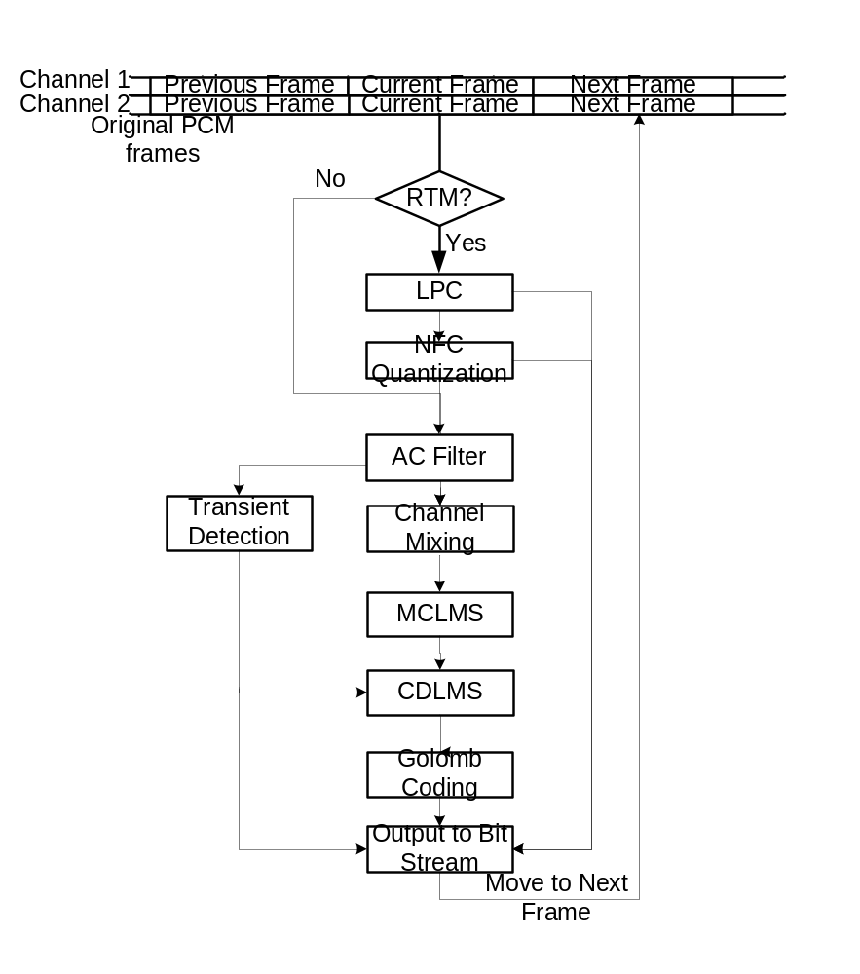
Figure 1 Windows Media Audio Lossless Encoder Block Diagram

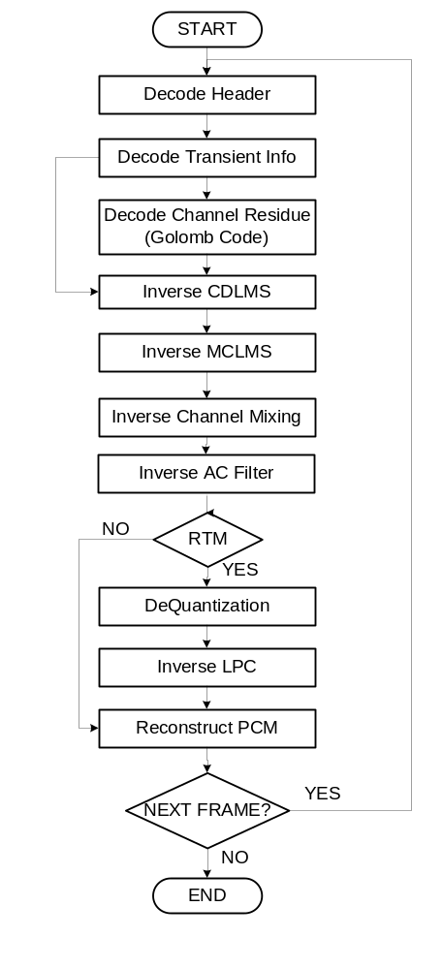

Figure 2 Windows Media Audio Lossless Decoder Block Diagram

Notation

Arithmetic Operators
+ | Addition.
− | Subtraction (as a binary operator) or negation (as a unary operator).
++ | Increment.
− − | Decrement.
* | Multiplication.
^ | Power.
/ | Integer or real division. If integer division, they are flagged as such. In this case, truncate the result toward zero. For example, 7/4 and −7/−4 are truncated to 1 and −7/4 and 7/−4 are truncated to −1.
// | Rest of the line is a comment.
| | | Absolute value.
 | | x | = x , when x > 0
 | | x | = 0, when x == 0
 | | x | = −x, when x < 0
% | Modulus operator. Defined only for positive numbers.
Sign( ) | Sign.
 | Sign(x) = 1, when x > 0
 | Sign(x) = 0, when x == 0
 | Sign(x) = −1, when x < 0
INT ( ) | Truncation to integer operator. Returns the integer part of the real-valued argument.
NINT ( ) | Nearest integer operator. Returns the nearest integer value to the real-valued argument. Half-integer values are rounded away from zero.
sin | Sine.
cos | Cosine.
max | Maximum of the arguments.
min | Minimum of the arguments.
exp | Exponential.
√ | Square root.
log2 | Logarithm to base 2.

Logical Operators
|| | Logical OR.
&& | Logical AND.
! | Logical NOT

Relational Operators
> | Greater than.
>= | Greater than or equal to.
< | Less than.
<= | Less than or equal to.
== | Equal to.
!= | Not equal to.

Bitwise Operators
A twos complement number representation is assumed where the bitwise operators are used.
& | AND
| | OR
>> | Shift right with sign extension.
<< | Shift left with zero fill.

Assignment
= | Assignment operator.

Mnemonics
The following mnemonics are defined to describe the different data types used in the coded bit stream.
Uimsbf | Unsigned integer, most significant bit first.
Imsbf | Signed integer, most significant bit first.
The byte order of multi-byte words is the same as network byte order: most significant byte first.

How to Read the Bitstream Syntax?
The syntax of a legal WMA Lsl bitstream is described in Section 2. The syntax description uses the following style. Each data item in the bit stream is in bold type, e.g. tile_aligned. Its length in bits, and a mnemonic for its type follows the data item’s name. The mnemonics used in this document are given in Section 1.1.6.

The action caused by a decoded data element in a bit stream depends on the value of that data element and on data elements previously decoded. The decoding of the data elements and the definition of the state variables used in their decoding are described in Sections through 5.

The language constructs used to describe the bitstream syntax are same as in ‘C’ language (cf. Table 1). The conditionals, branching etc are given in normal type. In the evaluation of the conditionals, we use the 'C'-code convention that a variable or expression evaluating to a non-zero value is equivalent to a condition that is TRUE.

Table 1 Conditionals & loops in the syntax description
while ( condition )  {  data_element0  . . .  } | if ( condition)  {  data_element3  . . .  }  else  {  data_element4  . . .  }
do  {  data_element1  . . .  } while ( condition ) | for (expr1; expr2; expr3)  {  data_element5  . . .  }
if ( condition)  {  data_element2  . . .  } | Functionx ()  {  data_element6  …  }

Just like in ‘C’, nested conditional constructs are allowed. For compactness, the {} may be omitted when only one data element follows. We use the following notation while describing the arrays. Note that when a particular element of an array is given in bold, e.g. data_element [m][n], that particular element value should be read from the bitstream, using the bit-length and type that are associated with the data element. On the other hand, if that element is given in normal font, e.g. data_element7 [m][n], its value should be used in a conditional or other valid “C” statement, and should not be decoded.

Table 2 Array notation
Syntax | Semantic
data_element [ ] | data_element [ ] is an array of data. The number of data elements is indicated by the context.
data_element [n] | data_element [n] is the n+1th element of an array of data.
data_element [m][n] | data_element [m][n] is the m+1, n+1 th element of a two-dimensional array of data.
data_element [l][m][n] | data_element [l][m][n] is the l+1, m+1, n+1 th element of a three-dimensional array of data.

Definition of Function bytealigned()
The function bytealigned ( ) returns 1 if the current position is on a byte boundary, that is the next bit in the bit stream is the first bit in a byte. Otherwise it returns 0.

Definition of Function data_available()
This function returns a value of ‘1’ as long as data is available, otherwise ‘0’.

Definition of Function LOG2(i)
int LOG2(unsigned int i)
{
unsigned int iLog2 = 0;
while ((i >> iLog2) > 1)
iLog2++;
Return iLog2;
}

Definition of Function CEILOFLOG2(i)
Table 3 Ceil of LOG2 Function
unsigned int CEILOFLOG2(unsigned int i)
{
unsigned int iCeilLog2
for (iCeilLog2 = 0; (1 << iCeilLog2) < i; iCeilLog2++);
return (iCeilLog2)
}

Definition of I32 I16
I32 is signed 32 bits integer and I16 is signed 16 bits integer.

Bitstream Syntax

Using the notation introduced in Section 1.1, this section provides the syntax of a legal WMA Lsl bitstream here. In particular, it defines a correct and error-free input bit stream. One should not assume that blindly following this syntax/semantic implements a satisfactory decoding procedure in all the cases. Actual decoders must include a means to recognize lost packets, a means to process users seek requests, as well as a means to present the decompressed data.

Interleaved in the bitstream syntax are hints to the decoding process. The decoding process itself is described in Sections through 5.

A WMA Lsl bitstream, in most cases, is present in advanced streaming format (ASF). The ASF is specified in a separate document available from Microsoft Corp. The following parameters are assumed to be available at the decoder through the ASF stream or otherwise:
- FormatTag, is the presented bitstream a WMA Lsl bitstream,
- samples_per_second, the sample rate in Hz of the source material,
- num_channels, the number of channels in the source material,
- bytes_per_second, the average compressed stream rate, in number of bytes per second,
- bits_per_packet, the fixed packet size, in bits,
- encoder_options, a bit-packed word with values indicating if certain features of the bitstream are used or not,
- bytes_per_sample, the container size for each decoded sample per channel (can either be 2 or 3),
- validBitsPerSample, that can either be 16 or 24, which indicates the size in bits of valid data portion in decoded sample per channel. Rest of the (least significant “8 * bytes_per_sample – validBitsPerSample”) bits in each output container are guaranteed to be zero.
- bitsPerSample, that can either be 16 or 24. bitsPerSample = ((validBitsPerSample + 7) >>3) * 8.
- channel_mask, a bit-packed double word indicating the “recommended” speaker positions for each source channel.

In addition, a number of playback parameters are also passed to the decoder at the initialization time:
- drc_setting, dynamic range control setting, which could be one of D_DRC_HIGH, D_DRC_MED, or D_DRC_LOW,
- peak_amplitude_ref, peak_amplitude_target, rms_amplitude_ref, rms_amplitude_target, all 32-bit integers to control dynamic range control.

Based on these parameter values, the following parameter values are computed, as described in Section 3, and are used in the bitstream parsing:

- version_number
- samples_per_frame,
- log2_bits_per_packet,
- allow_subframes,
- fFrameSizeInHeader,
- fGenerateDRCParams,
- cBitSize, and
- log2_samppfr.

Overall Decode Process
WMA Lsl Packets, in general, are embodied in ASF stream. However, it is possible that the WMA Lsl packets are embedded in other multiplex formats.

If WMA Lsl packets are embodied in ASF stream, multiple WMA Lsl packets could be embedded in one ASF packet, as shown in Figure 3. The details of ASF stream and its parsing are beyond the scope of this document. This document covers only WMA Lsl Packets.

ASF Header Section
ASF Data Section containing N ASF Packets each of which contain one or more payloads
Packet/Payload
Header
One or more WMA Lls Packets
Packet/Payload
Header
One or more WMA Lls Packets
Packet/Payload
Header
One or more WMA Lls Packets
WMA
Lls
Packet
Header
Frame 0
starts and may continue
on in subsequent WMA
Lls Packets
WMA
Lls
Packet
Header
More
Bits for
Frame
j-1
Frame j
starts and may
continue on in
subsequent WMA
Lls Packets
WMA
Lls
Packet
Header
More
Bits for
Frame
m-1
Frame m (last)
ends in the last
payload that
contains WMA
Lls Packets
WMA Lls
Packet
Sequence
number
4-bits
seekable?
1-bit
WMA Lls
Packet
Bit Offset To
Beginning of
Next Frame
More Bits for Frame j-1
Frame j starts here and may continue on in subsequent WMA Lls Packets.
ASF File:
Spiced
packet?
1-bit
Figure 3 WMA-Lsl Packets in ASF Stream

The decoding process happens in two stages: depacketization, followed by frame decoding, as shown in Figure 4. The packet layer decoder feeds bits to the frame layer decoder. A frame refers to a constant number of samples of audio. The number of compressed bits representing a frame varies over time.

WMA Lls
Bitstream

Packet Layer

Decoder

Raw Bits

Frame Layer

Decoder

Audio Samples

Bitstream
Buffer

new_packet_header

Figure 4 Cascaded Packet and Frame Layer Decoders
Syntax to follow in each layer appears next.

Packet Layer Decoder
Table 4 Syntax of decode_packet_layer()
Syntax | # bits | Notes
decode_packet_layer()
{
initialize(); |  | Section 3
while (data_available())
{
decode_packet();
}
}

Table 5 Syntax of decode_packet()
Syntax | # bits | Notes
decode_packet()
{
new_packet_header = 1;
decode_packet_header();
// Send remaining (payload) bits in the packet to
// frame layer to be decoded.
}

Table 6 Syntax of decode_packet_header()
Syntax | No of bits | Notes
decode_packet_header()
{
packet_number | 4 | uimsbf
seekable_frame_in_packet | 1 | uimsbf
spliced_packet | 1 | uimsbf
seek_offset_in_bits | log2_bits_per_packet+1 | Section 3.2
}

Frame Layer Decoder
This layer listens to the packet layer decoder, and calls decode_frame() continuously.

Table 7 Syntax of decode_frame_layer()
Syntax | # bits | Notes
decode_frame_layer()
{
while (data_available())
{
decode_frame_header ();
decode_frame_data ();
if (!more_frames_in_this_packet)  move on to next packet. |  | decode_frame  _data can change this flag
}
}

Syntax for Frame Header
Table 8 Syntax of decode_frame_header ()
Syntax | # bits | Notes
decode_frame_header()
{
// Perform initialization |  | Section 5.1
if (fFrameSizeInHeader) |  | Section 3.6
compressed_frame_size_bits | log2_bits_  per_packet+1 | Section 3.3
decode_tile_configuration ();
if (fGenerateDRCParams) |  | Section 3.6
drc_frame_scale_factor | 8 | uimsbf
decode_silence_information(); |  | Table 10
}

Table 9 Syntax of decode_tile_configuration()
Syntax | # bits | Notes
decode_tile_configuration() |  | Sections 5.2, 5.3
{
if (!allow_subframes)
{
// Nothing to decode from bitstream
int iCh;// One subframe
num_tiles = 1;
for (iCh = 0;
iCh < num_channels; iCh++)
{
subframe_config[iCh].num_subframes = 1;
subframe_config[iCh].subframe_start [0] = 0;
subframe_config[iCh].subframe_size [0] =
samples_per_frame;
}
tile_start[0] = 0;
tile_size[0] = samples_per_frame;
}
else
{
tile_aligned | 1 | uimsbf
int samples_left = samples_per_frame * num_channels;
num_tiles = 0;
while (samples_left > 0)
{
// Compute tileStartPosition
computeTileStartPosition(); |  | Section 5.3.1
// Determine set of possible channels in the tile &
// count number of such channels
bool skip_size = (samples_per_frame-tileStartPosition)  == samples_per_smallest_window; |  | Section 5.3.2
if (skip_size)
tile_sizes[num_tiles] =
samples_per_smallest_window;
else
{
// compute cBitSize
int tile_size_shift;
cBitSize = determineBitsForTileSize(); |  | Section 5.3.3
tile_size_ratio | cBitSize | uimsbf
tile_sizes[num_tiles] = samples_per_smallest_window *
(tile_size_scale + 1);
}
samples_left = samples_left –
num_channels * tile_sizes[num_tiles];
updateSubframeConfigOfChannels(); |  | Section 5.3.4
num_tiles=num_tiles+1;
} // while (samples_left > 0)
}
}
Note: In WMA Lsl bitstream, tile_align must be true. If it is false, decoder should report corrupted bitstream and reset. That bit is inherited from WMA Pro and has no use in WMA Lsl.

The sign extension is done through the small function:

Table 10 Syntax of decode_silence_information()
Syntax | # bits | Notes
decode_silence_information()
{
leading_silence_samples = 0;
trailing_silence_samples = 0;
silence_info_present | 1 | uimsbf
if (silence_info_present)
{
leading_silence_info_present | 1 | uimsbf
if (leading_silence_info_present)
leading_silence_samples | log2_samppfr+1 | uimsbf
trailing_silence_info_present | 1 | uimsbf
if (trailing_silence_info_present)
trailing_silence_samples | log2_samppfr+1 | uimsbf
}
}
Note: In WMA Lsl bitstream, leading_silence_info_present is always false. That bit is inherited from WMA Pro and is useless in WMA Lsl.

Syntax for Frame Data

Table 11 Syntax for Frame Data
Syntax | # bits | Notes
decode_frame_data()
{
int iTile;
for (iTile = 0;
iTile < num_tiles; iTile++)
{
tile_size = tile_sizes[iTile];
decode_tile_header(); |  | Table 12
decode_tile_data(); |  | Table 18
}
Do
{
more_stuff_bits | 1 | uimsbf
} while (!more_stuff_bits);
more_frames_in_this_packet | 1 | uimsbf
}
Note: The bit more_frames_in_this_packet refers to the packet where the current compressed frame started (i.e. where its frame header started). If this bit is 0, then there are no more frames that start in the packet where the current frame has started. If this bit is 1, then one or more compressed frames start in that packet.

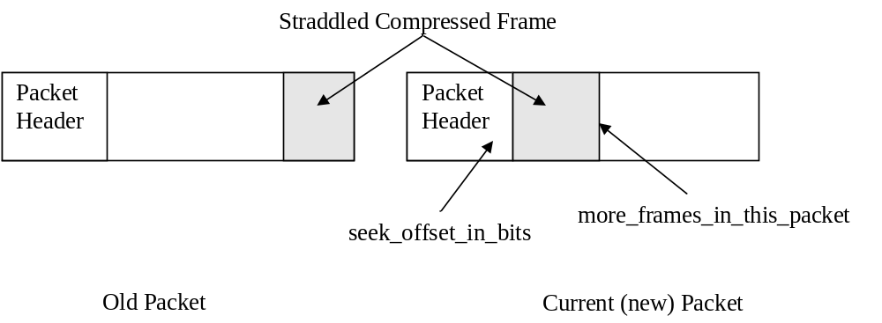
Figure 5 Straddling Compressed Frame
As a rule, if the current frame is straddling across packets (Figure 5), more_frames_in_this_packet is zero. In this straddled frame case, to determine if there are any more compressed frames in the current (new) packet, the following logic is used.

The seek_offset_in_bits field present in the current (new) packet header indicates where the next compressed frame begins. If this offset is inside the current packet, there are more valid compressed frames in the current packet. If on the other hand, the seek_offset_in_bits points to outside the current packet, the remainder of the current packet is all stuffing, and should be skipped over. This logic is valid irrespective of whether the seekable_frame_in_packet in the current packet header is 0 or 1.

Syntax for Tile Header
Table 12 Syntax for Tile Header
Syntax | # bits | Notes
decode_tile_header() |  | Section 6.2
{
seekable_tile // Is this tile seekable? | 1 | uimsbf
if (seekable_tile) {
clear_codec_buffers (); |  | Section 6.2.2
decode_codec_paras (); |  | Table 13
reset_codec (); |  | Section 6.2.2
}
rawpcm_tile | 1 | Uimsbf
if (rawpcm_tile)
{
for (iCh = 0; iCh < num_channels; iCh++)
{
is_channel_coded[iCh] = 1;
}
}
for (iCh = 0; iCh < num_channels; iCh++)
{
is_channel_coded[iCh] | 1 | uimsbf
} | 1 | uimsbf
if (bV3RTM)
{
do_lpc | 1 | uimsbf
if (do_lpc)
{
decode_lpc (); |  | Table 17
}
}
padding_zeros | 1 | uimsbf
if (padding_zeros)
{
padding_zeros | 5 | uimsbf
}
}
Note: In WMA Lsl, do_arithmetic_coding is always 0. If a value of 1 is received, it indicates bitstream corruption, and the decoder should act accordingly.

Table 13 Decode codec parameters
syntax | # bits | notes
decode_codec_para ()
{
do_arithmetic_coding // Is this tile coded by arithmetic coding? | 1 | uimsbf
do_acfilter // Is the AC filter involved? | 1 | uimsbf
do_inter_ch_decorr //Is the inter channel decorrelation used? | 1 | uimsbf
do_mclms // Is multi channel LMS used? | 1 | uimsbf
if (do_ac_filter)
{
decode_acfilter (); |  | Table 14
}
if (do_mclms)
{
decode_mclms (); |  | Table 15
}
decode_cdlms (); |  | Table 16
movave_scaling | 3 | uimsbf
quan_stepsize | 8 | uimsbf
quan_stepsize++;
}

Table 14 Syntax of decoding AC filter
syntax | # bits | notes
decode_acfilter ()
{
acfilter_order //AC filter order | 4 | uimsbf
acfilter_order++;
acfilter_scaling //AC filter scaling | 4 | uimsbf
for (iCoef = 0; iCoef < acfilter_order; iCoef++)
{
acfilter_coeffs[iCoef] // AC filter coefficients | acfilter_scaling | uimsbf
acfilter_coeffs[iCoef]++;
}
}

Table 15 Syntax of decoding MCLMS
syntax | # bits | notes
decode_mclms ()
{
mclms_order // Multi channel LMS filter order | 4 | uimsbf
mclms_order = (mclms_order + 1) * 2;
mclms_scaling // Multi channel LMS filter scaling | 4 | uimsbf
mclms_send_coef // Filter coefficients in bitstream? | 1 | uimsbf
if (mclms_send_coef)
{
int cBits, iShiftL, iShiftR;
cBits = LOG2(mclms_scaling + 1);
if ((1 << cBits) < (mclms_scaling + 1))
{
cBits++;
}
mclms_send_coef_bits | cBits | uimsbf
mclms_send_coef_bits += 2;
for (iCoef = 0; iCoef < mclms_order * num_channels
* num_channels; iCoef++)
{
mclms_coeffs[iCoef] | mclms_send_coef_bits | uimsbf
mclms_coeffs[iCoef] = ((mclms_coeffs[iCoef] << iShiftL)
>> iShiftR);
}
for (iCh = 0; iCh < num_channels; iCh)
{
for (iCoef = 0; iCoef < iCh; iCoef++)
{
mclms_coeffs_curr[iCh * num_channels + iCoef] | mclms_send_coef_bits | uimsbf
mclms_coeffs_curr[iCh * num_channels + iCoef] <<= iShiftL
mclms_coeffs_curr[iCh * num_channels + iCoef] >>= iShiftR
}
}
}
}

Table 16 Syntax of decoding CDLMS

Syntax | # bits | Notes
decode_cdlms ()
{
cdlms_send_coef | 1 | uimsbf
for (iCh = 0; iCh < num_channels; iCh++)
{
cdlms_ttl[iCh] | 3 | uimsbf
cdlms_ttl[iCh]++;
for (iLms = 0; iLms < cdlms_ttl[iCh]; iLms++)
{
cdlms[iCh][iLms].order | 7 | uimsbf
cdlms[iCh][iLms].order = (cdlms[iCh][ilms].order + 1) * 8
}
for (lLms = 0; iLms < cdlms_ttl[iCh]; iLms++)
{
cdlms[iCh][iLms].scaling | 4 | uimsbf
}
if (cdlms_send_coef)
{
for (iLms = 0; iLms < cdlms_ttl[iCh]; iLms++)
{
int cBits, iShiftL, iShiftR;
cBits = LOG2(cdlms[iCh][iLms].order);
if ((1 << cBits) < cdlms[iCh][iLms].order)
cBits++;
cdlms[iCh][iLms].coefsend | cBits | uimsbf
cdlms[iCh][iLms].coefsend++;
cBits = LOG2(cdlms[iCh][iLms].scaling + 1);
if ((1 << cBits) < (cdlms[iCh][iLms].scaling + 1))
cBits++;
cdlms[iCh][iLms].bitsend | cBits | uimsbf
cdlms[iCh][iLms].bitsend += 2;
iShiftL = 32 – cdlms[iCh][iLms].bitsend;
iShiftR = 32 - 2 – cdlms[iCh][iLms].scaling;
for (iCoef = 0; iCoef < cdlms[iCh][iLms].coefsend; iCoef++)
{
cdlms[iCh][iLms].coefs[iCoef] | cdlms[iCh][iLms].bitsend | uimsbf
cdlms[iCh][iLms].coefs[iCoef] <<= iShiftL;
cdlms[iCh][iLms].coefs[iCoef] >>= iShiftR;
}
}
}
}
}
Note: cdlms[iCh][iLms] means the iLmsth LMS filter in the iChth channel.

Table 17 Syntax of decoding LPC Filter
Syntax | # bits | notes
decode_lpc ()
{
{
lpc_order | 5 | uimsbf
lpc_order++;
lpc_scaling | 4 | uimsbf
lpc_intbits | 3 | uimsbf
lpc_intbits++;
for (iCh = 0; iCh < num_channels; iCh++)
{
for (iCoef = 0; iCoef < lpc_order; iCoef++)
{
cBits = lpc_scaling + lpc_intbits;
lpc_coefs[iCh][iCoef] | cBits | imsbf
}
}
}
}

Syntax for Tile Data
Table 18 Syntax for Tile Data
Syntax | # bits | Notes
decode_tile_data ()
{
if (rampcm_tile)
{
for (iCh = 0; iCh < num_channels; iCh++)
{
if (is_channel_coded[iCh])
decode_channel_coefficients_rawpcm (); |  | Table 19
}
}
else
{
for (iCh = 0; iCh < num_channels; iCh++)
{
if (is_channel_coded[iCh])
decode_channel_residues (); |  | Table 20
}
}
}

Table 19 Syntax to decode channel coefficients in ram_pcm_tile
Syntax | # bits | Notes
decode_channel_coefficients_rawpcm ()
{
int index=0;
int tile_size = tile_sizes[iTile];
for (iCoef = 0; iCoef < tile_size; iCoef++)
{
int cBits = validBitsPerSample – padding_zeros;
channel_coeffs[iCh][iCoef] | cBits | imsbf
}
}

Table 20 Syntax to decode channel residues in normal tile (non ram_pcm_tile)
Syntax | # bits | Notes
decode_channel_residues ()
{
int index=0;
int tile_size = tile_size[iTile];
transient[iCh] | 1 | uimsbf
if (transient)
{
transient_pos[iCh] | LOG2(tile_size) | uimsbf
}
if (seekable_tile)
{
ave_mean | validBitsPerSample | uimsbf
ave_sum[iCh] = ave_mean * << movave_scaling
ave_sum[iCh] = ave_sum[iCh] * 2;
}
if (seekable_tile)
{
iCoef = 0;
if (iCoef == 0)
{
if (do_inter_ch_decorr)
channel_residues[iCh][iCoef] | validBitsPerSample + 1 | imsbf
else
channel_residues[iCh][iCoef] | validBitsPerSample | imsbf
iCoef++;
}
for (iCoef; iCoef < tile_size; iCoef++)
{
int quo = 0;
while (1)
{
bit | 1 | uimsbf
if (bit)
quo++;
else
break;
}
if (quo == 32)
{
quobits | 5 | uimsbf
quobits++;
quo | quobits | uimsbf
}
ave_mean = (ave_sum[iCh] + (1 << movave_scaling) / 2)
>> movave_scaling;
idivPow2 = CEILOFLOG2(ave_mean);
rem | iDivPow2 | uimsbf
residue = (quo << idivPow2) + rem;
ave_sum[iCh] = residue + ave_sum[iCh]
– (ave_sum[iCh] >> movave_scaling);
if (residue & 0x1)
residue = -(residue >> 1) – 1;
else
residue = residue >> 1;
channel_residue[iCh][iCoef] = residue;
}
}
}

Parameter Definitions
To be populated further.
abs_level | Quantized absolute level of a non-zero coefficient. Used for band quantization steps as well as spectral coefficients.
allow_subframes | A boolean flag indicating if subframes might occur in a bitstream.
bitstream buffer | A buffer in a WMA lossless decoder for storage of compressed audio data.
bytes_per_second | The average compressed stream rate, in number of bytes per second.
encoder_options | A bit-packed word with values indicating if certain features of the bitstream are used or not.
is_channel_coded | An array indicating if a channel is coded (or spectral coefs skipped).
num_channels | The number of channels in the source material.
packet_number | A sequence number that helps in detecting lost packets.
payload | Data present in a packet, after the packet header.
samples_per_frame | The maximum number of new time-samples generated by an inverse transform.
samples_per_second | The sample rate in Hz of the source material.
sign_level | The sign of the quantized coefficient.
Imsbf | Signed integer, most significant bit first.
uimsbf | Unsigned integer, most significant bit first.
version_number | The version of WMA stream. WMA Lsl requires the version number to be 3.

Decoder Initialization
A WMA Lsl bitstream, in general, is present in advanced streaming format (ASF). The ASF is specified in a separate document. The following parameters are assumed to be available at the decoder through the ASF or other container stream:

- FormatTag. FormatTag indicate the bitstream is WMA Std, WMA Pro, or WMA Lsl. But both WMA Pro and WMA Lsl have version_number 3 and they use another variable bPureLossless to separate them.
- samples_per_second, the sample rate in Hz of the source material,
- num_channels, the number of channels in the source material,
- bytes_per_second, the average compressed stream rate, in number of bytes per second,
- bits_per_packet, the fixed packet size, in bits,
- encoder_options, a bit-packed word with values indicating if certain features of the bitstream are used or not,
- bytes_per_sample, the container size for each decoded sample per channel (can either be 2 or 3),
- validBitsPerSample, that can either be 16 or 24, which indicates the size in bits of valid data portion in decoded sample per channel. Rest of the (least significant “8 * bytes_per_sample – validBitsPerSample”) bits in each output container must be made zero by the decoder,
- channel_mask, a bit-packed double word indicating the “recommended” speaker positions for each source channel.

Based on these parameter values, a few additional parameters used in the decoding process are derived, as described below.

Is it WMA Lsl Bitstream?
FormatTag decoded from ASF stream tells the kind of the WMA bitstream it embodies. FormatTag 0x161 is WMA Std, 0x162 is WMA Pro, and 0x163 is WMA Lsl. But the WMA Lsl has another bit in encoder_option to express it is WMA Lsl if FormatTag is 0x162 or 0x163:

if (FormatTag == 0x163)
{
version_number = 3;
bPureLossless = TRUE;
}

if (FormatTag == 0x162 || FormatTag == 0x163)
{
version_number = 3;
bPureLossless = (encoder_options & D_ENCOPT3_PURE_LOSSLESS) ?
true : false;
}

Is it RTM Bitstream?
There is one bit in encoder_options to indicate if the WMA Lsl bitstream is RTM bitstream or BETA bitstream. That bit is used for a historic reason: the WMA Lsl bitstream syntax had to be enhanced marginally after the beta release. However, all the WMA Lsl bitstreams produced by the series 9 encoders (BETA as well as RTM) have bV3RTM value of 0. That means the final series 9 encoder did not turn that RTM bit on. But future encoders could generate bitstreams with bV3RTM value of 1.

if (encoder_options & ENCOPT3_RTMBITS)
bV3RTM = 1;

log2_bits_per_packet
This value is constant for the given bitstream, and is used in packet header decoding and frame-seek operation.
Equation 1

samples_per_frame
WMA Lsl codec processes the PCM samples frame by frame. The encoder first segments the PCM sequence (source material) evenly into frames. Each frame contains fixed number of samples from every channel and the number of samples in each channel is samples_per_frame. Its value is derived from the sampling rate of the source material samples_per_second in WMA Lsl through Equation 2.
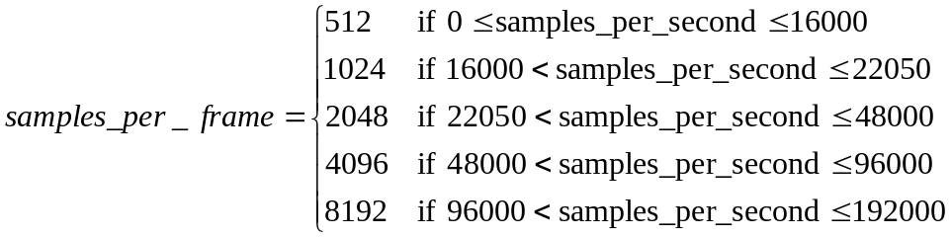
Equation 2
Then, samples_per_frame is modified based on encoder_options:
Equation 3
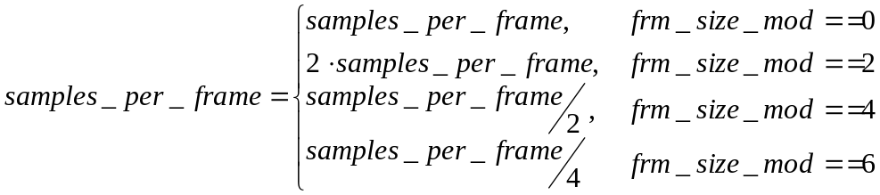
Equation 4

Sampling period is computed as:

Equation 5

Another quantity that depends on samples_per_frame is log2_samppfr:

.
Equation 6

Max Number of Subframes in One Frame
The maximum number of possible window sizes for any channel is specified in encoder_options, as follows:

iMaxSubFrameDiv = 1 << ((encoder_options & D_ENCOPT3_SUBFRM_DIV) >> 3);
samples_per_smallest_window = samples_per_frame/iMaxSubFrameDiv;
max_num_subframes = iMaxSubFrameDiv;
allow_subframes = (iMaxSubFrameDiv > 1) ? 1 : 0;

Unpack Other Encode Options
Other parts of encoder_options are split into multiple Booleans:

fFrameSizeInHeader = encoder_options & D_ENCOPT3_WRITE_FRAMESIZE_IN_HDR
fGenerateDRCParams = encoder_options & D_ENCOPT3_GENERATE_DRC_PARAMS

Initializing Data Structure for Lossless Codec
The WMA Lsl relies on linear prediction coding (LPC), multichannel least mean square (MCLMS), and cascaded least mean squares (CDLMS) filters to remove the redundancy in audio signal. Those filters are cascaded to get optimal compression performance. We call the value being processed by filters as channel_coeffs. At the first stage, the input of the LPC filter is just the channel PCM samples. The fundamental idea of all these methods is time domain prediction. Basically, the current coefficient channel_coeffs[iCh][iCoef] is predicted from previous coefficients channel_coeffs[iCh][iCoef – k] and the prediction error is passed to the next stage or encoded in the bitstream at the last stage. In decoder side, a reverse process is done. Basically, the prediction is done as same as encoder side, then the prediction error is added back to the predicted value to recover the original value. Therefore, in decoder, for each of the filters, two buffers are defines. One is filter_prevvalues which saves previous coefficients for the purpose of the prediction and the other is filter_coeffs which saves the filter coefficients. In LMS and MCLMS filters, more buffers need to be defined since they are adaptive filters.

LPC Filter Structure

LPC filter has two buffers. lpc_coeffs saves the filter coefficient and lpc_prevalues saves the previous channel_coeff value. Their type and length are shown in Table 21.

Table 21 LPC Buffers
 | type | length
lpc_coeffs | I32 | 40
lpc_prevalues | I32 | 40

AC Filter Structure
AC filter is actually a simple LPC filter. It maintains two buffers. One is for filter coefficients and the other is for previous values. Their types and length are shown in Table 22.

Table 22 AC Buffers
 | type | length
acfilter_coeffs | I32 | 16
acfilter_prevalues | I32 | 16

MCLMS Filter Structure
MCLMS has four buffers which are updated after every sample prediction. They are mclms_prevalues, mclms_coeffs, mclms_coeffs_curr, and mclms_update. Table 23 MCLMS Buffers shows the length and the type of those buffers.

Table 23 MCLMS Buffers
 | Type | length
mclms_prevalues | I32 – 24bits audio  I16 – 16bits audio | 8 * num_channels * 2
mclms_coeffs | I16 | 8 * num_channels * num_channels
mclms_coeffs_curr | I16 | num_channels * num_channels
mclms_updates | I16 | 8 * num_channels *2

LMS Filter Structure

Each LMS filter in CDLMS structure holds three buffers which are updated after every sample prediction. They are lms_prevvalues, lms_coeffs, and lms_updates. Their length and type are illustrated in Table 24. Since each channel can have multiple LMS filters, in Table 16 we actually use cdlms[iCh][iLms] to represent one LMS filter. Therefore, the corresponding buffer names are cdlms[iCh][iLms].prevalues, cdlms[iCh][iLms].coeffs, and cdlms[iCh][iLms].updates, respectively.

Table 24 LMS Buffers
 | Type | length
lms_prevalues | I32 – 24bits audio  I16 – 16bits audio | 256 * 2
lms_coeffs | I16 | 256
lms_updates | I16 | 256 * 2

Implementation Issue

In lossless compression, the representation of the data and the computation must be defined in detail, since the perfect reconstruction is required. Therefore, when implementing the decoder, all filter buffers’ type and length should be exactly as same as those of the reference decoder described in this document.

In codec initialization, all filter buffers are cleared to zero.

channel_residues and channel_coeffs
channel_residues and channel_coeffs buffer are defined which are used by each tile (Section 5.2). The new tile overwrites the previous tile’s content.

channel_residues[iCh][iCoef] means the (iCoef + 1)th coefficient in the current tile’s (iCh + 1)th channel.

Initializing Other Parameters
Other parameters are initialized as shown here. The same is done whenever a bitstream error is encountered.
new_packet_header = 0;
postproc_transform = 0;
for (iCh = 0; iCh < num_channels; iCh++)
{
subframe_size_curr[iCh] = samples_per_frame;
subframe_config[iCh].num_subframes = 1;
subframe_config[iCh].subframe_start[0] = 0;
subframe_config[iCh].subframe_size[0] =
samples_per_frame;
curr_coef_position[iCh] = 0;
}
This is followed by seeking to next seekable packet, and seeking to first frame in seekable packet, as described in Section 4.

Packet Layer Decoding
The packet size is fixed for a given WMA bitstream, and is known ahead of time, outside of the WMA bitstream. A packet can contain multiple compressed frames. Similarly, the last frame in a packet can straddle across multiple packets. If it does, that last frame can be completed decoded only after decoding portion of the next packet(s).

Conceptually, a packet layer decoder removes a packet header, and transfers the payload (remainder of a packet) to the frame layer decoder. In real implementations, this decoder detects lost/out of sequence packets and enables random seeks into a bitstream. They can use the parameter value seek_offset_in_bits to seek to the beginning of a new frame in any packet, whenever that packet is seekable. The packet is seekable if seekable_frame_in_packet is true.

The seek_offset_in_bits is the offset from the bit position AFTER decoding seek_offset_in_bits.

If the packet is seekable, the bit position “seek_offset_in_bits + log2_bits_per_packet+7” from the beginning of the packet must be inside the packet. Otherwise, the packet is considered to have been corrupted. The compressed bits starting at position “seek_offset_in_bits + log2_bits_per_packet+7” in the packet represent a frame that can be randomly decoded.

If spliced_packet is true, it indicates a discontinuity in the bitstream, this packet should be considered as the first packet, and the decoder must be reset, as described in Section 3. This bit is normally 0, and is made 1 only by bitstream editors to indicate bitstream splicing.

A packet layer decoder notifies the frame layer decoder whenever a new packet is received through new_packet_header signal.

Frame Layer Decoding
Frame layer decoding consists of decoding frame header and decoding frame data.

Frame Header Decoding
At the beginning of each frame header decoding, the following initialization is executed:

int iCh;
// Some initialization
for (iCh = 0; iCh < num_channels; iCh++)
{
subframe_config[iCh].num_subframes = 0;
subframe_config[iCh].subframe_start[0] = 0;
subframe_config[iCh].curr_subframe = 0;
curr_coef_position[iCh] = 0;
}

If fFrameSizeInHeader is true (Section 3.6), the frame header contains the size of compressed frame in bits. Similarly, if fGenerateDRCParams is true (Section 3.6), the frame header contains the dynamic range control scale factor for this frame.

The silence information is used to clip the decoded output so that the length (number of samples) of decoded waveform matches exactly what the original source waveform had (Section 7.7). In general, this information is present only at the end of a WMA Lsl stream.

WMA Lsl segments the source PCM samples into frames with fixed size and it allows multiple tiles in a frame. The exact size of the tile (i.e. tile configuration) is conveyed for each frame through the tile configuration in frame header, as described next.

Tile Configuration in WMA Lsl
Like WMA Pro, WMA Lsl can partition a frame into multiple tiles. But there are two differences. First, all tiles in WMA Lsl are aligned. Secondly, the size of the tile can be i*samples_per_smallest_window where i can be chosen from 1 to iMaxSubFrameDiv.

Figure 6 shows an example of tile partition in WMA Lsl.

Channel 0

Channel 1

0
1
2
0
1
2
3
3
Previous Frame fram
Current Frame fram
Next Frame
Figure 6 Example of Tile Configuration of a frame in WMA Lsl (for 2 channels) where the current frame is partitioned into 4 tiles.

Decoding Tile Configuration
The description of each tile includes:
- Tile start position.
- Tile size

Tile Start Position
In the process given in Table 9, the decoder searches for the tile start position (computeTileStartPosition()). This is done through:

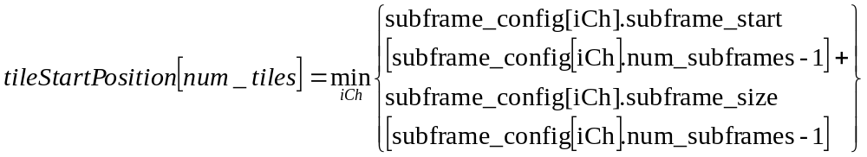
Equation 7
This gives the first sample in the frame that has not yet been covered by existing tiles.

Skip Size Information
If only one tile is left (i.e. its window size is minimum window size allowed) to be described, then the size information is skipped. The size of tile is samples_per_smallest_window computed in Section 3.5.

Determine Bits for Tile Size Description
The function determineTileSizeBits() computes cBitSize, as given below. Note that these values are fixed for the entire bitstream, and could be computed during initialization.

cBitSize = LOG2(iMaxSubFrameDiv – 1) + 1;

Update Subframe Configuration of Tile Channels
The function updateSubframeConfigOfChannels() updates the subframe configuration for channels that are members of the current tile. The tile_size and setOfTileChannels was decoded as described earlier.

int iCh;
for (iCh = 0; iCh < num_channels; iCh++)
{
if (iCh in setOfTileChannels[iTile])
{
int num_subframes = subframe_config[iCh].num_subframes;
subframe_config[iCh].subframe_size[num_subframes] = tile_size;
// start for next subframe
subframe_config[iCh].subframe_start[num_subframes+1] = subframe_config[iCh].subframe_start[num_subframes] + tile_size;
subframe_config[iCh].num_subframes += 1;
}
}

Tile Layer Decoding

Initialization
While decoding tile numbered iTile, the tile start position (tileStartPosition[iTile]), tile size (tile_sizes[iTile]), are already known from the decoded tile configuration.

Decoding Tile Header

Seekable or Non-seekable Tiles
A WMA Lsl bitstream can be seeked. That means decoder can start decoding from a packet in the middle of the bitstream. But not all packets are seekable. There is a bit seekable_frame_in_packet in packet header to indicate if the packet is seekable. A packet is seekable if and only if the first frame starting from that packet is seekable. Certainly, not all frames are seekable. Error: Reference source not found shows an example. A frame is seekable if and only if the first tile in the frame is seekable. Each tile has a bit (seekable_tile) in its header to represent it is seekable or not. The main reason for unseekable tiles comes from the LMS algorithm. LMS uses long and adaptive filter. The filter updates its coefficients adaptively from its initial value (0 by default) at the beginning of the seekable tile therefore it needs a certain amount of steps to converge and the LMS’ performance during the converging is not good. Another problem is the long filter. At the beginning of the seekable frame, previous channel_coeffs are not available and the prediction is done by using 0s which is not efficient. Therefore, in order to get better compression gain, only a small percentage of tiles are seekable. For unseekable tiles, the LMS predictors start from the final LMS predictor state in previous tile and no converging is needed. Certainly, the previous channel_coeffs are also saved in predictors’ prevvalues buffer.

The first tile of a WMA Lsl bitstream must be seekable.

s
u
u
u
u
u
u
u
s
u
Figure 7 Seekable and Unseekable Frames. S means seekable and U means unseekable.

Get New Codec Parameters at Seekable Tile
As we described in Section 6.2.1, the initial values and states of a nonseekable tile’s filters are the final filter values and states of the previous tile. But if the current tile is a seekable tile, decoder must reset all filters’ values and buffers to 0 by calling clear_codec_buffers ().

clear_codec_buffers ()
{
clean all buffers in AC filters to 0;
clean all buffers in LPC filters to 0;
clean all buffers in MCLMS filters to 0;
for (iCh = 0; iCh < num_channels; iCh++)
{
clean all buffers in CDLMS filters to 0;
ave_sum[iCh] = 0; //
}
}

Then the decoder needs to read some parameters such as filter order and filter scaling of the filters from the bitstream which is described in Table 13. The decoded codec parameters could be different from the parameters used in previous tiles.

At last, reset_codec need to be called to reset the codec based on the decoded code parameters.

reset_codec ()
{
mclms_recent = mclms_order * num_channels;
for (iCh = 0; iCh < num_channels; iCh++)
{
for (iLms = 0; iLms < lms_ttl[iCh]; iLms++)
{
cdlms[iCh][iLms].recent = cdlms[iCh][iLms].order;
}
}
}

Raw PCM Tiles
The WMA Lsl tile could be a raw PCM tile if the WMA Lsl codec fails to compress the audio efficiently. The lossless audio codec usually can compress the audio to half of its original size. But in some very special tiles which are very noisy or artificially designed the codec may generate a slightly more bits than original PCM bits. When such a problem happens, the encoder chooses to send uncompressed raw data to the bitstream.

RTM Bitstream and BETA Bitstream
The WMA Lsl takes advantage of the bV3RTM bit from encoder_options to add more features in RTM bitstream and be compatible with BETA bitstream at the same time. In the BETA bitstream, no LPC filter is used.

Decoding Tile Data

Decode Raw Data in Raw PCM Tile
If the tile header indicates the present tile is a raw PCM tile, the tile data are raw data instead of compressed bits. The decoding process is much easier. For each channel in the current tile, there are tile_size coefficients sent. Each coefficient uses validBitsPerSample bits to send the PCM samples directly. But if the tile’s padding_zeros is not 0, those PCM samples are right shifted by padding_zeros.

Decode Coefficient Residues (Golomb Code)
The channel _residues are encoded by Golomb coding. Golomb coding separates a residue into two parts using a divisor: quotient (quot) and remainder (rem). The divisor is always in the form of power of 2 therefore remain can be represented by iDivPow2 bits. The divisor is generated from the exponentially weighted moving average of previous residues. The quotient is sent by quo number of 0s followed by one 1. The remainder is sent in 2-ary format by iDivPow2 number of bits.

If the tile is seekable, we need to decode a transmitted moving average (ave_mean) first and compute ave_sum from it. Otherwise, the ave_sum has the final ave_mean value from previous tile.

If the tile is seekable, the first residue in each channel is decoded in a different way. Basically, the value is directly decoded from the bitstream as a validBitsPerSample bits signed integer if do_inter_ch_decorr is false or as a validBitsPerSample + 1 bits signed integer if do_inter_ch_decorr is true.

All other residues are decoded one by one. The quotient part has an escape mode. If the decoded quo is 32, that means it is an escaping code. Then a 5 bits quobits is decoded and the real quo value is the next following quobits bits in the bitstream. The second part is iDivPow2 bits’ rem. The iDivPow2 is derived from the moving ave_mean by function CEILOGLOG2 which basically calculates the ceil(log2(ave_mean)). ave_mean is computed from ave_sum[iCh]. The residue is computed by

residue = quo << iDivPow2 + rem

After decoding each residue, the ave_sum[iCh] is updated. The final value of ave_sum[iCh] of the current tile is the initial value of the ave_sum[iCh] of the next tile if the next tile is not seekable.

After Decoding a Tile
After decoding each tile, subframe_config[iCh].curr_subframe is updated for each channel in the tile:

int iCh;
for (iCh = 0; iCh < num_channels; iCh++)
{
subframe_config[iCh].curr_subframe += 1;
}

Reconstructing Audio Data
The reconstruction of audio data goes through a number of stages, as indicated in . The process is different, depending on how the tile was encoded.
If the tile is rawpcm tile, the decoded tile data is already the PCM samples shifted by padding_zeros. Otherwise, the decoded tile data are the residues after the predictions. Then, the residues need to be converted back to the PCM samples. Unlike WMA Pro, WMA Lsl does not use overlapping windows and therefore the time-domain audio is straightforwardly restored from the PCM samples in each tile based on the tile configuration.

If the tile is normally encoded (not rawpcm_tile), the data decoded are residues of prediction. Table 25 is the process to restore the original PCM samples in one tile from its decoded residues.

Table 25 Reconstruct Tile PCM Samples
recon_tile_pcm ()
{
if (rawpcm_tile != TRUE)
{
revert_cdlms ();
if (do_mclms)
{
revert_mclms ();
}
if (do_inter_ch_decorr)
{
revert_interchdecorr ();
}
if (do_ac_filter)
{
revert_acfilter ();
}
dequantize ();
if (V3RTM)
{
if (do_lpc)
{
revert_lpc ();
}
}
}

for (iCh = 0; iCh < num_channels; iCh++)
{
for (iCoef = 0; iCoef < tile_size; iCoef++)
{
channel_coeffs[iCh][iCoef] <= padding_zeros;
}
}
}

Revert CDLMS

Table 26 is the process to revert the CDLMS. Since CDLMS is the first stage in decoder, the input is channel_residues and the output is channel_coeffs. Except CDLMS, all the other processes work locally on channel_coeffs buffer.

Table 26 Reverse the Cascaded LMS Prediction Process
revert_cdlms ()
{
for (iCh = 0; iCh < num_channels; iCh++)
{
if (is_channel_coded[iCh] == 0)
continue;
for (iCoef = 0; iCoef < tile_size; iCoef++)
{
I32 iPred;
I32 channel_coeff = channel_residues[iCh][index];
if (iCoef is the first sample of a merged transient area)
useHighUpdateSpeed(iCh);
for (iLms =num_lms; iLms >= 0; iLms--)
{
iPred = lms_predict(ilms);
channel_coeff += iPred;
lms_update(ilms, channel_coeff, iPred);
}
if(iCoef is the last sample of a merged transient area)
useNormalUpdateSpeed(iCh);
channel_coeffs[iCh][index]= channel_coeff;
}
}
}

LMS is adaptive prediction filter which updates its filter coefficients sample by sample. In order to increase the efficiency of the prediction, WMA Lsl permits two different updating speeds based on the characteristics of the signal. For transient areas where signal changes dramatically a faster updating speed is used while in other areas normal speed is used. WMA Lsl bit stream uses transientpos[iCh] in tile data to indicate the starting position of a transient area in each channel. Starting from transientpos[iCh], all following samples_per_frame/2 samples are considered to be the transient area. The first sample of a seekable subframe is also considered as the starting of a transient area which is samples_per_frame samples long. Different channels may have different transient areas. One channel’s transient areas could overlap. For example, if a new transient area starts before the end of the previous transient area, those two areas overlap. Decoder should merge the overlapped transient areas and get the final start and end positions.

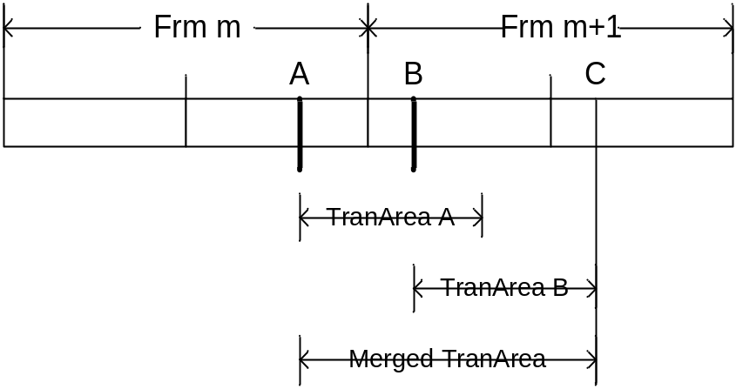
Figure 8 Transient Areas
Figure 8 illustrates an example of transient areas. There are two frames: frame m and frame m+1. Each frame has two subframes. The first subframe of the frame m and the second subframe of the frame m+1 do not send transientpos[iCh]. The second subframe of frame m and the first subframe of the frame m+1 send position A and B as their transientpos[iCh]. TranArea A and TranArea B are the corresponding transient areas. They overlap and the merged transient area is from position A to position C.
When the decoder meets the starting sample of a transient area (after merging), it will call useHighUpdateSpeed to increase the LMS coefficients updating speed. After it processes all samples in the transient area (after position C), it will call useNormalUpdateSpeed to restore the normal LMS updating speed.
Table 27 useHighUpdateSpeed Function
useHighUpdatingSpeed(iCh)
{
updatingSpeed[iCh] = 16;
for (iLms =num_lms; iLms >= 0; iLms--)
{
int iRecent = cdlms[iCh][ilms].recent;
if (bV3RTM)
{
for (iCoef = 0; iCoef < cdlms[iCh][ilms].order; iCoef++)
{
cdlms[iCh][ilms].update[iCoef + iRecent] *= 2;
}
}
else
{
for (iCoef = 0; iCoef < cdlms[iCh][ilms].order; iCoef++)
{
cdlms[iCh][ilms].update[iCoef] *= 2;
}
}
}
}

Table 28 useNormalUpdateSpeed Function
useNormalUpdateSpeed(iCh)
{
updatingSpeed = 8;
for (iLms =num_lms; iLms >= 0; iLms--)
{
int iRecent = cdlms[iCh][ilms].recent;
if (bV3RTM)
{
for (iCoef = 0; iCoef < cdlms[iCh][ilms].order; iCoef++)
{
cdlms[iCh][ilms].update[iCoef + iRecent] /= 2;
}
}
else
{
for (iCoef = 0; iCoef < cdlms[iCh][ilms].order; iCoef++)
{
cdlms[iCh][ilms].update[iCoef] /= 2;
}
}

}
}

Table 29 lms_predict Function
lms_predict(ilms)
{
I32 iPred = 0;
int iRecent = cdlms[iCh][ilms].recent;

for (iCoef = 0; iCoef < cdlms[iCh][ilms].order; iCoef++)
{
// The result of the multiplication is 32 bits integer.
iPred += cdlms[iCh][ilms].coeffs[iCoef] *
cdlms[iCh][ilms].prevvalues[iCoef + iRecent];
}
iPred += (1 << (cdlms[iCh][ilms].scaling – 1));
iPred >= cdlms[iCh][ilms].scaling;
return (iPred);
}

Table 30 lms_update Function
lms_update(ilms, iInput, iPred)
{
int iRecent = cdlms[iCh][ilms].recent;

if (iInput > iPred)
{
for (iCoef = 0; iCoef < cdlms[iCh][ilms].order; iCoef++)
{
cdlms[iCh][ilms].coeffs[index] +=
cdlms[iCh][ilms].updates[iCoef + iRecent];
}
}
else
{
for (iCoef = 0; iCoef < cdlms[iCh][ilms].order; iCoef++)
{
cdlms[iCh][ilms].coeffs[iCoef] -=
cdlms[iCh][ilms].update[iCoef];
}
}
cdlms[iCh][ilms].recent--;
if (iInput > (1 << (bitsPerSample – 1)) - 1)
{
cdlms[iCh][iLms].prevalues[iRecent] =
(1 << (bitsPerSample – 1)) – 1;
}
else if (iInput < -(1 << (validbitspersample – 1)))
{
cdlms[iCh][iLms].prevalues[iRecent] =
-(1 << (validbitspersample – 1);
}
else
{
cdlms[iCh][iLms].prevalues[iRecent] = iInput;
}
if (iInput > iPred)
{
cdlms[iCh][ilms].updates[iRecent] = updateSpeed[iCh];
else if (iInput < iPred)
{
cdlms[iCh][ilms].updates[iRecent] = -upateSpeed[iCh];
}
cdlms[iCh][ilms].updates[iRecent + cdlms[iCh][ilms].order >> 4] >>= 2;
lms_updates[iCh][ilms][iRecent + cdlms[iCh][ilms].order >> 3] >>= 1;
if (cdlms[iCh][ilms].recent == 0)
{
if (validBitsPerSample == 16) {
memcpy (cdlms[iCh][iLms].prevvalues + cdlms[iCh][iLms].orders, cdlms[iCh][iLms].prevvalues,
2 * cdlms[iCh][iLms].order);
memcpy (cdlms[iCh][iLms].updates + cdlms[iCh][iLms].orders, cdlms[iCh][iLms].updates,
2 * cdlms[iCh][iLms].order);
}
else if (validBitsPerSample == 24)
{
memcpy (cdlms[iCh][iLms].prevvalues + cdlms[iCh][iLms].orders, cdlms[iCh][iLms].prevvalues,
4 * cdlms[iCh][iLms].order);
memcpy (cdlms[iCh][iLms].updates + cdlms[iCh][iLms].orders, cdlms[iCh][iLms].updates,
2 * cdlms[iCh][iLms].order);
}
cdlms[iCh][iLms].recent = cdlms[iCh][iLms].order;
}
}

Revert MCLMS
Table 31 describes how to revert the multi channel LMS (MCLMS) process in decoder.

Table 31 Revert multi channel LMS process
revert_mclms ()
{
for (iCoef = 0; iCoef < tile_size; iCoef++)
{
mclms_predict ();
mclms_update ();
}
}

mclms_predict ()
{
for (iCh = 0; iCh < num_channels; iCh++)
{
if (ch_coded[iCh] == 0)
continue;
iPred = 0;
for (i = 0; i < mclms_order * num_channels; i++)
{
iPred += mclms_coeffs[i + mclms_order * num_channels * iCh]
* mclms_prevals[i];
}
for (i = 0; i < iCh; i++)
{
iPred += channel_coeffs[iCh][iCoef]
* mclms_coeffs_curr[i + mclms_order * num_channels * iCh];
}
channel_coeffs[iCh][iCoef] =
channel_residues[iCh][iCoef] + iPred;
}
}

mclms_update ()
{
for (iCh = 0; iCh < num_channels; iCh++)
{
iPredErr = channel_coeffs[iCh][iCoef] - channel_residues[iCh][iCoef];
if (iPredErr > 0)
{
for (i = 0; i < mclms_orders * num_channels; i++)
{
mclms_coeffs[i + iCh * mclms_order * number_channels]
+= mclms_updates[mclms_recent + i];
}

for (j = 0; j < i; j++)
{
if (channel_coeffs[iCh][iCoef] > 0)
mclms_coeffs_curr[iCh * num_channels + j] += 1;
else if (channel_coeffs[iCh][iCoef] < 0)
mclms_coeffs_curr[iCh * num_channels + j] -= 1;
}
}
else if (iPredErr < 0)
{
for (i = 0; i < mclms_orders * num_channels; i++)
{
mclms_coeffs[i + iCh * mclms_order * number_channels]
-= mclms_updates[mclms_recent + i];
}

for (j = 0; j < i; j++)
{
if (channel_coeffs[iCh][iCoef] > 0)
mclms_coeffs_curr[iCh * num_channels + j] -= 1;
else if (channel_coeffs[iCh][iCoef] < 0)
mclms_coeffs_curr[iCh * num_channels + j] += 1;
}

}
}

for (iCh = num_channels - 1; iCh >=0; iCh++)
{
mclms_recent --;
if (channel_coeffs[iCh][iCoef] > MaxPrevValue)
mclms_prevalues[mclms_recent] = MaxPrevValue;
else if ((channel_coeffs[iCh][iCoef] <- MinPrevValue)
mclms_prevalues[mclms_recent] = MinPrevValue;

if (channel_coeffs[iCh][iCoef] > 0)
mclms_updates[mclms_recent] = 1;
else if (channel_coeffs[iCh][iCoef] < 0)
mclms_updates[mclms_recent] = -1;
else
mclms_updates[mclms_recent] = 0;
}

if (mclms_recent == 0)
{
memcpy (mclms_prevvalues[mclms_orders * num_channels], mclms_prevvalues,
bytes_per_sample * mclms_order * num_channels);
memcpy (mclms_updates[mclms_orders * num_channels],
mclms_updates,
bytes_per_sample * mclms_order * num_channels);
mclms_recent = num_channels * mclms_order;
}
}

Revert inter channel decorrelation
Table 32 describes the process to revert the inter channel decorrelation.
Table 32 Revert inter channel decorrelation
revert_inter_ch_decorr ()
{
if (num_channels != 2)
{
return;
}
else
{
for (iCoef = 0; iCoef < tile_size; iCoef)
{
channel_coeffs[0][iCoef] -= channel_coeffs[1][iCoef] >> 1;
channel_coeffs[1][iCoef] += channel_coeffs[0][iCoef];
}
}
}

Revert AC filter
Table 33 describes the process to revert the AC filter.
Table 33 Revert AC Filter
revert_acfilter ()
{
for (iCh = 0; iCh < num_channels; iCh++)
{
for (iCoef = 0; iCoef < tile_size; iCoef++)
{
ac_predict ();
ac_update ();
}
}
}

Table 34 acfilter_predict function
acfilter_predict ()
{
I32 iPred = 0;
for (iTap = 0; iTap < acfilter_order; iTap++)
{
iPred += acfilter_coeffs[iTap] * acfilter_prevvalues[iTap];
}
iPred = iPred >> acfilter_scaling;
channel_coeffs[iCh][iCoeff] += iPred;
}

acfilter_update ()
{
for (iTap = 1; iTap < ac_order; iTap++)
{
acfilter_prevvalues[iTap] = acfilter_prevvalues[iTap - 1];
}
acfilter_prevvalues[0] = channel_coefs[iCh][iCoeff];
}

Dequantization
Table 35 describes the process to do dequantization.

Table 35 Dequantization
dequantize ()
{
for (iCh = 0; iCh < num_channels; iCh++)
{
for (iCoef = 0; iCoef < tile_size; iCoef++)
{
channel_coeffs[iCh][iCoef] *= quan_stepsize;
}
}
}

Revert LPC filter

The revert_lpc function is shown in Table 36.

Table 36 Revert LPC
revert_lpc ()
{
iCoef = 0;
if (seekable_tile)
{
channel_coeffs[1] += channel_coeffs[0];
channel_coeffs[2] += channel_coeffs[1] * 2 - channel_coeffs[0];
lpc_prevvalues[0] = channel_coeffs[2];
lpc_prevvalues[1] = channel_coeffs[1];
lpc_prevvalues[2] = channel_coeffs[0];
}

for (iCoef; iCoef < tile_size; iCoef++)
{
lpc_predict ();
lpc_update ();
}
}

revert_lpc ()
{
iCoef = 0;
if (seekable_tile)
{
channel_coeffs[1] += channel_coeffs[0];
channel_coeffs[2] += channel_coeffs[1] * 2 - channel_coeffs[0];
lpc_prevvalues[0] = channel_coeffs[2];
lpc_prevvalues[1] = channel_coeffs[1];
lpc_prevvalues[2] = channel_coeffs[0];
}

for (iCoef; iCoef < tile_size; iCoef++)
{
lpc_predict ();
lpc_update ();
}
}

lpc_predict ()
{
I32 iPred = 0;
for (iTap = 0; iTap < lpc_order; iTap++)
{
iPred += lpc_coeffs[iCh][iTap] * lpc_prevvalues[iCh][iTap];
}
iPred = iPred >> lpc_scaling[iCh];
channel_coeffs[iCh][iCoef] -= iPred;
}

lpc_update ()
{
for (iTap = 1; iTap < lpc_order; iTap++)
{
lpc_prevvalues[iCh][iTap] = lpc_prevvalues[iCh][iTap - 1];
}
lpc_prevvalues[iCh][0] = channel_coeffs[iCh][iCoef];
}

Removal of Silent Samples
When silence information is present in the frame header, this information is used to clip the reconstructed samples before passing them to the presentation unit. If trailing silence information is present, the final trailing_silence_samples of the reconstructed samples are pruned. These samples were added by the encoder to round-up the input signal into frames. Thus, the total number of samples given out by the WMA Lsl decoder to the presentation unit in a frame is:

num_samples = max (0, samples_per_frame – trailing_silence_samples)
Equation 8

Tables

Constants
Table 37 Constants used by the decoder
Constant | Value
D_DRC_HIGH | 0
D_DRC_MED | 1
D_DRC_LO | 2
D_ENCOPT3_PURE_LOSSLESS | 0x0001
D_ENCOPT3_FRM_SIZE_MOD | 0x0006
D_ENCOPT3_SUBFRM_DIV | 0x0038
D_ENCOPT3_WRITE_FRAMESIZE_IN_HDR | 0x0040
D_ENCOPT3_GENERATE_DRC_PARAMS | 0x0080
D_ENCOPT3_RTMBITS | 0x0100
D_SPEAKER_LOW_FREQUENCY | 0x0008
D_CURRFRM | 0
D_NEXTFRM | 1

Speaker positions (Informative)
Table 38 Constants defining speaker positions for source channels
Constant | Value
SPEAKER_FRONT_LEFT | 0x0000 0001
SPEAKER_FRONT_RIGHT | 0x0000 0002
SPEAKER_FRONT_CENTER | 0x0000 0004
SPEAKER_LOW_FREQUENCY | 0x0000 0008
SPEAKER_BACK_LEFT | 0x0000 0010
SPEAKER_BACK_RIGHT | 0x0000 0020
SPEAKER_FRONT_LEFT_OF_CENTER | 0x0000 0040
SPEAKER_FRONT_RIGHT_OF_CENTER | 0x0000 0080
SPEAKER_BACK_CENTER | 0x0000 0100
SPEAKER_SIDE_LEFT | 0x0000 0200
SPEAKER_SIDE_RIGHT | 0x0000 0400
SPEAKER_TOP_CENTER | 0x0000 0800
SPEAKER_TOP_FRONT_LEFT | 0x0000 1000
SPEAKER_TOP_FRONT_CENTER | 0x0000 2000
SPEAKER_TOP_FRONT_RIGHT | 0x0000 4000
SPEAKER_TOP_BACK_LEFT | 0x0000 8000
SPEAKER_TOP_BACK_CENTER | 0x0001 0000
SPEAKER_TOP_BACK_RIGHT | 0x0002 0000

Parameter Restrictions on Legal WMA Bitstreams & Compliant WMA Lsl Decoders

Legal WMA Lsl Version 9 Bitstreams
All legal WMA Lsl bitstreams follow the syntax specified in this document. In addition, they have to obey parametric limitations listed in to be decodable by WMA decoders:

Table 39 Parameter limitations of WMA Lsl 9.0 legal bit streams
Parameter | Limitation
Maximum number of channels | 8
Maximum subframe size | 4096
Minimum subframe size | 128
Maximum duration per packet | 2.0sec
Source resolution (bits/channel-sample) | 16 or 24
Maximum sampling rate (Hz) | 96000

Maximum buffer size requirements
WMA Lossless is intended mainly for local playback. For these applications, depending on the decode speed and read rate, very smaller buffer (such as a few bytes) could be used.

Compliant WMA LSL Version 9 Decoders
The compliance of WMA Lossless decoders is multi-fold.

First, they should be able to accept and decode all WMA Lossless bit streams generated by Windows Media Encoder Version 9. This implies all the sample rates, number of channels, sample depth, packet sizes, etc in each “profile” that the decoder would like to be compliant. These profiles are defined in Table 40. In addition, they should be able to handle all bitstream syntax elements of WMA Lossless, even if WMA Encoder Versions 9 and 9.1 did not produce such bit streams, within the limits of profiles of choice. Some such bit streams are part of the compliance suite.

Second, the decoders should produce decoded output that is numerically identical (bit for bit) to that of the reference decoder, for all bit streams that fall into the supported profile.

Profile | Property |  | Notes
N1 | Sampling Rate | ≤ 48Khz | Stereo only implementation recommended for media devices
N1 | Channels | Stereo Only | Stereo only implementation recommended for media devices
N2 | Sampling Rate | ≤ 96 KHz | Recommended for archival of stereo and multi-channel content under 96Khz sampling rate
N2 | Channels | ≤ 5.1
N3 | Sampling Rate | ≤ 192 KHz | Recommended for archival of stereo and multi-channel content under 192KHz sampling rate.
N3 | Channels | ≤ 7.1
Table 40 WMA Lossless Profile/Level Summary

Measuring Compliance of Decoders
The compliant decoder should produce decoded output that is numerically identical (bit for bit) to that of the reference decoder, for all bit streams that fall into the supported profile.

Modes of Microsoft’s WMA Lossless Version 9 Encoder
WMA Lossless bitstream is variable bit rate streams (VBR). The encoder_options is currently 0xE0. That is, bV3RTM is false for all current streams. However, the decoders should be able to handle the cases when bV3RTM is true. The WMA Lsl bitstream is assumed to be locally available.

Table 41 WMA Lossless Version 9 Encoder Modes
Mode  No | Quality Setting | Bitrate (bits/sec) specified in the ASF Header | Sampling Rate | Num-  ber of Chan-nels | Valid Bits Per Sam-ple | Packet Size (Bytes)
1 | 100 | 1152032 | 44100 | 2 | 16 | 13375
2 | 100 | 1152032 | 44100 | 2 | 24 | 13375
3 | 100 | 1152000 | 48000 | 2 | 24 | 12288
4 | 100 | 1152000 | 48000 | 6 | 24 | 12288
5 | 100 | 1152032 | 88200 | 2 | 24 | 13375
6 | 100 | 1152000 | 96000 | 2 | 24 | 12288
7 | 100 | 1152000 | 96000 | 6 | 24 | 12288

Glossary

abs_level | Quantized absolute level of a non-zero spectral coefficient.
allow_subframes | A boolean flag indicating if subframes might occur in a bitstream.
API | Application programming interface.
ASF | Advanced Streaming Format.
bits_per_packet | WMA Lossless packet size in bits, fixed for a given stream.
bitstream buffer | A buffer in a WMA Lossless decoder for storage of compressed audio data. It smoothes fluctuations in compressed frame size.
bytes_per_second | The average compressed stream rate, in number of bytes per second.
encoder_options | A bit-packed word with values indicating if certain features of the bitstream are used or not.
fFrameSizeInHeader | Is size of compressed frame available in WMA Lossless packet header?
iMaxSubFrameDiv | Maximum ratio between largest and smallest tile.
Inverse quantization | The process of recovering amplitudes from indices generated by a quantizer.
is_channel_coded | An array indicating if a channel is coded (or skipped).
iTile | A running counter of tiles within a frame.
iWin | Log2 of current window size-ratio.
LMS filtering | Least means square filtering.
lms_prevvalues, lms_coeffs, lms_updates | Shift registers holding LMS parameters.
log2_bits_per_packet | Number of bits to represent number of bits of the last frame started in previous packet, appearing in the current packet. Also used to represent compressed frame size in bits.
log2_samppfr | log2(samples_per_frame)
lossless_tile | A Boolean indicating that lossless coding is performed on the tile, rather than lossy coding.
LPC | Linear Predictive Coding
lpc_order | Length of LPC filter+1.
max_num_subframes | The maximum number of subframes for a channel in a frame. This value is useful in determining the memory that would have to be reserved.
max_quant_step_band | The maximum of quant_step_band for a given channel in a tile. Derived by processing quant_step_band.
new_packet_header | A signal from packet layer decoder indicating the beginning of a new packet.
num_channels | The number of channels in the source material.
num_tiles | At the end of decoding a frame header, this value indicates the total number of tiles covering the frame.
packet_number | A sequence number that helps in detecting lost packets.
Payload | Data present in a packet, after the packet header.
PCM | Pulse Code Modulation. Fixed amplitude resolution digital representation of waveforms.
Quantization | Process of limiting the number of possible amplitudes, with intent to reduce the number of bits needed to represent the amplitude. Generates a finite value, finite precision symbol representation for input amplitude.
samples_per_frame | The maximum number of new time-samples generated by an inverse transform.
samples_per_second | The sample rate in Hz of the source material.
sampling_period | Inter-sample duration: reciprocal of samples per_second.
SDK | Software developers’ kit.
seekable_frame_in_packet | A Boolean indicating whether decoding (after a reset) can start from current packet.
seek_offset_in_bits | The number of bits of the last frame that started in previous packet, appearing in the current packet.
setOfTileChannels | A set of source channels that are members of a given tile.
spliced_packet | If true, it indicates bitstream discontinuity.
subframes | Overlapping windows of MLT that encompass a frame of a channel.
subframe_config | An array of structures to hold windowing information for current frame, parts of previous frame, parts of next frame.
subframe_size_curr | The size of the current subframe (in number of transform coefficients per channel) for a given source channel.
subframe_start | The sample position of the current subframe in an audio frame for a given source channel.
Tile | Set of channel windows that have identical start and stop positions. That is, a set of windows that are co-sited in time in a given frame. Set members are source channel numbers. Tile properties (description) include tile size, start time, stop time, and channels present in the tile.
uimsbf | Unsigned integer, most significant bit first.
validBitsPerSample | Indicates the size in bits of valid data portion in decoded sample per channel. It can either be 16 or 24 for this release of WMA Lossless.
version_number | The version of WMA Lossless stream. It can only have a value of 3. Other version numbers indicate other syntaxes.
WMA | Windows media audio

