DICOM Image Viewer
Python + ‘Qt Quick’ Dojo

Introduction
In this dojo we create an application for viewing medical images (DICOM) using Qt, its Qt Quick module, QML and Python. Following additional modules for Python will be used:
- PyQt5 module for accessing Qt
- Pillow for image processing
- pydicom, NumPy for working with DICOM images
Dojo is prepared for Windows operating system and it should be possible to perform it also on Linux and other operating systems supported by the used technologies.

Preparation

Python Installation
Download latest Python 3 Release from https://www.python.org/downloads/windows/ (version 3.7.3 at the time of creation of this document). Either 32 or 64 bit version should be fine; tested version was 64 bit (despite the screenshot showing 32 bit).
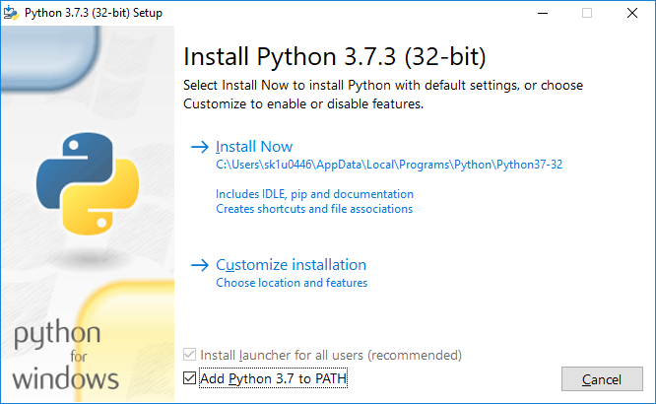
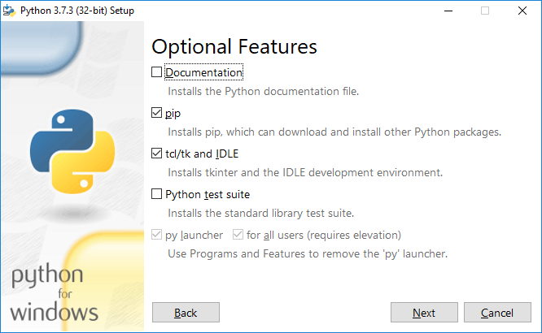
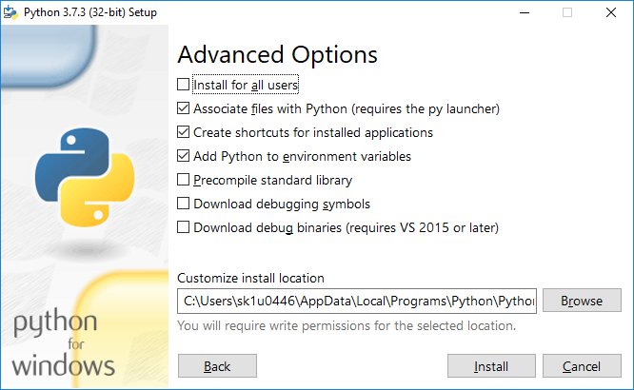
Test the installation by entering python to command line. It should launch Python console. Type exit() to exit from the Python console.

Qt Installation
Download Qt Online Installer for Windows from https://www.qt.io/download-qt-installer.
Run the installer. In the ‘Select Components’ page, choose Qt for 64 bit MSVC from the latest version (version 5.13.0 at the time of creation of this document). Leave other options to default values. Finish the installer.
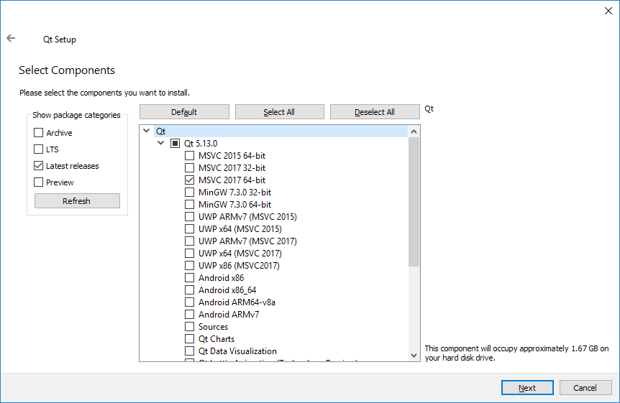
To test the installation launch Qt Creator from start menu and select Tools → Options → Kits. There should be an auto-detected kit for MSVC.

Installation of Python Modules
In command line following commands to install additional Python modules:
- pip install pillow
- pip install pyqt5
- pip install pydicom
- pip install numpy
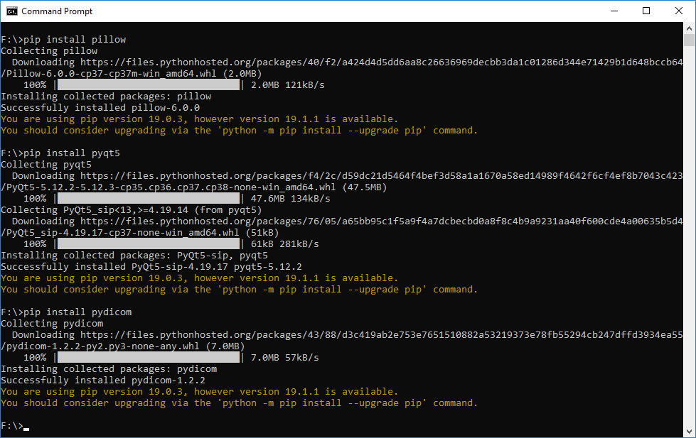
Test the installation:
- Start IDLE (which is a Python shell) from Start Menu
- Try to import installed modules by entering:
import PIL.Image
from PyQt5.QtQuick import QQuickView
import pydicom
import numpy
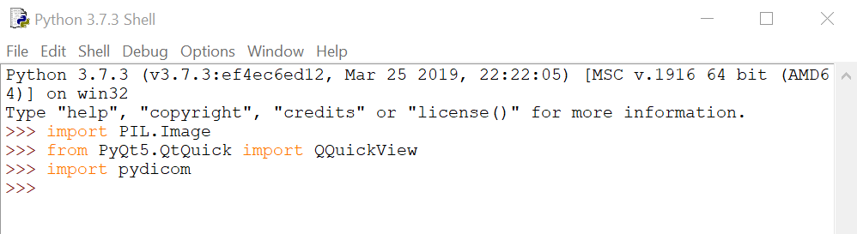
Commands should execute without any output to the shell window.

Patient Data
A patient data with two studies where each study contains one CT and one PT series were used in this dojo.

Dojo
Note: This chapter contains screenshots of code with some lines highlighted and some with red background. In the dojo session, highlighted lines should be added or modified, red lines should be removed.

Hello World
Let’s create basic empty window application. We demonstrate:
- Creation of a new Qt-Python project in Qt Creator IDE and other basic IDE functions
- The most simple QML code
- Interconnection of QML and Python

- Launch Qt Creator from start menu.
- Create new project using template ‘Qt for Python – Empty’.
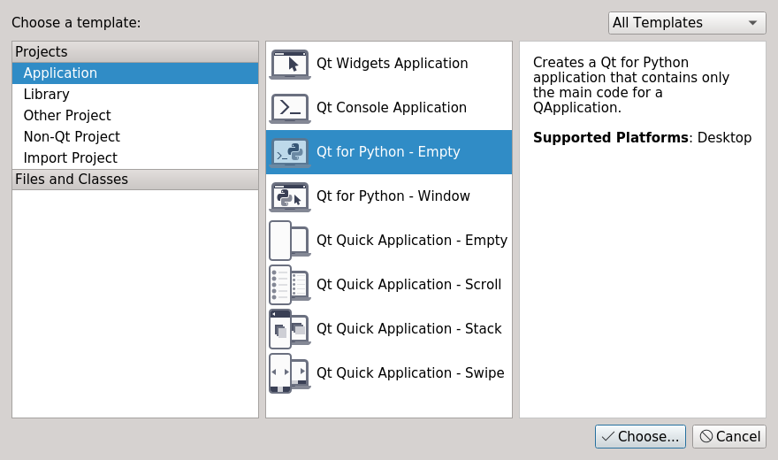
Select ‘Choose...’ and on the next page, name the project ‘dicom_image_viewer’ and select directory where it shall be created. Finish the wizard. Project with files main.pyproject and main.py will be created.
- Create new QML file main.qml.
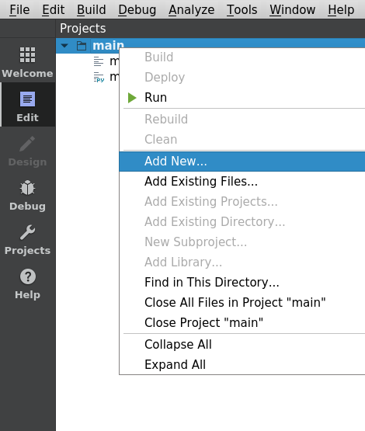
In Projects pane do a right click on ‘main’ and select ‘Add New...’.
Select ‘QML File (Qt Quick 2)’ template.
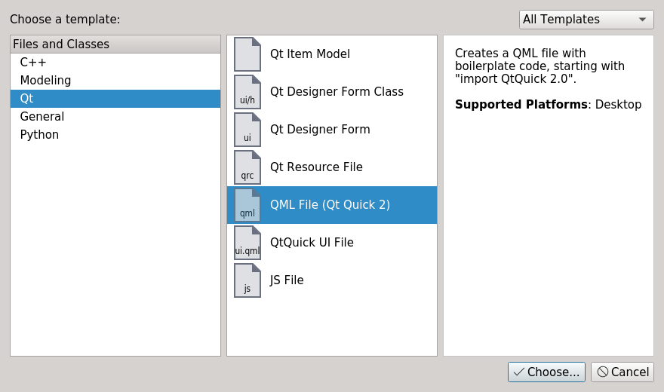
Type main to the Name field.
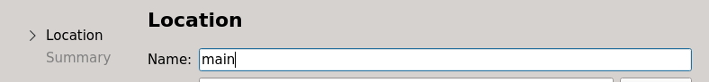
Finish the wizard.
- In main.py add implementation for minimal QtQuick application.
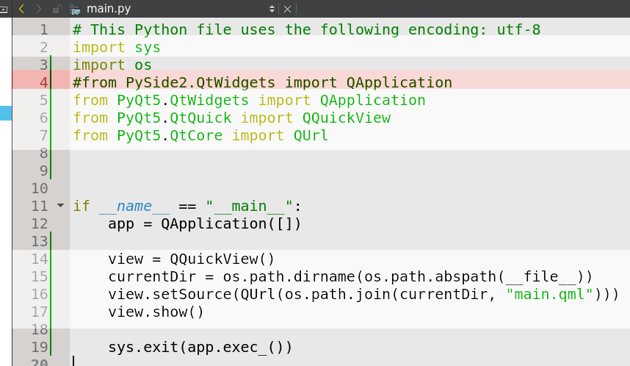
We create an instance of QQuickView class which is able to create a window and show QML scene. We set a QML file to the view and finally call show() method to display the window.
- Run the application with Ctrl+R. It will open an empty window. The window is empty because our main.qml contains only Item which has no appearance. It is just a base type for all other visual items.

Show a DICOM Image
Now we are going to display a DICOM image. We will demonstrate:
- QML properties
- Image QML type
- Creation of a new Python class
  - Subclassing, instance methods
- Usage of a custom image provider for Image
- Simple usage of pydicom module to read DICOM image
- Simple usage of pillow module

- Edit our main.qml file so that it contains Image object.
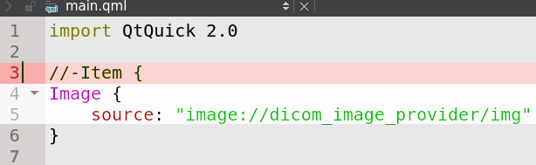
- Create new python class DicomImageProvider in a new file dicom_image_provider.py.
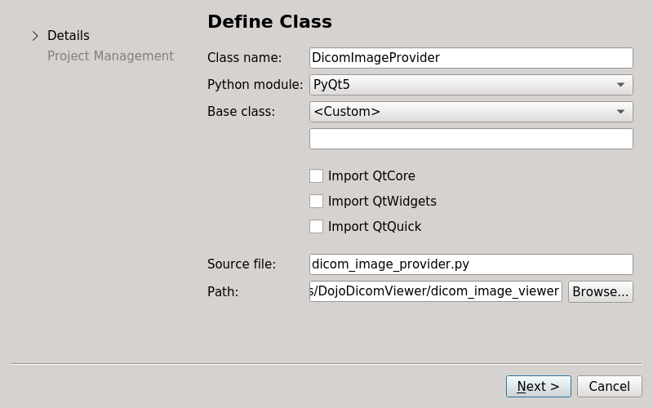
Modify the file as follows:
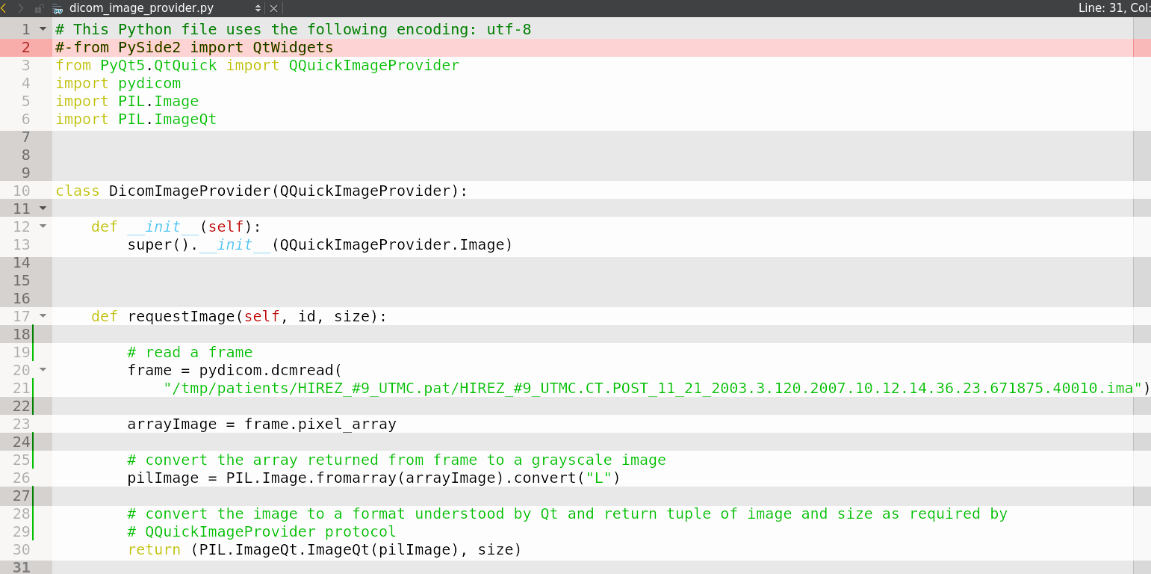
The class provides a DICOM image to QML Image object. Based on source property of Image the method DicomImageProvider.requestImage gets value “img” into parameter id. We will not use it so far and always return hard-coded image.
- Finally we have to register our DicomImageProvider in main.py:
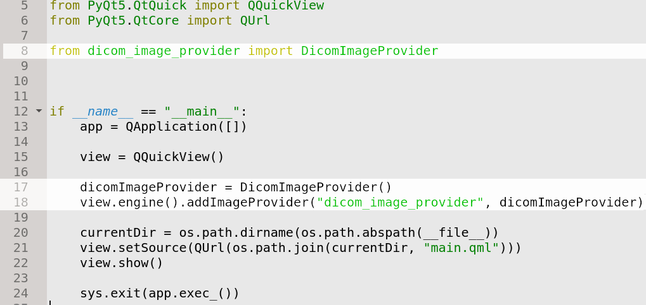
We register it under name “dicom_image_provider” which corresponds to the name used in Image’s source property (in main.qml).
- Run the application. A window with DICOM image shall be shown.

Create a Layout
Let’s display the image in a layout. We demonstrate:
- Grid QML type
- QML object hierarchy
- Definition of a new QML type
- Create a new QML file Layout2x2.qml and create a grid of Image-s in it with source property set to the image source:
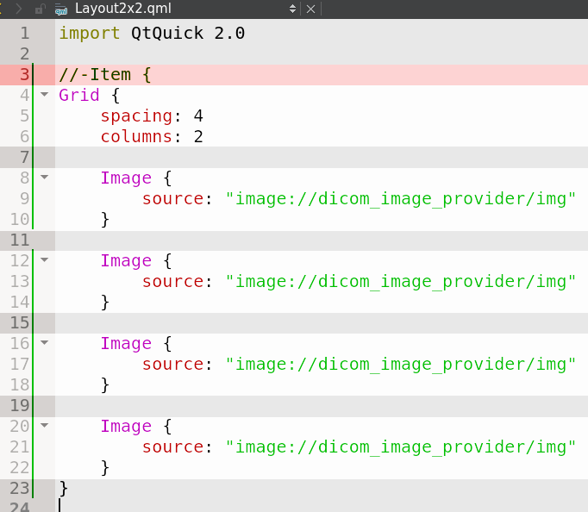
- By creating Layout2x2.qml we defined a new QML object type. Use it in main.qml instead of Image:
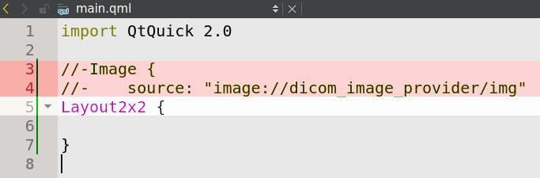
- Run the application. A window with loaded image duplicated in 2x2 layout should be shown.

Show Multiple Images
So far we loaded only a single image. To load and display more we need to modify our Layout2x2 and add code to parse DICOM data. We demonstrate:
- Passing values to custom image provider via URI
- Various Python traits
  - Documenting APIs
  - Calling instance methods
  - Usage of tuple
  - Instance variables
  - Naming convention for internal members
  - “Magic” methods to add indexer (variable[index]) to a custom class
  - Lambda functions
  - List comprehensions
  - Iterators
  - Walking through directory tree
  - for loops
  - Default parameter values in functions

- First, we need to think about how to specify which images (studies, series) from the loaded patient will be shown in the Layout2x2. Lets define following protocol:
<study_number>/<series_number>
Modify Layout2x2.qml so that is specifies which study and series to display in each segment by the protocol above.
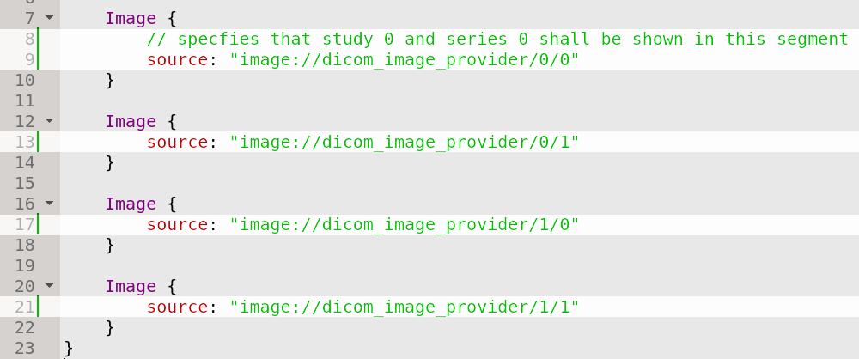
- Then we have to modify DicomImageProvider so that it serves requested images according to the protocol. Add code for parsing the URI to get study number and series number from it.
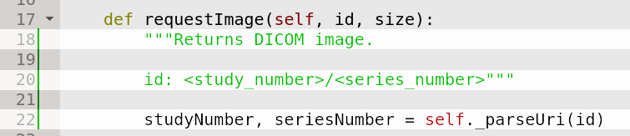
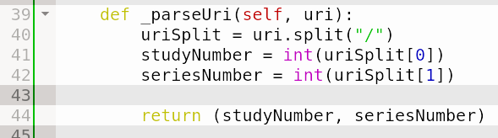
- DicomImageProvider will need some support for loading and parsing DICOM data to get required study and series. Let’s make it require patients object in the constructor. The Patients class we will create later.
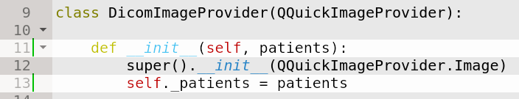
- Use patients instance to get study and series with given number plus some frame.
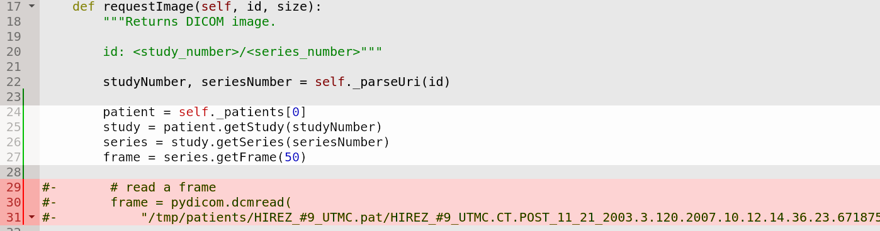
We defined here a set of objects which we can consider to be our domain model. Now we know that we need to create Patients, Patient, Study and Series classes with respective APIs.
- But first update construction of DicomImageProvider because it now requires patients parameter. Doing so we will define also how the constructor signature of Patients class should look like. Update main.py:
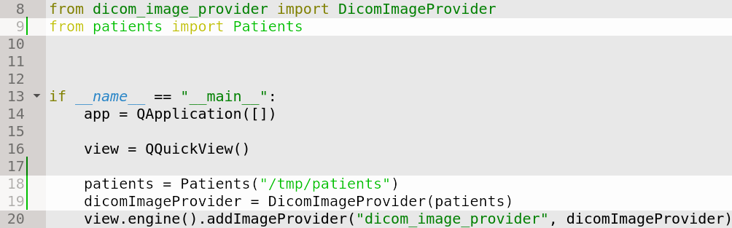
- Now let’s create our set of domain model classes. First the Patients class.
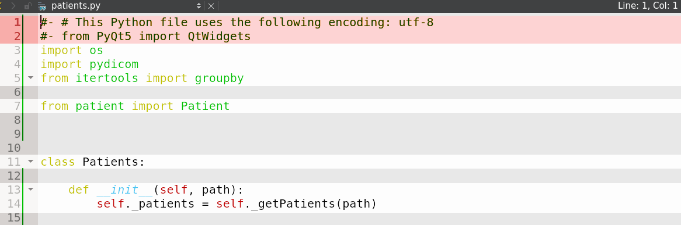
Add Add __getitem__ method to support access via indexes (patients[key]). This is considered to be a public API of that class.
Add _getPatients method. It returns list of Patient objects. Underscore denotes that the class is not intended for public use. It however does not prevent it. It is just a convention.
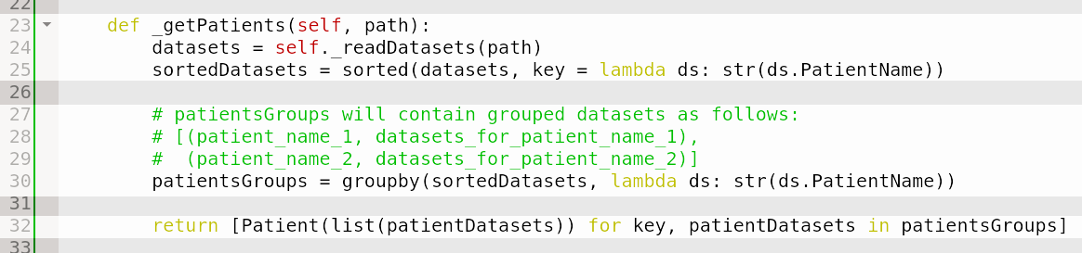
Add _readDatasets method which walks through directory tree and reads each file via dcmread method from pydicom library.
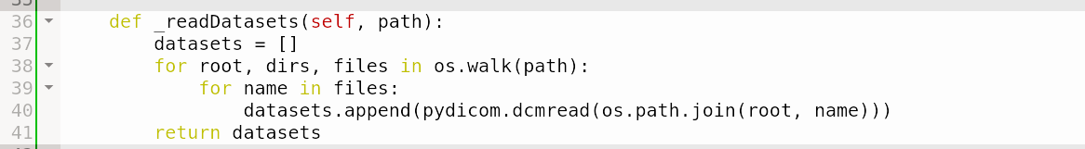
- Create Patient class
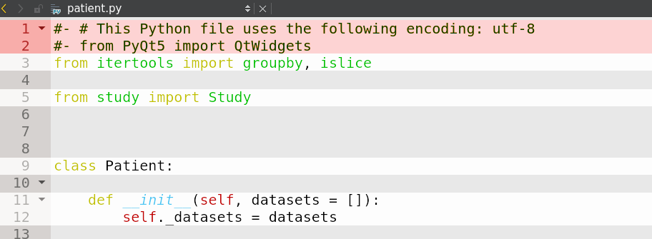
Add getStudy public method and its helper _getStudies.
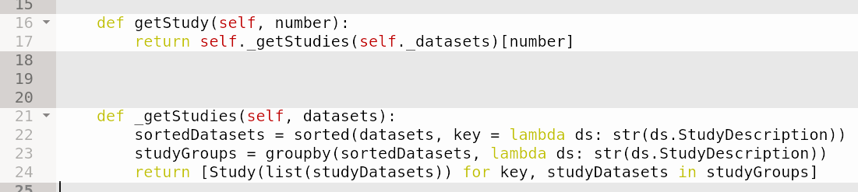
- Create Study class
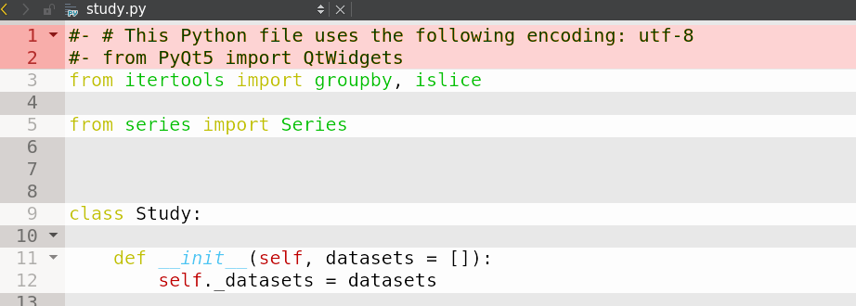
Add getSeries and _getSerieses methods.
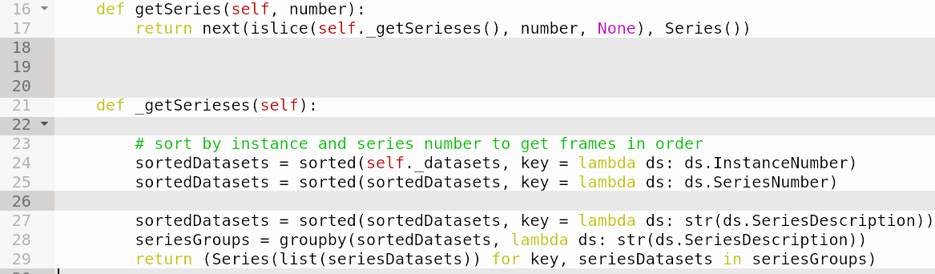
- Finally, add Series class
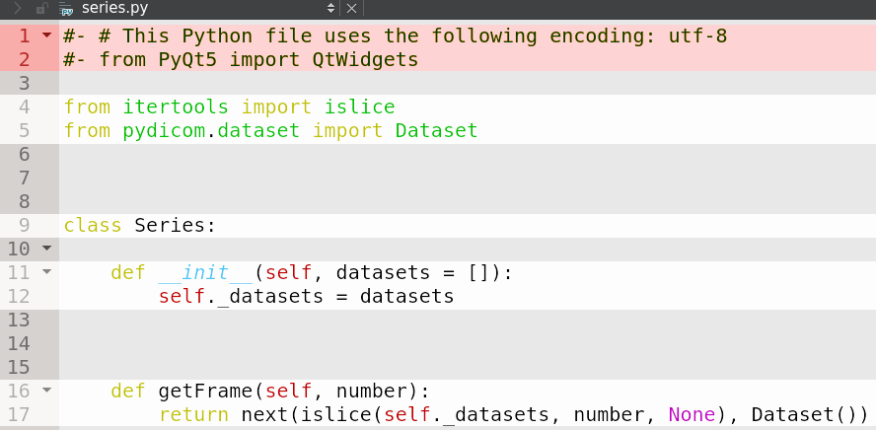
- Run the application. Our layout is now filled with images from different studies and series. Images have different sizes though. Let’s fix it. In main.qml specify size of Layout2x2 by setting its width and height properties. Although we did not define those properties in QML object type definition (Layout2x2.qml) it has them anyway – custom QML object types have publicly available all attributes of their root object.
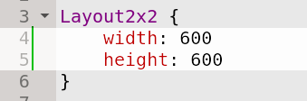
In Layout2x2.qml specify size of each segment (Image) as a half of the visual parent size.
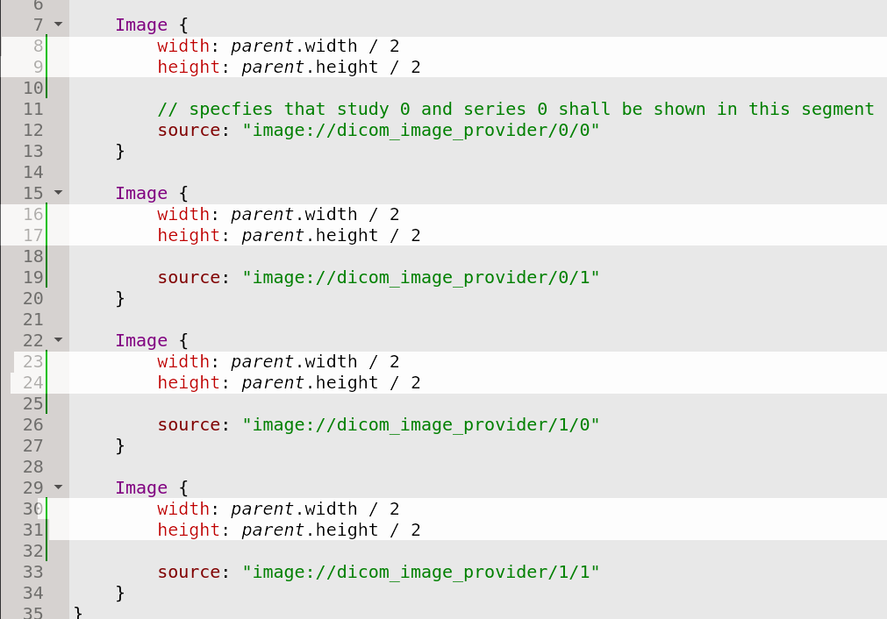
- Run the application again. Sizes of all four images are now equal.

Add Navigator
Lets add a navigator panel which shows loaded patients. We demonstrate:
- QML anchors
- Usage of QML ListView type
- QML model and delegate pattern
- Populating QML ListView from Python
- Defining properties in Python classes
- Python ternary operator
- Exposing python object to QML via context property
- We need to add a top-level Rectangle object to main.qml. Inside it will be the navigator and the Layout2x2 object. First, put Layout2x2 inside.
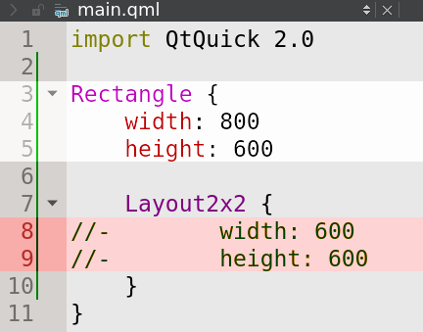
- Add another Rectangle into root one which will represent the navigator. Set its id, color, width and height properties. For Layout2x2 object define anchors so that it knows where it should be placed relative to the navigator.
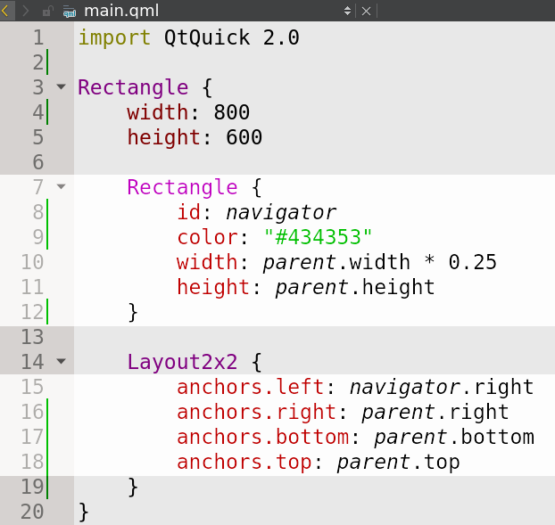
- Run the application and see that a panel – which is out future navigator – is now on the left side of the application window.
- Let’s populate the navigator with study descriptions. Add ListView object to the navigator. It displays list of items (study descriptions in our case); it needs a model and a delegate. Model provides the data. Delegate defines how each item will be visualized.
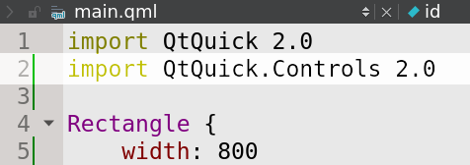
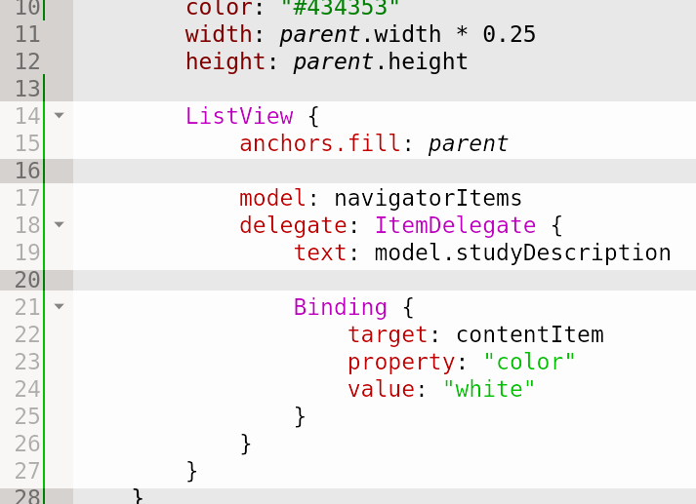
- The model navigatorItems we implement in Python. Define a new class NavigatorItems which derives from QAbstractListModel. It has to implement base methods: data, rowCount and roleNames.
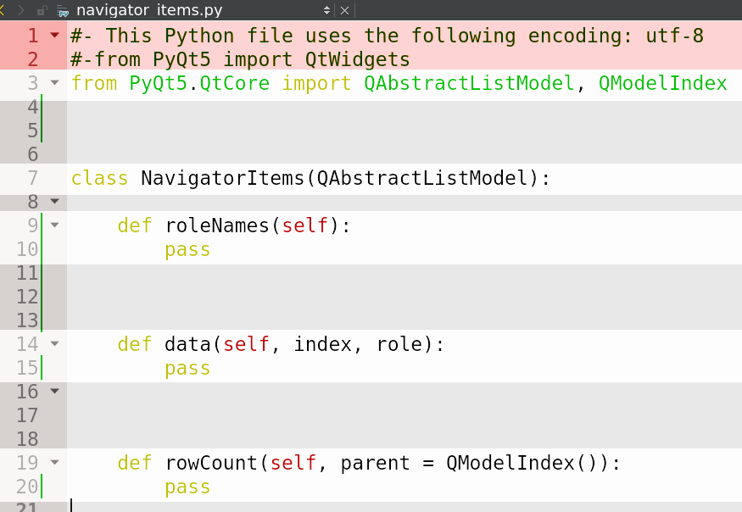
Add constructor which will take a parameter patients as the (domain) model. Also add a method which will populate this (view) model with study descriptions. We will need new API in Patient and Study classes which we add later.
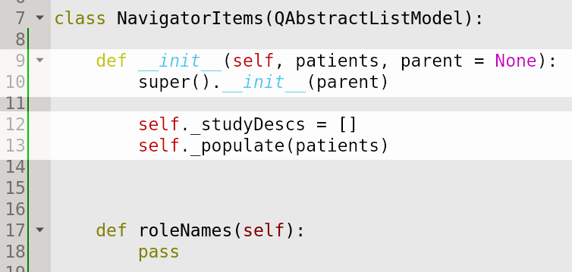
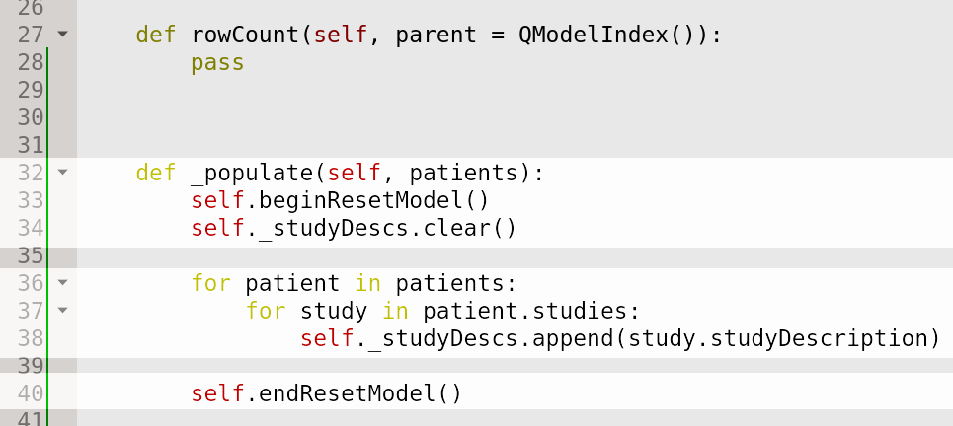
Now implement overridden methods.
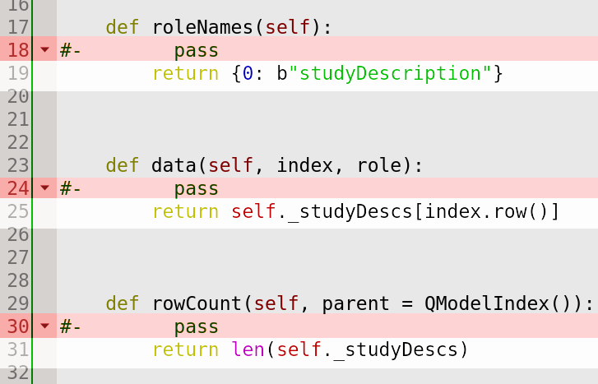
- Add new property studies required by NavigatorItems to Patient class. First get and store studies in an instance variable. The property will then return the instance variable.
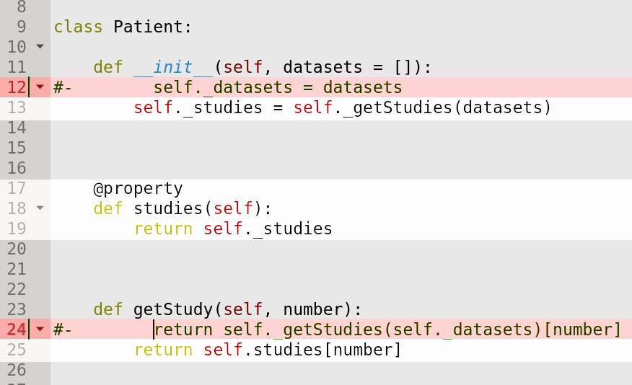
- Add another property studyDescription required by NavigatorItems to Study class.
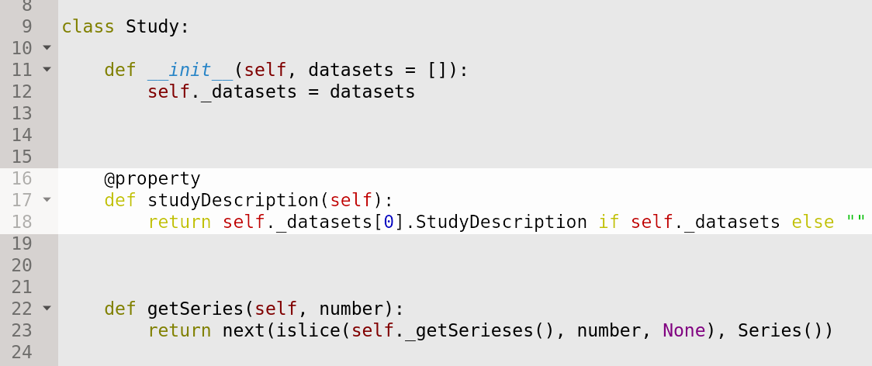
- Finally, we pass the instance of NavigatorItems to view. In main.py add lines:
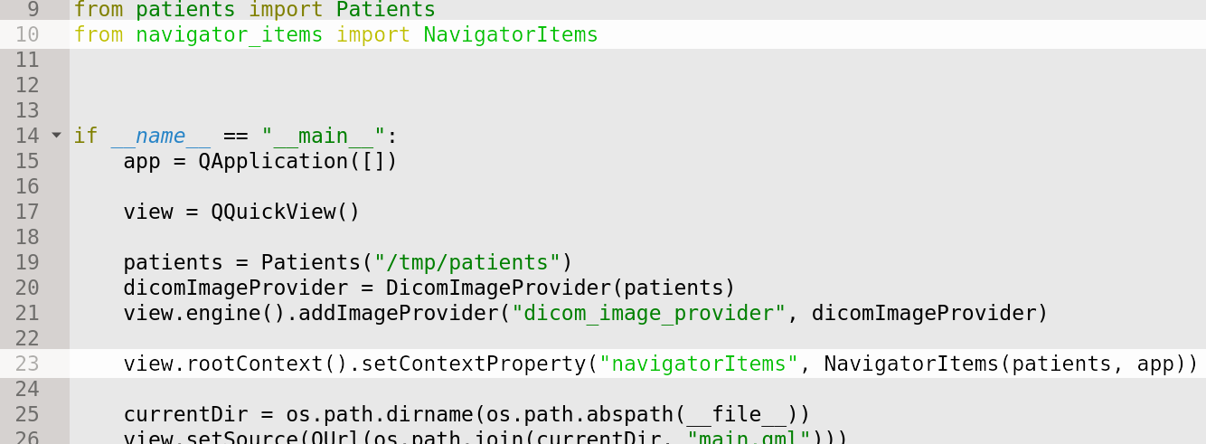
- Run the application. Navigator now contains study descriptions.

Scrolling Through Images
Currently we are displaying a single frame from a series. Let’s add possibility to scroll through frames with mouse wheel. We will demonstrate:
- Defining a custom property in QML type
- QML property binding
- Handling mouse events in QML using MouseArea
- Signal handling in QML
- Usage of javascript in QML
- Our DicomImageProvider always returns hardcoded frame nr. 50. We need to make it parametric. Extend the protocol for getting images by frame number:
<study_number>/<series_number>/<frame_number>
Modify DicomImageProvider to process frame_number parameter.
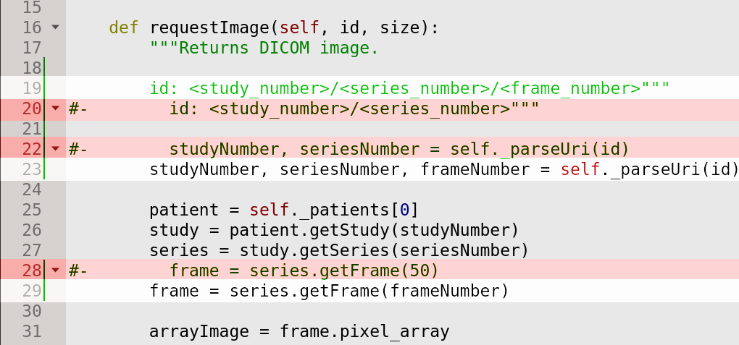
Also its private helper for parsing the URI.
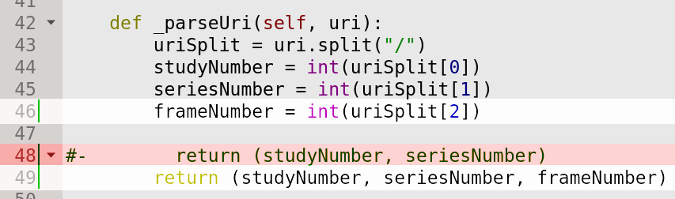
- Layout2x2 has to use the new protocol to request the image now. Currently it contains four Image objects which can not scroll. We create a new type where we implement scrolling and use the new protocol. Let’s call it Segment. So create a new file Segment.qml. It will contain Image and properties stackSource and frame (let’s give it a default value 50 which is the same as we had in DicomImageProvider).
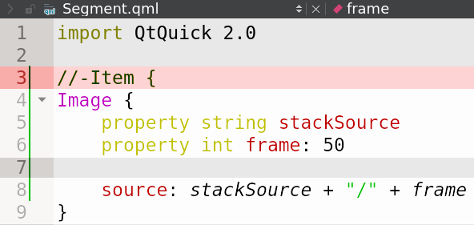
- Layout2x2 needs to use new Segment type instead of Image.
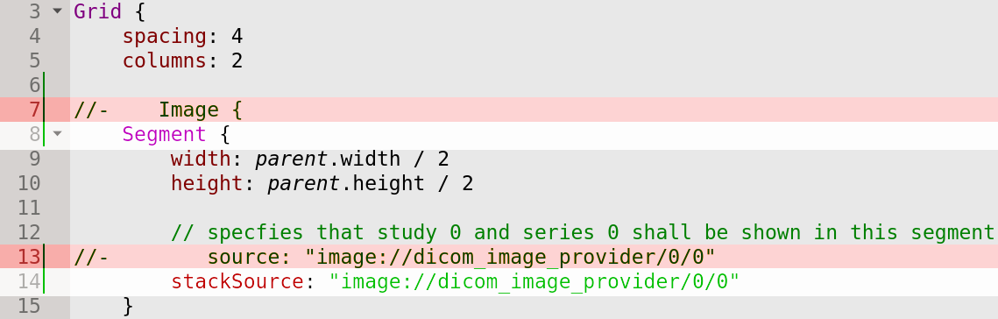
Run the application. It should display four static images, same as before.
- For scrolling we need to change frame value based on mouse wheel movement. Add MouseArea and onWheel handler to Segment.qml.
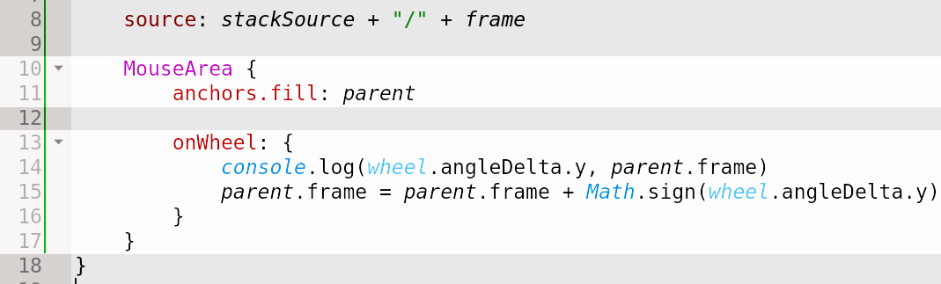
Run the application. Now we should be able to scroll.
- There is a glitch. The program allows us to scroll outside of series boundaries and then it crashes. Let’s fix that. First, fix scrolling to a frame higher that number of frames. The exception occurs when trying to get pixel data from an empty frame in DicomImageProvider. Add simple condition there which returns an empty image in such case.
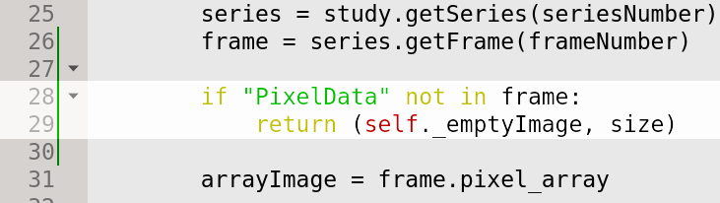
Define the empty image in constructor.
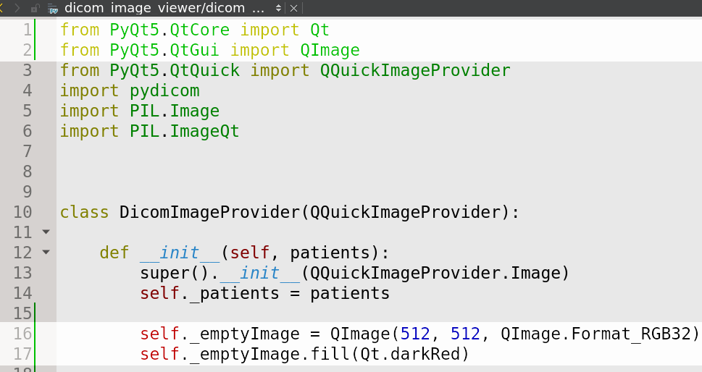
When scrolling to negative frame numbers call to islice function in Series.getFrame throws an exception. We shall check for negative values in series.py.
Run the program and scroll outside of series boundaries. Application does not crash anymore.

Drawing Measurements
Let’s make a simple measurement drawing which will be, in our case, a simple line without actual measurement value. We demonstrate:
- Usage of Canvas for drawing graphics
- Passing a custom Python class (type) to QML
- Functions in QML
- Multiple Python classes in a single file

- For drawing lines we will use Canvas QML type. We insert it to Segment.qml next to Image object. In order to do that first we have to wrap Image object into Item object.
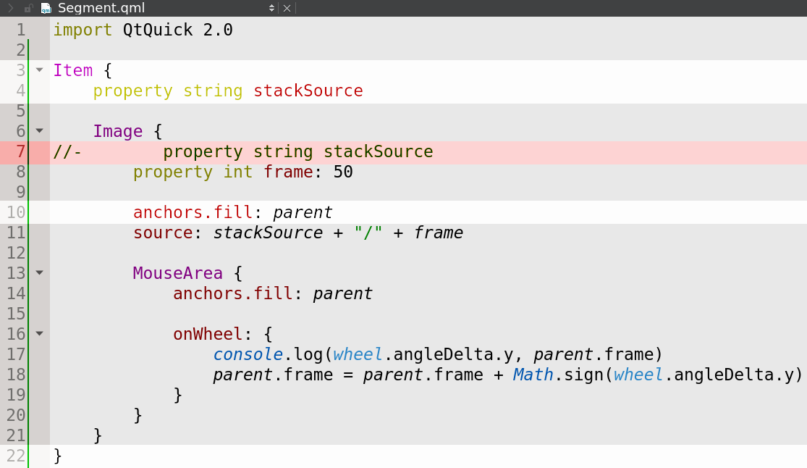
Insert Canvas object.
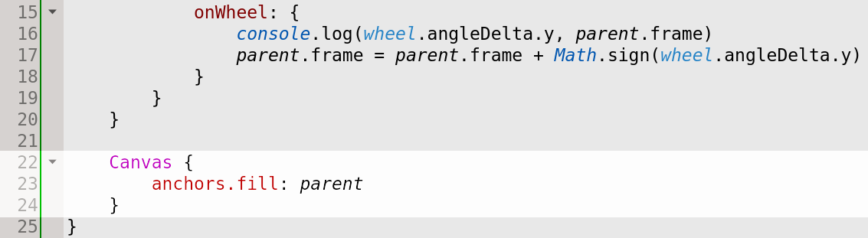
Since we are going to use mouse to draw the lines we need to add MouseArea and handle appropriate signals. There are in our case pressed and positionChanged. Upon the pressed we store the starting point for the line and upon positionChanged we draw the line.
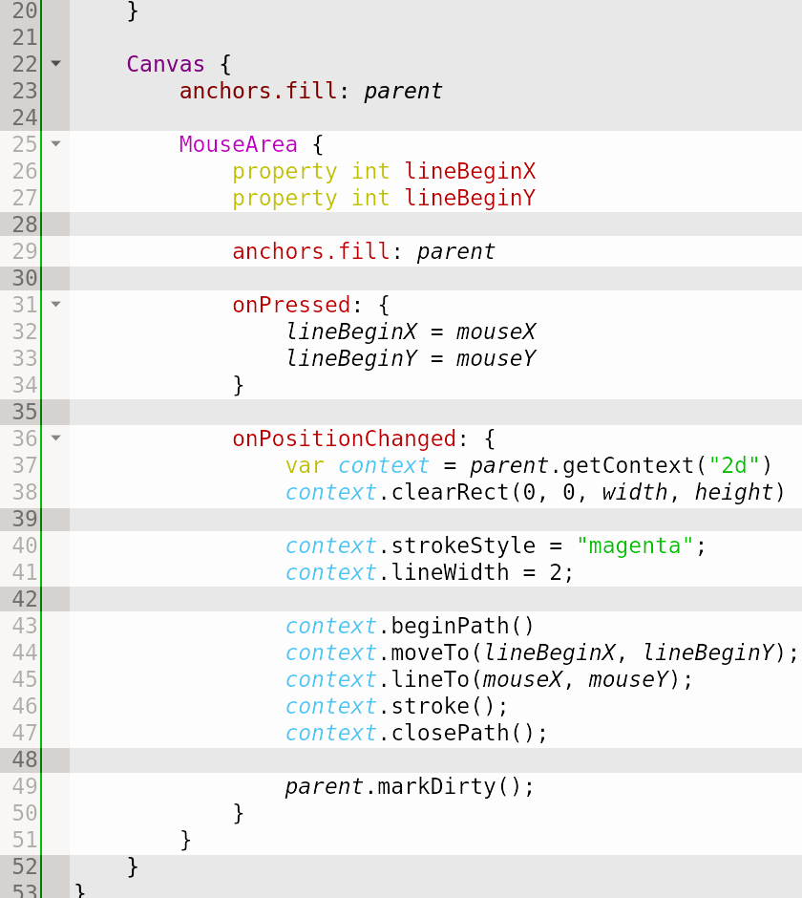
Run the program and draw lines with mouse. Scroll the image. We see that only a single line per segment can be drawn. Also, scrolling keeps the line visible. We would like to draw multiple lines and “attach” them to a frame so that scrolling to a different frame will hide the line.
- For such logic we need a backend class that will hold the drawn lines. Let’s create Measurements class in a new file measurements.py and add APIs for getting and adding measurements.
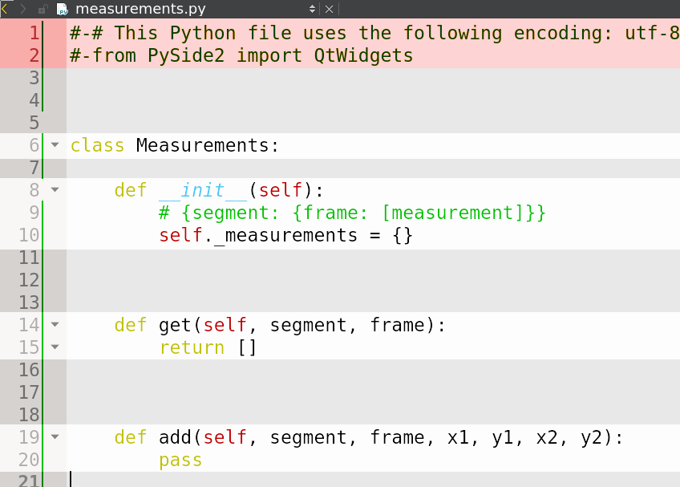
Implement methods.
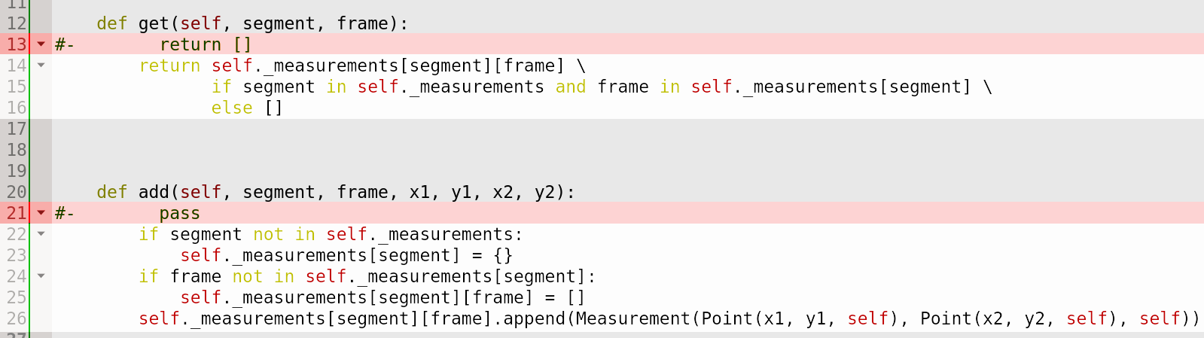
Add classes for Measurement and Point to the same file measurements.py.
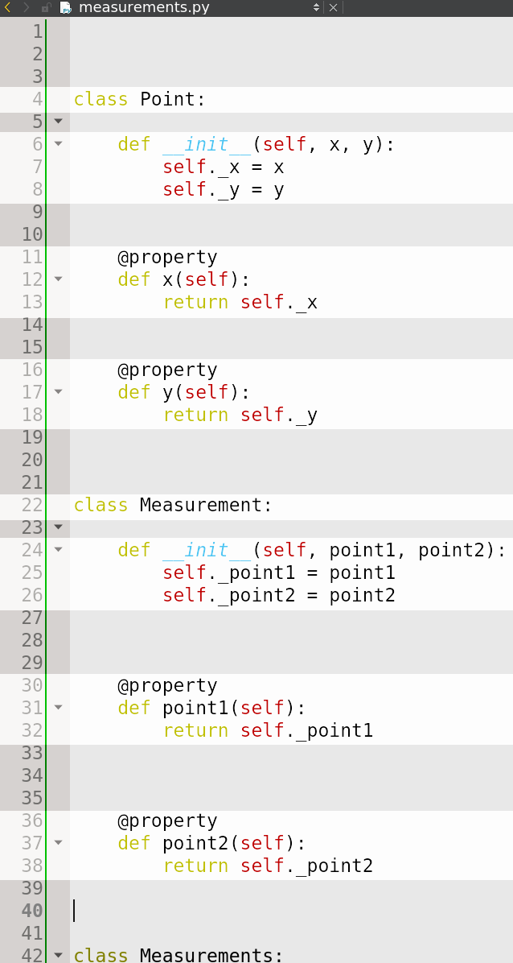
- Now we have our python classes for measurements implemented but we have to make them accessible from QML. For that we need to make some small changes there. Derive Point class from QObject and use @pyqtProperty instead of @property.
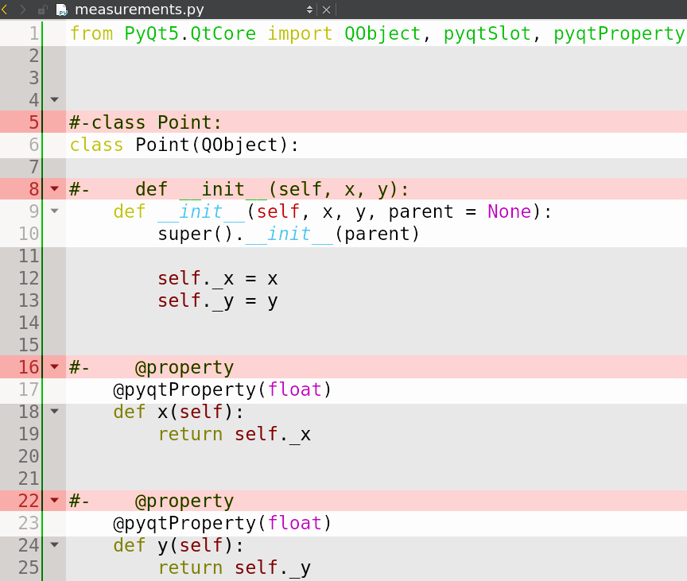
Same for Measurement class.
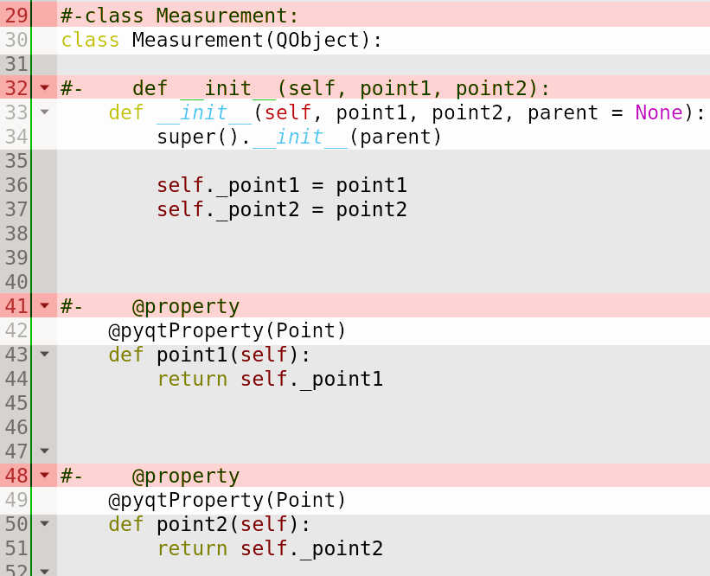
Also for Measurements class.
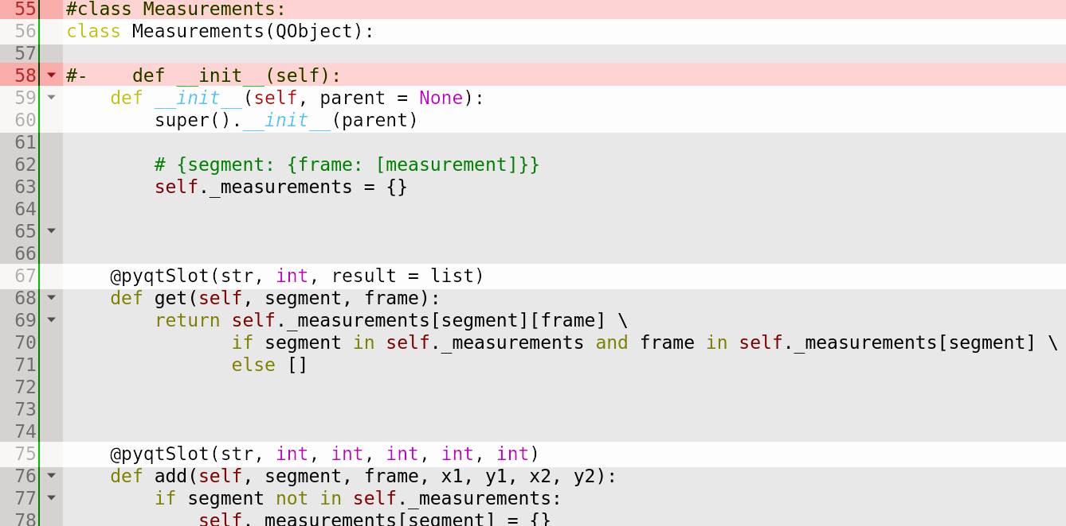
Now we have our measurement classes ready for usage in QML.
- In main.py register Point and Measurement classes for QML so that it knows them. Also add context property to access instance of Measurements class.
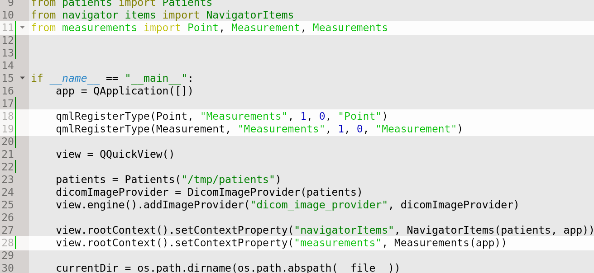
- Now use the classes in QML to store and retrieve measurements. As measurements are stored per segment we have to somehow identify them. Add new property segmentId to Segment.
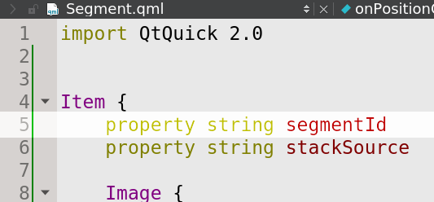
Initialize the segmentId property for each segment in Layout2x2.
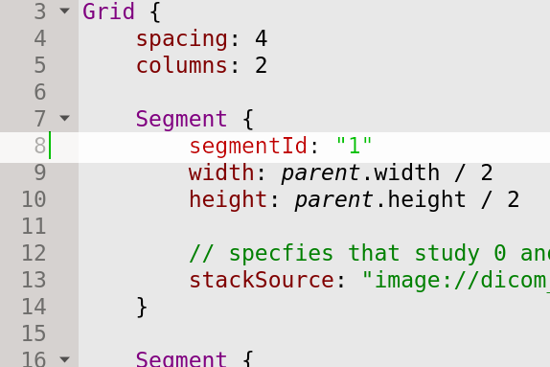
For retrieving and drawing measurements on a particular frame we will create a new function in Segment.qml.
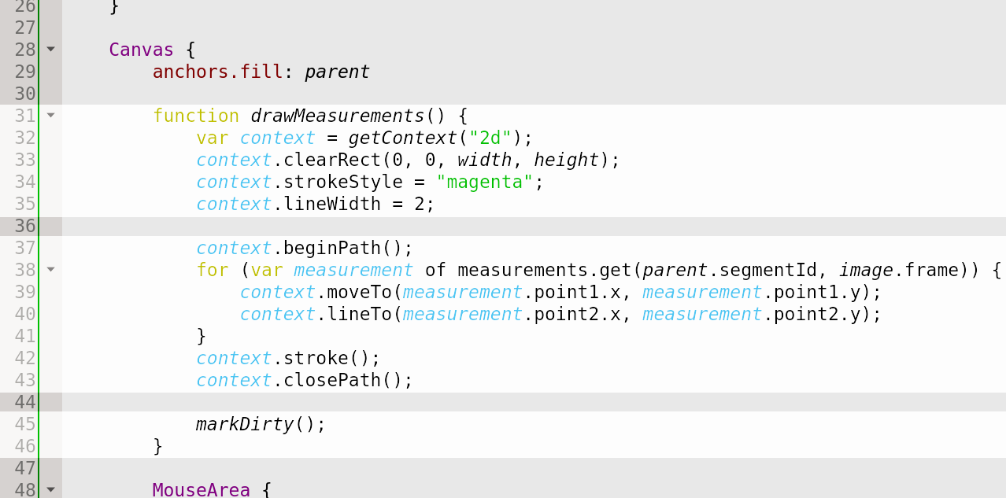
We call that function when frame changes and also during drawing of a new line. In order to access the function from a different object (which is not a child), add id to Canvas.
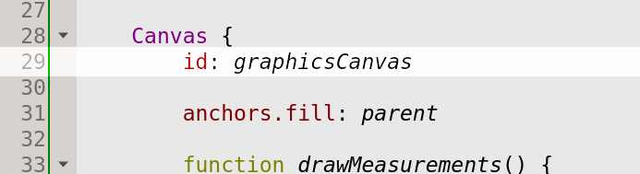
Now we can call the function from Image.
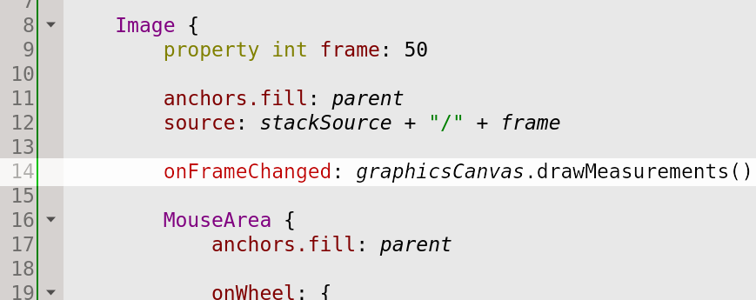
Also add call to drawMeasurements from MouseArea within Canvas when a new line is being drawn.
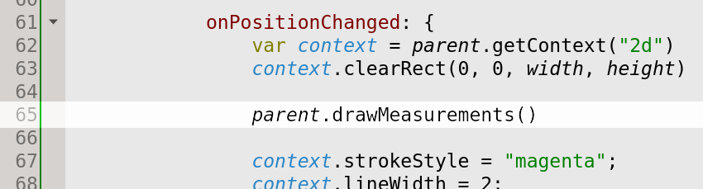
Finally, we can not forget to populate the measurements collection. We do that upon mouse button release.
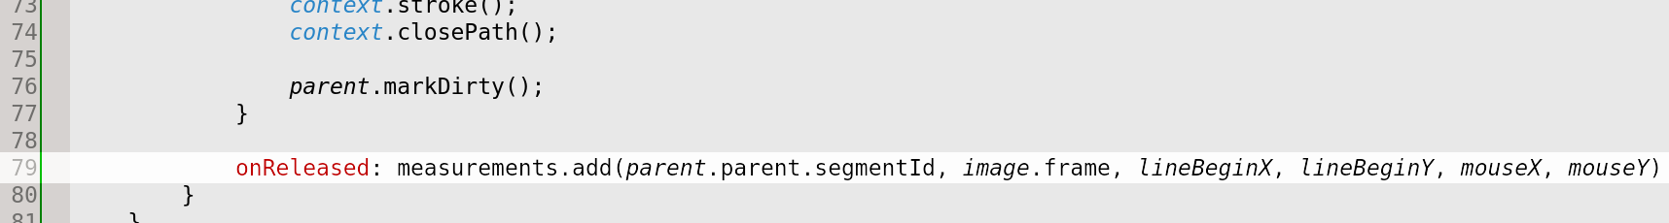
Run the application. Now the measurements can be drawn per segment and per frame.
We have finished the dojo.

