IaC – Jenkins’s pipeline to provision AWS resources using Terraform Cloud/Enterprise

Author: Rajesh Sanjeevi
Kind: Draft
Version: 1.0

Contents
Environment Required 3
1. Jenkin’s Environment 3
1.1 Plugins required 3
1.2 Credentials required 4
1.2.1 TFC/TFE User Token 4
1.2.2 TFC/TFE Team Token 4
2. Terraform Enterprise/Cloud 5
2.1 Workspaces 5
2.1.1 Workspace to manage K8S Resources 5
2.1.2 Workspace to manage AWS Resources 6
2.2 Variable Set 8
2.3 Team Access 10
3. Jenkins Job Configuration 11
4. Appendix 13

Environment Required
- Jenkins
- Terraform Cloud/Enterprise
- Source code repository (GitHub)

Jenkin’s Environment

Plugins required

- HTTP Request Plugin
- Terraform Plugin
- Source Code Plugin

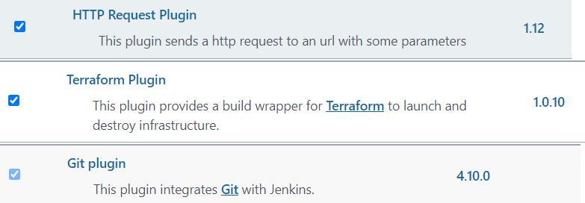

1.2 Credentials required
- Terraform Cloud/Enterprise access token (user token/team token). This is used while configuring Jenkins pipeline job.

TFC/TFE User Token

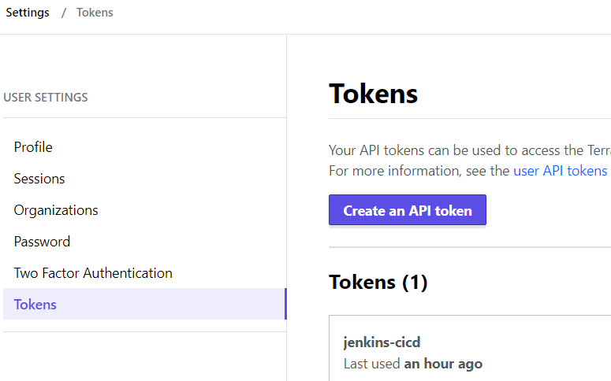

TFC/TFE Team Token

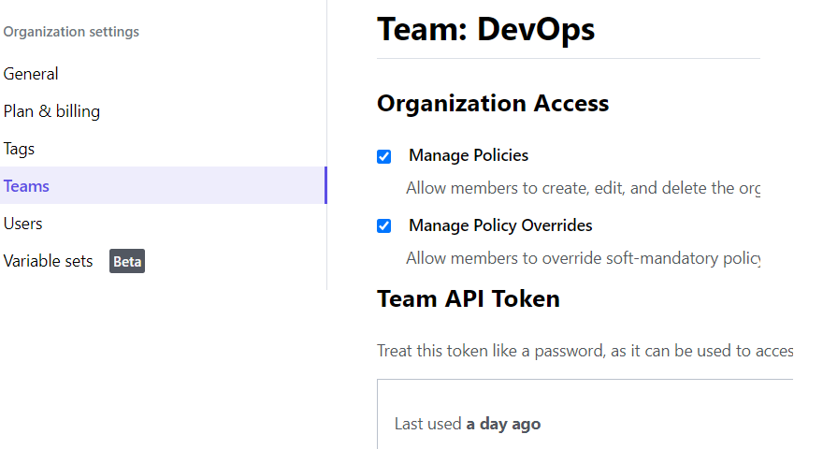

- Source Code repository access credentials (GitHub). Get the username and password to access GitHub is configured as credentials in Jenkins
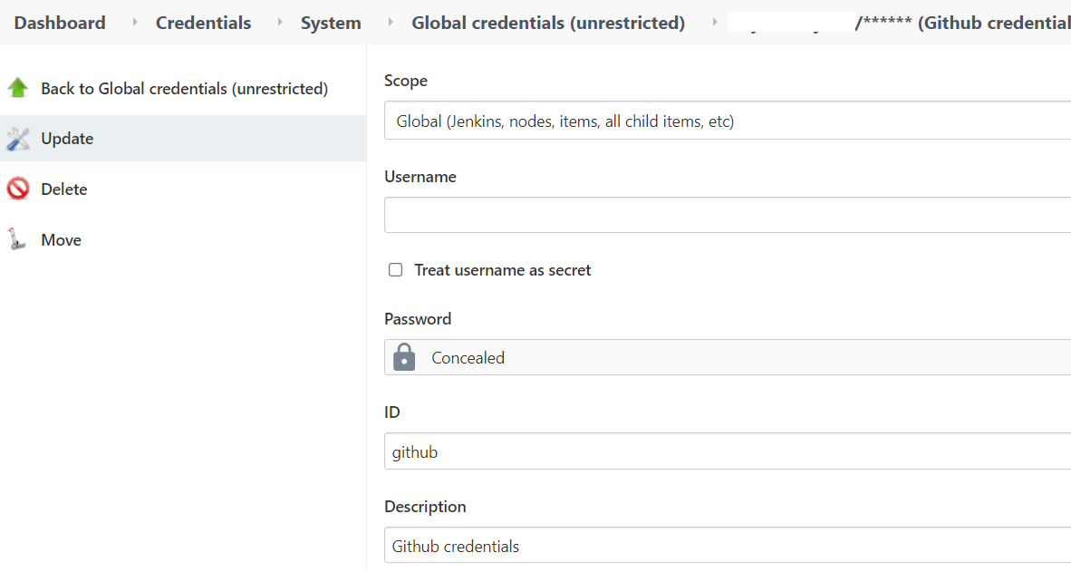

Terraform Enterprise/Cloud

The following are required to configure in Terraform.
- Workspaces
- Team Token/User Token (It is covered in previous section)
- Variable set

Workspaces

The terraform code is developed as two sets. They are required to run one after the other to provision AWS resources including EKS cluster and further provision Kubernetes resources inside EKS cluster, for example config-map, storage class and ha proxy. Hence two workspaces are required to configure in Terraform inside the organization.

Workspace to manage K8S Resources

A workspace to manage K8s resources. Set the execution mode to Remote, Apply method to Manual and Terraform version above 1.0.5
Note: This workspace refers to the state file of AWS resources workspace.
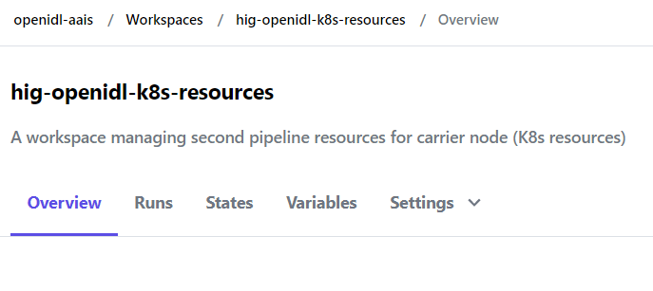
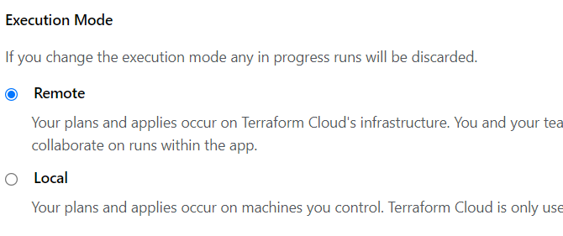
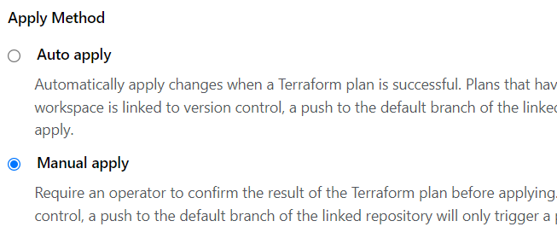
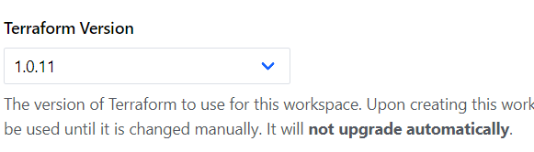

2.1.2 Workspace to manage AWS Resources

A workspace to manage AWS resources. Set the execution mode to Remote, Apply method to Manual, Terraform version above 1.0.5 and for allow the state file of this workspace is accessible to the workspace used to manage K8s resources.
Note: This workspace shares its state file with K8s resources workspace

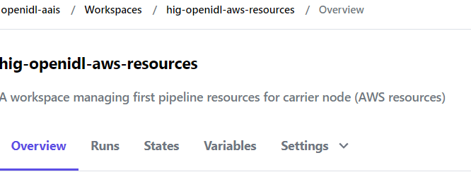

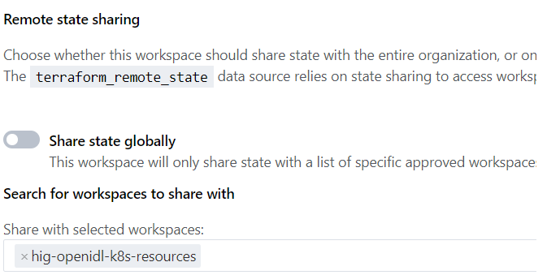

Variable Set

Configure a variable set and share them to the workspaces configured in previous section as most of the variables and inputs are shared across. You can prefer to store all sensitive information inside variable set and have rest of the input compiled as input file carrier.tfvars and store in the repository under directory “aws”.
Note: The Jenkins code refers to carrier.tfvars file and copies that to the terraform code directory for terraform to refer for inputs. In case you choose to have all inputs as variable set, the Jenkins code needs to be updated to remove the action of copying code.

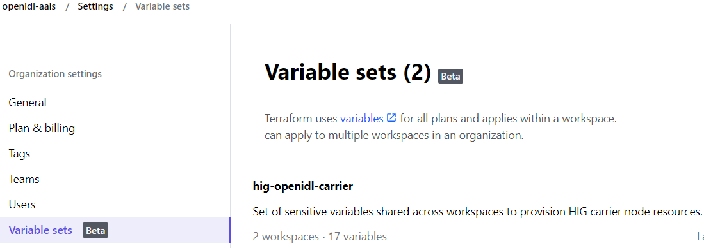

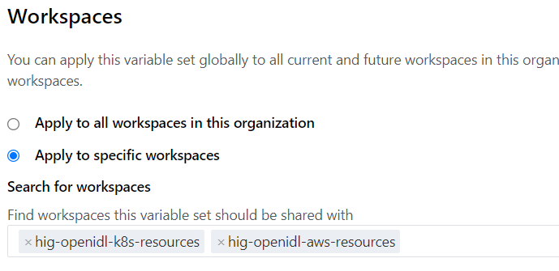

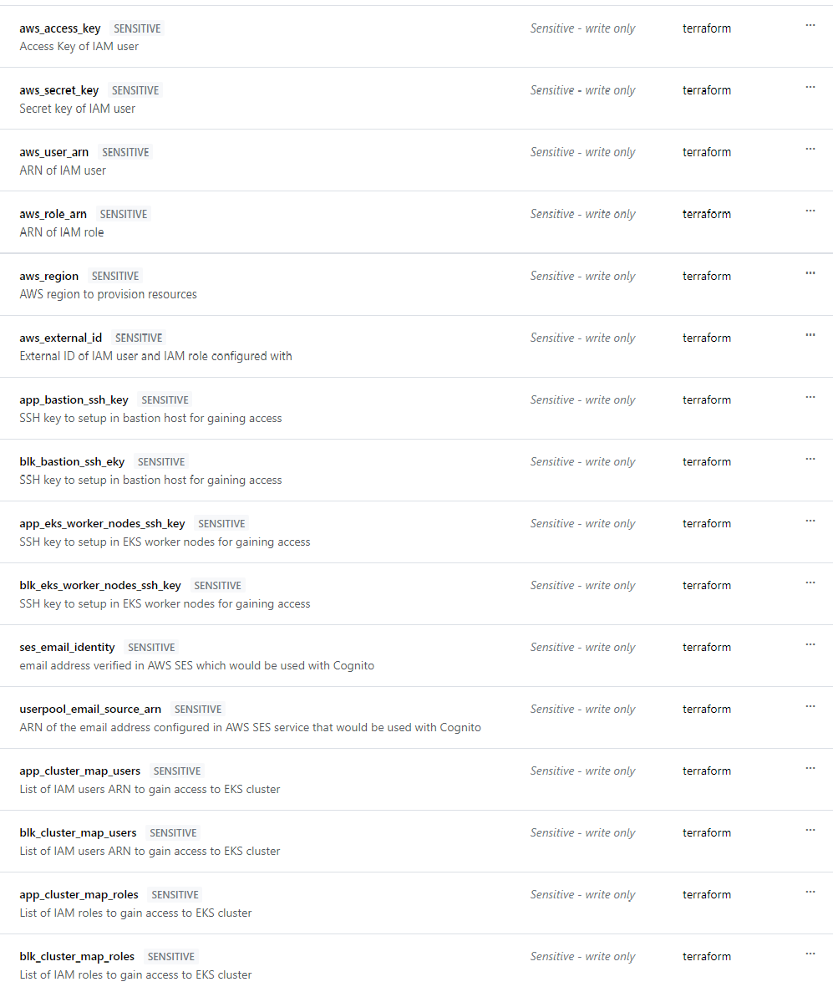

Team Access

Finally in each workspace configured enable team access in case team token is chosen as preferred method for API access.
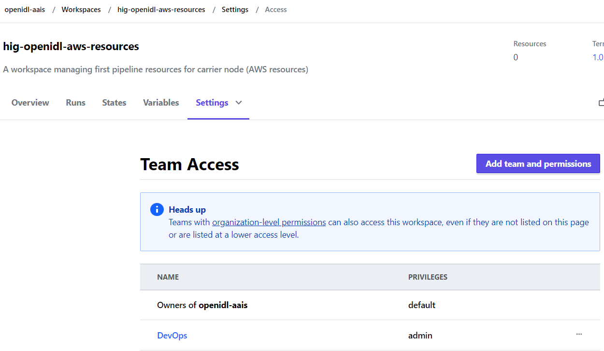

Jenkins Job Configuration

Configure a Jenkins pipeline job with the below.
- Parametrize the pipeline as per below screenshot which includes the following information.
  - TF_ADDRESS (Sting type)
  - TF_BEARER_TOKEN (Password type)
  - GIHUB_BRANCH (Sting type)
  - TF_ORGNAME (Sting type)
  - TF_AWS_WORKSPACE (Sting type)
  - TF_K8S_WORKSPACE (Sting type)

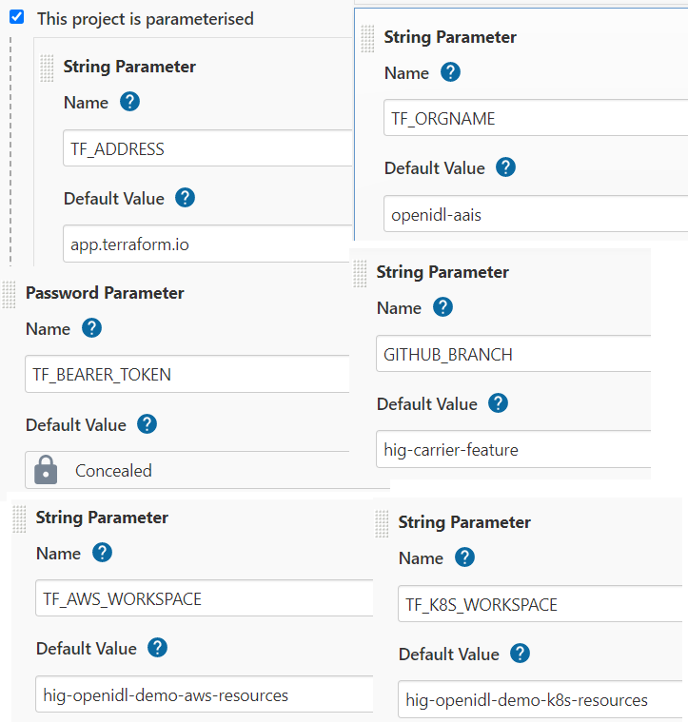

- Configure the pipeline to refer to GitHub/other source code repository to a specific branch and to the Jenkins job file as below.

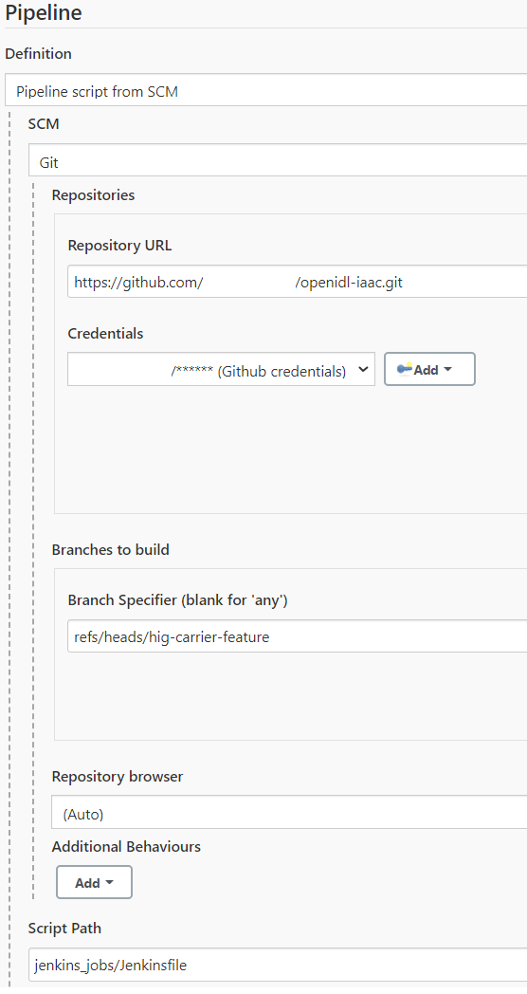

Appendix

The following are the changes made to the code and ensure they are always enabled correctly before pipeline is triggered.

- In case all terraform inputs are preferred to setup as variables using variable set in Terraform Enterprise/Cloud. The marked lines need to be commented/removed from the Jenkins pipeline code located under Jenkins_jobs/Jenkinsfile
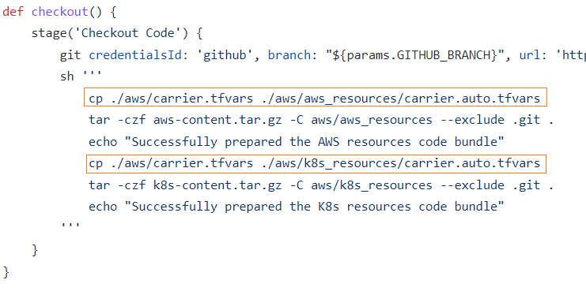
- Activate the right AWS provider configuration in the code for aws_resources code set. 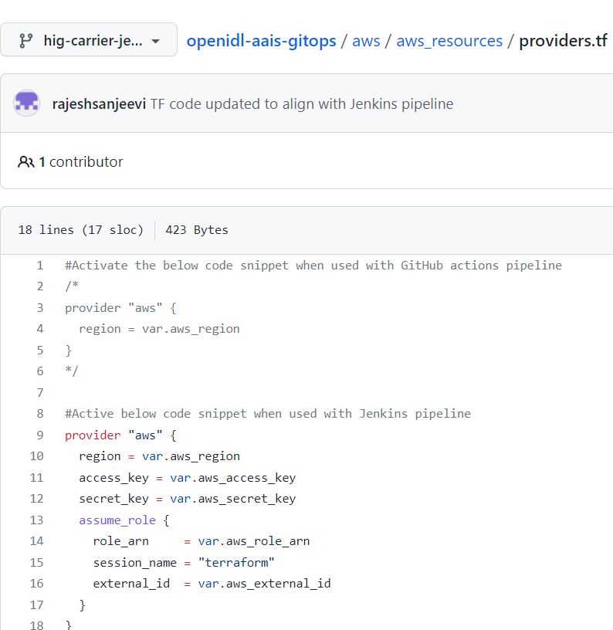

- Comment the terraform backend section of the code in both aws_resources and k8s_resources code set in the file main.tf. Below is an example.
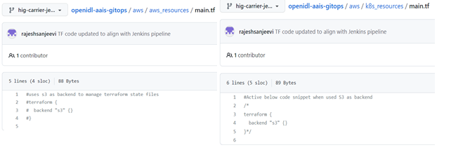
- Activate the AWS provider configuration as below for k8s_resources code set and for remaining providers like Kubernetes and helm requires no changes.
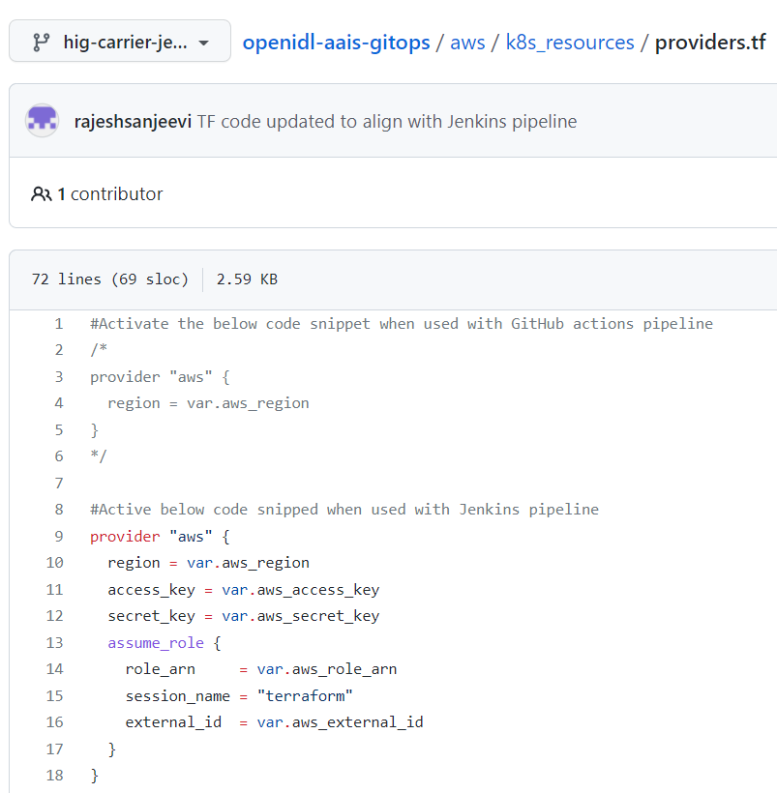

- Finally update/activate the code relevant code snippet as below for data.tf in k8s_resources code set.
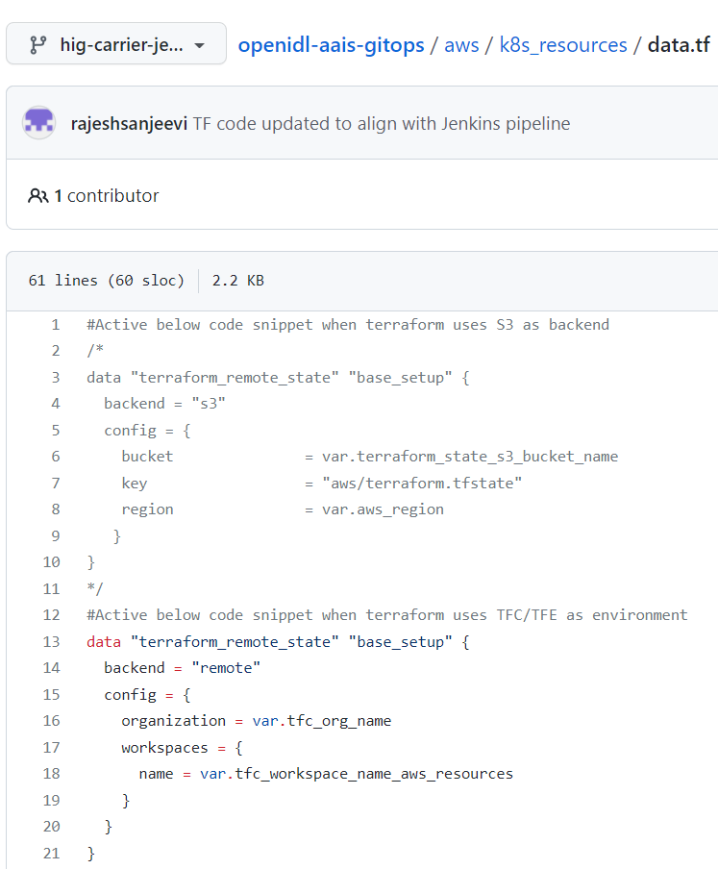
NOTE: Refer to the templates located in the repository under aws/templates/node_type/ to investigate the required variables and the relevant inputs to be either prepared as input file or as variable set before the pipeline can be triggered. Ensure that the information is keyed either in input file or in variable set.

#Applicable when Terraform Cloud/Enterprise is used
tfc_org_name = "openidl-hig"
tfc_workspace_name_aws_resources = "hig-openidl-aws-resources"

