

Merged

with a test laboratory

Author: Kirky DeLong, Sardis Harward and Antonia Harward
Editor: Niederstätter Michael
Last Modified: May 2010
Version: 11

The idea of this iLab installation 4
Service Broker Requirements 5
iLab Process Agents 5
Grants and Qualifiers 6
Resource Mapping 6
Requirements 7
iLab Installation Directory 7
.NET 2.0 Framework 7
What is a GUID 8
Installing from the Pre-built Binaries 8
General Installation Process 9
iLabs Installation Check List 10
iLab Service Broker 11
Service Broker Web Site 11
Create the Database 13
Grant Access to the Database 13
Service Broker Database Scripts 14
Web.Config 17
Update the Database Name 18
Update Email Addresses 18
Update Default Passkey 18
Web.Config Parameters to be aware of: 18
Testing Your Service Broker Installation 19
Self-Registration Fields 19
iLab Service Broker Self Registration 20
Error Messages 22
Userside Scheduling Services (USS) 23
USS Web Site 23
Create the Database 23
Grant Access to the Database 23
USS Database Scripts 24
Web.Config 25
Update the Database Name 26
Update Default Passkey 26
Web.Config Parameters to be aware of: 27
Test the Scheduling Services: 27
USS Self Registration 27
Labside Scheduling Service 29
LSS Web Site 29
Create the Database 29
Grant Access to the Database 29
LSS Database Scripts 30
Web.Config 32
Update the Database Name 32
Update Default Passkey 33
Web.Config Parameters to be aware of: 33
Test the Scheduling Services: 33
LSS Self Registration 33
Lab Proxy Server 35
Lab Proxy Web Site 35
Create the Database 35
Grant Access to the Database 35
LPS Database Scripts 36
Web.Config 37
Update the Database Name 38
Update Default Passkey 39
Web.Config Parameters to be aware of: 39
Test the LabProxy Server: 39
LPS Self Registration 39
Configure the URL of online Laboratory: 41
ASP Demo Lab 41
Users and Groups 42
Process Agents 44
Service Broker 45
Userside Scheduling Server (USS) 46
Labside Scheduling Server (LSS) 48
Lap Proxy Server (LPS) 49
Lab Proxy Client 50
Lab Client Record 50
Client Loader Script 50
Associate the Lab Server 51
Associate the USS 52
Associate Groups 52
Create a Test User 52
Group Membership 53
Setup Lab Proxy Experiment 53
Manage USS 54
Manage LSS 54
Running the ASP DemoLab Experiment 56
Grants 58
Web.config issue 58
Incorrect Password 59

Overview
This document describes the steps necessary to get an iLab Service Broker and Process Agents installed and functioning correctly in the single domain scenario. This document also contains instructions on how to install and configure a demo Interactive Experiment (to test your iLab Service Broker).

The idea of this iLab installation

ATTENTION: This is not a standard iLab shared architecture installation – this package is a modification of the original package which provides some additional functionality.
The intention of this package is to foster the integration of any type of laboratory, realized with different technologies to the iLabs architecture. The current iLab package provides all services and a TimeOfDay experiment, which shows the main functionalities and gives you an idea how to build on this framework and how to use the iLab libraries. But currently this solution is acceptable only for users which have developed their laboratory with Microsoft .NET technologies.
If not using .NET and the provided libraries one can still use the various other packages like for example the Lab Server for LabVIEW. There is not for all technologies a Lab Server package available and if this is the case one has to develop its own Lab Server or to connect the laboratory somehow to a current solution.
Because of this limitation the idea came up to use a certain middleware instead of the lab server to create a general purpose interface which allows the integration of different types of laboratories. In fact this middleware acts like a proxy, therefore in this document it is called Lab Proxy.
In the following figure an overview of the original structure compared to the resulting structure of the adaption can be seen.

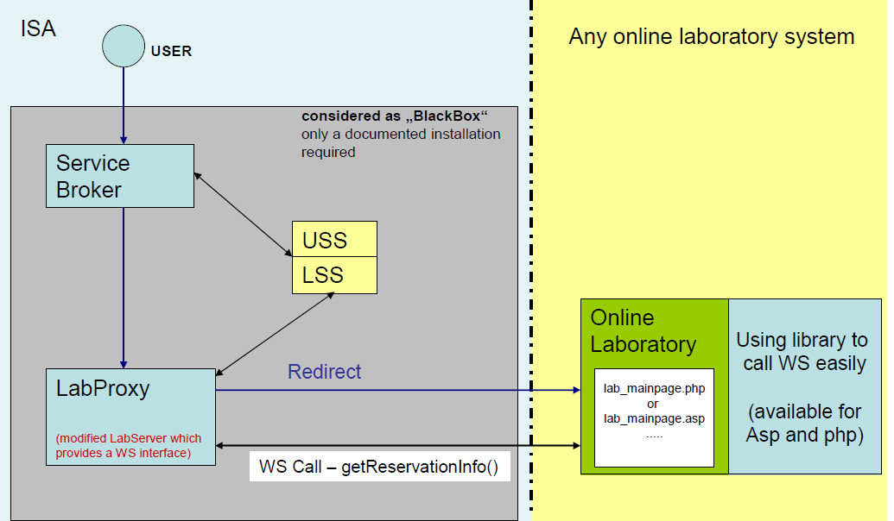
The communication between online laboratory and LabProxy is done in the following way:
• The LabProxy redirects a valid request (which means the ticket was verified) to the online laboratory page. The passkey of the reservation and the service broker URL will be posted.
• The online laboratory retrieves information of the current reservation by calling the web service of the LabProxy Server (the passkey is used to identify the reservation).
• A library (available in asp & php) further simplifies the interaction between LabProxy/online laboratory and a static method can be used to check whether the current reservation is still valid. This allows you easily to check whether the session has to be terminated or not.

Conclusion
This extension simplifies the integration of iLabs for many laboratory developers even in cases where before integration was a big effort because of the use of other technologies not supported currently by the Lab Server.
This solution can be used very flexible by any online laboratory and communicates with the Lab Server via SOAP web service.

Service Broker Requirements
You should have already installed and configured one or more computers to run the iLab Service Broker and Process Agents. This document will assume that you have at least one Service Broker installed and configured. Since the iLab architecture uses web services you can run all servers on a single machine or each service on a separate machine. See iLab document “iLabs Service Broker Machine Build Operating System and Database Install Guide” for instructions on installing and configuring the operating system and database. This document can be downloaded from the http://icampus.mit.edu/iLabs/Architecture/Downloads/default.aspx website.
- Windows 2003 Server Enterprise Edition
- SQL Server 2000 with Service Pack 3a
- Visual Studio.NET 2005 Professional and Library
It is also assumed that your computer(s) are connected to the Internet and have valid IP addresses and domain names. In order for the web services in iLab Architecture to communicate with each other, the service will need to communicate over the Internet. This document does not address network connectivity issues. Please contact your local systems administrator to make sure that your computer(s) are connected to the Internet and can communicate with each other correctly.
This document assumes that you are using Windows 2003 Server Enterprise Edition and SQL Server 2000 Enterprise with Service Pack 3a. There is a help document called “iLabs Service Broker XP notes.doc” with some configuration suggestions and notes about installing the iLab Service Broker under Windows XP with SQL Server Express. This document is not an install guide but a set of notes about the issues that can arise when installing under Windows XP with Microsoft SQL Express. We recommend and support the use of Windows 2003 Server Enterprise Edition and SQL Server 2000 Enterprise with Service Pack 3a.

iLab Process Agents
A process agent in the iLab architecture is a web service that implements the ProcessAgent interface. A process agent can be a web service or a web server. In addition to having the physical machines correctly installed and configured, you will need to have downloaded and installed the code or pre-built iLab services.
In the iLab architecture there are four types of services described; iLabServiceBroker ( ISB), Experiment Storage Server (ESS), User Scheduling Server (USS),Lab Scheduling Server (LSS), Interactive Lab Server (ILS), Batch Lab Server (BLS). This bootstrapping guide will assume that your iLab domain will have one iLab Service Broker and at least one of each of the servers, except the ESS, which is not considered in this document. Also included in this release is a LabProxy which replaces the ILS and connects your laboratory by using a standard web service interface to the LabProxy.
Process Agents used in this package:
- User-side Scheduling Server (USS)
- Lab-side Scheduling Server (LSS)
- Lab Proxy Server (LPS) which is realized like a Interactive Lab Server but provides an Interface to labs which are anywhere, and which are developed in any program language. As the name says it acts like a Proxy.
One important item to remember about Process Agents is that services (USS and LSS) can have only one Administration group, but may have many Management groups.

Grants and Qualifiers
Grants are the permissions given to an agent (either a group or user). Qualifiers are the resources (services or servers) that Agents are allowed to perform actions on.
Grants have three parts: Group, Function, and Qualifier.
- Groups
- Functions are the permissions or TicketType that a group has on a particular qualifier.
- Qualifiers are resources or resource mappings.

Resource Mapping
- Resources such as scheduling and storage are associated with clients, process agents or groups.
- Resource Mappings are resource associations with one key to many values.
- Authorizations come from the Grant table not the Resource Mapping table.
- In the case of a single domain, resource mappings will be used to map client -> USS, client -> LSS and LS -> LSS. Mapping_id’s are unique. TicketTypes needed for each resource are stored in the grants information.

Map_ID | KeyType | KeyValue (DB) | ValueType | ValueValue (DB)
12 | “client” | Client_object (client_id) | “ResourceType” | “USS”
 |  |  | “ProcessAgent” | USS_Object (pa_id)
 |  |  | “TicketType” | “Schedule session”
13 | “LabServer” | LS_Object (pa_id) | “ResourceType” | “LSS”
 |  |  | “ProcessAgent” | LSS_Object (pa_id)
 |  |  | “TicketType” | “Manage LS”

Installing iLab Servers
Currently, there is only one version of the iLab’s distribution files that can be downloaded from http://icampus.mit.edu/iLabs/architecture/ website:
The standard distribution contains both the SDK and a pre-built set of web sites ilab_Project_Release_2.zip. If you want to use the pre-built services use the builds directory. If you intend to set up a development environment with full source code, use the code in the services directory for compiling. Note: Visual Studio 2005 is the recommended install, since you will need to build the local installation.

Requirements
You should have the following software already installed and configured before you begin to set up the iLab Service Broker.
- Windows 2003 Server Enterprise
- SQL Server 2000 or 2005
- Microsoft .Net 2.0 Framework
- Visual Studio.NET 2005 Professional and Library (optional, but required for compiling the SDK version)
The installation and configuration of the server computers is described in the iLabs Service Broker OS and Database Install Guide.

iLab Installation Directory
- Create a folder called iLabs (typically on the C or D drive)
- Unzip the iLabs Distribution archive iLab_withLabproxy.zip into this folder.
  - Right-click on the zip file
  - Select Extract All…
  - Click Next>
  - Click Finish
The structure of the new iLab directories includes the following (there may be other directories).
\iLabs\Builds – Precompiled versions.
\iLabs\Database – Database scripts and models.

The documentation which you are currently reading can be found also in the root folder of the package.

.NET 2.0 Framework
The iLabs Architecture needs the .NET 2.0 framework to be installed. This is not installed when you installed Windows Server 2003.
Download the Microsoft .NET framework from http://www.microsoft.com/downloads/ there should be a link to the .NET Framework Version 2.0 Redistributable Package (x86).
This document assumes that you will be installing each service separately or on separate machines. This document is organized by service.
If you are installing all the services on a single machine, a more efficient way to set up the services is by activity; i.e., all the databases at once. This document is not configured to follow this method, but you can use the included checklist to install by activity.

What is a GUID
A Globally Unique Identifier or GUID is a special type of identifier used in software applications in order to provide a unique string for referencing. It is typically a string of letters and numbers separated by hyphens. iLab uses GUIDs to ensure the Process Agent IDs are unique. Since Process Agents such as the Service Broker, Experiment Storage Service, User-Side Scheduling and Lab-Side Scheduling exchange credentials, it is very important that their identifiers be unique. This ensures the correct service is accessed when needed.
There are several free, on-line, easy to use GUID generators available, or you can use the GUID generator provided with Visual Studio .NET. If you have installed Visual Studio.NET 2003, GuidGen.exe is available in the C:\Program Files\Microsoft Visual Studio.NET 2003\Common7\Tools directory. To create a GUID, select Registry Format, Click the Copy button, and paste the resulting GUID between the quote marks following the value field. Edit out the bracket and hyphen characters ({-}). On pages that require a GUID assigned to the pages subject, a utility button is displayed to generate a new GUID. Use this utility only if the object’s GUID has not been generated by another method.
BUG: The Service Broker GUID needs to be 35 characters or less due to some legacy code in the batched architecture. If you enter a GUID into the web.config file directly, please make sure that it is less than 35 characters long including dashes and underscores.

Installing from the Pre-built Binaries
Use the pre-built version of the code included in the distribution’s Builds directory. To use the pre-built version, when creating the virtual directories, set the directory location to the Builds directory for each service rather than the services directory.

General Installation Process
A more detailed description of each installation process will follow. Each service installation will follow the same general process:
- Create a virtual directory
- Create the database (tables and stored procedures)
- Edit Web.config file as necessary
- Complete self-registration
After a service is installed the Service Broker needs to create a trusted relationship with the service. This is done in the bootstrapping section of this document.
URGENT: This document assumes that you have compiled the iLab architecture and will be using the Services directory for the IIS virtual directories and editing the web.config files.

iLabs Installation Check List
iLab Service Broker
- Create Virtual Web Site
- Create Database
- Database Permissions
- Database Process Agent scripts
- Database Ticketing scripts
- Database Interactive Service Broker scripts
- Edit Web.Config file
- Test service
- Register domain services
UserSide Scheduling Service
- Create Virtual Web Site
- Create Database
- Database Permissions
- Database Process Agent scripts
- Database USS scripts
- Edit Web.Config file
- Test service
- USS self registration
LabSide Scheduling Service
- Create Virtual Web Site
- Create Database
- Database Permissions
- Database Process Agent scripts
- Database LSS scripts
- Edit Web.Config file
- Test service
- LSS self registration
LabProxy Server
- Create Virtual Web Site
- Create Database
- Database Permissions
- Database Process Agent scripts
- Edit Web.Config file
- Test service
- LPS self registration
Your custom Online Laboratory
- Required adoptions
- Libraries & Examples ready to use

iLab Service Broker

Service Broker Web Site
First, create a virtual directory in IIS.
- Right-Click on My Computer
- Click Manage
- Expand Services and Applications
- Expand Internet Information Services
- Expand Web Sites
- Expand Default Web Site
- Right-click on Default Web Site
- Select New->Virtual Directory
- Click Next to start the Virtual Directory Creation Wizard
- In the Alias box, type iLabServiceBroker
- Click Next
- Click the Browse button and navigate to the location where your Service Broker code is located. The path should resemble \*local_path*\ iLabServiceBroker directory.
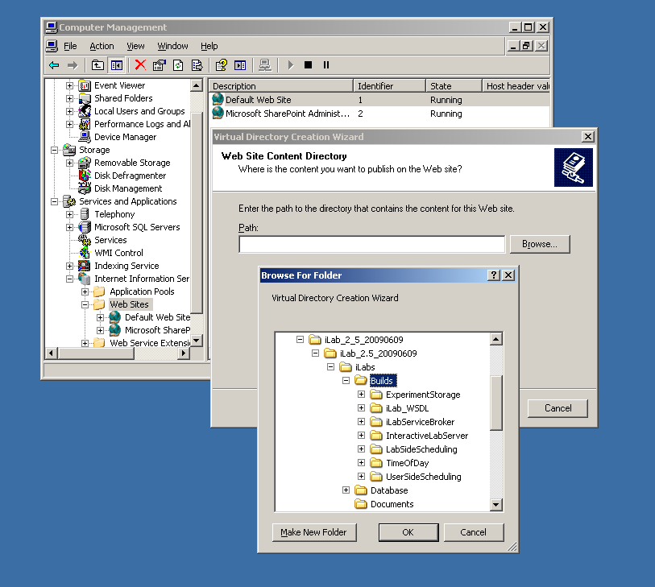

For notational purposes we will use \*local_path*\ to represent the directory on your local computer where the code is unzipped.

- Click Next
- Access Permissions: make sure you check the Run Scripts, Execute and Read permission boxes
- Click Next
- Click Finish
- You should see the Service Broker site listed under the Default Web Site
- Right click on the iLabServiceBroker website and select Properties
- Select the ASP.NET tab
- Use the pull-down list for the ASP.NET version and select 2.0.xxx. Where xxx is the current release version.
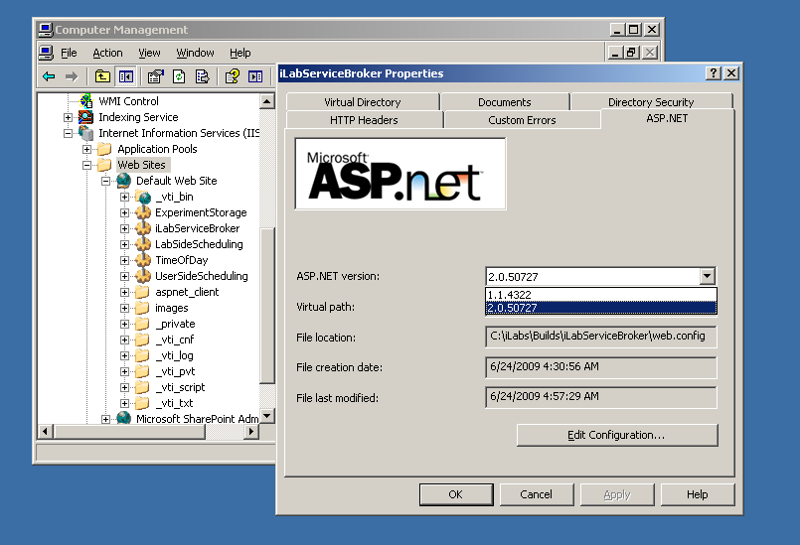
- Select OK and close the properties window
- Close the Computer Management Window
This document assumes that you will be installing each service separately or on separate machine. This document is organized by service.
If you are installing all the services on a single machine, a more efficient way to set up the services is by activity; i.e., all of the virtual directories at once. This document is not configured to follow this method, but you can use the included checklist to install by activity.

Create the Database
First, create the database.
- Start-> Enterprise Manager
- Console Root->Microsoft SQL Servers->SQL Server Group->(local)->Databases
- Right-Click on Databases
- New Database…
- Name: ilab_ISB (This is the default. You can use any name you would like but you must update the web.config file to use the different name)
- Click OK

Grant Access to the Database
- Expand the Security folder in Enterprise Manager.
- Right-click Logins, select New Login…
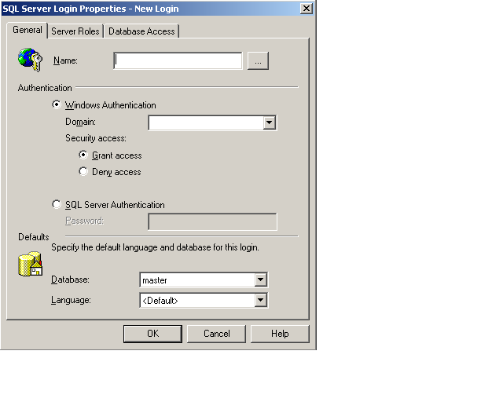
- In the Name box, type NT AUTHORITY\NETWORK SERVICE
  - Note: if you already have a login for NT AUTHORITY\NETWORK SERVICE, double-click on it and continue with the next step. If you are installing under Windows XP, please check the Windows XP notes guide for the proper security name to use.
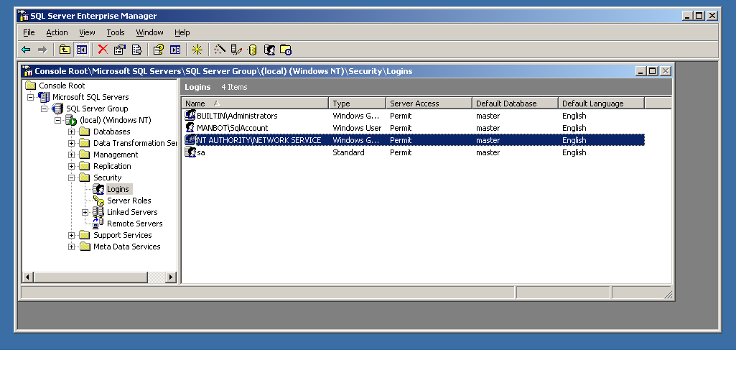
- Click the Database Access tab
- Check the box next to ilab_ISB (or the database name you used above)
- In the box below, click the box next to db_owner
- Click OK

Service Broker Database Scripts
For each Process Agent created (ISB, USS, LSS, ESS, and LPS), you will need to run Process Agent scripts that are generic for all process agents, and specific scripts for the particular Process Agent you are creating. The generic process agent scripts are in a directory called ProcessAgent and specific database scripts will be in named directories, for example ServiceBroker.
This document contains two ways to run the database scripts for Microsoft SQL server; from within the SQL Query Analyzer or from the loader scripts that are in the DB_Scripts directory. The preferred method of creating a new service database is to use Method 2: Using the SQL loader scripts. If you are just updating a stored procedure and not the database, it is best to use the SQL Query analyzer. We include Method1: Using the SQL Query Analyzer for your information.
NOTE: the SQL loader scripts do not work under Windows XP with SQL Express – if you are using Windows XP and SQL Express you will need to use the SQL Query Analyzer.
Do NOT attempt both methods – choose one.
METHOD 1: Using the SQL Query Analyzer:
- Expand Databases
- Select the ilab_ISB database (or what you named it) in Enterprise Manager.
- On the menu bar, select Tools -> SQL Query Analyzer
- In Query Analyzer, click File->Open…
- Browse to database scripts directory typically (\*local_path*\iLabs\ Database\DB_Scripts\ProcessAgent)
- In the ProcessAgent directory select and open the ProcessAgentTables.sql
This directory contains the database scripts for all of the Process Agents. You will set up and run the ProcessAgent database scripts before running the service-specific database scripts. This is important because there is a key from the iLab Service Broker foreign to the Process Agents table.
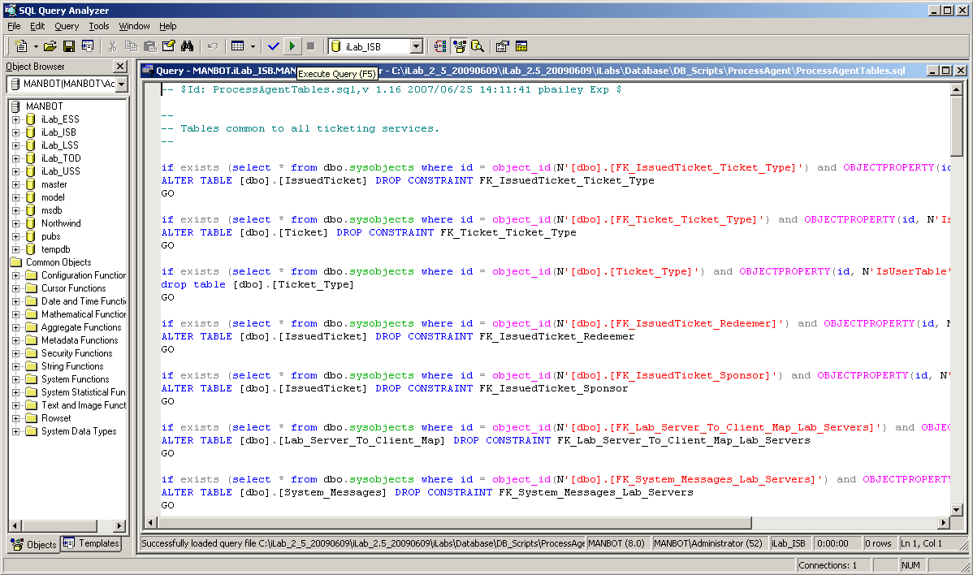
- Again make sure the correct database, ilab_ISB, is the selected database in the dropdown menu at the top of the window. *This is very important because the scripts will be installed in the database specified by this pull-down menu.
- Click the green triangle “play” button to run the script
- You should see a message: “The command(s) completed Successsfully.”
- Follow the same procedure, File → Open, to open and run the ProcessAgentProcedures.sql script.
- You should see the same message: “The command(s) completed Successsfully.”
- Open and run the SetDefaultsPA.sql script.
- You should see several messages: “1 row(s) affective.” and “Checking Identity Information ….”.
Next, set up and run the Interactive Service Broker-specific database scripts (typically located in \*local_path*\iLabs\ Database\DB_Scripts\ServiceBroker).
- In Query Analyzer, click File->Open…
- Browse to database scripts directory, typically (\*local_path*\iLabs\ Database\DB_Scripts\ServiceBroker)
- Open and run the TIssuerTables.sql script.
- Open and run the TIssuerProcedures.sql scripts.
- Open and run the ServiceBrokerCoreTables.sql script.
- Again you should see the message: “The command(s) completed Successsfully.”
- Open and run ServiceBrokerCoreProcedures.sql, as above
- Open and run ServiceBrokerCoreDefaultValues.sql as above
- You should see several messages: “1 row(s) affective.” and “Checking Identity Information ….”.
- Close SQL Query Manager and Enterprise Manager
METHOD 2: Using the SQL loader scripts:
- Open a Command Prompt window. Start -> Programs -> Accessories -> Command Prompt.
- A DOS window should open.
- Change the directory to the DBscripts directory.
- Type: “cd \*local_path*\iLabs\ Database\DB_Scripts\”
- Type: “LoadISB ilab_ISB” where ilab_ISB is the name of your database.
- You should see something similar to the following with your directory path and database name.
D:\iLabsInteractive\iLabs_NET20\iLabs\Database\DB_Scripts>loadISB iLab_ISB
D:\iLabsInteractive\iLabs_NET20\iLabs\Database\DB_Scripts>echo populating iLab_ISB
populating InteractiveSB InteractiveSB
D:\iLabsInteractive\iLabs_NET20\iLabs\Database\DB_Scripts>call ISB_tables.bat iLab_ISB
D:\iLabsInteractive\iLabs_NET20\iLabs\Database\DB_Scripts>echo InteractiveSB Tables: ilab_ISB
InteractiveSB Tables: ilab_ISB
D:\iLabsInteractive\iLabs_NET20\iLabs\Database\DB_Scripts>isqlw -E -d ilab_ISBeSB -i .\Ticketing\ProcessAgentTables.sql -o isbBuild0.log
D:\iLabsInteractive\iLabs_NET20\iLabs\Database\DB_Scripts>isqlw -E -d ilab_ISB -i .\Ticketing\SetdefaultsTicketing.sql -o isbBuild1.log
D:\iLabsInteractive\iLabs_NET20\iLabs\Database\DB_Scripts>isqlw -E -d ilab_ISB
-i .\Ticketing\TIssuerTables.sql -o isbBuild2.log
D:\iLabsInteractive\iLabs_NET20\iLabs\Database\DB_Scripts>isqlw -E -d ilab_ISB
-i .\InteractiveSB\ServiceBrokerCoreTables.sql -o isbBuild3.log
D:\iLabsInteractive\iLabs_NET20\iLabs\Database\DB_Scripts>isqlw -E -d ilab_ISB
-i .\InteractiveSB\ServiceBrokerCoreDefaultValues.sql -o isbBuild4.log
D:\iLabsInteractive\iLabs_NET20\iLabs\Database\DB_Scripts>call ISB_procedures.bat ilab_ISB
D:\iLabsInteractive\iLabs_NET20\iLabs\Database\DB_Scripts>echo InteractiveLS Procedures: ilab_ISB
InteractiveLS Procedures: ilab_ISB
D:\iLabsInteractive\iLabs_NET20\iLabs\Database\DB_Scripts>isqlw -E -d ilab_ISB -i .\Ticketing\ProcessAgentProcedures.sql -o isbBuild1.log -r
D:\iLabsInteractive\iLabs_NET20\iLabs\Database\DB_Scripts>isqlw -E -d ilab_ISB -i .\Ticketing\TIssuerProcedures.sql -o isbBuild4.log -r
D:\iLabsInteractive\iLabs_NET20\iLabs\Database\DB_Scripts>isqlw -E -d ilab_ISB -i .\InteractiveSB\ServiceBrokerCoreProcedures.sql -o isbBuild6.log -r

Web.Config
An overview of editing the web.config
Web.config is a text file containing configuration information in an XML format. It resides in the root of the Service Broker web site (typically in the \*local_path*\iLabs\Services\iLabServiceBroker directory). Web.config.template ships with this release.
If this is a new installation of the Service Broker, delete any existing copy of the Web.Config file. Copy web.config.template and paste the file into the same directory. Rename the copy “web.config” and edit it using notepad.
There are two ways to configure a service: editing the web.config file for that service directly using a program such as notepad, or using the self-registration webpage supplied as part of the installation package. Please note that not all fields can be configured using the self-registration webpages; there are certain fields that can only be edited in the web.config file. Also, changes made on the self-registration pages are not updated in the web.config file.
<?xml version="1.0"?>
<configuration xmlns="http://schemas.microsoft.com/.NetConfiguration/v2.0">
<!-- This area contains the Services specific configuration properties YOU MUST SET THESE-->
<appSettings>
<!--
Interactive ServiceBroker Web.Config -->

<!--
ProcessAgent required Keys -->
<!-- THE FOLLOWING MUST BE SET FOR ALL SERVICES, used to define the service -->
<!-- The following keys specify the WebService required Values -->
<!-- They are used by the SelfRegistration page to generate the ProcessAgent's
Bootstrap ProcessAgent Record, which must be created before installing domain credientials -->

<add key="serviceType" value="SERVICE BROKER"/>
<!-- The name of the Service displayed for the user, please change -->
<add key="serviceName" value="Default iLab ServiceBroker"/>
<!-- This Service's GUID You must supply a vaild GUID, see createGUID.exe, may be any string, 50 characters or less. -->
<add key="serviceGUID" value=""/>
<add key="codebaseURL" value="http://localhost/iLabServiceBroker"/>
<add key="serviceURL" value="http://localhost/iLabServiceBroker/iLabServiceBroker.asmx"/>
<add key="defaultPasskey" value="Let me in!"/>

<!-- the database connection information
NOTE: You Must set the database catalog to the database name that you created as part of the instalation process -->
<add key="sqlConnection" value="data source=(local);initial catalog=iLab_ISB;Integrated Security=SSPI" />

<!-- Optional path and filename for application log. The directory must exisit & be writeable to the IIS worker process -->
<add key="logPath" value=""/>

<!-- ServiceBroker Specific Keys -->
<!-- Cookie support for applets needed for .Net 2.0. This should only need to be changed if you host more than one SB per machine -->
<add key="isbAuthCookieName" value="isbAuth" />

<!-- CHANGE THIS TO LOCAL ADDRESS: email address where help requests are sent -->
<add key="supportMailAddress" value="ilab-comment@mit.edu"/>
<!-- CHANGE THIS TO LOCAL ADDRESS: default email address where requests for membership in a group are sent.
If the group has a contact address mail will be sent to that address -->
<add key="registrationMailAddress" value="your_email@your_machine.edu"/>
<add key="genericFromMailAddress" value="your_email@your_machine.edu"/>

<!-- email address where bug reports are sent, this for the centralized bug tracking system at MIT.
Append a local mail address if you want to also recieve bug reports ( comma delimited ) -->
<add key="bugReportMailAddress" value="ilab-bug@mit.edu"/>
<add key="bugReportOptions" value="System-wide error,Login,Group Issues,Grant Issues,UserInterface,Business logic"/>
<add key="helpOptions" value="General Help,Logging In,Running Lab,Page Specific Help"/>

……………………………………..

Update the Database Name
Update the database connection variable in the web.config file to use the name you chose when you created the database. Note the default database name is set to ilab_ISB. If you used a different database name, update the catalog value in the key. This name MUST match the name of your database exactly including capitalization.
<add key=”sqlConnection”
value="data source=(local);initial catalog=ilab_ISB;Integrated Security = SSPI" />

Update Email Addresses
Do not forget to update the email address keys or else users will encounter errors when registering and sending bugs.
<add key="supportMailAddress" value=" your_email@your_machine.edu " />
<add key="registrationMailAddress" value=" your_email@your_machine.edu " />
<add key="genericFromMailAddress" value="your_email@your_machine.edu"/>

Update Default Passkey
The default Pass Key is a simple string used by process agents to exchange credential information the first time only. This can be any string you would like. We recommend that you not change this.

<add key="defaultPasskey" value="" /> Set to “Let me in!” by default

Web.Config Parameters to be aware of:
There are several other parameters that you should be aware of in web.config, for example, bugreportMailAddress which is the email address that bug reports will be sent to.
serviceType | SERVICE BROKER (do not change this)
serviceName | A default name - should be changed in selfRegister (later)
serviceGuid | Must be created in selfRegister (later)
codebaseURL | SB application URL, change to DNS name in selfRegister (later)
serviceURL | SB’s service URL, change to DNS name in selfRegister (later)
defaultPassKey | Initial Passkey for credential exchange
sqlConnection | Database name, default ilab_ISB
bugReportingMailAddress | Enter a local email address or leave ilab-bug@mit.edu you may add comma delimited additional addresses
supportMailAddress | Enter a local email address
registrationMailAddress | Enter a local email address
genericFromMailAddress | Enter a local email address
NOTE: In the following steps it is best to use the fully qualified URLs in this document rather than localhost. localhost is good for testing but not for web service registrations. Make sure to use fully qualified URLs for registration. It is also important that your registration URLs be consistent. Do not mix the use of fully qualified URLs, localhost and IP addresses within a single service setup. Mixing registration URLs will cause problems with web service communications.

Testing Your Service Broker Installation
- Open Internet Explorer
- Browse to http://localhost/iLabServiceBroker/iLabServiceBroker.asmx
- The iLab Service Broker service description page should be displayed
- Browse to http://localhost/iLabServiceBroker
- Log in as follows:
  - Username: SuperUser
  - Password: ilab
Using the http://localhost is a good way to test your service installation, but you should also test with the fully qualified URLs in this document. The iLab architecture is designed to use fully qualified URLs, and unexpected things can happen when using localhost.
- Browse to http://machinename.edu/iLabServiceBroker/iLabServiceBroker.asmx
- The iLab Service Broker service description page should be displayed
- Browse to http:// machinename.edu /iLabServiceBroker
- Log in as follows:
  - Username: SuperUser
  - Password: ilab

Self-Registration Fields
Most of the setup information like the serviceName, serviceGUID and codebaseURL will now be entered in the Service Broker self-registration page when you first login to the Service Broker. This is the preferred method, but you can also enter the information into the web.config file and it will be loaded into the self-registration page for you to check.
NOTE: Currently, changes made in the self-registration page are not updated in the web.config file.

Each Service Broker and Process Agent must have a unique GUID (Globally Unique Identifier) which will identify this particular Service Broker to all lab servers and Process Agents. This GUID will be supplied to the Lab Server(s) administrator so that the Lab Server can be configured to communicate with this Service Broker. We use a GUID produced on the Service Broker's machine with all the '-', '{', and '}' characters stripped out. You can generate your own GUID and enter it in the web.config, or use the “Generate GUID” button on the Service Broker’s self registration page and then remove the hyphens (this is the preferred method).

BUG: The Service Broker GUID needs to be 35 characters or less due to some legacy code in the batched architecture. If you enter a GUID into the web.config file directly, please make sure that it is less than 35 characters long including dashes and hyphens.

iLab Service Broker Self Registration
In order for process agents to exchange credentials, their information needs to be entered into the Process Agents table. There is a self-registration web service included with each process agent. You cannot register a process agent until after you have created and edited the corresponding web.config file.
- Open Internet Explorer
- Browse to http://machinename.edu/iLabServiceBroker/
- Login as SuperUser
- Click on the “Services & Clients” tab
- Click on the “Self Registration” tab in the sub-menu
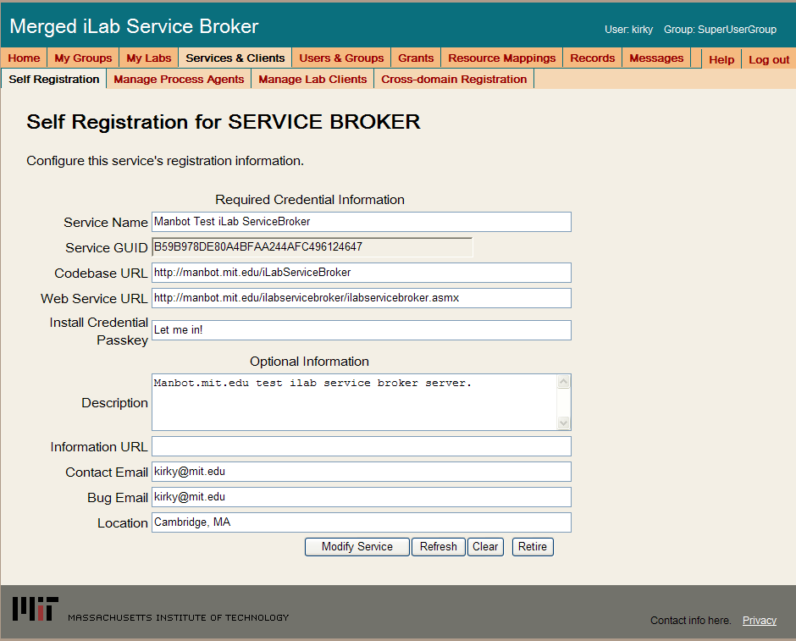
- Modify Service Name, CodeBase & Webservice URLs as needed. Please make sure that the Service Name is unique. Be sure to use fully qualified URLs.
  - Codebase URL: http://machinename.edu/iLabServiceBroker
  - Web Service URL: http://machinename.edu/iLabServiceBroker/iLabServiceBroker.asmx
- If necessary, use the “Create GUID” button to generate a new GUID and remove the hyphens.
BUG: The Service Broker GUID needs to be 35 characters or less due to some legacy code in the batched architecture. If you used the “Create GUID” button to generate the GUID, please remove the hyphens “-“ from the GUID before saving.
- Update the optional fields (Description, Information URL, Contact Email, Bug Email and Location) as needed.
- Click the Save Service button
NOTE: Currently, changes made in the self-registration page are not updated in the web.config file.
Please be aware that there are certain fields that can not be configured from the Service Broker self-registration page. For example, the default passkey for registering process agents such as the ESS can only be edited in the web.config file. Similarly, configuring email addresses for bugs and notices can also only be edited in the web.config file. Please see the section on the web.config for more information.

Error Messages
When testing your installation of the Service Broker you may see one of the following error messages:
- “Cannot open database requested in login 'ilab_ISB'. Login fails. Login failed for user 'NT AUTHORITY\NETWORK SERVICE'.”
- Edit the web.config and enter the correct database name.
- “The page cannot be displayed. You have attempted to execute a CGI, ISAPI, or other executable program from a directory that does not allow programs to be executed.” The Virtual Directory in IIS does not have the correct permissions. Remove the virtual directory and recreate it with the correct permissions.
- In the System News and Messages section of the login page you may see one of the following messages:
  - An Administrator needs to edit web.config and add a value for registrationMailAddress. This is the default email address where requests for membership in a group are sent.
  - An Administrator needs to add a value for supportMailAddress. This is the email address where help requests are sent.
To remove error or warning messages from the System News and Message area,
- Login as SuperUser
- Select the Messages tab from the top menu
- Click on the system bullet in the message type area
- Select a message to delete and click remove.

Userside Scheduling Services (USS)

USS Web Site
First, create a virtual directory in IIS.
- Right-Click on My Computer (renamed to your computer name)
- Click Manage
- Expand Services and Applications
- Expand Internet Information Services
- Expand Web Sites
- Expand Default Web Site
- Right-click on Default Web Site
- Select New->Virtual Directory
- Click Next to enter the Virtual Directory Creation Wizard
- In the Alias box, type UserSideScheduling
- Click Next
- Enter \*local_path*\iLabs\Services\UserSideScheduling in the Directory box (or click the Browse button, and navigate to the location where your Service Broker code is). If you are using the pre-built code, please use the builds directory.
- Click Next
- Access Permissions: make sure you check the Run Scripts, Execute and Read permission boxes
- Click Next
- Click Finish
- You should see the UserSideScheduling site listed under the Default Web Site
- Right click on the UserSideScheduling website and select Properties
- Select the ASP.NET tab
- Use the pull-down list for the ASP.NET version and select 2.0.xxx. Where xxx is the current release version.
- Select OK and close the properties window
- Close the Computer Management Window

Create the Database
First, create the database.
- Start-> Enterprise Manager
- Console Root->Microsoft SQL Servers->SQL Server Group->(local)->Databases
- Right-Click on Databases

- New Database…
- Name: ilab_USS (You can use any name you would like but you must update the web.config file if you change this name)
- Click OK

Grant Access to the Database
- Expand the Security folder in Enterprise Manager.
- Double-click on the NT AUTHORITY\NETWORK SERVICE under Logins
- Click the Database Access tab
- Check the box next to ilab_USS (or the database name you used above)
- In the box below, click the box next to db_owner
- Click OK

USS Database Scripts
This document contains two ways to run the database scripts for Microsoft SQL server; from within the SQL Query Analyzer or from the loader scripts that are in the DB_Scripts directory. The preferred method of creating a new service database is to use Method 2: Using the SQL loader scripts. If you are just updating a stored procedure and not the database, it is best way is to use the SQL Query analyzer. We include Method1: Using the SQL Query Analyzer for your information.
NOTE: the SQL loader scripts do not work under Windows XP with SQL Express – if you are using Windows XP and SQL Express you will need to use the SQL Query Analyzer.
Do NOT attempt both methods – choose one.
METHOD 1: Using the SQL Query Analyzer:
- Start-> Enterprise Manager
- Console Root->Microsoft SQL Servers->SQL Server Group->(local)->Databases
- Expand Databases
- Select the ilab_USS database (or what you named it) in Enterprise Manager.
- On the menu bar, select Tools -> SQL Query Analyzer
- In Query Analyzer, click File -> Open…
- Browse to \*local_path*\iLabs\Database\DB_Scripts\ProcessAgent
Every service must have its own Process Agent information. These tables should exist before the service-specific tables are added to each database.
- In the ProcessAgent directory select and open the ProcessAgentTables.sql
- Make sure the correct database is the selected database in the dropdown menu at the top - *This is very important, because the scripts will be installed in the database specified by this pull-down menu.
- Click the green triangle “play” button to run the script
- You should see a message: “The command(s) completed Successsfully.”
- Follow the same procedure, File→Open, to open and run the ProcessAgentProcedures.sql script.
- You should see the same message: “The command(s) completed Successsfully.”
- Open and run the SetDefaultsPA.sql script.
Next, set up and run the USS database script.
- In Query Analyzer, Click File -> Open…
- Browse to database scripts directory typically \*local_path*\iLabs\ Database\DB_Scripts\Scheduling
- In the Scheduling directory select and open the USS_Tables.sql
- Make sure the correct database is the selected database in the dropdown at the top, then click the green triangle “play” button to run the script
- You should see the message: “The command(s) completed Successsfully.”
- Follow the same procedure to open and run the USS_Procedures.sql script.
- Again you should see the message: “The command(s) completed Successsfully.”
- Close SQL Query Manager and Enterprise Manager
METHOD 2: Using the SQL loader scripts:
- Open a Command Prompt window. Start -> Programs -> Accessories -> Command Prompt.
- A DOS window should open.
- Change the directory to the DBscripts directory.
- Type: “cd \*local_path*\iLabs\ Database\DB_Scripts\”
- Type: “LoadUSS ilab_USS” where ilab_USS is the name of your database.
- You should see something similar to the following with your directory path and database name.
D:\iLabsInteractive\iLabs_NET20\iLabs\Database\DB_Scripts>loadUSS Ilab_USS
D:\iLabsInteractive\iLabs_NET20\iLabs\Database\DB_Scripts>echo loading USS: USSdb
loading USS: Ilab_USS
D:\iLabsInteractive\iLabs_NET20\iLabs\Database\DB_Scripts>call USS_tables.bat USSdb
D:\iLabsInteractive\iLabs_NET20\iLabs\Database\DB_Scripts>echo USS Tables: Ilab_USS
USS Tables: Ilab_USS
D:\iLabsInteractive\iLabs_NET20\iLabs\Database\DB_Scripts>isqlw -E -d Ilab_USS -i .
\Ticketing\ProcessAgentTables.sql -o ussBuild.log
D:\iLabsInteractive\iLabs_NET20\iLabs\Database\DB_Scripts>isqlw -E -d Ilab_USS -i .
\Ticketing\SetdefaultsTicketing.sql -o ussBuild.log
D:\iLabsInteractive\iLabs_NET20\iLabs\Database\DB_Scripts>isqlw -E -d Ilab_USS -i .
\Scheduling\USS_Tables.sql -o ussBuild.log
D:\iLabsInteractive\iLabs_NET20\iLabs\Database\DB_Scripts>call USS_procedures.bat Ilab_USS
D:\iLabsInteractive\iLabs_NET20\iLabs\Database\DB_Scripts>echo USS Procedures: USSdb
USS Procedures: Ilab_USS
D:\iLabsInteractive\iLabs_NET20\iLabs\Database\DB_Scripts>isqlw -E -d Ilab_USS -i .
\Ticketing\ProcessAgentProcedures.sql -o lssBuild.log
D:\iLabsInteractive\iLabs_NET20\iLabs\Database\DB_Scripts>isqlw -E -d Ilab_USS -i .
\Scheduling\USS_Procedures.sql -o lssBuild.log
D:\iLabsInteractive\iLabs_NET20\iLabs\Database\DB_Scripts>

Web.Config
An overview of editing the web.config
Web.config is a text file containing configuration information in an XML format, residing in the root of the USS Services web site (typically in the \*local_path*\iLabs\ Services\ UserSideScheduling directory). Web.config.template ships with this release. If the web.config file already exists, delete it. Copy web.config.template and paste the file into the same directory. Rename the copy “web.config” and edit it using notepad.
NOTE: Currently, changes made in the self-registration page are not updated in the web.config file.
<?xml version="1.0"?>
<configuration>
<appSettings>
<!--
LabSideScheduling Web.Config -->

<!--
ProcessAgent required Keys -->
<!-- THE FOLLOWING MUST BE SET FOR ALL SERVICES, used to define the service -->
<!-- The following keys specify the WebService required Values -->
<!-- They are used by the SelfRegistration page to generate the ProcessAgent's
Bootstrap ProcessAgent Record, which must be created before installing domain credientials -->
<!-- The Service Type - Do Not Change -->
<add key="serviceType" value="SCHEDULING SERVER"/>
<!-- The name of the Service displayed for the user, please change -->
<add key="serviceName" value="Default UserScheduling Server"/>
<!-- This Service's GUID You must supply a vaild GUID, see createGUID.exe, may be any string, 50 characters or less. -->
<add key="serviceGUID" value=""/>
<add key="codebaseURL" value="http://localhost/UserSideScheduling"/>
<add key="serviceURL" value="http://localhost/UserSideScheduling/UserScheduling.asmx"/>
<add key="defaultPasskey" value="USS"/>

<!-- the database connection information
NOTE: You Must set the database catalog to the database name that you created as part of the instalation process -->
<add key="sqlConnection" value="data source=(local);initial catalog=iLab_USS;Integrated Security=SSPI"/>
……………………………………..

Update the Database Name
Update the database connection variable in the web.config file to use the name you chose when you created the database. Note the default database name is set to ilab_USS. If you used a different database name, update the catalog value in the key.
<add key=”sqlConnection”
value="data source=(local);initial catalog=ilab_USS;Integrated Security = SSPI" />

Update Default Passkey
The default Pass Key is a simple string used by process agents to exchange credential information the first time only. This can be any string you would like. We recommend that you not change this.

<add key="defaultPasskey" value="USS" />

Web.Config Parameters to be aware of:
ServiceType | SCHEDULING SERVER – Do not Change
service Name | USS unique name – Change in selfRegister (later)
serviceGuid | USS GUID - Set in selfRegister (later)
codebaseURL | USS’s applicaiton URL – Change in selfRegister (later)
serviceURL | USS’s service URL– Change in selfRegister (later)
DefaultPassKey | Initial Passkey for credential exchange
sqlConnection | Database name – default ilab_USS

Test the Scheduling Services:
- Open Internet Explorer
- Browse to http://localhost/UserSideScheduling/UserScheduling.asmx
Using the http://localhost is a good way to test your service installation, but you should also test with the fully qualified URLs in this document. The iLab architecture is designed to use fully qualified URLs, and unexpected things can happen when using localhost.
Self Registration
Most of the setup information like the serviceName, serviceGUID and codebaseURL will now be entered in the self-registration page. This is the preferred method, but you can also enter the information into the web.config file and it will be loaded into the self-registration page for you to check. Make sure to use fully qualified URLs in the self-registration page.
Each Process Agent must have a unique GUID (Globally Unique Identifier) which will identify this particular Process Agent to all lab servers. This GUID will be supplied to the Lab Server(s) administrator so that the Lab Server can be configured to communicate with this Service Broker. We use a GUID produced on with all the '{', and '}' characters stripped out. You can generate your own GUID and enter it in the web.config or use the “Generate GUID” button on the Service Broker’s self registration page (this is the preferred method).

USS Self Registration
In order for process agents to exchange credentials, their information needs to be entered into the Process Agents table. There is a self-registration web service included with each process agent. You cannot register a process agent until after you have created and edited the corresponding web.config file.
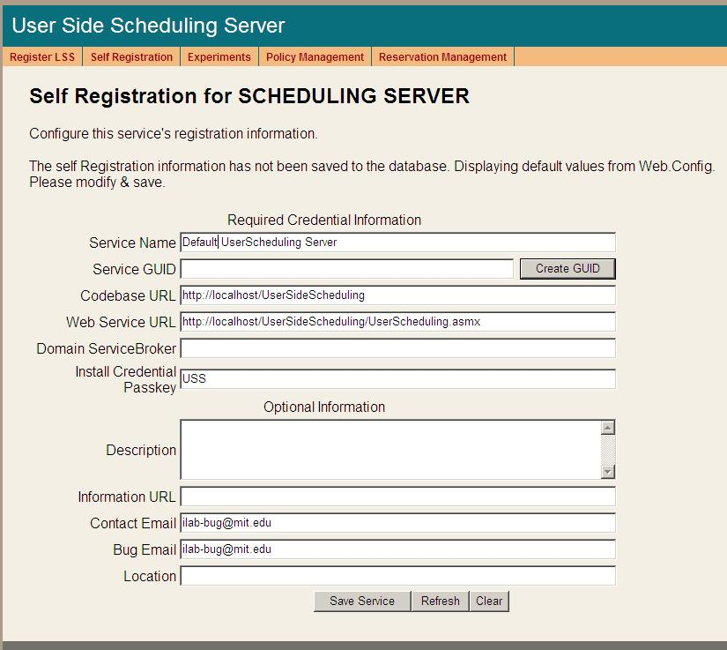
- Open Internet Explorer
- Browse to http://machinename.edu/UserSideScheduling/selfRegistration.aspx
- Modify the USS Service Name, CodeBase & Webservice URLs as needed. Please make sure that the Service Name is unique. Make sure to use fully qualified URLs.
  - Codebase URL: http://machinename.edu/UserSideScheduling
  - Web Service URL: http://machinename.edu/UserSideScheduling/UserScheduling.asmx
- If necessary, use the “Create GUID” button to generate a new GUID
BUG: The Service Broker GUID needs to be 35 characters or less due to some legacy code in the batched architecture. If you used the “Create GUID” button to generate the GUID, please remove the hyphens “-“ from the GUID before saving.
- Update the optional fields (Description, Information URL, Contact Email, Bug Email and Location) as needed.
- Click the Save Service button
NOTE: Currently, changes made in the self-registration page are not updated in the web.config file.

Labside Scheduling Service

LSS Web Site
First, create a virtual directory in IIS.
- Right-Click on My Computer (renamed to your computer name)
- Click Manage
- Expand Services and Applications
- Expand Internet Information Services
- Expand Web Sites
- Expand Default Web Site
- Right-click on Default Web Site
- Select New->Virtual Directory
- Click Next to enter the Virtual Directory Creation Wizard
- In the Alias box, type LabSideScheduling
- Click Next
- Enter \*local_path* \LabSideScheduling in the Directory box (or click the Browse button, and navigate to the location where your Service Broker code is). If you used the pre-built code please use the builds directory.
- Click Next
- Access Permissions: make sure you check the Run Scripts, Execute and Read permission boxes
- Click Next
- Click Finish
- You should see the LabSideScheduling site listed under the Default Web Site
- Right click on the LabSideScheduling website and select Properties
- Select the ASP.NET tab
- Use the pull-down list for the ASP.NET version and select 2.0.xxx. Where xxx is the current release version.
- Select OK and close the properties window
- Close the Computer Management Window

Create the Database
First, create the database.
- Start-> Enterprise Manager
- Console Root->Microsoft SQL Servers->SQL Server Group->(local)->Databases
- Right-Click on Databases
- New Database…
- Name: ilab_LSS (You can use any name you would like but you must update the web.config file if you change this name)
- Click OK

Grant Access to the Database
- Expand the Security folder in Enterprise Manager.
- Double-click on the NT AUTHORITY\NETWORK SERVICE under Logins
- Click the Database Access tab
- Check the box next to ilab_LSS (or the database name you used above)
- In the box below, click the box next to db_owner
- Click OK

LSS Database Scripts
This document contains two ways to run the database scripts for Microsoft SQL server; from within the SQL Query Analyzer or from the loader scripts that are in the DB_Scripts directory. The preferred method of creating a new service database is to use Method 2: Using the SQL loader scripts. If you are just updating a stored procedure and not the database, it is best way to use the SQL Query analyzer. We include Method1: Using the SQL Query Analyzer for your information.
NOTE: the SQL loader scripts do not work under Windows XP with SQL Express – if you are using Windows XP and SQL Express you will need to use the SQL Query Analyzer.
Do NOT attempt both methods – choose one.
METHOD 1: Using the SQL Query Analyzer:
- Start-> Enterprise Manager
- Console Root->Microsoft SQL Servers->SQL Server Group->(local)->Databases
- Expand Databases
- Select the ilab_LSS database (or what you named it) in Enterprise Manager.
- On the menu bar, select Tools -> SQL Query Analyzer
- In Query Analyzer, click File -> Open…
- Browse to database scripts directory typically \*local_path*\iLabs\ Database\DB_Scripts\ProcessAgent
Every service must have its own Process Agent information. These tables should exist before the service-specific tables are added to each database.
- In the ProcessAgent directory select and open the ProcessAgentTables.sql
- Make sure the correct database is the selected database in the dropdown menu at the top - *This is very important, because the scripts will be installed in the database specified by this pull-down menu.
- Click the green triangle “play” button to run the script
- You should see a message: “The command(s) completed Successsfully.”
- Follow the same procedure, File→Open, to open and run the ProcessAgentProcedures.sql script.
- You should see the same message: “The command(s) completed Successsfully.”
- Open and run the SetDefaultsPA.sql script.
Next, set up and run the LSS database scripts, typically located in \*local_path*\iLabs\ Database\DB_Scripts\Scheduling.
- In Query Analyzer, click File -> Open…
- In the Scheduling directory select and open the LSS_Tables.sql
- Make sure the correct database is the selected database in the dropdown at the top, then click the green triangle “play” button to run the script
- You should see the message: “The command(s) completed Successsfully.”
- Follow the same procedure to open and run the LSS_Procedures.sql script.
- Again, you should see the message: “The command(s) completed Successsfully.”
- Close SQL Query Manager and Enterprise Manager
METHOD 2: Using the SQL loader scripts:
- Open a Command Prompt window. Start -> Programs -> Accessories -> Command Prompt.
- A DOS window should open.
- Change the directory to the DBscripts directory.
- Type: “cd :\*local_path*\iLabs\ Database\DB_Scripts\”
- Type: “LoadLSS ilab_LSS” where ilab_LSS is the name of your database.
- You should see something similar to the following with your directory path and database name.
D:\iLabsInteractive\iLabs_NET20\iLabs\Database\DB_Scripts>loadLSS LSSdb
D:\iLabsInteractive\iLabs_NET20\iLabs\Database\DB_Scripts>echo populating LSS LSSdb
populating LSS LSSdb
D:\iLabsInteractive\iLabs_NET20\iLabs\Database\DB_Scripts>call LSS_tables.bat LSSdb
D:\iLabsInteractive\iLabs_NET20\iLabs\Database\DB_Scripts>echo LSS Tables: LSSdb
LSS Tables: LSSdb
D:\iLabsInteractive\iLabs_NET20\iLabs\Database\DB_Scripts>isqlw -E -d LSSdb -i .
\Ticketing\ProcessAgentTables.sql -o lssBuild.log
D:\iLabsInteractive\iLabs_NET20\iLabs\Database\DB_Scripts>isqlw -E -d LSSdb -i .
\Ticketing\SetdefaultsTicketing.sql -o lssBuild.log
D:\iLabsInteractive\iLabs_NET20\iLabs\Database\DB_Scripts>isqlw -E -d LSSdb -i .
\Scheduling\LSSCreateTableScript.sql -o lssBuild.log
D:\iLabsInteractive\iLabs_NET20\iLabs\Database\DB_Scripts>call LSS_procedures.bat LSSdb
D:\iLabsInteractive\iLabs_NET20\iLabs\Database\DB_Scripts>echo LSS Procedures: LSSdb
LSS Procedures: LSSdb
D:\iLabsInteractive\iLabs_NET20\iLabs\Database\DB_Scripts>isqlw -E -d LSSdb -i .
\Ticketing\ProcessAgentProcedures.sql -o lssBuild.log
D:\iLabsInteractive\iLabs_NET20\iLabs\Database\DB_Scripts>isqlw -E -d LSSdb -i .
\Scheduling\LSSstoreprocedure.sql -o lssBuild.log
D:\iLabsInteractive\iLabs_NET20\iLabs\Database\DB_Scripts>

Web.Config
An overview of editing the web.config
NOTE: Currently, changes made in the self-registration page are not updated in the web.config file.
Web.config is a text file containing configuration information in XML format, residing in the root of the LSS Services web site (typically in the \*local_path*\LabSideScheduling directory). Web.config.template ships with this release. If a web.config file already exists, please delete it. Copy web.config.template and paste the file into the same directory. Rename the copy “web.config” and edit it using notepad.

<?xml version="1.0"?>
<configuration xmlns="http://schemas.microsoft.com/.NetConfiguration/v2.0">
<appSettings>
<!--
LabSideScheduling Web.Config -->
<!--
ProcessAgent required Keys -->
<!-- THE FOLLOWING MUST BE SET FOR ALL SERVICES, used to define the service -->
<!-- The following keys specify the WebService required Values -->
<!-- They are used by the SelfRegistration page to generate the ProcessAgent's
Bootstrap ProcessAgent Record, which must be created before installing domain credientials -->

<add key="serviceType" value="LAB SCHEDULING SERVER"/>
<!-- The name of the Service displayed for the user, please change -->
<add key="serviceName" value="Default LabScheduling Server"/>
<!-- This Service's GUID You must supply a vaild GUID, see createGUID.exe, may be any string, 50 characters or less. -->
<add key="serviceGUID" value=""/>
<add key="codebaseURL" value="http://localhost/LabSideScheduling"/>
<add key="serviceURL" value="http://localhost/LabSideScheduling/LabScheduling.asmx"/>
<add key="defaultPasskey" value="LSS"/>

<!-- the database connection information
NOTE: You Must set the database catalog to the database name that you created as part of the instalation process -->
<add key="sqlConnection" value="data source=(local);initial catalog=iLab_LSS;Integrated Security=SSPI"/>
……………………………………..

Update the Database Name
Update the database connection variable in the web.config file to use the name you chose when you created the database. Note the default database name is set to ilab_LSS. If you used a different database name, update the catalog value in the key.
<add key=”sqlConnection”
value="data source=(local);initial catalog=ilab_LSS;Integrated Security = SSPI" />

Update Default Passkey
The default Pass Key is a simple string used by process agents to exchange credential information the first time only. This can be any string you would like. We recommend that you not change this.

<add key="defaultPasskey" value="LSS" />

Web.Config Parameters to be aware of:
ServiceType | LAB SCHEDULING SERVER –Do Not Change
serviceName | LSS unique name – change in selfRegister (later)
serviceGuid | This is the LSS’s Guid – change in selfRegister (later)
codebaseURL | LSS application URL – change in selfRegister (later)
serviceURL | LSS’s service URL
DefaultPassKey | Initial Passkey for credential exchange
sqlConnection | Database name – default ilab_LSS

Test the Scheduling Services:
- Open Internet Explorer
- Browse to http://localhost/LabSideScheduling/LabScheduling.asmx
Using the http://localhost is a good way to test your service installation, but you should also test with the fully qualified URLs in this document. The iLab architecture is designed to use fully qualified URLs, and unexpected things can happen when using localhost.
Self Registration

Most of the setup information like the serviceName, serviceGUID and codebaseURL will now be entered in the self-registration page. This is the preferred method, but you can also enter the information into the web.config file and it will be loaded into the self-registration page for you to check. Use fully qualified URLs.

Each Process Agent must have a unique GUID (Globally Unique Identifier) which will identify this particular Process Agent to all lab servers. This GUID will be supplied to the Lab Server(s) administrator so that the Lab Server can be configured to communicate with this Service Broker. We use a GUID produced on with all the '{', and '}' characters stripped out. You can generate your own GUID and enter it in the web.config use the “Generate GUID” button on the Service Broker’s self registration page (this is the preferred method).

LSS Self Registration
In order for process agents to exchange credentials, their information needs to be entered into the Process Agents table. There is a self-registration web service included with each process agent. You should not self register a process agent until after you have created and edited the corresponding web.config file.
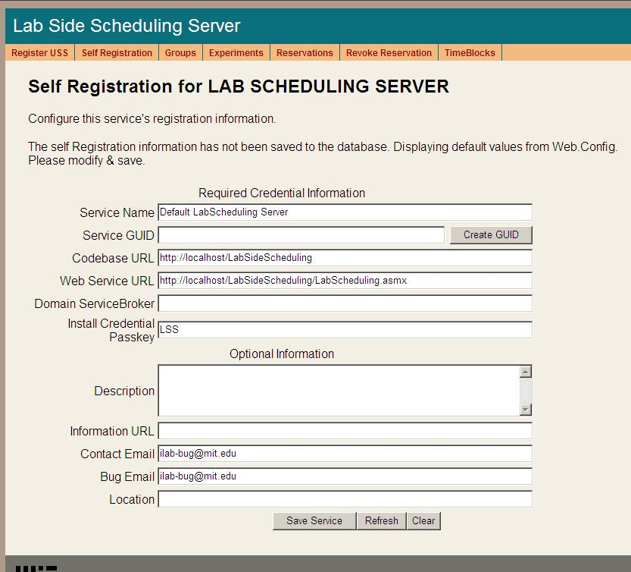
- Open Internet Explorer
- Browse to http://localhost/LabSideScheduling/selfRegistration.aspx
- Modify Service Name, CodeBase & Webservice URLs as needed. Please make sure that the Service Name is unique. Be sure to use fully qualified URLs.
  - Codebase URL: http://machinename.edu/LabSideScheduling
  - Web Service URL: http://machinename.edu/LabSideScheduling/LabScheduling.asmx
- If necessary, use the “Create GUID” button to generate a new GUID
BUG: The Service Broker GUID needs to be 35 characters or less due to some legacy code in the batched architecture. If you used the “Create GUID” button to generate the GUID, please remove the hyphens “-“ from the GUID before saving.
- Update the optional fields (Description, Information URL, Contact Email, Bug Email and Location) as needed.
- Click the Save Service button
NOTE: Currently, changes made in the self-registration page are not updated in the web.config file.

Lab Proxy Server

Lab Proxy Web Site
First, create a virtual directory in IIS.
- Right-Click on My Computer (renamed to your computer name)
- Click Manage
- Expand Services and Applications
- Expand Internet Information Services
- Expand Web Sites
- Expand Default Web Site
- Right-click on Default Web Site
- Select New->Virtual Directory
- Click Next to enter the Virtual Directory Creation Wizard
- In the Alias box, type LabProxy
- Click Next
- Enter \*local_path*\LabProxy in the Directory box (or click the Browse button, and navigate to the location where your Service Broker code is). If you used the pre-built code, please use the builds directory.
- Click Next
- Access Permissions: make sure you check the Run Scripts, Execute and Read permission boxes
- Click Next
- Click Finish
- You should see the LabProxy site listed under the Default Web Site
- Right click on the LabProxy website and select Properties
- Select the ASP.NET tab
- Use the pull-down list for the ASP.NET version and select 2.0.xxx. Where xxx is the current release version.
- Select OK and close the properties window
- Close the Computer Management Window

Create the Database
First, create the database.
- Start-> Enterprise Manager
- Console Root->Microsoft SQL Servers->SQL Server Group->(local)->Databases
- Right-Click on Databases
- New Database…
- Name: ilab_LPS (You can use any name you would like but you must update the web.config file if you change this name)
- Click OK

Grant Access to the Database
- Expand the Security folder in Enterprise Manager.
- Double-click on the NT AUTHORITY\NETWORK SERVICE under Logins
- Click the Database Access tab
- Check the box next to ilab_LPS (or the database name you used above)
- In the box below, click the box next to db_owner
- Click OK

LPS Database Scripts
This document contains two ways to run the database scripts for Microsoft SQL server; from within the SQL Query Analyzer or from the loader scripts that are in the DB_Scripts directory. The preferred method of creating a new service database is to use Method 2: Using the SQL loader scripts. If you are just updating a stored procedure and not the database, it is best to use the SQL Query analyzer. We include Method1: Using the SQL Query Analyzer for your information.
NOTE: the SQL loader scripts do not work under Windows XP with SQL Express – if you are using Windows XP and SQL Express you will need to use the SQL Query Analyzer.
Do NOT attempt both methods – choose one.
METHOD1: Using the SQL Query Analyzer:
- Start-> Enterprise Manager
- Console Root->Microsoft SQL Servers->SQL Server Group->(local)->Databases
- Expand Databases
- Select the ilab_LPS database (or what you named it) in Enterprise Manager.
- On the menu bar, Select Tools -> SQL Query Analyzer
- In Query Analyzer, Click File->Open…
- Browse to database scripts directory typically (\*local_path*\Database\DB_Scripts\ProcessAgent)
Every service must have its own Process Agent information. These tables should exist before the service-specific tables are added to each database.
- In the ProcessAgent directory select and open the ProcessAgentTables.sql
- Make sure the correct database is the selected database in the dropdown at the top - *This is very important, because the scripts will be installed in the database specified by this pull-down menu.
- Click the green triangle “play” button to run the script
- You should see a message: “The command(s) completed Successsfully.”
- Follow the same procedure, File→Open, to open and run the ProcessAgentProcedures.sql script.
- You should see the same message: “The command(s) completed Successsfully.”
- Open and run the SetDefaultsPA.sql script.
- Close SQL Query Manager and Enterprise Manager
For the Lab Proxy Server, there are no process agent-specific database scripts that need to be run.
METHOD 2: Using the SQL loader scripts:
- Open a Command Prompt window. Start -> Programs -> Accessories -> Command Prompt.
- A DOS window should open.
- Change the directory to the DBscripts directory.
- Type: “D:” to change the disk if you need to
- Type: “cd :\*local_path*\Database\DB_Scripts\”
- Type: “LoadLPS ilab_LPS” where ilab_LPS is the name of your database.
- You should see something similar to the following with your directory path and database name.
C:\ilab\Database\DB_Scripts>LoadLPS ilab_LPS
C:\ilab\Database\DB_Scripts>echo populating LPS ilab_LPS
populating LPS ilab_LPS
C:\ilab\Database\DB_Scripts>call LPS_tables.bat ilab_LPS
C:\ilab\Database\DB_Scripts>echo populating LPS ilab_LPS
populating LPS ilab_LPS
C:\ilab\Database\DB_Scripts>isqlw -E -d ilab_LPS -i .\ProcessAgent\ProcessAgentTables.sql -o LPSBuild0.log
C:\ilab\Database\DB_Scripts>isqlw -E -d ilab_LPS -i .\ProcessAgent\SetdefaultsPA.sql -o LPSBuild1.log
C:\ilab\Database\DB_Scripts>call LPS_procedures.bat ilab_LPS
C:\ilab\Database\DB_Scripts>echo LPS Procedures: ilab_LPS
LPS Procedures: ilab_LPS
C:\ilab\Database\DB_Scripts>isqlw -E -d ilab_LPS -i .\ProcessAgent\ProcessAgentProcedures.sql -o LPSBuild2.log
C:\ilab\Database\DB_Scripts>

Web.Config
An overview of editing the web.config
Web.config is a text file containing configuration information in XML format, residing in the root of the LabProxy web site (typically in the \*local_path*\LabProxy directory). Web.config.template ships with this release. If a web.config already exists, please delete it. Copy web.config.template and paste the file into the same directory. Rename the copy “web.config” and edit it using notepad. Use only fully qualified URLs in the web.config file.
NOTE: Currently, changes made in the self-registration page are not updated in the web.config file.

<?xml version="1.0"?>
<configuration>
<appSettings>
<!--
Interactive TimeOfDay Web.Config -->

<!--
ProcessAgent required Keys -->
<!-- THE FOLLOWING MUST BE SET FOR ALL SERVICES, used to define the service -->
<!-- The following keys specify the WebService required Values -->
<!-- They are used by the SelfRegistration page to generate the ProcessAgent's
Bootstrap ProcessAgent Record, which must be created before installing domain credientials -->

<add key="serviceType" value="LAB SERVER"/>
<!-- The name of the Service displayed for the user, please change -->
<add key="serviceName" value="Default LabProxy Server"/>
<!-- This Service's GUID You must supply a vaild GUID, see createGUID.exe, may be any string, 50 characters or less. -->
<add key="serviceGUID" value=""/>
<add key="codebaseURL" value="http://localhost/ LabProxy "/>
<add key="serviceURL" value="http://localhost/LabProxy/iLabWebService.asmx "/>
<add key="defaultPasskey" value="LPS"/>

<!-- the database connection information
NOTE: You Must set the database catalog to the database name that you created as part of the instalation process -->
<add key="sqlConnection" value="data source=(local);initial catalog=iLab_LPS;Integrated Security=SSPI"/>

Update the Database Name
Update the database connection variable in the web.config file to use the name you chose when you created the database. Note the default database name is set to ilab_LPS. If you used a different database name, update the catalog value in the key.
<add key=”sqlConnection”
value="data source=(local);initial catalog=ilab_LPS;Integrated Security = SSPI" />

Note: there is an mistake in the web.config file in the release … check the database name in the web.config file and make sure that the database name you used to create the database matches exactly including capitalization.

Update Default Passkey
The default Pass Key is a simple string used by process agents to exchange credential information the first time only. This can be any string you would like. We recommend that you not change this.

<add key="defaultPasskey" value="LPS" />

Web.Config Parameters to be aware of:
serviceType | LAB SERVER – Do Not Change
serviceName | Lab Server unique name – Change in selfRegistration
serviceGuid | This is the LSS’s Guid name – Set in selfRegistration
codebaseURL | Lab Server URL – Change in selfRegistration
serviceURL | Lab Server’s service URL – Change in selfRegistration
DefaultPassKey | Initial Passkey for credential exchange
sqlConnection | Database name – default ilab_LPS

Test the LabProxy Server:
- Open Internet Explorer
- Browse to http://localhost/LabProxy/iLabWebService.asmx
Using the http://localhost is a good way to test your service installation, but you should also test with the fully qualified URLs in this document. The iLab architecture is designed to use fully qualified URLs, and unexpected things can happen when using localhost.
Self Registration
Most of the setup information like the serviceName, serviceGUID and codebaseURL will now be entered in the web service self-registration page. This is the preferred method, but you can also enter the information into the web.config file and it will be loaded into the self-registration page for you to check.

Each Process Agent must have a unique GUID (Globally Unique Identifier) which will identify this particular Process Agent to all lab servers. This GUID will be supplied to the Lab Server(s) administrator so that the Lab Server can be configured to communicate with this Service Broker. We use a GUID produced on with all the '{', and '}' characters stripped out. You can generate your own GUID and enter it in the web.config or use the “Generate GUID” button on the Service Broker’s self registration page (this is the preferred method).

LPS Self Registration
In order for process agents to exchange credentials, their information needs to be entered into the Process Agents table. There is a self-registration webservice included with each process agent. You cannot register a process agent until after you have created and edited the corresponding web.config file.
- Open Internet Explorer
- Browse to http://localhost/LabProxy/selfRegistration.aspx
- Modify Service Name, CodeBase & Webservice URLs as needed. Please make sure that the Service Name is unique. Be sure to use fully qualified URLs.
  - Codebase URL: http://machinename.edu/ LabProxy
  - Web Service URL: http://machinename.edu/LabProxy/iLabWebService.asmx
- If necessary, use the “Create GUID” button to generate a new GUID
BUG: The Service Broker GUID needs to be 35 characters or less due to some legacy code in the batched architecture. If you used the “Create GUID” button to generate the GUID, please remove the hyphens “-“ from the GUID before saving.
- Update the optional fields (Description, Information URL, Contact Email, Bug Email and Location) as needed.
- Click the Save Service button
NOTE: Currently, changes made in the self-registration page are not updated in the web.config file.
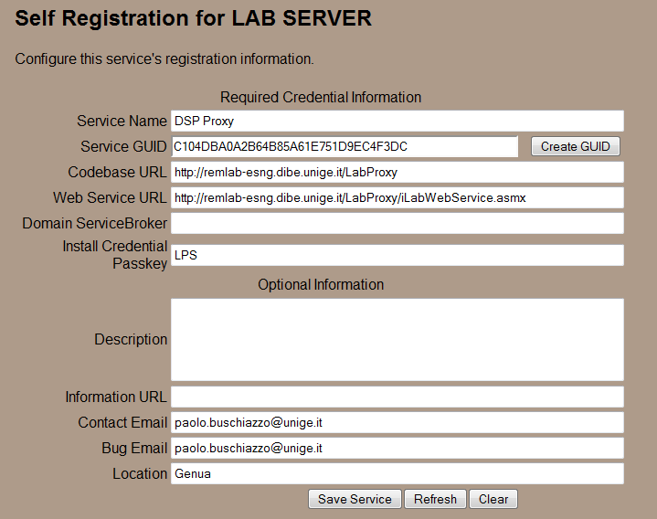

Configure the URL of the Online Laboratory:

Since the proxy is only used to verify if the reservation is valid and he forwards after a successful verification of the ticket to your online Laboratory.
In this case the installation of the “ASPDemoLab” will be described. In fact at this part any kind of laboratory can be connected to the LabProxy.
- Open the Web.config file
- Insert your laboratory URL here:
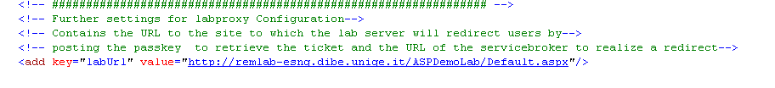
This is everything which is required to configure additionally to the standard iLab configuration procedure.
In the next chapter you will be guided through the installation of the ASPDemoLab which will show you how a concrete lab can be connected to the LabProxy.

ASP Demo Lab

ASP Demo Lab Web Site
First, create a virtual directory in IIS.
- Right-Click on My Computer (renamed to your computer name)
- Click Manage
- Expand Services and Applications
- Expand Internet Information Services
- Expand Web Sites
- Expand Default Web Site
- Right-click on Default Web Site
- Select New->Virtual Directory
- Click Next to enter the Virtual Directory Creation Wizard
- In the Alias box, type ASPDemoLab
- Click Next
- Enter \*local_path*\ ASPDemoLab in the Directory box (or click the Browse button, and navigate to the location where your Service Broker code is). If you used the pre-built code, please use the builds directory.
- Click Next
- Access Permissions: make sure you check the Run Scripts, Execute and Read permission boxes
- Click Next
- Click Finish
- You should see the ASPDemoLab site listed under the Default Web Site
- Right click on the ASPDemoLab website and select Properties
- Select the ASP.NET tab
- Use the pull-down list for the ASP.NET version and select 2.0.xxx. Where xxx is the current release version.
- Select OK and close the properties window
- Close the Computer Management Window

Configure ASP Demo Lab

ASPDemoLab uses a library which calls a web service on the Lab Proxy. It passes the current passkey received previously from the LabProxy when redirecting after a successful ticket validation. As response the web service sends information about the current reservation:
- Time of reservation expiration (if in valid reservation period – otherwise NULL)
- Experiment ID (can be used for logging)
- Group ID (can be used to differ between different exercises which will be loaded or any other configuration you want to have)

- Open the folder ASPDemoLab
- Open ASPDemoLab.sln with visual studio
- Open “Default.aspx.cs” an modify the URL in the function call with your web service URL:
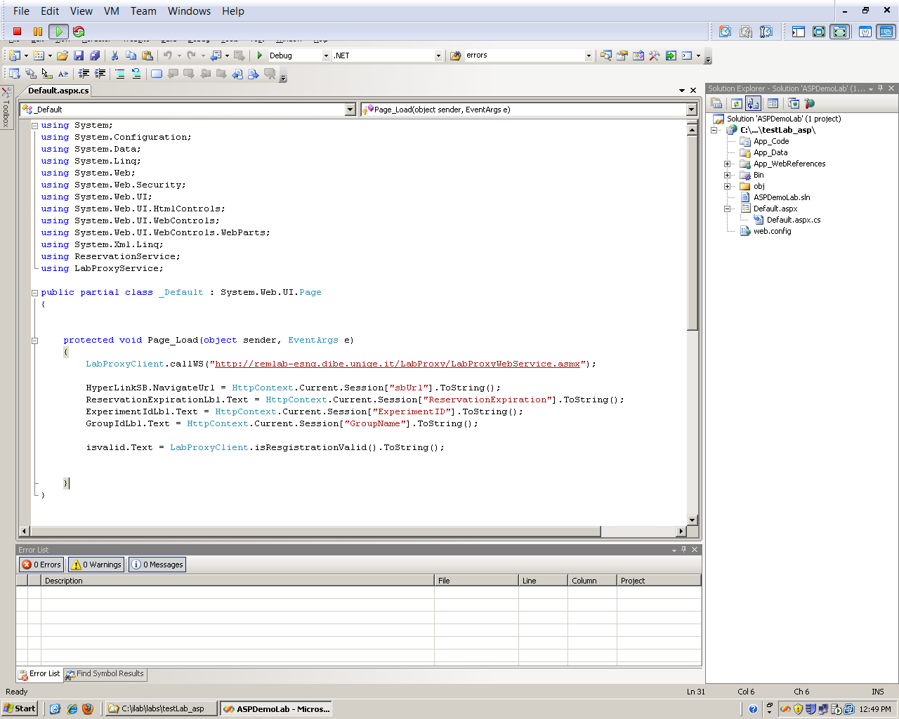
“/LabProxy/LabProxyWebService.asmx” usually remains; you just have to change the first part of the URL to your servers web address.
- LabProxyClient is in fact a library which was created to communicate easily with the LabProxy. If the call is successful the information about the reservation is stored automatically in the current session.
- Once called the web service and retrieved the reservation data the function LabProxyClient.isResgistrationValid() can be used anywhere in your project to check whether the current reservation is still valid (returns true or false)
- In the ASPDemoLab this can be proved by clicking on the Refresh button of the demo page after a session is expired.
- From this point on it lies in the hand of each individual online laboratory to terminate the session and allow the next user with valid reservation to enter.
Output of the ASP Demo Lab Page:
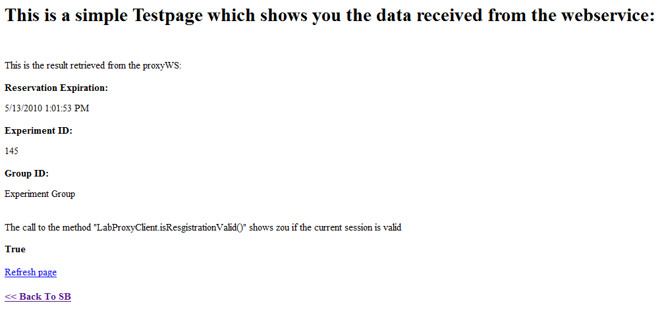

INFO: The library written to connect your custom laboratory is available in the package. Currently a library is available for ASP and PHP, other languages can simply call the SOAP 1.1 / 1.2 web service.

If you want to use the PHP library have a look at the example in the library directory of the package.

Bootstrapping
Bootstrapping is the process of enabling the various iLab services to recognize each other and exchange credentials.
This initial bootstrapping process will assume that you are logged into the iLab Service Broker as a SuperUser and that all servers are in the same domain. To manage the USS and LSS directly, you will need to be logged in as the correct management group – not as SuperUser
This document will set up and configure the different services for the Service Broker, and configure the LabProxy with a demo page.
NOTE: This document assumes that you will replace your computer’s name and fully qualified URL where ever you see “machinename.edu”.
NOTE: Before beginning the bootstrapping process, any and all current security patches and internet browser updates must be downloaded and installed.

Users and Groups
At the time of installation, the database script creates one default user and group called “SuperUser”. This user is the Service Broker’s administrator and has full permissions. Any user added to this group will also have full administration permissions on the Service Broker.
In addition to the SuperUser group, you will need administrator groups for Process Agent services such as the USS and LSS, and a management group for each user group. Members of the administration groups will have SuperUser permissions on the specified Process Agent; typically these are the lab or department administrators. Members of the management groups will have control over a particular group of students; typically these are the class TAs.
Create an administrator group for administering the Userside Scheduling Server (USS) called USS_admin
- Navigate to http://machinename.edu/ilabservicebroker
- Log in as SuperUser
- Click on the Users & Groups tab on the main menu of the Service Broker.
- In the sub-menu, select the Administer Groups tab.
- Click on the Add Service Admin Group button. A popup window should appear.
- Enter the Group Name “USS_admin”.
- Enter a Description, “Administration group for the USS”.
- Enter the administrator’s contact email address.
- This service does not need a request group, so do not click on Need Request group.
- This is a Administer group, so you do not need to add or change the Direct Group Membership area.
- Click on the Save Changes button. The new group should be listed on the Administer Groups page.
Create an Administrator group for administering the Labside Scheduling Server (LSS) called LSS_admin
- On the Administer Groups page, click on the Add Service Admin Group button. A popup window should appear.
- Enter the Group Name “LSS_admin”.
- Enter a Description, “Administration group for the LSS”.
- Enter the administrator’s contact email address.
- Click on the Save Changes button. The new LSS_admin group should be listed on the Administer Groups page.
Create a management group for managing the Lab Server (LS) configurations on the Labside Scheduling Server (LSS). In our case we will be managing the LabProxy Server configuration on the LSS, but this group will manage all the Lab Servers using this LSS.
- On the Administer Groups page, click on the Add Service Admin Group button. A popup window should appear.
- Enter the Group Name “Manage_LPS_on_LSS”.
- Enter a Description, “Managers group for managing the Lab Servers using the LSS”.
- Enter the administrator’s contact email address.
- Click on the Save Changes button. The new group should be listed on the Administer Groups page.
Create a management group for managing the Lab Proxys users group on the Userside Scheduling Server (USS)
- On the Administer Groups page, click on the Add Service Admin Group button. A popup window should appear.
- Enter the Group Name “Manage_Users_on_USS”.
- Enter a Description, “Managers group for managing the LabProxy (and the connected laboratory) users on the USS”.
- Enter the administrator’s contact email address.
- Click on the Save Changes button. The new group should be listed on the Administer Groups page.
Create a group for users of the LabProxy and the connected Experiment
- On the Administer Groups page, click on the Add Group button. A popup window should appear.
- Enter the Group Name “Experiment_Group”.
- Enter a Description, “User Experiment Group for running and testing Experiments”.
- Enter the administrator’s contact email address.
- The LabProxy service does not need any additional groups, so do not click on Need Request group or Need course Staff Group.
- Click on the Save Changes button. The new Experiment_Group group should be listed on the Administer Groups page.
- Next, we need to give this group permission to create and store experiments. Click on the Edit button for the Experiment_Group. A popup window will appear.
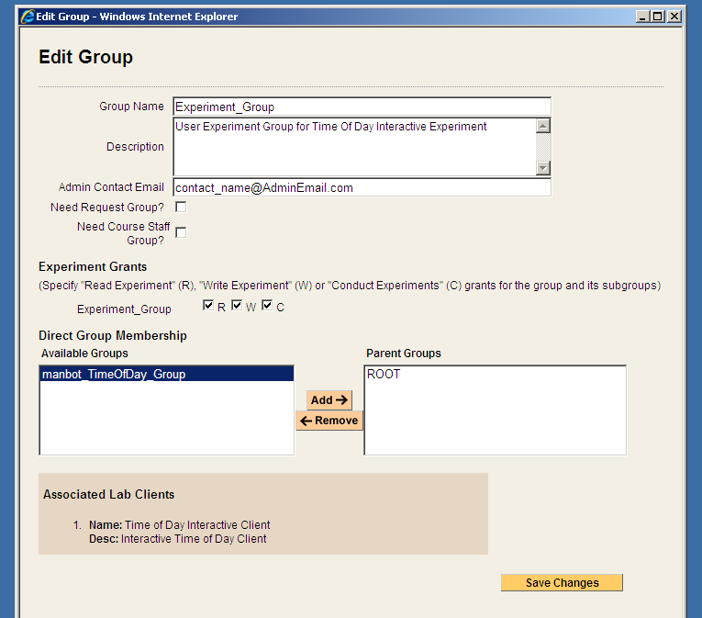
- In the Experiment Grants area under Experiment_Group click on the R, W and C boxes.
- Click on Save Changes

Process Agents
Process Agents are services (web servers or web service calls) that the Service Broker can use. Setting up a new Process Agent is a two step process. We have tried to automate this process as much as possible to eliminate the need for human data entry. For each Process Agent (except the Service Broker) you will need to contact the Process Agent administrator via email and get the web services URL and an initial passkey. With these two items (web services URL and passkey) you should be able to install domain credentials.

Service Broker
The Service Broker Information page can be found on the Service Broker Information tab in the Service & Clients sub-menu. This page provides the self-Registration function for the iLab Service Broker. Initially, this information is retrieved from the Service Broker’s web.config file. On this page, you can create a new GUID for the Service Broker, if needed, and edit the defaults for serverName, serviceURL, applicationURL.
If you have already modified the defaults in the Service Broker’s web.config file, you can use this page to make sure the information is correct. Remember all URLs must be fully qualified including protocol and actual host DNS name or IP address. These variables that used for all communication between this service and all other services.
This information is used to create process agent credentials and can not be changed once an external process agent is registered. Note: If you are developing and all services will reside on the development machine you may leave the machine name as localhost but this is not recommended. We recommend using fill qualified URLs at all times.
If you have not already done so, register the Service Broker.
Add Service Broker’s Information to the Process Agents table.
- Click on the Service Broker Information tab.
- Modify Service Name, CodeBase & Webservice URLs as necessary. Please be sure that the Service Name is unique. Be sure to use fully qualified URLs.
  - Codebase URL: http://machinename.edu/iLabServiceBroker
  - Web Service URL: http://machinename.edu/iLabServiceBroker/iLabServiceBroker.asmx
- If necessary, use the “Create GUID” button to generate a new GUID and remove the hyphens.
BUG: The Service Broker GUID needs to be 35 characters or less due to some legacy code in the batched architecture. If you used the “Create GUID” button to generate the GUID, please remove the hyphens “-“ from the GUID before saving.

- Click on the Save Changes button to add the Service Brokers credentials to the Process Agents table.
Next, complete the Service Broker information in the Process Agent’s table
- Click on the Services & Clients tab
- Click on the Manage Process Agents tab
- Use the Services pull-down menu to select the Service Broker.
- Enter your University Name and Service Broker name into the description field, if it is not already entered.
- Enter a URL for service information in the info_URL box, if available
- Enter a contact email into the correct box.
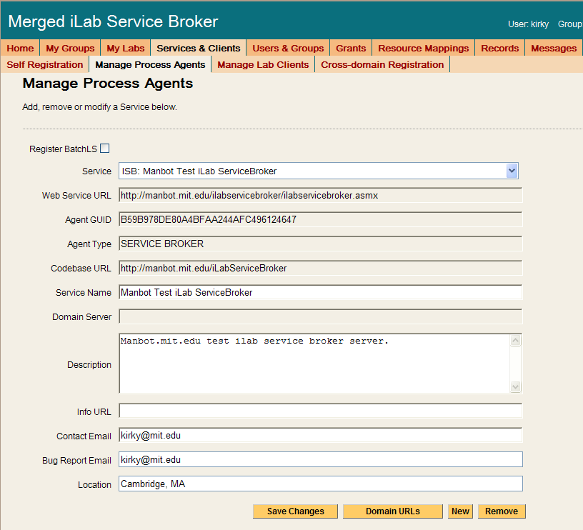
- Click Save Changes. You should see a green box at the top of the page stating that the record has been modified.
For the Service Broker, there are no additional Domain URLs that need to be entered. Changes made from the Manage Process Agents page will NOT be reflected in the web.config file.

Userside Scheduling Server (USS)
To add the User-side Scheduling Service to the Service Broker, you will need the web service URL and an initial passkey for the USS. This should be exchanged via email if you are not the owner of these services. For this document, we will assume that you are the administrator for all services and that you will be using the default initial passkey values.
Add the USS to the Service Broker and exchange credentials.
- Click on the Manage Process Agents tab
- Enter USS info (web services URL & passkey) into the correct fields. Default Web Services URL: http://machinename.edu/UserSideScheduling/UserScheduling.asmx
- Default Passkey: USS
- Click on the Install domain credentials button.
- A register web service call is made using the web services URL and initial passkey, to get the process Agents information and credentials.
- You should see a green message bar at the top of the page stating that a “Relationship has been created and saved.”
Associate the USS Administration Group with the USS.
- Still on the “Manage Process Agents” page, select the “USS_admin” group from the Admin Group pull down list. (This is the administrator group that will manage the USS that was created earlier.)
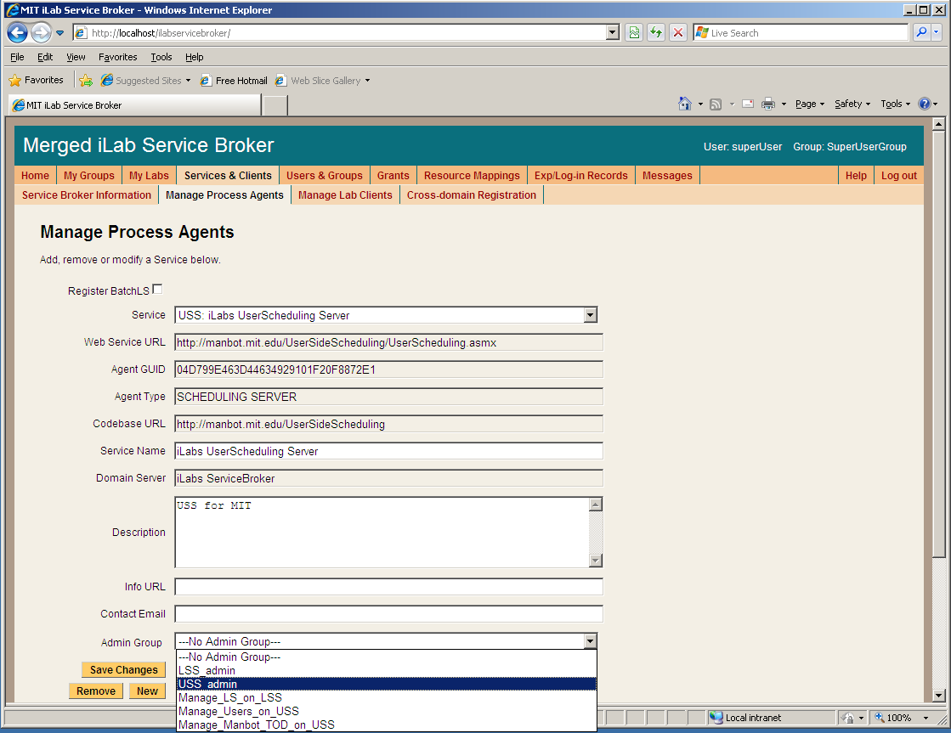
- You can use the description area to make notes about the process agent as needed. Enter “USS for your_university name” into the description area.
- Click Save Changes. You should see a green message bar at the top of the page stating that the record has been successfully modified.
Domain URLs are needed for administering and managing the USS. These URLs are automatically generated and entered into the database. To check the domain URLs:
- Click on the Domain URLs button. The domain URLs will be displayed in the Existing URL area.
- For the USS, there should be three domain URLs. Administer_USS, Manage_USS_Group, and Schedule_Session
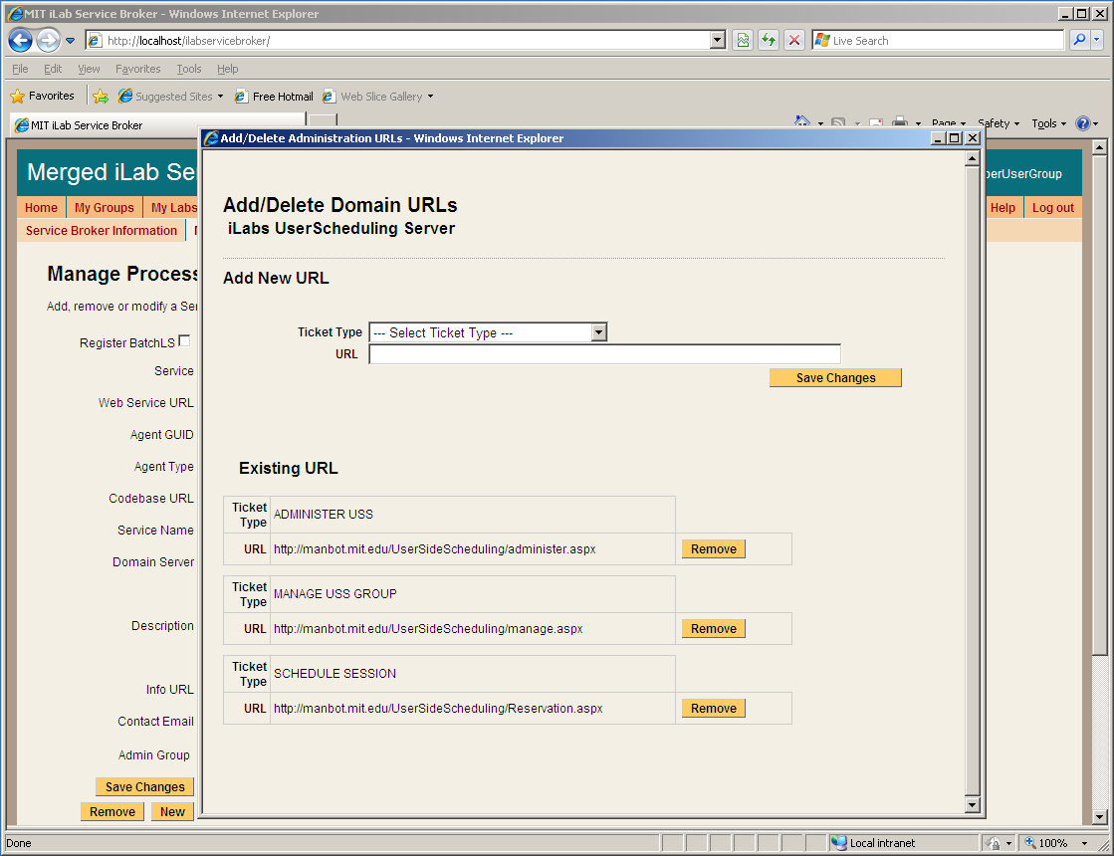
- Close the Domain URLs popup window.

Labside Scheduling Server (LSS)
To add the Labside Scheduling Service to the Service Broker, you will need the web service URL for the LSS and an initial passkey. This should be exchanged via email if you are not the owner of these services. For this document, we will assume that you are the administrator for all services and that you will be using the default initial passkey values.
Add the LSS to the Service Broker and exchange credentials.
- Click on the Manage Process Agents tab
- Enter LSS info (web services URL & passkey) into the correct fields.
- Default Web Services URL: http://machinename.edu/LabSideScheduling/LabScheduling.asmx
- Default Passkey: LSS
- Click on the Install domain credentials button.
- A register web service call is made using the web services URL and initial passkey, to get the process Agents information and credentials.
- You should see a green message bar at the top of the page stating that a “Relationship has been created and saved.”
Associate the LSS Administration Group with the USS.
- Select the “LSS_admin” group from the Admin Group pull down list. (This is the administration group that will manage the LSS.)
- You can use the description area to make notes about the process agent as necessary. Enter “LSS for your_university name” into the description area.
- Click Save Changes. You should see a green message bar at the top of the page stating that the record has been successfully updated.
Domain URLs are needed for administering and managing the USS. These URLs are automatically generated and entered into the database. To check the domain URLs:
- Click on the Domain URLs button. The domain URLs will be displayed in the Existing URL area.
- For the USS, there should be two domain URLs: Administer_LSS and Manage_Lab.
- Close the Domain URLs popup window.

Lab Proxy Server (LPS)
To add the Lab Proxy to the Service Broker, you will need the web service URL and an initial passkey for the Lab Server. This should be exchanged via email if you are not the owner of these services. For this document, we will assume that you are the administrator for all services and that you will be using the default initial passkey values.
Add the Lab Proxy Server to the Service Broker and exchange credentials.
- Click on the Manage Process Agents tab
- Enter LS info (web services URL & passkey) into the correct fields.
- Default Web Services URL: http://machinename.edu/LabProxy/
- Default Passkey: LPS
- Click on the Install domain credentials button.
- A register web service call is made using the web services URL and initial passkey, to get the process Agents information and credentials.
- You should see a green message bar at the top of the page stating that a “Relationship has been created and saved.”
Associate the LSS and management group with this Lab Server.
- Select the LSS to associate with this Lab Server from the pull-down list
- Select a Management group (Manage_LPS_on_LSS) from the pull-down list
- Click the Associate button
The Lab Server does not need an Admin Group nor does it have any Domain URLs entered.

Lab Proxy Client

Lab Client Record
Create a Lab Proxy Client record.
- Click the Manage Lab Clients tab.
- Lab Client Name: “Your Lab Name”
- Click the Make Guid button to generate a new GUID for this client. GUIDs can not be changed once the client record is saved.
- Version: 1.5
- Short Description: custom
- Long Description: custom
- Contact First Name: Your Name
- Contact Last Name: Your Name
- Contact Email: your@email_address
- Click on the box next to Needs Scheduling

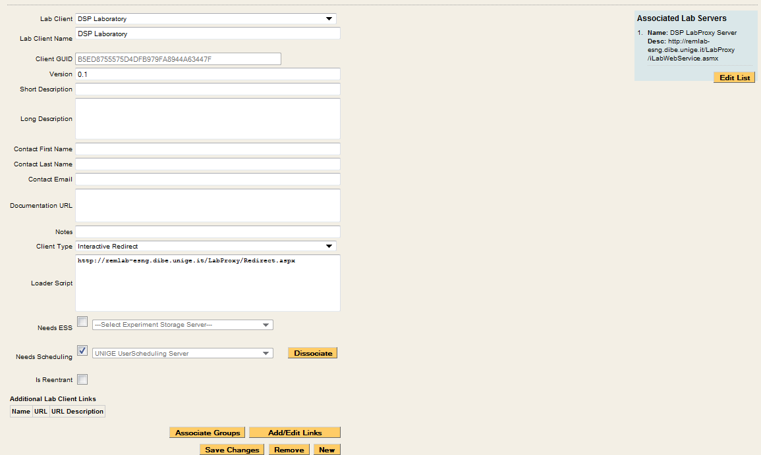

Client Loader Script
Your Lab in connection with LabProxy is an HTML redirect client. Make sure to use fully qualified URLs.
Set up the Client loader scripts.
You should still be on the Manage Lab Clients page.
- On “Your laboratory” client page, select “Interactive Redirect” from the Client Type pull-down list.
- Enter the redirect URL “http://machinename.edu/LabProxy/Redirect.aspx” into Loader Script area.
- Click Save Changes
- You should see a green message bar at the top of the page stating that the record has been modified.

Associate the Lab Server
You should still be on the Manage Lab Clients page.
Associate the LabProxy Server with the “Your Laboratory” Client.
- Click the Edit List button under Associated Lab Servers in the upper right column. A popup window will appear.
- In the popup window, notice the LabProxy web service URL in the left hand box labeled Available Lab Server.
- Select the LabProxy Server web service URL so it is highlighted, then select the Add >> button.
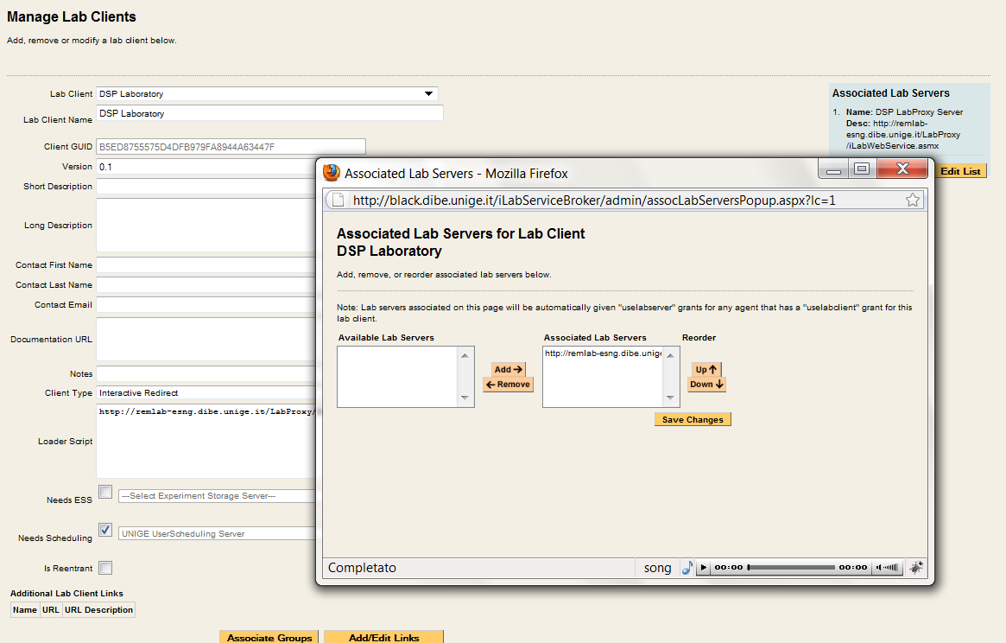
- Click the Save Changes.
- The LabProxy server should now appear in the blue box labeled Associated Lab Servers.

Associate the USS
Your experiment uses the USS. Before the experiment can be run, the USS and optional (if used) the ESS must be associated with the client.
- Use the Needs Scheduling pull-down list to select which USS this client will use.
- Click the Associate button.
- You should see a green message bar at the top of the page stating that record has been successfully associated.

Associate Groups
Associate the “Your laboratory” client with the user and management groups.
- Click the Associate groups button at the bottom of the Manage Lab clients page.
- The “Your Laboratory” client should already be selected.
- The associated services (USS, Lab Server) should contain the correct information.
- Select the group that will use this client. In this case, select the Experiment_Group from the pull-down list.
- Use the pull-down list to select the management group for the Experiment_Group. In this case, select the Manage_Users_on_ USS group.
- Click the Save Changes button. The associated groups and manager should now be listed.
- A green bar should appear at the top of the window indicating a successful update.
- Close the popup window and return to the Manage Lab Clients Page.

Create a Test User
You will need a new user for testing.
Create a test user.
- Click the Users & Groups Tab.
- Click the Manage Users tab.
- Enter the user information for a test account. Use any username, information and password that you want.
- Select the Save Change button.
- A green bar at the top of the page should indicate that you have successfully created a new user.

Group Membership
Now that there is a test user, it needs to be given the correct group memberships. For testing purposes, the user needs to be part of five groups.
Add the user to the LSS_admin, Manage_LPS_on_LSS, USS_admin, Manage_Users_on_USS, and Experiment_Group groups.
- Click the Group Membership Tab.
- In the left hand “Users and Groups” tree, click the + sign next to the NewUserGroup.
- You should see your test user listed.
- Click on your test username to highlight it.
- In the right side “Target Groups” tree, select LSS_admin group
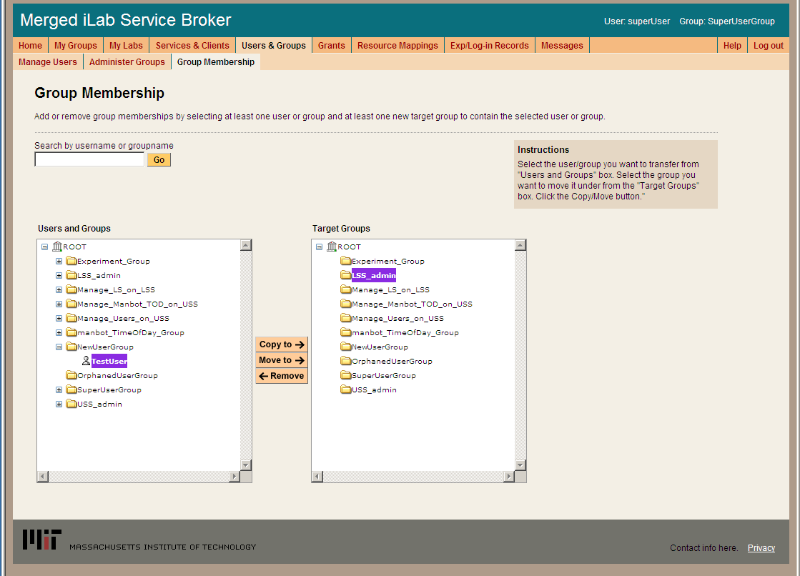
- Click on the Move To -> button
- In the left hand “Users and Groups” tree, the test user should now appear under the LSS_admin Group.
- Click on the test username under the LSS_admin group
- Click on the right side “Target Groups” tree, select Manage_LS_on_LSS group
- This time select the Copy To -> button.
- Repeat this process and copy the test user to the Manage_Users_on_USS group, the USS_admin group, and the Experiment_Group.
- You should now be in 5 groups.

Setup Lab Proxy Experiment
Log out of the SuperUser account and log in as your test user.

Manage USS
Manage the Laboratory users on the USS
- Select Manage_Users_on_USS as your group.
- In the Service Administration page, use the – Select Process Agent - pull down list to select your USS.
- Click the USS Manage Group button
- The User Side Scheduling Server should load.
- Click on the Policy Management tab.
- Use the pull down list to select the Experiment
- The group should automatically fill in.
- Enter the Minimum Time Required: 1
- Enter the Maximum Reservation Time: 5
- Click the Save Changes button
- Click the Back to Service Broker tab.
- Click on the My Groups tab.

Manage LSS
Manage the LabProxy server on the LSS
- Select Manage_LPS_on_LSS as your group.
- In the Service Administration page, use the – Select Process Agent - pull down list to select your LSS.
- Click the Manage Lab button
- The Lab Side Scheduling Server should load.
- Click on the Experiment tab.
- Select the Lab Client “YourLabName” from the list on the left.
- The client information should automatically populate the fields.
- Update the fields as follows:
- Enter Minimum Time (min): 1
- Enter Prepare Time (min): 0
- Enter Recover Time (min): 0
- Enter Early Arrive Time (min): 0
- Click the Save Changes button.
HINT: The following steps have to be done with IE, because the script is not working in other browsers (at least in firefox..)

- Click on the TimeBlocks tab.
- Click New.
- Use the Lab Server Resource pull down list to select your “YourLabName”.
- In Recurrence Type: select Single Block
- In the Date Span field, use the calendar icons to set the Begin Date and End Date.
- Set the Quantum to 1
- Leave the Start Time set to 12:00 AM
- Leave the End Time set to 12:00 AM
- Click Save
- In the TimeBlock tab, select the time block you just created.
- In the left column of the Select Experiment block, select the “YourLabName” Client
- Click on the Permit button
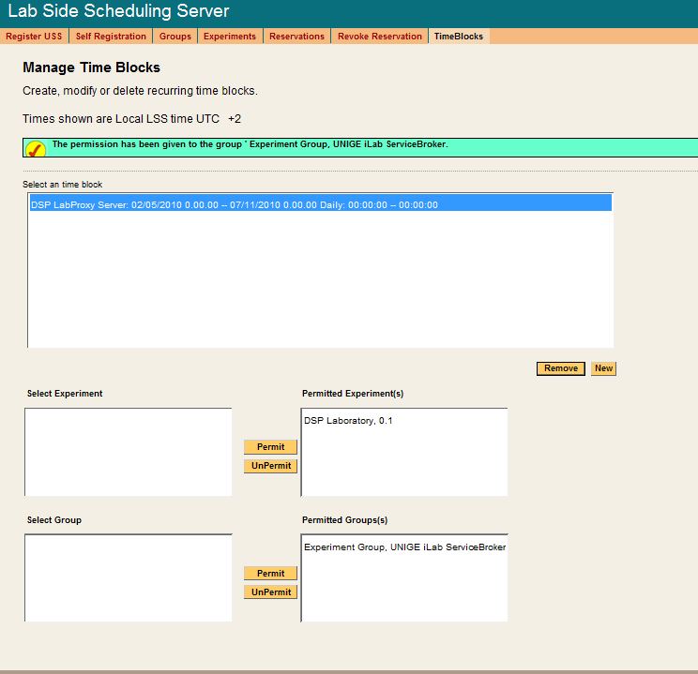
- A green bar at the top of the page should state that permissions have been granted to the experiment.
- In the left column of the Select Group block, select the Experiment_Group
- Click on the Permit button
- A green bar at the top of the page should state that permissions have been granted to the group.
- Click the Back to Service Broker tab.
- Click on the My Groups tab.
The following experiment is just for confirmation of a clean install, no administration or configuration is needed.

Running the ASP DemoLab Experiment
Make sure that you have logged out of the SuperUser account and log in as your test user.
Scheduling and Running the “Your Lab Name” Experiment
- Select Experiment_Group as your effective group.
- From the My Labs page, click on the Schedule/Redeem Session button.
- In the scheduling window, the highlighted date should be set to today.
- Click on today’s date in the calendar area – if your browser has popup blocker turned on, you will need to hold the ctrl-key down and click on the date.
- In the scheduling popup window, the available times are identified in green and the reserved times are red. Click on the first green area.
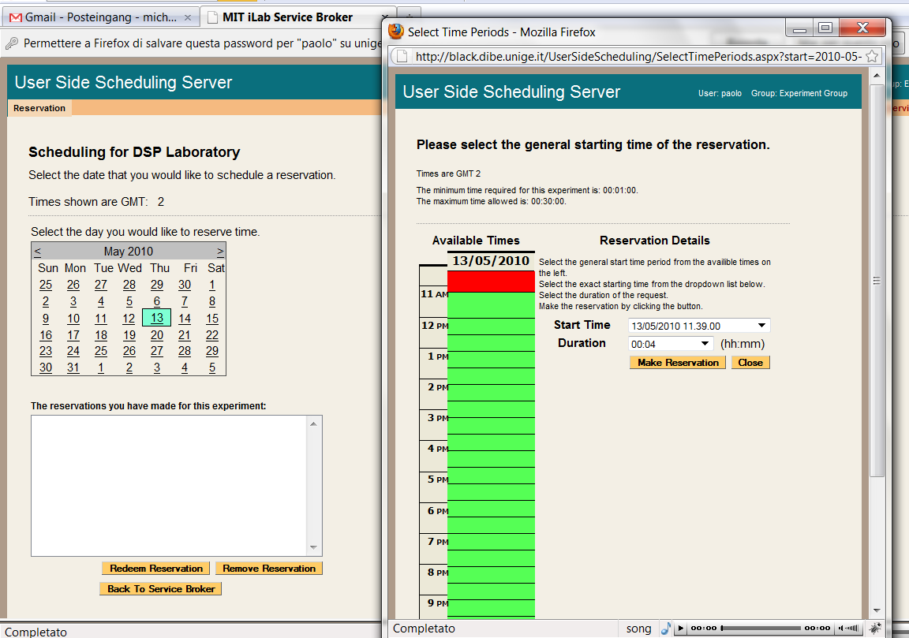
- In the Reservation Details area, use the Start Time pull down to select your start time and the Duration pull down to select your reservation length. In this case select 5 minutes for your duration.
- Click on the Make Reservation button.
- You will see a message in a green bar at the top of the window that says “The reservation is confirmed successfully”.
- Click on the Close button
- The reservation should appear in the reservation window.
BUG: There is an occasional issue in the Firefox browser and the reservation does not automatically appear in the reservations box area. Use the “Back to Service Broker” button, then the Schedule/Redeem Session button. Your reservation should appear. This is an inconsistent bug and has not been tracked down yet.

- Click on the reservation to highlight it.
- Click on the Redeem Reservation button.
- Depending on the computers clock a small green bar may appear at the top of the page letting you know how long until the reservation is valid. If this happens, wait the allotted time and click the Redeem Reservation button again.
- On the My Labs page, click the Launch Client button.
- The “Your Lab Name” Lab Client will load. (not very exciting)
- If you are using the ASP Demo Lab the result of the reservation data retrieved from the WS should be shown. Furthermore the output of a function which can be used to look whether the session is still valid is shown.

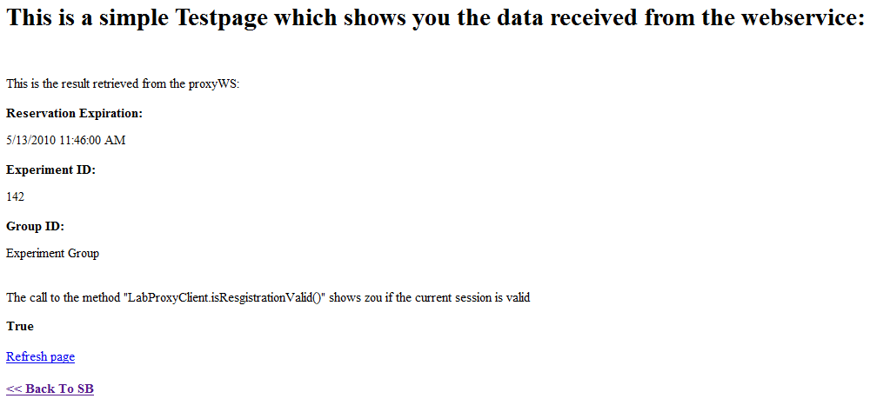

- Use the << Back To SB link to return to the Service Broker.

Troubleshooting

Grants
Currently, the bootstrapping process does not automatically give the managers of the LSS the correct permissions to manage the lab server on the LSS. This will be fixed in the next release.
- Give the Managers of the LSS permission to manage the LS.
  - Click on the Grant tab in the main menu.
  - In the Users & Groups tree on the left side, click on Manage_LS_on_LSS group to highlight it.
  - Under functions, click on Manage Lab.
  - Under Qualifiers, select the resource mapping between the Interactive Lab Sever and the LSS; Look for a resource mapping where the Process Agent: ILS and the ResourceType: LSS
  - Click the Add Grant button.
  - A green message bar should appear at the top of the screen indicating a successful update.

  - Note: You may get this error message: “Unable to find script library ‘/aspnet_client…WebUIValidation.js’ If you see this, do the following:
  - Open a command prompt with Start->Run-CMD
  - Type CD\Windows\Microsoft.NET\Framework\v1.1.4322
  - Type aspnet_regiis –c
  - You should see a message that says “Start copying the ASP.NET client side script files for this version (1.1.4322.0)…Finished copying the ASP.NET client side script files for this version (1.1.4322.0)”
  - Type Exit to close the command prompt
  - Click OK on the “Unable to find script library” error message

Web.config issue
There is a problem with the specified service’s web.config file. Please delete the current web.config file from the service’s directory and copy the web.config.template to create a new web.config file.
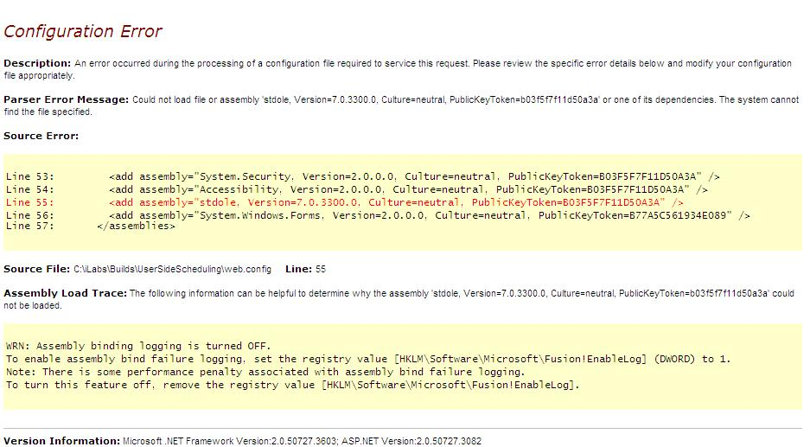

Incorrect Password
Incorrect password was supplied when trying to install domain credentials. Check the web.config file for the service or the database for the correct password.
