Interface Control Document

FOR
Inter VTS Exchange Format

Release 0_1_50_1_4



TABLE OF CONTENTS

1 Introduction 3
1.1 Identification 3
1.2 Referenced Documents 3
2 INTERFACE SPECIFICATION 4
2.1 Interface diagrams 4
2.2 User Connection 4
2.2.1 Introduction 4
2.2.2 Message types and priorities 5
2.2.3 Interface requirements 5
2.2.4 Messages 6
2.3 XML messages 7
2.3.1 Introduction 7
2.3.2 General XML message structure 7
2.3.3 Accuracies 7
2.3.4 Control Information Messages 8
2.3.4.1 LoginRequest 8
2.3.4.2 Login Response 8
2.3.4.3 Logout 8
2.3.4.4 Ping 10
2.3.4.5 Pong 11
2.3.4.6 Service Request 12
2.3.4.7 Server Status 13
2.3.5 Real Time Position Data Messages 14
2.3.5.1 Vessel Data 14
APPENDIX A LIST OF FIGURES 15
APPENDIX B List of Tables 16
APPENDIX C Abbreviations 17
APPENDIX D XML Schema 18

Introduction

Identification
This Interface Control Document (ICD) describes the requirements and the detailed design of the Inter VTS Data Exchange Format (IVEF).

Referenced Documents
Refer. | Title | Identification code
[ITU/IEC] | AIS Transponder Definition | ITU-1371-3, IEC-63993-2
[XSD] | XML Schema Definition | IVEF_xmlschema.xsd

INTERFACE SPECIFICATION

Interface diagrams
IVEF Interfaces are simple point-to-point connections (TCP/IP) between the VTS server and the VTS user as depicted in the figure below.
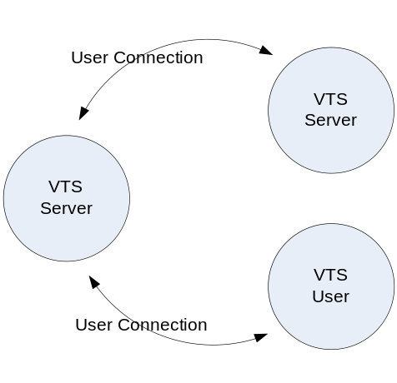
Figure 1 IVEF user connections
The IVEF protocol in itself has no provisions for encryption and data compression. These features are covered by the channel approach. IVEF will send information through standard channels. These channels can convert between physical, electrical and network interfaces, but also add layers of compression and encryption.
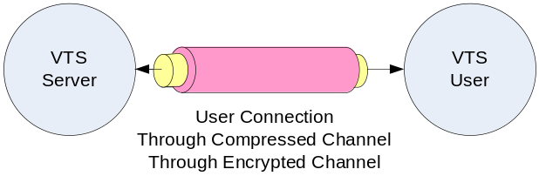

Figure 2 User connection through compressed and encrypted channel
The definition and properties of the channels are not described here, because they are not an integral part of the interface.
TBD may be add a recommendation for a compression format if used, like gzip.

User Connection

Introduction
Whenever an IVEF user wants to connect to an IVEF server, it has to initiate the connection by sending a Login message. The IVEF server validates the login requests and if correct, it sends a LoginResponse message. The IVEF server then looks up the default services for that user. An example of a service is:

“using an interval of 10 seconds, output all position information and static voyage information about all vessels that are within in the following area ( x,y ) – ( x1,y1 ) – ( x2, y2 ) – ( x3,y3 )”

Please note that x, x1, x2 and x3 shall be specified in Longitude coordinates and that y, y1, y2 and y3 shall be specified as Latitude coordinates.

After the IVEF user is logged on, the IVEF server starts outputting the tracks that match the specification in the service.
TBD consider the specification of user profiles, e.g. add allowed services request

Message types and priorities

The IVEF User Connection (IUC) can be divided in a number of message types. It supports a number of transmission characteristics:

- Single occurrence (SO)
- Periodic, with a specified update rate (PER)
- A-periodic, synchronous with the received track update (A-PER)
- On change, updates are sent as fields change (OC)

Two types of messages are distinguished:

Message type A - Non-realtime messages,

Message type B – Realtime messages.

The table below describes all messages that can be distinguished, what type of message it is (A or B) and the priority that this message type will have. For a description of priorities, see 2.2.3.
TBD Add table with priorities and their description

Message | SO | PER | A-PER | OC
Control Information (CI) | A1 | N/A | N/A | N/A
Real Time Position data (RTPD) Vessel Data (Track based) | A3 | B2 | B2 | B2
Real Time Position data (RTPD) Vessel Data (Plan based) | A3 | B4 | N/A | A3
User Requests (UR) | A1 | N/A | N/A | N/A
Table 1 Message types and priorities

Interface requirements
The resulting interface combines many messages which are sent through a single channel. When the capacity of this channel is not sufficient, or when a certain transmission characteristic is to be maintained (e.g. periodic transmission of RTPD), the priorities of the messages shall be as defined in Table 1.
For every message type, A or B, maximum delay can be specified. If the delays increase beyond the maximum, messages will not be sent (given the priority as in 2.2) in order to ensure transmission of the messages with higher priority. Messages, that are not sent due to insufficient bandwidth, will not be resent. Whenever the queue is full and messages are not being sent, because the queue is full, a ServerStatus message is sent from the IVEF server to the IVEF user to inform the IVEF user.
TBD should this specification contain performance requirements, like e.g. minimum response time?

Messages
The IUC supports the following messages; the contents and meaning of the messages mentioned below are covered in chapter 2.3

Message | From |  | To | Description
Control Information Messages
Login | User | Server |  | This message identifies an IVEF user
Login Response | Server | User |  | OK or NOT
Logout | User | Server |  | Logout from the server
Ping | Both | Both |  | Heartbeat message
Pong | Both | Both |  | Response to a Heartbeat message
Service Request | User | Server |  | Request a service, this message contains the contents of the new service
Service Request Response | Server | User |  | OK or NOT OK
Server Status | Server | User |  | Can come as response or automatically
Real Time Position Data Messages
Vessel Data Track based | Server |  | User | The position, static- and voyage related data of a track, this message is used for IVEF users that are mainly interested in position data
Vessel Data Plan based | Server |  | User | The position, static- and voyage related data of a track, this message is used for IVEF users that are mainly interested in plan data
Table 2 Interface Messages

XML messages

Introduction
This chapter describes the XML messages that may be sent between IVEF users and a IVEF server and vise versa.

General XML message structure
All XML messages sent and received by an IVEF server shall have the following layout:

- XML version tag
- Main node
- Header node, child node of Main node
- Body node, child node of Main node
- Message specific node(s) , one or more, child node(s) of the Body node

example:

<?xml version="1.0" ?>
<IVEF_xxx xmlns="urn:http://www.iala.org/XMLSchema/IVEF/1.0">
<Header Version="1.0" MsgRefId="DJ45SGFL-B103-4113-A100-DJ45SGFL"/>
<Body>
Message specific nodes will be placed here
</Body>
</IVEF_xxx>

Accuracies
The following accuracies are required to ensure a proper working of the system.
TBD Define minimum resolution of the various attributes.

Attribute | Resolution | belonging to element (see [XSD])
Altitude | 0 | PosReport
AntPosDistFromFront | 0 | StaticData
AntPosDistFromLeft | 0 | StaticData
ATA | 0 | Voyage
Breadth | 0 | PosReport and Vesseldata
COG | 1 | PosReport
ETA | 0 | Voyage
Lat | 5 | Pos
Length | 0 | PosReport and Vesseldata
Long | 5 | Pos
MaxDraught | 1 | StaticData
MaxAirDraught | 1 | StaticData
Orientation | 0 | PosReport
Period | 0 | Transmission
RateOfTurn | 0 | PosReport
SOG | 1 | PosReport
TimeStamp | 2 | Ping and Pong
UpdateTime | 2 | PosReport
Accuracy | 0 | PosReport

Control Information Messages

LoginRequest

Introduction
The LoginRequest.xml message is sent by an IVEF user to an IVEF server. The purpose of this message is to identify an IVEF user to the IVEF server.

Message flow

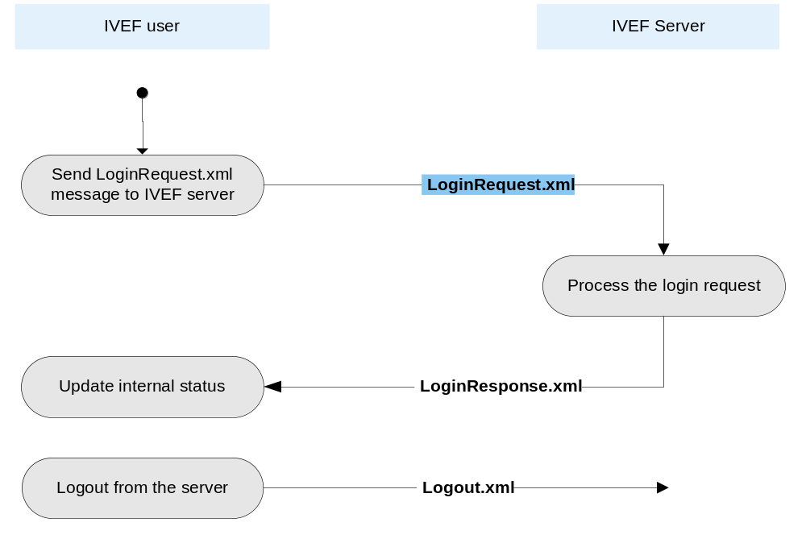

Figure 3 Message flow LoginRequest.xml

Data elements of LoginRequest.xml message

See [XSD] for all details

Login Response

Introduction
The LoginResponse.xml (see Figure 3) message is sent by an IVEF server to an IVEF user in response to a LoginRequest.xml message. The purpose of this message is to indicate whether or not the user is successfully logged in. If the IVEF user is not accepted by the IVEF server, a LoginResponse message is sent with status “Declined”, the network connection will be terminated.

Logout

Introduction
The Logout.xml (see Figure 3) message is a notification, sent by an IVEF user to the IVEF server, to terminate the connection.

TBD XXX.

The closing of the network connection can be used by the IVEF user as an indication that the logout succeeded.
Also, when the connection between an IVEF server and an IVEF user is closed for whatever reason with no request, the IVEF user will have to initiate the connection and logon again to get the service data requested.

Ping

Introduction
A ping message can be sent by either an IVEF user or an IVEF server as an alive message. A ping message will be answered by the receiver with a pong message.

Message flow

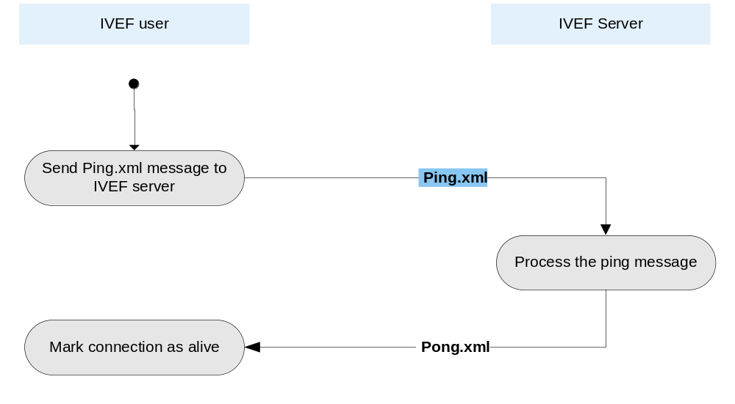

Figure 4 Message flow Ping.xml

Data elements of Ping.xml message

See [XSD] for all details

Pong

Introduction
A pong message can be sent by either an IVEF user or an IVEF server as a response to a ping message.

Message flow

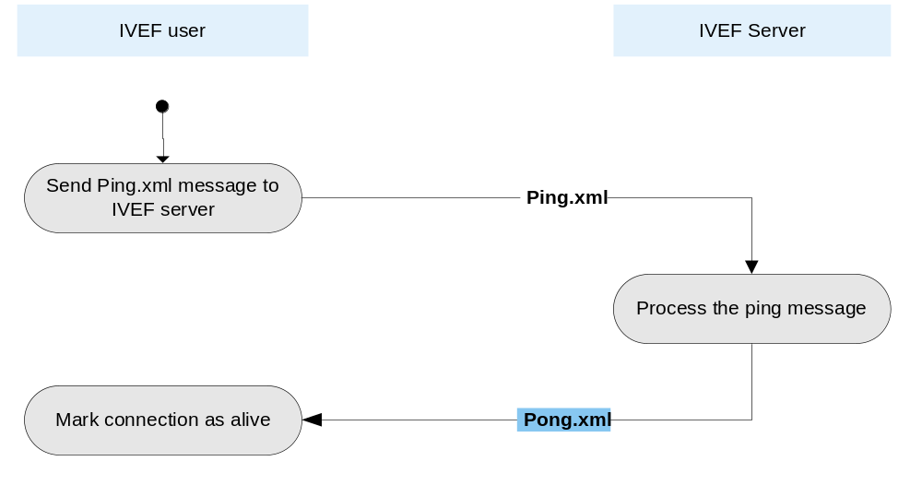

Figure 5 Message flow Pong.xml

Data elements of Pong.xml message

See [XSD] for all details

Service Request

Introduction
After login the user can sent a service request. The request should be within the defined rights of the user. If the service request is accepted by the server, the previous (default) service is replaced by this.
Service request will not be implemented in the first release. It is described here to illustrate the properties of a service.

Message flow

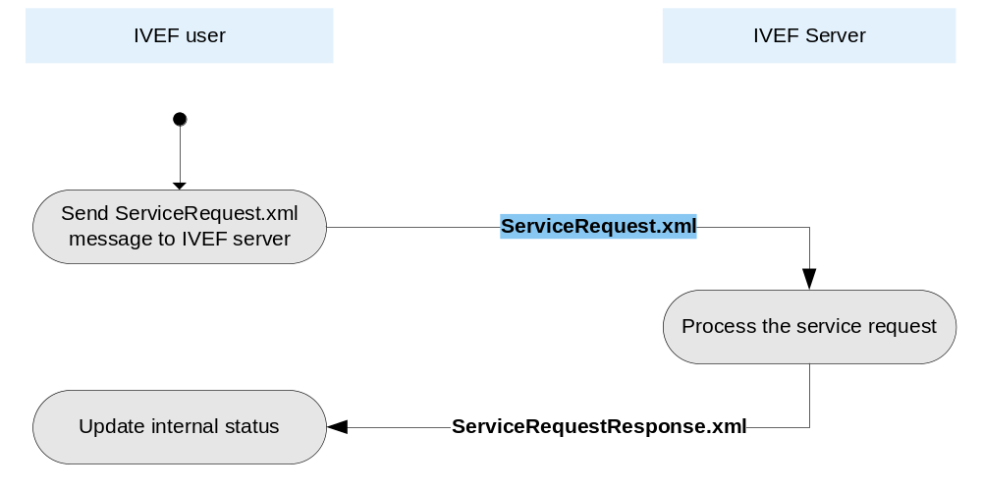
Figure 6 Message flow ServiceRequest.xml

Data elements of ServiceRequest.xml message
See [XSD] for all details

Server Status

Introduction
A Server Status message can be sent by an IVEF server to indicate the status if the server. These messages will come autonomously.

Message flow

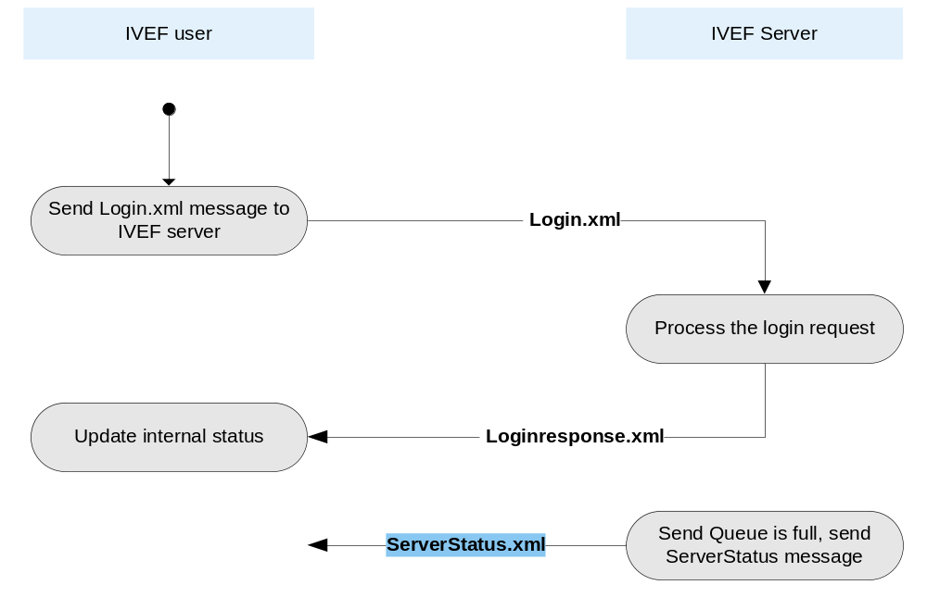
Figure 7 Message flow ServerStatus.xml

Data elements of ServerStatus.xml message

See [XSD] for all details

Real Time Position Data Messages

Vessel Data

Introduction
A Vessel Data message contains data (position, static and voyage related data) about one or more vessels.
After an IVEF user identified itself using a Login message, the IVEF server starts sending Vessel Data messages if a predefined service is available for the user or the IVEF server sends Vessel Data on an accepted New Service Request message.

Message flow

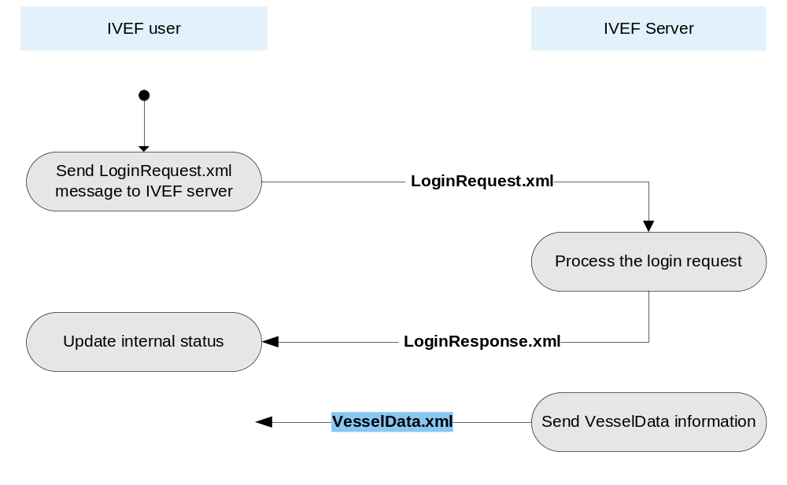
Figure 8 Message flow VesselData.xml

Data elements of VesselData.xml message

See [XSD] for all details

APPENDIX A LIST OF FIGURES
Figure 1 IVEF user connections 4
Figure 2 User connection through compressed and encrypted channel 4
Figure 3 Message flow LoginRequest.xml 8
Figure 4 Message flow Ping.xml 10
Figure 5 Message flow Pong.xml 11
Figure 6 Message flow ServiceRequest.xml 12
Figure 7 Message flow ServerStatus.xml 13
Figure 8 Message flow VesselData.xml 14

APPENDIX B List of Tables
Table 1 Message types and priorities 5
Table 2 Interface Messages 6

APPENDIX C Abbreviations
AIS | Automatic Identification System
ATA | Actual Time of Arrival
COG | Course Over Ground
CSCI | Computer Software Configuration Item
ETA | Estimated Time of Arrival
FS | Functional Specification
ICD | Interface Control Document
IMO | International Maritime Organisation
ITU | International Technical Union
RTPD | Real Time Position Data
SOG | Speed Over Ground
TCP/IP | Transmission Control Protocol / Internet Protocol
UTC | Coordinated Universal Time
WGS-84 | World Geodetic System 1984
XML | Extensible Markup Language

APPENDIX D XML Schema

Elements
Header
LoginRequest
LoginResponse
Logout
MSG_LoginRequest
MSG_LoginResponse
MSG_Logout
MSG_Ping
MSG_Pong
MSG_ServerStatus
MSG_ServiceRequest
MSG_VesselData
Ping
Pong
Pos
PosReport
ServerStatus
ServiceRequest
StaticData
TaggedItem
VesselData
Voyage

element Header
diagram | 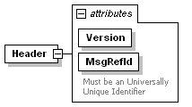
namespace | urn:http://www.ivef.org/XMLSchema/IVEF/0.1.5
properties
  content | complex
used by
  elements | MSG_LoginRequest MSG_LoginResponse MSG_Logout MSG_Ping MSG_Pong MSG_ServerStatus MSG_ServiceRequest MSG_VesselData
attributes
  Name | Type | Use | Default | Fixed | Annotation
  Version | xs:string | required |  | 0.1.5
  MsgRefId | derived by: xs:string | required
    documentation
    Must be an Universally Unique Identifier
source | <xs:element name="Header">  <xs:complexType>  <xs:attribute name="Version" type="xs:string" use="required" fixed="0.1.5"/>  <xs:attribute name="MsgRefId" use="required">  <xs:annotation>  <xs:documentation>Must be an Universally Unique Identifier</xs:documentation>  </xs:annotation>  <xs:simpleType>  <xs:restriction base="xs:string"/>  </xs:simpleType>  </xs:attribute>  </xs:complexType>  </xs:element>

element LoginRequest
diagram | 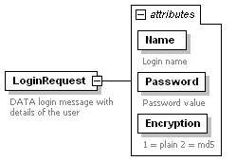
namespace | urn:http://www.ivef.org/XMLSchema/IVEF/0.1.5
properties
  content | complex
used by
  element | MSG_LoginRequest/Body
attributes
  Name | Type | Use | Default | Fixed | Annotation
  Name | derived by: xs:string | required
    documentation
    Login name
  Password | derived by: xs:string | required
    documentation
    Password value
  Encryption | derived by: xs:integer | required
    documentation
    1 = plain 2 = md5
annotation
  documentation
  DATA login message with details of the user
source | <xs:element name="LoginRequest">  <xs:annotation>  <xs:documentation>DATA login message with details of the user</xs:documentation>  </xs:annotation>  <xs:complexType>  <xs:attribute name="Name" use="required">  <xs:annotation>  <xs:documentation>Login name</xs:documentation>  </xs:annotation>  <xs:simpleType>  <xs:restriction base="xs:string">  <xs:maxLength value="256"/>  </xs:restriction>  </xs:simpleType>  </xs:attribute>  <xs:attribute name="Password" use="required">  <xs:annotation>  <xs:documentation>Password value</xs:documentation>  </xs:annotation>  <xs:simpleType>  <xs:restriction base="xs:string">  <xs:maxLength value="256"/>  </xs:restriction>  </xs:simpleType>  </xs:attribute>  <xs:attribute name="Encryption" use="required">  <xs:annotation>  <xs:documentation>1 = plain 2 = md5</xs:documentation>  </xs:annotation>  <xs:simpleType>  <xs:restriction base="xs:integer">  <xs:enumeration value="1"/>  <xs:enumeration value="2"/>  </xs:restriction>  </xs:simpleType>  </xs:attribute>  </xs:complexType>  </xs:element>

element LoginResponse
diagram | 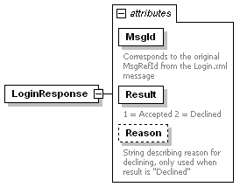
namespace | urn:http://www.ivef.org/XMLSchema/IVEF/0.1.5
properties
  content | complex
used by
  element | MSG_LoginResponse/Body
attributes
  Name | Type | Use | Default | Fixed | Annotation
  MsgId | derived by: xs:string | required
    documentation
    Corresponds to the original MsgRefId from the Login.xml message
  Result | derived by: xs:integer | required
    documentation
    1 = Accepted 2 = Declined
  Reason | derived by: xs:string | optional
    documentation
    String describing reason for declining, only used when result is "Declined"
source | <xs:element name="LoginResponse">  <xs:complexType>  <xs:attribute name="MsgId" use="required">  <xs:annotation>  <xs:documentation>Corresponds to the original MsgRefId from the Login.xml message</xs:documentation>  </xs:annotation>  <xs:simpleType>  <xs:restriction base="xs:string">  <xs:maxLength value="36"/>  </xs:restriction>  </xs:simpleType>  </xs:attribute>  <xs:attribute name="Result" use="required">  <xs:annotation>  <xs:documentation>1 = Accepted 2 = Declined</xs:documentation>  </xs:annotation>  <xs:simpleType>  <xs:restriction base="xs:integer">  <xs:enumeration value="1"/>  <xs:enumeration value="2"/>  </xs:restriction>  </xs:simpleType>  </xs:attribute>  <xs:attribute name="Reason" use="optional">  <xs:annotation>  <xs:documentation>String describing reason for declining, only used when result is "Declined"</xs:documentation>  </xs:annotation>  <xs:simpleType>  <xs:restriction base="xs:string">  <xs:maxLength value="256"/>  </xs:restriction>  </xs:simpleType>  </xs:attribute>  </xs:complexType>  </xs:element>

element Logout
diagram | 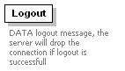
namespace | urn:http://www.ivef.org/XMLSchema/IVEF/0.1.5
annotation
  documentation
  DATA logout message, the server will drop the connection if logout is successfull
source | <xs:element name="Logout">  <xs:annotation>  <xs:documentation>DATA logout message, the server will drop the connection if logout is successfull</xs:documentation>  </xs:annotation>  </xs:element>

element MSG_LoginRequest
diagram | 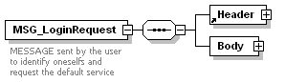
namespace | urn:http://www.ivef.org/XMLSchema/IVEF/0.1.5
properties
  content | complex
children | Header Body
annotation
  documentation
  MESSAGE sent by the user to identify oneselfs and request the default service
source | <xs:element name="MSG_LoginRequest">  <xs:annotation>  <xs:documentation>MESSAGE sent by the user to identify oneselfs and request the default service</xs:documentation>  </xs:annotation>  <xs:complexType>  <xs:sequence>  <xs:element ref="Header"/>  <xs:element name="Body">  <xs:complexType>  <xs:sequence>  <xs:element ref="LoginRequest"/>  </xs:sequence>  </xs:complexType>  </xs:element>  </xs:sequence>  </xs:complexType>  </xs:element>

element MSG_LoginRequest/Body
diagram | 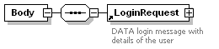
namespace | urn:http://www.ivef.org/XMLSchema/IVEF/0.1.5
properties
  isRef | 0
  content | complex
children | LoginRequest
source | <xs:element name="Body">  <xs:complexType>  <xs:sequence>  <xs:element ref="LoginRequest"/>  </xs:sequence>  </xs:complexType>  </xs:element>

element MSG_LoginResponse
diagram | 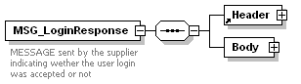
namespace | urn:http://www.ivef.org/XMLSchema/IVEF/0.1.5
properties
  content | complex
children | Header Body
annotation
  documentation
  MESSAGE sent by the supplier indicating wether the user login was accepted or not
source | <xs:element name="MSG_LoginResponse">  <xs:annotation>  <xs:documentation>MESSAGE sent by the supplier indicating wether the user login was accepted or not</xs:documentation>  </xs:annotation>  <xs:complexType>  <xs:sequence>  <xs:element ref="Header"/>  <xs:element name="Body">  <xs:complexType>  <xs:sequence>  <xs:element ref="LoginResponse"/>  </xs:sequence>  </xs:complexType>  </xs:element>  </xs:sequence>  </xs:complexType>  </xs:element>

element MSG_LoginResponse/Body
diagram | 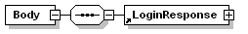
namespace | urn:http://www.ivef.org/XMLSchema/IVEF/0.1.5
properties
  isRef | 0
  content | complex
children | LoginResponse
source | <xs:element name="Body">  <xs:complexType>  <xs:sequence>  <xs:element ref="LoginResponse"/>  </xs:sequence>  </xs:complexType>  </xs:element>

element MSG_Logout
diagram | 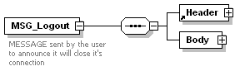
namespace | urn:http://www.ivef.org/XMLSchema/IVEF/0.1.5
properties
  content | complex
children | Header Body
annotation
  documentation
  MESSAGE sent by the user to announce it will close it's connection
source | <xs:element name="MSG_Logout">  <xs:annotation>  <xs:documentation>MESSAGE sent by the user to announce it will close it's connection</xs:documentation>  </xs:annotation>  <xs:complexType>  <xs:sequence>  <xs:element ref="Header"/>  <xs:element name="Body">  <xs:complexType>  <xs:sequence>  <xs:element name="Logout">  <xs:annotation>  <xs:documentation>Logout element node</xs:documentation>  </xs:annotation>  </xs:element>  </xs:sequence>  </xs:complexType>  </xs:element>  </xs:sequence>  </xs:complexType>  </xs:element>

element MSG_Logout/Body
diagram | 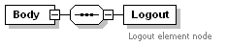
namespace | urn:http://www.ivef.org/XMLSchema/IVEF/0.1.5
properties
  isRef | 0
  content | complex
children | Logout
source | <xs:element name="Body">  <xs:complexType>  <xs:sequence>  <xs:element name="Logout">  <xs:annotation>  <xs:documentation>Logout element node</xs:documentation>  </xs:annotation>  </xs:element>  </xs:sequence>  </xs:complexType>  </xs:element>

element MSG_Logout/Body/Logout
diagram | 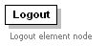
namespace | urn:http://www.ivef.org/XMLSchema/IVEF/0.1.5
properties
  isRef | 0
annotation
  documentation
  Logout element node
source | <xs:element name="Logout">  <xs:annotation>  <xs:documentation>Logout element node</xs:documentation>  </xs:annotation>  </xs:element>

element MSG_Ping
diagram | 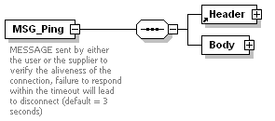
namespace | urn:http://www.ivef.org/XMLSchema/IVEF/0.1.5
properties
  content | complex
children | Header Body
annotation
  documentation
  MESSAGE sent by either the user or the supplier to verify the aliveness of the connection, failure to respond within the timeout will lead to disconnect (default = 3 seconds)
source | <xs:element name="MSG_Ping">  <xs:annotation>  <xs:documentation>MESSAGE sent by either the user or the supplier to verify the aliveness of the connection, failure to respond within the timeout will lead to disconnect (default = 3 seconds)</xs:documentation>  </xs:annotation>  <xs:complexType>  <xs:sequence>  <xs:element ref="Header"/>  <xs:element name="Body">  <xs:complexType>  <xs:sequence>  <xs:element ref="Ping"/>  </xs:sequence>  </xs:complexType>  </xs:element>  </xs:sequence>  </xs:complexType>  </xs:element>

element MSG_Ping/Body
diagram | 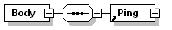
namespace | urn:http://www.ivef.org/XMLSchema/IVEF/0.1.5
properties
  isRef | 0
  content | complex
children | Ping
source | <xs:element name="Body">  <xs:complexType>  <xs:sequence>  <xs:element ref="Ping"/>  </xs:sequence>  </xs:complexType>  </xs:element>

element MSG_Pong
diagram | 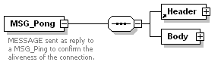
namespace | urn:http://www.ivef.org/XMLSchema/IVEF/0.1.5
properties
  content | complex
children | Header Body
annotation
  documentation
  MESSAGE sent as reply to a MSG_Ping to confirm the aliveness of the connection.
source | <xs:element name="MSG_Pong">  <xs:annotation>  <xs:documentation>MESSAGE sent as reply to a MSG_Ping to confirm the aliveness of the connection.</xs:documentation>  </xs:annotation>  <xs:complexType>  <xs:sequence>  <xs:element ref="Header"/>  <xs:element name="Body">  <xs:complexType>  <xs:sequence>  <xs:element ref="Pong"/>  </xs:sequence>  </xs:complexType>  </xs:element>  </xs:sequence>  </xs:complexType>  </xs:element>

element MSG_Pong/Body
diagram | 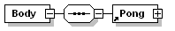
namespace | urn:http://www.ivef.org/XMLSchema/IVEF/0.1.5
properties
  isRef | 0
  content | complex
children | Pong
source | <xs:element name="Body">  <xs:complexType>  <xs:sequence>  <xs:element ref="Pong"/>  </xs:sequence>  </xs:complexType>  </xs:element>

element MSG_ServerStatus
diagram | 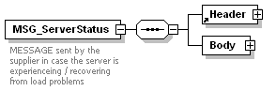
namespace | urn:http://www.ivef.org/XMLSchema/IVEF/0.1.5
properties
  content | complex
children | Header Body
annotation
  documentation
  MESSAGE sent by the supplier in case the server is experienceing / recovering from load problems
source | <xs:element name="MSG_ServerStatus">  <xs:annotation>  <xs:documentation>MESSAGE sent by the supplier in case the server is experienceing / recovering from load problems</xs:documentation>  </xs:annotation>  <xs:complexType>  <xs:sequence>  <xs:element ref="Header"/>  <xs:element name="Body">  <xs:complexType>  <xs:sequence>  <xs:element ref="ServerStatus"/>  </xs:sequence>  </xs:complexType>  </xs:element>  </xs:sequence>  </xs:complexType>  </xs:element>

element MSG_ServerStatus/Body
diagram | 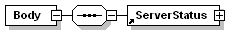
namespace | urn:http://www.ivef.org/XMLSchema/IVEF/0.1.5
properties
  isRef | 0
  content | complex
children | ServerStatus
source | <xs:element name="Body">  <xs:complexType>  <xs:sequence>  <xs:element ref="ServerStatus"/>  </xs:sequence>  </xs:complexType>  </xs:element>

element MSG_ServiceRequest
diagram | 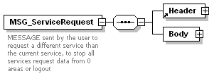
namespace | urn:http://www.ivef.org/XMLSchema/IVEF/0.1.5
properties
  content | complex
children | Header Body
annotation
  documentation
  MESSAGE sent by the user to request a different service than the current service, to stop all services request data from 0 areas or logout
source | <xs:element name="MSG_ServiceRequest">  <xs:annotation>  <xs:documentation>MESSAGE sent by the user to request a different service than the current service, to stop all services request data from 0 areas or logout</xs:documentation>  </xs:annotation>  <xs:complexType>  <xs:sequence>  <xs:element ref="Header"/>  <xs:element name="Body">  <xs:complexType>  <xs:sequence>  <xs:element ref="ServiceRequest"/>  </xs:sequence>  </xs:complexType>  </xs:element>  </xs:sequence>  </xs:complexType>  </xs:element>

element MSG_ServiceRequest/Body
diagram | 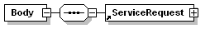
namespace | urn:http://www.ivef.org/XMLSchema/IVEF/0.1.5
properties
  isRef | 0
  content | complex
children | ServiceRequest
source | <xs:element name="Body">  <xs:complexType>  <xs:sequence>  <xs:element ref="ServiceRequest"/>  </xs:sequence>  </xs:complexType>  </xs:element>

element MSG_VesselData
diagram | 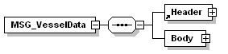
namespace | urn:http://www.ivef.org/XMLSchema/IVEF/0.1.5
properties
  content | complex
children | Header Body
source | <xs:element name="MSG_VesselData">  <xs:complexType>  <xs:sequence>  <xs:element ref="Header"/>  <xs:element name="Body">  <xs:complexType>  <xs:sequence>  <xs:element ref="VesselData" maxOccurs="unbounded"/>  </xs:sequence>  </xs:complexType>  </xs:element>  </xs:sequence>  </xs:complexType>  </xs:element>

element MSG_VesselData/Body
diagram | 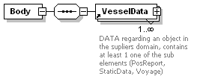
namespace | urn:http://www.ivef.org/XMLSchema/IVEF/0.1.5
properties
  isRef | 0
  content | complex
children | VesselData
source | <xs:element name="Body">  <xs:complexType>  <xs:sequence>  <xs:element ref="VesselData" maxOccurs="unbounded"/>  </xs:sequence>  </xs:complexType>  </xs:element>

element Ping
diagram | 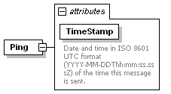
namespace | urn:http://www.ivef.org/XMLSchema/IVEF/0.1.5
properties
  content | complex
used by
  element | MSG_Ping/Body
attributes
  Name | Type | Use | Default | Fixed | Annotation
  TimeStamp | xs:dateTime | required
    documentation
    Date and time in ISO 8601 UTC format (YYYY-MM-DDThh:mm:ss.sssZ) of the time this message is sent.
source | <xs:element name="Ping">  <xs:complexType>  <xs:attribute name="TimeStamp" type="xs:dateTime" use="required">  <xs:annotation>  <xs:documentation>Date and time in ISO 8601 UTC format (YYYY-MM-DDThh:mm:ss.sssZ) of the time this message is sent.</xs:documentation>  </xs:annotation>  </xs:attribute>  </xs:complexType>  </xs:element>

element Pong
diagram | 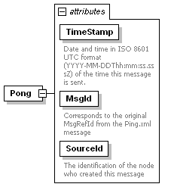
namespace | urn:http://www.ivef.org/XMLSchema/IVEF/0.1.5
properties
  content | complex
used by
  element | MSG_Pong/Body
attributes
  Name | Type | Use | Default | Fixed | Annotation
  TimeStamp | xs:dateTime | required
    documentation
    Date and time in ISO 8601 UTC format (YYYY-MM-DDThh:mm:ss.sssZ) of the time this message is sent.
  MsgId | derived by: xs:string | required
    documentation
    Corresponds to the original MsgRefId from the Ping.xml message
  SourceId | xs:integer | required
    documentation
    The identification of the node who created this message
source | <xs:element name="Pong">  <xs:complexType>  <xs:attribute name="TimeStamp" type="xs:dateTime" use="required">  <xs:annotation>  <xs:documentation>Date and time in ISO 8601 UTC format (YYYY-MM-DDThh:mm:ss.sssZ) of the time this message is sent.</xs:documentation>  </xs:annotation>  </xs:attribute>  <xs:attribute name="MsgId" use="required">  <xs:annotation>  <xs:documentation>Corresponds to the original MsgRefId from the Ping.xml message</xs:documentation>  </xs:annotation>  <xs:simpleType>  <xs:restriction base="xs:string">  <xs:maxLength value="36"/>  </xs:restriction>  </xs:simpleType>  </xs:attribute>  <xs:attribute name="SourceId" type="xs:integer" use="required">  <xs:annotation>  <xs:documentation>The identification of the node who created this message</xs:documentation>  </xs:annotation>  </xs:attribute>  </xs:complexType>  </xs:element>

element Pos
diagram | 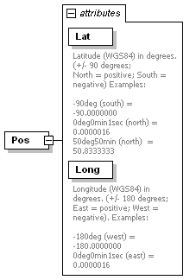
namespace | urn:http://www.ivef.org/XMLSchema/IVEF/0.1.5
properties
  content | complex
used by
  elements | ServiceRequest/Area PosReport
attributes
  Name | Type | Use | Default | Fixed | Annotation
  Lat | derived by: xs:decimal | required
    documentation
    Latitude (WGS84) in degrees. (+/- 90 degrees;
    North = positive; South = negative) Examples:
    -90deg (south) = -90.0000000
    0deg0min1sec (north) = 0.0000016
    50deg50min (north) = 50.8333333
  Long | derived by: xs:decimal | required
    documentation
    Longitude (WGS84) in degrees. (+/- 180 degrees; East = positive; West = negative). Examples:
    -180deg (west) = -180.0000000
    0deg0min1sec (east) = 0.0000016
source | <xs:element name="Pos">  <xs:complexType>  <xs:attribute name="Lat" use="required">  <xs:annotation>  <xs:documentation>Latitude (WGS84) in degrees. (+/- 90 degrees;  North = positive; South = negative) Examples:  -90deg (south) = -90.0000000  0deg0min1sec (north) = 0.0000016  50deg50min (north) = 50.8333333</xs:documentation>  </xs:annotation>  <xs:simpleType>  <xs:restriction base="xs:decimal">  <xs:minInclusive value="-90.00000"/>  <xs:maxInclusive value="+90.00000"/>  </xs:restriction>  </xs:simpleType>  </xs:attribute>  <xs:attribute name="Long" use="required">  <xs:annotation>  <xs:documentation>Longitude (WGS84) in degrees. (+/- 180 degrees; East = positive; West = negative). Examples:  -180deg (west) = -180.0000000  0deg0min1sec (east) = 0.0000016</xs:documentation>  </xs:annotation>  <xs:simpleType>  <xs:restriction base="xs:decimal">  <xs:maxInclusive value="+180.00000"/>  <xs:minExclusive value="-180.00000"/>  </xs:restriction>  </xs:simpleType>  </xs:attribute>  </xs:complexType>  </xs:element>

element PosReport
diagram | 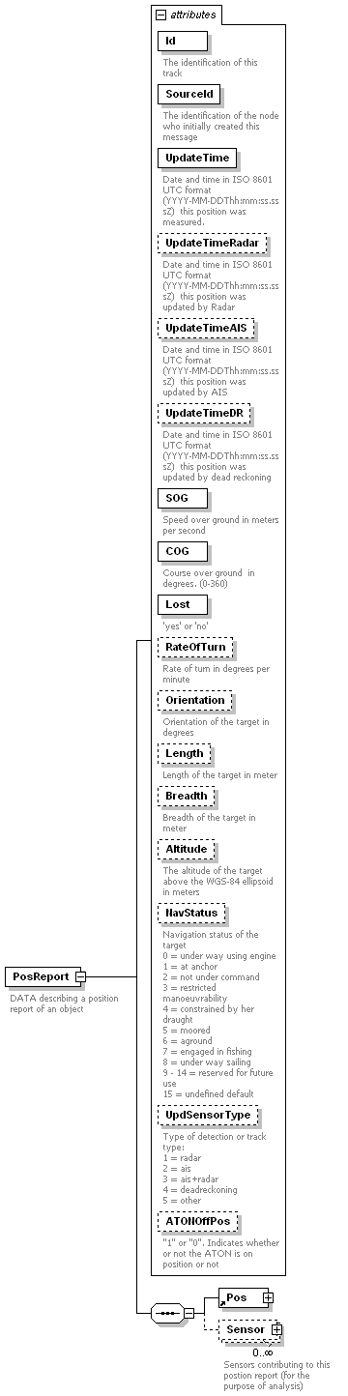
namespace | urn:http://www.ivef.org/XMLSchema/IVEF/0.1.5
properties
  content | complex
children | Pos Sensor
used by
  element | VesselData
attributes
  Name | Type | Use | Default | Fixed | Annotation
  Id | xs:integer | required
    documentation
    The identification of this track
  SourceId | xs:integer | required
    documentation
    The identification of the node who initially created this message
  UpdateTime | xs:dateTime | required
    documentation
    Date and time in ISO 8601 UTC format (YYYY-MM-DDThh:mm:ss.sssZ) this position was measured.
  UpdateTimeRadar | xs:dateTime | optional
    documentation
    Date and time in ISO 8601 UTC format (YYYY-MM-DDThh:mm:ss.sssZ) this position was updated by Radar
  UpdateTimeAIS | xs:dateTime | optional
    documentation
    Date and time in ISO 8601 UTC format (YYYY-MM-DDThh:mm:ss.sssZ) this position was updated by AIS
  UpdateTimeDR | xs:dateTime | optional
    documentation
    Date and time in ISO 8601 UTC format (YYYY-MM-DDThh:mm:ss.sssZ) this position was updated by dead reckoning
  SOG | derived by: xs:decimal | required
    documentation
    Speed over ground in meters per second
  COG | derived by: xs:decimal | required
    documentation
    Course over ground in degrees. (0-360)
  Lost | derived by: xs:string | required
    documentation
    'yes' or 'no'
  RateOfTurn | xs:decimal | optional
    documentation
    Rate of turn in degrees per minute
  Orientation | derived by: xs:decimal | optional
    documentation
    Orientation of the target in degrees
  Length | derived by: xs:decimal | optional
    documentation
    Length of the target in meter
  Breadth | derived by: xs:decimal | optional
    documentation
    Breadth of the target in meter
  Altitude | xs:decimal | optional
    documentation
    The altitude of the target above the WGS-84 ellipsoid in meters
  NavStatus | derived by: xs:integer | optional
    documentation
    Navigation status of the target
    0 = under way using engine
    1 = at anchor
    2 = not under command
    3 = restricted manoeuvrability
    4 = constrained by her draught
    5 = moored
    6 = aground
    7 = engaged in fishing
    8 = under way sailing
    9 - 14 = reserved for future use
    15 = undefined default
  UpdSensorType | derived by: xs:integer | optional
    documentation
    Type of detection or track type:
    1 = radar
    2 = ais
    3 = ais+radar
    4 = deadreckoning
    5 = other
  ATONOffPos | xs:boolean | optional
    documentation
    "1" or "0". Indicates whether or not the ATON is on position or not
annotation
  documentation
  DATA describing a position report of an object
source | <xs:element name="PosReport">  <xs:annotation>  <xs:documentation>DATA describing a position report of an object</xs:documentation>  </xs:annotation>  <xs:complexType>  <xs:sequence>  <xs:element ref="Pos"/>  <xs:element name="Sensor" minOccurs="0" maxOccurs="unbounded">  <xs:annotation>  <xs:documentation>Sensors contributing to this postion report (for the purpose of analysis)</xs:documentation>  </xs:annotation>  <xs:complexType>  <xs:attribute name="SenId" use="required">  <xs:annotation>  <xs:documentation>Identifier of local sensor contributing to position report</xs:documentation>  </xs:annotation>  <xs:simpleType>  <xs:restriction base="xs:decimal">  <xs:maxInclusive value="65536"/>  <xs:minInclusive value="0"/>  </xs:restriction>  </xs:simpleType>  </xs:attribute>  <xs:attribute name="TrkId" use="required">  <xs:annotation>  <xs:documentation>local Identifier of track from sensor contributing to position report</xs:documentation>  </xs:annotation>  <xs:simpleType>  <xs:restriction base="xs:decimal">  <xs:maxInclusive value="65536"/>  <xs:minInclusive value="0"/>  </xs:restriction>  </xs:simpleType>  </xs:attribute>  </xs:complexType>  </xs:element>  </xs:sequence>  <xs:attribute name="Id" type="xs:integer" use="required">  <xs:annotation>  <xs:documentation>The identification of this track</xs:documentation>  </xs:annotation>  </xs:attribute>  <xs:attribute name="SourceId" type="xs:integer" use="required">  <xs:annotation>  <xs:documentation>The identification of the node who initially created this message</xs:documentation>  </xs:annotation>  </xs:attribute>  <xs:attribute name="UpdateTime" type="xs:dateTime" use="required">  <xs:annotation>  <xs:documentation>Date and time in ISO 8601 UTC format (YYYY-MM-DDThh:mm:ss.sssZ) this position was measured.</xs:documentation>  </xs:annotation>  </xs:attribute>  <xs:attribute name="UpdateTimeRadar" type="xs:dateTime" use="optional">  <xs:annotation>  <xs:documentation>Date and time in ISO 8601 UTC format (YYYY-MM-DDThh:mm:ss.sssZ) this position was updated by Radar</xs:documentation>  </xs:annotation>  </xs:attribute>  <xs:attribute name="UpdateTimeAIS" type="xs:dateTime" use="optional">  <xs:annotation>  <xs:documentation>Date and time in ISO 8601 UTC format (YYYY-MM-DDThh:mm:ss.sssZ) this position was updated by AIS</xs:documentation>  </xs:annotation>  </xs:attribute>  <xs:attribute name="UpdateTimeDR" type="xs:dateTime" use="optional">  <xs:annotation>  <xs:documentation>Date and time in ISO 8601 UTC format (YYYY-MM-DDThh:mm:ss.sssZ) this position was updated by dead reckoning</xs:documentation>  </xs:annotation>  </xs:attribute>  <xs:attribute name="SOG" use="required">  <xs:annotation>  <xs:documentation>Speed over ground in meters per second</xs:documentation>  </xs:annotation>  <xs:simpleType>  <xs:restriction base="xs:decimal">  <xs:minInclusive value="0"/>  </xs:restriction>  </xs:simpleType>  </xs:attribute>  <xs:attribute name="COG" use="required">  <xs:annotation>  <xs:documentation>Course over ground in degrees. (0-360) </xs:documentation>  </xs:annotation>  <xs:simpleType>  <xs:restriction base="xs:decimal">  <xs:fractionDigits value="1"/>  <xs:minInclusive value="0"/>  <xs:maxInclusive value="360"/>  </xs:restriction>  </xs:simpleType>  </xs:attribute>  <xs:attribute name="Lost" use="required">  <xs:annotation>  <xs:documentation>'yes' or 'no'</xs:documentation>  </xs:annotation>  <xs:simpleType>  <xs:restriction base="xs:string">  <xs:enumeration value="no"/>  <xs:enumeration value="yes"/>  </xs:restriction>  </xs:simpleType>  </xs:attribute>  <xs:attribute name="RateOfTurn" type="xs:decimal" use="optional">  <xs:annotation>  <xs:documentation>Rate of turn in degrees per minute</xs:documentation>  </xs:annotation>  </xs:attribute>  <xs:attribute name="Orientation" use="optional">  <xs:annotation>  <xs:documentation>Orientation of the target in degrees</xs:documentation>  </xs:annotation>  <xs:simpleType>  <xs:restriction base="xs:decimal">  <xs:minInclusive value="0.0"/>  <xs:maxInclusive value="360.0"/>  </xs:restriction>  </xs:simpleType>  </xs:attribute>  <xs:attribute name="Length" use="optional">  <xs:annotation>  <xs:documentation>Length of the target in meter</xs:documentation>  </xs:annotation>  <xs:simpleType>  <xs:restriction base="xs:decimal">  <xs:minInclusive value="0"/>  </xs:restriction>  </xs:simpleType>  </xs:attribute>  <xs:attribute name="Breadth" use="optional">  <xs:annotation>  <xs:documentation>Breadth of the target in meter</xs:documentation>  </xs:annotation>  <xs:simpleType>  <xs:restriction base="xs:decimal">  <xs:minInclusive value="0"/>  </xs:restriction>  </xs:simpleType>  </xs:attribute>  <xs:attribute name="Altitude" type="xs:decimal" use="optional">  <xs:annotation>  <xs:documentation>The altitude of the target above the WGS-84 ellipsoid in meters</xs:documentation>  </xs:annotation>  </xs:attribute>  <xs:attribute name="NavStatus" use="optional">  <xs:annotation>  <xs:documentation>Navigation status of the target  0 = under way using engine  1 = at anchor  2 = not under command  3 = restricted manoeuvrability  4 = constrained by her draught  5 = moored  6 = aground  7 = engaged in fishing  8 = under way sailing  9 - 14 = reserved for future use  15 = undefined default</xs:documentation>  </xs:annotation>  <xs:simpleType>  <xs:restriction base="xs:integer">  <xs:enumeration value="0"/>  <xs:enumeration value="1"/>  <xs:enumeration value="2"/>  <xs:enumeration value="3"/>  <xs:enumeration value="4"/>  <xs:enumeration value="5"/>  <xs:enumeration value="6"/>  <xs:enumeration value="7"/>  <xs:enumeration value="8"/>  <xs:enumeration value="9"/>  <xs:enumeration value="10"/>  <xs:enumeration value="11"/>  <xs:enumeration value="12"/>  <xs:enumeration value="13"/>  <xs:enumeration value="14"/>  <xs:enumeration value="15"/>  </xs:restriction>  </xs:simpleType>  </xs:attribute>  <xs:attribute name="UpdSensorType" use="optional">  <xs:annotation>  <xs:documentation>Type of detection or track type:  1 = radar  2 = ais  3 = ais+radar  4 = deadreckoning  5 = other</xs:documentation>  </xs:annotation>  <xs:simpleType>  <xs:restriction base="xs:integer">  <xs:enumeration value="1"/>  <xs:enumeration value="2"/>  <xs:enumeration value="3"/>  <xs:enumeration value="4"/>  <xs:enumeration value="5"/>  </xs:restriction>  </xs:simpleType>  </xs:attribute>  <xs:attribute name="ATONOffPos" type="xs:boolean" use="optional">  <xs:annotation>  <xs:documentation>"1" or "0". Indicates whether or not the ATON is on position or not</xs:documentation>  </xs:annotation>  </xs:attribute>  </xs:complexType>  </xs:element>

element PosReport/Sensor
diagram | 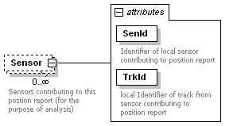
namespace | urn:http://www.ivef.org/XMLSchema/IVEF/0.1.5
properties
  isRef | 0
  minOcc | 0
  maxOcc | unbounded
  content | complex
attributes
  Name | Type | Use | Default | Fixed | Annotation
  SenId | derived by: xs:decimal | required
    documentation
    Identifier of local sensor contributing to position report
  TrkId | derived by: xs:decimal | required
    documentation
    local Identifier of track from sensor contributing to position report
annotation
  documentation
  Sensors contributing to this postion report (for the purpose of analysis)
source | <xs:element name="Sensor" minOccurs="0" maxOccurs="unbounded">  <xs:annotation>  <xs:documentation>Sensors contributing to this postion report (for the purpose of analysis)</xs:documentation>  </xs:annotation>  <xs:complexType>  <xs:attribute name="SenId" use="required">  <xs:annotation>  <xs:documentation>Identifier of local sensor contributing to position report</xs:documentation>  </xs:annotation>  <xs:simpleType>  <xs:restriction base="xs:decimal">  <xs:maxInclusive value="65536"/>  <xs:minInclusive value="0"/>  </xs:restriction>  </xs:simpleType>  </xs:attribute>  <xs:attribute name="TrkId" use="required">  <xs:annotation>  <xs:documentation>local Identifier of track from sensor contributing to position report</xs:documentation>  </xs:annotation>  <xs:simpleType>  <xs:restriction base="xs:decimal">  <xs:maxInclusive value="65536"/>  <xs:minInclusive value="0"/>  </xs:restriction>  </xs:simpleType>  </xs:attribute>  </xs:complexType>  </xs:element>

element ServerStatus
diagram | 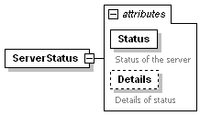
namespace | urn:http://www.ivef.org/XMLSchema/IVEF/0.1.5
properties
  content | complex
used by
  element | MSG_ServerStatus/Body
attributes
  Name | Type | Use | Default | Fixed | Annotation
  Status | derived by: xs:string | required
    documentation
    Status of the server
  Details | derived by: xs:string | optional
    documentation
    Details of status
source | <xs:element name="ServerStatus">  <xs:complexType>  <xs:attribute name="Status" use="required">  <xs:annotation>  <xs:documentation>Status of the server</xs:documentation>  </xs:annotation>  <xs:simpleType>  <xs:restriction base="xs:string">  <xs:enumeration value="queuefull"/>  <xs:enumeration value="ok"/>  </xs:restriction>  </xs:simpleType>  </xs:attribute>  <xs:attribute name="Details" use="optional">  <xs:annotation>  <xs:documentation>Details of status</xs:documentation>  </xs:annotation>  <xs:simpleType>  <xs:restriction base="xs:string">  <xs:maxLength value="50"/>  </xs:restriction>  </xs:simpleType>  </xs:attribute>  </xs:complexType>  </xs:element>

element ServiceRequest
diagram | 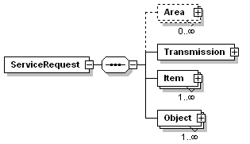
namespace | urn:http://www.ivef.org/XMLSchema/IVEF/0.1.5
properties
  content | complex
children | Area Transmission Item Object
used by
  element | MSG_ServiceRequest/Body
source | <xs:element name="ServiceRequest">  <xs:complexType>  <xs:sequence>  <xs:element name="Area" minOccurs="0" maxOccurs="unbounded">  <xs:complexType>  <xs:sequence>  <xs:element ref="Pos" maxOccurs="unbounded"/>  </xs:sequence>  </xs:complexType>  </xs:element>  <xs:element name="Transmission">  <xs:complexType>  <xs:attribute name="Type" use="required">  <xs:annotation>  <xs:documentation>Type of transmission, possible values are:  1 = single occurrence  2 = periodic  3 = synchronic  4 = on change</xs:documentation>  </xs:annotation>  <xs:simpleType>  <xs:restriction base="xs:integer">  <xs:enumeration value="1"/>  <xs:enumeration value="2"/>  <xs:enumeration value="3"/>  <xs:enumeration value="4"/>  </xs:restriction>  </xs:simpleType>  </xs:attribute>  <xs:attribute name="Period" type="xs:decimal" use="optional">  <xs:annotation>  <xs:documentation> Specifies he time between two periodic updates in seconds</xs:documentation>  </xs:annotation>  </xs:attribute>  </xs:complexType>  </xs:element>  <xs:element name="Item" maxOccurs="unbounded">  <xs:complexType>  <xs:attribute name="Element" use="required">  <xs:annotation>  <xs:documentation>Describes requested Vessel data element, possible values:  1 = position  2 = static data  3 = voyage</xs:documentation>  </xs:annotation>  <xs:simpleType>  <xs:restriction base="xs:integer">  <xs:enumeration value="1"/>  <xs:enumeration value="2"/>  <xs:enumeration value="3"/>  </xs:restriction>  </xs:simpleType>  </xs:attribute>  <xs:attribute name="Field" type="xs:string" use="required">  <xs:annotation>  <xs:documentation>Selected field. Can be 'all' or one of the items of vessel data PositionReport, Static Data or Voyage</xs:documentation>  </xs:annotation>  </xs:attribute>  </xs:complexType>  </xs:element>  <xs:element name="Object" maxOccurs="unbounded">  <xs:complexType>  <xs:attribute name="FileName" use="required">  <xs:annotation>  <xs:documentation>Name of the filter. The filter can be a predefined selector or can be defined here in the future. One of the predefined selectors will be 'all'</xs:documentation>  </xs:annotation>  </xs:attribute>  </xs:complexType>  </xs:element>  </xs:sequence>  </xs:complexType>  </xs:element>

element ServiceRequest/Area
diagram | 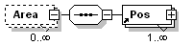
namespace | urn:http://www.ivef.org/XMLSchema/IVEF/0.1.5
properties
  isRef | 0
  minOcc | 0
  maxOcc | unbounded
  content | complex
children | Pos
source | <xs:element name="Area" minOccurs="0" maxOccurs="unbounded">  <xs:complexType>  <xs:sequence>  <xs:element ref="Pos" maxOccurs="unbounded"/>  </xs:sequence>  </xs:complexType>  </xs:element>

element ServiceRequest/Transmission
diagram | 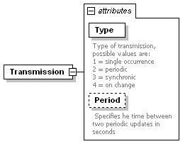
namespace | urn:http://www.ivef.org/XMLSchema/IVEF/0.1.5
properties
  isRef | 0
  content | complex
attributes
  Name | Type | Use | Default | Fixed | Annotation
  Type | derived by: xs:integer | required
    documentation
    Type of transmission, possible values are:
    1 = single occurrence
    2 = periodic
    3 = synchronic
    4 = on change
  Period | xs:decimal | optional
    documentation
    Specifies he time between two periodic updates in seconds
source | <xs:element name="Transmission">  <xs:complexType>  <xs:attribute name="Type" use="required">  <xs:annotation>  <xs:documentation>Type of transmission, possible values are:  1 = single occurrence  2 = periodic  3 = synchronic  4 = on change</xs:documentation>  </xs:annotation>  <xs:simpleType>  <xs:restriction base="xs:integer">  <xs:enumeration value="1"/>  <xs:enumeration value="2"/>  <xs:enumeration value="3"/>  <xs:enumeration value="4"/>  </xs:restriction>  </xs:simpleType>  </xs:attribute>  <xs:attribute name="Period" type="xs:decimal" use="optional">  <xs:annotation>  <xs:documentation> Specifies he time between two periodic updates in seconds</xs:documentation>  </xs:annotation>  </xs:attribute>  </xs:complexType>  </xs:element>

element ServiceRequest/Item
diagram | 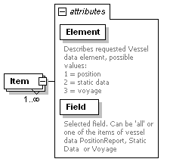
namespace | urn:http://www.ivef.org/XMLSchema/IVEF/0.1.5
properties
  isRef | 0
  minOcc | 1
  maxOcc | unbounded
  content | complex
attributes
  Name | Type | Use | Default | Fixed | Annotation
  Element | derived by: xs:integer | required
    documentation
    Describes requested Vessel data element, possible values:
    1 = position
    2 = static data
    3 = voyage
  Field | xs:string | required
    documentation
    Selected field. Can be 'all' or one of the items of vessel data PositionReport, Static Data or Voyage
source | <xs:element name="Item" maxOccurs="unbounded">  <xs:complexType>  <xs:attribute name="Element" use="required">  <xs:annotation>  <xs:documentation>Describes requested Vessel data element, possible values:  1 = position  2 = static data  3 = voyage</xs:documentation>  </xs:annotation>  <xs:simpleType>  <xs:restriction base="xs:integer">  <xs:enumeration value="1"/>  <xs:enumeration value="2"/>  <xs:enumeration value="3"/>  </xs:restriction>  </xs:simpleType>  </xs:attribute>  <xs:attribute name="Field" type="xs:string" use="required">  <xs:annotation>  <xs:documentation>Selected field. Can be 'all' or one of the items of vessel data PositionReport, Static Data or Voyage</xs:documentation>  </xs:annotation>  </xs:attribute>  </xs:complexType>  </xs:element>

element ServiceRequest/Object
diagram | 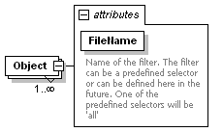
namespace | urn:http://www.ivef.org/XMLSchema/IVEF/0.1.5
properties
  isRef | 0
  minOcc | 1
  maxOcc | unbounded
  content | complex
attributes
  Name | Type | Use | Default | Fixed | Annotation
  FileName |  | required
    documentation
    Name of the filter. The filter can be a predefined selector or can be defined here in the future. One of the predefined selectors will be 'all'
source | <xs:element name="Object" maxOccurs="unbounded">  <xs:complexType>  <xs:attribute name="FileName" use="required">  <xs:annotation>  <xs:documentation>Name of the filter. The filter can be a predefined selector or can be defined here in the future. One of the predefined selectors will be 'all'</xs:documentation>  </xs:annotation>  </xs:attribute>  </xs:complexType>  </xs:element>

element StaticData
diagram | 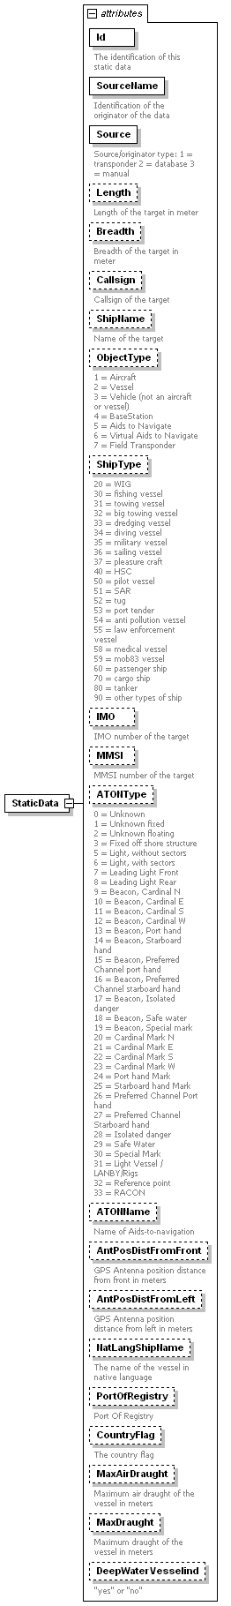
namespace | urn:http://www.ivef.org/XMLSchema/IVEF/0.1.5
properties
  content | complex
used by
  element | VesselData
attributes
  Name | Type | Use | Default | Fixed | Annotation
  Id | derived by: xs:string | required
    documentation
    The identification of this static data
  SourceName | xs:string | required
    documentation
    Identification of the originator of the data
  Source | derived by: xs:integer | required
    documentation
    Source/originator type: 1 = transponder 2 = database 3 = manual
  Length | derived by: xs:decimal | optional
    documentation
    Length of the target in meter
  Breadth | derived by: xs:decimal | optional
    documentation
    Breadth of the target in meter
  Callsign | xs:string | optional
    documentation
    Callsign of the target
  ShipName | derived by: xs:string | optional
    documentation
    Name of the target
  ObjectType | derived by: xs:integer | optional
    documentation
    1 = Aircraft
    2 = Vessel
    3 = Vehicle (not an aircraft or vessel)
    4 = BaseStation
    5 = Aids to Navigate
    6 = Virtual Aids to Navigate
    7 = Field Transponder
  ShipType | derived by: xs:integer | optional
    documentation
    20 = WIG
    30 = fishing vessel
    31 = towing vessel
    32 = big towing vessel
    33 = dredging vessel
    34 = diving vessel
    35 = military vessel
    36 = sailing vessel
    37 = pleasure craft
    40 = HSC
    50 = pilot vessel
    51 = SAR
    52 = tug
    53 = port tender
    54 = anti pollution vessel
    55 = law enforcement vessel
    58 = medical vessel
    59 = mob83 vessel
    60 = passenger ship
    70 = cargo ship
    80 = tanker
    90 = other types of ship
  IMO | xs:integer | optional
    documentation
    IMO number of the target
  MMSI | xs:integer | optional
    documentation
    MMSI number of the target
  ATONType | derived by: xs:integer | optional
    documentation
    0 = Unknown
    1 = Unknown fixed
    2 = Unknown floating
    3 = Fixed off shore structure
    5 = Light, without sectors
    6 = Light, with sectors
    7 = Leading Light Front
    8 = Leading Light Rear
    9 = Beacon, Cardinal N
    10 = Beacon, Cardinal E
    11 = Beacon, Cardinal S
    12 = Beacon, Cardinal W
    13 = Beacon, Port hand
    14 = Beacon, Starboard hand
    15 = Beacon, Preferred Channel port hand
    16 = Beacon, Preferred Channel starboard hand
    17 = Beacon, Isolated danger
    18 = Beacon, Safe water
    19 = Beacon, Special mark
    20 = Cardinal Mark N
    21 = Cardinal Mark E
    22 = Cardinal Mark S
    23 = Cardinal Mark W
    24 = Port hand Mark
    25 = Starboard hand Mark
    26 = Preferred Channel Port hand
    27 = Preferred Channel Starboard hand
    28 = Isolated danger
    29 = Safe Water
    30 = Special Mark
    31 = Light Vessel / LANBY/Rigs
    32 = Reference point
    33 = RACON
  ATONName | xs:string | optional
    documentation
    Name of Aids-to-navigation
  AntPosDistFromFront | xs:decimal | optional
    documentation
    GPS Antenna position distance from front in meters
  AntPosDistFromLeft | xs:decimal | optional
    documentation
    GPS Antenna position distance from left in meters
  NatLangShipName | xs:string | optional
    documentation
    The name of the vessel in native language
  PortOfRegistry | xs:string | optional
    documentation
    Port Of Registry
  CountryFlag | xs:string | optional
    documentation
    The country flag
  MaxAirDraught | derived by: xs:decimal | optional
    documentation
    Maximum air draught of the vessel in meters
  MaxDraught | derived by: xs:decimal | optional
    documentation
    Maximum draught of the vessel in meters
  DeepWaterVesselind | derived by: xs:string | optional
    documentation
    "yes" or "no"
source | <xs:element name="StaticData">  <xs:complexType>  <xs:attribute name="Id" use="required">  <xs:annotation>  <xs:documentation>The identification of this static data</xs:documentation>  </xs:annotation>  <xs:simpleType>  <xs:restriction base="xs:string">  <xs:maxLength value="40"/>  </xs:restriction>  </xs:simpleType>  </xs:attribute>  <xs:attribute name="SourceName" type="xs:string" use="required">  <xs:annotation>  <xs:documentation>Identification of the originator of the data</xs:documentation>  </xs:annotation>  </xs:attribute>  <xs:attribute name="Source" use="required">  <xs:annotation>  <xs:documentation>Source/originator type: 1 = transponder 2 = database 3 = manual</xs:documentation>  </xs:annotation>  <xs:simpleType>  <xs:restriction base="xs:integer">  <xs:enumeration value="1"/>  <xs:enumeration value="2"/>  <xs:enumeration value="3"/>  </xs:restriction>  </xs:simpleType>  </xs:attribute>  <xs:attribute name="Length" use="optional">  <xs:annotation>  <xs:documentation>Length of the target in meter</xs:documentation>  </xs:annotation>  <xs:simpleType>  <xs:restriction base="xs:decimal">  <xs:minExclusive value="0"/>  </xs:restriction>  </xs:simpleType>  </xs:attribute>  <xs:attribute name="Breadth" use="optional">  <xs:annotation>  <xs:documentation>Breadth of the target in meter</xs:documentation>  </xs:annotation>  <xs:simpleType>  <xs:restriction base="xs:decimal">  <xs:minExclusive value="0"/>  </xs:restriction>  </xs:simpleType>  </xs:attribute>  <xs:attribute name="Callsign" type="xs:string" use="optional">  <xs:annotation>  <xs:documentation>Callsign of the target</xs:documentation>  </xs:annotation>  </xs:attribute>  <xs:attribute name="ShipName" use="optional">  <xs:annotation>  <xs:documentation>Name of the target</xs:documentation>  </xs:annotation>  <xs:simpleType>  <xs:restriction base="xs:string"/>  </xs:simpleType>  </xs:attribute>  <xs:attribute name="ObjectType" use="optional">  <xs:annotation>  <xs:documentation>1 = Aircraft  2 = Vessel  3 = Vehicle (not an aircraft or vessel)  4 = BaseStation  5 = Aids to Navigate  6 = Virtual Aids to Navigate  7 = Field Transponder</xs:documentation>  </xs:annotation>  <xs:simpleType>  <xs:restriction base="xs:integer">  <xs:enumeration value="1"/>  <xs:enumeration value="2"/>  <xs:enumeration value="3"/>  <xs:enumeration value="4"/>  <xs:enumeration value="5"/>  <xs:enumeration value="6"/>  <xs:enumeration value="7"/>  </xs:restriction>  </xs:simpleType>  </xs:attribute>  <xs:attribute name="ShipType" use="optional">  <xs:annotation>  <xs:documentation>20 = WIG  30 = fishing vessel  31 = towing vessel  32 = big towing vessel  33 = dredging vessel  34 = diving vessel  35 = military vessel  36 = sailing vessel  37 = pleasure craft  40 = HSC  50 = pilot vessel  51 = SAR  52 = tug  53 = port tender  54 = anti pollution vessel  55 = law enforcement vessel  58 = medical vessel  59 = mob83 vessel  60 = passenger ship  70 = cargo ship  80 = tanker  90 = other types of ship</xs:documentation>  </xs:annotation>  <xs:simpleType>  <xs:restriction base="xs:integer">  <xs:enumeration value="20"/>  <xs:enumeration value="30"/>  <xs:enumeration value="31"/>  <xs:enumeration value="32"/>  <xs:enumeration value="33"/>  <xs:enumeration value="34"/>  <xs:enumeration value="35"/>  <xs:enumeration value="36"/>  <xs:enumeration value="37"/>  <xs:enumeration value="40"/>  <xs:enumeration value="50"/>  <xs:enumeration value="51"/>  <xs:enumeration value="52"/>  <xs:enumeration value="53"/>  <xs:enumeration value="54"/>  <xs:enumeration value="55"/>  <xs:enumeration value="58"/>  <xs:enumeration value="59"/>  <xs:enumeration value="60"/>  <xs:enumeration value="70"/>  <xs:enumeration value="80"/>  <xs:enumeration value="90"/>  </xs:restriction>  </xs:simpleType>  </xs:attribute>  <xs:attribute name="IMO" type="xs:integer" use="optional">  <xs:annotation>  <xs:documentation>IMO number of the target</xs:documentation>  </xs:annotation>  </xs:attribute>  <xs:attribute name="MMSI" type="xs:integer" use="optional">  <xs:annotation>  <xs:documentation>MMSI number of the target</xs:documentation>  </xs:annotation>  </xs:attribute>  <xs:attribute name="ATONType" use="optional">  <xs:annotation>  <xs:documentation>0 = Unknown  1 = Unknown fixed  2 = Unknown floating  3 = Fixed off shore structure  5 = Light, without sectors  6 = Light, with sectors  7 = Leading Light Front  8 = Leading Light Rear  9 = Beacon, Cardinal N  10 = Beacon, Cardinal E  11 = Beacon, Cardinal S  12 = Beacon, Cardinal W  13 = Beacon, Port hand  14 = Beacon, Starboard hand  15 = Beacon, Preferred Channel port hand  16 = Beacon, Preferred Channel starboard hand  17 = Beacon, Isolated danger  18 = Beacon, Safe water  19 = Beacon, Special mark  20 = Cardinal Mark N  21 = Cardinal Mark E  22 = Cardinal Mark S  23 = Cardinal Mark W  24 = Port hand Mark  25 = Starboard hand Mark  26 = Preferred Channel Port hand  27 = Preferred Channel Starboard hand  28 = Isolated danger  29 = Safe Water  30 = Special Mark  31 = Light Vessel / LANBY/Rigs  32 = Reference point  33 = RACON</xs:documentation>  </xs:annotation>  <xs:simpleType>  <xs:restriction base="xs:integer">  <xs:enumeration value="0"/>  <xs:enumeration value="1"/>  <xs:enumeration value="2"/>  <xs:enumeration value="3"/>  <xs:enumeration value="5"/>  <xs:enumeration value="6"/>  <xs:enumeration value="7"/>  <xs:enumeration value="8"/>  <xs:enumeration value="9"/>  <xs:enumeration value="10"/>  <xs:enumeration value="11"/>  <xs:enumeration value="12"/>  <xs:enumeration value="13"/>  <xs:enumeration value="14"/>  <xs:enumeration value="15"/>  <xs:enumeration value="16"/>  <xs:enumeration value="17"/>  <xs:enumeration value="18"/>  <xs:enumeration value="19"/>  <xs:enumeration value="20"/>  <xs:enumeration value="21"/>  <xs:enumeration value="22"/>  <xs:enumeration value="23"/>  <xs:enumeration value="24"/>  <xs:enumeration value="25"/>  <xs:enumeration value="26"/>  <xs:enumeration value="27"/>  <xs:enumeration value="28"/>  <xs:enumeration value="29"/>  <xs:enumeration value="30"/>  <xs:enumeration value="31"/>  <xs:enumeration value="32"/>  <xs:enumeration value="33"/>  </xs:restriction>  </xs:simpleType>  </xs:attribute>  <xs:attribute name="ATONName" type="xs:string" use="optional">  <xs:annotation>  <xs:documentation>Name of Aids-to-navigation</xs:documentation>  </xs:annotation>  </xs:attribute>  <xs:attribute name="AntPosDistFromFront" type="xs:decimal" use="optional">  <xs:annotation>  <xs:documentation>GPS Antenna position distance from front in meters</xs:documentation>  </xs:annotation>  </xs:attribute>  <xs:attribute name="AntPosDistFromLeft" type="xs:decimal" use="optional">  <xs:annotation>  <xs:documentation>GPS Antenna position distance from left in meters</xs:documentation>  </xs:annotation>  </xs:attribute>  <xs:attribute name="NatLangShipName" type="xs:string" use="optional">  <xs:annotation>  <xs:documentation>The name of the vessel in native language</xs:documentation>  </xs:annotation>  </xs:attribute>  <xs:attribute name="PortOfRegistry" type="xs:string" use="optional">  <xs:annotation>  <xs:documentation>Port Of Registry</xs:documentation>  </xs:annotation>  </xs:attribute>  <xs:attribute name="CountryFlag" type="xs:string" use="optional">  <xs:annotation>  <xs:documentation>The country flag</xs:documentation>  </xs:annotation>  </xs:attribute>  <xs:attribute name="MaxAirDraught" use="optional">  <xs:annotation>  <xs:documentation>Maximum air draught of the vessel in meters</xs:documentation>  </xs:annotation>  <xs:simpleType>  <xs:restriction base="xs:decimal">  <xs:minExclusive value="0"/>  </xs:restriction>  </xs:simpleType>  </xs:attribute>  <xs:attribute name="MaxDraught" use="optional">  <xs:annotation>  <xs:documentation>Maximum draught of the vessel in meters</xs:documentation>  </xs:annotation>  <xs:simpleType>  <xs:restriction base="xs:decimal">  <xs:minExclusive value="0"/>  </xs:restriction>  </xs:simpleType>  </xs:attribute>  <xs:attribute name="DeepWaterVesselind" use="optional">  <xs:annotation>  <xs:documentation>"yes" or "no"</xs:documentation>  </xs:annotation>  <xs:simpleType>  <xs:restriction base="xs:string">  <xs:enumeration value="yes"/>  <xs:enumeration value="no"/>  </xs:restriction>  </xs:simpleType>  </xs:attribute>  </xs:complexType>  </xs:element>

element TaggedItem
diagram | 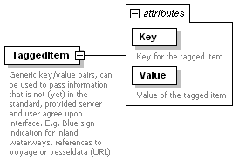
namespace | urn:http://www.ivef.org/XMLSchema/IVEF/0.1.5
properties
  content | complex
used by
  element | VesselData
attributes
  Name | Type | Use | Default | Fixed | Annotation
  Key | derived by: xs:string | required
    documentation
    Key for the tagged item
  Value | derived by: xs:string | required
    documentation
    Value of the tagged item
annotation
  documentation
  Generic key/value pairs, can be used to pass information that is not (yet) in the standard, provided server and user agree upon interface. E.g. Blue sign indication for inland waterways, references to voyage or vesseldata (URL)
source | <xs:element name="TaggedItem">  <xs:annotation>  <xs:documentation>Generic key/value pairs, can be used to pass information that is not (yet) in the standard, provided server and user agree upon interface. E.g. Blue sign indication for inland waterways, references to voyage or vesseldata (URL)</xs:documentation>  </xs:annotation>  <xs:complexType>  <xs:attribute name="Key" use="required">  <xs:annotation>  <xs:documentation>Key for the tagged item</xs:documentation>  </xs:annotation>  <xs:simpleType>  <xs:restriction base="xs:string">  <xs:minLength value="1"/>  <xs:maxLength value="42"/>  </xs:restriction>  </xs:simpleType>  </xs:attribute>  <xs:attribute name="Value" use="required">  <xs:annotation>  <xs:documentation>Value of the tagged item</xs:documentation>  </xs:annotation>  <xs:simpleType>  <xs:restriction base="xs:string">  <xs:minLength value="1"/>  <xs:maxLength value="42"/>  </xs:restriction>  </xs:simpleType>  </xs:attribute>  </xs:complexType>  </xs:element>

element VesselData
diagram | 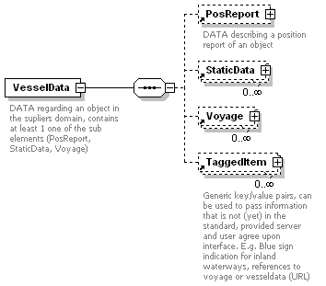
namespace | urn:http://www.ivef.org/XMLSchema/IVEF/0.1.5
properties
  content | complex
children | PosReport StaticData Voyage TaggedItem
used by
  element | MSG_VesselData/Body
annotation
  documentation
  DATA regarding an object in the supliers domain, contains at least 1 one of the sub elements (PosReport, StaticData, Voyage)
source | <xs:element name="VesselData">  <xs:annotation>  <xs:documentation>DATA regarding an object in the supliers domain, contains at least 1 one of the sub elements (PosReport, StaticData, Voyage)</xs:documentation>  </xs:annotation>  <xs:complexType>  <xs:sequence>  <xs:element ref="PosReport" minOccurs="0"/>  <xs:element ref="StaticData" minOccurs="0" maxOccurs="unbounded"/>  <xs:element ref="Voyage" minOccurs="0" maxOccurs="unbounded"/>  <xs:element ref="TaggedItem" minOccurs="0" maxOccurs="unbounded"/>  </xs:sequence>  </xs:complexType>  </xs:element>

element Voyage
diagram | 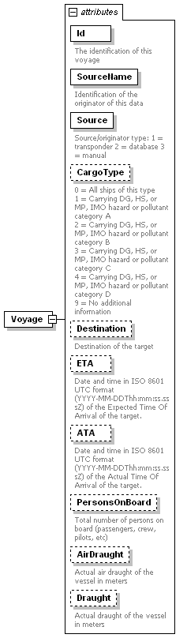
namespace | urn:http://www.ivef.org/XMLSchema/IVEF/0.1.5
properties
  content | complex
used by
  element | VesselData
attributes
  Name | Type | Use | Default | Fixed | Annotation
  Id | derived by: xs:string | required
    documentation
    The identification of this voyage
  SourceName | xs:string | required
    documentation
    Identification of the originator of this data
  Source | derived by: xs:integer | required
    documentation
    Source/originator type: 1 = transponder 2 = database 3 = manual
  CargoType | derived by: xs:integer | optional
    documentation
    0 = All ships of this type
    1 = Carrying DG, HS, or MP, IMO hazard or pollutant category A
    2 = Carrying DG, HS, or MP, IMO hazard or pollutant category B
    3 = Carrying DG, HS, or MP, IMO hazard or pollutant category C
    4 = Carrying DG, HS, or MP, IMO hazard or pollutant category D
    9 = No additional information
  Destination | xs:string | optional
    documentation
    Destination of the target
  ETA | xs:dateTime | optional
    documentation
    Date and time in ISO 8601 UTC format (YYYY-MM-DDThh:mm:ss.sssZ) of the Expected Time Of Arrival of the target.
  ATA | xs:dateTime | optional
    documentation
    Date and time in ISO 8601 UTC format (YYYY-MM-DDThh:mm:ss.sssZ) of the Actual Time Of Arrival of the target.
  PersonsOnBoard | derived by: xs:decimal | optional
    documentation
    Total number of persons on board (passengers, crew, pilots, etc)
  AirDraught | derived by: xs:decimal | optional
    documentation
    Actual air draught of the vessel in meters
  Draught | derived by: xs:decimal | optional
    documentation
    Actual draught of the vessel in meters
source | <xs:element name="Voyage">  <xs:complexType>  <xs:attribute name="Id" use="required">  <xs:annotation>  <xs:documentation>The identification of this voyage</xs:documentation>  </xs:annotation>  <xs:simpleType>  <xs:restriction base="xs:string">  <xs:maxLength value="40"/>  </xs:restriction>  </xs:simpleType>  </xs:attribute>  <xs:attribute name="SourceName" type="xs:string" use="required">  <xs:annotation>  <xs:documentation>Identification of the originator of this data</xs:documentation>  </xs:annotation>  </xs:attribute>  <xs:attribute name="Source" use="required">  <xs:annotation>  <xs:documentation>Source/originator type: 1 = transponder 2 = database 3 = manual</xs:documentation>  </xs:annotation>  <xs:simpleType>  <xs:restriction base="xs:integer">  <xs:enumeration value="1"/>  <xs:enumeration value="2"/>  <xs:enumeration value="3"/>  </xs:restriction>  </xs:simpleType>  </xs:attribute>  <xs:attribute name="CargoType" use="optional">  <xs:annotation>  <xs:documentation>0 = All ships of this type  1 = Carrying DG, HS, or MP, IMO hazard or pollutant category A  2 = Carrying DG, HS, or MP, IMO hazard or pollutant category B  3 = Carrying DG, HS, or MP, IMO hazard or pollutant category C  4 = Carrying DG, HS, or MP, IMO hazard or pollutant category D  9 = No additional information</xs:documentation>  </xs:annotation>  <xs:simpleType>  <xs:restriction base="xs:integer">  <xs:enumeration value="0"/>  <xs:enumeration value="1"/>  <xs:enumeration value="2"/>  <xs:enumeration value="3"/>  <xs:enumeration value="4"/>  <xs:enumeration value="9"/>  </xs:restriction>  </xs:simpleType>  </xs:attribute>  <xs:attribute name="Destination" type="xs:string" use="optional">  <xs:annotation>  <xs:documentation>Destination of the target</xs:documentation>  </xs:annotation>  </xs:attribute>  <xs:attribute name="ETA" type="xs:dateTime" use="optional">  <xs:annotation>  <xs:documentation>Date and time in ISO 8601 UTC format (YYYY-MM-DDThh:mm:ss.sssZ) of the Expected Time Of Arrival of the target.</xs:documentation>  </xs:annotation>  </xs:attribute>  <xs:attribute name="ATA" type="xs:dateTime" use="optional">  <xs:annotation>  <xs:documentation>Date and time in ISO 8601 UTC format (YYYY-MM-DDThh:mm:ss.sssZ) of the Actual Time Of Arrival of the target.</xs:documentation>  </xs:annotation>  </xs:attribute>  <xs:attribute name="PersonsOnBoard" use="optional">  <xs:annotation>  <xs:documentation>Total number of persons on board (passengers, crew, pilots, etc)</xs:documentation>  </xs:annotation>  <xs:simpleType>  <xs:restriction base="xs:decimal">  <xs:minExclusive value="0"/>  </xs:restriction>  </xs:simpleType>  </xs:attribute>  <xs:attribute name="AirDraught" use="optional">  <xs:annotation>  <xs:documentation>Actual air draught of the vessel in meters</xs:documentation>  </xs:annotation>  <xs:simpleType>  <xs:restriction base="xs:decimal">  <xs:minExclusive value="0"/>  </xs:restriction>  </xs:simpleType>  </xs:attribute>  <xs:attribute name="Draught" use="optional">  <xs:annotation>  <xs:documentation>Actual draught of the vessel in meters</xs:documentation>  </xs:annotation>  <xs:simpleType>  <xs:restriction base="xs:decimal">  <xs:minExclusive value="0"/>  </xs:restriction>  </xs:simpleType>  </xs:attribute>  </xs:complexType>  </xs:element>

