Schema ivef0_2.xsd

schema location: | \ivef-sdk\branches\IVEF_0_2_0_BETA1\doc\ivef0_2.xsd
attribute form default:
element form default: | qualified
targetNamespace: | http://www.ivef.org/XMLSchema/IVEF/0.2.0

Elements
Area
Crossing
ForeignId
ForeignName
Header
LoginRequest
LoginResponse
Logout
Message
MSG_IVEF
Notification
ObjectData
Penetration
Ping
Pong
Pos
ServerStatus
ServiceRequest
ServiceRequestResponse
TaggedItem
TrackData
VesselData
VoyageData

element Area
diagram | 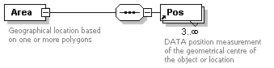
children | Pos
used by
  elements | Penetration ServiceRequest
attributes
  Name | Type | Use | Default | Fixed | Annotation
  Name | derived by: xs:string | optional
    documentation
    Name of the area
annotation
  documentation
  Geographical location based on one or more polygons

element Crossing
diagram | 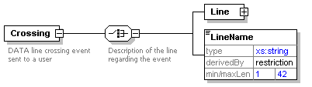
children | Line LineName
used by
  element | Notification
attributes
  Name | Type | Use | Default | Fixed | Annotation
  Name | derived by: xs:string | required
    documentation
    Name of the event
  SourceId | xs:integer | required
    documentation
    The unique identification of the node who initially created this message
  TimeStamp | xs:dateTime | required
    documentation
    Date and time in (subset of ISO 8601) UTC format (YYYY-MM-DDThh:mm:ss.sssZ) of the time this message is sent.
annotation
  documentation
  DATA line crossing event sent to a user

element Crossing/Line
diagram | 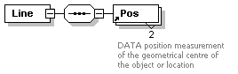
children | Pos

element Crossing/LineName
diagram | 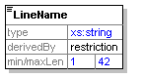

element ForeignId
diagram | 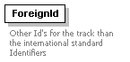
used by
  element | VesselData/Identifier
attributes
  Name | Type | Use | Default | Fixed | Annotation
  Id | derived by: xs:string | required
    documentation
    Name of the Identifier
  Value | derived by: xs:string | required
    documentation
    Value of the identifier
annotation
  documentation
  Other Id's for the track than the international standard Identifiers

element ForeignName
diagram | 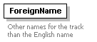
used by
  element | VesselData/Identifier
attributes
  Name | Type | Use | Default | Fixed | Annotation
  Lang | derived by: xs:string | required
    documentation
    Languange (ISO 3166-1-alpha2)
  Name | derived by: xs:string | required
    documentation
    Name in the foreign language
annotation
  documentation
  Other names for the track than the English name

element Header
diagram | 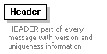
used by
  element | MSG_IVEF
attributes
  Name | Type | Use | Default | Fixed | Annotation
  MsgRefId | derived by: xs:string | required
    documentation
    Must be an Universally Unique Identifier for each message (TU-T Rec. X.667 | ISO/IEC 9834-8.) Reply messages refer to this id to identify the message they are replying to. In its canonical form, a UUID consists of 32 hexadecimal digits, displayed in 5 groups separated by hyphens, in the form 8-4-4-4-12 for a total of 36 characters, enclosed by brackets. For example:
    {550e8400-e29b-41d4-a716-446655440000}
  Version | xs:string | required |  | 0.2.0
    documentation
    Defines the version of the protocol used. Syntax is major.minor.patch patch releases fix only bugs, minor releases may add functionality but are compatible, major releases are not compatible
annotation
  documentation
  HEADER part of every message with version and uniqueness information

element LoginRequest
diagram | 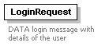
used by
  element | MSG_IVEF/Body
attributes
  Name | Type | Use | Default | Fixed | Annotation
  Encryption | derived by: xs:integer | required
    documentation
    1 = plain 2 = SHA-512
  Name | derived by: xs:string | required
    documentation
    Login name
  Password | derived by: xs:string | required
    documentation
    Password value
annotation
  documentation
  DATA login message with details of the user

element LoginResponse
diagram | 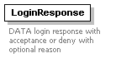
used by
  element | MSG_IVEF/Body
attributes
  Name | Type | Use | Default | Fixed | Annotation
  Reason | derived by: xs:string | optional
    documentation
    String describing reason for declining, only used when result is "Declined"
  ResponseOn | derived by: xs:string | required
    documentation
    Corresponds to the original MsgRefId from the Login.xml message. Must be an Universally Unique Identifier (TU-T Rec. X.667 | ISO/IEC 9834-8.)
  Result | derived by: xs:integer | required
    documentation
    1 = Accepted 2 = Declined
annotation
  documentation
  DATA login response with acceptance or deny with optional reason

element Logout
diagram | 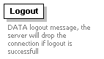
used by
  element | MSG_IVEF/Body
annotation
  documentation
  DATA logout message, the server will drop the connection if logout is successfull

element Message
diagram | 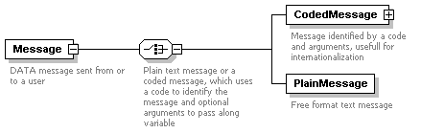
children | CodedMessage PlainMessage
used by
  element | Notification
attributes
  Name | Type | Use | Default | Fixed | Annotation
  Destination | derived by: xs:string | optional
    documentation
    Name of the destination, not available when broadcasting
  Origin | derived by: xs:string | required
    documentation
    Name of the sender
  Priority | xs:integer | optional
    documentation
    The priority of this message, 1 beeing the most urgent
  TimeStamp | xs:dateTime | required
    documentation
    Date and time in (subset of ISO 8601) UTC format (YYYY-MM-DDThh:mm:ss.sssZ) of the time this message is sent.
annotation
  documentation
  DATA message sent from or to a user

element Message/CodedMessage
diagram | 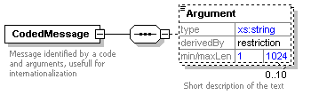
children | Argument
attributes
  Name | Type | Use | Default | Fixed | Annotation
  Code | derived by: xs:string | required
    documentation
    Code of the message, meaning of the code and the need for additional parameters is left free to the end user.
annotation
  documentation
  Message identified by a code and arguments, usefull for internationalization

element Message/CodedMessage/Argument
diagram | 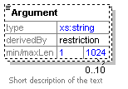
annotation
  documentation
  Short description of the text

element Message/PlainMessage
diagram | 
attributes
  Name | Type | Use | Default | Fixed | Annotation
  Subject | derived by: xs:string | optional
    documentation
    Short description of the text
  Text | derived by: xs:string | required
    documentation
    Actual text
annotation
  documentation
  Free format text message

element MSG_IVEF
diagram | 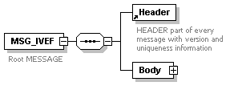
children | Header Body
annotation
  documentation
  Root MESSAGE

element MSG_IVEF/Body
diagram | 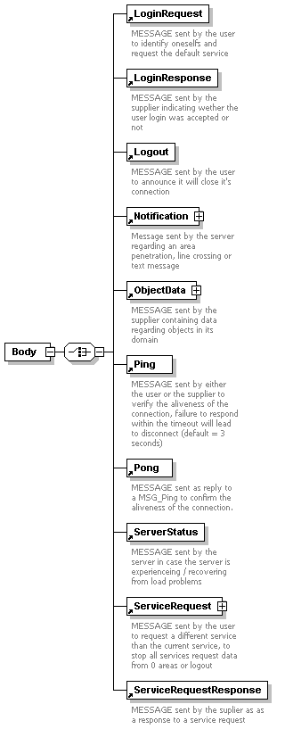
children | LoginRequest LoginResponse Logout Notification ObjectData Ping Pong ServerStatus ServiceRequest ServiceRequestResponse
attributes
  Name | Type | Use | Default | Fixed | Annotation
  Type | derived by: xs:string | required
    documentation
    Type of message

element Notification
diagram | 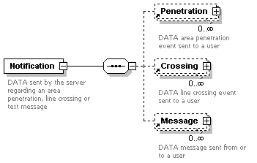
children | Penetration Crossing Message
used by
  element | MSG_IVEF/Body
annotation
  documentation
  DATA sent by the server regarding an area penetration, line crossing or text message

element ObjectData
diagram | 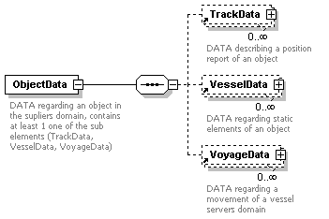
children | TrackData VesselData VoyageData
used by
  element | MSG_IVEF/Body
attributes
  Name | Type | Use | Default | Fixed | Annotation
  Id | xs:integer | required
    documentation
    The unique identification of this object, typically identical to Id in the TrackData, but not required
annotation
  documentation
  DATA regarding an object in the supliers domain, contains at least 1 one of the sub elements (TrackData, VesselData, VoyageData)

element Penetration
diagram | 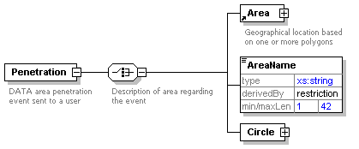
children | Area AreaName Circle
used by
  element | Notification
attributes
  Name | Type | Use | Default | Fixed | Annotation
  Name | derived by: xs:string | required
    documentation
    Name of the event
  SourceId | xs:integer | required
    documentation
    The unique identification of the node who initially created this message
  TimeStamp | xs:dateTime | required
    documentation
    Date and time in (subset of ISO 8601) UTC format (YYYY-MM-DDThh:mm:ss.sssZ) of the time this message is sent.
annotation
  documentation
  DATA area penetration event sent to a user

element Penetration/AreaName
diagram | 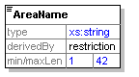

element Penetration/Circle
diagram | 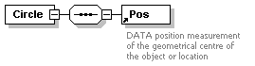
children | Pos
attributes
  Name | Type | Use | Default | Fixed | Annotation
  Range | derived by: xs:integer | required
    documentation
    Range of the circle in meter

element Ping
diagram | 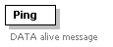
used by
  element | MSG_IVEF/Body
attributes
  Name | Type | Use | Default | Fixed | Annotation
  TimeStamp | xs:dateTime | required
    documentation
    Date and time in (subset ISO 8601) UTC format (YYYY-MM-DDThh:mm:ss.sssZ) of the time this message is sent.
annotation
  documentation
  DATA alive message

element Pong
diagram | 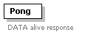
used by
  element | MSG_IVEF/Body
attributes
  Name | Type | Use | Default | Fixed | Annotation
  ResponseOn | derived by: xs:string | required
    documentation
    Corresponds to the original MsgRefId from the Ping.xml message. Must be an Universally Unique Identifier (TU-T Rec. X.667 | ISO/IEC 9834-8.)
  SourceId | xs:integer | required
    documentation
    The identification of the node who created this message
  TimeStamp | xs:dateTime | required
    documentation
    Date and time in (subset of ISO 8601) UTC format (YYYY-MM-DDThh:mm:ss.sssZ) of the time this message is sent.
annotation
  documentation
  DATA alive response

element Pos
diagram | 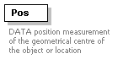
used by
  elements | Area Penetration/Circle Crossing/Line TrackData VoyageData/Waypoint
attributes
  Name | Type | Use | Default | Fixed | Annotation
  Altitude | xs:decimal | optional
    documentation
    The altitude of the target above the WGS-84 ellipsoid in meters
  EstAccAlt | xs:decimal | optional
    documentation
    Estimated accuracy
    (i.e. standard deviation) of the calculated position of a target
    expressed in m
  EstAccLat | xs:decimal | optional
    documentation
    Estimated accuracy
    (i.e. standard deviation) of the calculated position of a target
    expressed in m
  EstAccLong | xs:decimal | optional
    documentation
    Estimated accuracy
    (i.e. standard deviation) of the calculated position of a target
    expressed in m
  Lat | derived by: xs:decimal | required
    documentation
    Latitude (WGS84) in degrees. (+/- 90 degrees;
    North = positive; South = negative) Examples:
    -90deg (south) = -90.0000000
    0deg0min1sec (north) = 0.0000016
    50deg50min (north) = 50.8333333
  Long | derived by: xs:decimal | required
    documentation
    Longitude (WGS84) in degrees. (+/- 180 degrees; East = positive; West = negative). Examples:
    -180deg (west) = -180.0000000
    0deg0min1sec (east) = 0.0000016
annotation
  documentation
  DATA position measurement of the geometrical centre of the object or location

element ServerStatus
diagram | 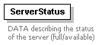
used by
  element | MSG_IVEF/Body
attributes
  Name | Type | Use | Default | Fixed | Annotation
  Details | derived by: xs:string | optional
    documentation
    Details of status
  Status | xs:boolean | required
    documentation
    Status of the server
annotation
  documentation
  DATA describing the status of the server (full/available)

element ServiceRequest
diagram | 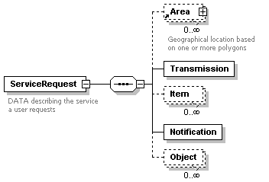
children | Area Transmission Item Notification Object
used by
  element | MSG_IVEF/Body
annotation
  documentation
  DATA describing the service a user requests

element ServiceRequest/Transmission
diagram | 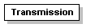
attributes
  Name | Type | Use | Default | Fixed | Annotation
  Period | xs:decimal | optional
    documentation
    Specifies he time between two periodic updates in seconds, for type 2 (seconds) and 3 (minutes)
  Type | derived by: xs:integer | required
    documentation
    Type of transmission, possible values are:
    1 = single occurrence
    2 = periodic (predicted, seconds domain)
    3 = down sampled (not predicted, minute domain)
    4 = synchronous
    5 = on change

element ServiceRequest/Item
diagram | 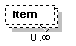
attributes
  Name | Type | Use | Default | Fixed | Annotation
  Element | derived by: xs:integer | required
    documentation
    Describes requested Object data element, possible values:
    1 = TrackData
    2 = VesselData
    3 = VoyageData
  Field | derived by: xs:string | required
    documentation
    Selected field. Can be 'all' or one of the items of object data TrackData, VesselData or VoyageData

element ServiceRequest/Notification
diagram | 
used by
  element | MSG_IVEF/Body
attributes
  Name | Type | Use | Default | Fixed | Annotation
  Event | xs:boolean | optional
  Messages | xs:boolean | optional

element ServiceRequest/Object
diagram | 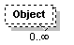
attributes
  Name | Type | Use | Default | Fixed | Annotation
  FilterName | derived by: xs:string | required
    documentation
    Name of the filter. The filter can be a predefined selector of the server. One of the predefined selectors will be 'all', others can defined here in the future

element ServiceRequestResponse
diagram | 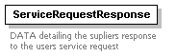
used by
  element | MSG_IVEF/Body
attributes
  Name | Type | Use | Default | Fixed | Annotation
  Reason | derived by: xs:string | optional
    documentation
    String describing reason for declining, only used when result is "Declined"
  ResponseOn | derived by: xs:string | required
    documentation
    Corresponds to the original MsgRefId from the ServiceRequest message. Must be an Universally Unique Identifier (TU-T Rec. X.667 | ISO/IEC 9834-8.)
  Result | derived by: xs:integer | required
    documentation
    1 = Accepted 2 = Declined
annotation
  documentation
  DATA detailing the supliers response to the users service request

element TaggedItem
diagram | 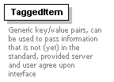
used by
  elements | VesselData VoyageData
attributes
  Name | Type | Use | Default | Fixed | Annotation
  Key | derived by: xs:string | required
    documentation
    Key for the tagged item
  Value | derived by: xs:string | required
    documentation
    Value of the tagged item
annotation
  documentation
  Generic key/value pairs, can be used to pass information that is not (yet) in the standard, provided server and user agree upon interface

element TrackData
diagram | 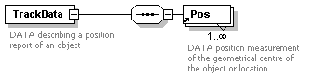
children | Pos
used by
  element | ObjectData
attributes
  Name | Type | Use | Default | Fixed | Annotation
  COG | derived by: xs:decimal | required
    documentation
    Course over ground in degrees. (0-360)
  EstAccSOG | xs:decimal | optional
    documentation
    Estimated accuracy
    (i.e. standard deviation) of the calculated value
    expressed in m
  EstAccCOG | xs:decimal | optional
    documentation
    Estimated accuracy
    (i.e. standard deviation) of the calculated value
    expressed in m
  EstAccOrientation | xs:decimal | optional
    documentation
    Estimated accuracy
    (i.e. standard deviation) of the calculated value
    expressed in m
  Id | xs:integer | required
    documentation
    The unique identification of this track. Valid from first message with TrackStatus!=Terminated to first message with TrackStatus=Terminated
  Length | derived by: xs:decimal | optional
    documentation
    Length of the target in meter
  NavStatus | derived by: xs:integer | optional
    documentation
    Navigation status of the target
    0 = under way using engine
    1 = at anchor
    2 = not under command
    3 = restricted manoeuvrability
    4 = constrained by her draught
    5 = moored
    6 = aground
    7 = engaged in fishing
    8 = under way sailing
    15 = undefined default
  Orientation | derived by: xs:decimal | optional
    documentation
    Orientation of the target in degrees
  ROT | xs:decimal | optional
    documentation
    Rate of turn in degrees per minute
  SOG | derived by: xs:decimal | required
    documentation
    Speed over ground in meters per second
  SourceId | xs:integer | required
    documentation
    The unique identification of the node who initially created this message
  SourceName | derived by: xs:string | optional
    documentation
    Identification of the originator of the data
  UpdateTime | xs:dateTime | required
    documentation
    Date and time in UTC format (YYYY-MM-DDThh:mm:ss.sssZ) (subset of ISO 8601) this position was measured.
  TrackStatus | derived by: xs:integer | required
    documentation
    1 = Updated,
    2 = Coasted,
    3 = Terminated
  Width | derived by: xs:decimal | optional
    documentation
    Width of the target in meter
annotation
  documentation
  DATA describing a position report of an object

element VesselData
diagram | 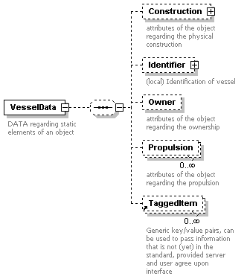
children | Construction Identifier Owner Propulsion TaggedItem
used by
  element | ObjectData
attributes
  Name | Type | Use | Default | Fixed | Annotation
  Class | derived by: xs:integer | optional
    documentation
    0 = Unknown
    1 = Vessel
    2 = Aids to Navigate
  Deleted | xs:boolean | optional
    documentation
    This VesselData is marked for deletion
  Detained | xs:boolean | optional
    documentation
    Vessel is detained
  BlackListed | xs:boolean | optional
    documentation
    Vessel is blacklisted
  Id | derived by: xs:string | required
    documentation
    The unique identification of this static data
  SourceId | xs:integer | required
    documentation
    The unique identification of the node who initially created this message
  SourceName | derived by: xs:string | optional
    documentation
    Identification of the originator of the data
  SourceType | derived by: xs:integer | required
    documentation
    Source/originator type: 1 = AIS transponder 2 = VTS Plan Server 3 = Operator
  UpdateTime | xs:dateTime | optional
    documentation
    Date and time in UTC format (YYYY-MM-DDThh:mm:ss.sssZ) (subset of ISO 8601) this data was compiled
annotation
  documentation
  DATA regarding static elements of an object

element VesselData/Construction
diagram | 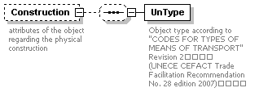
children | UnType
attributes
  Name | Type | Use | Default | Fixed | Annotation
  Constructor | derived by: xs:string | optional
    documentation
    Identification of the constructing shipyard
  DeadWeight | derived by: xs:decimal | optional
    documentation
    Dead weight in tons
  GrossWeight | derived by: xs:decimal | optional
    documentation
    Gross weight in tons
  HullColor | derived by: xs:string | optional
    documentation
    Color of Hull (in RGB hex)
  HullMaterial | derived by: xs:string | optional
    documentation
    Material used for Hull construction
  HullType | derived by: xs:integer | optional
    documentation
    Type of hull (1 = single, 2 = double, 3 = triple)
  Length | derived by: xs:decimal | optional
    documentation
    Length of the target in meter
  LloydsShipType | xs:integer | optional
    documentation
    Number indicating type of vessel
  MaxAirDraught | derived by: xs:decimal | optional
    documentation
    Maximum air draught of the object in meters
  MaxDraught | derived by: xs:decimal | optional
    documentation
    Maximum draught of the object in meters
  MaxPersonsOnBoard | derived by: xs:decimal | optional
    documentation
    The maximum number of persons on board of the object (crew, support, passengers, pilots)
  MaxSpeed | derived by: xs:decimal | optional
    documentation
    The maximum speed the object is able to sustain with normal draft and load
  NetWeight | derived by: xs:decimal | optional
    documentation
    Net weight in tons
  TideBound | xs:boolean | optional
    documentation
    Object is tide bound for current destination (deep water vessel indicator)
  Width | derived by: xs:decimal | optional
    documentation
    Width of the target in meter
annotation
  documentation
  attributes of the object regarding the physical construction

element VesselData/Construction/UnType
diagram | 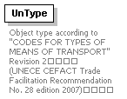
attributes
  Name | Type | Use | Default | Fixed | Annotation
  CodeA | derived by: xs:integer | required
  CodeB | derived by: xs:integer | required
  Mode | derived by: xs:integer | required
annotation
  documentation
  Object type according to "CODES FOR TYPES OF MEANS OF TRANSPORT" Revision 2
  (UNECE CEFACT Trade Facilitation Recommendation No. 28 edition 2007)

element VesselData/Identifier
diagram | 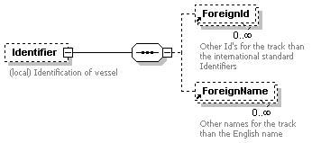
children | ForeignId ForeignName
attributes
  Name | Type | Use | Default | Fixed | Annotation
  Callsign | derived by: xs:string | optional
    documentation
    Callsign of the target, in accordance with Article 19, Section III of the ITU Radio Regulations (RR)
  IMO | xs:integer | optional
    documentation
    IMO number of the target
  Name | derived by: xs:string | optional
    documentation
    Name of the target
  MMSI | xs:integer | optional
    documentation
    MMSI number of the target
  SatCom | xs:integer | optional
    documentation
    SatCom number under which the target can be reached
  Telephone | derived by: xs:string | optional
    documentation
    Telephone number under which the target can be reached
annotation
  documentation
  (local) Identification of vessel

element VesselData/Owner
diagram | 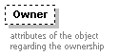
attributes
  Name | Type | Use | Default | Fixed | Annotation
  Company | derived by: xs:string | optional
    documentation
    Identification of the company associated with the object
  CountryFlag | derived by: xs:string | optional
    documentation
    The country flag (ISO 3166-1-alpha2)
  CountryOwner | derived by: xs:string | optional
    documentation
    The country flag (ISO 3166-1-alpha2)
  HomePort | derived by: xs:string | optional
    documentation
    Home port of the target (UN/LOCODE)
  Owner | derived by: xs:string | optional
    documentation
    Identification of the owner of the object
  PortOfRegistry | derived by: xs:string | optional
    documentation
    Port Of Registry (UN/LOCODE)
annotation
  documentation
  attributes of the object regarding the ownership

element VesselData/Propulsion
diagram | 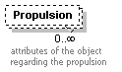
attributes
  Name | Type | Use | Default | Fixed | Annotation
  MainEngine | xs:boolean | required
    documentation
    Indicates whether this engine the main engine
  Power | derived by: xs:decimal | required
    documentation
    The power of this engine in HP
annotation
  documentation
  attributes of the object regarding the propulsion

element VoyageData
diagram | 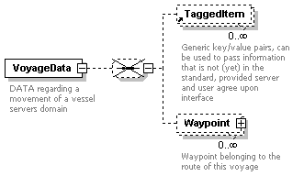
children | TaggedItem Waypoint
used by
  element | ObjectData
attributes
  Name | Type | Use | Default | Fixed | Annotation
  AirDraught | derived by: xs:decimal | optional
    documentation
    Actual air draught of the vessel in meters
  Agent | derived by: xs:string | optional
    documentation
    Agent responsible for this voyage
  ATA | xs:dateTime | optional
    documentation
    Date and time in (subset of ISO 8601) UTC format (YYYY-MM-DDThh:mm:ss.sssZ) of the Actual Time Of Arrival of the target at the destination
  Id | derived by: xs:string | required
    documentation
    The identification of this voyage
  CargoDescr | derived by: xs:string | optional
    documentation
    Description of the cargo
  CargoType | derived by: xs:integer | optional
    documentation
    0 = All ships of this type
    1 = Carrying DG, HS, or MP, IMO hazard or pollutant category A
    2 = Carrying DG, HS, or MP, IMO hazard or pollutant category B
    3 = Carrying DG, HS, or MP, IMO hazard or pollutant category C
    4 = Carrying DG, HS, or MP, IMO hazard or pollutant category D
    5 = Carrying DG, HS, or MP, IMO hazard or pollutant of unknown category
  CargoWeight | xs:integer | optional
    documentation
    Weight of the cargo in tons
  Company | derived by: xs:string | optional
    documentation
    Identification of the company associated with this objects voyage
  Crew | derived by: xs:decimal | optional
    documentation
    The number of crew on board of the object
  Deleted | xs:boolean | optional
    documentation
    This voyage is marked for deletion
  DestCode | derived by: xs:string | optional
    documentation
    Destination of the target (UN/LOCODE) optionally addended with local location code (e.g. BEANR0170100497 = Antwerp, HANSADOK 497)
  DestName | derived by: xs:string | optional
    documentation
    Destination name of the target e.g. local code for berth/lock/bridge/terminal
  Draught | derived by: xs:decimal | optional
    documentation
    Actual draught of the vessel in meters
  ETA | xs:dateTime | optional
    documentation
    Date and time in (subset of ISO 8601) UTC format (YYYY-MM-DDThh:mm:ss.sssZ) of the Expected Time Of Arrival of the target at the destination
  ISPSLevel | derived by: xs:decimal | optional
    documentation
    The ISPS level of the object (1 = normal, 2 = heightended, 3 = exceptional)
  Loaded | xs:boolean | optional
    documentation
    Loaded or unloaded with cargo
  NextPort | derived by: xs:string | optional
    documentation
    Next port of the target (UN/LOCODE)
  Passengers | derived by: xs:decimal | optional
    documentation
    The number of passengers on board of the object
  PersonsOnBoard | derived by: xs:decimal | optional
    documentation
    The number of persons on board of the object, should equal the sum of crew, passengers and support personel if available
  Pilots | derived by: xs:decimal | optional
    documentation
    The number of support pilots on board of the object
  PrevPort | derived by: xs:string | optional
    documentation
    Previous port of the target (UN/LOCODE)
  RouteBound | xs:boolean | optional
    documentation
    This object is bound to the route of this voyage
  SourceId | xs:integer | required
    documentation
    The unique identification of the node who initially created this message
  SourceName | derived by: xs:string | optional
    documentation
    Identification of the originator of this data
  SourceType | derived by: xs:integer | required
    documentation
    Source/originator type: 1 = transponder, 2 = database, 3 = manual, 4 = other
  Support | derived by: xs:decimal | optional
    documentation
    The number of support personel on board of the object
  TankerStatus | derived by: xs:integer | optional
    documentation
    Describes the status of the tanker
    0 = Non gas free
    1 = Gas free
    2 = Inert
  Tugs | derived by: xs:decimal | optional
    documentation
    Number of supporting tugs
  UpdateTime | xs:dateTime | optional
    documentation
    Date and time in (subset of ISO 8601) UTC format (YYYY-MM-DDThh:mm:ss.sssZ) this data was compiled
annotation
  documentation
  DATA regarding a movement of a vessel servers domain

element VoyageData/Waypoint
diagram | 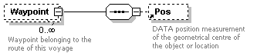
children | Pos
attributes
  Name | Type | Use | Default | Fixed | Annotation
  ATA | xs:dateTime | optional
    documentation
    Date and time in UTC format (YYYY-MM-DDThh:mmZ) (subset of ISO 8601 ) of the Actual Time Of Arrival of the target.
  ETA | xs:dateTime | optional
    documentation
    Date and time in UTC format (YYYY-MM-DDThh:mmZ) (subset of ISO 8601) of the Expected Time Of Arrival of the target.
  LoCode | derived by: xs:string | optional
    documentation
    Waypoint name in UN/LOCODE optionally addended with local location code (e.g. BEANR0170100497 = Antwerp, HANSADOK 497)
  Name | derived by: xs:string | required
    documentation
    Name of the waypoint
annotation
  documentation
  Waypoint belonging to the route of this voyage

XML Schema documentation generated by XMLSpy Schema Editor http://www.altova.com/xmlspy

