Interface Control Document

FOR
Inter VTS Exchange Format

TABLE OF CONTENTS
Introduction 4
Identification 4
Document Overview 4
Referenced Documents 4
INTERFACE SPECIFICATION 5
Interface diagrams 5
User Connection 5
Introduction 5
Message types and priorities 6
Interface requirements 6
Messages 8
XML messages 10
Introduction 10
General XML message structure 10
Accuracies 10
Control Information Messages 12
LoginRequest 12
Login Response 12
Logout 13
Ping 15
Pong 16
Service Request 17
Server Status 18
Real Time Position Data Messages 18
Vessel Data 18
Interface Control 20
Responsibilities for Interfaces 20
Change Control 20
Interface Schedule 20
Interface Testing 20
APPENDIX A LIST OF FIGURES 21
APPENDIX B List of Tables 22
APPENDIX C Abbreviations 23

Introduction

Identification
This Interface Control Document (ICD) describes the requirements and the detailed design of the Inter VTS Data Exchange Format (IVEF).

Referenced Documents
Refer. | Title | Identification code
[ITU/IEC] | AIS Transponder Definition | ITU-1371-3, IEC-63993-2
[XSD] | XML Schema Definition | IVEF_xmlschema.xsd

INTERFACE SPECIFICATION

Interface diagrams
IVEF Interfaces are simple point-to-point connections (TCP/IP) between the VTS server and the VTS user as depicted in the figure below.
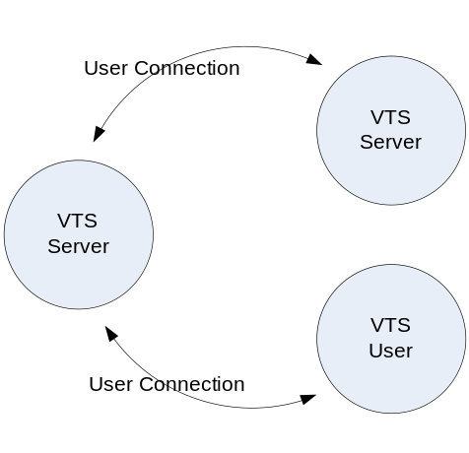
Figure 1 IVEF user connections
The IVEF protocol in itself has no provisions for encryption and data compression. These features are covered by the channel approach. IVEF will send information through standard channels. These channels can convert between physical, electrical and network interfaces, but also add layers of compression and encryption.
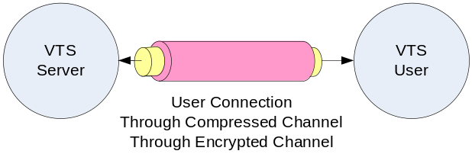

Figure 2 User connection through compressed and encrypted channel
The definition and properties of the channels are not described here, because they are not an integral part of the interface.
TBD may be add a recommendation for a compression format if used, like gzip.

User Connection

Introduction
Whenever an IVEF user wants to connect to an IVEF server, it has to initiate the connection by sending a Login message. The IVEF server validates the login requests and if correct, it sends a LoginResponse message. The IVEF server then looks up the default services for that user. An example of a service is:

“using an interval of 10 seconds, output all position information and static voyage information about all vessels that are within in the following area ( x,y ) – ( x1,y1 ) – ( x2, y2 ) – ( x3,y3 )”

Please note that x, x1, x2 and x3 shall be specified in Longitude coordinates and that y, y1, y2 and y3 shall be specified as Latitude coordinates.

After the IVEF user is logged on, the IVEF server starts outputting the tracks that match the specification in the service.
TBD consider the specification of user profiles, e.g. add allowed services request

Message types and priorities

The IVEF User Connection (IUC) can be divided in a number of message types. It supports a number of transmission characteristics:

- Single occurrence (SO)
- Periodic, with a specified update rate (PER)
- A-periodic, synchronous with the received track update (A-PER)
- On change, updates are sent as fields change (OC)

Two types of messages are distinguished:

Message type A - Non-realtime messages,

Message type B – Realtime messages.

The table below describes all messages that can be distinguished, what type of message it is (A or B) and the priority that this message type will have. For a description of priorities, see .
TBD Add table with priorities and their description

Message | SO | PER | A-PER | OC
Control Information (CI) | A1 | N/A | N/A | N/A
Real Time Position data (RTPD) Vessel Data (Track based) | A3 | B2 | B2 | B2
Real Time Position data (RTPD) Vessel Data (Plan based) | A3 | B4 | N/A | A3
User Requests (UR) | A1 | N/A | N/A | N/A
Table 1 Message types and priorities

Interface requirements
The resulting interface combines many messages which are sent through a single channel. When the capacity of this channel is not sufficient, or when a certain transmission characteristic is to be maintained (e.g. periodic transmission of RTPD), the priorities of the messages shall be as defined in Table 1.
For every message type, A or B, maximum delay can be specified. If the delays increase beyond the maximum, messages will not be sent (given the priority as in ) in order to ensure transmission of the messages with higher priority. Messages, that are not sent due to insufficient bandwidth, will not be resent. Whenever the queue is full and messages are not being sent, because the queue is full, a ServerStatus message is sent from the IVEF server to the IVEF user to inform the IVEF user.
TBD should this specification contain performance requirements, like e.g. minimum response time?

Messages
The IUC supports the following messages; the contents and meaning of the messages mentioned below are covered in chapter

Message | From |  | To | Description
Control Information Messages
Login | User | Server |  | This message identifies an IVEF user
Login Response | Server | User |  | OK or NOT
Logout | User | Server |  | Logout from the server
Ping | Both | Both |  | Heartbeat message
Pong | Both | Both |  | Response to a Heartbeat message
Service Request | User | Server |  | Request a service, this message contains the contents of the new service
Service Request Response | Server | User |  | OK or NOT OK
Server Status | Server | User |  | Can come as response or automatically
Real Time Position Data Messages
Vessel Data Track based | Server |  | User | The position, static- and voyage related data of a track, this message is used for IVEF users that are mainly interested in position data
Vessel Data Plan based | Server |  | User | The position, static- and voyage related data of a track, this message is used for IVEF users that are mainly interested in plan data
Table 2 Interface Messages

XML messages

Introduction
This chapter describes the XML messages that may be sent between IVEF users and a IVEF server and vise versa.

General XML message structure
All XML messages sent and received by an IVEF server shall have the following layout:

- XML version tag
- Main node
- Header node, child node of Main node
- Body node, child node of Main node
- Message specific node(s) , one or more, child node(s) of the Body node

example:

<?xml version="1.0" ?>
<IVEF_xxx xmlns="urn:http://www.iala.org/XMLSchema/IVEF/1.0">
<Header Version="1.0" MsgRefId="DJ45SGFL-B103-4113-A100-DJ45SGFL"/>
<Body>
Message specific nodes will be placed here
</Body>
</IVEF_xxx>

Accuracies

The following accuracies are required to ensure a proper working of the system.
TBD Define minimum resolution of the various attributes.

Attribute | Resolution | belonging to element (see [XSD])
Altitude | 0 | PosReport
AntPosDistFromFront | 0 | StaticData
AntPosDistFromLeft | 0 | StaticData
ATA | 0 | Voyage
Breadth | 0 | PosReport and Vesseldata
COG | 1 | PosReport
ETA | 0 | Voyage
Lat | 5 | Pos
Length | 0 | PosReport and Vesseldata
Long | 5 | Pos
MaxDraught | 1 | StaticData
MaxAirDraught | 1 | StaticData
Orientation | 0 | PosReport
Period | 0 | Transmission
RateOfTurn | 0 | PosReport
SOG | 1 | PosReport
TimeStamp | 2 | Ping and Pong
UpdateTime | 2 | PosReport
Accuracy | 0 | PosReport

Control Information Messages

LoginRequest

Introduction
The LoginRequest.xml message is sent by an IVEF user to an IVEF server. The purpose of this message is to identify an IVEF user to the IVEF server.

Message flow

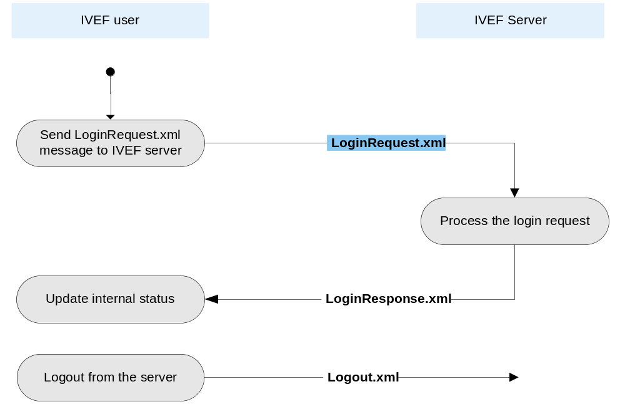

Figure 3 Message flow LoginRequest.xml

Data elements of LoginRequest.xml message

See [XSD] for all details

Login Response

Introduction
The LoginResponse.xml (see Figure 3) message is sent by an IVEF server to an IVEF userain response to a LoginRequest.xml message. The purpose of this message is to indicate whether or not the user is successfully logged in. If the IVEF userdis not accepted by the IVEF server, a LoginResponse message is sent with status “Declinedr, the network connection will bedterminated.

Logout

Introduction
The Logout.xml (see Figure 3) message is a notification, sent by an IVEF user to thn IVEF server, totterminate the connection.

TBD XXX.

The closing of the network connection can be used by the IVEF user as an indication that the logout succeeded.
Also, when the connection between an IVEF server and an IVEF user is closed for whatever reason with no request, the IVEF user will have to initiate the connection and logon again to get the service data requested.

Ping

Introduction
A ping message can be sent by either an IVEF user or an IVEF server as an alive message. A ping message will be answered by the receiver with a pong message.

Message flow

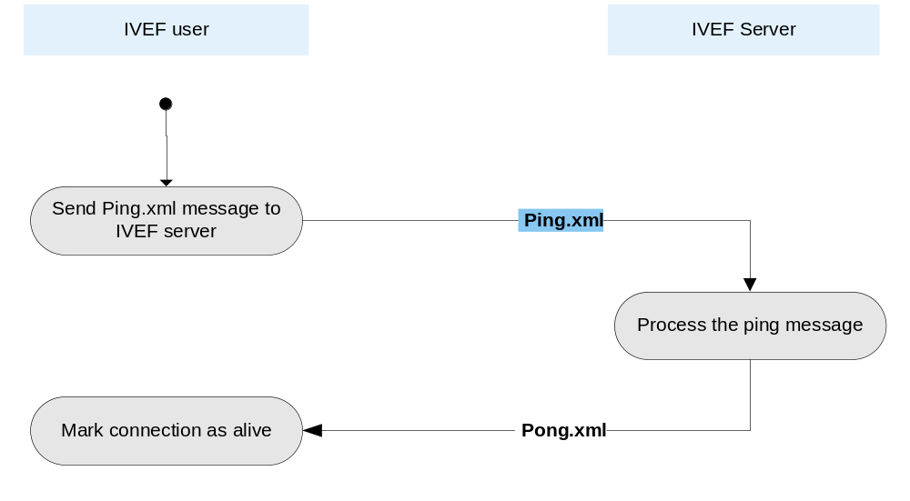

Figure 6 Message flow Ping.xml

Data elements of Ping.xml message

See [XSD] for all details

Pong

Introduction
A pong message can be sent by either an IVEF user or an IVEF server as a response to a ping message.

Message flow

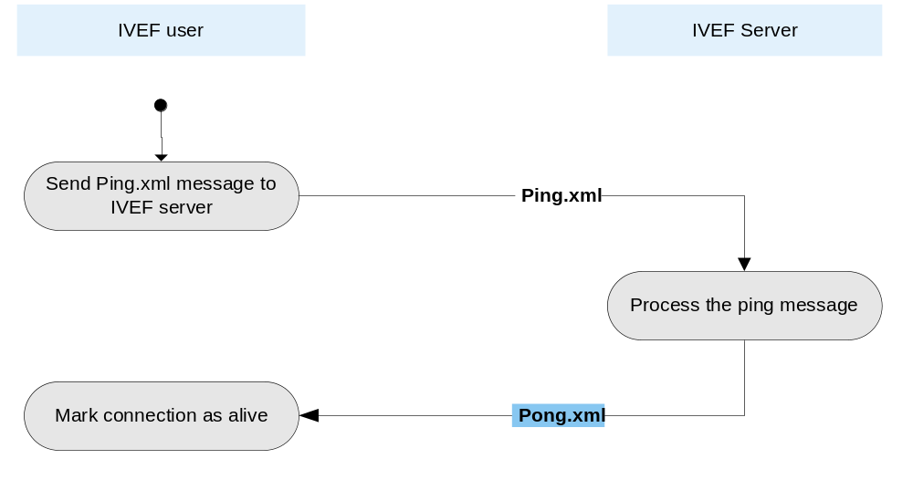

Figure 7 Message flow Pong.xml

Data elements of Pong.xml message

See [XSD] for all details

Service Request

Introduction
After login the user can sent a service request. The request should be within the defined rights of the user. If the service request is accepted by the server, the previous (default) service is replaced by this.
Service request will not be implemented in the first release. It is described here to illustrate the properties of a service.

Message flow

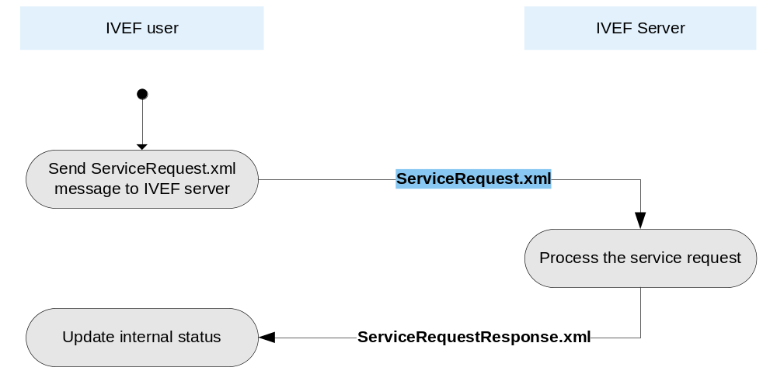
Figure 8 Message flow ServiceRequest.xml

Data elements of ServiceRequest.xml message
See [XSD] for all details

Server Status

Introduction
A Server Status message can be sent by an IVEF server to indicate the status if the server. These messages will come autonomously.

Message flow

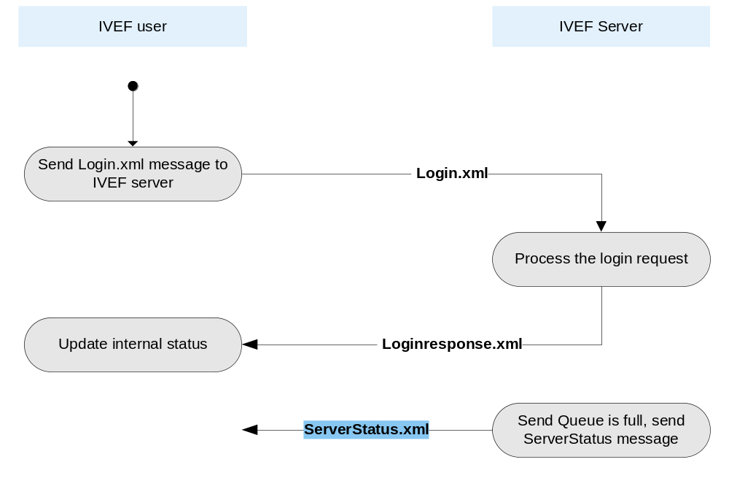
Figure 9 Message flow ServerStatus.xml

Data elements of ServerStatus.xml message

See [XSD] for all details

Real Time Position Data Messages

Vessel Data

Introduction
A Vessel Data message contains data (position, static and voyage related data) about one or more vessels.
After an IVEF user identified itself using a Login message, the IVEF server starts sending Vessel Data messages if a predefined service is available for the user or the IVEF server sends Vessel Data on an accepted New Service Request message.

Message flow

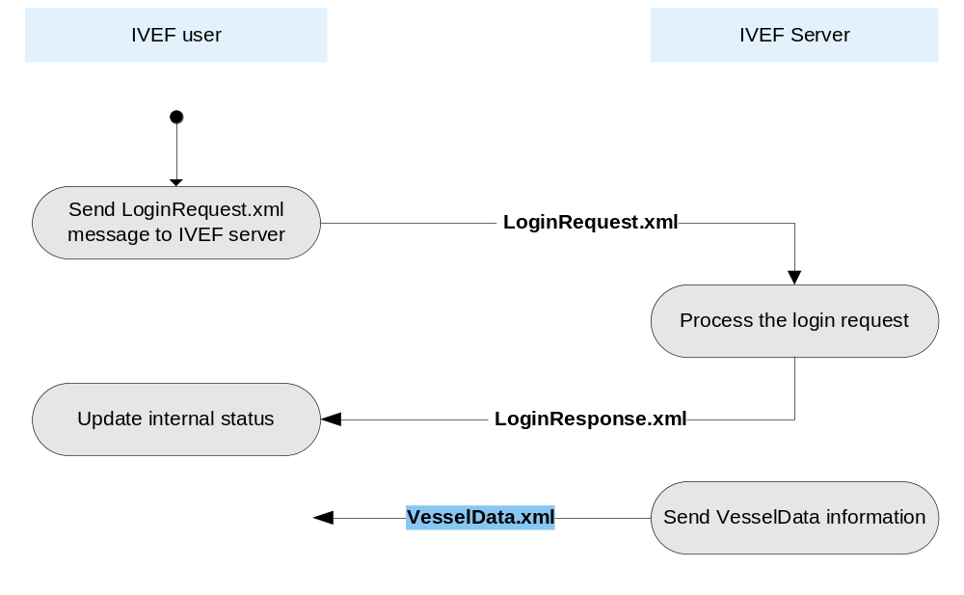
Figure 10 Message flow VesselData.xml

Data elements of VesselData.xml message

See [XSD] for all details

APPENDIX A LIST OF FIGURES
Figure 1 IVEF user connections 5
Figure 2 User connection through compressed and encrypted channel 5
Figure 3 Message flow LoginRequest.xml 12
Figure 4 Message flow LoginResponse.xml 13
Figure 5 Message flow Logout.xml 14
Figure 6 Message flow Ping.xml 15
Figure 7 Message flow Pong.xml 16
Figure 8 Message flow ServiceRequest.xml 17
Figure 9 Message flow ServerStatus.xml 18
Figure 10 Message flow VesselData.xml 19

APPENDIX B List of Tables
Table 1 Message types and priorities 6
Table 2 Interface Messages 9

APPENDIX C Abbreviations
AIS | Automatic Identification System
ATA | Actual Time of Arrival
COG | Course Over Ground
CSCI | Computer Software Configuration Item
ETA | Estimated Time of Arrival
FS | Functional Specification
ICD | Interface Control Document
IMO | International Maritime Organisation
ITU | International Technical Union
RTPD | Real Time Position Data
SOG | Speed Over Ground
TCP/IP | Transmission Control Protocol / Internet Protocol
UTC | Coordinated Universal Time
WGS-84 | World Geodetic System 1984
XML | Extensible Markup Language

