Service Name: Message Envelope

element MSG_IVEF
diagram | 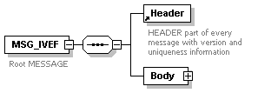
children | Header Body

element MSG/Header
diagram | 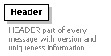
used by
  element | MSG_IVEF
attributes
  Name | Type | Use | Annotation
  MsgRefId | derived by: xs:string | required
  Version | xs:string | required
annotation
  documentation
  HEADER part of every message with version and uniqueness information

element MSG_IVEF/Body
diagram | 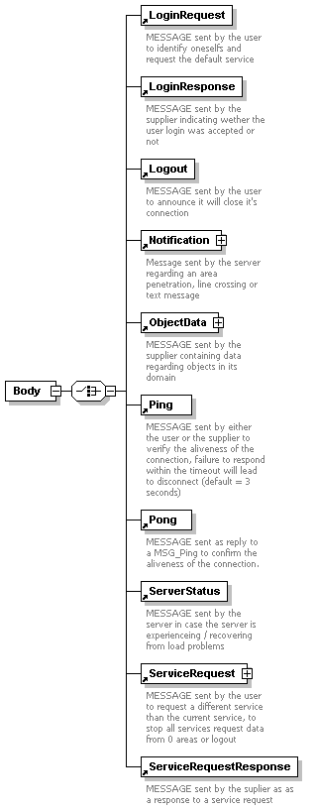
children | LoginRequest LoginResponse Logout Notification ObjectData Ping Pong ServerStatus ServiceRequest ServiceRequestResponse
attributes
  Name | Type | Use | Default | Fixed | Annotation
  Type | derived by: xs:string | required

Service Name: LoginRequest

Service Name: LoginResponse

Service Name: Logout

Service Name: Ping

Service Name: Pong

Service Name: ServiceRequest

Service Name: ServiceRequestResponse

Service Name: ServiceStatus

Service Name: ObjectData

Service Name: Notification

element Area
diagram | 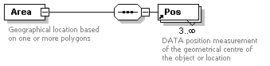
children | Pos
used by
  elements | Penetration ServiceRequest
attributes
  Name | Type | Use | Default | Fixed | Annotation
  Name | derived by: xs:string | optional
annotation
  documentation
  Geographical location based on one or more polygons

element Crossing
diagram | 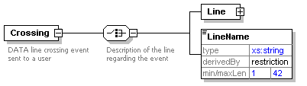
children | Line LineName
used by
  element | Notification
attributes
  Name | Type | Use | Default | Fixed | Annotation
  Name | derived by: xs:string | required
  SourceId | xs:integer | required
  TimeStamp | xs:dateTime | required
annotation
  documentation
  DATA line crossing event sent to a user

element Crossing/Line
diagram | 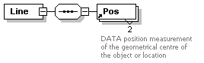
children | Pos

element Crossing/LineName
diagram | 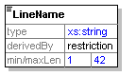

element ForeignId
diagram | 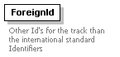
used by
  element | VesselData/Identifier
attributes
  Name | Type | Use | Default | Fixed | Annotation
  Id | derived by: xs:string | required
  Value | derived by: xs:string | required
annotation
  documentation
  Other Id's for the track than the international standard Identifiers

element ForeignName
diagram | 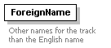
used by
  element | VesselData/Identifier
attributes
  Name | Type | Use | Default | Fixed | Annotation
  Lang | derived by: xs:string | required
  Name | derived by: xs:string | required
annotation
  documentation
  Other names for the track than the English name

element LoginRequest
diagram | 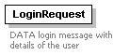
used by
  element | MSG_IVEF/Body
attributes
  Name | Type | Use | Default | Fixed | Annotation
  Encryption | derived by: xs:integer | required
  Name | derived by: xs:string | required
  Password | derived by: xs:string | required
annotation
  documentation
  DATA login message with details of the user

element LoginResponse
diagram | 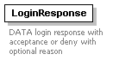
used by
  element | MSG_IVEF/Body
attributes
  Name | Type | Use | Default | Fixed | Annotation
  Reason | derived by: xs:string | optional
  ResponseOn | derived by: xs:string | required
  Result | derived by: xs:integer | required
annotation
  documentation
  DATA login response with acceptance or deny with optional reason

element Logout
diagram | 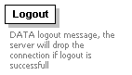
used by
  element | MSG_IVEF/Body
annotation
  documentation
  DATA logout message, the server will drop the connection if logout is successfull

element Message
diagram | 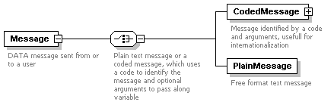
children | CodedMessage PlainMessage
used by
  element | Notification
attributes
  Name | Type | Use | Default | Fixed | Annotation
  Destination | derived by: xs:string | optional
  Origin | derived by: xs:string | required
  Priority | xs:integer | optional
  TimeStamp | xs:dateTime | required
annotation
  documentation
  DATA message sent from or to a user

element Message/CodedMessage
diagram | 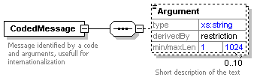
children | Argument
attributes
  Name | Type | Use | Default | Fixed | Annotation
  Code | derived by: xs:string | required
annotation
  documentation
  Message identified by a code and arguments, usefull for internationalization

element Message/CodedMessage/Argument
diagram | 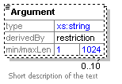
annotation
  documentation
  Short description of the text

element Message/PlainMessage
diagram | 
attributes
  Name | Type | Use | Default | Fixed | Annotation
  Subject | derived by: xs:string | optional
  Text | derived by: xs:string | required
annotation
  documentation
  Free format text message

element Notification
diagram | 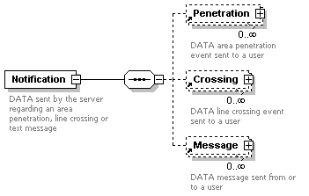
children | Penetration Crossing Message
used by
  element | MSG_IVEF/Body
annotation
  documentation
  DATA sent by the server regarding an area penetration, line crossing or text message

element ObjectData
diagram | 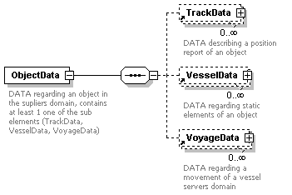
children | TrackData VesselData VoyageData
used by
  element | MSG_IVEF/Body
attributes
  Name | Type | Use | Default | Fixed | Annotation
  Id | xs:integer | required
annotation
  documentation
  DATA regarding an object in the supliers domain, contains at least 1 one of the sub elements (TrackData, VesselData, VoyageData)

element Penetration
diagram | 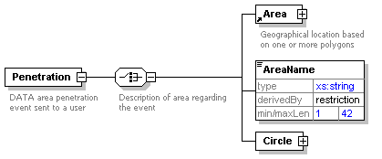
children | Area AreaName Circle
used by
  element | Notification
attributes
  Name | Type | Use | Default | Fixed | Annotation
  Name | derived by: xs:string | required
  SourceId | xs:integer | required
  TimeStamp | xs:dateTime | required
annotation
  documentation
  DATA area penetration event sent to a user

element Penetration/AreaName
diagram | 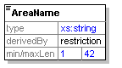

element Penetration/Circle
diagram | 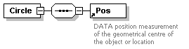
children | Pos
attributes
  Name | Type | Use | Default | Fixed | Annotation
  Range | derived by: xs:integer | required

element Ping
diagram | 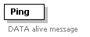
used by
  element | MSG_IVEF/Body
attributes
  Name | Type | Use | Default | Fixed | Annotation
  TimeStamp | xs:dateTime | required
annotation
  documentation
  DATA alive message

element Pong
diagram | 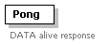
used by
  element | MSG_IVEF/Body
attributes
  Name | Type | Use | Default | Fixed | Annotation
  ResponseOn | derived by: xs:string | required
  SourceId | xs:integer | required
  TimeStamp | xs:dateTime | required
annotation
  documentation
  DATA alive response

element Pos
diagram | 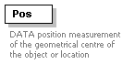
used by
  elements | Area Penetration/Circle Crossing/Line TrackData VoyageData/Waypoint
attributes
  Name | Type | Use | Default | Fixed | Annotation
  Altitude | xs:decimal | optional
  EstAccAlt | xs:decimal | optional
  EstAccLat | xs:decimal | optional
  EstAccLong | xs:decimal | optional
  Lat | derived by: xs:decimal | required
  Long | derived by: xs:decimal | required
annotation
  documentation
  DATA position measurement of the geometrical centre of the object or location

element ServerStatus
diagram | 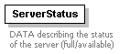
used by
  element | MSG_IVEF/Body
attributes
  Name | Type | Use | Default | Fixed | Annotation
  Details | derived by: xs:string | optional
  Status | xs:boolean | required
annotation
  documentation
  DATA describing the status of the server (full/available)

element ServiceRequest
diagram | 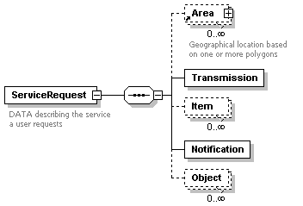
children | Area Transmission Item Notification Object
used by
  element | MSG_IVEF/Body
annotation
  documentation
  DATA describing the service a user requests

element ServiceRequest/Transmission
diagram | 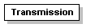
attributes
  Name | Type | Use | Default | Fixed | Annotation
  Period | xs:decimal | optional
  Type | derived by: xs:integer | required

element ServiceRequest/Item
diagram | 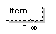
attributes
  Name | Type | Use | Default | Fixed | Annotation
  Element | derived by: xs:integer | required
  Field | derived by: xs:string | required

element ServiceRequest/Notification
diagram | 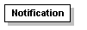
used by
  element | MSG_IVEF/Body
attributes
  Name | Type | Use | Default | Fixed | Annotation
  Event | xs:boolean | optional
  Messages | xs:boolean | optional

element ServiceRequest/Object
diagram | 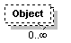
attributes
  Name | Type | Use | Default | Fixed | Annotation
  FilterName | derived by: xs:string | required

element ServiceRequestResponse
diagram | 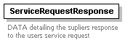
used by
  element | MSG_IVEF/Body
attributes
  Name | Type | Use | Default | Fixed | Annotation
  Reason | derived by: xs:string | optional
  ResponseOn | derived by: xs:string | required
  Result | derived by: xs:integer | required
annotation
  documentation
  DATA detailing the supliers response to the users service request

element TaggedItem
diagram | 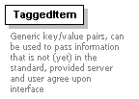
used by
  elements | VesselData VoyageData
attributes
  Name | Type | Use | Default | Fixed | Annotation
  Key | derived by: xs:string | required
  Value | derived by: xs:string | required
annotation
  documentation
  Generic key/value pairs, can be used to pass information that is not (yet) in the standard, provided server and user agree upon interface

element TrackData
diagram | 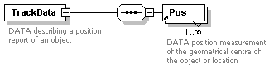
children | Pos
used by
  element | ObjectData
attributes
  Name | Type | Use | Default | Fixed | Annotation
  COG | derived by: xs:decimal | required
  EstAccSOG | xs:decimal | optional
  EstAccCOG | xs:decimal | optional
  EstAccOrientation | xs:decimal | optional
  Id | xs:integer | required
  Length | derived by: xs:decimal | optional
  NavStatus | derived by: xs:integer | optional
  Orientation | derived by: xs:decimal | optional
  ROT | xs:decimal | optional
  SOG | derived by: xs:decimal | required
  SourceId | xs:integer | required
  SourceName | derived by: xs:string | optional
  UpdateTime | xs:dateTime | required
  TrackStatus | derived by: xs:integer | required
  Width | derived by: xs:decimal | optional
annotation
  documentation
  DATA describing a position report of an object

element VesselData
diagram | 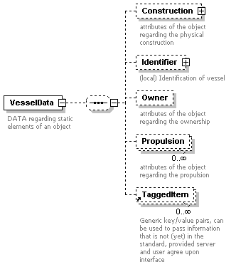
children | Construction Identifier Owner Propulsion TaggedItem
used by
  element | ObjectData
attributes
  Name | Type | Use | Default | Fixed | Annotation
  Class | derived by: xs:integer | optional
  Deleted | xs:boolean | optional
  Detained | xs:boolean | optional
  BlackListed | xs:boolean | optional
  Id | derived by: xs:string | required
  SourceId | xs:integer | required
  SourceName | derived by: xs:string | optional
  SourceType | derived by: xs:integer | required
  UpdateTime | xs:dateTime | optional
annotation
  documentation
  DATA regarding static elements of an object

element VesselData/Construction
diagram | 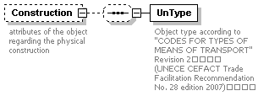
children | UnType
attributes
  Name | Type | Use | Default | Fixed | Annotation
  Constructor | derived by: xs:string | optional
  DeadWeight | derived by: xs:decimal | optional
  GrossWeight | derived by: xs:decimal | optional
  HullColor | derived by: xs:string | optional
  HullMaterial | derived by: xs:string | optional
  HullType | derived by: xs:integer | optional
  Length | derived by: xs:decimal | optional
  LloydsShipType | xs:integer | optional
  MaxAirDraught | derived by: xs:decimal | optional
  MaxDraught | derived by: xs:decimal | optional
  MaxPersonsOnBoard | derived by: xs:decimal | optional
  MaxSpeed | derived by: xs:decimal | optional
  NetWeight | derived by: xs:decimal | optional
  TideBound | xs:boolean | optional
  Width | derived by: xs:decimal | optional
annotation
  documentation
  attributes of the object regarding the physical construction

element VesselData/Construction/UnType
diagram | 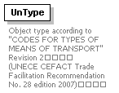
attributes
  Name | Type | Use | Default | Fixed | Annotation
  CodeA | derived by: xs:integer | required
  CodeB | derived by: xs:integer | required
  Mode | derived by: xs:integer | required
annotation
  documentation
  Object type according to "CODES FOR TYPES OF MEANS OF TRANSPORT" Revision 2
  (UNECE CEFACT Trade Facilitation Recommendation No. 28 edition 2007)

element VesselData/Identifier
diagram | 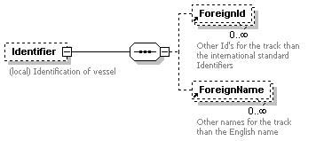
children | ForeignId ForeignName
attributes
  Name | Type | Use | Default | Fixed | Annotation
  Callsign | derived by: xs:string | optional
  IMO | xs:integer | optional
  Name | derived by: xs:string | optional
  MMSI | xs:integer | optional
  SatCom | xs:integer | optional
  Telephone | derived by: xs:string | optional
annotation
  documentation
  (local) Identification of vessel

element VesselData/Owner
diagram | 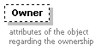
attributes
  Name | Type | Use | Default | Fixed | Annotation
  Company | derived by: xs:string | optional
  CountryFlag | derived by: xs:string | optional
  CountryOwner | derived by: xs:string | optional
  HomePort | derived by: xs:string | optional
  Owner | derived by: xs:string | optional
  PortOfRegistry | derived by: xs:string | optional
annotation
  documentation
  attributes of the object regarding the ownership

element VesselData/Propulsion
diagram | 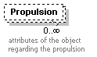
attributes
  Name | Type | Use | Default | Fixed | Annotation
  MainEngine | xs:boolean | required
  Power | derived by: xs:decimal | required
annotation
  documentation
  attributes of the object regarding the propulsion

element VoyageData
diagram | 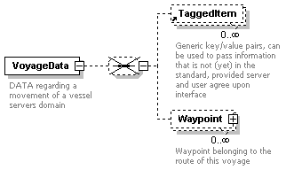
children | TaggedItem Waypoint
used by
  element | ObjectData
attributes
  Name | Type | Use | Default | Fixed | Annotation
  AirDraught | derived by: xs:decimal | optional
  Agent | derived by: xs:string | optional
  ATA | xs:dateTime | optional
  Id | derived by: xs:string | required
  CargoDescr | derived by: xs:string | optional
  CargoType | derived by: xs:integer | optional
  CargoWeight | xs:integer | optional
  Company | derived by: xs:string | optional
  Crew | derived by: xs:decimal | optional
  Deleted | xs:boolean | optional
  DestCode | derived by: xs:string | optional
  DestName | derived by: xs:string | optional
  Draught | derived by: xs:decimal | optional
  ETA | xs:dateTime | optional
  ISPSLevel | derived by: xs:decimal | optional
  Loaded | xs:boolean | optional
  NextPort | derived by: xs:string | optional
  Passengers | derived by: xs:decimal | optional
  PersonsOnBoard | derived by: xs:decimal | optional
  Pilots | derived by: xs:decimal | optional
  PrevPort | derived by: xs:string | optional
  RouteBound | xs:boolean | optional
  SourceId | xs:integer | required
  SourceName | derived by: xs:string | optional
  SourceType | derived by: xs:integer | required
  Support | derived by: xs:decimal | optional
  TankerStatus | derived by: xs:integer | optional
  Tugs | derived by: xs:decimal | optional
  UpdateTime | xs:dateTime | optional
annotation
  documentation
  DATA regarding a movement of a vessel servers domain

element VoyageData/Waypoint
diagram | 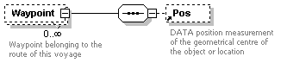
children | Pos
attributes
  Name | Type | Use | Default | Fixed | Annotation
  ATA | xs:dateTime | optional
  ETA | xs:dateTime | optional
  LoCode | derived by: xs:string | optional
  Name | derived by: xs:string | required
annotation
  documentation
  Waypoint belonging to the route of this voyage

XML Schema documentation generated by XMLSpy Schema Editor http://www.altova.com/xmlspy

