
AISM Association of Internationale de Signalisation Maritime IALA
International Association of Marine Aids to Navigation and Lighthouse Authorities
IALA Recommendation XXX

on

the IVEF Service

[Working towards Edition 1.0]

20ter, rue Schnapper, 78100
Saint Germain en Laye, France
Telephone +33 1 34 51 70 0 Telefax +33 1 34 51 82 05
E-mail - iala-aism@wanadoo.fr Internet - http://iala-aism.org

Document Revisions
Revisions to the IALA Document are to be noted in the table prior to the issue of a revised document.
Date | Page / Section Revised | Requirement for Revision
Recommendation on the IVEF Service
(Recommendation XXX)

THE COUNCIL

RECALLING that one of the aims of the Association is to foster safe, economic and efficient movement of vessels and the protection of the environment through the improvement and harmonisation of aids to navigation, vessel traffic services and other means world-wide.

NOTING
- IALA Recommendation e-Nav 140 on “The e-Navigation Architecture – the initial Shore-based Perspective” [1]
- IMO’s strategic plan regarding e-Navigation; [2]
- IMO has expressed an interest in the contribution of IALA to the work on e-Navigation; [3]

RECOGNISING that the e-Navigation architecture will assist in the development and maintenance of application interactions between ship and shore, shore and ship and between shore and shore, in the following fields
- shore-based technical e-Navigation services;
- technical means for communication;
- data modelling and referential data;
- Human Machine Interface presentations;

RECOGNISING ALSO the responsibilities of IALA National Members regarding international and/or regional e-Navigation applications
- that the shore-based e-Navigation systems of National Members are embedded into local, national, regional and global topologies of systems;
- that there are data/information flow chains within the local, national, regional and global topologies of systems which support local, national, regional, and global e-Navigation applications;
- that requirements regarding quality parameters, such as accuracy, reliability, continuity, confidentiality, and others, will need to be taken into account when designing elements of the common shore-based e-Navigation system architecture;

RECOGNISING FURTHER that the Inter-VTS Exchange Format (IVEF) service as laid out in this Recommendation will assist National Members in the efficient deployment of their services to the mariner and to the maritime community by
- allowing shore-based systems of a National Member to participate in harmonised data exchange;
- easing the integration of components;
- improving the efficiency in organisational terms by exploiting commonalities;
- harmonising data exchange to other shore-based stakeholders’ systems (local, national, regional, global);
- taking into account the value, timeliness and sensitivity of data.

RECOMMENDS
that National Members, introducing an IVEF Service into their shore infrastructure, take into account the principles as set out in the annex to this recommendation.

IALA Recommendation on the IVEF Service

Table of Contents

Main Part
2.1 Overview 6
2.2 Capabilities of the IVEF Service for the Shore-based e-Navigation System 7
2.3 Data Model of the IVEF Service 10
2.4 Interaction/Security Model of the IVEF Service 11
2.4.2.1.1 Service Model
2.4.2.1.2 Description
2.4.2.1.3 VESSEL: vessel data
2.4.2.1.4 TRACK: track data
2.4.2.1.5 VOYAGE: Voyage-related data
2.4.2.2.1 Service Model:
2.4.2.2.2 Description
2.4.2.2.3 LOGIN/LOGIN_RESP/LOGOUT
2.4.2.2.4 SERVICE_REQ/ SERVICE _RESP
2.4.2.3.1 Service Model:
2.4.2.3.2 Description
2.4.2.3.3 PING/PONG/SERV_STAT
2.5 Interfacing Model of the IVEF Service 22
2.6 Quality Parameters of the IVEF Service 22
2.7 Test model of the IVEF Service 23
2.8 Administration model of the IVEF Service 23

- The IVEF Service as described by other IALA Recommendations
The IVEF Service is a gateway service, as contained in the general description of the common shore-based system architecture in the “IALA Recommendation on Shore-based e-Navigation System Architecture” [ref XXX]. Such a gateway service is specialised in data exchange shore-to-shore. It interfaces to other e-Navigation systems and to external systems of “third parties”. These systems may request the IVEF service to forward relevant data to them. A IVEF service can interface shore-based systems locally, regionally, and globally.
- Service Model of the IVEF Service
  - Overview
The IVEF Service description is organised according to the (draft) “IALA Recommendation on Generic e-Navigation Service Engineering Model Template” [ref XXX] as depicted in figure 1.
The description contains exactly those elements that are relevant for a full description of the service. The following is a brief description of these elements:

Basic IVEF Services: capabilities of the IVEF Service and its functional interface statements.
Data Model: the abstract descriptions of the data provided by the IVEF Service at its Basic IVEF Services to shore-based e-Navigation systems and external systems. It defines the data types and data objects of the IVEF Service.
Interaction Model: the dynamics of the interaction of individual components of the IVEF Service (data flow and protocol).
Interfacing Model: the data encoding and interface protocols between the provider of the IVEF Service and the clients, requesting data from the service.
Security Model: control of access to the IVEF Service (filtering and access rights).
Quality Parameters: performance and reliability considerations of the IVEF Service.
Test Model: test and validation of the IVEF service.
Administration Model: the technical administration and maintenance aspects of the IVEF Service.

A full description of these aspects follows in the remainder of this document.

Figure 1 IVEF Service model
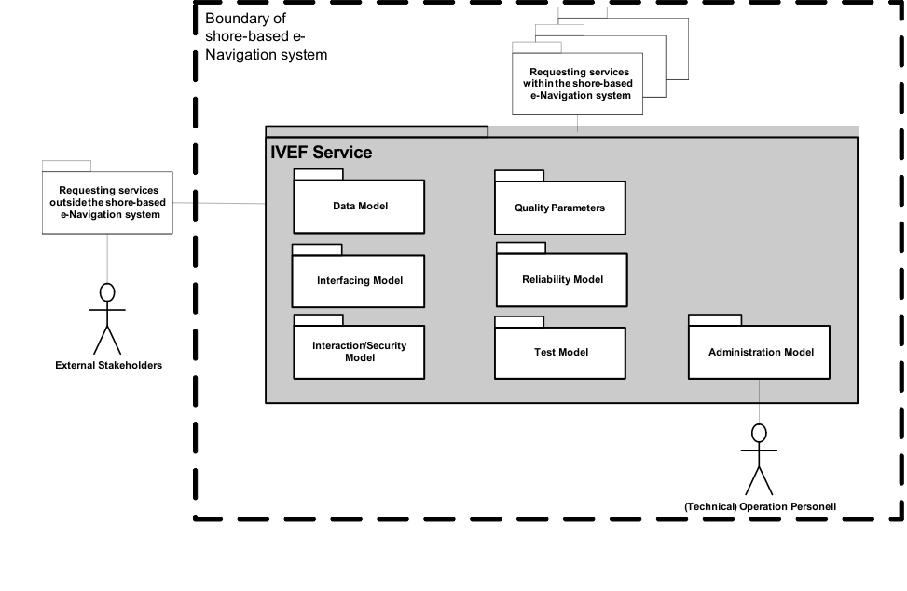
Note Interaction/Security, Quality/Reliability Models need to be adapted
  - Capabilities of the IVEF Service for the Shore-based e-Navigation System
    - Introduction
The IVEF Service is an optional part of a shore-based e-Navigation system. Its basic purpose is to provide a vessel traffic image to related vessel traffic service systems, to e-Navigation stakeholders and relevant external parties. Any IVEF Service provides, at least, the so-called Basic IVEF Services (BIS). A particular characteristic of the IVEF Service is they are only rendered on request of another e-Navigation system or an external system (figure 2).
Figure 2 The IVEF Service in Operation
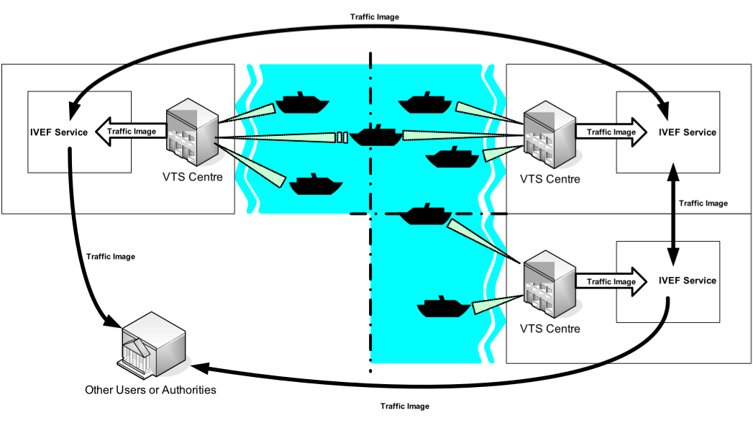

    - Basic IVEF Services (BIS)
There is only one basic IVEF service, which is

Vessel Traffic Image Data Exchange Service – deliver vessel traffic situation data, according to a specific service profile. Such a service profile determines e.g. the data items delivered, the area of interest and the update rate.

The IVEF Service is part of the e-Navigation Client/Server-based architecture. A general way of describing communication architectures is via the ISO/OSI reference model [ref XXX], which describes communication between applications through a layered model. Each higher-level layer in this model increases the level of abstraction. The communication between client and server is described here at the so-called “application layer” in the reference model. The implementation of the lower layers is not discussed here. It is suggested to use a secured and reliable link between the client and server.

Figure 3 IVEF Service Client/Server Model
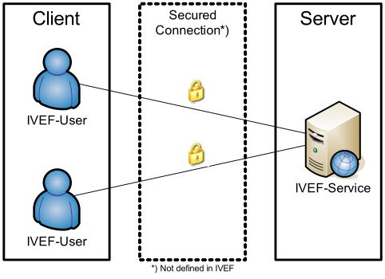

    - General Use Cases

Figure 4 IVEF Service Primary Use Case
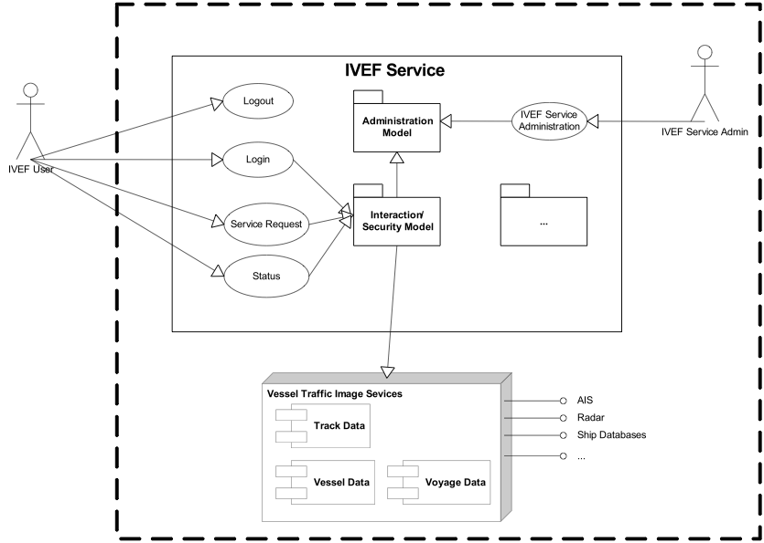
Note Interaction/Security, Quality/Reliability Models need to be adapted

  - Data Model of the IVEF Service
    - Introduction
TBD
See Appendix XXX
    - The Place of the IVEF Service in the e-Navigation Architecture
Figure 1 illustrates the place of the IVEF Service in the e-Navigation architecture as described by IALA Recommendation on the E-Navigation Architecture – the shore perspective (IALA Recommendation eNAV-101). It clearly identifies the co-operative nature of the shore-based IVEF Service. Note that the IVEF Service shares the dependencies of the e-Navigation architecture.

Figure 1: Place of the IVEF Service within the e-Navigation architecture


Shore-based e-Nav system

IVEF
Service
VTS 1
IB
Wireless
Communication
Ship’s
sensors
Shipboard
Applications

Sensor
Data

VTS
Application 2
Application 3
Application 4
Since the “gateway services” of the shore-based e-Navigation system will be requested by other e-Navigation services within that system, there can be identified multiple client-server-relationships. Those can be combined to a hierarchy within the shore-based e-Navigation system as indicated by Figure 3 (following page).

Figure 3: Client-server relationships of the IVEF Service with other shore-based e-Navigation services – resulting hierarchy of shore-based e-Navigation services and the place of the IVEF Service

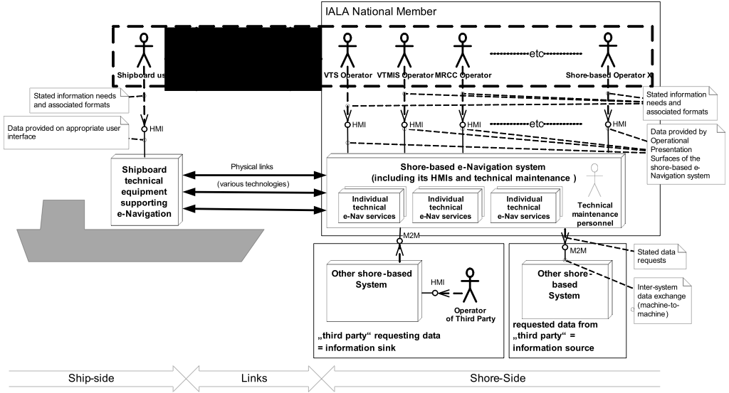
    - The Universal Maritime Data Model (UMDM) and its Relation with the IVEF Service
The Data Model of the IVEF Service is a [subset | application] of the UMDM. It provides the well-structured and abstract (functional) description of the data, the IVEF Service exchanges with requesting services of the common shore-based e-Navigation system. In the UMDM all data objects are expressively described in one place together, with data attributes based on an appropriate data type definition.

Also, the Data Model shows the contribution of the different BAS to the overall knowledge the shore based e-Navigation system may gain about a traffic object (mainly ships) by the IVEF Service at all. Hence, the Data Model shows the contributions of the IVEF Service to the Universal Maritime Data Model (UMDM).

The Data Model provides the designers of requesting services and /or applications precise information on what data the IVEF Service may provide (receive) or expect (transmit)

Although, the Data Model does not contain encoding information, encoding is required on application level (i.e. regarding the BAS). The Data Model of the IVEF Service provides flexibility in selecting an encoding technique as deemed appropriate by the competent authority. A portfolio of appropriate encoding techniques to be used with data objects of the IVEF Service is given in the section on the Interfacing Model.
  - Interaction/Security Model of the IVEF Service
    - Context
IVEF Service Interfaces are point-to-point connections between an eNav Gateways. One Gateway acts as an information source whereas the other Gateway acts as an information sink.

The IVEF Service in itself has no provisions for encryption and data compression, these features are covered by additional transport layers. IVEF describes the data exchange format, additional transport layers can convert between physical, electrical and network interfaces, but also add layers of compression and encryption.
The justification of this approach is the fact that compression and encryption are well covered by authorities and still undergo rapid development.

Recommended layers (at this time) are TCP/IP for transport, SSL for encryption and ZLIB (RFC-1950) for compression.
eNav Gateway
Information Source
eNav Gateway
Information Sink
IVEF
Service
IVEF
Client

Compression
e.g. ZLIB
Compression
e.g. ZLIB

Encryption
e.g. SSL
Encryption
e.g. SSL

Transport
e.g. TCP/IP

      - Service Negotiation
The IVEF interface is a service based protocol. This means that the data exchange between the parties is not pre-defined, but rather the result of a negotiation between the information provider and the information consumer.
      - Introduction
When a client (an eNav Gateway acting as an information sink) wants to connect to server (an eNav Gateway acting as an information source), it has to initiate the service by authenticating. To do this, the client sends a Login message to the server, the server validates the login requests and if correct, it sends a LoginResponse message. The server initiates the default service for that particular user. An example of a service is:

“using an interval of 10 seconds, output all position information and voyage information about all vessels that are within in the following area ( x,y ) – ( x1,y1 ) – ( x2, y2 ) – ( x3,y3)”1

After the client is logged on, the server starts outputting the traffic image that matches the specification in the service.

The client can also sent a ServiceRequest to terminate or change the active service. Services can be defined with different transmission characteristics, which allows of a server push or client pull of the information, or a combination.

      - Service parameters
A service is defined by a number of parameters:

- Object Selection, which objects should be sent?
  - Area based
  - Filter based on the object properties (e.g. length > 50 m)
- Item Selection, which information elements should be sent?
  - Track Information
  - Vessel Information
  - Voyage Information
- Transmission Selection, when should it be sent?
  - Single Occurrence (Pull)
  - Periodic, with specified update rate (Push)
  - A-Periodic, synchronous with update (Push)
      - Information flow dynamics
The interface supports the following messages; the contents and meaning of the messages mentioned below are covered in chapter.

Message | From | To | Description
Control Information Messages
Login | Client | Server | This message is used to identify the client
Login Response | Server | Client | Login accepted or refused, if refused a reason will be supplied
Logout | Client | Server | This message is used to terminate the IVEF Service
Ping | Both | Both | Heartbeat message
Pong | Both | Both | Response to a Heartbeat message
Service Request | Client | Server | This message contains the definition of the service requested by the client. It will replace the current service.
Service Request Response | Server | Client | Request accepted or refused, if refused a reason will be supplied
Service Status | Server | Client | This message will be sent by the server to indicate the status of the service.
Real Time Messages
Object Data | Server | User | The track, vessel- and voyage related data of objects in the traffic image.
Table 1: Interface Messages
      - Timing and priorities
Control Information Messages have a higher priority than Real-Time Messages. This means that in an overload situation, Object Data Messages may be dropped in favor of Control Information Messages.

The service must start with a login message. The server will terminate the connection on transport layer when any other message is received in order to prevent one possible DoS scenario. If a service is interrupted on transport level, both sides will terminate the session and the client must login again to restart the service.

Messages sent as a response to another message (LoginResponse, ServiceRequestReponse and Pong) must be responded to within 4 seconds. If the response message is not received within the specified timeout, the sender will retry 3 times before terminating the service.

Ping messages must be sent when the sender has no other means to detect whether the receiver is still connected. The Ping message must be sent after 20 seconds of inactivity.

    - Part I: Primary service use cases of the BIS
The primary service use cases all have in common, that they are justified by at least one interaction with a “requesting service” within the common eNAV system architecture: The “requesting service” is any other service of the common eNAV system architecture putting a request (logon) to the BIS in the previous chapter.

Ref234305733 provides an overview on all primary service use cases of the BIS.
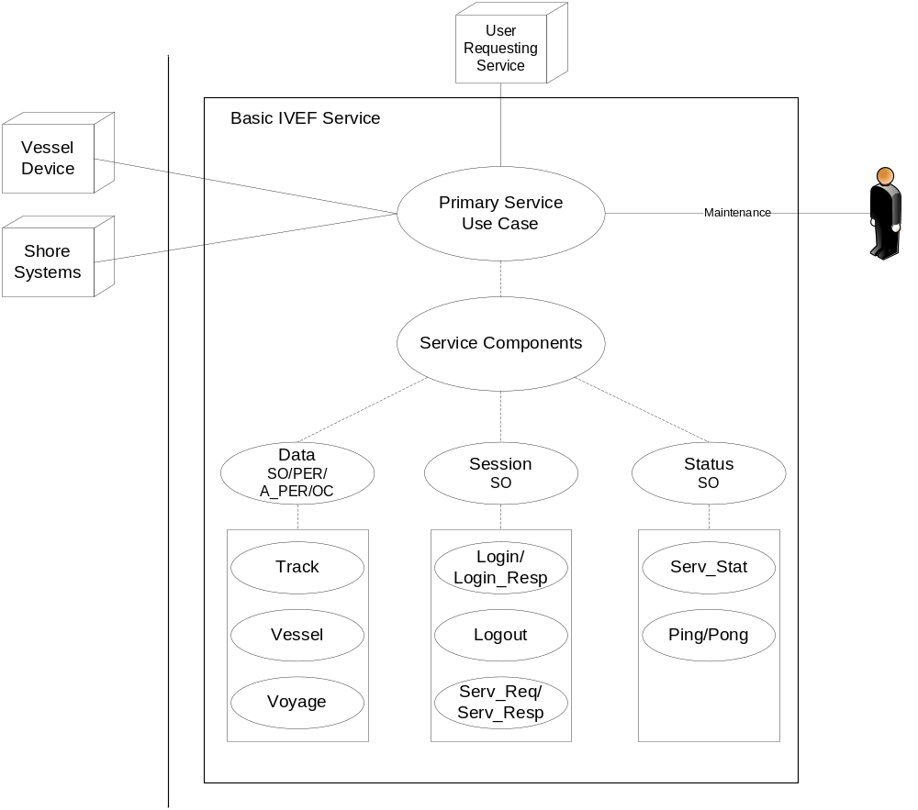
Figure 1: Overview of the primary service use cases of the IVEF Service

Note: The dotted lines indicate inheritance relationship.

The complete list of external BIS Components and their categories is given below:

BIS Components:

STATUS: Service Status
DATA: Object Data
SESSION: Session Management

BIS Transmission Category

SO: Single occurrence (non-realtime)
PER: Periodic, with a specified update rate (real-time)
A-PER: A-periodic, synchronous with the received track update (real-time)
OC: On change, updates are sent as data elements change

BIS Basic Service Data Elements:

LOGIN: Authentication request
LOGIN_RESP: Authentication response
LOGOUT: Service termination notification
SERV_REQ: Service request (category, area)
SERV_RESP: Service response
SERV_STAT: Service Status
PING: Alive request
PONG: Alive response
TRACK: Track data
VESSEL: Vessel data
VOYAGE: Voyage data
      - Service Component DATA

Service Model

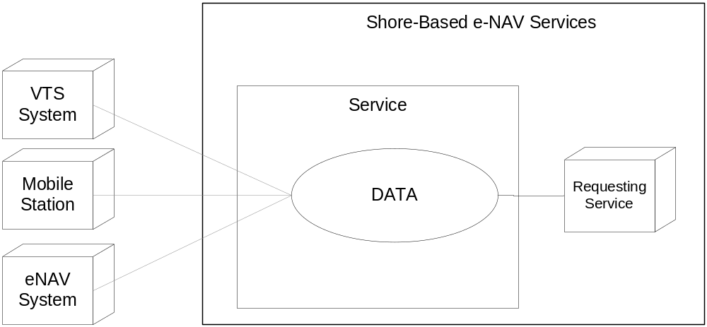
Figure 2: The DATA Service Component

Description

The DATA service component provides the following information:

- Object track information; generally dynamic information about an object such as present position and speed
- Optionally Object vessel data; more or less pertinent information about an object such as call sign, IMO number and object dimensions
- Optionally Voyage data; such as Destination, ETA,....

Service Data Structure

See appendix XXX

VESSEL: vessel data

Use:
- The vessel information is used to identify and classify ships.

Risks:

- The vessel information is obtained from several sources including manual entry onboard a ship or in a VTS system or from database systems. It is possible that this data may be incorrect.

Service Data Structure

See appendix XXX

Operating Characteristics
- The BIS shall start automatically upon logon confirmation
- The data will be sent depending on transmission category

TRACK: track data
Use:
- The track data combined with the data derived from VESSEL and, optionally, VOYAGE represents the actual traffic image.

Risks:
- The track data that is exchanged is the result multi-sensor fusion of various sensors. Sensor data is inherently noisy and subject to all kinds of disturbances, therefore the track represents the best effort representation of the true situation, but not necessary the true situation itself.

Service Data Structure

See appendix XXX

Operational Characteristics
- The BIS shall start automatically upon logon confirmation
- The data will be sent depending on transmission category

VOYAGE: Voyage-related data
Use:
- The voyage-related ship information is used to classify ships with regard to cargo, draught, destination and the route.

Risks:

- The voyage information is entered onboard a ship or in a VTS system and it is possible that this data may be incorrect;

- Information on the type of cargo provides only the classification of dangerous goods (Carrying DG, HS, or MP, IMO hazard or pollutant category A, B, C, D). This may not be sufficient in case of SAR/Pollution prevention.

Service Data Structure

See appendix XXX

Operational Characteristics

- The BIS shall start automatically upon logon confirmation
- The data will be sent depending on transmission category

      - Service Component SESSION

Service Model:

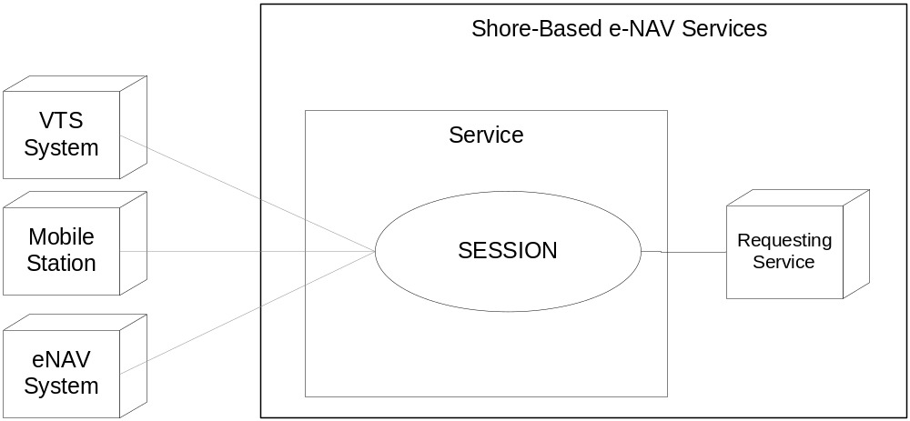
Figure 3: SESSION

Description
The SESSION service component is responsible for set-up, termination and terms-of-service negotiation.

LOGIN/LOGIN_RESP/LOGOUT
Use:
- A session is started by issuing a login request with the appropriate account details
- The account details are verified and the service responds with a login response granting or denying access to the service
- A session can be terminated by issuing a logout request

Risks

- Secured communication should be considered on the transport layer. IVEF provides only authentication support. Encryption and non repudiation must be established on transport layer using suitable technologies (VPN, https, ssl, direct lines…)

Service Data Structure

See appendix XXX

SERVICE_REQ/ SERVICE _RESP
Use:
- A service request is used to negotiate the terms-of-service, i.e. data content, area of interest and frequency of delivery;
- A service request is acknowledged by a service response. Once acknowledge it will replace the previous service request.

Risks

- A service request could lead to a data link overload. The client is responsible for issuing the service request that matches the available resources.
- The server could be overloaded by to many user requests. Proper mechanism should be applied.

Service Data Structure

See appendix XXX

      - Service Component STATUS

Service Model:

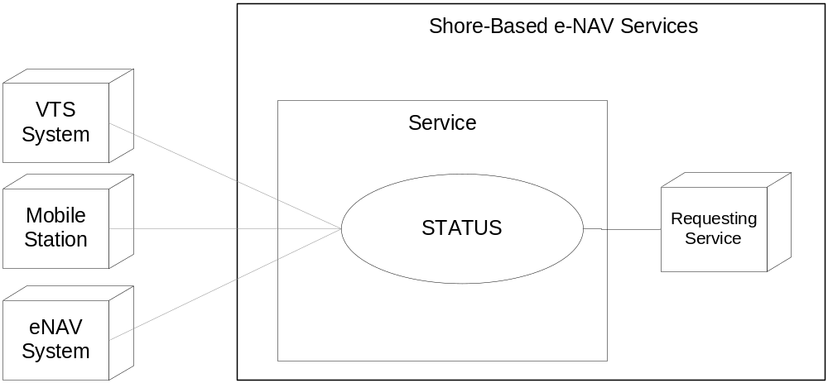
Figure 4: STATUS

Description
The STATUS service component provides service-related status information and maintains alive status

PING/PONG/SERV_STAT

Use:
- PING / PONG are messages exchanged at regular time intervals to verify alive status of the data link.
- SERV_STAT indicates the status of the server to the client (ok/not ok) with an optional description.

Risks

- No risks

Service Data Structure

See appendix XXX

    - Part II: Secondary service use cases of the BIS
      - LOCAL ADAPTATION

Use:
- The TAGGED_ITEM message can be used for non-standard, additional data exchange.

Risks

- Requires additional agreement between client side and server side.

Service Data Structure

See appendix XXX

  - Interfacing Model of the IVEF Service

The IVEF Service refers to the Presentation and Application layers as defined by the Open Systems Interconnection (OSI) Reference Model (International Standards Organization (ISO) Standard 7498)
1 – Physical Layer
2 – Data Link Layer
3 – Network Layer
4 – Transport Layer
5 – Session Layer
6 – Presentation Layer
7 – Application Layer
Figure 5: OSI Model

The definition of the lower telecommunication support layers is out of the scope of the IVEF Service. Transmission of IVEF coded vessel traffic image can make use of any available communication medium, for instance a packet switched Wide Area Network (WAN) as well as a Local Area Network (LAN).

The lower telecommunication protocol levels should be agreed between the partners of the data exchange, taking into account specific requirements with respect to reliability, security, latency etc.

In order to ease the exchange of data between different systems (e.g. potential network interconnection) it is advisable to apply standard telecommunication protocols (e.g. TCP/IP).

The IVEF Service uses XML (W3C, XML 1.1) as a Presentation protocol and defines the structure of the data to be exchanged over the communication medium.

  - Quality Parameters of the IVEF Service
The quality parameters of the IVEF Service depend on the intended use of the service: is it a real-time service, suitable for Vessel Traffic Services, or a near-realtime or non-realtime monitoring service that is regularly updated?

An important assumption of the service is that the server and client systems operate with a common time reference. Therefore it is recommended to use a time service that provides UTC time, e.g. based on GNSS or internet time servers (NTP), at both the server and client.

A possible application of the IVEF Service is the provision of monitoring data to a stakeholder, for example a ship owner that wants to have information on his fleet. In such a case, only the relevant data will be delivered; everything else will be filtered out. Also the update rate will be fairly low, say in the order of a few messages per hour. Furthermore, neither availability of the service nor message delays are critical issues.

Although the IVEF Service is a one-way service (from server to client), a common operational scenario, where VTSs are involved, is a mutual service, where each VTS provides data to the other (figure XXX).
In such a scenario, three areas are considered
Domain of Interest (DoI) – the geographical area which is of interest to a particular VTS centre. In general, this is the total sensor coverage area
Domain of Responsibility (DoR) – the area for which the VTS centre is mandated to provide their VTS service, i.e. a Information Service, Traffic Organisation Service or Navigational Assistance Service.
Domain of Cooperation (DoC) – a subarea within the cross-section of the DoIs of the two VTSs where special processing is done to guarantee continuity of position, speed and course of objects.
In order to use the concept of the DoC, additional functionality is required in both VTSs.
This additional functionality consists of
- the capability of associating multiple tracks to a single object, i.e. in the DoC, both systems will have a track and these tracks must be correlated to the same physical object, for instance via matching position and speed, or some other method.
- the capability of smoothing out differences between the correlated tracks for the same object. The recommended processing to guarantee continuity across the Domain of Cooperation is to use a weighted average of the track states (see figure XXX).

In such a scenario, there should be a mutual agreement between the VTSs involved about the quality of service. This agreement should address
- availability and timeliness of the IVEF Service,
- emergency/breakdown procedures, if applicable,
- integrity of the VTS data delivered. This also concerns possible filtering of the data, for instance for commercial reasons.

A more complicated use case is where there are multiple providers of an IVEF Service to a common authority. The common authority is responsible for further distribution of the data to recognised data users. This means that the common authority is also responsible for validation of these users. In this case, there will be agreements between the common authority and the IVEF Service providers, but also between the common authority and the recognised data users. Obviously, the quality aspects in these agreements may be quite different, depending on the intended use of the data.
  - Test model of the IVEF Service

    - Well formed messages
Each IVEF Service Message must comply with the W3C XML specification. This specification defines an XML document as a text which is well-formed, i.e., it satisfies a list of syntax rules provided in the specification. The list is fairly lengthy; some key points are:

- It contains only properly-encoded legal Unicode characters.
- None of the special syntax characters such as "<" and "&" appear except when performing their markup-delineation roles.
- The begin, end, and empty-element tags which delimit the elements are correctly nested, with none missing and none overlapping.
- The element tags are case-sensitive; the beginning and end tags must match exactly.
- There is a single "root" element which contains all the other elements.

    - Valid messages
In addition to being well-formed, an IVEF Service Message must also be valid. This means that data elements and attributes must comply with the definition as specified in Appendix XXX. In addition the values must adhere to minima, maxima, length, precision etc. as specified in Appendix XXX.

    - Valid data
like all track numbers should be unique? Schema tron?????

    - Interaction behaviour
A login should be answered by a login response, ping/pong, service req/resp, object data etc.
Perhaps add a UML Activity graph like:

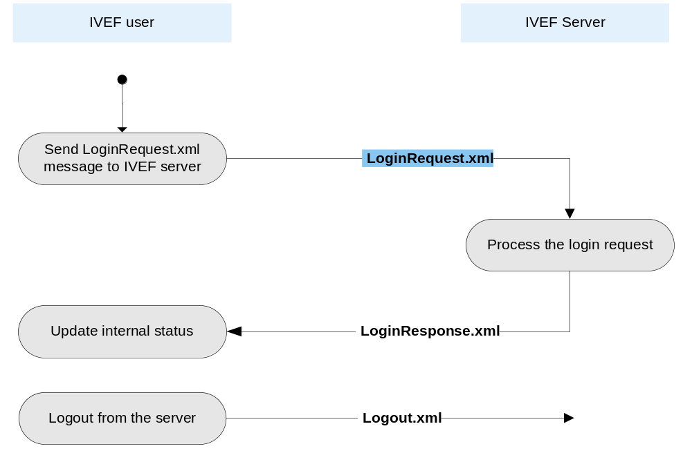

  - Administration model of the IVEF Service
Service and user definition. Maintenance

- Definitions

Object – a vessel, an Aid-to-Navigation or a helicopter (SAR)
Gateway Service – a generic type of service as defined in Reference [201]

- Abbreviations
BIS – Basic IVEF Service
IVEF – Inter-system Vessel traffic image Exchange Format
ISO/OSI – The International Standards Organisation
SAR – Search and Rescue
TIE – Traffic Image Exchange

“Regional” in the context of this Recommendation is seen from a global perspective, i.e. a region could be a continent or a substantial part of a continent. E. g. the Baltic Sea as a whole is a region in this regard.
Please note that x, x1, x2 and x3 shall be specified in Longitude coordinates and that y, y1, y2 and y3 shall be specified as Latitude coordinates.
e.g. in an overload situation the server may drop messages, in this situation the Service Status message is sent to the client to make him aware of lost information.
Depending on the transport layer (e.g. SCTP), and receiver activity, the sender may detect the connection state of the receiver automatically. In this case the Ping message is not required.

