
IALA Recommendation
####

On

the Inter-VTS Exchange Format (IVEF) Service

Edition No. 1

September 2010

AISM Association Internationale de Signalisation Maritime IALA
International Association of Marine Aids to Navigation and Lighthouse Authorities
20ter, rue Schnapper, 78100
Saint Germain en Laye, France
Telephone: +33 1 34 51 70 01 Fax: +33 1 34 51 82 05
e-mail: iala-aism@wanadoo.fr Internet: www.iala-aism.org

Document Revisions
Revisions to the IALA Document are to be noted in the table prior to the issue of a revised document.
Date | Page / Section Revised | Requirement for Revision
10 May 2010 | New document | First draft for review
7 June 2010 | Figures, editorial | Updated according to comments of IVEF group members. Reformatted Annex describing the xsd

IALA Recommendation on the Inter-VTS Exchange Format (IVEF) Service
(Recommendation ####)

THE COUNCIL:
RECALLING that one of the aims of the Association is to foster safe, economic and efficient movement of vessels and the protection of the marine environment through the improvement and harmonisation of aids to navigation, vessel traffic services and other means world-wide;
NOTING
- IALA Recommendation eNAV 140 on “The e-Navigation Architecture – the Initial Shore-based Perspective” [1],
- IMO’s strategic plan regarding e-Navigation [2],
- that IMO expressed an interest in the contribution of IALA to the work on e-Navigation [3];
RECOGNISING that the e-Navigation architecture will assist in the development and maintenance of application interactions between ship and shore and shore to shore, in the following fields
- shore-based technical e-Navigation services,
- technical means for communication,
- data modelling and referential data,
- Human-Machine Interface presentations;
RECOGNISING ALSO the responsibilities of IALA National Members regarding national and international e-Navigation applications
- that the shore-based e-Navigation systems of National Members are embedded into local, regional, national, supra-national and global topologies of systems,
- that there are data/information flow chains within the local, regional, national, supra-national and global topologies of systems which support local, regional, national, supra-national and global e-Navigation applications,
- that requirements regarding quality parameters, such as accuracy, reliability, continuity, confidentiality, and others, will need to be taken into account when designing elements of the common shore-based e-Navigation system architecture;
RECOGNISING FURTHER that the Inter-VTS Exchange Format (IVEF) service, as laid out in this Recommendation, will assist in the efficient deployment of services to the mariner and to the maritime community by
- allowing shore-based systems of National Member and other appropriate Authorities and Entities to participate in harmonised data exchange;
- easing the integration of components;
- improving the efficiency in organisational terms by exploiting commonalities;
- harmonising data exchange to systems of other shore-based stakeholders (local, regional, national and global);
- taking into account the value, timeliness and sensitivity of data.
RECOMMENDS that National Members and other appropriate Authorities and Entities, introducing an IVEF Service into their shore infrastructure, take into account the principles as set out in the annex to this recommendation.

Table of Contents
1 Introduction 7
2 The IVEF Service as described by other IALA Recommendations 8
3 Service Model of the IVEF Service 8
3.1 Overview 8
3.2 Capabilities of the IVEF Service for the Shore-based e-Navigation System 9
3.2.1 Introduction 9
3.2.2 Basic IVEF Services (BIS) 10
3.2.3 General Use Cases 10
3.3 Data Model of the IVEF Service 11
3.3.1 Introduction 11
3.3.2 The Place of the IVEF Service in the e-Navigation Architecture 11
3.4 Interaction Model of the IVEF Service 12
3.4.1 Context 12
3.4.2 Service Negotiation 13
3.4.3 Part I: Primary service use cases of the BIS 16
3.4.4 Part II: Secondary service use cases of the BIS 22
3.5 Security Model of the IVEF Service 22
3.6 Interfacing Model of the IVEF Service 23
3.7 Quality Parameters of the IVEF Service 23
3.8 Test model of the IVEF Service 25
3.8.1 Well formed messages 25
3.8.2 Valid messages 26
3.8.3 Valid data 26
3.8.4 Interaction behaviour 26
3.9 Administration Model of the IVEF Service 26
4 References 27
5 Definitions 27
6 Abbreviations 27
7 Appendix: Data Definition 28
7.1 Element Definitions 28
7.2 Attribute Definitions 45

Index of Tables
Table 1: Interface Messages 15

Index of Figures
Figure 1 The IVEF Service in Operation 7
Figure 2 The IVEF Service Client/Server Model 8
Figure 3 The IVEF Service Model 9
Figure 4 IVEF Service Primary Use Case 10
Figure 5 The Place of the IVEF Service within the e-Navigation architecture 11
Figure 6 Client-server relationships of the IVEF Service with other shore-based e-Navigation services 12
Figure 7 The Communications Stack 13
Figure 8 Overview of the primary service use cases of the IVEF Service 17
Figure 9 The DATA Service Component 18
Figure 10 The Session Service Component 20
Figure 11 The Status Service Component 21
Figure 12 The ISO/OSI Reference Model 23
Figure 13 Domains of Interest, Responsibility and Cooperation 24
Figure 14 IVEF Service using a Common Authority 25
Figure 15 Login/Logout Activity Graph 26

Annex – the Inter-VTS Exchange Format (IVEF) Service
- Introduction
The IVEF Service is intended to provide a common framework for the exchange of vessel traffic image information between shore-based e-Navigation systems, such as VTS systems, e-Navigation stakeholders and relevant external parties.
Figure 1 shows such a situation, where VTS centres share information about the common operational area and also to relevant other users and authorities.

Figure 1 The IVEF Service in Operation
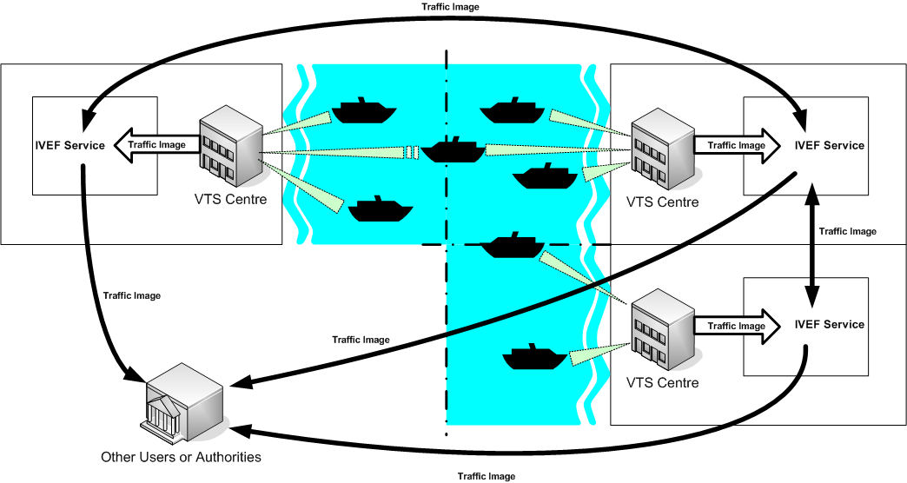

The IVEF Service is client/server-based. Clients make a connection to a server, running the IVEF Service and receive traffic image data according to their specific preferences and authorisations (Figure 2). Different clients may specify different data requirements, such as the area of interest, the update frequency and the particular traffic objects that are relevant to them. Based on the client credentials, the IVEF Service will enforce restrictions on the data that is being served to the client. These restrictions can be specified by the data provider.

Figure 2 The IVEF Service Client/Server Model
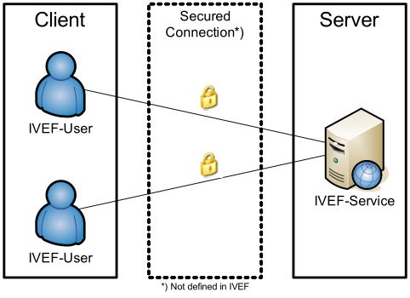

- The IVEF Service as described by other IALA Recommendations
The IVEF Service is a gateway service, as contained in the general description of the common shore-based system architecture in the “IALA Recommendation on Shore-based e-Navigation System Architecture” [see reference 1]. Such a gateway service is specialised in data exchange shore-to-shore. It interfaces to other e-Navigation systems and to external systems of “third parties”. These systems may request the IVEF service to forward relevant data to them. A IVEF service can interface shore-based systems locally, nationally, regionally, and globally.
- Service Model of the IVEF Service
  - Overview
The IVEF Service specification is organised according to the (draft) “IALA Recommendation on Generic e-Navigation Service Engineering Model Template” [reference 1] as depicted in Figure 3.

Figure 3 The IVEF Service Model
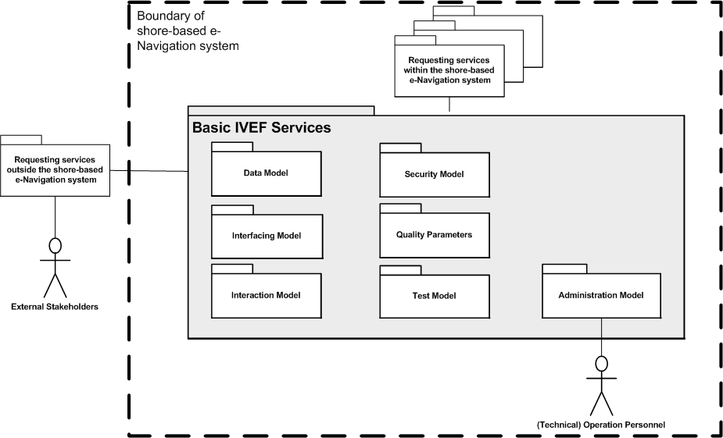

The specification contains exactly those elements that are relevant for a full description of the service. The following is a brief description of these elements:

Basic IVEF Services: capabilities of the IVEF Service and its functional interface statements.
Data Model: the abstract descriptions of the data provided by the IVEF Service at its Basic IVEF Services to shore-based e-Navigation systems and external systems. It defines the data types and data objects of the IVEF Service.
Interaction Model: the dynamics of the interaction of individual components of the IVEF Service (data flow and protocol).
Interfacing Model: the data encoding and interface protocols between the provider of the IVEF Service and the clients, requesting data from the service.
Security Model: control of access to the IVEF Service (filtering and access rights).
Quality Parameters: performance and reliability considerations of the IVEF Service.
Test Model: test and validation of the IVEF service.
Administration Model: the technical administration and maintenance aspects of the IVEF Service.
A full description of all these aspects follows in the remainder of this document.
  - Capabilities of the IVEF Service for the Shore-based e-Navigation System
    - Introduction
The IVEF Service is an optional part of a shore-based e-Navigation system. Its basic purpose is to provide a vessel traffic image to related vessel traffic service systems, to e-Navigation stakeholders and to relevant external parties. Any IVEF Service provides, at least, the so-called Basic IVEF Services (BIS). A particular characteristic of the IVEF Service is that these services are only rendered on request of another e-Navigation system or of an external system, i.e. the IVEF Service follows the client/server model as already described in the introduction of this specification (Figure 3).

    - Basic IVEF Services (BIS)
There is only one basic IVEF service, which is

Vessel Traffic Image Data Exchange Service – deliver vessel traffic situation data, according to a specific service profile. Such a service profile determines e.g. the data items delivered, the area of interest and the update rate.

The IVEF Service is part of the e-Navigation Client/Server-based architecture. A general way of describing communication architectures is via the ISO/OSI reference model [reference 3], which describes communication between applications through a layered model. Each higher-level layer in this model increases the level of abstraction. The communication between client and server is described here at the so-called “application layer” in the reference model. The implementation of the lower layers is not discussed here. It is only suggested to use a secured and reliable link between the client and server.

    - General Use Cases
Figure 4 IVEF Service Primary Use Case
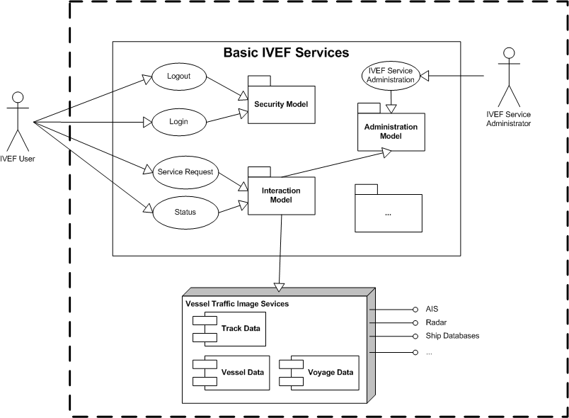

  - Data Model of the IVEF Service
    - Introduction
The Data Model of the IVEF Service is intended to be part of the IALA Universal Maritime Data Model (IALA UMDM), as described in [reference 1]. It provides the well-structured and abstract (functional) description of the data that is exchanged through the IVEF Service.

The Data Model itself does not contain data encoding information which is required to create an actual implementation of the service. Separating the data encoding from the Data Model of the IVEF Service provides flexibility in selecting an encoding technique as deemed appropriate by the competent authority. A portfolio of suitable encoding techniques for data objects of the IVEF Service is given in section 3.6 on the Interfacing Model.
    - The Place of the IVEF Service in the e-Navigation Architecture
Figure 5 illustrates the place of the IVEF Service in the e-Navigation architecture as described by IALA Recommendation on the e-Navigation Architecture – the Shore Perspective [reference 1]. It clearly identifies the co-operative nature of the shore-based IVEF Service. Note that the IVEF Service shares the dependencies of the e-Navigation architecture.

Figure 5 The Place of the IVEF Service within the e-Navigation architecture

Shore-based e-Navigation system

IVEF
Service
VTS 1
Integrated
Bridge

Wireless
Communication
Ship’s
sensors
Shipboard
Applications

Sensor
Data

VTS
Application 2
Application 3
Application 4
There may be many client-server-relationships, since the “gateway services” of the shore-based e-Navigation system may be requested by other e-Navigation services within that system, there can be identified. These client-server-relationships can be combined into a hierarchy within the shore-based e-Navigation system (see Figure 6).

Figure 6 Client-server relationships of the IVEF Service with other shore-based e-Navigation services
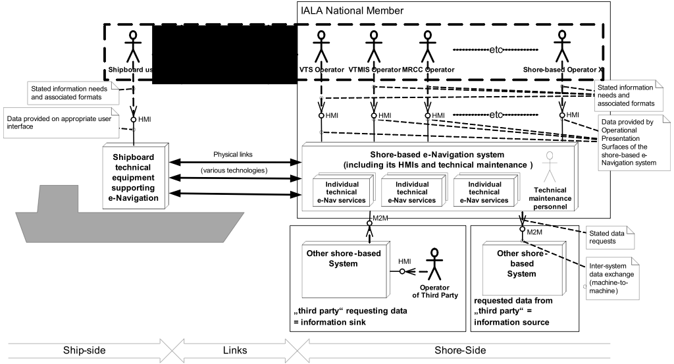

  - Interaction Model of the IVEF Service
    - Context
IVEF Service Interfaces are point-to-point connections between e-Navigation Gateways. One Gateway acts as an information source whereas the other Gateway acts as an information sink. The IVEF Service

Note that the IVEF Service by itself has no provisions for data compression and encryption. IVEF describes the data exchange format between eNAV applications; it relies on transport layers underneath to convert between physical, electrical and network interfaces. Additional transport layers may add data compression and encryption, depending on the system requirements (see Figure 7).

Figure 7 The Communications Stack
eNav Gateway
Information Source
eNav Gateway
Information Sink
IVEF
Service
IVEF
Client
Compression
e.g. ZLIB
Decompression

Encryption
e.g. TLS/SSL
Decryption
Transport
e.g. TCP/IP

The justification for this approach is the fact that these transport layers are already well-defined and standardised. Furthermore, standard compression and encryption algorithms are readily available.

Recommended layers (at this time) are TCP/IP for transport, TLS [reference 5] or SSL [reference 5] for encryption and ZLIB [reference 7] for compression.

    - Service Negotiation
The IVEF interface is a service based protocol. This means that the data exchange between the parties is not pre-defined, but rather the result of a negotiation between the information provider and the information consumer.
      - Introduction
When a client (an eNav Gateway acting as an information sink) wants to connect to server (an eNav Gateway acting as an information source), it has to initiate the service by authenticating. To do this, the client sends a Login message to the server, the server validates the login requests and if correct, it sends a LoginResponse message. The server initiates the default service for that particular user. An example of a service is:

“using an interval of 10 seconds, output all position information and voyage information about all vessels that are within in the following area ( x,y ) – ( x1,y1 ) – ( x2, y2 ) – ( x3,y3)”1

After the client is logged on, the server starts outputting the traffic image that matches the specification in the service.

The client can also sent a ServiceRequest to terminate or change the active service. Services can be defined with different transmission characteristics, which allows of a server push or client pull of the information, or a combination.
      - Service parameters
A service is defined by a number of parameters:

- Object Selection, which objects should be sent?
  - Area based
  - Filter based on the object properties (e.g. length > 50 m)
- Item Selection, which information elements should be sent?
  - Track Information
  - Vessel Information
  - Voyage Information
- Transmission Selection, when should it be sent?
  - Single Occurrence (Pull)
  - Periodic, with specified update rate (Push)
  - A-Periodic, synchronous with update (Push)

      - Information flow dynamics
The interface supports the following messages; the contents and meaning of the messages mentioned below are covered in chapter.

Table 1: Interface Messages
Message | From | To | Description
Control Information Messages
Login | Client | Server | This message is used to identify the client
Login Response | Server | Client | Login accepted or refused, if refused a reason will be supplied
Logout | Client | Server | This message is used to terminate the IVEF Service
Ping | Both | Both | Heartbeat message
Pong | Both | Both | Response to a Heartbeat message
Service Request | Client | Server | This message contains the definition of the service requested by the client. It will replace the current service.
Service Request Response | Server | Client | Request accepted or refused, if refused a reason will be supplied
Service Status | Server | Client | This message will be sent by the server to indicate the status of the service.
Real Time Messages
Object Data | Server | User | The track, vessel- and voyage related data of objects in the traffic image.

      - Timing and priorities
Control Information Messages have a higher priority than Real-Time Messages. This means that in an overload situation, Object Data Messages may be dropped in favour of Control Information Messages.

The service must start with a login message. The server will terminate the connection on transport layer when any other message is received, in order to prevent a possible Denial-of-Service (DoS) by mis-configured or malicious clients. If a service is interrupted at transport level, both server- and client sides will terminate the session and the client must login again to regain access to the service.

Messages, sent as a response to another message (LoginResponse, ServiceRequestReponse and Pong), must be responded to within agreed-upon period (e.g. 4 seconds). If the response message is not received within a specified timeout period, the sender may retry sending the message before terminating the service.

Ping messages must be sent when the sender has no other means to detect whether the receiver is still connected. The Ping message must be sent after an agreed-upon period of inactivity.

    - Part I: Primary service use cases of the BIS
The primary service use cases all have in common, that they are justified by at least one interaction with a “requesting service” within the common eNAV system architecture: The “requesting service” is any other service of the common shore-based e-Navigation system architecture making a request (logon) to the BIS in the previous chapter.

Figure 8 Overview of the primary service use cases of the IVEF Service
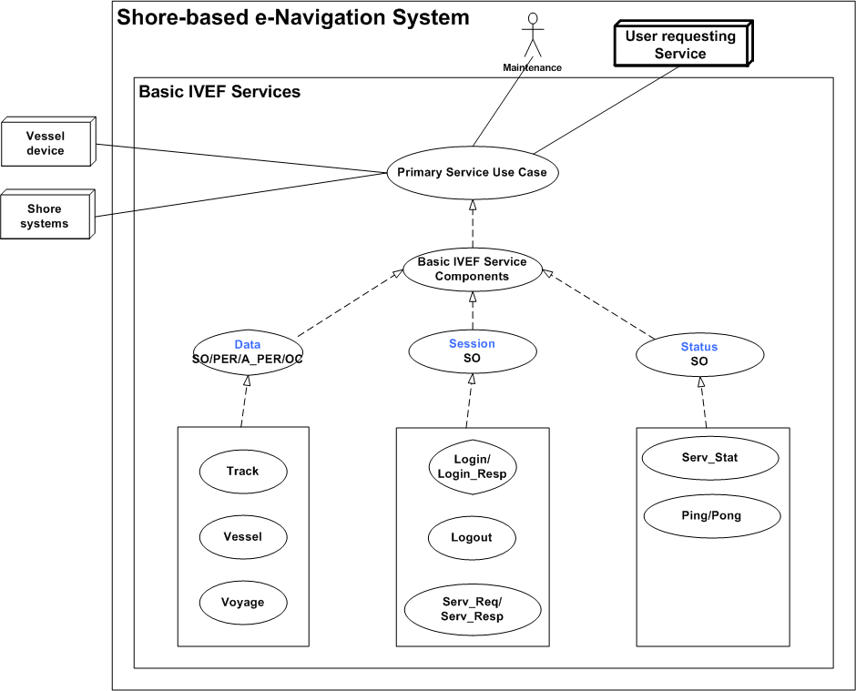
Note: The dotted lines indicate inheritance relationship.

The complete list of external BIS Components and their categories is given below:

BIS Components:

STATUS: | Service Status
DATA: | Object Data
SESSION: | Session Management

BIS Transmission Category

SO: | Single occurrence (non-realtime)
PER: | Periodic, with a specified update rate (real-time)
A-PER: | A-periodic, synchronous with the received track update (real-time)
OC: | On change, updates are sent as data elements change

BIS Basic Service Data Elements:

LOGIN: | Authentication request
LOGIN_RESP: | Authentication response
LOGOUT: | Service termination notification
SERV_REQ: | Service request (category, area)
SERV_RESP: | Service response
SERV_STAT: | Service Status
PING: | Alive request
PONG: | Alive response
TRACK: | Track data
VESSEL: | Vessel data
VOYAGE: | Voyage data

      - Service Component DATA

Service Model

Figure 9 The DATA Service Component
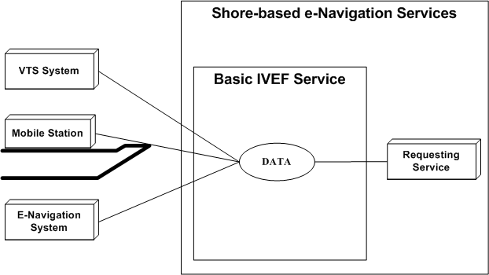

Description

The DATA service component provides the following information:

- Object track information; generally dynamic information about an object such as present position and speed
- Optionally Object vessel data; more or less pertinent information about an object such as call sign, IMO number and object dimensions
- Optionally Voyage data; such as Destination, ETA,....

Service Data Structure

See section 7

VESSEL: Vessel Data

Use:
- The vessel information is used to identify and classify ships.

Risks:

- The vessel information is obtained from several sources including manual entry onboard a ship or in a VTS system or from database systems. It is possible that this data may be incorrect.

Service Data Structure

See section 7

Operating Characteristics

- The BIS shall start automatically upon logon confirmation
- The data will be sent depending on transmission category

TRACK: Track Data
Use:
- The track data combined with the data derived from VESSEL and, optionally, VOYAGE represents the actual traffic image.

Risks:
- The track data that is exchanged is the result multi-sensor fusion of various sensors. Sensor data is inherently noisy and subject to all kinds of disturbances, therefore the track represents the best effort representation of the true situation, but not necessary the true situation itself.

Service Data Structure

See section 7

Operational Characteristics
- The BIS shall start automatically upon logon confirmation
- The data will be sent depending on transmission category

VOYAGE: Voyage-related Data
Use:
- The voyage-related ship information is used to classify ships with regard to cargo, draught, destination and the route.

Risks:

- The voyage information is entered onboard a ship or in a VTS system and it is possible that this data may be incorrect;

- Information on the type of cargo provides only the classification of dangerous goods (Carrying DG, HS, or MP, IMO hazard or pollutant category A, B, C, D). This may not be sufficient in case of SAR/Pollution prevention.

Service Data Structure

See section 7

Operational Characteristics

- The BIS shall start automatically upon logon confirmation
- The data will be sent depending on transmission category

      - Service Component SESSION

Service Model

Figure 10 The Session Service Component
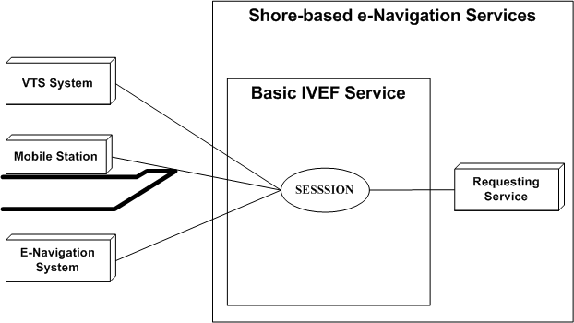

Description
The SESSION service component is responsible for set-up, termination and terms-of-service negotiation.

LOGIN/LOGIN_RESP/LOGOUT
Use:
- A session is started by issuing a login request with the appropriate account details
- The account details are verified and the service responds with a login response granting or denying access to the service
A session can be terminated by issuing a logout request

Risks

- Secured communication should be considered on the transport layer. IVEF provides only authentication support. Encryption and non repudiation must be established on transport layer using suitable technologies (VPN, https, ssl, direct lines…)

Service Data Structure

See section 7

SERVICE_REQ/ SERVICE _RESP
Use:
- A service request is used to negotiate the terms-of-service, i.e. data content, area of interest and frequency of delivery;
- A service request is acknowledged by a service response. Once acknowledge it will replace the previous service request.

Risks

- A service request could lead to a data link overload. The client is responsible for issuing the service request that matches the available resources.
- The server could be overloaded by to many user requests. Proper mechanism should be applied.

Service Data Structure

See section 7
      - Service Component STATUS

Service Model

Figure 11 The Status Service Component
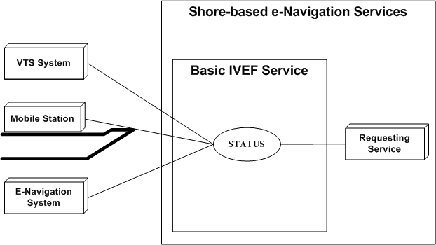

Description
The STATUS service component provides service-related status information and maintains alive status

PING/PONG/SERV_STAT

Use:
- PING / PONG are messages exchanged at regular time intervals to verify alive status of the data link.
- SERV_STAT indicates the status of the server to the client (ok/not ok) with an optional description.

Risks

- No risks

Service Data Structure

See section 7

    - Part II: Secondary service use cases of the BIS
      - LOCAL ADAPTATION

Use:
- The TAGGED_ITEM message can be used for non-standard, additional data exchange.

Risks

- Requires additional agreement between client side and server side.

Service Data Structure

See section 7
  - Security Model of the IVEF Service
The security model concerns the following aspects of the service

- Authentication – this concerns both clients of the service and providers of the service,
- Authorisation – this concerns the clients of the service,
- Data protection – this concerns the data that is being exchanged,
- Physical security – this concerns access to the server- and client systems and the interconnecting network.

The security model of the Basic IVEF Service adresses only the first two items, i.e. authentication and authorisation. The latter two items are outside the scope of this document. For data protection, suitable encryption methods can be defined at communication link-level (see section 3.4) or by providing a, so-called, Virtual Private Network (VPN) for clients.

The IVEF service is usually strictly contained within a shore-based e-Navigation system. Hence, it is assumed that appropriate measures for safeguarding the physical security of the service have been taken at the system level.

The model that is chosen for authentication and authorisation is a simple one, based on a shared secret between client and server (such a shared secret is commonly refererred to as “password”). There is no specific authentication of the server (although this can arranged, e.g. by using SSL certificates) and knowledge of the shared secret is assumed to identify the client. Once the client has authenticated itself, a set of client-specific rules is enforced by the server to guarantee that only those data are sent to the client for which the client is authorised (see also section 3.9).

Note that the security model of the IVEF service is, in fact, independent of the traffic image exchange service and can easily be replaced by a more elaborate security model (e.g. based on certificates) if required.
  - Interfacing Model of the IVEF Service
The IVEF Service refers to the Presentation and Application layers as defined by the Open Systems Interconnection (OSI) Reference Model [reference 3].

Figure 12 The ISO/OSI Reference Model
1 – Physical Layer
2 – Data Link Layer
3 – Network Layer
4 – Transport Layer
5 – Session Layer
6 – Presentation Layer
7 – Application Layer

The definition of the lower-level telecommunication support layers is beyond the scope of the IVEF Service definition. Transmission of an IVEF-coded vessel traffic image can make use of any available communication medium, for instance a packet-switched Wide Area Network (WAN) or a Local Area Network (LAN).

The specific lower-level telecommunication protocol layers should be agreed upon by all partners of the data exchange, taking into account requirements such as data rates, reliability, security and latency.

In order to ease the exchange of data between different systems (e.g. potential network interconnection) it is advisable to apply standard telecommunication protocols (e.g. TCP/IP).

The IVEF Service uses XML [reference 3] as a Presentation Layer protocol and defines the structure of the data to be exchanged over the communication medium.
  - Quality Parameters of the IVEF Service
The quality parameters of the IVEF Service depend on the intended use of the service: is it a real-time service, suitable for Vessel Traffic Services, or a near-realtime or non-realtime monitoring service that is regularly updated?

An important assumption of the service is that the server and client systems operate with a common time reference. Therefore it is recommended to use a time service that provides UTC time, e.g. based on GNSS or internet time servers (NTP), at both the server and client.

A possible application of the IVEF Service is the provision of monitoring data to a stakeholder, for example a ship owner that wants to have information on his fleet. In such a case, only the relevant data will be delivered; everything else will be filtered out. Also the update rate will be fairly low, say in the order of a few messages per hour. Furthermore, neither availability of the service nor message delays are critical issues.
Figure 13 Domains of Interest, Responsibility and Cooperation
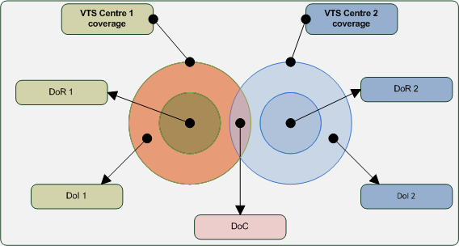

Although the IVEF Service is a one-way service (from server to client), a common operational scenario, where VTSs are involved, is a mutual service, where each VTS provides data to the other (Figure 1).
In such a scenario, three areas are considered
Domain of Interest (DoI) – the geographical area which is of interest to a particular VTS centre. In general, this is the total sensor coverage area
Domain of Responsibility (DoR) – the area for which the VTS centre is mandated to provide their VTS service, i.e. a Information Service, Traffic Organisation Service or Navigational Assistance Service.
Domain of Cooperation (DoC) – a subarea within the cross-section of the DoIs of the two VTSs where special processing is done to guarantee continuity of position, speed and course of objects.
In order to use the concept of the DoC, additional functionality is required in both VTSs.
This additional functionality consists of
- the capability of associating multiple tracks to a single object, i.e. in the DoC, both systems will have a track and these tracks must be correlated to the same physical object, for instance via matching position and speed, or some other method.
- the capability of smoothing out differences between the correlated tracks for the same object. The recommended processing to guarantee continuity across the Domain of Cooperation is to use a weighted average of the track states (see Figure 13).

In such a scenario, there should be a mutual agreement between the VTSs involved about the quality of service. This agreement should address
- availability and timeliness of the IVEF Service,
- emergency/breakdown procedures, if applicable,
- integrity of the VTS data delivered. This also concerns possible filtering of the data, for instance for commercial reasons.

A more complicated use case is where there are multiple providers of an IVEF Service to a common authority (Figure 14). The common authority is responsible for further distribution of the data to recognised data users. This means that the common authority is also responsible for validation of these users. In this case, there will be agreements between the common authority and the IVEF Service providers, but also between the common authority and the recognised data users. Obviously, the quality aspects in these agreements may be quite different, depending on the intended use of the data.
Figure 14 IVEF Service using a Common Authority
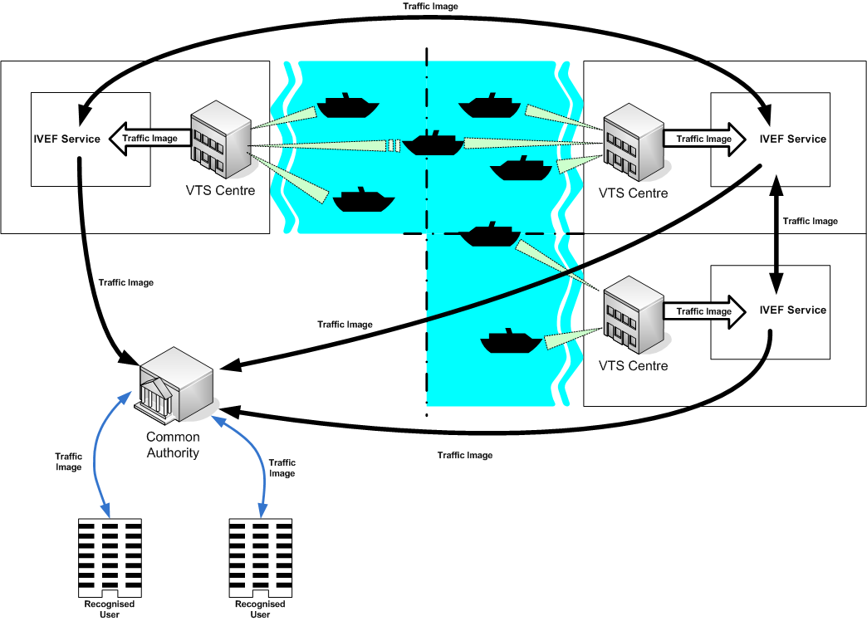
  - Test model of the IVEF Service
    - Well formed messages
Each IVEF Service Message must comply with the W3C XML specification [reference 3]. This specification defines an XML document as a text, which is well-formed, i.e., it satisfies a list of syntax rules provided in the specification. The list of rules is fairly lengthy; the most important rules are:

- A message contains only properly-encoded legal Unicode characters.
- None of the special syntax characters such as "<" and "&" appear except when performing their markup-delineation roles.
- The begin, end, and empty-element tags, which delimit the elements, are correctly nested, with none missing and none overlapping.
- The element tags are case-sensitive; the beginning and end tags must match exactly.
- There is a single "root" element, which contains all the other elements.

    - Valid messages
In addition to being well-formed, an IVEF Service Message must also be valid. This means that data elements and attributes must comply with the definition as specified in section 7. In addition, the values must adhere to minimum value, maximum value, length, precision etc., as specified in section 7.

    - Valid data
All track numbers, at any given time instant, should be unique.

    - Interaction behaviour
A login should be answered by a login response as indicated in Figure 15. The same holds, modus modendi, for ping/pong and service req/service respextively.

Figure 15 Login/Logout Activity Graph
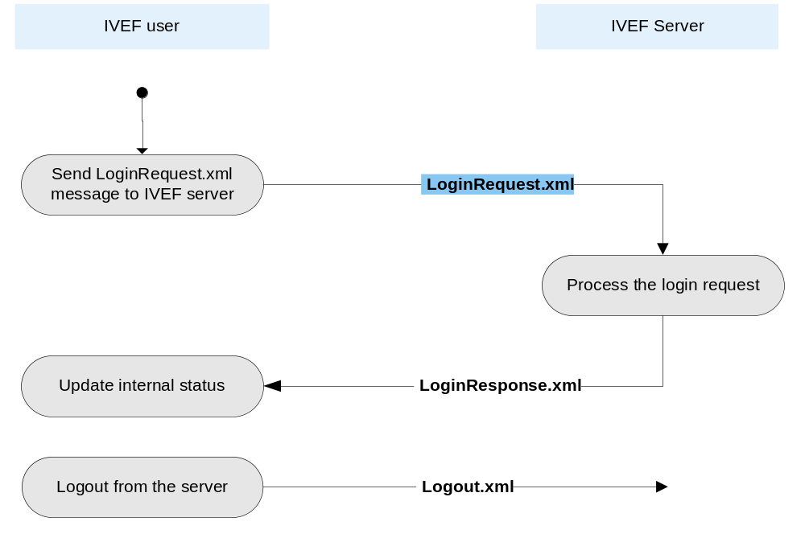

  - Administration Model of the IVEF Service
The Administration Model describes the aspects of the service that can be configured by service provider. For the IVEF Service, this concerns the maintenance of the user database. The user database contains the shared secret for each user and the user authorisations, i.e. the restrictions, that are enforced by the server, on the data that is provided to a particular user. Additionally, the user database may contain default services for each user. These default services may be adapted by the respective user or be left to the discreteness of the service provider.
Considering the complexity of the user database, it is strongly recommended to provide a graphical Human-Machine Interface (HMI) for this purpose.
- References
- IALA Recommendation on the e-Navigation Architecture – the Shore Perspective, IALA Recommendation eNAV-101
- Generic e-Navigation Service Engineering Model Template, (draft) IALA Recommendation eNAV-210, 2009
- Open Systems Interconnection (OSI) Reference Model, International Standards Organization (ISO) Standard 7498-1, 1994
- Extensible Markup Language (XML) 1.0 (Fifth Edition), W3C Recommendation 26 November 2008, http://www.w3.org/TR/2008/REC-xml-20081126/
- The Transport Layer Security (TLS) Protocol, Version 1.2, August 2008, http://www.ietf.org/rfc/rfc5246.txt
- The SSL Protocol, Version 3.0, November, 1996, http://www.mozilla.org/projects/security/pki/nss/ssl/draft302.txt
- ZLIB Compressed Data Format Specification, Version 3.3, May 1996, http://www.ietf.org/rfc/rfc1950.txt
- Definitions

Object – a vessel, an Aid-to-Navigation or a helicopter (SAR)
Gateway Service – a generic type of service, as defined in [reference 1]

- Abbreviations
BIS – Basic IVEF Services
DoC – Domain of Cooperation
DoI – Domain of Interest
DoR – Domain of Responsibility
DoS – Denial of Service
GNSS – Global Navigation Satellite System
HMI – Human-Machine Interface
IALA – International Association of Marine Aids to Navigation and Lighthouse Authorities
IALA UMDM – IALA Universal Maritime Data Model
IVEF – Inter-system Vessel traffic image Exchange Format
ISO – The International Standards Organisation
LAN – Local-Area Network
NTP – Network Time Protocol
OSI – Open Systems Interconnection
SAR – Search and Rescue
SSL – Secure Socket Layer
TCP/IP – Transmission Control Protocol/Internet Protocol
TIE – Traffic Image Exchange
UTC – Universal Time Coordinated
VTS – Vessel Traffic Services
W3C – World-Wide Web Consortium
WAN – Wide-Area Network
XML – eXtensible Markup Language
- Appendix: Data Definition
  - Element Definitions
Element MSG_IVEF
Annotations | Root MESSAGE
Diagram | 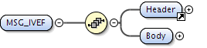
Children | Body, Header

Element Header
Annotations | HEADER part of every message with version and uniqueness information
Diagram | 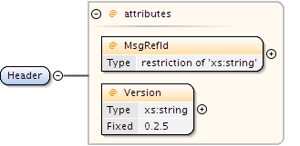
Used by
  Element | MSG_IVEF
Attributes
  Name | Use | Annotation
  MsgRefId | required | Must be an Universally Unique Identifier for each message (TU-T Rec. X.667 | ISO/IEC 9834-8.) Reply messages refer to this id to identify the message they are replying to. In its canonical form, a UUID consists of 32 hexadecimal digits, displayed in 5 groups separated by hyphens, in the form 8-4-4-4-12 for a total of 36 characters, enclosed by brackets. For example: {550e8400-e29b-41d4-a716-446655440000}
  Version | required | Defines the version of the protocol used. Syntax is major.minor.patch patch releases fix only bugs, minor releases may add functionality but are compatible, major releases are not compatible

Element MSG_IVEF / Body
Diagram | 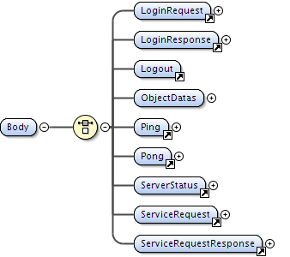
Children | LoginRequest, LoginResponse, Logout, ObjectDatas, Ping, Pong, ServerStatus, ServiceRequest, ServiceRequestResponse

Element LoginRequest
Annotations | DATA login message with details of the user
Diagram | 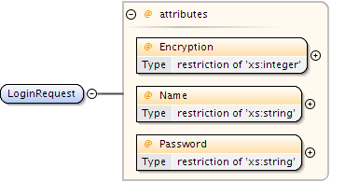
Used by
  Element | MSG_IVEF/Body
Attributes
  Name | Use | Annotation
  Encryption | required | 1 = plain 2 - 6 the 5 most common encryption 0 = custom
  Name | required | Login name
  Password | required | Password value

Element LoginResponse
Annotations | DATA login response with acceptance or deny with optional reason
Diagram | 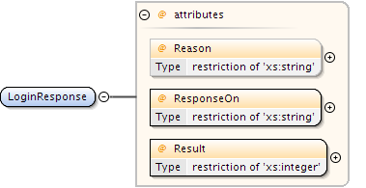
Used by
  Element | MSG_IVEF/Body
Attributes
  Name | Use | Annotation
  Reason | optional | String describing reason for declining, only used when result is "Declined"
  ResponseOn | required | Corresponds to the original MsgRefId from the Login.xml message. Must be an Universally Unique Identifier (TU-T Rec. X.667 | ISO/IEC 9834-8.)
  Result | required | 1 = Accepted 2 = Declined

Element Logout
Annotations | DATA logout message, the server will drop the connection if logout is successfull
Diagram
Used by
  Element | MSG_IVEF/Body

Element Body / MSG_IVEF / ObjectDatas
Diagram | 
Children | ObjectData

Element ObjectData
Annotations | DATA regarding an object in the supliers domain, contains at least 1 one of the sub elements (TrackData, VesselData, VoyageData)
Diagram | 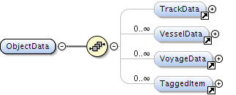
Used by
  Element | MSG_IVEF/Body/ObjectDatas
Children | TaggedItem, TrackData, VesselData, VoyageData

Element TrackData
Annotations | DATA describing a position report of an object
Diagram | 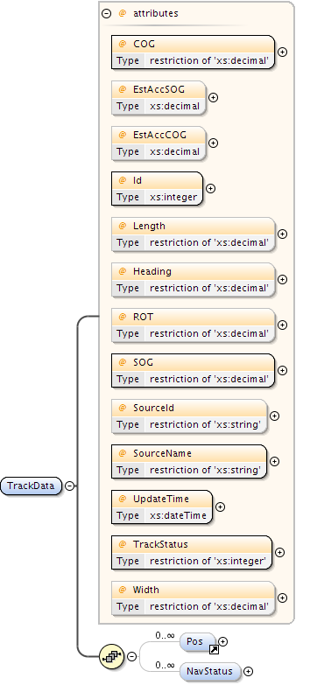
Used by
  Element | ObjectData
Children | NavStatus, Pos
Attributes
  Name | Use | Annotation
  COG | required | Course over ground in degrees. (0-360)
  EstAccCOG | optional | Estimated accuracy standard deviation of the calculated value expressed in degrees
  EstAccSOG | optional | Estimated accuracy standard deviation of the calculated value expressed in m/s
  Heading | optional | Heading of the target in degrees
  Id | required | The unique identification of this track. Valid from first message with TrackStatus!=Terminated to first message with TrackStatus=Terminated
  Length | optional | Measured length of the target in meter
  ROT | optional | Rate of turn in degrees per minute
  SOG | required | Speed over ground in meters per second
  SourceId | optional | Unique identification of the producer (UN/LOCODE) in case multiple producers exist on the same LOCODE, the local competent authority can optionally addended this with a local code (e.g. BE ANR 01 = Antwerp, 01)
  SourceName | required | Identification of the originator of the data
  TrackStatus | required | 1 = Updated, (sensors are updating the track) 2 = Coasted, (no sensor is updating the track) 3 = Dropped
  UpdateTime | required | Date and time in UTC format (YYYY-MM-DDThh:mm:ss.sssZ) (subset of ISO 8601) this position was measured.
  Width | optional | Measured Width of the target in meter

Element Pos
Annotations | DATA position measurement of the geometrical centre of the object or location
Diagram | 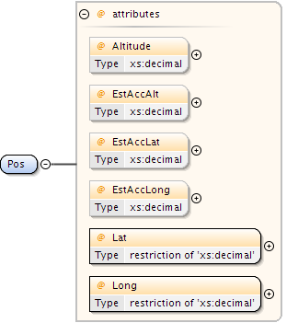
Used by
  Elements | Area, TrackData, VoyageData/Waypoint
Attributes
  Name | Use | Annotation
  Altitude | optional | The altitude of the target above the WGS-84 ellipsoid in meters
  EstAccAlt | optional | Estimated accuracy standard deviation of the calculated position of a target expressed in m
  EstAccLat | optional | Estimated accuracy standard deviation of the calculated position of a target expressed in m
  EstAccLong | optional | Estimated accuracy standard deviation of the calculated position of a target expressed in m
  Lat | required | Latitude (WGS84) in degrees. (+/- 90 degrees; North = positive; South = negative) Examples: -90deg (south) = -90.0000000 0deg0min1sec (north) = 0.0000016 50deg50min (north) = 50.8333333
  Long | required | Longitude (WGS84) in degrees. (+/- 180 degrees; East = positive; West = negative). Examples: -180deg (west) = -180.0000000 0deg0min1sec (east) = 0.0000016

Element TrackData / NavStatus
Diagram | 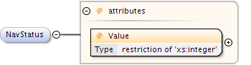
Attributes
  Name | Use | Annotation
  Value | required | Navigation status of the target 0 = under way using engine 1 = at anchor 2 = not under command 3 = restricted manoeuvrability 4 = constrained by her draught 5 = moored 6 = aground 7 = engaged in fishing 8 = under way sailing 9 = engaged in fishing other than trawling 10 = air-cushion vessel in non displacement mode or WIG craft taking off, landing or in flight 11 = power driven vessel towing astern 12 = power driven vessel pushing ahead or towing alongside 13 = in distress or requiring assistance 14 = AIS SART, seeking to attract attention 15 = undefined default

Element VesselData
Annotations | DATA regarding static elements of an object
Diagram | 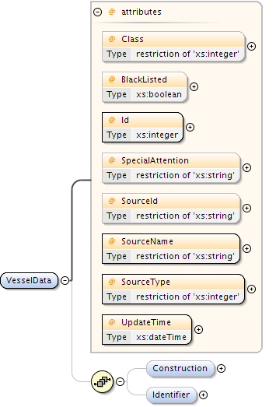
Used by
  Element | ObjectData
Children | Construction, Identifier
Attributes
  Name | Use | Annotation
  BlackListed | optional | Vessel is blacklisted by a NCA
  Class | optional | 0 = Unknown 1 = Vessel 2 = Aids to Navigate
  Id | required | The unique identification of this vesseldata. Valid from first message with TrackStatus!=Terminated to first message with TrackStatus=Terminated
  SourceId | optional | Unique identification of the producer (UN/LOCODE) in case multiple producers exist on the same LOCODE, the local competent authority can optionally addended this with a local code (e.g. BE ANR 01 = Antwerp, 01)
  SourceName | required | Identification of the originator of the data
  SourceType | required | Source/originator type: 0 = Unknown, 1 = Transponder, 2 = Database (VTS Plan Server), 3 = Manual (VTS Officer), 4 = Fused, 5 = External Source
  SpecialAttention | optional | Vessel is under special attention of the NCA or fairway authorities
  UpdateTime | required | Date and time in UTC format (YYYY-MM-DDThh:mm:ss.sssZ) (subset of ISO 8601) this data was compiled

Element VesselData / Construction
Annotations | attributes of the object regarding the physical construction
Diagram | 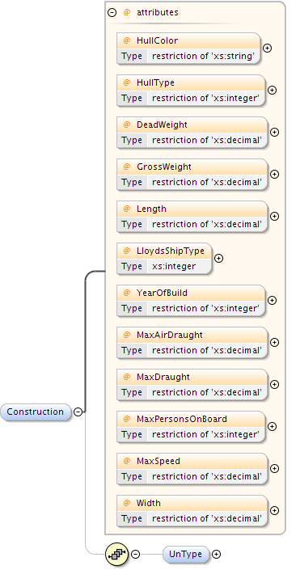
Children | UnType
Attributes
  Name | Use | Annotation
  DeadWeight | optional | Dead weight in tons
  GrossWeight | optional | Gross weight in tons
  HullColor | optional | Color of Hull (in RGB hex) for SAR operations
  HullType | optional | Type of hull (1 = single, 2 = double, 3 = triple)
  Length | optional | The overall length of the target in meter as confirmed by NCA
  LloydsShipType | optional | Number indicating type of vessel
  MaxAirDraught | optional | Maximum air draught of the object in meters, to be used if voyage data is not available
  MaxDraught | optional | Maximum draught of the object in meters, to be used if voyage data is not available
  MaxPersonsOnBoard | optional | The maximum number of persons on board of the object (crew, support, passengers, pilots)
  MaxSpeed | optional | The maximum speed the object is able to sustain with normal draft and load
  Width | optional | Overall width of the target in meter as confirmed by the NCA
  YearOfBuild | optional | The year the vessel was build in 4 digits e.g. 2010

Element Construction / VesselData / UnType
Annotations | Object type according to CODES FOR TYPES OF MEANS OF TRANSPORT Revision 2 (UNECE CEFACT Trade Facilitation Recommendation No. 28 edition 2007)
Diagram | 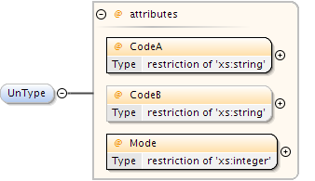
Attributes
  Name | Use | Annotation
  CodeA | required
  CodeB | optional
  Mode | required

Element VesselData / Identifier
Annotations | (local) Identification of vessel
Diagram | 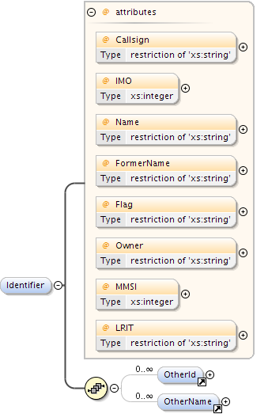
Children | OtherId, OtherName
Attributes
  Name | Use | Annotation
  Callsign | optional | Callsign of the target, in accordance with Article 19, Section III of the ITU Radio Regulations (RR)
  Flag | optional | The country flag (ISO 3166-1-alpha2)
  FormerName | optional | Previous name of the target
  IMO | optional | IMO number of the target
  LRIT | optional | LRIT identification
  MMSI | optional | MMSI number of the target
  Name | optional | Name of the target
  Owner | optional | Name of owner the target

Element OtherId
Annotations | Other Id's for the track than the world wide international standard Identifiers, e.g. regional indentifiers like ENI
Diagram | 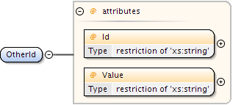
Used by
  Element | VesselData/Identifier
Attributes
  Name | Use | Annotation
  Id | required | Name of the Identifier
  Value | required | Value of the identifier

Element OtherName
Annotations | Other names for the track than the English name
Diagram | 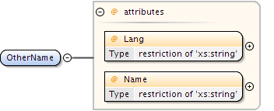
Used by
  Element | VesselData/Identifier
Attributes
  Name | Use | Annotation
  Lang | required | Languange (ISO 3166-1-alpha2)
  Name | required | Name in the foreign language

Element VoyageData
Annotations | DATA regarding a movement of a vessel servers domain
Diagram | 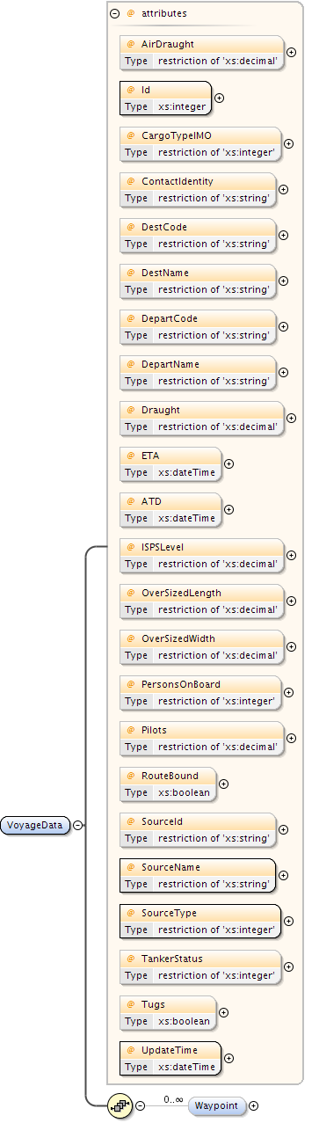
Used by
  Element | ObjectData
Children | Waypoint
Attributes
  Name | Use | Annotation
  ATD | optional | Date and time in (subset of ISO 8601) UTC format (YYYY-MM-DDThh:mm:ss.sssZ) of the Actual Time Of Departure of the target
  AirDraught | optional | Actual air draught of the vessel in meters
  CargoTypeIMO | optional | 0 = All ships of this type 1 = Carrying DG, HS, or MP, IMO hazard or pollutant category A 2 = Carrying DG, HS, or MP, IMO hazard or pollutant category B 3 = Carrying DG, HS, or MP, IMO hazard or pollutant category C 4 = Carrying DG, HS, or MP, IMO hazard or pollutant category D 5 = Carrying DG, HS, or MP, IMO hazard or pollutant of unknown category
  ContactIdentity | optional | reference to the identity associated with this objects voyage
  DepartCode | optional | Departure of the target (UN/LOCODE) optionally addended with local location code (e.g. BEANR0170100497 = Antwerp, HANSADOK 497)
  DepartName | optional | Departure name of the target e.g. local code for berth/lock/bridge/terminal
  DestCode | optional | Destination of the target (UN/LOCODE) optionally addended with local location code (e.g. BEANR0170100497 = Antwerp, HANSADOK 497)
  DestName | optional | Destination name of the target e.g. local code for berth/lock/bridge/terminal
  Draught | optional | Actual draught of the vessel in meters
  ETA | optional | Date and time in (subset of ISO 8601) UTC format (YYYY-MM-DDThh:mm:ss.sssZ) of the Expected Time Of Arrival of the target at the destination
  ISPSLevel | optional | The ISPS level of the object (1 = normal, 2 = heightended, 3 = exceptional)
  Id | required | The unique identification of this voyagedata. Valid from first message with TrackStatus!=Terminated to first message with TrackStatus=Terminated
  OverSizedLength | optional | Length of the target in meter as confirmed by NCA, in case of a convoy of barges
  OverSizedWidth | optional | Width of the target in meter as confirmed by the NCA, in case of a convoy of barges
  PersonsOnBoard | optional | The number of persons on board of the object, should equal the sum of crew, passengers and support personel if available
  Pilots | optional | Pilot status 0 = unknown 1 = pilot on board 2 = object under remote pilotage 3 = pilot required
  RouteBound | optional | This object is bound to the route of this voyage
  SourceId | optional | Unique identification of the producer (UN/LOCODE) in case multiple producers exist on the same LOCODE, the local competent authority can optionally addended this with a local code (e.g. BE ANR 01 = Antwerp, 01)
  SourceName | required | Identification of the originator of this data
  SourceType | required | Source/originator type: 0 = Unknown, 1 = Transponder, 2 = Database (VTS Plan Server), 3 = Manual (VTS Officer), 4 = Fused, 5 = External Source
  TankerStatus | optional | Describes the status of the tanker 0 = Non gas free 1 = Gas free 2 = Inert
  Tugs | optional | Object uses tugs
  UpdateTime | required | Date and time in (subset of ISO 8601) UTC format (YYYY-MM-DDThh:mm:ss.sssZ) this data was compiled

Element VoyageData / Waypoint
Annotations | Waypoint belonging to the route of this voyage
Diagram | 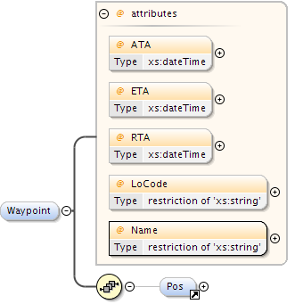
Children | Pos
Attributes
  Name | Use | Annotation
  ATA | optional | Date and time in UTC format (YYYY-MM-DDThh:mmZ) (subset of ISO 8601 ) of the Actual Time Of Arrival of the target.
  ETA | optional | Date and time in UTC format (YYYY-MM-DDThh:mmZ) (subset of ISO 8601) of the Expected Time Of Arrival of the target.
  LoCode | optional | Waypoint name in UN/LOCODE optionally addended with local location code (e.g. BEANR0170100497 = Antwerp, HANSADOK 497)
  Name | required | Name of the waypoint
  RTA | optional | Date and time in UTC format (YYYY-MM-DDThh:mmZ) (subset of ISO 8601) of the Requested Time Of Arrival of the target.

Element TaggedItem
Annotations | Generic key/value pairs, can be used to pass information that is not (yet) in the standard, provided server and user agree upon interface. E.g. Blue sign indication for inland waterways, references to voyage or vesseldata (URL)
Diagram | 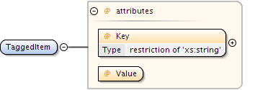
Used by
  Element | ObjectData
Attributes
  Name | Use | Annotation
  Key | required | Key for the tagged item
  Value | required | Value of the tagged item, can be of any type

Element Ping
Annotations | DATA alive message
Diagram | 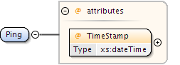
Used by
  Element | MSG_IVEF/Body
Attributes
  Name | Use | Annotation
  TimeStamp | required | Date and time in (subset ISO 8601) UTC format (YYYY-MM-DDThh:mm:ss.sssZ) of the time this message is sent.

Element Pong
Annotations | DATA alive response
Diagram | 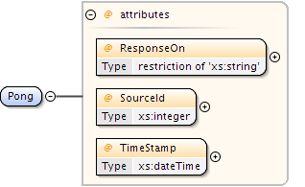
Used by
  Element | MSG_IVEF/Body
Attributes
  Name | Use | Annotation
  ResponseOn | required | Corresponds to the original MsgRefId from the Ping.xml message. Must be an Universally Unique Identifier (TU-T Rec. X.667 | ISO/IEC 9834-8.)
  SourceId | required | The identification of the node who created this message
  TimeStamp | required | Date and time in (subset of ISO 8601) UTC format (YYYY-MM-DDThh:mm:ss.sssZ) of the time this message is sent.

Element ServerStatus
Annotations | DATA describing the status of the server (full/available)
Diagram | 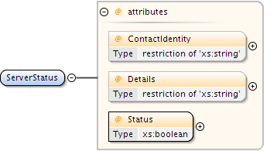
Used by
  Element | MSG_IVEF/Body
Attributes
  Name | Use | Annotation
  ContactIdentity | optional | reference to the identity associated with this service
  Details | optional | Details of status
  Status | required | Status of the server (ok / not ok)

Element ServiceRequest
Annotations | DATA describing the service a user requests
Diagram | 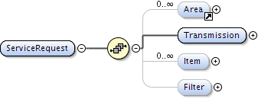
Used by
  Element | MSG_IVEF/Body
Children | Area, Filter, Item, Transmission

Element Area
Annotations | Geographical location based on one or more polygons
Diagram | 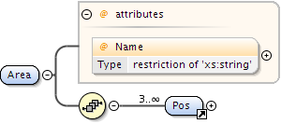
Used by
  Element | ServiceRequest
Children | Pos
Attributes
  Name | Use | Annotation
  Name | optional | Name of the area

Element ServiceRequest / Transmission
Diagram | 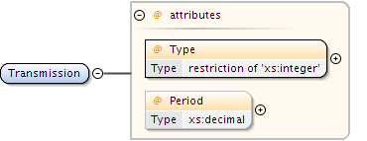
Attributes
  Name | Use | Annotation
  Period | optional | Specifies the time between two periodic updates in seconds
  Type | required | Type of transmission, possible values are: 1 = single occurrence (whole image) 2 = periodic occurence (predicted, whole image) 3 = a-periodic occurence (synchronous, whenever an object is updated)

Element ServiceRequest / Item
Diagram | 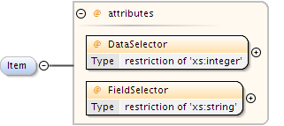
Attributes
  Name | Use | Annotation
  DataSelector | required | Describes requested Object data element, possible values: 1 = TrackData 2 = VesselData 3 = VoyageData
  FieldSelector | required | Selected field. Can be 'all' or one of the items of object data TrackData, VesselData or VoyageData, to be changed into an enumeration of strings once these have been fixed

Element ServiceRequest / Filter
Diagram | 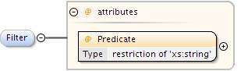
Attributes
  Name | Use | Annotation
  Predicate | required | Filter expression in XPath 1.0 definition (http://www.w3.org/TR/1999/REC-xpath-19991116) A Filter must start with //ObjectData (Filter always on entire objects) and can not go beyond a single objects parameters (next/previous/last etc.) Examples: All objects: //ObjectData All objects faster then 10 m/s: //ObjectData[TrackData[@SOG > 10]] All objects named "Krieken": //ObjectData[VesselData/Identifier[@Name = "Krieken"]] All objects heading for Antwerp, HANSADOK 497 with a max keelheigth of 20m: //ObjectData[VoyageData[@DestCode = BEANR0170100497]] AND //ObjectData[VesselData/Construction[@MaxKeelHeigth > 20]]

Element ServiceRequestResponse
Annotations | DATA detailing the supliers response to the users service request
Diagram | 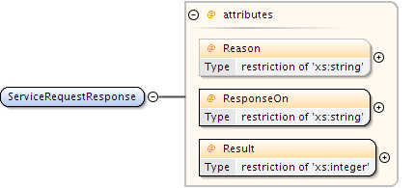
Used by
  Element | MSG_IVEF/Body
Attributes
  Name | Use | Annotation
  Reason | optional | String describing reason for declining, when result is "Declined", or a string describing the restrictions when the result is "Accepted with restrictions"
  ResponseOn | required | Corresponds to the original MsgRefId from the ServiceRequest message. Must be an Universally Unique Identifier (TU-T Rec. X.667 | ISO/IEC 9834-8.)
  Result | required | 1 = Accepted, 2 = Declined, 3 = Accepted with restrictions

  - Attribute Definitions

Attribute ATA
Annotations | Date and time in UTC format (YYYY-MM-DDThh:mmZ) (subset of ISO 8601 ) of the Actual Time Of Arrival of the target.
Type | xs:dateTime
Used by
  Element | VoyageData/Waypoint

Attribute ATD
Annotations | Date and time in (subset of ISO 8601) UTC format (YYYY-MM-DDThh:mm:ss.sssZ) of the Actual Time Of Departure of the target
Type | xs:dateTime
Used by
  Element | VoyageData

Attribute AirDraught
Annotations | Actual air draught of the vessel in meters
Type | restriction of xs:decimal
Facets
  fractionDigits | 2
  minExclusive | 0
Used by
  Element | VoyageData

Attribute Altitude
Annotations | The altitude of the target above the WGS-84 ellipsoid in meters
Type | xs:decimal
Used by
  Element | Pos

Attribute BlackListed
Annotations | Vessel is blacklisted by a NCA
Type | xs:boolean
Used by
  Element | VesselData

Attribute COG
Annotations | Course over ground in degrees. (0-360)
Type | restriction of xs:decimal
Facets
  fractionDigits | 1
  maxInclusive | 360
  minInclusive | 0
Used by
  Element | TrackData

Attribute Callsign
Annotations | Callsign of the target, in accordance with Article 19, Section III of the ITU Radio Regulations (RR)
Type | restriction of xs:string
Facets
  minLength | 0
  maxLength | 9
Used by
  Element | VesselData/Identifier

Attribute CargoTypeIMO
Annotations | 0 = All ships of this type 1 = Carrying DG, HS, or MP, IMO hazard or pollutant category A 2 = Carrying DG, HS, or MP, IMO hazard or pollutant category B 3 = Carrying DG, HS, or MP, IMO hazard or pollutant category C 4 = Carrying DG, HS, or MP, IMO hazard or pollutant category D 5 = Carrying DG, HS, or MP, IMO hazard or pollutant of unknown category
Type | restriction of xs:integer
Facets
  enumeration | 0
  enumeration | 1
  enumeration | 2
  enumeration | 3
  enumeration | 4
  enumeration | 5
Used by
  Element | VoyageData

Attribute Class
Annotations | 0 = Unknown 1 = Vessel 2 = Aids to Navigate
Type | restriction of xs:integer
Facets
  enumeration | 0
  enumeration | 1
  enumeration | 2
Used by
  Element | VesselData

Attribute CodeA
Type | restriction of xs:string
Facets
  pattern | [0-9A-Z]{2,3}
Used by
  Element | VesselData/Construction/UnType

Attribute CodeB
Type | restriction of xs:string
Facets
  pattern | [1-9A-Z]
Used by
  Element | VesselData/Construction/UnType

Attribute ContactIdentity
Annotations | reference to the identity associated with this objects voyage
Type | restriction of xs:string
Facets
  minLength | 1
  maxLength | 254
Used by
  Element | VoyageData

Attribute ContactIdentity
Annotations | reference to the identity associated with this service
Type | restriction of xs:string
Facets
  minLength | 1
  maxLength | 254
Used by
  Element | ServerStatus

Attribute DataSelector
Annotations | Describes requested Object data element, possible values: 1 = TrackData 2 = VesselData 3 = VoyageData
Type | restriction of xs:integer
Facets
  enumeration | 1
  enumeration | 2
  enumeration | 3
Used by
  Element | ServiceRequest/Item

Attribute DeadWeight
Annotations | Dead weight in tons
Type | restriction of xs:decimal
Facets
  minExclusive | 0
Used by
  Element | VesselData/Construction

Attribute DepartCode
Annotations | Departure of the target (UN/LOCODE) optionally addended with local location code (e.g. BEANR0170100497 = Antwerp, HANSADOK 497)
Type | restriction of xs:string
Facets
  minLength | 5
  maxLength | 15
Used by
  Element | VoyageData

Attribute DepartName
Annotations | Departure name of the target e.g. local code for berth/lock/bridge/terminal
Type | restriction of xs:string
Facets
  minLength | 1
  maxLength | 42
Used by
  Element | VoyageData

Attribute DestCode
Annotations | Destination of the target (UN/LOCODE) optionally addended with local location code (e.g. BEANR0170100497 = Antwerp, HANSADOK 497)
Type | restriction of xs:string
Facets
  minLength | 5
  maxLength | 15
Used by
  Element | VoyageData

Attribute DestName
Annotations | Destination name of the target e.g. local code for berth/lock/bridge/terminal
Type | restriction of xs:string
Facets
  minLength | 1
  maxLength | 42
Used by
  Element | VoyageData

Attribute Details
Annotations | Details of status
Type | restriction of xs:string
Facets
  maxLength | 50
Used by
  Element | ServerStatus

Attribute Draught
Annotations | Actual draught of the vessel in meters
Type | restriction of xs:decimal
Facets
  fractionDigits | 2
  minExclusive | 0
Used by
  Element | VoyageData

Attribute ETA
Annotations | Date and time in UTC format (YYYY-MM-DDThh:mmZ) (subset of ISO 8601) of the Expected Time Of Arrival of the target.
Type | xs:dateTime
Used by
  Element | VoyageData/Waypoint

Attribute ETA
Annotations | Date and time in (subset of ISO 8601) UTC format (YYYY-MM-DDThh:mm:ss.sssZ) of the Expected Time Of Arrival of the target at the destination
Type | xs:dateTime
Used by
  Element | VoyageData

Attribute Encryption
Annotations | 1 = plain 2 - 6 the 5 most common encryption 0 = custom
Type | restriction of xs:integer
Facets
  enumeration | 1
  enumeration | 2
Used by
  Element | LoginRequest

Attribute EstAccAlt
Annotations | Estimated accuracy standard deviation of the calculated position of a target expressed in m
Type | xs:decimal
Used by
  Element | Pos

Attribute EstAccCOG
Annotations | Estimated accuracy standard deviation of the calculated value expressed in degrees
Type | xs:decimal
Used by
  Element | TrackData

Attribute EstAccLat
Annotations | Estimated accuracy standard deviation of the calculated position of a target expressed in m
Type | xs:decimal
Used by
  Element | Pos

Attribute EstAccLong
Annotations | Estimated accuracy standard deviation of the calculated position of a target expressed in m
Type | xs:decimal
Used by
  Element | Pos

Attribute EstAccSOG
Annotations | Estimated accuracy standard deviation of the calculated value expressed in m/s
Type | xs:decimal
Used by
  Element | TrackData

Attribute FieldSelector
Annotations | Selected field. Can be 'all' or one of the items of object data TrackData, VesselData or VoyageData, to be changed into an enumeration of strings once these have been fixed
Type | restriction of xs:string
Facets
  minLength | 1
  maxLength | 42
Used by
  Element | ServiceRequest/Item

Attribute Flag
Annotations | The country flag (ISO 3166-1-alpha2)
Type | restriction of xs:string
Facets
  minLength | 2
  maxLength | 2
Used by
  Element | VesselData/Identifier

Attribute FormerName
Annotations | Previous name of the target
Type | restriction of xs:string
Facets
  minLength | 1
  maxLength | 42
Used by
  Element | VesselData/Identifier

Attribute GrossWeight
Annotations | Gross weight in tons
Type | restriction of xs:decimal
Facets
  minExclusive | 0
Used by
  Element | VesselData/Construction

Attribute Heading
Annotations | Heading of the target in degrees
Type | restriction of xs:decimal
Facets
  maxInclusive | 360.0
  minInclusive | 0.0
Used by
  Element | TrackData

Attribute HullColor
Annotations | Color of Hull (in RGB hex) for SAR operations
Type | restriction of xs:string
Facets
  minLength | 6
  maxLength | 6
Used by
  Element | VesselData/Construction

Attribute HullType
Annotations | Type of hull (1 = single, 2 = double, 3 = triple)
Type | restriction of xs:integer
Facets
  enumeration | 1
  enumeration | 2
  enumeration | 3
Used by
  Element | VesselData/Construction

Attribute IMO
Annotations | IMO number of the target
Type | xs:integer
Used by
  Element | VesselData/Identifier

Attribute ISPSLevel
Annotations | The ISPS level of the object (1 = normal, 2 = heightended, 3 = exceptional)
Type | restriction of xs:decimal
Facets
  enumeration | 1
  enumeration | 2
  enumeration | 3
Used by
  Element | VoyageData

Attribute Id
Annotations | The unique identification of this track. Valid from first message with TrackStatus!=Terminated to first message with TrackStatus=Terminated
Type | xs:integer
Used by
  Element | TrackData

Attribute Id
Annotations | Name of the Identifier
Type | restriction of xs:string
Facets
  minLength | 1
  maxLength | 42
Used by
  Element | OtherId

Attribute Id
Annotations | The unique identification of this vesseldata. Valid from first message with TrackStatus!=Terminated to first message with TrackStatus=Terminated
Type | xs:integer
Used by
  Element | VesselData

Attribute Id
Annotations | The unique identification of this voyagedata. Valid from first message with TrackStatus!=Terminated to first message with TrackStatus=Terminated
Type | xs:integer
Used by
  Element | VoyageData

Attribute Key
Annotations | Key for the tagged item
Type | restriction of xs:string
Facets
  minLength | 1
  maxLength | 42
Used by
  Element | TaggedItem

Attribute LRIT
Annotations | LRIT identification
Type | restriction of xs:string
Facets
  minLength | 1
  maxLength | 42
Used by
  Element | VesselData/Identifier

Attribute Lang
Annotations | Languange (ISO 3166-1-alpha2)
Type | restriction of xs:string
Facets
  minLength | 2
  maxLength | 2
Used by
  Element | OtherName

Attribute Lat
Annotations | Latitude (WGS84) in degrees. (+/- 90 degrees; North = positive; South = negative) Examples: -90deg (south) = -90.0000000 0deg0min1sec (north) = 0.0000016 50deg50min (north) = 50.8333333
Type | restriction of xs:decimal
Facets
  fractionDigits | 5
  maxInclusive | +90.00000
  minInclusive | -90.00000
Used by
  Element | Pos

Attribute Length
Annotations | Measured length of the target in meter
Type | restriction of xs:decimal
Facets
  minExclusive | 0
Used by
  Element | TrackData

Attribute Length
Annotations | The overall length of the target in meter as confirmed by NCA
Type | restriction of xs:decimal
Facets
  minExclusive | 0
Used by
  Element | VesselData/Construction

Attribute LloydsShipType
Annotations | Number indicating type of vessel
Type | xs:integer
Used by
  Element | VesselData/Construction

Attribute LoCode
Annotations | Waypoint name in UN/LOCODE optionally addended with local location code (e.g. BEANR0170100497 = Antwerp, HANSADOK 497)
Type | restriction of xs:string
Facets
  minLength | 5
  maxLength | 15
Used by
  Element | VoyageData/Waypoint

Attribute Long
Annotations | Longitude (WGS84) in degrees. (+/- 180 degrees; East = positive; West = negative). Examples: -180deg (west) = -180.0000000 0deg0min1sec (east) = 0.0000016
Type | restriction of xs:decimal
Facets
  fractionDigits | 5
  maxInclusive | +180.00000
  minExclusive | -180.00000
Used by
  Element | Pos

Attribute MMSI
Annotations | MMSI number of the target
Type | xs:integer
Used by
  Element | VesselData/Identifier

Attribute MaxAirDraught
Annotations | Maximum air draught of the object in meters, to be used if voyage data is not available
Type | restriction of xs:decimal
Facets
  fractionDigits | 1
  minExclusive | 0
Used by
  Element | VesselData/Construction

Attribute MaxDraught
Annotations | Maximum draught of the object in meters, to be used if voyage data is not available
Type | restriction of xs:decimal
Facets
  fractionDigits | 1
  minExclusive | 0
Used by
  Element | VesselData/Construction

Attribute MaxPersonsOnBoard
Annotations | The maximum number of persons on board of the object (crew, support, passengers, pilots)
Type | restriction of xs:integer
Facets
  minExclusive | 0
Used by
  Element | VesselData/Construction

Attribute MaxSpeed
Annotations | The maximum speed the object is able to sustain with normal draft and load
Type | restriction of xs:decimal
Facets
  minExclusive | 0
Used by
  Element | VesselData/Construction

Attribute Mode
Type | restriction of xs:integer
Facets
  enumeration | 1
  enumeration | 2
  enumeration | 3
  enumeration | 4
  enumeration | 6
  enumeration | 7
  enumeration | 8
Used by
  Element | VesselData/Construction/UnType

Attribute MsgRefId
Annotations | Must be an Universally Unique Identifier for each message (TU-T Rec. X.667 | ISO/IEC 9834-8.) Reply messages refer to this id to identify the message they are replying to. In its canonical form, a UUID consists of 32 hexadecimal digits, displayed in 5 groups separated by hyphens, in the form 8-4-4-4-12 for a total of 36 characters, enclosed by brackets. For example: {550e8400-e29b-41d4-a716-446655440000}
Type | restriction of xs:string
Facets
  minLength | 36
  maxLength | 42
Used by
  Element | Header

Attribute Name
Annotations | Login name
Type | restriction of xs:string
Facets
  maxLength | 256
Used by
  Element | LoginRequest

Attribute Name
Annotations | Name in the foreign language
Type | restriction of xs:string
Facets
  minLength | 1
  maxLength | 42
Used by
  Element | OtherName

Attribute Name
Annotations | Name of the target
Type | restriction of xs:string
Facets
  minLength | 1
  maxLength | 42
Used by
  Element | VesselData/Identifier

Attribute Name
Annotations | Name of the waypoint
Type | restriction of xs:string
Facets
  minLength | 1
  maxLength | 42
Used by
  Element | VoyageData/Waypoint

Attribute Name
Annotations | Name of the area
Type | restriction of xs:string
Facets
  minLength | 1
  maxLength | 42
Used by
  Element | Area

Attribute OverSizedLength
Annotations | Length of the target in meter as confirmed by NCA, in case of a convoy of barges
Type | restriction of xs:decimal
Facets
  fractionDigits | 1
  minExclusive | 0
Used by
  Element | VoyageData

Attribute OverSizedWidth
Annotations | Width of the target in meter as confirmed by the NCA, in case of a convoy of barges
Type | restriction of xs:decimal
Facets
  fractionDigits | 1
  minExclusive | 0
Used by
  Element | VoyageData

Attribute Owner
Annotations | Name of owner the target
Type | restriction of xs:string
Facets
  minLength | 1
  maxLength | 42
Used by
  Element | VesselData/Identifier

Attribute Password
Annotations | Password value
Type | restriction of xs:string
Facets
  maxLength | 256
Used by
  Element | LoginRequest

Attribute Period
Annotations | Specifies the time between two periodic updates in seconds
Type | xs:decimal
Used by
  Element | ServiceRequest/Transmission

Attribute PersonsOnBoard
Annotations | The number of persons on board of the object, should equal the sum of crew, passengers and support personel if available
Type | restriction of xs:integer
Facets
  minExclusive | 0
Used by
  Element | VoyageData

Attribute Pilots
Annotations | Pilot status 0 = unknown 1 = pilot on board 2 = object under remote pilotage 3 = pilot required
Type | restriction of xs:decimal
Facets
  minExclusive | 0
Used by
  Element | VoyageData

Attribute Predicate
Annotations | Filter expression in XPath 1.0 definition (http://www.w3.org/TR/1999/REC-xpath-19991116) A Filter must start with //ObjectData (Filter always on entire objects) and can not go beyond a single objects parameters (next/previous/last etc.) Examples: All objects: //ObjectData All objects faster then 10 m/s: //ObjectData[TrackData[@SOG > 10]] All objects named "Krieken": //ObjectData[VesselData/Identifier[@Name = "Krieken"]] All objects heading for Antwerp, HANSADOK 497 with a max keelheigth of 20m: //ObjectData[VoyageData[@DestCode = BEANR0170100497]] AND //ObjectData[VesselData/Construction[@MaxKeelHeigth > 20]]
Type | restriction of xs:string
Facets
  minLength | 1
  maxLength | 1024
Used by
  Element | ServiceRequest/Filter

Attribute ROT
Annotations | Rate of turn in degrees per minute
Type | restriction of xs:decimal
Facets
  fractionDigits | 1
  maxInclusive | 720
  minExclusive | -720
Used by
  Element | TrackData

Attribute RTA
Annotations | Date and time in UTC format (YYYY-MM-DDThh:mmZ) (subset of ISO 8601) of the Requested Time Of Arrival of the target.
Type | xs:dateTime
Used by
  Element | VoyageData/Waypoint

Attribute Reason
Annotations | String describing reason for declining, only used when result is "Declined"
Type | restriction of xs:string
Facets
  maxLength | 256
Used by
  Element | LoginResponse

Attribute Reason
Annotations | String describing reason for declining, when result is "Declined", or a string describing the restrictions when the result is "Accepted with restrictions"
Type | restriction of xs:string
Facets
  maxLength | 256
Used by
  Element | ServiceRequestResponse

Attribute ResponseOn
Annotations | Corresponds to the original MsgRefId from the Login.xml message. Must be an Universally Unique Identifier (TU-T Rec. X.667 | ISO/IEC 9834-8.)
Type | restriction of xs:string
Facets
  minLength | 36
  maxLength | 42
Used by
  Element | LoginResponse

Attribute ResponseOn
Annotations | Corresponds to the original MsgRefId from the Ping.xml message. Must be an Universally Unique Identifier (TU-T Rec. X.667 | ISO/IEC 9834-8.)
Type | restriction of xs:string
Facets
  minLength | 36
  maxLength | 42
Used by
  Element | Pong

Attribute ResponseOn
Annotations | Corresponds to the original MsgRefId from the ServiceRequest message. Must be an Universally Unique Identifier (TU-T Rec. X.667 | ISO/IEC 9834-8.)
Type | restriction of xs:string
Facets
  minLength | 36
  maxLength | 42
Used by
  Element | ServiceRequestResponse

Attribute Result
Annotations | 1 = Accepted 2 = Declined
Type | restriction of xs:integer
Facets
  enumeration | 1
  enumeration | 2
Used by
  Element | LoginResponse

Attribute Result
Annotations | 1 = Accepted, 2 = Declined, 3 = Accepted with restrictions
Type | restriction of xs:integer
Facets
  enumeration | 1
  enumeration | 2
  enumeration | 3
Used by
  Element | ServiceRequestResponse

Attribute RouteBound
Annotations | This object is bound to the route of this voyage
Type | xs:boolean
Used by
  Element | VoyageData

Attribute SOG
Annotations | Speed over ground in meters per second
Type | restriction of xs:decimal
Facets
  fractionDigits | 1
  minInclusive | 0
Used by
  Element | TrackData

Attribute SourceId
Annotations | Unique identification of the producer (UN/LOCODE) in case multiple producers exist on the same LOCODE, the local competent authority can optionally addended this with a local code (e.g. BE ANR 01 = Antwerp, 01)
Type | restriction of xs:string
Facets
  minLength | 5
  maxLength | 15
Used by
  Element | TrackData

Attribute SourceId
Annotations | Unique identification of the producer (UN/LOCODE) in case multiple producers exist on the same LOCODE, the local competent authority can optionally addended this with a local code (e.g. BE ANR 01 = Antwerp, 01)
Type | restriction of xs:string
Facets
  minLength | 5
  maxLength | 15
Used by
  Element | VesselData

Attribute SourceId
Annotations | Unique identification of the producer (UN/LOCODE) in case multiple producers exist on the same LOCODE, the local competent authority can optionally addended this with a local code (e.g. BE ANR 01 = Antwerp, 01)
Type | restriction of xs:string
Facets
  minLength | 5
  maxLength | 15
Used by
  Element | VoyageData

Attribute SourceId
Annotations | The identification of the node who created this message
Type | xs:integer
Used by
  Element | Pong

Attribute SourceName
Annotations | Identification of the originator of the data
Type | restriction of xs:string
Facets
  minLength | 1
  maxLength | 42
Used by
  Element | TrackData

Attribute SourceName
Annotations | Identification of the originator of the data
Type | restriction of xs:string
Facets
  minLength | 1
  maxLength | 42
Used by
  Element | VesselData

Attribute SourceName
Annotations | Identification of the originator of this data
Type | restriction of xs:string
Facets
  minLength | 1
  maxLength | 42
Used by
  Element | VoyageData

Attribute SourceType
Annotations | Source/originator type: 0 = Unknown, 1 = Transponder, 2 = Database (VTS Plan Server), 3 = Manual (VTS Officer), 4 = Fused, 5 = External Source
Type | restriction of xs:integer
Facets
  enumeration | 1
  enumeration | 2
  enumeration | 3
  enumeration | 4
  enumeration | 5
Used by
  Element | VesselData

Attribute SourceType
Annotations | Source/originator type: 0 = Unknown, 1 = Transponder, 2 = Database (VTS Plan Server), 3 = Manual (VTS Officer), 4 = Fused, 5 = External Source
Type | restriction of xs:integer
Facets
  enumeration | 1
  enumeration | 2
  enumeration | 3
  enumeration | 4
  enumeration | 5
Used by
  Element | VoyageData

Attribute SpecialAttention
Annotations | Vessel is under special attention of the NCA or fairway authorities
Type | restriction of xs:string
Facets
  maxLength | 20
Used by
  Element | VesselData

Attribute Status
Annotations | Status of the server (ok / not ok)
Type | xs:boolean
Used by
  Element | ServerStatus

Attribute TankerStatus
Annotations | Describes the status of the tanker 0 = Non gas free 1 = Gas free 2 = Inert
Type | restriction of xs:integer
Facets
  enumeration | 0
  enumeration | 1
  enumeration | 2
Used by
  Element | VoyageData

Attribute TimeStamp
Annotations | Date and time in (subset ISO 8601) UTC format (YYYY-MM-DDThh:mm:ss.sssZ) of the time this message is sent.
Type | xs:dateTime
Used by
  Element | Ping

Attribute TimeStamp
Annotations | Date and time in (subset of ISO 8601) UTC format (YYYY-MM-DDThh:mm:ss.sssZ) of the time this message is sent.
Type | xs:dateTime
Used by
  Element | Pong

Attribute TrackStatus
Annotations | 1 = Updated, (sensors are updating the track) 2 = Coasted, (no sensor is updating the track) 3 = Dropped
Type | restriction of xs:integer
Facets
  enumeration | 1
  enumeration | 2
  enumeration | 3
Used by
  Element | TrackData

Attribute Tugs
Annotations | Object uses tugs
Type | xs:boolean
Used by
  Element | VoyageData

Attribute Type
Annotations | Type of transmission, possible values are: 1 = single occurrence (whole image) 2 = periodic occurence (predicted, whole image) 3 = a-periodic occurence (synchronous, whenever an object is updated)
Type | restriction of xs:integer
Facets
  enumeration | 1
  enumeration | 2
  enumeration | 3
Used by
  Element | ServiceRequest/Transmission

Attribute UpdateTime
Annotations | Date and time in UTC format (YYYY-MM-DDThh:mm:ss.sssZ) (subset of ISO 8601) this position was measured.
Type | xs:dateTime
Used by
  Element | TrackData

Attribute UpdateTime
Annotations | Date and time in UTC format (YYYY-MM-DDThh:mm:ss.sssZ) (subset of ISO 8601) this data was compiled
Type | xs:dateTime
Used by
  Element | VesselData

Attribute UpdateTime
Annotations | Date and time in (subset of ISO 8601) UTC format (YYYY-MM-DDThh:mm:ss.sssZ) this data was compiled
Type | xs:dateTime
Used by
  Element | VoyageData

Attribute Value
Annotations | Navigation status of the target 0 = under way using engine 1 = at anchor 2 = not under command 3 = restricted manoeuvrability 4 = constrained by her draught 5 = moored 6 = aground 7 = engaged in fishing 8 = under way sailing 9 = engaged in fishing other than trawling 10 = air-cushion vessel in non displacement mode or WIG craft taking off, landing or in flight 11 = power driven vessel towing astern 12 = power driven vessel pushing ahead or towing alongside 13 = in distress or requiring assistance 14 = AIS SART, seeking to attract attention 15 = undefined default
Type | restriction of xs:integer
Facets
  maxInclusive | 15
  minInclusive | 0
Used by
  Element | TrackData/NavStatus

Attribute Value
Annotations | Value of the identifier
Type | restriction of xs:string
Facets
  minLength | 1
  maxLength | 42
Used by
  Element | OtherId

Attribute Value
Annotations | Value of the tagged item, can be of any type
Used by
  Element | TaggedItem

Attribute Version
Annotations | Defines the version of the protocol used. Syntax is major.minor.patch patch releases fix only bugs, minor releases may add functionality but are compatible, major releases are not compatible
Type | xs:string
Used by
  Element | Header

Attribute Width
Annotations | Measured Width of the target in meter
Type | restriction of xs:decimal
Facets
  minExclusive | 0
Used by
  Element | TrackData

Attribute Width
Annotations | Overall width of the target in meter as confirmed by the NCA
Type | restriction of xs:decimal
Facets
  minExclusive | 0
Used by
  Element | VesselData/Construction

Attribute YearOfBuild
Annotations | The year the vessel was build in 4 digits e.g. 2010
Type | restriction of xs:integer
Facets
  totalDigits | 4
Used by
  Element | VesselData/Construction

Please note that x, x1, x2 and x3 shall be specified in Longitude coordinates and that y, y1, y2 and y3 shall be specified as Latitude coordinates.
e.g. in an overload situation the server may drop messages, in this situation the Service Status message is sent to the client to make him aware of lost information.
Depending on the transport layer (e.g. SCTP), and receiver activity, the sender may detect the connection state of the receiver automatically. In this case the Ping message is not required.

