
IALA Recommendation
####

On

the Inter-VTS Exchange Format (IVEF) Service

Edition No. 1

September 2010

AISM Association Internationale de Signalisation Maritime IALA
International Association of Marine Aids to Navigation and Lighthouse Authorities
20ter, rue Schnapper, 78100
Saint Germain en Laye, France
Telephone: +33 1 34 51 70 01 Fax: +33 1 34 51 82 05
e-mail: iala-aism@wanadoo.fr Internet: www.iala-aism.org

Document Revisions
Revisions to the IALA Document are to be noted in the table prior to the issue of a revised document.
Date | Page / Section Revised | Requirement for Revision
10 May 2010 | New document | First draft for review

IALA Recommendation on the Inter-VTS Exchange Format (IVEF) Service
(Recommendation ####)

THE COUNCIL:
RECALLING that one of the aims of the Association is to foster safe, economic and efficient movement of vessels and the protection of the marine environment through the improvement and harmonisation of aids to navigation, vessel traffic services and other means world-wide;
NOTING
- IALA Recommendation eNAV 140 on “The e-Navigation Architecture – the Initial Shore-based Perspective” [1],
- IMO’s strategic plan regarding e-Navigation [2],
- that IMO expressed an interest in the contribution of IALA to the work on e-Navigation [3];
RECOGNISING that the e-Navigation architecture will assist in the development and maintenance of application interactions between ship and shore and shore to shore, in the following fields
- shore-based technical e-Navigation services,
- technical means for communication,
- data modelling and referential data,
- Human-Machine Interface presentations;
RECOGNISING ALSO the responsibilities of IALA National Members regarding national and international e-Navigation applications
- that the shore-based e-Navigation systems of National Members are embedded into local, regional, national, supra-national and global topologies of systems,
- that there are data/information flow chains within the local, regional, national, supra-national and global topologies of systems which support local, regional, national, supra-national and global e-Navigation applications,
- that requirements regarding quality parameters, such as accuracy, reliability, continuity, confidentiality, and others, will need to be taken into account when designing elements of the common shore-based e-Navigation system architecture;
RECOGNISING FURTHER that the Inter-VTS Exchange Format (IVEF) service, as laid out in this Recommendation, will assist in the efficient deployment of services to the mariner and to the maritime community by
- allowing shore-based systems of National Member and other appropriate Authorities and Entities to participate in harmonised data exchange;
- easing the integration of components;
- improving the efficiency in organisational terms by exploiting commonalities;
- harmonising data exchange to systems of other shore-based stakeholders (local, regional, national and global);
- taking into account the value, timeliness and sensitivity of data.
RECOMMENDS that National Members and other appropriate Authorities and Entities, introducing an IVEF Service into their shore infrastructure, take into account the principles as set out in the annex to this recommendation.

Table of Contents
1 Introduction 7
2 The IVEF Service as described by other IALA Recommendations 8
3 Service Model of the IVEF Service 8
3.1 Overview 8
3.2 Capabilities of the IVEF Service for the Shore-based e-Navigation System 9
3.2.1 Introduction 9
3.2.2 Basic IVEF Services (BIS) 10
3.2.3 General Use Cases 10
3.3 Data Model of the IVEF Service 11
3.3.1 Introduction 11
3.3.2 The Place of the IVEF Service in the e-Navigation Architecture 11
3.4 Interaction Model of the IVEF Service 12
3.4.1 Context 12
3.4.2 Service Negotiation 13
3.4.3 Part I: Primary service use cases of the BIS 16
3.4.4 Part II: Secondary service use cases of the BIS 22
3.5 Security Model of the IVEF Service 22
3.6 Interfacing Model of the IVEF Service 23
3.7 Quality Parameters of the IVEF Service 23
3.8 Test model of the IVEF Service 25
3.8.1 Well formed messages 25
3.8.2 Valid messages 25
3.8.3 Valid data 25
3.8.4 Interaction behaviour 25
3.9 Administration Model of the IVEF Service 26
4 References 26
5 Definitions 26
6 Abbreviations 27
7 Appendix: Data Definition 28

Index of Tables
Table 1: Interface Messages 15

Index of Figures
Figure 1 The IVEF Service in Operation 7
Figure 2 The IVEF Service Client/Server Model 8
Figure 3 The IVEF Service Model 9
Figure 4 IVEF Service Primary Use Case 10
Figure 5 The Place of the IVEF Service within the e-Navigation architecture 11
Figure 6 Client-server relationships of the IVEF Service with other shore-based e-Navigation services 12
Figure 7 The Communications Stack 13
Figure 8 Overview of the primary service use cases of the IVEF Service 17
Figure 9 The DATA Service Component 18
Figure 10 The Session Service Component 20
Figure 11 The Status Service Component 21
Figure 12 The ISO/OSI Reference Model 23
Figure 13 Domains of Interest, Responsibility and Cooperation 24
Figure 14 Login/Logout activity graph 26

Annex – the Inter-VTS Exchange Format (IVEF) Service
- Introduction
The IVEF Service is intended to provide a common framework for the exchange of vessel traffic image information between shore-based e-Navigation systems, such as VTS systems, e-Navigation stakeholders and relevant external parties.
Figure 1 shows such a situation, where VTS centres share information about the common operational area and also to relevant other users and authorities.

Figure 1 The IVEF Service in Operation
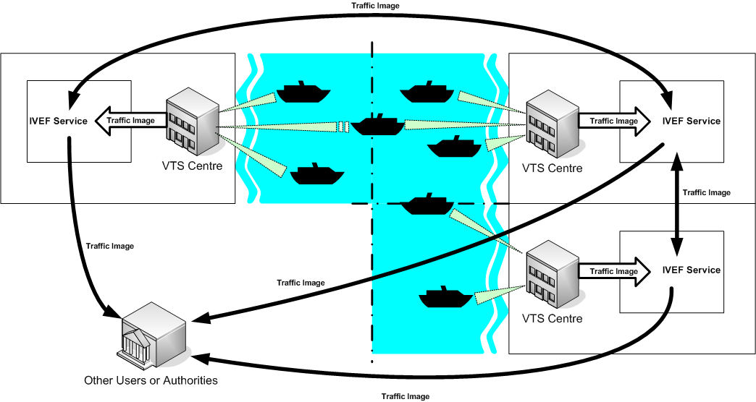

The IVEF Service is client/server-based. Clients make a connection to a server, running the IVEF Service and receive traffic image data according to their specific preferences and authorisations (Figure 2). Different clients may specify different data requirements, such as the area of interest, the update frequency and the particular traffic objects that are relevant to them. Based on the client credentials, the IVEF Service will enforce restrictions on the data that is being served to the client. These restrictions can be specified by the data provider.

Figure 2 The IVEF Service Client/Server Model
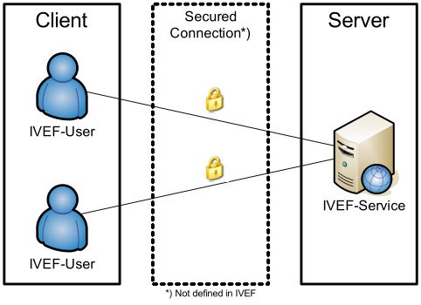

- The IVEF Service as described by other IALA Recommendations
The IVEF Service is a gateway service, as contained in the general description of the common shore-based system architecture in the “IALA Recommendation on Shore-based e-Navigation System Architecture” [see reference 1]. Such a gateway service is specialised in data exchange shore-to-shore. It interfaces to other e-Navigation systems and to external systems of “third parties”. These systems may request the IVEF service to forward relevant data to them. A IVEF service can interface shore-based systems locally, nationally, regionally, and globally.
- Service Model of the IVEF Service
  - Overview
The IVEF Service specification is organised according to the (draft) “IALA Recommendation on Generic e-Navigation Service Engineering Model Template” [reference 1] as depicted in Figure 3.

Figure 3 The IVEF Service Model
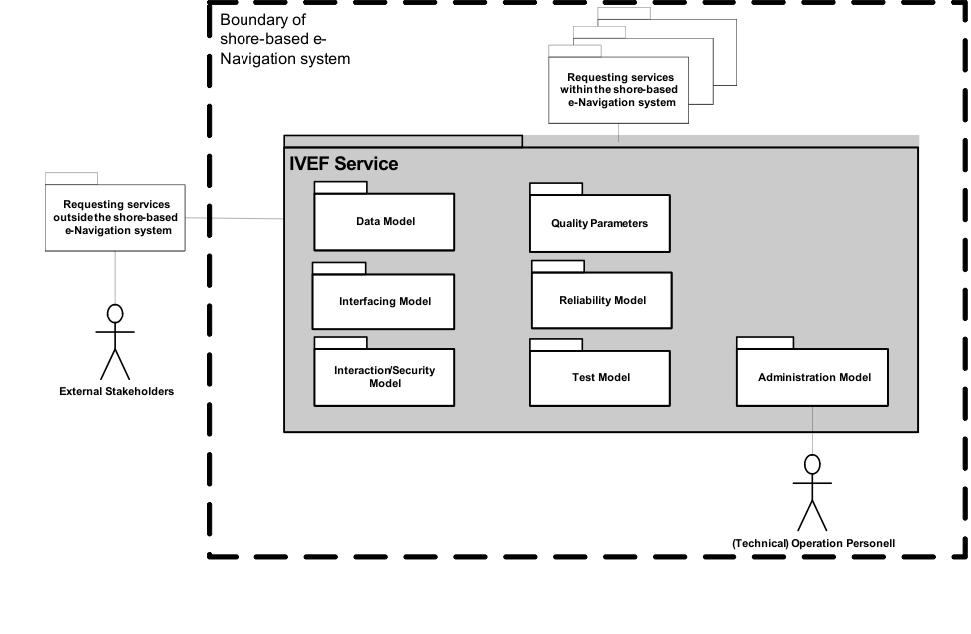
The specification contains exactly those elements that are relevant for a full description of the service. The following is a brief description of these elements:

Basic IVEF Services: capabilities of the IVEF Service and its functional interface statements.
Data Model: the abstract descriptions of the data provided by the IVEF Service at its Basic IVEF Services to shore-based e-Navigation systems and external systems. It defines the data types and data objects of the IVEF Service.
Interaction Model: the dynamics of the interaction of individual components of the IVEF Service (data flow and protocol).
Interfacing Model: the data encoding and interface protocols between the provider of the IVEF Service and the clients, requesting data from the service.
Security Model: control of access to the IVEF Service (filtering and access rights).
Quality Parameters: performance and reliability considerations of the IVEF Service.
Test Model: test and validation of the IVEF service.
Administration Model: the technical administration and maintenance aspects of the IVEF Service.
A full description of all these aspects follows in the remainder of this document.
  - Capabilities of the IVEF Service for the Shore-based e-Navigation System
    - Introduction
The IVEF Service is an optional part of a shore-based e-Navigation system. Its basic purpose is to provide a vessel traffic image to related vessel traffic service systems, to e-Navigation stakeholders and to relevant external parties. Any IVEF Service provides, at least, the so-called Basic IVEF Services (BIS). A particular characteristic of the IVEF Service is that these services are only rendered on request of another e-Navigation system or of an external system, i.e. the IVEF Service follows the client/server model as already described in the introduction of this specification (Figure 3).

    - Basic IVEF Services (BIS)
There is only one basic IVEF service, which is

Vessel Traffic Image Data Exchange Service – deliver vessel traffic situation data, according to a specific service profile. Such a service profile determines e.g. the data items delivered, the area of interest and the update rate.

The IVEF Service is part of the e-Navigation Client/Server-based architecture. A general way of describing communication architectures is via the ISO/OSI reference model [reference 3], which describes communication between applications through a layered model. Each higher-level layer in this model increases the level of abstraction. The communication between client and server is described here at the so-called “application layer” in the reference model. The implementation of the lower layers is not discussed here. It is only suggested to use a secured and reliable link between the client and server.

    - General Use Cases
Figure 4 IVEF Service Primary Use Case
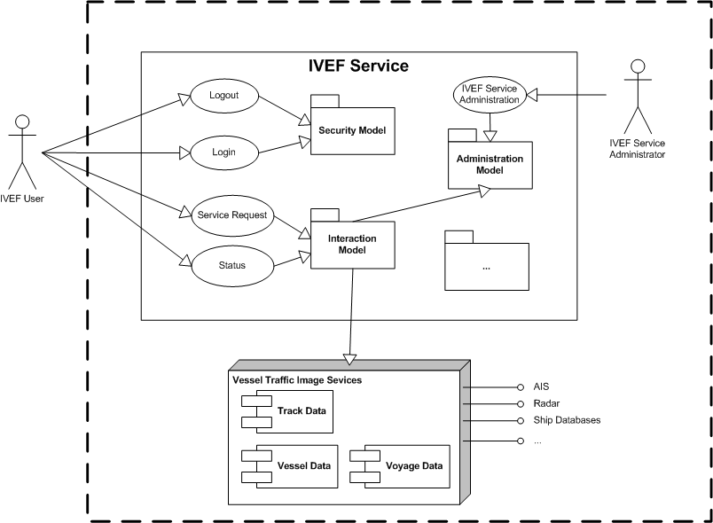

  - Data Model of the IVEF Service
    - Introduction
The Data Model of the IVEF Service is intended to be part of the Universal Maritime Data Model (UMDM), as described in [reference 1]. It provides the well-structured and abstract (functional) description of the data that is exchanged through the IVEF Service.

The Data Model itself does not contain data encoding information which is required to create an actual implementation of the service. Separating the data encoding from the Data Model of the IVEF Service provides flexibility in selecting an encoding technique as deemed appropriate by the competent authority. A portfolio of suitable encoding techniques for data objects of the IVEF Service is given in section 3.6 on the Interfacing Model.
    - The Place of the IVEF Service in the e-Navigation Architecture
Figure 5 illustrates the place of the IVEF Service in the e-Navigation architecture as described by IALA Recommendation on the e-Navigation Architecture – the Shore Perspective [reference 1]. It clearly identifies the co-operative nature of the shore-based IVEF Service. Note that the IVEF Service shares the dependencies of the e-Navigation architecture.

Figure 5 The Place of the IVEF Service within the e-Navigation architecture

Shore-based e-Navigation system

IVEF
Service
VTS 1
Integrated
Bridge

Wireless
Communication
Ship’s
sensors
Shipboard
Applications

Sensor
Data

VTS
Application 2
Application 3
Application 4
There may be many client-server-relationships, since the “gateway services” of the shore-based e-Navigation system may be requested by other e-Navigation services within that system, there can be identified. These client-server-relationships can be combined into a hierarchy within the shore-based e-Navigation system (see Figure 6).

Figure 6 Client-server relationships of the IVEF Service with other shore-based e-Navigation services
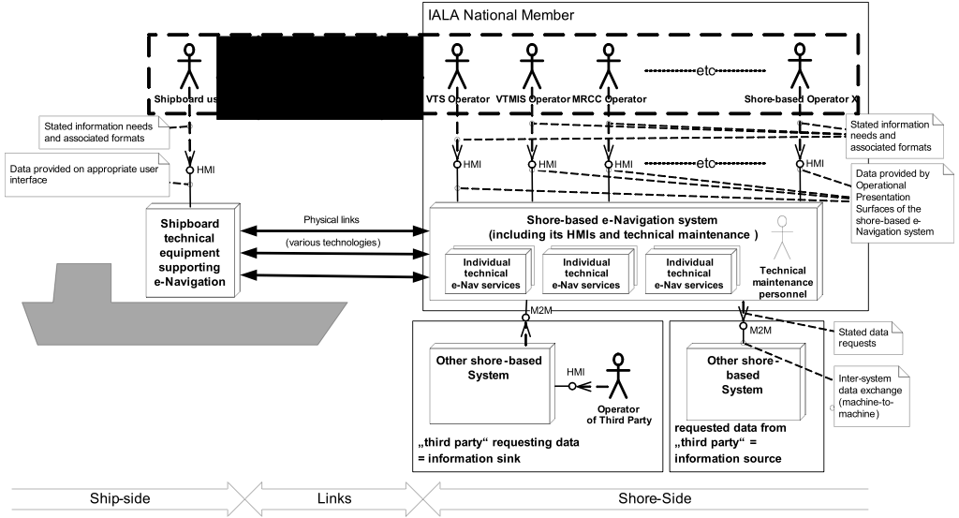

  - Interaction Model of the IVEF Service
    - Context
IVEF Service Interfaces are point-to-point connections between e-Navigation Gateways. One Gateway acts as an information source whereas the other Gateway acts as an information sink. The IVEF Service

Note that the IVEF Service by itself has no provisions for data compression and encryption. IVEF describes the data exchange format between eNAV applications; it relies on transport layers underneath to convert between physical, electrical and network interfaces. Additional transport layers may add data compression and encryption, depending on the system requirements (see Figure 7).

Figure 7 The Communications Stack
eNav Gateway
Information Source
eNav Gateway
Information Sink
IVEF
Service
IVEF
Client
Compression
e.g. ZLIB
Decompression

Encryption
e.g. SSL
Decryption
Transport
e.g. TCP/IP

The justification for this approach is the fact that these transport layers are already well-defined and standardised. Furthermore, standard compression and encryption algorithms are readily available.

Recommended layers (at this time) are TCP/IP for transport, SSL for encryption and ZLIB (RFC-1950) for compression.

    - Service Negotiation
The IVEF interface is a service based protocol. This means that the data exchange between the parties is not pre-defined, but rather the result of a negotiation between the information provider and the information consumer.
      - Introduction
When a client (an eNav Gateway acting as an information sink) wants to connect to server (an eNav Gateway acting as an information source), it has to initiate the service by authenticating. To do this, the client sends a Login message to the server, the server validates the login requests and if correct, it sends a LoginResponse message. The server initiates the default service for that particular user. An example of a service is:

“using an interval of 10 seconds, output all position information and voyage information about all vessels that are within in the following area ( x,y ) – ( x1,y1 ) – ( x2, y2 ) – ( x3,y3)”1

After the client is logged on, the server starts outputting the traffic image that matches the specification in the service.

The client can also sent a ServiceRequest to terminate or change the active service. Services can be defined with different transmission characteristics, which allows of a server push or client pull of the information, or a combination.
      - Service parameters
A service is defined by a number of parameters:

- Object Selection, which objects should be sent?
  - Area based
  - Filter based on the object properties (e.g. length > 50 m)
- Item Selection, which information elements should be sent?
  - Track Information
  - Vessel Information
  - Voyage Information
- Transmission Selection, when should it be sent?
  - Single Occurrence (Pull)
  - Periodic, with specified update rate (Push)
  - A-Periodic, synchronous with update (Push)

      - Information flow dynamics
The interface supports the following messages; the contents and meaning of the messages mentioned below are covered in chapter.

Table 1: Interface Messages
Message | From | To | Description
Control Information Messages
Login | Client | Server | This message is used to identify the client
Login Response | Server | Client | Login accepted or refused, if refused a reason will be supplied
Logout | Client | Server | This message is used to terminate the IVEF Service
Ping | Both | Both | Heartbeat message
Pong | Both | Both | Response to a Heartbeat message
Service Request | Client | Server | This message contains the definition of the service requested by the client. It will replace the current service.
Service Request Response | Server | Client | Request accepted or refused, if refused a reason will be supplied
Service Status | Server | Client | This message will be sent by the server to indicate the status of the service.
Real Time Messages
Object Data | Server | User | The track, vessel- and voyage related data of objects in the traffic image.

      - Timing and priorities
Control Information Messages have a higher priority than Real-Time Messages. This means that in an overload situation, Object Data Messages may be dropped in favour of Control Information Messages.

The service must start with a login message. The server will terminate the connection on transport layer when any other message is received, in order to prevent a possible Denial-of-Service (DoS) by mis-configured or malicious clients. If a service is interrupted at transport level, both server- and client sides will terminate the session and the client must login again to regain access to the service.

Messages, sent as a response to another message (LoginResponse, ServiceRequestReponse and Pong), must be responded to within agreed-upon period (e.g. 4 seconds). If the response message is not received within a specified timeout period, the sender may retry sending the message before terminating the service.

Ping messages must be sent when the sender has no other means to detect whether the receiver is still connected. The Ping message must be sent after an agreed-upon period of inactivity.

    - Part I: Primary service use cases of the BIS
The primary service use cases all have in common, that they are justified by at least one interaction with a “requesting service” within the common eNAV system architecture: The “requesting service” is any other service of the common shore-based e-Navigation system architecture making a request (logon) to the BIS in the previous chapter.

Figure 8 Overview of the primary service use cases of the IVEF Service
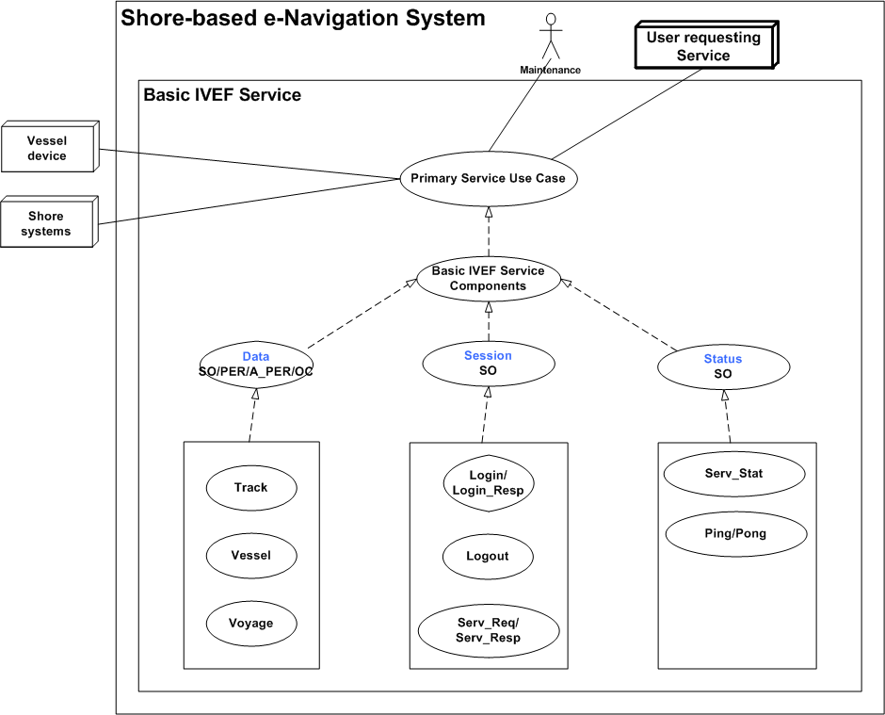
Note: The dotted lines indicate inheritance relationship.

The complete list of external BIS Components and their categories is given below:

BIS Components:

STATUS: | Service Status
DATA: | Object Data
SESSION: | Session Management

BIS Transmission Category

SO: | Single occurrence (non-realtime)
PER: | Periodic, with a specified update rate (real-time)
A-PER: | A-periodic, synchronous with the received track update (real-time)
OC: | On change, updates are sent as data elements change

BIS Basic Service Data Elements:

LOGIN: | Authentication request
LOGIN_RESP: | Authentication response
LOGOUT: | Service termination notification
SERV_REQ: | Service request (category, area)
SERV_RESP: | Service response
SERV_STAT: | Service Status
PING: | Alive request
PONG: | Alive response
TRACK: | Track data
VESSEL: | Vessel data
VOYAGE: | Voyage data

      - Service Component DATA

Service Model

Figure 9 The DATA Service Component
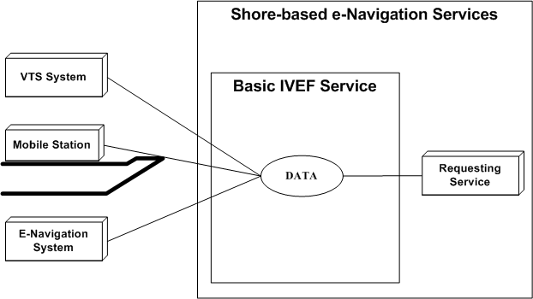

Description

The DATA service component provides the following information:

- Object track information; generally dynamic information about an object such as present position and speed
- Optionally Object vessel data; more or less pertinent information about an object such as call sign, IMO number and object dimensions
- Optionally Voyage data; such as Destination, ETA,....

Service Data Structure

See section 7

VESSEL: Vessel Data

Use:
- The vessel information is used to identify and classify ships.

Risks:

- The vessel information is obtained from several sources including manual entry onboard a ship or in a VTS system or from database systems. It is possible that this data may be incorrect.

Service Data Structure

See section 7

Operating Characteristics

- The BIS shall start automatically upon logon confirmation
- The data will be sent depending on transmission category

TRACK: Track Data
Use:
- The track data combined with the data derived from VESSEL and, optionally, VOYAGE represents the actual traffic image.

Risks:
- The track data that is exchanged is the result multi-sensor fusion of various sensors. Sensor data is inherently noisy and subject to all kinds of disturbances, therefore the track represents the best effort representation of the true situation, but not necessary the true situation itself.

Service Data Structure

See section 7

Operational Characteristics
- The BIS shall start automatically upon logon confirmation
- The data will be sent depending on transmission category

VOYAGE: Voyage-related Data
Use:
- The voyage-related ship information is used to classify ships with regard to cargo, draught, destination and the route.

Risks:

- The voyage information is entered onboard a ship or in a VTS system and it is possible that this data may be incorrect;

- Information on the type of cargo provides only the classification of dangerous goods (Carrying DG, HS, or MP, IMO hazard or pollutant category A, B, C, D). This may not be sufficient in case of SAR/Pollution prevention.

Service Data Structure

See section 7

Operational Characteristics

- The BIS shall start automatically upon logon confirmation
- The data will be sent depending on transmission category

      - Service Component SESSION

Service Model

Figure 10 The Session Service Component
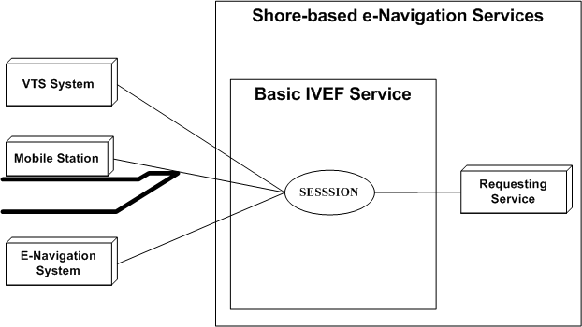

Description
The SESSION service component is responsible for set-up, termination and terms-of-service negotiation.

LOGIN/LOGIN_RESP/LOGOUT
Use:
- A session is started by issuing a login request with the appropriate account details
- The account details are verified and the service responds with a login response granting or denying access to the service
A session can be terminated by issuing a logout request

Risks

- Secured communication should be considered on the transport layer. IVEF provides only authentication support. Encryption and non repudiation must be established on transport layer using suitable technologies (VPN, https, ssl, direct lines…)

Service Data Structure

See section 7

SERVICE_REQ/ SERVICE _RESP
Use:
- A service request is used to negotiate the terms-of-service, i.e. data content, area of interest and frequency of delivery;
- A service request is acknowledged by a service response. Once acknowledge it will replace the previous service request.

Risks

- A service request could lead to a data link overload. The client is responsible for issuing the service request that matches the available resources.
- The server could be overloaded by to many user requests. Proper mechanism should be applied.

Service Data Structure

See section 7
      - Service Component STATUS

Service Model

Figure 11 The Status Service Component
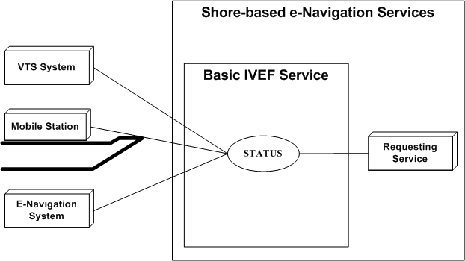

Description
The STATUS service component provides service-related status information and maintains alive status

PING/PONG/SERV_STAT

Use:
- PING / PONG are messages exchanged at regular time intervals to verify alive status of the data link.
- SERV_STAT indicates the status of the server to the client (ok/not ok) with an optional description.

Risks

- No risks

Service Data Structure

See section 7

    - Part II: Secondary service use cases of the BIS
      - LOCAL ADAPTATION

Use:
- The TAGGED_ITEM message can be used for non-standard, additional data exchange.

Risks

- Requires additional agreement between client side and server side.

Service Data Structure

See section 7
  - Security Model of the IVEF Service
The security model concerns the following aspects of the service

- Authentication – this concerns both clients of the service and providers of the service,
- Authorisation – this concerns the clients of the service,
- Data protection – this concerns the data that is being exchanged,
- Physical security – this concerns access to the server- and client systems and the interconnecting network.

The security model of the Basic IVEF Service adresses only the first two items, i.e. authentication and authorisation. The latter two items are outside the scope of this document. For data protection, suitable encryption methods can be defined at communication link-level (see section 3.4) or by providing a, so-called, Virtual Private Network (VPN) for clients.

The IVEF service is usually strictly contained within a shore-based e-Navigation system. Hence, it is assumed that appropriate measures for safeguarding the physical security of the service have been taken at the system level.

The model that is chosen for authentication and authorisation is a simple one, based on a shared secret between client and server (such a shared secret is commonly refererred to as “password”). There is no specific authentication of the server (although this can arranged, e.g. by using SSL certificates) and knowledge of the shared secret is assumed to identify the client. Once the client has authenticated itself, a set of client-specific rules is enforced by the server to guarantee that only those data are sent to the client for which the client is authorised (see also section 3.9).

Note that the security model of the IVEF service is, in fact, independent of the traffic image exchange service and can easily be replaced by a more elaborate security model (e.g. based on certificates) if required.
  - Interfacing Model of the IVEF Service
The IVEF Service refers to the Presentation and Application layers as defined by the Open Systems Interconnection (OSI) Reference Model [reference 3].

Figure 12 The ISO/OSI Reference Model
1 – Physical Layer
2 – Data Link Layer
3 – Network Layer
4 – Transport Layer
5 – Session Layer
6 – Presentation Layer
7 – Application Layer

The definition of the lower-level telecommunication support layers is beyond the scope of the IVEF Service definition. Transmission of an IVEF-coded vessel traffic image can make use of any available communication medium, for instance a packet-switched Wide Area Network (WAN) or a Local Area Network (LAN).

The specific lower-level telecommunication protocol layers should be agreed upon by all partners of the data exchange, taking into account requirements such as data rates, reliability, security and latency.

In order to ease the exchange of data between different systems (e.g. potential network interconnection) it is advisable to apply standard telecommunication protocols (e.g. TCP/IP).

The IVEF Service uses XML [reference 3] as a Presentation Layer protocol and defines the structure of the data to be exchanged over the communication medium.
  - Quality Parameters of the IVEF Service
The quality parameters of the IVEF Service depend on the intended use of the service: is it a real-time service, suitable for Vessel Traffic Services, or a near-realtime or non-realtime monitoring service that is regularly updated?

An important assumption of the service is that the server and client systems operate with a common time reference. Therefore it is recommended to use a time service that provides UTC time, e.g. based on GNSS or internet time servers (NTP), at both the server and client.

A possible application of the IVEF Service is the provision of monitoring data to a stakeholder, for example a ship owner that wants to have information on his fleet. In such a case, only the relevant data will be delivered; everything else will be filtered out. Also the update rate will be fairly low, say in the order of a few messages per hour. Furthermore, neither availability of the service nor message delays are critical issues.
Figure 13 Domains of Interest, Responsibility and Cooperation
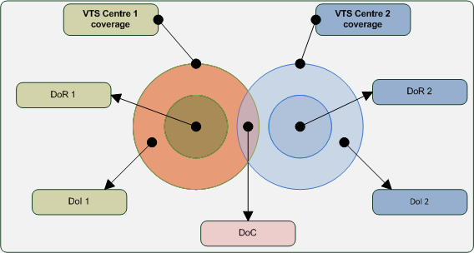

Although the IVEF Service is a one-way service (from server to client), a common operational scenario, where VTSs are involved, is a mutual service, where each VTS provides data to the other (Figure 1).
In such a scenario, three areas are considered
Domain of Interest (DoI) – the geographical area which is of interest to a particular VTS centre. In general, this is the total sensor coverage area
Domain of Responsibility (DoR) – the area for which the VTS centre is mandated to provide their VTS service, i.e. a Information Service, Traffic Organisation Service or Navigational Assistance Service.
Domain of Cooperation (DoC) – a subarea within the cross-section of the DoIs of the two VTSs where special processing is done to guarantee continuity of position, speed and course of objects.
In order to use the concept of the DoC, additional functionality is required in both VTSs.
This additional functionality consists of
- the capability of associating multiple tracks to a single object, i.e. in the DoC, both systems will have a track and these tracks must be correlated to the same physical object, for instance via matching position and speed, or some other method.
- the capability of smoothing out differences between the correlated tracks for the same object. The recommended processing to guarantee continuity across the Domain of Cooperation is to use a weighted average of the track states (see Figure 13).

In such a scenario, there should be a mutual agreement between the VTSs involved about the quality of service. This agreement should address
- availability and timeliness of the IVEF Service,
- emergency/breakdown procedures, if applicable,
- integrity of the VTS data delivered. This also concerns possible filtering of the data, for instance for commercial reasons.

A more complicated use case is where there are multiple providers of an IVEF Service to a common authority. The common authority is responsible for further distribution of the data to recognised data users. This means that the common authority is also responsible for validation of these users. In this case, there will be agreements between the common authority and the IVEF Service providers, but also between the common authority and the recognised data users. Obviously, the quality aspects in these agreements may be quite different, depending on the intended use of the data.
  - Test model of the IVEF Service
    - Well formed messages
Each IVEF Service Message must comply with the W3C XML specification [reference 3]. This specification defines an XML document as a text, which is well-formed, i.e., it satisfies a list of syntax rules provided in the specification. The list of rules is fairly lengthy; the most important rules are:

- A message contains only properly-encoded legal Unicode characters.
- None of the special syntax characters such as "<" and "&" appear except when performing their markup-delineation roles.
- The begin, end, and empty-element tags, which delimit the elements, are correctly nested, with none missing and none overlapping.
- The element tags are case-sensitive; the beginning and end tags must match exactly.
- There is a single "root" element, which contains all the other elements.

    - Valid messages
In addition to being well-formed, an IVEF Service Message must also be valid. This means that data elements and attributes must comply with the definition as specified in section 7. In addition, the values must adhere to minimum value, maximum value, length, precision etc., as specified in section 7.

    - Valid data
All track numbers, at any given time instant, should be unique.

    - Interaction behaviour
A login should be answered by a login response as indicated in Figure 14. The same holds, modus modendi, for ping/pong and service req/service resp.
Figure 14 Login/Logout activity graph
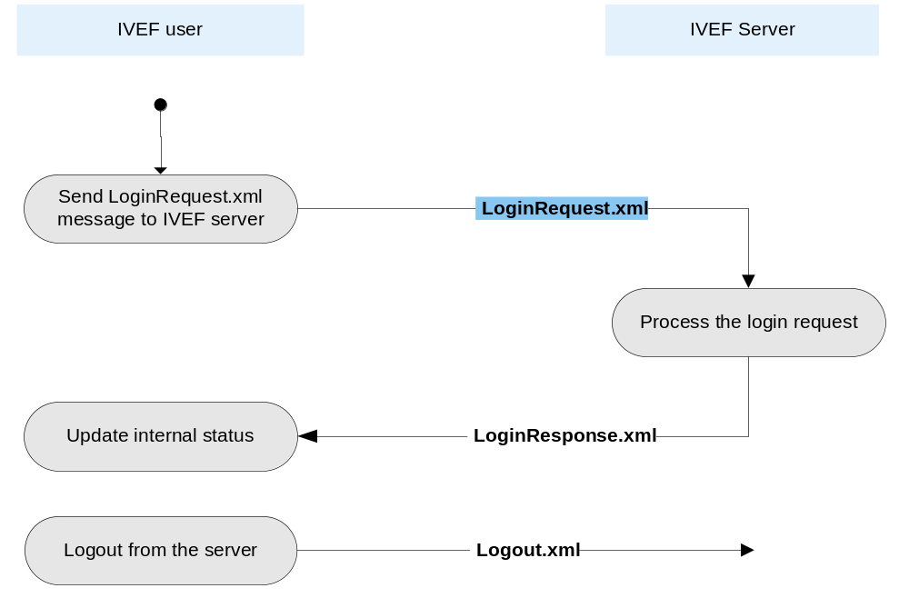

  - Administration Model of the IVEF Service
The Administration Model describes the aspects of the service that can be configured by service provider. For the IVEF Service, this concerns the maintenance of the user database. The user database contains the shared secret for each user and the user authorisations, i.e. the restrictions, that are enforced by the server, on the data that is provided to a particular user. Additionally, the user database may contain default services for each user. These default services may be adapted by the respective user or be left to the discreteness of the service provider.
Considering the complexity of the user database, it is strongly recommended to provide a graphical Human-Machine Interface (HMI) for this purpose.
- References
- IALA Recommendation on the e-Navigation Architecture – the Shore Perspective, IALA Recommendation eNAV-101
- Generic e-Navigation Service Engineering Model Template, (draft) IALA Recommendation eNAV-210, 2009
- Open Systems Interconnection (OSI) Reference Model, International Standards Organization (ISO) Standard 7498-1, 1994
- Extensible Markup Language (XML) 1.0 (Fifth Edition), W3C Recommendation 26 November 2008, http://www.w3.org/TR/2008/REC-xml-20081126/
- Definitions

Object – a vessel, an Aid-to-Navigation or a helicopter (SAR)
Gateway Service – a generic type of service, as defined in [reference 1]

- Abbreviations
BIS – Basic IVEF Services
DoC – Domain of Cooperation
DoI – Domain of Interest
DoR – Domain of Responsibility
DoS – Denial of Service
GNSS – Global Navigation Satellite System
HMI – Human-Machine Interface
IVEF – Inter-system Vessel traffic image Exchange Format
ISO – The International Standards Organisation
LAN – Local-Area Network
NTP – Network Time Protocol
OSI – Open Systems Interconnection
SAR – Search and Rescue
SSL – Secure Socket Layer
TCP/IP – Transmission Control Protocol/Internet Protocol
TIE – Traffic Image Exchange
UMDM – Universal Maritime Data Model
UTC – Universal Time Coordinated
VTS – Vessel Traffic Services
W3C – World-Wide Web Consortium
WAN – Wide-Area Network
XML – eXtensible Markup Language
- Appendix: Data Definition

attribute form default:
element form default: | qualified
targetNamespace: | http://www.iala-to-be-confirmed.org/XMLSchema/IVEF/0.2.3

Elements
Area
Header
LoginRequest
LoginResponse
Logout
MSG_IVEF
ObjectData
OtherId
OtherName
Ping
Pong
Pos
ServerStatus
ServiceRequest
ServiceRequestResponse
TaggedItem
TrackData
VesselData
VoyageData

element Area
diagram | 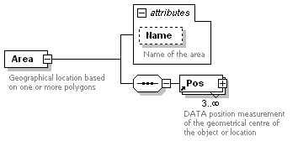
namespace | http://www.iala-to-be-confirmed.org/XMLSchema/IVEF/0.2.3
properties
  content | complex
children | Pos
used by
  element | ServiceRequest
attributes
  Name | Type | Use | Default | Fixed | Annotation
  Name | derived by: xs:string | optional
    documentation
    Name of the area
annotation
  documentation
  Geographical location based on one or more polygons
source | <xs:element name="Area">  <xs:annotation>  <xs:documentation>Geographical location based on one or more polygons</xs:documentation>  </xs:annotation>  <xs:complexType>  <xs:sequence>  <xs:element ref="Pos" minOccurs="3" maxOccurs="unbounded"/>  </xs:sequence>  <xs:attribute name="Name" use="optional">  <xs:annotation>  <xs:documentation>Name of the area</xs:documentation>  </xs:annotation>  <xs:simpleType>  <xs:restriction base="xs:string">  <xs:minLength value="1"/>  <xs:maxLength value="42"/>  </xs:restriction>  </xs:simpleType>  </xs:attribute>  </xs:complexType>  </xs:element>

element Header
diagram | 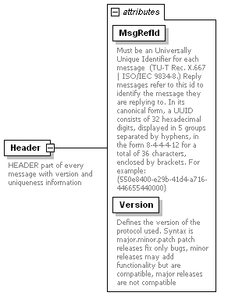
namespace | http://www.iala-to-be-confirmed.org/XMLSchema/IVEF/0.2.3
properties
  content | complex
used by
  element | MSG_IVEF
attributes
  Name | Type | Use | Default | Fixed | Annotation
  MsgRefId | derived by: xs:string | required
    documentation
    Must be an Universally Unique Identifier for each message (TU-T Rec. X.667 | ISO/IEC 9834-8.) Reply messages refer to this id to identify the message they are replying to. In its canonical form, a UUID consists of 32 hexadecimal digits, displayed in 5 groups separated by hyphens, in the form 8-4-4-4-12 for a total of 36 characters, enclosed by brackets. For example:
    {550e8400-e29b-41d4-a716-446655440000}
  Version | xs:string | required |  | 0.2.3
    documentation
    Defines the version of the protocol used. Syntax is major.minor.patch patch releases fix only bugs, minor releases may add functionality but are compatible, major releases are not compatible
annotation
  documentation
  HEADER part of every message with version and uniqueness information
source | <xs:element name="Header">  <xs:annotation>  <xs:documentation>HEADER part of every message with version and uniqueness information</xs:documentation>  </xs:annotation>  <xs:complexType>  <xs:attribute name="MsgRefId" use="required">  <xs:annotation>  <xs:documentation>Must be an Universally Unique Identifier for each message (TU-T Rec. X.667 | ISO/IEC 9834-8.) Reply messages refer to this id to identify the message they are replying to. In its canonical form, a UUID consists of 32 hexadecimal digits, displayed in 5 groups separated by hyphens, in the form 8-4-4-4-12 for a total of 36 characters, enclosed by brackets. For example:  {550e8400-e29b-41d4-a716-446655440000}</xs:documentation>  </xs:annotation>  <xs:simpleType>  <xs:restriction base="xs:string">  <xs:minLength value="36"/>  <xs:maxLength value="42"/>  </xs:restriction>  </xs:simpleType>  </xs:attribute>  <xs:attribute name="Version" type="xs:string" use="required" fixed="0.2.3">  <xs:annotation>  <xs:documentation>Defines the version of the protocol used. Syntax is major.minor.patch patch releases fix only bugs, minor releases may add functionality but are compatible, major releases are not compatible</xs:documentation>  </xs:annotation>  </xs:attribute>  </xs:complexType>  </xs:element>

element LoginRequest
diagram | 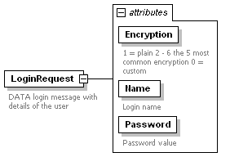
namespace | http://www.iala-to-be-confirmed.org/XMLSchema/IVEF/0.2.3
properties
  content | complex
used by
  element | MSG_IVEF/Body
attributes
  Name | Type | Use | Default | Fixed | Annotation
  Encryption | derived by: xs:integer | required
    documentation
    1 = plain 2 - 6 the 5 most common encryption 0 = custom
  Name | derived by: xs:string | required
    documentation
    Login name
  Password | derived by: xs:string | required
    documentation
    Password value
annotation
  documentation
  DATA login message with details of the user
source | <xs:element name="LoginRequest">  <xs:annotation>  <xs:documentation>DATA login message with details of the user</xs:documentation>  </xs:annotation>  <xs:complexType>  <xs:attribute name="Encryption" use="required">  <xs:annotation>  <xs:documentation>1 = plain 2 - 6 the 5 most common encryption 0 = custom</xs:documentation>  </xs:annotation>  <xs:simpleType>  <xs:restriction base="xs:integer">  <xs:enumeration value="1"/>  <xs:enumeration value="2"/>  </xs:restriction>  </xs:simpleType>  </xs:attribute>  <xs:attribute name="Name" use="required">  <xs:annotation>  <xs:documentation>Login name</xs:documentation>  </xs:annotation>  <xs:simpleType>  <xs:restriction base="xs:string">  <xs:maxLength value="256"/>  </xs:restriction>  </xs:simpleType>  </xs:attribute>  <xs:attribute name="Password" use="required">  <xs:annotation>  <xs:documentation>Password value</xs:documentation>  </xs:annotation>  <xs:simpleType>  <xs:restriction base="xs:string">  <xs:maxLength value="256"/>  </xs:restriction>  </xs:simpleType>  </xs:attribute>  </xs:complexType>  </xs:element>

element LoginResponse
diagram | 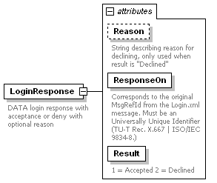
namespace | http://www.iala-to-be-confirmed.org/XMLSchema/IVEF/0.2.3
properties
  content | complex
used by
  element | MSG_IVEF/Body
attributes
  Name | Type | Use | Default | Fixed | Annotation
  Reason | derived by: xs:string | optional
    documentation
    String describing reason for declining, only used when result is "Declined"
  ResponseOn | derived by: xs:string | required
    documentation
    Corresponds to the original MsgRefId from the Login.xml message. Must be an Universally Unique Identifier (TU-T Rec. X.667 | ISO/IEC 9834-8.)
  Result | derived by: xs:integer | required
    documentation
    1 = Accepted 2 = Declined
annotation
  documentation
  DATA login response with acceptance or deny with optional reason
source | <xs:element name="LoginResponse">  <xs:annotation>  <xs:documentation>DATA login response with acceptance or deny with optional reason</xs:documentation>  </xs:annotation>  <xs:complexType>  <xs:attribute name="Reason" use="optional">  <xs:annotation>  <xs:documentation>String describing reason for declining, only used when result is "Declined"</xs:documentation>  </xs:annotation>  <xs:simpleType>  <xs:restriction base="xs:string">  <xs:maxLength value="256"/>  </xs:restriction>  </xs:simpleType>  </xs:attribute>  <xs:attribute name="ResponseOn" use="required">  <xs:annotation>  <xs:documentation>Corresponds to the original MsgRefId from the Login.xml message. Must be an Universally Unique Identifier (TU-T Rec. X.667 | ISO/IEC 9834-8.)</xs:documentation>  </xs:annotation>  <xs:simpleType>  <xs:restriction base="xs:string">  <xs:minLength value="36"/>  <xs:maxLength value="42"/>  </xs:restriction>  </xs:simpleType>  </xs:attribute>  <xs:attribute name="Result" use="required">  <xs:annotation>  <xs:documentation>1 = Accepted 2 = Declined</xs:documentation>  </xs:annotation>  <xs:simpleType>  <xs:restriction base="xs:integer">  <xs:enumeration value="1"/>  <xs:enumeration value="2"/>  </xs:restriction>  </xs:simpleType>  </xs:attribute>  </xs:complexType>  </xs:element>

element Logout
diagram | 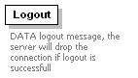
namespace | http://www.iala-to-be-confirmed.org/XMLSchema/IVEF/0.2.3
used by
  element | MSG_IVEF/Body
annotation
  documentation
  DATA logout message, the server will drop the connection if logout is successfull
source | <xs:element name="Logout">  <xs:annotation>  <xs:documentation>DATA logout message, the server will drop the connection if logout is successfull</xs:documentation>  </xs:annotation>  </xs:element>

element MSG_IVEF
diagram | 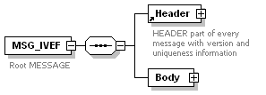
namespace | http://www.iala-to-be-confirmed.org/XMLSchema/IVEF/0.2.3
properties
  content | complex
children | Header Body
annotation
  documentation
  Root MESSAGE
source | <xs:element name="MSG_IVEF">  <xs:annotation>  <xs:documentation>Root MESSAGE</xs:documentation>  </xs:annotation>  <xs:complexType>  <xs:sequence>  <xs:element ref="Header"/>  <xs:element name="Body">  <xs:complexType>  <xs:choice>  <xs:element ref="LoginRequest">  <xs:annotation>  <xs:documentation>MESSAGE sent by the user to identify oneselfs and request the default service</xs:documentation>  </xs:annotation>  </xs:element>  <xs:element ref="LoginResponse">  <xs:annotation>  <xs:documentation>MESSAGE sent by the supplier indicating wether the user login was accepted or not</xs:documentation>  </xs:annotation>  </xs:element>  <xs:element ref="Logout">  <xs:annotation>  <xs:documentation>MESSAGE sent by the user to announce it will close it's connection</xs:documentation>  </xs:annotation>  </xs:element>  <xs:element name="ObjectDatas">  <xs:complexType>  <xs:sequence>  <xs:element ref="ObjectData" maxOccurs="unbounded">  <xs:annotation>  <xs:documentation>MESSAGE sent by the supplier containing data regarding objects in its domain</xs:documentation>  </xs:annotation>  </xs:element>  </xs:sequence>  </xs:complexType>  </xs:element>  <xs:element ref="Ping">  <xs:annotation>  <xs:documentation>MESSAGE sent by either the user or the supplier to verify the aliveness of the connection, failure to respond within the timeout will lead to disconnect (default = 3 seconds)</xs:documentation>  </xs:annotation>  </xs:element>  <xs:element ref="Pong">  <xs:annotation>  <xs:documentation>MESSAGE sent as reply to a MSG_Ping to confirm the aliveness of the connection.</xs:documentation>  </xs:annotation>  </xs:element>  <xs:element ref="ServerStatus">  <xs:annotation>  <xs:documentation>MESSAGE sent by the server in case the server is experienceing / recovering from load problems</xs:documentation>  </xs:annotation>  </xs:element>  <xs:element ref="ServiceRequest">  <xs:annotation>  <xs:documentation>MESSAGE sent by the user to request a different service than the current service, to stop all services request data from 0 areas or logout</xs:documentation>  </xs:annotation>  </xs:element>  <xs:element ref="ServiceRequestResponse">  <xs:annotation>  <xs:documentation>MESSAGE sent by the suplier as as a response to a service request</xs:documentation>  </xs:annotation>  </xs:element>  </xs:choice>  </xs:complexType>  </xs:element>  </xs:sequence>  </xs:complexType>  </xs:element>

element MSG_IVEF/Body
diagram | 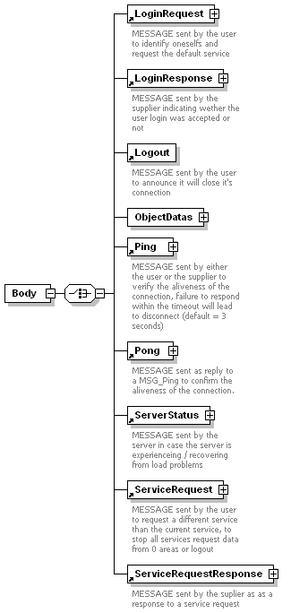
namespace | http://www.iala-to-be-confirmed.org/XMLSchema/IVEF/0.2.3
properties
  isRef | 0
  content | complex
children | LoginRequest LoginResponse Logout ObjectDatas Ping Pong ServerStatus ServiceRequest ServiceRequestResponse
source | <xs:element name="Body">  <xs:complexType>  <xs:choice>  <xs:element ref="LoginRequest">  <xs:annotation>  <xs:documentation>MESSAGE sent by the user to identify oneselfs and request the default service</xs:documentation>  </xs:annotation>  </xs:element>  <xs:element ref="LoginResponse">  <xs:annotation>  <xs:documentation>MESSAGE sent by the supplier indicating wether the user login was accepted or not</xs:documentation>  </xs:annotation>  </xs:element>  <xs:element ref="Logout">  <xs:annotation>  <xs:documentation>MESSAGE sent by the user to announce it will close it's connection</xs:documentation>  </xs:annotation>  </xs:element>  <xs:element name="ObjectDatas">  <xs:complexType>  <xs:sequence>  <xs:element ref="ObjectData" maxOccurs="unbounded">  <xs:annotation>  <xs:documentation>MESSAGE sent by the supplier containing data regarding objects in its domain</xs:documentation>  </xs:annotation>  </xs:element>  </xs:sequence>  </xs:complexType>  </xs:element>  <xs:element ref="Ping">  <xs:annotation>  <xs:documentation>MESSAGE sent by either the user or the supplier to verify the aliveness of the connection, failure to respond within the timeout will lead to disconnect (default = 3 seconds)</xs:documentation>  </xs:annotation>  </xs:element>  <xs:element ref="Pong">  <xs:annotation>  <xs:documentation>MESSAGE sent as reply to a MSG_Ping to confirm the aliveness of the connection.</xs:documentation>  </xs:annotation>  </xs:element>  <xs:element ref="ServerStatus">  <xs:annotation>  <xs:documentation>MESSAGE sent by the server in case the server is experienceing / recovering from load problems</xs:documentation>  </xs:annotation>  </xs:element>  <xs:element ref="ServiceRequest">  <xs:annotation>  <xs:documentation>MESSAGE sent by the user to request a different service than the current service, to stop all services request data from 0 areas or logout</xs:documentation>  </xs:annotation>  </xs:element>  <xs:element ref="ServiceRequestResponse">  <xs:annotation>  <xs:documentation>MESSAGE sent by the suplier as as a response to a service request</xs:documentation>  </xs:annotation>  </xs:element>  </xs:choice>  </xs:complexType>  </xs:element>

element MSG_IVEF/Body/ObjectDatas
diagram | 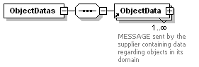
namespace | http://www.iala-to-be-confirmed.org/XMLSchema/IVEF/0.2.3
properties
  isRef | 0
  content | complex
children | ObjectData
source | <xs:element name="ObjectDatas">  <xs:complexType>  <xs:sequence>  <xs:element ref="ObjectData" maxOccurs="unbounded">  <xs:annotation>  <xs:documentation>MESSAGE sent by the supplier containing data regarding objects in its domain</xs:documentation>  </xs:annotation>  </xs:element>  </xs:sequence>  </xs:complexType>  </xs:element>

element ObjectData
diagram | 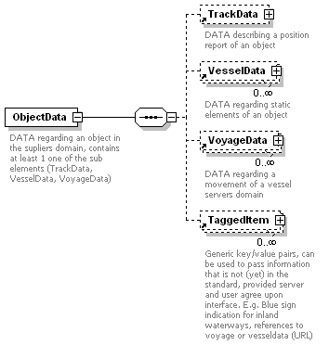
namespace | http://www.iala-to-be-confirmed.org/XMLSchema/IVEF/0.2.3
properties
  content | complex
children | TrackData VesselData VoyageData TaggedItem
used by
  element | MSG_IVEF/Body/ObjectDatas
annotation
  documentation
  DATA regarding an object in the supliers domain, contains at least 1 one of the sub elements (TrackData, VesselData, VoyageData)
source | <xs:element name="ObjectData">  <xs:annotation>  <xs:documentation>DATA regarding an object in the supliers domain, contains at least 1 one of the sub elements (TrackData, VesselData, VoyageData)</xs:documentation>  </xs:annotation>  <xs:complexType>  <xs:sequence>  <xs:element ref="TrackData" minOccurs="0"/>  <xs:element ref="VesselData" minOccurs="0" maxOccurs="unbounded"/>  <xs:element ref="VoyageData" minOccurs="0" maxOccurs="unbounded"/>  <xs:element ref="TaggedItem" minOccurs="0" maxOccurs="unbounded"/>  </xs:sequence>  </xs:complexType>  </xs:element>

element OtherId
diagram | 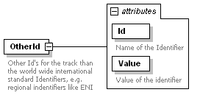
namespace | http://www.iala-to-be-confirmed.org/XMLSchema/IVEF/0.2.3
properties
  content | complex
used by
  element | VesselData/Identifier
attributes
  Name | Type | Use | Default | Fixed | Annotation
  Id | derived by: xs:string | required
    documentation
    Name of the Identifier
  Value | derived by: xs:string | required
    documentation
    Value of the identifier
annotation
  documentation
  Other Id's for the track than the world wide international standard Identifiers, e.g. regional indentifiers like ENI
source | <xs:element name="OtherId">  <xs:annotation>  <xs:documentation>Other Id's for the track than the world wide international standard Identifiers, e.g. regional indentifiers like ENI</xs:documentation>  </xs:annotation>  <xs:complexType>  <xs:attribute name="Id" use="required">  <xs:annotation>  <xs:documentation>Name of the Identifier</xs:documentation>  </xs:annotation>  <xs:simpleType>  <xs:restriction base="xs:string">  <xs:minLength value="1"/>  <xs:maxLength value="42"/>  </xs:restriction>  </xs:simpleType>  </xs:attribute>  <xs:attribute name="Value" use="required">  <xs:annotation>  <xs:documentation>Value of the identifier</xs:documentation>  </xs:annotation>  <xs:simpleType>  <xs:restriction base="xs:string">  <xs:minLength value="1"/>  <xs:maxLength value="42"/>  </xs:restriction>  </xs:simpleType>  </xs:attribute>  </xs:complexType>  </xs:element>

element OtherName
diagram | 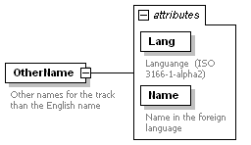
namespace | http://www.iala-to-be-confirmed.org/XMLSchema/IVEF/0.2.3
properties
  content | complex
used by
  element | VesselData/Identifier
attributes
  Name | Type | Use | Default | Fixed | Annotation
  Lang | derived by: xs:string | required
    documentation
    Languange (ISO 3166-1-alpha2)
  Name | derived by: xs:string | required
    documentation
    Name in the foreign language
annotation
  documentation
  Other names for the track than the English name
source | <xs:element name="OtherName">  <xs:annotation>  <xs:documentation>Other names for the track than the English name</xs:documentation>  </xs:annotation>  <xs:complexType>  <xs:attribute name="Lang" use="required">  <xs:annotation>  <xs:documentation>Languange (ISO 3166-1-alpha2)</xs:documentation>  </xs:annotation>  <xs:simpleType>  <xs:restriction base="xs:string">  <xs:minLength value="2"/>  <xs:maxLength value="2"/>  </xs:restriction>  </xs:simpleType>  </xs:attribute>  <xs:attribute name="Name" use="required">  <xs:annotation>  <xs:documentation>Name in the foreign language</xs:documentation>  </xs:annotation>  <xs:simpleType>  <xs:restriction base="xs:string">  <xs:minLength value="1"/>  <xs:maxLength value="42"/>  </xs:restriction>  </xs:simpleType>  </xs:attribute>  </xs:complexType>  </xs:element>

element Ping
diagram | 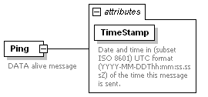
namespace | http://www.iala-to-be-confirmed.org/XMLSchema/IVEF/0.2.3
properties
  content | complex
used by
  element | MSG_IVEF/Body
attributes
  Name | Type | Use | Default | Fixed | Annotation
  TimeStamp | xs:dateTime | required
    documentation
    Date and time in (subset ISO 8601) UTC format (YYYY-MM-DDThh:mm:ss.sssZ) of the time this message is sent.
annotation
  documentation
  DATA alive message
source | <xs:element name="Ping">  <xs:annotation>  <xs:documentation>DATA alive message</xs:documentation>  </xs:annotation>  <xs:complexType>  <xs:attribute name="TimeStamp" type="xs:dateTime" use="required">  <xs:annotation>  <xs:documentation>Date and time in (subset ISO 8601) UTC format (YYYY-MM-DDThh:mm:ss.sssZ) of the time this message is sent.</xs:documentation>  </xs:annotation>  </xs:attribute>  </xs:complexType>  </xs:element>

element Pong
diagram | 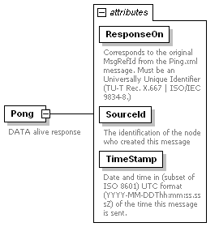
namespace | http://www.iala-to-be-confirmed.org/XMLSchema/IVEF/0.2.3
properties
  content | complex
used by
  element | MSG_IVEF/Body
attributes
  Name | Type | Use | Default | Fixed | Annotation
  ResponseOn | derived by: xs:string | required
    documentation
    Corresponds to the original MsgRefId from the Ping.xml message. Must be an Universally Unique Identifier (TU-T Rec. X.667 | ISO/IEC 9834-8.)
  SourceId | xs:integer | required
    documentation
    The identification of the node who created this message
  TimeStamp | xs:dateTime | required
    documentation
    Date and time in (subset of ISO 8601) UTC format (YYYY-MM-DDThh:mm:ss.sssZ) of the time this message is sent.
annotation
  documentation
  DATA alive response
source | <xs:element name="Pong">  <xs:annotation>  <xs:documentation>DATA alive response</xs:documentation>  </xs:annotation>  <xs:complexType>  <xs:attribute name="ResponseOn" use="required">  <xs:annotation>  <xs:documentation>Corresponds to the original MsgRefId from the Ping.xml message. Must be an Universally Unique Identifier (TU-T Rec. X.667 | ISO/IEC 9834-8.)</xs:documentation>  </xs:annotation>  <xs:simpleType>  <xs:restriction base="xs:string">  <xs:minLength value="36"/>  <xs:maxLength value="42"/>  </xs:restriction>  </xs:simpleType>  </xs:attribute>  <xs:attribute name="SourceId" type="xs:integer" use="required">  <xs:annotation>  <xs:documentation>The identification of the node who created this message</xs:documentation>  </xs:annotation>  </xs:attribute>  <xs:attribute name="TimeStamp" type="xs:dateTime" use="required">  <xs:annotation>  <xs:documentation>Date and time in (subset of ISO 8601) UTC format (YYYY-MM-DDThh:mm:ss.sssZ) of the time this message is sent.</xs:documentation>  </xs:annotation>  </xs:attribute>  </xs:complexType>  </xs:element>

element Pos
diagram | 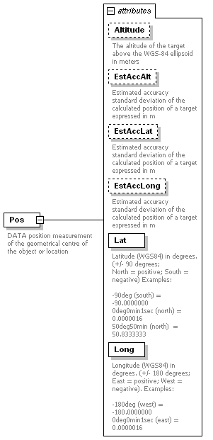
namespace | http://www.iala-to-be-confirmed.org/XMLSchema/IVEF/0.2.3
properties
  content | complex
used by
  elements | Area TrackData VoyageData/Waypoint
attributes
  Name | Type | Use | Default | Fixed | Annotation
  Altitude | xs:decimal | optional
    documentation
    The altitude of the target above the WGS-84 ellipsoid in meters
  EstAccAlt | xs:decimal | optional
    documentation
    Estimated accuracy
    standard deviation of the calculated position of a target
    expressed in m
  EstAccLat | xs:decimal | optional
    documentation
    Estimated accuracy
    standard deviation of the calculated position of a target
    expressed in m
  EstAccLong | xs:decimal | optional
    documentation
    Estimated accuracy
    standard deviation of the calculated position of a target
    expressed in m
  Lat | derived by: xs:decimal | required
    documentation
    Latitude (WGS84) in degrees. (+/- 90 degrees;
    North = positive; South = negative) Examples:
    -90deg (south) = -90.0000000
    0deg0min1sec (north) = 0.0000016
    50deg50min (north) = 50.8333333
  Long | derived by: xs:decimal | required
    documentation
    Longitude (WGS84) in degrees. (+/- 180 degrees; East = positive; West = negative). Examples:
    -180deg (west) = -180.0000000
    0deg0min1sec (east) = 0.0000016
annotation
  documentation
  DATA position measurement of the geometrical centre of the object or location
source | <xs:element name="Pos">  <xs:annotation>  <xs:documentation>DATA position measurement of the geometrical centre of the object or location</xs:documentation>  </xs:annotation>  <xs:complexType>  <xs:attribute name="Altitude" type="xs:decimal" use="optional">  <xs:annotation>  <xs:documentation>The altitude of the target above the WGS-84 ellipsoid in meters</xs:documentation>  </xs:annotation>  </xs:attribute>  <xs:attribute name="EstAccAlt" type="xs:decimal" use="optional">  <xs:annotation>  <xs:documentation>Estimated accuracy  standard deviation of the calculated position of a target  expressed in m</xs:documentation>  </xs:annotation>  </xs:attribute>  <xs:attribute name="EstAccLat" type="xs:decimal" use="optional">  <xs:annotation>  <xs:documentation>Estimated accuracy  standard deviation of the calculated position of a target  expressed in m</xs:documentation>  </xs:annotation>  </xs:attribute>  <xs:attribute name="EstAccLong" type="xs:decimal" use="optional">  <xs:annotation>  <xs:documentation>Estimated accuracy  standard deviation of the calculated position of a target  expressed in m</xs:documentation>  </xs:annotation>  </xs:attribute>  <xs:attribute name="Lat" use="required">  <xs:annotation>  <xs:documentation>Latitude (WGS84) in degrees. (+/- 90 degrees;  North = positive; South = negative) Examples:  -90deg (south) = -90.0000000  0deg0min1sec (north) = 0.0000016  50deg50min (north) = 50.8333333</xs:documentation>  </xs:annotation>  <xs:simpleType>  <xs:restriction base="xs:decimal">  <xs:fractionDigits value="5"/>  <xs:minInclusive value="-90.00000"/>  <xs:maxInclusive value="+90.00000"/>  </xs:restriction>  </xs:simpleType>  </xs:attribute>  <xs:attribute name="Long" use="required">  <xs:annotation>  <xs:documentation>Longitude (WGS84) in degrees. (+/- 180 degrees; East = positive; West = negative). Examples:  -180deg (west) = -180.0000000  0deg0min1sec (east) = 0.0000016</xs:documentation>  </xs:annotation>  <xs:simpleType>  <xs:restriction base="xs:decimal">  <xs:fractionDigits value="5"/>  <xs:maxInclusive value="+180.00000"/>  <xs:minExclusive value="-180.00000"/>  </xs:restriction>  </xs:simpleType>  </xs:attribute>  </xs:complexType>  </xs:element>

element ServerStatus
diagram | 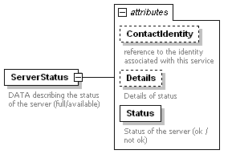
namespace | http://www.iala-to-be-confirmed.org/XMLSchema/IVEF/0.2.3
properties
  content | complex
used by
  element | MSG_IVEF/Body
attributes
  Name | Type | Use | Default | Fixed | Annotation
  ContactIdentity | derived by: xs:string | optional
    documentation
    reference to the identity associated with this service
  Details | derived by: xs:string | optional
    documentation
    Details of status
  Status | xs:boolean | required
    documentation
    Status of the server (ok / not ok)
annotation
  documentation
  DATA describing the status of the server (full/available)
source | <xs:element name="ServerStatus">  <xs:annotation>  <xs:documentation>DATA describing the status of the server (full/available)</xs:documentation>  </xs:annotation>  <xs:complexType>  <xs:attribute name="ContactIdentity" use="optional">  <xs:annotation>  <xs:documentation>reference to the identity associated with this service</xs:documentation>  </xs:annotation>  <xs:simpleType>  <xs:restriction base="xs:string">  <xs:minLength value="1"/>  <xs:maxLength value="254"/>  </xs:restriction>  </xs:simpleType>  </xs:attribute>  <xs:attribute name="Details" use="optional">  <xs:annotation>  <xs:documentation>Details of status</xs:documentation>  </xs:annotation>  <xs:simpleType>  <xs:restriction base="xs:string">  <xs:maxLength value="50"/>  </xs:restriction>  </xs:simpleType>  </xs:attribute>  <xs:attribute name="Status" type="xs:boolean" use="required">  <xs:annotation>  <xs:documentation>Status of the server (ok / not ok)</xs:documentation>  </xs:annotation>  </xs:attribute>  </xs:complexType>  </xs:element>

element ServiceRequest
diagram | 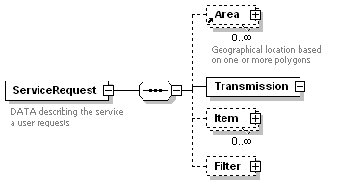
namespace | http://www.iala-to-be-confirmed.org/XMLSchema/IVEF/0.2.3
properties
  content | complex
children | Area Transmission Item Filter
used by
  element | MSG_IVEF/Body
annotation
  documentation
  DATA describing the service a user requests
source | <xs:element name="ServiceRequest">  <xs:annotation>  <xs:documentation>DATA describing the service a user requests</xs:documentation>  </xs:annotation>  <xs:complexType>  <xs:sequence>  <xs:element ref="Area" minOccurs="0" maxOccurs="unbounded"/>  <xs:element name="Transmission">  <xs:complexType>  <xs:attribute name="Type" use="required">  <xs:annotation>  <xs:documentation>Type of transmission, possible values are:  1 = single occurrence (whole image)  2 = periodic occurence (predicted, whole image)  3 = a-periodic occurence (synchronous, whenever an object is updated)</xs:documentation>  </xs:annotation>  <xs:simpleType>  <xs:restriction base="xs:integer">  <xs:enumeration value="1"/>  <xs:enumeration value="2"/>  <xs:enumeration value="3"/>  </xs:restriction>  </xs:simpleType>  </xs:attribute>  <xs:attribute name="Period" type="xs:decimal" use="optional">  <xs:annotation>  <xs:documentation> Specifies the time between two periodic updates in seconds</xs:documentation>  </xs:annotation>  </xs:attribute>  </xs:complexType>  </xs:element>  <xs:element name="Item" minOccurs="0" maxOccurs="unbounded">  <xs:complexType>  <xs:attribute name="DataSelector" use="required">  <xs:annotation>  <xs:documentation>Describes requested Object data element, possible values:  1 = TrackData  2 = VesselData  3 = VoyageData</xs:documentation>  </xs:annotation>  <xs:simpleType>  <xs:restriction base="xs:integer">  <xs:enumeration value="1"/>  <xs:enumeration value="2"/>  <xs:enumeration value="3"/>  </xs:restriction>  </xs:simpleType>  </xs:attribute>  <xs:attribute name="FieldSelector" use="required">  <xs:annotation>  <xs:documentation>Selected field. Can be 'all' or one of the items of object data TrackData, VesselData or VoyageData, to be changed into an enumeration of strings once these have been fixed</xs:documentation>  </xs:annotation>  <xs:simpleType>  <xs:restriction base="xs:string">  <xs:minLength value="1"/>  <xs:maxLength value="42"/>  </xs:restriction>  </xs:simpleType>  </xs:attribute>  </xs:complexType>  </xs:element>  <xs:element name="Filter" minOccurs="0">  <xs:complexType>  <xs:attribute name="Predicate" use="required">  <xs:annotation>  <xs:documentation>Filter expression in XPath 1.0 definition (http://www.w3.org/TR/1999/REC-xpath-19991116)  A Filter must start with //ObjectData (Filter always on entire objects) and can not go beyond a single objects parameters (next/previous/last etc.)  Examples:  All objects: //ObjectData  All objects faster then 10 m/s: //ObjectData[TrackData[@SOG &gt; 10]]  All objects named "Krieken": //ObjectData[VesselData/Identifier[@Name = "Krieken"]]  All objects heading for Antwerp, HANSADOK 497 with a max keelheigth of 20m: //ObjectData[VoyageData[@DestCode = BEANR0170100497]] AND //ObjectData[VesselData/Construction[@MaxKeelHeigth &gt; 20]]  </xs:documentation>  </xs:annotation>  <xs:simpleType>  <xs:restriction base="xs:string">  <xs:minLength value="1"/>  <xs:maxLength value="1024"/>  </xs:restriction>  </xs:simpleType>  </xs:attribute>  </xs:complexType>  </xs:element>  </xs:sequence>  </xs:complexType>  </xs:element>

element ServiceRequest/Transmission
diagram | 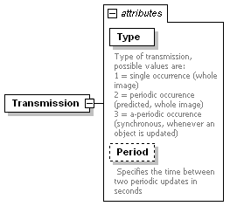
namespace | http://www.iala-to-be-confirmed.org/XMLSchema/IVEF/0.2.3
properties
  isRef | 0
  content | complex
attributes
  Name | Type | Use | Default | Fixed | Annotation
  Type | derived by: xs:integer | required
    documentation
    Type of transmission, possible values are:
    1 = single occurrence (whole image)
    2 = periodic occurence (predicted, whole image)
    3 = a-periodic occurence (synchronous, whenever an object is updated)
  Period | xs:decimal | optional
    documentation
    Specifies the time between two periodic updates in seconds
source | <xs:element name="Transmission">  <xs:complexType>  <xs:attribute name="Type" use="required">  <xs:annotation>  <xs:documentation>Type of transmission, possible values are:  1 = single occurrence (whole image)  2 = periodic occurence (predicted, whole image)  3 = a-periodic occurence (synchronous, whenever an object is updated)</xs:documentation>  </xs:annotation>  <xs:simpleType>  <xs:restriction base="xs:integer">  <xs:enumeration value="1"/>  <xs:enumeration value="2"/>  <xs:enumeration value="3"/>  </xs:restriction>  </xs:simpleType>  </xs:attribute>  <xs:attribute name="Period" type="xs:decimal" use="optional">  <xs:annotation>  <xs:documentation> Specifies the time between two periodic updates in seconds</xs:documentation>  </xs:annotation>  </xs:attribute>  </xs:complexType>  </xs:element>

element ServiceRequest/Item
diagram | 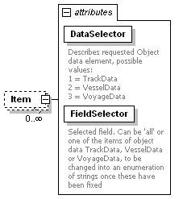
namespace | http://www.iala-to-be-confirmed.org/XMLSchema/IVEF/0.2.3
properties
  isRef | 0
  minOcc | 0
  maxOcc | unbounded
  content | complex
attributes
  Name | Type | Use | Default | Fixed | Annotation
  DataSelector | derived by: xs:integer | required
    documentation
    Describes requested Object data element, possible values:
    1 = TrackData
    2 = VesselData
    3 = VoyageData
  FieldSelector | derived by: xs:string | required
    documentation
    Selected field. Can be 'all' or one of the items of object data TrackData, VesselData or VoyageData, to be changed into an enumeration of strings once these have been fixed
source | <xs:element name="Item" minOccurs="0" maxOccurs="unbounded">  <xs:complexType>  <xs:attribute name="DataSelector" use="required">  <xs:annotation>  <xs:documentation>Describes requested Object data element, possible values:  1 = TrackData  2 = VesselData  3 = VoyageData</xs:documentation>  </xs:annotation>  <xs:simpleType>  <xs:restriction base="xs:integer">  <xs:enumeration value="1"/>  <xs:enumeration value="2"/>  <xs:enumeration value="3"/>  </xs:restriction>  </xs:simpleType>  </xs:attribute>  <xs:attribute name="FieldSelector" use="required">  <xs:annotation>  <xs:documentation>Selected field. Can be 'all' or one of the items of object data TrackData, VesselData or VoyageData, to be changed into an enumeration of strings once these have been fixed</xs:documentation>  </xs:annotation>  <xs:simpleType>  <xs:restriction base="xs:string">  <xs:minLength value="1"/>  <xs:maxLength value="42"/>  </xs:restriction>  </xs:simpleType>  </xs:attribute>  </xs:complexType>  </xs:element>

element ServiceRequest/Filter
diagram | 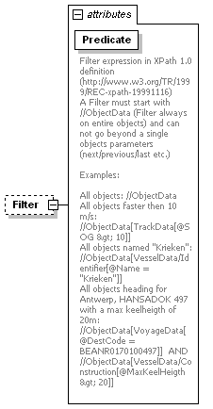
namespace | http://www.iala-to-be-confirmed.org/XMLSchema/IVEF/0.2.3
properties
  isRef | 0
  minOcc | 0
  maxOcc | 1
  content | complex
attributes
  Name | Type | Use | Default | Fixed | Annotation
  Predicate | derived by: xs:string | required
    documentation
    Filter expression in XPath 1.0 definition (http://www.w3.org/TR/1999/REC-xpath-19991116)
    A Filter must start with //ObjectData (Filter always on entire objects) and can not go beyond a single objects parameters (next/previous/last etc.)
    Examples:
    All objects: //ObjectData
    All objects faster then 10 m/s: //ObjectData[TrackData[@SOG &gt; 10]]
    All objects named "Krieken": //ObjectData[VesselData/Identifier[@Name = "Krieken"]]
    All objects heading for Antwerp, HANSADOK 497 with a max keelheigth of 20m: //ObjectData[VoyageData[@DestCode = BEANR0170100497]] AND //ObjectData[VesselData/Construction[@MaxKeelHeigth &gt; 20]]
source | <xs:element name="Filter" minOccurs="0">  <xs:complexType>  <xs:attribute name="Predicate" use="required">  <xs:annotation>  <xs:documentation>Filter expression in XPath 1.0 definition (http://www.w3.org/TR/1999/REC-xpath-19991116)  A Filter must start with //ObjectData (Filter always on entire objects) and can not go beyond a single objects parameters (next/previous/last etc.)  Examples:  All objects: //ObjectData  All objects faster then 10 m/s: //ObjectData[TrackData[@SOG &gt; 10]]  All objects named "Krieken": //ObjectData[VesselData/Identifier[@Name = "Krieken"]]  All objects heading for Antwerp, HANSADOK 497 with a max keelheigth of 20m: //ObjectData[VoyageData[@DestCode = BEANR0170100497]] AND //ObjectData[VesselData/Construction[@MaxKeelHeigth &gt; 20]]  </xs:documentation>  </xs:annotation>  <xs:simpleType>  <xs:restriction base="xs:string">  <xs:minLength value="1"/>  <xs:maxLength value="1024"/>  </xs:restriction>  </xs:simpleType>  </xs:attribute>  </xs:complexType>  </xs:element>

element ServiceRequestResponse
diagram | 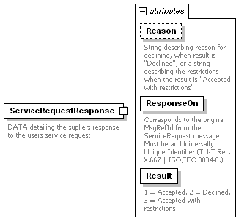
namespace | http://www.iala-to-be-confirmed.org/XMLSchema/IVEF/0.2.3
properties
  content | complex
used by
  element | MSG_IVEF/Body
attributes
  Name | Type | Use | Default | Fixed | Annotation
  Reason | derived by: xs:string | optional
    documentation
    String describing reason for declining, when result is "Declined", or a string describing the restrictions when the result is "Accepted with restrictions"
  ResponseOn | derived by: xs:string | required
    documentation
    Corresponds to the original MsgRefId from the ServiceRequest message. Must be an Universally Unique Identifier (TU-T Rec. X.667 | ISO/IEC 9834-8.)
  Result | derived by: xs:integer | required
    documentation
    1 = Accepted, 2 = Declined, 3 = Accepted with restrictions
annotation
  documentation
  DATA detailing the supliers response to the users service request
source | <xs:element name="ServiceRequestResponse">  <xs:annotation>  <xs:documentation>DATA detailing the supliers response to the users service request</xs:documentation>  </xs:annotation>  <xs:complexType>  <xs:attribute name="Reason" use="optional">  <xs:annotation>  <xs:documentation>String describing reason for declining, when result is "Declined", or a string describing the restrictions when the result is "Accepted with restrictions"</xs:documentation>  </xs:annotation>  <xs:simpleType>  <xs:restriction base="xs:string">  <xs:maxLength value="256"/>  </xs:restriction>  </xs:simpleType>  </xs:attribute>  <xs:attribute name="ResponseOn" use="required">  <xs:annotation>  <xs:documentation>Corresponds to the original MsgRefId from the ServiceRequest message. Must be an Universally Unique Identifier (TU-T Rec. X.667 | ISO/IEC 9834-8.)</xs:documentation>  </xs:annotation>  <xs:simpleType>  <xs:restriction base="xs:string">  <xs:minLength value="36"/>  <xs:maxLength value="42"/>  </xs:restriction>  </xs:simpleType>  </xs:attribute>  <xs:attribute name="Result" use="required">  <xs:annotation>  <xs:documentation>1 = Accepted, 2 = Declined, 3 = Accepted with restrictions</xs:documentation>  </xs:annotation>  <xs:simpleType>  <xs:restriction base="xs:integer">  <xs:enumeration value="1"/>  <xs:enumeration value="2"/>  <xs:enumeration value="3"/>  </xs:restriction>  </xs:simpleType>  </xs:attribute>  </xs:complexType>  </xs:element>

element TaggedItem
diagram | 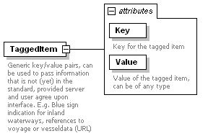
namespace | http://www.iala-to-be-confirmed.org/XMLSchema/IVEF/0.2.3
properties
  content | complex
used by
  element | ObjectData
attributes
  Name | Type | Use | Default | Fixed | Annotation
  Key | derived by: xs:string | required
    documentation
    Key for the tagged item
  Value |  | required
    documentation
    Value of the tagged item, can be of any type
annotation
  documentation
  Generic key/value pairs, can be used to pass information that is not (yet) in the standard, provided server and user agree upon interface. E.g. Blue sign indication for inland waterways, references to voyage or vesseldata (URL)
source | <xs:element name="TaggedItem">  <xs:annotation>  <xs:documentation>Generic key/value pairs, can be used to pass information that is not (yet) in the standard, provided server and user agree upon interface. E.g. Blue sign indication for inland waterways, references to voyage or vesseldata (URL)</xs:documentation>  </xs:annotation>  <xs:complexType>  <xs:attribute name="Key" use="required">  <xs:annotation>  <xs:documentation>Key for the tagged item</xs:documentation>  </xs:annotation>  <xs:simpleType>  <xs:restriction base="xs:string">  <xs:minLength value="1"/>  <xs:maxLength value="42"/>  </xs:restriction>  </xs:simpleType>  </xs:attribute>  <xs:attribute name="Value" use="required">  <xs:annotation>  <xs:documentation>Value of the tagged item, can be of any type</xs:documentation>  </xs:annotation>  </xs:attribute>  </xs:complexType>  </xs:element>

element TrackData
diagram | 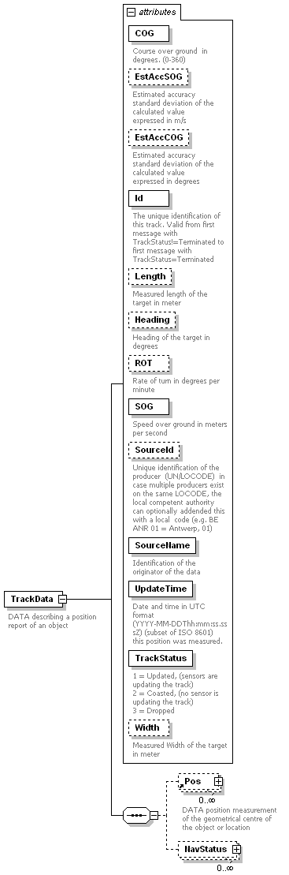
namespace | http://www.iala-to-be-confirmed.org/XMLSchema/IVEF/0.2.3
properties
  content | complex
children | Pos NavStatus
used by
  element | ObjectData
attributes
  Name | Type | Use | Default | Fixed | Annotation
  COG | derived by: xs:decimal | required
    documentation
    Course over ground in degrees. (0-360)
  EstAccSOG | xs:decimal | optional
    documentation
    Estimated accuracy
    standard deviation of the calculated value
    expressed in m/s
  EstAccCOG | xs:decimal | optional
    documentation
    Estimated accuracy
    standard deviation of the calculated value
    expressed in degrees
  Id | xs:integer | required
    documentation
    The unique identification of this track. Valid from first message with TrackStatus!=Terminated to first message with TrackStatus=Terminated
  Length | derived by: xs:decimal | optional
    documentation
    Measured length of the target in meter
  Heading | derived by: xs:decimal | optional
    documentation
    Heading of the target in degrees
  ROT | derived by: xs:decimal | optional
    documentation
    Rate of turn in degrees per minute
  SOG | derived by: xs:decimal | required
    documentation
    Speed over ground in meters per second
  SourceId | derived by: xs:string | optional
    documentation
    Unique identification of the producer (UN/LOCODE) in case multiple producers exist on the same LOCODE, the local competent authority can optionally addended this with a local code (e.g. BE ANR 01 = Antwerp, 01)
  SourceName | derived by: xs:string | required
    documentation
    Identification of the originator of the data
  UpdateTime | xs:dateTime | required
    documentation
    Date and time in UTC format (YYYY-MM-DDThh:mm:ss.sssZ) (subset of ISO 8601) this position was measured.
  TrackStatus | derived by: xs:integer | required
    documentation
    1 = Updated, (sensors are updating the track)
    2 = Coasted, (no sensor is updating the track)
    3 = Dropped
  Width | derived by: xs:decimal | optional
    documentation
    Measured Width of the target in meter
annotation
  documentation
  DATA describing a position report of an object
source | <xs:element name="TrackData">  <xs:annotation>  <xs:documentation>DATA describing a position report of an object</xs:documentation>  </xs:annotation>  <xs:complexType>  <xs:sequence>  <xs:element ref="Pos" minOccurs="0" maxOccurs="unbounded"/>  <xs:element name="NavStatus" minOccurs="0" maxOccurs="unbounded">  <xs:complexType>  <xs:attribute name="Value" use="required">  <xs:annotation>  <xs:documentation>Navigation status of the target  0 = under way using engine  1 = at anchor  2 = not under command  3 = restricted manoeuvrability  4 = constrained by her draught  5 = moored  6 = aground  7 = engaged in fishing  8 = under way sailing  9 = engaged in fishing other than trawling  10 = air-cushion vessel in non displacement mode or WIG craft taking off, landing or in flight  11 = power driven vessel towing astern  12 = power driven vessel pushing ahead or towing alongside  13 = in distress or requiring assistance  14 = AIS SART, seeking to attract attention  15 = undefined default  </xs:documentation>  </xs:annotation>  <xs:simpleType>  <xs:restriction base="xs:integer">  <xs:minInclusive value="0"/>  <xs:maxInclusive value="15"/>  </xs:restriction>  </xs:simpleType>  </xs:attribute>  </xs:complexType>  </xs:element>  </xs:sequence>  <xs:attribute name="COG" use="required">  <xs:annotation>  <xs:documentation>Course over ground in degrees. (0-360) </xs:documentation>  </xs:annotation>  <xs:simpleType>  <xs:restriction base="xs:decimal">  <xs:fractionDigits value="1"/>  <xs:minInclusive value="0"/>  <xs:maxInclusive value="360"/>  </xs:restriction>  </xs:simpleType>  </xs:attribute>  <xs:attribute name="EstAccSOG" type="xs:decimal" use="optional">  <xs:annotation>  <xs:documentation>Estimated accuracy  standard deviation of the calculated value  expressed in m/s</xs:documentation>  </xs:annotation>  </xs:attribute>  <xs:attribute name="EstAccCOG" type="xs:decimal" use="optional">  <xs:annotation>  <xs:documentation>Estimated accuracy  standard deviation of the calculated value  expressed in degrees</xs:documentation>  </xs:annotation>  </xs:attribute>  <xs:attribute name="Id" type="xs:integer" use="required">  <xs:annotation>  <xs:documentation>The unique identification of this track. Valid from first message with TrackStatus!=Terminated to first message with TrackStatus=Terminated</xs:documentation>  </xs:annotation>  </xs:attribute>  <xs:attribute name="Length" use="optional">  <xs:annotation>  <xs:documentation>Measured length of the target in meter</xs:documentation>  </xs:annotation>  <xs:simpleType>  <xs:restriction base="xs:decimal">  <xs:minExclusive value="0"/>  </xs:restriction>  </xs:simpleType>  </xs:attribute>  <xs:attribute name="Heading" use="optional">  <xs:annotation>  <xs:documentation>Heading of the target in degrees</xs:documentation>  </xs:annotation>  <xs:simpleType>  <xs:restriction base="xs:decimal">  <xs:minInclusive value="0.0"/>  <xs:maxInclusive value="360.0"/>  </xs:restriction>  </xs:simpleType>  </xs:attribute>  <xs:attribute name="ROT" use="optional">  <xs:annotation>  <xs:documentation>Rate of turn in degrees per minute</xs:documentation>  </xs:annotation>  <xs:simpleType>  <xs:restriction base="xs:decimal">  <xs:fractionDigits value="1"/>  <xs:minExclusive value="-720"/>  <xs:maxInclusive value="720"/>  </xs:restriction>  </xs:simpleType>  </xs:attribute>  <xs:attribute name="SOG" use="required">  <xs:annotation>  <xs:documentation>Speed over ground in meters per second</xs:documentation>  </xs:annotation>  <xs:simpleType>  <xs:restriction base="xs:decimal">  <xs:fractionDigits value="1"/>  <xs:minInclusive value="0"/>  </xs:restriction>  </xs:simpleType>  </xs:attribute>  <xs:attribute name="SourceId" use="optional">  <xs:annotation>  <xs:documentation>Unique identification of the producer (UN/LOCODE) in case multiple producers exist on the same LOCODE, the local competent authority can optionally addended this with a local code (e.g. BE ANR 01 = Antwerp, 01)</xs:documentation>  </xs:annotation>  <xs:simpleType>  <xs:restriction base="xs:string">  <xs:minLength value="5"/>  <xs:maxLength value="15"/>  </xs:restriction>  </xs:simpleType>  </xs:attribute>  <xs:attribute name="SourceName" use="required">  <xs:annotation>  <xs:documentation>Identification of the originator of the data</xs:documentation>  </xs:annotation>  <xs:simpleType>  <xs:restriction base="xs:string">  <xs:minLength value="1"/>  <xs:maxLength value="42"/>  </xs:restriction>  </xs:simpleType>  </xs:attribute>  <xs:attribute name="UpdateTime" type="xs:dateTime" use="required">  <xs:annotation>  <xs:documentation>Date and time in UTC format (YYYY-MM-DDThh:mm:ss.sssZ) (subset of ISO 8601) this position was measured.</xs:documentation>  </xs:annotation>  </xs:attribute>  <xs:attribute name="TrackStatus" use="required">  <xs:annotation>  <xs:documentation>1 = Updated, (sensors are updating the track)  2 = Coasted, (no sensor is updating the track)  3 = Dropped</xs:documentation>  </xs:annotation>  <xs:simpleType>  <xs:restriction base="xs:integer">  <xs:enumeration value="1"/>  <xs:enumeration value="2"/>  <xs:enumeration value="3"/>  </xs:restriction>  </xs:simpleType>  </xs:attribute>  <xs:attribute name="Width" use="optional">  <xs:annotation>  <xs:documentation>Measured Width of the target in meter</xs:documentation>  </xs:annotation>  <xs:simpleType>  <xs:restriction base="xs:decimal">  <xs:minExclusive value="0"/>  </xs:restriction>  </xs:simpleType>  </xs:attribute>  </xs:complexType>  </xs:element>

element TrackData/NavStatus
diagram | 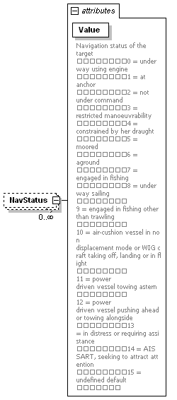
namespace | http://www.iala-to-be-confirmed.org/XMLSchema/IVEF/0.2.3
properties
  isRef | 0
  minOcc | 0
  maxOcc | unbounded
  content | complex
attributes
  Name | Type | Use | Default | Fixed | Annotation
  Value | derived by: xs:integer | required
    documentation
    Navigation status of the target
    0 = under way using engine
    1 = at anchor
    2 = not under command
    3 = restricted manoeuvrability
    4 = constrained by her draught
    5 = moored
    6 = aground
    7 = engaged in fishing
    8 = under way sailing
    9 = engaged in fishing other than trawling
    10 = air-cushion vessel in non displacement mode or WIG craft taking off, landing or in flight
    11 = power driven vessel towing astern
    12 = power driven vessel pushing ahead or towing alongside
    13 = in distress or requiring assistance
    14 = AIS SART, seeking to attract attention
    15 = undefined default
source | <xs:element name="NavStatus" minOccurs="0" maxOccurs="unbounded">  <xs:complexType>  <xs:attribute name="Value" use="required">  <xs:annotation>  <xs:documentation>Navigation status of the target  0 = under way using engine  1 = at anchor  2 = not under command  3 = restricted manoeuvrability  4 = constrained by her draught  5 = moored  6 = aground  7 = engaged in fishing  8 = under way sailing  9 = engaged in fishing other than trawling  10 = air-cushion vessel in non displacement mode or WIG craft taking off, landing or in flight  11 = power driven vessel towing astern  12 = power driven vessel pushing ahead or towing alongside  13 = in distress or requiring assistance  14 = AIS SART, seeking to attract attention  15 = undefined default  </xs:documentation>  </xs:annotation>  <xs:simpleType>  <xs:restriction base="xs:integer">  <xs:minInclusive value="0"/>  <xs:maxInclusive value="15"/>  </xs:restriction>  </xs:simpleType>  </xs:attribute>  </xs:complexType>  </xs:element>

element VesselData
diagram | 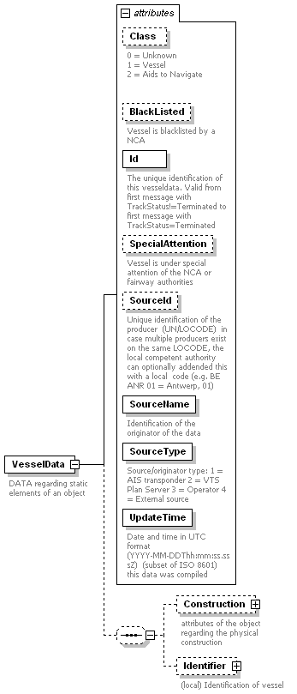
namespace | http://www.iala-to-be-confirmed.org/XMLSchema/IVEF/0.2.3
properties
  content | complex
children | Construction Identifier
used by
  element | ObjectData
attributes
  Name | Type | Use | Default | Fixed | Annotation
  Class | derived by: xs:integer | optional
    documentation
    0 = Unknown
    1 = Vessel
    2 = Aids to Navigate
  BlackListed | xs:boolean | optional
    documentation
    Vessel is blacklisted by a NCA
  Id | xs:integer | required
    documentation
    The unique identification of this vesseldata. Valid from first message with TrackStatus!=Terminated to first message with TrackStatus=Terminated
  SpecialAttention | derived by: xs:string | optional
    documentation
    Vessel is under special attention of the NCA or fairway authorities
  SourceId | derived by: xs:string | optional
    documentation
    Unique identification of the producer (UN/LOCODE) in case multiple producers exist on the same LOCODE, the local competent authority can optionally addended this with a local code (e.g. BE ANR 01 = Antwerp, 01)
  SourceName | derived by: xs:string | required
    documentation
    Identification of the originator of the data
  SourceType | derived by: xs:integer | required
    documentation
    Source/originator type: 1 = AIS transponder 2 = VTS Plan Server 3 = Operator 4 = External source
  UpdateTime | xs:dateTime | required
    documentation
    Date and time in UTC format (YYYY-MM-DDThh:mm:ss.sssZ) (subset of ISO 8601) this data was compiled
annotation
  documentation
  DATA regarding static elements of an object
source | <xs:element name="VesselData">  <xs:annotation>  <xs:documentation>DATA regarding static elements of an object</xs:documentation>  </xs:annotation>  <xs:complexType>  <xs:sequence minOccurs="0">  <xs:element name="Construction" minOccurs="0">  <xs:annotation>  <xs:documentation>attributes of the object regarding the physical construction</xs:documentation>  </xs:annotation>  <xs:complexType>  <xs:sequence minOccurs="0">  <xs:element name="UnType" minOccurs="0">  <xs:annotation>  <xs:documentation>Object type according to CODES FOR TYPES OF MEANS OF TRANSPORT Revision 2 (UNECE CEFACT Trade Facilitation Recommendation No. 28 edition 2007) Check latest version</xs:documentation>  </xs:annotation>  <xs:complexType>  <xs:attribute name="CodeA" use="required">  <xs:simpleType>  <xs:restriction base="xs:integer">  <xs:minInclusive value="0"/>  <xs:maxInclusive value="138"/>  </xs:restriction>  </xs:simpleType>  </xs:attribute>  <xs:attribute name="CodeB" use="required">  <xs:simpleType>  <xs:restriction base="xs:integer">  <xs:minInclusive value="0"/>  <xs:maxInclusive value="9"/>  </xs:restriction>  </xs:simpleType>  </xs:attribute>  <xs:attribute name="Mode" use="required">  <xs:simpleType>  <xs:restriction base="xs:integer">  <xs:enumeration value="1"/>  <xs:enumeration value="2"/>  <xs:enumeration value="3"/>  <xs:enumeration value="6"/>  <xs:enumeration value="7"/>  <xs:enumeration value="8"/>  </xs:restriction>  </xs:simpleType>  </xs:attribute>  </xs:complexType>  </xs:element>  </xs:sequence>  <xs:attribute name="HullColor" use="optional">  <xs:annotation>  <xs:documentation>Color of Hull (in RGB hex) for SAR operations</xs:documentation>  </xs:annotation>  <xs:simpleType>  <xs:restriction base="xs:string">  <xs:minLength value="6"/>  <xs:maxLength value="6"/>  </xs:restriction>  </xs:simpleType>  </xs:attribute>  <xs:attribute name="HullType" use="optional">  <xs:annotation>  <xs:documentation>Type of hull (1 = single, 2 = double, 3 = triple)</xs:documentation>  </xs:annotation>  <xs:simpleType>  <xs:restriction base="xs:integer">  <xs:enumeration value="1"/>  <xs:enumeration value="2"/>  <xs:enumeration value="3"/>  </xs:restriction>  </xs:simpleType>  </xs:attribute>  <xs:attribute name="DeadWeight" use="optional">  <xs:annotation>  <xs:documentation>Dead weight in tons</xs:documentation>  </xs:annotation>  <xs:simpleType>  <xs:restriction base="xs:decimal">  <xs:minExclusive value="0"/>  </xs:restriction>  </xs:simpleType>  </xs:attribute>  <xs:attribute name="GrossWeight" use="optional">  <xs:annotation>  <xs:documentation>Gross weight in tons</xs:documentation>  </xs:annotation>  <xs:simpleType>  <xs:restriction base="xs:decimal">  <xs:minExclusive value="0"/>  </xs:restriction>  </xs:simpleType>  </xs:attribute>  <xs:attribute name="Length" use="optional">  <xs:annotation>  <xs:documentation>The overall length of the target in meter as confirmed by NCA</xs:documentation>  </xs:annotation>  <xs:simpleType>  <xs:restriction base="xs:decimal">  <xs:minExclusive value="0"/>  </xs:restriction>  </xs:simpleType>  </xs:attribute>  <xs:attribute name="LloydsShipType" type="xs:integer" use="optional">  <xs:annotation>  <xs:documentation>Number indicating type of vessel </xs:documentation>  </xs:annotation>  </xs:attribute>  <xs:attribute name="YearOfBuild" use="optional">  <xs:annotation>  <xs:documentation>The year the vessel was build in 4 digits e.g. 2010</xs:documentation>  </xs:annotation>  <xs:simpleType>  <xs:restriction base="xs:integer">  <xs:totalDigits value="4"/>  </xs:restriction>  </xs:simpleType>  </xs:attribute>  <xs:attribute name="MaxAirDraught" use="optional">  <xs:annotation>  <xs:documentation>Maximum air draught of the object in meters, to be used if voyage data is not available</xs:documentation>  </xs:annotation>  <xs:simpleType>  <xs:restriction base="xs:decimal">  <xs:fractionDigits value="1"/>  <xs:minExclusive value="0"/>  </xs:restriction>  </xs:simpleType>  </xs:attribute>  <xs:attribute name="MaxDraught" use="optional">  <xs:annotation>  <xs:documentation>Maximum draught of the object in meters, to be used if voyage data is not available</xs:documentation>  </xs:annotation>  <xs:simpleType>  <xs:restriction base="xs:decimal">  <xs:fractionDigits value="1"/>  <xs:minExclusive value="0"/>  </xs:restriction>  </xs:simpleType>  </xs:attribute>  <xs:attribute name="MaxPersonsOnBoard" use="optional">  <xs:annotation>  <xs:documentation>The maximum number of persons on board of the object (crew, support, passengers, pilots)</xs:documentation>  </xs:annotation>  <xs:simpleType>  <xs:restriction base="xs:integer">  <xs:minExclusive value="0"/>  </xs:restriction>  </xs:simpleType>  </xs:attribute>  <xs:attribute name="MaxSpeed" use="optional">  <xs:annotation>  <xs:documentation>The maximum speed the object is able to sustain with normal draft and load</xs:documentation>  </xs:annotation>  <xs:simpleType>  <xs:restriction base="xs:decimal">  <xs:minExclusive value="0"/>  </xs:restriction>  </xs:simpleType>  </xs:attribute>  <xs:attribute name="Width" use="optional">  <xs:annotation>  <xs:documentation>Overall width of the target in meter as confirmed by the NCA</xs:documentation>  </xs:annotation>  <xs:simpleType>  <xs:restriction base="xs:decimal">  <xs:minExclusive value="0"/>  </xs:restriction>  </xs:simpleType>  </xs:attribute>  </xs:complexType>  </xs:element>  <xs:element name="Identifier" minOccurs="0">  <xs:annotation>  <xs:documentation>(local) Identification of vessel</xs:documentation>  </xs:annotation>  <xs:complexType>  <xs:sequence>  <xs:element ref="OtherId" minOccurs="0" maxOccurs="unbounded"/>  <xs:element ref="OtherName" minOccurs="0" maxOccurs="unbounded"/>  </xs:sequence>  <xs:attribute name="Callsign" use="optional">  <xs:annotation>  <xs:documentation>Callsign of the target, in accordance with Article 19, Section III of the ITU Radio Regulations (RR)</xs:documentation>  </xs:annotation>  <xs:simpleType>  <xs:restriction base="xs:string">  <xs:minLength value="0"/>  <xs:maxLength value="9"/>  </xs:restriction>  </xs:simpleType>  </xs:attribute>  <xs:attribute name="IMO" type="xs:integer" use="optional">  <xs:annotation>  <xs:documentation>IMO number of the target</xs:documentation>  </xs:annotation>  </xs:attribute>  <xs:attribute name="Name" use="optional">  <xs:annotation>  <xs:documentation>Name of the target</xs:documentation>  </xs:annotation>  <xs:simpleType>  <xs:restriction base="xs:string">  <xs:minLength value="1"/>  <xs:maxLength value="42"/>  </xs:restriction>  </xs:simpleType>  </xs:attribute>  <xs:attribute name="FormerName" use="optional">  <xs:annotation>  <xs:documentation>Previous name of the target</xs:documentation>  </xs:annotation>  <xs:simpleType>  <xs:restriction base="xs:string">  <xs:minLength value="1"/>  <xs:maxLength value="42"/>  </xs:restriction>  </xs:simpleType>  </xs:attribute>  <xs:attribute name="Flag" use="optional">  <xs:annotation>  <xs:documentation>The country flag (ISO 3166-1-alpha2)</xs:documentation>  </xs:annotation>  <xs:simpleType>  <xs:restriction base="xs:string">  <xs:minLength value="2"/>  <xs:maxLength value="2"/>  </xs:restriction>  </xs:simpleType>  </xs:attribute>  <xs:attribute name="Owner" use="optional">  <xs:annotation>  <xs:documentation>Name of owner the target</xs:documentation>  </xs:annotation>  <xs:simpleType>  <xs:restriction base="xs:string">  <xs:minLength value="1"/>  <xs:maxLength value="42"/>  </xs:restriction>  </xs:simpleType>  </xs:attribute>  <xs:attribute name="MMSI" type="xs:integer" use="optional">  <xs:annotation>  <xs:documentation>MMSI number of the target</xs:documentation>  </xs:annotation>  </xs:attribute>  <xs:attribute name="LRIT" use="optional">  <xs:annotation>  <xs:documentation>LRIT identification</xs:documentation>  </xs:annotation>  <xs:simpleType>  <xs:restriction base="xs:string">  <xs:minLength value="1"/>  <xs:maxLength value="42"/>  </xs:restriction>  </xs:simpleType>  </xs:attribute>  </xs:complexType>  </xs:element>  </xs:sequence>  <xs:attribute name="Class" use="optional">  <xs:annotation>  <xs:documentation>0 = Unknown  1 = Vessel  2 = Aids to Navigate  </xs:documentation>  </xs:annotation>  <xs:simpleType>  <xs:restriction base="xs:integer">  <xs:enumeration value="0"/>  <xs:enumeration value="1"/>  <xs:enumeration value="2"/>  </xs:restriction>  </xs:simpleType>  </xs:attribute>  <xs:attribute name="BlackListed" type="xs:boolean" use="optional">  <xs:annotation>  <xs:documentation>Vessel is blacklisted by a NCA</xs:documentation>  </xs:annotation>  </xs:attribute>  <xs:attribute name="Id" type="xs:integer" use="required">  <xs:annotation>  <xs:documentation>The unique identification of this vesseldata. Valid from first message with TrackStatus!=Terminated to first message with TrackStatus=Terminated</xs:documentation>  </xs:annotation>  </xs:attribute>  <xs:attribute name="SpecialAttention" use="optional">  <xs:annotation>  <xs:documentation>Vessel is under special attention of the NCA or fairway authorities</xs:documentation>  </xs:annotation>  <xs:simpleType>  <xs:restriction base="xs:string">  <xs:maxLength value="20"/>  </xs:restriction>  </xs:simpleType>  </xs:attribute>  <xs:attribute name="SourceId" use="optional">  <xs:annotation>  <xs:documentation>Unique identification of the producer (UN/LOCODE) in case multiple producers exist on the same LOCODE, the local competent authority can optionally addended this with a local code (e.g. BE ANR 01 = Antwerp, 01)</xs:documentation>  </xs:annotation>  <xs:simpleType>  <xs:restriction base="xs:string">  <xs:minLength value="5"/>  <xs:maxLength value="15"/>  </xs:restriction>  </xs:simpleType>  </xs:attribute>  <xs:attribute name="SourceName" use="required">  <xs:annotation>  <xs:documentation>Identification of the originator of the data</xs:documentation>  </xs:annotation>  <xs:simpleType>  <xs:restriction base="xs:string">  <xs:minLength value="1"/>  <xs:maxLength value="42"/>  </xs:restriction>  </xs:simpleType>  </xs:attribute>  <xs:attribute name="SourceType" use="required">  <xs:annotation>  <xs:documentation>Source/originator type: 1 = AIS transponder 2 = VTS Plan Server 3 = Operator 4 = External source</xs:documentation>  </xs:annotation>  <xs:simpleType>  <xs:restriction base="xs:integer">  <xs:enumeration value="1"/>  <xs:enumeration value="2"/>  <xs:enumeration value="3"/>  </xs:restriction>  </xs:simpleType>  </xs:attribute>  <xs:attribute name="UpdateTime" type="xs:dateTime" use="required">  <xs:annotation>  <xs:documentation>Date and time in UTC format (YYYY-MM-DDThh:mm:ss.sssZ) (subset of ISO 8601) this data was compiled</xs:documentation>  </xs:annotation>  </xs:attribute>  </xs:complexType>  </xs:element>

element VesselData/Construction
diagram | 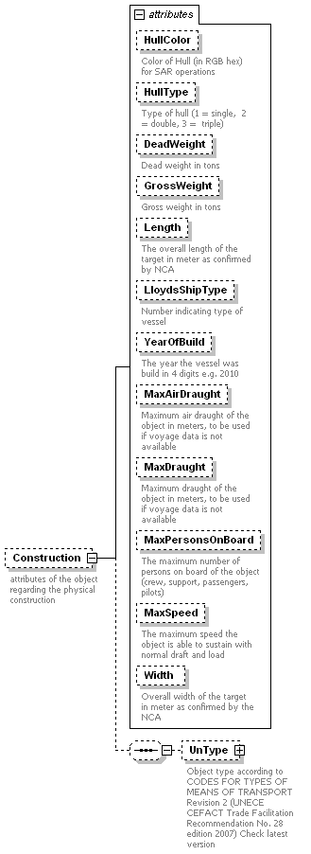
namespace | http://www.iala-to-be-confirmed.org/XMLSchema/IVEF/0.2.3
properties
  isRef | 0
  minOcc | 0
  maxOcc | 1
  content | complex
children | UnType
attributes
  Name | Type | Use | Default | Fixed | Annotation
  HullColor | derived by: xs:string | optional
    documentation
    Color of Hull (in RGB hex) for SAR operations
  HullType | derived by: xs:integer | optional
    documentation
    Type of hull (1 = single, 2 = double, 3 = triple)
  DeadWeight | derived by: xs:decimal | optional
    documentation
    Dead weight in tons
  GrossWeight | derived by: xs:decimal | optional
    documentation
    Gross weight in tons
  Length | derived by: xs:decimal | optional
    documentation
    The overall length of the target in meter as confirmed by NCA
  LloydsShipType | xs:integer | optional
    documentation
    Number indicating type of vessel
  YearOfBuild | derived by: xs:integer | optional
    documentation
    The year the vessel was build in 4 digits e.g. 2010
  MaxAirDraught | derived by: xs:decimal | optional
    documentation
    Maximum air draught of the object in meters, to be used if voyage data is not available
  MaxDraught | derived by: xs:decimal | optional
    documentation
    Maximum draught of the object in meters, to be used if voyage data is not available
  MaxPersonsOnBoard | derived by: xs:integer | optional
    documentation
    The maximum number of persons on board of the object (crew, support, passengers, pilots)
  MaxSpeed | derived by: xs:decimal | optional
    documentation
    The maximum speed the object is able to sustain with normal draft and load
  Width | derived by: xs:decimal | optional
    documentation
    Overall width of the target in meter as confirmed by the NCA
annotation
  documentation
  attributes of the object regarding the physical construction
source | <xs:element name="Construction" minOccurs="0">  <xs:annotation>  <xs:documentation>attributes of the object regarding the physical construction</xs:documentation>  </xs:annotation>  <xs:complexType>  <xs:sequence minOccurs="0">  <xs:element name="UnType" minOccurs="0">  <xs:annotation>  <xs:documentation>Object type according to CODES FOR TYPES OF MEANS OF TRANSPORT Revision 2 (UNECE CEFACT Trade Facilitation Recommendation No. 28 edition 2007) Check latest version</xs:documentation>  </xs:annotation>  <xs:complexType>  <xs:attribute name="CodeA" use="required">  <xs:simpleType>  <xs:restriction base="xs:integer">  <xs:minInclusive value="0"/>  <xs:maxInclusive value="138"/>  </xs:restriction>  </xs:simpleType>  </xs:attribute>  <xs:attribute name="CodeB" use="required">  <xs:simpleType>  <xs:restriction base="xs:integer">  <xs:minInclusive value="0"/>  <xs:maxInclusive value="9"/>  </xs:restriction>  </xs:simpleType>  </xs:attribute>  <xs:attribute name="Mode" use="required">  <xs:simpleType>  <xs:restriction base="xs:integer">  <xs:enumeration value="1"/>  <xs:enumeration value="2"/>  <xs:enumeration value="3"/>  <xs:enumeration value="6"/>  <xs:enumeration value="7"/>  <xs:enumeration value="8"/>  </xs:restriction>  </xs:simpleType>  </xs:attribute>  </xs:complexType>  </xs:element>  </xs:sequence>  <xs:attribute name="HullColor" use="optional">  <xs:annotation>  <xs:documentation>Color of Hull (in RGB hex) for SAR operations</xs:documentation>  </xs:annotation>  <xs:simpleType>  <xs:restriction base="xs:string">  <xs:minLength value="6"/>  <xs:maxLength value="6"/>  </xs:restriction>  </xs:simpleType>  </xs:attribute>  <xs:attribute name="HullType" use="optional">  <xs:annotation>  <xs:documentation>Type of hull (1 = single, 2 = double, 3 = triple)</xs:documentation>  </xs:annotation>  <xs:simpleType>  <xs:restriction base="xs:integer">  <xs:enumeration value="1"/>  <xs:enumeration value="2"/>  <xs:enumeration value="3"/>  </xs:restriction>  </xs:simpleType>  </xs:attribute>  <xs:attribute name="DeadWeight" use="optional">  <xs:annotation>  <xs:documentation>Dead weight in tons</xs:documentation>  </xs:annotation>  <xs:simpleType>  <xs:restriction base="xs:decimal">  <xs:minExclusive value="0"/>  </xs:restriction>  </xs:simpleType>  </xs:attribute>  <xs:attribute name="GrossWeight" use="optional">  <xs:annotation>  <xs:documentation>Gross weight in tons</xs:documentation>  </xs:annotation>  <xs:simpleType>  <xs:restriction base="xs:decimal">  <xs:minExclusive value="0"/>  </xs:restriction>  </xs:simpleType>  </xs:attribute>  <xs:attribute name="Length" use="optional">  <xs:annotation>  <xs:documentation>The overall length of the target in meter as confirmed by NCA</xs:documentation>  </xs:annotation>  <xs:simpleType>  <xs:restriction base="xs:decimal">  <xs:minExclusive value="0"/>  </xs:restriction>  </xs:simpleType>  </xs:attribute>  <xs:attribute name="LloydsShipType" type="xs:integer" use="optional">  <xs:annotation>  <xs:documentation>Number indicating type of vessel </xs:documentation>  </xs:annotation>  </xs:attribute>  <xs:attribute name="YearOfBuild" use="optional">  <xs:annotation>  <xs:documentation>The year the vessel was build in 4 digits e.g. 2010</xs:documentation>  </xs:annotation>  <xs:simpleType>  <xs:restriction base="xs:integer">  <xs:totalDigits value="4"/>  </xs:restriction>  </xs:simpleType>  </xs:attribute>  <xs:attribute name="MaxAirDraught" use="optional">  <xs:annotation>  <xs:documentation>Maximum air draught of the object in meters, to be used if voyage data is not available</xs:documentation>  </xs:annotation>  <xs:simpleType>  <xs:restriction base="xs:decimal">  <xs:fractionDigits value="1"/>  <xs:minExclusive value="0"/>  </xs:restriction>  </xs:simpleType>  </xs:attribute>  <xs:attribute name="MaxDraught" use="optional">  <xs:annotation>  <xs:documentation>Maximum draught of the object in meters, to be used if voyage data is not available</xs:documentation>  </xs:annotation>  <xs:simpleType>  <xs:restriction base="xs:decimal">  <xs:fractionDigits value="1"/>  <xs:minExclusive value="0"/>  </xs:restriction>  </xs:simpleType>  </xs:attribute>  <xs:attribute name="MaxPersonsOnBoard" use="optional">  <xs:annotation>  <xs:documentation>The maximum number of persons on board of the object (crew, support, passengers, pilots)</xs:documentation>  </xs:annotation>  <xs:simpleType>  <xs:restriction base="xs:integer">  <xs:minExclusive value="0"/>  </xs:restriction>  </xs:simpleType>  </xs:attribute>  <xs:attribute name="MaxSpeed" use="optional">  <xs:annotation>  <xs:documentation>The maximum speed the object is able to sustain with normal draft and load</xs:documentation>  </xs:annotation>  <xs:simpleType>  <xs:restriction base="xs:decimal">  <xs:minExclusive value="0"/>  </xs:restriction>  </xs:simpleType>  </xs:attribute>  <xs:attribute name="Width" use="optional">  <xs:annotation>  <xs:documentation>Overall width of the target in meter as confirmed by the NCA</xs:documentation>  </xs:annotation>  <xs:simpleType>  <xs:restriction base="xs:decimal">  <xs:minExclusive value="0"/>  </xs:restriction>  </xs:simpleType>  </xs:attribute>  </xs:complexType>  </xs:element>

element VesselData/Construction/UnType
diagram | 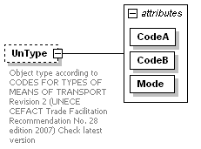
namespace | http://www.iala-to-be-confirmed.org/XMLSchema/IVEF/0.2.3
properties
  isRef | 0
  minOcc | 0
  maxOcc | 1
  content | complex
attributes
  Name | Type | Use | Default | Fixed | Annotation
  CodeA | derived by: xs:integer | required
  CodeB | derived by: xs:integer | required
  Mode | derived by: xs:integer | required
annotation
  documentation
  Object type according to CODES FOR TYPES OF MEANS OF TRANSPORT Revision 2 (UNECE CEFACT Trade Facilitation Recommendation No. 28 edition 2007) Check latest version
source | <xs:element name="UnType" minOccurs="0">  <xs:annotation>  <xs:documentation>Object type according to CODES FOR TYPES OF MEANS OF TRANSPORT Revision 2 (UNECE CEFACT Trade Facilitation Recommendation No. 28 edition 2007) Check latest version</xs:documentation>  </xs:annotation>  <xs:complexType>  <xs:attribute name="CodeA" use="required">  <xs:simpleType>  <xs:restriction base="xs:integer">  <xs:minInclusive value="0"/>  <xs:maxInclusive value="138"/>  </xs:restriction>  </xs:simpleType>  </xs:attribute>  <xs:attribute name="CodeB" use="required">  <xs:simpleType>  <xs:restriction base="xs:integer">  <xs:minInclusive value="0"/>  <xs:maxInclusive value="9"/>  </xs:restriction>  </xs:simpleType>  </xs:attribute>  <xs:attribute name="Mode" use="required">  <xs:simpleType>  <xs:restriction base="xs:integer">  <xs:enumeration value="1"/>  <xs:enumeration value="2"/>  <xs:enumeration value="3"/>  <xs:enumeration value="6"/>  <xs:enumeration value="7"/>  <xs:enumeration value="8"/>  </xs:restriction>  </xs:simpleType>  </xs:attribute>  </xs:complexType>  </xs:element>

element VesselData/Identifier
diagram | 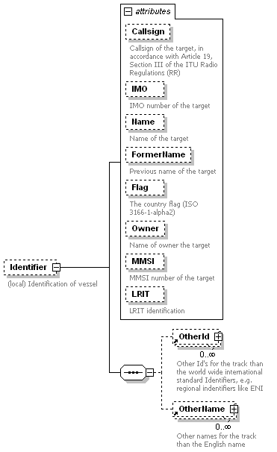
namespace | http://www.iala-to-be-confirmed.org/XMLSchema/IVEF/0.2.3
properties
  isRef | 0
  minOcc | 0
  maxOcc | 1
  content | complex
children | OtherId OtherName
attributes
  Name | Type | Use | Default | Fixed | Annotation
  Callsign | derived by: xs:string | optional
    documentation
    Callsign of the target, in accordance with Article 19, Section III of the ITU Radio Regulations (RR)
  IMO | xs:integer | optional
    documentation
    IMO number of the target
  Name | derived by: xs:string | optional
    documentation
    Name of the target
  FormerName | derived by: xs:string | optional
    documentation
    Previous name of the target
  Flag | derived by: xs:string | optional
    documentation
    The country flag (ISO 3166-1-alpha2)
  Owner | derived by: xs:string | optional
    documentation
    Name of owner the target
  MMSI | xs:integer | optional
    documentation
    MMSI number of the target
  LRIT | derived by: xs:string | optional
    documentation
    LRIT identification
annotation
  documentation
  (local) Identification of vessel
source | <xs:element name="Identifier" minOccurs="0">  <xs:annotation>  <xs:documentation>(local) Identification of vessel</xs:documentation>  </xs:annotation>  <xs:complexType>  <xs:sequence>  <xs:element ref="OtherId" minOccurs="0" maxOccurs="unbounded"/>  <xs:element ref="OtherName" minOccurs="0" maxOccurs="unbounded"/>  </xs:sequence>  <xs:attribute name="Callsign" use="optional">  <xs:annotation>  <xs:documentation>Callsign of the target, in accordance with Article 19, Section III of the ITU Radio Regulations (RR)</xs:documentation>  </xs:annotation>  <xs:simpleType>  <xs:restriction base="xs:string">  <xs:minLength value="0"/>  <xs:maxLength value="9"/>  </xs:restriction>  </xs:simpleType>  </xs:attribute>  <xs:attribute name="IMO" type="xs:integer" use="optional">  <xs:annotation>  <xs:documentation>IMO number of the target</xs:documentation>  </xs:annotation>  </xs:attribute>  <xs:attribute name="Name" use="optional">  <xs:annotation>  <xs:documentation>Name of the target</xs:documentation>  </xs:annotation>  <xs:simpleType>  <xs:restriction base="xs:string">  <xs:minLength value="1"/>  <xs:maxLength value="42"/>  </xs:restriction>  </xs:simpleType>  </xs:attribute>  <xs:attribute name="FormerName" use="optional">  <xs:annotation>  <xs:documentation>Previous name of the target</xs:documentation>  </xs:annotation>  <xs:simpleType>  <xs:restriction base="xs:string">  <xs:minLength value="1"/>  <xs:maxLength value="42"/>  </xs:restriction>  </xs:simpleType>  </xs:attribute>  <xs:attribute name="Flag" use="optional">  <xs:annotation>  <xs:documentation>The country flag (ISO 3166-1-alpha2)</xs:documentation>  </xs:annotation>  <xs:simpleType>  <xs:restriction base="xs:string">  <xs:minLength value="2"/>  <xs:maxLength value="2"/>  </xs:restriction>  </xs:simpleType>  </xs:attribute>  <xs:attribute name="Owner" use="optional">  <xs:annotation>  <xs:documentation>Name of owner the target</xs:documentation>  </xs:annotation>  <xs:simpleType>  <xs:restriction base="xs:string">  <xs:minLength value="1"/>  <xs:maxLength value="42"/>  </xs:restriction>  </xs:simpleType>  </xs:attribute>  <xs:attribute name="MMSI" type="xs:integer" use="optional">  <xs:annotation>  <xs:documentation>MMSI number of the target</xs:documentation>  </xs:annotation>  </xs:attribute>  <xs:attribute name="LRIT" use="optional">  <xs:annotation>  <xs:documentation>LRIT identification</xs:documentation>  </xs:annotation>  <xs:simpleType>  <xs:restriction base="xs:string">  <xs:minLength value="1"/>  <xs:maxLength value="42"/>  </xs:restriction>  </xs:simpleType>  </xs:attribute>  </xs:complexType>  </xs:element>

element VoyageData
diagram | 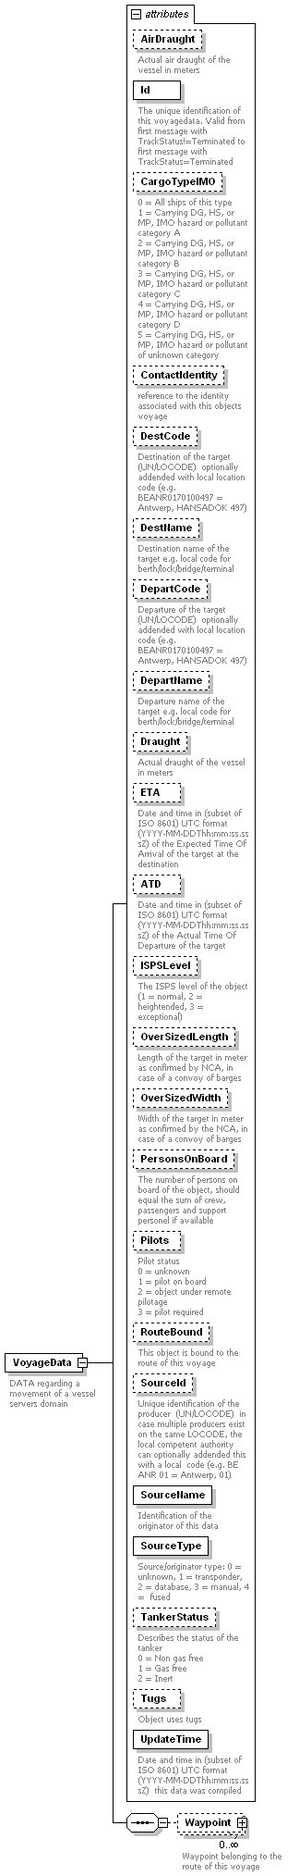
namespace | http://www.iala-to-be-confirmed.org/XMLSchema/IVEF/0.2.3
properties
  content | complex
children | Waypoint
used by
  element | ObjectData
attributes
  Name | Type | Use | Default | Fixed | Annotation
  AirDraught | derived by: xs:decimal | optional
    documentation
    Actual air draught of the vessel in meters
  Id | xs:integer | required
    documentation
    The unique identification of this voyagedata. Valid from first message with TrackStatus!=Terminated to first message with TrackStatus=Terminated
  CargoTypeIMO | derived by: xs:integer | optional
    documentation
    0 = All ships of this type
    1 = Carrying DG, HS, or MP, IMO hazard or pollutant category A
    2 = Carrying DG, HS, or MP, IMO hazard or pollutant category B
    3 = Carrying DG, HS, or MP, IMO hazard or pollutant category C
    4 = Carrying DG, HS, or MP, IMO hazard or pollutant category D
    5 = Carrying DG, HS, or MP, IMO hazard or pollutant of unknown category
  ContactIdentity | derived by: xs:string | optional
    documentation
    reference to the identity associated with this objects voyage
  DestCode | derived by: xs:string | optional
    documentation
    Destination of the target (UN/LOCODE) optionally addended with local location code (e.g. BEANR0170100497 = Antwerp, HANSADOK 497)
  DestName | derived by: xs:string | optional
    documentation
    Destination name of the target e.g. local code for berth/lock/bridge/terminal
  DepartCode | derived by: xs:string | optional
    documentation
    Departure of the target (UN/LOCODE) optionally addended with local location code (e.g. BEANR0170100497 = Antwerp, HANSADOK 497)
  DepartName | derived by: xs:string | optional
    documentation
    Departure name of the target e.g. local code for berth/lock/bridge/terminal
  Draught | derived by: xs:decimal | optional
    documentation
    Actual draught of the vessel in meters
  ETA | xs:dateTime | optional
    documentation
    Date and time in (subset of ISO 8601) UTC format (YYYY-MM-DDThh:mm:ss.sssZ) of the Expected Time Of Arrival of the target at the destination
  ATD | xs:dateTime | optional
    documentation
    Date and time in (subset of ISO 8601) UTC format (YYYY-MM-DDThh:mm:ss.sssZ) of the Actual Time Of Departure of the target
  ISPSLevel | derived by: xs:decimal | optional
    documentation
    The ISPS level of the object (1 = normal, 2 = heightended, 3 = exceptional)
  OverSizedLength | derived by: xs:decimal | optional
    documentation
    Length of the target in meter as confirmed by NCA, in case of a convoy of barges
  OverSizedWidth | derived by: xs:decimal | optional
    documentation
    Width of the target in meter as confirmed by the NCA, in case of a convoy of barges
  PersonsOnBoard | derived by: xs:integer | optional
    documentation
    The number of persons on board of the object, should equal the sum of crew, passengers and support personel if available
  Pilots | derived by: xs:decimal | optional
    documentation
    Pilot status
    0 = unknown
    1 = pilot on board
    2 = object under remote pilotage
    3 = pilot required
  RouteBound | xs:boolean | optional
    documentation
    This object is bound to the route of this voyage
  SourceId | derived by: xs:string | optional
    documentation
    Unique identification of the producer (UN/LOCODE) in case multiple producers exist on the same LOCODE, the local competent authority can optionally addended this with a local code (e.g. BE ANR 01 = Antwerp, 01)
  SourceName | derived by: xs:string | required
    documentation
    Identification of the originator of this data
  SourceType | derived by: xs:integer | required
    documentation
    Source/originator type: 0 = unknown, 1 = transponder, 2 = database, 3 = manual, 4 = fused
  TankerStatus | derived by: xs:integer | optional
    documentation
    Describes the status of the tanker
    0 = Non gas free
    1 = Gas free
    2 = Inert
  Tugs | xs:boolean | optional
    documentation
    Object uses tugs
  UpdateTime | xs:dateTime | required
    documentation
    Date and time in (subset of ISO 8601) UTC format (YYYY-MM-DDThh:mm:ss.sssZ) this data was compiled
annotation
  documentation
  DATA regarding a movement of a vessel servers domain
source | <xs:element name="VoyageData">  <xs:annotation>  <xs:documentation>DATA regarding a movement of a vessel servers domain</xs:documentation>  </xs:annotation>  <xs:complexType>  <xs:sequence>  <xs:element name="Waypoint" minOccurs="0" maxOccurs="unbounded">  <xs:annotation>  <xs:documentation>Waypoint belonging to the route of this voyage</xs:documentation>  </xs:annotation>  <xs:complexType>  <xs:sequence>  <xs:element ref="Pos" minOccurs="0"/>  </xs:sequence>  <xs:attribute name="ATA" type="xs:dateTime" use="optional">  <xs:annotation>  <xs:documentation>Date and time in UTC format (YYYY-MM-DDThh:mmZ) (subset of ISO 8601 ) of the Actual Time Of Arrival of the target.</xs:documentation>  </xs:annotation>  </xs:attribute>  <xs:attribute name="ETA" type="xs:dateTime" use="optional">  <xs:annotation>  <xs:documentation>Date and time in UTC format (YYYY-MM-DDThh:mmZ) (subset of ISO 8601) of the Expected Time Of Arrival of the target.</xs:documentation>  </xs:annotation>  </xs:attribute>  <xs:attribute name="RTA" type="xs:dateTime" use="optional">  <xs:annotation>  <xs:documentation>Date and time in UTC format (YYYY-MM-DDThh:mmZ) (subset of ISO 8601) of the Requested Time Of Arrival of the target.</xs:documentation>  </xs:annotation>  </xs:attribute>  <xs:attribute name="LoCode" use="optional">  <xs:annotation>  <xs:documentation>Waypoint name in UN/LOCODE optionally addended with local location code (e.g. BEANR0170100497 = Antwerp, HANSADOK 497)</xs:documentation>  </xs:annotation>  <xs:simpleType>  <xs:restriction base="xs:string">  <xs:minLength value="5"/>  <xs:maxLength value="15"/>  </xs:restriction>  </xs:simpleType>  </xs:attribute>  <xs:attribute name="Name" use="required">  <xs:annotation>  <xs:documentation>Name of the waypoint</xs:documentation>  </xs:annotation>  <xs:simpleType>  <xs:restriction base="xs:string">  <xs:minLength value="1"/>  <xs:maxLength value="42"/>  </xs:restriction>  </xs:simpleType>  </xs:attribute>  </xs:complexType>  </xs:element>  </xs:sequence>  <xs:attribute name="AirDraught" use="optional">  <xs:annotation>  <xs:documentation>Actual air draught of the vessel in meters</xs:documentation>  </xs:annotation>  <xs:simpleType>  <xs:restriction base="xs:decimal">  <xs:fractionDigits value="2"/>  <xs:minExclusive value="0"/>  </xs:restriction>  </xs:simpleType>  </xs:attribute>  <xs:attribute name="Id" type="xs:integer" use="required">  <xs:annotation>  <xs:documentation>The unique identification of this voyagedata. Valid from first message with TrackStatus!=Terminated to first message with TrackStatus=Terminated</xs:documentation>  </xs:annotation>  </xs:attribute>  <xs:attribute name="CargoTypeIMO" use="optional">  <xs:annotation>  <xs:documentation>0 = All ships of this type  1 = Carrying DG, HS, or MP, IMO hazard or pollutant category A  2 = Carrying DG, HS, or MP, IMO hazard or pollutant category B  3 = Carrying DG, HS, or MP, IMO hazard or pollutant category C  4 = Carrying DG, HS, or MP, IMO hazard or pollutant category D  5 = Carrying DG, HS, or MP, IMO hazard or pollutant of unknown category</xs:documentation>  </xs:annotation>  <xs:simpleType>  <xs:restriction base="xs:integer">  <xs:enumeration value="0"/>  <xs:enumeration value="1"/>  <xs:enumeration value="2"/>  <xs:enumeration value="3"/>  <xs:enumeration value="4"/>  <xs:enumeration value="5"/>  </xs:restriction>  </xs:simpleType>  </xs:attribute>  <xs:attribute name="ContactIdentity" use="optional">  <xs:annotation>  <xs:documentation>reference to the identity associated with this objects voyage</xs:documentation>  </xs:annotation>  <xs:simpleType>  <xs:restriction base="xs:string">  <xs:minLength value="1"/>  <xs:maxLength value="254"/>  </xs:restriction>  </xs:simpleType>  </xs:attribute>  <xs:attribute name="DestCode" use="optional">  <xs:annotation>  <xs:documentation>Destination of the target (UN/LOCODE) optionally addended with local location code (e.g. BEANR0170100497 = Antwerp, HANSADOK 497)</xs:documentation>  </xs:annotation>  <xs:simpleType>  <xs:restriction base="xs:string">  <xs:minLength value="5"/>  <xs:maxLength value="15"/>  </xs:restriction>  </xs:simpleType>  </xs:attribute>  <xs:attribute name="DestName" use="optional">  <xs:annotation>  <xs:documentation>Destination name of the target e.g. local code for berth/lock/bridge/terminal</xs:documentation>  </xs:annotation>  <xs:simpleType>  <xs:restriction base="xs:string">  <xs:minLength value="1"/>  <xs:maxLength value="42"/>  </xs:restriction>  </xs:simpleType>  </xs:attribute>  <xs:attribute name="DepartCode" use="optional">  <xs:annotation>  <xs:documentation>Departure of the target (UN/LOCODE) optionally addended with local location code (e.g. BEANR0170100497 = Antwerp, HANSADOK 497)</xs:documentation>  </xs:annotation>  <xs:simpleType>  <xs:restriction base="xs:string">  <xs:minLength value="5"/>  <xs:maxLength value="15"/>  </xs:restriction>  </xs:simpleType>  </xs:attribute>  <xs:attribute name="DepartName" use="optional">  <xs:annotation>  <xs:documentation>Departure name of the target e.g. local code for berth/lock/bridge/terminal</xs:documentation>  </xs:annotation>  <xs:simpleType>  <xs:restriction base="xs:string">  <xs:minLength value="1"/>  <xs:maxLength value="42"/>  </xs:restriction>  </xs:simpleType>  </xs:attribute>  <xs:attribute name="Draught" use="optional">  <xs:annotation>  <xs:documentation>Actual draught of the vessel in meters</xs:documentation>  </xs:annotation>  <xs:simpleType>  <xs:restriction base="xs:decimal">  <xs:fractionDigits value="2"/>  <xs:minExclusive value="0"/>  </xs:restriction>  </xs:simpleType>  </xs:attribute>  <xs:attribute name="ETA" type="xs:dateTime" use="optional">  <xs:annotation>  <xs:documentation>Date and time in (subset of ISO 8601) UTC format (YYYY-MM-DDThh:mm:ss.sssZ) of the Expected Time Of Arrival of the target at the destination</xs:documentation>  </xs:annotation>  </xs:attribute>  <xs:attribute name="ATD" type="xs:dateTime" use="optional">  <xs:annotation>  <xs:documentation>Date and time in (subset of ISO 8601) UTC format (YYYY-MM-DDThh:mm:ss.sssZ) of the Actual Time Of Departure of the target</xs:documentation>  </xs:annotation>  </xs:attribute>  <xs:attribute name="ISPSLevel" use="optional">  <xs:annotation>  <xs:documentation>The ISPS level of the object (1 = normal, 2 = heightended, 3 = exceptional)</xs:documentation>  </xs:annotation>  <xs:simpleType>  <xs:restriction base="xs:decimal">  <xs:enumeration value="1"/>  <xs:enumeration value="2"/>  <xs:enumeration value="3"/>  </xs:restriction>  </xs:simpleType>  </xs:attribute>  <xs:attribute name="OverSizedLength" use="optional">  <xs:annotation>  <xs:documentation>Length of the target in meter as confirmed by NCA, in case of a convoy of barges</xs:documentation>  </xs:annotation>  <xs:simpleType>  <xs:restriction base="xs:decimal">  <xs:fractionDigits value="1"/>  <xs:minExclusive value="0"/>  </xs:restriction>  </xs:simpleType>  </xs:attribute>  <xs:attribute name="OverSizedWidth" use="optional">  <xs:annotation>  <xs:documentation>Width of the target in meter as confirmed by the NCA, in case of a convoy of barges</xs:documentation>  </xs:annotation>  <xs:simpleType>  <xs:restriction base="xs:decimal">  <xs:fractionDigits value="1"/>  <xs:minExclusive value="0"/>  </xs:restriction>  </xs:simpleType>  </xs:attribute>  <xs:attribute name="PersonsOnBoard" use="optional">  <xs:annotation>  <xs:documentation>The number of persons on board of the object, should equal the sum of crew, passengers and support personel if available</xs:documentation>  </xs:annotation>  <xs:simpleType>  <xs:restriction base="xs:integer">  <xs:minExclusive value="0"/>  </xs:restriction>  </xs:simpleType>  </xs:attribute>  <xs:attribute name="Pilots" use="optional">  <xs:annotation>  <xs:documentation>Pilot status  0 = unknown  1 = pilot on board  2 = object under remote pilotage  3 = pilot required</xs:documentation>  </xs:annotation>  <xs:simpleType>  <xs:restriction base="xs:decimal">  <xs:minExclusive value="0"/>  </xs:restriction>  </xs:simpleType>  </xs:attribute>  <xs:attribute name="RouteBound" type="xs:boolean" use="optional">  <xs:annotation>  <xs:documentation>This object is bound to the route of this voyage</xs:documentation>  </xs:annotation>  </xs:attribute>  <xs:attribute name="SourceId" use="optional">  <xs:annotation>  <xs:documentation>Unique identification of the producer (UN/LOCODE) in case multiple producers exist on the same LOCODE, the local competent authority can optionally addended this with a local code (e.g. BE ANR 01 = Antwerp, 01)</xs:documentation>  </xs:annotation>  <xs:simpleType>  <xs:restriction base="xs:string">  <xs:minLength value="5"/>  <xs:maxLength value="15"/>  </xs:restriction>  </xs:simpleType>  </xs:attribute>  <xs:attribute name="SourceName" use="required">  <xs:annotation>  <xs:documentation>Identification of the originator of this data</xs:documentation>  </xs:annotation>  <xs:simpleType>  <xs:restriction base="xs:string">  <xs:minLength value="1"/>  <xs:maxLength value="42"/>  </xs:restriction>  </xs:simpleType>  </xs:attribute>  <xs:attribute name="SourceType" use="required">  <xs:annotation>  <xs:documentation>Source/originator type: 0 = unknown, 1 = transponder, 2 = database, 3 = manual, 4 = fused</xs:documentation>  </xs:annotation>  <xs:simpleType>  <xs:restriction base="xs:integer">  <xs:enumeration value="1"/>  <xs:enumeration value="2"/>  <xs:enumeration value="3"/>  <xs:enumeration value="4"/>  <xs:enumeration value="5"/>  </xs:restriction>  </xs:simpleType>  </xs:attribute>  <xs:attribute name="TankerStatus" use="optional">  <xs:annotation>  <xs:documentation>Describes the status of the tanker  0 = Non gas free  1 = Gas free  2 = Inert</xs:documentation>  </xs:annotation>  <xs:simpleType>  <xs:restriction base="xs:integer">  <xs:enumeration value="0"/>  <xs:enumeration value="1"/>  <xs:enumeration value="2"/>  </xs:restriction>  </xs:simpleType>  </xs:attribute>  <xs:attribute name="Tugs" type="xs:boolean" use="optional">  <xs:annotation>  <xs:documentation>Object uses tugs</xs:documentation>  </xs:annotation>  </xs:attribute>  <xs:attribute name="UpdateTime" type="xs:dateTime" use="required">  <xs:annotation>  <xs:documentation>Date and time in (subset of ISO 8601) UTC format (YYYY-MM-DDThh:mm:ss.sssZ) this data was compiled</xs:documentation>  </xs:annotation>  </xs:attribute>  </xs:complexType>  </xs:element>

element VoyageData/Waypoint
diagram | 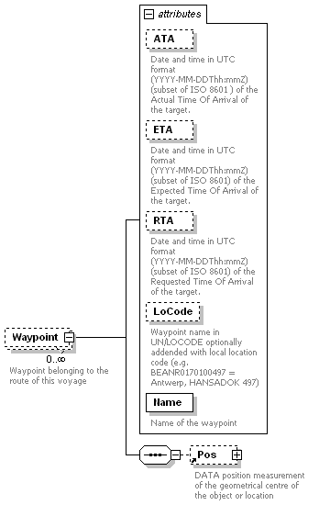
namespace | http://www.iala-to-be-confirmed.org/XMLSchema/IVEF/0.2.3
properties
  isRef | 0
  minOcc | 0
  maxOcc | unbounded
  content | complex
children | Pos
attributes
  Name | Type | Use | Default | Fixed | Annotation
  ATA | xs:dateTime | optional
    documentation
    Date and time in UTC format (YYYY-MM-DDThh:mmZ) (subset of ISO 8601 ) of the Actual Time Of Arrival of the target.
  ETA | xs:dateTime | optional
    documentation
    Date and time in UTC format (YYYY-MM-DDThh:mmZ) (subset of ISO 8601) of the Expected Time Of Arrival of the target.
  RTA | xs:dateTime | optional
    documentation
    Date and time in UTC format (YYYY-MM-DDThh:mmZ) (subset of ISO 8601) of the Requested Time Of Arrival of the target.
  LoCode | derived by: xs:string | optional
    documentation
    Waypoint name in UN/LOCODE optionally addended with local location code (e.g. BEANR0170100497 = Antwerp, HANSADOK 497)
  Name | derived by: xs:string | required
    documentation
    Name of the waypoint
annotation
  documentation
  Waypoint belonging to the route of this voyage
source | <xs:element name="Waypoint" minOccurs="0" maxOccurs="unbounded">  <xs:annotation>  <xs:documentation>Waypoint belonging to the route of this voyage</xs:documentation>  </xs:annotation>  <xs:complexType>  <xs:sequence>  <xs:element ref="Pos" minOccurs="0"/>  </xs:sequence>  <xs:attribute name="ATA" type="xs:dateTime" use="optional">  <xs:annotation>  <xs:documentation>Date and time in UTC format (YYYY-MM-DDThh:mmZ) (subset of ISO 8601 ) of the Actual Time Of Arrival of the target.</xs:documentation>  </xs:annotation>  </xs:attribute>  <xs:attribute name="ETA" type="xs:dateTime" use="optional">  <xs:annotation>  <xs:documentation>Date and time in UTC format (YYYY-MM-DDThh:mmZ) (subset of ISO 8601) of the Expected Time Of Arrival of the target.</xs:documentation>  </xs:annotation>  </xs:attribute>  <xs:attribute name="RTA" type="xs:dateTime" use="optional">  <xs:annotation>  <xs:documentation>Date and time in UTC format (YYYY-MM-DDThh:mmZ) (subset of ISO 8601) of the Requested Time Of Arrival of the target.</xs:documentation>  </xs:annotation>  </xs:attribute>  <xs:attribute name="LoCode" use="optional">  <xs:annotation>  <xs:documentation>Waypoint name in UN/LOCODE optionally addended with local location code (e.g. BEANR0170100497 = Antwerp, HANSADOK 497)</xs:documentation>  </xs:annotation>  <xs:simpleType>  <xs:restriction base="xs:string">  <xs:minLength value="5"/>  <xs:maxLength value="15"/>  </xs:restriction>  </xs:simpleType>  </xs:attribute>  <xs:attribute name="Name" use="required">  <xs:annotation>  <xs:documentation>Name of the waypoint</xs:documentation>  </xs:annotation>  <xs:simpleType>  <xs:restriction base="xs:string">  <xs:minLength value="1"/>  <xs:maxLength value="42"/>  </xs:restriction>  </xs:simpleType>  </xs:attribute>  </xs:complexType>  </xs:element>

Please note that x, x1, x2 and x3 shall be specified in Longitude coordinates and that y, y1, y2 and y3 shall be specified as Latitude coordinates.
e.g. in an overload situation the server may drop messages, in this situation the Service Status message is sent to the client to make him aware of lost information.
Depending on the transport layer (e.g. SCTP), and receiver activity, the sender may detect the connection state of the receiver automatically. In this case the Ping message is not required.

