AISM Association of Internationale de Signalisation Maritime IALA
International Association of Marine Aids to Navigation and Lighthouse Authorities

IALA Recommendation XXX

on

the IVEF Service

[Working towards Edition 1.0]


20ter, rue Schnapper, 78100
Saint Germain en Laye, France
Telephone +33 1 34 51 70 0 Telefax +33 1 34 51 82 05
E-mail - iala-aism@wanadoo.fr Internet - http://iala-aism.org

Document Revisions
Revisions to the IALA Document are to be noted in the table prior to the issue of a revised document.
Date | Page / Section Revised | Requirement for Revision
Recommendation on the IVEF Service
(Recommendation XXX)

THE COUNCIL

RECALLING that one of the aims of the Association is to foster safe, economic and efficient movement of vessels and the protection of the environment through the improvement and harmonisation of aids to navigation, vessel traffic services and other means world-wide.

NOTING
- IALA Recommendation e-Nav 101 on the [initial] e-Navigation architecture – the shore-based perspective [1]
- IMO’s strategic plan regarding e-Navigation; [2]
- IMO has expressed an interest in the contribution of IALA to the work on e-Navigation; [3]

RECOGNISING that the e-Navigation architecture will assist in the development and maintenance of application interactions between ship and shore, shore and ship and between shore and shore, in the following fields
- shore-based technical e-Navigation services;
- technical means for communication;
- data modelling and referential data;
- Human Machine Interface presentations;

RECOGNISING ALSO the responsibilities of IALA National Members regarding international and/or regional e-Navigation applications
- that the shore-based e-Navigation systems of National Members are embedded into local, national, regional and global topologies of systems;
- that there are data/information flow chains within the local, national, regional and global topologies of systems which support local, national, regional, and global e-Navigation applications;
- that requirements regarding quality parameters, such as accuracy, reliability, continuity, confidentiality, and others, will need to be taken into account when designing elements of the common shore-based e-Navigation system architecture;

RECOGNISING FURTHER that the IVEF service as laid out in this Recommendation will assist National Members in the efficient deployment of their services to the mariner and to the maritime community by
- allowing shore-based systems of a National Member to participate in harmonised data exchange;
- easing the integration of components;
- improving the efficiency in organisational terms by exploiting commonalities;
- improving the life cycle management;
- harmonising data exchange to other shore-based stakeholders’ systems (local, national, regional, global);
- complying with the anticipated performance requirements from IMO, i.e. rendering the shore-based systems “e-Navigation compliant”;
- obtaining cost benefits from the above bullets;
- taking into account the sensitivity of data;

RECOMMENDS
that National Members, introducing an IVEF Service into their shore infrastructure, take into account the principles as set out in the annex to this recommendation.

IALA Recommendation on the IVEF Service

Table of Contents

Main Part
1 The IVEF Service as described by other IALA Recommendations 6
2 Service Model of the IVEF Service 6
2.1 Overview 6
2.2 Capabilities of the IVEF Service for the Shore-based e-Navigation System 7
2.3 Data Model of the IVEF Service 10
2.4 Interaction/Security Model of the IVEF Service 12
2.5 Interfacing Model of the IVEF Service 28
2.6 Quality Parameters of the IVEF Service 28
2.7 Reliability model of the IVEF Service 28
2.8 Test model of the IVEF Service 28
3 Definitions 28
4 Abbreviations 28

The IVEF Service as described by other IALA Recommendations
The IVEF Service is a gateway service, as described in the general layout of the common shore-based system architecture in the “IALA Recommendation on Shorebased e-Navigation System Architecture” (eNAV-201). Such a gateway service is specialised in data exchange shore-to-shore. It interfaces to other e-Navigation systems and to external systems of “third parties”, which request, in the case of the IVEF service, relevant data to be forwarded to them or, in the general gateway service case, also provide data needed within the own system. A “Gateway Service” can interface shore-based systems locally, regionally, and globally.

Service Model of the IVEF Service

Overview
The IVEF Service is designed, operated and maintained as described in IALA Recommendation on Generic e-Navigation Service Engineering Model Template (eNAV-210). This section applies the generic engineering model template to the IVEF Service (refer to Figure 1).

The following is a brief description of the relevant aspects of the IVEF service.

Basic IVEF Services: capabilities the IVEF Service and functional interface statements
Data Model: introduces abstract descriptions of the data provided by the IVEF Service at its Basic IVEF Services to the shore-based e-Navigation system, i.e. defines data types and data objects of the IVEF Service
Interaction/Security Model: introduces the dynamics and the security of the interaction of individual components of the IVEF Service (data flow dynamics, such as push or pull concepts)
Interfacing Model: deals with data encoding for interfacing and with interface protocols proper between components of the IVEF Service
Quality Parameters: introduces parameters to quantify the performance of the IVEF service
Reliability Model: provides an analytical framework for reliability considerations of the IVEF Service
Test Model: provides a test strategy on service level

The models within Figure 1, all describe a particular aspect of the IVEF service. A complete description of these aspects is contained in their respective chapters.

Figure 1 IVEF Service model
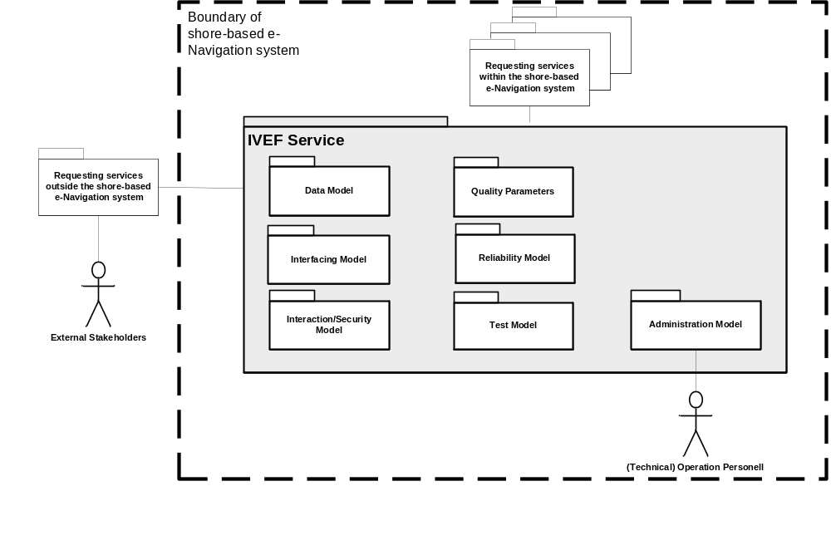

Capabilities of the IVEF Service for the Shore-based e-Navigation System

Introduction
The IVEF Service is an optional part of a shore-based e-Navigation system. The IVEF Service provides particular capabilities that can be defined as Basic IVEF Services (BIS). IVEF Services are only rendered on request of another e-Navigation system or an external system.
The IVEF Service is part of the shore-based e-Navigation system. Hence it would be of primary interest to any other shore-based e-Navigation service, what capabilities the IVEF Service contributes to the shore-based e-Navigation system. The Aim is to provide and exchange the traffic images to neighboured vessel traffic services or authorities.

Figure 2 The IVEF Service in Operation
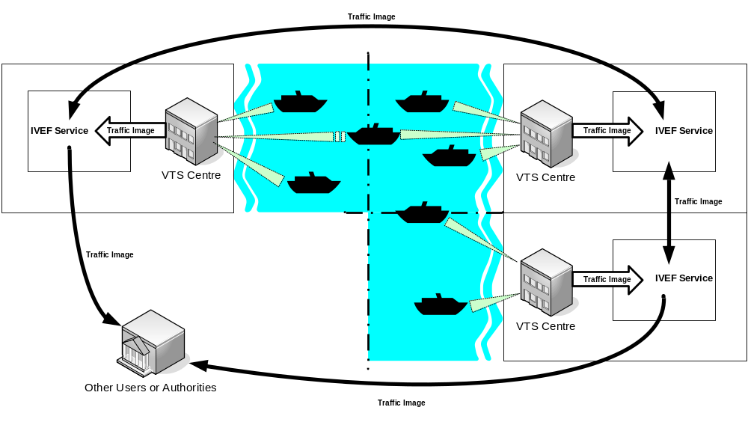

List of Basic IVEF Services (BIS)
There is only one basic IVEF service, i.e. the
- Vessel Traffic Image Data Exchange Service – deliver vessel traffic situation data, according to a specific service profile. The service profile determines e.g. the data items delivered, the area of interest and the update rate.

The IVEF Service bases on a typical Client/Server architecture. In the ISO/OSI model it represents the application layer. Lower layers are not defined herewith, but it is recommended to use secured and reliable links between the client and servers.

Figure 3 IVEF Service Client/Server Model
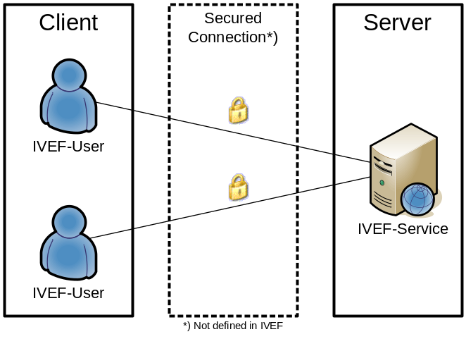

More detailed information on the Basic IVEF Services is available in section XXX.

General Use Cases

Figure 4 IVEF Service Primary Use Case
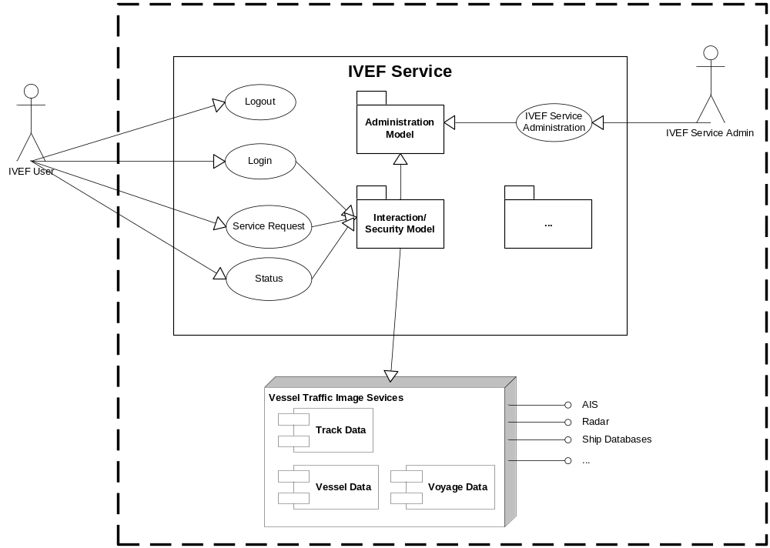

Data Model of the IVEF Service

Introduction
The above Basic IVEF Services define the functionality provided by the IVEF Service to the shore-based e-Navigation system in an abstract manner. They are operations performed on certain data objects, or: they are f(x), to express it in mathematical terms. The data objects treated by the Basic IVEF Services are the operands, i.e. the ‘x’, of these functions. To provide a complete picture of what the IVEF Service delivers to the shore-based e-Navigation system, it is necessary to consider those data objects and their structure and mutual relationship. Eventually, it is the data, which is only relevant for other services of the shore-based e-Navigation system.

The Place of the IVEF Service in the e-Navigation Architecture
Figure 1 illustrates the place of the IVEF Service in the e-Navigation architecture as described by IALA Recommendation on the E-Navigation Architecture – the shore perspective (IALA Recommendation eNAV-101). It clearly identifies the co-operative nature of the shore-based IVEF Service. Note that the IVEF Service shares the dependencies of the e-Navigation architecture.

Figure 1: Place of the IVEF Service within the e-Navigation architecture
Shore-based e-Nav system

IVEF Service
VTS 1
Ship technology
environment
IBS
mobile AIS station
Ship’s
sensors
Shipboard
Applications

Sensor
Data

VTS
mariner
Application 2
Application 3
Application 4

Since the “gateway services” of the shore-based e-Navigation system will be requested by other e-Navigation services within that system, there can be identified multiple client-server-relationships. Those can be combined to a hierarchy within the shore-based e-Navigation system as indicated by Figure 3 (following page).

Figure 3: Client-server relationships of the IVEF Service with other shore-based e-Navigation services – resulting hierarchy of shore-based e-Navigation services and the place of the IVEF Service

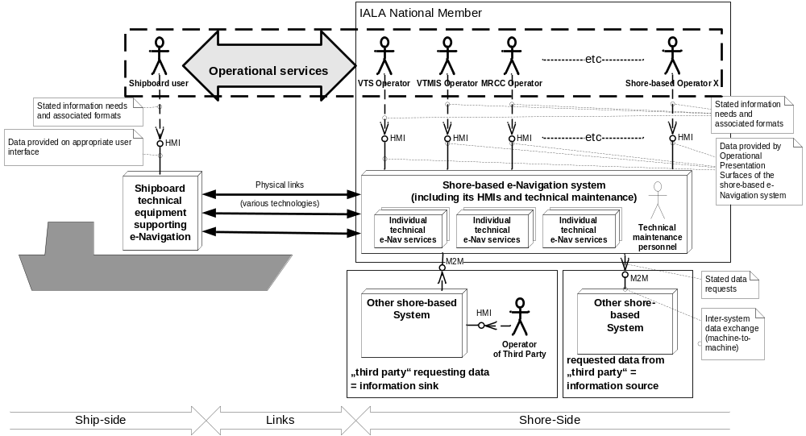

Usage of the Universal Maritime Data Model (UMDM) by the IVEF Service
The Data Model of the IVEF Service is a [subset | application] of the UMDM. It provides the well-structured and abstract (functional) description of the data, the IVEF Service exchanges with requesting services of the common shore-based e-Navigation system. In the UMDM all data objects are expressively described in one place together, with data attributes based on an appropriate data type definition.

Also, the Data Model shows the contribution of the different BAS to the overall knowledge the shore based e-Navigation system may gain about a traffic object (mainly ships) by the IVEF Service at all. Hence, the Data Model shows the contributions of the IVEF Service to the Universal Maritime Data Model (UMDM). It also assigns the Universal Data Object Identifiers (U.DOI) of the data objects of the IVEF Service.

The Data Model provides the designers of requesting services and / or applications using precise information on what data the IVEF Service may provide (receive) or expect (transmit), without the need to know e.g. the encoding details of ITU Recommendation M.1371. Hence the data model helps to encapsulate the “science of the IVEF” proper and confine it to the IVEF Service on behalf of the shore-based e-Navigation system as a whole.

Although, the Data Model does not contain encoding information, encoding is required on application level (i.e. regarding the BAS). The Data Model supports a variety of general purpose encoding techniques on application level, such as XML or SQL-like queries, but also more efficient and tailored encoding schemes such as e-Nav-61162 sentences (with abstract data content, though). Hence, the Data Model of the IVEF Service provides flexibility in selecting an encoding technique as deemed appropriate by the competent authority. A portfolio of appropriate encoding techniques to be used with data objects of the IVEF Service is given in the Interfacing Model (see below).

The Data Model of the IVEF Service is given in section XXX

Interaction/Security Model of the IVEF Service

Part I: Primary service use cases of the TIE Service
The most important features are the primary use cases of the TIE Service. The primary service use cases all have in common, that they are justified by at least one interaction with a “requesting service” within the common eNAV system architecture: The “requesting service” is any other service of the common eNAV system architecture putting a request (logon) to the TIE Service as indicated in the previous chapter.

The primary service use cases of the TIE Service as derived by the above use case derivation process are called external TIE Services (TIE). Therefore, it is the external TIE, which genuinely treat the TIE data. However, there might be additional primary use cases required, namely e.g. replay functionality.

Error: Reference source not found provides an overview on all primary service use cases of the TIE Service.

Figure 5 Overview of the primary service use cases of the IVEF Service
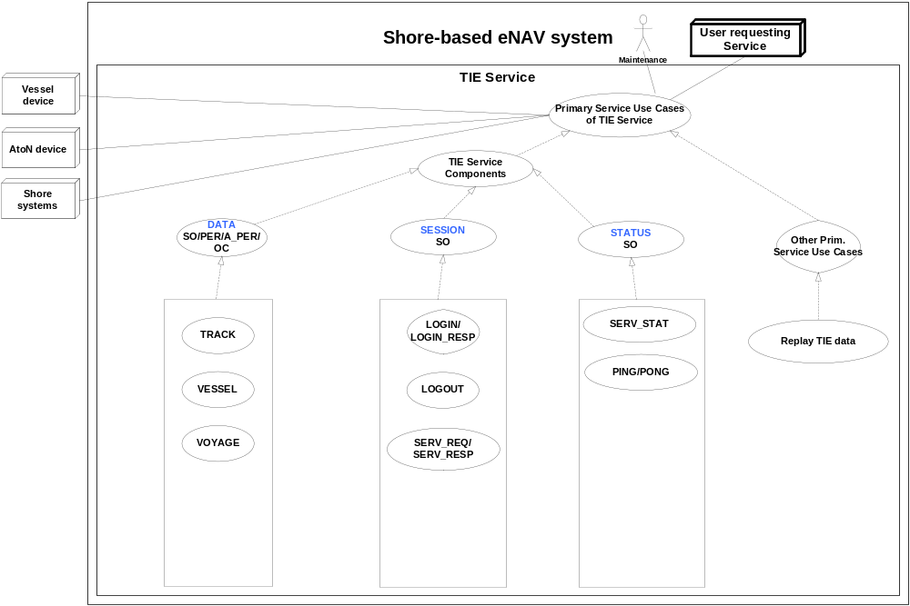
Note: The dotted lines indicate inheritance relationship.

The complete list of external TIE Services and their categories is given below:

TIE Service Data Category:

STATUS: Service Status
DATA: Object Data
SESSION: Session Management

TIE Transmission Category

SO: Single occurrence (non-realtime)
PER: Periodic, with a specified update rate (real-time)
A-PER: A-periodic, synchronous with the received track update (real-time)
OC: On change, updates are sent as data elements change

TIE Basic Service Data Elements:

LOGIN: Authentication request
LOGIN_RESP: Authentication response
LOGOUT: Service termination notification
SERV_REQ: Service request (category, area)
SERV_RESP: Service response
SERV_STAT: Service Status
PING: Alive request
PONG: Alive response
TRACK: Track data
VESSEL: Vessel data
VOYAGE: Voyage data

Service Component DATA

Service Model

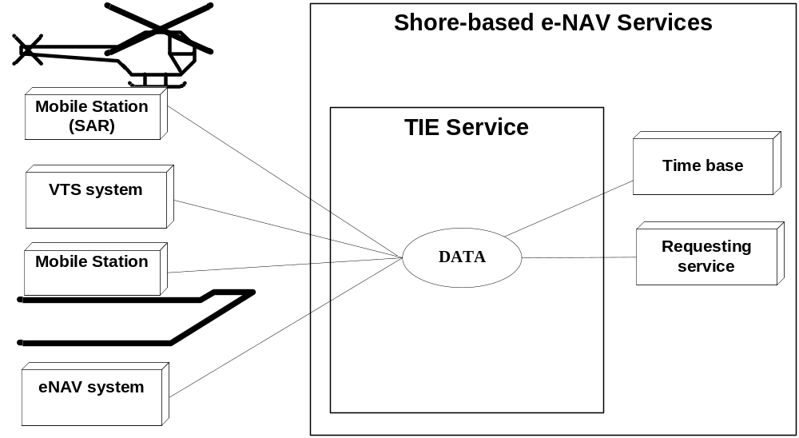

Figure 1: The DATA Service Component

Description

The DATA service component provides the following information:

- Object track information; generally dynamic information about an object such as present position and speed
- Object vessel data; more or less pertinent information about an object such as call sign, IMO number and object dimensions
- Voyage data.

Service Data Structure

The following elements are generic elements that are part of every message:

Element MSG_IVEF
Root MESSAGE

Children Body, Header
Attributes None

Element MSG_IVEF / Header
HEADER part of every message with version and uniqueness information

Children None
Attributes
Qname | Type | Fixed | Restriction | Required | Annotation
MsgRefId | restriction of xs:string |  |  | required | Must be an Universally Unique Identifier for each message (TU-T Rec. X.667 | ISO/IEC 9834-8.) Reply messages refer to this id to identify the message they are replying to. In its canonical form, a UUID consists of 32 hexadecimal digits, displayed in 5 groups separated by hyphens, in the form 8-4-4-4-12 for a total of 36 characters, enclosed by brackets. For example:  {550e8400-e29b-41d4-a716-446655440000}
Version | xs:string | 0.2.0 |  | required | Defines the version of the protocol used. Syntax is major.minor.patch patch releases fix only bugs, minor releases may add functionality but are compatible, major releases are not compatible

Element MSG_IVEF / Body

Children LoginRequest, LoginResponse, Logout, ObjectData, Ping, Pong, ServerStatus, ServiceRequest, ServiceResponse

Attributes
Qname | Type | Fixed | Restriction | Required | Annotation
Type | restriction of xs:string |  |  | required | Type of message

The following elements are the specific elements for the DATA service component.
Element ObjectData
DATA regarding an object in the supliers domain, contains at least 1 one of the sub elements (TrackData, VesselData, VoyageData)

Children TrackData, VesselData, VoyageData
Attributes
Qname | Type | Fixed | Restriction | Required | Annotation
Id | xs:integer |  |  | required | The unique identification of this object, typically identical to Id in the TrackData, but not required

VESSEL: vessel data

Use:
- The vessel information is used to identify and classify ships.

Risks:

- The vessel information is obtained from several sources including manual entry onboard a ship or in a VTS system or from database systems. It is possible that this data may be incorrect.

Service Data Structure

Element VesselData

DATA regarding static elements of an object

Children Construction, Identifier, Owner, Propulsion, TaggedItem

Attributes
Qname | Type | Fixed | Restriction | Required | Annotation
BlackListed | xs:boolean |  |  | optional | Vessel is blacklisted
Class | restriction of xs:integer |  |  | optional | 0 = Unknown  1 = Vessel  2 = Aids to Navigate
Deleted | xs:boolean |  |  | optional | This VesselData is marked for deletion
Detained | xs:boolean |  |  | optional | Vessel is detained
Id | restriction of xs:string |  |  | required | The unique identification of this static data
SourceId | xs:integer |  |  | required | The unique identification of the node who initially created this message
SourceName | restriction of xs:string |  |  | optional | Identification of the originator of the data
SourceType | restriction of xs:integer |  |  | required | Source/originator type: 1 = IVEF transponder 2 = VTS Plan Server 3 = Operator
UpdateTime | xs:dateTime |  |  | optional | Date and time in UTC format (YYYY-MM-DDThh:mm:ss.sssZ) (subset of ISO 8601) this data was compiled

Element VesselData / Construction

Attributes of the object regarding the physical construction

Children UnType

Attributes
Qname | Type | Fixed | Restriction | Required | Annotation
Constructor | restriction of xs:string |  |  | optional
  Identification of the constructing shipyard
DeadWeight | restriction of xs:decimal |  |  | optional
  Dead weight in tons
GrossWeight | restriction of xs:decimal |  |  | optional
  Gross weight in tons
HullColor | restriction of xs:string |  |  | optional
  Color of Hull (in RGB hex)
HullMaterial | restriction of xs:string |  |  | optional
  Material used for Hull construction
HullType | restriction of xs:integer |  |  | optional
  Type of hull (1 = single, 2 = double, 3 = triple)
Length | restriction of xs:decimal |  |  | optional
  Length of the target in meter
LloydsShipType | xs:integer |  |  | optional
  Number indicating type of vessel
MaxAirDraught | restriction of xs:decimal |  |  | optional
  Maximum air draught of the object in meters
MaxDraught | restriction of xs:decimal |  |  | optional
  Maximum draught of the object in meters
MaxPersonsOnBoard | restriction of xs:decimal |  |  | optional
  The maximum number of persons on board of the object (crew, support, passengers, pilots)
MaxSpeed | restriction of xs:decimal |  |  | optional
  The maximum speed the object is able to sustain with normal draft and load
NetWeight | restriction of xs:decimal |  |  | optional
  Net weight in tons
TideBound | xs:boolean |  |  | optional
  Object is tide bound for current destination (deep water vessel indicator)
Width | restriction of xs:decimal |  |  | optional
  Width of the object in meter

Element Construction / VesselData / UnType

Object type according to "CODES FOR TYPES OF MEANS OF TRANSPORT" Revision 2 (UNECE CEFACT Trade Facilitation Recommendation No. 28 edition 2007)

Children None

Attributes
Qname | Type | Fixed | Restriction | Required | Annotation
CodeA | restriction of xs:integer |  |  | required
CodeB | restriction of xs:integer |  |  | required
Mode | restriction of xs:integer |  |  | required

Element VesselData / Identifier

(local) Identification of vessel

Children ForeignId, ForeignName

Attributes
Qname | Type | Fixed | Restriction | Required | Annotation
Callsign | restriction of xs:string |  |  | optional
  Callsign of the target, in accordance with Article 19, Section III of the ITU Radio Regulations (RR)
IMO | xs:integer |  |  | optional
  IMO number of the target
MMSI | xs:integer |  |  | optional
  MMSI number of the target
Name | restriction of xs:string |  |  | optional
  Name of the target
SatCom | xs:integer |  |  | optional
  SatCom number under which the target can be reached
Telephone | restriction of xs:string |  |  | optional
  Telephone number under which the target can be reached

Element ForeignId

(local) Identification of vessel

Children None

Attributes
Qname | Type | Fixed | Restriction | Required | Annotation
Id | restriction of xs:string |  |  | required
  Name of the Identifier
Value | restriction of xs:string |  |  | required
  Value of the identifier

Element ForeignName

Other names for the track than the English name

Children None

Attributes
Qname | Type | Fixed | Restriction | Required | Annotation
Lang | restriction of xs:string |  |  | required
  Languange (ISO 3166-1-alpha2)
Name | restriction of xs:string |  |  | required
  Name in the foreign language

Element VesselData / Owner

attributes of the object regarding the ownership

Children None

Attributes
Qname | Type | Fixed | Restriction | Required | Annotation
Company | restriction of xs:string |  |  | optional
  Identification of the company associated with the object
CountryFlag | restriction of xs:string |  |  | optional
  The country flag (ISO 3166-1-alpha2)
CountryOwner | restriction of xs:string |  |  | optional
  The country flag (ISO 3166-1-alpha2)
HomePort | restriction of xs:string |  |  | optional
  Home port of the target (UN/LOCODE)
Owner | restriction of xs:string |  |  | optional
  Identification of the owner of the object
PortOfRegistry | restriction of xs:string |  |  | optional
  Port Of Registry (UN/LOCODE)

Element VesselData / Propulsion

attributes of the object regarding the propulsion

Children None

Attributes
Qname | Type | Fixed | Restriction | Required | Annotation
MainEngine | xs:boolean |  |  | required
  Indicates whether this engine the main engine
Power | restriction of xs:decimal |  |  | required
  The power of this engine in HP

Operating Characteristics
- The TIE shall start automatically upon logon confirmation
- The data will be sent depending on transmission category

TRACK: track data
Use:
- The track data combined with the data derived from VESSEL and, optionally, VOYAGE represents the actual traffic image.

Risks:
- Sensor data is inherently noisy and subject to all kinds of disturbances. Although filtering and multi-sensor fusion mitigates the effects thereof, care must be taken when using this information

Service Data Structure

Element Pos
DATA position measurement of the geometrical centre of the object or location

Children None
Attributes
Qname | Type | Fixed | Restriction | Required | Annotation
Altitude | xs:decimal |  |  | optional | The altitude of the target above the WGS-84 ellipsoid in meters
EstAccAlt | xs:decimal |  |  | optional | Estimated accuracy  (i.e. standard deviation) of the calculated position of a target  expressed in m
EstAccLat | xs:decimal |  |  | optional | Estimated accuracy  (i.e. standard deviation) of the calculated position of a target  expressed in m
EstAccLong | xs:decimal |  |  | optional | Estimated accuracy  (i.e. standard deviation) of the calculated position of a target  expressed in m
Lat | restriction of xs:decimal |  |  | required | Latitude (WGS84) in degrees. (+/- 90 degrees;  North = positive; South = negative) Examples:  -90deg (south) = -90.0000000  0deg0min1sec (north) = 0.0000016  50deg50min (north) = 50.8333333
Long | restriction of xs:decimal |  |  | required | Longitude (WGS84) in degrees. (+/- 180 degrees; East = positive; West = negative). Examples:  -180deg (west) = -180.0000000  0deg0min1sec (east) = 0.0000016

Element TrackData
DATA describing a position report of an object

Children Pos
Attributes
Qname | Type | Fixed | Restriction | Required | Annotation
COG | restriction of xs:decimal |  |  | required | Course over ground in degrees. (0-360)
EstAccCOG | xs:decimal |  |  | optional | Estimated accuracy  (i.e. standard deviation) of the calculated value  expressed in m
EstAccOrientation | xs:decimal |  |  | optional | Estimated accuracy  (i.e. standard deviation) of the calculated value  expressed in m
EstAccSOG | xs:decimal |  |  | optional | Estimated accuracy  (i.e. standard deviation) of the calculated value  expressed in m
Id | xs:integer |  |  | required | The unique identification of this track. Valid from first message with TrackStatus!=Terminated to first message with TrackStatus=Terminated
Length | restriction of xs:decimal |  |  | optional | Length of the target in meter
NavStatus | restriction of xs:integer |  |  | optional | Navigation status of the target  0 = under way using engine  1 = at anchor  2 = not under command  3 = restricted maneuverability  4 = constrained by her draught  5 = moored  6 = aground  7 = engaged in fishing  8 = under way sailing  15 = undefined default
Orientation | restriction of xs:decimal |  |  | optional | Orientation of the target in degrees
ROT | xs:decimal |  |  | optional | Rate of turn in degrees per minute
SOG | restriction of xs:decimal |  |  | required | Speed over ground in meters per second
SourceId | xs:integer |  |  | required | The unique identification of the node who initially created this message
SourceName | restriction of xs:string |  |  | optional | Identification of the originator of the data
TrackStatus | restriction of xs:integer |  |  | required | 1 = Updated,  2 = Coasted,  3 = Terminated
UpdateTime | xs:dateTime |  |  | required | Date and time in UTC format (YYYY-MM-DDThh:mm:ss.sssZ) (subset of ISO 8601) this position was measured.
Width | restriction of xs:decimal |  |  | optional | Width of the target in meter

Operational Characteristics
- The TIE shall start automatically upon logon confirmation
- The data will be sent depending on transmission category

VOYAGE: Voyage-related data
Use:
- The voyage-related ship information is used to classify ships with regard to cargo, draught and routes.
- The ship's destination is important in order to determine the route of a ship.

Risks:

- The voyage information is entered manually onboard a ship or in a VTS system and it is possible that this data may be incorrect;

- Information on the type of cargo provides only the classification of dangerous goods (Carrying DG, HS, or MP, IMO hazard or pollutant category A, B, C, D). This may not be sufficient in case of SAR/Pollution prevention.

Service Data Structure

Element VoyageData
DATA regarding a movement of a vessel servers domain

Children TaggedItem, Waypoint
Attributes
Qname | Type | Fixed | Restriction | Required | Annotation
ATA | xs:dateTime |  |  | optional
  Date and time in (subset of ISO 8601) UTC format (YYYY-MM-DDThh:mm:ss.sssZ) of the Actual Time Of Arrival of the target at the destination
Agent | restriction of xs:string |  |  | optional
  Agent responsible for this voyage
AirDraught | restriction of xs:decimal |  |  | optional
  Actual air draught of the vessel in meters
CargoDescr | restriction of xs:string |  |  | optional
  Description of the cargo
CargoType | restriction of xs:integer |  |  | optional
  0 = All ships of this type
  1 = Carrying DG, HS, or MP, IMO hazard or pollutant category A
  2 = Carrying DG, HS, or MP, IMO hazard or pollutant category B
  3 = Carrying DG, HS, or MP, IMO hazard or pollutant category C
  4 = Carrying DG, HS, or MP, IMO hazard or pollutant category D
  5 = Carrying DG, HS, or MP, IMO hazard or pollutant of unknown category
CargoWeight | xs:integer |  |  | optional
  Weight of the cargo in tons
Company | restriction of xs:string |  |  | optional
  Identification of the company associated with this objects voyage
Crew | restriction of xs:decimal |  |  | optional
  The number of crew on board of the object
Deleted | xs:boolean |  |  | optional
  This voyage is marked for deletion
DestCode | restriction of xs:string |  |  | optional
  Destination of the target (UN/LOCODE) optionally addended with local location code (e.g. BEANR0170100497 = Antwerp, HANSADOK 497)
DestName | restriction of xs:string |  |  | optional
  Destination name of the target e.g. local code for berth/lock/bridge/terminal
Draught | restriction of xs:decimal |  |  | optional
  Actual draught of the vessel in meters
ETA | xs:dateTime |  |  | optional
  Date and time in (subset of ISO 8601) UTC format (YYYY-MM-DDThh:mm:ss.sssZ) of the Expected Time Of Arrival of the target at the destination
ISPSLevel | restriction of xs:decimal |  |  | optional
  The ISPS level of the object (1 = normal, 2 = heightended, 3 = exceptional)
Id | restriction of xs:string |  |  | required
  The identification of this voyage
Loaded | xs:boolean |  |  | optional
  Loaded or unloaded with cargo
NextPort | restriction of xs:string |  |  | optional
  Next port of the target (UN/LOCODE)
Passengers | restriction of xs:decimal |  |  | optional
  The number of passengers on board of the object
PersonsOnBoard | restriction of xs:decimal |  |  | optional
  The number of persons on board of the object, should equal the sum of crew, passengers and support personel if available
Pilots | restriction of xs:decimal |  |  | optional
  The number of support pilots on board of the object
PrevPort | restriction of xs:string |  |  | optional
  Previous port of the target (UN/LOCODE)
RouteBound | xs:boolean |  |  | optional
  This object is bound to the route of this voyage
SourceId | xs:integer |  |  | required
  The unique identification of the node who initially created this message
SourceName | restriction of xs:string |  |  | optional
  Identification of the originator of this data
SourceType | restriction of xs:integer |  |  | required
  Source/originator type: 1 = transponder, 2 = database, 3 = manual, 4 = other
Support | restriction of xs:decimal |  |  | optional
  The number of support personel on board of the object
TankerStatus | restriction of xs:integer |  |  | optional
  Describes the status of the tanker
  0 = Non gas free
  1 = Gas free
  2 = Inert
Tugs | restriction of xs:decimal |  |  | optional
  Number of supporting tugs
UpdateTime | xs:dateTime |  |  | optional
  Date and time in (subset of ISO 8601) UTC format (YYYY-MM-DDThh:mm:ss.sssZ) this data was compiled

Element VoyageData / Waypoint
Waypoint belonging to the route of this voyage

Children Pos
Attributes
Qname | Type | Fixed | Restriction | Required | Annotation
ATA | xs:dateTime |  |  | optional
  Date and time in UTC format (YYYY-MM-DDThh:mmZ) (subset of ISO 8601 ) of the Actual Time Of Arrival of the target.
ETA | xs:dateTime |  |  | optional
  Date and time in UTC format (YYYY-MM-DDThh:mmZ) (subset of ISO 8601) of the Expected Time Of Arrival of the target.
LoCode | restriction of xs:string |  |  | optional
  Waypoint name in UN/LOCODE optionally addended with local location code (e.g. BEANR0170100497 = Antwerp, HANSADOK 497)
Name | restriction of xs:string |  |  | required
  Name of the waypoint

Operational Characteristics

- The TIE shall start automatically upon logon confirmation
- The data will be sent depending on transmission category

Service Component SESSION

Service Model:

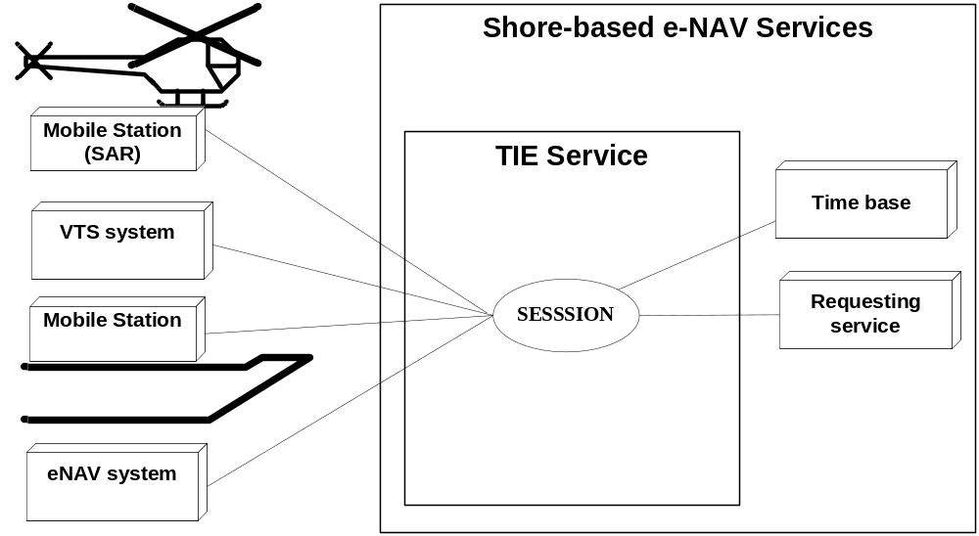
Figure 2: SESSION

Description

The SESSION service component is responsible for set-up, termination and terms-of-service negotiation

LOGIN/LOGIN_RESP/LOGOUT
Use:
- A session is started by issueing a login request with the appropriate account details
- The account details are verified and the service responds with a login response granting or denying access to the service
- A session can be terminated by issuing a logout request

Risks

- TBD

Service Data Structure

Element LoginRequest
DATA login message with details of the user

Children None
Attributes
Qname | Type | Fixed | Restriction | Required | Annotation
Encryption | restriction of xs:integer |  |  | required | 1 = plain 2 = SHA-512
Name | restriction of xs:string |  |  | required | Login name
Password | restriction of xs:string |  |  | required | Password value

Element LoginResponse
DATA login response with acceptance or deny with optional reason

Children None
Attributes
Qname | Type | Fixed | Restriction | Required | Annotation
Reason | restriction of xs:string |  |  | optional | String describing reason for declining, only used when result is "Declined"
ResponseOn | restriction of xs:string |  |  | required | Corresponds to the original MsgRefId from the Login.xml message. Must be an Universally Unique Identifier (TU-T Rec. X.667 | ISO/IEC 9834-8.)
Result | restriction of xs:integer |  |  | required | 1 = Accepted 2 = Declined

Element Logout
DATA logout message, the server will drop the connection if logout is successful

Children None
Attributes None

SERVICE_REQ/ SERVICE _RESP
Use:
- A service request is used to negotiate the terms-of-service, i.e. data content and frequency of delivery;
- A service request is acknowledged by a service response

Risks

- TBD

Service Data Structure

Element ServiceRequest
DATA describing the service a user requests

Children Area, Item, Notifications, Object, Transmission
Attributes None

Element Area
Geographical location based on one or more polygons

Children Pos
Attributes

Qname | Type | Fixed | Restriction | Required | Annotation
Name | restriction of xs:string |  |  | optional
  Name of the area

Element ServiceRequest / Transmission

Children None
Attributes
Qname | Type | Fixed | Restriction | Required | Annotation
Period | xs:decimal |  |  | optional
  Specifies he time between two periodic updates in seconds, for type 2 (seconds) and 3 (minutes)
Type | restriction of xs:integer |  |  | required
  Type of transmission, possible values are:
  1 = single occurrence
  2 = periodic (predicted, seconds domain)
  3 = down sampled (not predicted, minute domain)
  4 = synchronous
  5 = on change

Element ServiceRequest / Item

Children None
Attributes
Qname | Type | Fixed | Restriction | Required | Annotation
Element | restriction of xs:integer |  |  | required
  Describes requested Object data element, possible values:
  1 = TrackData
  2 = VesselData
  3 = VoyageData
Field | restriction of xs:string |  |  | required
  Selected field. Can be 'all' or one of the items of object data TrackData, VesselData or VoyageData

Element ServiceRequest / Object

Children None
Attributes
Qname | Type | Fixed | Restriction | Required | Annotation
FilterName | restriction of xs:string |  |  | required
  Name of the filter. The filter can be a predefined selector of the server. One of the predefined selectors will be 'all', others can defined here in the future

Element ServiceResponse
DATA detailing the supliers response to the users service request

Children None
Attributes
Qname | Type | Fixed | Restriction | Required | Annotation
Reason | restriction of xs:string |  |  | optional
  String describing reason for declining, only used when result is "Declined"
ResponseOn | restriction of xs:string |  |  | required
  Corresponds to the original MsgRefId from the ServiceRequest message. Must be an Universally Unique Identifier (TU-T Rec. X.667 | ISO/IEC 9834-8.)
Result | restriction of xs:integer |  |  | required
  1 = Accepted 2 = Declined

Service Component STATUS

Service Model:

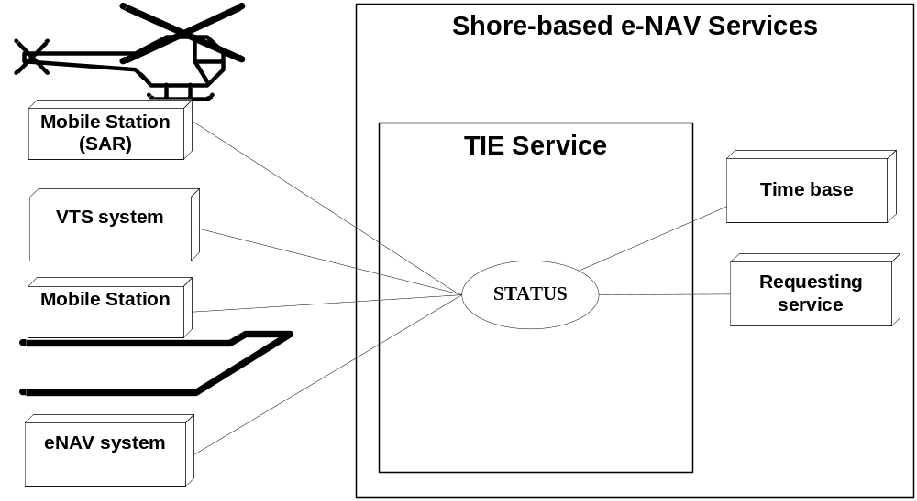
Figure 3: STATUS

Description

The STATUS service component provides service-related status information and maintains alive status

PING/PONG/SERV_STAT

Use:
- PING / PONG are messages exchanged at regular time intervals to verify alive status of the datalink.
- SERV_STAT

Risks

- TBD

Service Data Structure

Element Ping
DATA alive message

Children None
Attributes
Qname | Type | Fixed | Restriction | Required | Annotation
TimeStamp | xs:dateTime |  |  | required
  Date and time in (subset ISO 8601) UTC format (YYYY-MM-DDThh:mm:ss.sssZ) of the time this message is sent.

Element Pong
DATA alive response

Children None
Attributes
Qname | Type | Fixed | Restriction | Required | Annotation
ResponseOn | restriction of xs:string |  |  | required
  Corresponds to the original MsgRefId from the Ping.xml message. Must be an Universally Unique Identifier (TU-T Rec. X.667 | ISO/IEC 9834-8.)
SourceId | xs:integer |  |  | required
  The identification of the node who created this message
TimeStamp | xs:dateTime |  |  | required
  Date and time in (subset ISO 8601) UTC format (YYYY-MM-DDThh:mm:ss.sssZ) of the time this message is sent.

Element ServerStatus
DATA describing the status of the server (full/available)

Children None
Attributes
Qname | Type | Fixed | Restriction | Required | Annotation
Details | restriction of xs:string |  |  | optional
  Details of status
Status | xs:boolean |  |  | required
  Status of the server

Part II: Secondary service use cases of the TIE Service
To be extended

LOCAL ADAPTATION

Use:
- The TAGGED_ITEM message can be used for non-standard loca data exchange.

Risks

- It is non-standard.

Service Data Structure

Element TaggedItem
Generic key/value pairs, can be used to pass information that is not (yet) in the standard, provided server and user agree upon interface

Children None
Attributes
Qname | Type | Fixed | Restriction | Required | Annotation
Key | restriction of xs:string |  |  | required
  Key for the tagged item
Value | restriction of xs:string |  |  | required
  Value of the tagged item

Interfacing Model of the IVEF Service
Describe that IVEF does not depend on a particular transport layer, design parameters are deadline, lifespan, reliability etc.

XML (UTF8)

Quality Parameters of the IVEF Service
Depends on usage, timestamp and std deviation is provided in the data format

Reliability model of the IVEF Service
Depends on usage.

Test model of the IVEF Service
Validity, well formedness, correctness, protocol interaction

Definitions

Object – a vessel, an Aid-to-Navigation or a helicopter (SAR)
Gateway Service – a generic type of service as defined in ref [201]

Abbreviations
IVEF – Inter-system Vessel traffic image Exchange Format
SAR – Search and Rescue

“Regional” in the context of this Recommendation is seen from a global perspective, i.e. a region could be a continent or a substantial part of a continent. E. g. the Baltic Sea as a whole is a region in this regard.

