Differences in Perceptions of Effectiveness Regarding Transition Planning as
Viewed by Major Stakeholders in Development of Post Graduate
Options With Special Needs Secondary Students

A dissertation submitted in partial fulfillment

of the requirements for the degree of

DOCTOR OF EDUCATION

To the faculty of the

School of Education

Department of Administration and Instructional Leadership

St. John’s University

Jamaica, NY

By

JOHN KARAHALIS

Submitted Approved

Date Date

_________________ __________________

(Student’s signature) (Mentor’s signature)

Table of Contents

Chapter I: Introduction

Chapter II: Literature Review

Background on Special Education Law

Transitional Planning Process in New York State

Review of Related Literature

Chapter III: Methodology

Chapter 1
INTRODUCTION
The purpose of this study is to explore the effectiveness of the Individuals with Disabilities Act (IDEA) transition mandates as viewed by major stakeholders. The IDEA is a Federal Special Education legislation that provides the provision of free and appropriate public education services to students with disabilities. Since 1990, the Individuals with Disabilities Act along with New York state laws and regulations have required school districts to provide transition planning and services to New York State’s approximately 140,000 secondary students with disabilities who are between the ages of 15 and 21. In 2004 the phrase further education and the emphasis on effective transition services was added. The phrase “transition services means a coordinated set of activities for a child with a disability that (1) is designed to be results oriented, in terms of improving the academic and functional achievement of the individual and facilitating the child’s movement from school to post-school activities; (2) is based on the child’s needs; and (3) includes the development of employment and other post-school adult living objectives.

Commonly faces issues for students with disabilities nearing graduation include pursuing vocational training or academic education, getting a job and living independently. In the case with students with disabilities the choices may be more complex and require a great deal of planning. In New York State transition services are required to be part of a student’s Individualized Education Plan
(I.E.P.) that goes into effect at age 12 years as a career assessment known as a Level One Assessment.

The purpose of the following study is to explore how the system put forth by NYS regarding Transition Planning Services functions as a cohesive unit to promote postgraduate employment. The research question to be addressed by this study is the perception of effectiveness as viewed by major stakeholders in the process Foremost will be the students themselves as well as parents, job /vocational coaches, and employers all of whom have a vested interest in the success of the program. Any factors for possible improvement will also be explored and discussed to determine the need for positive change in future planning.

The following definitions are provided to ensure uniformity and understanding of these terms throughout the study. The researcher developed all definitions not accompanied by a citation.
- Transition Planning- Is the formalized way to assure that students with disabilities are prepared while still in high school for post- school learning, independent living and employment success.
- Individualized Education Plan (IEP) an educational team generated document in effect for the school year that the student turns 15 and is updated annually.
- Job Coach- An individual who provides training and support at the job site to an individual with a disability.
- Supported Employment- Support services for persons with substantial disabilities designed to assist integration in competitive employment.
- VESID- The office of Vocational and Educational Services for Individuals with Disabilities whose role is to assist the student with disability to obtain an employment outcome in the most integrated employment setting consistent with the individual’s unique employment factors: Including strengths, resources, priorities, abilities, capabilities, career interests and informed choice.
www.vesid.nysed.gov
- Disabilities*- N.Y.S. recognizes the following specific disabilities as eligible for Transition Services.
Autism & Asperger’s Syndrome
Deaf-Blindness
Deafness
Emotional Disturbance
Hearing Impairment
Learning Disabilities
Mental Retardation
Multiple Disabilities
Orthopedic Impairment
Other Health Impairment
Speech or Language Impairment
Traumatic Brain Injury
Visual Impairments including Blindness

*Definitions of the preceding terms can be found in the glossary section of this dissertation
(Excerpts from section 200.1 of the regulations of the Commissioner of Education)

Chapter 2

LITERATURE REVIEW

BACKGROUND ON SPECIAL EDUCATION LAW

Under the U.S. Constitution, education is not fundamental right of the citizens of the United States. The 10th Amendment to the Constitution provides that “powers not delegated to the United States by the Constitution, nor prohibited by it to the States, are reserved to the States. Thus, resulting in the duty of education to individual States, which provide education as an entitlement.

In 1954 the U.S. Supreme Court ruled in the case of Brown v. Board of Education that separate educational facilities for racial minority children were “inherently unequal” As a result of this ruling states could not limit access to particular schools based on race. In these ruling parents of children with disabilities filed lawsuits using the identical argument.

The first Federal law-mentioning children with disabilities was enacted in 1965 as Public law 89-313 which established grant programs for state –run schools and institutions for children with disabilities.

Finally, in 1975 Public Law 94-142 required that schools provide access to a free and appropriate public education that is provided in the least restrictive environment.
In 1990 the first Public Law that mentioned IDEA mandated transition services. In addition autism and traumatic brain injury were included as disability conditions.
In 2001 Public Law 107-110 more commonly known as the No Child Left behind Act was enacted.
In 2004 Public Law 108-446 became known as the Individuals with Disabilities Education Improvement Act which was an Amendment and reauthorization of IDEA.

Transition Planning Process in NYS
Transition Services:
Transition Services are activities that prepare students with disabilities to move from school to post-school life. The activities must be based on the student’s needs, preferences and interests and need to include activities in the following areas:
- Instruction
- Related Services
- Community Experiences
- Development of Employment
- Acquisition of Daily Living Skills

Federal IDEA law requires the district Committee on Special Education (CSE) to coordinate transition planning and provide transition services through the Individualized Education Plan, (IEP). In addition it is imperative that schools need to have the active participation of students, families and community agencies in order to make the transition process effective and meaningful for individual students.

Each year VESID monitors approximately 116 school districts, and publicly reports on the percentage of youth in the state who are aged 15 and above who have an IEP that includes coordinated, measurable, annual IEP goals and Transition services that enable students to meet their post secondary goals. Results from 2008 indicate that only 46% of youth have IEP transition plans that are calculated to help them achieve their post secondary goals with full compliance with State and Federal requirements. While improvement has been made over previous years the target goal is full 100% compliance.
Potsdam Institute for Applied Research (PIAR) located at the State of New York (SUNY) is involved in locating and in interviewing a sample of the students from each school district one year after graduating from school. Students from the class of 2005 one year after graduating found that 17% were enrolled in post-secondary schools, 29% were competitively employed and 46% had done both. The NYS education Department believes these results are an overestimation of actual post-secondary outcomes for all students with disabilities. (Rebecca H. Cort, NYS Education Dept. VESID Committee: Transition Planning and services for students with disabilities, October 30, 2008.)

REVIEW OF RELATED LITERATURE
The transition from high school to future endeavors is a difficult time for many adolescents. It is a time often with concern, confusion and excitement as students and their families attempt to coordinate future goals. Options may include college, vocational options with or without family associations and / or enlisting in military service. In the case of students with special needs the same issues are present but exacerbated due to the degree of limitations each student possesses. Prior to IDEA legislation options for these students were severely limited.
Since transition planning was mandated in IDEA the implementation of said policy has been reviewed. Quality of life issues were viewed as a conceptual framework for evaluating transition outcomes, Halpern (1993).
From 1989 to 1993 the U.S. Department of Education, Office of Special Education programs funded a series of model- demonstration projects to promote self-determination for youth with disabilities (Ward & Kohler, 1996) Self-determination has been identified as a critical outcome of the transition process for students with disabilities (Halloram, 1993; Wehman 1993). This funding was necessitated as a result to numerous literature indicating that students with disabilities were graduating with substandard post graduate outcomes, (Chafsey-Rusch, Rusch & O’Reilly, 1991) Other researchers reported the need for people with disabilities need increased choice and more control over decisions that impact their lives (Gagne, 1994; Kennedy, 1996). Hasazi, Furney and Destafano (1999) in researching the IDEA mandates found factors supporting and challenges to implementation.
The need for educators to dedicate time and effort in the success of transition planning includes many factors. For example, quality of life issues are emphasized as an outcome for adults with disabilities. (Gagne, 1994; Kennedy 1996). Additionally, the effect of attitudes and abilities as it relates to autonomy
may relate to involvement in educational planning and unproblematic decision making (darn Reusen & Bos, 1994 Wehmeyer & Ward, 1995). In can also be said that students who leave school as self-determined young people should achieve more positive adult outcomes, (Wehmeyer & Schwartz 1997).

In determining implementation of Transition Planning each student may be influenced by a number of individuals, which may be a factor in a student’s positive experience. From family, teachers, counselors, job coaches and employers each individual brings their own conceived attitudes and expectations
of what constitutes a successful occurrence. Wagner, Newman and Cameto, (1993), researched the issue of “What makes a difference?” in influences on post school outcomes of youth with disabilities. A follow up study also reviewed “changes over time in the secondary school experiences of students with disabilities, (Wagner et al. 2004)

The chart below is an illustrative representation of how a student interacts with factors that promote the Transition Planning Services concept. With Transition Planning as the construct the student is affected by three significant stakeholders, all of whom play a collaborative role in the outcome of the program. By taking a deeper look into student interaction the researchers will explore this collective construct. The present researchers will attempt to evaluate the attitudinal perspective on those stakeholders in Transition Panning combining a qualitative and quantitative research approach and to investigate issues that may be in need of modification or alteration.

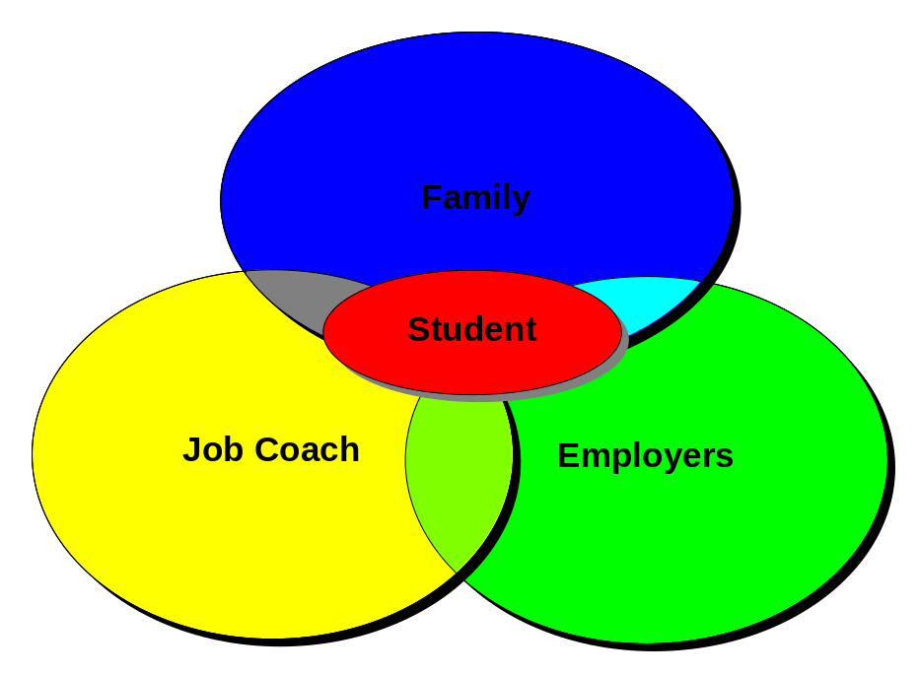
Transition Planning
Transition Planning
Transition Planning
Transition Planning

Chapter 3
METHODOLOGY

It is the intent of the researchers to continue in investigating the effectiveness of Transition Planning over time specifically, is there a correlation between years
after graduation and compliance to the program? Secondly, do parents, job coaches and employers see the need of said program changing the longer a student has been involved with the program? Finally, although the implementation of the program can be well documented for most post-graduate consumers, is there a reduction of follow-up services the longer a student has been away from his completed academic program. In investigating the above each researcher will need to extensively look into each of the various stakeholders and their interpretation that address the above questions. This can best be accomplished in a collaborative project that among other issues will allow for split half reliability using two alternate groups assigned randomly. Through this study we intend to illicit the responses from consumers, families, employers, and job coaches pertaining to the above as well as the intrinsic value of the program. Participants will be asked a series of questions using a qualitative approach which will include a five point Likert* scale regarding each stakeholders personal experiences and attitudes on a variety of topics related to transition Planning. Each researcher will attempt to gain responses from a pool of available respondents in the New York Suffolk County geographic area. Questions will include the following areas:
- Personal experience in securing Transition Planning
- How each respondent learned about Transition Planning and from whom?
- The ease or difficulty in completing the process including
dealing with local and State Government agencies
- How do individual sections of the process fit with NYS practice and how familiar are you with them?
- Are there other considerations that have been overlooked?
- Suggestions (if any) for changes or area(s) in need or improvement in the Transition Process

* Likert is a scale in which respondents indicate their level of agreement with statements that express a favorable or unfavorable attitude toward a concept being measured.

