Graph Toolbox extension for OpenJUMP
v 1.0.0 (2021-04-12) by Michaël Michaud

History
1.0.0 (2021-04-10) : Refactoring for OpenJUMP 2, JTS 1.18 and JGraphT 1.5
Bug fix in skeletonizer (branches touching holes were not removed)
------
0.8.0 (2020-09-29) : Add new Stream orders (Shreve, Horton, Hack)
0.7.0 (2020-09-23) : Make strahlerNumber plugin more memory friendly and way faster
0.6.3 (2019-06-24) : SkeletonPlugIn : improve meanWidth calculation
0.6.2 (2019-05-22) : fix bug in SkeletonPlugIn : incorrect relativeMinForkLength
0.6.1 (2018-06-17) : refactor to use AbstractPlugIn parameters in GraphNodesPlugIn
0.6.0 (2018-06-11) : refactore/improve SkeletonPlugIn (simplify parameters)
0.5.8 (2018-05-27) : improve SkeletonPlugIn (and add a parameter)
0.5.6 (2018-01-27) : add finnish translation
0.5.5 (2017-06-06) : improvements of HydrographicNetworkAnalysis and Skeleton plugins
0.5.0 (2017-04-10) : add HydrographicNetworkAnalysis plugin
0.4.1 (2017-02-03) : fix small I18N problem
0.4.0 (2017-01-12) : add directed Graph in Graph nodes plugin
0.3.0 (2016-10-23) : upgrade jgrapht to 0.9, add Skeleton plugin
0.2.0 (2014-07-16) : addition of Strahler Numbers plugin
0.1.0 (2010-04-22) : first svn version

General concepts

Graph Extension is a set of plugins bundled as a jar file to be placed in OpenJUMP plugin directory (default plugin directory is lib/ext).
Graph extension has two dependencies :
- JGraphT is a graph library implementing many graph algorithms, a few of which are used by OpenJUMP graph extension
- jump-jgrapht includes glue-code between JGraphT and OpenJUMP feature model. jump-jgrapht has been bundled in a separate jar, so that other extensions can easily use other JGraphT algorithms.

Jump-jgrapht glue-code
The way jump-jgrapht build a graph from a feature collection is very simple : it uses linear features as edges and LineString end-points as nodes. From version 0.1.3, it can also insert isolated point as nodes of degree 1. It test connectivity using equals() method between first and last coordinate of each LineString. That means that
- graph construction only makes sense for linear networks
- feature collection is supposed to be correctly noded. If two features intersect at a point strictly interior to one of the feature (rather than at their extremity), the graph will not connect these features together.
TODO : Currently, jump-jrapht includes code to create undirected graphs from a feature collection. There is no code to create directed graphs yet. It would be interesting to add this feature, but there is no unique way to modelize a directed graph in a GIS (one can use natural orientation of LineStrings, single-attribute-based orientation, orientation defined by several attributes...).

Graph extension plugins and common options
Every plugin from graph extension is installed in the Plugins menu of OpenJUMP, in a submenu called... Graph.
Most options have a tooltip giving more details about option signification.
Some options are common to several plugins :
- 3D graph : if selected, the graph will be computed in 3D. This means that two lines which are connected in the plan but have end-points at different altitudes will not be connected in the graph.
- Use attribute : if selected, the plugin will allow to select an attribute, and will compute a different graph for each set of features having the same attribute value.
- ignore empty : this option is linked to the previous one. If ignore empty is selected, features with null value and features with empty string will be excluded from the graph. This feature can be used, for example, to build one graph by river and to exclude unnamed rivers.

Graph nodes PlugIn

This PlugIn computes all the nodes of a directed graph. Options will allow to output :
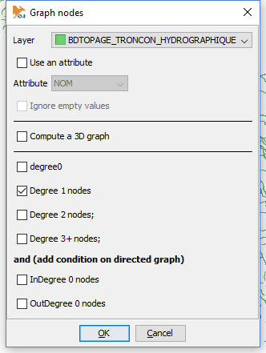
- degree 0 nodes : isolated nodes. It makes no sense for a pure linear network. It could represent puntal features isolated from the network in a mixed geometry layer (implemented in 0.1.3).
- degree 1 nodes : pendant nodes, or end-nodes. Nodes connected to one edge only. Very useful to find interruptions in a network.
- degree 2 nodes : nodes linking two linear features exactly.
- degree 3+ nodes : nodes where 3 edges or more connect together. They represent intersections or forks in a network. It is possible to know the exact degree of each node in the output node layer (see here after).

The second part makes it possible to add a condition on the number of InGoing (resp. OutGoing) edges. Ex. InDegree 0 nodes means that the is no edge ending on the node.
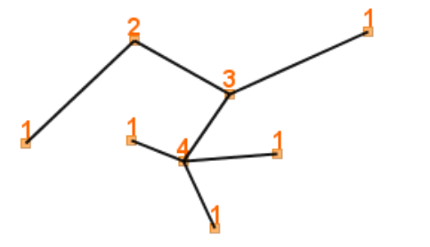
Common options are also available to compute a 3D graph rather than a 2D one, or to compute a distinct graph for each distinct value of a user-defined attribute.
The result of this PlugIn is a unique layer named after the original layer name followed by "-nodes", and with one attribute containing the degree of each node.
Tip : you can easily create separate layers for each degree using Edit > Extract > Create separate layers for each attribute value.

Connected components PlugIn
This plugin analyzes the connectivity of a graph. If the graph is not fully connected, several connected subgraphs are computed.

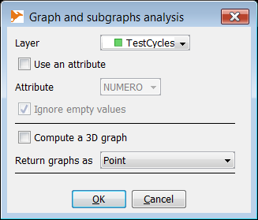
The plugin outputs two layers. One describing original graph(s) characteristics and one for the connected components. Attributes for each layer are :
Original graph(s)
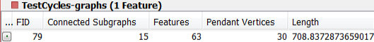
- Connected subgraphs : number of connected subgraphs in the graph
- Features : total number of features in the graph
- Pendant nodes : total number of pendant nodes (or end-nodes)
- Length : total length of the graph
Connected subgraph(s)
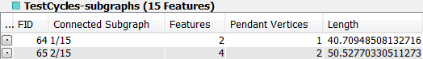
- Connected subgraph : number of the connected subgraph as 2/3 for the second (unordered) connected subgraph of a graph
- Features : number of features in the connected subgraph
- Pendant nodes : number of pendant nodes (or end-nodes)
- Length : total length of the connected subgraph
Geometries representing graphs in those two layers maybe one of the following :
- Point : the whole graph or subgraph is represented as a single point (getInteriorPoint JTS function)
- MultiLineString : the whole graph or subgraph is represented as a MultiLineString which is a combination of all the linestrings of the graph (or subgraph)
- Simplified MultiLineString : the graph (or subgraph) is represented as a MultiLineString where each original LineString is replaced by a simplified LineString composed of two points : initial coordinate and end coordinate.

Cycle detection PlugIn

Cycle detection finds simple cycles in a layer representing a network. It can be used, for example, to find traffic-circle in a road network, anastomosis in a river network...
Number of cycles in a network can be very high, even if the plugin only returns only simple cycles.
You can limit the number of returned cycles using the following parameters :
- minimum number of features : minimum number of features composing the cycle. You may want, for example, select every cycle but the one made of a single feature (LinearRing).
- maximum number of features : maximum number of features composing the graph.
- maximum length : maximum length of the cycle. Used to remove large cycles. The unit is the map unit (beware maps in decimal degrees)
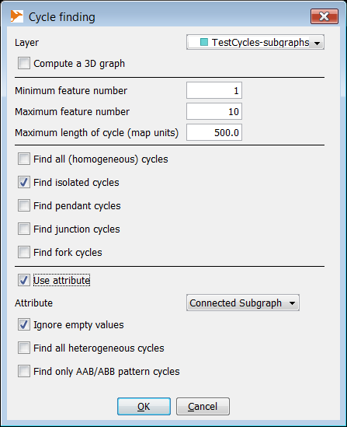
Other options make it possible to select cycles depending on their "degree" :
- isolated cycles (degree 0) : there is no edge entering or leaving the cycle. If an attribute is used (see below), this option means that the cycle has homogeneous attribute values and that there is no entering or leaving edge with the same attribute value
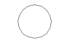
- pendant cycle (degree 1) : there is only one edge connected to the cycle. If an attribute is used (see below), this option means that the cycle has homogeneous attribute values and that only one edge with the same attribute value is connected to the cycle
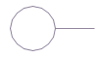
- junction cycle (degree 2) : there is exactly two edges connected to the cycle and not belonging to it. If an attribute is used (see below), this option means that the cycle has homogeneous attribute values and that exactly 2 edges with the same attribute values are connected to the cycle :
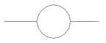
- fork cycle (degree 3+) : there is three edges or more connected to the cycle. If an attribute is used (see below), this option means that the cycle has homogeneous attribute values and that at least 3 edges with the same attribute values are connected to the cycle :
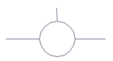
There is a third section to select cycles with heterogeneous attributes. One can choose to return :
- all cycles with heterogeneous attributes (cycles with at least two different values, including null)
- only cycles including two degree 3 nodes, one with incident edges having attribute values A, A and B and the other incident edges having values A, B and B. This pattern, shown in the figures here after, often shows continuity problems due to wrong attribute values.
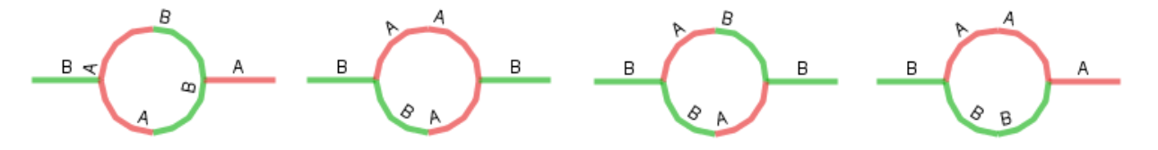

Stream Orders PlugIn

This Plugin is used to classify a hierarchical network (especially a hydrographic network) using the concept of Strahler Numbers developped by Arthur Newell Strahler and Robert E. Horton.
The plugin makes use of the JGraphT library. It processes a oriented graph, either connected or not. Note that the graph is always interpreted as an oriented graph. In the case of a hydrographic network, this means that every edge must have been digitized in the flowing direction.
See also https://svn.osgeo.org/grass/grass-addons/grass7/raster/r.stream.order/r.stream.order.html for a more complete description and some more illustrations

Strahler Stream order

How it works ?
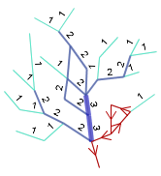
Every edge starting at a source point is given the stream order 1. Downstreams stream order have always an order > = upstream.
For a edge E, if the highest order of its ancestors is n and only one ancestor has order n, E is also given the order n. On the other hand, if E has 2 or more ancestors with order n, it is given the order n+1.
Improvements
To keep a consistent hierarchy in the case of anastomosis, the algorithm consider that a stream dividing into several streams meeting up again later keeps its order unchanged. In other words. if ancestors of an edge have themselves common ancestors, they are considered as a single ancestor (see figure).

Case of braided networks
To maintain a consistent hierarchy in the case of braided networks, the algorithm considers that if an arc divides into two arcs, then the arcs meet again, the order does not change. In other words, predecessors are counted as different, if their ancestors are also different (see diagram).
Old and new algorithm differ in the way to manage the case of braided networks :
In the old algorithm, the order of an edge is only incremented to "n + 1" if it is fed by two chops of order "n" which have absolutely no common ancestor.
The new algorithm follows the article "A fast recursive GIS algorithm for computing Strahler stream order in braided and nonbraided networks". In this algorithm, the order of the edge is incremented to "n + 1" if it has two tributaries of order "n" belonging to different segments. A segment is defined here as the set of connected segments of homogeneous order.
Below are some examples indicating the common points and the different points of the two algorithms.
Former algorithm | New algorithm
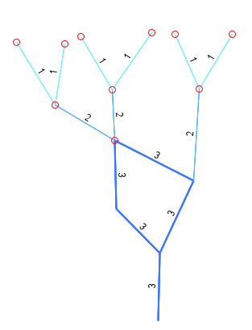
Last edge edge predecessors have common ancestors : its stream order is not incremented | Last edge predecessors have a common segment head : its stream order is not incremented
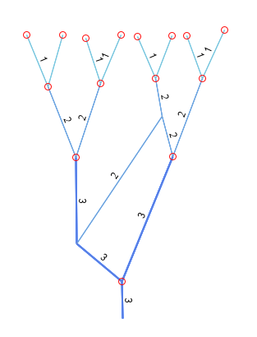 | 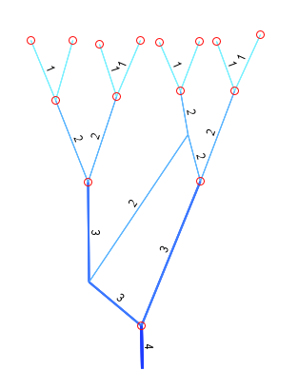
Last edge predecessors have common predecessors : its stream order is not incremented. | Last edge predecessors have common predecessors, but different segment head (only an order two affluent from the right basin contribute to the left affluent) : stream order is incremented.

Corner cases
The stream order of a cycle can't be determined. As a consequence, if the algorithm encounter a cycle while traversing the graph (from upstream to downstream) all the edges flowing from the cycle are undetermined (see red edges in the figure).

Shreve Stream Order
With the Shreve Order head channels are set to 1 and a channel with two affluents of orders n and m is set to n+m. The order is divided by 2 (or more) if the stream divides into several channels. That’s the reason why it uses a double and not an integer as for Strahler order.

Metrics
Max distance : Maximum distance to a source. Computed downstream. Max distance value of an edge = edge length + max value of its affluents. The length may be taken from the edge geometry or from an attribute (to avoid loading complex geometries into memory).
Flow accumulation : Flow accumulation of every channel is computed as the sum of the flow accumulation of its direct predecessors plus the length of the current channel. It is divided if the stream divides into several channels. This measure is necessary to compute Horton or Hack orders.
As for Strahler and Shreve orders, these metrics are computed with a recursive algo traversing the network from upstreams to downstreams. They are used in the computation of Horton (Flow accumulation) and Hack (one version uses Flow accumulation and the other the Max Distance).

Horton and Hack Stream Orders
Horton and Hack Stream Orders use metrics previously described, but need a network traversal starting from river mouths to the heads. At each confluent, they preserve the mouth order on the main upstream, main confluent being defined according to Strahler order and/or one of the previously described metrics.
Horton Order : this order is based on the Strahler order. First, Strahler and accumulation flow are computed. Then, the network is traversed from the river’s mouth to every source. At every confluence, the tributaries are set their Strahler order except the main tributary which is set with the downstream Horton order. The main tributary is the one with the highest Straghler order, and if two tributaries have the same Strahler order, the one with the highest flow accumulation is choosen. This way, the importance of a stream is propagated from its mouth to its main source.
Hack Order : Hack order set one to every edge located at a river mouth. During the upstream traversal, at each confluent, the n order is preserved on the main affluent, and other affluents are set to n+1. Main affluent is determined according to the max distance or to the flow accumulation meric. This produce two different orders, one based on the maximum length of a single channel and the other on the total accumulated length of all affluents of a channel.
Checking hack order option adds 4 attributes to the result
HackFlowO : Hack Order based on the Flow accumulation
HackFlow : The maximum flow accumulation propagated along the whole stream
HackDistO : Hack Order based on the maximum distance to a source
HackDist : The maximum distance to a source, propagated along the whole stream
HackDFO : Main upstream is determined according to the MaxDist x FlowAcc product
HackDF : The MaxDist x FlowAcc product is propagated bottom-up along the whole main stream

MouthDist : intermediate result to follow th emain stream when it contains diffluents with dead-end branches (see below).

Hack Order, braided networks and dead-ends : theorically, if a channel has several successors, as in the case of braided networks, its order should be the lowest hack order of its successors (main stream). However, if one of the successors is a short dead-end stream, its 1 order will be favored instead of the longest, main downstream. To avoid it, the downstream choice takes the highest distance to the mouth into account, and the choosen downstream channel is the one with the « highest distance to mouth / hack order ». In some cases, the fact that the criteria to choose the main upstream and the criteria to choose the main downstream are different may lead to order change along a stream (the main stream may be different if we follow a constant order or the constant metric accompanying it).

Hack Order and cycles : the probability to find cycles is higher near the mouth of a river than near its source. As the Hack order propagates bottom-up, the choice has been made not to nullify all upstreams orders when a cycle is found. Instead, after a cycle, Hack order is re-initialized. It may give a more important order (lower value) to a river than what it should.

Skeleton PlugIn

Skeleton PlugIn creates a skeleton (MultiLineString) out of Polygons.
Algorithm is inspired by H2GIS documentation (https://github.com/orbisgis/h2gis/wiki/3.1-Extract-central-skeleton), but it replaces betweenness centrality algorithm, which happens to be very slow, by an iterative elimination of edges.

Algorithm
Preparation step : computes final parameters from user input parameters.
If automatic width computation is set to true, the minimum width is computed for each polygon. Determination of the minimum width is sensitive because :
- if minimum width parameter is too large, edges of the voronoi diagram may not be entirely included in the original polygon, and the skeleton maybe truncated or interrupted.
- if minimum width parameter is too small, the polygon outline will be over-densified, and it may dramatically slow down the computation time.
To get a good compromise between precision and speed, the algorithm uses some heuristics.
It computes the Mean width of the polygon, and estimates its Min With, exploring different values, down to Mean/64. If the Min Width estimation is as low as Mean/64, it means that the thinnest part of the polygon maybe even thinner than that, and a small buffer is applied to the polygon. This preprocess can avoid an artificial split of the polygon and help to decrease the densification factor and improve speed. In an other hand, it can change unintentionally the topology of the orifginal polygon.
First step : computes the voronoi diagram from the polygon vertices. Before computing the voronoi diagram the boundary is densified. Indeed, if vertices are too far from each others, edges that are supposed to materialize the skeleton may cross the polygon boundary. The densification parameter is determined by the minimal width of the polygon, which may be user defined or computed by the program.

Second step : edges are extracted from the voronoi diagram. All edges partially or completely outside the polygon are removed. | 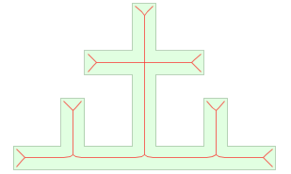

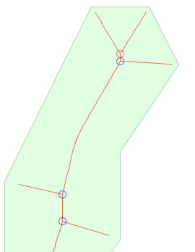 | Third step : an iterative process examines all nodes of degree 3+ with at least two terminal adjacent edges (edges which opposite node has degree 1), and remove the least relevant edge according to two parameters :  - the edge length (smaller is less relevant) and  - the minimum distance to the boundary (more far is less relevant).  This iterative process may be repeated a large number of times to eliminate small branches of a complex polygon (adding iterations does not use much cpu)  On this figure, only the red node, touching two ending segments, will be processed at this stage. The top left segment will be eliminated

Fourth step : after iterative process, remaining ending edges are removed if they are shorter than the minimum fork length parameter (default = 2,5 times the mean width).
Beautifying ends : in polygons with a square end, the skeleton may ends with small oblique segments which are not representative of the general polygon orientation. A post-process tries to eliminate these small segments.
Extending ends : in some cases, it is useful to have a skeleton which ends extends to the boundary of the polygon. An option makes this possible.
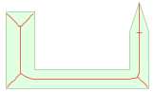 | 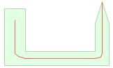 | 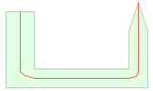
All edges from Voronoï | After small forks elimination | After extending ends

Options
Automatic width computation
If this parameter is set, the program automatically computes a min width and a mean width. First, the program computes the mean width of the polygon from its area and perimeter. Then, a min width is approximated using different buffer size.
Minimum width
Min width can be set manually. It should be the minimum width of the thinest polygon. It determines polygon boundaries densification. Consecutive points of the boundary must be closer to each other than two vertices on opposite sides. Min width also determines precision of the result.

Minimum fork length
This parameter determines the number of forks which will be kept. It may be relative to the polygon width or in map units (see next parameter). Forks with a length lesser than this parameter will be removed. The tricky part is to keep small voronoi segments which will finally form longer forks (made possible dring the iterative process).
...relative to mean width (default is 2,5) / in map units
Snap edge ends to polygon boundary
This option extends skeleton ends to the polygon boundary
Display a layer with Initial voronoi edges
Keep original voronoi edges in a layer for further analyze.

TODO : add an option to force the skeleton to connect to some points on the boundary
TODO : use a shortest path algorithm to keep only useful paths in polygons with holes (currently, polygons with holes have an edge around each hole)

Hydrographic Network Analysis
This plugin is used to detect or correct the topology of a Hydrographic network.
A hydrographic network is supposed to be described by a Directed Graph where edges have the same orientation as the water flow.

Anomaly detection
The plugin can find 3 types of anomaly
Cycles : presence of a cycle in the graph. A hydrographic network should never contain cycles. The plugin can find cycles and put the result of this serach in a layer named « xxx-cycle-anomaly ».
Sources with several outgoing edges : find every source with several outgoind edges. This case is not necessarily a topological anomaly, but it is at least very suspect. Such sources are copied in a layer named « xxx-node-anomaly » and symbolized with a small red ring.
Sinks with several incoming edges : find every sink with several incoming edges. This case is not necessarily a topological anomaly, but it is at least very suspect. Such sinks are copied in a layer named « xxx-node-anomaly » and symbolized with a small red ring.
Use Z values : find every edge where Z value of the start node minus z value of the end node is negative. If « tolerance for z value » is not null, orientation is considered valid if start Z is more than end Z minus -tolerance. Downward edges are copied into a layer named

Anomaly correction
If correction is checked, the plugin will successively try to repair the following problems.
- Downward edges
- Sources with several outgoind edges
- Sinks with several incoming edges
- Cycles
Use Z values : upward edges are repaired first. Be careful, it may create new cycles, or new node anomalies. Some of them can be repaired in the next steps, but corrections of cycles and suspicious nodes will not be applied if they entail upward edges.
Sources with several outgoind edges
Sinks with several incoming edges
Cycles

