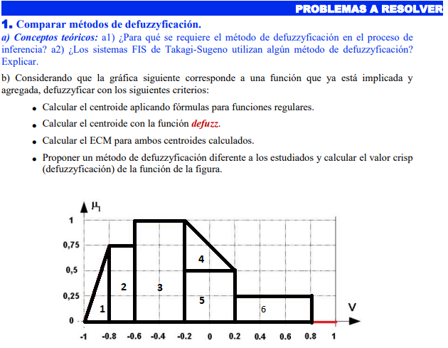

1: Área de 1: b\*h/2 = 0.2\*0.75/2=0.075 x1= 2/3b =0.2\*2/3=0.1333 y1= h/3=0.75/3=0.25

2: Área de 2: b\*h = 0.2\*0.75=0.15 x2= b/2 =0.2/2=0.1 y2= h/2=0.75/2=0.375

3: Área de 3: b\*h = 0.4\*1=0.4 x3= b/2 =0.4/2=0.2 y3= h/2=1/2=0.5

4: Área de 4: b\*h/2 = 0.4\*0.5/2=0.1 x4= 2/3b =0.4\*2/3=0.2666 y4= h/3=0.5/3=0.1666

5: Área de 5: b\*h = 0.4\*0.5=0.2 x5= b/2 =0.4/2=0.2 y5= h/2=0.5/2=0.25

6: Área de 6: b\*h = 0.6\*0.25=0.15 x6= b/2 =0.6/2=0.3 y6= h/2=0.25/2=0.125

Calculo de las coordenadas del Centroide:

xcog= 0.2014

Ycog=0.3352