

OpenL Tablets Developers Guide

OpenL Tablets 5.7.0
OpenL Tablets Infrastructure

Document number: TP_OpenL_Dev_2.4_LSh
Revised: 06-30-2010

Table of Contents
\
Preface 4
Audience 4
Related Information 4
Typographic Conventions 4
Chapter 1: Introducing OpenL Tablets 6
What Is OpenL Tablets? 6
Basic Concepts 6
Rules 7
Tables 7
Projects 7
Wrappers 7
System Overview 8
Installing OpenL Tablets 9
Tutorials and Examples 9
Tutorials 9
Examples 10
Chapter 2: OpenL Tablets Rules Projects 12
What is it OpenL Rules Project? 12
Project’s elements 12
Rules project descriptor 12
What is a rules project descriptor? 12
Quick Overview 12
Descriptor Elements 13
Project resolving 14
Project Descriptor resolver 14
Excel file resolver 14
How to start with OpenL Rules Project 14
Create project using Maven archetype 14
Create project using Eclipse plugin 15
Edit rules 15
Generating a Wrapper 15
Index 20

Preface
This preface is an introduction to the Exigen Decision Services OpenL Tablets Reference Guide.
The following topics are included in this preface:
- Audience
- Related Information
- Typographic Conventions

Audience
This guide is mainly intended for developers who create applications employing the table based decision making mechanisms offered by OpenL Tablets technology. However, business analysts and other users can also benefit from this guide by learning the basic OpenL Tablets concepts described herein.
Basic knowledge of Java, Eclipse, Ant, and Excel® is required to use this guide effectively.

Related Information
The following table lists sources of information related to contents of this guide:
Related information
Title | Description
OpenL Web Studio User's Guide | Document describing OpenL Web Studio, a web application for managing OpenL Tablets projects through web browser.
Exigen Studio Designer's Guide | Document describing the Exigen Process Backbone development environment.
http://ant.apache.org/ | Website describing how to install and use Ant, a Java-based build tool.
http://openl-tablets.sourceforge.net/ | OpenL Tablets open source project website.
Exigen Decision Services BLS Developer's Guide | Document describes BLS Rules, another rule processing framework included in Exigen Decision Services.

Typographic Conventions
The following styles and conventions are used in this guide:
Typographic styles and conventions
Convention | Description
Bold | - Represents user interface items such as check boxes, command buttons, dialog boxes, drop-down list values, field names, menu commands, menus, option buttons, perspectives, tabs, tooltip labels, tree elements, views, and windows.  - Represents keys, such as F9 or CTRL+A.  - Represents a term the first time it is defined.
Courier | Represents file and directory names, code, system messages, and command-line commands.
Courier Bold | Represents emphasized text in code.
Select File > Save As | Represents a command to perform, such as opening the File menu and selecting Save As.
Italic | - Represents any information to be entered in a field.  - Represents documentation titles.
< > | Represents placeholder values to be substituted with user specific values.
Hyperlink | Represents a hyperlink. Clicking a hyperlink displays the information topic or external source.

Chapter 1: Introducing OpenL Tablets
OpenL TabletsThis section introduces OpenL Tablets and describes its main concepts.
The following topics are included in this section:
- What Is OpenL Tablets?
- Basic Concepts
- System Overview
- Installing OpenL Tablets
- Tutorials and Examples

What Is OpenL Tablets?
OpenL TabletsOpenL Tablets is a rules management framework based on tables presented in Excel and Word documents. Using unique concepts, OpenL Tablets facilitates treating business documents containing business logic specifications as executable source code. Since the format of tables used by OpenL Tablets is familiar to business users, OpenL Tablets bridges a gap between business users and developers, thus reducing costly enterprise software development errors and dramatically shortening the software development cycle.
In a very simplified overview, OpenL Tablets can be considered as a table processor that extracts tables from Excel and Word documents and makes them accessible from Java programs.
OpenL Tablets is built using the OpenL technology providing a framework for development of different language configurations.
OpenL TabletsThe major advantages of using OpenL Tablets are as follows:
- OpenL Tablets removes the gap between software implementation and business documents, rules, and policies.
- Business rules become transparent to Java developers.
For example, decision tables are transformed into Java methods, and data tables become accessible as Java data arrays through the familiar getter and setter JavaBeans mechanism. The transformation is performed automatically.
- OpenL Tablets verifies syntax and type errors in all project document data, providing convenient and detailed error reporting.
- OpenL Tablets is able to directly point to a problem in an Excel or Word document.
- OpenL Tablets provides calculation explanation capabilities, enabling expansion of any calculation result by pointing to source arguments in the original documents.
- OpenL Tablets provides cross-indexing and search capabilities within all project documents.
OpenL Tablets supports the .xls and .doc file formats.

Basic Concepts
OpenL TabletsThis section describes the following main OpenL Tablets concepts:
- Rules
- Tables
- Projects
- Wrappers

Rules
OpenL TabletsIn OpenL Tablets, a rule is a logical statement consisting of conditions and actions. If a rule is called and all its conditions are true then the corresponding actions are executed. Basically, a rule is an IF-THEN statement. The following is an example of a rule expressed in human language:
If a service request costs less than 1,000 dollars and takes less than 8 hours to execute then the service request must be approved automatically.
Instead of executing actions, rules can also return data values to the calling program.

Tables
OpenL TabletsBasic information OpenL Tablets deals with, such as rules and data, is presented in tables. Different types of tables serve different purposes. For detailed information on table types, see Table Types.

Projects
OpenL TabletsOpenL TabletsAn OpenL Tablets project is a container of all resources required for processing rule related information. Usually, a project contains Excel or Word files, Java code, and Ant task for generating wrappers of table files. For detailed information on projects, see Chapter 3: Working With Projects.
There can be situations where OpenL Tablets projects are used in the development environment but not in production, depending on the technical aspects of a solution.

Wrappers
OpenL TabletsA wrapper is a Java class that exposes decision tables as Java methods, data tables as Java objects and allows developers to access table information from code. To access a particular table from Java code, a wrapper Java class must be generated for the Excel or Word file where the table is defined. Wrappers are essential for solutions where compiled OpenL Tablets project code is embedded in solution applications. If tables are accessed through web services, client applications are not aware of wrappers but they are still used on the server.
Wrappers can be dynamic or static as described in the following table:
Wrapper types
Type | Description
Dynamic | For a dynamic wrapper, only a rule interface must be defined upon project creation. The rules run-time factory provides instances implementing this interface in run-time.  Using dynamic wrappers, and not the static wrappers, is recommended.
Static | The wrapper Java class is generated in a rule project for a static wrapper, which contains all OpenL Tablets API usage logic to call rules.
Using dynamic wrappers, rather than static wrappers, is more advantageous as it enables OpenL Tablets users to clearly define the rules displayed in the application. Using a static wrapper can be inconvenient in that a wrapper must be regenerated each time a new version of OpenL Tablets is released.
OpenL Tablets provides a specific Ant task that can be used for static generation of a wrapper from any Excel or Word file automatically.
A static wrapper class must be regenerated in the following situations:
- A table signature, such as method name, input parameters, and return values, is modified.
- A table is added or deleted in the corresponding file.
Wrapper classes do not have to be regenerated if table data is modified or if conditions and actions are added or removed.
For more information on generating wrappers, see Generating a Wrapper.

System Overview
The following diagram shows how OpenL Tablets is used by different types of users:
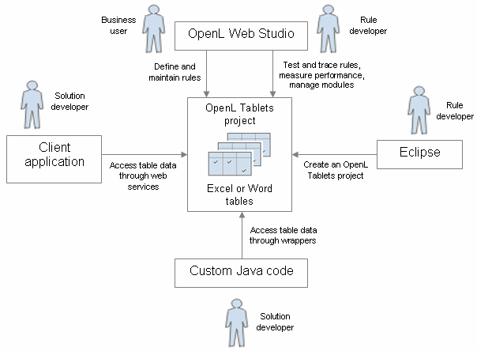
Figure 1: OpenL Tablets overview
The following is a typical lifecycle of an OpenL Tablets project:
A rule developer creates a new OpenL Tablets project in Eclipse.
In addition to the project itself, the rule developer also creates correctly structured tables in Excel or Word files based on requirements and includes them in the project.
A business user accesses tables in the OpenL Tablets project and defines rules.
Typically, this task is performed through OpenL Web Studio in a web browser.
A rule developer performs unit tests and performance tests on rules through advanced OpenL Web Studio features.
A developer who creates other parts of the solution employs business rules directly through the OpenL Tablets engine or remotely through web services.
Whenever required, the business user updates or adds new rules to project tables.

Installing OpenL Tablets
OpenL TabletsOpenL Tablets development environment is installed as an Eclipse feature delivered as part of the Exigen Process Backbone installation package. The installation process of the OpenL Tablets feature is the same as for any other Eclipse feature.
The development environment is required only for creating OpenL Tablets projects and launching OpenL Web Studio. If ready OpenL Tablets projects are accessed through OpenL Web Studio or web services, no specific software needs to be installed.

Tutorials and Examples
The OpenL Tablets Eclipse feature contains several preconfigured projects intended for new users who want to learn working with OpenL Tablets quickly.
These projects are organized into following groups:
- Tutorials
- Examples

Tutorials
OpenL Tablets provides ten tutorial projects demonstrating basic OpenL Tablets features beginning very simply and moving on to more advanced projects. Files in the tutorial projects contain detailed comments allowing new users to grasp basic concepts quickly.
To create a tutorial project, proceed as follows:
- In Eclipse, select File > New > Project.
In the new project wizard, expand the OpenL Tablets > Tutorials folder.
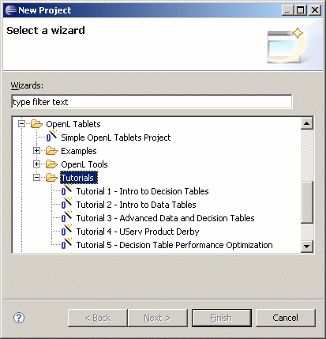
Figure 2: Creating tutorial projects
Select an appropriate tutorial project, and click Next.
In the next page, click Finish.

Examples
OpenL Tablets provides five example projects that demonstrate how OpenL Tablets can be used in various business domains.
To create an example project, proceed as follows:
- In Eclipse, select File > New > Project.
In the new project wizard, expand the OpenL Tablets > Examples folder.
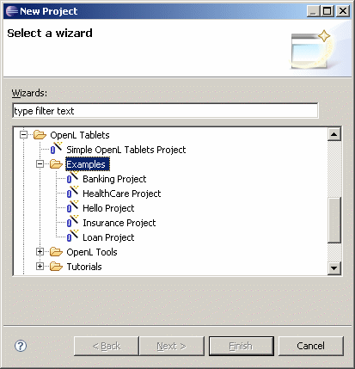
Figure 3: Creating example projects
Select an appropriate example project and click Next.
In the next page, click Finish.

Chapter 2: OpenL Tablets Rules Projects
OpenL TabletsThis section describes about OpenL Tablets
rules projects: how to create and how to use.
The following topics are included in this section:
- What is it OpenL Rules Project?
- Project’s elements
- Rules project descriptor
Project resolving
- How to start with OpenL Rules project

What is it OpenL Rules Project?
TBD

Project’s elements
TBD

Rules project descriptor

What is a rules project descriptor?
A rules project descriptor is an XML file that contains information about the project and configuration details used by OpenL to load and compile the rules project. The predefined name is used for a rules project descriptor - rules.xml

Quick Overview
The snippet bellow is the example of rules project descriptor:

<project>
<!-- Project identifier. String value which defines project uniquely. -->
<id>my-project-id</id>
<!-- Project name. -->
<name>Project name</name>
<!-- Optional. Comment string to project. -->
<comment>comment</comment>

<!-- OpenL project includes one or more rules modules. -->
<modules>

<module>
<name>MyModule1</name>
<type>static</type>
<classname>com.test.MyWrapper</classname>

<!--
Rules root document. Usually excel file on file system.
-->
<rules-root path="MyModule1.xls"/>

</module>

<module>
<name>MyModule2</name>
<type>api</type>

<!--
Rules root document. Usually excel file on file system.
-->
<rules-root path="MyModule2.xls"/>

</module>

</modules>

<!-- Project's classpath (list of all dependencies). -->
<classpath>
<entry path="path1"/>
<entry path="path2"/>
</classpath>

</project>

Descriptor Elements
Descriptor file contains several sections what describes projects configuration.

Project configurations
Project section
Tag | Required | Description
id | yes | Project id. String value which defines project uniquely.
name | yes | Project name. String value which defines user-friendly project name.
comment | no | Comment for project.
modules | yes | Defines modules of project. Project can have one or more modules.
classpath | no | Project relative classpath.

Module configurations
Module section
Tag | Required | Description
name | yes | Module name. String value which defines user-friendly module name.  Notice: Used by WebStudio application as module display name.
type | yes | Module instantiation type. Possible values (case-insensitive): static, dynamic, api. Defines the way of OpenL project instantiation.
classname | yes/no | Used together with type. Defines name of wrapper class. Not required for api type.
rules-root | yes/no | Used together with type. Defines path to the main file of rules module.

Classpath configurations
Classpath section
Tag | Required | Description
entry | no | Defines path to the classpath entry (classes or jar file).

Project resolving
TBD

Project Descriptor resolver
TBD

Excel file resolver
TBD

How to start with OpenL Rules Project
OpenL Rules project as any other projects can be used as module of other project. Let’s look how you can add to your project OpenL Rules project.
At first, you need to create OpenL Rules project. It can be done in following ways: using maven archetype, using eclipse plugin and manually.

Create project using Maven archetype
OpenL Tablets has archetype which can be used to create simple OpenL Rules project.
Execute in command line the following command:
mvn archetype:generate
Maven runs archetype console wizard. Select openl-simple-project-archetype menu item. Follow with maven creation wizard.
After all steps are done you should have new maven based project on file system. It’s a OpenL Rules project which has one module with simple rules.
Execute in command line the following command from root of project folder to compile project:
mvn install

Create project using Eclipse plugin
TBD
Create project manually
OpenL doesn’t oblige user to use predefined ways of project creation process and provides way to use your own project structure. You can use OpenL Project Resolving mechanism as a base for your project structure definition. Depends on resolving strategy you need create more or less files and folders but several project’s elements must be defined. See Project’s elements section of the current document for more details.

Edit rules
After you created a project you need to create business rules. You can do it using WebStudio application or manually using MS Excel. If you used the simple rules project there are several simple predefined rules you have as example.

Generating a Wrapper
Access to rules and data in Excel tables is realized through OpenL Tablets API. OpenL Tablets provides wrappers to developers to facilitate easier usage.

Generating a Dynamic Wrapper
Only an interface must be defined when creating a project for a dynamic wrapper. OpenL Tablets users can clearly define rules displayed in the application by using this interface. Using dynamic wrappers is a recommended practice.
This section illustrates the creation of a dynamic wrapper for a Simple project in Eclipse with the OpenL Tablets Eclipse Update Site installed. Only one rule hello1 is created in the Simple project by default.
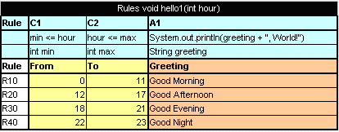
Figure 4: The hello1 rule table
Proceed as follows:
- In the project src folder, create an interface as follows:

public interface Simple {
void hello1(int i);
}

- Create a class for a wrapper as follows:

package template;

import static java.lang.System.out;
import org.openl.rules.runtime.RuleEngineFactory;

public class Dynamic_wrapper {

public static void main(String[] args) {
//define the interface
RuleEngineFactory<simple> rulesFactory =
new RuleEngineFactory<Simple>("rules/TemplateRules.xls",
Simple.class);

Simple rules = rulesFactory.newInstance();
rules.hello1(12);

}
}

When the class is run, it executes and displays Good Afternoon, World!

Generating a Static Wrapper
To generate a static wrapper class, proceed as follows:
- Configure the Ant task file as described in Configuring the Ant Task File.
- Execute the Ant task file as described in Executing the Ant Task File.
For an example of how to use a static and dynamic wrapper, see Example of Using Static and Dynamic Wrappers.

Configuring the Ant Task File
Create Ant build file which will be contains task to generate wrapper.
The following is an example of the build file (GenerateJavaWrapper.build.xml file):
<project name="GenJavaWrapper" default="generate" basedir="../">
<taskdef name="openlgen" classname="org.openl.conf.ant.JavaWrapperAntTask"/>

<target name="generate">
<echo message="Generating wrapper classes..."/>

<openlgen openlName="org.openl.xls" userHome="."
srcFile="rules/Rules.xls"
targetClass="com.exigen.claims.RulesWrapper"
displayName="Rule table wrapper"
targetSrcDir="gen"
>
</openlgen>

<openlgen openlName="org.openl.xls" userHome="."
srcFile="rules/Data.xls"
targetClass=" com.exigen.claims.DataWrapper"
displayName="Data table wrapper"
targetSrcDir="gen"
>
</openlgen>

</target>
</project>

For each Excel file, an individual <openlgen> section must be added between the <target> and </target> tags.
Each <openlgen> section has a number of parameters that must be adjusted. The following table describes <openlgen> section parameters:
Parameters in the <openlgen> section
Parameter | Description
openlName | OpenL configuration to be used. For OpenL Tablets, the following value must always be used:  org.openl.xls
userHome | Location of user defined resources relative to the current OpenL Tablets project.
srcFile | Reference to the Excel or Word file for which a wrapper class must be generated.
targetClass | Full name of the wrapper class to be generated.  OpenL Web Studio recognizes modules in projects by wrapper classes and uses their names in the user interface. If there are multiple wrappers with identical names, only one of them is recognized as a module in OpenL Web Studio.
displayName | End user oriented title of the file that appears in OpenL Web Studio.
targetSrcDir | Folder where the generated wrapper class must be placed.

Executing the Ant Task File
To execute the Ant task file and generate wrappers, proceed as follows:
- In Eclipse, refresh the project.
- Execute the Ant task XML file as an Ant build.
- Refresh the project again so that wrapper classes are displayed in Eclipse.
Once wrappers are generated, the corresponding Excel or Word files can be used in the solution.

Example of Using a Static and Dynamic Wrapper
The following example illustrates the use of static and dynamic wrappers:
public class Tutorial1Main {

public interface Tutorial1Rules {
void hello1(int i);
}

public static void main(String[] args)
{
out.println("\n* OpenL Tutorial 1\n");

out.println("Working using static wrapper...\n");

callRulesWithStaticWrapper();

out.println("\nWorking using dynamic wrapper...\n");

allRulesWithDynamicWrapper();
}

private static void callRulesWithStaticWrapper() {
//Get current hour
Calendar calendar = Calendar.getInstance();
int hour = calendar.get(Calendar.HOUR_OF_DAY);

//Creates new instance of Java Wrapper for our lesson
Tutorial_1Wrapper tut1 = new Tutorial_1Wrapper();

//Step 1
out.println("* Executing OpenL rules...\n");
// Call the method wrapping Decision Table "hello1"
tut1.hello1(hour);
}

private static void callRulesWithDynamicWrapper(){
// Creates new instance of OpenL Rules Factory
RuleEngineFactory<Tutorial1Rules> rulesFactory =
new RuleEngineFactory<Tutorial1Rules>("rules/Tutorial_1.xls", Tutorial1Rules.class);

//Creates new instance of dynamic Java Wrapper for our lesson
Tutorial1Rules rules = rulesFactory.newInstance();

//Get current hour
Calendar calendar = Calendar.getInstance();
int hour = calendar.get(Calendar.HOUR_OF_DAY);

out.println("* Executing OpenL rules...\n");
rules.hello1(hour);
}
}

Index

A
ant task file
configuring, 17
executing, 18
E
examples, 9, 10
G
guide
audience, 4
related information, 4
typographic conventions, 4
O
OpenL Tablets
advantages, 6
basic concepts, 6
definition, 6
installing, 9
introduction, 6
project, 7
rules, 7
tables, 7
wrapper, 7
OpenL Tablets, 12
OpenL Tablets project
definition, 7
P
project
definition, 7
R
rule
definition, 7
S
system overview, 8
T
tutorials, 9
W
wrapper
definition, 7
generating, 15

definition, 7

