

OpenL Tablets Tutorial

^{Exigen Process Backbone®} 7.0.2
OpenL Tablets

History of Revisions
History of revisions
Revision date | Version | Author | Description
Aug 20, 2008 | 0.1 | Maris Freimanis | Outline draft created.
Dec 23, 2008 | 0.2 | Juris Olekss | Full draft written.

Document number: TP_EPB_7.0.2_OpenLTablets_Tutorial_0.2_JO
Revised: 12-23-2008
EXIGEN CONFIDENTIAL – FOR AUTHORIZED USERS ONLY
Important Notice
Information in this document, as well as the software products and programs described in it, is furnished by Exigen Properties, Inc. and/or affiliates (Exigen) under license and may be used or copied only in accordance with the terms of such license. This document, the information contained in it, as well as the software products and programs described herein are considered confidential, proprietary, trade secrets of Exigen. You may not copy, create derivatives, decipher, decompile, develop, or otherwise reverse engineer this document, the information contained in it, or the software products and programs described. Exigen and its licensors retain all intellectual property and ownership rights to the information contained herein, as well as the software products and programs (including, but not limited to, software libraries, interfaces, source codes, documentation and training materials) described herein.
The content of this document is furnished for informational use only, is subject to change without notice, may contain technical inaccuracies or typographical errors, and should not be construed as a representation, warranty or commitment by Exigen or any other person or entity. Exigen may make improvements and/or changes in the software products and programs described in this document at any time without notice. Exigen is not responsible or liable for any changes made to this document. In particular, modifications in or to the data model described herein may have occurred or may occur in a new product release after publication of this documentation. In accordance with Exigen standard support policy, any issues arising as a result of such modifications shall not be considered support issues and shall not be covered by Exigen maintenance and support. To be clear, Exigen is providing this document and the information contained in it, "as is" without any representations, covenants, or warranties, including those of merchantability or fitness for a particular purpose. Some jurisdictions do not allow disclaimer of express or implied warranties in certain transactions; in that case, this notice may not apply.
Information published by Exigen on the Internet or World Wide Web may contain references or cross-references to Exigen software products and programs, as well as Exigen services that are not announced or available in your country. Such references do not imply that Exigen intends to announce such software products programs or such services in your country. Consult your local Exigen business contact for information regarding the Exigen software products and programs and Exigen services that may be available to you.
By using this document, you agree that, in no event will Exigen or its licensors be liable to any party for any direct, indirect, special or other consequential damages for any use of this document, the information contained herein, or the software products and programs described herein, including, without limitation, any lost profits, business interruption, loss of programs or other data on your information handling system or otherwise, even if Exigen were expressly advised of the possibility of such damages.
Trademark
Exigen, the Exigen logo, and Exigen Process Backbone are registered trademarks and trademarks of Exigen Properties, Inc. in the United States and/or other countries.
Microsoft, Windows, and Excel are either registered trademarks or trademarks of Microsoft Corporation in the United States and/or other countries.
All other trademarks, service marks, or registered trademarks are the property of their respective companies.
Support contact information
Telephone:  1-866-4EXIGEN North America  1-506-674-4025 All other countries  1-800-508-192 Australia (within Australia only)  0-800-448-898 New Zealand (within New Zealand only) | Website: http://www.exigengroup.com/  Fax: 1-506-674-4014  Email: support@exigengroup.com

Table of Contents
Introducing the OpenL Tablets Tutorial 6
Tutorial Overview 6
Audience and Objectives 6
Tutorial Organization 6
Learning Module Organization 7
Related Information 7
Typographic Conventions 7
OpenL Tablets Overview 8
What Is OpenL Tablets? 8
Basic Concepts 8
Tutorial Application Overview 9
Preparing the Environment 10
Software Requirements 10
Tutorial Package Overview 10
Configuring the Environment 11
Learning Module 1: Creating an OpenL Tablets Project 13
Topic Summary 13
Exercise 13
Creating an OpenL Tablets Project 13
Renaming Project Elements 14
Generating a Wrapper 15
Test Your Progress 15
Learning Module 2: Creating a Method Table and a Configuration Table 17
Topic Summary 17
Exercise 17
Defining a Person 17
Defining a Residence 18
Creating a Method Table 19
Creating a Configuration Table 20
Test Your Progress 20
Learning Module 3: Creating Decision Tables 22
Topic Summary 22
Exercise 23
Creating a Decision Table for Calculating Premium Percentage 23
Creating a Decision Table for Calculating Discounts 26
Test Your Progress 26
Learning Module 4: Creating a Data Table and a Data Type 28
Topic Summary 28
Exercise 28
Creating a Simple Data Table 28
Creating a Data Type Table 29
Creating an Advanced Data Table 30
Test Your Progress 30
Learning Module 5: Using OpenL Web Studio 32
Topic Summary 32
Exercise 32
Launching OpenL Web Studio 32
Using the Table Editor 33
Test Your Progress 35
Learning Module 6: Creating a Test Table and Testing Rules 36
Topic Summary 36
Exercise 36
Creating a Data Table with Test Records 36
Creating a Person Test Table 37
Test Your Progress 38
Learning Module 7: Using BEX Expressions 41
Topic Summary 41
Exercise 42
Using a Simple BEX Expression 42
Using the Notion of Explanatory Variables 42
Test Your Progress 43
Learning Module 8: Benchmarking 45
Topic Summary 45
Exercise 45
Creating a Test Table for the getDiscountBEX Table 45
Using Benchmarking in OpenL Web Studio 46
Test Your Progress 48
Learning Module 9: Calculating a Premium 49
Topic Summary 49
Exercise 49
Test Your Progress 50
Conclusion 52

Introducing the OpenL Tablets Tutorial
This section describes the purpose and scope of this tutorial and briefly introduces OpenL Tablets. The following topics are included in this chapter:
- Tutorial Overview
- OpenL Tablets Overview
- Tutorial Application Overview
- Preparing the Environment

Tutorial Overview
This section describes the objectives and organization of this tutorial. The tutorial conventions and sources of related information are also provided. The following topics are included in this section:
- Audience and Objectives
- Tutorial Organization
- Learning Module Organization
- Related Information
- Typographic Conventions

Audience and Objectives
This tutorial introduces new users to OpenL Tablets on a basis of practical exercises. During this tutorial, a user gradually builds a sample application. For information on the sample application, see Tutorial Application Overview. The user is expected to read and execute learning modules in the order they are described in this tutorial.
Users working with this tutorial must have basic knowledge of the following:
- Java
- Eclipse
- Excel®
After completing this tutorial, you will be able to:
- understand business rules
- create business rules using Java expressions
- create business rules using business expression grammar (BEX) expressions
- define custom data types
- call business rules from a Java application
- test business rules
- benchmark business rules

Tutorial Organization
This tutorial is organized as follows:
Tutorial organization
Learning module | Description
Learning Module 1: Creating an OpenL Tablets Project | Describes creating a new OpenL Tablets project.
Learning Module 2: Creating a Method Table and a Configuration Table | Describes a method table and configuration table.
Learning Module 3: Creating Decision Tables | Describes creating simple decision tables for calculating insurance premiums and their discounts.
Learning Module 4: Creating a Data Table and a Data Type | Introduces a data table and a data type table.
Learning Module 5: Using OpenL Web Studio | Introduces OpenL Web Studio.
Learning Module 6: Creating a Test Table and Testing Rules | Describes a test table and demonstrates testing a decision table using OpenL Web Studio.
Learning Module 7: Using BEX Expressions | Introduces the BEX grammar in rule conditions.
Learning Module 8: Benchmarking | Demonstrates benchmarking using OpenL Web Studio.
Learning Module 9: Calculating a Premium | Concludes the tutorial by simply calculating an insurance premium based on predefined input values.

Learning Module Organization
Each learning module in this tutorial is organized as follows:
Organization of a learning module
Section | Description
Topic Summary | Introduces learning module contents and involved product concepts and describes a scenario for the practical exercises.
Exercise | Provides step-by-step instructions for executing the scenario identified in the topic summary.
Test Your Progress | Identifies how to verify that exercises described in the learning module are completed successfully.

Related Information
The following table lists sources of information related to contents of this tutorial:
Related information
Source | Related information
OpenL Tablets Reference Guide | Document describing the OpenL Tablets technology.
OpenL Web Studio User’s Guide | Document describing OpenL Web Studio, a web application for managing OpenL Tablets projects through web browser.
http://openl-tablets.sourceforge.net/ | OpenL Tablets open source project website.

Typographic Conventions
The following styles and conventions are used in this guide:
Typographic styles and conventions
Convention | Description
Bold | - Represents user interface items such as check boxes, command buttons, dialog boxes, drop-down list values, field names, menu commands, menus, option buttons, perspectives, tabs, tooltip labels, tree elements, views, and windows.  - Represents keys, such as F9 or CTRL+A.  - Represents a term the first time it is defined.
Courier | Represents file and directory names, code, system messages, and command-line commands.
Courier Bold | Represents emphasized text in code.
Select File > Save As | Represents a command to perform, such as opening the File menu and selecting Save As.
Italic | - Represents any information to be entered in a field.  - Represents documentation titles.
< > | Represents placeholder values to be substituted with user specific values.
Hyperlink | Represents a hyperlink. Clicking a hyperlink displays the information topic or external source.

OpenL Tablets Overview
This section provides a general overview of OpenL Tablets. For detailed information on the component, see OpenL Tablets Reference Guide.
The following topics are included in this section:
- What Is OpenL Tablets?
- Basic Concepts

What Is OpenL Tablets?
OpenL Tablets is a rules management framework based on tables presented in Excel documents. Using unique concepts, OpenL Tablets facilitates treating business documents containing business logic specifications as executable source code. Since the format of tables used by OpenL Tablets is familiar to business users, OpenL Tablets bridges a gap between business users and developers, thus reducing costly enterprise software development errors and dramatically shortening the software development cycle.
In a very simplified overview, OpenL Tablets can be considered as a table processor that extracts tables from Excel documents and makes them accessible from Java programs.

Basic Concepts
This section describes the following main OpenL Tablets concepts:
- Rules
- Tables
- Projects
- Wrappers
- OpenL Web Studio

Rules
In OpenL Tablets, a rule is a logical statement consisting of conditions and actions. If a rule is called and all its conditions are true then the corresponding actions are executed. Basically, a rule is an IF-THEN statement. The following is an example of a rule expressed in human language:
If a service request costs less than 1,000 dollars and takes less than 8 hours to execute then the service request must be approved automatically.
Instead of executing actions, rules can also return data values to the calling program.

Tables
Basic information OpenL Tablets deals with, such as rules and data, is presented in tables. Different types of tables serve different purposes.

Projects
An OpenL Tablets project is a container of all resources required for processing rule related information. Usually, a project contains Excel files, Java code, and wrappers of table files.

Wrappers
A wrapper is a Java class that exposes decision tables as Java methods, data tables as Java objects and allows developers to access table information from code. To access a particular table from Java code, a wrapper Java class must be generated for the Excel file where the table is defined.

OpenL Web Studio
OpenL Web Studio is a web application employed by business users and developers to view, edit, and manage business rules and rule projects created using OpenL Tablets technology. By using OpenL Web Studio, users can modify rules directly in a web browser without installing additional tools. OpenL Web Studio provides better functionality than the OpenL Tablets Eclipse feature in terms of browsing projects, modifying rules, viewing errors, and executing tests. However, for more advanced activities, such as compiling Java code, generating table wrappers, and running Ant scripts, users must use Eclipse.

Tutorial Application Overview
In this tutorial, you will build a simple insurance premium calculation project for individuals insuring their home. Based on various inputs, such as residence value, type, and person's age, the premium will be calculated using rules defined in Excel tables.
The following main business entities will be used in the application:
Business entities in the tutorial application
Entity | Description
Person | Individual who wishes to insure a dwelling for one year.  The following person attributes will be used in the application:  - name  - gender  - age
Residence | Place of residence that a person wishes to insure for one year.  The following residence attributes will be used in the application:  - value in dollars  - dwelling type, such as an apartment or private house  - construction type, such as wooden, concrete, or mixed
Policy Type | Type of the insurance policy specifying additional specifics of the coverage.  The following policy types will be used in the application:
  Type | Description
  Basic | Cheapest policy type that covers only the residence.
  Blue | Policy type that covers both the residence and all property inside it, such as furniture, home appliances, and so on.
  Green | Policy type that covers the residence and provides life insurance to all persons living on the premises.
  Platinum | Most expensive policy type that covers the residence, all property within, and lives of all persons living in the residence.

Preparing the Environment
This section lists software and hardware requirements and describes the setup process to be performed before executing exercises described in this tutorial. The following topics are included:
- Software Requirements
- Tutorial Package Overview
- Configuring the Environment

Software Requirements
This tutorial requires the following software to be installed on the user's workstation:
- Windows® XP or later
- Java SDK 1.5 or later
- Excel 97 or later
- web browser

Tutorial Package Overview
The OpenL Tablets tutorial is delivered within the OpenLTablets_7.0.2_Tutorial.zip file. The ZIP package contains the following:
- this tutorial
- Eclipse SDK 3.3.1 with the preinstalled OpenL Tablets 5.1.0 feature
- Eclipse workspace containing a copy of the project developed in this tutorial
- OpenL Tablets documentation

Configuring the Environment
To set up the environment required to complete this tutorial, proceed as follows:
- Extract the OpenLTablets_7.0.2_Tutorial.zip file on your hard disk.
- In the OpenLTablets_7.0.2_Tutorial\eclipse folder, launch the eclipse.exe file.
The Workspace Launcher window appears.
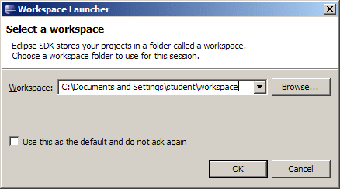
Figure 1: Selecting the workspace folder
- In the Workspace field, select the following path:
<disk>:\OpenLTablets_7.0.2_Tutorial\eclipse\workspace
where <disk> is your hard disk letter.
- Select the Use this as the default and do not ask again check box.
This must be done only once.
- Click OK.
The main Eclipse window appears.
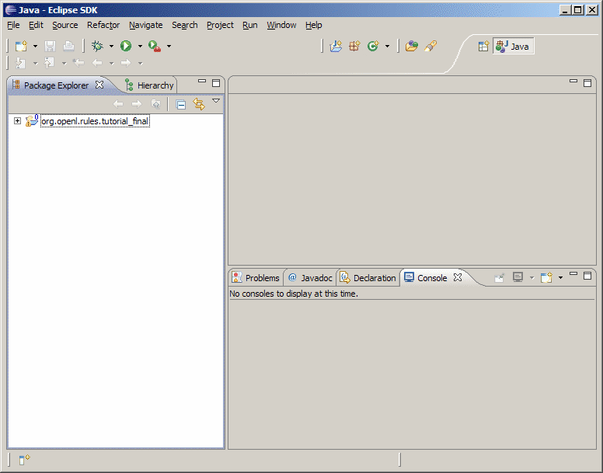
Figure 2: Eclipse SDK
Note: Notice the org.openl.rules.tutorial_final project is already present in the workspace. This project is a copy of the project that you will create in this tutorial. It is provided only as a reference.
Eclipse SDK is ready for the tutorial.

Learning Module 1: Creating an OpenL Tablets Project
This learning module describes creating a new OpenL Tablets project. The following topics are included in this learning module:
- Topic Summary
- Exercise
- Test Your Progress

Topic Summary
An OpenL Tablets project must be created to store all information related to the tutorial application. Additionally, an OpenL Tablets project is required to launch OpenL Web Studio.
Typically, an OpenL Tablets project contains the following general elements:
- Excel files
- Ant task for generating file wrappers
- wrappers
- additional Java code
Ant is a Java-based software build system.
The following table describes the physical structure of an OpenL Tablets project:
OpenL Tablets project structure
Folder | Contents
src | Contains all project Java classes apart from wrappers.
rules | Contains Excel files.
gen | Contains generated wrapper classes.
bin | Contains compiled Java code.
build | Contains Ant configuration file for generating wrapper classes.

Exercise
The following exercises must be executed to complete this learning module:
- Creating an OpenL Tablets Project
- Renaming Project Elements
- Generating a Wrapper

Creating an OpenL Tablets Project
To create an OpenL Tablets project, proceed as follows:
- Start Eclipse.
- Select File > New > Project.
The New Project window appears.
- In the tree, expand the OpenL Tablets folder and select Simple OpenL Tablets Project.
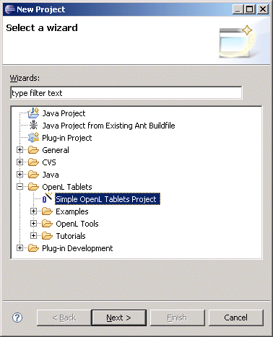
Figure 3: Creating an OpenL Tablets project
- Click Next.
- In the Project name field, enter org.openl.rules.tutorial.
- Click Finish.
A new OpenL Tablets project is created.

Renaming Project Elements
The default OpenL Tablets project element names are not suitable. They must be renamed to correspond to the tutorial application.
To rename OpenL Tablets project elements, proceed as follows:
- In the left pane, expand the org.openl.rules.tutorial\src folder.
- Right click the template package and select Refractor > Rename.
The Rename Package window appears.
- In the New name field, enter org.openl.rules.tutorial.
- Click OK.
- Click Continue.
The package is renamed.
- Expand the rules folder.
- Right click the TemplateRules.xls file and select Refractor > Rename.
The Rename Resource window appears.
- In the New name field, enter PremiumCalculationRules.xls.
- Click OK.
The file is renamed.

Generating a Wrapper
To access a particular table from Java code, a wrapper Java class must be generated for the Excel file where the table is defined. Whenever new tables are added or when the table structure is changed in Excel files, the wrapper must be regenerated.
To generate a wrapper for the PremiumCalculationRules.xls file, proceed as follows:
- In the left pane, expand the org.openl.rules.tutorial\build folder.
- Right click GenerateJavaWrapper.build.xml file and select Open With > Ant Editor.
The file is opened in an editor.
- Modify the reference to the Excel file, the name of the wrapper class, and display name as follows:
srcFile="rules/PremiumCalculationRules.xls"
targetClass="org.openl.rules.tutorial.TableWrapper"
displayName="Premium Calculation"
For more information on GenerateJavaWrapper.build.xml file contents, see Exigen Decision Services OpenL Tablets Reference Guide, Chapter 3: Working With Projects, Generating a Wrapper.
- Save and close the file.
- Right click Generate org.openl.rules.tutorial Wrapper.launch and select Run As > Generate org.openl.rules.tutorial Wrapper.
- Right click the project and select Refresh.
In the gen folder, the org.openl.rules.tutorial package containing the TableWrapper class appears.

Test Your Progress
To check if rules in the project are working correctly, proceed as follows:
- In the org.openl.rules.tutorial\src folder, in the org.openl.rules.tutorial package, double click the Main.java file.
- Change file contents to the following:
package org.openl.rules.tutorial;

import org.openl.rules.tutorial.TableWrapper;

public class Main {
public static void main(String[] args)
{
TableWrapper jw = new TableWrapper();
jw.hello1(10);
}
}
This code executes the sample decision table already provided in the Excel file.
- Save and close the file.
- To execute the class, right click the Main.java file and select Run As > Java Application.
If everything is configured correctly, a greeting message is displayed in the Console view. The message text depends on the time of day.
Note: Since the package template located in the org.openl.rules.tutorial\gen folder is not used, it can be deleted.

Learning Module 2: Creating a Method Table and a Configuration Table
This learning module describes a method table and configuration table. To demonstrate them, two Java beans will be created representing two business entities of the tutorial application. The following topics are included in this module:
- Topic Summary
- Exercise
- Test Your Progress

Topic Summary
The template application deals with simple business entities, such as person, residence, and policy type, described in Tutorial Application Overview. These entities must be represented as business object models so that they can be used in rules and Java code.
Since in the tutorial application there can be many different persons and residences, these are best modeled as Java beans and this learning module describes how to do it. In contrast, policy types are strictly defined and limited. Therefore, they are suitable to be described within a data table. Data tables are described in Learning Module 4: Creating a Data Table and a Data Type.
Any Java code can be executed from within an Excel file using a method table. A method table is basically a Java method included in a table. In this learning module, a method table will be used to test the person and residence Java beans. However, the OpenL Tablets engine must be told which Java packages it must import and use. This will be achieved using a specific table type named configuration table. A configuration table provides information to the OpenL Tablets engine about available Java packages. Another purpose of a configuration file is to point to other Excel files that can be referenced in tables.

Exercise
The following exercises must be executed to complete this learning module:
- Defining a Person
- Defining a Residence
- Creating a Method Table
- Creating a Configuration Table

Defining a Person
Defining a person involves creating a Java bean with person's key attributes as follows:
- In the left pane, expand the org.openl.rules.tutorial\src folder.
- Right click the org.openl.rules.tutorial package and select New > Class.
The New Java Class window appears.
- In the Name field, enter Person and click Finish.
A new Java class is created.
- Modify the code as follows:
package org.openl.rules.tutorial;

public class Person {

String name;
String gender;
int age;

public String getName() {
return name;
}

public void setName(String name) {
this.name = name;
}

public String getGender() {
return gender;
}

public void setGender(String gender) {
this.gender = gender;
}

public int getAge() {
return age;
}

public void setAge(int age) {
this.age = age;
}

}
- Save and close the file.

Defining a Residence
To create a Java bean characterizing a residence, proceed as follows:
- In the left pane, expand the org.openl.rules.tutorial\src folder.
- Right click the org.openl.rules.tutorial package and select New > Class.
The New Java Class window appears.
- In the Name field, enter Residence and click Finish.
A new Java class is created.
- Modify the code as follows:
package org.openl.rules.tutorial;

public class Residence {

Double value;
String dwellingType;
String constructionType;

public Double getValue() {
return value;
}

public void setValue(Double value) {
this.value = value;
}

public String getDwellingType() {
return dwellingType;
}

public void setDwellingType(String dwellingType) {
this.dwellingType = dwellingType;
}

public String getConstructionType() {
return constructionType;
}

public void setConstructionType(String constructionType) {
this.constructionType = constructionType;
}

}
- Save and close the file.

Creating a Method Table
To create a method table that tests the Person and Residence classes, proceed as follows:
- In the org.openl.rules.tutorial/rules folder, right click the PremiumCalculationRules.xls file and select Open With > System Editor.
The file is opened in Excel.
- In the Excel file, create a new worksheet named Main.
- In the Main worksheet, in any arbitrary place, create a table consisting of two cells with the following contents:
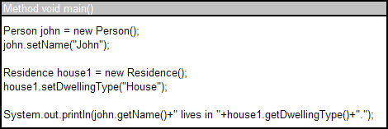
Figure 4: Method table
The first row is a table header with the following pattern:
Method <return value> <method name with optional parameters>
'Method' is a keyword telling the engine that this is a method table.
The second cell contains pure Java code to be executed. The code in the table simply creates one instance of Person and one instance of Residence, sets one property for each, and displays them in the console. 'Person' and 'Residence' are Java beans you defined in the preceding exercises.

Creating a Configuration Table
The method table defined in the preceding exercise cannot be executed at this moment because the OpenL Tablets engine does not know what Person and Residence are. The engine must be told to import the package where Person and Residence Java beans are defined. This is achieved using a configuration table.
To create a configuration table importing the Person and Residence classes, proceed as follows:
- In the PremiumCalculationRules.xls file, open the Environment worksheet.
The worksheet already contains a configuration table, which is identified by the keyword 'Environment'. For this learning module, this table can be reused with a small adjustment.
- In the table, in the row starting with the word 'import', change the package to org.openl.rules.tutorial.
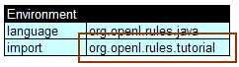
Figure 5: Importing a Java package
The word 'import' tells the engine that the specified package, in this case org.openl.rules.tutorial, must be imported. As a result, the Java beans Person and Residence defined in the package become accessible from within the Excel file.
Note: The row starting with the word 'language' tells the engine that the language used in table expressions is Java, but in this case this row is not mandatory.
Another keyword that can be used in a configuration table is 'include', which tells the engine to include another Excel file. Tables defined in an included file can be called from the current Excel file.
- Save and close the Excel file.

Test Your Progress
To execute the code defined in the method table, proceed as follows:
- To regenerate the table wrapper, right click Generate org.openl.rules.tutorial Wrapper.launch and select Run As > Generate org.openl.rules.tutorial Wrapper.
- Right click the org.openl.rules.tutorial project and select Refresh.
- In the org.openl.rules.tutorial\src folder, double click the Main.java class.
This class will be used to call the method table.
- Change the Main.java class code to the following:
package org.openl.rules.tutorial;

public class Main {
public static void main(String[] args)
{
TableWrapper tw = new TableWrapper();
tw.main();
}
}
The method main() is the name of the method specified in the first row of the method table.
- Save and close the Main.java class.
- Right click it and select Run As > Java Application.
If everything is set correctly, the following text is displayed in the console:
John lives in House.
Note: After this learning module, the worksheet Main will no longer be used and can be deleted from the Excel file.

Learning Module 3: Creating Decision Tables
This learning module describes creating simple decision tables for calculating insurance premiums and their discounts. The following topics are included:
- Topic Summary
- Exercise
- Test Your Progress

Topic Summary
In the scenario covered by this tutorial, the premium of an insurance policy is calculated as a relatively small percentage of the total residence value. The actual percentage number is determined by the type and construction of the residence as described in the following table, which is provided by a business analyst:
Type | Construction | Premium percentage
House | Wooden | 0.50
House | Concrete | 0.10
House | Mixed | 0.12
Apartment | Wooden | 0.70
Apartment | Concrete | 0.11
Apartment | Mixed | 0.14
As can be seen from the preceding table, insurance premiums for less secure residences cost more. For example, a premium for a wooden apartment that is valued at 40,000 dollars would cost 40,000 * 0.7 / 100 = 280 dollars, whereas a premium for a concrete house with the same value would cost 40,000 * 0.1 / 100 = 40 dollars.
In addition, discounts can be applied to premium policies based on person's gender and age as described in the following table, which is also provided by a business analyst:
Gender | Age | Discount in percent
Female | 18-28 | 0
Female | 29-39 | 5
Female | 40-50 | 7
Female | 51+ | 10
Male | 18-35 | 0
Male | 36-50 | 5
Male | 51-60 | 7
Male | 61+ | 10
In this learning module, you will turn this business information into decision tables so that the rules can be calculated automatically by the OpenL Tablets engine. A decision table contains a set of rules describing decision situations where the state of a number of conditions determines the execution of a set of actions. It is the basic table type used in OpenL Tablets decision making. Each decision table can be executed as a Java method.

Exercise
The following exercises must be executed to complete this learning module:
- Creating a Decision Table for Calculating Premium Percentage
- Creating a Decision Table for Calculating Discounts

Creating a Decision Table for Calculating Premium Percentage
To create a decision table for calculating the base premium percentage, proceed as follows:
- In the org.openl.rules.tutorial\rules folder, double click the PremiumCalculationRules.xls file.
The file is opened in Excel.
- In the Rules worksheet, delete all tables that are already present and copy or recreate the first table provided in Topic Summary.
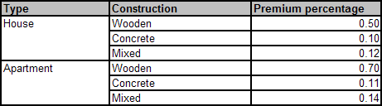
Figure 6: Rules for calculating premium percentage
It is a good practice to create an additional first column to enumerate rules. In addition, such column is mandatory if the first column contains merged cells, as is the case with this table.
- Create an additional column as shown in the following figure:
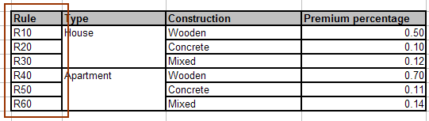
Figure 7: Additional column for identifying rules
At this moment, the table contains just text and numbers that has no meaning to the OpenL Tablets engine. You must first specify that this is actually a decision table and then provide logic how the percentage is calculated.
- To specify that the table is a decision table, add a new row with merged cells just before the table with the following contents:
Rules Double getPremiumPercentage(Residence residence)
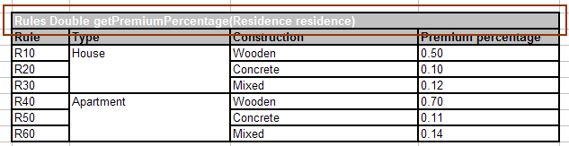
Figure 8: Table header
'Rules' is a keyword identifying that this is a decision table. 'Double' specifies the type of value returned by the table. 'getPremiumPercentage' is the name of the method used to call this table. The parentheses define input parameters for the method. In this case, an instance of the Residence class will be passed as an input.
- To define the logic behind this table, add three new rows between the first and second row and add contents as shown in the following figure:
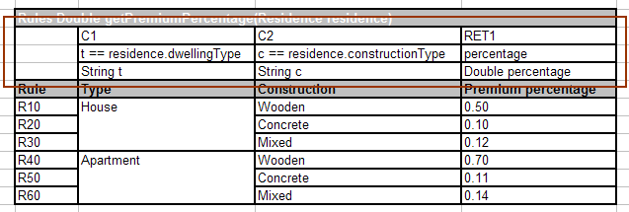
Figure 9: Adding logical information to a decision table
The following table describes the general purpose of each of the three added rows:
Logical rows in a decision table
Row number | Description
1 | Row that can consist of the following cell types:  All other cells in this row are ignored and can be used as comments.  If a table contains action columns, the engine executes actions for all rules whose conditions are true. If a table has a return column, the engine stops processing rules after the first executed rule. If a return column has a blank cell and the rule is executed, the engine does not stop but continues checking rules in the table.
  Type | Description | Examples
  Condition column header | Identifies that the column contains rule condition and its parameters. It must start with character 'C' followed by a number. | C1, C5, C8
  Action column header | Identifies that the column contains rule actions. It must start with character 'A' followed by a number. | A1, A2, A5
  Return value column header | Identifies that the column contains values to be returned to the calling program. Since there can be only one return value, the only allowed content of the cell is 'RET1'. | RET1
2 | Row containing cells with code statements for condition, action, and return value column headers. OpenL Tablets supports Java grammar enhanced with OpenL Business Expression (BEX) grammar features.  Code in these cells can use any Java objects and methods visible to the OpenL Tablets engine.  Purpose of each cell in this row depends on the cell above it as follows:
  Cell above | Purpose
  Condition column header | Specifies the logical expression of the condition. It can reference parameters in the method header and parameters in cells below.  The cell must contain an expression returning a Boolean value. All condition expressions must be true to execute a rule.
  Action column header | Specifies code to be executed if all conditions of the rule are true. The code can reference parameters in the method header and parameters in cells below.
  Return value column header | Specifies expression used for calculating the return value. The type of the expression must match the return value specified in the method header. This cell can reference parameters in the method header and parameters in cells below.
3 | Row containing parameter definition cells. Each cell in this row specifies the type and name of parameters in cells below it.  Parameter name must be one word corresponding to Java identification rules.  Parameter type must be one of the following:  - primitive Java types  - Java classes visible to the engine  - one-dimensional arrays of the above types  - data tables or their attributes

Creating a Decision Table for Calculating Discounts
To create a decision table for calculating premium discounts based on person's gender and age, proceed as follows:
- In the PremiumCalculationRules.xls file, in the Rules worksheet, create another decision table resembling the following:
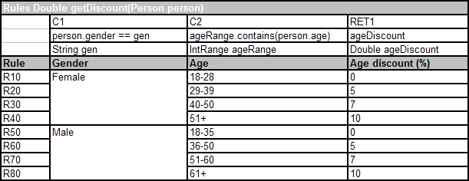
Figure 10: Rules for calculating a premium discount
The column containing age ranges utilizes a specific OpenL Tablets class org.openl.rules.helpers.IntRange, which provides an easy way to specify ranges of whole numbers. In addition, the class has a method contains() for determining whether a particular number lies within a range.
- Save and close the Excel file.

Test Your Progress
To test the decision tables defined in this learning module, proceed as follows:
- To regenerate the table wrapper, right click Generate org.openl.rules.tutorial Wrapper.launch and select Run As > Generate org.openl.rules.tutorial Wrapper.
- Right click the org.openl.rules.tutorial project and select Refresh.
- In the org.openl.rules.tutorial\src folder, double click the Main.java class.
This class will be used to call the decision tables.
- Change the Main.java class code to the following:
package org.openl.rules.tutorial;

public class Main {
public static void main(String[] args)
{
TableWrapper tw = new TableWrapper();

Residence r = new Residence();
r.setDwellingType("House");
r.setConstructionType("Mixed");

Person p = new Person();
p.setAge(55);
p.setGender("Female");

System.out.println(tw.getPremiumPercentage(r));
System.out.println(tw.getDiscount(p));
}
}
The code defines a mixed construction private house belonging to a 55 years old woman. After that it calls the decision tables getPremiumPercentage and getDiscount to calculate the corresponding premium percentage and discount. Returned values are printed out in the console.
- Save and close the Main.java class.
- Right click it and select Run As > Java Application.
If everything is set correctly, the following text is displayed in the console:
0.12
10.0
As you can see from the previously defined tables, these are correct return values to the specified input parameters.

Learning Module 4: Creating a Data Table and a Data Type
This learning module describes creating a simple data table and an advanced data table associated with a data type table. The following topics are included:
- Topic Summary
- Exercise
- Test Your Progress

Topic Summary
A data table contains relational data, which can be referenced from other Excel tables or even Java code. In particular, data tables can contain instances of Java classes or OpenL Tablets data types. A data type defines an OpenL Tablets data carrier.
Depending on the type of objects stored in a data table, the way they can be accessed from Java is affected as follows:
- If a data table contains instances of a Java class, they can be accessed as an array of that Java class.
- If a data table contains instances of an OpenL Tablets data type, they can be accessed as an array of the org.openl.types.impl.DynamicObject class.
In this learning module, you will first create a simple data table of String values for storing genders, namely 'Male' and 'Female'. After that you will create a more advanced data table containing policy types described in Tutorial Application Overview. The advanced data table will be based on an OpenL Tablets data type. This learning module will also provide examples of code for accessing the data tables from Java.

Exercise
The following exercises must be executed to complete this learning module:
- Creating a Simple Data Table
- Creating a Data Type Table
- Creating an Advanced Data Table

Creating a Simple Data Table
To create a simple data table for storing genders, proceed as follows:
- Open the PremiumCalculationRules.xls file.
- Create a new worksheet and name it Data.
- Create the following table in the new worksheet.
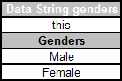
Figure 11: Simple data table
Data table headers have the following format:
Data <data type> <name of the table>
where 'Data' is a keyword telling the engine that this is a data table, and <data type> is either a Java class or OpenL Tablets data type.
In this case, the table is a simple String array containing values 'Male' and 'Female'.

Creating a Data Type Table
Policy types specified in Tutorial Application Overview will be stored in a more sophisticated data table. However, before that a data type must be created to model a policy type.
To create a data type for a policy type, proceed as follows:
- In the PremiumCalculationRules.xls file, open the Data worksheet.
- In the worksheet, create the following table:
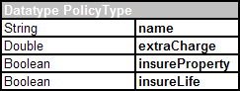
Figure 12: Data type table
Warning: If tables within the same worksheet are too close together, table editing may not work in OpenL Web Studio. It is recommended to insert more than one blank line between tables.
The first row is the header containing the keyword 'Datatype' followed by the name of the data type. Every row, beginning with the second one, represents one property of the data type. The first column contains property types; the second column contains corresponding property names.
The following table describes the purpose of each PolicyType property:
PolicyType properties
Property | Purpose
name | Policy type name, such as 'Basic', 'Blue', 'Green', and 'Platinum'.
extraCharge | Factor by which the basic policy cost is increased in percent.
insureProperty | Indicator telling whether this policy type covers property within the residence.
insureLife | Indicator telling whether this policy type provides life insurance to all residents.

Creating an Advanced Data Table
Now you are ready to define specific policy types. To create a data table with policy types, proceed as follows:
- In the PremiumCalculationRules.xls file, open the Data worksheet.
- In the worksheet, create the following table:
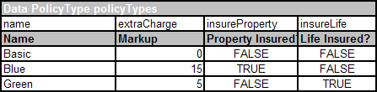
Figure 13: Advanced data table
In this case, the table stores instances of the data type PolicyType, which is defined in a data type table created in the preceding exercise.
Each cell in the second row contains one attribute of the data type. Normally, the second row is hidden to business users. The third row contains attribute display names. Each row starting with the fourth one contains values for specific data type instances.
- Save and close the Excel file.
Note: The policy type Platinum is not defined at this stage. It will be added later using OpenL Web Studio.

Test Your Progress
Now you will access both data tables from Java code to see if they are correctly defined. The provided code example shows the difference between accessing a data table associated with a Java class and a data table associated with an OpenL Tablets data type.
To test the data tables, proceed as follows:
- To regenerate the table wrapper, right click Generate org.openl.rules.tutorial Wrapper.launch and select Run As > Generate org.openl.rules.tutorial Wrapper.
- Right click the org.openl.rules.tutorial project and select Refresh.
- In the org.openl.rules.tutorial\src folder, double click the Main.java class.
This class will be used to call the data tables.
- Change the Main.java class code to the following:
package org.openl.rules.tutorial;

import org.openl.types.impl.DynamicObject;

public class Main {
public static void main(String[] args) {
TableWrapper tw = new TableWrapper();

//display all genders
System.out.println("Defined genders:");
String[] genders = tw.getGenders();
for (int i = 0; i < genders.length; i++)
System.out.println(genders[i]);

//markup for this policy type will be displayed
String policyType = "Blue";

Double m = 0.00;
//get the array of policy types and find the right one
DynamicObject[] pt = tw.getPolicyTypes();
for (int i = 0; i < pt.length; i++) {
if (pt[i].getFieldValue("name").toString().equals(policyType))
m = Double.valueOf(pt[i].getFieldValue("extraCharge").toString());
}
//display the markup in console
System.out.println("Markup for policy type '"+policyType+"' = "+m+"%");
}
}
First, the code retrieves an array of genders. Notice it is a simple array of Strings. Secondly, the code displays the markup value for policy type 'Blue'. Since PolicyType is not a Java class, the process of reading instances of this type is slightly more complex and involves a specific class DynamicObject. As you can see, the method for accessing data tables in both cases is constructed as follows:
get<name of the data table in lower case>()
- Save and close the Main.java class.
- Right click it and select Run As > Java Application.
If everything is set correctly, the following text is displayed in the console:
Defined genders:
Male
Female
Markup for policy type 'Blue' = 15.0%
- Optionally, test other policy types by changing the value of the policyType variable from 'Blue' to 'Green' or 'Basic'.

Learning Module 5: Using OpenL Web Studio
This learning module introduces OpenL Web Studio. The following topics are included:
- Topic Summary
- Exercise
- Test Your Progress

Topic Summary
OpenL Web Studio is a web application employed by business users and developers to remotely view, edit, and manage business rules and rule projects created using OpenL Tablets technology. Users can modify rules directly in a web browser without installing additional tools by using OpenL Web Studio. OpenL Web Studio provides better functionality than the OpenL Tablets Eclipse feature in terms of browsing projects, modifying rules, viewing errors, and executing tests. However, for more advanced activities, such as compiling Java code, generating table wrappers, and running Ant scripts, users must use Eclipse.
In this learning module, you will launch OpenL Web Studio and add the missing policy type Premium to the data table policyTypes.

Exercise
The following exercises must be executed to complete this learning module:
- Launching OpenL Web Studio
- Using the Table Editor

Launching OpenL Web Studio
Normally, OpenL Web Studio is run on a separate server so that multiple users can access the same instance. In this learning module, you will launch OpenL Web Studio locally. OpenL Web Studio launcher is automatically included in the OpenL Tablets project.
To launch OpenL Web Studio, proceed as follows:
- Close all tutorial Excel files.
- In Eclipse, in the org.openl.rules.tutorial project, right click WebStudio Starter.launch and select Run As > WebStudio Starter.
Eclipse starts the OpenL Web Studio server and after a short while the application is opened in your web browser.
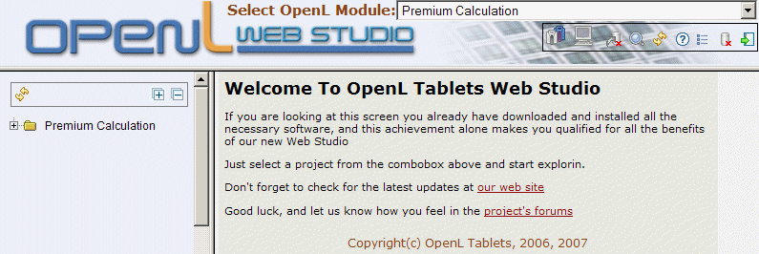
Figure 14: OpenL Web Studio
The application displays one module at a time. To switch between modules, the user must select a module in the Select OpenL Module list box. One rule project can contain several modules.
The left pane displays the module tree providing a view of elements in the currently displayed rule module.
When a table is selected, the right pane displays contents of the table and provides controls for modifying table data, running tests, and checking test results.
- If the Premium Calculation module is not already selected, in the Select OpenL Module list box, select Premium Calculation.
OpenL Web Studio provides the following modes of displaying tables:
Table display modes
Mode | Description
Business view | Project view is business oriented displaying only those project elements relevant to a business user. Structure of the tree is logical rather than physical. Rule tables are organized into categories based on Excel table sheets.  OpenL Web Studio provides three slightly differing business views, mainly in the depth of the module tree. To switch between the different business views, a user must repeatedly click the business view button.  The user can switch to the business view by clicking Business View .
Developer view | Project is displayed in a way convenient to developers with module tree elements organized by type rather than logic.  User can switch to developer view by clicking Developer View .
By default, the business view is used.

Using the Table Editor
In this exercise, you will add a new row to the policyTypes data table. To modify the table, proceed as follows:
- In the left pane, expand the module tree.
- Find and click the policyTypes table.
The selected table is displayed in the right pane in read only mode.
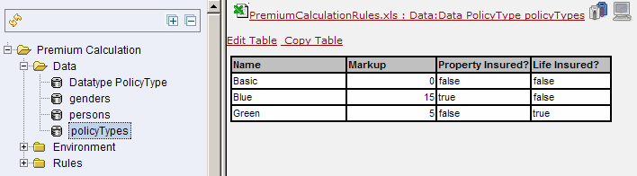
Figure 15: Selecting a table
- Position the mouse pointer over the table and wait until the pop up menu appears.
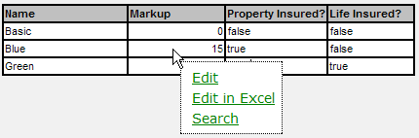
Figure 16: Rule editor pop up menu
- Click Edit.
The view changes to the table editor. In this mode table cell values can be modified and new rows can be added.
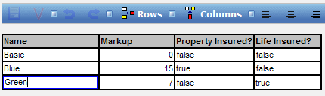
Figure 17: Editing a table
- Click any cell in the last row and select Rows > Add Row.
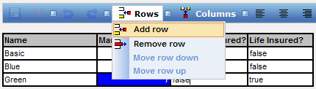
Figure 18: Adding a new row
A new row is inserted in the table.
- Modify values in the new row as shown in the following figure:
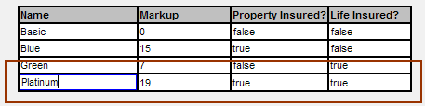
Figure 19: New row in a table
- Click the save button .
The new policy type is defined.

Test Your Progress
To see whether OpenL Web Studio has actually modified the Excel file, proceed as follows:
- Close the web browser.
- In Eclipse, terminate the OpenL Web Studio server.
- Open the PremiumCalculationRules.xls file.
If everything worked correctly, a new row defining the Platinum policy type has appeared in the policyTypes data table.

Learning Module 6: Creating a Test Table and Testing Rules
This learning module describes a test table and demonstrates testing a decision table using OpenL Web Studio. The following topics are included:
- Topic Summary
- Exercise
- Test Your Progress

Topic Summary
Testing rules involves checking whether the actual results returned by decision tables match the expected results. In OpenL Tablets, rule testing is best performed using test tables. A test table calls a particular decision table or method, provides test input values, and checks whether the returned values match the expected values. Test results are conveniently displayed in OpenL Web Studio.
In this learning module you will test the decision table getDiscount. To achieve this, you will need the following:
- a data table with fictional person records that can be used as test values
- a test table that uses the data table to test the decision table getDiscount
This learning module will also introduce the concept of a foreign key, which is used to establish a relationship between two tables.

Exercise
The following exercises must be executed to complete this learning module:
- Creating a Data Table with Test Records
- Creating a Person Test Table

Creating a Data Table with Test Records
In this exercise, you will create a data table containing records of fictional persons. This table will later be used in testing.
To create a data table with person records, proceed as follows:
- Open the PremiumCalculationRules.xls file and create a new worksheet named Test.
- In the Test worksheet, create the following data table:
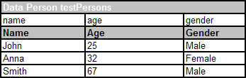
Figure 20: Data table with test persons
These persons will be passed to the getDiscount decision table to check the discount calculation logic.
Since values for the property gender are fixed and defined in the table genders, a reference to the table genders can be established. Such mechanism ensures that the user does not enter incorrect gender values.
- To create a reference or foreign key for the table genders, create an additional table row as shown in the following diagram:
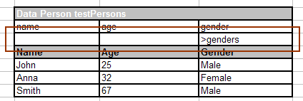
Figure 21: Creating a foreign key
This row specifies that the property gender points to the table genders. In general, foreign keys have the following syntax:
> <referenced data table name> <column name of the referenced data table>
If a reference is made to the first column in another table, as is the case in this exercise, the column name does not have to be specified.
Now, when the reference is established, if a wrong gender name is entered in the table testPersons, OpenL Tablets will report an error during generation of the wrapper class. In the next exercise, you will see another benefit of using foreign keys.
Note: To ensure users enter correct values, cell data validation lists can be used in Excel limiting the range of values users can type in.

Creating a Person Test Table
To create a test table that tests the getDiscount decision table with test values defined in the testPersons data table, in the Test worksheet, create the following table:
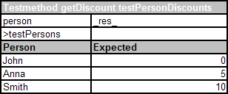
Figure 22: Person test table
A test table has the following structure:
- The first row is the table header, which has the following format:
Testmethod <method name> <test table name>
'Testmethod' is a keyword that identifies a test table. The second parameter is the name of the decision table method or any other Java method to be tested. The third parameter is the name of the test table, which is also the name of the method by which the test table can be executed from Java code.
- The second row provides a separate cell for each input parameter of the decision table method followed by column _res_, which contains the expected test result values. Parameter names must match the names of input parameters of the method that they test.
- The third row specifies foreign keys.
- The fourth row contains display values intended for business users.
- Starting with the fifth row, each row is an individual test run.
When a test table is called, the OpenL Tablets engine calls the specified method for every row in the test table and passes the corresponding input parameters to it.
Notice that in this case a foreign key is used again. However, in this table, it not only ensures data integrity, but also allows referencing a whole table record through one parameter. This is important because it provides means for supplying a whole record or instance to the decision table as an input parameter.

Test Your Progress
To execute unit tests defined in the table testPersonDiscounts, proceed as follows:
- To regenerate the table wrapper, right click Generate org.openl.rules.tutorial Wrapper.launch and select Run As > Generate org.openl.rules.tutorial Wrapper.
- To launch OpenL Web Studio, in Eclipse, in the org.openl.rules.tutorial project, right click WebStudio Starter.launch and select Run As > WebStudio Starter.
OpenL Web Studio is launched in a web browser.
- In the Select OpenL Module list box, select Premium Calculation.
- In the module tree, select Premium Calculation > Rules and select the getDiscount table.
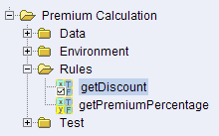
Figure 23: Decision table with tests assigned
Notice that the table icon differs from the one used for the table getPremiumPercentage. An icon with a check box identifies a decision table that has tests defined for it.
- To execute all tests for the getDiscount table, in the right pane click the test button.
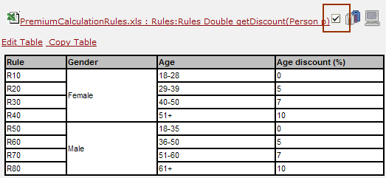
Figure 24: Executing tests for a decision table
OpenL Web Studio displays test results.
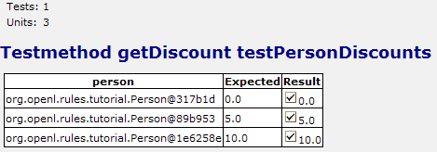
Figure 25: Test results
Every row in the table represents one call of the decision table. If a call returns a value that does not match the expected value, the test is failed. Failed tests are represented by the mark. Passed tests are represented by the mark. In this case, all tests were passed.
Alternatively, a user can execute all unit tests in all test tables by clicking the test button above the module tree.
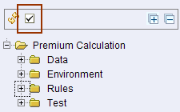
Figure 26: Executing all tests within a module
- Close the web browser.
- In Eclipse, terminate the OpenL Web Studio server.

Learning Module 7: Using BEX Expressions
This learning module introduces the BEX grammar in rule conditions. The following topics are included:
- Topic Summary
- Exercise
- Test Your Progress

Topic Summary
BEX language enables users to write expressions similar to natural human language. The existing Java business object model automatically becomes the basis for open business vocabulary used by BEX. For example, Java expression 'policy.effectiveDate' is equivalent with BEX expression 'Effective Date of the Policy'.
The following table represents BEX keyword equivalents to Java expressions:
BEX keywords
Java expression | BEX equivalents
== | - equals to  - same as
!= | - does not equal to  - different from
a.b | b of the a
< | is less than
> | is more than
<= | - is less or equal  - is in
!> | is no more than
>= | is more or equal
!< | is no less than
In addition, BEX supports a notation where an expression is written using simple variables followed by the attributes they represent. For example, assume the following BEX expression is used:
(Agreed Value of the vehicle - Market Value of the vehicle) / Market Value of the vehicle is more than Limit Defined By User
As can be seen from the example, long expressions are hard to read. However, the expression is much simpler if written according to the notion of explanatory variables as follows:
(A - M) / M > X, where
A - Agreed Value of the vehicle,
M - Market Value of the vehicle,
X - Limit Defined By User
This syntax is similar to the one used in scientific publications and is much easier to read for complex expressions. It provides a good mix of mathematical clarity and business readability.
In this learning module, you will create copies of the existing decision tables and change some of the rule conditions to BEX expressions. This will not result in any changes or improvements in functionality but will help you understand how BEX works.

Exercise
The following exercises must be executed to complete this learning module:
- Using a Simple BEX Expression
- Using the Notion of Explanatory Variables

Using a Simple BEX Expression
In this exercise, you will create a copy of the getPremiumPercentage decision table and change the first condition to a simple BEX expression. To create the table, proceed as follows:
- Open the PremiumCalculationRules.xls file.
- In the Rules worksheet, make a copy of the getPremiumPercentage decision table.
- Change the name of the copied table to getPremiumPercentageBEX.
- In the copied table, change the following condition:
t == residence.dwellingType
to the following:
dwelling type of the residence equals to t
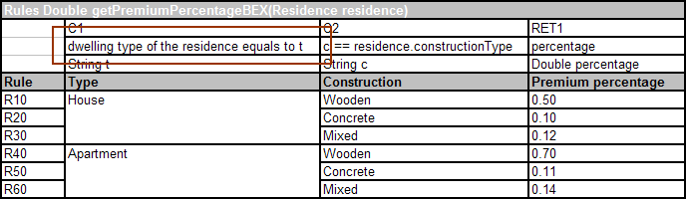
Figure 27: Simple BEX expression
Both expressions are equivalent but, as you can see, if the BEX grammar is used, the expression becomes more readable to a non-technical person.

Using the Notion of Explanatory Variables
In this exercise, you will create a copy of the getDiscount decision table and change the first condition to a BEX expression using the notion of explanatory variables. To create the table, proceed as follows:
- In the Rules worksheet, make a copy of the getDiscount decision table.
- Change the name of the copied table to getDiscountBEX.
- In the copied table, change the following condition:
person.gender == gen
to the following:
A == B, where A - gender of the person, B – gen
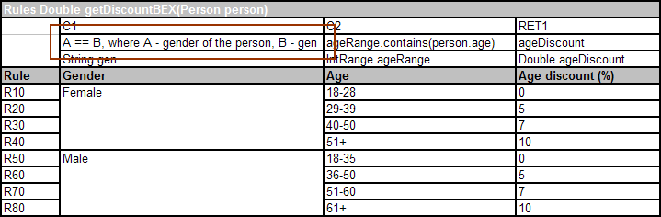
Figure 28: BEX expression with the notion of explanatory variables
As you can see, the expression specifies a logical condition involving two variables A and B and defines what those variables represent. This notion is also part of the BEX grammar.
- Save and close the Excel file.

Test Your Progress
To test the copied decision tables, you will use similar code to what was used in Learning Module 3: Creating Decision Tables. To test the decision tables containing BEX expressions, proceed as follows:
- To regenerate the table wrapper, right click Generate org.openl.rules.tutorial Wrapper.launch and select Run As > Generate org.openl.rules.tutorial Wrapper.
- Right click the org.openl.rules.tutorial project and select Refresh.
- In the org.openl.rules.tutorial\src folder, double click the Main.java class.
This class will be used to call the decision tables.
- Change the Main.java class code to the following:
package org.openl.rules.tutorial;

public class Main {
public static void main(String[] args)
{
TableWrapper tw = new TableWrapper();

Residence r = new Residence();
r.setDwellingType("House");
r.setConstructionType("Mixed");

Person p = new Person();
p.setAge(55);
p.setGender("Female");

System.out.println(tw.getPremiumPercentageBEX(r));
System.out.println(tw.getDiscountBEX(p));
}
}
- Save and close the Main.java class.
- Right click it and select Run As > Java Application.
If everything is set correctly, the following text is displayed in the console:
0.12
10.0

Learning Module 8: Benchmarking
This learning module demonstrates benchmarking using OpenL Web Studio. The following topics are included:
- Topic Summary
- Exercise
- Test Your Progress

Topic Summary
OpenL Web Studio provides benchmarking tools for measuring execution time for all appropriate OpenL Tablets elements. Benchmarking is useful for optimizing the rule structure and identifying critical paths in rule calculation.
In this learning module, you will use benchmarking to find out which grammar consumes more execution time, Java or BEX. Finding it out will not be hard because you already have two functionally equal decision tables with different grammars.

Exercise
The following exercises must be executed to complete this learning module:
- Creating a Test Table for the getDiscountBEX Table
- Using Benchmarking in OpenL Web Studio

Creating a Test Table for the getDiscountBEX Table
Before comparing the grammars, a test table must be created for the getDiscountBEX table. The new test table will have the same contents as the test table that you already have but it will call the getDiscountBEX table instead of the getDiscount table.
To create a test table for the getDiscountBEX table, proceed as follows:
- In the PremiumCalculationRules.xls file, in the Test worksheet, make a copy of the testPersonDiscounts table.
- Change the name of the copied table to testPersonDiscountsBEX.
- Change the decision table to be called to getDiscountBEX.
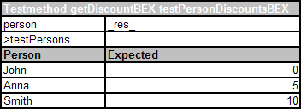
Figure 29: Test table for calling the getDiscountBEX decision table
- Save and close the Excel file.

Using Benchmarking in OpenL Web Studio
To compare the getDiscount and getDiscountBEX table performance using benchmarking, proceed as follows:
- To regenerate the table wrapper, right click Generate org.openl.rules.tutorial Wrapper.launch and select Run As > Generate org.openl.rules.tutorial Wrapper.
- To launch OpenL Web Studio, in Eclipse, in the org.openl.rules.tutorial project, right click WebStudio Starter.launch and select Run As > WebStudio Starter.
OpenL Web Studio is launched in a web browser.
- In the Select OpenL Module list box, select Premium Calculation.
First, you will measure execution of the testPersonDiscounts table and then you will do the same for the testPersonDiscountsBEX table. After that, the results can be compared.
- In the module tree, select this Premium Calculation > Test > testPersonDiscounts.
- In the right pane, click the benchmark button.
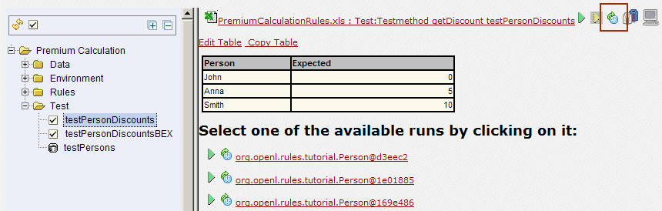
Figure 30: Benchmarking a test table
Execution results are displayed in a table.
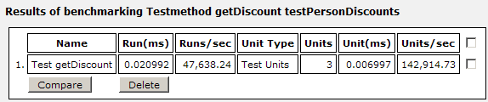
Figure 31: Benchmarking results
- Repeat steps 4 and 5 for the testPersonDiscountsBEX table.
The benchmarking results table now displays two entries.
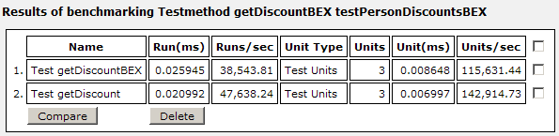
Figure 32: Benchmarking results with two entries
- To compare the two results, select check boxes next to both rows and click Compare.
OpenL Web Studio compares both executions and displays the results.
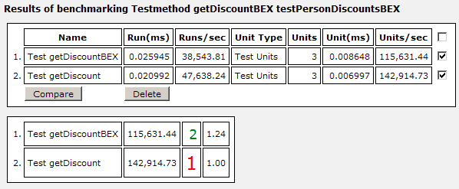
Figure 33: Comparing benchmarking results
As can be seen from the results, BEX grammar takes slightly more execution time than regular Java expressions.

Test Your Progress
Since each decision table was benchmarked only once, the results can be inaccurate because the execution time can be influenced by a number of different external factors.
To achieve a more precise result, benchmark both test tables again two or three times and compare all the results. If it is still true that BEX expressions take longer to process than Java, execution entries of the testPersonDiscounts table should achieve higher rank.
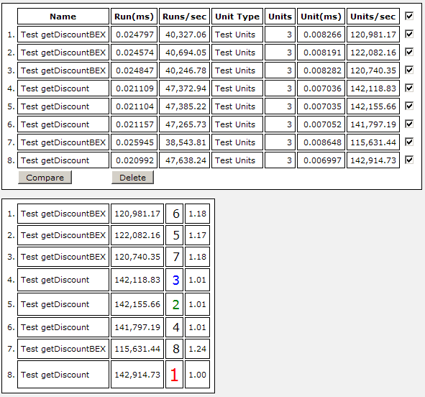
Figure 34: Comparing results of multiple runs

Learning Module 9: Calculating a Premium
This final learning module demonstrates calculating an insurance premium based on predefined input values. The following topics are included:
- Topic Summary
- Exercise
- Test Your Progress

Topic Summary
This learning module is a general conclusion of this tutorial in which you will create a simple Java class with predefined input values that calculates a premium by calling decision tables and data tables of the project created in this tutorial. By executing this learning module you will verify that the project works as a whole application.

Exercise
To create a Java class that calculates an insurance premium based on rules defined in the org.openl.rules.tutorial project, proceed as follows:
- In Eclipse, open the Main.java class.
- Modify its contents as follows:
package org.openl.rules.tutorial;

import org.openl.types.impl.DynamicObject;

public class Main {
public static void main(String[] args) {
TableWrapper tw = new TableWrapper();

//define a person
Person p = new Person();
p.setName("Andrew");
p.setAge(55);
p.setGender("Male");
System.out.println("Person: "+p.getName()+" ("+p.getGender()+", "+p.getAge()+")");

//define person's residence
Residence r = new Residence();
r.setValue(60000.00);
r.setDwellingType("House");
r.setConstructionType("Concrete");
System.out.println("Residence: "+r.getConstructionType()+" "+
r.getDwellingType()+", value = "+r.getValue()+"$");

//policy type used
String policyType = "Blue";
System.out.println("Policy type = "+policyType);

//calculate premium base value
Double baseValue = r.getValue()*tw.getPremiumPercentage(r)/100;
System.out.println("Premium base value = "+baseValue+"$");

//calculate premium discount based on person's age and gender
Double discount = tw.getDiscount(p);
System.out.println("Premium discount = "+discount+"%");

//calculate premium markup based on policy type
Double markup = 0.00;
//get the array of policy types and find the right one
DynamicObject[] pt = tw.getPolicyTypes();
for (int i = 0; i < pt.length; i++)
if (pt[i].getFieldValue("name").toString().equals(policyType))
markup = Double.valueOf(pt[i].getFieldValue("extraCharge").toString());
System.out.println("Premium markup = "+markup+"%");

//final calculation
Double finalValue = baseValue+baseValue*(markup-discount)/100;
System.out.println("FINAL PREMIUM VALUE = "+finalValue+"$");
}
}
This code defines a specific person, residence, and policy type and calculates the corresponding insurance premium value. In real life situations, this would be accomplished by some end user oriented application providing user interface for entering values.
Note: Optionally, you can replace methods getPremiumPercentage() and getDiscount() with getPremiumPercentageBEX() and getDiscountBEX(). This would enable the engine to use tables with BEX expressions rather than Java statements but the general functionality would be the same.
- Save and close the Main.java class.

Test Your Progress
To see the output of the Main.java class, in Eclipse, right click the class and select Run As > Java Application.
The following text is displayed in the Console view:
Person: Andrew (Male, 55)
Residence: Concrete House, value = 60000.0$
Policy type = Blue
Premium base value = 60.0$
Premium discount = 10.0%
Premium markup = 15.0%
FINAL PREMIUM VALUE = 63.0$
You can try experimenting with different input values to see how the output changes.

Conclusion
Congratulations! You have completed the OpenL Tablets tutorial. Now that you know how to create simple rules, you can begin to build increasingly complex applications as you learn more about OpenL Tablets on your own. We hope this tutorial was helpful to you.

