Quick helper how to prepare OpenL Tablets Guide
- При закрытом файле открываем Properties документа и исправляем OpenLVersion
- Применяем все изменения документа (accept all changes), удаляем комментарии, лишние выделения
- Update all fields документа. Обратить внимание, что версия ОпенЛ в колонтитулах на заглавных первых двух листах и остальных обновляется по отдельности
- Перепроверить стили текста (Body Text), заголовков, рисунков (Picture), надписей (Capture), номера картинок, код (Code). Картинки рекомендуется вставлять в документ через соответствующее меню Word
- Проверяем, что ссылки на другие ОпенЛ документы должны быть версии latest
- Проверяем, что: элементы интерфейса и управляющие комбинации с полужирным шрифтом (кроме +), ссылки – italic и т.д.
- Обновляем Index при выключенном режиме . Помощь: чтобы вставить Index, insert index -> mark entry -> mark
- Обновляем Content
- Сохраняем документ в pdf формате (save as pdf).
- Удаляем Content и т.д. до Chapter 1, Index и запускаем Help Converter Add-Ins.
- Меняем Product Name (на то, что на сайте в url), Script Location (у меня на D:\programs\script\Convert.pl), Source File Locations (кнопкой “Save Temporaly” создаем источник, ниже указываем созданный). Конвертируем.
- Названия папки с hlml документацией также должны совпадать с теми, что в url на сайте. Архивируем папки с подготовленными html документацией. Зипки и pdf документы отправляем члену команды, отвечающему за сайт (Андрею), по почте.

Generating HTML Help

What you need
- Installed Perl.
- Installed Macro Help Converter.
- Script for conversion.
- The document to be converted.
This section describes how to prepare the document created in Word format to generate HTML format documentation.
The following topics are described:
- Preparing a Document for Conversion to Online Help
- Installing Help Converter
- Creating HTML Help

Preparing a Document for Conversion to Online Help
Help Converter correctly converts only documents based on the Exigen template.
To prepare a document for conversion to online help, proceed as follows:
- Delete the following pages and sections:
- preface
- index
- Delete the links to the deleted pages and sections.
- Delete screenshot captions.
A screenshot caption is a text after a screenshot starting with the word 'Figure'.

Installing Help Converter
Help Converter is a specific Word macro. It must be installed on the computer used for generating help. It works correctly on Word 2000 and 2003.
To install Help Converter, proceed as follows:
- Close Word.
- Run the Setup.exe file.
The Welcome to the InstallShield Wizard for Help Converter appears.
- Click Next.
- In the Select Microsoft Office Startup window, select Browse, select the Program Files\Microsoft Office\Office\Startup folder, and click OK.
- Click Next.
- Wait until the installation is complete.
The InstallShield Wizard Complete window appears.
- Click Finish.
After installation, the Help Converter icon appears when running Word .

Creating HTML Help
To create help, proceed as follows:
- On your workstation, create the Help folder for help.
- In Word, open the guide to be converted into help and ensure it corresponds to requirements described in Preparing a Document for Conversion to Online Help.
- In the toolbar, click .
The Help Converter window appears.
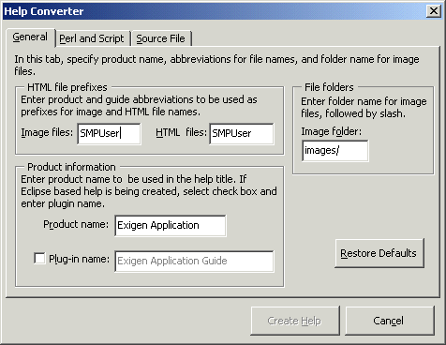
Figure 1: Help Converter General tab
- In the Image files field, enter the image files prefix, for example User_.
Prefixes are important if several HTML helps are located in the same folder.
- In the HTML files field, enter the content files prefix, for example User_.
- In the Image folder field, enter the name of the folder where all image files must be saved.
Usually, the default value is acceptable.
- In the Product name field, enter the product name.
This value appears in the HTML title bar and table of contents.
- Leave the Plug-in name check box cleared.
- Select the Perl and Script tab.
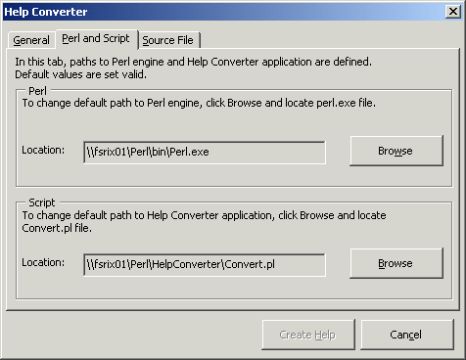
Figure 2: Help Converter: Perl and Script
- If the paths to the Perl engine and the Help Converter script must be configured, to locate the correct paths, use browse buttons.
- Select the Source File tab.
- In the Saving temporary source file section, click Save Temporary.
- Locate the Help folder and save the temporary HTML file using any arbitrary name.
The path and filename of the saved HTML file appears in the Target file section, in the Location field.
- In the Specifying temporary source file section, select the temporary HTML file created in the previous step.
- Click Create Help.
A console window opens and the conversion process begins.
- Review the status messages that appear during the conversion process.
If the document is large, conversion can take several minutes.
- When the console window closes, open the Help folder and view a list of generated files and folders.
- To check that everything was fine, open the index.html, and check that links work fine, menu and images exists.
17. When generating HELP for one of the Openl docs, menu is not shown. To fix it go to the toc.html, find the menu item that contains quotes in the name and escape it.

