


Rating Engine Tutorial

OpenL Tablets

Document number: TP_OpenL_Tutorial_2.2_LSh
Revised: 06-23-2010
EXIGEN CONFIDENTIAL – FOR AUTHORIZED USERS ONLY
Important Notice
Information in this document, as well as the software products and programs described in it, is furnished by Exigen Insurance Solutions, Inc. and/or affiliates (Exigen) under license and may be used or copied only in accordance with the terms of such license. This document, the information contained in it, as well as the software products and programs described herein are considered confidential, proprietary, trade secrets of Exigen. You may not copy, create derivatives, decipher, decompile, develop, or otherwise reverse engineer this document, the information contained in it, or the software products and programs described. Exigen and its licensors retain all intellectual property and ownership rights to the information contained herein, as well as the software products and programs (including, but not limited to, software libraries, interfaces, source codes, documentation and training materials) described herein.
The content of this document is furnished for informational use only, is subject to change without notice, may contain technical inaccuracies or typographical errors, and should not be construed as a representation, warranty or commitment by Exigen or any other person or entity. Exigen may make improvements and/or changes in the software products and programs described in this document at any time without notice. Exigen is not responsible or liable for any changes made to this document. In particular, modifications in or to the data model described herein may have occurred or may occur in a new product release after publication of this documentation. In accordance with Exigen standard support policy, any issues arising as a result of such modifications shall not be considered support issues and shall not be covered by Exigen maintenance and support. To be clear, Exigen is providing this document and the information contained in it, "as is" without any representations, covenants, or warranties, including those of merchantability or fitness for a particular purpose. Some jurisdictions do not allow disclaimer of express or implied warranties in certain transactions; in that case, this notice may not apply.
Information published by Exigen on the Internet or World Wide Web may contain references or cross-references to Exigen software products and programs, as well as Exigen services that are not announced or available in your country. Such references do not imply that Exigen intends to announce such software products programs or such services in your country. Consult your local Exigen business contact for information regarding the Exigen software products and programs and Exigen services that may be available to you.
By using this document, you agree that, in no event will Exigen or its licensors be liable to any party for any direct, indirect, special or other consequential damages for any use of this document, the information contained herein, or the software products and programs described herein, including, without limitation, any lost profits, business interruption, loss of programs or other data on your information handling system or otherwise, even if Exigen were expressly advised of the possibility of such damages.
Trademark
Exigen, the Exigen logo, Exigen Process Backbone, Business Process Utility, Insurance Suite, Lending Process Backbone, Communication Process Backbone, PolicyCore are registered trademarks and trademarks of Exigen Insurance Solutions, Inc. in the United States and/or other countries.
Microsoft, Windows, Internet Explorer, and Word are either registered trademarks or trademarks of Microsoft Corporation in the United States and/or other countries.
All other trademarks, service marks, or registered trademarks are the property of their respective companies.
Support contact information
Telephone:  1-866-4EXIGEN North America  1-506-674-6922 All other countries | Website: http://www.exigeninsurance.com/  Fax: 1-415-402-2022  Email: support@exigeninsurance.com
Table of Contents
Introducing the OpenL Tablets Tutorial 5
Tutorial Overview 5
Audience and Objectives 5
Tutorial Organization 6
Learning Module Organization 6
Related Information 6
Typographic Conventions 7
OpenL Tablets Overview 7
What Is OpenL Tablets? 7
Basic Concepts 7
Tutorial Application Overview 8
Preparing the Environment 8
Hardware and Software Requirements 9
Tutorial Package Overview 9
Installing the Environment 9
Learning Module 1: Creating an OpenL Tablets Project 10
Topic Summary 10
OpenL Tablets Project Structure 10
OpenL Web Studio 11
Exercise 11
Creating an OpenL Tablets Project 11
Generating a Wrapper 13
Creating an OpenL Web Studio Project 14
Test Your Progress 16
Launching the Project in OpenL Web Studio 16
Troubleshooting: Switching the Port Used by OpenL Web Studio 17
Learning Module 2: Creating and Testing a Decision Table 19
Topic Summary 19
OpenL Tablets Table Recognition Algorithm 19
OpenL Tablets Table Types 20
BEX Expressions 20
Exercise 21
Understanding OpenL Web Studio UI 21
Creating a Construction Age Discount Table 23
Test Your Progress 27
Creating a Test Table 27
Running the Test Table 28
Learning Module 3: Creating and Testing More Complex Decision Tables 32
Topic Summary 32
Introducing a Two Dimensional Table 32
Introducing a Three Dimensional Table 32
Introducing Benchmarking 33
Exercise 33
Creating a Two Dimensional Table 34
Creating a Three Dimensional Table Referencing Another Table 36
Test Your Progress 38
Testing the Base Rates Table 39
Testing the Earthquake Rates Table 40
Using Benchmarking in OpenL Web Studio 41
Learning Module 4: Creating and Testing Spreadsheets 43
Topic Summary 43
Introducing a Spreadsheet Table 43
Introducing a Method Table 43
Exercise 44
Test Your Progress 45
Learning Module 5: Investigating the Rating Engine Logic 47
Topic Summary 47
Exercise 48
Initiating the Review 48
Reviewing Master Spreadsheets 48
Reviewing Supporting Spreadsheets and Tables 51
Test Your Progress 53
Learning Module 6: Importing an OpenL Tablets Project 56
Topic Summary 56
Exercise 57
Importing an OpenL Tablets Project into Eclipse 57
Launching the Imported Project in OpenL Web Studio 60
Test Your Progress 60
Reviewing a Master Spreadsheet Table of the Imported Project 60
Reviewing Other Spreadsheets of the Imported Project 62
Conclusion 63
Appendix A: Product Factory Attributes 64

Introducing the OpenL Tablets Tutorial
This section outlines the purpose and scope of this tutorial, briefly introduces the product and tutorial application, and explains how to prepare the environment for the tutorial learning modules.
The following topics are included in this section:
- Tutorial Overview
- OpenL Tablets Overview
- Tutorial Application Overview
- Preparing the Environment

Tutorial Overview
This section identifies the tutorial audience and its objectives, introduces tutorial and learning module organization, lists the documentation related to this tutorial, and defines the typographic conventions used in the tutorial.
The following topics are included in this section:
- Audience and Objectives
- Tutorial Organization
- Learning Module Organization
- Related Information
- Typographic Conventions

Audience and Objectives
This tutorial introduces new users to OpenL Tablets on the basis of practical exercises. During this tutorial, the user gradually builds a sample application. For information on the sample application, see Tutorial Application Overview. The user is expected to read and execute the learning modules in the order they are offered in this tutorial.
Users working with this tutorial must have a basic knowledge of the following:
- Java
- Eclipse
- Excel®
You will be able to perform the following tasks after completing this tutorial:
- create and test OpenL Tablets decision tables that implement business rules
- develop and test OpenL Tablets spreadsheet tables
- benchmark business rules
- investigate the rating engine logic and its OpenL Tablets implementation
- create and import projects in OpenL Tablets
- run and update a project in OpenL Web Studio

Tutorial Organization
This tutorial is organized as follows:
Information on how to use this tutorial
Section | Description
Learning Module 1: Creating an OpenL Tablets Project | Explains how to create a simple OpenL Tablets project and launch OpenL Web Studio. You will be able to create a simple OpenL Tablets project, generate a wrapper, and run the project in OpenL Web Studio after completing this module.
Learning Module 2: Creating and Testing a Decision Table | Introduces OpenL Web Studio UI and its functionality. You will be able to create and test a simple OpenL Tablets table after completing this module.
Learning Module 3: Creating and Testing More Complex Decision Tables | Explains how to create two and three dimensional tables and how a table can process results retrieved from another table. This learning module also includes a benchmarking exercise.
Learning Module 4: Creating and Testing Spreadsheets | Explains how to create and test a spreadsheet table that retrieves information from decision tables developed in the previous learning modules.
Learning Module 5: Investigating the Rating Engine Logic | Explains how to investigate the rating engine logic based on the customer’s input.
Learning Module 6: Importing an OpenL Tablets Project | Describes importing a predefined OpenL Tablets project.

Learning Module Organization
Each learning module in this tutorial is organized as follows:
Organization of learning module
Section | Description
Topic Summary | Introduces learning module contents and involved product concepts and lists the goals reached after completing this module.
Exercise | Provides step-by-step instruction for developing a scenario identified in the module topic summary.
Test Your Progress | Specifies how to verify that tasks described in the learning module are completed successfully and summarizes key points covered in the module.

Related Information
The following information is related to this tutorial:
Related information
Location | Description
OpenL Tablets Reference Guide | Document explaining the OpenL Tablets technology.
OpenL Web Studio User’s Guide | Document explaining OpenL Web Studio, a web application for managing OpenL Tablets projects through a web browser.

Typographic Conventions
The following styles and conventions are used in this guide:
Typographic styles and conventions
Convention | Description
Bold | - Represents user interface items such as check boxes, command buttons, dialog boxes, drop-down list values, field names, menu commands, menus, option buttons, perspectives, tabs, tooltip labels, tree elements, views, and windows.  - Represents keys, such as F9 or CTRL+A.  - Represents a term the first time it is defined.
Courier | Represents file and directory names, code, system messages, and command-line commands.
Courier Bold | Represents emphasized text in code.
Select File > Save As | Represents a command to perform, such as opening the File menu and selecting Save As.
Italic | - Represents any information to be entered in a field.  - Represents documentation titles.
< > | Represents placeholder values to be substituted with user specific values.
Hyperlink | Represents a hyperlink. Clicking a hyperlink displays the information topic or external source.

OpenL Tablets Overview
This section provides a general overview of OpenL Tablets. For detailed information on the component, see OpenL Tablets Reference Guide.
The following topics are included in this section:
- What Is OpenL Tablets?
- Basic Concepts

What Is OpenL Tablets?
OpenL Tablets is a rules management framework based on tables presented in Excel documents. OpenL Tablets facilitates the treatment of business documents containing business logic specifications as executable source code. Since the format of tables used by OpenL Tablets is familiar to business users, OpenL Tablets bridges a gap between business users and developers, thus reducing costly enterprise software development errors and dramatically shortening the software development cycle.
OpenL Tablets can be considered as a table processor that extracts tables from Excel documents and makes them accessible for Java programs.

Basic Concepts
This section explains the main OpenL Tablets concepts:
- Rules
- Tables
- Projects
- Wrappers
- OpenL Web Studio

Rules
A rule is a logical statement consisting of conditions and actions in OpenL Tablets. If a rule is called, and all its conditions are true, then the corresponding actions are executed. Basically, a rule is an IF-THEN statement. The following is an example of a rule expressed in human language:
If a service request costs less than 1,000 dollars and takes less than 8 hours to execute then the service request must be approved automatically.
Rules can also return data values to the calling program instead of executing actions.

Tables
Tables are the basic information that OpenL Tablets deals with. Information such as rules and data is presented in tables. There are various types of tables serving different purposes.

Projects
An OpenL Tablets project is a container for all resources required to process rule related information. Usually, a project contains Excel files, Java code, and wrappers of table files.

Wrappers
A wrapper is a Java class that exposes decision tables as Java methods and data tables as Java objects. A wrapper allows developers to access table information from code. A wrapper Java class must be generated for the Excel file where the table is defined in order to access a particular table from Java code.

OpenL Web Studio
OpenL Web Studio is a web application employed by business users and developers to view, edit, and manage business rules and rule projects that were created using OpenL Tablets technology. Users can modify rules directly in a web browser without installing additional tools by using OpenL Web Studio. OpenL Web Studio provides better functionality than the OpenL Tablets Eclipse feature in terms of browsing projects, modifying rules, viewing errors, and executing tests. However, for more advanced activities, such as compiling Java code, generating table wrappers, and running Ant scripts, Eclipse is used.

Tutorial Application Overview
This tutorial will teach you how to create a simple rating engine for insurance premium calculation using the OpenL Tablets tables.
You will investigate a complex rating engine for calculating policy premium for homeowners, condos, and tenants in the last two learning modules of the tutorial. The application is presented in a set of tables, statements, and text format rules, which are interrelated and interdependent.

Preparing the Environment
This section lists software and hardware requirements and describes the setup process to be performed before executing the exercises offered in this tutorial:
- Hardware and Software Requirements
- Tutorial Package Overview
- Installing the Environment

Hardware and Software Requirements
This tutorial requires the following software to be installed on the user's workstation:
Hardware and software requirements
Requirement | Description
Windows® XP or later
Excel 97 or later | Excel is required for editing rating engine rules.
Web browser | Internet Explorer 6.
RAM 2 GB | This is a recommended value to run Eclipse and OpenL Web Studio simultaneously.  Otherwise, loading Eclipse and OpenL Web Studio can take longer time.

Tutorial Package Overview
The OpenL Tablets tutorial is delivered to the customer with the following items:
- installation package required for launching OpenL Web Studio
- installation package required for launching Eclipse with preinstalled OpenL Tablets

Installing the Environment
Environment installation instructions
Environment | Installation instructions | Description
OpenL Web Studio | In a browser, enter download URL specified by your trainer and run the Web_Studio_install.cmd file.  The files are copied to your local drive, to the C:\OpenLRET directory, and OpenL Web Studio with a preliminary created empty project is launched. | This installation is intended for business users who will use OpenL Web Studio for creating and modifying rating engine tables.  The next step is to begin creating a rating engine as described in Learning Module 2: Creating and Testing a Decision Table.
Eclipse with the preinstalled OpenL Tablets plug-in. | Insert the installation CD and run the Development_Environment_install.cmd file.  The files are copied to your local drive, to the C:\OpenLRET directory, and Eclipse is launched. | This installation is intended for developers who will create projects and manage rating engine data on the technical level.  The next step is to create a project as described in Learning Module 1: Creating an OpenL Tablets Project and proceed with creating a rating engine as described in the following learning modules.

Learning Module 1: Creating an OpenL Tablets Project
This learning module explains how to create a simple OpenL Tablets project and launch OpenL Web Studio. You will be able to create a simple OpenL Tablets project, generate a wrapper, and run the project in OpenL Web Studio after completing this module.
The following topics are included in this learning module:
- Topic Summary
- Exercise
- Test Your Progress

Topic Summary
This section introduces the OpenL Tablets project structure components and OpenL Web Studio.
The following topics are included in this section:
- OpenL Tablets Project Structure
- OpenL Web Studio

OpenL Tablets Project Structure
An OpenL Tablets project must be created to store the information related to the tutorial application. Additionally, an OpenL Tablets project is required to launch OpenL Web Studio.
Typically, an OpenL Tablets project is Eclipse compatible and contains the following general elements:
- Excel files
- Ant task for generating file wrappers
- wrappers
- additional Java code
- third party libraries
Ant is a Java-based software build system.
Note: Using third party libraries requires adding a lib folder, putting libraries in that folder, and adding a reference in a project to these libraries.
Note: For the OpenL Tablets plug-in version later than 5.3.1 build 20100128, Ant task and wrappers are no longer used.
The following table describes the physical structure of an OpenL Tablets project:
OpenL Tablets project structure
Folder | Contents
src | Contains all project Java classes not including wrappers.
rules | Contains Excel files.
gen | Contains generated wrapper classes.
bin | Contains compiled Java code.
target | Contains compiled Java code if Maven is used.
build | Contains Ant configuration file for generating wrapper classes and a generated properties file for OpenL Web Studio.
Note: For the OpenL Tablets plug-in version newer than 5.3.1 build 20100128, the Maven project structure is used.

OpenL Web Studio
OpenL Web Studio is a web application employed by business users and developers to remotely view, edit, and manage business rules and rule projects created using OpenL Tablets technology. Users can modify rules directly in a web browser without installing additional tools by using OpenL Web Studio. OpenL Web Studio provides better functionality than the OpenL Tablets Eclipse feature in terms of browsing projects, modifying rules, viewing errors, and executing tests.
However, for more advanced activities, such as compiling Java code, generating table wrappers, and running Ant scripts, Eclipse is used.

Exercise
This exercise explains how to create a project, generate a wrapper for this project, and generate a project for launching OpenL Web Studio. The following topics are included:
- Creating an OpenL Tablets Project
- Generating a Wrapper
- Creating an OpenL Web Studio Project

Creating an OpenL Tablets Project
To create an OpenL Tablets project, proceed as follows:
- To launch Eclipse, locate the C:\OpenLRET directory and run the Start_Development_Environment.cmd file.
- Select File > New > Project.
- In the Select a wizard window, select OpenL Tablets > Simple OpenL Tablets Project and click Next.
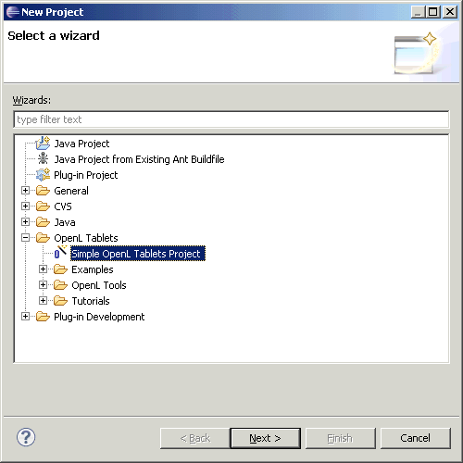
Figure 1: Selecting a project type
- In the Simple OpenL Tablets Project window, in the Project name field, enter SampleProject.
- Click Finish.
The project is created and appears in the Package Explorer perspective.
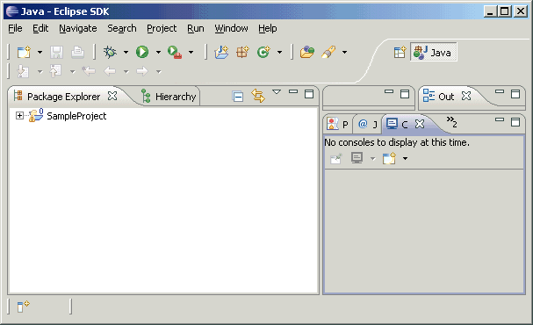
Figure 2: A newly created project

Generating a Wrapper
A wrapper Java class must be generated for the Excel file where the table is defined to access a particular table from Java code. Whenever new tables are added or when the table structure is changed in Excel files, the wrapper must be regenerated.
Proceed as follows:
- In Eclipse, expand the created project.
- Right click Generate SampleProject Wrapper.launch and select Run As > Generate SampleProject Wrapper.
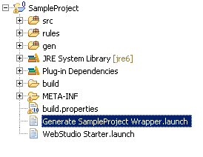
Figure 3: Generating a wrapper for a project
The wrapper generation progress can be verified in the console perspective and ends up with the status Terminated.
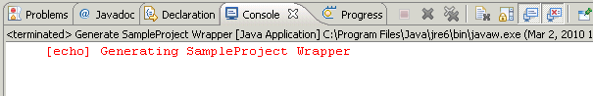
Figure 4: The console perspective

Creating an OpenL Web Studio Project
Launching OpenL Web Studio requires generating an OpenL Web Studio project. Proceed as follows:
- In Eclipse, select File > New > Project.
- In the Select a wizard window, select OpenL Tablets > OpenL Tools > OpenL WebStudio – Web based editing environment and click Next.
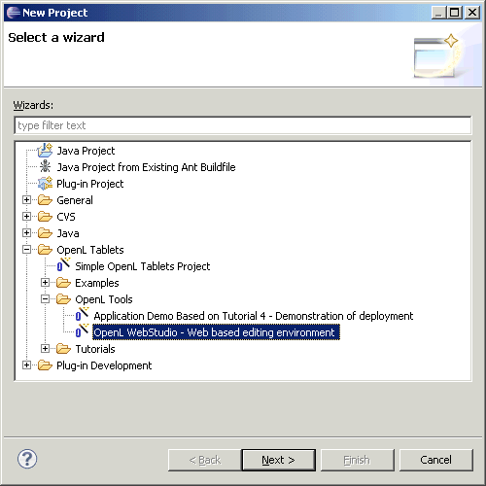
Figure 5: Creating an OpenL Web Studio project
- In the OpenL WebStudio Project window, in the Project name field, enter org.openl.rules.webstudio and click Finish.
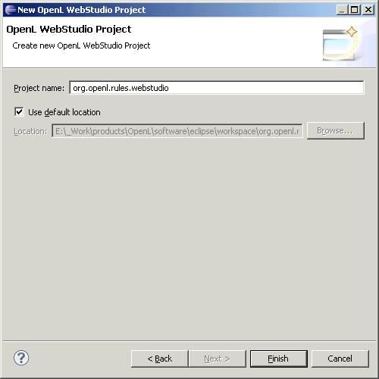
The project is created and appears in Package Explorer.
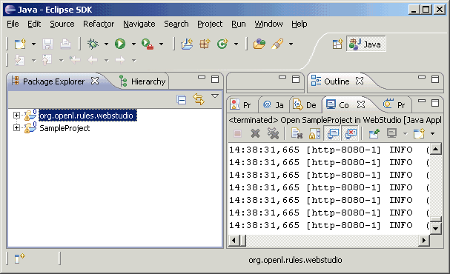
Figure 6: A project created for launching OpenL Web Studio

Test Your Progress
This section instructs the user on how to launch the newly created project in OpenL Web Studio. It also provides troubleshooting for a situation when OpenL Web Studio is not launched because the default port is used by other applications.
The following topics are included:
- Launching the Project in OpenL Web Studio
- Troubleshooting: Switching the Port Used by OpenL Web Studio

Launching the Project in OpenL Web Studio
In this section, you will launch the newly created project in OpenL Web Studio to test your progress. Proceed as follows:
- In Eclipse, find SampleProject.
- Right click it and select Run As > Edit OpenL Project in WebStudio.
- In the Edit launch configuration properties window, in the Project field, click Browse and select org.openl.rules.webstudio.
- Click OK.
Eclipse starts the OpenL Web Studio server and after a short while the application is opened in your web browser.
Note: OpenL Web Studio startup speed depends on your computer RAM. The recommended value is 2 GB of RAM.
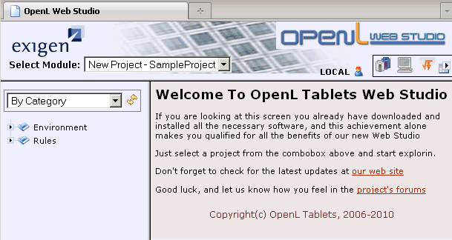
Figure 7: Launching the created project in OpenL Web Studio
The application displays one module at a time. The user must select a module in the Select Module list box to switch between modules. One rule project can contain several modules.
The left pane displays the module tree providing a view of the elements in the currently displayed rule module.
When a table is selected, the right pane displays the contents of the table and provides controls for modifying table data, running tests, and checking test results.
- Ensure that the New Project – SampleProject module is selected.
OpenL Web Studio provides the following modes of displaying tables:
Table display modes
Mode | Description
Business view | The business view is business oriented, displaying only those project elements relevant to a business user. The structure of the tree is logical rather than physical. Rule tables are organized into categories based on Excel table sheets.  OpenL Web Studio provides three business views with slight differences, mainly in the depth of the module tree. The user must repeatedly click the business view button to switch between the different business views.  The user can switch to the business view by clicking Business View .
Developer view | A project is displayed in a way convenient to developers with module tree elements organized by type rather than logic.  The user can switch to developer view by clicking Developer View .
By default, the business view is used.

Troubleshooting: Switching the Port Used by OpenL Web Studio
If upon OpenL Web Studio startup, OpenL Web Studio is not launched in a web browser, and the log in the Eclipse console log identifies that the default port 8080 is used by other applications, modify the port value used by OpenL Web Studio as follows:
- In the directory where Eclipse is installed, locate the following directory:
plugins\org.openl.lib.apache.tomcat_5.4.0.RC3\apache-tomcat-6.0.20\conf
- Open the server.xml file for editing in any text editor, such as Notepad.
- Find the following fragment:
<Connector port="8080" protocol="HTTP/1.1"
connectionTimeout="20000"
redirectPort="8443" />
- Change the port value to any unoccupied value, such as 8081.
- Save the changes and run OpenL Web Studio.

Learning Module 2: Creating and Testing a Decision Table
This learning module introduces OpenL Web Studio UI and functionality. You will be able to create a simple OpenL Tablets table and test it after completing this module.
The following topics are included:
- Topic Summary
- Exercise
- Test Your Progress

Topic Summary
This section introduces OpenL Tablets table recognition algorithm and table types. It also provides a brief overview of BEX expressions that can be used for building expressions in a language close to human natural language.
The following topics are included:
- OpenL Tablets Table Recognition Algorithm
- OpenL Tablets Table Types
- BEX Expressions

OpenL Tablets Table Recognition Algorithm
This section explains the algorithm of how the OpenL Tablets engine looks for supported tables in Excel or Word files. It is important to build tables according to the requirements of this algorithm; otherwise the tables will not be recognized correctly.
OpenL Tablets utilizes Excel concepts of workbooks and worksheets. These can be represented and maintained in multiple Excel files. Each workbook is comprised of one or more worksheets used to separate information by categories. Each worksheet, in turn, is comprised of one or more tables. Workbooks can include tables of different types, each of which can support a different underlying logic.
The following is the general table recognition algorithm:
- The engine looks into each spreadsheet and tries to identify logical tables.
Logical tables must be separated by at least one empty row, or column, or start at the very first row or column. Table parsing is performed from left to right and from top to bottom. The first populated cell that does not belong to a previously parsed table becomes the top-left corner of a new logical table.
- The engine reads the text in the top left cell of a recognized logical table to determine its type.
If the top left cell of a table starts with a predefined keyword then such table is recognized as an OpenL Tablets table.
For more information on table types and predefined keywords, see OpenL Tablets Table Types.
All tables that do not have any of the preceding keywords in the top left cell are ignored. They can be used as comments in Excel or Word files.
- The engine determines the width and height of the table using populated cells as clues.
It is a good practice to merge all cells in the first table row, so the first row explicitly specifies the table width. The first row is called the table header. To put a table title before the header row, an empty row must be used between the title and the first row of the actual table.

OpenL Tablets Table Types
The following are the supported keywords:
Table type keywords
Keyword | Table type | Description
Spreadsheet | Spreadsheet | Is an analogue of the Excel table with rows, columns, formulas, and calculations as contents. Spreadsheets can also call decision tables, or other spreadsheets, to make a decision on values; and based on those, make calculations.
Rules or DT | Decision table | Contains a set of rules describing decision situations where the state of a number of conditions determines the execution of a set of actions. It is the basic table type used in OpenL Tablets decision making.
Data | Data table | Defines an OpenL Tablets data store similar to a table in a relational database. Data types can be used in data tables.
Datatype | Data type table | Contains relational data that can be referenced from other tables within OpenL Tablets. In addition, information in data tables can be accessed from Java code through wrappers as Java arrays. Data tables can contain Java classes or OpenL Tablets data types.
Testmethod | Test table | Used to perform unit tests on decision tables and method tables. It calls a particular method, provides test input values, and checks whether the returned value matches the expected value. Test tables are mostly used for testing decision tables.
Runmethod | Run method table | Calls a particular decision table or method table multiple times and provides input values for each individual call. Therefore, run method tables are similar to test tables, except they do not perform a check of values returned by the called method.
Method or Code | Method table | Is a Java method described within a table.
Environment | Configuration table | Provides information to the OpenL Tablets engine about available Java packages. Another purpose of a configuration file is to point to other Excel and Word files that can be referenced in tables.
We will review decision tables and spreadsheets in this tutorial.
For more information on OpenL Tablets table types, see OpenL Tablets Reference Guide.

BEX Expressions
BEX language enables users to write expressions similar to natural human language. The existing Java business object model automatically becomes the basis for the open business vocabulary used by BEX. For example, Java expression 'policy.effectiveDate' is equivalent to the BEX expression 'Effective Date of the Policy'.
The following table represents BEX keyword equivalents to Java expressions:
BEX keywords
Java expression | BEX equivalents
== | - equals to  - same as
!= | - is not equal to  - different from
a.b | b of the a
< | is less than
> | is more than
<= | - is less or equal  - is in
!> | is no more than
>= | is more or equal
!< | is no less than
In addition, BEX supports a notation where an expression is written using simple variables followed by the attributes they represent. For example, assume the following BEX expression is used:
(Agreed Value of the vehicle - Market Value of the vehicle) / Market Value of the vehicle is more than Limit Defined By User
As can be seen from the example, long expressions are hard to read. However, the expression is much simpler if written according to the notion of explanatory variables as follows:
(A - M) / M > X, where
A - Agreed Value of the vehicle,
M - Market Value of the vehicle,
X - Limit Defined By User
This syntax is similar to the one used in scientific publications and is much easier to read for complex expressions. It provides a good mix of mathematical clarity and business readability.

Exercise
This exercise introduces OpenL Web Studio UI and simple decision tables. You will be able to modify an existing table in OpenL Web Studio and create a new table after completing this exercise.
The following topics are included:
- Understanding OpenL Web Studio UI
- Creating a Construction Age Discount Table

Understanding OpenL Web Studio UI
You will review a sample table created in your project by default in this section. You will briefly review OpenL Web Studio UI and try editing table values. Proceed as follows:
- To launch OpenL Web Studio, locate the C:\OpenLRET directory and run the Start_Web_Studio.cmd file.
- Ensure the New Project – SampleProject module is selected.
- In the module tree on the left, expand the Rules folder and click the hello1 table.
The selected table is displayed in the right pane in read only mode.
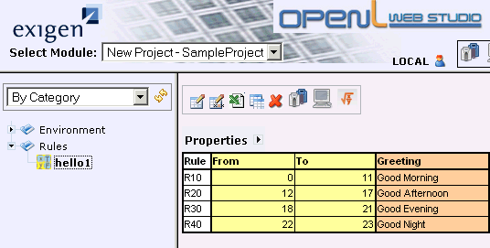
Figure 8: Displaying the table
This is an example of a decision table that displays a definite greeting based on the time value. The first row lists rule names, the next two columns define time interval border values, and the last column contains a greeting. For example, if the value is 14, the rule R20 returns a greeting Good Afternoon.
- Position the mouse pointer over the table and wait until the pop up menu appears.
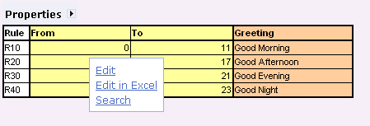
Alternatively, you can use the appropriate icons in the toolbar above the table.
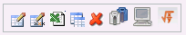
Figure 9: A toolbar for working with a table
- Click Edit.
The view changes to the table editor. In this mode table cell values can be modified and new rows can be added.
- For the rule R30, double click the To value field and enter 20.
- For the rule R40, double click the From value field and enter 21.
- To save the changes, click the Save icon .
The result table must resemble the following:
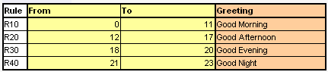
Figure 10: Viewing the updated table

Creating a Construction Age Discount Table
You will create a decision table that defines the discount factor value depending on the construction age in this section. A simple Excel table defining the discount factor dependency on the age of construction follows:
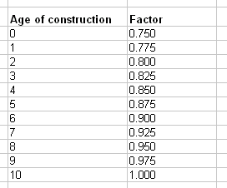
Figure 11: A table on calculating the discount factor
To create a table, proceed as follows:
- In OpenL Web Studio, for the New Project – SampleProject module, display the hello1 table.
- Click Edit table in Excel .
The Excel file containing the table is opened. The Rules tab contains a decision table, and the Environment tab contains rule module settings, such as references to the business object model and other dependencies.
- Add a new spreadsheet and name it Age of Construction.
This step is optional. Creating a spreadsheet creates a branch with the same name in OpenL Web Studio, in the module tree. If all tables are created in the Rules tab, they all will appear under the same Rules branch in the module tree.
- In this spreadsheet, create a table provided at the beginning of this exercise.
Your spreadsheet must resemble the following:
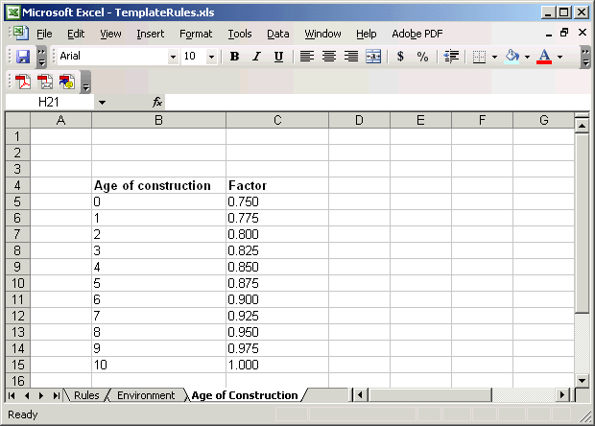
Figure 12: A spreadsheet with a created table
- To specify that the table is a decision table, add a new row with merged cells just before the table with the following contents:
Rules DoubleValue getAgeDiscount(int dwellAge)
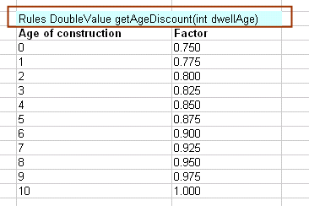
Figure 13: Adding a table header
'Rules' is the keyword identifying a decision table. 'DoubleValue' specifies the type of value returned by the table. 'getAgeDiscount' is the name of the method used to call this table. The parentheses define input parameters for the method. In this case, an instance of the dwellAge class will be passed as an input.
- To define the logic behind this table, add three new rows between the first and second row and add contents as shown in the following figure:
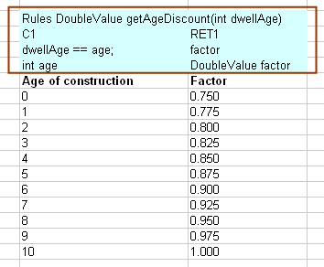
Figure 14: Adding logical information to a decision table
By adding this header you define that for the provided construction age value, an appropriate factor value is retrieved. For example, if the construction is 7 years old, the factor value is 0.925.
The following table describes the general purpose of each of the three added rows:
Logical rows in a decision table
Row number | Description
1 | Row that can consist of the following cell types:  All other cells in this row are ignored and can be used as comments.  If a table contains action columns, the engine executes actions for all rules whose conditions are true. If a table has a return column, the engine stops processing rules after the first executed rule. If a return column has a blank cell and the rule is executed, the engine does not stop but continues checking rules in the table.
  Type | Description | Examples
  Condition column header | Identifies a column containing rule condition and its parameters. It must start with character 'C' followed by a number. | C1, C5, C8
  Action column header | Identifies a column containing rule actions. It must start with character 'A' followed by a number. | A1, A2, A5
  Return value column header | Identifies a column containing values to be returned to the calling program. Since there can be only one return value, the only allowed content of the cell is 'RET1'. | RET1
2 | Row containing cells with code statements for condition, action, and return value column headers. OpenL Tablets supports Java grammar enhanced with OpenL Business Expression (BEX) grammar features.  Code in these cells can use any Java objects and methods visible to the OpenL Tablets engine.  The purpose of each cell in this row depends on the cell above it as follows:
  Cell above | Purpose
  Condition column header | Specifies the logical expression of the condition. It can reference parameters in the method header and parameters in cells below.  The cell must contain an expression returning a Boolean value. All condition expressions must be true to execute a rule.
  Action column header | Specifies code to be executed if all conditions of the rule are true. The code can reference parameters in the method header and parameters in cells below.
  Return value column header | Specifies expression used for calculating the return value. The type of the expression must match the return value specified in the method header. This cell can reference parameters in the method header and parameters in cells below.
3 | Row containing parameter definition cells. Each cell in this row specifies the type and name of parameters in cells below it.  Parameter name must be one word corresponding to Java identification rules.  Parameter type must be one of the following:  - primitive Java types  - Java classes visible to the engine  - one-dimensional arrays of the above types  - data tables or their attributes
- Save your changes.
Use the following steps and switch to OpenL Web Studio to verify that the table was successfully created.
- In OpenL Web Studio, click the Refresh Project icon.
The Age of Construction tab you created in Excel must appear in the tree on the left.
- Expand it and click the getAgeDiscount table.
The table is displayed.
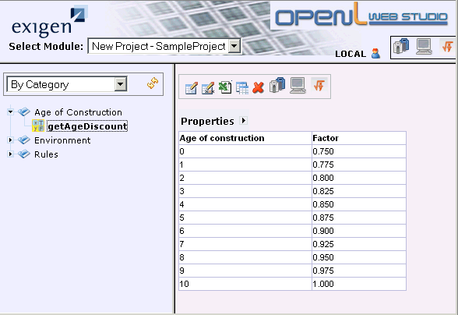
Figure 15: The getAgeDiscount available in OpenL Web Studio

Test Your Progress
In this section, you will create and run a test table for the newly created construction age discount table.
The following topics are included:
- Creating a Test Table
- Running the Test Table

Creating a Test Table
To create a table for testing the construction age discount table, proceed as follows:
- In Excel, in the Age of Construction spreadsheet, next to your created table, create the following table of three columns:
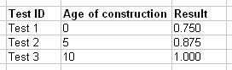
Figure 16: A test table draft
The first column identifies test ID, the second displays age values you will be using for testing, and the last column displays the expected result.
- Add the OpenL Tablets semantics to the test table.
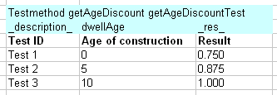
Figure 17: An OpenL Tablets test table
A test table has the following structure:
- The first row is the table header, which has the following format:
Testmethod <method name> <test table name>
'Testmethod' is the keyword that identifies a test table. The second parameter is the name of the decision table method or any other Java method to be tested. The third parameter is the name of the test table, which is also the name of the method by which the test table can be executed from Java code.
- The second row defines a column for naming tests, a column for the age input parameter of the decision table method, and a column _res_, which contains the expected test result values. Parameter names must match the names of input parameters of the method that they test.
- The third row contains table column names displayed to business users.
- Starting with the fourth row, each row is an individual test run.
When a test table is called, the OpenL Tablets engine calls the specified method for every row in the test table and passes to it the corresponding input parameters.
- Save the changes.

Running the Test Table
To execute unit tests defined in the table getAgeDiscountTest, proceed as follows:
- Ensure that you save the changes you made in the Excel file.
- Switch to OpenL Web Studio and refresh the project by clicking Refresh Project .
- In the module tree, expand the Age of Construction branch and verify that it contains the getAgeDiscountTest table.
- Click the getAgeDiscountTest table.
The table is displayed on the right. Notice that the getAgeDiscount table icon differs from icons used for other tables . A check box identifies that a decision table has tests defined for it. Notice also the test table icon which differentiates test tables from other tables.
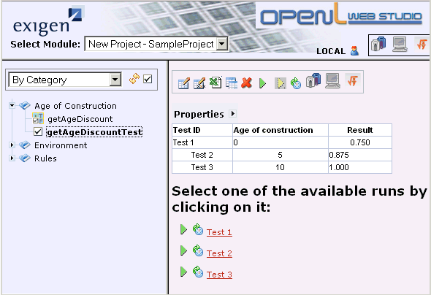
Figure 18: Displaying the test table in OpenL Web Studio
- To execute one of the tests, click the Run icon next to the test name.
- To execute all tests, click the Run All Tests icon .
OpenL Web Studio displays test results.
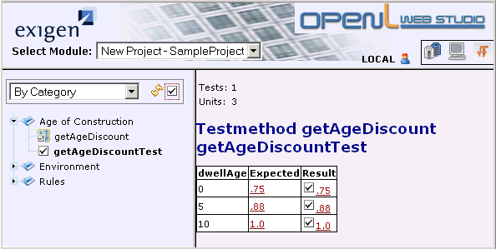
Figure 19: The getAgeDiscount table test results
Every row in the table represents one call of the decision table. If a call returns a value that does not match the expected value, the test fails. Failed tests are represented by the mark. Passed tests are represented by the mark. In this case, all tests were passed.
Now let’s add two more tests, one containing valid data and another one with incorrect data.
- Switch to Excel and update the test table as follows:
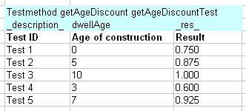
Figure 20: The updated getAgeDiscountTest table
If you compare entered values to values in the getAgeDiscount table, you notice that the test 4 contains an incorrect expected result, and test 5 contains the correct expected result.
- Save the changes in Excel.
- Switch to OpenL Web Studio and refresh the project.
- Run all tests for the test table.
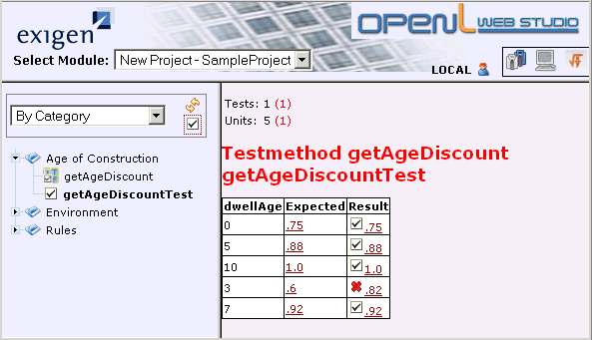
Figure 21: Test results with an erroneous test
As you can see, test 4 failed, where you provided an incorrect expected result.
- To find out how the result is calculated, in the Result column, click the value link, and in the Explanation window that appears, in the pane on the left, click the R4.factor link.
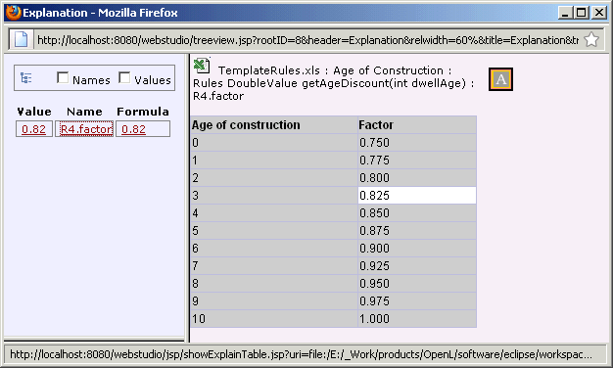
Figure 22: Reviewing calculation details in the Explanation window
The pane on the right names the table used for calculation and displays the table contents. Calculation logic can be traced to find errors.

Learning Module 3: Creating and Testing More Complex Decision Tables
This section explains how to create two and three dimensional tables and how a table can process results retrieved from another table. This learning module also includes a benchmarking exercise.
The following topics are included in this section:
- Topic Summary
- Exercise
- Test Your Progress

Topic Summary
This section explains the business logic of tables developed in this learning module, briefly describes benchmarking, and includes the following topics:
- Introducing a Two Dimensional Table
- Introducing a Three Dimensional Table
- Introducing Benchmarking

Introducing a Two Dimensional Table
A two dimensional table created in this learning module represents value calculation based on two factors. An Excel representation of the base rate calculation table is as follows:
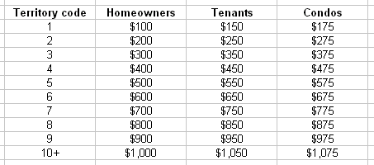
Figure 23: An Excel version of the two dimensional table
In this table, the base rate value is derived based on the code value and policy type. For example, for the code 7 and tenant policy, the base rate value is $750. Notice that the table contains a value range for code values equal or more than 10. When defining a decision table, such value type must be set to IntRange.

Introducing a Three Dimensional Table
A three dimensional table developed in this learning module represents earthquake rate calculation based on three factors, earthquake zone, coverage type, and dwelling type. In addition, this exercise illustrates how a table can use the calculation results retrieved from another decision table. In this example, the earthquake value is denoted based on the provided territory code.
Thus, the exercise is based on developing two decision tables:
- A simple table for transforming the territory code into the earthquake zone value.
This table resembles a table described in Learning Module 2: Creating and Testing a Decision Table and its Excel representation is as follows.
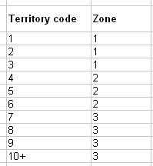
Figure 24: A simple table for retrieving an earthquake zone based on the territory code
For example, for the territory code 6, the earthquake zone value is 2.
- A more complex table transforms the earthquake zone value retrieved from a simpler table, the coverage type, and dwelling type into an earthquake rate value. The table Excel representation is as follows.
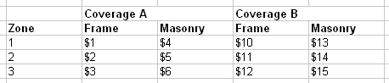
Figure 25: A complex table using another table calculation results
For example, for the zone 2, coverage B, and Frame dwelling type, the earthquake rate is $11.

Introducing Benchmarking
OpenL Web Studio provides benchmarking tools for measuring execution time for all appropriate OpenL Tablets elements. Benchmarking is useful for optimizing the rule structure and identifying critical paths in rule calculation.
You will run benchmarking for the developed test tables as described in Test Your Progress in this learning module.

Exercise
This section instructs you on how to create complex decision tables. You will learn to create a base rate table that represents a two dimensional table, and an earthquake rate table that represents a three dimensional table referencing another table.
The following topics are included:
- Creating a Two Dimensional Table
- Creating a Three Dimensional Table Referencing Another Table

Creating a Two Dimensional Table
To create a two dimensional table for base rate calculation, proceed as follows:
- To open the project Excel file, in OpenL Web Studio, in the module tree, click any table and click Edit table in Excel .
- In the Excel file, create a Base Rates spreadsheet.
- Create the base rate table as follows:
Figure 26: A base rates table
Now you need to add lines specific to the OpenL Tablets decision table representation as described in the following steps.
- Add four empty rows before the table.
- In the first row, enter the following table header information:
Rules DoubleValue getBaseRate(IntRange territoryCode, String policyType)
As already mentioned in Introducing a Two Dimensional Table, using the 10+ code value requires using the IntRange value type.
- In the second row, identify the territory code as a condition.
- For three policy type columns, split the row and identify those as a return value.
The table resembles the following.
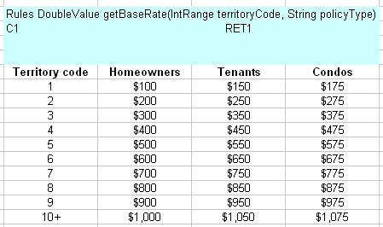
Figure 27: Creating the Base Rates table header
- In the fourth row, specify the variables’ names and types as follows:
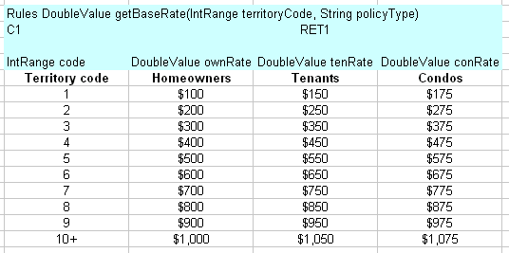
Figure 28: Adding parameter names and types
- In the third row, for the Territory code column, enter the following statement:
code.contains(territoryCode.getMin())||code.contains(territoryCode.getMax())
This expression binds territoryCode received as an input parameter to the code parameter value in the table.
- For the other three columns, split the cells and enter the following statement:
if (policyType.equals("Homeowners")) return ownRate ; if (policyType.equals("Tenants")) return tenRate; if (policyType.equals("Condos")) return conRate; return -1;
- Save the changes.
- Refresh the project in OpenL Web Studio and view the created table.
The result resembles the following:
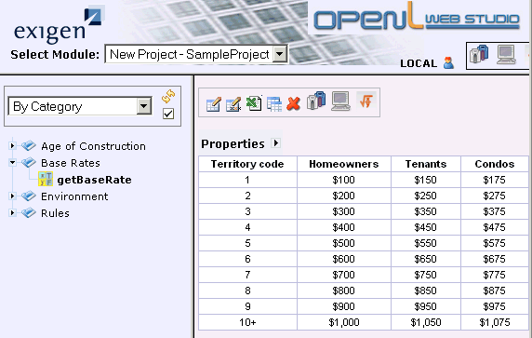
Figure 29: Verifying the Base Rates table in OpenL Web Studio

Creating a Three Dimensional Table Referencing Another Table
This section explains how to create a three dimensional table for earthquake rate value calculation and a table for transforming the territory code into the earthquake zone. Proceed as follows:
- In OpenL Web Studio, open the project Excel file.
- Create an EQ Rates spreadsheet.
The following steps describe creating a simple table for transforming the territory code into the earthquake zone. This table syntax resembles the one described in Creating a Construction Age Discount Table.
- Create the following table:
Figure 30: The first table contents
- Add the decision table header as follows:
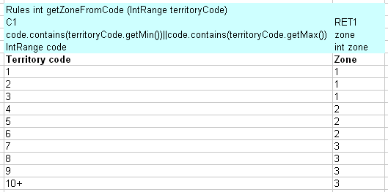
Figure 31: A table for converting a territory code into an earthquake zone
This decision table syntax identifies that the territoryCode value, received as an input parameter, is converted into a zone value. For example, for the territory code 7, zone 3 is returned as a result.
Now you will create the three dimensional table that references the getZoneFromCode table.
- In the same spreadsheet, create the following table:
- Insert five empty rows between the line identifying the coverage type and the line with column names.
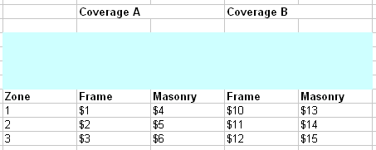
Figure 32: Creating a frame for the decision table
The OpenL Tablets syntax does not support two table header rows, so you separated the coverage header from the column header with an empty line, still keeping it above the table for easier perception of the table.
- In the first row, add the decision table header as follows:
Rules DoubleValue getEQRate (IntRange territoryCode, String covType, String dwellType)
As you can see, this table receives three input parameters, territoryCode, covType, and dwellType.
- In the second row, set the Zone column as a condition, and, for the next four columns, split cells and set the result cell as a return value.
- In the fourth row, define parameter names and types as follows:
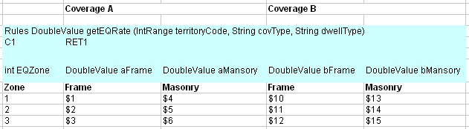
Figure 33: Specifying parameter names and types
- In the third line, for the Zone column, define the following statement:
EQZone == getZoneFromCode(territoryCode)
- For the next four columns, split cells and enter the following statement:
if (covType.equals("A")) return dwellType.equals("Frame") ? aFrame : aMansory ; if (covType.equals("B")) return dwellType.equals("Frame") ? bFrame : bMansory ; return -1;
- Save the changes.
- In OpenL Web Studio, refresh the project and in the module tree, expand the EQ Rates branch.
This branch must contain two tables, getEQRate and getZoneFromCode.
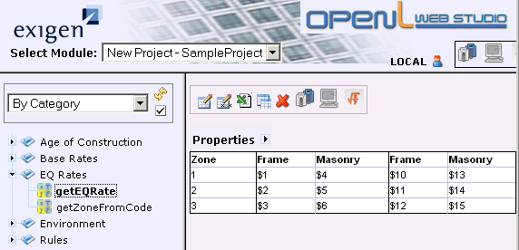
Figure 34: The getEQRate table in OpenL Web Studio

Test Your Progress
This section explains how to create tables for testing your developed base rates and earthquake rates tables and provides an example of the use of benchmarking.
The following topics are included:
- Testing the Base Rates Table
- Testing the Earthquake Rates Table
- Using Benchmarking in OpenL Web Studio

Testing the Base Rates Table
To test the base rates table, proceed as follows:
- In OpenL Web Studio, open the project Excel file.
- In the Base Rates spreadsheet, create the following table:
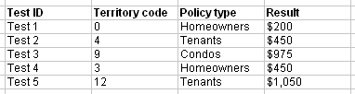
Figure 35: The base rates test table contents
If you compare this table to the created base rates table, you will notice that Test 1 and Test 4 will fail. Test 1 references a territory code that does not exist in the base rates table, and the Test 4 expected result is incorrect.
- Add the test table header as follows:
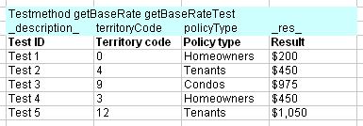
Figure 36: The complete test table for the base rates table
- Save the changes.
- In OpenL Web Studio, refresh the project.
- Ensure that the getBaseRateTest table appears under the Base Rates branch in the module tree.
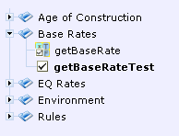
Figure 37: Expanding the Base Rates branch
- Run the tests .
Tests 1 and 4 fail in the test results.
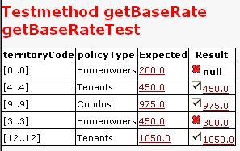
Figure 38: Running the getBaseRateTest table

Testing the Earthquake Rates Table
To test the earthquake rate table, proceed as follows:
- In OpenL Web Studio, open the project Excel file.
- In the EQ Rates spreadsheet, create the following table:
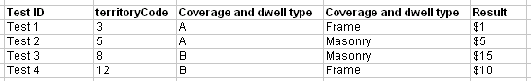
Figure 39: The earthquake rates test table contents
If you compare this table to the created getEQRate and getZoneFromCode tables, you will see that Test 4 will fail as its expected result is incorrect.
- Add the test table header as follows:
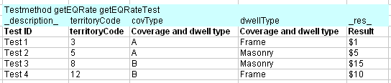
Figure 40: The complete test table for the earthquake rates table
- Save the changes.
- In OpenL Web Studio, refresh the project.
- Ensure that the getEQRateTest table appears under the EQ Rates branch in the module tree.
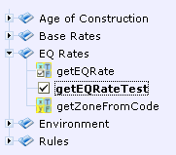
Figure 41: Expanding the EQ Rates branch
- Run the tests .
Test 4 fails in the test results.
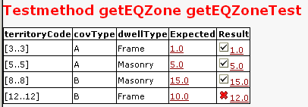
Figure 42: Figure 48: Running the getEQRateTest table

Using Benchmarking in OpenL Web Studio
To check table performance using benchmarking, proceed as follows:
- In OpenL Web Studio, in the module tree, expand the EQ Rates branch and click the test table.
- Click the benchmarking icon.
Test table performance evaluation results are displayed.
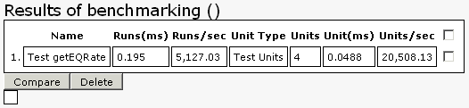
Figure 43: Test table benchmarking results
- For the same test table, run benchmarking two more times.
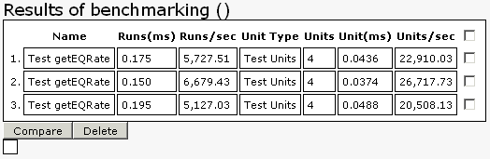
Figure 44: Running benchmarking three times for the same table
Now you can compare the performance results.

Learning Module 4: Creating and Testing Spreadsheets
This section explains how to create and test a spreadsheet table that retrieves information from decision tables developed in the previous learning modules. The following topics are included:
- Topic Summary
- Exercise
- Test Your Progress

Topic Summary
This section briefly describes the spreadsheet table concept and syntax and introduces a method table used for testing the spreadsheet table. The following topics are included:
- Introducing a Spreadsheet Table
- Introducing a Method Table

Introducing a Spreadsheet Table
A spreadsheet table in OpenL Tablets is an analogue of the Excel table with rows, columns, formulas, and calculations as contents. Spreadsheets can also call decision tables or other spreadsheets to make decisions on values, and based on those, make calculations.
You will develop a spreadsheet table for calculating the policy premium value defined as a sum of all values retrieved from tables created in this tutorial. This means the policy premium value is defined as a sum of the following values:
- construction age factor
- base rate
- earthquake rate
The format of the spreadsheet table header is as follows:
Spreadsheet SpreadsheetResult nameOfTableOrMethod(ARGUMENTS)
The following table describes the spreadsheet table header syntax:
Spreadsheet table header syntax
Element | Description
Spreadsheet | Reserved word that defines the type of the table.
SpreadsheetResult | Type of the return value. SpreadsheetResult must always be used.
nameOfTableOrMethod | Name of the table.
ARGUMENTS | Input arguments.

Introducing a Method Table
A method table is a Java method described within a table. The following is an example of a method table:
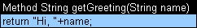
Figure 45: A method table
The first row is a table header, which has the following format:
<keyword> <return type> <method name and parameters>
where <keyword> is either 'Method' or 'Code'.
The second row is the actual code to be executed. It can reference parameters passed to the method and all Java objects and tables visible to the OpenL Tablets engine.
Both a test table and method table must be used to test the spreadsheet table developed in this learning module. The created spreadsheet table returns four values as a result; three for the calculated intermediate values of the construction age, base rate, and earthquake rate, and one for the total policy premium value. The test tables used in the preceding modules use only one input value from the spreadsheet table. A method table enables retrieving one value from the spreadsheet table, and then this value can be used in a usual test table for unit testing.

Exercise
To create a policy premium calculation spreadsheet, proceed as follows:
- In OpenL Web Studio, open the project Excel file.
- Create a Spreadsheet Table spreadsheet.
- In a row, split three cells and enter the spreadsheet table header as follows:
Spreadsheet SpreadsheetResult getPolicyValue(int dwellAge, IntRange territoryCode, String policyType, String covType, String dwellType)
The spreadsheet table will use calculations from all tables created in the preceding learning modules and you must specify all input parameters for those tables as input parameters for the spreadsheet table.
- Add the following column names:
- Step
- Name
- Value
The table resembles the following:
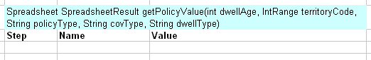
Figure 46: Creating a spreadsheet table
- In the first line of the table, in the Step column, enter Step1, and in the Name column, enter Age of construction.
- In the Value column, enter {getAgeDiscount(dwellAge)}.
The value will be calculated by calling the getAgeDiscount table and providing the appropriate input parameter.
- Fill in the rest of the table as follows:
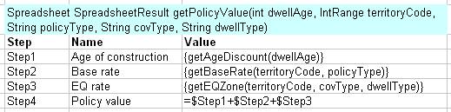
Figure 47: The spreadsheet table
As you can see, the policy premium value is calculated as a sum of the steps 1-3.
- Save the changes.
- In OpenL Web Studio, refresh the project and ensure that the module tree contains the Spreadsheet Table branch with a getPolicyValue table.

Test Your Progress
To test the created spreadsheet table, proceed as follows:
- In OpenL Web Studio, open the project Excel file.
- Open the Spreadsheet Table spreadsheet.
- To create a method table, enter the following method table header:
Method DoubleValue getPolicyValueMethod(int dwellAge, IntRange territoryCode, String policyType, String covType, String dwellType)
- For the method table contents, enter the following statement:
return getPolicyValue(dwellAge, territoryCode, policyType, covType, dwellType).getFieldValue("$Value$Step4");
The method table resembles the following:
Figure 48: A method table for testing the spreadsheet table
As you can see, the method table receives same input values as the spreadsheet table, and returns the value from Step4 of the spreadsheet table representing the total policy premium value.
- Now create the test table of seven columns as follows:
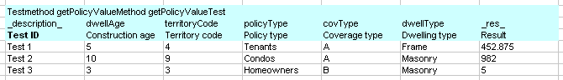
Figure 49: A test table for testing the spreadsheet table
Remember to split the cells of the test table header line. If you manually calculate the values using test values and tables created in the preceding learning modules, you will notice that Test 3 will fail as it provides an incorrect result value.
- Save the changes.
- In OpenL Web Studio, refresh the project.
The Spreadsheet Table branch must contain the created spreadsheet table, method, and test table.
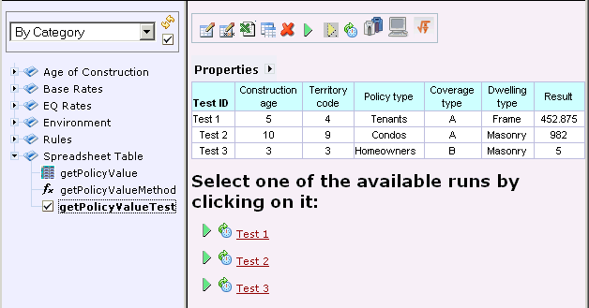
Figure 50: The Spreadsheet Table branch contents with the displayed test table contents
- Run all tests and verify that test 3 failed as expected.
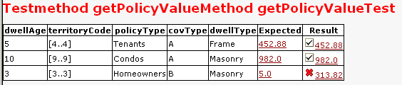
Figure 51: A spreadsheet test table with one test failed

Learning Module 5: Investigating the Rating Engine Logic
This section explains how to investigate the rating engine logic based on the customer’s input and includes the following topics:
- Topic Summary
- Exercise
- Test Your Progress

Topic Summary
When input from a customer is received, it is usually represented as a set of data, or rule, statements stored in a Word document, Excel spreadsheet, or a PDF file.
Business analyst tasks assume going through the following phases:
Input processing steps
Step | Location | Description | Reference
1. | Review input documents. | At this phase, the analyst reviews information provided by a customer as input and identifies rating algorithm logic. The next step is to determine how the rating algorithm data is interrelated.  This means reviewing factors and rule statements describing how the customer’s business works, and understanding how these factors and statements impact one another. | Learning Module 5: Investigating the Rating Engine Logic > Exercise
2. | Organize data into a spreadsheet. | The next step is to group the logically related data into Excel spreadsheets and transform text format rules and factors into simple tables.  If necessary, Excel links and named regions can be used to simplify navigation within spreadsheets.  In real life situations, a customer’s inconsistency in naming factors, or using legacy names in a spreadsheet, can necessitate more research time to make decisions regarding the location of the proper rate table or algorithm. The better a customer’s rating documentation is organized, the easier the analyst’s task of locating and understanding different parts of the rating engine will be.
3. | Prepare rating engine data for a specific implementation. | When the rating engine data is organized, it must be prepared for processing by a selected tool.  OpenL Tablets requires a definite set of modifications to be applied to tables in Excel, such as define a table type, data types, functions with parameters and return data calls.  At this point, the analyst also creates a vocabulary and connects a rating algorithm to the business model attributes.  If necessary, this phase can involve developers for tasks such as integrating Excel tables with Java code. This phase is primarily fulfilled by an analyst. | - Learning Module 2: Creating and Testing a Decision Table  - Learning Module 3: Creating and Testing More Complex Decision Tables  - Learning Module 4: Creating and Testing Spreadsheets
You will review input documents in this learning module. For the sake of simplicity, data in the sample Excel file provided for revision is divided into spreadsheets, thus covering the phase of organizing data into a spreadsheet. The following sections of this tutorial contain comments and recommendations on how to logically group data in real situations.

Exercise
This section explains how to review the customer’s input on business processes, factors, and rules, and how to understand rating engine logic. The following topics are included:
- Initiating the Review
- Reviewing Master Spreadsheets
- Reviewing Supporting Spreadsheets and Tables

Initiating the Review
In this section, you will review the EMHomeRules_simple.xls file provided with this tutorial. This file contains customer provided data on homeowner policy calculation for the homeowners, tenants, and condo situations.
Proceed as follows:
- Open the C:\OpenLRET\Samples\EMHomeRules_simple.xls file.
The file contains various spreadsheets, which means that the customer has already grouped information into logical sets.
Later on, when the rule engine logic is investigated, this data can be regrouped as necessary.
- Review spreadsheets.
The following sections will help you to review spreadsheets with input data provided by a customer.

Reviewing Master Spreadsheets
A master spreadsheet represents the main calculations of the rating engine. All other spreadsheets are logically subordinated to master spreadsheets.
The master spreadsheet’s purpose is to simplify information representation and navigation. Typically a master spreadsheet will not contain complex calculations and long tables with factors and values relationships. Instead, the master spreadsheet is left as clear and simple as possible, and for calculations, it calls functions and factors from other spreadsheets. Links to spreadsheets must be provided in order to simplify navigations.
Proceed as follows:
- In the EMHomeRules_simple.xls file, select the EM Home Rating Steps spreadsheet.
With the next spreadsheet, EM TN and CO Steps, it represents a master spreadsheet of this Excel file.
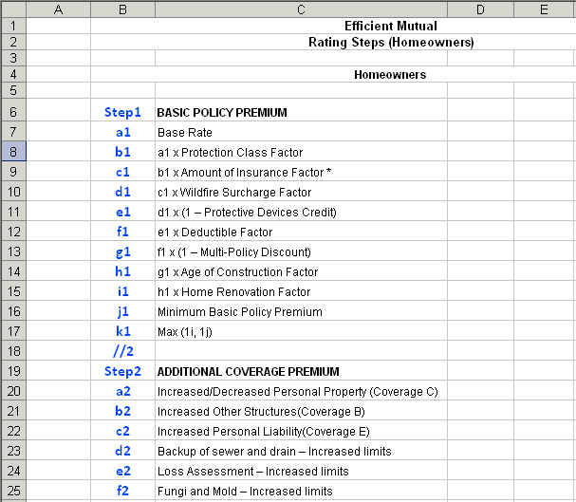
Figure 52: Reviewing a master spreadsheet
- Look at the top four rows.
These rows contain information about the company name, Efficient Mutual, and spreadsheet contents, which are steps for calculating rates. Line 4 says that this spreadsheet contains information for the homeowner case.
- Switch to the next spreadsheet, EM TN and CO Steps.
As you can see, it resembles the EM Home Rating Steps spreadsheet and represents rating calculation steps for the tenants and condos case.
Depending on the customer’s company business specifics, one or more master spreadsheets can be used. In this example, tenants and condo case calculations coincide, but they both differ from the homeowner case calculations. This is why two master spreadsheets are used.
- Now switch to the EM Home Rating Steps spreadsheet and check the spreadsheet name.
Figure 53: Spreadsheet name
It contains the abbreviation of the customer’s company name, EM, and identifies spreadsheet contents, rating steps, and specialization, homeowners. Putting an abbreviation of the company name stresses the difference between these two master spreadsheets and all other spreadsheets.
When organizing your own spreadsheets, think of your own system for naming those, or use an approach similar to this example.
- Now check the table contents, starting with line 6.
Column B lists the sequential steps of the policy calculation. Column C lists the calculation rule groups for the following policy premium calculation:
- basic policy premium
- additional coverage premium
- earthquake premium
- total policy premium
Each group of premium calculation rules demonstrates the step-by-step calculation of the corresponding premium. For example, the total policy premium value is calculated as a sum of the basic, additional coverage, and earthquake premium values.
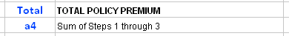
Figure 54: Rule on calculating the total policy premium value
Now let’s review the basic policy premium calculation steps.
- See step a1 in line 7.
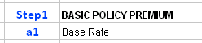
Figure 55: Step a1, line 7
First, it says that the base rate value must be retrieved. If you check the spreadsheets names, you will find the spreadsheet named Base Rates that contains base rate values. We will review that spreadsheet further in this tutorial.
- See the next step, which is b1 in line 8.
Figure 56: Step b1, line 8
It says that the step b1 value is calculated as the step a1 value multiplied by the protection class factor. Check the spreadsheets names and you will find the Protection Class sheet that holds data for protection class value calculation. You will review that spreadsheet further in this tutorial.
- In a similar way, go through all policy calculation steps in this spreadsheet and ensure that you can find spreadsheets containing appropriate values calculations information.
- Note that a spreadsheet can contain not only tables, but also text format rules.
For example, line 45 defines a rule on rounding the Amount of Insurance factor value.
Figure 57: A rule for rounding the value
- Now switch to the EM TN and CO Steps spreadsheet and review it in a similar manner.

Reviewing Supporting Spreadsheets and Tables
All spreadsheets and tables other than master spreadsheets are considered supporting. Such supporting spreadsheets contain various data, factors, rules, statements, and other information provided by a customer. This data describes the customer’s business specifics in one spreadsheet, or in multiple sheets. Depending on the size and complexity of your application, organize the data so that each spreadsheet contains logically related data.
The Excel file reviewed in this tutorial contains two master spreadsheets described in Reviewing Master Spreadsheets and multiple supporting spreadsheets with grouped information for premium factors calculation.
In this section, we will review several typical supporting spreadsheets. Proceed as follows:
- In the EMHomeRules_simple.xls file, select the Base Rates spreadsheet.
The first column of the table, EM Territory, contains territory codes. The other three columns provide base rate values for the homeowner, tenant, or condo cases. When a user selects the appropriate territory code and homeowner type in the application, the base rate value is retrieved.
For example, for the tenant case, for the entered code 107, the base rate value is $792.
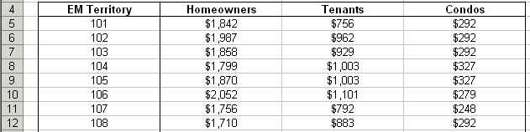
Figure 58: Determining a base rate value
Tables such as these can be considered as a simple case and will require little effort when preparing it for further processing.
- Switch to the Protection Class spreadsheet.
This spreadsheet contains three tables. The two tables on the left contain dependencies between the protection class value and construction type, for the homeowner, tenant, or condo case.
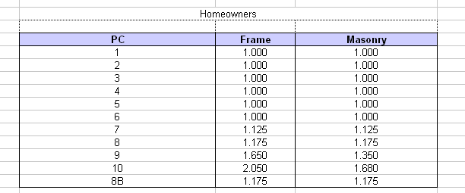
Figure 59: Dependencies between the protection class value and construction type
The table on the right defines the construction’s full name and type depending on the construction code provided in the first column.
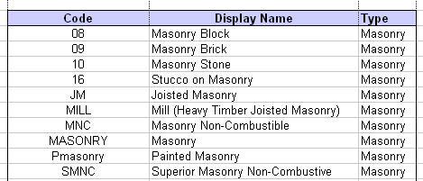
Figure 60: Dependency between construction code and its full name and type
A spreadsheet such as this can be considered as a simple case as well, as it consists of two simple tables.
- Switch to the Amount of Insurance spreadsheet.
This spreadsheet contains a set of text format rules identifying how the insurance amount is calculated. For tenants and condos, the insurance amount factor is calculated up to the provided formulas. For homeowners, the provided formula is applied to amounts exceeding $8,000,000, and, for smaller amounts, the table on the left is used.
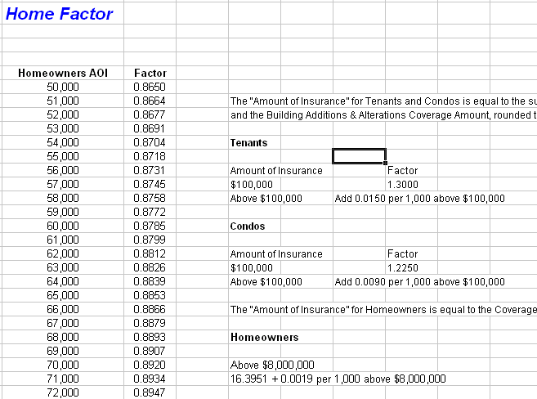
Figure 61: The Amount of Insurance tab
This input is considered a complicated case, mostly because the textual format input must be converted into tables, with formulas, before further processing.
- Review the rest of the tabs in a similar manner.

Test Your Progress
Review the sample Excel file spreadsheets and compare your understanding of those to the brief explanation provided in the following table:
Workbook spreadsheets overview
Spreadsheet | Description
EM Home Rating Steps | Master spreadsheet about how policy premium for the homeowner case is calculated. The table contains references to other spreadsheets and formulas that describe factor interrelationships.
EM TN and CO Steps | Master spreadsheet about how to calculate a policy premium for condo and tenant cases. The table contains references to other spreadsheets and formulas that describe factor interrelationships.
Base Rates | Supporting spreadsheet about how to calculate the base rate based on the provided territory code. Base rate values differ for homeowner, tenant, and condo cases.
Protection Class | Supporting spreadsheet about how to determine the protection class based on the construction code.
Amount of Insurance | Supporting spreadsheet about how the insurance amount is calculated. For tenants and condos, the insurance amount factor is calculated up to the provided formulas. For homeowners, the provided formula is applied to the amount exceeding $8,000,000; and for smaller amounts, the table on the left is used.
Wildfire Surcharge | Supporting spreadsheet about how the wildlife surcharge is calculated based on the distance to high or very high vegetation.
Protective Devices Credit | Supporting spreadsheet about how the protective devices credit amount is calculated based on the protective device type. Note that the amount is calculated as the least of the following values:  - maximum allowed percentage of credit, which is 35%  - sum of credit percentage values for the protective devices installed
Deductible | Supporting spreadsheet about how the premium deductible is calculated. Note that formulas differ for homeowner and condo or tenant cases.
Multi_Policy Discount | Supporting spreadsheet about how the discount in case of multiple policies is calculated.
Age of Construction | Supporting spreadsheet about how the age of construction factor is determined. Note that if a home qualifies for the home renovation discount, the age of construction surcharge is not applied.
Home Renovation | Supporting spreadsheet about how the home renovation factor value is determined depending on the number of years since renovation.
Minimum Basic Policy Premium | Supporting spreadsheet about how the minimum basic policy premium is determined depending on whether it is a homeowner, tenant, or condo case policy.
Homeowner_s Coverage C change | Supporting spreadsheet for calculating coverage C value. Note the rule on coverage value increasing or decreasing.
Coverage B change | Supporting spreadsheet for calculating the increased coverage B value.
Personal Liability change | Supporting spreadsheet for calculating the personal liability rate based on the personal liability limit value.
Backup of Sewer and Drain | Supporting spreadsheet about how to calculate the rate value for the sewer and drain backup, based on the coverage amount.
Loss Assessment | Supporting spreadsheet about how to calculate the loss assessment value based on the coverage amount value.
Fungi | Supporting spreadsheet about how to get the fungi rate value based on the coverage amount value.
Condo Rental to Others | Supporting spreadsheet about calculating the condo rental factor value.
Other Structure Rented to Other | Supporting spreadsheet about calculating the factor value when a structure, other than a home, is rented to other families. Note that the value depends on whether the structure is rented to one or two families, and is dependent on the personal liability limit.
Student Away from Home | Supporting spreadsheet about calculating student away from home extended coverage.
Identity Theft | Supporting spreadsheet for calculating theft identity factor.
Worker_s Compensation | Supporting spreadsheet about how to calculate worker’s compensation coverage for residence employees.
EQ Base Rates | Supporting spreadsheet about earthquake base rates calculation.
EQ Zone Map | Supporting spreadsheet about earthquake zone detection based on the zip code.
EQ Deductible | Supporting spreadsheet about earthquake factor calculation based on the deductible value.
EQ Multi_Story | Supporting spreadsheet about calculating the factor value when various earthquake stories occurred.
EQ Year Built | Supporting spreadsheet about calculating the earthquake related factor related to the year when the construction was built.
EQ Loss Assessment | Supporting spreadsheet about calculating the earthquake caused loss assessment, based on the earthquake zone, construction type, and deductible percentage values.
Env | OpenL Tablets specific spreadsheet for configuring environment technical information. This spreadsheet is not involved in rating engine calculations.

Learning Module 6: Importing an OpenL Tablets Project
This learning module explains importing a predefined OpenL Tablets project. The following topics are included in this learning module:
- Topic Summary
- Exercise
- Test Your Progress

Topic Summary
An OpenL Tablets project stores all information related to the rating engine application reviewed in the previous learning module. Additionally, an OpenL Tablets project is required to launch OpenL Web Studio.
Typically, an OpenL Tablets project is Eclipse compatible and contains the following general elements:
- Excel files
- Ant task for generating file wrappers
- wrappers
- additional Java code
- third party libraries
Note: Using third party libraries requires adding a lib folder, putting libraries in that folder, and adding a reference in a project to these libraries.
Ant is a Java-based software build system.
Note: For the OpenL Tablets plug-in version later than 5.3.1 build 20100128, Ant task and wrappers are no longer used.
The following table describes the physical structure of an OpenL Tablets project:
OpenL Tablets project structure
Folder | Contents
src | Contains all project Java classes apart from wrappers.
rules | Contains Excel files.
gen | Contains generated wrapper classes.
bin | Contains compiled Java code.
target | Contains compiled Java code if Maven is used.
build | Contains Ant configuration file for generating wrapper classes and a generated properties file for OpenL Web Studio.
Note: For the OpenL Tablets plug-in version later than 5.3.1 build 20100128, the Maven project structure is used.
You will import an OpenL Tablets project that is already configured as necessary in this learning module.

Exercise
This section explains how to import a preconfigured OpenL Tablets project into Eclipse. The following topics are included in this section:
- Importing an OpenL Tablets Project into Eclipse
- Launching the Imported Project in OpenL Web Studio

Importing an OpenL Tablets Project into Eclipse
To import a configured OpenL Tablets project into Eclipse, proceed as follows:
- In Eclipse, select File > Import.
- Select Existing Projects into Workspace and click Next.
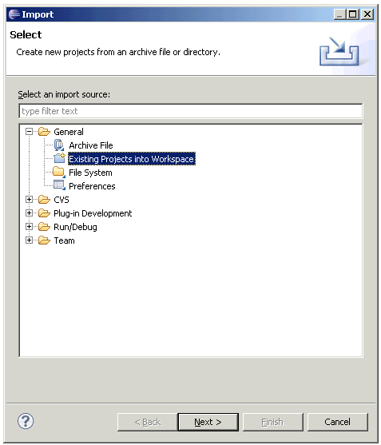
Figure 62: Running the import wizard
- In the Import Project window that appears, in the Select root directory: field, locate the C:\OpenLRET\Samples\eis-openl-training directory.
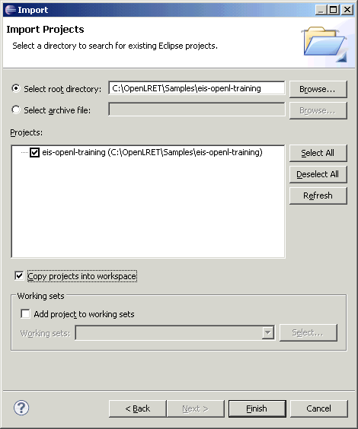
Figure 63: Specifying a root directory
- In the Projects section, ensure that eis-openl-training project is selected.
- Select the Copy projects into workspace check box and click Finish.
The project is imported and appears in Eclipse, in the Package Explorer view.
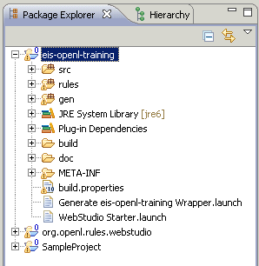
Figure 64: An imported project in the Package Explorer
- If the red cross icon appears next to the project name indicating errors occurred upon project importing, proceed as follows:
- Ensure that the Project > Build Automatically option is selected.
- Select Project > Clean, select the eis-openl-training project, and click Clean projects selected below.
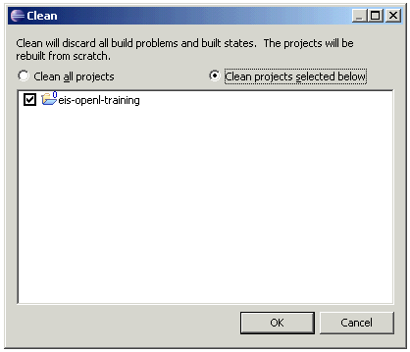
Figure 65: Cleaning the selected projects

Launching the Imported Project in OpenL Web Studio
To launch the imported project in OpenL Web Studio, proceed as follows:
- In Eclipse, in Package Explorer, expand the imported eis-openl-training project.
- To generate a wrapper, right click Generate eis-openl-training Wrapper.launch and select Run As > Generate eis-openl-training Wrapper.
- To launch the project in OpenL Web Studio, right click the project name and select Run As > Edit OpenL Project in WebStudio.
A project is displayed in your browser.
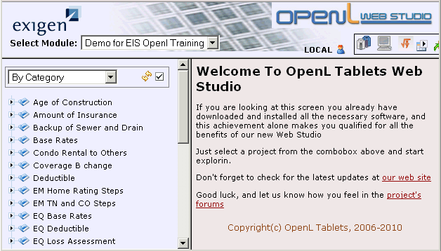
Figure 66: Displaying an imported project in OpenL Web Studio

Test Your Progress
This section explains reviewing the imported project and includes the following topics:
- Reviewing a Master Spreadsheet Table of the Imported Project
- Reviewing Other Spreadsheets of the Imported Project

Reviewing a Master Spreadsheet Table of the Imported Project
You will review a master spreadsheet table in this section. This table is a master spreadsheet reviewed in the previous learning module, with OpenL Web Studio syntax added. Proceed as follows:
- Open the eis-openl-training project Excel file.
This can be done by one of the following actions:
- In Eclipse, expand eis-openl-training >rules, right click EMHomeRules.xls and select Open with > System Editor.
- In OpenL Web Studio with the eis-openl-training project launched, click any decision table in the module tree, and when the table is displayed, click Edit in Excel .
- In the Excel file, select the EM Home Rating Steps spreadsheet.
Note that the table header defines the table type as a spreadsheet.
- Review the spreadsheet using the following description of table columns:
Transformed EM Home Rating Steps spreadsheet columns
Column name | Description
Step | Sequential step of policy premium calculation.  Values in this column are involved in the calculation.
EM Algorithm | Business activity description provided by the customer.  This column is informative and is not involved in calculations.
Name | Factor or coverage name used in UI next to the calculated value displaying the extended result.
Formula | Applies the required modifications to the value retrieved in the Value column. Examples of these modifications are rounding the calculated value or summarizing values from other cells.  Note that formulas must closely correspond to description in the EM Algorithm column.
Value | Calls out the required function of the decision table stored in this workbook. Note that decision tables can reside in different spreadsheets. The result usually returns a factor or coverage value.
CVG | Contains the coverage code. Different coverage values are calculated in various parts of the workbook. This column describes which coverage this line belongs to.
Type | Identifies the type of a calculated value to properly display it in UI. Examples of types are a premium, factor, discount, and coverage.
Round | Defines whether the value must be rounded, and to what degree. The actual rounding is performed in the Formula column.  This column is informative and is not involved in calculations.
Note one more column to the right from the table, which provides links to the spreadsheets where the appropriate decision table resides.
- Scroll down the spreadsheet and check the SpreadsheetResult decision table.
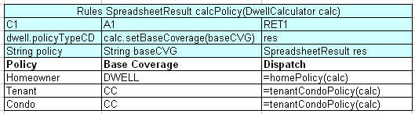
Figure 67: SpreadsheetResult decision table
As you can see from the table header, this table receives policy type as an input parameter, retrieves information about the coverage type, and defines which master spreadsheet must be used.

Reviewing Other Spreadsheets of the Imported Project
Open the EMHomeRules.xls file and review all its spreadsheets not covered in this tutorial. Ensure that the rating engine logic remains clear to you. For more information on the specific tables, contact your trainer.

Conclusion
Congratulations! You have completed the OpenL Tablets tutorial. Now that you know how to create simple rules, you can begin to build increasingly complex applications as you learn more about OpenL Tablets on your own. We hope this tutorial was helpful to you.

Appendix A: Product Factory Attributes
The following table lists Product Factory attributes for a typical homeowners product:
Product Factory attributes
Building block | Attribute name
WorkersCompensationCoverage | numberHouseholdEmployees
WorkersCompensationCoverage | workersCompensationCoverageInd
WorkersCompensationCoverage | seqNo
WorkersCompensationCoverage | employmentType
AdditionalInterest | interestTypeCd
AdditionalInterest | accountNumber
AdditionalInterest | addressLine2
AdditionalInterest | stateProvCd
AdditionalInterest | addressLine3
AdditionalInterest | postalCode
AdditionalInterest | countryCd
AdditionalInterest | email
AdditionalInterest | financedAmt
AdditionalInterest | name
AdditionalInterest | city
AdditionalInterest | secondName
AdditionalInterest | addressLine1
AdditionalResidence | numberOfFamilies
AdditionalResidence | seasonalSecondaryUsageInd
AdditionalResidence | rentedToOthersInd
BackupSewerDrainCoverage | coverageCd
BackupSewerDrainCoverage | limitAmount
BackupSewerDrainCoverage | seqNo
BackupSewerDrainCoverage | limitAppliesToCd
BackupSewerDrainCoverage | limitValuationCd
BackupSewerDrainCoverage | expirationDt
BackupSewerDrainCoverage | effectiveDt
BackupSewerDrainCoverage | limitIncludedInd
BackupSewerDrainCoverage | deductibleAmount
BackupSewerDrainCoverage | coverLevelCd
BackupSewerDrainCoverage | deductibleAppliesToCd
BackupSewerDrainCoverage | deductibleTypeCd
BrokerChangeAction | policyNumber
BrokerChangeAction | transactionEffectiveDate
BrokerChangeAction | commissionOverrideInd
BrokerChangeAction | newAgency
BrokerChangeAction | newSubProducer
BrokerChangeAction | commissionPercent
BrokerChangeAction | currentCommissionPercent
BrokerChangeAction | effectiveDate
BrokerChangeAction | currentAgency
BrokerChangeAction | mainInsured
BrokerChangeAction | currentSubProducer
BrushFireSurcharge | prxWildfireRiskInd
BrushFireSurcharge | brushFireSurchargeInd
BrushFireSurcharge | prxWildlandUrbanCd
BrushFireSurcharge | prxDistHighWildfireRisk
BrushFireSurcharge | alternativeRoadAvailabilityInd
BrushFireSurcharge | closedEaves
BrushFireSurcharge | overrideDistanceToHighCd
BrushFireSurcharge | primaryAccessRoadLessThan16FeetWide
BrushFireSurcharge | severityOfSlopeOfRoadCd
BrushFireSurcharge | prxDistanceToWildlands
BrushFireSurcharge | unpavedAccessRoad
BuildingImprovementsInfo | renovated
BuildingImprovementsInfo | renovationDate
BuildingProtection | protectionClassGradeCd
ConstructionInfo | roofType
ConstructionInfo | trackCocInd
ConstructionInfo | roofingMaterial.roofDeckMaterialCd
ConstructionInfo | yearBuilt
ConstructionInfo | distanceToBrush
ConstructionInfo | roofingMaterial.id
ConstructionInfo | effectivenessGradeTypeCd
ConstructionInfo | id
ConstructionInfo | yearUpdated
ConstructionInfo | roofGeometryTypeCd
ConstructionInfo | shuttersDescription
ConstructionInfo | numberOfStories
ConstructionInfo | windowWindResistanceDescription
ConstructionInfo | roofingMaterial.roofDeckAttachmentCd
ConstructionInfo | constructionTypeCd
ConstructionInfo | openingProtectionCd
ConstructionInfo | shuttersCd
ConstructionInfo | roofingMaterial.roofWallAttachmentCd
ConstructionInfo | windowWindResistanceCd
ConstructionInfo | cocInd
CopyQuoteInfo | txDate
CoverageA | limitAmount
CoverageA | limitValuationCd
CoverageA | deductibleAmount
CoverageB | limitAmount
CoverageB | limitValuationCd
CoverageB | deductibleAmount
CoverageBAA | coverageCd
CoverageBAA | limitAmount
CoverageBAA | seqNo
CoverageBAA | limitAppliesToCd
CoverageBAA | limitValuationCd
CoverageBAA | effectiveDt
CoverageBAA | expirationDt
CoverageBAA | deductibleAmount
CoverageBAA | coverLevelCd
CoverageBAA | deductibleAppliesToCd
CoverageBAA | deductibleTypeCd
CoverageC | coverageCd
CoverageC | limitAmount
CoverageC | seqNo
CoverageC | limitAppliesToCd
CoverageC | limitValuationCd
CoverageC | effectiveDt
CoverageC | expirationDt
CoverageC | deductibleAmount
CoverageC | coverLevelCd
CoverageC | deductibleAppliesToCd
CoverageC | deductibleTypeCd
CoverageD | coverageCd
CoverageD | limitAmount
CoverageD | seqNo
CoverageD | limitAppliesToCd
CoverageD | limitValuationCd
CoverageD | expirationDt
CoverageD | effectiveDt
CoverageD | deductibleAmount
CoverageD | coverLevelCd
CoverageD | deductibleAppliesToCd
CoverageD | limitAmountDisplay
CoverageD | deductibleTypeCd
CoverageE | coverageCd
CoverageE | limitAmount
CoverageE | seqNo
CoverageE | limitAppliesToCd
CoverageE | limitValuationCd
CoverageE | effectiveDt
CoverageE | expirationDt
CoverageE | deductibleAmount
CoverageE | coverLevelCd
CoverageE | deductibleAppliesToCd
CoverageE | deductibleTypeCd
CoverageF | coverageCd
CoverageF | limitAmount
CoverageF | seqNo
CoverageF | limitAppliesToCd
CoverageF | limitValuationCd
CoverageF | effectiveDt
CoverageF | expirationDt
CoverageF | deductibleAmount
CoverageF | coverLevelCd
CoverageF | deductibleAppliesToCd
CoverageF | deductibleTypeCd
CoveragesMultiView | DwellQuestionnaire.earthquakeCoverageInd
CoveragesMultiView | DwellQuestionnaire.studentAwayFromHomeInd
CreditSurchargeSummary | selectedCreditsCodeList
CreditSurchargeSummary | selectedSurchargesCodeList
CreditSurchargeSummary | totalAppliedCreditsFactor
CreditSurchargeSummary | totalAppliedSurchargesFactor
CustomerAccess | addressLine2
CustomerAccess | stateProvCd
CustomerAccess | firstName
CustomerAccess | lastName
CustomerAccess | addressLine3
CustomerAccess | postalCode
CustomerAccess | countryCd
CustomerAccess | suffix
CustomerAccess | titleCd
CustomerAccess | producerCd
CustomerAccess | email
CustomerAccess | middleName
CustomerAccess | phoneNumber
CustomerAccess | city
CustomerAccess | addressLine1
Dwell | territoryCd
Dwell | seqNo
Dwell | primaryResidence
Dwell | defaultDeductibleAmount
Dwell | viewResidenceInd
Dwell | policyTypeCd
Dwell | numberOfFamilies
DwellQuestionnaire | studentAwayFromHomeInd
DwellQuestionnaire | withinSafeDistanceToHydrantInd
DwellQuestionnaire | brushEligibilityInd
DwellQuestionnaire | brushFireEligibilityInd
DwellQuestionnaire | earthquakeCoverageInd
DwellQuestionnaire | within1000FeetToShoreInd
DwellQuestionnaire | seasonalSecondaryUsageInd
DwellQuestionnaire | rentedToOthersInd
DwellQuestionnaire | areInspectionReportsAvailableInd
DwellQuestionnaire | farmingOnPremisesInd
DwellQuestionnaire | primaryLocationInd
DwellQuestionnaire | orderInspectionInd
DwellQuestionnaire | ownerOccupiedInd
DwellQuestionnaire | riskRetrofittedInd
DwellQuestionnaire | businessConductedOnPremisesInd
DwellQuestionnaire | isThereGasShutoffValveInd
DwellQuestionnaire | excludeLiabilityInd
DwellQuestionnaire | withinSafeDistanceToFireStationInd
DwellQuestionnaire | primaryResidenceInd
EarthquakeCoverage | coverageCd
EarthquakeCoverage | limitAmount
EarthquakeCoverage | seqNo
EarthquakeCoverage | limitAppliesToCd
EarthquakeCoverage | limitValuationCd
EarthquakeCoverage | deductiblePct
EarthquakeCoverage | expirationDt
EarthquakeCoverage | effectiveDt
EarthquakeCoverage | deductibleAmount
EarthquakeCoverage | coverLevelCd
EarthquakeCoverage | deductibleAppliesToCd
EarthquakeCoverage | deductibleTypeCd
EarthquakeLossAssessment | limitAmount
EarthquakeLossAssessment | deductiblePct
FungiMoldCoverage | coverageCd
FungiMoldCoverage | limitAmount
FungiMoldCoverage | seqNo
FungiMoldCoverage | limitAppliesToCd
FungiMoldCoverage | limitValuationCd
FungiMoldCoverage | expirationDt
FungiMoldCoverage | effectiveDt
FungiMoldCoverage | limitIncludedInd
FungiMoldCoverage | deductibleAmount
FungiMoldCoverage | coverLevelCd
FungiMoldCoverage | deductibleAppliesToCd
FungiMoldCoverage | deductibleTypeCd
IdentityTheftCoverage | coverageCd
IdentityTheftCoverage | limitAmount
IdentityTheftCoverage | seqNo
IdentityTheftCoverage | limitAppliesToCd
IdentityTheftCoverage | limitValuationCd
IdentityTheftCoverage | effectiveDt
IdentityTheftCoverage | expirationDt
IdentityTheftCoverage | deductibleAmount
IdentityTheftCoverage | coverLevelCd
IdentityTheftCoverage | deductibleAppliesToCd
IdentityTheftCoverage | deductibleTypeCd
InspectionInfoSummary | areInspectionReportsAvailable
InspectionInfoSummary | orderInspectionInd
InspectionInfoSummary | reasonForNotOrderingInspection
InspectionInfoSummary | dateOfInspection
InspectionRequest | secContactPhone
InspectionRequest | primaryContactPhone
InspectionRequest | uwPhoneNumberExt
InspectionRequest | agentName
InspectionRequest | reasonCd
InspectionRequest | uwName
InspectionRequest | agentPhoneNumberExt
InspectionRequest | dateOrdered
InspectionRequest | agentPhoneNumber
InspectionRequest | specInstructions
InspectionRequest | uwPhoneNumber
InspectionRequest | agentEmail
InspectionRequest | secContactName
InspectionRequest | reportTypeCd
InspectionRequest | uwEmail
InspectionRequest | statusCd
InspectionRequest | primaryContactName
InsuredCommunicationInfo | emailTypeCd
InsuredCommunicationInfo | phoneNumber1
InsuredCommunicationInfo | email
InsuredCommunicationInfo | phoneType1
InsuredEmploymentInfo | employerCd
InsuredEmploymentInfo | occupationClassCd
InsuredEmploymentInfo | occupationDesc
InsuredFormerAddress | streetNumber
InsuredFormerAddress | usageType
InsuredFormerAddress | addressLine2
InsuredFormerAddress | addressDisplayValue
InsuredFormerAddress | stateProvCd
InsuredFormerAddress | displayValue
InsuredFormerAddress | addressLine3
InsuredFormerAddress | county
InsuredFormerAddress | postalCode
InsuredFormerAddress | streetName
InsuredFormerAddress | countryCd
InsuredFormerAddress | regionCd
InsuredFormerAddress | streetType
InsuredFormerAddress | unitNumber
InsuredFormerAddress | city
InsuredFormerAddress | addressLine1
InsuredPrimaryAddress | streetNumber
InsuredPrimaryAddress | usageType
InsuredPrimaryAddress | addressLine2
InsuredPrimaryAddress | addressDisplayValue
InsuredPrimaryAddress | stateProvCd
InsuredPrimaryAddress | displayValue
InsuredPrimaryAddress | addressLine3
InsuredPrimaryAddress | county
InsuredPrimaryAddress | postalCode
InsuredPrimaryAddress | streetName
InsuredPrimaryAddress | countryCd
InsuredPrimaryAddress | regionCd
InsuredPrimaryAddress | streetType
InsuredPrimaryAddress | unitNumber
InsuredPrimaryAddress | city
InsuredPrimaryAddress | addressLine1
InsuredPrincipal | lengthTimeKnown
InsuredPrincipal | rentOrOwn
InsuredPrincipal | principalRoleCd
InsuredPrincipal | addressLessInd
InsuredPrincipal | salutation
InsuredPrincipal | legalEntityCd
InsuredPrincipal | mainInsured
InsuredPrincipal | maritalStatusCd
InsuredPrincipal | displayValue
InsuredPrincipal | firstName
InsuredPrincipal | age
InsuredPrincipal | insuredShortName
InsuredPrincipal | suffix
InsuredPrincipal | knownSince
InsuredPrincipal | insuredName
InsuredPrincipal | titleCd
InsuredPrincipal | occupationDesc
InsuredPrincipal | nameTypeCd
InsuredPrincipal | middleName
InsuredPrincipal | insuredType
InsuredPrincipal | gender
InsuredPrincipal | employerCd
InsuredPrincipal | otherName
InsuredPrincipal | dateOfEmployment
InsuredPrincipal | legalIdentification
InsuredPrincipal | employerDesc
InsuredPrincipal | additionalName
InsuredPrincipal | additionalNameInd
InsuredPrincipal | lastName
InsuredPrincipal | yearsEmployed
InsuredPrincipal | occupationClassCd
InsuredPrincipal | ageDisplay
InsuredPrincipal | dateOfBirth
InsuredPrincipal | differentAddressInd
InsuredPrincipal | oid
InsuredWorkAddress | addressLine3
InsuredWorkAddress | postalCode
InsuredWorkAddress | countryCd
InsuredWorkAddress | addressLine2
InsuredWorkAddress | stateProvCd
InsuredWorkAddress | city
InsuredWorkAddress | addressLine1
Location | riskLocationCd
Location | description
LossAssessmentCoverage | coverageCd
LossAssessmentCoverage | limitAmount
LossAssessmentCoverage | seqNo
LossAssessmentCoverage | limitAppliesToCd
LossAssessmentCoverage | limitValuationCd
LossAssessmentCoverage | expirationDt
LossAssessmentCoverage | effectiveDt
LossAssessmentCoverage | limitIncludedInd
LossAssessmentCoverage | deductibleAmount
LossAssessmentCoverage | coverLevelCd
LossAssessmentCoverage | deductibleAppliesToCd
LossAssessmentCoverage | deductibleTypeCd
LossInfo | locationDescription
LossInfo | lossDescription
LossInfo | lossDate
LossInfo | lossAmount
LossInfo | lossTypeCd
MortgageeAddress | addressLine3
MortgageeAddress | postalCode
MortgageeAddress | countryCd
MortgageeAddress | addressLine2
MortgageeAddress | stateProvCd
MortgageeAddress | city
MortgageeAddress | addressLine1
MortgageeBillingInfo | mortageeName
MortgageeBillingInfo | loanNumber
MortgageeBillingInfo | phoneNumber
MultiPolicyDiscount | policyNumber
MultiPolicyDiscount | expiration
MultiPolicyDiscount | productCd
OtherOrPriorPolicy | policyNumber
PaymentOption | paymentPlanCd
PaymentOption | billingMethodCd
Policy | transactionEffectiveDate
Policy | expiration
Policy | rateEffectiveDateOverridenInd
Policy | riskStateCd
Policy | underwritingStatusCd
Policy | insuredTypeCd
Policy | customerNumber
Policy | durationInMonthsDisplayValue
Policy | imported
Policy | productCd
Policy | contractDisplay
Policy | policyNumber
Policy | policyEngine
Policy | policyStatusCd
Policy | effective
Policy | rateEffectiveDate
Policy | policyTitle
Policy | inceptionDate
Policy | durationInMonths
Policy | branchCd
Policy | underwriterCd
Policy | underwriterReferral
Policy | txType
PolicyAdditionalInfo | replacementOrDuplicatePolicy
PolicyAdditionalInfo | currentCarrierCd
PolicyAdditionalInfo | priorExpirationDate
PolicyAdditionalInfo | priorPolicyNumber
PolicyAdditionalInfo | insuredWithCarrierSinceYear
PolicyAdditionalInfo | otherInsuranceInd
PolicyAdditionalInfo | cancelledOrRefusedReason
PolicyAdditionalInfo | insuranceEverCancelledOrRefused
PolicyAdditionalInfo | prioCarrierCd
PolicyAdditionalInfo | currentCarrierPremium
PolicyBillingInfo | billingAccountName
PolicyBillingInfo | otherName
PolicyBillingInfo | billingAccountType
PolicyBillingInfo | dueDate
PolicyBillingInfo | addressLine2
PolicyBillingInfo | stateProvCd
PolicyBillingInfo | firstName
PolicyBillingInfo | lastName
PolicyBillingInfo | postalCode
PolicyBillingInfo | addressLine3
PolicyBillingInfo | countryCd
PolicyBillingInfo | billType
PolicyBillingInfo | titleCd
PolicyBillingInfo | producerCd
PolicyBillingInfo | nameTypeCd
PolicyBillingInfo | middleName
PolicyBillingInfo | phoneNumber
PolicyBillingInfo | city
PolicyBillingInfo | addressLine1
PolicyBillingInfo | paymentPlan
PolicyCancelAction | cancelDate
PolicyCancelAction | cancellationReason
PolicyCancelAction | supportingData
PolicyCancelAction | cancellationReasonOther
PolicyCancelNoticeAction | policyTxInfo.daysOfNotice
PolicyCancelNoticeAction | policyTxInfo.supportingData
PolicyCancelNoticeAction | policyTxInfo.printNotice
PolicyCancelNoticeAction | policyTxInfo.txReasonCd
PolicyCancelNoticeAction | policyTxInfo.txDate
PolicyCancelNoticeAction | policyTxInfo.txReasonOther
PolicyDoNotRenewAction | txReasonCd
PolicyDoNotRenewAction | txDate
PolicyDoNotRenewAction | txStatusCd
PolicyIssueMailingAddress | streetNumber
PolicyIssueMailingAddress | usageType
PolicyIssueMailingAddress | addressLine2
PolicyIssueMailingAddress | addressDisplayValue
PolicyIssueMailingAddress | stateProvCd
PolicyIssueMailingAddress | displayValue
PolicyIssueMailingAddress | addressLine3
PolicyIssueMailingAddress | county
PolicyIssueMailingAddress | postalCode
PolicyIssueMailingAddress | streetName
PolicyIssueMailingAddress | countryCd
PolicyIssueMailingAddress | regionCd
PolicyIssueMailingAddress | streetType
PolicyIssueMailingAddress | unitNumber
PolicyIssueMailingAddress | city
PolicyIssueMailingAddress | addressLine1
PolicyIssueSummary | methodOfDelivery
PolicyIssueSummary | sendTo
PolicyIssueSummary | insurredEmail
PolicyIssueSummary | issueDate
PolicyIssueSummary | notes
PolicyIssueSummary | brokerEmail
PolicyMultiViewOnly | Policy.underwriterReferral
PolicyMultiViewOnly | Policy.effective
PolicyMultiViewOnly | Policy.underwritingStatusCd
PolicyMultiViewOnly | Policy.expiration
PolicyMultiViewOnly | Policy.insuredTypeCd
PolicyMultiViewOnly | Policy.policyTitle
PolicyMultiViewOnly | Policy.riskStateCd
PolicyMultiViewOnly | Policy.contractDisplay
PolicyMultiViewOnly | PolicyPrintingInfo.suppressPrintingInd
PolicyMultiViewOnly | Policy.imported
PolicyMultiViewOnly | Policy.rateEffectiveDate
PolicyMultiViewOnly | Policy.branchCd
PolicyMultiViewOnly | Policy.policyEngine
PolicyMultiViewOnly | Policy.inceptionDate
PolicyMultiViewOnly | Policy.rateEffectiveDateOverridenInd
PolicyMultiViewOnly | OtherOrPriorPolicy.policyNumber
PolicyMultiViewOnly | Policy.underwriterCd
PolicyPrintingInfo | suppressPrintingInd
PolicyReinstateAction | reinstateDate
PolicyRemoveDoNotRenewAction | txReasonCd
PolicyRemoveDoNotRenewAction | txDate
PolicyRemoveDoNotRenewAction | txStatusCd
PolicyRetroEndorsementAction | rollbackDate
PolicyTransactionInfo | txReason
PolicyTransactionInfo | txEffectiveDate
PolicyTransactionInfo | doNotRenewStatus
PolicyTransactionInfo | lastActionReasonCd
PolicyTransactionInfo | doNotRenewInd
PolicyTransactionInfo | lastActionEffectiveDate
ProducerInfo | producerCd
ProducerInfo | subProducerCd
ProducerInfo | editableInd
ProposeQuoteAction | notes
QuoteCompanyDeclineAction | txReasonCd
QuoteCompanyDeclineAction | txDate
QuoteCompanyDeclineAction | declineType
QuoteCompanyDeclineAction | txReasonCd
QuoteCompanyDeclineAction | txDate
QuoteCompanyDeclineAction | declineType
QuoteIssueAction | methodOfDelivery
QuoteIssueAction | sendTo
QuoteIssueAction | insurredEmail
QuoteIssueAction | issueDate
QuoteIssueAction | notes
QuoteIssueAction | addressLine2
QuoteIssueAction | brokerEmail
QuoteIssueAction | stateProvCd
QuoteIssueAction | addressLine3
QuoteIssueAction | postalCode
QuoteIssueAction | countryCd
QuoteIssueAction | city
QuoteIssueAction | addressLine1
RatingInfoMultiView | DwellQuestionnaire.withinSafeDistanceToFireStationInd
RatingInfoMultiView | Dwell.numberOfFamilies
RatingInfoMultiView | BuildingImprovementsInfo.renovationDate
RatingInfoMultiView | ConstructionInfo.yearUpdated
RatingInfoMultiView | DwellQuestionnaire.excludeLiabilityInd
RatingInfoMultiView | BuildingProtection.protectionClassGradeCd
RatingInfoMultiView | ConstructionInfo.roofType
RatingInfoMultiView | DwellQuestionnaire.riskRetrofittedInd
RatingInfoMultiView | DwellQuestionnaire.within1000FeetToShoreInd
RatingInfoMultiView | Dwell.territoryCd
RatingInfoMultiView | BuildingImprovementsInfo.renovated
RatingInfoMultiView | DwellQuestionnaire.withinSafeDistanceToHydrantInd
RatingInfoMultiView | ConstructionInfo.yearBuilt
RatingInfoMultiView | ConstructionInfo.constructionTypeCd
RatingInfoMultiView | ConstructionInfo.cocInd
ResidenceAddress | streetNumber
ResidenceAddress | usageType
ResidenceAddress | addressLine2
ResidenceAddress | addressDisplayValue
ResidenceAddress | stateProvCd
ResidenceAddress | displayValue
ResidenceAddress | addressLine3
ResidenceAddress | county
ResidenceAddress | postalCode
ResidenceAddress | streetName
ResidenceAddress | countryCd
ResidenceAddress | regionCd
ResidenceAddress | streetType
ResidenceAddress | unitNumber
ResidenceAddress | city
ResidenceAddress | addressLine1
ResidenceOtherOrPriorPolicy | policyNumber
ResidenceOtherOrPriorPolicy | insurerName
ResidenceOtherOrPriorPolicy | insurerCd
RiskAddress | streetNumber
RiskAddress | usageType
RiskAddress | addressLine2
RiskAddress | addressDisplayValue
RiskAddress | stateProvCd
RiskAddress | displayValue
RiskAddress | addressLine3
RiskAddress | county
RiskAddress | postalCode
RiskAddress | streetName
RiskAddress | countryCd
RiskAddress | regionCd
RiskAddress | streetType
RiskAddress | unitNumber
RiskAddress | city
RiskAddress | addressLine1
RiskAddressMultiView | RiskAddress.city
RiskAddressMultiView | DwellQuestionnaire.seasonalSecondaryUsageInd
RiskAddressMultiView | RiskAddress.addressLine3
RiskAddressMultiView | RiskAddress.countryCd
RiskAddressMultiView | DwellQuestionnaire.primaryResidenceInd
RiskAddressMultiView | DwellQuestionnaire.farmingOnPremisesInd
RiskAddressMultiView | RiskAddress.addressLine2
RiskAddressMultiView | DwellQuestionnaire.rentedToOthersInd
RiskAddressMultiView | Dwell.territoryCd
RiskAddressMultiView | RiskAddress.addressLine1
RiskAddressMultiView | DwellQuestionnaire.businessConductedOnPremisesInd
RiskAddressMultiView | DwellQuestionnaire.isThereGasShutoffValveInd
RiskAddressMultiView | RiskAddress.stateProvCd
RiskAddressMultiView | Dwell.policyTypeCd
RiskAddressMultiView | RiskAddress.postalCode
RiskAddressMultiView | DwellQuestionnaire.ownerOccupiedInd
RiskAddressMultiView | ConstructionInfo.numberOfStories

