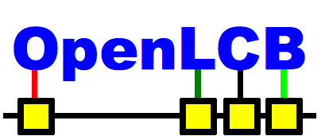
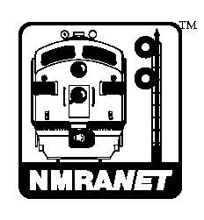
Report to NMRA Board
Winter Meeting
Atlanta, Georgia
Feb 8-10 2013

Participation
We continue to have a vibrant and active membership. Membership in the OpenLCB egroup continues rise, above 160 members now. The NMRAnet egroup has 52 members.

Presentations
Activities over the last year include several demonstrations at train shows, including the NMRA and Springfield, and smaller meetings.
- Alex Shepherd presented at the anAMRA (American Model Railroaders Association) in Hamilton NZ in October 2012.
- Don Goodman-Wilson presented two clinics at the 2012 NMRA National Convention in Grand Rapids:
An Introduction to OpenLCB / NMRAnet S-9.7
OpenLCB / NMRAnet for Developers and DIY
- Ken Cameron has presented at:
2013 Springfield Show: Introducing NMRAnet / OpenLCB

Protocols and Documentation
The group has made good progress on the protocols, and their documentation as Standards and Technical Notes. Progress is communicated on the web by way of a Dashboard at http://www.openlcb.org/trunk/documents/OpenLCBDashboard.html .

Adopted:
- S-9.7.1 NMRAnet® Physical Layer
- TN-9.7.1 NMRAnet® Physical Layer Technical Note

Submitted for Adoption by NMRA:
- GenCommonInfoTN – General Information Technical Note
- GenGlossaryTN – General Glossary Technical Note
- GenUniqueIdS – Unique Node Identifiers Standard
- GenUniqueIdTN – Unique Node Identifiers Technical Note
- CanFrameTransferS/TN – CAN Frame Standard and Technical Note

In Review by OpenLCB:
- GenCdiS/TN – General Configuration Definition Information Standard and TN
- GenAcdiS/TN – General Abbreviated CDI Standard and TN
- GenSimpleNodeInfoS/TN – Simple Node Information Protocol Standard and TN

Near Completion:
- GenEventTransportS/TN – General Event Transport Standard and TN
- GenDatagramTransportS/TN – General Datagram Transport Standard and TN

OpenLCB / NMRAnet Development Kit
The kit was funded, designed, assembled and distributed to 20 model railroaders around the world, including New Zealnad, Australia, Canada, USA, Spain, and Denmark.

Some highlights from their use:

2012 NMRA Convention, Grand Rapids
- Don Goodman-Wilson, Ken Cameron, David Harris and others demonstrated the DevKIt, and use of its nodes for layout control and traction.
- Ken Cameron demonstrated at the Springfield Show this January.

