Annotran
Translation by Annotation

Quick Start Guide and Tutorial

What is Annotran?
“Annotran” is a piece of software that allows you to write and read translations of web pages by using annotations. It has been developed by staff at Birkbeck, University of London as part of a grant from the Andrew W. Mellon Foundation for the Open Library of Humanities platform.
The basic idea is that users can select a language and audience group and then add annotations to a page. These “annotations” are linked to sentences on the page itself and represent a translation of the selected text into a different language. For instance, if I highlighted the text “Hello” on a page and had French selected, my annotation might read “Bonjour” or “Salut”. Annotran then allows other users to view these translations, rendering them in-line in the page.
Annotran has been tested in Firefox and Chrome as of October 2016.

Quick Start Tutorial

Installation
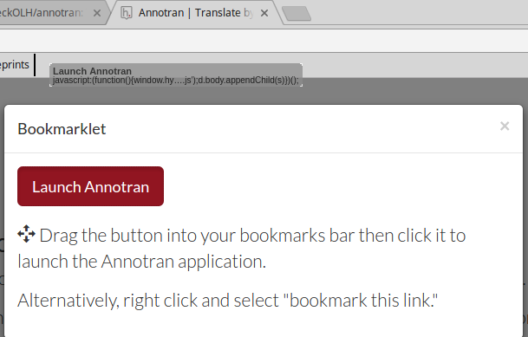
To begin using Annotran, first visit https://annotran.openlibhums.org/. On this page, click the red text “bookmarklet” and then, in the resulting popup window, drag the red box labelled “Start Annotran” to the bookmarks bar in your browser.

Launching the sidebar
To launch the sidebar, click the bookmarklet that you have installed. Upon launch, you will be presented with a blank sidebar that looks like this:
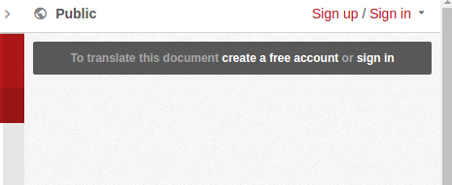
To create an account, click the “Sign up” link and enter your details. You should then receive an activation email request. If this does not arrive, please check your spam email folder. If you already have an annotran account, click “Sign in”.
Once you are signed in, you will see a more feature-complete sidebar:
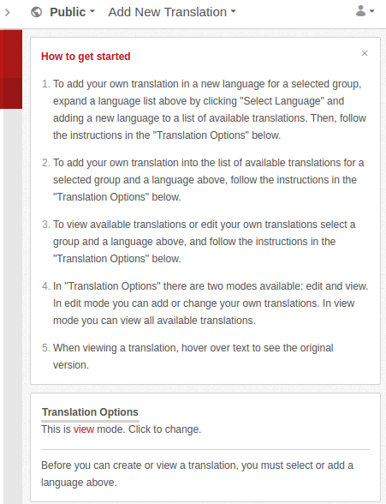

Adding a new translation
To write a new translation from here, first add a language. Click the dropdown at the top that says “Add New Translation” and select the desired target language. Note that, if there are already translations on a page, this dropdown may display the name of a language instead of “Add New Translation”:
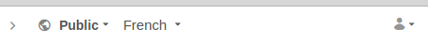
At this point, click the red word “view” in the sentence “This is view mode. Click to change.”
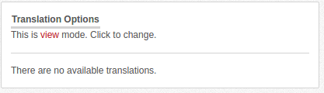
Then decide whether you wish to translate either by selecting specific text or by moving through a document sentence-by-sentence:
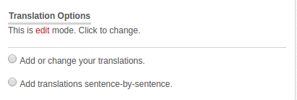

Translating individual chunks of text
If you select “Add or change your translations” you can then highlight any portion of text on a web page and write a translation just for this portion. When you highlight text, a small “adder” icon will appear, which you can click:
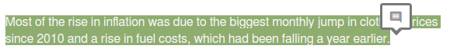
When you click the adder, the option will appear to write a translation in the sidebar:
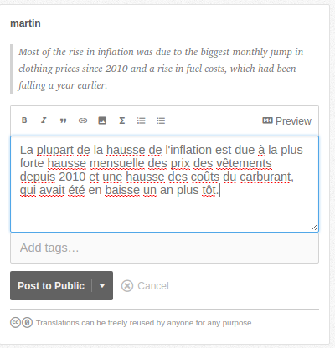
When you are happy with your translation (which, hopefully, will be better than my French above), press “Post to Public” to make the translation live. You can repeat this as many times as is needed on a page but you cannot write more than one translation in the same language for the same piece of text.

Translating paragraphs of text in sentence-by-sentence mode
In sentence-by-sentence mode, Annotran will attempt to move sequentially through a document, automatically selecting the next sentence when you add a translation. To activate sentence-by-sentence editing, click the option “Add translations sentence-by-sentence” when moving into edit mode and then click on a paragraph of text to begin. Please note that sentence-by-sentence mode works best on well-structured documents with clearly defined sentences.

Translating in private groups
Translations can either be public, private (visible only to the translating user) or in a private shared group. To post a private translation, click the dropdown to the right of the “Post to Public” option (as above) and select “Only Me”.
To post to a private shared group, click the dropdown at the top of the sidebar that says “Public” and select the option “New Group” or select a private shared group. You can invite others to join the group by using the “View group activity and invite others” link under the group name in the dropdown menu. Please note that you may need to reload the Annotran sidebar after adding a new group.

Viewing existing translations
When you come to a page that has existing translations, the Annotran sidebar will look like this:
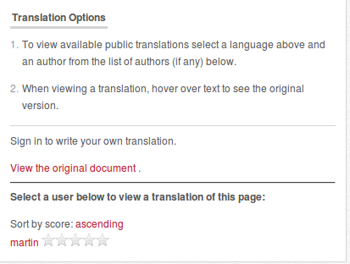
To view a translation, simply click the name of the translating user. In this case, “martin”. This will then substitute the translation back into the document:
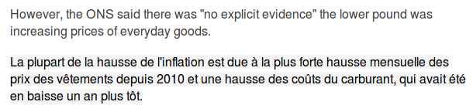
You can also hover over any translated text to view the original-language text.

Rating and reporting translations
You can rate a translation or report a translation as spam/abuse by clicking the stars next to a username. (Note that you cannot rate or report your own translations.)
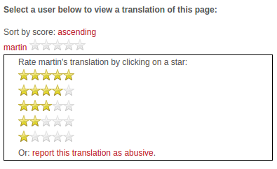

Troubleshooting, problems, and bugs
The most common problem that users encounter is when translating dynamic pages. Annotran does not work well on content that changes, since we use a complex process to ensure that annotations are linked to document locations. Annotran should not, therefore, be used on documents that frequently change, such as liveblogs.
Any other bugs can be reported at the Github issue tracker for the project: https://github.com/birkbeckOLH/annotran.

