Stage - discharge curves, discharge – sediment discharge curves, interpolations, hydro -measurements

Introduction
Hydrology uses interpolation mathematical methods in order to calculate missing values of time series. Calculation of the water stage of an aquifer (or any other water mass) is a matter of great hydrological interest. The processes presented in this chapter are the following::
- Mass and area calculation of a reservoir.
- Underground reservoir leaks estimation.
- Stream Discharge calculation using stage – discharge equations.
- Stream sediment discharge using stage – discharge equations.
The spillway’s discharge calculation is a simple case that can be faced using the Hydrognomon application. However, there is no special reference to it in this chapter. Particular emphasis is given to the stage – discharge curves of complex problems. A methodology for facilitating the natural problem’s description is also presented, as well as methods of curves plotting, hydraulic methods for estimation of expansion curves and necessary corrections for measuring errors.
Finally, there is a reference to the applied methodology for stream hydro measurements recording and to the necessary calculations for discharge or speed time series plotting.

Stage - reservoirs’ mass area curves
Storage’s and reservoirs’ free surface estimation can result from stage – mass area curves application. These curves can derive easily from basin’s topography using a Geographic Information System (GIS). These curves are polygonal because they are plotted using points (h_{i}, y_{i}), where h_{i} is the stage’s absolute value of the free surface and y_{i} is the variable of interest (storage or surface). The y may result from logarithmic interpolation between two successive points (h_{i}, y_{i}) and (h_{i+1}, y_{i+1}).
If h is the stage between two successive stages h_{i} and h_{i+1} on a stage – mass surface curve, then y is:
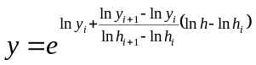 5.
The stage (h) values result from the relevant time series, recorded from a recording machine or a water stage meter or even from combination e.g. of two measuring devices (see unit 1.4).

Reservoirs’ underground leakage estimation
In order to plot reservoirs’ water balance, reservoirs’ underground bottom leakage estimation is demanded. There are various leakage estimation models. The less complex models propose a linear equation like the following: (Efstratiades et al., 2000):
Q_{L} = a (H-H₀) + b 5.
Q_{L} is the discharge, a the underground leakage coefficient, H₀ the reference stage, H the absolute stage value of the free water surface and b some constant. This model can be adjusted by empirical methods or simple mathematical methods, taking into account permeability of the geological formations, or by solving the water balance, if the runoff to the reservoir is known.
The mathematical model, applied by Hydrognomon, uses a third – degree equation, taking into account the seasonal variance of the phenomenon. The model’s mathematical expression is the following equation:
Q_{L} = a_{i}H³ + b_{i}H² + c_{i}H + d_{i} 5.
a_{i}, b_{i}, c_{i} the polynomial coefficients, d_{i} the constant and i=1…12 refers to the months of the year. The stage (H) values result from the relevant time series, recorded from a recording machine or a water stage meter or even from combination e.g. of two measuring devices (see unit 1.4).

Discharge calculation using stage measurements and stage – discharge curves
The applied methodology for discharge calculation using stage – discharge curves is described by Christofides (1998) and Koytsoyiannis and Ksanthopoulos (1999, p. 328, 330 and 339). The algorithm’s implementation that calculates the discharges in Hydrognomon is in accordance with these descriptions. Christofides’ description (1998) is represented below subjected to the appropriate adjustments for Hydrognomon software package.
In case of natural aquifers, where the installation of any control section is impossible (e.g. flow measuring channel), a suitable stage – discharge equation is used : Q = f(h), Q is the discharge and h the stage measurement. A hydrometric station is required for the implementation of this equation. The station should record measurements of stage and discharge systematically e.g. using small mills. The equation Q = f(h) is known as stage – discharge equation (or curve). A simple form of the stage – discharge curve is the following: (Koytsoyiannis & Ksanthopoulos, 1999):
Q = C (h – a)^{N} 5.
a is the stage value for zero discharge and C, N parameters that result from curve’s adjustment to the hydro measurements. The general stage –discharge curves relation contains n points (h_{i}, q_{i}), h_{i+1}>h_{i} ∀i. The discharges for every h result from the double logarithmic interpolation:
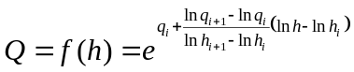 5.
The points h_{i} and h_{i+1} should follow the inequality: h_{i}≤h<h_{i+1}. If there are not such points (h>h_{n}), then the curve is expanded (extrapolation) using the equation (5.5) and the points h_{n-1}, h_{n}. If an expansion curve is provided, the interpolation is applied between the last point of the stage – discharge curve and the first point of the expansion curve, using the equation (5.5).
A constant value h₀ is added to stage values h and h_{i} (offset). This constant does not change the results. Usually it is a number that fulfills the following inequation: h_{i}+h₀>0. Consequently, negative numbers are avoided at the logarithmic equation (5.5). The inverse function is often useful:
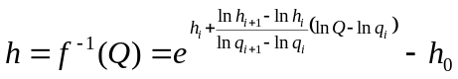 5.
The stage –discharge curves change over time, due to changes of stream’s properties. This can be easily proved by plotting a double logarithmic chart from the hydro measurements points (h_{i}, q_{i}). This change cannot be easily expressed in mathematics. So the sample of hydro measurements is divided to m periods: (h_{i}^{(j)}, q_{i}^{(j)}), j=1...m. The discharge Q calculation from stage h results using the appropriate curve (according to the relevant period). A semi – graphic way is used for the division, like in Hydrognomon (see paragraph 5.5.1), or a fully automated procedure (see Tsakalias and Koutsoyiannis, 1999).
Usually in stage – measurements curves, there are some missing values, especially in extreme cases such as floods. Expansion curves are used for the infilling of missing values. The expansion curves are usually stable during the measuring period and they are plotted using hydraulic functions ( uniform flow in open channels). Topography data (stream intersection) and maximum values of available measurements are used for curve plotting (see Koytsoyiannis and Ksanthopoulos, 1999, p. 333).
Given the stage – discharge curves, the export of discharge time series from a stage time series would seem to be a simple procedure. However, discharge measurements may deviate from predicted ones by stage – discharge curves. These deviations do not appear due to inaccurate measurements or other insignificant events, but due to other natural causes and they should be taken into account. For the same section in two different instances of same stage, discharge may differ, because the discharge is different between the phase of rising and the phase of fall (Shaw, 1994, p. 118-119). The difference is attributed to water liquid properties. The gradual change of the streambed’s characteristics (e.g. plant growth, ice development, gradual sediment deposition) is described by Linsley et al. (1949 p. 204-205).
For insignificant changes, it is not recommended to define a special period and a different stage – discharge curve. This procedure is suitable for cases of sharp and sudden changes followed by a period of stability. For insignificant and temporary changes, it is better to use only one stage – discharge curve and take into account the possible deviations, using the stage correction method, also called Stout correction (Shaw, 1994). There are not detailed specifications about this method in the available bibliography, so the methods’ application is based on Christofides research (Christofides, 1998).

Stage correction
The stage – discharge curve is a function f that combines the stage h with the discharge Q:
Q = f(h) 5.
Taking into account the discharge measurements deviations from stage – discharge curve, discharge is slightly different:
Q' = Q + ΔQ 5.
Practically, discharge is corrected indirectly, through stage correction:
Q' = f(h + Δh) 5.
Δh is calculated by means of the method mentioned above. The correction is added to the stage before stage – discharge interpolation. The method is called stage correction, but the term is misleading. The intention is not to correct the stage, but the discharge. The measured stage was h, not h + Δh. Δh is a correction added in order to correct the stage – discharge curve’s inaccuracy.
Δh is a function of time. It is easily calculated at the instance of discharge measurement. If hm_{i} and qm_{i} are the measured stage and discharge of the i measurement, the calculated discharge (without correction) is:
Q = f(hm_{i}) 5.
Discharge measurements deviate from the predictions of the stage –discharge curve, i.e. Q ≠ qm_{i}. In this case, qm_{i} (instead of Q) should be predicted by the curve. So Δh is calculated as:
qm_{i} = f(hm_{i} + Δh)
⇔ hm_{i} + Δh = f ^{–1}(qm_{i}) 5.
⇔ Δh = f ^{–1}(qm_{i}) – hm_{i}
The corrected stage hm_{i} + Δh results from interpolation of discharge qm_{i} in the stage – discharge curve.
In order to calculate stage correction at any time, it is regarded that Δh is a linear function of time (see Figure 5.1).
So, Δh variation can be expressed as a function of time:
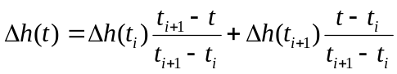 5.
Δh_{i}

Δh_{i+1}

Δh_{i+2}

Δh_{i+3}

t

Δh

Hydro measurements measurementΘέσεις υδρομετρήσεων
Figure 5.1: Schematic representation of Stout correction

In special cases (e.g. if the measurements are regular and stream section’s properties permit adjustments) the curve can be adjusted to deviations (Shaw, 1994 p. 119) as shown in Figure 5.2. As far as Greece is concerned, riverbeds rarely have smooth properties. Consequently, the recommended solution is to express Δh as a linear function of time.
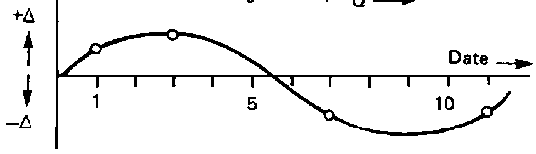
Figure 5.2: Stout correction, Shaw (1994)

However, there are cases that linear function is not applicable (Linsley et al. 1949, p. 205). Such a case is presented in Figure 5.3. There are 7 measurements. Between the 5th and the 6th one, linear function was used. Between the 1st and the 2nd one, period changes as well as the stage – discharge curve. The 1st measurement is the last one of the first period, while the 2nd is the first measurement of the next period. As far as the stage – discharge curve has changed, deviations Δh are different and non – comparable any more. So, there is no linear function able to express a relation between them. The only acceptable assumption is that Δh remains constant between the last measurement and the end of the period and also between the end of the period and the first measurement.
t

Δh

Period’s change
Sharp incident
1
3
7
6
5
4
2
Figure 5.3: Various cases of stage correction (Δh) changes

The 3rd measurement was regarded as incorrect, so it was ignored and the values between the 2nd and the 4th measurement are predicted by a linear function.
Between the 4th and 5th measurement a sudden and sharp incident happened (e.g. a storm), that influenced riverbed’s behavior. So, measurements 4 and 5 cannot be connected through a linear function. Between measurements 6 and 7, the sharp incident lasted long, so it is regarded that Δh changed in a linear way during the incident.
In this application, only period changes automatically. The other parameters (e.g. when a sharp incident happened, how long did it last, if streambed’s behavior changed because of it, which measurements are incorrect) are defined by the user. For slight Δh the way of change does not matter. For significant Δh values, every measurement should be taken into account and examined. The application should list the measurements that were ignored during curve plotting as well as the measurements’ Δh that exceeded a certain threshold, defined by the user.
Δh should be regarded as a separate time series with the same time step as stage’s time series step. For time series handling, the necessary visual tools are at user’s disposal. The stage and rainfall time series are easily accessible, which facilitates sharp incidences’ detection. Sharp incidences (start time and end) can be identified as well as discharge measurements that should be ignored. So the application calculates stage correction, according to the rules described above. Periods of zero Δh can also be defined by the user. Finally, Δh time series can be modified (in any way) according to user’s judgment, and saved for further processing.
If Stout correction refers to stage of the expansion curve, it decreases to zero according to the law of linear interpolation for stage of expansion curve’s beginning. This reduction does not happen, if there is no defined expansion curve, so expansion results from regular stage – discharge curve’s interpolation.

Stage correction for stage recorders’ errors
For the application of the described methodology, it is assumed that the measurements were correct or at least coherent and that deviations between measurements and predicted values from curves are due to natural causes. Practically, there are a lot of other problems (common in Greece) caused by inaccurate measurements. In some cases, there are measurements recorded at the same time from a stage recorder and a stage meter, that differ. Sometimes, stage measurement and discharge measurement are held simultaneously by different working groups and the recorded values of stage do not match. These problems are dealt with the following stage correction method, proposed by Koytsoyiannis and Ksanthopoylos (1999, p.330). This method can often improve data and enhance results. This chapter refers to stage recorder’s stage correction. The next one refers to dealing with differences of regular stage measurements from discharge measurements. These corrections should be completed before the already described.
In order to calculate discharges, stage time series is demanded and results from stage meter’s records that were used for stage –discharge curves plotting. If there are records from a stage recorder (except for the stage meter), they can also be used. However, there are not always records from both devices. If the stage recorder is out of order, there are only stage meter’s measurements. If the observer is absent or the files were lost, there will be only stage recorder’s records. In general, the used data come from a daily time series sm recorded by a stage meter and an hour or two hour time series sg recorded by a stage meter.
If there were no measuring errors, the union ss of these two time series would produce a stage time series of irregular time step (some times daily, sometimes hour or two hours’ time step). There are measurements done at the same time by the two devices, that they should coincide. However they are different, because of incorrect settings of the stage recorder, or incorrect introduction of the paper inside the stage recorder, or digitalization error etc. The simple union of the two time series is impossible, because of this difference. Consequently, corrections are required.
In case of deviation, one of the two measurements can be considered as correct, or both can be rejected as errors and another value e.g. their average can be used instead of them. It is assumed that the stage meter’s measurement is correct according to the following reasons:
- The stage recorder is sensitive, while the stage meter is reliable, and its measurements can be easily read
- The point is to calculate the most accurate discharge, so the accurate stage measurement is insignificant. After all, the stage varies and its value depends on the defined zero level. The significant stage is the compatible one with the stage that produced the stage – discharge curve. This curve resulted from discharge measurements from stage meter (not stage recorder)
Assuming that there are two successive stage meter’s measurements sm_{i} and sm_{i+1,} between them there are also stage recorder’s measurements. At the same time of sm_{i} and sm_{i+1} measurements, there are also stage recorders measurements sg_{a} and sg_{b}. Actually they are not absolutely simultaneous measurements. If stage meter’s measurement was recorded at 08:00 and stage recorder’s measurement was recorded at 08:05, these two measurements are considered to be simultaneous. The time tolerance can be about an hour. sg_{a} and sg_{b} differ from sm_{i} and sm_{i+1}. The differences Δsg_{a} and Δsg_{b} are:
Δsg_{a} = sm_{i} – sg_{a} 5.
Δsg_{b} = sm_{i+1} – sg_{b} 5.
Considering that Δsg changes linearly between two measurements, every stage between them of time series sg can be corrected, using e.g. the Equation (5.12) where Δsg_{a} and Δsg_{b} are used instead of Δh.
The stage correction of time series sg results to a corrected time series sg'. The union of sm time series with sg' time series results to ss time series, with time step identical to sg time series step (e.g. hour time step). For periods that there are only stage meter’s measurements, missing values will be infilled between two measurements of a stage meter.
This method is quite useful for correction of small errors. However, it should be paid special attention to its application. If sm time series resulted from stage meter established to a different position from stage recorder’s position, stage recorder’s measurements should be ignored, at least for this method, because it is not applicable to any case and so it is possible to produce incorrect results. Consequently, this method should be applied only in case of not extended errors. Moreover, every difference between stage meter’s and stage recorder’s measurements, should be examined separately by the user, before applying any correction method.

Stage correction for differences during discharge measurements
Stage recorder’s data correction results to ss time series, that is superset of sm. The next problem is that time series’ stages during discharge measurements hm do not coincide with the simultaneous values of sm. This may happen due to one of the following reasons:
- Discharge measurement lasts about two hours. During this procedure the stage may vary. So, the stage at the beginning and the stage at the end are recorded and finally their average is used. Regular stage meter’s results may differ from average values of the same time.
- Actual recording time may differ from the registered ones, because of human error, or observer’s inconsistency. So, measurements, considered to be simultaneous, may not be.
- There are incorrect records because of false stage meter’s registering. Even if the crews should register the records of every stage meter, sometimes they register some of them or just one of them. Maybe the used data come from a different stage meter from the registered one. Μπορεί να μη γνωρίζουμε ποιο σταθμήμετρο είναι το καταγραφέν, ή μπορεί να είναι διαφορετικό από εκείνο που καταγράφεται από τον παρατηρητή στις τακτικές σταθμημετρήσεις (σε μερικούς σταθμούς με πολλά σταθμήμετρα δεν καταγράφονται όλα).
The point is to calculate the most accurate discharge, so the accurate stage measurement is insignificant. After all the stage varies and its value depends on the defined zero level. The significant stage is the compatible one with the stage that produced the stage – discharge curve. This curve was plotted using discharge measurements. So, if there is a difference between ss and discharge measurements, the measured value is considered to be correct. The correction procedure uses the same methodology as the one described in the previous paragraph: assuming that there are two successive discharge measurements hm_{i} and hm_{i+1}, between them there are also ss time series’ stage measurements. At the same time of measurements hm_{i} and hm_{i+1} , there are stage measurements ss_{a} and ss_{b}.
As described above, the differences are expressed as:
Δss_{a} = hm_{i} – ss_{a} 5.
Δss_{b} = hm_{i+1} – ss_{b} 5.
where Δss changes in a linear way between two discharge measurements so Equation (5.12) is applied to estimate the interventing values using Δss_{a} and Δss_{b} instead of Δh.
So, stages ss' recorded at the measuring points will be correct (i.e. they will coincide with the discharge measurements’ stages). Unfortunately, there is no proof that this method is useful for points between discharge measurements, since these measurements were not completed at the same time but probably a significant time interval separates them. If deviations Δss_{a} and Δss_{b} are due to registration of the wrong stage meter, the stages of the interventing points cannot be corrected with certainty. However, this method sometimes can enhance the false values. Special attention should be paid at the use of this method because in some cases it is totally inappropriate for adjustment of measurements recorded from a different stage meter than the one used for discharge measurements (which means that the curves are different too).
For the application of the correction that was described at the last two chapters, Δsg and Δss should be considered as separate time series, with time step identical to stage time series step. For time series handling, the necessary visual tools are at user’s disposal. Relevant time series (stage meters, stage recorders and discharge measurements) are quite accessible, which facilitates error detection. The measurements that should be ignored, can be defined by the user. Finally, Δsg and Δss time series can be modified (in any way) according to user’s judgment. Actually, the corrections depend on user’s critical mind. The deviations are detected and represented by the system and the user decides about the corrections. Finally, time series are saved.
The corrections mentioned above are empirical and resulted from the idea of stage correction method. The inserted corrections are not quite secure. The estimated discharge values may facilitate the procedure, but abnormalities, that demand the use of corrections, reveal data of bad quality. The quality problem should be taken seriously into account in order to come to conclusions about the reliability of the produced discharge time series.

Discharge estimation
The three stage corrections are the following: correction Δsg that refers to stage recorder’s errors, correction Δss, that refers to the deviations between stage measurements and discharge measurements, and correction Δh, that refers to deviations of discharge measurements from curves. Correction Δsg should be applied on stage recorder’s time series sg. Correction Δss should be applied on the ενιαια stage time series ss (that contains correction Δsg). Finally, correction Δh (stout) should be applied on the corrected ενιαία stage time series ss' (that contains the other two corrections). So discharge results from the relationship:
Q = f(ss' + Δh) 5.
where f is the relevant stage – discharge curve. To be more accurate:
ss = sm ∪ (sg + Δsg) 5.
Q = f(ss + Δss + Δh) 5.
If data contains no errors, Δsg = Δss = 0.
The final discharge time series can be saved. The relevant correction time series Δsg, Δss, Δh should be always saved too (if they have not been already saved).

Stage – discharge curve plotting
The plotting of stage – discharge curve is quite complex, because the curves are time varying and the measurements do not cover the full range of stream’s discharges. The procedure is simplified by separating it into the following stages:
- The hydro measurements are separated in homogeneous periods
- Εντοπισμός των εξωκείμενων σημείων στάθμης – παροχής
- The stage – discharge curve is plotted for each period separately
- The expansion curve is estimated
The above steps can be automated to a large extent, using technics like genetic algorithms. Such a system was created by Tsakalias and Koutsoyiannis (1999) and it will be used in a future Hydrognomon version. The method used by the current version is semi – graphic for the first two steps (periods separation - εντοπισμός των εξωκείμενων σημείων) which is quite friendly to the user.

Definition of homogeneous periods - εντοπισμός εξωκείμενων σημείων
First of all the number of different periods is estimated. The hydro – measurements points are depicted using a different color for each period. The start and the end of each period can change manually with simple tools, like a sliding bar. New curves can be inserted or deleted, according to user’s judgment. Possible time to change period, could be the burst time of intense flood events, i.e. events that are able to change streambed’s properties.
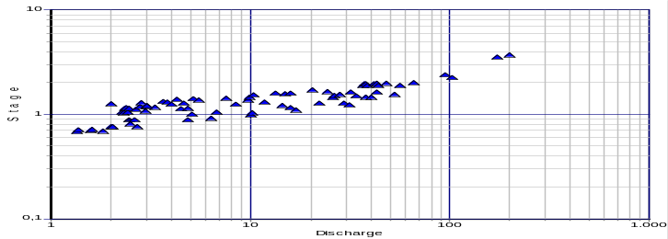
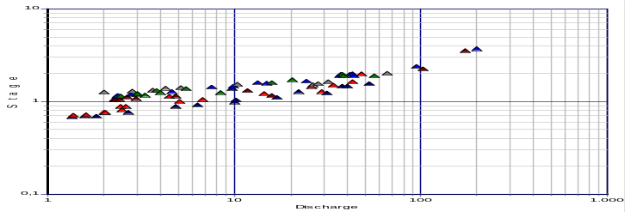
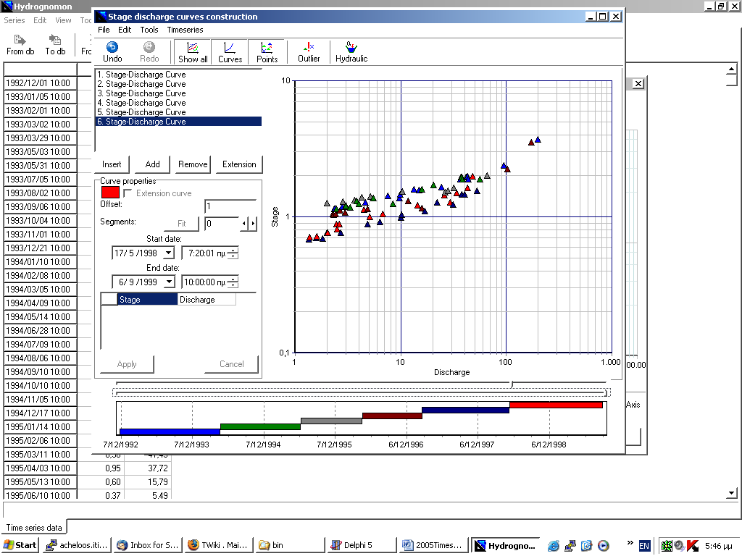
Figure 5.4: Hydro – measurements’ separation in homogeneous periods (with different color)
Hydro – measurements 1992 – 1998, station “Poros Riganiou”, river Euinos.

Various facilities are provided to the user by the system, like display of only one period, selective display of points or curves, hide of εξωκείμενων σημείων etc. Finally, the user decides the positions of periods’ change, according to points’ tendency to adapt to simple geographical models, like a straight line or a polygonal curve etc. Different solutions can be tested, adapted to stage – discharge curves, saved and compared to each other later on.
Finally, the user decides which are the εξωκείμενα σημεία and they are marked by an appropriate graphical function. This test is empirical and it is based on user’s judgment. The justification of this decision is based on methodology that uses statistical documentation, i.e. observing that the determination coefficient is improved, by removing such points.

Curves’ adjustment to hydro – measurements
Linear regression is used in order to adjust stage –discharge curves to hydro – measurements’ points. A number of vertices is defined (from 0 – line segment to n-2), by the user and it can vary for each period. Then, through an exhausting algorithm, the measured stages are checked as possible vertices. Finally a group of vertices that gives the best determination coefficient is chosen. The classified group should consist of increasing stage and discharge values.
Before determining the curves, a value for constant h₀ should be defined (see unit’s introduction). Usually, the chosen value remains the same for every period and added to the measured stages h_{i} negative values are avoided (negative values could cause errors during logarithmic calculations).
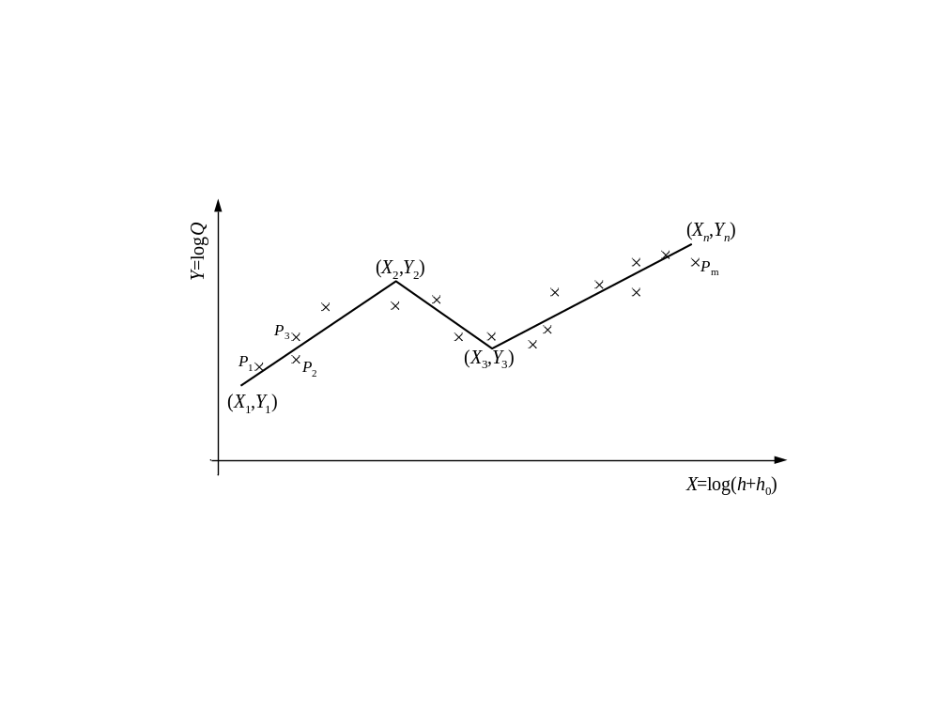
Figure 5.5: A possible stage – discharge curve. Given the X_{i} , the optimal group Y_{i} is searched

The determination coefficient results from the general Equation (7.9) and defines adjustment’s quality for each curve separately and for every curve and every period. Let n-2 the number of vertices that defines n-1line segments from n points (X_{i}, Y_{i}). X_{i} are defined as the values of the independent variable and they result from the logarithms of the stage values (increased by the constant h₀). Y_{i} are defined as the values of the depending variable and result from the logarithm of the discharge values. X_{i} are given and come from hydro – measurements. The question is to calculate the optimal Y_{i} group for the given X_{i} group and a determination coefficient that will be used for the final selection. Acceptable results are those that give increasing discharge.
Let P_{j} the m points of hydro – measurements with coordinates (x_{Pj}, y_{Pj}), that derive from the logarithms of stage and discharge. Every line segment [i-1 – i] is examined separately using the points P_{j} that refer exclusively to this specific line segment (X_{i-1} ≤ x_{Pj} < X_{i}). If the sum of squares is subjected to differentiation with respect to Y_{i-1} (in order to minimize the error), the following equation is valid:
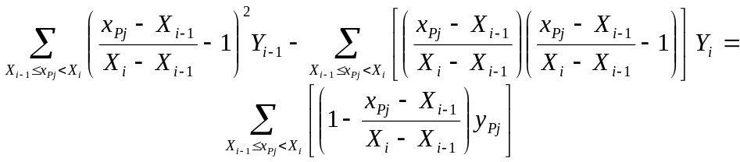 5.
If i=2...n, n-1 equations for n unknowns (Y_{i}) result from the above equation. Another equation is produced by differentiation with respect to Y_{n}, reversing the coefficients of Y_{i-1} and Y_{i} in the equation (5.20) for i=n. Finally, the unknown Y_{i} results from the solution of the system of n equations. The points (X_{i}, Y_{i}) are a possible solution of the stage –discharge curve. At last, the chosen solution is the one that produces monotonic Y_{i} and optimal determination coefficient, calculated from the general Equation (7.9). Having calculated the optimal set, after lots of trials, the points of the stage – discharge curve are:
(h_{i}, Q_{i}) = ( e^{Xi} – h₀, e^{Yi} ) 5.
Logarithmic interpolation is applied, according to the already described methodology, and finally the stage – discharge curve consists of the points (h_{i}, Q_{i}).
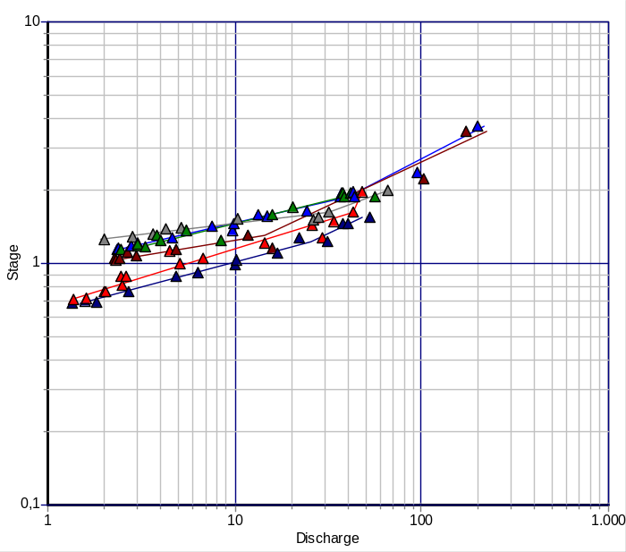
Figure 5.6: Stage – discharge curves’ plot.
Curves with one vertices, adjusted to period separation of Figure 5.4

Expansion curve introduction with hydraulic equations
Expansion curves refer to relations that connect stage and discharge values, when there are no hydro measurements. It is assumed that only one expansion curve is sufficient to describe the stage –discharge relation for each one period. It has been noticed that stage – discharge curves tend to converge for large stage and discharge values.
The used methodology for expansion curves’ plotting, is not based on hydro measurements exclusively, since there are no available measurements for this region. The used methodology usually combines hydraulic equations and the highest hydro measurements’ values. Curve plotting can be achieved by exclusive use of hydraulic relations, since streams properties (roughness and channel’s inclination) are known. The plotting methodology for usual stage –discharge values can also be applied, combined with hydro measurements or not.

Manning and Chezy equations
Manning and Chezy equations are used for expansion curve plotting (Koytsoyiannis, 1999, Demetriou 1994). They are two of the most widespread relations for discharge calculation in open channels with free surface. Flow speed in free surface channel is calculated from Manning formula:
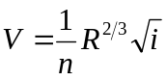 5.
where n is the dimensionless roughness coefficient, R the hydraulic section’s radius and i free surface’s inclination. If the flow is uniform, inclination i is equal to streambed’s inclination J. According to Manning, discharge results from speed’s multiplication with section’s area A:
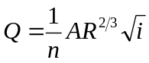 5.
Flow speed is calculated from Chezy formula:
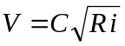 5.
where C the Chezy roughness coefficient, R the hydraulic section’s radius and i free surfaces inclination. According to Chezy, discharge results from multiplication with section’s area as:
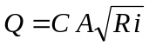 5.
Chezy equations gives milder discharges and sometimes it is preferred instead of Manning formula. A and R are usually known as far as section’s properties and stage are known. Roughness coefficients (n for Manning and C for Chezy) and hydraulic inclination i (or J assuming uniform flow) can be defined by the user. Alternatively, relevant products (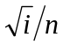 for Manning and 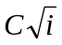for Chezy) can be defined using the maximum hydro measurements’ values and optimal adjustment through linear regression.

Calculation of Water section’s properties
In order to calculate discharge from Manning or Chezy formulas, water section’s properties (hydraulic radius R and water section’s surface area A) should be calculated. Hydraulic radius derives from the relation:
5.
where Π is the wetted perimeter of the water stream. If stream’s section is depicted as a polygonal line with n vertices p_{i} = (x_{i}, y_{i}), it is sufficient to find the curved areas, defined by the intersections with the straight line y = h, where h is the water stage. Curved regions are defined by the intersections with stream ‘s section (x_{s}, y_{s}) and (x_{e}, y_{e}) and all the included points i = k...l (1<k<l<n).
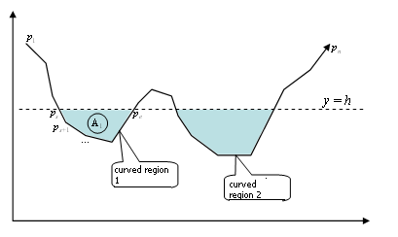
Figure 5.7: Water section in relation with stream’s section and water stage.

It is assumed that surface is the sum of individual curved areas. The same applies to the wetted perimeter. The relevant equations are:
Π = 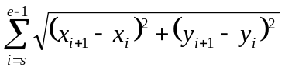 5.
and
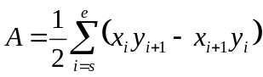 5.
where p_{e+1}≡p_{s}.
The sections that define the curved areas, result from the straight line y = h and the linear equation between two points i and i+1:
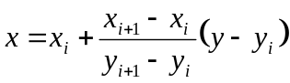 5.
The number of sections should be an even number. Otherwise, closed areas cannot be drawn and an error message is displayed. The polygonal line must be defined anti clockwise in the Cartesian plane (e.g. in an open channel the points are given from left to right), and the line should intersect with itself. Figure 5.8 represents some examples of water sections that can be used in order to calculate section’s properties as well as some problematic cases.
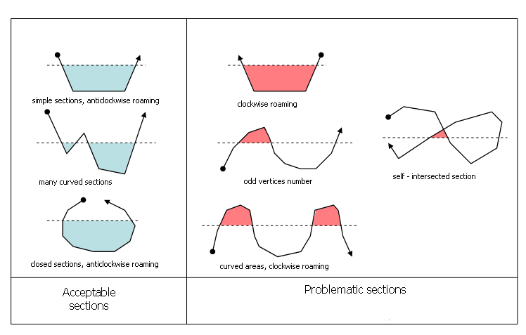
Figure 5.8: Acceptable and problematic sections for water section’s properties calculation

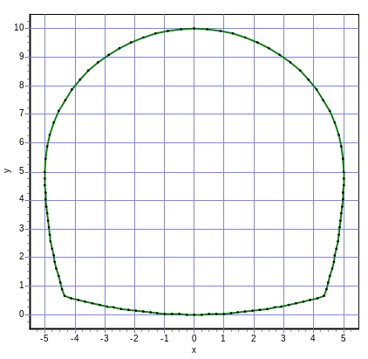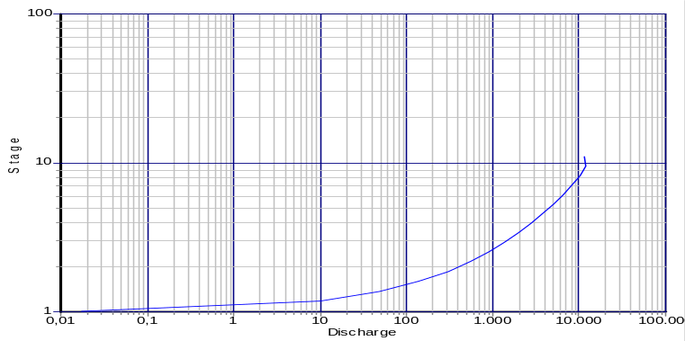
Figure 5.9: Stage – discharge curve plotting in H ydrognomon for a closed section. Use of Manning formula with n=0.0015, i=0.012

Coefficients’ adjustment by means of homogeneous straight line
Manning and Chezy formulas’ coefficients can be defined by the user, if there is enough data, e.g. section’s roughness η or hydraulic inclination i (assuming that it follows streambed’s inclination). If these formulas are used for expansion curve plotting, coefficients can be estimated through optimal adjustment of the relations to hydro measurements data. Hydro measurements are classified in ascending order. Then a sufficient number of hydro measurements (from the maximum measured discharge values of every period) is chosen. In Hydrognomon the default value for this number is n=8.
If (h_{i}, Q_{i}) the hydro – measurements sample that will be used for coefficients adjustment, the hydraulic relationships can be expressed as:
Q = G f(h) 5.
where f(h) is a relationship that depends on geometrical characteristics of the section (area A and hydraulic radius R), on stage h and on a properties coefficient G that contains roughness and inclination. For Manning formula, G is calculated as:
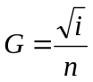 and f(h) = AR^{2/3} 5.
For Chezy formula, G is calculated as:
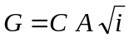 and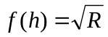 5.
f(h) function can be calculated from stage measurements and section’s properties, according to the methodology described above. Assuming that f(h_{i}) values are the values of an independent variable, while discharge measurements Q_{i} are the values of a dependent variable, properties coefficient G is estimated through linear regression – case of homogeneous straight line (see paragraph 7.2.3). Finally, G value results from the relation:
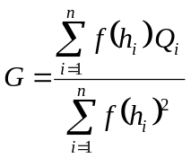 5.
The determination coefficient, which is calculated from the generalized Equation (7.9), is the quality criterion of the model’s adjustment to hydro – measurements. C, i or n can be calculated, if just one of them is known (e.g. if inclination is known, roughness can be calculated).

Discharge – sediment discharge curves
Plotting of discharge – sediment discharge curves and relevant calculations (discharge interpolation in relevant curve in order to calculate discharge), demand the same principles and methodologies that were described for stage – discharge curves, but with the following modifications:
- Discharge is the independent variable (like stage in the case of stage – discharge curves) while sediment discharge is the dependent one (like discharge in the case of stage – discharge curves).
- The constant term (offset) is not used and there are no negative discharge values.
- The interpolation is double logarithmic like in the case of stage – discharge curves.
- There are no expansion curves contrary to the case of stage – discharge curves.
- Different calendar periods can be introduced (like in the case of stage – discharge curves), however two more subsets are defined for each period. These subsets refer to summer and winter months (dry and wet season). The period between November and October can be considered as wet season. From May to October it is considered to be the dry period. However, the start time and the end of the wet or dry period can be defined by the user.
- In sediment discharge calculations through interpolation , there are no corrections, like stage correction, or union of stage meter’s and stage recorder’s samples etc., that were possible in the case of stage – discharge curves.

Hydro – measurements registration, compilation of discharge time series from hydro – measurements
In Hydrognomon stream hydro – measurements data is registered and pasted to a file that later on is registered to a data base. This file contains properties of sections, stage records and hydro – measurements in different depths, by different methods. This data can be used for automated calculation of average speed or average discharge as well as for production of autonomous stage –discharge time series. Further exploitation of stage – discharge time series is analyzed in the following chapters.

Requirements for hydro – measurements data registration
The general requirements for data registration are presented below. Discharge calculations take into account the following requirements. Understanding of the requirements facilitates the use of the relevant Hydrognomon application.
- Every registration file refers to a specific position of a specific stream. The file contains data of sections, stage measurements and hydro – measurements.
- Section’s geometry, where hydro – measurements take place, should be possible to be registered. However, with the pass of time, section’s properties change, so it is possible to register up to ten sections with their geometrical characteristics. The geometrical characteristics are described through the section’s polygonal, i.e. from a set of n points (x_{i}, y_{i}). Coordinates x_{i}, y_{i} refer to an arbitrary coordinates system, but y always refers to depth while x to distance from the left bank (it is assumed that the flow is uniform so the bank where the measurement takes place does not play a significant role, because in the case of reverse flow the discharge is considered to be the same). However, y can be the deeper section’s point and the starting point of x can be the most distant point of the bank. In general, there must be agreement between y and the reference system of the stage measurements. Polygonal roaming is counterclockwise. The same tool used for expansion curves application, can be used for drawing – insertion of sections.
- Successive hydro measurements sessions can be defined by the user. Each session is characterized from the characteristic time of the measurements. The session may contain lots of hydro measurements and may last for some time, so the characteristic time should be in the middle of the measurement. Each session is combined with one of the ten geometrical sections by the user. If only one section has been defined, it is used for every session. Moreover, for every session the stage measurement recorded from established stage meter, is inserted. Finally, the measuring way of X for hydro measurements strips is determined ( if it starts from the start of the current wet section of the current session or if it is an absolute value X, according to section’s polygonal coordinates). From each session results a single registration for the produced stage and discharge time series. After data insertion, it is possible to check the stage (if it does not exceed section’s borders) and draw up the wet section.
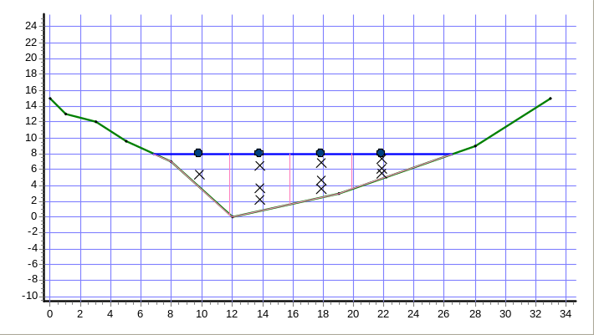
Figure 5.10: Hydro measurement session as displayed in Hydrognomon. Green refers to the section, blue to the wet section, positions of hydro measurements’ columns (dots), strips (pink) and hydro measurements (X).

- For every session one or more vertical hydro measurements strips are defined. If no strips are defined, at the results the discharge time series registration will be empty. For each strip, a distance X, where the hydro measurements’ column took place, is inserted and it is measured as described in requirement 3. Each strip’s width depends on the positions and it may not be constant. Total strip’s depth, demanded for area’s calculation, results from the intersection of the vertical straight line that crossed the hydro measurement’s (X) column and the section’s streambed. Finally, for each strip the hydro measurements’ system is defined. There are the following choices: (a) one measurement at the 0.6 of the depth, (b) two measurements at 0.2 and 0.8 of the depth, (c) three measurements at 0.2, 0.6 and 0.8 of the depth, (d) n random measurements at arbitrary depths logarithmically adjusted (turbulent flow), (ε) n random measurements at arbitrary depths with parabola adjustment (laminar flow). Actually, laminar flow does not exist. Streams’ flow is always turbulent. However, the relation is maintained in case of better numerical data adjustment. Having inserted strip’s properties, by pressing a button, data’s consistency is checked and average speed is calculated (speed values have been already inserted, see requirement 5).
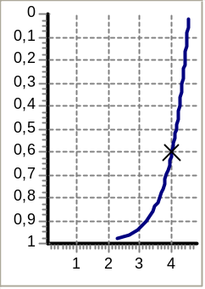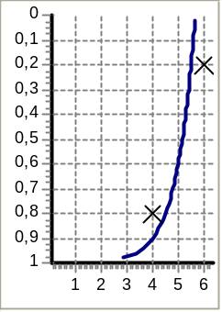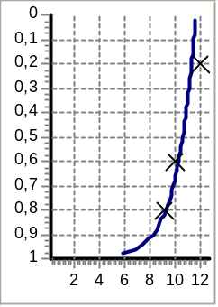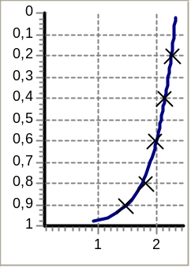
Figure 5.11: Hydro – measurements’ methodologies: standard (a), (b) και (c) at 0.6 - 0.2 and 0.8 – 0.2, 0.6 and 0.8 of the depth. 5 random points (d) logarithmic curve optimal adjustment to 5 random points.

- After defining the strips and the measurement methodology for each strip, speed values are inserted to the system. For standard measurements at 0.2, 0.6 and 0.8 of the depth (at every possible combination), speed values are inserted at these depths by the user. The points can be used in order to plot a logarithmic curve that represents the speed values’ profile for turbulent flow with stable streambed’s point where speed is zero. In the case of random points’ use, the depths (actually the depths’ fractions) where the measurements take place, should be defined by the user. Finally, speed values are registered by pressing a button. Calculations and plotting result from the command described at requirement 4. In the case of random points, after registration, the conversion coefficients c₁, c₂ appear (see next paragraph) as well as the correlation coefficient of the adjustment.

Average speed – discharge calculation
The technique used for section’s average discharge calculation is quite simple and it is based on section’s division into zones (vertical strips), average speed calculation of a strip ( from the hydro measurements column adjusted to the strip) and surface integration (sum of individual multiples of strip’s average speed and surface). The procedure of calculation is analyzed by Koytsoyiannis and Ksanthopoulos (1999, p. 319-328).
Each strip is defined by the horizontal position of the hydro measurements column. If there is no neighboring strip on the left or right, its start / end is defined by the start / end of the wet section. If there is neighboring strip, its end / start is defined by the average distance between the successive hydro measuring columns. If d_{i} is the total depth of each strip, Δw_{i} the width and 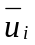 the strip’s average strip, the average discharge of the whole section is:
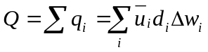 5.
Section’s average speed results from dividing Q with the total wet surface.
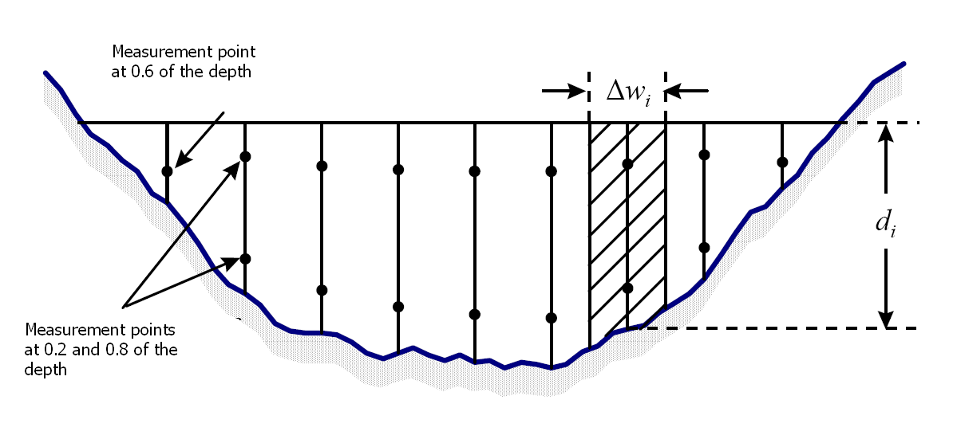
Figure 5.12: Section’s division into strips, hydro – measurements
(Koytsoyiannis and Ksanthopoulos, 1999, p. 322)

Stream’s flow is considered to be turbulent, while the laminar flow boundary layer is considered to be so thin that turbulent flow is applied across the whole section. The speed distribution follows logarithmic law. Standard measurements at 0.2, 0.6 or / and 0.8 of the depth, derive from these considerations (the measurement starts from the surface and ends on the streambed). Moreover, measurements can take place at any depth and at any number.
Table 5.1: Strips’ average speed for various measurement cases
Measurements | Speed distribution (H: depth fraction from bed = 1 – y/d) | Section’s – hydro measurement column’s average speed
1 point at 0.6 of the depth (u_{0.6}) | Logarithmic (turbulent flow) | u_{0.6}
2 points at 0.2 and 0.8 of the depth (u_{0.2} and u_{0.8}) | Logarithmic (turbulent flow)
3 points at 0.2, 0.6 and 0.8 of the depth (u_{0.2}, u_{0.6} and u_{0.8}) | Logarithmic (turbulent flow)
n points at random depths y, logarithmic law | u(H) = c₁ + c₂ log₁₀H | c₁ – c₂ log₁₀(e)
n points at random depths y, parabola law | u(H) = H ( c₁ + c₂ H)

Since speed distribution is expressed by logarithmic law, if H→0 (y/d→1), speed cannot be defined. Actually this does not happen, because of boundary layer’s existence. However, this relation can be integrated for average speed calculation with integration boundaries 0 and 1 since the integral contains the term H logH that is zero for H→0. This is how derives the above equation for average speed.
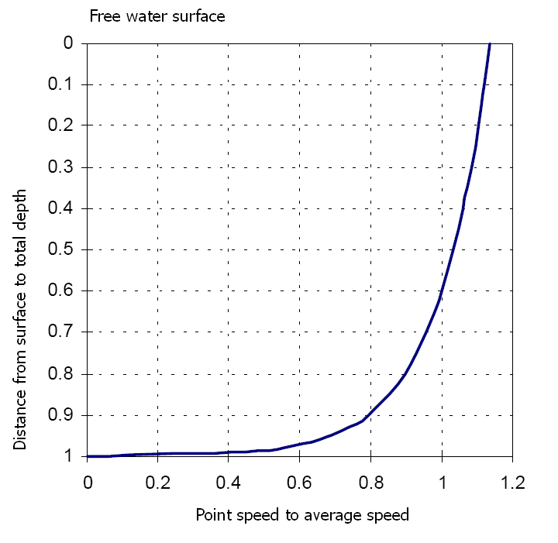
Figure 5.13: Typical speed distribution to a vertical stream’s section
(Koytsoyiannis and Ksanthopoulos, 1999, p. 321)

Coefficients c₁ and c₂ are determined through linear regression from n hydro measurements to random depths y by adjusting the formula Y = c₁+c₂*X. It is reminded that y or y/d can be defined by the user. Regression coefficients are determined by common statistical methods for straight line’s best fit at the points (X, Y), that result from the following hydro – measurements:
Table 5.2: Hydro measurement points’ transformation for linear regression, H=(1-y/d), referring to points H with speed: u_{H}
Regression law | X | Y
Logarithmic | log₁₀ H | u_{H}
Parabola | H

