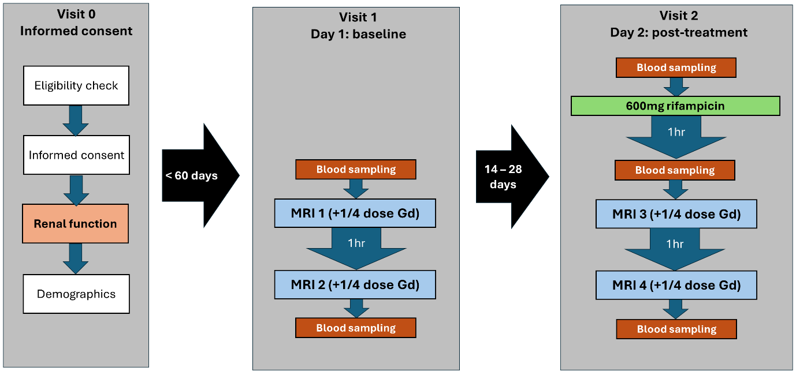
Figure 1: Flow diagram of the final protocol after dose escalation, showing the study design and assessments performed at each visit. Visit 0 was a screening visit to assess eligibility for the study, take informed consent and collect key data. Visit 1 was the baseline visit, no more than 60 days after consent. It involved two MRI scans at least 2 hours apart, and blood tests before and after the scans. The post-treatment visit 2 took place between 2 and 4 weeks after the baseline visit, and involved blood sampling before oral rifampicin administration, then after 1 hour a repeat of the same protocol performed at visit 1.
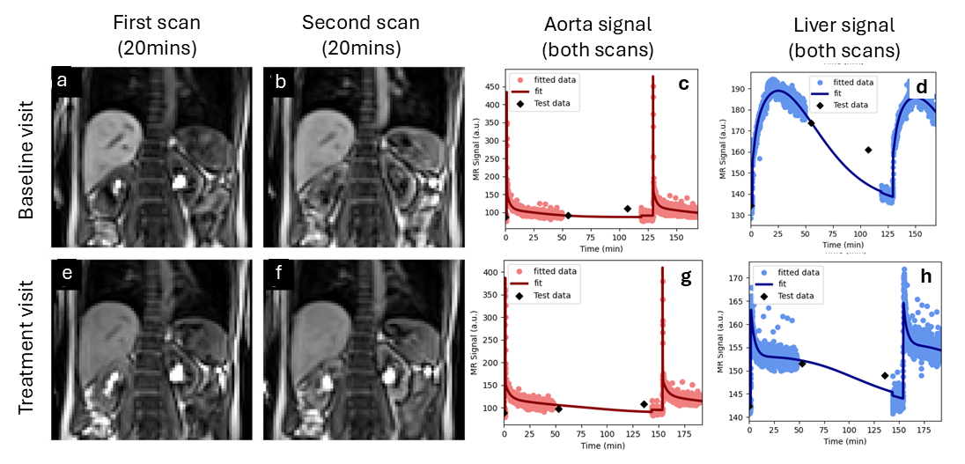
Figure 2: Signals for the two scans performed on the same day for one volunteer at baseline (top row) and after a single 600 mg dose of rifampicin (bottom row). The top row shows an image of the first scan (a) and second scan (b) at peak enhancement (20mins after injection), and signal-time curves of gadoxetate data in the aorta (c) and liver (d). The bottom row (e-h) shows the same data for the treatment visit. The plots shows the signal with the model fit superposed, showing a small discontinuity before the second scan due to signal recalibration. The MOLLI T1-values are fed through the signal model and plotted as part of the quality control process (checkpoints) but are not used in the actual model fit.

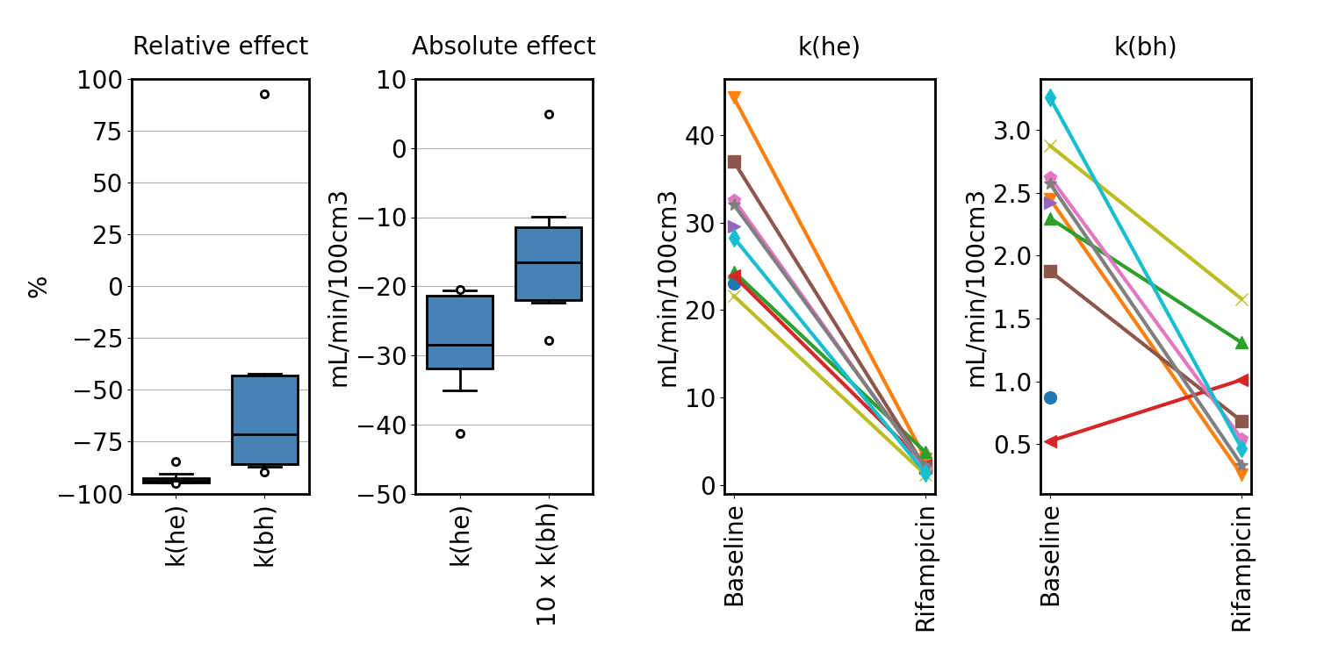
Figure 3. Rifampicin effect on the primary endpoints k(he) (hepatocellular uptake rate) and k(bh) (hepatocellular excretion rate) across the population. Box plots on the left show the relative and absolute effect size across the population. Absolute effect sizes for k(bh) have been scaled with a factor 10 to improve visualisation. Line plots on the right show individual values at baseline and after single dose of rifampicin, with each line representing an individual participant. Values for participants that attended the baseline visit only are shown with a single plot symbol.

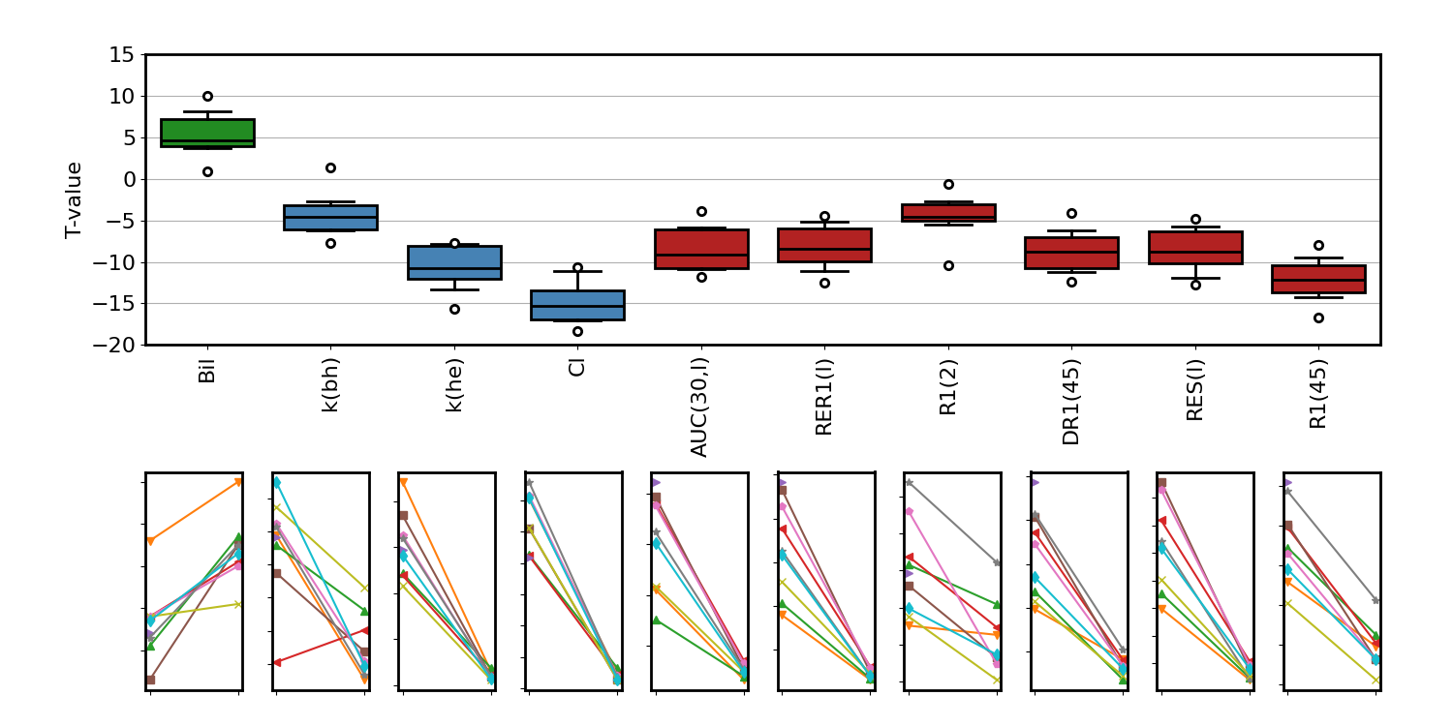
Figure 4. Participant-level rifampicin effect for all parameters that show a significant change in the mean value (p<0.01). The top row shows the difference between rifampicin and baseline relative to the standard error of the difference (T-value), with LFT markers in green, hepatocellular (HC) markers in blue, and semi-quantitative (SQ) markers in red. The bottom row shows the individual changes for the corresponding biomarkers. Explicit names for the biomarkers can found in tables 3, 4.

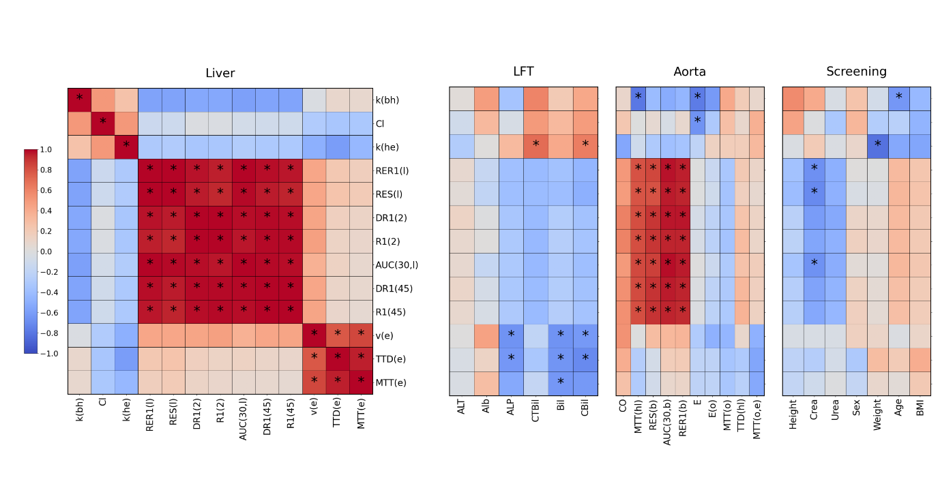
Figure 5. Cluster plot of correlations between liver biomarkers at baseline. The vertical axis for each panel shows the MRI liver biomarkers. The horizontal axis shows the MRI liver biomarkers (left panel) and LFT’s (right panel). Negative correlations are shown in blue and positive correlations in red, and significant correlations (p<0.01) are marked with (*). Explicit names for the biomarkers can found in tables 3, 4.

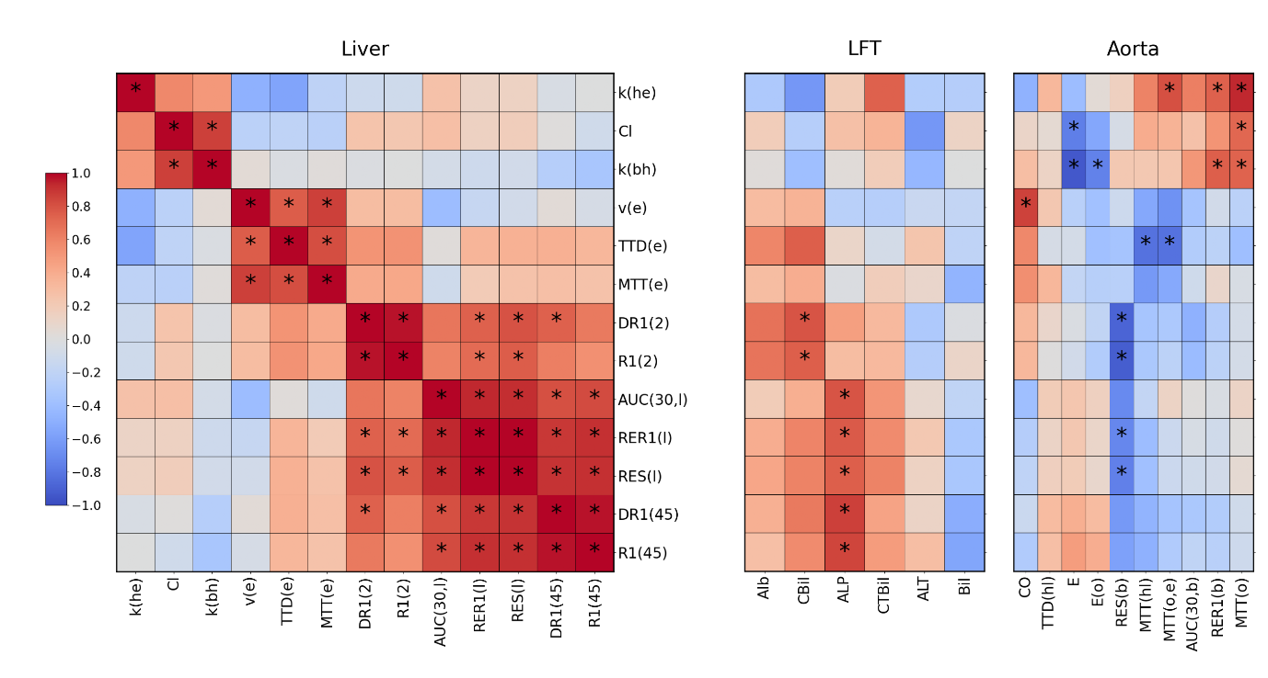
Figure 6. Cluster plot of correlation coefficients between changes (rifampicin – baseline) in liver biomarkers. The vertical axis in each panel shows the change in MRI liver biomarkers. The horizontal axis shows the change in MRI liver biomarkers (left panel) and change in LFT’s (right panel). Negative correlations are shown in blue and positive correlations in red, and significant correlations (p<0.01) are marked with (*). Explicit names for the biomarkers can found in tables 3, 4.

