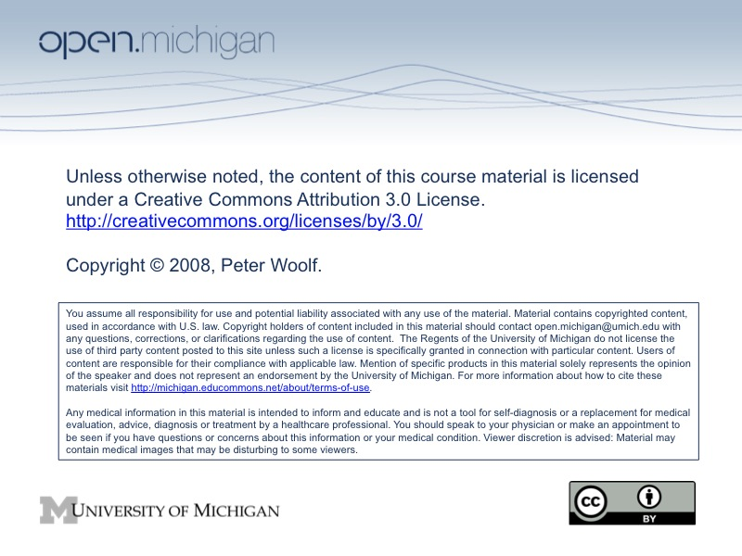

ChE 466 Process Dynamics & Control
Syllabus

Instructor:
Peter Woolf

Course Description:
As a practicing chemical engineer, you will be faced with the task of doing things reliably in an uncertain world and with imperfect understanding. In this course we will show you a variety of approaches to reduce or manage this uncertainty through the use of robust designs, dynamic systems theory, nonlinear dynamics, control theory, and statistics.
The structure of the course this year has been changed significantly to accommodate a more flexible and interactive learning environment. The primary difference in this course is that lectures have been (and are being) pre-recorded so that they can be viewed at any time via the web or pod cast. Recording lectures provides you with two advantages: (1) flexibility and (2) better use of time. With a recorded lecture, you can watch the lectures whenever you like, wherever you like, at any speed you like, and as many times as you like. With lecture time moved to outside of the course, we can allocate the time we have in the scheduled class meeting time for interactive work and smaller group question and answer sessions.
A second difference of this course is in wiki form, and as such is something that we all are actively responsible for creating and maintaining. This text is freely available online at http://controls.engin.umich.edu.

Objectives:
At the conclusion of this course you should be able to:
      - Describe a process, how it works, and what your control objectives are
      - Instrument a process
      - Describe processes with appropriate diagrams
      - Numerically model a process from physical and logical models.
      - Fit a model to data.
      - Understand feed-forward, feed-back, and PID control of systems
      - Tune process controllers
      - Understand the principles behind multi-objective control architectures
      - Predict product quality range for a process
      - Identify sensitivities in process models

Web Site:
This course has two websites. The first is a University of Michigan CTools website:
http://ctools.umich.edu
If you have already signed up for the course, then the appropriate courses should already be selected for you. Otherwise, search for “process control” to find the course. On this site we will post additional reading material and much of the paperwork of the course.

The second website is the wiki textbook site hosted here:
http://controls.engin.umich.edu/wiki
To edit this site, you will need to sign up for an account to the site. This restricted account will allow only members of the class to edit and upload content on the site.

Textbook & Reading Assignments:
There is no textbook purchase required for this course—the text is the wiki. The course projects, exams, quizzes, and homeworks will all be derived from this source. In addition, lectures will be linked from the text for viewing online or download. Students are responsible for all material in the wiki readings and lectures.
Note that this class has a lot of reading, and you will not be able to digest all of the material in detail. Your job in this class is to keep up with the readings and to learn the concepts behind the topic.

Wiki updates:
Thanks to the efforts of previous classes in ’06 and ’07, you now have access to a fairly complete online text for learning control theory. However, this project is of variable quality, in some cases including oversights, excess material, or confusing descriptions. These problems are present in even the best printed text books, but in contrast to a printed text, this text you can correct and improve.
Improving the text not only helps others around the world learn control theory, but also benefits you. By reading the text with a critical eye, you will quickly learn to identify what you do and do not understand. By rewriting sections of the text to make them better, you will significantly deepen your own understanding of the material. As the adage says, “you never know a subject until you have to teach it to someone else”
For this class, you will be required to submit 5 wiki updates. For these updates, you will need to:
- Identify a section or passage in the controls wiki that could use improvement
- Correct or improve the section
- Write up a brief summary of your update and why it is important (up to 4 sentences)
- A link to the change on the wiki. Such a link should look something like this:
http://controls.engin.umich.edu/wiki/index.php?title=PIDTuningOptimization&diff=8167&oldid=8145

Changes on the wiki can be generated by clicking on the page history (tab on the top of the page) and “compare selected versions”
For bonus points, you can submit up to 5 additional corrections. The quality and significance of each update will be graded as pass fail based on the importance and scale of the contribution. A single small correction such as correcting a few typos will not be sufficient for a pass, while correction of many typos, significant errors, improved illustrations, significant editorial improvements, and page pruning to avoid redundancy will be much more likely to be significant.

Lecture feedback:
For each recorded lecture you will be required to turn in either a question or a point that you found interesting from the lecture on the schedule specified on the syllabus. The reason behind this assignment is to keep you on track, watching the lectures at a reasonable pace, and keep you engaged. In addition, it tells me what material you are and are not understanding so that I can address these points.

Class Structure:
In a typical class, you will have the following duties:
- Before class, watch the recorded lecture and read through the associated wiki text notes.
- While watching the recorded lecture, take notes in your own words, noting questions, important points, and relationships. These notes will reinforce the material and will provide an easier reference during exam time.
- After watching the lecture you will upload your lecture feedback noting either a question on something you did not understand or if you understood the lecture, a point that you found particularly interesting.
- During class time, come to class with your questions. The GSI and I will be there to help answer these questions and to occasionally guide the whole group if a common question arises.
- After you gain confidence in the material, try out the homework. If you have questions on the homework, bring them to class.

Note that in this class structure, attending the Tuesday and Thursday class time is not required every day except for days when guest lectures are scheduled.

Homework:
Homework in this course will be due approximately every week. The homework will give you an opportunity to try out the material for yourself to see if it makes sense. Homework due dates are listed on the syllabus. Late homework will be accepted up to 24 hours after the due date for 50% credit. The bottom homework score will be dropped. All homeworks must be turned in on the CTools site.

Exams:
Exams in the course will be all take home and done individually. These exams will require significant computational use, and will often include an open-ended component. Exam grades will be converted to class points based on z-scores. Late exams will not be accepted.

Honor code:
We expect that all work done for this course will be original, and that all members of the group will contribute equally to the group’s project. Suspected violations of the honor code should be brought to the attention of your instructor, or directly to the Honor Council.

Grading Policy:
Course grades will be weighted according to the following grading formula.

Lecture feedback: 10%
Homeworks: 25%
Exam I 20%
Exam II 20%
Final Exam 20%
Wiki updates: 5%

For the course, a total of 1000 points will be assigned based on the above proportions. Grades will be scaled based on the performance of the top students in the course. The expectation is that all students will do well in this course if they actively participate in the course, keep up with the readings, and actively seek and ask questions.
All requests for special assistance will be handled in accordance with the standard policies of the University of Michigan and the College of Engineering.

