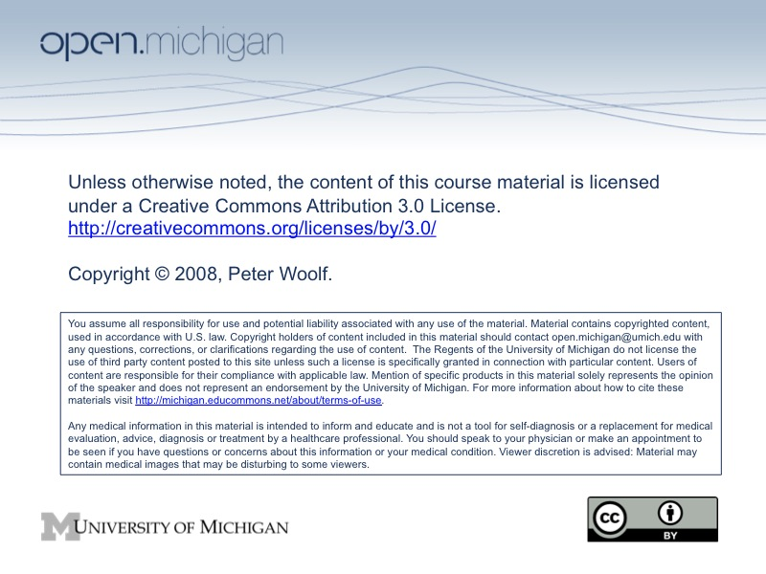

Detailed Course outline for ChemE 466, Fall 2008
Date | Topics | Reading and Lecture assignments | Lecture feedback due | Homework Due
9/2 | • Introduction, course organization  • Modeling Basics, 1. Verbal Modeling | Lecture:  #1, #2, #3  Reading:  http://controls.engin.umich.edu/wiki/index.php/Help  http://controls.engin.umich.edu/wiki/index.php/VerbalModeling
9/4 | • Modeling Basics, 2. incidence graphs | Lecture:  #4  Reading:  http://controls.engin.umich.edu/wiki/index.php/IncidenceGraphs | Lecture #1, #2, #3, #4
9/9 | • Modeling Basics, 3. Excel modeling part 1 | Lecture:  #5  Reading:  http://controls.engin.umich.edu/wiki/index.php/ExcelModelingGeneral | Lecture #5 | HW #1
9/11 | • Modeling Basics, 3. Excel modeling part 2 | Lecture:  #6  Reading:  http://controls.engin.umich.edu/wiki/index.php/ExcelModelingGeneral  http://controls.engin.umich.edu/wiki/index.php/NoiseModeling  http://controls.engin.umich.edu/wiki/index.php/Fitting_ODE_parameters_to_data_using_Excel | Lecture #6
9/16 | • Modeling Basics, 4. Numerical ODE solving in Excel  • Modeling Basics, 5. Solving ODEs with Mathematica | Lecture:  #7  Reading:  http://controls.engin.umich.edu/wiki/index.php/ExcelModelingODE  http://controls.engin.umich.edu/wiki/index.php/Solving_ODEs_with_Mathematica | Lecture #7 | HW #2
9/18 | IN CLASS EVENT: Industrial speakers  • Modeling Case study: 1. Surge tank model  • Level and pressure sensors and valve selection | Lecture:  #8  Reading:  http://controls.engin.umich.edu/wiki/index.php/LevelSensors  http://controls.engin.umich.edu/wiki/index.php/Surge_Tank_Model  http://controls.engin.umich.edu/wiki/index.php/ValveModeling  http://controls.engin.umich.edu/wiki/index.php/ValveTypesSelection  http://controls.engin.umich.edu/wiki/index.php/PressureSensors | Lecture #8
9/23 | • Modeling Case study: 2. Surge tank model  • Temperature and flow sensors | Lecture:  #9  Reading:  http://controls.engin.umich.edu/wiki/index.php/Heated_Surge_Tank_Model  http://controls.engin.umich.edu/wiki/index.php/CSTRHeatExchangeModel  http://controls.engin.umich.edu/wiki/index.php/TemperatureSensors  http://controls.engin.umich.edu/wiki/index.php/FlowSensors | Lecture #9 | HW #3
9/25 | • Piping and Instrumentation Diagrams | Lecture:  #10  Reading:  http://controls.engin.umich.edu/wiki/index.php/PIDStandardNotation  http://controls.engin.umich.edu/wiki/index.php/PIDStandardStructure  http://controls.engin.umich.edu/wiki/index.php/PIDStandardPitfalls  http://controls.engin.umich.edu/wiki/index.php/PIDSafetyFeatures | Lecture #10
9/30 | • Logical Modeling  • Logical control programs | Lecture:  #11  Reading:  http://controls.engin.umich.edu/wiki/index.php/BooleanModels  http://controls.engin.umich.edu/wiki/index.php/LogicalPrograms | Lecture #11 | HW #4
10/2 | Exam I | Exam I
10/7 | • PID controllers | Lecture:  #12  Reading:  http://controls.engin.umich.edu/wiki/index.php/PIDIntro  http://controls.engin.umich.edu/wiki/index.php/PIDDownsides | Lecture #12 | HW #5
10/9 | • Tuning PID controllers | Lecture:  #13  Reading:  http://controls.engin.umich.edu/wiki/index.php/PIDTuningClassical  http://controls.engin.umich.edu/wiki/index.php/PIDTuningOptimization | Lecture #13
10/14 | • Dynamical systems analysis: fixed points and linearization | Lecture:  #14  Reading:  http://controls.engin.umich.edu/wiki/index.php/FixedPoints  http://controls.engin.umich.edu/wiki/index.php/LinearizingODEs | Lecture #14 | HW #6
10/16 | • Evaluating stability using eigenvectors and eigenvalues | Lecture:  #15  Reading:  http://controls.engin.umich.edu/wiki/index.php/EigenvaluesEigenvectors  http://controls.engin.umich.edu/wiki/index.php/EigenvalueStability | Lecture #15
10/21 |  | Fall Break: no class
10/23 | • Evaluating stability using phase portraits | Lecture:  #16  Reading:  http://controls.engin.umich.edu/wiki/index.php/PhasePlaneAnalysis | Lecture #16 | HW #7
10/28 | - Root locus plots  - Routh stability | Lecture:  #17  Reading:  http://controls.engin.umich.edu/wiki/index.php/RootLocusPlots  http://controls.engin.umich.edu/wiki/index.php/RouthStability | Lecture #17
10/30 | • Control architectures: feedback, feed forward, ratio, and cascade control | Lecture:  #18  Reading:  http://controls.engin.umich.edu/wiki/index.php/Feedback_control  http://controls.engin.umich.edu/wiki/index.php/FFControl  http://controls.engin.umich.edu/wiki/index.php/CascadeControl  http://controls.engin.umich.edu/wiki/index.php/RatioControl | Lecture #18
11/4 | • MIMO control with Model Predictive Control, part 1 | Lecture:  #19  Reading:  http://controls.engin.umich.edu/wiki/index.php/MPC | Lecture #19 | HW#8  Election day! Vote!
11/6 | • MIMO control with Model Predictive Control, part 2 | Lecture:  #20  Reading:  http://controls.engin.umich.edu/wiki/index.php/MPC | Lecture #20
11/11 | Exam II | Exam II |  | HW#9
11/13 | • Basic statistics: mean, median, average, standard deviation, z-scores, and p-value  • Six sigma  • Control charts | Lecture:  #21  Reading:  http://controls.engin.umich.edu/wiki/index.php/Basic_statistics:_mean%2C_median%2C_average%2C_standard_deviation%2C_z-scores%2C_and_p-value  http://controls.engin.umich.edu/wiki/index.php/What_is_6_sigma%3F  http://controls.engin.umich.edu/wiki/index.php/SPC:_Basic_control_charts:_theory_and_construction%2C_sample_size%2C_x-bar%2C_r_charts%2C_s_charts | Lecture #21
11/18 | • Factor analysis and ANOVA | Lecture:  #22  Reading:  http://controls.engin.umich.edu/wiki/index.php/Factor_analysis_and_ANOVA | Lecture #22 | HW#10
11/20 | • Correlation, mutual information, and clustering | Lecture:  #23  Reading:  http://controls.engin.umich.edu/wiki/index.php/Correlation_and_Mutual_Information | Lecture #23
11/25 | • Bayes rule, probability  • Markov chain models  • Multinomial distributions | Lecture:  #24  Reading:  http://controls.engin.umich.edu/wiki/index.php/Bayes_Rule%2C_conditional_probability%2C_independence  http://controls.engin.umich.edu/wiki/index.php/Occasionally_dishonest_casino:_crimes_or_just_noise%3F  http://controls.engin.umich.edu/wiki/index.php/Multinomial_distributions | Lecture #24 | HW#11
11/27 |  | Thanksgiving Recess: No class
12/2 | • Bayesian networks and Dynamic Bayesian networks | Lecture:  #25  Reading:  http://controls.engin.umich.edu/wiki/index.php/Bayesian_network_theory | Lecture #25 | HW#12
12/4 | • Learning and analyzing Bayesian networks | Lecture:  #26  Reading:  http://controls.engin.umich.edu/wiki/index.php/Learning_and_analyzing_Bayesian_networks_with_Genie  http://www.cs.duke.edu/~amink/software/banjo/documentation/banjo.user.pdf | Lecture #26
12/9 | • Design of experiments using orthogonal arrays | Lecture:  #27  Reading:  http://controls.engin.umich.edu/wiki/index.php/Design_of_experiments_via_taguchi_methods:_orthogonal_arrays | Lecture #27 | HW #13
12/12 | FINAL due at 3:30 PM

