

SAID ZIANI
SLIDES MADE BY
LILIA MEHAMLI
PRESENTED BY
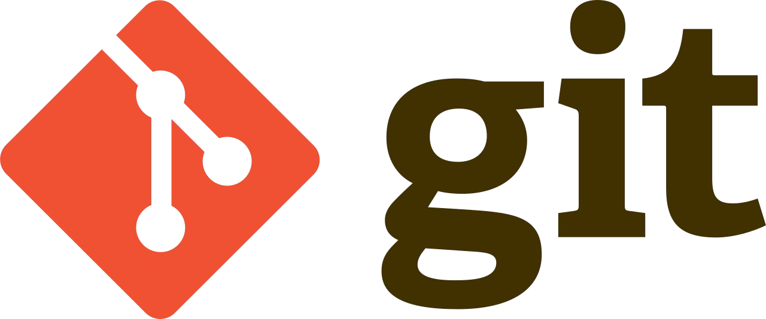



Some famous VCS
VCS allows you to revert selected files back to a previous state, revert the entire
project back to a previous state, compare changes over time, see who last modified
something that might be causing a problem, who introduced an issue and when,
and more.
VCS (Version Control System)
“Ce qui ne se partage pas, se perd”
“Ce qui ne se partage pas, se perd”
etc...
-
Remote work
-
Collaborative Team work and Conflict resolution
-
Branching and merging
-
Traceability and bug tracking
-
See who last modified something that might be
causing a problem
-
Going back to previous versions
-
A complete long-term change history of every file
-
BENEFITS OF VCS
“Ce qui ne se partage pas, se perd”
Git is a mature, actively maintained open source project originally developed in 2005
by Linus Torvalds. Developers who have worked with Git are well represented
in the pool of available software development talent and it works well on a
wide range of operating systems and IDEs.
WHAT IS GIT ?
Support for nonlinear development workflows, Efficient in
both Small and Large projects, Compatibility with many existing
systems.
-
FLEXIBILITY:
Relationships between files and directories, versions, tags
and commits, all of these objects are secured with SHA1.
-
SECURITY:
Git focuses on the file content itself, Fully Distributed,
Fast and Reliable
-
PERFORMANCE:
















“Ce qui ne se partage pas, se perd”
COMPANIES AND PROJECTS USING GIT
“Ce qui ne se partage pas, se perd”
Download: https://git-scm.com/download/mac
Mac OS :
Download: https://git-scm.com/download/win
Windows :
sudo apt install git
$
Linux :
INSTALL GIT
“Ce qui ne se partage pas, se perd”
git config --global user.email fooboo@host.com
$
git config --global user.name "Foo Boo"
$
GIT configuration
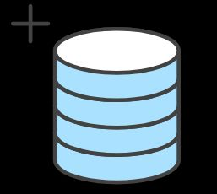
“Ce qui ne se partage pas, se perd”
After creating a new project directory,
git init
$
Start a new repository
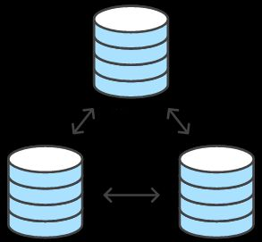
“Ce qui ne se partage pas, se perd”
git clone username@host:/path/myawesomeproject
$
Remote server:
Locally:
git clone /path/myawesomeproject
$
Clone an existing project
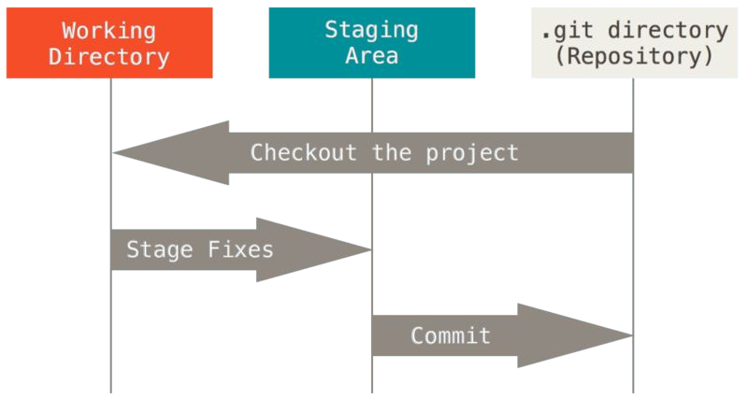
“Ce qui ne se partage pas, se perd”
GIT workflow
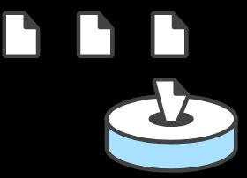
“Ce qui ne se partage pas, se perd”
git commit -m “add myfile.ext to the repo”
$
Commit changes with understandable and explicit
messages
Add changes to the index:
git add myfile.ext
$
Saving changes

“Ce qui ne se partage pas, se perd”
git log --oneline
$
or
git log [-p]
$
List the project history
State of working directory
git status
$
Inspecting repository
“Ce qui ne se partage pas, se perd”
Difference between two commits
git diff commit_hash_1 commit_hash_2
$
git show commit_hash
$
History of all changes on specific commit
History of all changes on specific file
git blame myfile.ext
$
Inspecting repository
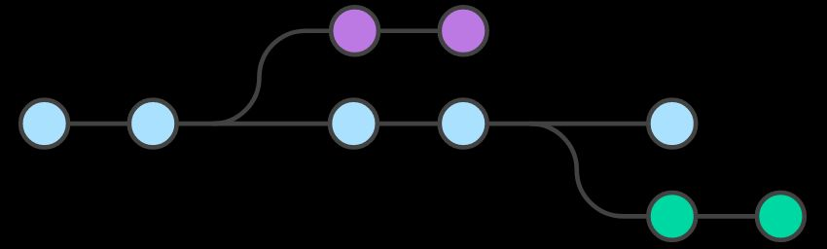
“Ce qui ne se partage pas, se perd”
GIT branching model
“Ce qui ne se partage pas, se perd”
git branch -d feature_name
$
Delete an existing branch
git checkout another_feature_name
$
Switch to another branch
Create a new branch and switch to it
git checkout -b feature_name
$
GIT branching model
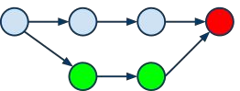
“Ce qui ne se partage pas, se perd”
git checkout feature_name
$
git merge another_feature_name
$
Merging Branches
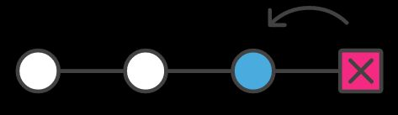

“Ce qui ne se partage pas, se perd”
git reset --hard commit_hash
$
Reset files to specific commit
git revert commit_hash
$
Revert commit
Checkout commit
git checkout commit_hash
$
Undoing commits and changes
“Ce qui ne se partage pas, se perd”
git pull origin branch_name
$
Pull change from a remote server
git push origin branch_name
$
Push changes to a remote server
Connect local repository to a remote server
git remote add origin remote_server
$
Working on a single central repository
“Ce qui ne se partage pas, se perd”
(exp : wp-config.php)
Credentials
-
(exp : npm-debug.log)
Language and Framework Files
-
(exp : .idea)
IDE project files
-
(exp : thumbs.db)
Operating System Files
-
What to add to .gitignore ?
A.gitignore file specifies intentionally untracked files that
GIT should ignore. Files already tracked by GIT are not
affected.
.gitignore
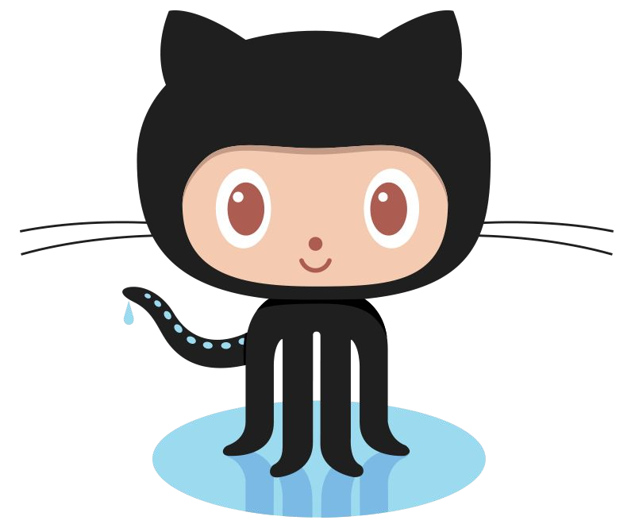
“Ce qui ne se partage pas, se perd”
requests, task management, etc.
features such as bug tracking, feature
control and several collaboration
computer code. It provides access
VCS using git. It is mostly used for
GitHub is a web-based hosting service for
Introduction to Github
Thank you!

