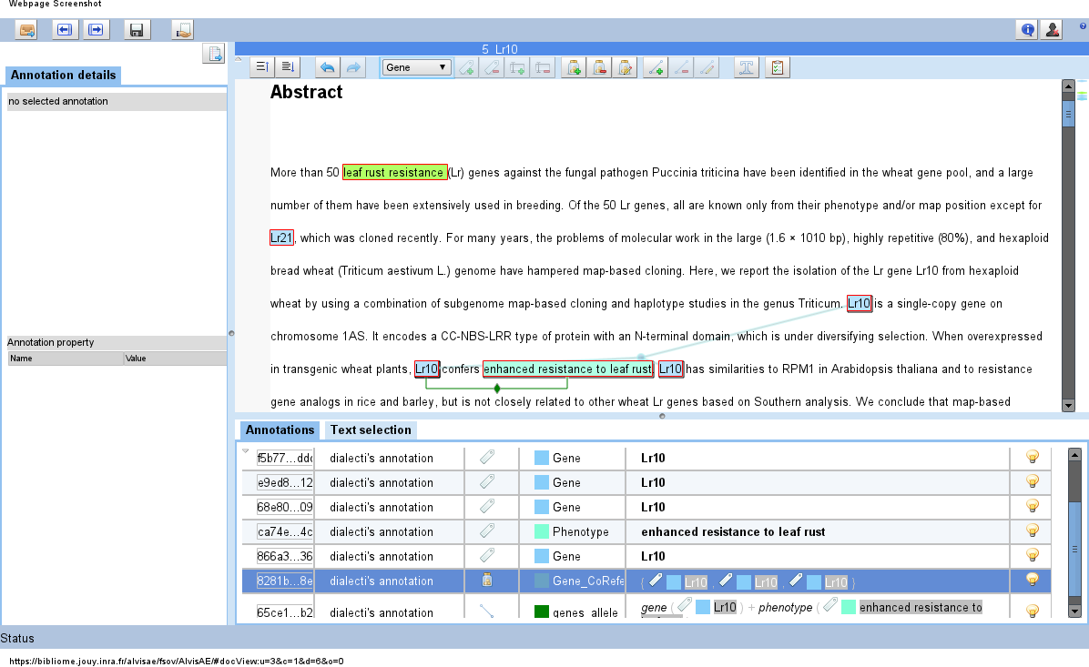
» FSOV Project

AlvisAE: Annotation Editor of the Alvis Chain

User Guide

1. Nature of the application

A web application
AlvisAE is an editor that facilitates the annotation of text documents with the goal of extracting knowledge. The application can be accessed by any modern web browser (navigator), such as Firefox, Safari, Chrome, etc. There is no installation needed by the user, and the editor is accessible from any computer, by simply entering its URL in a browser:
https://bibliome.jouy.inra.fr/alvisae/fsov/AlvisAE/

What AlvisAE does in a few lines
The words of interest are annotated in an intuitive way, by selecting them with the pointer (mouse) and choosing the correct type from the toolbar. The relations between those words can be declared in an equally intuitive fashion, either by drag and drop if it only concerns two objects, or by an extensive relation menu below the text. Finally, groups of objects can be created in order to indicate that the given terms correspond to the same entity.

Figure 1. Main application

2. AlvisAE for FSOV

AlvisAE has been adapted to the FSOV project, in order to include the appropriate users, corpus and annotations. The credentials necessary for the experts will be given separately, the corpus is produced automatically or manually by other tools and lastly, the annotations and relations used for this corpus are detailed below.

Annotations

Types
There are 7 types of annotations that have been defined in the context of this project.
- Gene
This type of annotation will be used for genes (ex. Lr1) in the literal sense, but also as an abstraction to a gene allele. In the literature we wish to annotate and for the purposes of this project, the particular allele of a gene are often omitted, but characteristics are attributed, for example, to a particular gene in a variety, something which actually speaks of the particular allele of this gene in said variety. However in order to annotate a relation between, for example, a certain phenotype (enhanced resistance to leaf rust) with a gene -allele- (and a variety), we will connect the gene to the phenotype.
- Marker
We annotate as marker anything that indicates a proper name, locus or any other kind of name substitute of a marker, if necessary. Valid examples would be “gwm351”, “S19M93-140 locus”, or “marker for PinA-D1”.
- Trait
This straight-forward annotation concerns traits such as “leaf rust resistance”, or “plant height”.
- Phenotype
As a phenotype we annotate a specific case of a trait, such as (respectively) “resistant to leaf rust”, or “dwarf plant”
- Variety
An annotation for a variety will concern its proper name as well as any other mention of it (“Ct” for “Courtot”, “CS” for “Chinese Spring”). Note that it is strongly recommended to create a group (see below) to show that an abbreviation and a proper name are related.
- AlleleSize
A marker's allele size. A valid example would be “400bp”.
- Type
A marker's type: ex. “Microsattelite”.

Relations

Binary Relations
- marker_alleleSize (marker, alleleSize)
- marker_of_type (marker, type)
- marker_tags_gene (marker, gene)
- gene_contros_trait (gene, trait)
- genes_allele_expresses_phenotype (gene, phenotype)
- variety_has_phenotype (variety, phenotype)
- trait_has_value (trait, phenotype)

Ternary Relations
- marker_size_in_variety (marker, alleleSize, variety)
marker_tags_gene_in_variety (marker, gene, variety)
- gene_expresses_phenotype_in_variety (gene, phenotype, variety)
- trait_has_phenotype_in_variety (trait, phenotype, variety).

There are 11 possible types of relations between the terms annotated with names which have been chosen to be explanatory of the relationship they represent.
Please note that there is a certain overlap between some of the ternary and some binary relations, the expert is advised to use the more complete relation where this is possible (ternary); the binary alternatives exist in order to facilitate the annotation in case of information not included, or implied or is expressed vaguely. This overlaps aims to extract as much correct information as it is possible, without compromising accuracy and correctness.
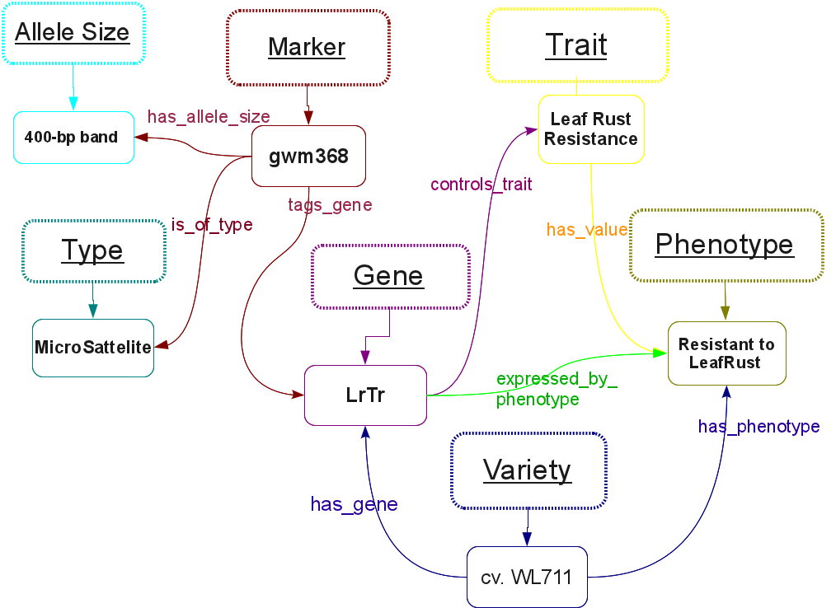

Figure 2. Binary Relations and Terms

3. Using AlvisAE

In this section you can find a detailed description of all actions necessary to complete your work, along with screenshots. You can additionally find a walk-through of a simple example in video format included in the documentation package you received.

3.1 Signing in

From the first screen on https://bibliome.jouy.inra.fr/alvisae/fsov/AlvisAE/ you will be invited to “Start!”. By clicking on “Start!” a login form will pop up, insert your username and password (given separately) and either click on “Sign-in” or press Enter on your keyboard.
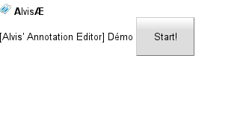
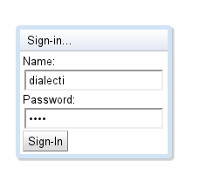

Figure 3 & 4. “Start!” and enter credentials.

3.2 Campaign & Document view

You will then be presented with a menu for selecting a Campaign, where you click to choose the FSOV campaign. When you do, the list of the documents available for annotation is shown below. Select the document you wish to work on either by double clicking, or by simply clicking on it, and then clicking on the icon of a blue arrow at the right part of the screen to continue.

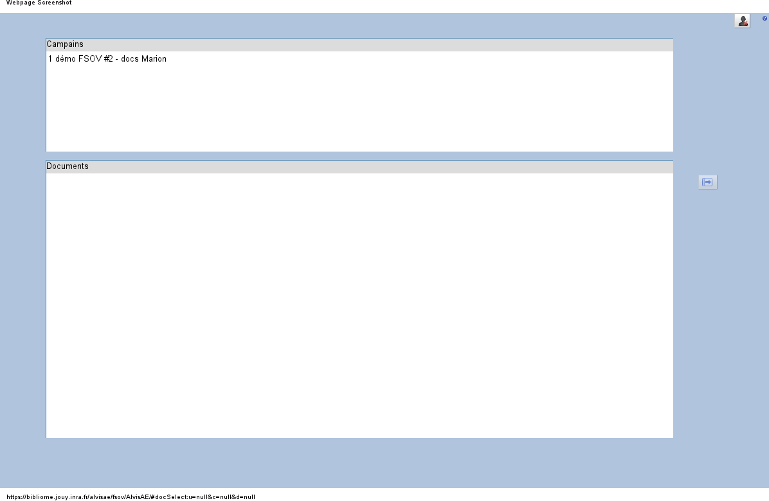
Figure 5. Campaign View.

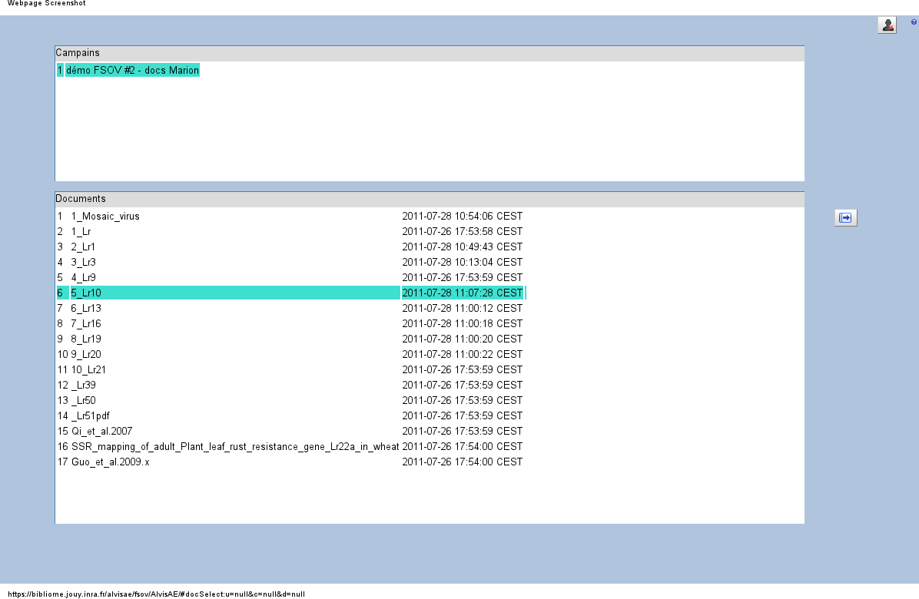
Figure 6. Document View.

3.3 Annotation View

This is the main application interface and where the annotation process takes place.
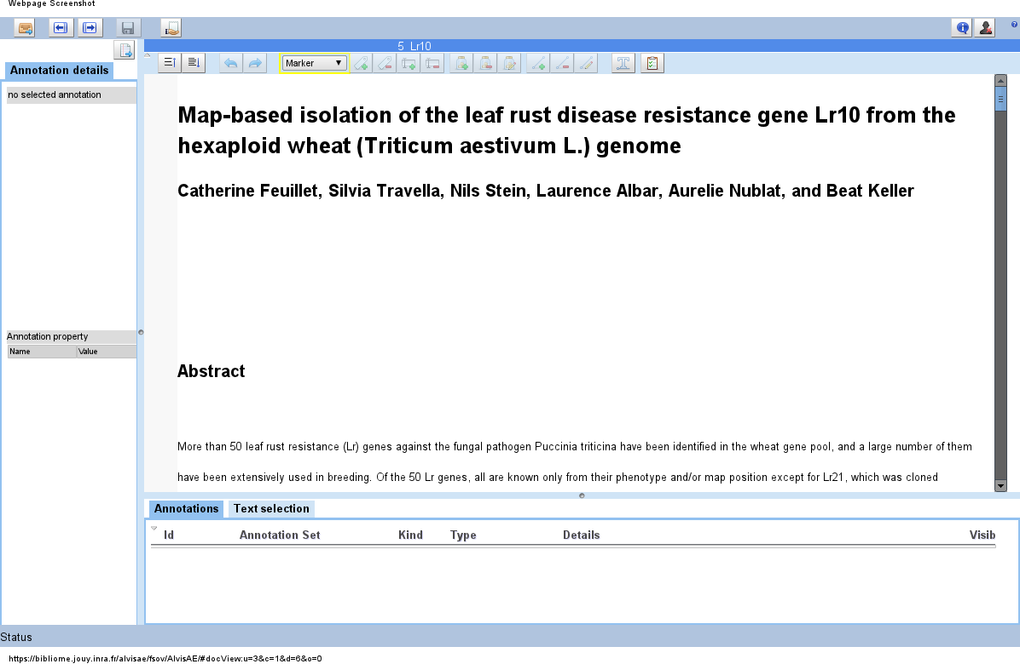
Figure 7. A new non-annotated document loaded in AlvisAE.

After working with the document in the bottom panel we can see the annotations and relationships that we have already added.
Editing the relationships or the annotations can be done either by selecting the text or clicking on an existing annotation in the top half panel (document text), or by clicking the item in the list on the bottom (see Figure 8).
In the annotation list, hold down the “Control” (Ctrl) key on your keyboard to select multiple annotations. Note that the annotation list is the only way you can add a relationship between more than two annotations.

* Rearranging the view: If you wish to give more or less space in the available panels (left, bottom and top), you can click on the blue line (with a small circle in the middle) that separates them and move it so as to resize the areas according to your preference.
Figure 8. A part of a document that has already been annotated.

Remember at all times there is an explanation in the form of a tooltip for every tool available if you point your mouse cursor over it and leave it there for a few seconds.

Also note the little lightbulb icon at the last column of the annotation list: by turning it on or off by clicking, you can hide or show the corresponding element. Attention: when already loading an annotated document the relationships will be “hidden”. To activate them either click on their light bulb or put your mouse pointer over one of their arguments.

Taking a detailed look at the toolbar, here are the possible actions when annotating.

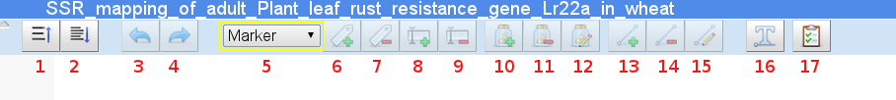
- Increase space between lines
- Decrease space between lines
- Undo last move (can undo more than the last modification)
- Redo last undone move
- Drop-down menu of available annotation types.
- Add annotation of selected type
- Remove selected annotation
- Add selected text to current annotation
- Remove selected text to current annotation
- Add group
- Remove group
- Edit group
- Add relationship
- Remove relationship
- Edit relationship
- Switch text/relation view
- Validate current document

Scenarios of use
Here are some examples of use to give you an idea:

Adding a gene annotation:
- Select the text you want to annotate in the document text.
- Select Gene from the drop down menu (button 5).
- Click on the icon to add an annotation (button 6).
Adding a group:
- Click on the first element you wish to add to a group in the annotation list (bottom half of the screen).
- Hold down the Ctrl key of your keyboard and select (click on) the rest of the annotation you want to group, one by one.
- Click on the icon to add a group (button 10).
Adding a relationship:
- There exist two ways:
  - The first way is by following the same steps 1 & 2 of the group scenario above and then clicking on the relationship icon (button 13).
  - Additionally, you can use the following way for binary relationships:
  - Click on the first annotation you wish to include in a relationship.
  - Move your mouse pointer near the edges of the colored rectangular box defining this annotation, a little magnet (Figure 9) will appear: grab it with your mouse pointer (which should know be a small white hand), drag it (move your mouse and simultaneously hold your mouse key clicked) and drop it inside the colored defining box of the second annotation; when you are successfully inside that area the box will be highlighted green.
- When you release your key (“drop”), or when you click on the “add relationship” icon, the relationship pop-up will show up (Figure 10). Select the type of the relationship from the drop-down menu, and assign the annotations to their correct types.

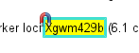

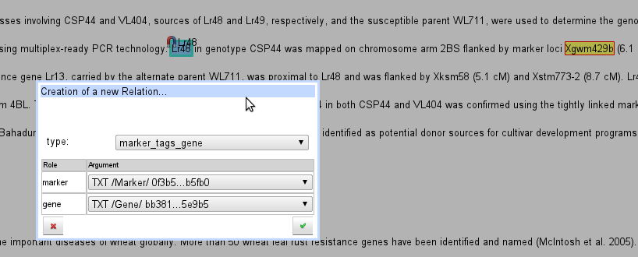
Figure 9. The drag-and-drop magnet.

Figure 10. The relationship addition menu.

During annotation you might it useful to use some keyboard shortcuts. For example, A stands for “Add a text annotation” and S or the Delete key on your keyboard (Del or Suppr)stands for the deletion of one. You can find these shortcuts in the tooltips you get when placing your mouse pointer over each icon of the tools.

Lastly, coming back to the description of the interface, we have the toolbar of document navigation/saving:

- Return to the list of documents
- Previous document
- Next document
- Save current document
- Finalize current document
- Repeat last information/error message
- Sign out
- Show information about the application

