
OpenMM
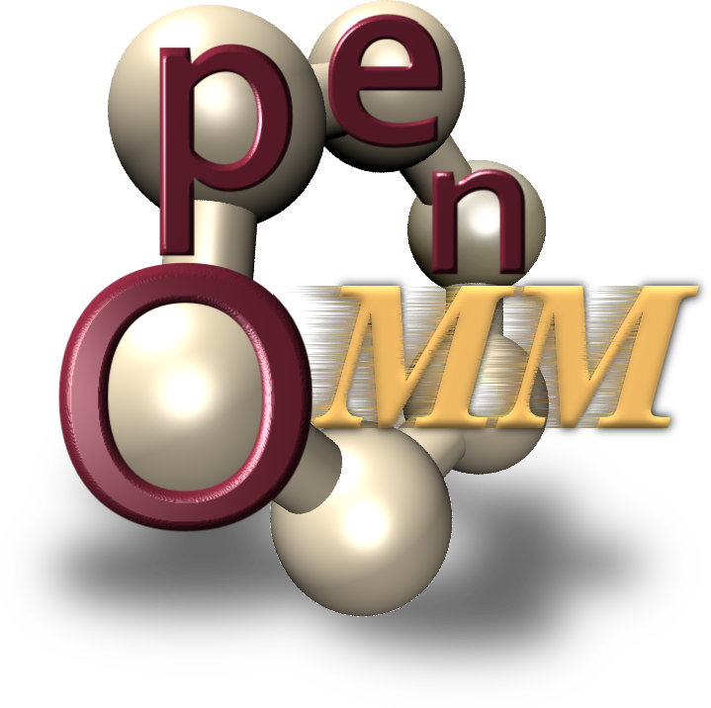

Getting Started Guide
August 28, 2009
Website: Simtk.org/home/openmm

Copyright and Permission Notice

Portions copyright (c) 2009 Stanford University and Joy P. Ku
Contributors: Joy P. Ku, Jeanette Schmidt, Peter Eastman

Permission is hereby granted, free of charge, to any person obtaining a copy of this document (the "Document"), to deal in the Document without restriction, including without limitation the rights to use, copy, modify, merge, publish, distribute, sublicense, and/or sell copies of the Document, and to permit persons to whom the Document is furnished to do so, subject to the following conditions:

This copyright and permission notice shall be included in all copies or substantial portions of the Document.

THE DOCUMENT IS PROVIDED "AS IS", WITHOUT WARRANTY OF ANY KIND, EXPRESS OR IMPLIED, INCLUDING BUT NOT LIMITED TO THE WARRANTIES OF MERCHANTABILITY, FITNESS FOR A PARTICULAR PURPOSE AND NONINFRINGEMENT. IN NO EVENT SHALL THE AUTHORS, CONTRIBUTORS OR COPYRIGHT HOLDERS BE LIABLE FOR ANY CLAIM, DAMAGES OR OTHER LIABILITY, WHETHER IN AN ACTION OF CONTRACT, TORT OR OTHERWISE, ARISING FROM, OUT OF OR IN CONNECTION WITH THE DOCUMENT OR THE USE OR OTHER DEALINGS IN THE DOCUMENT.

Acknowledgments

OpenMM software and all related activities are funded by the Simbios National Center for Biomedical Computing through the National Institutes of Health Roadmap for Medical Research, Grant U54 GM072970. Information on the National Centers can be found at http://nihroadmap.nih.gov/bioinformatics.

Table of Contents

1 Overview 9
2 Prerequisites 11
3 Quick Instructions 13
4 Installing OpenMM 15
4.1 Visual Studio 8 version 15
4.2 Visual Studio 9 version 15
4.3 Linux 16
4.4 Mac OSX 17
5 Installing GPU software 19
5.1 Installing CUDA for NVIDIA GPUs 19
5.1.1 Windows 19
5.1.2 Mac OS X 21
5.2 Installing CAL and Brook for ATI GPUs 23
5.2.1 Checking Catalyst Software Suite version 23
5.2.2 Other software required 23
5.2.3 Downloading and installing the Catalyst Software Suite 24
5.2.4 Testing your installation 24
6 Verify Installation By Running OpenMM Example Files 27
6.1 Download Example Files 27
6.2 Run Example Files 27
6.2.1 Visual Studio 27
6.2.2 Mac OS X/Linux 29
6.2.3 Troubleshooting 30

Overview

OpenMM provides pre-compiled binaries for a number of platforms:

- Windows
  - Visual Studio 8 – supported on NVIDIA and ATI GPUs
  - Visual Studio 9 – supported on NVIDIA GPUs
- Linux (32 and 64 bit) – supported on NVIDIA GPUs
- Mac OS X – supported on NVIDIA GPUs

Source code is also available. This manual provides instructions on using the pre-compiled binaries and running the test examples.

Prerequisites

To run OpenMM and the provided test examples, you will need:

- A C++ compiler
  - gcc on Mac/Linux - We have tested the examples on Centos 5.2 with gcc 4.1.2 and on Mac OS X 10.5.6 and 10.5.7 with gcc 4.0.1
  - Visual Studio 8 or 9 on Windows - You can download a free version of Visual C++ 2008 Express Edition (similar to Visual Studio 9) from http://www.microsoft.com/express/vc/

- OpenMM pre-compiled binaries for your platform (see Section 4 below)

- OpenMM example files (see Section 6 below)

- To take advantage of the GPU-accelerated molecular dynamics, you must have a supported GPU. You will also need to have the special programming language(s) used for your particular GPU (see Section 5).

Quick Instructions

Below is a quick-start guide to getting OpenMM and running the provided test examples. More details follow in the subsequent sections.

- Download OpenMM binaries from http://simtk.org/home/openmm. Extract files and save to C:\ProgramFiles\OpenMM (Windows) or /usr/local/openmm (Mac OS X/Linux).

- Set path variables for the lib directory within in the openmm or OpenMM folder – See Section 4 for more detailed instructions.

- Install GPU software, if applicable – See Section 5 for more detailed instructions.

- Download and unzip OpenMMExample.zip file (available on http://simtk.org/home/openmm). These are also included in the examples folder when you download the OpenMM source code.

- Build and run the “HelloArgon” program to test the installation – see Section 6 for more detailed instructions.
  - On Linux/Mac OS X, type make. Run the “HelloArgon” program.
  - On Windows, double click on “HelloArgon.sln” located in the HelloArgonVS8 folder. Make sure the Solution Configuration in Visual Studios is set to "Release"; due to incompatibilities among Visual Studios versions, we do not provide pre-compiled debug binaries. Build the program (Select Debug -> Start Without Debugging).

Installing OpenMM

The pre-compiled OpenMM libraries can be obtained from http://simtk.org/home/openmm. Click on “Downloads.” Under the list of “Pre-compiled binaries,” select the file that corresponds to your platform. The instructions below focus just on installing from the binaries. However, source code for OpenMM is also available.

Visual Studio 8 version

Extract all files from the zip file and place them in C:\Program Files \OpenMM. Programs that use OpenMM should include C:\Program Files \OpenMM\lib in the PATH. If you have an ATI GPU, also include C:\Program Files\OpenMM\lib\brook in the PATH. To set the PATH permanently:

- Click on Start -> Control Panel -> System
- Click on the “Advanced” tab or the “Advanced system settings” link
- Click “Environment Variables”
- Under “System variables,” double-click the line for “Path”
- Add C:\Program Files \OpenMM\lib (and if appropriate, C:\Program Files\OpenMM\lib\brook) to the “Variable value”
- If you install OpenMM to a location other than C:\ProgramFiles, you will also need to set the variable OPENMM_PLUGIN_DIR. Under “System variables,” click the “New” button. Set the “Variable name” to OPENMM_PLUGIN_DIR. Set the “Variable value” to the path for the OpenMM/lib/plugins directory. Click “OK.”
- Click “OK”

Visual Studio 9 version

Extract all files from the zip file and place them in C:\Program Files \OpenMM. Programs that use OpenMM should include C:\Program Files \OpenMM\lib in the PATH. To set the PATH permanently:

- Click on Start -> Control Panel -> System
- Click on the “Advanced” tab
- Click “Environment Variables”
- Under “System variables,” select the line for “Path”
- Add C:\Program Files \OpenMM\lib (and if appropriate, C:\Program Files\OpenMM\lib\brook) to the “Variable value”
- If you install OpenMM to a location other than C:\ProgramFiles, you will also need to set the variable OPENMM_PLUGIN_DIR. Under “System variables,” click the “New” button. Set the “Variable name” to OPENMM_PLUGIN_DIR. Set the “Variable value” to the path for the OpenMM/lib/plugins directory. Click “OK.”
- Click “OK”

Linux

Extract all files from the zip file and place them in /usr/local/openmm. Programs that use OpenMM should include /usr/local/openmm/lib in the LD_LIBRARY_PATH. To set the LD_LIBRARY_PATH, type :

export LD_LIBRARY_PATH=/usr/local/openmm/lib:$LD_LIBRARY_PATH

This sets the LD_LIBRARY_PATH only for the terminal you are in. To set it permanently, you will need to add it to, for example, your .bash_profile if you use the BASH shell.

If you choose to install OpenMM some place other than the default location (/usr/local/openmm), you will need to also set the OPENMM_PLUGIN_DIR to the openmm/lib/plugins directory. For example:

export OPENMM_PLUGIN_DIR=/usr/jpk/openmm/lib/plugins

Again, to set the variable permanently, you will need to add it to, for example, your .bash_profile if you use the BASH shell.

Mac OSX

Extract all files from the zip file and place them in /usr/local/openmm. Programs that use OpenMM should include /usr/local/openmm/lib in the DYLD_LIBRARY_PATH. To set the DYLD_LIBRARY_PATH, type:

export DYLD_LIBRARY_PATH=/usr/local/openmm/lib:$DYLD_LIBRARY_PATH

This sets the DYLD_LIBRARY_PATH only for the terminal you are in. To set it permanently, you will need to add it to your .bash_profile.

If you choose to install OpenMM some place other than the default location (/usr/local/openmm), you will need to also set the OPENMM_PLUGIN_DIR to the openmm/lib/plugins directory. For example:

export OPENMM_PLUGIN_DIR=/Users/jpk/openmm/lib/plugins

Again, to set the variable permanently, you will need to add it to, for example, your .bash_profile if you use the BASH shell.

Installing GPU software

To take advantage of the GPU acceleration provided via OpenMM, your computer needs to be equipped with one of the supported GPU cards:

Supported NVIDIA GPUs:
http://www.nvidia.com/object/cuda_learn_products.html

Supported ATI GPUs on desktops (Note supported operating systems):
http://ati.amd.com/technology/streamcomputing/requirements.html

ATI Mobility Radeon GPU boards on laptops from ATI notebook PC partners

You also need to install CUDA (for NVIDIA GPUs) or CAL and Brook (for ATI GPUs), and test them before running OpenMM and the provided examples.

ATI does not provide CAL and Brook for Macintosh desktops or laptops. However, it may be possible to get the acceleration on a Macintosh desktop with an ATI Radeon GPU by running Windows with Bootcamp (http://www.apple.com/macosx/features/bootcamp.html). VMWare, another software for running Windows on a Macintosh, will not enable your machine to access the GPU.

Installing CUDA for NVIDIA GPUs

For NVIDIA GPUs, you need to have CUDA version 2.2 or later installed to get the GPU acceleration. It is recommended that you test your installation before trying to run OpenMM and the provided examples.

Windows
- Go to http://www.nvidia.com/object/cuda_get.html

- Download and install the CUDA Driver, the CUDA Toolkit, and the CUDA SDK code samples. You need version 2.2 or later. The driver and toolkit are needed to get the GPU acceleration. The code samples are required for testing purposes.

- To verify that you’ve installed things correctly, run a sample program available with the SDK code samples.

  - Go to Start -> All Programs -> NVIDIA Corporation -> NVIDIA CUDA SDK -> NVIDIA CUDA SDK Browser

  - A window appears showing all the different sample programs you can try running (Figure 5.1).

  - Locate the program “Device Query” and click on the associated “Run” link on the right-hand side. If things are running correctly, a window will appear stating how many devices are running CUDA (there should be at least 1) and that it/they passed the test.

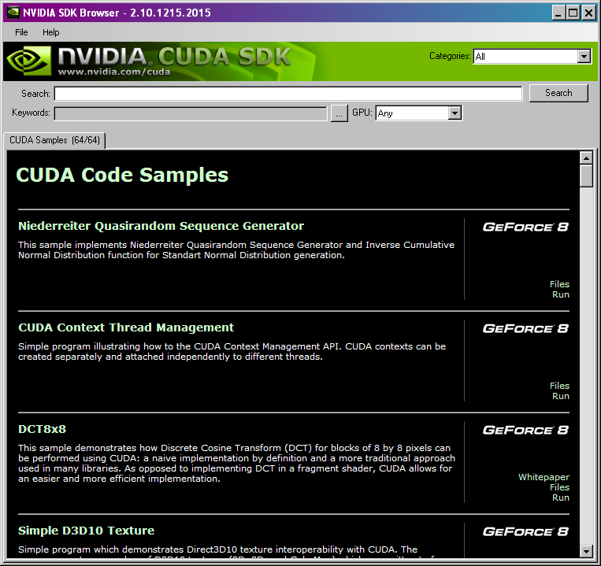
Figure 5.1: Window for browsing the NVIDIA code samples

Mac OS X
- Go to http://www.nvidia.com/object/cuda_get.html

- Download and install the CUDA Toolkit and the CUDA SDK code samples. You need version 2.2 or later. You will also need the CUDA driver. With some versions of the toolkit, the driver is included; with others, it is listed as a separate download. If the driver is listed separately, make sure you download that as well. The toolkit and driver are needed to get the GPU acceleration. The code samples are required for testing purposes.

- To verify that you’ve installed things correctly, run a sample program available with the SDK code samples.

  - Open a terminal window. Go to Macintosh HD -> Applications -> Utilities. Click on Terminal.

  - Set your environment variables so that your computer can locate the CUDA programs by typing:

export PATH=/usr/local/cuda/bin:$PATH

export DYLD_LIBRARY_PATH=/usr/local/cuda/lib: $DYLD_LIBRARY_PATH

This sets the environment variables only for the terminal you are in. To set them permanently, you will need to add it to your .bash_profile.

  - Within the terminal window, navigate to the location of the code samples. If you installed everything in the default directories, then you would type one of the following (depending on the version of SDK that you downloaded):

cd /Developer/CUDA

OR

cd /Developer/GPU Computing

  - Compile the test programs by typing:

make

  - Navigate to the location of the compiled programs by typing one of the following (depending on the version of SDK that you downloaded):

cd /Developer/CUDA/bin/darwin/release

OR

cd /Developer/GPU Computing/bin/darwin/release

  - Run the deviceQuery program:

./deviceQuery

If things are running correctly, you will see how many devices are running CUDA (there should be at least 1) and a printout saying that it/they passed the test.

Troubleshooting:

If no devices are found, verify that you have a supported GPU card. An incomplete CUDA installation, where the CUDA installer fails to install a required kernel extension, could also cause this problem. In this case, re-run the installer and select to do a custom installation. Check the box to install the kernel extension.

If you have multiple GPUs and only one is activated, this may be because of the energy-saving options (this is the case for new MacBook Pros, which ship with a deactivated 9600M GPU). To change the energy-saving options, click System Preferences -> Energy Saver and set the graphics option to “Higher Performance.” You will need to log out and then log back in for the new options to take effect.

Additional instructions and troubleshooting tips are provided in the “Getting Started” manual on the CUDA download site.

Installing CAL and Brook for ATI GPUs

For ATI GPUs, you must have CAL and Brook installed to get the GPU acceleration. Catalyst Software Suite version 8.12 and later provide these. Again, ATI does not provide this software for Macintosh desktops or laptops.

Checking Catalyst Software Suite version

On Windows, you can check what version of Catalyst Software Suite you have:

Go to Start -> All Programs -> Catalyst Control Center -> Catalyst Control Center

In the Catalyst Control Center, click Information Center -> Graphics Software -> Catalyst Version. If you don’t see a listing for Catalyst Version, you don’t have the driver at all and need to download it. Only versions 8.12 and later have the needed software.

Other software required
Check http://ati.amd.com/technology/streamcomputing/requirements.html for the latest information about supported operating systems. In particular, you may need to update your Windows operating system to have the latest service pack (SP).

For Windows, you will also need Microsoft .NET Framework 2.0. To check to see if you already have it:

- Go to Start -> Control Panel -> Add or Remove Programs

- Look to see if Microsoft .NET Framework 2.0 is listed in the window that appears. If not, you need to download and install it. The AMD/ATI website provides a link for your specific platform via their on-line installation instructions. You can also go directly to Microsoft to download it:

http://msdn.microsoft.com/en-us/netframework/aa731542.aspx

Select the redistributable package that corresponds to your computer: x86 version, x64 (64-bit) version or the IA64 (Intel 64-bit) version.

Downloading and installing the Catalyst Software Suite
To get the Catalyst Software Suite, which contains the versions of CAL and Brook needed, go to: http://ati.amd.com/support/driver.html. Make sure you get version 8.12 or later.

Testing your installation
To verify that you’ve installed things correctly, download and install SDK from http://ati.amd.com/technology/streamcomputing/sdkdwnld.html.
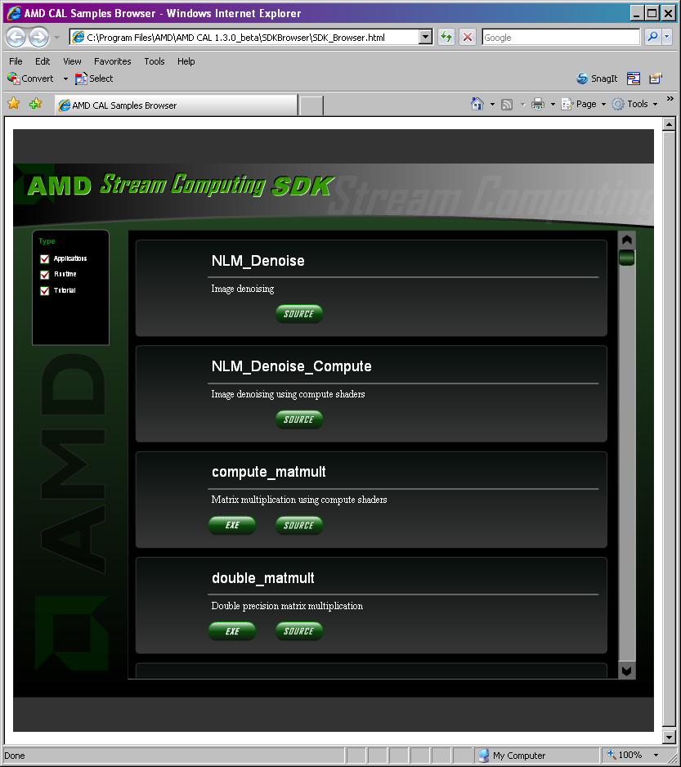
Figure 5.2: Window for browsing the AMD/ATI code samples

- Go to Start -> All Programs -> AMD -> AMD CAL 1.3.0_beta -> AMD CAL Samples Browser to bring up the window shown in Figure 5.2.

- Scroll to the bottom of the list and find FindNumDevices. Click on the associated EXE button. When asked if you want to run or save the file, select “Run.”

- If things are running correctly, a window will appear stating how many devices are running CAL (there should be at least 1).

Verify Installation By Running OpenMM Example Files

Download Example Files

Go to http://simtk.org/home/openmm and click on “Downloads.” Select the OpenMMExamples.zip file and unzip them to wherever you like. Note: the examples are also included in the examples folder when you download the OpenMM source code.

Run Example Files

Four example files are in the examples folder. See the README file in the package for details about the different examples.

The instructions below are for running the HelloArgon program. A similar process would be used to run the other examples.

Visual Studio

Navigate to wherever you saved the example files. Descend into the directory folder HelloArgonVS8. Double-click the file HelloArgon.sln (a Microsoft Visual Studio Solution file). Visual Studio will launch.

Note: these files were created using Visual Studio 8. If you are using Visual Studio 9 (2008 Express Edition), the program will ask if you want to convert the files to the new version. Agree and continue through the conversion process.
In Visual Studio, make sure the "Solution Configuration" is set to "Release" and not "Debug". The “Solution Configuration” can be set using the drop-down menu in the top toolbar, next to the green arrow (see Figure 6.1 below).

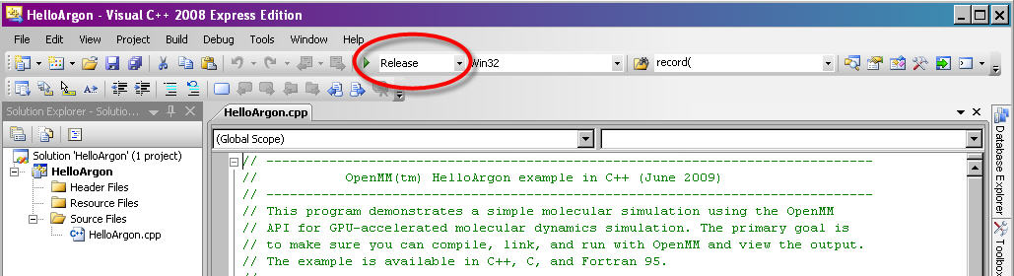
Figure 6.3: Setting "Solution Configuration" to "Release" mode in Visual Studio

From the command options select Debug -> Start Without Debugging.

You should see a series of lines like the following output on your screen:

…

MODEL 250
ATOM 1 AR AR 1 0.233 0.000 0.000 1.00 0.00
ATOM 2 AR AR 1 5.068 0.000 0.000 1.00 0.00
ATOM 3 AR AR 1 9.678 0.000 0.000 1.00 0.00
ENDMDL
MODEL 251
ATOM 1 AR AR 1 0.198 0.000 0.000 1.00 0.00
ATOM 2 AR AR 1 5.082 0.000 0.000 1.00 0.00
ATOM 3 AR AR 1 9.698 0.000 0.000 1.00 0.00
ENDMDL
MODEL 252
ATOM 1 AR AR 1 0.165 0.000 0.000 1.00 0.00
ATOM 2 AR AR 1 5.097 0.000 0.000 1.00 0.00
ATOM 3 AR AR 1 9.717 0.000 0.000 1.00 0.00
ENDMDL

The very first line of the output will indicate whether you are running on a CPU or a GPU (REMARK Using….). If you have a supported GPU, the program should, by default, run on the GPU.

You can also output the results to a PDB file that could be visualized using programs like VMD (http://www.ks.uiuc.edu/Research/vmd/) or PyMol (http://pymol.sourceforge.net/). To do this within Visual Studios:

    - Right-click on the project name and select the “Properties” option.
    - On the “Property Pages” form, select “Debugging” under the “Configuration Properties” node.
    - In the “Command Arguments” field, type:

> argon.pdb

This will save the output to a file called “argon.pdb” in the current working directory. If you want to save it to another directory, you will need to specify it.
    - Select “OK”

Now, when you run the program in Visual Studio, no text will appear. After a long pause, you should see the message “Press any key to continue…,” indicating that the program is complete and that the PDB file has been completely written.

Check the troubleshooting section below if you have problems running the example.

Mac OS X/Linux
Navigate to wherever you saved the example files.

Verify your makefile by consulting the MakefileNotes file in this directory, if necessary.

Type:
make

Then run the program by typing:
./HelloArgon
You should see a series of lines like the following output on your screen:
…

MODEL 250
ATOM 1 AR AR 1 0.233 0.000 0.000 1.00 0.00
ATOM 2 AR AR 1 5.068 0.000 0.000 1.00 0.00
ATOM 3 AR AR 1 9.678 0.000 0.000 1.00 0.00
ENDMDL
MODEL 251
ATOM 1 AR AR 1 0.198 0.000 0.000 1.00 0.00
ATOM 2 AR AR 1 5.082 0.000 0.000 1.00 0.00
ATOM 3 AR AR 1 9.698 0.000 0.000 1.00 0.00
ENDMDL
MODEL 252
ATOM 1 AR AR 1 0.165 0.000 0.000 1.00 0.00
ATOM 2 AR AR 1 5.097 0.000 0.000 1.00 0.00
ATOM 3 AR AR 1 9.717 0.000 0.000 1.00 0.00
ENDMDL

The very first line of the output will indicate whether you are running on the CPU or a GPU (REMARK Using….). If you have a supported GPU, the program should, by default, run on the GPU.

You can also output the results to a PDB file that could be visualized using programs like VMD (http://www.ks.uiuc.edu/Research/vmd/) or PyMol (http://pymol.sourceforge.net/) by typing:

HelloArgon > argon.pdb

Troubleshooting

You get the error message: "The application failed to initialize properly (0xc0150002). Click OK to terminate the application"

This may be because OpenMM is trying to run the ATI GPU software (Brook) and is unable to locate it. You do not need to have this software installed to run the examples. Just move all Brook-related files located in the OpenMM/lib/plugins directory (file names will contain the word “Brook” in them) to a higher level directory and run the example again.

