OpenMV-H7 A Python programmable machine vision camera.

Features

  - 32-Bit Arm Cortex-M7 operating at 400MHz.
  - High bandwidth 1MB SRAM / 2MB FLASH.
  - Double-precision Floating Point Unit (FPU).
  - Full DSP instructions, hardware JPEG encoding.
- 2 UARTs, 2 I2C, 1 SPI, 1 CAN, 3 TIM/PWM.
- 1 USB full speed (FS) for programming.
- 1 RGB LED and 2 IR LEDS on board.
- 1 uSD Card socket (supports up to 64GBs).
- High efficiency switching regulator (1A out).
- Low noise LDO for sensor analog supply.
- LiPo battery connector.

- Less than 150-mA power consumption.

- Modular sensor design supports multiple sensors:

– OV7725 640x480.

– MT9V034 (Global Shutter Sensor).

– FLIR 1,2 and 3 thermal imaging sensors.

Description

The OpenMV cameras are low-power, Python3 programmable machine vision cameras that support an extensive set of image processing functions and neural networks. OpenMV cameras are programmed using a cross-platform IDE which allows viewing the camera's frame buffer, accessing sensor controls, uploading scripts to the camera via serial over USB (or WiFi/BLE if available).
The OpenMV-H7 camera base board is based on the STM32H7 Arm Cortex-M7 MCU operating at 400MHz, and featuring 1MB SRAM, 2MB FLASH, FPU, DSP and a hardware JPEG encoder. The base board has a modular sensor design, decoupling the sensor from the camera. The modular sensor design enables the camera to support multiple sensors including OV7725, MT9V03x global shutter sensor and FLIR Lepton 1, 2 and 3 thermal sensors.

Device Information

PART NUMBER | BODY SIZE (NOM)
OPENMV-H7 | 1.4 in × 1.75 in

Applications

- Home automation.
- Robot guidance.
- Industrial Applications.
- Surveillance Applications.
- Object detection and tracking.
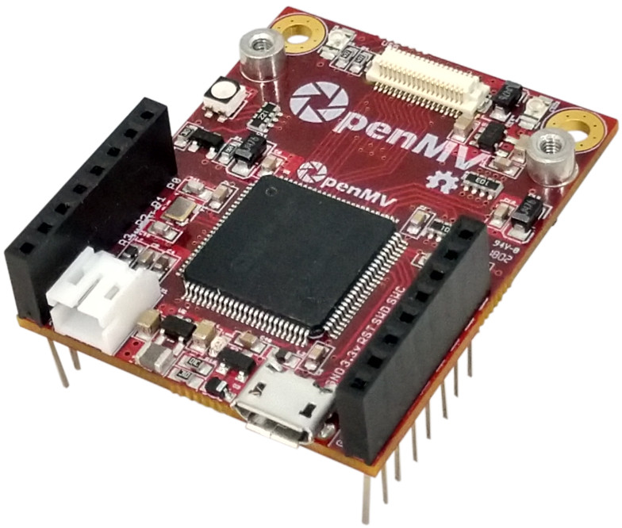

Table of Contents
1 Features 1
2 Description 1
3 Applications 1
4 Pin Configurations and Functions 3
5 Electrical Characteristics 4
5.1 Absolute Maximum Ratings 4
5.2 Recommended Operating Conditions 4
6 Mechanical Information 5

Pin Configurations and Functions

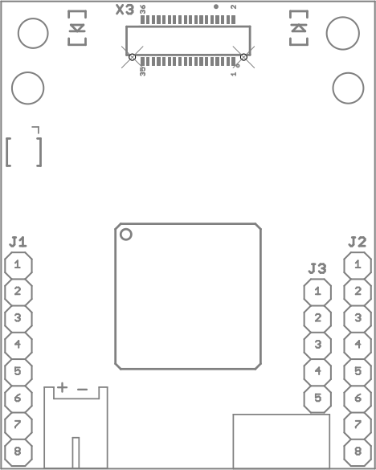

Pin Functions
Pin |  |  | Description
Header | No | Name | Description
J1 Pin Configuration
J1 | 1 | P0 | UART1 RX – TM1 CH3N – SPI 2 MOSI
J1 | 2 | P1 | UART1 TX – TM1 CH2N – SPI 2 MISO
J1 | 3 | P2 | CAN2 TX – TM1 CH1N – SPI 2 SCLK
J1 | 4 | P3 | CAN2 RX – SPI 2 SS
J1 | 5 | P4 | TIM2 CH3 – I2C 2 SCL – UART 3 TX
J1 | 6 | P5 | TIM2 CH4 – I2C 2 SDA – UART3 RX
J1 | 7 | P6 | TIM2 CH1 – DAC – ADC
J1 | 8 | 3.3 | 3.3V Rail (250 mA Supply MAX).
J2 Pin Configuration
J2 | 1 | RST | Reset (Connect to GND to reset).
J2 | 2 | BOOT | Boot 0 (Connect to 3.3V for DFU mode).
J2 | 3 | SYN | Frame synchronization pin (Use to frame sync cams).
J2 | 4 | P9 | Servo3 – TIM4 CH3
J2 | 5 | P8 | Servo2 – TIM4 CH2 – I2C4 SDA
J2 | 6 | P7 | Servo1 – TIM4 CH1 – I2C4 SCL
J2 | 7 | VIN | VIN (3.6V – 5V).
J2 | 8 | GND | GND Rail
J3 Pin Configuration
J3 | 1 | SWC | Serial wire debug clock.
J3 | 2 | SWD | Serial wire debug data.
J3 | 3 | RST | Reset (active low).
J3 | 4 | 3.3V | 3.3V rail (500 mA Supply MAX)
J3 | 5 | GND | GND rail

Electrical Characteristics

5.1 Absolute Maximum Ratings¹
SYMBOL | RATINGS |  | MIN | MAX |  | UNIT
V_{IN} | External input supply voltage range. |  | 3.6 | 5.5 |  | V
V_{OUT} | External output supply voltage range. |  |  | 3.3 |  | V
V_{I/O} | Input voltage range on ADC/DAC pins. |  | -0.3 | 4.0 |  | V
V_{I/O} | Input voltage range on any other pins. |  | -0.3 | 7.3 |  | V
I_{OUT} | External output supply current range. |  |  |  | 600 | mA
I_{I/O} | Output current sunk by any I/O and control pin |  |  | 20 |  | mA
I_{I/O} | Output current sourced by any I/O and control pin |  |  | -20 |  | mA
ΣI_{I/O} | Total output current sunk by all I/Os and control pins |  |  | 140 |  | mA
ΣI_{I/O} | Total output current sourced by all I/Os and control pins |  |  | 140 |  | mA
T_{J} | Junction temperature. |  |  | 125 |  | °C
T_{stq} | Storage temperature. |  | -65 | 150 |  | °C

5.2 Recommended Operating Conditions

SYMBOL | RATINGS | MIN | MAX |  | UNIT
V_{IN} | External input supply voltage range. | 3.6 | 5.0 |  | V
V_{OUT} | External output supply voltage range. |  | 3.3 |  | V
V_{I/O} | Input voltage range on ADC/DAC pins. | -0.3 | 3.6 |  | V
V_{I/O} | Input voltage range on any other pins. | -0.3 | 5.0 |  | V
I_{OUT} | External output supply current range. |  |  | 500 | mA
T_{J} | Junction temperature. | -40 | 125 |  | °C

- Stresses beyond those listed under Absolute Maximum Ratings may cause permanent damage to the device. These are stress ratings only, which do not imply functional operation of the device at these or any other conditions beyond those indicated under Recommended Operating Conditions. Exposure to absolute-maximum-rated conditions for extended periods may affect device reliability.

Mechanical Information
The following information is the most current data available for the designated device. This data is subject to change without notice and without revision of this document.

