# Open Opportunities Bug Bash 3/6/18

### (updated 3/15/18)

Table of Contents

I. Bugs Reported During Bug Bash 1

II. Mobile Issues Reported During Bug Bash 17

III. Questions 19

IV. Known Issues that came up during testing 20

V. Enhancements 21

VI. Release Bugs Entered (prior to bug bash) 24

# Bugs Reported During Bug Bash

Action: Determine if these are actual bugs, enter into Github, determine what needs to be fixed with this release vs later.

1. Not signed in, click Browse Opportunities, open an opportunity, select apply, sign in, I’m now at the signed in landing page instead of on the opportunity. (Entered Bug 1823 prior to bug bash)

* This came up multiple times during the bug bash. Dev Response: Fixed

1. Edit profile: Save profile and Discard changes should be sentence case Dev Response: Fixed
2. Copy this Opportunity modal – Title and buttons should be sentence case Dev Response: Fixed

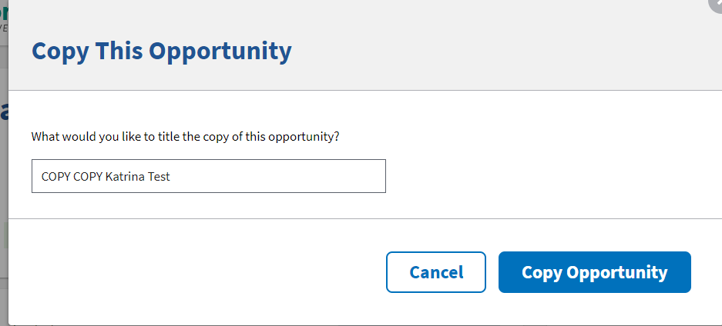

1. The names are just slightly cut off in the applicant listing Dev Response: Fixed

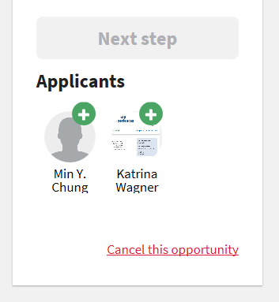

1. Timeout flashes across screen so fast you can’t see it. Dev Response: When testing the timeout warning, it will prompt after 12 minutes of inactivity to give you a 3 minute warning. So if everyone is waiting a full 15 minutes and on some other page or doing something else and not paying attention until right at 15 minutes that maybe while they are experiencing the "blinking" affect. also remember any keypress on the keyboard fires off an activity event which resets the timer and closes the modal

* Program Office: Non Issue, works as designed.

1. Email on this link should be [openopps@usajobs.gov](mailto:openopps@usajobs.gov) Dev Response: Fixed and will update the grammar on the page once PO provides updated text on 3/7/18. Grammar updates complete

Program Office: Entered enhancement 1842 to rework this page down the road to use the USAJOBS no search results guidelines and provide help links.

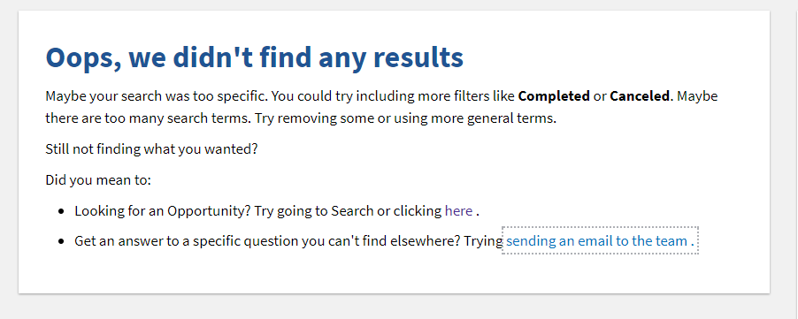

1. Admin 🡪 Click on name 🡪 menu comes down and I can’t click off it Dev Response: Fixed

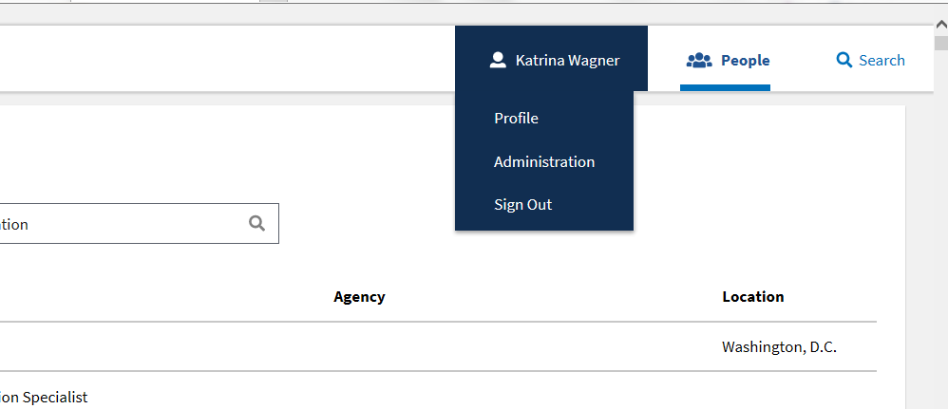

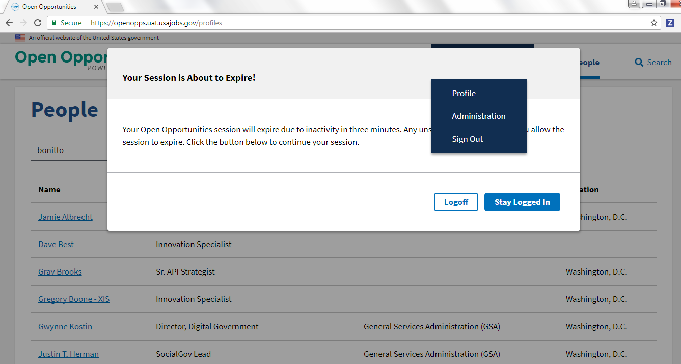

Dev Response: Works the same on the USAJOBS site. Must click on your name to close menu.

1. Admin 🡪 Tasks Dev Response: Fixed

There should be hover text above each of the icons

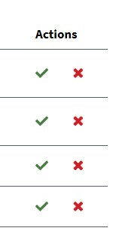

1. Admin 🡪 Tasks Dev Response: Fixed

If click on the green check mark, modal confirmation is a different style

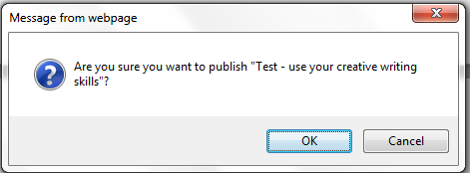

Program Office: Enter bug 1843 to also have the modal applied to the delete

1. Buttons say find and browse opportunities – can we change both to say “Browse Opportunities” or “Find Opportunities” Dev Response: Fixed - used Find
2. People search option doesn’t work: People icon, enter name in search, nothing happens.

People search in Admin only seems to work well if you search by last name Dev Response: Fixed to work for name search but not agency. Dev will look into more and update at least the default text. Update 3/7 – Brice fixed so search works for name, title, agency, and location.

Program Office: Entered bug 1844. People search is currently going to work for name so this ticket will add agency and determine weighting

1. Select All button not working  
   Click Search then select all  
   All are marked.  Also, should have a de-select.  If I click it again nothing happens Dev Response: Fixed

Program Office: Entered ticket 1845 to add a deselect all option

1. Logged in landing page (needs to be redesigned). Can we remove the right rail under the Welcome. It’s not working. Dev Response: Fixed

Program Office: Entered enhancement 1846 to redesign signed in landing page.

1. Cancel your application link still displays but does not work. Is there an email associated with this? Dev Response: 1751 covers this and is on the backlog. Since this is new functionality, suggest removing the link for now. Part 2: The email would be new functionality and I believe it’s backlogged. (Katrina response – Cancel opportunity is an email but we will need a new email for cancel application.)

Program Office: For now, dev will remove the “Cancel Application” link (complete). 1751 will add it back with functionality association post release.

1847 will cover applicant notification of withdrawing their application

1. If an opportunity is in draft, the email shouldn’t say that “you will be notified when someone signs up” Dev Response: Fixed

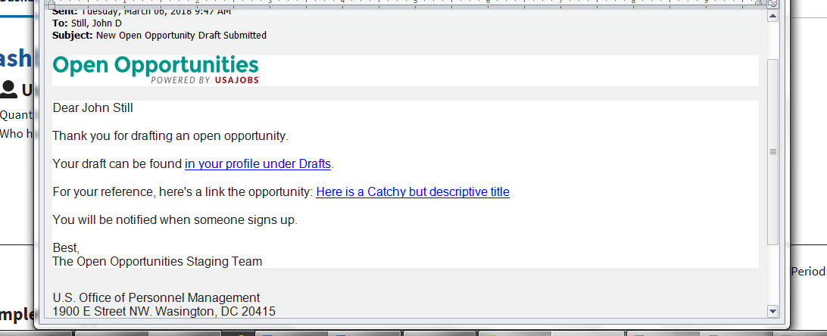

1. Remove the right rail on the signed in landing page under the welcome. It is broken Dev Response: Fixed – removed from side rail
2. 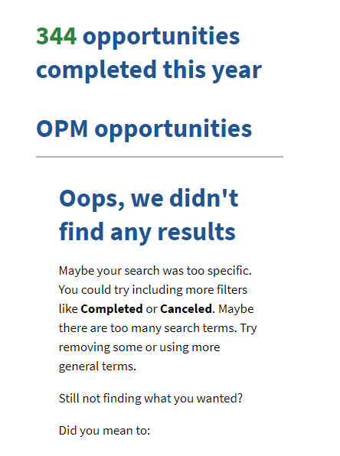

Draft email, click on link, status submitted, but apply button shows. Apply should not display on submitted tasks. <insert John’s email>

Dev Response: Fixed

1. Most users able to create an account with a gmail account. Should fail but letting people through. Enhancement listed below that the message should say something more specific than “Registration failed” like “You must use a government email account for this system.”

Program Office: Entered ticket 1849

1. Create or Edit an opportunity – Estimated completion date can be in the past. Should only be able to save a date of today or the future.

Program Office: Entered ticket 1850. Also entered 1851 to remove the detail option from this page per Lisa.

1. Click on “Upload” from edit profile, tried a .jpg or a .png and nothing happens. Also should there be a remove for the photo? Photo finally came up when I left the page and came back.

Program Office: Entered bug 1852

1. Opportunity - When no participants are assigned, user thought the green plus sign in the assigned participants section was where he should click. Took a minute to realize he should scroll down. 1 - Should not be clickable (hand displays on hover) 2- Edit text to say “Click + from the Applicants list below to assign participants” Dev Response: Fixed

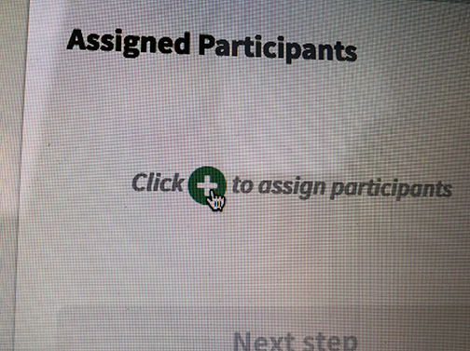

1. User submitted an opportunity, admin approved, user edited opportunity, took status back to “Submitted” where admin had to approve again. Once it is approved it should stay approved.
   * When someone edits an opportunity that is open it should stay open. It should not revert back to submitted for admin to reopen.
   * When Andrea edited an open task, the opportunity state changed from open to submitted and everyone who had signed up when it was open disappeared.

Dev: Fixed

1. Updated date on profile 🡪 Created 🡪 displays as yesterday’s date

Entered bug 1854

1. Create Opportunity (Chrome)

When I select a day of the week from the calendar, in this case 3/30/18:

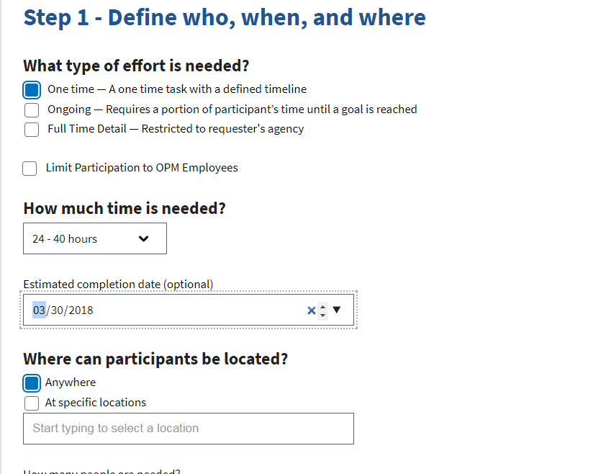

After saving the opportunity, the date changes to 3/29/18 (Thursday)

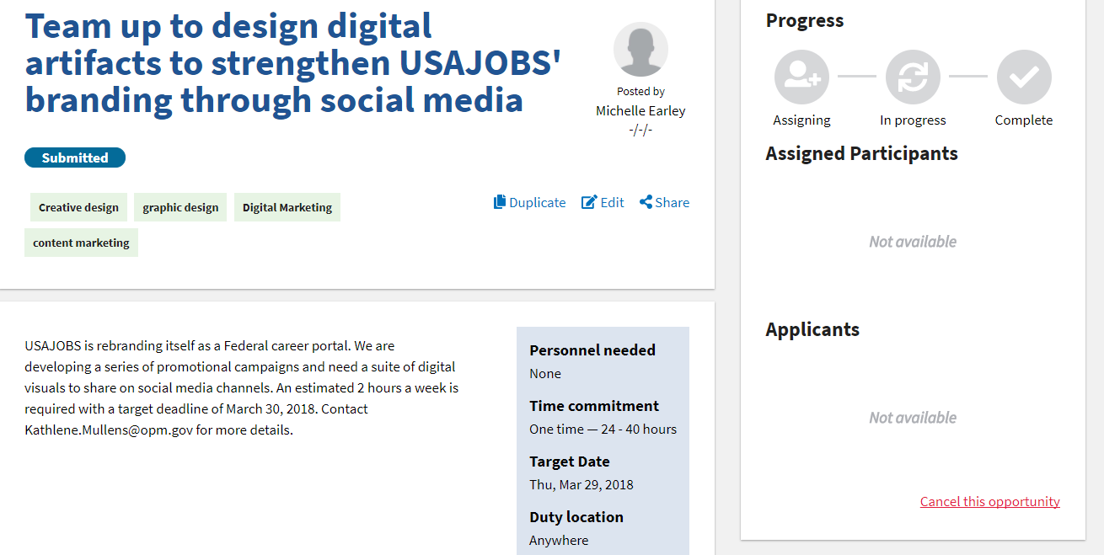

In addition, the “Posted by Michelle Earley -/-/-“ date created is missing.

This date only shows when the opportunity is open. Since this is in submitted status it won’t show. Created enhancement 1857 to hide this field until posted.

1. Julie Jackson – Chrome – clicked Create new account and it flashed up and took her right back to sign in. Happened over and over. Worked ok in IE. Could this be a cookies issue? This also happened on a different user testing in mobile on both Chrome and Safari.

Hard to say on Julie’s issue. Keep an eye on whether others also have this issue. Entered bug 1858 for mobile as this is a known issue.

1. Instructions are out of line on edit opportunity

**Dev: Fixed**

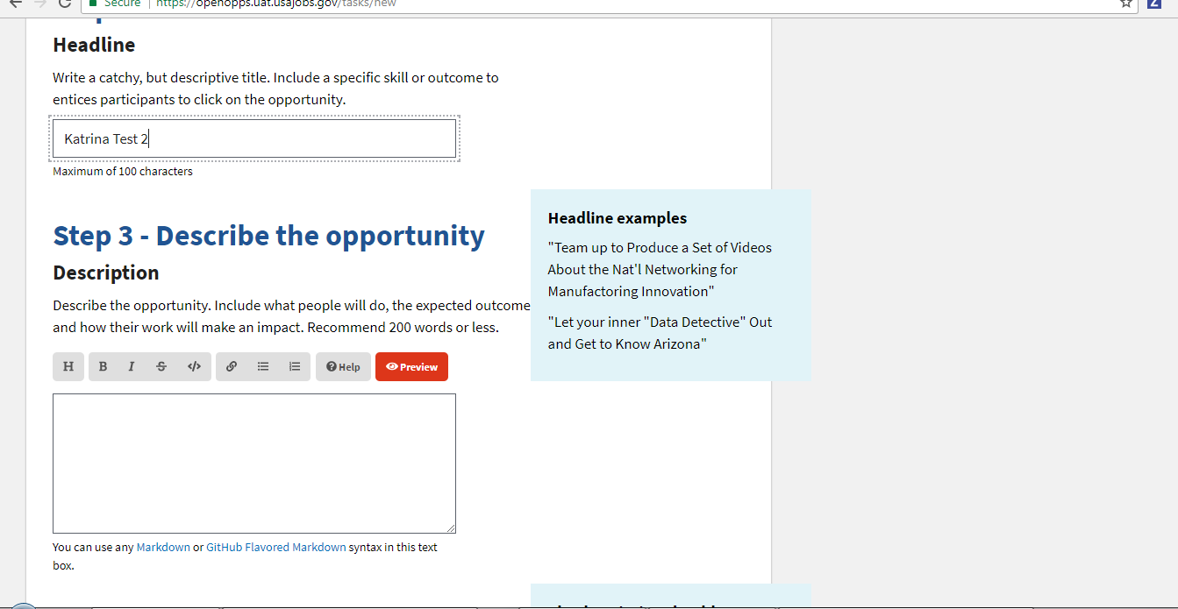

1. Save as draft on Chrome didn’t work (works for some and not others. Save as Draft and Submit for review buttons didn’t work for user in IE.

Entered bug 1859 for IE. Issue is when you don’t have all required fields entered. For the draft, no errors are thrown. For the Submit, error is thrown but the focus doesn’t go to the error so user isn’t aware.

1. (Michelle) When I entered an existing email address, the screen position did not change. I had to scroll up to see the error message. It would be helpful to repoint the screen to the error message.

Entered bug 1860 to scroll to top on error message.

1. Number of people in edit

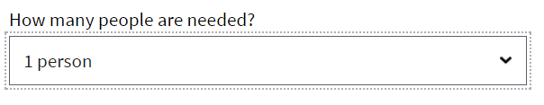Does not match was is displayed in announcement (john)

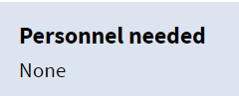

Created bug 1861

1. Non Admin users (Multiple Users), flipped toggle to off. Can’t get back to job because “Not Open” doesn’t display in her profile and she can’t filter on Not open. Profile should display not open created opportunities. Created bug 1863
2. Blue toggle box should show the canceled date ‘Canceled on ##/##/##’

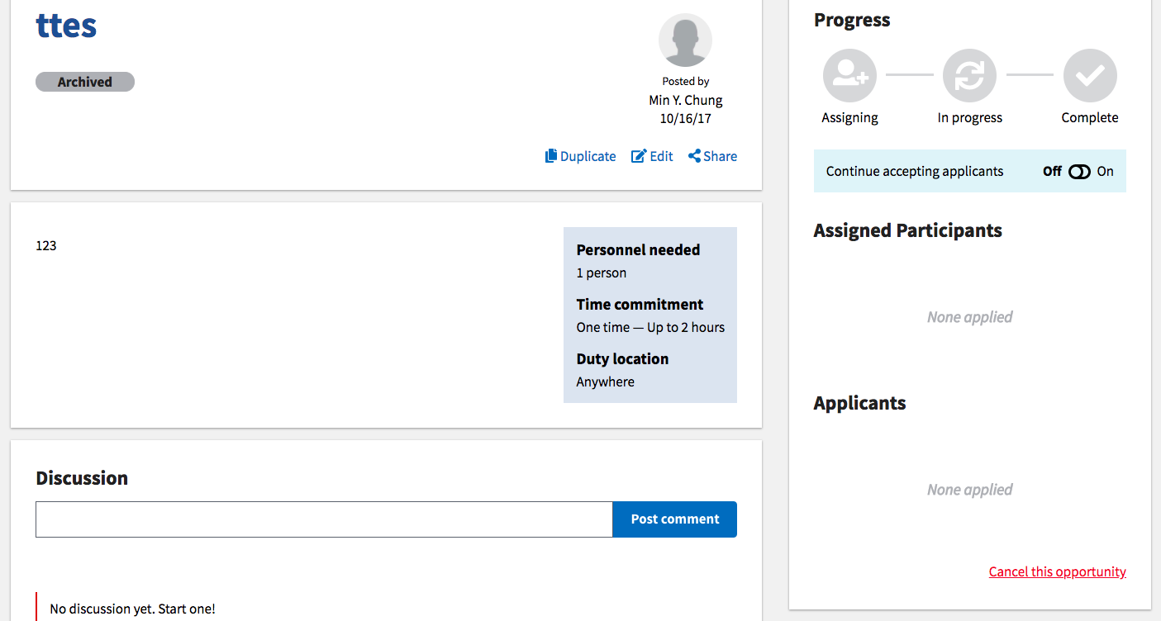

Created spike 1865

1. When an opportunity is under ‘In progress’ and the toggle is on, the left pill should be ‘Open’ while the progress bar stays ‘In progress’.

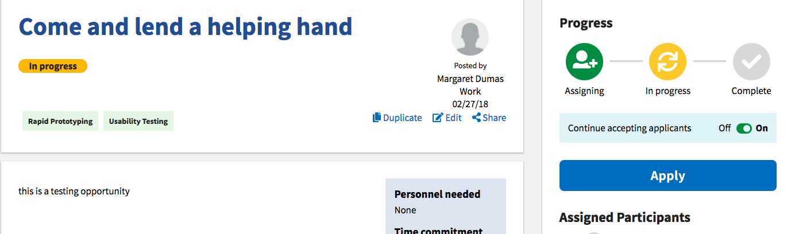

Created spike 1866

1. I haven’t seen this anywhere but in my (Min’s) profile. It has extra lines below Created opportunities

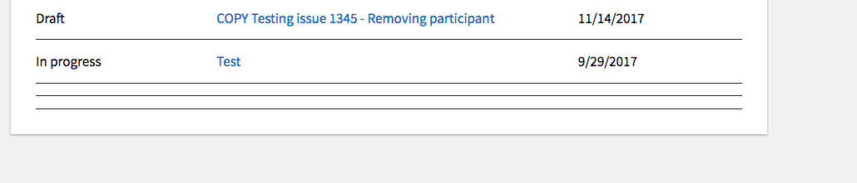

1. The bullets (rich text) is automatically populating 3 bullets. Also the bullets don’t number in order.

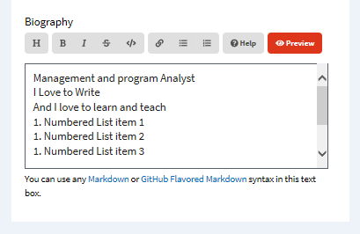

**Spike 1868**

1. **(Possibly an enhancement):** I'm using a MacBook Air with Chrome. under 'Edit Opportunity,' after I made changes to my opportunity & clicked 'save', I did not receive a pop up window indicating that my request will be reviewed.

Works as designed

1. Once I updated my task by editing the headline & then making a copy of it, my task changed to 'Submitted' status and I don't see it in the list of opportunities anymore. And Lisa didn't get an email note that my task had been moved back to 'Submitted' status from 'Open' status. And once I edited my task, it removed the applicants from my task. Works as designed – because it’s a copy I have to get approved.
2. Test to confirm: On my task when I assigned an applicant, the progress bar did not update to 'In Progress.' It stayed on 'Assigning' until I clicked on 'Okay', a few steps later. Works as designed. Won’t let you change to In Progress until you click next.
3. Page: Completed opportunity - Assigned participants shouldn’t see ‘Congratulations’ box after the opportunity has been completed.

Create bug 1869 to remove

1. 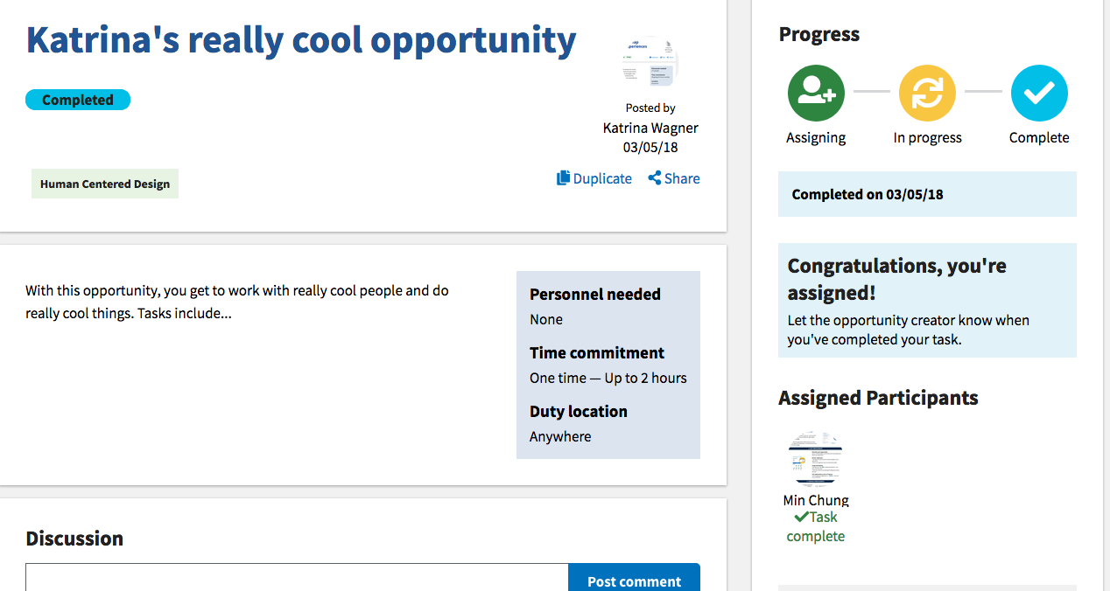 Page: Profile

For Participated opportunities, first column should say ‘Your status’ and status should be text Entered bug 1870

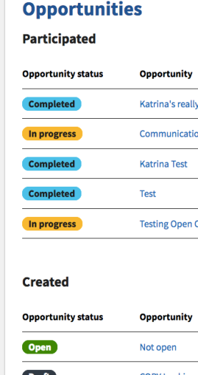-Applied

-Assigned

-Not assigned

-Complete

1. Page: Opportunity page

Opportunity creator’s name is not clickable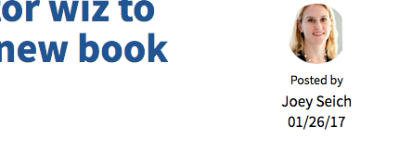 Fixed

1. Page: Search page - ‘Office of Personnel Management (OPM)’ needs to say ‘Office of Personnel Management (OPM) employees only’ and users should be able to filter them and see only OPM opportunities by clicking the checkbox ‘Restrict to OPM’ <https://projects.invisionapp.com/d/main#/console/12657410/265272109/preview>

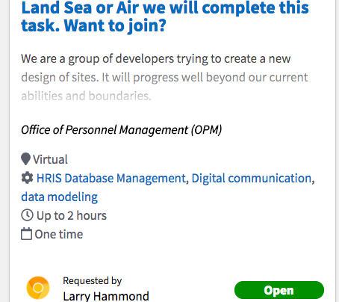

Entered ticket 1871

1. Page: Edit profile - ’Discard Changes’ + ‘Save Profile > sentence case Dev Response: Fixed

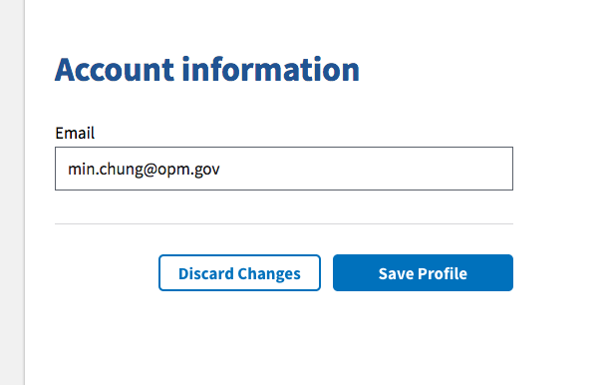**43)** Page: Profile I see 2 Newcomer badges

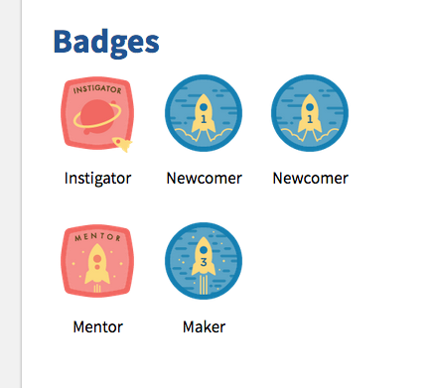

Entered ticket 1872 for database clean up of duplicates.

44)    When creating an opportunity the drop down menu has the time periods out of order. It should read

2-4 hours

4-8 hours

8-16 hours

16-24 hours

* 1. hours

Entered ticket 1873

# Mobile Issues Reported During Bug Bash

Action: Determine if these are actual bugs, enter into Github, determine what needs to be fixed with this release vs later.

Note: Users found mobile difficult to test because it was hard to see with format and photos being so off.

1. Browse opportunity page did not display correctly Bug 1875

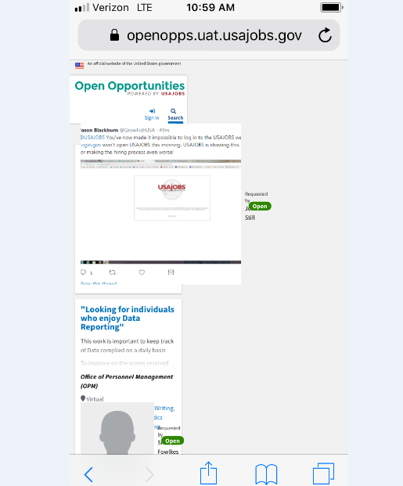

1. Task created on mobile devices do not send an email to let me/Lisa know they are there to be opened. Bug 1880
2. Pictures are huge Bug 1875
3. Unable to create a new account on mobile, flashed up and went back to sign in. I did not have an account so I needed to click on the Create an Account button.  When I did this it would briefly(about one second) display the page to create an account but then would automatically reload the Sign In page. Bug 1858
4. Issue Kelly was having on the profile page of mobile Bug 1881

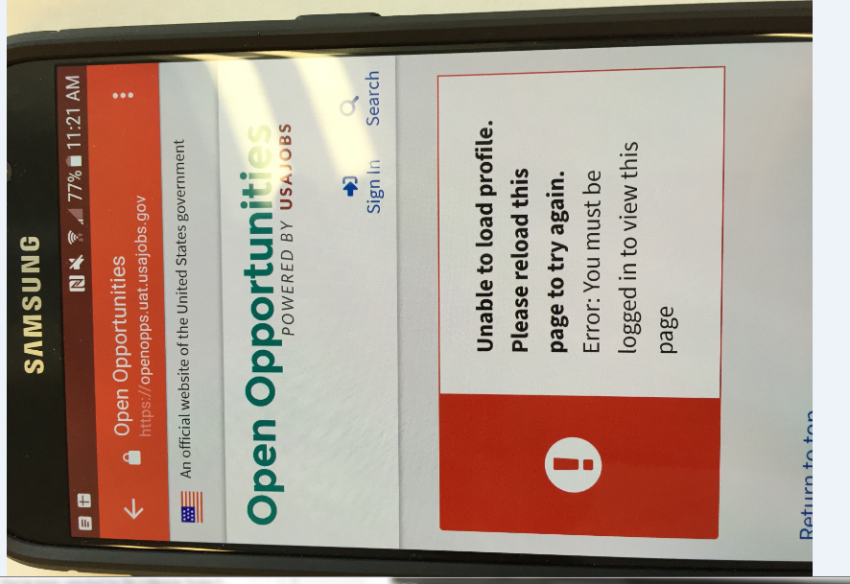

1. Browse Opportunities page would not display correctly (sent screen capture to Lisa).  Also, I could not click on the open buttons. Bug 1876
2. On the Browse Opportunities page, I do not see the “Find Yours” link (likely because the page is not displayed correctly as mentioned above) Bug 1876
3. When I click on Find Yours the Find Opportunities page header and footer loads, but the ‘Loading…’ circle just keeps spinning for minutes but does not complete. I tried it multiple times with same results. Screen capture pasted below. Bug 1882
4. The drop down menu for ‘Specific Location’ on the Create an Opportunity pages has Washington,DC listed multiple times. Known issue existing tickets 1571, 1710
5. I am unable to click on the opportunity I created from my profile page (screen capture below) Bug 1883

# Questions

1. Email displays odd text in the subject instead of apostrophe. Might just be my Outlook. Is there anything we can do for this? Spike 1877

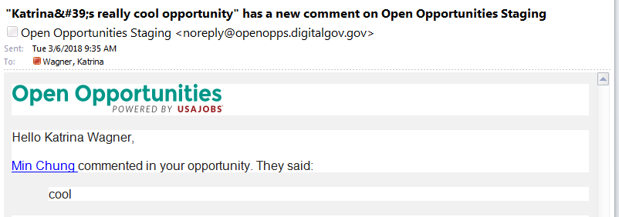

2) Question: I shouldn’t be able to assign people in a job that isn’t mine or is that just because I’m an admin? Dev Response: yes because you are an admin you can do anything. This probably needs to be revisited. Spike 1879

# Known Issues that came up during testing

** Action: would we want to bump up the priority in Github to complete sooner rather than later?

1. Locations repeating in location dropdown – existing tickets 1571, 1710

# Enhancements

**\*\* Action – if agree these should be entered in GitHub to be worked at a later date. complete**

1. Enhancement - Profile – changed “Updated date” to something more meaningful 1905
2. Enhancement – add reason why registration failed 1906

Create a New Account with a non-Government Email Address

* Visit homepage (log out if logged in)
* Click on Sign in
* Select Create a new account
* Enter a non government email address (i.e. gmail)
* You should see a Registration failed alert message.

1. Landing page and logged in landing page should be redesigned 1907
   * Sign in from Task Detail, After sign (enter email & password), When you are on the page it list latest achievements but at the top is the message…. There are 26…. ‘Find Yours’ is difficult to locate and unsure what to click to search opportunities
   * Creating an opportunity should be on the Top Nav of the landing page. Clicking search doesn’t really make sense to create an opportunity.
2. Administration – Users – Search enter Lisa and I get a ton of results; Enter Nelson I get only Nelsons. But search again and Lisa works. Might want to look at our search functionality Let’s discuss – bug or enhancement
3. Admin – Users: would be helpful if columns were sortable Would also be helpful if a total number of results display (multiple people suggested) 1908
4. Update terms and conditions link with new URL for help center done
5. Footer URLs: when you click on a URL and then click the back button you are taken to the top of the page. In USAJOBS if you click on the URL and click back your focus is taken to the bottom/footer of the page. Does not need to be done now but Lisa do you want a ticket for this for later? 1909
6. Create account page – Agency – when I type in OPM, OPM is 4th on the list. Since it’s an exact match it should be first. Consider updating down the road? Is this an existing ticket? New? 1910
7. Open Source link in footer – we should review this content. It has screen shots in it that might need to be updated. Also references a Google group – does anyone check that? <https://github.com/openopps/openopps-platform>

1911

1. Share link should not appear on completed or cancelled jobs or the text should be different more detail needed
2. **Multiple** users said it was unclear that they had to have their opportunity approved for it to open. Consider help or enhancements to assist. 1912
3. Users mentioned confusion over being cc’d on an email when someone applied to their task. Took them all a minute to realize. Suggested a different email with different text go to the task creator. 1914
4. Save as draft is confusing – add instructions on how to go back to submit 1915
5. Add a sort by option on opportunity listing page (i.e. date posted, estimated completion date, agency, etc.) (multiple users suggested) 1916
6. Opportunity create/edit – Step 2 of the title should really be step 1
   * One user also noted step 1 and step 2 seem similar ticket is not needed – I was confused by the way the test scenario was written
7. Suggest changing “Headline” to “Title” (2 users) 1917
8. Consider wording changes for “Task complete” vs “ Opportunity complete” the group has been discussing this topic on numerous occasion, not sure if we came to a final or if there is an existing ticket
9. Add ability to create an opportunity from my profile 1918
10. Add a filter to show “My opportunities” so I don’t have to navigate to profile 1920
11. The “open” status button is slightly confusing in that, I thought it would open the opportunity sure not if this is an enhancement
12. Once I marked my opportunity as 'Completed' I was no longer able to 'Cancel' it. However I could 'Cancel' my other opportunity that was still in 'Open' status. Not sure if this is an enhancement
13. Page: Admin > Agency dashboard (enhancement?) After OPM Users or OPM Opportunities is clicked and filtered, there is no way to go back and see the full list 1921
14. Many questions come in from Task Creators regarding how to link content as they do not understand Mark down language.  We should replace markdown with something easier to use. 1922
15. The dashboard (landing page) page can be seen when you login but after you leave that page there does not seem to be a way to get back to it. 1923
16. A read more link to see the full text of the requirements without having to click on the job. 1924

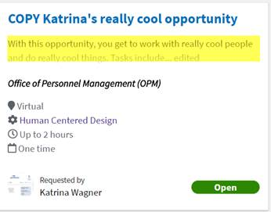

1. Add more filter options: More filter options (Add agency/requestor, location, time ) 1925
2. Add the ability to add images and videos to opportunities 1926

# Release Bugs Entered (prior to bug bash)

Action: Review and decide if any should be pushed with this release.

* 1832 – Search on People page doesn’t work (Status: In development)
* 1830 – only action against submitted opportunities (Status: In development)
* 1823 – shouldn’t have to search again for opportunity once I log in (Status: Backlog)
* 1811 – Create opportunity page, drop down spacing incorrect (Status: In Development)
* 1810 – Tabbing issue on administration (Status: Ready to deploy)
* 1809 – Duplicate opportunity keeps previous owner (Status: Needs review)
* 1808 – Agency admin can’t see tasks (Status: Ready to deploy)
* 1803 – Admin back button not working (Status: Ready to deploy)
* 1800 – Landing page text (Status: Requirements ready)
* 1796 – Able to add opportunity without required fields (Status: Backlog)
* 1794 – Password reset page needs correct error styling (Status: Ready to deploy)
* 1792 – Reset password doesn’t have padding (Status: Backlog)
* 1778 – Select all filter doesn’t work (Status: Backlog)
* 1776 – Text boxes are not consistently sized (Status: Backlog)
* 1769 – Can’t get to the site on IE (Status: Ready to deploy)
* 1766 – Page numbers display when there are no results (Status: Ready to deploy)
* 1764 – Top nav does not put focus on correct location (Status: Ready to deploy)
* 1762 – Browser tabs (Status: Backlog)
* 1761 – Task pages images of participants duplicate if you hover (Status: Backlog)