

**Openpay Integration**

Version 21.1.0



Table of Contents

1. Overview 2-3

1.1 Compatibility 2-3

1.2 Limitations, Constraints 2-3

1.3 Privacy, Payment 2-4

2. Integration Components 2-4

2.1 Components 2-4

2.1.1 Get PlanID 2-4

2.1.2 Prepare Redirect 2-4

2.1.3 Openpay Payment 2-4

2.2 Business Manager Configurations 2-5

2.2.1 Activating the cartridge in Business Manager 2-5

2.2.2 Enable Cartridge Module 2-6

2.2.3 Importing Metadata 2-6

2.2.4 Type Extensions 2-7

2.2.5 Payment Methods 2-8

2.2.6 Payment Processors 2-8

2.2.7 HTTP Service 2-8

2.2.8 Modify Content 2-8

3. Testing 3-8

3.1 Storefront Checkout flow 3-8

3.2 Backend Transaction 3-11

4. Operations, Maintenance 4-13

4.1 Availability 4-13

4.2 Support 4-13

5. Known Issues 5-13

6. Release History 6-14

**Intended Audience**

This document is for technical personal assigned to integrate Openpay into an existing Commerce Cloud shop solution.

# Overview

This document describes the technical integration of Openpay link cartridge.

Openpay is a next generation payment solution that allows customers to buy now and pay over a flexible timeframe without interest, giving them added cash flow confidence. Creating a seamless omni channel experience (in-store, online and through our app), we service several brands across multiple industries including retail, healthcare, automotive & home improvement.

We offer our customers convenient terms, and our merchants the opportunity to increase their incremental sales with a higher ATV.

Our customers are empowered to live their best life; with more choice, time and flexibility.

The Openpay link cartridge features include:

1. Openpay payment method – Storefront and widget configurations fulfilled natively within SFCC Business Manager, designed for Salesforce Commerce Cloud API version 16.2 or higher, based on SFRA site.
2. Checkout widget – Merchandise one or two Openpay instalment options upon selection of Openpay payment method.
3. Transaction management – View an order, order status or process full or partial refunds natively using Openpay order level transaction management within SFCC Business Manager.
4. All features are optimised to mobile breakpoint.
5. All features customisable to inherit the font family, colour and size of the website.

## Compatibility

This Cartridge works best with the SFRA version of 5.3.0 and compatibility mode 21.2

## Limitations, Constraints

None

## Privacy, Payment

None

# Integration Components

## Components

Openpay integration has the following cartridge:

* **Int_openpay_sfra** – This cartridge is the openpay integration cartridge for Store Front Reference Architecture Sites
* **bm_openpay** – Business Manager extension cartridge for transaction management.

### Get PlanID

To begin the checkout of a customer that chooses Openpay payment method on your website, a POST request must be submitted to request a PlanID. This happens when the order is placed after the summary page. The request contains the orders total price and an auth token issued by Openpay. The response to this request provides a unique PlanID that is saved to the order object as a custom attribute.

### Prepare Redirect

Once a PlanID is received a handover URL is composed that is used for redirection to Openpay. It contains all relevant information like return URL, cancel URL, customer and order information beside the PlanID.

### Openpay Payment

Openpay will be offered as another payment method for the shopper to be selected on the Billing Page.

When the shopper selects to Continue, they will be redirected to the Openpay site shopper is identified and payment is success in openpay, shopper will be return to Commerce Cloud. The shopper will be presented with the Order confirmation page with their order number. If the shopper selects to Cancel the transaction, they will be returned to the checkout page.

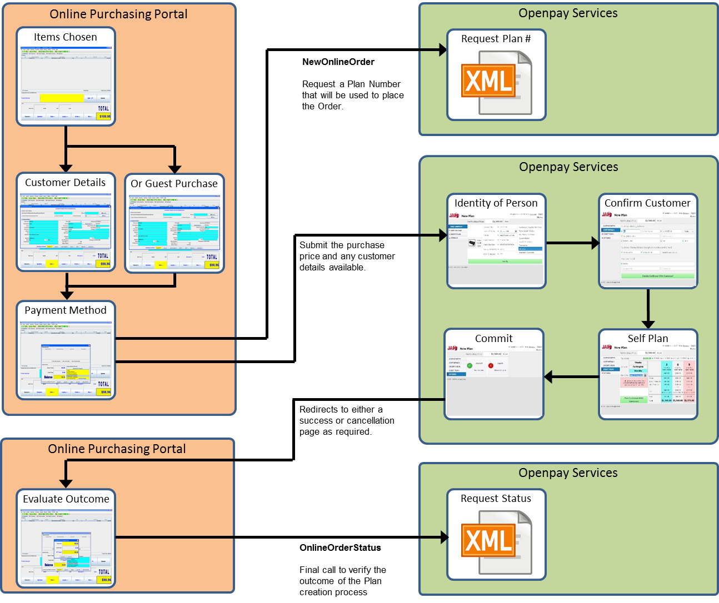

## Business Manager Configurations

For the Openpay integration to work, the following needs to be configured in the Business manager.

### Activating the cartridge in Business Manager

Before the Openpay functionality can become available to Site, the cartridges have to be added to the cartridge path of the Site. In order to do this, follow the following instructions:

1. Log into Business Manager.
2. Navigate to Administration > Sites > Manage Sites.
3. Click on the site name and on the next page go to the 'Settings' tab.
4. In the 'Cartridges' input field add 'int_openpay_sfra' in front of base cartridge.
5. Click on 'Apply' button.
6. To activate the cartridge for the Sandbox/Development/Production instances repeat steps 4 and 5 after selecting the appropriate instance from the 'Instance Type' dropdown menu.
7. Repeat steps 3 to 6 for each site that is to use Openpay.
8. Go to 'Manage the Business Manager site'.
9. In the Cartridges input field add ‘bm_openpay’
10. Click on 'Apply' button.

### Enable Cartridge Module

To enable Cartridge module,

1. Go to Administration > Organization > Roles & Permissions.
2. Click on "Administrator" and click on "Business Manager Modules" tab.
3. In Select Context dialog, check your site ID checkbox and click on "Apply" button.
4. Find ‘Openpay’ and check the checkbox to enable it.
5. Press ‘Update’ button

### Importing Metadata

For the Openpay integration to work, the following object structures (metadata) needs to be imported and configured in the Business manager. Follow the below steps:

1. In the cartridge bundle find **metadata/openpay-meta-import** folder.
2. Find the **sites** folder and inside it, find **RefArch** folder.
3. Rename this RefARch folder to the ID of your site. If you have multiple sites to which these meta has to be imported, then copy and paste this RefArch folder to replicate for other sites. Renames those folders with ID of corresponding sites.
4. Open the specific site folder and find **library** folder. Inside library folder find library.xml.
5. Edit the library.xml file to change the library-id mentioned in it. If your site uses private library, then remove the library-id attribute and its value. If your site uses shared library, then replace the existing library-id **RefArchSharedLibrary** in xml by your actual shared library id. Save the library.xml file.
6. In the cartridge bundle, inside **metadata** folder compress openpay-meta-import folder to generate **openpay-meta-import.zip** file.
7. Go to Business Manager Menu > Administration > Site Development > Site Import & Export
8. Under Import: Upload Archive: Ensure that the radio button with label **Local** is enabled (Else click on the radio button to enable it)
9. Click on Choose File input field, select the openpay-meta-import.zip file from open dialog box and click on upload button.
10. After finishing the upload, from the Archives list click the radio button corresponding to **openpay-meta-import.zip** and click on Import button.
11. Click on OK button of the confirmation box asking “Are you sure that you want to import the selected archive?”

### Type Extensions

After the successful metadata import following attributes should have been created.

In Business Manager, navigate to the Merchant Tools > Site Preferences > Custom Preferences. Custom site preference groups with the ID ‘Openpay General Config’ will be available after the successful import of metadata. Please select it and edit the attributes according to your Openpay account data.

For each site, set the values for your site preferences.

1. Custom Site Preferences

Group ID: Openpay General Config

* Is Openpay Enabled (isOpenpayEnabled - Boolean) – To enable or disable Openpay payment method.
* Openpay Username (openpayMerchantID - String) – Store identity number that is received from Openpay while merchant register account in Openpay.
* Openpay Password (openpayJamAuthToken - String) – GUID issued by openpay that merchant receives from Openpay
* Openpay Handover URL (openpayHandoverURL - String) – Redirection end point to Openpay
* Service ID (openpayServiceID – String) - Service ID as in Business Manager Menu > Administration > Operations > Services for the site.
* User Agent (openpayUserAgent - String) – User Agent for service call – Sample value: Openpay SFRA Cartridge/1.0.0 (Salesforce Commerce Cloud/1.0.0: Merchant/ 3000000000000xxxx)
* Minimum Checkout Value (openpayMinPrice - Number) – Minimum purchase value to display Openpay payment method in checkout page.
* Maximum Checkout value (openpayMaxPrice - Number) - Maximum purchase value to display Openpay payment method in checkout page.

1. Order custom attributes

* Openpay Payment Method (openpayIsOpOrder - Boolean)
* Openpay Plan ID (openpayPlanID - String)
* Plan Status (openpayPlanStatus - String)
* Transaction Status (openpayOrderStatus - String)
* Refund History (openpayRefundHistory - text)

### Payment Methods

Under Merchant Tools > Ordering > Payment Methods, check that payment methods with IDs ‘OPENPAY is created.

### Payment Processors

Under Merchant Tools > Ordering > Payment Processors, check that payment processors with IDs ‘OPENPAY’ is created.

Assign payment processor ‘OPENPAY’ to payment method ‘OPENPAY’.

### HTTP Service

Under Administration > Operations > Services, check that services with IDs ‘openpay.au.service’ and ‘openpay.uk.service’ are created.

### Modify Content

To edit content asset.

1. Navigate to Merchant Tools > Content > Content Assets.
2. Find the ‘openpayCheckoutWidget’ content asset.
3. Click on content asset ID and lock the content asset to edit the content.
4. After editing the body of content asset, click on Apply button and Unlock the content asset.

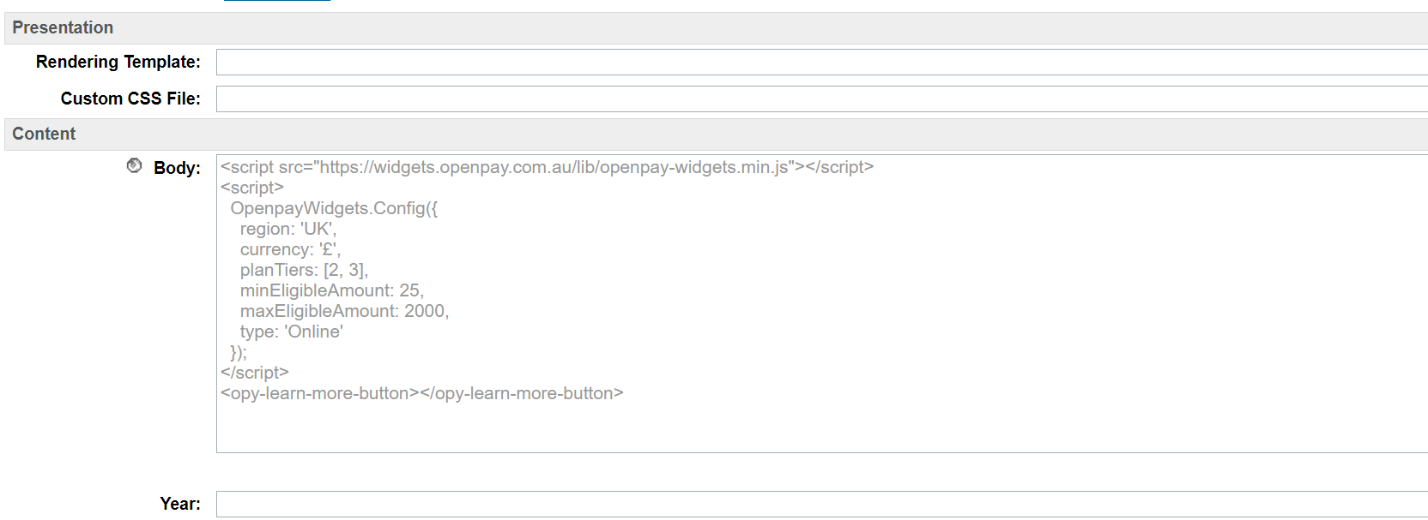

<script src="https://widgets.openpay.com.au/lib/openpay-widgets.min.js"></script>  
<script>  
 OpenpayWidgets.Config({  
 region: 'UK',  
 currency: '£',  
 planTiers: [2, 3],  
 minEligibleAmount: 25,  
 maxEligibleAmount: 2000,  
 type: 'Online'  
 });  
</script>

<opy-learn-more-button></opy-learn-more-button>

Where **region**: The region your store is located in.

**currency**: The currency symbol used in the widgets. Its value can be : $‎, A$, AU$, AUD or £

**planTiers**: An array of available plan tiers you have available in months.   
 E.g. [2,4,6] for 2 months, 4 months and 6 months

**minEligibleAmount**: The minimum eligible amount required before Openpay is eligible e.g 50

**maxEligibleAmount**: The maximum eligible amount required before Openpay is eligible e.g 500

# Testing

Once the cartridge is installed and integrated based on instructions, please try to place an order on your sandbox to test the functionality.

## Storefront Checkout flow

1. Add Product to cart
2. Click on Cart icon.
3. Click on the ‘Checkout’ button on cart page.
4. Fill shipping address.
5. Select Shipping option.
6. Click on ‘Next: Payment’ button.
7. You should see below option.

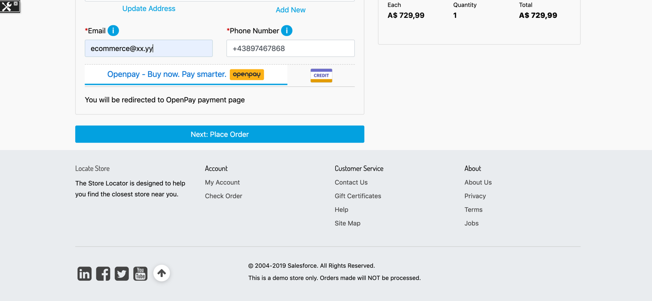

1. Select Openpay as payment method.
2. Click on ‘Next: Place Order’ button.
3. After you click on Place order, you should be redirected to Openpay website for choosing the right premium. If you are not registered then you will be asked for creating an account otherwise you see the following login page:

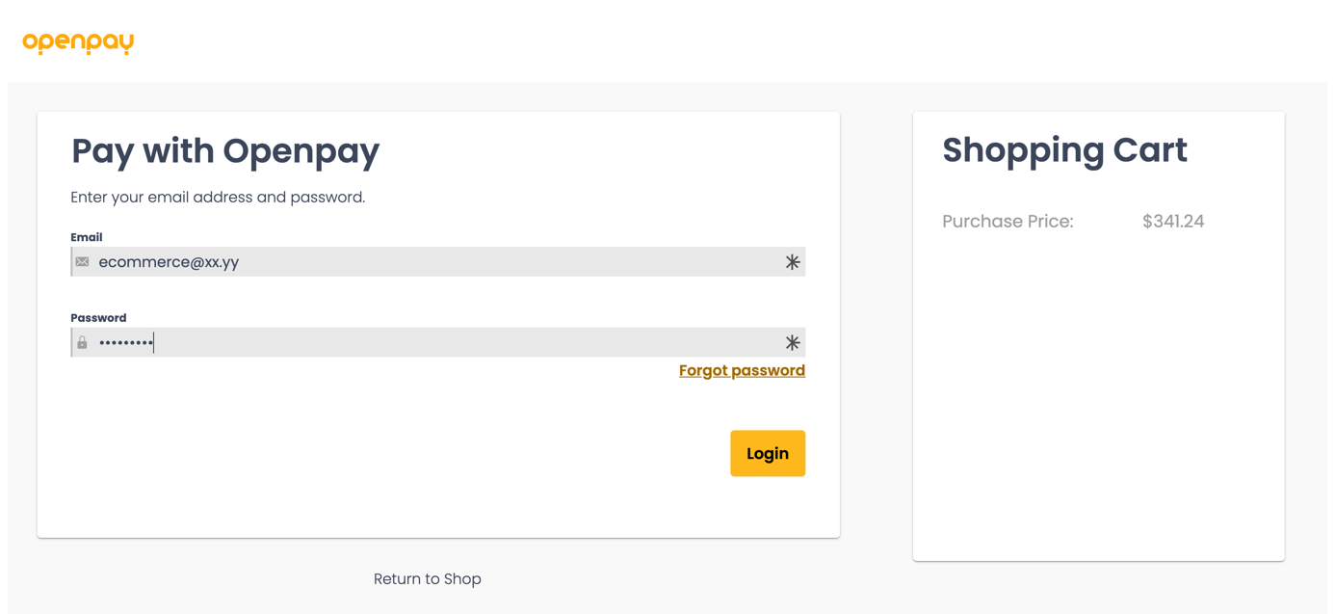

1. After login you can see plan option pick up page.

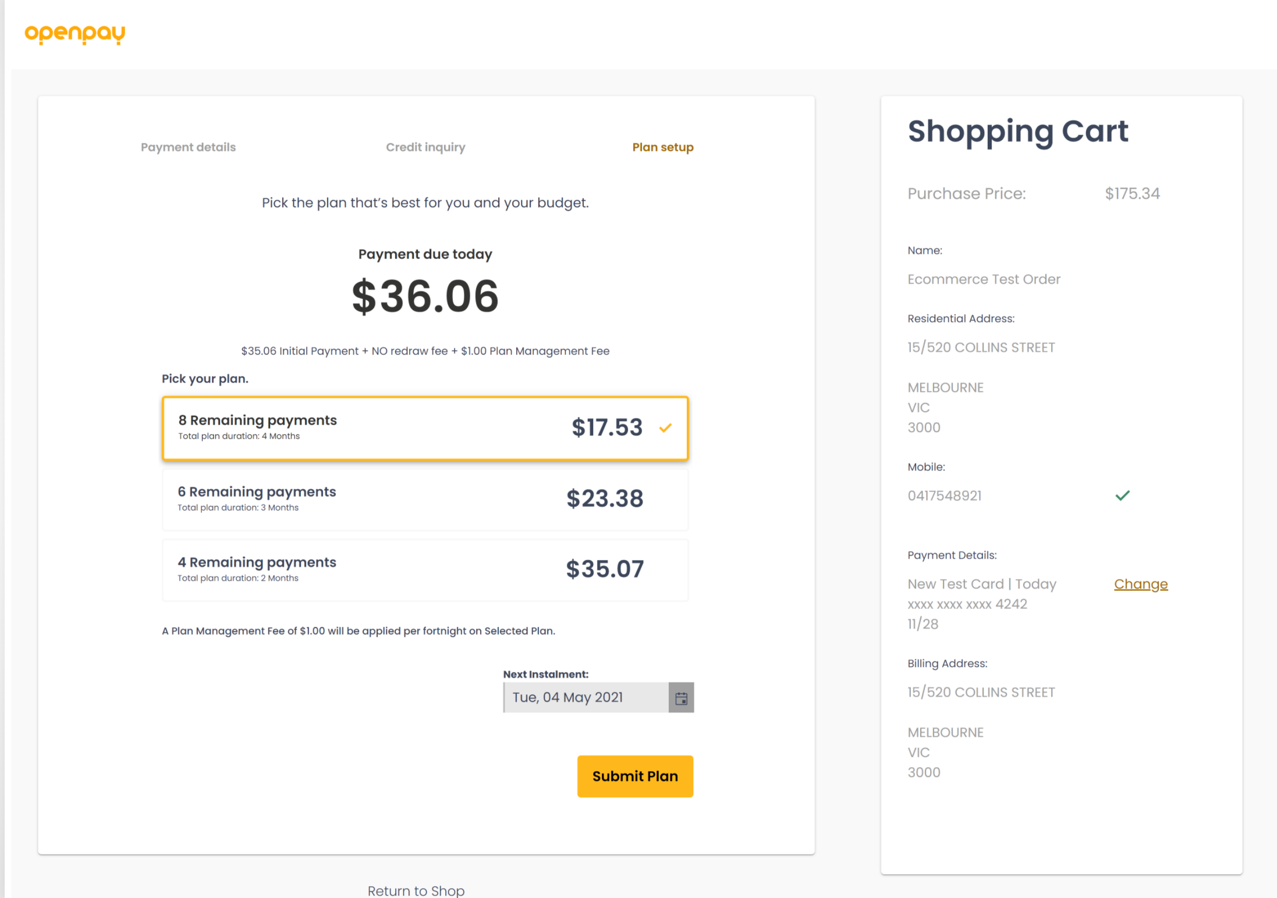

1. Select Plan option and click on ‘Submit Plan’ button.
2. After successful payment, you will be redirected to order confirmation page.

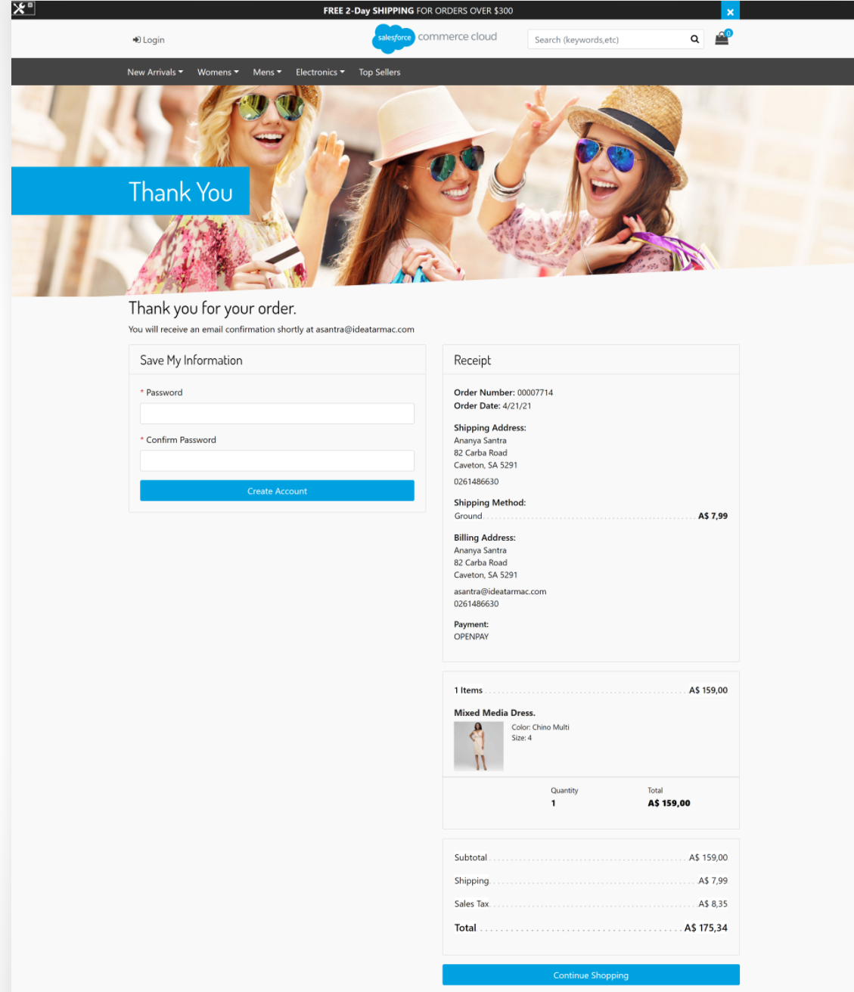

## Backend Transaction

To refund the transaction : Go to > Merchant Tools > Openpay > Transactions Management > click on the order Id from the list of orders which has to be refunded > Enter the amount to be refunded and click on ‘Refund’

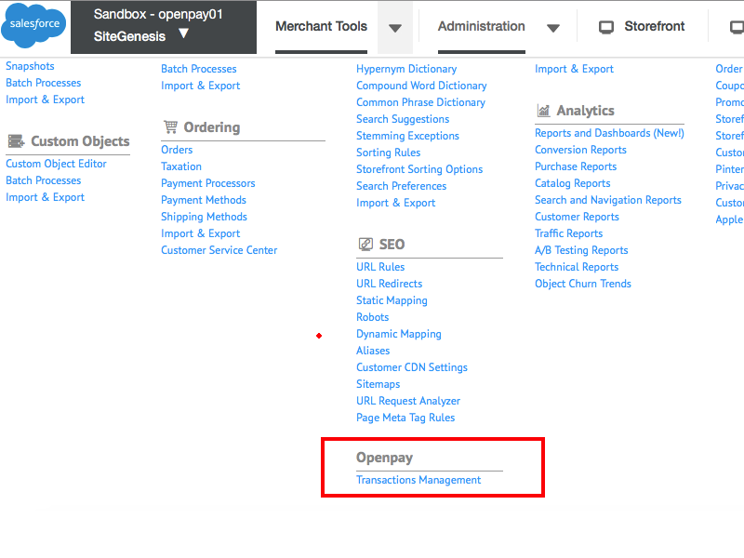

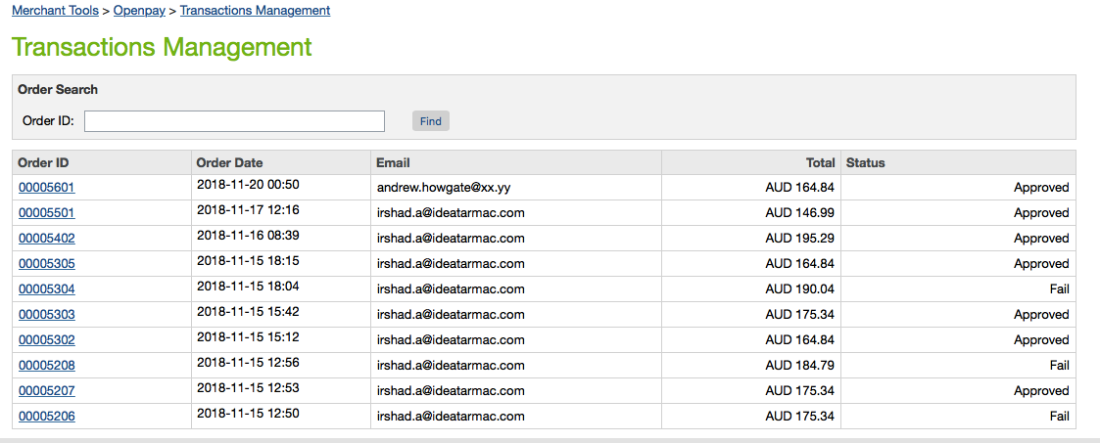

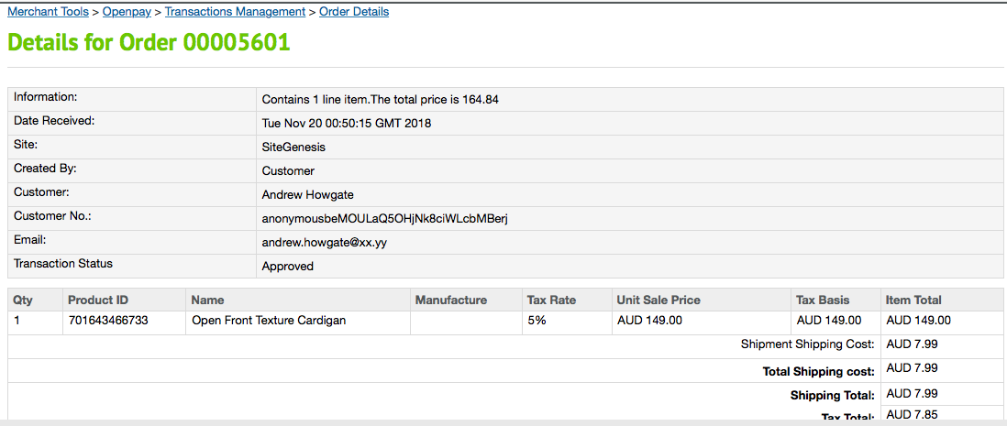

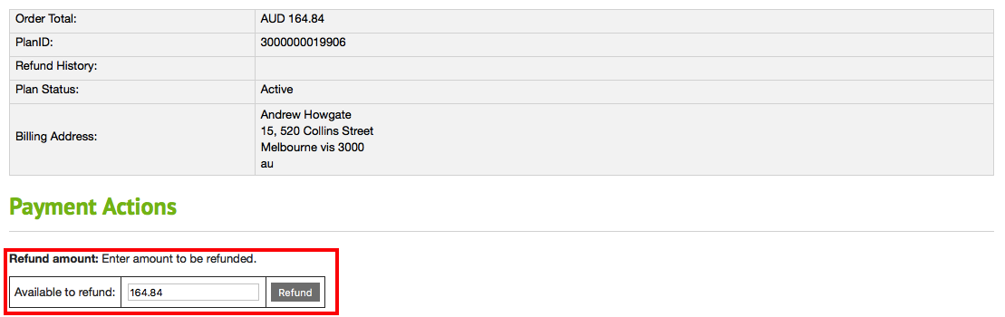

# Operations, Maintenance

## Availability

If Openpay API service is down, customers will see the error message when they try to place an order.

There will be errors detailing the exact issue in custom-openpay-ecom-…log and service-OpenpayAU -ecom…log log files.

If Openpay API service is down, then contact the Support team. Details are in Support section.

## Support

For any issues or support related enquiries for merchants, please contact us at info@openpay.com.au

# Known Issues

None

# Release History

|  |  |  |
| --- | --- | --- |
| Version | Date | Changes |
| 21.1.0 | 20-Apr-2021 | * Updated SFRA cartridge version |
| 19.2.2 | 10-Sep-2020 | * New branding – Yellow Line Logo |
| 19.2.1 | 16-Sep-2019 | * Support for UK site |
| 19.2.0 | 02-Jul-2019 | * Added new scheduled job to regularly update OnlineOrderstatus |
| 19.1.1 | 25-Jun-2019 | * Email ID is mandatory on Guest Checkout * SFRA Cartridge is compatible with latest SFRA base cartridge |
| 19.1.0 | 21-Mar-2019 | * Product List / Category Page Widget * Product Details Page Widget * Product Details Page info pop up * Mini-cart Dropdown Accelerator Widget * Checkout Page Widget * SFRA Cartridge |
| 18.1.0 | 20-Mar-2018 | * Initial release |