Supplementary Information - Analysis Code

Table of Contents

suppressPackageStartupMessages(library(tidyverse))  
library(targets)  
library(tarchetypes)  
library(visNetwork)

knitr::opts_knit$set(root.dir = "../../../", tar_interactive = FALSE, collapse = TRUE, comment = "#>")  
tar_unscript()

# 1 Disclaimer

This document only contains the high-level workflow. For a full documentation of the entire code base please visit the public code repository on github and the accompanying website for a readable report on the data structure and code results.

* <https://github.com/openpharma/quality_risk_assesment_clinical_trials>
* <https://openpharma.github.io/quality_risk_assesment_clinical_trials/index.html>

# 2 {targets} Workflow

## 2.1 Globals

options(tidyverse.quiet = TRUE)  
tar_option_set(  
 packages = c(  
 "gt",  
 "yardstick",  
 "broom",  
 "cowplot",  
 "glue",  
 "tidyverse",  
 "arrow",  
 "tarchetypes"  
 )  
 )  
purrr::map(dir("./src/R", full.names = TRUE), source)

## Established _targets.R and _targets_r/globals/globals.R.

## 2.2 Targets

### 2.2.1 Config

tar_target(  
 config,  
 list(  
 # columns that are not features  
 id_vars = c(  
 'category_id',  
 'modelling_category',  
 'classification',  
 'activity_id_new',  
 'start_date',  
 'index',  
 'date_first_study_activity',  
 'date_last_study_activity',  
 'protocol',  
 'file_name',  
 'source_row_index',  
 'audit_or_inspection',  
 'site_platinum_id',  
 'pi_platinum_id',  
 'site_num',  
 'country',  
 'site_activation_date',  
 'site_closed_date',  
 'site_closed_date_corr',  
 'study_start_date',  
 'study_end_date'  
 ),  
 max_year = 2020  
 )  
)

## Established _targets.R and _targets_r/targets/config.R.

### 2.2.2 Data

#### 2.2.2.1 Files

list(  
 tar_target(file_mm, "data/in/modelling_matrix.feather", format = "file"),  
 tar_target(file_mm_bin, "data/in/lasso_prep.feather", format = "file"),  
 tar_target(file_form, "data/in/glm_coefs.feather", format = "file"),  
 tar_target(file_cv, "data/in/indeces_annual_splits.feather", format = "file"),  
 tar_target(file_cat_lookup, "data/in/category_lookup.feather", format = "file"),  
 tar_target(file_feat_lookup, "data/in/feature_lookup.csv", format = "file")  
)

## Established _targets.R and _targets_r/targets/files.R.

#### 2.2.2.2 Load

list(  
 tar_target(df_mm, qract_read_and_anonymize(file_mm, config$id_vars, arrow::read_feather)),  
 tar_target(df_mm_bin, qract_read_and_anonymize(file_mm_bin, config$id_vars, arrow::read_feather)),  
 tar_target(df_form, qract_read_and_anonymize(file_form, config$id_vars, arrow::read_feather)),  
 tar_target(df_cv, qract_read_and_anonymize(file_cv, config$id_vars, arrow::read_feather)),  
 tar_target(df_cat_lookup, qract_read_and_anonymize(file_cat_lookup, config$id_vars, arrow::read_feather)),  
 tar_target(df_feat_lookup, qract_read_and_anonymize(file_feat_lookup, config$id_vars, readr::read_csv))  
)

## Established _targets.R and _targets_r/targets/load.R.

#### 2.2.2.3 Report

[link](01_data.html)

tarchetypes::tar_render(  
 report_data,  
 "src/Rmd/_01_data.Rmd",  
 output_file = "01_data.html",  
 output_dir = "src/Rmd/",  
 output_yaml = "src/Rmd/_site.yml"  
)

## Established _targets.R and _targets_r/targets/report_data.R.

### 2.2.3 Time Series Cross Validation

list(  
 tar_target(p_tscv, qract_plot_tscv(df_mm, df_cv, config$max_year)),  
 tar_target(df_cv_preds_and_coefs, qract_pred_cv(df_mm_bin, df_cv, df_form, config$id_vars))  
)

## Established _targets.R and _targets_r/targets/cv.R.

#### 2.2.3.1 Report

[link](02_cv.html)

tarchetypes::tar_render(  
 report_cv,  
 "src/Rmd/_02_cv.Rmd",  
 output_file = "02_cv.html",  
 output_dir = "src/Rmd/",  
 output_yaml = "src/Rmd/_site.yml"  
)

## Established _targets.R and _targets_r/targets/report_cv.R.

### 2.2.4 Performance

list(  
 tar_target(df_perf, qract_perf(df_cv_preds_and_coefs, config$max_year)),  
 tar_target(df_calib, qract_lin_calib(df_cv_preds_and_coefs, min_sample_size = 200)),  
 tar_target(df_bin, qract_bin_preds(df_cv_preds_and_coefs, n_bins = 4, confidence_level = .75)),  
 tar_target(  
 p_calib,  
 qract_plot_calibration_pub(  
 category_id_str = df_cv_preds_and_coefs$category_id %>% unique(),  
 df_bin,  
 df_calib,  
 df_cat_lookup,  
 uniform_color = "black",  
 color_calib = "grey"  
 )  
 )  
)

## Established _targets.R and _targets_r/targets/perf.R.

#### 2.2.4.1 Report

[link](03_perf.html)

tarchetypes::tar_render(  
 report_perf,  
 "src/Rmd/_03_perf.Rmd",  
 output_file = "03_perf.html",  
 output_dir = "src/Rmd/",  
 output_yaml = "src/Rmd/_site.yml"  
)

## Established _targets.R and _targets_r/targets/report_perf.R.

### 2.2.5 Forest Plots

list(  
 tar_target(  
 df_forest,  
 qract_forest_plots(  
 df_cv_preds_and_coefs,  
 df_feat_lookup,  
 df_mm,  
 df_cat_lookup,  
 category_ids = c(  
 "cnsn",  
 "dtin",  
 "sfty",  
 "ptpe"  
 )  
 )  
 ),  
 tar_target(  
 forest_files,  
 qract_save_forest_plots(  
 df_forest,  
 path = "./png"  
 ),  
 format = "file"  
 )  
)

## Established _targets.R and _targets_r/targets/forest.R.

#### 2.2.5.1 Report

[link](%22./04_forest.html%22)

tarchetypes::tar_render(  
 report_forest,  
 "src/Rmd/_04_forest.Rmd",  
 output_file = "04_forest.html",  
 output_dir = "src/Rmd/",  
 output_yaml = "src/Rmd/_site.yml"  
)

## Established _targets.R and _targets_r/targets/report_forest.R.

## 2.3 Run Workflow

tar_make()  
## ✓ skip target file_mm  
## ✓ skip target file_form  
## ✓ skip target config  
## ✓ skip target file_cat_lookup  
## ✓ skip target file_cv  
## ✓ skip target file_feat_lookup  
## ✓ skip target file_mm_bin  
## ✓ skip target df_form  
## ✓ skip target df_mm  
## ✓ skip target df_cat_lookup  
## ✓ skip target df_cv  
## ✓ skip target df_feat_lookup  
## ✓ skip target df_mm_bin  
## ✓ skip target p_tscv  
## ✓ skip target df_cv_preds_and_coefs  
## ✓ skip target report_data  
## ✓ skip target df_perf  
## ✓ skip target report_cv  
## ✓ skip target df_bin  
## ✓ skip target df_calib  
## ✓ skip target df_forest  
## ✓ skip target p_calib  
## ✓ skip target report_forest  
## ✓ skip target forest_files  
## ✓ skip target report_perf  
## ✓ skip pipeline

## 2.4 Visualise Workflow

### 2.4.1 Without Functions

tar_visnetwork(targets_only = TRUE, reporter = "silent")

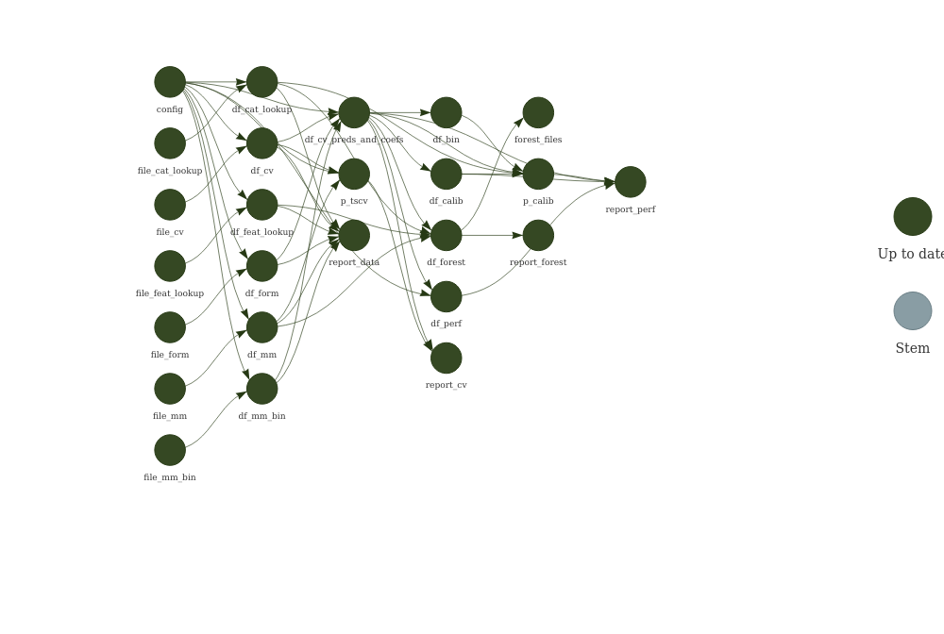

### 2.4.2 With Functions

tar_visnetwork(reporter = "silent")

