


jpylyzer: validator and properties extractor for JPEG 2000 Part 1 (JP2)
User Manual

jpylyzer version: 1.10

Johan van der Knijff
KB/ National Library of the Netherlands
Open Planets Foundation


This work was partially supported by the SCAPE Project. The SCAPE project is co-funded by the European Union under FP7 ICT-2009.4.1 (Grant Agreement number 270137).

Disclaimer
Both the program code and this manual have been carefully inspected before printing. However, no warranties, either expressed or implied, are made concerning the accuracy, completeness, reliability, usability, performance, or fitness for any particular purpose of the information contained in this manual, to the software described in this manual, and to other material supplied in connection therewith. The material is provided "as is". The entire risk as to its quality and performance is with the user.

Table of Contents

1 Introduction 1
1.1 About jpylyzer 1
1.2 Validation: scope and restrictions 1
‘Valid’ means ‘probably valid’ 1
No check on compressed bitstreams 1
Recommendations for use in quality assurance workflows 2
Note on ICC profile support 2
1.3 Outline of this User Manual 2
1.4 Funding 2
1.5 License 2
2 Installation and set-up 3
2.1 Obtaining the software 3
2.2 Installation of Python script (Linux/Unix, Windows, Mac OS X) 3
Testing the installation 3
Troubleshooting 4
2.3 Installation of Windows binaries (Windows only) 4
Testing the installation 4
Running jpylyzer without typing the full path 5
2.4 Installation of Debian packages (Ubuntu/Linux) 5
3 Using jpylyzer 7
3.1 Overview 7
3.2 Command-line usage 7
Synopsis 7
Output redirection 8
Creating well-formed XML with multiple images 8
User warnings 8
3.3 Using jpylyzer as a Python module 9
4 Structure of a JP2 file 11
4.1 Scope of this chapter 11
4.2 General format structure 11
4.3 General structure of a box 12
4.4 Defined boxes in JP2 12
5 Output format 15
5.1 Overview 15
5.2 toolInfo element 16
5.3 fileInfo element 16
5.4 isValidJP2 element 16
5.5 tests element 16
Default and verbose reporting of test results 17
5.6 properties element 17
6 JP2: box by box 19
6.1 About the properties and tests trees 19
Naming of properties 19
6.2 JPEG 2000 Signature box 19
Element name 19
Reported properties 19
Tests 20
6.3 File Type box 20
Element name 20
Reported properties 20
Tests 20
6.4 JP2 Header box (superbox) 20
Element name 20
Reported properties 20
Tests 21
6.5 Image Header box (child of JP2 Header box) 21
Element name 21
Reported properties 22
Tests 22
6.6 Bits Per Component box (child of JP2 Header box) 22
Element name 22
Reported properties 22
Tests 23
6.7 Colour Specification box (child of JP2 Header box) 23
Element name 23
Reported properties 23
Reported properties of ICC profiles 23
Tests 25
6.8 Palette box (child of JP2 Header box) 25
Element name 25
Reported properties 25
Tests 26
6.9 Component Mapping box (child of JP2 Header box) 26
Element name 26
Reported properties 26
Tests 26
6.10 Channel Definition box (child of JP2 Header box) 26
Element name 26
Reported properties 27
Tests 27
6.11 Resolution box (child of JP2 Header box, superbox) 27
Element name 27
Reported properties 27
Tests 27
6.12 Capture Resolution box (child of Resolution box) 28
Element name 28
Reported properties 28
Tests 28
6.13 Default Display Resolution box (child of Resolution box) 29
Element name 29
Reported properties 29
Tests 30
6.14 Contiguous Codestream box 30
6.15 Intellectual Property box 30
6.16 XML box 30
Element name 30
Reported properties 30
Tests 30
6.17 UUID box 31
Element name 31
Reported properties 31
Tests 31
6.18 UUID Info box (superbox) 32
Element name 32
Reported properties 32
Tests 32
6.19 UUID List box (child of UUID Info box) 32
Element name 32
Reported properties 32
Tests 32
6.20 Data Entry URL box (child of UUID Info box) 32
Element name 33
Reported properties 33
Tests 33
6.21 Unknown box 33
Element name 33
Reported properties 33
6.22 Top-level tests and properties 33
Element name 33
Reported properties 34
Tests 35
7 Contiguous Codestream box 37
7.1 General codestream structure 37
Markers and marker segments 37
General structure of the codestream 37
7.2 Limitations of codestream validation 38
Main codestream header 38
Tile parts 39
Bit streams 40
Detection of incomplete or truncated codestreams 40
Current limitations of comment extraction 40
7.3 Structure of reported output 40
7.4 Contiguous Codestream box 41
Element name 41
Reported properties 41
Tests 42
7.5 Image and tile size (SIZ) marker segment (child of Contiguous Codestream box) 43
Element name 43
Reported properties 43
Tests 44
7.6 Coding style default (COD) marker segment 45
Element name 45
Reported properties 45
Tests 46
7.7 Quantization default (QCD) marker segment 47
Element name 47
Reported properties 47
Tests 47
7.8 Comment (COM) marker segment 48
Element name 48
Reported properties 48
Tests 48
Note on support of Latin encoding 48
7.9 Tile part (child of Contiguous Codestream box) 49
Element name 49
Reported properties 49
Tests 49
7.10 Start of tile part (SOT) marker segment (child of tile part) 49
Element name 49
Reported properties 50
Tests 50
7.11 Coding style component (COC) marker segment 50
Element name 50
Reported properties 50
Tests 50
7.12 Region-of-interest (RGN) marker segment 51
Element name 51
Reported properties 51
Tests 51
7.13 Quantization component (QCC) marker segment 51
Element name 51
Reported properties 51
Tests 51
7.14 Progression order change (POC) marker segment 51
Element name 51
Reported properties 52
Tests 52
7.15 Packet length, main header (PLM) marker segment 52
Element name 52
Reported properties 52
Tests 52
7.16 Packed packet headers, main header (PPM) marker segment 52
Element name 52
Reported properties 52
Tests 53
7.17 Tile-part lengths (TLM) marker segment 53
Element name 53
Reported properties 53
Tests 53
7.18 Component registration (CRG) marker segment 53
Element name 53
Reported properties 53
Tests 53
7.19 Packet length, tile-part header (PLT) marker segment 54
Element name 54
Reported properties 54
Tests 54
7.20 Packed packet headers, tile-part header (PPT) marker segment 54
Element name 54
Reported properties 54
Tests 54
8 References 55

Introduction

About jpylyzer
This User Manual documents jpylyzer, a validator and feature extractor for JP2 images. JP2 is the still image format that is defined by JPEG 2000 Part 1 (ISO/IEC 15444-1). Jpylyzer was specifically created to answer the following questions that you might have about any JP2 file:
- Is this really a JP2 and does it really conform to the format's specifications (validation)?
- What are the technical characteristics of this image (feature extraction)?

Validation: scope and restrictions
Since the word ‘validation’ means different things to different people, a few words about the overall scope of jpylyzer. First of all, it is important to stress that jpylyzer is not a ‘one stop solution’ that will tell you that an image is 100% perfect. What jpylyzer does is this: based on the JP2 format specification (ISO/IEC 15444-1), it parses a file. It then subjects the file’s contents to a large number of tests, each of which is based on the requirements and restrictions that are defined by the standard. If a file fails one or more tests, this implies that it does not conform to the standard, and is no valid JP2. Importantly, this presumes that jpylyzer’s tests accurately reflect the format specification, without producing false positives.

‘Valid’ means ‘probably valid’
If a file passes all tests, this is an indication that it is probably valid JP2. This (intentionally) implies a certain degree of remaining uncertainty, which is related to the following.
First of all, jpylyzer (or any other format validator for that matter) ‘validates’ a file by trying to prove that it does not conform to the standard. It cannot prove that that a file does conform to the standard.
Related to this, even though jpylyzer’s validation process is very comprehensive, it is not complete. For instance, the validation of JPEG 2000 codestreams at this moment is still somewhat limited. Section 7.2 discusses these limitations in detail. Some of these limitations (e.g. optional codestream segment markers that are only minimally supported at this stage) may be taken away in upcoming versions of the tool.

No check on compressed bitstreams
One important limitation that most certainly will not be addressed in any upcoming versions is that jpylyzer does not analyse the data in the compressed bitstream segments. Doing so would involve decoding the whole image, and this is completely out of jpylyzer’s scope. As a result, it is possible that a JP2 that passes each of jpylyzer’s tests will nevertheless fail to render correctly in a viewer application.

Recommendations for use in quality assurance workflows
Because of the foregoing, a thorough JP2 quality assurance workflow should not rely on jpylyzer (or any other format validator) alone, but it should include other tests as well. Some obvious examples are:
- A rendering test that checks if a file renders at all
- Format migration workflows (e.g. TIFF to JP2) should ideally also include some comparison between source and destination images (e.g. a pixel-wise comparison)
Conversely, an image that successfully passes a rendering test or pixel-wise comparison may still contain problematic features (e.g. incorrect colour space information), so validation, rendering tests and pixel-wise comparisons are really complementary to each other.

Note on ICC profile support
At the time of writing an amendment is in preparation that will extend the support for embedded ICC profiles in JP2. Jpylyzer is already anticipating these changes, and as a result there is a minor discrepancy here between jpylyzer and the current standard text.

Outline of this User Manual
Chapter 2 describes the installation process of jpylyzer for Windows and Unix-based systems. Chapter 3 explains the usage of jpylyzer as a command-line tool, or as an importable Python module. Chapter 4 gives a brief overview of the structure of JP2 and its ‘box’ structure. Jpylyzer’s output format is explained in chapter 5. The final chapters give a detailed description of the tests that jpylyzer performs for validation, and its reported properties. Chapter 6 does this for all ‘boxes’, except for the ‘Contiguous Codestream’ box, which is given a chapter (7) of its own.

Funding
The development of jpylyzer was funded by the EU FP 7 project SCAPE (SCAlabable Preservation Environments). More information about this project can be found here:
http://www.scape-project.eu/

License
Jpylyzer is free software: you can redistribute it and/or modify it under the terms of the GNU Lesser General Public License as published by the Free Software Foundation, either version 3 of the License, or (at your option) any later version. This program is distributed in the hope that it will be useful, but WITHOUT ANY WARRANTY; without even the implied warranty of MERCHANTABILITY or FITNESS FOR A PARTICULAR PURPOSE. See the GNU Lesser General Public License for more details. You should have received a copy of the GNU Lesser General Public License along with this program. If not, see <http://www.gnu.org/licenses/>.
On Debian systems, the complete text of the GNU Lesser General Public License version 3 can be found in "/usr/share/common-licenses/LGPL-3".

Installation and set-up

Obtaining the software
To obtain the latest version of the software please use the download links at the jpylyzer homepage:
http://openplanets.github.io/jpylyzer/
You have three options:
- Use the Python source code. This allows you to run the software as a Python script on most popular platforms (Windows, Linux, Mac, etc.). However, this requires that you have a recent version of the Python interpreter available on your system.
- Alternatively, for Windows users there is also a set of stand-alone binaries. These allow you to run jpylyzer as an executable Windows application, without any need for installing Python. This option is particularly useful for Windows users who cannot (or don’t want to) install software on their system.
- For Linux users Debian packages are available. These allow you to run jpylyzer without any need for installing Python.
These options are described in the following sections.

Installation of Python script (Linux/Unix, Windows, Mac OS X)
First, download the source files using one of the ‘Source Code Downloads’ links on the OPF jpylyzer page.
Then unzip the contents of the ZIP file to an empty directory. If you are working on a Linux/Unix based system you may need to make the scripts executable, and convert any line breaks to Unix-style ones. To do this, use the following commands:
chmod 755 *.py
dos2unix *.py
In order to run the script you will need either Python 2.7, or Python 3.2 (or more recent). Python can be downloaded from:
http://python.org/

Testing the installation
To test your installation, open a console window (or command prompt) and type:
%jpylyzerPath%/jpylyzer.py -h
In the above command, replace %jpylyzerPath% with the full path to the jpylyzer installation directory (i.e. the directory that contains ‘jpylyzer.py’ and its associated files). For example, if you extracted the files to directory ‘/home/jpylyzer’, the command would become:
/home/jpylyzer/jpylyzer.py -h
Executing this command should result in the following screen output:
usage: jpylyzer.py [-h] [--verbose] [--wrapper] [--version] ...

JP2 image validator and properties extractor

positional arguments:
jp2In input JP2 image(s) or folder(s), prefix wildcard
(*) with backslash (\) in Linux

optional arguments:
-h, --help show this help message and exit
--verbose report test results in verbose format
--wrapper, -w wraps the output for individual image(s) in
'results' XML element
--version show program's version number and exit

Troubleshooting
If the above test didn’t run successfully, first verify the following possible causes:
- On Windows: check if files with a .py extension are associated with the Python interpreter. If you have multiple versions of Python on your system, make sure that the association does not link to a Python version that is incompatible with jpylyzer (e.g. Python 2.6 or older, or Python 3.0/3.1).
- On Unix/Linux: by default, jpylyzer uses the command interpreter that is defined by the ‘python’ environment variable. If this is linked to some (very) old version of Python, things may not work as expected. If you run into problems because of this, update the command interpreter references in jpylyzer.py, i.e. change:
#! /usr/bin/env python
into:
#! /usr/bin/env python27

Installation of Windows binaries (Windows only)
Download the binary using the link on the jpylyzer homepage. Unzip the contents of this file to an empty folder on your PC. Jpylyzer should now be ready for use.

Testing the installation
To test your installation, open a Command Prompt (‘DOS prompt’) and type:
%jpylyzerPath%\jpylyzer -h
In the above command, replace %jpylyzerPath% with the full path to the jpylyzer installation directory (i.e. the directory that contains ‘jpylyzer.exe’ and its associated files). For example, if you extracted the files to directory ‘c:\tools\jpylyzer’, the command would become:
c:\tools\jpylyzer\jpylyzer -h
Executing this command should result in the following screen output:
usage: jpylyzer.py [-h] [--verbose] [--wrapper] [--version] ...

JP2 image validator and properties extractor

positional arguments:
jp2In input JP2 image(s) or folder(s), prefix wildcard
(*) with backslash (\) in Linux

optional arguments:
-h, --help show this help message and exit
--verbose report test results in verbose format
--wrapper, -w wraps the output for individual image(s) in
'results' XML element
--version show program's version number and exit

Running jpylyzer without typing the full path
Optionally, you may also want to add the full path of the jpylyzer installation directory to the Windows ’Path’ environment variable. Doing so allows you to run jpylyzer from any directory on your PC without having to type the full path. In Windows XP you can do this by selecting ‘settings’ from the ‘Start’ menu; then go to ‘control panel’/’system’ and go to the ‘advanced’ tab. Click on the ‘environment variables’ button. Finally, locate the ‘Path’ variable in the ‘system variables’ window, click on ‘Edit’ and add the full jpylyzer path (this requires local Administrator privileges). The settings take effect on any newly opened command prompt.

Installation of Debian packages (Ubuntu/Linux)
For a number of Linux architectures Debian packages of jpylyzer exist. To install, simply download the .deb file, double-click on it and select Install Package. Alternatively you can also do this in the command terminal by typing:
sudo dpkg -i jpylyzer_1.9.0_i386.deb
In both cases you need to have administrative privileges.

Using jpylyzer

Overview
This chapter describes the general use of jpylyzer. The first sections cover the use of jpylyzer as a command-line tool and as an importable Python module.

Command-line usage
This section explains jpylyzer’s general command-line interface. For the sake of brevity, all command-line examples assume the use of the Python script; moreover, full paths are omitted. This means that, depending on your system and settings, you may have to substitute each occurrence of ‘jpylyzer.py’ with its full path, the corresponding Windows binary, or a combination of both. The following examples illustrate this:
This User Manual | jpylyzer.py
Substitution example Linux | /home/jpylyzer/jpylyzer.py
Substitution example Windows binaries | c:\tools\jpylyzer\jpylyzer

Furthermore, command line arguments that are given between square brackets (example: [-h]) are optional.

Synopsis
Jpylyzer can be invoked using the following command-line arguments:
jpylyzer.py [-h] [--verbose] [--wrapper] [--version] ...
With:
… | : input JP2 image(s)
[-h, --help] | : show help message and exit
[--verbose] | : report test results in verbose format
[--wrapper, -w] | : wraps the output for individual image(s) in 'results' XML element
[-v, --version] | : show program's version number and exit

Note that the input can either be a single image, a space-separated sequence of images, a pathname expression that includes multiple images, or any combination of the above. For example, the following command will process one single image:
jpylyzer.py rubbish.jp2
The next example shows how to process all files with a ‘jp2’ extension in the current directory:
jpylyzer.py *.jp2
Note that on Unix/Linux based systems pathname expressions may not work properly unless you wrap them in quotation marks:
jpylyzer.py “*.jp2”

Output redirection
All output (except warning and system error messages) is directed to the standard output device (stdout). By default this is the console screen. Use your platform’s standard output redirection operators to redirect output to a file. The most common situation will be to redirect the output of one invocation of jpylyzer to an XML file, which can be done with the ‘>’ operator (both under Windows and Linux):
jpylyzer.py jp2In > outputFile
E.g. the following command will run jpylyzer on image ‘rubbish.jp2’ and redirects the output to file ‘rubbish.xml’:
jpylyzer.py rubbish.jp2 > rubbish.xml
The format of the XML output is described in Chapter 5.

Creating well-formed XML with multiple images
By default, jpylyzer creates a separate XML tree for each analysed image, without any overarching hierarchy. If you use a pathname expression to process multiple images and redirect the output to a file, the resulting file will not be a well-formed XML document. An example:
jpylyzer.py rubbish.jp2 garbage.jp2 > rubbish.xml
In this case, the output for these 2 images is redirected to ‘rubbish.xml’, but the file will be a succession of two XML trees, which by itself is not well-formed XML. Use the --wrapper option if you want to create well-formed XML instead:
jpylyzer.py --wrapper rubbish.jp2 garbage.jp2 > rubbish.xml
In the above case the XML trees of the individual images are wrapped inside a ‘results’ element.

User warnings
Under the following conditions jpylyzer will print a user warning to the standard error device (typically the console screen):
- If there are no input images to check (typically because the value of jp2In refers to a non-existent file), the following warning message is shown:
User warning: no images to check!
- In some cases you will see the following warning message:
User warning: ignoring 'boxName' (validator function not yet implemented)
The reason for this: a JP2 file is made up of units that are called ‘boxes’. This is explained in more detail in Chapter 4. Each ‘box’ has its own dedicated validator function. At this stage validator functions are still missing for a small number of (optional) boxes. Jpylyzer will display the above warning message if it encounters a (yet) unsupported box. Any unsupported boxes are simply ignored, and the remainder of the file will be analyzed (and validated) normally.
- Finally, you may occasionally see this warning message:
User warning: ignoring unknown box
This happens if jpylyzer encounters a box that is not defined by JPEG 2000 Part 1. It should be noted that, to a large extent, JPEG 2000 Part 1 permits the presence of boxes that are defined outside the standard. Again, jpylyzer will simply ignore these and process all other boxes normally.

Using jpylyzer as a Python module
Instead of using jpylyzer from the command-line, you can also import it as a module in your own Python programs. To do so, put all the jpylyzer source files in the same directory as your own code. Then import jpylyzer into your code by adding:
import jpylyzer
Subsequently you can call any function that is defined in jpylyzer.py. In practice you will most likely only need the checkOneFile function, which can be called in the following way:
jpylyzer.checkOneFile(file)
Here, file is the path to a file object. The function returns an element object that can either be used directly, or converted to XML using the ElementTree module. The structure of the element object follows the XML output that described in Chapter 5.
Alternatively, you may only want to import the checkOneFile function, in which case the import statement becomes:
from jpylyzer import checkOneFile
This will allow you to call the function as follows:
checkOneFile(file)

Structure of a JP2 file

Scope of this chapter
This chapter gives a brief overview of the JP2 file format. A basic understanding of the general structure of JP2 is helpful for appreciating how jpylyzer performs its validation. It will also make it easier to understand jpylyzer‘s extracted properties, as these are reported as a hierarchical tree that corresponds to the internal structure of JP2.
For an exhaustive description of every detail of the format you are advised to consult Annex I (‘JP2 file format syntax’) and Annex A (‘Codestream syntax’) of ISO/IEC 15444-1.

General format structure
At the highest level, a JP2 file is made up of a collection of boxes. A box can be thought of as the fundamental building block of the format. Some boxes (‘superboxes’) are containers for other boxes. Figure 4-1 gives an overview of the top-level boxes in a JP2 file.
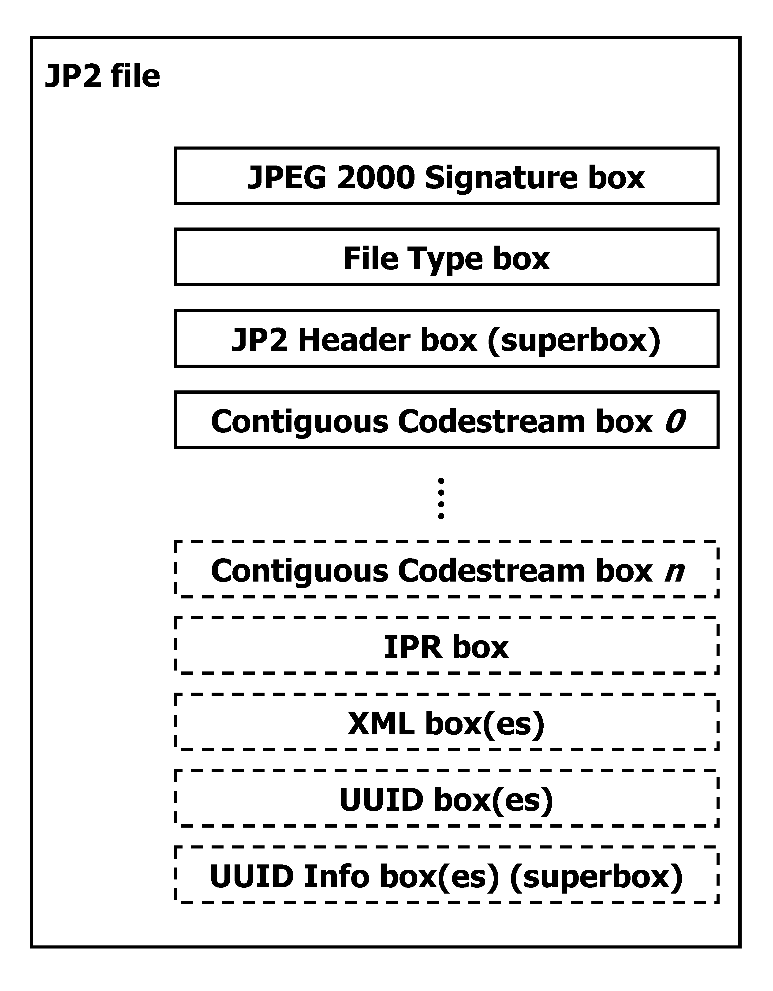
Figure 4-1 Top-level overview of a JP2 file (based on Figure I.1 in ISO/IEC 15444-1). Boxes with dashed borders are optional. 'Superbox' denotes a box that contains other box(es).

A number of things here are noteworthy to point out:
- Some of these boxes are required, whereas others (indicated with dashed lines in Figure 4-1) are optional.
- The order in which the boxes appear in the file is subject to some constraints (e.g. the first box in a JP2 must always be a ‘Signature’ box, followed by a ‘File Type’ box).
- Some boxes may have multiple instances (e.g. ‘Contiguous Codestream’ box), whereas others must be unique (e.g. ‘JP2 Header’ box).
More specific details can be found in the standard. The important thing here is that requirements like the above are something that should be verified by a validator, and this is exactly what jpylyzer does at the highest level of its validation procedure.

General structure of a box
All boxes are defined by a generic binary structure, which is illustrated by Figure 4-2. Most boxes are made up of the following three components:
- A fixed-length ‘box length’ field that indicates the total size of the box (in bytes).
- A fixed-length ‘box type’ field which specifies the type of information that can be found in this box
- The box contents, which contains the actual information within the box. Its internal format depends on the box type. The box contents of a ‘superbox’ will contain its child boxes (which can be parsed recursively).
In some cases a box will also contain an ‘extended box length field’. This field is needed if the size of a box exceeds 2³²-1 bytes, which is the maximum value that can be stored in the 4-byte ‘box length’ field.
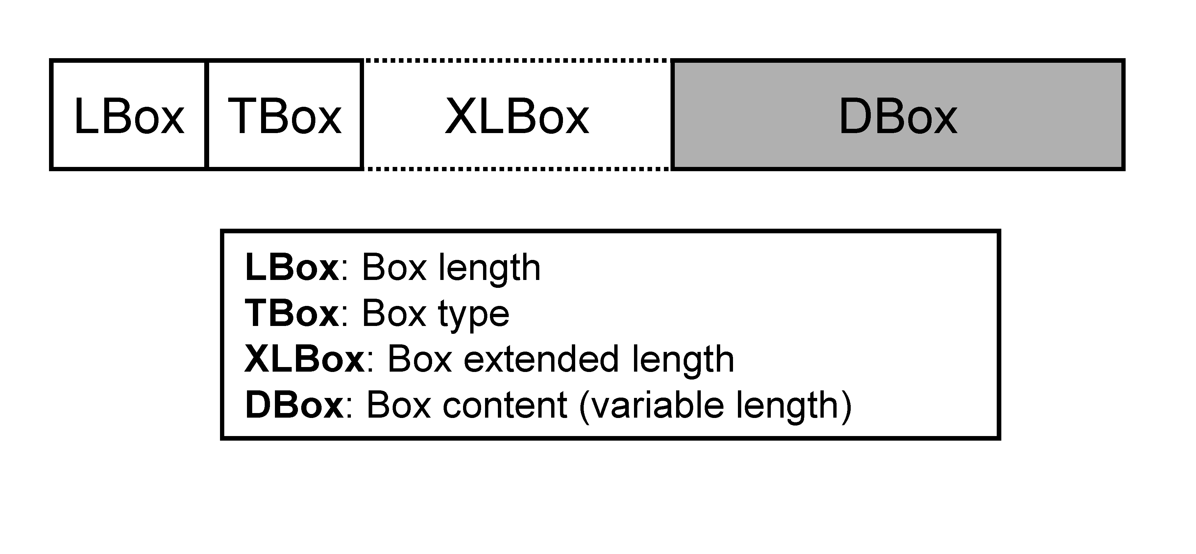
Figure 4-2 General structure of a box (based on Figure I.4 in ISO/IEC 15444-1).

Defined boxes in JP2
Table 4-1 lists all boxes that are defined in ISO/IEC 15444-1. A JP2 file may contain boxes that are not defined by the standard. Such boxes are simply skipped and ignored by conforming reader applications.

Table 4-1 Defined boxes in JP2 (taken from Table I.2 in ISO/IEC 15444-1, with minor modifications). Indentation in ‘box name’ column indicates hierarchical structure.
Box name | Superbox | Required? | Purpose
JPEG 2000 Signature box | No | Required | Identifies the file as being part of the JPEG 2000 family of files.
File Type box | No | Required | Specifies file type, version and compatibility information, including specifying if this file is a conforming JP2 file or if it can be read by a conforming JP2 reader.
JP2 Header box | Yes | Required | Contains a series of boxes that contain header-type information about the file.
- Image Header box | No | Required | Specifies the size of the image and other related fields.
- Bits Per Component box | No | Optional | Specifies the bit depth of the components in the file in cases where the bit depth is not constant across all components.
- Colour Specification box | No | Required | Specifies the colourspace of the image.
- Palette box | No | Optional | Specifies the palette which maps a single component in index space to a multiple-component image.
- Component Mapping box | No | Optional | Specifies the mapping between a palette and codestream components.
- Channel Definition box | No | Optional | Specifies the type and ordering of the components within the codestream, as well as those created by the application of a palette.
- Resolution box | Yes | Optional | Contains the grid resolution.
- Capture  Resolution box | No | Optional | Specifies the grid resolution at which the image was captured.
- Default Display  Resolution box | No | Optional | Specifies the default grid resolution at which the image should be displayed.
Contiguous Codestream box | No | Required | Contains the codestream.
Intellectual Property box | No | Optional | Contains intellectual property information about the image.
XML box | No | Optional | Provides a tool by which vendors can add XML formatted information to a JP2 file.
UUID box | No | Optional | Provides a tool by which vendors can add additional information to a file without risking conflict with other vendors.
UUID Info box | Yes | Optional | Provides a tool by which a vendor may provide access to additional information associated with a UUID.
- UUID List box | No | Optional | Specifies a list of UUIDs.
- URL box | No | Optional | Specifies a URL.

Output format
This chapter explains jpylyzer’s output format.

Overview
Jpylyzer generates its output in XML format. Figure 5-3 shows the output structure.
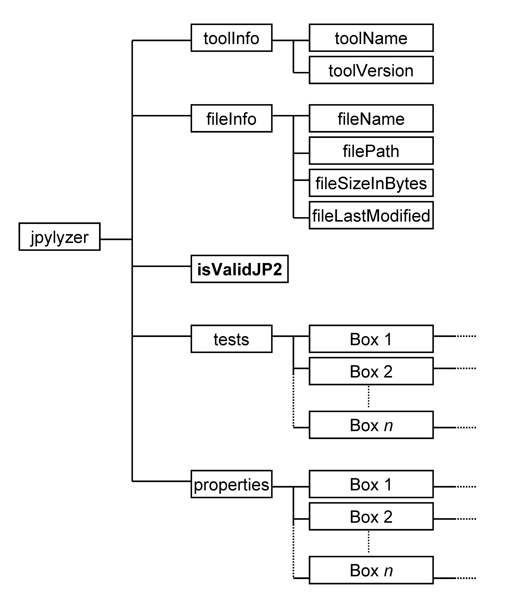
Figure 5-3 Jpylyzer’s XML output structure. Note that ‘box’ elements under ‘tests’ and ‘properties’ contain further sub-elements.
The root element (jpylyzer) contains 5 child elements:
- toolInfo: information about jpylyzer
- fileInfo: general information about the analysed file
- isValidJP2: outcome of the validation
- tests: outcome of the individual tests that are part of the validation process (organised by box)
- properties: image properties (organised by box)
If jpylyzer is executed with the --wrapper option, the root element is results, which contains one or more jpylyzer elements which otherwise follow the above structure.

toolInfo element
This element holds information about jpylyzer. Currently it contains the following sub-elements:
- toolName: name of the analysis tool (i.e. jpylyzer.py or jpylyzer, depending on whether the Python script or the Windows binaries were used)
- toolVersion: version of jpylyzer (jpylyzer uses a date versioning scheme)

fileInfo element
This element holds general information about the analysed file. Currently it contains the following sub-elements:
- filename: name of the analysed file without its path (e.g. “rubbish.jp2”)
- filePath: name of the analysed file, including its full absolute path (e.g. “d:\data\images\rubbish.jp2”)
- fileSizeInBytes: file size in bytes
- fileLastModified: last modified date and time

isValidJP2 element
This element contains the results of the validation. If a file passed all the tests (i.e. all tests returned “True”, see section 5.5) it is most likely valid JP2, and the value of isValidJP2 will be “True”. Its value is “False” otherwise.

tests element
This element is reserved to hold the outcomes of all the individual tests that jpylyzer performs to assess whether a file is valid JP2. The results are organised in a hierarchical tree that corresponds to JP2’s box structure. Each individual test can have two values:
- “True” if a file passed the test.
- “False” if a file failed the test.
If a file passed all tests, this is an indication that it is most likely valid JP2. In that case, the isValidJP2 element (section 5.4) has a value of “True” (and “False” in all other cases). These tests are all explained in chapters 6 and 7.

Default and verbose reporting of test results
By default, jpylyzer only reports any tests that failed (i.e. returned “False”), including the corresponding part of the box structure. For a valid JP2 the tests element will be empty. If the --verbose flag is used, the results of all tests are included (including those that returned “True”).

properties element
This element contains the extracted image properties, which are organised in a hierarchical tree that corresponds to JP2’s box structure. See chapters 6 and 7 for a description of the reported properties.

JP2: box by box
The following two chapters provide a detailed explanation of jpylyzer’s functionality and its output. In particular, the following two aspects are addressed:
- The reported properties
- The tests that jpylyzer performs to establish the validity of a file.

About the properties and tests trees
The ‘properties’ element in jpylyzer’s output holds a hierarchical tree structure that contains all extracted properties. The ‘tests’ tree follows the same structure. The hierarchy reflects JP2’s box structure (explained in Chapter 4): each box is represented by a corresponding output element that contains the corresponding property entries. If a box is a superbox, the output element will contain child elements for each child box. For some boxes, the output contains further sub-elements. This applies in particular to the Contiguous Codestream box, since its contents are more complex than any of the other boxes. Also, if a Colour Specification box contains an embedded ICC profile, the properties of the ICC profile are stored in a separate sub-element. In addition to this, one ‘property’ that is reported by jpylyzer (the compression ratio) is not actually extracted from any particular box. Instead, it is calculated from the file size and some properties from the Header boxes. As a result, it is reported separately in the root of the properties tree.

Naming of properties
The naming of the reported properties largely follows the standard (ISO/IEC 15444-1). Some minor differences follow from the fact that the standard does have any consistent use of text case, whereas jpylyzer uses lower camel case. In addition, some parameters in the standard are compound units that aggregate a number of Boolean ‘switches’, where no names are provided for each individual switch. An example of this is the Scod (coding style) parameter in the codestream header, which contains three switches that define the use of precincts, start-of-packet markers and end-of-packet markers. For cases like these jpylyzer uses its own (largely self-descriptive) names (which are all documented in these chapters).

JPEG 2000 Signature box
This box contains information that allows identification of the file as being part of the JPEG 2000 family of file formats.

Element name
signatureBox

Reported properties
None (box only holds JPEG 2000 signature, which includes non-printable characters)

Tests
Test name | True if
boxLengthIsValid | Size of box contents equals 4 bytes
signatureIsValid | Signature equals 0x0d0a870a

File Type box
This box specifies file type, version and compatibility information, including specifying if this file is a conforming JP2 file or if it can be read by a conforming JP2 reader.

Element name
fileTypeBox

Reported properties
Property | Description
br | Brand
minV | Minor version
cL* | Compatibility field (repeatable)

Tests
Test name | True if
boxLengthIsValid | (Size of box – 8) /4 is a whole number (integer)
brandIsValid | br equals 0x6a703220 (“jp2 ”)
minorVersionIsValid | minV equals 0
compatibilityListIsValid | Sequence of compatibility (cL) fields includes one entry that equals 0x6a703220 (“jp2 ”)

JP2 Header box (superbox)
This box is a superbox that holds a series of boxes that contain header-type information about the file.

Element name
jp2HeaderBox

Reported properties
Since this is a superbox, it contains a number of child boxes. These are represented as child elements in the properties tree:

Child element | Description
imageHeaderBox (section 6.5) | Properties from Image Header box (required)
bitsPerComponentBox (section 6.6) | Properties from Bits Per Component box (optional)
ColourSpecificationBox (section 6.7) | Properties from Colour Specification box (required)
paletteBox (section 6.8) | Properties from Palette box (optional)
componentMappingBox (section 6.9) | Properties from Component Mapping box (optional)
channelDefinitionBox (section 6.10) | Properties from Channel Definition box (optional)
resolutionBox (section 6.11) | Properties from Resolution box (optional)

Tests
Test name | True if
containsImageHeaderBox | Box contains required Image Header box
containsColourSpecificationBox | Box contains required Colour Specification box
containsBitsPerComponentBox | Box contains Bits Per Component Box, which is required if bPCSign and bPCDepth in Image Header Box equal 1 and 128, respectively (test is skipped otherwise)
firstJP2HeaderBoxIsImageHeaderBox | First child box is Image Header Box
noMoreThanOneImageHeaderBox | Box contains no more than one Image Header box
noMoreThanOneBitsPerComponentBox | Box contains no more than one Bits Per Component box
noMoreThanOnePaletteBox | Box contains no more than one Palette box
noMoreThanOneComponentMappingBox | Box contains no more than one Component Mapping box
noMoreThanOneChannelDefinitionBox | Box contains no more than one Channel Definition box
noMoreThanOneResolutionBox | Box contains no more than one Resolution box
colourSpecificationBoxesAreContiguous | In case of multiple Colour Specification boxes, they appear contiguously in the JP2 Header box
paletteAndComponentMappingBoxes  OnlyTogether | Box contains a Palette box (only if Component Mapping box is present); box contains a Component Mapping box (only if Palette box is present)

Image Header box (child of JP2 Header box)
This box specifies the size of the image and other related fields.

Element name
imageHeaderBox

Reported properties
Property | Description
height | Image height in pixels
width | Image width in pixels
nC | Number of image components
bPCSign | Indicates whether image components are signed or unsigned
bPCDepth | Number of bits per component
c | Compression type
unkC | Colourspace Unknown field (“yes” if colourspace of image data is unknown; “no” otherwise)
iPR | Intellectual Property field (“yes” if image contains intellectual property rights information; “no” otherwise)

Tests
Test name | True if
boxLengthIsValid | Size of box contents equals 14 bytes
heightIsValid | height is within range [1, 2³² - 1]
widthIsValid | width is within range [1, 2³² - 1]
nCIsValid | nC is within range [1, 16384]
bPCIsValid | bPCDepth is within range [1,38] OR bPCSign equals 255 (in the latter case the bit depth is variable)
cIsValid | c equals 7 (“jpeg2000”)
unkCIsValid | unkC equals 0 (“no”) or 1 (“yes”)
iPRIsValid | iPR equals 0 (“no”) or 1 (“yes”)

Bits Per Component box (child of JP2 Header box)
This (optional) box specifies the bit depth of the components in the file in cases where the bit depth is not constant across all components.

Element name
bitsPerComponentBox

Reported properties
Property | Description
bPCSign* | Indicates whether image component is signed or unsigned (repeated for each component)
bPCDepth* | Number of bits for this component (repeated for each component)

Tests
Test name | True if
bPCIsValid* | bPCDepth is within range [1,38] (repeated for each component)

Colour Specification box (child of JP2 Header box)
This box specifies the colourspace of the image.

Element name
colourSpecificationBox

Reported properties
Property | Description
meth | Specification method. Indicates whether colourspace of this image is defined as an enumerated colourspace or using a (restricted) ICC profile.
prec | Precedence
approx | Colourspace approximation
enumCS (if meth equals “Enumerated”) | Enumerated colourspace (as descriptive text string)
icc (if meth equals “Restricted ICC” or “Any ICC”) | Properties of ICC profile as child element (see below)

Reported properties of ICC profiles
If the colour specification box contains an embedded ICC profile, jpylyzer will also report the following properties (which are all grouped in an “icc” sub-element in the properties tree). An exhaustive explanation of these properties is given in the ICC specification (ISO 15076-1 / ICC.1:2004-10). Note that jpylyzer does not validate embedded ICC profiles (even though it does check if a specific ICC profile is allowed in JP2)!

Property | Description
profileSize | Size of ICC profile in bytes
preferredCMMType | Preferred CMM type
profileVersion | Profile version. Format: “majorRevision.minorRevision.bugFixRevision”
profileClass | Profile/device class
colourSpace | Colourspace
profileConnectionSpace | Profile connection space
dateTimeString | Date / time string. Format: “YYYY/MM/DD, h:m:s”
profileSignature | Profile signature
primaryPlatform | Primary platform
embeddedProfile | Flag that indicates whether profile is embedded in file (“yes”/”no”)
profileCannotBeUsedIndependently | Flag that indicates whether profile cannot (!) be used independently from the embedded colour data (“yes”/”no”)
deviceManufacturer | Identifies a device manufacturer
deviceModel | Identifies a device model
transparency | Indicates whether device medium is reflective or transparent
glossiness | Indicates whether device medium is glossy or matte
polarity | Indicates whether device medium is positive or negative
colour | Indicates whether device medium is colour or black and white
renderingIntent | Rendering intent
connectionSpaceIlluminantX | Profile connection space illuminant X
connectionSpaceIlluminantY | Profile connection space illuminant Y
connectionSpaceIlluminantZ | Profile connection space illuminant Z
profileCreator | Identifies creator of profile
profileID | Profile checksum (as hexadecimal string)
tag* | Signature of profile tag (repeated for each tag in the profile)
description | Profile description (extracted from ‘desc’ tag)

Tests
Test name | True if
methIsValid | meth equals 1 (enumerated colourspace) or 2 (restricted ICC profile)
precIsValid | prec equals 0
approxIsValid | approx equals 0
enumCSIsValid (if meth equals “Enumerated”) | enumCS equals 16 (“sRGB”), 17 (“greyscale”) or 18 (“sYCC”)
iccSizeIsValid (if meth equals “Restricted ICC”) | Actual size of embedded ICC profile equals value of profileSize field in ICC header
iccPermittedProfileClass (if meth equals “Restricted ICC”) | ICC profile class is “input device” or “display device”
iccNoLUTBasedProfile (if meth equals “Restricted ICC”) | ICC profile type is not N-component LUT based (which is not allowed in JP2)

Palette box (child of JP2 Header box)
This (optional) box specifies the palette which maps a single component in index space to a multiple-component image.

Element name
paletteBox

Reported properties
Property | Description
nE | Number of entries in the table
nPC | Number of palette columns
bSign* | Indicates whether values created by this palette column are signed or unsigned (repeated for each column)
bDepth* | Bit depth of values created by this palette column (repeated for each column)
cP** | Value for this entry (repeated for each column, and for the number of entries)

Tests
Test name | True if
nEIsValid | nE is within range [0,1024]
nPCIsValid | nPC is within range [1,255]
bDepthIsValid* | bDepth is within range [1,38] (repeated for each column)

Component Mapping box (child of JP2 Header box)
This (optional) box specifies the mapping between a palette and codestream components.

Element name
componentMappingBox

Reported properties
Property | Description
cMP* | Component index (repeated for each channel)
mTyp* | Specifies how channel is generated from codestream component (repeated for each channel)
pCol* | Palette component index (repeated for each channel)

Tests
Test name | True if
cMPIsValid | cMP is within range [0,16384]
mTypIsValid* | mTyp is within range [0,1] (repeated for each channel)
pColIsValid* | pCol is 0 if mTyp is 0 (repeated for each channel)

Channel Definition box (child of JP2 Header box)
This (optional) box specifies the type and ordering of the components within the codestream, as well as those created by the application of a palette.

Element name
channelDefinitionBox

Reported properties
Property | Description
n | Number of channel descriptions
cN* | Channel index (repeated for each channel)
cTyp* | Channel type (repeated for each channel)
cAssoc* | Channel association (repeated for each channel)

Tests
Test name | True if
nIsValid | n is within range [1, 65535]
boxLengthIsValid | (Size of box – 2) / equals 6*n
cNIsValid* | cN is within range [0, 65535] (repeated for each channel)
cTypIsValid* | cType is within range [0, 65535] (repeated for each channel)
cAssocIsValid* | cAssoc is within range [0, 65535] (repeated for each channel)

Resolution box (child of JP2 Header box, superbox)
This (optional) box contains the grid resolution.

Element name
resolutionBox

Reported properties
Since this is a superbox, it contains one or two child boxes. These are represented as child elements in the properties tree:
Child element | Description
captureResolutionBox (section 6.12) | Properties from Capture Resolution box
displayResolutionBox (section 6.13) | Properties from Default Display Resolution box

Tests
Test name | True if
containsCaptureOrDisplayResolutionBox | Box contains either a Capture Resolution box or a Default Display Resolution box, or both
noMoreThanOneCaptureResolutionBox | Box contains no more than one Capture Resolution box
noMoreThanOneDisplayResolutionBox | Box contains no more than one Default Display Resolution box

Capture Resolution box (child of Resolution box)
This (optional) box specifies the grid resolution at which the image was captured.

Element name
captureResolutionBox

Reported properties
Resolution information in this box is stored as a set of vertical and horizontal numerators, denominators and exponents. Jpylyzer also reports the corresponding grid resolutions in pixels per meter and pixels per inch, which are calculated from these values.
Property | Description
vRcN | Vertical grid resolution numerator
vRcD | Vertical grid resolution denominator
hRcN | Horizontal grid resolution numerator
hRcD | Horizontal grid resolution denominator
vRcE | Vertical grid resolution exponent
hRcE | Horizontal grid resolution exponent
vRescInPixelsPerMeter | Vertical grid resolution, expressed in pixels per meter
hRescInPixelsPerMeter | Horizontal grid resolution, expressed in pixels per meter
vRescInPixelsPerInch | Vertical grid resolution, expressed in pixels per inch
hRescInPixelsPerInch | Horizontal grid resolution, expressed in pixels per inch

Tests
Test name | True if
boxLengthIsValid | Size of box contents equals 10 bytes
vRcNIsValid | vRcN is within range [1,65535]
vRcDIsValid | vRcD is within range [1,65535]
hRcNIsValid | hRcN is within range [1,65535]
hRcDIsValid | hRcD is within range [1,65535]
vRcEIsValid | vRcE is within range [-127,128]
hRcEIsValid | hRcE is within range [-127,128]

Default Display Resolution box (child of Resolution box)
This (optional) box specifies the default grid resolution at which the image should be displayed.

Element name
displayResolutionBox

Reported properties
Resolution information in this box is stored as a set of vertical and horizontal numerators, denominators and exponents. Jpylyzer also reports the corresponding grid resolutions in pixels per meter and pixels per inch, which are calculated from these values.
Property | Description
vRdN | Vertical grid resolution numerator
vRdD | Vertical grid resolution denominator
hRdN | Horizontal grid resolution numerator
hRdD | Horizontal grid resolution denominator
vRdE | Vertical grid resolution exponent
hRdE | Horizontal grid resolution exponent
vResdInPixelsPerMeter | Vertical grid resolution, expressed in pixels per meter
hResdInPixelsPerMeter | Horizontal grid resolution, expressed in pixels per meter
vResdInPixelsPerInch | Vertical grid resolution, expressed in pixels per inch
hResdInPixelsPerInch | Horizontal grid resolution, expressed in pixels per inch

Tests
Test name | True if
boxLengthIsValid | Size of box contents equals 10 bytes
vRdNIsValid | vRdN is within range [1,65535]
vRdDIsValid | vRdD is within range [1,65535]
hRdNIsValid | hRdN is within range [1,65535]
hRdDIsValid | hRdD is within range [1,65535]
vRdEIsValid | vRdE is within range [-127,128]
hRdEIsValid | hRdE is within range [-127,128]

Contiguous Codestream box
This box contains the codestream. See chapter 7.

Intellectual Property box
This (optional) box contains intellectual property information about the image. The JP2 format specification (ISO/IEC 15444-1) does not provide any specific information about this box, other than stating that “the definition of the format of [its] contents […] is reserved for ISO”. As a result, jpylyzer does not currently include a validator function for this box, which is now simply ignored. Jpylyzer will display a user warning message in that case.

XML box
This (optional) box contains XML formatted information.

Element name
xmlBox

Reported properties
If the contents of this box are well-formed XML (see ‘tests’ below), the ‘xmlBox’ element in the properties tree will contain the contents of the XML box. Note that, depending on the character encoding of the original XML, it may contain characters that are not allowed in ASCII (which is the encoding used for jpylyzer’s output). Any such characters will be represented by numerical entity references in the output. If the box contents are not well-formed XML, no properties are reported for this box.

Tests
Test name | True if
containsWellformedXML | Contents of box are parsable, well-formed XML

Note that jpylyzer does not check whether the XML is valid, as this is not required by the standard. Besides, doing so would make jpylyzer significantly slower for XML that contains references to external schemas and DTDs.

UUID box
This (optional) box contains additional (binary) information, which may be vendor-specific. Some applications (e.g. Kakadu and ExifTool) also use this box for storing XMP metadata (see Section 1.1.4 in Part 3 of the XMP specification).

Element name
uuidBox

Reported properties
If the value of uuid indicates the presence of XMP metadata and the contents of this box are well-formed XML, (see ‘tests’ below), the ‘uuidBox’ element in the properties tree will contain the XMP data. Note that, depending on the character encoding of the original XML, it may contain characters that are not allowed in ASCII (which is the encoding used for jpylyzer’s output). Any such characters will be represented by numerical entity references in the output. In all other cases, the ‘uuidBox’ element will contain a standard string representation the of UUID.
Property | Description
uuid | Standard string representation of UUID (only if uuid has value other than be7acfcb-97a9-42e8-9c71-999491e3afac). For an explanation of UUIDs see e.g. Leach et al., 2005.
XMP data | XMP metadata (only if uuid has value be7acfcb-97a9-42e8-9c71-999491e3afac)

Note that except for the XMP case, jpylyzer will not be able to report any information on the actual contents of this box, since it is defined outside of the scope of JPEG 2000.

Tests
Test name | True if
boxLengthIsValid | Size of box contents is greater than 16 bytes
containsWellformedXML | Contents of box are parsable, well-formed XML (this test is only performed if uuid has value be7acfcb-97a9-42e8-9c71-999491e3afac)

UUID Info box (superbox)
This (optional) box contains additional information associated with a UUID.

Element name
uuidInfoBox

Reported properties
This is a superbox which contains two child boxes. These are represented as child elements in the properties tree:
Child element | Description
uuidListBox (section 6.19) | Properties from UUID List box
urlBox (section 6.20) | Properties from Data Entry URL box

Tests
Test name | True if
containsOneListBox | Box contains exactly one UUID List box
containsOneURLBox | Box contains exactly one Data Entry URL box

UUID List box (child of UUID Info box)
This (optional) box specifies a list of UUIDs.

Element name
uuidListBox

Reported properties
Property | Description
nU | Number of UUIDs
uuid* | Standard string representation of UUID (repeated nU times)

Tests
Test name | True if
boxLengthIsValid | Size of box equals nU*16 + 2

Data Entry URL box (child of UUID Info box)
This (optional) box specifies a URL.

Element name
urlBox

Reported properties
Property | Description
version | Version number
loc | Location, which specifies a URL of the additional information associated with the UUIDs in the UUID List box that resides in the same UUID Info box

Tests
Test name | True if
flagIsValid | Three bytes that make up “flag” field equal 0x00 00 00 (‘flag’ is not reported to output because it only contains null bytes)
locIsUTF8 | Location (URL) can be decoded to UTF-8

Unknown box
An image may contain boxes that are not defined by ISO/IEC 15444-1. Although jpylyzer ignores such boxes, it will report some minimal info that will allow interested users to identify them to a limited extent.

Element name
unknownBox

Reported properties
Property | Description
boxType | Four-character text string that specifies the type of information that is found in this box (corresponds to TBox in section I.4 of ISO/IEC 15444-1).

Top-level tests and properties
This section describes the tests and output for the top file level.

Element name
properties

Reported properties
The metrics that are listed here are not ‘properties’ in a strict sense; instead they are secondary or derived metrics that are calculated by combining information from different parts / boxes of the file.
Property | Description
compressionRatio | Compression ratio

The compression ratio is calculated as the ratio between the size of the uncompressed image data and the actual file size:
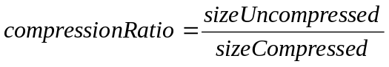
Here, sizeCompressed is simply the file size (fileSizeInBytes in output file’s ‘fileInfo’ element). The uncompressed size (in bytes) can be calculated by multiplying the number of bytes per pixel by the total number of pixels:
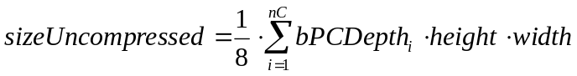
With:
nC | : number of image components (from Image Header box)
i | : component index
bPCDepth_{i} | : bits per component for component i (from Image Header box or Bits Per  Component box)
height | : image height (from Image Header box)
width | : image width (from Image Header box)

In addition, the root of the properties tree contains the elements for all top-level boxes:

Child element | Description
signatureBox (section 6.2) | Properties from JPEG 2000 Signature box
fileTypeBox (section 6.3) | Properties from File Type box
jp2HeaderBox (section 6.4) | Properties from JP2 Header box
contiguousCodestreamBox (chapter 7) | Properties from Contiguous Codestream box
intellectualPropertyBox (section 6.15) | Properties from Intellectual Property box (optional)
xmlBox (section 6.16) | Properties from XML box (optional)
uuidBox (section 6.17) | Properties from UUID box (optional)
uuidInfoBox (section 6.18) | Properties from UUID Info box (optional)

Tests
The tests that jpylyzer performs at the root level fall in either of the following two categories:
- Tests for the presence of required top-level boxes, the order in which they appear and restrictions on the number of instances for specific boxes
- Tests for consistency of information in different parts of the file. In particular, a lot of the information in the Image Header box is redundant with information in the codestream header, and jpylyzer performs a number of tests to verify the consistency between these two.

Test name | True if
containsSignatureBox | File root contains a JPEG 2000 Signature box
containsFileTypeBox | File root contains a File Type box
containsJP2HeaderBox | File root contains a JP2 Header box
containsContiguousCodestreamBox | File root contains a Contiguous Codestream box
containsIntellectualPropertyBox | File root contains an Intellectual Property box, which is required if iPR field in Image Header Box equals 1 (test is skipped otherwise)
firstBoxIsSignatureBox | First box is JPEG 2000 Signature box
secondBoxIsFileTypeBox | Second box is File Type box
locationJP2HeaderBoxIsValid | JP2 Header box is located after File Type Box and before (first) Contiguous Codestream box
noMoreThanOneSignatureBox | File root contains no more than one JPEG 2000 Signature box
noMoreThanOneFileTypeBox | File root contains no more than one File Type box
noMoreThanOneJP2HeaderBox | File root contains no more than one JP2 Header box
heightConsistentWithSIZ | Value of height from Image Header Box equals ysiz –yOsiz from codestream SIZ header
widthConsistentWithSIZ | Value of width from Image Header Box equals xsiz –xOsiz from codestream SIZ header
nCConsistentWithSIZ | Value of nC from Image Header Box equals csiz from codestream SIZ header
bPCSignConsistentWithSIZ | Values of bPCSign from Image Header box (or Bits Per Component box) are equal to corresponding ssizSign values from codestream SIZ header
bPCDepthConsistentWithSIZ | Values of bPCDepth from Image Header box (or Bits Per Component box) are equal to corresponding ssizDepth values from codestream SIZ header

Contiguous Codestream box

General codestream structure
The Contiguous Codestream box holds the JPEG 2000 codestream, which contains the actual image data in a JP2.

Markers and marker segments
A codestream is made up of a number of functional entities which are called markers and marker segments. A marker is essentially a 2-byte delimiter that delineates the start or end position of a functional entity. A marker segment is the combination of a marker and a set of associated parameters (segment parameters). However, not every marker has any associated parameters.

General structure of the codestream
The codestream is made up of the following components (illustrated in Figure 7-4):
- A start of codestream marker that indicates the start of the codestream
- A main codestream header (which includes a number of header marker segments)
- A sequence of one or more tile parts. Each tile part consists of the following components:
  - A start of tile-part marker segment, which indicates the start of a tile part and which also contains index information of the tile part and its associated tile
  - Optionally this may be followed by one or more additional tile-part header marker segments
  - A start of data marker that indicates the start of the bitstream for the current tile part
  - The bitstream
- An ‘end of codestream’ marker that indicates the end of the codestream.
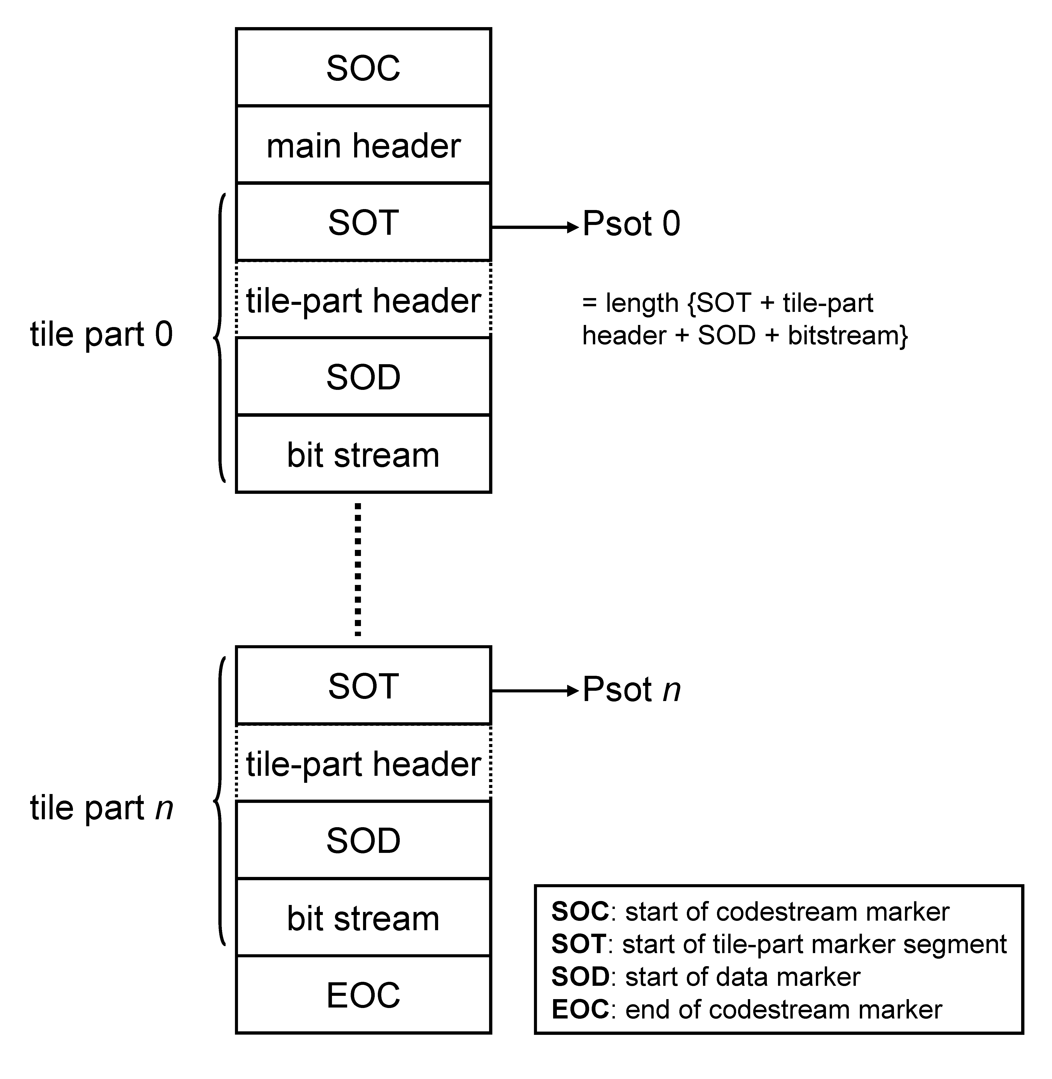
Figure 7-4 General structure of a JPEG 2000 codestream.

Limitations of codestream validation
It is important to stress here that jpylyzer currently doesn’t support the full set of marker segments that can occur in a codestream. As a result, the validation of codestreams is somewhat limited. These limitations are discussed in this section.

Main codestream header
Annex A of ISO/IEC 15444-1 lists a total of 13 marker segments that can occur in the main codestream header. Most of these are optional. The current version of jpylyzer only offers full support (i.e. reads and validates) for the following main header marker segments (which includes all the required ones):
- Start of codestream (SOC) marker segment (required)
- Image and tile size (SIZ) marker segment (required)
- Coding style default (COD) marker segment (required)
- Quantization default (QCD) marker segment (required)
- Comment (COM) marker segment (optional)
In addition the codestream header may also contain any of the following marker segments, which are all optional:
- Coding style component (COC) marker segment (optional)*
- Region-of-interest (RGN) marker segment (optional) *
- Quantization component (QCC) marker segment (optional) *
- Progression order change (POC) marker segment (optional) *
- Packet length, main header (PLM) marker segment (optional) *
- Packed packet headers, main header (PPM) marker segment (optional) *
- Tile-part lengths (TLM) marker segment (optional) *
- Component registration (CRG) marker segment (optional) *
The above marker segments (which are marked with an asterisk) are only minimally supported at this stage: if jpylyzer encounters any of them, it will include the corresponding element in the properties element of the output. However, jpylyzer currently does not analyse the contents of these marker segments, which means that the respective elements in the output will be empty.

Tile parts
The tile part validation has similar limitations. The standard lists 11 marker segments that can occur in the tile part header. Currently, jpylyzer only fully supports the following ones:
- Start of tile part (SOT) marker segment (required)
- Coding style default (COD) marker segment (optional)
- Quantization default (QCD) marker segment (optional)
- Comment (COM) marker segment (optional)
- Start of data (SOD) marker segment (required)
In addition the following optional marker segments may also occur:
- Coding style component (COC) marker segment (optional)*
- Region-of-interest (RGN) marker segment (optional) *
- Quantization component (QCC) marker segment (optional) *
- Progression order change (POC) marker segment (optional) *
- Packet length, tile-part header (PLT) marker segment (optional) *
- Packed packet headers, tile-part header (PPT) marker segment (optional) *
These marker segments (which are marked with an asterisk) are only minimally supported at this stage: if jpylyzer encounters any of them, it will include the corresponding element in the properties element of the output. However, jpylyzer currently does not analyse their contents, and the respective elements in the output will be empty.

Bit streams
In addition to the above limitations, jpylyzer can not be used to establish whether the data in the bitstream are correct (this would require decoding the compressed image data, which is completely out of jpylyzer’s scope). As a result, if jpylyzer is used as part of a quality assurance workflow, it is recommended to also include an additional check on the image contents. Also, jpylyzer does not perform any checks on marker segments within the bit-stream: start-of packet (SOP) and end-of-packet (EPH) markers.

Detection of incomplete or truncated codestreams
A JP2’s tile part header contains information that makes it possible to detect incomplete and truncated codestreams in most cases. Depending on the encoder software used, this method may fail for images that only contain one single tile part (i.e. images that do not contain tiling).

Current limitations of comment extraction
Both the codestream header and the tile part header can contain comment marker segments, which are used for embedding arbitrary binary data or text. Jpylyzer will extract the contents of any comments that are text.

Structure of reported output
Figure 7-5 illustrates the structure of jpylyzer’s codestream-level output. At the top level, the SIZ, COD, QCD and COM marker segments are each represented as individual sub elements. The tile part properties are nested in a tileParts element, where each individual tile part is represented as a separate tilePart sub element.
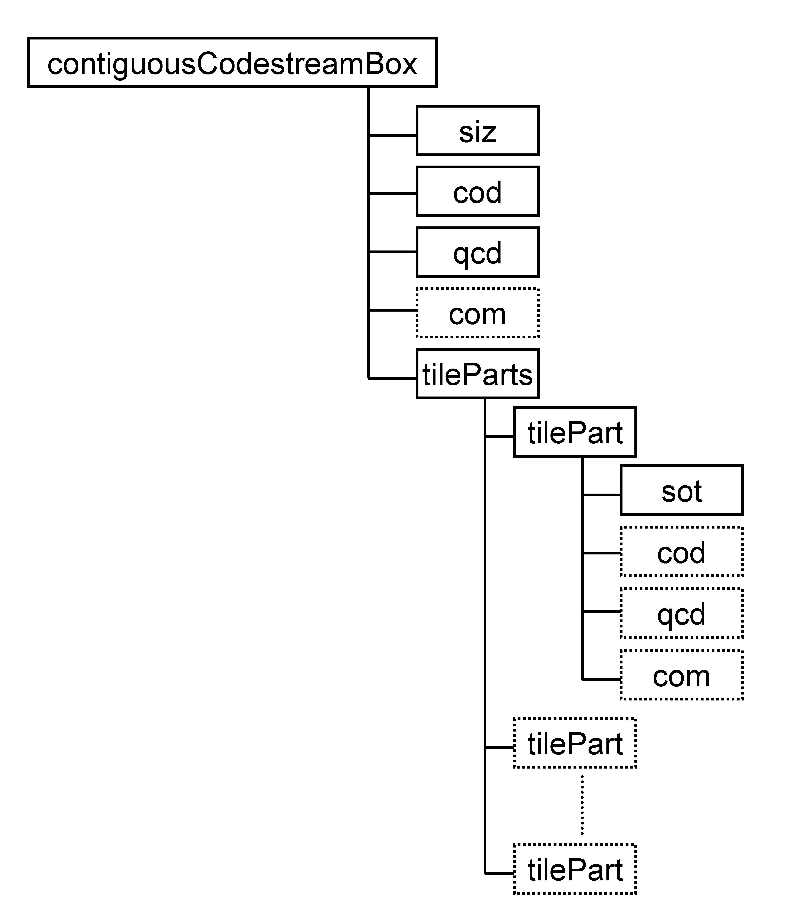
Figure 7-5 Structure of codestream-level XML output

Contiguous Codestream box

Element name
contiguousCodestreamBox

Reported properties
The reported properties for this box are organised into a number groups, which are represented as child elements in the properties tree:

Child element | Description
siz (section 7.5) | Properties from the image and tile size (SIZ) marker segment (codestream main header)
cod (section 7.6) | Properties from the coding style default (COD) marker segment (codestream main header)
qcd (section 7.7) | Properties from the quantization default (QCD) marker segment (codestream main header)
com (section 7.8) | Properties from the (optional) comment (COM) marker segment (codestream main header)
tileParts (section 7.9) | Properties from individual tile parts

Tests
Test name | True if
codestreamStartsWithSOCMarker | First 2 bytes in codestream constitute a start of codestream (SOC) marker segment
foundSIZMarker | Second marker segment in codestream is image and tile size (SIZ) marker segment
foundCODMarker | Codestream main header contains coding style default (COD) marker segment
foundQCDMarker | Codestream main header contains quantization default (QCD) marker segment
quantizationConsistentWithLevels | Values of quantization parameters from QCD marker segment are consistent with levels from COD marker segment
foundExpectedNumberOfTiles | Number of encountered tiles is consistent with expected number of tiles (as calculated from SIZ marker, see section 7.5)
foundExpectedNumberOfTileParts | For all tiles, number of encountered tile parts is consistent with expected number of tile parts (values of tnsot from SOT marker, see section 7.10)
foundEOCMarker | Last 2 bytes in codestream constitute an end of codestream (EOC) marker segment

Image and tile size (SIZ) marker segment (child of Contiguous Codestream box)

Element name
siz

Reported properties
Property | Description
lsiz | Length of SIZ marker segment in bytes
rsiz | Decoder capabilities
xsiz | Width of reference grid
ysiz | Heigth of reference grid
xOsiz | Horizontal offset from origin of reference grid to left of image area
yOsiz | Vertical offset from origin of reference grid to top of image area
xTsiz | Width of one reference tile with respect to the reference grid
yTsiz | Height of one reference tile with respect to the reference grid
xTOsiz | Horizontal offset from origin of reference grid to left side of first tile
yTOsiz | Vertical offset from origin of reference grid to top side of first tile
numberOfTiles | Number of tiles
csiz | Number of components
ssizSign* | Indicates whether image component is signed or unsigned (repeated for each component)
ssizDepth* | Number of bits for this component (repeated for each component)
xRsiz* | Horizontal separation of sample of this component with respect to reference grid (repeated for each component)
yRsiz* | Vertical separation of sample of this component with respect to reference grid (repeated for each component)

Tests
Test name | True if
lsizIsValid | lsiz is within range [41,49190]
rsizIsValid | rsiz equals 0 (“ISO/IEC 15444-1”), 1 (“Profile 0”) or 2 (“Profile 1”)
xsizIsValid | xsiz is within range [1,2³² - 1]
ysizIsValid | ysiz is within range [1,2³² - 1]
xOsizIsValid | xOsiz is within range [0,2³² - 2]
yOsizIsValid | yOsiz is within range [0,2³² - 2]
xTsizIsValid | xTsiz is within range [1,2³² - 1]
yTsizIsValid | yTsiz is within range [1,2³² - 1]
xTOsizIsValid | xTOsiz is within range [0,2³² - 2]
yTOsizIsValid | yTOsiz is within range [0,2³² - 2]
csizIsValid | csiz is within range [1,16384]
lsizConsistentWithCsiz | lsiz equals 38 + 3*csiz
ssizIsValid* | ssizDepth is within range [1,38] (repeated for each component)
xRsizIsValid* | xRsiz is within range [1,255] (repeated for each component)
yRsizIsValid* | yRsiz is within range [1,255] (repeated for each component)

Coding style default (COD) marker segment

Element name
cod

Reported properties
Property | Description
lcod | Length of COD marker segment in bytes
precincts | Indicates use of precincts (“yes”/“no”)
sop | Indicates use of start of packet marker segments (“yes”/“no”)
eph | Indicates use of end of packet marker segments (“yes”/“no”)
order | Progression order
layers | Number of layers
multipleComponentTransformation | Indicates use of multiple component transformation (“yes”/“no”)
levels | Number of decomposition levels
codeBlockWidth | Code block width
codeBlockHeight | Code block height
codingBypass | Indicates use of coding bypass (“yes”/“no”)
resetOnBoundaries | Indicates reset of context probabilities on coding pass boundaries (“yes”/“no”)
termOnEachPass | Indicates termination on each coding pass (“yes”/“no”)
vertCausalContext | Indicates vertically causal context (“yes”/“no”)
predTermination | Indicates predictable termination (“yes”/“no”)
segmentationSymbols | Indicates use of segmentation symbols (“yes”/“no”)
transformation | Wavelet transformation: “9-7 irreversible” or “5-3 reversible”
precinctSizeX* | Precinct width (repeated for each resolution level; order: low to high) (only if precincts is “yes”)
precinctSizeY* | Precinct heigth (repeated for each resolution level; order: low to high) (only if precincts is “yes”)

Tests
Test name | True if
lcodIsValid | lcod is within range [12,45]
orderIsValid | order equals 0 (“LRCP”), 1 (“RLCP”), 2 (“RPCL”), 3 (“PCRL”) or 4 (“CPRL”)
layersIsValid | layers is within range [1,65535]
multipleComponentTransformation  IsValid | multipleComponentTransformation equals 0 or 1
levelsIsValid | levels is within range [0,32]
lcodConsistentWithLevelsPrecincts | lcod equals 12 (precincts = “no”) or lcod equals 13 + levels (precincts = “yes”)
codeBlockWidthExponentIsValid | codeBlockWidthExponent is within range [2,10]
codeBlockHeightExponentIsValid | codeBlockHeightExponent is within range [2,10]
sumHeightWidthExponentIsValid | codeBlockWidthExponent + codeBlockHeightExponent ≤ 12
precinctSizeXIsValid* | precinctSizeX ≥ 2 (except lowest resolution level) (repeated for each resolution level; order: low to high) (only if precincts is “yes”)
precinctSizeYIsValid* | precinctSizeY ≥ 2 (except lowest resolution level) (repeated for each resolution level; order: low to high) (only if precincts is “yes”)

Quantization default (QCD) marker segment

Element name
qcd

Reported properties
Property | Description
lqcd | Length of QCD marker segment in bytes
qStyle | Quantization style for all components
guardBits | Number of guard bits
epsilon* | - If qStyle equals 0 (“no quantization”): Epsilon exponent in Eq E-5 of ISO/IEC 15444-1 (repeated for all decomposition levels; order: low to high)  - If qStyle equals 1 (“scalar derived”): Epsilon exponent in Eq E-3 of ISO/IEC 15444-1  - If qStyle equals 2 (“scalar expounded”): Epsilon exponent in Eq E-3 of ISO/IEC 15444-1 (repeated for all decomposition levels; order: low to high)
mu* | - If qStyle equals 1 (“scalar derived”): mu constant in Eq E-3 of ISO/IEC 15444-1  - if qStyle equals 2 (“scalar expounded”) : mu constant in Eq E-3 of ISO/IEC 15444-1 (repeated for all decomposition levels; order: low to high)

Tests
Test name | True if
lqcdIsValid | lqcd is within range [4,197]
qStyleIsValid | qStyle equals 0 (“no quantization”), 1 (“scalar derived”), or 2 (“scalar expounded”)

Comment (COM) marker segment

Element name
com

Reported properties
Property | Description
lcom | Length of COM marker segment in bytes
rcom | Registration value of marker segment (indicates whether this comment contains binary data or text)
comment | Embedded comment as text (only if rcom = 1 )

Tests
Test name | True if
lcomIsValid | lqcd is within range [5,65535]
rcomIsValid | rcom equals 0 (“binary”) or 1 (“ISO/IEC 8859-15 (Latin”))

Note on support of Latin encoding
If a codestream comment contains characters that are not allowed in ASCII, these will be represented by numeric entity references in the output (this applies to, for example, accented characters, which are common in e.g. French and German).

Tile part (child of Contiguous Codestream box)
Tile-part level properties and tests. This is not a box or a marker segment!

Element name
tilePart (child of tileParts)

Reported properties
Each tile part element can contain a number of child elements:
Child element | Description
sot (section 7.10) | Properties from start of tile (SOT) marker segment
cod (section 7.6) | Properties from the (optional) coding style default (COD) marker segment (tile part header)
qcd (section 7.7) | Properties from the (optional) quantization default (QCD) marker segment (tile part header)
com (section 7.8) | Properties from the (optional) comment (COM) marker segment (tile part header)

Tests
Test name | True if
foundNextTilePartOrEOC | Tile part start offset + tilePartLength points to either start of new tile or EOC marker (useful for detecting within-codestream byte corruption)
foundSODMarker | Last marker segment of tile part is a start-of-data (SOD) marker

Start of tile part (SOT) marker segment (child of tile part)

Element name
sot

Reported properties
Property | Description
lsot | Length of SOT marker segment in bytes
isot | Tile index
psot | Length of tile part
tpsot | Tile part index
tnsot | Number of tile-parts of a tile in the codestream (value of 0 indicates that number of tile-parts of tile in the codestream is not defined in current header)

Tests
Test name | True if
lsotIsValid | lsot equals 10
isotIsValid | isot is within range [0,65534]
psotIsValid | psot is not within range [1,13]
tpsotIsValid | tpsot is within range [0,254]

The following marker segments are only minimally supported: jpylyzer will report their presence in the properties element, but it does not perform any further tests or analyses. This may change in upcoming versions of the software.

Coding style component (COC) marker segment

Element name
coc

Reported properties
Property | Description

Tests
Test name | True if

Region-of-interest (RGN) marker segment

Element name
rgn

Reported properties
Property | Description

Tests
Test name | True if

Quantization component (QCC) marker segment

Element name
qcc

Reported properties
Property | Description

Tests
Test name | True if

Progression order change (POC) marker segment

Element name
poc

Reported properties
Property | Description

Tests
Test name | True if

Packet length, main header (PLM) marker segment

Element name
plm

Reported properties
Property | Description

Tests
Test name | True if

Packed packet headers, main header (PPM) marker segment

Element name
ppm

Reported properties
Property | Description

Tests
Test name | True if

Tile-part lengths (TLM) marker segment

Element name
tlm

Reported properties
Property | Description

Tests
Test name | True if

Component registration (CRG) marker segment

Element name
crg

Reported properties
Property | Description

Tests
Test name | True if

Packet length, tile-part header (PLT) marker segment

Element name
plt

Reported properties
Property | Description

Tests
Test name | True if

Packed packet headers, tile-part header (PPT) marker segment

Element name
ppt

Reported properties
Property | Description

Tests
Test name | True if

References
ICC. Specification ICC.1:1998-09 – File Format for Color Profiles. International Color Consortium, 1998. 29 December 2010 <http://www.color.org/ICC-1_1998-09.pdf>.
ISO/IEC. Information technology — JPEG 2000 image coding system: Core coding system. ISO/IEC 15444-1, Second edition. Geneva: ISO/IEC, 2004a. 28 Dec 2010 <http://www.jpeg.org/public/15444-1annexi.pdf> (“Annex I: JP2 file format syntax” only).
ISO/IEC. Information technology — JPEG 2000 image coding system: Extensions. ISO/IEC 15444-2, First edition. Geneva: ISO/IEC, 2004b. 28 Dec 2010 <http://www.jpeg.org/public/15444-2annexm.pdf> (“Annex M: JPX extended file format syntax” only).
Leach, P., Mealling, M. & Salz, R. A Universally Unique IDentifier (UUID) URN namespace. Memo, IETF. July 2005 <http://tools.ietf.org/html/rfc4122.html>.

The jpylyzer binaries were created using the PyInstaller package: http://www.pyinstaller.org/
Note that jpylyzer will not work under Python versions 3.0-3.1!
Note that jpylyzer versions 1.8 and earlier returned a formatted XML string instead of an element object!
Note that jpylyzer versions 1.4 and earlier used the verbose output format by default. This behaviour has changed in version 1.5 onwards, as the lengthy output turned out to be slightly confusing to some users.
The “Any ICC” method is defined in ISO/IEC 15444-2 (the JPX format), and is not allowed in JP2. However, jpylyzer offers limited support for JPX here by also reporting the properties of ICC profiles that were embedded using this method. Note that any file that uses this method will fail the “methIsValid” test (and thereby the validation).
Important: ISO/IEC 15444-1 only allows “input device” profiles. Support of “display device” profiles will most likely be added soon through an amendment to the standard. Jpylyzer is already anticipating these changes, but by doing so it is deviating from the existing standard in the interim period.
Calculated as: 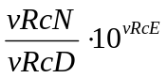
Calculated as: 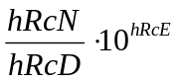
Calculated as:
Calculated as:
Calculated as: 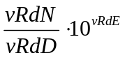
Calculated as: 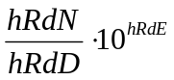
Calculated as:
Calculated as:
Link: http://wwwimages.adobe.com/www.adobe.com/content/dam/Adobe/en/devnet/xmp/pdfs/cs6/XMPSpecificationPart3.pdf
However, support for start of packet (SOP) and end of packet (EPH) markers may be included in future versions.
For example, in a TIFF to JP2 conversion workflow one could include a pixel-by-pixel comparison of the values in the TIFF and the JP2.
The consistency check verifies if the length of the quantization default marker segment (lqcd from qcd) is consistent with the quantization style (qStyle from qcd) and the number of decomposition levels (levels from cod). They are consistent if the following equation is true: 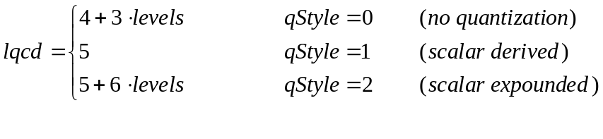
Calculated as 