Module: DSpace Configuration

Module overview:
This module describes how to configure some of the most common features used in DSpace. The module looks in detail at how the submission interface can be modified from the out of the box setup to suit an institutions needs. The module then continues with a look at email notifications & subscriptions, how to configure RSS feeds and concludes with an overview of the UNIX cron job and its use in DSpace

Module objectives:
By the end of this module you will:
- Understand how to configure the submission interface via input-forms.xml
- How to configure Emails/Notifications & Subscriptions
- How to enable and configure RSS feeds
- How to configure nightly scripts (filter media/index-all)

Note
For the practical exercise, please refer to your sheet ‘Local instructions’ for details of the following:
- How to launch a terminal window and a web browser
- What the path to [DSpace] and [DSpace-src] is
- How to restart Tomcat
- What the URL of your DSpace installation is

The Submission Configuration File

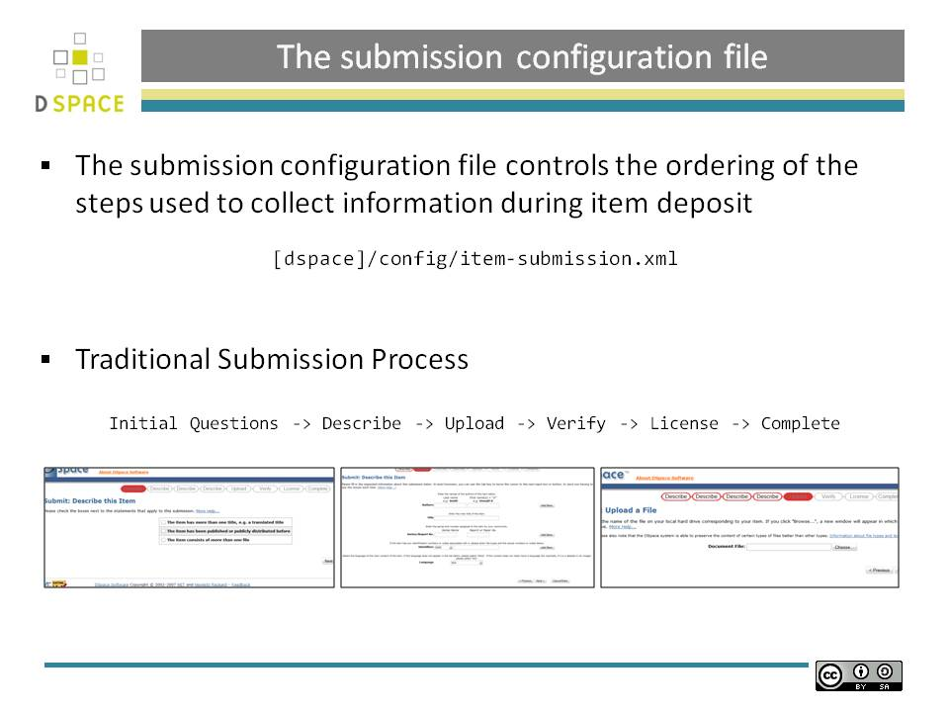The submission configuration file

The [DSpace]/config/item-submission.xml contains the submission configurations for both the DSpace JSP user interface (JSPUI) or the DSpace XML user interface (XMLUI or Manakin). This configuration file contains detailed documentation within the file itself, which should help you better understand how to best utilize it.

The Structure of item-submission.xml

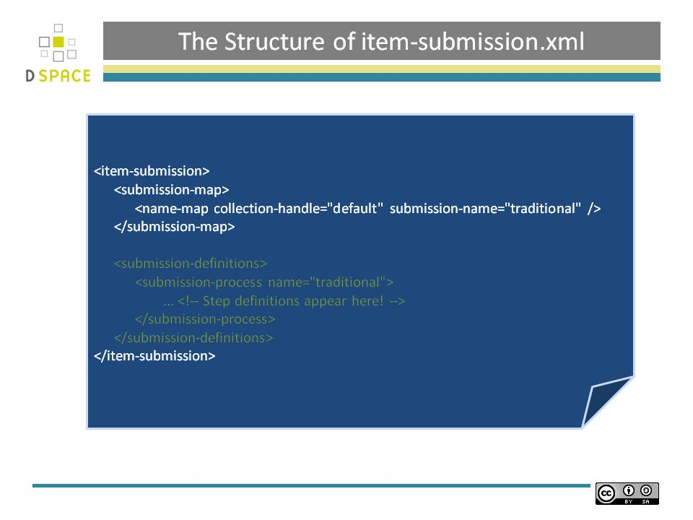The Structure of item-submission.xml

If you would like to customize the steps used or the ordering of the steps, you can do so within the <submission-definition> section of the item-submission.xml .

In addition, you may also specify different Submission Processes for different DSpace Collections. This can be done in the <submission-map> section. The item-submission.xml file itself documents the syntax required to perform these configuration changes.

The Submission Map

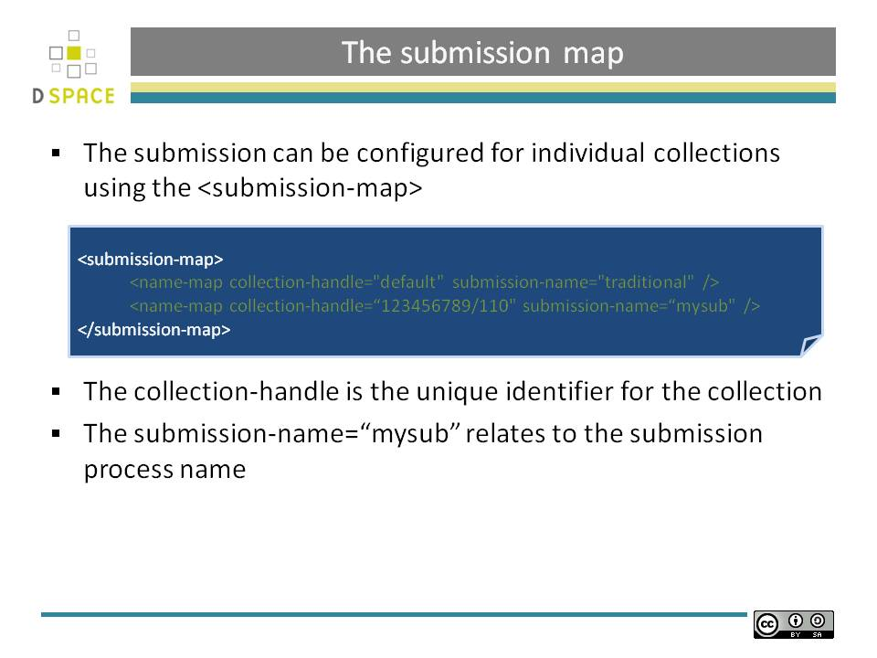The Submission Map

The Submission Process

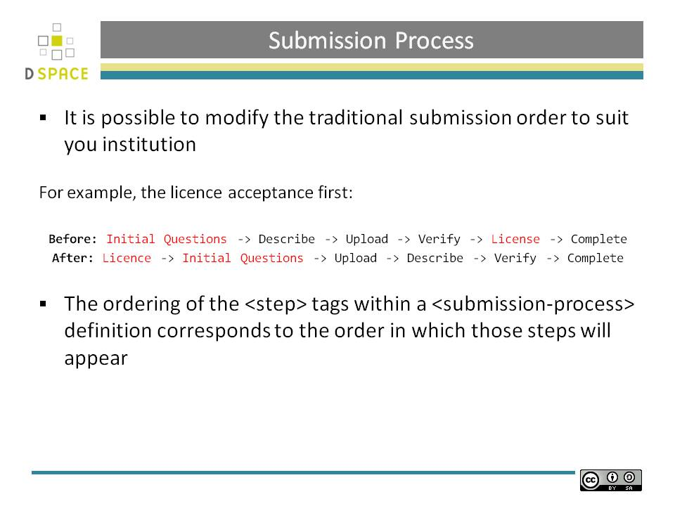The Submission Process
It is possible to modify the traditional submission order to suit you institution
For example, the licence acceptance first:
Before: Initial Questions -> Describe -> Upload -> Verify -> License -> Complete
After: Licence -> Initial Questions -> Upload -> Describe -> Verify -> Complete
The ordering of the <step> tags within a <submission-process> definition corresponds to the order in which those steps will appear

The Submission Process

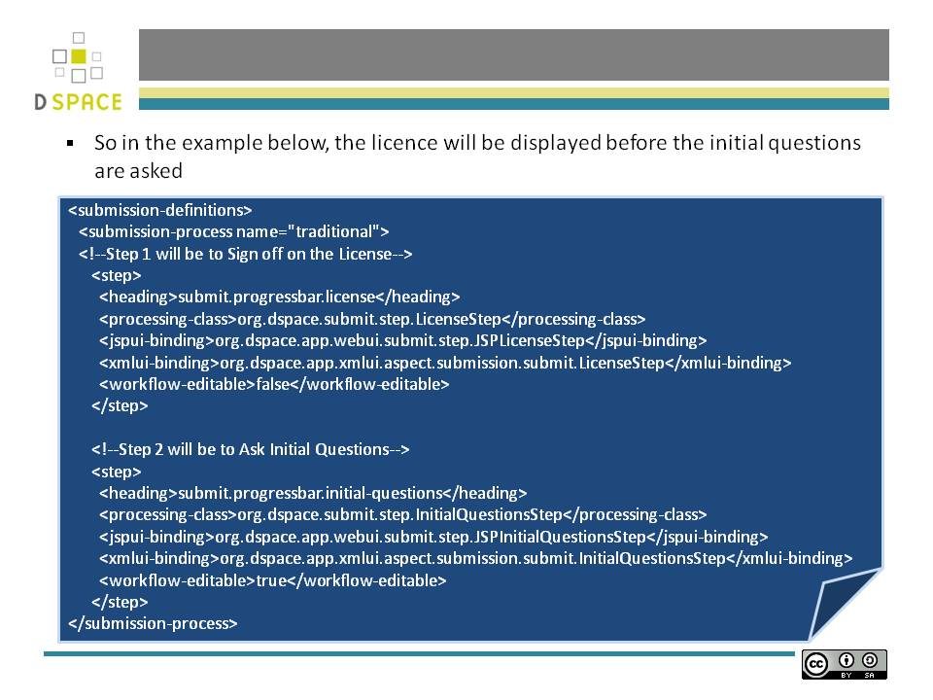The Submission Process

The ordering of the <step> tags within a <submission-process> definition directly corresponds to the order in which those steps will appear!

For example, the following defines a Submission Process where the License step directly precedes the Initial Questions step (more information about the structure of the information under each <step> tag can be found in the section on Structure of the <step> Definition below):
Each step contains the following elements. The required elements are so marked:
heading
Partial I18N key (defined in Messages.properties for JSPUI or messages.xml for XMLUI) which corresponds to the text that should be displayed in the submission Progress Bar for this step. This partial I18N key is prefixed within either the Messages.properties or messages.xml file, depending on the interface you are using. Therefore, to find the actual key, you will need to search for the partial key with the following prefix:
- XMLUI: prefix is xmlui.Submission. (e.g. "xmlui.Submission.submit.progressbar.describe" for 'Describe' step)
- JSPUI: prefix is jsp. (e.g. "jsp.submit.progressbar.describe" for 'Describe' step)
The 'heading' need not be defined if the step should not appear in the progress bar (e.g. steps which perform automated processing, i.e. non-interactive, should not appear in the progress bar).
processing-class (Required)
Full Java path to the Processing Class for this Step. This Processing Class must perform the primary processing of any information gathered in this step, for both the XMLUI and JSPUI. All valid step processing classes must extend the abstract `org.DSpace.submit.AbstractProcessingStep` class (or alternatively, extend one of the pre-existing step processing classes in org.DSpace.submit.step.*)
jspui-binding
Full Java path of the JSPUI "binding" class for this Step. This "binding" class should initialize and call the appropriate JSPs to display the step's user interface. A valid JSPUI "binding" class must extend the abstract `org.DSpace.app.webui.submit.JSPStep` class. This property need not be defined if you are using the XMLUI interface, or for steps which only perform automated processing, i.e. non-interactive steps.
xmlui-binding
Full Java path of the XMLUI "binding" class for this Step. This "binding" class should generate the Manakin XML (DRI document) necessary to generate the step's user interface. A valid XMLUI "binding" class must extend the abstract `org.DSpace.app.xmlui.submission.AbstractSubmissionStep` class. This property need not be defined if you are using the JSPUI interface, or for steps which only perform automated processing, i.e. non-interactive steps.
workflow-editable
Defines whether or not this step can be edited during the Edit Metadata process with the DSpace approval/rejection workflow process. Possible values include true and false. If undefined, defaults to true (which means that workflow reviewers would be allowed to edit information gathered during that step).

Practical: Submission Order

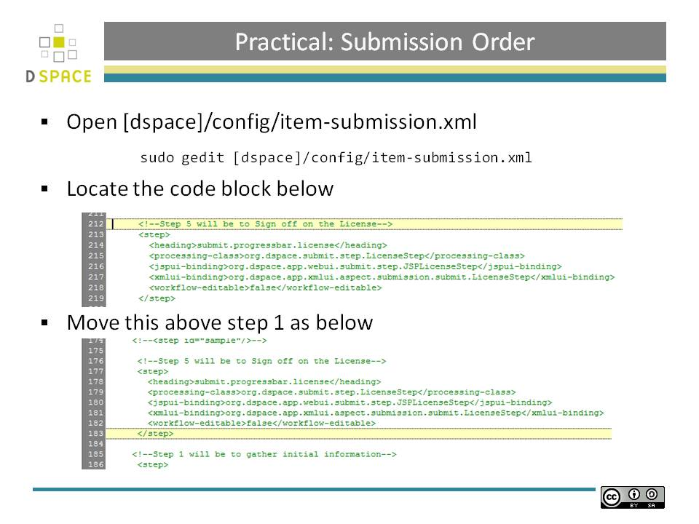

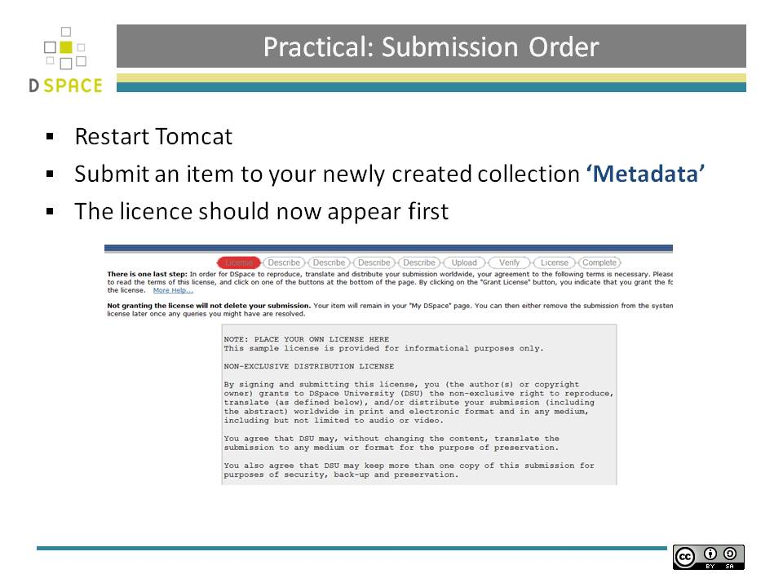

A bit on Metadata

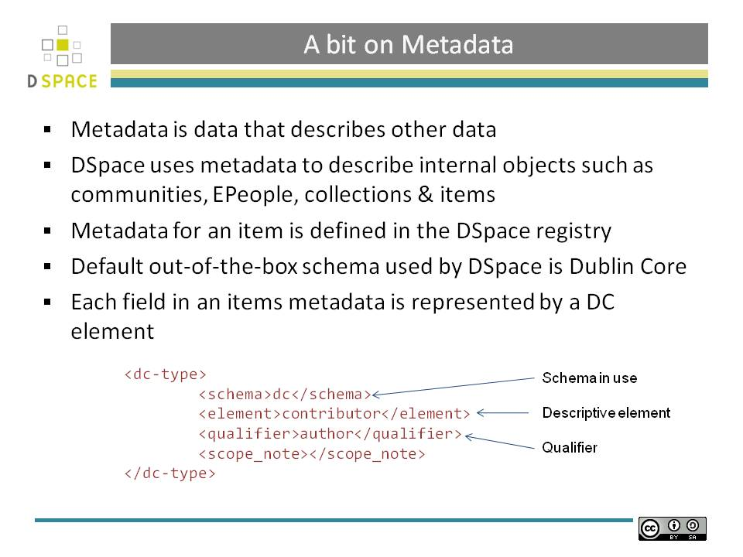A bit on Metadata

Descriptive Metadata

DSpace can support multiple flat metadata schemas for describing an item.

A qualified Dublin Core metadata schema loosely based on the Library Application Profile set of elements and qualifiers is provided by default. The set of elements and qualifiers used by MIT Libraries comes pre-configured with the DSpace source code. However, you can configure multiple schemas and select metadata fields from a mix of configured schemas to describe your items.

Other descriptive metadata about items (e.g. metadata described in a hierarchical schema) may be held in serialized bitstreams. Communities and collections have some simple descriptive metadata (a name, and some descriptive prose), held in the DBMS.

Administrative Metadata

This includes preservation metadata, provenance and authorization policy data. Most of this is held within DSpace's relation DBMS schema. Provenance metadata (prose) is stored in Dublin Core records. Additionally, some other administrative metadata (for example, bitstream byte sizes and MIME types) is replicated in Dublin Core records so that it is easily accessible outside of DSpace.

Structural Metadata

This includes information about how to present an item, or bitstreams within an item, to an end-user, and the relationships between constituent parts of the item. As an example, consider a thesis consisting of a number of TIFF images, each depicting a single page of the thesis. Structural metadata would include the fact that each image is a single page, and the ordering of the TIFF images/pages. Structural metadata in DSpace is currently fairly basic; within an item, bitstreams can be arranged into separate bundles as described above. A bundle may also optionally have a primary bitstream. This is currently used by the HTML support to indicate which bitstream in the bundle is the first HTML file to send to a browser.

A bit more on Metadata

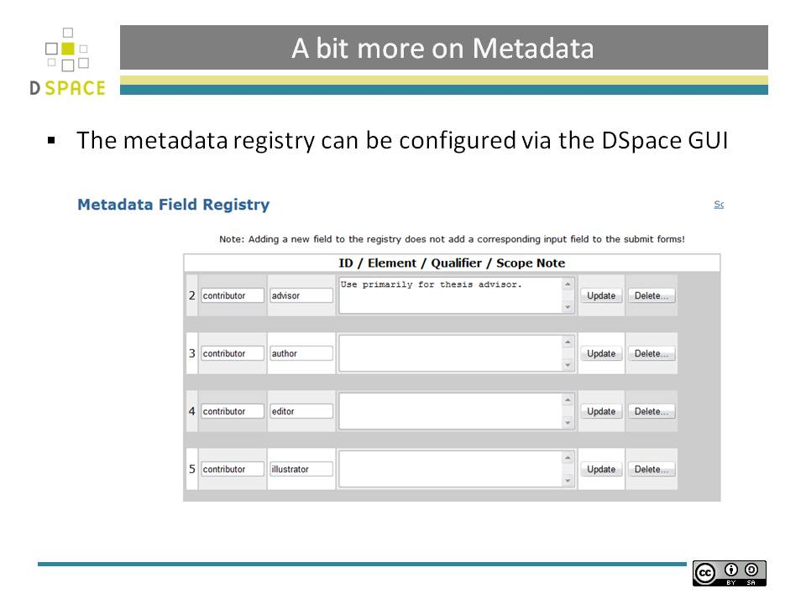

A bit more on Metadata
The DSpace registry can be found from the administration menu when logged into DSpace.
Metadata Schema Registry
The default metadata schema in DSpace is Dublin Core, so it is distributed with a single entry in the source XML file for that namespace. If you wish to add more schemas you can do this in one of two ways. Via the DSpace admin UI you may define new Metadata Schemas, edit existing schemas and move elements between schemas. But you may also modify the XML file (or provide an additional one), and re-import the data as follows:
[DSpace]/bin/dsrun org.DSpace.adminster.SchemaImporter -f [xml file]

The Submission Process

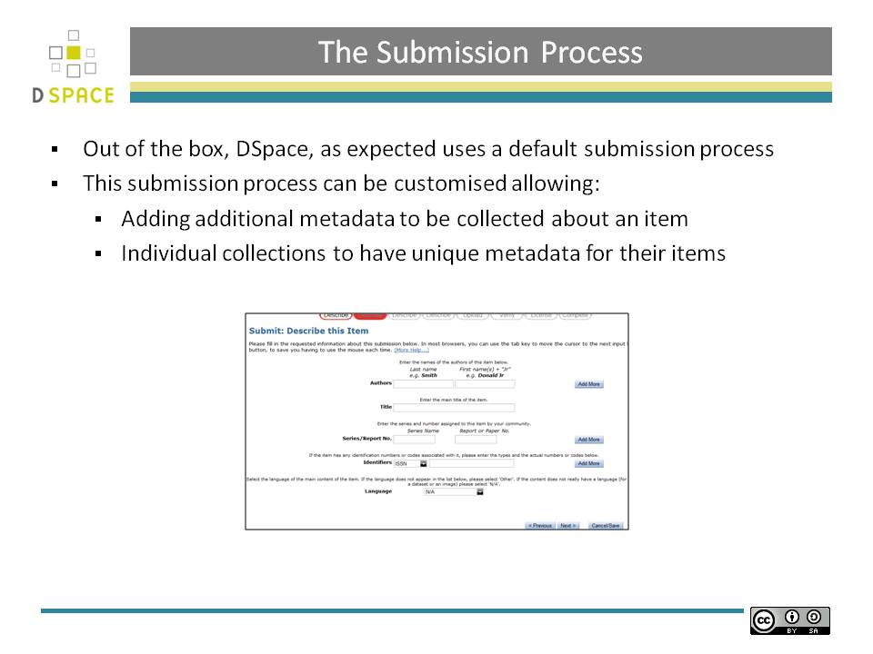 The Submission Process
Additional information on the submission process can be found at:
[DSpace]/docs/submission.html

Input-forms.xml

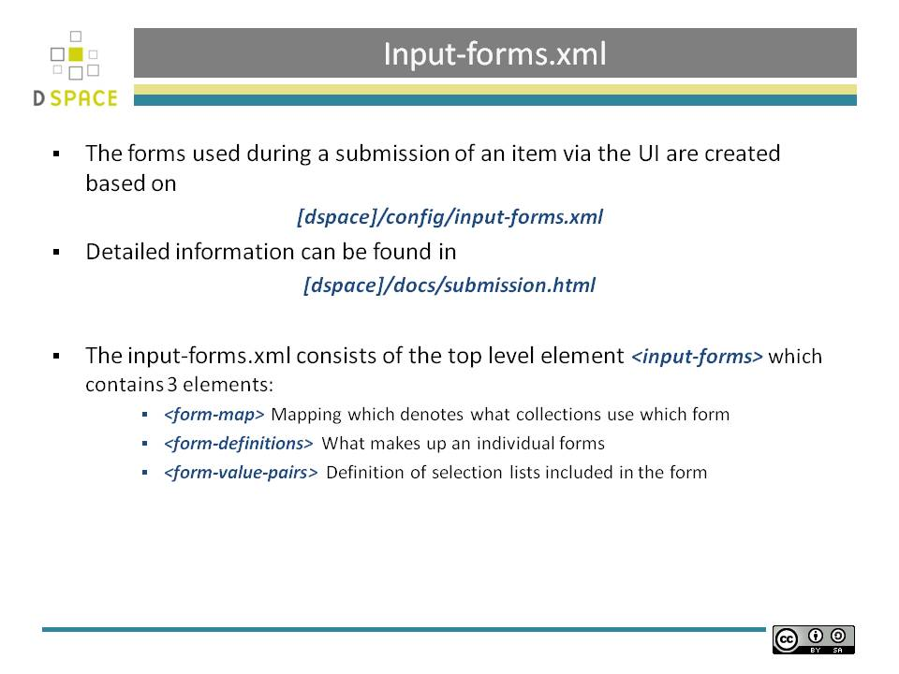 Input-forms.xml
The forms used during a submission of an item via the UI are created based on
[dspace]/config/input-forms.xml
Detailed information can be found in

[dspace]/docs/submission.html

The input-forms.xml consists of the top level element <input-forms> which contains 3 elements:

<form-map> Mapping which denotes what collections use which form

<form-definitions> What makes up an individual forms

<form-value-pairs> Definition of selection lists included in the form

Form Map

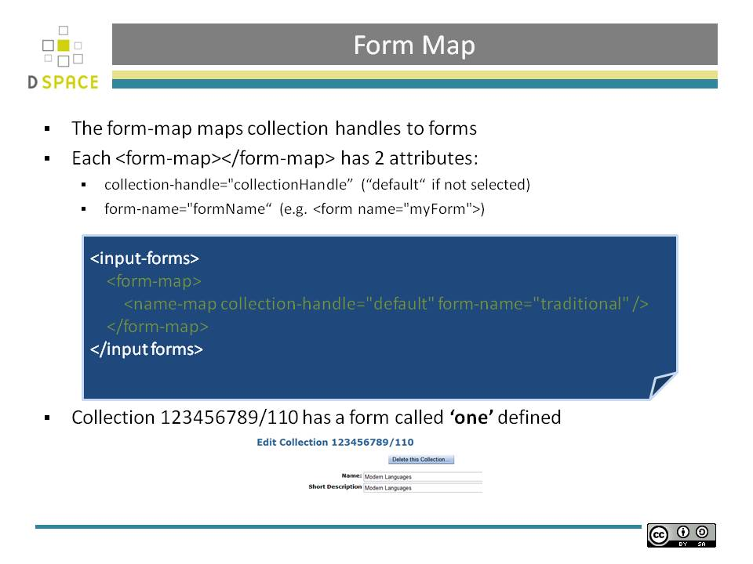Form Map

Each name-map element within form-map associates a collection with the name of a form set. Its collection-handle attribute is the Handle of the collection, and its form-name attribute is the form set name, which must match the name attribute of a form element.

For example, the following fragment shows how the collection with handle "12345.6789/42" is attached to the "TechRpt" form set:

<form-map>
<name-map collection-handle="12345.6789/42" form-name="TechRpt" />
...
</form-map>

<form-definitions>
<form name="TechRept">
...
</form-definitions>

Form Definitions

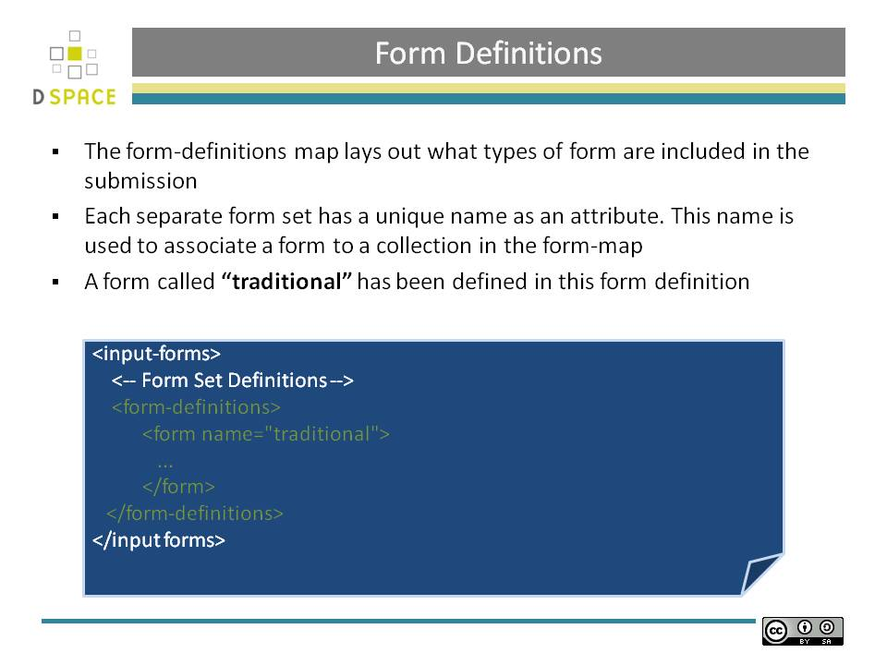Form Definitions

You can add a new form set by creating a new form element within the form-definitions element. It has one attribute, name, which as seen above must match the value of the name-map for the collections it is to be used for.

The content of the form is a sequence of page elements. Each of these corresponds to a Web page of forms for entering metadata elements

Form Definitions

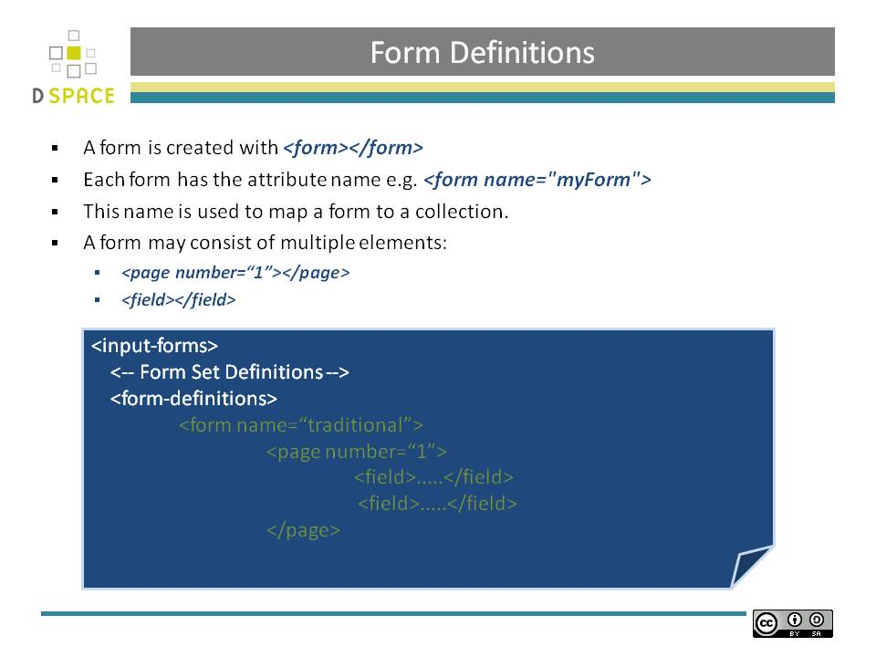Form Definitions

The content of the form is a sequence of page elements. Each of these corresponds to a Web page of forms for entering metadata elements, presented in sequence between the initial "Describe" page and the final "Verify" page (which presents a summary of all the metadata collected).

A form must contain at least one and at most six pages. They are presented in the order they appear in the XML. Each page element must include a number attribute, that should be its sequence number, e.g.

<page number="1">

Form Definitions - Fields

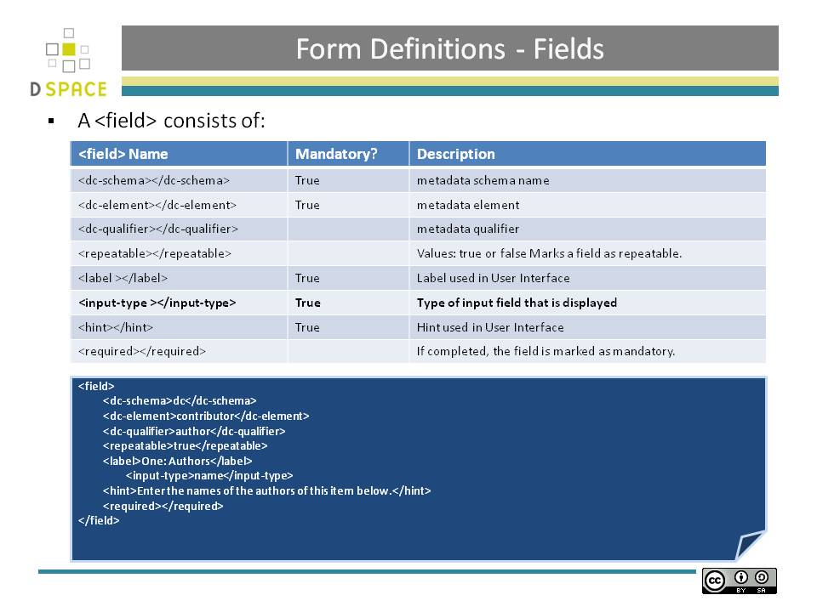Form Definitions - Fields

Each field contains the following elements, in the order indicated. The required sub-elements are so marked:

dc-schema (Required)

Name of metadata schema employed, e.g. dc for Dublin Core. This value must match the value of the schema element defined in dublin-core-types.xml

dc-element (Required)

Name of the Dublin Core element entered in this field, e.g. contributor.

dc-qualifier

Qualifier of the Dublin Core element entered in this field, e.g. when the field is contributor.advisor the value of this element would be advisor. Leaving this out means the input is for an unqualified DC element.

repeatable

Value is true when multiple values of this field are allowed, false otherwise. When you mark a field repeatable, the UI servlet will add a control to let the user ask for more fields to enter additional values. Intended to be used for arbitrarily-repeating fields such as subject keywords, when it is impossible to know in advance how many input boxes to provide.

label (Required)

Text to display as the label of this field, describing what to enter, e.g. "Your Advisor's Name".

input-type (Required)

Defines the kind of interactive widget to put in the form to collect the Dublin Core value.

hint (Required)

Content is the text that will appear as a "hint", or instructions, next to the input fields. Can be left empty, but it must be present.

required

When this element is included with any content, it marks the field as a required input. If the user tries to leave the page without entering a value for this field, that text is displayed as a warning message. For example, <required>You must enter a title.</required>

Note that leaving the required element empty will not mark a field as required, e.g.:

<required></required>

visibility

When this optional element is included with a value, it restricts the visibility of the field to the scope defined by that value. If the element is missing or empty, the field is visible in all scopes. Currently supported scopes are:

workflow: the field will only be visible in the workflow stages of submission. This is good for hiding difficult fields for users, such as subject classifications, thereby easing the use of the submission system.

submit: the field will only be visible in the initial submission, and not in the workflow stages.

For example:

<visibility>workflow</visibility>

Note that it is considered a configuration error to limit a field's scope while also requiring it - an exception will be generated when this combination is detected.

Form Definitions - Fields

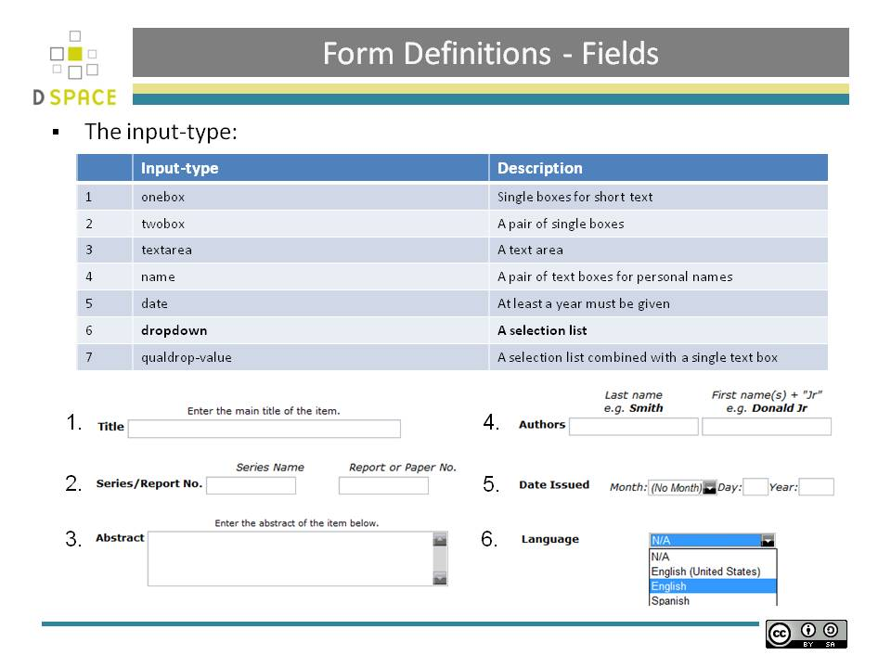

Form Definitions - Fields

onebox -- A single text-entry box.

twobox -- A pair of text-entry boxes, used for repeatable values such as the DC subject item.

textarea -- Large block of text that can be entered on multiple lines, e.g. for an abstract.

name -- Personal name, with separate fields for family name and first name. When saved they are appended in the format 'LastName, FirstName'

date -- Calendar date. When required, demands that at least the year be entered.

series -- Series/Report name and number. Separate fields are provided for series name and series number, but they are appended (with a semicolon between) when saved.

dropdown -- Choose value(s) from a "drop-down" menu list. Note: You must also include a value for the value-pairs-name attribute to specify a list of menu entries from which to choose. Use this to make a choice from a restricted set of options, such as for the language item.

qualdrop_value -- Enter a "qualified value", which includes both a qualifier from a drop-down menu and a free-text value. Used to enter items like alternate identifiers and codes for a submitted item, e.g. the DC identifier field.

list -- Choose value(s) from a checkbox or radio button list. If the repeatable attribute is set to true, a list of checkboxes is displayed. If the repeatable attribute is set to false, a list of radio buttons is displayed. Note: You must also include a value for the value-pairs-name attribute to specify a list of values from which to choose.

Form Value Pairs

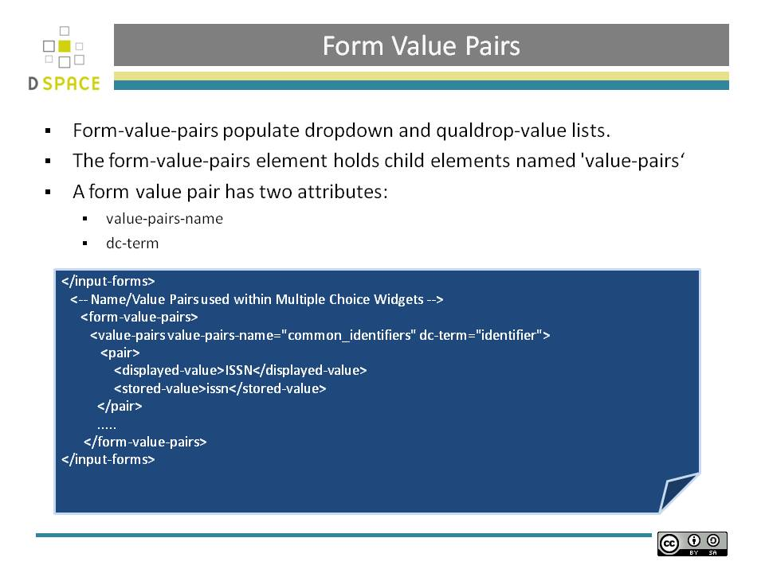Form Value Pairs

Finally, your custom form description needs to define the "value pairs" for any fields with input types that refer to them. Do this by adding a value-pairs element to the contents of form-value-pairs. It has the following required attributes:

value-pairs-name -- Name by which an input-type refers to this list.

dc-term -- Qualified Dublin Core field for which this choice list is selecting a value.

Each value-pairs element contains a sequence of pair sub-elements, each of which in turn contains two elements:

displayed-value -- Name shown (on the web page) for the menu entry.

stored-value -- Value stored in the DC element when this entry is chosen.

Modifying Input-Forms.xml
See the practical session at the end of this workbook for further information

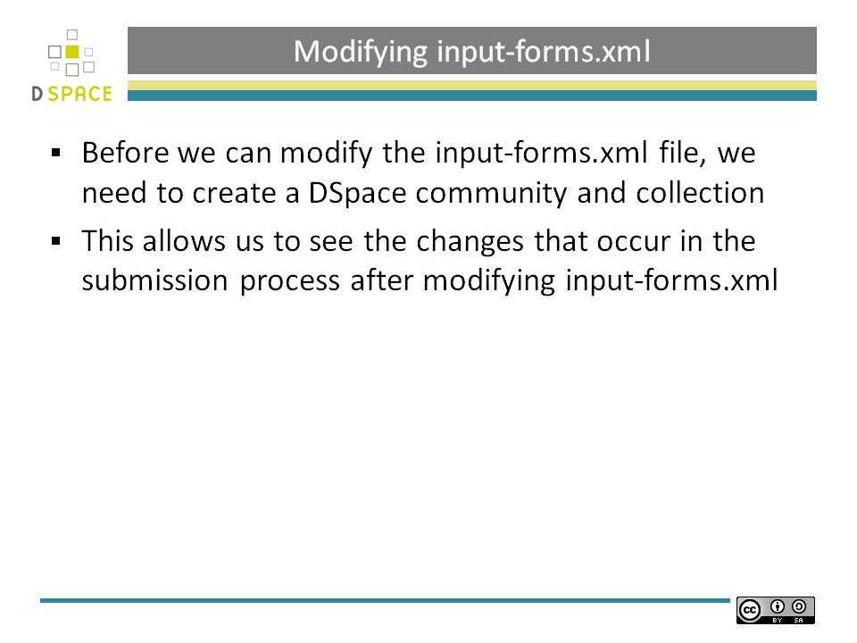

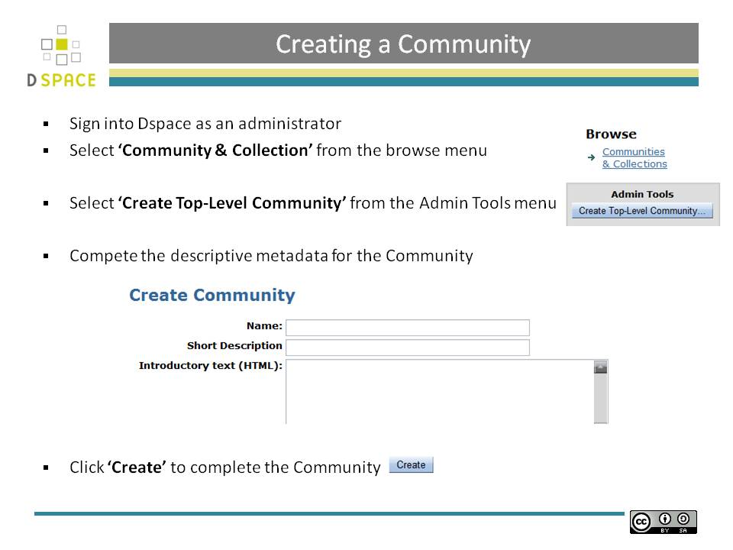

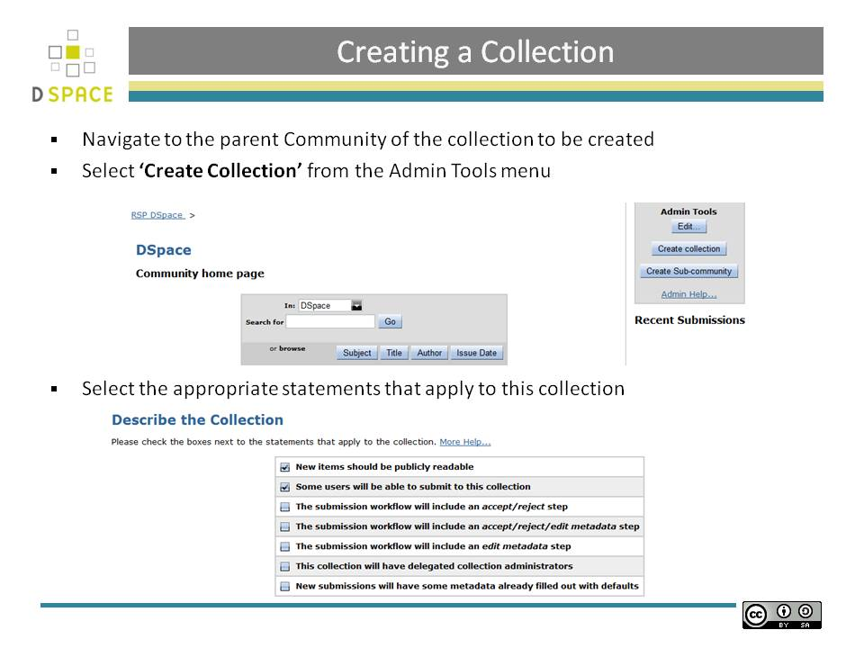
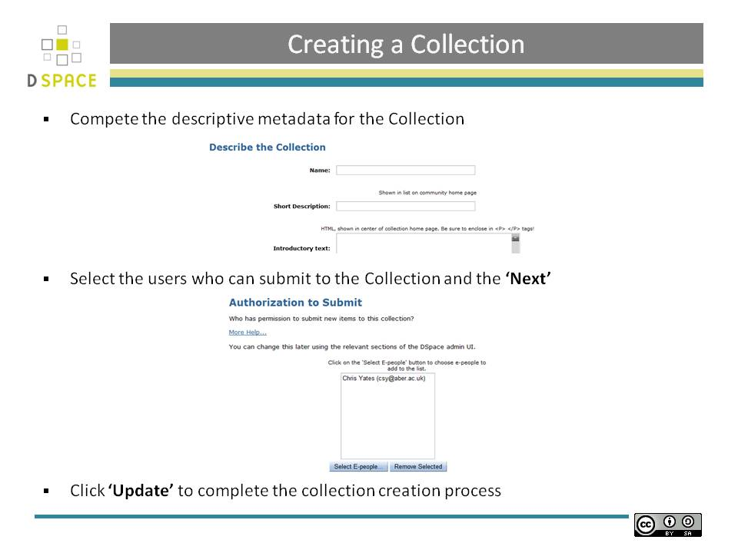

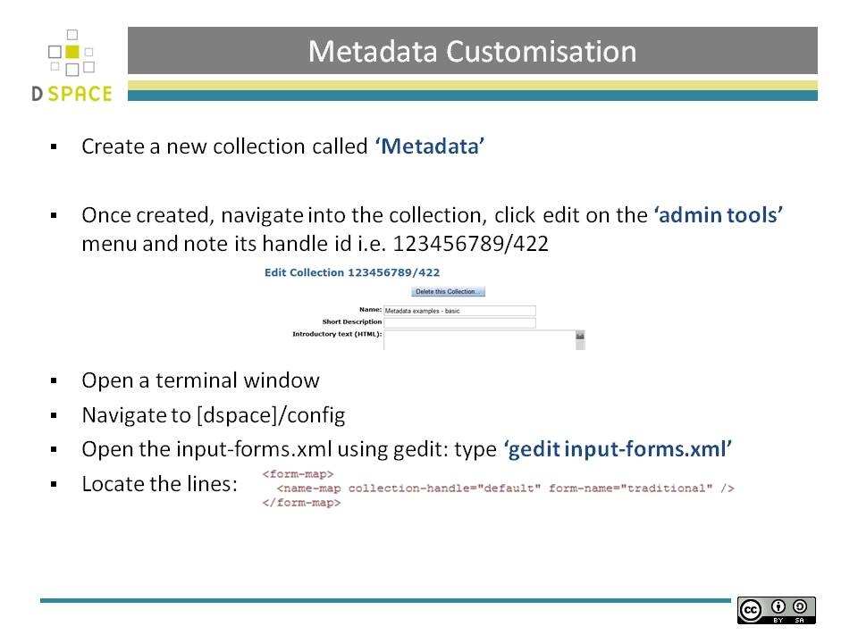

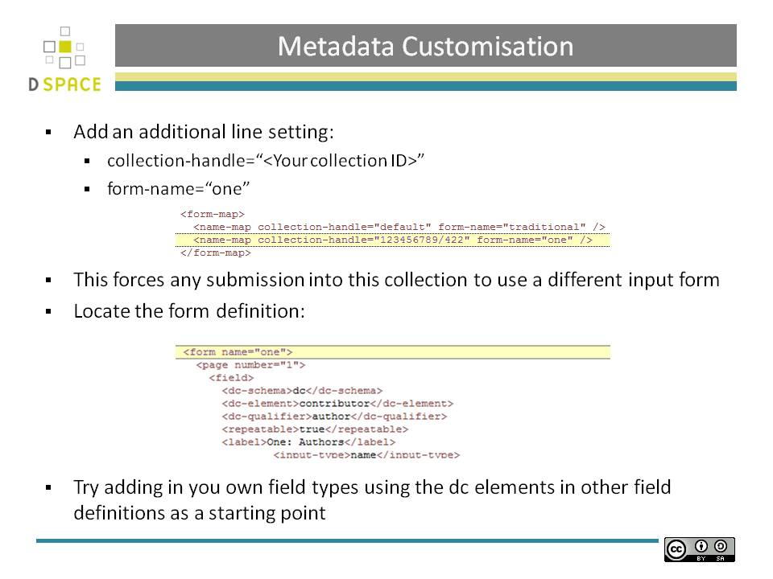

Email Notification & Subscription

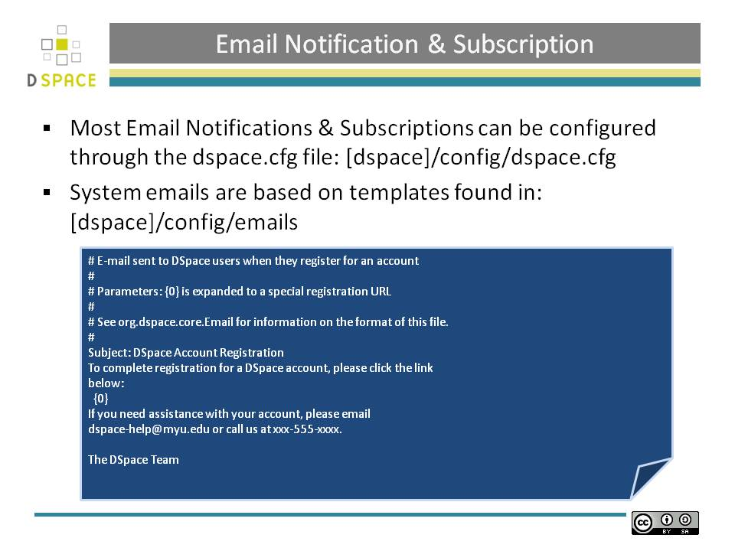Email Notification & Subscription

Sometimes DSpace automatically sends e-mail messages to users, for example to inform them of a new workflow task, or as a subscription e-mail alert. The wording of emails can be changed by editing the relevant file in [DSpace]/config/emails. Each file is commented. Be careful to keep the right number 'placeholders' (e.g.{2}).

Note: You should replace the contact-information "DSpace-help@myu.edu or call us at xxx-555-xxxx" with your own contact details in:

config/emails/change_password

config/emails/register

RSS Syndication

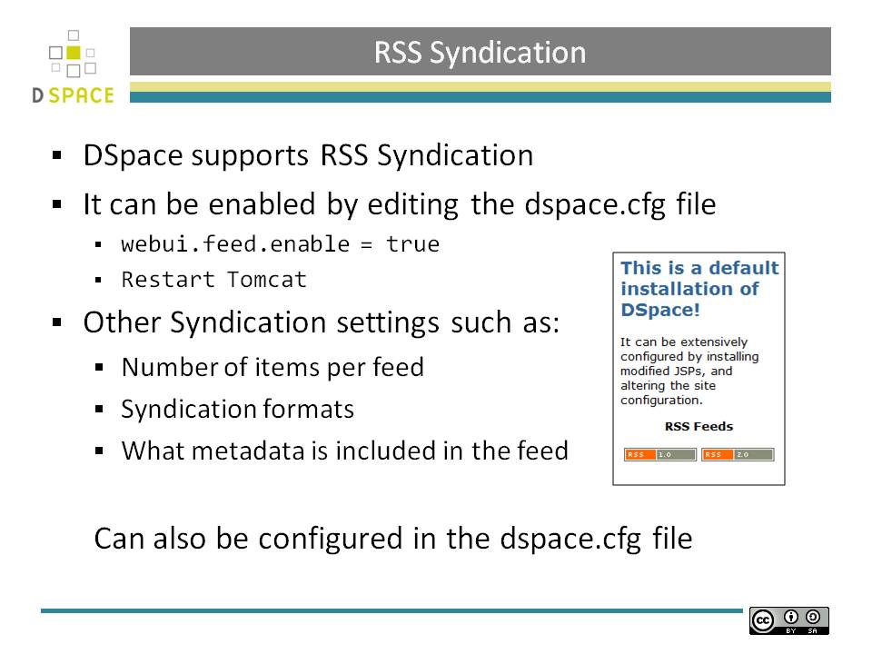RSS Syndication

RSS Syndication

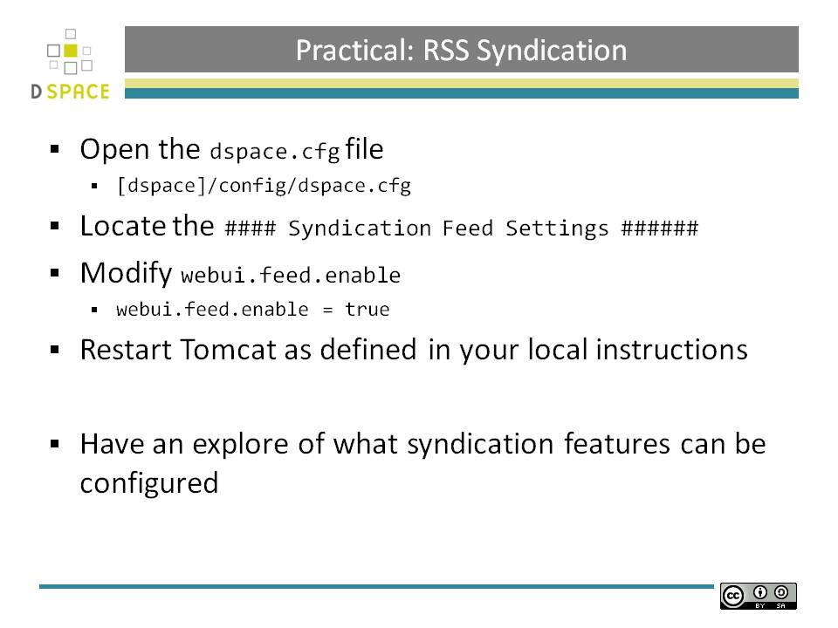RSS Syndication

See the practical session at the end of this workbook for further information

Nightly Scripts

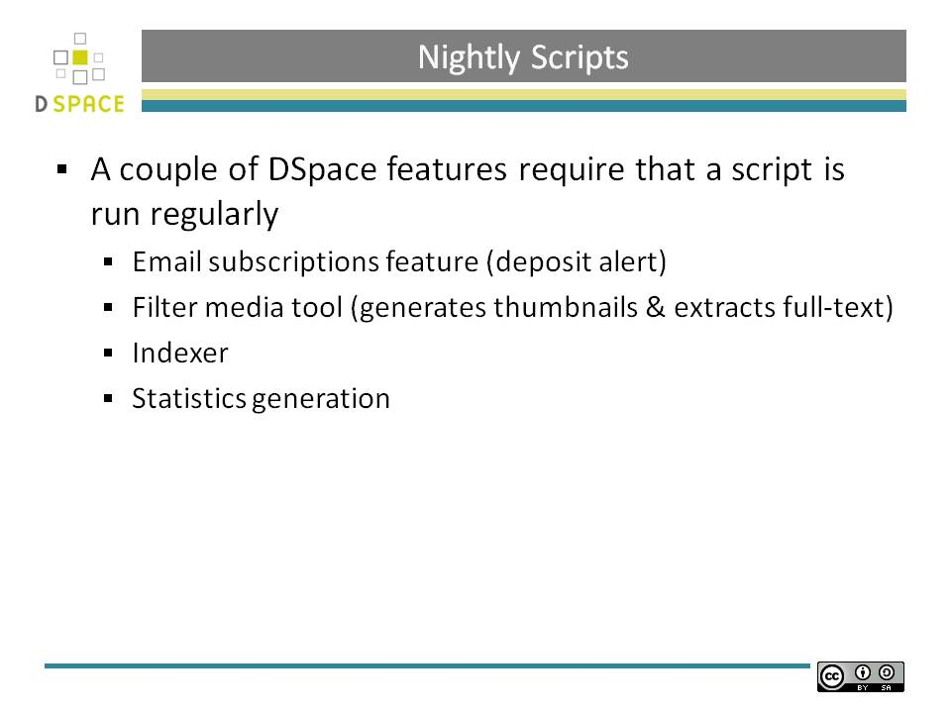Nightly Scripts
A couple of DSpace features require that a script is run regularly
- Email subscriptions feature (deposit alert)
- Filter media tool (generates thumbnails & extracts full-text)
- Indexer
- Statistics generation

Nightly Scripts

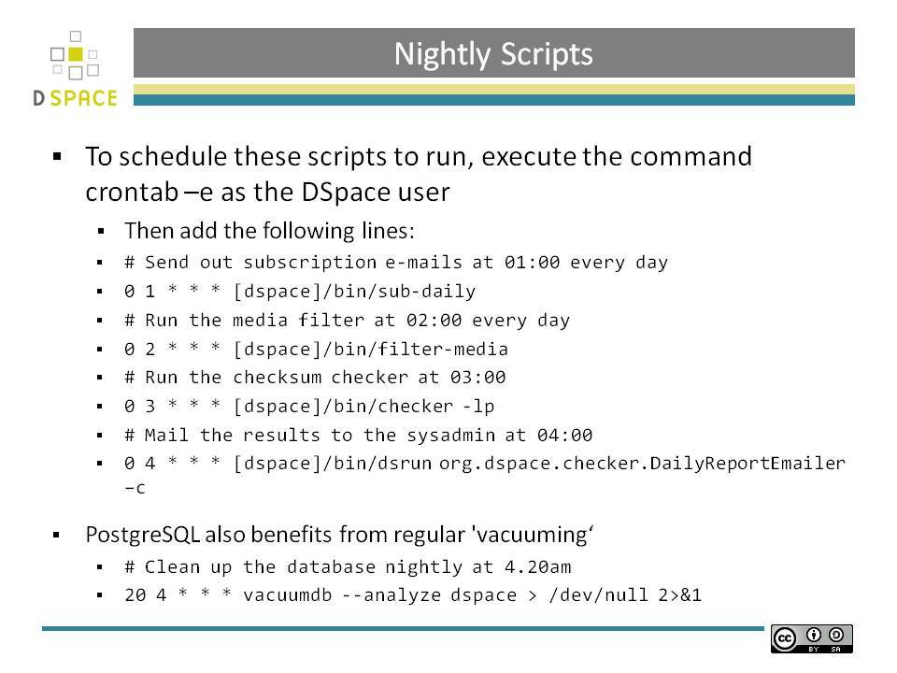Nightly Scripts
You should choose execution times which are most useful to you, and you should ensure that the -report- scripts run a short while after the analysis scripts to give them time to complete (a run of around 8 months worth of logs can take around 25 seconds to complete); the resulting reports will let you know how long analysis took and you can adjust your cron times accordingly.
Nightly Scripts

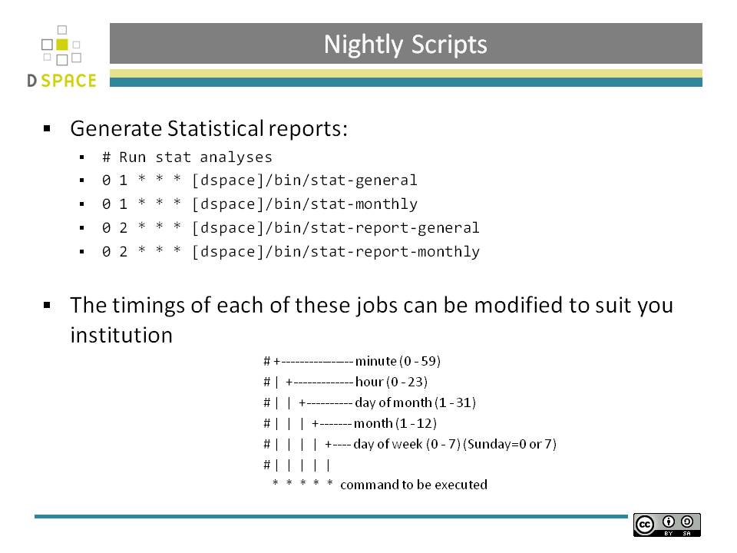

Practical: Modifying item-submission.xml
- Before we can modify the item-submission.xml, we need to create a DSpace community and collection. This allows us to see the changes that occur in the submission process after modifying item-submission.xml. If you’ve not already done this in the module “Repository Structure” create a new collection called ‘Metadata’
- This collection will be required to test the submission process shortly.
- Open [DSpace]/config/item-submission.xml
sudo gedit [DSpace]/config/item-submission.xml
- Locate the code block below
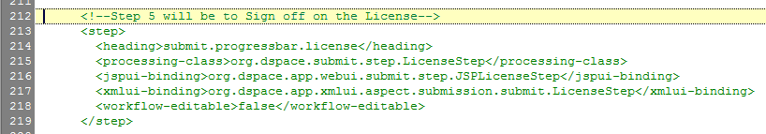
- Move this above step 1 as below
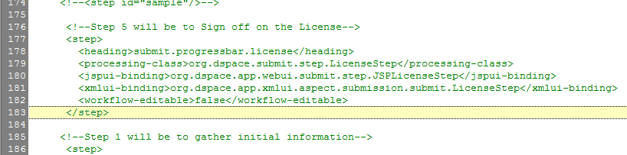
- Restart Tomcat
- Submit an item to your newly created collection ‘Metadata’
- The licence should now appear first in the submission process.
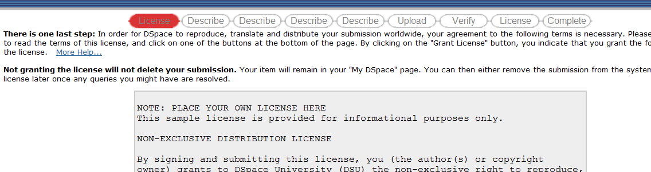

Practical: Modifying input-forms.xml
- Before we can modify the item-submission.xml, we need to create a DSpace community and collection. This allows us to see the changes that occur in the submission process after modifying item-submission.xml. If you’ve not already done this in the module “Repository Structure” create a new collection called ‘Metadata’
- Once created, navigate into the collection, click edit on the ‘admin tools’ menu and note its handle id i.e. 123456789/422
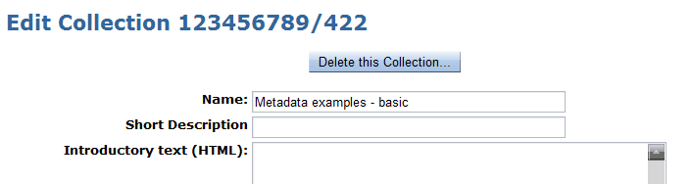
- Open a terminal window
- Navigate to [DSpace]/config
- Open the input-forms.xml using gedit: type ‘gedit input-forms.xml’
- Locate the lines:
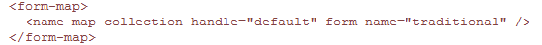
- Add an additional line setting:
  - collection-handle=“<Your collection ID>”
  - form-name=“one”
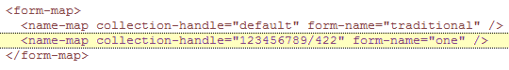
- This forces any submission into this collection to use a different input form

- Locate the form definition:
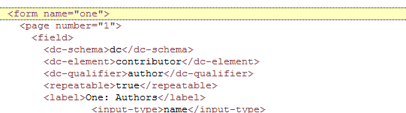
- Try adding in you own field types using the dc elements in other field definitions as a starting point
- Restart Tomcat
- Submit an item to your newly created collection ‘Metadata’
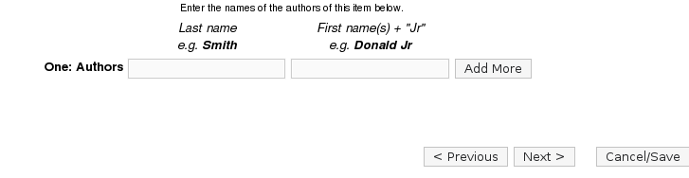
- The submission form input should now modified

Credits
- These notes have been produced by:
  - Stuart Lewis & Chris Yates

  - Repository Support Project


    - http://www.rsp.ac.uk/
  - Part of the RepositoryNet
  - Funded by JISC
    - http://www.jisc.ac.uk/

